### 11.4.4 SPACE-VECTOR-BASED MODULATING TECHNIQUES IN CSIS

The objective of the SV-based modulating technique is to generate PWM load line currents that are on average equal to given load line currents. This is done digitally in each sampling period by properly selecting the switch states from the valid ones of the CSI ([Table 11.6](https://learning.oreilly.com/library/view/power-electronics-handbook/9780128114087/B9780128114070000118_1.xhtml#t0035)) and the proper calculation of the period of times they are used. As in VSIs, the selection and time calculations are based upon the space-vector transformation.

#### **11.4.4.1 Space-Vector Transformation in CSIs**

Similarly to VSIs, the vector of three-phase line-modulating signals  can be represented by the complex vector  by means of Eqs. [(11.31)](https://learning.oreilly.com/library/view/power-electronics-handbook/9780128114087/B9780128114070000118_1.xhtml#fo0160) and [(11.32)](https://learning.oreilly.com/library/view/power-electronics-handbook/9780128114087/B9780128114070000118_1.xhtml#fo0165). For three-phase balanced sinusoidal modulating waveforms, which feature an amplitude *îc* and an angular frequency *ω*, the resulting modulating signal complex vector  becomes a vector of fixed module *îc*, which rotates at frequency *ω* ([Fig. 11.37](https://learning.oreilly.com/library/view/power-electronics-handbook/9780128114087/B9780128114070000118_2.xhtml#f0190)). Similarly, the SV transformation is applied to the line currents of the nine states of the CSI normalized with respect to *ii*, which generates nine space vectors (,  in [Fig. 11.37](https://learning.oreilly.com/library/view/power-electronics-handbook/9780128114087/B9780128114070000118_2.xhtml#f0190)). As expected,  to  are nonnull line current vectors, and , , and  are null line current vectors.

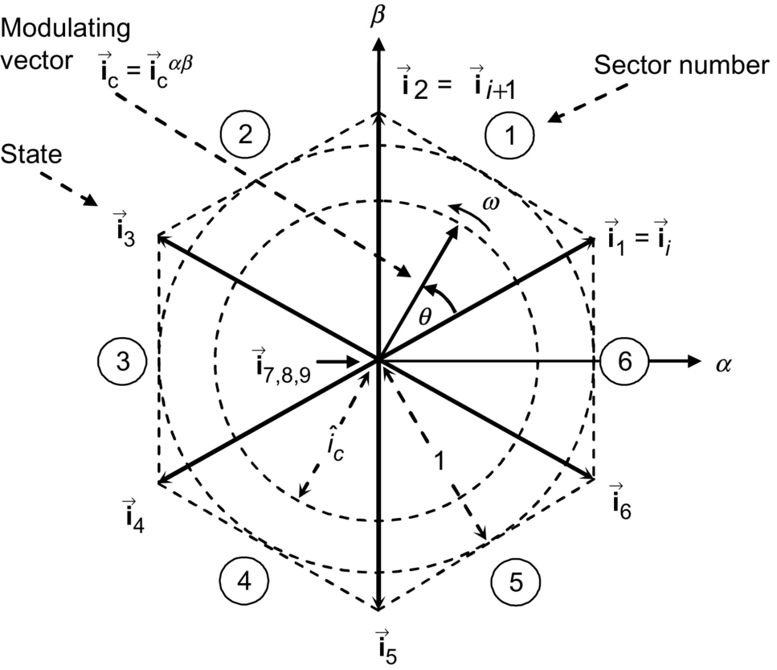

**FIG. 11.37** The space-vector representation in CSIs.

The SV technique approximates the line-modulating signal space vector  by using the nine space vectors (, ) available in CSIs. If the modulating signal vector  is between the arbitrary vectors  and , then  and  combined with one zero SV ( or  or ) should be used to generate . To ensure that the generated current in one sampling period *Ts* (made up of the currents provided by the vectors , , and  used during times *Ti*, , and  is on average equal to the vector , the following expressions should hold:

 **(11.52)**

**** **(11.53)**

**** **(11.54)**

where . Although the SVM technique selects the vectors to be used and their respective on-times, the sequence in which they are used, the selection of the zero space vector, and the normalized sampled frequency remain undetermined.

#### **11.4.4.2 Space-Vector Sequences and Zero Space-Vector Selection**

Although there is no systematic approach to generate a SV sequence, a graphic representation shows that the sequence , ,  (where the chosen  depends upon the sector) provides high performance in terms of minimizing unwanted harmonics and reducing the switching frequency. To obtain the zero SV that minimizes the switching frequency, it is assumed that **Ic** is in sector ②. Then, [Fig. 11.38](https://learning.oreilly.com/library/view/power-electronics-handbook/9780128114087/B9780128114070000118_2.xhtml#f0195) shows all the possible transitions that could be found in sector ②. It can be seen that the zero vector  should be chosen to minimize the switching frequency in all cases. [Table 11.7](https://learning.oreilly.com/library/view/power-electronics-handbook/9780128114087/B9780128114070000118_2.xhtml#t0040) gives a summary of the zero space vector to be used in each sector in order to minimize the switching frequency. However, it should be noted that [Table 11.7](https://learning.oreilly.com/library/view/power-electronics-handbook/9780128114087/B9780128114070000118_2.xhtml#t0040) is valid only for the sequence , , . Another sequence will require reformulating the zero space-vector selection algorithm.

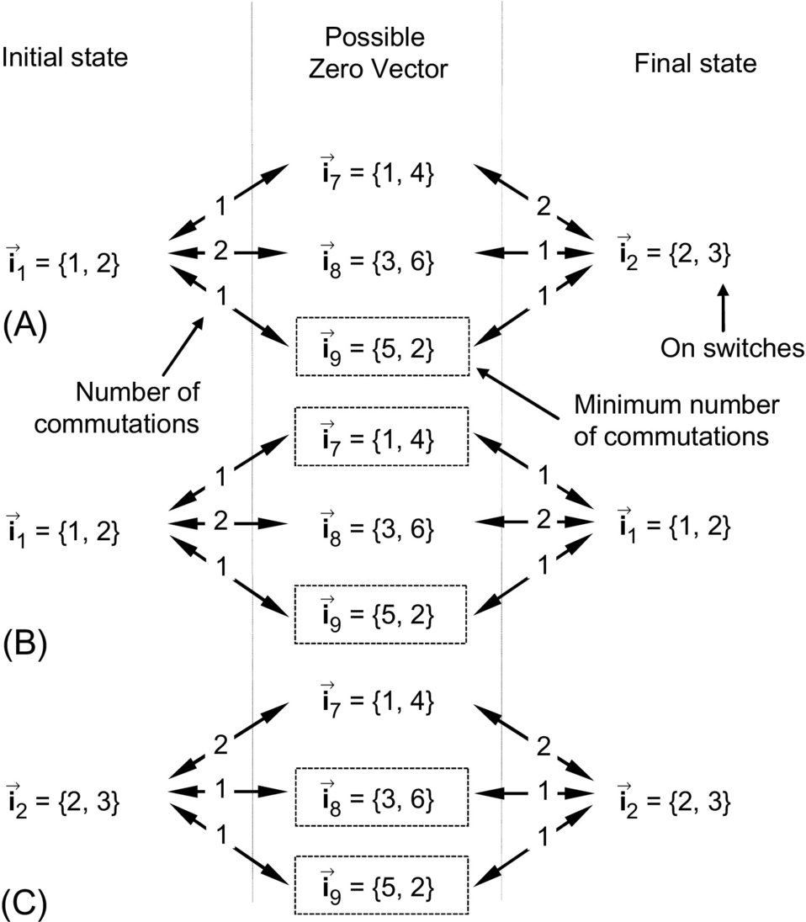

**FIG. 11.38** Possible state transitions in sector ② involving a zero SV: (A) transition,  or ; (B) transition, ; and (C) transition, .

**Table 11.7**

**Zero SV for minimum switching frequency in CSI and sequence , , **

|  |  |  |  |
| --- | --- | --- | --- |
| **Sector** | si226_e | si227_e | si228_e |
| ① | si232_e | si233_e | si234_e |
| ② | si233_e | si236_e | si237_e |
| ③ | si236_e | si239_e | si240_e |
| ④ | si239_e | si242_e | si234_e |
| ⑤ | si242_e | si245_e | si237_e |
| ⑥ | si245_e | si232_e | si240_e |

#### **11.4.4.3 The Normalized Sampling Frequency**

As in VSIs modulated by an SV approach, the normalized sampling frequency *fsn* should be an integer multiple of 6 to minimize uncharacteristic harmonics. As an example, [Fig. 11.39](https://learning.oreilly.com/library/view/power-electronics-handbook/9780128114087/B9780128114070000118_2.xhtml#f0200) shows the relevant waveforms of a CSI SVM for  and . [Fig. 11.39](https://learning.oreilly.com/library/view/power-electronics-handbook/9780128114087/B9780128114070000118_2.xhtml#f0200) also shows that the first set of relevant harmonics load line current are at *fsn*.

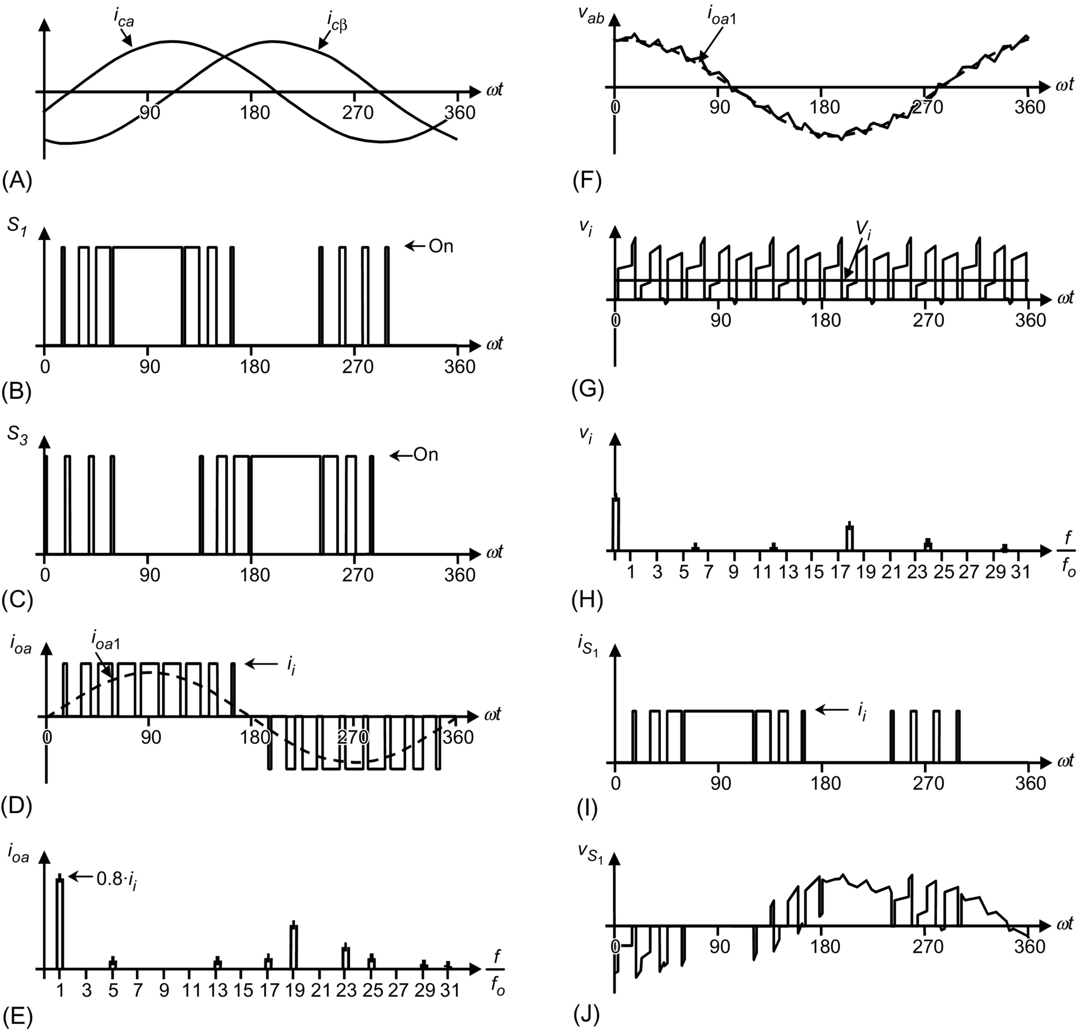

**FIG. 11.39** The three-phase CSI. Ideal waveforms for space-vector modulation (, ): (A) modulating signals, (B) switch *S*1 state, (C) switch *S*3 state, (D) ac output current, (E) ac output current spectrum, (F) ac output voltage, (G) dc voltage, (H) dc voltage spectrum, (I) switch *S*1 current, and (J) switch *S*1 voltage.

### 11.4.5 DC LINK VOLTAGE IN THREE-PHASE CSIS

An instantaneous power balance indicates that

 **(11.55)**

where *van*(*t*), *vbn*(*t*), and *vcn*(*t*) are the phase filter voltages as shown in [Fig. 11.40](https://learning.oreilly.com/library/view/power-electronics-handbook/9780128114087/B9780128114070000118_2.xhtml#f0205). If the filter is large enough and a relatively high switching frequency is used, the phase voltages become nearly sinusoidal balanced waveforms. On the other hand, if the ac output currents are considered sinusoidal and the dc link current is assumed constant , Eq. [(11.55)](https://learning.oreilly.com/library/view/power-electronics-handbook/9780128114087/B9780128114070000118_2.xhtml#fo0280) can be simplified to



**FIG. 11.40** Phase voltage definition in a wye-connected filter.

 **(11.56)**

where *Von* is the rms ac output phase voltage, *Io*1 is the rms fundamental line current, and *ϕ* is an arbitrary filter-load angle. Hence, the dc link voltage expression can be further simplified to the following:

 **(11.57)**

where  is the rms load line voltage. The resulting dc link voltage expression indicates that the first line current harmonic *Io*1 generates a clean dc current. However, as the load line currents contain harmonics around the normalized sampling frequency *fsn*, the dc link current will contain harmonics but around *fsn* as shown in [Fig. 11.39H](https://learning.oreilly.com/library/view/power-electronics-handbook/9780128114087/B9780128114070000118_2.xhtml#f0200). Similarly, in carrier-based PWM techniques, the dc link current will contain harmonics around the carrier frequency *mf* ([Fig. 11.31](https://learning.oreilly.com/library/view/power-electronics-handbook/9780128114087/B9780128114070000118_1.xhtml#f0160)).

In practical implementations, a CSI requires a dc current source that should behave as a constant (as required by PWM CSIs) or variable (as square-wave CSIs) current source. Such current sources should be implemented as separate units.

## 11.5 Multilevel Inverters

The traditional inverters can generate an output in two or three different levels. For instance, a single-phase full-bridge inverter can produce *vi*, , and zero; this type of output is unacceptable in the medium- to high-voltage ranges due to the high *dv*/*dt* present in the PWM ac line voltages. In order to solve this, the multilevel inverters were initially proposed. However, now, their use has been more extended not only due to the low harmonic content obtained at low switching frequencies but also for the good efficiency obtained.

Different multilevel topologies have been proposed. The goal is to produce an output defined by different levels that can be voltage or current levels. The basic principle is to connect the output to multiple points, one at a time. [Fig. 11.41A](https://learning.oreilly.com/library/view/power-electronics-handbook/9780128114087/B9780128114070000118_2.xhtml#f0210) shows the idea for a voltage-source configuration. Usually, the number *M* of possible level defines the name of the inverter; for instance, if five points are available as in [Fig. 11.41A](https://learning.oreilly.com/library/view/power-electronics-handbook/9780128114087/B9780128114070000118_2.xhtml#f0210) (*M*=5), the inverter is usually named a five-level inverter.



**FIG. 11.41** Basic principle of multilevel output: (A) voltage source and (B) typical output.

For a five-level inverter, the output voltage shown in [Fig. 11.41B](https://learning.oreilly.com/library/view/power-electronics-handbook/9780128114087/B9780128114070000118_2.xhtml#f0210) would be produced. By simple inspection, this output voltage looks more similar to a sinusoidal waveform; then, the harmonic content is expected to be lower than traditional inverters, and the power semiconductors are operating at low switching frequency.

### 11.5.1 VOLTAGE SOURCE-BASED MULTILEVEL TOPOLOGIES

The three-phase VSI can be called also two-level VSI due to the fact that the inverter phase voltages *vaN*, *vbN*, and *vcN* ([Fig. 11.17](https://learning.oreilly.com/library/view/power-electronics-handbook/9780128114087/B9780128114070000118_1.xhtml#f0090)) are instantaneously either *vi*/2 or − *vi*/2. In other words, the phase voltages can take one of the two voltage levels. However, regarding to multilevel inverters, the topologies usually have more than two levels.

The typical multilevel voltage-source topologies are the neutral-point-clamped (also called diode-clamped) inverters, the flying capacitors, and the cascaded configuration. Since they are voltage-source converters, the compulsory rules described in [Section 11.2.1](https://learning.oreilly.com/library/view/power-electronics-handbook/9780128114087/B9780128114070000118_1.xhtml#s0020) also apply, but certainly, some remarks are made for each converter.

#### **11.5.1.1 Neutral Point Clamped Inverter**

In [Fig. 11.42](https://learning.oreilly.com/library/view/power-electronics-handbook/9780128114087/B9780128114070000118_2.xhtml#f0215), the neutral-point-clamped inverter is shown (three levels). For this topology, not only an *M*-level inverter requires (*M*−1) capacitors and 2(*M*−1) switching semiconductors per leg, but also 2(*M*−2) additional diodes must be included per leg; for instance, Da+ and Da− are added for the left leg. *M*−1 devices per leg must be on to select the desired level.



**FIG. 11.42** Three-phase three-level VSI topology, neutral-point-clamped inverter.

[Table 11.8](https://learning.oreilly.com/library/view/power-electronics-handbook/9780128114087/B9780128114070000118_2.xhtml#t0045) gives the switch states of the three-level inverter, just left leg. As it can be observed, not only always two switches are on, but also the signal S1a is the opposite of S4a, and S1b is the opposite of S4b. These conditions must be always satisfied. The switch states for phases *b* and c are identical to those of phase *a*.

**Table 11.8**

**Valid switch states for the three-level neutral-point-clamped inverter, the left leg**

|  |  |  |  |  |  |  |
| --- | --- | --- | --- | --- | --- | --- |
| ***s*1*a*** | ***s*1*b*** | ***s*4*a*** | ***s*4*b*** | ***van*** | **Components conducting** | |
| 1 | 1 | 0 | 0 | *vi*/2 | *S*1*a*, *S*1*b* | If si250_e |
| *D*1*a*, *D*1*b* | If si251_e |
| 0 | 1 | 1 | 0 | 0 | *S*1*b*, si252_e | If si250_e |
| *S*4*a*, si254_e | If si251_e |
| 0 | 0 | 1 | 1 | si53_e | *D*4*a*, *D*4*b* | If si250_e |
| *S*4*a*, *S*4*b* | If si251_e |

#### **11.5.1.2 Flying Capacitors Inverter**

In [Fig. 11.43](https://learning.oreilly.com/library/view/power-electronics-handbook/9780128114087/B9780128114070000118_2.xhtml#f0220), the flying capacitor inverter is shown (three levels). For this topology, an *M*-level inverter requires  capacitors per leg (considering that the capacitors have the same voltage rating) and 2(*M*−1) switching semiconductors per leg, but no additional diodes are required. Also *M*−1 switches per leg must be on to select the desired level.



**FIG. 11.43** Three-phase three-level VSI topology, flying capacitors.

[Table 11.9](https://learning.oreilly.com/library/view/power-electronics-handbook/9780128114087/B9780128114070000118_2.xhtml#t0050) is the switch state of the three-level inverter, just left leg. As it can be observed, not only always two switches are on, but also the signal S1a is the opposite of S4a, and S1b is the opposite of S4b. These conditions must be always satisfied. [Table 11.9](https://learning.oreilly.com/library/view/power-electronics-handbook/9780128114087/B9780128114070000118_2.xhtml#t0050) shows that there is more than one switching state to produce the zero output level; this redundancy should be employed to distribute the losses or to regulate the capacitor voltages. Moreover, as the number of levels increase, more redundancy exists at different levels.

**Table 11.9**

**Valid switch states for the three-level flying capacitors inverter, left leg**

|  |  |  |  |  |  |  |
| --- | --- | --- | --- | --- | --- | --- |
| ***s*1*a*** | ***s*1*b*** | ***s*4*a*** | ***s*4*b*** | ***vaN*** | **Components conducting** | |
| 1 | 1 | 0 | 0 | *vi*/2 | *S*1*a*, *S*1*b* | If si250_e |
| *D*1*a*, *D*1*b* | If si251_e |
| 1 | 0 | 0 | 1 | 0 | *S*1*a*, *D*4*b* | If si250_e |
| *D*1*a*, *S*4*b* | If si251_e |
| 0 | 1 | 1 | 0 | 0 | *S*1*b*, *D*4*a* | If si250_e |
| *D*1*b*, *S*4*a* | If si251_e |
| 0 | 0 | 1 | 1 | si81_e /2 | *D*4*a*, *D*4*b* | If si250_e |
| *S*4*a*, *S*4*b* | If si251_e |

#### **11.5.1.3 Casacade Inverter**

In [Fig. 11.44](https://learning.oreilly.com/library/view/power-electronics-handbook/9780128114087/B9780128114070000118_2.xhtml#f0225), the cascade inverter is shown (five levels). This topology is based on several full-bridge single-phase voltage-source inverters with their output connected in series. An *M*-level inverter requires (*M*−1)/2 single-phase full-bridge VSI per leg and 2(*M*−1) switching semiconductors per leg, but no additional diodes are required. Also *M*−1 switches per leg must be on to select the desired level.



**FIG. 11.44** Single-phase five-level VSI topology, cascade.

[Table 11.10](https://learning.oreilly.com/library/view/power-electronics-handbook/9780128114087/B9780128114070000118_2.xhtml#t0055) gives the switch states of the five-level inverter. Notice that only the top switch control signals of each single-phase full-bridge VSI are shown. Their respective bottom switch control signals are complementary, in order to accomplish with the first compulsory rule for VSIs. As it can be observed, always four devices are on; notice that since a single-phase full-bridge inverter is used, the same rules apply for the control signals of the semiconductors. As it can be observed in [Table 11.10](https://learning.oreilly.com/library/view/power-electronics-handbook/9780128114087/B9780128114070000118_2.xhtml#t0055), there are more than one switching state to produce some output levels; this redundancy should be employed to distribute the losses. Moreover, as the number of levels increases, more redundancy exists at different levels.

**Table 11.10**

**Valid switch states for the five-level cascade inverter, left leg**

|  |  |  |  |  |
| --- | --- | --- | --- | --- |
| **si268_e** | si269_e | si270_e | si271_e | ***van*** |
| 1 | 0 | 1 | 0 | *vi* |
| 1 | 0 | 0 | 0 | *vi*/2 |
| 1 | 0 | 1 | 1 | *vi*/2 |
| 0 | 0 | 1 | 0 | *vi*/2 |
| 1 | 1 | 1 | 0 | *vi*/2 |
| 0 | 0 | 0 | 0 | 0 |
| 0 | 0 | 1 | 1 | 0 |
| 1 | 0 | 0 | 1 | 0 |
| 0 | 1 | 1 | 0 | 0 |
| 1 | 1 | 0 | 0 | 0 |
| 1 | 1 | 1 | 1 | 0 |
| 0 | 1 | 0 | 0 | si53_e |
| 0 | 1 | 1 | 1 | si53_e |
| 0 | 0 | 0 | 1 | si53_e |
| 1 | 1 | 0 | 1 | si53_e |
| 0 | 1 | 0 | 1 | si81_e |

### 11.5.2 CURRENT SOURCE-BASED MULTILEVEL TOPOLOGIES

Duality is found in many aspects related to voltage- and current-source inverters. Perhaps, the most evident is the duality in terms of modulating techniques. Thus, current-source-based multilevel topologies are available as well. There are different topologies reported: paralleled, two-stage, and embedded configurations.

[Fig. 11.45](https://learning.oreilly.com/library/view/power-electronics-handbook/9780128114087/B9780128114070000118_2.xhtml#f0230) shows a three-level *M*=3 current-source topology, which is formed by paralleling two three-phase CSI topologies, the named paralleled CSI ([Table 11.11](https://learning.oreilly.com/library/view/power-electronics-handbook/9780128114087/B9780128114070000118_2.xhtml#t0060)). The main goal is to share evenly the ac current **io**abc among the two topologies (). This should be ensured by having equal dc link currents (). Similarly to voltage-source-based multilevel topologies, this could be achieved either by using two independent dc link currents or by properly gating the power semiconductors.



**FIG. 11.45** Three-phase three-level paralleled CSI topology.

**Table 11.11**

**Valid switch states for the three-level paralleled inverter, left legs**

|  |  |  |  |  |
| --- | --- | --- | --- | --- |
| ***s*11** | ***s*12** | ***s*41** | ***s*42** | ***ioa*** |
| 1 | 1 | 0 | 0 | *ii2*+*ii1* |
| 1 | 1 | 0 | 1 | *ii1* |
| 1 | 1 | 1 | 0 | *ii2* |
| 1 | 1 | 1 | 1 | 0 |
| 1 | 0 | 1 | 1 | −*ii2* |
| 0 | 1 | 1 | 1 | −*ii1* |
| 0 | 0 | 1 | 1 | −(*ii2*+*ii1*) |

### 11.5.3 MODULATION TECHNIQUES IN MULTILEVEL INVERTERS

As in traditional inverters, the sinusoidal pulse width and space-vector modulation can be employed in multilevel inverters, for both CSI and VSI.

#### **11.5.3.1 The SPWM Technique**

The main objective is to generate the appropriate gating signals so as to obtain fundamental inverter phase voltages or currents equal to a given set of modulating signals. Specifically, the SPWM in three-level VSIs uses a sinusoidal set of modulating signals (*vca*, *vcb*, and *vcc* for phases *a*, *b*, and *c*, respectively) and *M*−1=2 triangular type of carrier signals (*v*Δ1 and *v*Δ2) as illustrated in [Fig. 11.46A](https://learning.oreilly.com/library/view/power-electronics-handbook/9780128114087/B9780128114070000118_2.xhtml#f0235). The best results are obtained if the carrier signals are in-phase (synchronized with the modulating signal) and feature an odd normalized frequency (e.g., ). According to [Fig. 11.46A](https://learning.oreilly.com/library/view/power-electronics-handbook/9780128114087/B9780128114070000118_2.xhtml#f0235) and considering a neutral-point-clamped inverter ([Fig. 11.42](https://learning.oreilly.com/library/view/power-electronics-handbook/9780128114087/B9780128114070000118_2.xhtml#f0215)), the switch *S*1*a* is turned either on if  or off if , and switch *S*1*b* is turned either on if  or off if . Additionally, the switch *S*4*a* status is obtained as the opposite to switch *S*1*a*, and the switch *S*4*b* status is obtained as the opposite to switch *S*1*b*. In order to use the same set of carrier signals to generate the gating signals for phases *b* and *c*, the normalized frequency of the carrier signal *mf* should be a multiple of 3. Thus, the possible values are .



**FIG. 11.46** Three-level VSI topology. Relevant waveforms using an SPWM (, ): (A) modulating and carrier signals, (B) switch *S*1*a* status, (C) switch *S*4*b* status, (D) inverter phase *a* voltage, (E) inverter phase *a* voltage spectrum, (F) load line voltage, (G) load line voltage spectrum, and (H) phase-load *a* voltage.

[Fig. 11.46](https://learning.oreilly.com/library/view/power-electronics-handbook/9780128114087/B9780128114070000118_2.xhtml#f0235) shows the relevant waveforms for a three-level neutral-point-clamped inverter modulated by means of an SPWM technique (, ). Specifically, [Fig. 11.46D](https://learning.oreilly.com/library/view/power-electronics-handbook/9780128114087/B9780128114070000118_2.xhtml#f0235) shows the inverter phase voltage, which is clearly a three-level type of voltage, and [Fig. 11.46F](https://learning.oreilly.com/library/view/power-electronics-handbook/9780128114087/B9780128114070000118_2.xhtml#f0235) shows the load line voltage, which shows that the step voltages are at most *vi*/2. More importantly, the inverter phase voltage ([Fig. 11.46E](https://learning.oreilly.com/library/view/power-electronics-handbook/9780128114087/B9780128114070000118_2.xhtml#f0235)) contains harmonics at  with  and  and at  with  and . For instance, the first set of harmonics (, ) are at 15, , . The inverter line voltage ([Fig. 11.46G](https://learning.oreilly.com/library/view/power-electronics-handbook/9780128114087/B9780128114070000118_2.xhtml#f0235)) contains harmonics at  with  and  and at  with  and . For instance, the first set of harmonics in the line voltages (, ) are at , .

All the other features of carrier-based PWM techniques also apply in multilevel inverters. Firstly, the fundamental component of the inverter phase voltages satisfies

 **(11.58)**

and thus, the line voltages satisfy

 **(11.59)**

where  is the linear operating region. To further increase the amplitude of the load voltages, the overmodulation operating region can be used by further increasing the modulating signal amplitudes (), where the line voltages range in

 **(11.60)**

Second, the modulating signals could be improved by adding a third harmonic (zero sequence), which will increase the linear region up to . This results in a maximum fundamental line-voltage component equal to *vi*; as a third point, a nonsinusoidal set of modulating signals could also be used by the modulating technique. This is the case where nonsinusoidal line voltages are required as in active filter applications, and finally, because of the two quadrants operation of VSIs, the multilevel inverter could equally be used in applications where the active power flow goes from the dc to the ac side or from the ac to the dc side.

In general, for an *M*-level inverter modulated by means of a carrier-based technique, three modulating signals 120*°* out of phase and *M*−1 carrier signals are required. Key waveforms are shown in [Fig. 11.47](https://learning.oreilly.com/library/view/power-electronics-handbook/9780128114087/B9780128114070000118_2.xhtml#f0240).



**FIG. 11.47** Five-level VSI topology. Relevant waveforms using a SPWM (, ): (A) inverter phase *a* voltage, (B) inverter phase *a* voltage spectrum, (C) load line voltage, and (D) load line voltage spectrum.

One of the drawbacks of the multilevel inverter is that the dc link capacitor voltages or inductor currents, depending on the type of inverter, should be regulated. Unfortunately, this is not a natural operating condition mainly due to the fact that the storage elements are operated in a not symmetrical manner, and therefore, they will not equally share energy.

#### **11.5.3.2 The SPWM Technique in Three-level CSIs**

As in three-level VSIs, the main objective is to generate the appropriate 12 gating signals so as to obtain fundamental inverter line currents equal to a given set of modulating signals. Specifically, the SPWM in three-level inverters uses a sinusoidal set of modulating signals (*ica*, *icb*, and *icc* for phases *a*, *b*, and *c*, respectively) and  triangular type of carrier signals (*i*Δ1 and *i*Δ2) as illustrated in [Fig. 11.48A and E](https://learning.oreilly.com/library/view/power-electronics-handbook/9780128114087/B9780128114070000118_2.xhtml#f0245). The best results are obtained if the carrier signals are 180*°* out of phase and feature an odd normalized frequency (e.g., ). In order to use the same set of carrier signals to generate the gating signals for phases *b* and *c*, the normalized frequency of the carrier signal *mf* should be a multiple of 3. Thus, the possible values are .



**FIG. 11.48** Three-level CSI topology. Relevant waveforms using an SPWM (, ): (A) modulating signals and carrier signal 1, (B) switch *S*11 status, (C) inverter 1 linear current, (D) inverter 1 linear current spectrum, (E) modulating signals and carrier signal 2, (F) switch *S*12 status, (G) inverter 2 linear current, and (H) inverter 2 linear current spectrum.

[Fig. 11.48](https://learning.oreilly.com/library/view/power-electronics-handbook/9780128114087/B9780128114070000118_2.xhtml#f0245) shows the relevant waveforms for a three-level inverter modulated by means of an SPWM technique (, ). Specifically, [Fig. 11.48B and F](https://learning.oreilly.com/library/view/power-electronics-handbook/9780128114087/B9780128114070000118_2.xhtml#f0245) show the gating signals obtained as described earlier in this chapter. The inverter line currents shown in [Fig. 11.48C and G](https://learning.oreilly.com/library/view/power-electronics-handbook/9780128114087/B9780128114070000118_2.xhtml#f0245) feature spectra shown in [Fig. 11.48D and H](https://learning.oreilly.com/library/view/power-electronics-handbook/9780128114087/B9780128114070000118_2.xhtml#f0245), respectively. As expected, the inverter line currents contain harmonics at  with  and  and at  with  and . For instance, the first set of harmonics in the line currents ( 1, ) are at , .

The total inverter line current is shown in [Fig. 11.49A](https://learning.oreilly.com/library/view/power-electronics-handbook/9780128114087/B9780128114070000118_2.xhtml#f0250) and features the first set of unwanted harmonics around 2*mf* ([Fig. 11.49B](https://learning.oreilly.com/library/view/power-electronics-handbook/9780128114087/B9780128114070000118_2.xhtml#f0250)). This becomes the first advantage of using a multilevel topology as the filtering component requirements become more relaxed. All the other features of carrier-based PWM techniques also apply in current-source multilevel inverters. For instance, (I) the fundamental component of the line currents satisfies



**FIG. 11.49** Three-level CSI topology. Relevant waveforms using an SPWM (, ): (A) total inverter line current and (B) total inverter line current spectrum.

 **(11.61)**

where  is the linear operating region. Also, (II) to further increase the amplitude of the load currents, a zero-sequence signal could be injected to the modulating signals, in this case,

 **(11.62)**

the overmodulation operating region can be used by further increasing the modulating signal amplitudes (), where the line currents range in

 **(11.63)**

Also, (III) a nonsinusoidal set of modulating signals could also be used by the modulating technique. This is the case where nonsinusoidal line currents are required as in active filter applications, and (IV) because of the two quadrants operation of CSIs, the multilevel inverter could equally be used in applications where the active power flow goes from the dc to the ac side or from the ac to the dc side. In general, for an *N*-level inverter modulated by means of a carrier-based technique, three modulating signals 120*°* out of phase and  carrier signals are required, and the line currents in the inverters have a peak value of *ii*/().

One of the drawbacks of the multilevel inverter is that the dc link capacitors cannot be supplied by a single dc voltage source. This is due to the fact that the currents required by the inverter in the dc bus are not symmetrical, and therefore, the capacitors will not equally share the dc supply voltage *vi*. To overcome this problem, two alternatives are developed later on.

#### **11.5.3.3 The Space-Vector Modulation**

The SV modulating technique can be applied using the same principles used in two-level inverters. However, the higher number of voltage levels increases the complexity of the practical implementation of the technique. For instance, in *M*=3-level inverters, each leg allows *M*=3 different switch combinations as indicated in the previous sections. Therefore, in a three-phase system, there are *M* 3=27 total valid switch combinations, which generate *M* 3=27 load line voltages that are represented by *M* 3=27 space vectors (, ) in [Fig. 11.50](https://learning.oreilly.com/library/view/power-electronics-handbook/9780128114087/B9780128114070000118_2.xhtml#f0255). For instance,  is due to the line voltages , ,  in per unit. Thus, although the principle of operation is the same, the SV digital algorithm will have to deal with a higher number of states *M* 3. Moreover, because some space vectors (e.g.,  and  in [Fig. 11.50](https://learning.oreilly.com/library/view/power-electronics-handbook/9780128114087/B9780128114070000118_2.xhtml#f0255)) produce the same load voltage terminals, the algorithm will have to decide between the two based on additional criteria and that of the basic SV approach. Clearly, as the number of level increases, the algorithm becomes more and more elaborate. However, the benefits are not evident as the number of level increases. The maximum number of levels used in practical applications is five. This is based on a compromise between the complexity of the implementation and the benefits of the resulting waveforms.



**FIG. 11.50** The space-vector representation in a three-level VSI.

#### **11.5.3.4 Balancing Issues**

The operation for the multilevel converter was made considering an even distribution of the voltage across the dc link capacitors or current of the inductors, depending of the type of inverter. This even distribution is not naturally achieved and could be overcome by supplying the storage elements from independent supplies or properly gating the power semiconductors of the inverter in order to minimize the unbalance.

[Fig. 11.51](https://learning.oreilly.com/library/view/power-electronics-handbook/9780128114087/B9780128114070000118_2.xhtml#f0260) shows an ASD based on a three-level VSI, where the dc link capacitors are feed from two different sources. This approach is being commercially used as it ensures a robust balanced dc link voltage distribution and operates with a high-performance type of ac main current. Indeed, for an *M*-level inverter, *M*−1-independent dc voltage supplies are required that could be provided by *M*−1 six-pulse rectifiers feed from an *M*−1 pulse transformer. Therefore, the ac main currents are an *M*−1-level type of waveform.



**FIG. 11.51** ASD based on a three-phase three-level VSI topology.

This approach cannot be used when the inverter does not feature dc link voltage supplies. This is the case of static power reactive power compensators and static power active filters. In this case, the proper gating of the power semiconductors becomes the only choice to keep and balance the dc link voltages. [Fig. 11.52A](https://learning.oreilly.com/library/view/power-electronics-handbook/9780128114087/B9780128114070000118_2.xhtml#f0265) shows this case where the current added by the inverter *io*abc provides the reactive power and current harmonics such that the ac main current *is*abc features a given power factor.



**FIG. 11.52** Reactive power and current harmonics compensator based on a three-phase three-level VSI topology: (A) power topology, (B) carrier and modulating signals, and (C) *δ* closed-loop scheme.

The SPWM modulating technique could be used as in [Fig. 11.46](https://learning.oreilly.com/library/view/power-electronics-handbook/9780128114087/B9780128114070000118_2.xhtml#f0235); however, the zero level of the carrier *δ* is left as a manipulable variable in [Fig. 11.52B](https://learning.oreilly.com/library/view/power-electronics-handbook/9780128114087/B9780128114070000118_2.xhtml#f0265). In fact, it is used to control the difference of the upper and lower capacitor voltages . A closed-loop alternative is depicted in [Fig. 11.52C](https://learning.oreilly.com/library/view/power-electronics-handbook/9780128114087/B9780128114070000118_2.xhtml#f0265) to manipulate *δ*. The modulating signals **vc**abc are left to control the reactive power and current harmonics injected into the ac mains by regulating the currents **io**abc and keep the total dc link voltage  equal to a reference. Both loops are not included in [Fig. 11.52C](https://learning.oreilly.com/library/view/power-electronics-handbook/9780128114087/B9780128114070000118_2.xhtml#f0265).

## 11.6 Closed-Loop Operation of Inverters

In the inverter, as a classic power converter, the output depends on different conditions. For instance, in ASDs, the load usually changes, so the ac waveforms should be adjusted to these new conditions. Also, as the dc power supplies are not ideal and the dc quantities are not fixed, the inverter should compensate for such variations. Such adjustments can be done automatically by means of a closed-loop approach. Inverters also provide an alternative to changing the load operating conditions.

There are two alternatives for closed-loop operation, the feedback and the feedforward approaches. It is known that the feedback approach can compensate for both the perturbations (dc power variations) and the load variations (load torque changes). However, the feedforward strategy is more effective in mitigating perturbations as it prevents its negative effects at the load side. These cause-effect issues are analyzed in three-phase inverters in the following, although similar results are obtained for single-phase VSIs.

### 11.6.1 FEEDFORWARD TECHNIQUES IN VOLTAGE SOURCE INVERTERS

The dc link bus voltage in VSIs is usually considered a constant-voltage source *vi*. Unfortunately and due to the fact that most practical applications generate the dc bus voltage by means of a diode rectifier ([Fig. 11.53](https://learning.oreilly.com/library/view/power-electronics-handbook/9780128114087/B9780128114070000118_2.xhtml#f0270)), the dc bus voltage contains low-order harmonics such as the sixth, twelfth, … (due to six-pulse diode rectifiers) and the second harmonic if the ac voltage supply features an unbalance, which is usually the case. Additionally, if the three-phase load is unbalanced, as in UPS applications, the dc input current in the inverter *ii* also contains the second harmonic, which in turn contributes to the generation of a second voltage harmonic in the dc bus.



**FIG. 11.53** Three-phase VSI topology with a diode-based front-end rectifier.

The basic principle of feedforward approaches is to sense the perturbation and then modify the input in order to compensate for its effect. In this case, the dc link voltage should be sensed, and the modulating technique should accordingly be modified. The fundamental *ab* line voltage in a VSI SPWM can be written as

 **(11.64)**

where  is the carrier signal peak,  and  are the modulating signal peaks, and *vca*(*t*) and *vcb*(*t*) are the modulating signals. If the dc bus voltage *vi* varies around a nominal *Vi* value, then the fundamental line voltage varies proportionally; however, if the carrier signal peak  is redefined as

 **(11.65)**

where  is the carrier signal peak ([Fig. 11.54](https://learning.oreilly.com/library/view/power-electronics-handbook/9780128114087/B9780128114070000118_2.xhtml#f0275)), then the resulting fundamental *ab* line voltage in a VSI SPWM is



**FIG. 11.54** The three-phase VSI. Feedforward control technique to reject dc bus voltage variations.

 **(11.66)**

where, clearly, the result does not depend upon the variations of the dc bus voltage.

[Fig. 11.55](https://learning.oreilly.com/library/view/power-electronics-handbook/9780128114087/B9780128114070000118_2.xhtml#f0280) shows the waveforms generated by the SPWM under a severe dc bus voltage variation (a second harmonic has been added manually to a constant *Vi*). As a consequence, the ac line voltage generated by the VSI is distorted as it contains low-order harmonics ([Fig. 11.55E](https://learning.oreilly.com/library/view/power-electronics-handbook/9780128114087/B9780128114070000118_2.xhtml#f0280)). These operating conditions may not be acceptable in standard applications such as ASDs because the load will draw distorted three-phase currents as well. The feedforward loop performance is illustrated in [Fig. 11.56](https://learning.oreilly.com/library/view/power-electronics-handbook/9780128114087/B9780128114070000118_2.xhtml#f0285). As expected, the carrier signal is modified so as to compensate for the dc bus voltage variation ([Fig. 11.56B](https://learning.oreilly.com/library/view/power-electronics-handbook/9780128114087/B9780128114070000118_2.xhtml#f0285)). This is probed by the spectrum of the ac line voltage that does not contain low-order harmonics ([Fig. 11.56E](https://learning.oreilly.com/library/view/power-electronics-handbook/9780128114087/B9780128114070000118_2.xhtml#f0285)). It should be noted that ; therefore, the compensation capabilities are limited by the required ac line voltage.



**FIG. 11.55** The three-phase VSI. Waveforms for regular SPWM (, ): (A) dc bus voltage, (B) carrier and modulating signals, (C) ac output voltage, and (D) ac output voltage spectrum.



**FIG. 11.56** The three-phase VSI. Waveforms for SPWM including a feedforward loop (, ): (A) carrier and modulating signals, (B) modified carrier and modulating signals, (C) ac output voltage, and (D) ac output voltage spectrum.

The performance of the feedforward approach depends upon the frequency of the harmonics present in the dc bus voltage and the carrier signal frequency. Fortunately, the relevant unwanted harmonics to be found in the dc bus voltage are the second, due to unbalanced supply voltages, and/or the sixth as the dc bus voltage is generated by means of a six-pulse diode rectifier. Therefore, a carrier signal featuring a 15-pu frequency is found to be sufficient to properly compensate for dc bus voltage variations.

Unbalanced loads generate a dc input current *ii* that contains a second harmonic, which contributes to the dc bus voltage variation. The previous feedforward approach can compensate for such perturbation and maintain balanced ac load voltages.

Digital techniques can also be modified in order to compensate for dc bus voltage variations by means of a feedforward approach.

The duality principle between the voltage- and the current-source inverters indicates that, as described previously, the feedforward approach can be also used for CSIs and for VSIs. Therefore, low-order harmonics present in the dc bus current can be compensated for before they appear at the load side. This can be done for both analog-based (e.g., carrier-based) and digital-based (e.g., space-vector) modulating techniques.

### 11.6.2 FEEDBACK TECHNIQUES IN VOLTAGE SOURCE INVERTERS

Unlike the feedforward advantages, the feedback techniques are more effective to regulate than the system output by gating signals of the inverters properly. Another important difference is that feedback techniques need to sense the controlled variables. In general, the controlled variables (output to the system) are chosen according to the control objectives. For instance, in ASDs, it is usually necessary to keep the motor line currents equal to a given set of sinusoidal references. Therefore, the controlled variables become the ac line currents. There are several alternatives to implement feedback techniques in VSIs, and three of them are discussed next.

#### **11.6.2.1 Hysteresis Current Control**

The main purpose here is to force the ac line current to follow a given reference. The status of the power semiconductors are changed whenever the actual *ioa* current goes beyond a given reference . [Fig. 11.57](https://learning.oreilly.com/library/view/power-electronics-handbook/9780128114087/B9780128114070000118_2.xhtml#f0290) shows the hysteresis current controller for one phase. Identical controllers are used in the other phases. The implementation of this controller is simple as it requires a simple comparator operating in the hysteresis mode; thus, the controller and modulator are combined in one unit.



**FIG. 11.57** Hysteresis current control, one phase.

Unfortunately, there are several drawbacks associated with the technique itself. First, the switching frequency cannot be predicted as in carrier-based modulators, and therefore, the harmonic content of the ac line voltages and currents becomes random ([Fig. 11.58D](https://learning.oreilly.com/library/view/power-electronics-handbook/9780128114087/B9780128114070000118_2.xhtml#f0295)). This could be a disadvantage when designing the filtering components. Second, as three-phase loads do not have the neutral connected as in ASDs, the load currents add up to zero. This means that only two ac line currents can be controlled independently at any given instant. Therefore, one of the hysteresis controllers is redundant at a given time. This explains why the load current goes beyond the limits and introduces limit cycles ([Fig. 11.58A](https://learning.oreilly.com/library/view/power-electronics-handbook/9780128114087/B9780128114070000118_2.xhtml#f0295)). Finally, although the ac load currents add up to zero, the controllers cannot ensure that all load line currents feature a zero dc component in one load cycle.



**FIG. 11.58** The three-phase VSI. Ideal waveforms for hysteresis current control: (A) actual ac load current and reference, (B) switch *S*1 state, (C) ac output voltage, and (D) ac output voltage spectrum.

#### **11.6.2.2 Linear Control of VSIs**

Proportional and proportional-integrative controllers can also be used in VSIs by employing a transformation. The main purpose is to generate the modulating signals *vca*, *vcb*, and *vcc* in a closed-loop fashion as depicted in [Fig. 11.59](https://learning.oreilly.com/library/view/power-electronics-handbook/9780128114087/B9780128114070000118_2.xhtml#f0300). The modulating signals can be used by a carrier-based technique such as the SPWM (as depicted in [Fig. 11.59](https://learning.oreilly.com/library/view/power-electronics-handbook/9780128114087/B9780128114070000118_2.xhtml#f0300)) or by space-vector modulation. Because the load line currents add up to zero, the load line current references must add up to zero. Thus, the abc/ αβγ transformation can be used to reduce to two controllers the overall implementation scheme as the γ component is always zero. This avoids limit cycles in the ac load currents.



**FIG. 11.59** The three-phase VSI. Feedback control based on linear controllers.

The transformation of a set of variables in the stationary abc frame **x**abc into a set of variables in the stationary αβ frame **x**αβ is given by

 **(11.67)**

The selection of the controller (P, PI, …) is done according to the control procedures such as steady-state error, settling time, and overshoot. [Fig. 11.60](https://learning.oreilly.com/library/view/power-electronics-handbook/9780128114087/B9780128114070000118_2.xhtml#f0305) shows the relevant waveforms of a VSI SPWM controlled by means of a PI controller as shown in [Fig. 11.59](https://learning.oreilly.com/library/view/power-electronics-handbook/9780128114087/B9780128114070000118_2.xhtml#f0300).



**FIG. 11.60** The three-phase VSI. Ideal waveforms for a PI controller in a feedback loop (, ): (A) actual ac load current and reference, (B) carrier and modulating signals, (C) ac output voltage, and (D) ac output voltage spectrum.

Although it is difficult to prove that no limit cycles are generated, the ac line current appears very much sinusoidal. Moreover, the ac line voltage generated by the VSI preserves the characteristics of such waveforms generated by SPWM modulators.

However, an error between the actual *ioa* and the ac line current reference *ioa*,*ref* can be observed ([Fig. 11.60A](https://learning.oreilly.com/library/view/power-electronics-handbook/9780128114087/B9780128114070000118_2.xhtml#f0305)). This error is inherent to linear controllers and cannot be totally eliminated, but it can be minimized by increasing the gain of the controller. However, the noise in the circuit is also increased, which could deteriorate the overall performance of the control scheme. The inherent presence of the error in this type of controllers is due to the fact that the controller needs a sinusoidal error to generate sinusoidal modulating signals *vca*, *vcb*, and *vcc*, as required by the modulator. Therefore, an error must exist between the actual and the ac line current references.

Nevertheless, as current-controlled VSIs are actually the inner loops in many control strategies, their inherent errors are compensated by the outer loop. This is the case of ASDs, where the outer speed loop compensates the inner current loops. In general, if the outer loop is implemented with dc quantities (such as speed), it can compensate the ac inner loops (such as ac line currents). If it is mandatory that a zero steady-state error be achieved with the ac quantities, then a stationary (abc frame) to rotating (dq frame) transformation is a valid alternative to use.

#### **11.6.2.3 Linear Control of VSIs in a Rotating Frame**

The rotating dq transformation allows ac three-phase circuits to be operated as if they were dc circuits. This is based upon a mathematical operation, that is, the transformation of a set of variables in the stationary abc frame **x**abc into a set of variables in the rotating dq0 frame **x**dq0. The transformation is given by

 **(11.68)**

where *ω* is the angular frequency of the ac quantities. For instance, the current vector given by

 **(11.69)**

becomes the vector

 **(11.70)**

where *I* and *φ* are the amplitude and phase of the line currents, respectively. It can be observed that (a) the zero-component *i*0 is always zero as the three-phase quantities add up to zero and (b) the d and q components *id*, *iq* are dc quantities. Thus, linear controllers should help to achieve zero steady-state error. The control strategy shown in [Fig. 11.61](https://learning.oreilly.com/library/view/power-electronics-handbook/9780128114087/B9780128114070000118_2.xhtml#f0310) is an alternative where the zero-component controller has been eliminated due to the fact that the line currents at the load side add up to zero.



**FIG. 11.61** The three-phase VSI. Feedback control based on dq0 transformation.

The controllers in [Fig. 11.61](https://learning.oreilly.com/library/view/power-electronics-handbook/9780128114087/B9780128114070000118_2.xhtml#f0310) include an integrator that generates the appropriate dc outputs *md* and *mq* even if the actual and the line current references are identical. This ensures that the zero steady-state error is achieved. The decoupling block in [Fig. 11.61](https://learning.oreilly.com/library/view/power-electronics-handbook/9780128114087/B9780128114070000118_2.xhtml#f0310) is used to eliminate the cross coupling effect generated by the dq0 transformation and to allow an easier design of the parameters of the controllers.

The dq0 transformation requires the intensive use of multiplications and trigonometric functions. These operations can readily be done by means of digital microprocessors. Also, analog implementations would indeed be involved.

### 11.6.3 FEEDBACK TECHNIQUES IN CURRENT SOURCE INVERTERS

Duality indicates that CSIs should be controlled as equally as VSIs except that the voltages become currents and the currents become voltages. Thus, hysteresis, linear, and dq linear-based control strategies are also applicable to CSIs; however, the controlled variables are the load voltages instead of the load line currents.

For instance, the linear control of a CSI based on a dq transformation is depicted in [Fig. 11.62](https://learning.oreilly.com/library/view/power-electronics-handbook/9780128114087/B9780128114070000118_2.xhtml#f0315). In this case, a passive balanced load is considered. In order to show that zero steady-state error is achieved, the per phase equations of the converter are written as



**FIG. 11.62** The three-phase CSI. Feedback control based on dq0 transformation.

 **(11.71)**

**** **(11.72)**

The ac line currents are in fact imposed by the modulator, and they satisfy

 **(11.73)**

Replacing Eq. [(11.73)](https://learning.oreilly.com/library/view/power-electronics-handbook/9780128114087/B9780128114070000118_2.xhtml#fo0370) into the model of the converter Eqs. [(11.71)](https://learning.oreilly.com/library/view/power-electronics-handbook/9780128114087/B9780128114070000118_2.xhtml#fo0360) and [(11.72)](https://learning.oreilly.com/library/view/power-electronics-handbook/9780128114087/B9780128114070000118_2.xhtml#fo0365), using the dq0 transformation and assuming null zero component, the model of the converter becomes

 **(11.74)**

**** **(11.75)**

where **W** is given by

 **(11.76)**

A first approximation is to assume that the decoupling block is not there; in other words, . On the other hand, the model of the controllers can be written as

 **(11.77)**

where *k* and *T* are the proportional and integrative gains of the PI controller that are chosen to achieve a desired dynamic response. Combining the model of the controllers and the model of the converter in dq coordinates and using the Laplace transform, the following relationship between the reference and actual phase-load voltages is found:

 **(11.78)**

Finally, in order to prove that the zero steady-state error is achieved for step inputs in either the d or q component of the phase-load voltage reference, the previous expression is evaluated in . This results in the following:

 **(11.79)**

As expected, the actual and reference values are identical. Finally, the relationship in Eq. [(11.78)](https://learning.oreilly.com/library/view/power-electronics-handbook/9780128114087/B9780128114070000118_2.xhtml#fo0395) is a matrix that is not diagonal. This means that both the actual and the reference phase-load voltages are coupled. In order to obtain a decoupled control, the decoupling block in [Fig. 11.62](https://learning.oreilly.com/library/view/power-electronics-handbook/9780128114087/B9780128114070000118_2.xhtml#f0315) should be properly chosen.

## 11.7 Regeneration in Inverters

Industrial applications are usually characterized by a power flow that goes from the ac distribution system to the load. This is, for example, the case of an ASD operating in the motoring mode. In this instance, the active power flows from the dc side to the ac side of the inverter. However, there are an important number of applications in which the load may supply power to the system. Moreover, this could be an occasional condition and a normal operating condition. This is known as the regenerative operating mode. For example, when an ASD reduces the speed of an electric machine, this can be considered a transient condition. Downhill belt conveyors in mining applications can be considered as a normal operating condition. In order to simplify the notation, it could be said that an inverter operates in the motoring mode when the power flows from the dc to the ac side and in the regenerative mode when the power flows from the ac to the dc side.

### 11.7.1 MOTORING OPERATING MODE IN THREE-PHASE VSIS

This is the case where the power flows from the dc side to the ac side of the inverter. [Fig. 11.63](https://learning.oreilly.com/library/view/power-electronics-handbook/9780128114087/B9780128114070000118_2.xhtml#f0320) shows a simplified scheme of an ASD where the motor has been modeled by three *RLe* branches, where the sources **e**abc are the back emf. Because the ac line voltages applied by the inverter are imposed by the pulse width modulation technique being used, they can be adjusted according to specific requirements. In particular, [Fig. 11.64](https://learning.oreilly.com/library/view/power-electronics-handbook/9780128114087/B9780128114070000118_2.xhtml#f0325) shows the relevant waveforms in a steady state for the motoring operating mode of the ASD. To simplify the analysis, a constant dc bus voltage  has been considered.



**FIG. 11.63** Three-phase VSI topology with a diode-based front-end rectifier.



**FIG. 11.64** The ASD based on a VSI. Motoring mode: (A) dc bus voltage, (B) dc bus current, (C) ac line-load voltage, (D) ac phase-load voltage, (E) motor line current and back emf, and (F) shaft power.

It can be observed that (i) the dc bus current *ii* features a dc value *Ii* that is positive and (ii) the motor line current is in phase with the back emf. Both features confirm that the active power flows from the dc source to the motor. This is also confirmed by the shaft power plot ([Fig. 11.64F](https://learning.oreilly.com/library/view/power-electronics-handbook/9780128114087/B9780128114070000118_2.xhtml#f0325)), which is obtained as

 **(11.80)**

### 11.7.2 REGENERATIVE OPERATING MODE IN THREE-PHASE VSIS

The back emf sources **e**abc are functions of the machine speed, and as such, they ideally change just as the speed changes. The regeneration operating mode can be achieved by properly modifying the ac line voltages applied to the machine. This is done by the speed outer loop that could be based on a scalar (e.g., *V*/*f*) or vectorial (e.g., field-oriented) control strategy. As indicated earlier, there are two cases of regenerative operating modes.

#### **11.7.2.1 Occasional Regenerative Operating Mode**

This mode is required during transient conditions such as in occasional braking of electric machines (ASDs). Specifically, the speed needs to be reduced, and the kinetic energy is taken into the dc bus. Because the motor line voltage is imposed by the VSI, the speed reduction should be done in such a way that the motor line currents do not exceed the maximum values. This boundary condition will limit the ramp-down speed to a minimum, but shorter braking times will require a mechanical braking system.

[Fig. 11.65](https://learning.oreilly.com/library/view/power-electronics-handbook/9780128114087/B9780128114070000118_2.xhtml#f0330) shows a transition from the motoring to regenerative operating mode for an ASD as shown in [Fig. 11.63](https://learning.oreilly.com/library/view/power-electronics-handbook/9780128114087/B9780128114070000118_2.xhtml#f0320). Here, a stiff dc bus voltage has been used. Zone I in [Fig. 11.65](https://learning.oreilly.com/library/view/power-electronics-handbook/9780128114087/B9780128114070000118_2.xhtml#f0330) is the motoring mode, zone II is a transition condition, and zone III is the regeneration mode. The line voltage is adjusted dynamically to obtain nominal motor line currents during regeneration ([Fig. 11.65D](https://learning.oreilly.com/library/view/power-electronics-handbook/9780128114087/B9780128114070000118_2.xhtml#f0330)). Zone III clearly shows that the shaft power gets reversed.



**FIG. 11.65** The ASD based on a VSI. Motoring to regenerative operating mode transition: (A) dc bus current, (B) ac line motor voltage, (C) ac phase motor voltage, (D) motor line current and back emf, and (E) shaft power.

Occasional regeneration means that the drive rarely goes into this operating mode. Therefore, such energy can be (a) left uncontrolled or (b) burned in resistors that are paralleled to the dc bus. The first option is used in low- to medium-power applications that use diode-based front-end rectifiers. Therefore, the dc bus current flows into the dc bus capacitor, and the dc bus voltage rises accordingly to

 **(11.81)**

where Δ*vi* is the dc bus voltage variation, *C* is the dc bus voltage capacitor, *Ii* is the average dc bus current during regeneration, and Δ*t* is the duration of the regeneration operating mode. Usually, the drives have the capacitor *C* designed to allow a 10% overvoltage in the dc bus.

The second option uses burning resistors *RR* that are paralleled in the dc bus as shown in [Fig. 11.66](https://learning.oreilly.com/library/view/power-electronics-handbook/9780128114087/B9780128114070000118_2.xhtml#f0335) by means of the switch *SR*. A closed-loop strategy based on the actual dc bus voltage modifies the duty cycle of the turn-on/turnoff of the switch *SR* in order to keep such voltage under a given reference. This alternative is used when the energy recovered by the VSI would result in an acceptable dc bus voltage variation if an uncontrolled alternative is used.



**FIG. 11.66** The ASD based on a VSI. Burning resistor strategy.

There are some special cases where the regeneration operating mode is frequently used. For instance, electric shovels in mining companies have repetitive working cycles, and  of the energy is sent back into the dc bus. In this case, a valid alternative is to send back the energy into the ac distribution system.

The schematic shown in [Fig. 11.67](https://learning.oreilly.com/library/view/power-electronics-handbook/9780128114087/B9780128114070000118_2.xhtml#f0340) is capable of taking the kinetic energy and sending it into the ac grid. As reviewed earlier, the regeneration operating mode reverses the polarity of the dc current *ii*, and because the diode-based front-end converter cannot take negative currents, a thyristor-based front-end converter is added. Similarly to the burning resistor approach, a closed-loop strategy based on the actual dc bus voltage *vi* modifies the commutation angle *α* of the thyristor rectifier in order to keep such voltage under a given reference.



**FIG. 11.67** The ASD based on a VSI. Diode-thyristor-based front-end rectifier with regeneration capabilities.

#### **11.7.2.2 Regenerative Operating Mode as Normal operating Mode**

Fewer industrial applications are capable of returning energy into the ac distribution system on a continuous basis. For instance, mining companies usually transport their product downhill for a few kilometers before processing it. In such cases, the drive maintains the transportation belt conveyor at constant speed and takes the kinetic energy. Due to the large amount of energy and the continuous operating mode, the drive should be capable of taking the kinetic energy, transforming it into electric energy, and sending it into the ac distribution system. This would make the drive a generator that would compensate for the active power required by other loads connected to the electric grid.

The schematic shown in [Fig. 11.68](https://learning.oreilly.com/library/view/power-electronics-handbook/9780128114087/B9780128114070000118_2.xhtml#f0345) is a modern alternative for adding regeneration capabilities to the VSI-based drive on a continuous basis. In contrast to the previous alternatives, this scheme uses a VSI topology as an active front-end converter, which is generally called voltage-source rectifier (VSR). The VSR operates in two quadrants, that is, positive dc voltages and positive/negative dc currents as reviewed earlier. This feature makes it a perfect match for ASDs based on a VSI. Some of the advantages of using a VSR topology are the following: (i) The ac supply current can be as sinusoidal as required (by increasing the switching frequency of the VSR or the ac line inductance), (ii) the operation can be done at a unity displacement power factor in both motoring and regenerative operating modes, and (iii) the control of the VSR is done in both motoring and regenerative operating modes by a single dc bus voltage loop.



**FIG. 11.68** The ASD based on a VSI. Active front-end rectifier with regeneration capabilities.

### 11.7.3 REGENERATIVE OPERATING MODE IN THREE-PHASE CSIS

There are drives where the motor side converter is a CSI. This is usually the case where near sinusoidal motor voltages are needed instead of the PWM type of waveform generated by VSIs. This is normally the case for medium-voltage applications. Such inverters require a dc current source that is constructed by means of a controlled rectifier.

[Fig. 11.69](https://learning.oreilly.com/library/view/power-electronics-handbook/9780128114087/B9780128114070000118_2.xhtml#f0350) shows a CSI-based ASD where the dc current source is generated by means of a thyristor-based rectifier in combination with a dc link inductor *Ldc*. In order to maintain a constant dc link current , the thyristor-based rectifier adjusts the commutation angle *α* by means of a closed-loop control strategy. Assuming a constant dc link current, the regenerating operating mode is achieved when the dc link voltage *vi* reverses its polarity. This can be done by modifying the PWM pattern applied to the CSI as in the VSI-based drive. To maintain the dc link current constant, the thyristor-based rectifier also reverses its dc link voltage *vr*. Fortunately, the thyristor rectifier operates in two quadrants, that is, positive dc link currents and positive/negative dc link voltages. Thus, no additional equipment is required to include regeneration capabilities in CSI-based drives.



**FIG. 11.69** The ASD based on a CSI. Thyristor-based rectifier.

Similarly, an active front-end rectifier could be used to improve the overall performance of the thyristor-based rectifier. A PWM current-source rectifier (CSR) could replace the thyristor-based rectifier with the following added advantages: (i) The ac supply current can be as sinusoidal as required (e.g., by increasing the switching frequency of the CSR), (ii) the operation can be done at a unity displacement power factor in both motoring and regenerative operating modes, and (iii) the control of the CSR is done in both motoring and regenerative operating modes by a single dc bus current loop.

## Further Reading

**Inverters Applications**

[1] Huang Chih-Yi, Wei Chao-Peng, Yu Jung-Tai, Hu Yeu-Jent. Torque and current control of induction motor drives for inverter switching frequency reduction. *IEEE Trans. Ind. Electron.* 2005;52(5):1364–1371.

[2] Huang Chih-Yi, Wei Chao-Peng, Yu Jung-Tai, Hu Yeu-Jent. Torque and current control of induction motor drives for inverter switching frequency reduction. *IEEE Trans. Ind. Electron.* 2005;52(5):1364–1371.

[3] J. Espinoza, L. Morán, J. Guzmán, Multi-level three-phase current source inverter based AC drive for high performance applications, Conf. Rec. PESC'05, Recife, Brazil, June 2005.

[4] Joós G., Espinoza J. Three phase series var compensation based on a voltage controlled current source inverter with supplemental modulation index control. *IEEE Trans. Power Electron.* 1999;15(3):587–598.

[5] Jain P., Espinoza J., Jin H. Performance of a single-stage UPS system for single-phase trapezoidal-shaped ac voltage supplies. *IEEE Trans. Power Electron.* 1998;13(5):912–923.

[6] Akagi H. The state-of-the-art of power electronics in Japan. *IEEE Trans. Power Electron.* 1998;13(2):345–356.

[7] Wu T., Yu T. Off-line applications with single-stage converters. *IEEE Trans. Ind. Appl.* 1997;44(5):638–647.

[8] Wu T., Yu T. Off-line applications with single-stage converters. *IEEE Trans. Ind. Appl.* 1997;44(5):638–647.

[9] Espinoza J., Joós G. A current source inverter induction motor drive system with reduced losses. *IEEE Trans. Ind. Appl.* 1998;34(4):796–805.

[10] Ryan M., Brumsickle W., Lorenz R. Control topology options for single-phase UPS inverters. *IEEE Trans. Ind. Appl.* 1997;33(2):493–501.

[11] Jungreis A., Kelly A. Adjustable speed drive for residential applications. *IEEE Trans. Ind. Appl.* 1995;31(6):1315–1322.

[12] Rajashekara K. History of electrical vehicles in General Motors. *IEEE Trans. Ind. Appl.* 1994;30(4):897–904.

[13] Bose B. Power electronics and motion control – Technology status and recent trends. *IEEE Trans. Ind. Appl.* 1993;29(5):902–909.

[14] Bhowmik S., Spée R. A guide to the application-oriented selection of ac/ac converter topologies. *IEEE Trans. Power Electron.* 1993;8(2):156–163.

**Current Source Inverters**

[15] J. Espinoza, L. Morán, N. Zargari, Multi-level three-phase current source inverter based series voltage compensator, Conf. Rec. PESC'05, Recife, Brazil, June 2005.

[16] Pande M., Jin H., Joós G. Modulated integral control technique for compensating switch delays and nonideal dc buses in voltage-source inverters. *IEEE Trans. Ind. Electron.* 1997;44(2):182–190.

[17] Espinoza J., Joós G. Current-source converter on-line pattern generator switching frequency minimization. *IEEE Trans. Ind. Appl.* 1997;44(2):198–206.

[18] Joós G., Moschopoulos G., Ziogas P. A high performance current source inverter. *IEEE Trans. Power Electron.* 1993;8(4):571–579.

[19] Loh Poh Chiang, Holmes D.G. Analysis of multiloop control strategies for LC/CL/LCL-filtered voltage-source and current-source inverters. *IEEE Trans. Ind. Appl.* 2005;41(2):644–654.

[20] Salo M., Tuusa H. Vector-controlled PWM current-source-inverter-fed induction motor drive with a new stator current control method. *IEEE Trans. Ind. Electron.* 2005;52(2):523–531.

[21] Dong Shen, Lehn P.W. Modeling, analysis, and control of a current source inverter-based STATCOM. *IEEE Trans. Power Delivery.* 2002;17(1):248–253.

[22] Bendre A., Wallace I., Nord J., Venkataramanan G. A current source PWM inverter with actively commutated SCRs. *IEEE Trans. Power Electron.* 2002;17(4):461–468.

[23] Han B.M., Moon S.I. Static reactive-power compensator using soft-switching current-source inverter. *IEEE Trans. Ind. Electron.* 2001;48(6):1158–1165.

[24] Zmood D.N., Holmes D.G. Improved voltage regulation for current-source inverters. *IEEE Trans. Ind. Appl.* 2001;37(4):1028–1036.

**Impedance Source Inverters**

[25] Peng Fang Zheng. Z-Source Inverter. *IEEE Trans. Ind. Appl.* 2003;39(2):504–510.

[26] Peng F.Z., Yuan X., Fang X., Qian Z. Z-source inverter for adjustable speed drives. *IEEE Power Electron. Lett.* 2003;1(2):33–35.

[27] Vázquez N., Baeza E., Perea A., Hernández C., Vázquez E., López H. ‘Z’ and ‘qZ’ Source Inverters as Electronic Ballast. *IEEE Trans. Power Electron.* 2016;31(11):7651–7660.

[28] Siwakoti Y.P., Loh P.C., Blaabjerg F., Town G.E. Y-Source Impedance Network. *IEEE Trans. Power Electron.* 2014;29(7):3250–3254.

[29] Xia C., Li X. Z-source inverter-based approach to the zero-crossing point detection of back EMF for sensorless brushless DC motor. *IEEE Trans. Power Electron.* 2015;30(3):1488–1498.

[30] Fernao Pires V., Cordeiro A., Foito D., Martins J.F. Quasi-Z-source inverter with a T-type converter in normal and failure moden. *IEEE Trans. Power Electron.* 2016;31(11):7462–7470.

[31] Beer K., Piepenbreier B. *Properties and Advantages of the Quasi-Z-Source Inverter for DC-AC Conversion for Electric Vehicle Applications.* In: Anti-Counterfeiting, Security and Identification (ASID), 2012 International Conference on; 2010:1–6.

[32] Yuan L., Peng Z. *AC Small Signal Modeling, Analysis and Control of Quasi-Z-Source Converter.* In: Power Electronics and Motion Control Conference (IPEMC), 2012 7th International; 2012:1848–1854.

**Modulating Techniques and Control Strategies**

[33] Espinoza J., Joós G. DSP implementation of output voltage reconstruction in CSI based converters. *IEEE Trans. Ind. Electron.* 1998;45(6):895–904.

[34] Kazmierkowski M., Malesani L. Current control techniques for three-phase voltage-source PWM converters: A survey. *IEEE Trans. Ind. Electron.* 1998;45(5):691–703.

[35] Tilli A., Tonielli A. Sequential design of hysteresis current controller for three-phase inverter. *IEEE Trans. Ind. Electron.* 1998;45(5):771–781.

[36] Chung D., Kim J., Sul S. Unified voltage modulation technique for real-time three-phase power conversion. *IEEE Trans. Ind. Appl.* 1998;34(2):374–380.

[37] Malesani L., Mattavelli P., Tomasin P. Improved constant-frequency hysteresis current control of VSI inverters with simple feed-forward bandwidth prediction. *IEEE Trans. Ind. Appl.* 1997;33(5):1194–1202.

[38] Rahman M., Radwin T., Osheiba A., Lashine A. Analysis of current controllers for voltage-source inverter. *IEEE Trans. Ind. Electron.* 1997;44(4):477–485.

[39] Trzynadlowski A., Kirlin R., Legowski S. Space vector PWM technique with minimum switching losses and a variable pulse rate. *IEEE Trans. Ind. Electron.* 1997;44(2):173–181.

[40] Tadakuma S., Tanaka S., Naitoh H., Shimane K. Improvement of robustness of vector-controlled induction motors using feedforward and feedback control. *IEEE Trans. Power Electron.* 1997;12(2):221–227.

[41] Holtz J., Beyer B. Fast current trajectory tracking control based on synchronous optimal pulse width modulation. *IEEE Trans. Ind. Appl.* 1995;31(5):1110–1120.

[42] Espinoza J., Joós G., Ziogas P. *Voltage controlled current source inverters.* In: Conf. Rec. IECON'92; USA: San Diego CA; 1992:512–517 November.

[43] Wang Fei. Sine-triangle versus space-vector modulation for three-level PWM voltage-source inverters. *IEEE Trans. Ind. Appl.* 2002;38(2):500–506.

[44] Tse K.K., Chung Henry Shu-Hung, Ron Hui S.Y., So H.C. A comparative study of carrier-frequency modulation techniques for conducted EMI suppression in PWM converters. *IEEE Trans. Ind. Electron.* 2002;49(3):618–627.

[45] Shi K.L., Li H. Optimized PWM strategy based on genetic algorithms. *IEEE Trans. Ind. Electron.* 2005;52(5):1558–1561.

**Overmodulation**

[46] Hava A., Sul S., Kerkman R., Lipo T. Dynamic overmodulation characteristics of triangle intersection PWM methods. *IEEE Trans. Ind. Appl.* 1999;35(4):896–907.

[47] Hava A., Kerkman R., Lipo T. Carrier-based PWM-VSI overmodulation strategies: Analysis, comparison, and design. *IEEE Trans. Power Electron.* 1998;13(4):674–689.

[48] Bae Bon-Ho, Sul Seung-Ki. A novel dynamic overmodulation strategy for fast torque control of high-saliency-ratio AC motor. *IEEE Trans. Ind. Appl.* 2005;41(4):1013–1019.

[49] Park Hee-Jhung, Youn Myung-Joong. A new time-domain discontinuous space-vector PWM technique in overmodulation region. *IEEE Trans. Ind. Electron.* 2003;50(2):349–355.

[50] Mondal S.K., Bose B.K., Oleschuk V., Pinto J.O.P. Space vector pulse width modulation of three-level inverter extending operation into overmodulation region. *IEEE Trans. Power Electron.* 2003;18(2):604–611.

[51] Khambadkone A.M., Holtz J. Compensated synchronous PI current controller in overmodulation range and six-step operation of space-vector-modulation-based vector-controlled drives. *IEEE Trans. Ind. Electron.* 2002;49(3):574–580.

[52] Narayanan G., Ranganathan V.T. Extension of operation of space vector PWM strategies with low switching frequencies using different overmodulation algorithms. *IEEE Trans. Power Electron.* 2002;17(5):788–798.

[53] Bakhshai A.R., Joos G., Jain P.K., Jin Hua. Incorporating the overmodulation range in space vector pattern generators using a classification algorithm. *IEEE Trans. Power Electron.* 2000;15(1):83–91.

**Selective Harmonic Elimination**

[54] Bowe S., Grewal S. Novel space-vector-based harmonic elimination inverter control. *IEEE Trans. Ind. Appl.* 2000;36(2):549–557.

[55] Li L., Czarkowski D., Liu Y., Pillay P. Multilevel selective harmonic elimination PWM technique in series-connected voltage inverters. *IEEE Trans. Ind. Appl.* 2000;36(1):160–170.

[56] Karshenas H., Kojori H., Dewan S. Generalized techniques of selective harmonic elimination and current control in current source inverters/converters. *IEEE Trans. Power Electron.* 1995;10(5):566–573.

[57] Patel H., Hoft R. Generalized techniques of harmonic elimination and voltage control in thyristor inverters, Part I-Harmonic elimination. *IEEE Trans. Ind. Appl.* 1973;9(3):310–317.

[58] Wells J.R., Nee B.M., Chapman P.L., Krein P.T. Selective harmonic control: a general problem formulation and selected solutions. *IEEE Trans. Power Electron.* 2005;20(6):1337–1345.

[59] Newman M.J., Holmes D.G., Nielsen J.G., Blaabjerg F. A dynamic voltage restorer (DVR) with selective harmonic compensation at medium voltage level. *IEEE Trans. Ind. Appl.* 2005;41(6):1744–1753.

[60] Espinoza J.R., Joos G., Guzman J.I., Moran L.A., Burgos R.P. Selective harmonic elimination and current/voltage control in current/voltage-source topologies: a unified approach. *IEEE Trans. Ind. Electron.* 2001;48(1):71–81.

**Effects of PWM-Type of Voltage Waveforms**

[61] Aoki N., Satoh K., Nabae A. Damping circuit to suppress motor terminal overvoltage and ringing in PWM inverter-fed ac motor drive systems with long motor leads. *IEEE Trans. Ind. Appl.* 1999;35(5):1015–1020.

[62] Rendusara D., Enjeti P. An improved inverter output filter configuration reduces common and differential modes at the motor terminals in PWM drive systems. *IEEE Trans. Power Electron.* 1998;13(6):1135–1153.

[63] Chen S., Lipo T. Bearing currents and shaft voltages of an induction motor under hard- and soft-switching inverter excitation. *IEEE Trans. Ind. Appl.* 1998;34(5):1042–1048.

[64] von Jouanne A., Zhang H., Wallace A. An evaluation of mitigation techniques for bearing currents, EMI and overvoltages in ASD applications. *IEEE Trans. Ind. Appl.* 1998;34(5):1113–1122.

[65] Akagi H., Doumoto T. A passive EMI filter for preventing high-frequency leakage current from flowing through the grounded inverter heat sink of an adjustable-speed motor drive system. *IEEE Trans. Ind. Appl.* 2005;41(5):1215–1223.

**Multilevel Inverters**

[66] Tolbert L., Habetler T. Novel multilevel inverter carrier-based PWM method. *IEEE Trans. Ind. Appl.* 1999;35(5):1098–1107.

[67] Walker G., Ledwich G. Bandwidth considerations for multilevel converters. *IEEE Trans. Power Electron.* 1999;15(1):74–81.

[68] Liang Y., Nwankpa C. A new type of STATCOM based on cascading voltage-source inverters with phase-shifted unipolar SPWM. *IEEE Trans. Ind. Appl.* 1999;35(5):1118–1123.

[69] Schibli N., Nguyen T., Rufer A. A three-phase multilevel converter for high-power induction motors. *IEEE Trans. Power Electron.* 1998;13(5):978–986.

[70] Lai J., Peng F. Multilevel converters – A new breed of power converters. *IEEE Trans. Ind. Appl.* 1997;32(3):509–517.

[71] Tallam R.M., Naik R., Nondahl T.A. A carrier-based PWM scheme for neutral-point voltage balancing in three-level inverters. *IEEE Trans. Ind. Appl.* 2005;41(6):1734–1743.

[72] Perez M.A., Espinoza J.R., Rodriguez J.R., Lezana P. Regenerative medium-voltage AC drive based on a multicell arrangement with reduced energy storage requirements. *IEEE Trans. Ind. Electron.* 2005;52(1):171–180.

[73] Antunes F.L.M., Braga H.A.C., Barbi I. Application of a Generalized Current Multilevel Cell to Current-Source Inverters. *IEEE Trans. Ind. Electron.* 1999;46(1):31–38.

[74] Barbosa P.G., Carvalho H.A., Barbosa M. do C., Coelho E. Boost current multilevel inverter and its application on single-phase grid-connected photovoltaic systems. *IEEE Trans. Power Electron.* 2006;21(4):1116–1124.

[75] Vázquez N., López H., Hernández C., Vázquez E., Osorio R., Arau J. A Different Multilevel Current Source Inverter. *IEEE Trans. Ind. Electron.* 2010;57(8):2623–2632.

**Regeneration**

[76] Verdelho P., Marques G. DC voltage control and stability analysis of PWM-voltage-type reversible rectifiers. *IEEE Trans. Ind. Electron.* 1998;45(2):263–273.

[77] Espinoza J., Joós G., Bakhshai A. *Non-linear control and stabilization of PWM current source rectifiers in the regeneration mode.* In: Conf. Rec. APEC'97; USA: Atlanta GA; 1997:902–908 February.

[78] Hinkkanen M., Luomi J. Stabilization of regenerating-mode operation in sensorless induction motor drives by full-order flux observer design. *IEEE Trans. Ind. Electron.* 2004;51(6):1318–1328.

[79] Tanaka T., Fujikawa S., Funabiki S. A new method of damping harmonic resonance at the DC link in large-capacity rectifier-inverter systems using a novel regenerating scheme. *IEEE Trans. Ind. Appl.* 2002;38(4):1131–1138.

[80] Rodriguez J., Pontt J., Silva E., Espinoza J., Perez M. *Topologies for regenerative cascaded multilevel inverters”.* In: Conf. Rec. PESC'03, Acapulco, Mexico; 2003:519–524.

**12**

# Resonant and Soft-Switching Converters

Muhammad H. Rashid Florida Polytechnic University, Lakeland, FL, United States

Shu Yuen (Ron) Hui The University of Hong Kong, Pokfulam, Hong Kong

Henry Shu-Hung Chung City University of Hong Kong, Kowloon, Hong Kong

## Abstract

Advances in power electronics in the last few decades have led to not only just improvements in power devices but also new concepts in converter topologies, modulations, and control strategies. In the 1970s, conventional pulse-width modulation (PWM) power converters were operated in a switched-mode operation. Due to the nonideal switching characteristics, power switches have to switch their currents within the turn-on and turn-off times under the hard-switching conditions, causing undesired voltage and current stresses. More importantly, hard switching would cause high power and heat dissipation, introducing many reliability problems. In order to reduce the switching losses and improve the conversion efficiency, various resonant and soft-switching techniques have been proposed and widely used in various power electronic applications. The basic concept is to introduce an extra circuit, utilize parasitic elements, and/or timing control to profile switching trajectories, so that the switches are switched softly. This chapter gives an overview of various resonant and soft-switching techniques, such as zero-voltage switching, zero-current switching, zero-voltage transition, series resonance, and parallel resonance. It will start from describing the basic principles of those techniques to their applications to various systems, such as DC-DC power conversion and DC-AC power conversion. The electromagnetic compatibility performance will also be addressed. The emphasis is placed on the basic operating principle and practicality of the converters without using much mathematical analysis.

### KEYWORDS

Resonant converters; Soft switching; Zero-voltage switching; Zero-current switching; DC-DC power conversion; DC-AC power conversion

12.1 [Introduction](https://learning.oreilly.com/library/view/power-electronics-handbook/9780128114087/B978012811407000012X.xhtml#s0010)

12.2 [Classification](https://learning.oreilly.com/library/view/power-electronics-handbook/9780128114087/B978012811407000012X.xhtml#s0015)

12.3 [Resonant Switch](https://learning.oreilly.com/library/view/power-electronics-handbook/9780128114087/B978012811407000012X.xhtml#s0020)

12.3.1 ZC Resonant Switch

12.3.2 ZV Resonant Switch

12.4 [Quasi-Resonant Converters](https://learning.oreilly.com/library/view/power-electronics-handbook/9780128114087/B978012811407000012X.xhtml#s0035)

12.4.1 ZCS-QRCs

12.4.2 ZVS-QRC

12.4.3 Comparisons Between ZCS and ZVS

12.5 [ZVS in High Frequency Applications](https://learning.oreilly.com/library/view/power-electronics-handbook/9780128114087/B978012811407000012X.xhtml#s0055)

12.5.1 ZVS With Clamped Voltage

12.5.2 Phase-Shifted Converter With Zero Voltage Transition

12.6 [Multi-Resonant Converters](https://learning.oreilly.com/library/view/power-electronics-handbook/9780128114087/B978012811407000012X.xhtml#s0070)

12.7 [Zero-Voltage-Transition Converters](https://learning.oreilly.com/library/view/power-electronics-handbook/9780128114087/B978012811407000012X.xhtml#s0075)

12.8 [Non-Dissipative Active Clamp Network](https://learning.oreilly.com/library/view/power-electronics-handbook/9780128114087/B978012811407000012X.xhtml#s0080)

12.9 [Load Resonant Converters](https://learning.oreilly.com/library/view/power-electronics-handbook/9780128114087/B978012811407000012X.xhtml#s0085)

12.9.1 Series Resonant Converters

12.9.2 Parallel Resonant Converters

12.9.3 Series-Parallel Resonant Converter

12.10 [Control Circuits for Resonant Converters](https://learning.oreilly.com/library/view/power-electronics-handbook/9780128114087/B978012811407000012X.xhtml#s0135)

12.10.1 QRCs and MRCs

12.10.2 Phase-Shifted, ZVT FB Circuit

12.11 [Extended-Period Quasi-Resonant Converters](https://learning.oreilly.com/library/view/power-electronics-handbook/9780128114087/B978012811407000012X.xhtml#s0150)

12.11.1 Soft-Switched DC-DC Flyback Converter

12.11.2 A ZCS Bidirectional Flyback DC-DC Converter

12.12 [Soft-Switching and EMI Suppression](https://learning.oreilly.com/library/view/power-electronics-handbook/9780128114087/B978012811407000012X.xhtml#s0180)

12.13 [Snubbers and Soft-Switching for High Power Devices](https://learning.oreilly.com/library/view/power-electronics-handbook/9780128114087/B978012811407000012X.xhtml#s0185)

12.14 [Soft-Switching DC-AC Power Inverters](https://learning.oreilly.com/library/view/power-electronics-handbook/9780128114087/B978012811407000012X.xhtml#s0190)

12.14.1 Resonant (Pulsating) DC Link Inverter

12.14.2 Active-Clamp Resonant DC Link Inverter

12.14.3 Resonant DC Link Inverter With Low Voltage Stress

12.14.4 Quasi-Resonant Soft-Switched Inverter

12.14.5 RPI and ARCPI

[References](https://learning.oreilly.com/library/view/power-electronics-handbook/9780128114087/B978012811407000012X.xhtml#bi0010)

## 12.1 Introduction

Advances in power electronics in the last few decades have led to not only improvements in power devices but also new concepts in converter topologies and control. In the 1970s, conventional pulse-width modulation (PWM) power converters were operated in a switched-mode operation. Power switches have to cut off the load current within the turn-on and turn-off times under the hard-switching conditions. Hard switching refers to the stressful switching behavior of the power electronic devices. The switching trajectory of a hard-switched power device is shown in [Fig. 12.1](https://learning.oreilly.com/library/view/power-electronics-handbook/9780128114087/B978012811407000012X.xhtml#f0010). During the turn-on and turn-off processes, the power device has to withstand high voltage and current simultaneously, resulting in high switching losses and stress.

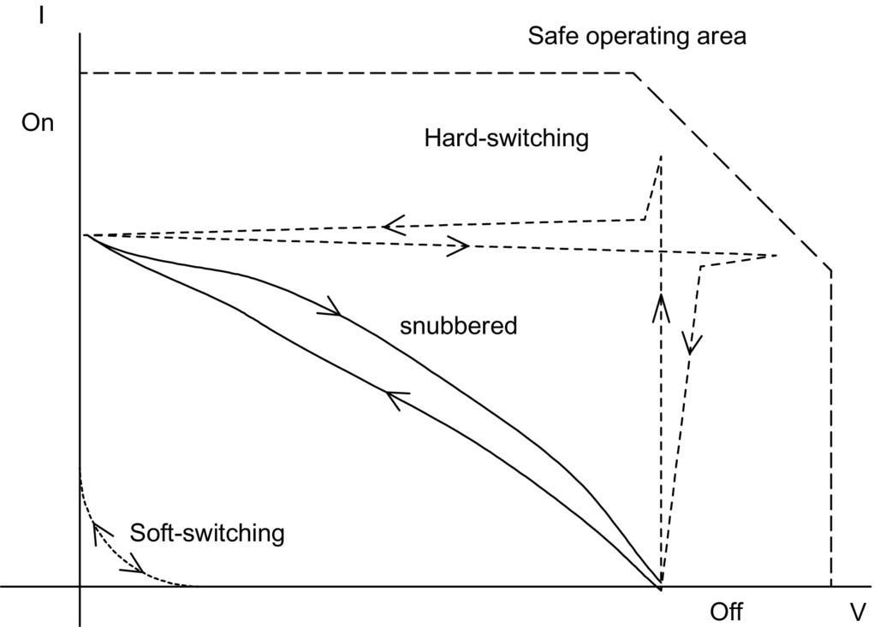

**FIG. 12.1** Typical switching trajectories of power switches.

Dissipative passive snubbers are usually added to the power circuits so that the *dv/dt* and *di/dt* of the power devices could be reduced and the switching loss and stress be diverted to the passive snubber circuits. However, the switching loss is proportional to the switching frequency, thus limiting the maximum switching frequency of the power converters. Typical converter switching frequency was limited to a few tens of kilohertz (typically 20–50 kHz) in the early 1980s. The stray inductive and capacitive components in the power circuits and power devices still cause considerable transient effects, which in turn give rise to electromagnetic interference (EMI) problems. [Fig. 12.2](https://learning.oreilly.com/library/view/power-electronics-handbook/9780128114087/B978012811407000012X.xhtml#f0015) shows ideal switching waveforms and typical practical waveforms of the switch voltage. The transient ringing effects are major causes of EMI.

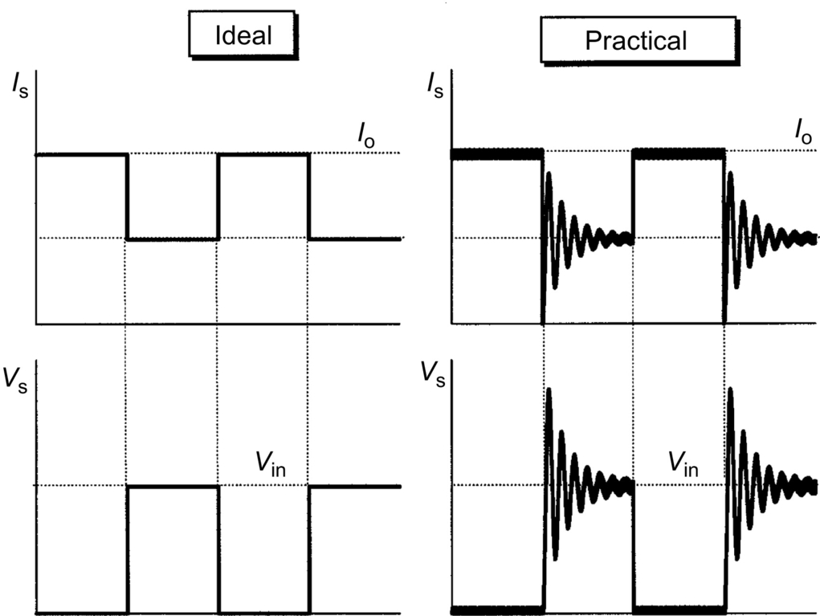

**FIG. 12.2** Typical: (A) ideal and (B) practical switching waveforms.

In the 1980s, lots of research efforts were diverted toward the use of resonant converters. The concept was to incorporate resonant tanks in the converters to create oscillatory (usually sinusoidal) voltage and/or current waveforms so that zero-voltage switching (ZVS) or zero-current switching (ZCS) conditions can be created for the power switches. The reduction of switching loss and the continual improvement of power switches allow the switching frequency of the resonant converters to reach hundreds of kilohertz (typically 100–500 kHz). Consequently, the size of magnetic components can be reduced, and the power density of the converters increased. Various forms of resonant converters have been proposed and developed. However, most of the resonant converters suffer several problems. When compared with the conventional PWM converters, the resonant current and the voltage of resonant converters have high peak values, leading to higher conduction loss and higher *V* and *I* rating requirements for the power devices. Also, many resonant converters require frequency modulation (FM) for output regulation. Variable switching frequency operation makes the filter design and control more complicated.

In the late 1980s and throughout the 1990s, further improvements have been made in converter technology. New generations of soft-switched converters that combine the advantages of conventional PWM converters and resonant converters have been developed. These soft-switched converters have switching waveforms similar to those of conventional PWM converters except that the rising and falling edges of the waveforms are “smoothed” with no transient spikes. Unlike the resonant converters, new soft-switched converters usually utilize the resonance in a controlled manner. Resonance is allowed to occur just before and during the turn-on and turn-off processes so as to create ZVS and ZCS conditions. Other than that, they behave just like conventional PWM converters. With simple modifications, many customized control integrated circuits (ICs) designed for conventional converters can be employed for soft-switched converters. Because the switching loss and stress have been reduced, soft-switched converter can be operated at the very high frequency (typically 500 kHz to a few megahertz). Soft-switching converters also provide an effective solution to suppress EMI and have been applied to DC-DC, AC-DC, and DC-AC converters. This chapter covers the basic technology of resonant and soft-switching converters. Various forms of soft-switching techniques such as ZVS, ZCS, voltage clamping, and zero-voltage transition methods are addressed. The emphasis is placed on the basic operating principle and practicality of the converters without using much mathematical analysis.

## 12.2 Classification

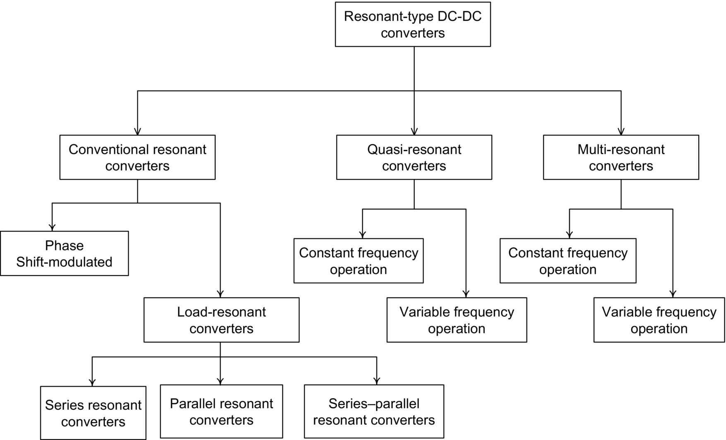

## 12.3 Resonant Switch

Prior to the availability of fully controllable power switches, thyristors were the major power devices used in power electronic circuits. Each thyristor requires a commutation circuit, which usually consists of an *LC* resonant circuit, for forcing the current to zero in the turn-off process [[1](https://learning.oreilly.com/library/view/power-electronics-handbook/9780128114087/B978012811407000012X.xhtml#bb0010)]. This mechanism is in fact a type of zero-current turn-off process. With the recent advancement in semiconductor technology, the voltage and current handling capability and the switching speed of fully controllable switches have significantly been improved. In many high-power applications, controllable switches such as gate turn-offs (GTOs) and insulated-gate bipolar transistors (IGBTs) have replaced thyristors [[2](https://learning.oreilly.com/library/view/power-electronics-handbook/9780128114087/B978012811407000012X.xhtml#bb0015),[3](https://learning.oreilly.com/library/view/power-electronics-handbook/9780128114087/B978012811407000012X.xhtml#bb0020)]. However, the use of resonant circuit for achieving ZCS and/or ZVS [[4](https://learning.oreilly.com/library/view/power-electronics-handbook/9780128114087/B978012811407000012X.xhtml#bb0025)–[8](https://learning.oreilly.com/library/view/power-electronics-handbook/9780128114087/B978012811407000012X.xhtml#bb0045)] has also emerged as a new technology for power converters. The concept of resonant switch that replaces conventional power switch is introduced in this section.

A resonant switch is a subcircuit comprising a semiconductor switch S and resonant elements, *Lr* and *Cr* [[9](https://learning.oreilly.com/library/view/power-electronics-handbook/9780128114087/B978012811407000012X.xhtml#bb0050)–[11](https://learning.oreilly.com/library/view/power-electronics-handbook/9780128114087/B978012811407000012X.xhtml#bb0060)]. The switch S can be implemented by a unidirectional or bidirectional switch, which determines the operation mode of the resonant switch. Two types of resonant switches [[12](https://learning.oreilly.com/library/view/power-electronics-handbook/9780128114087/B978012811407000012X.xhtml#bb0065)], including zero-current (ZC) resonant switch and zero-voltage (ZV) resonant switches, are shown in [Figs. 12.3](https://learning.oreilly.com/library/view/power-electronics-handbook/9780128114087/B978012811407000012X.xhtml#f0020) and [12.4](https://learning.oreilly.com/library/view/power-electronics-handbook/9780128114087/B978012811407000012X.xhtml#f0025), respectively.

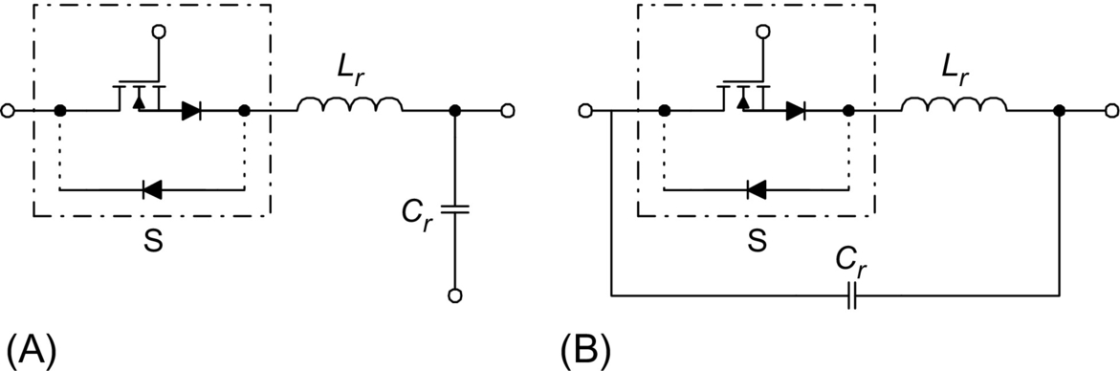

**FIG. 12.3** Zero-current (ZC) resonant switch. (A) Option 1. (B) Option 2.

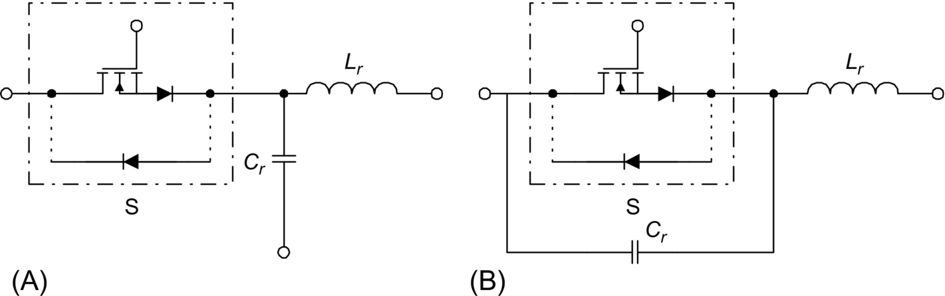

**FIG. 12.4** Zero-voltage (ZV) resonant switch. (A) Option 1. (B) Option 2.

### 12.3.1 ZC RESONANT SWITCH

In a ZC resonant switch, an inductor *Lr* is connected in series with a power switch S in order to achieve zero-current switching (ZCS). If the switch S is a unidirectional switch, the switch current is allowed to resonate in the positive half cycle only. The resonant switch is said to operate in *half-wave* mode. If a diode is connected in antiparallel with the unidirectional switch, the switch current can flow in both directions. In this case, the resonant switch can operate in *full-wave* mode. At turn-on, the switch current will rise slowly from zero. It will then oscillate, because of the resonance between *Lr* and *Cr*. Finally, the switch can be commutated at the next zero-current duration. The objective of this type of switch is to shape the switch current waveform during conduction time in order to create a zero-current condition for the switch to turn off [[13](https://learning.oreilly.com/library/view/power-electronics-handbook/9780128114087/B978012811407000012X.xhtml#bb0070)].

### 12.3.2 ZV RESONANT SWITCH

In a ZV resonant switch, a capacitor *Cr* is connected in parallel with the switch S for achieving zero-voltage switching (ZVS). If the switch S is a unidirectional switch, the voltage across the capacitor *Cr* can oscillate freely in both positive and negative half cycle. Thus, the resonant switch can operate in *full-wave* mode. If a diode is connected in antiparallel with the unidirectional switch, the resonant capacitor voltage is clamped by the diode to zero during the negative half cycle. The resonant switch will then operate in *half-wave* mode. The objective of a ZV switch is to use the resonant circuit to shape the switch voltage waveform during the off time in order to create a zero-voltage condition for the switch to turn on [[13](https://learning.oreilly.com/library/view/power-electronics-handbook/9780128114087/B978012811407000012X.xhtml#bb0070)].

## 12.4 Quasi-Resonant Converters

Quasi-resonant converters (QRCs) can be considered as a hybrid of resonant and PWM converters. The underlying principle is to replace the power switch in PWM converters with the resonant switch. A large family of conventional converter circuits can be transformed into their resonant converter counterparts. The switch current and/or voltage waveforms are forced to oscillate in a quasi-sinusoidal manner, so that ZCS and/or ZVS can be achieved. Both ZCS-QRCs and ZVS-QRCs have *half-wave* and *full-wave* mode of operations [[8](https://learning.oreilly.com/library/view/power-electronics-handbook/9780128114087/B978012811407000012X.xhtml#bb0045)–[10](https://learning.oreilly.com/library/view/power-electronics-handbook/9780128114087/B978012811407000012X.xhtml#bb0055),[12](https://learning.oreilly.com/library/view/power-electronics-handbook/9780128114087/B978012811407000012X.xhtml#bb0065)].

### 12.4.1 ZCS-QRCS

A ZCS-QRC designed for *half-wave* operation is illustrated with a buck-type DC-DC converter. The schematic is shown in [Fig. 12.5A](https://learning.oreilly.com/library/view/power-electronics-handbook/9780128114087/B978012811407000012X.xhtml#f0030). It is formed by replacing the power switch in conventional PWM buck converter with the ZC resonant switch in [Fig. 12.3A](https://learning.oreilly.com/library/view/power-electronics-handbook/9780128114087/B978012811407000012X.xhtml#f0020). The circuit waveforms in steady state are shown in [Fig. 12.5B](https://learning.oreilly.com/library/view/power-electronics-handbook/9780128114087/B978012811407000012X.xhtml#f0030). The output filter inductor *Lf* is sufficiently large so that its current is approximately constant. Prior to turning the switch on, the output current *Io* freewheels through the output diode *Df*. The resonant capacitor voltage *VCr* equals zero. At *t*0, the switch is turned on with ZCS. A quasi-sinusoidal current *IS* flows through *Lr* and *Cr*, the output filter, and the load. S is then softly commutated at *t*1 with ZCS again. During and after the gate pulse, the resonant capacitor voltage *VCr* rises and then decays at a rate depending on the output current. Output voltage regulation is achieved by controlling the switching frequency. Operation and characteristics of the converter depend mainly on the design of the resonant circuit *Lr Cr*. The following parameters are defined: voltage conversion ratio *M*, characteristic impedance *Zr*, resonant frequency *fr*, normalized load resistance *r*, and normalized switching frequency *γ*:

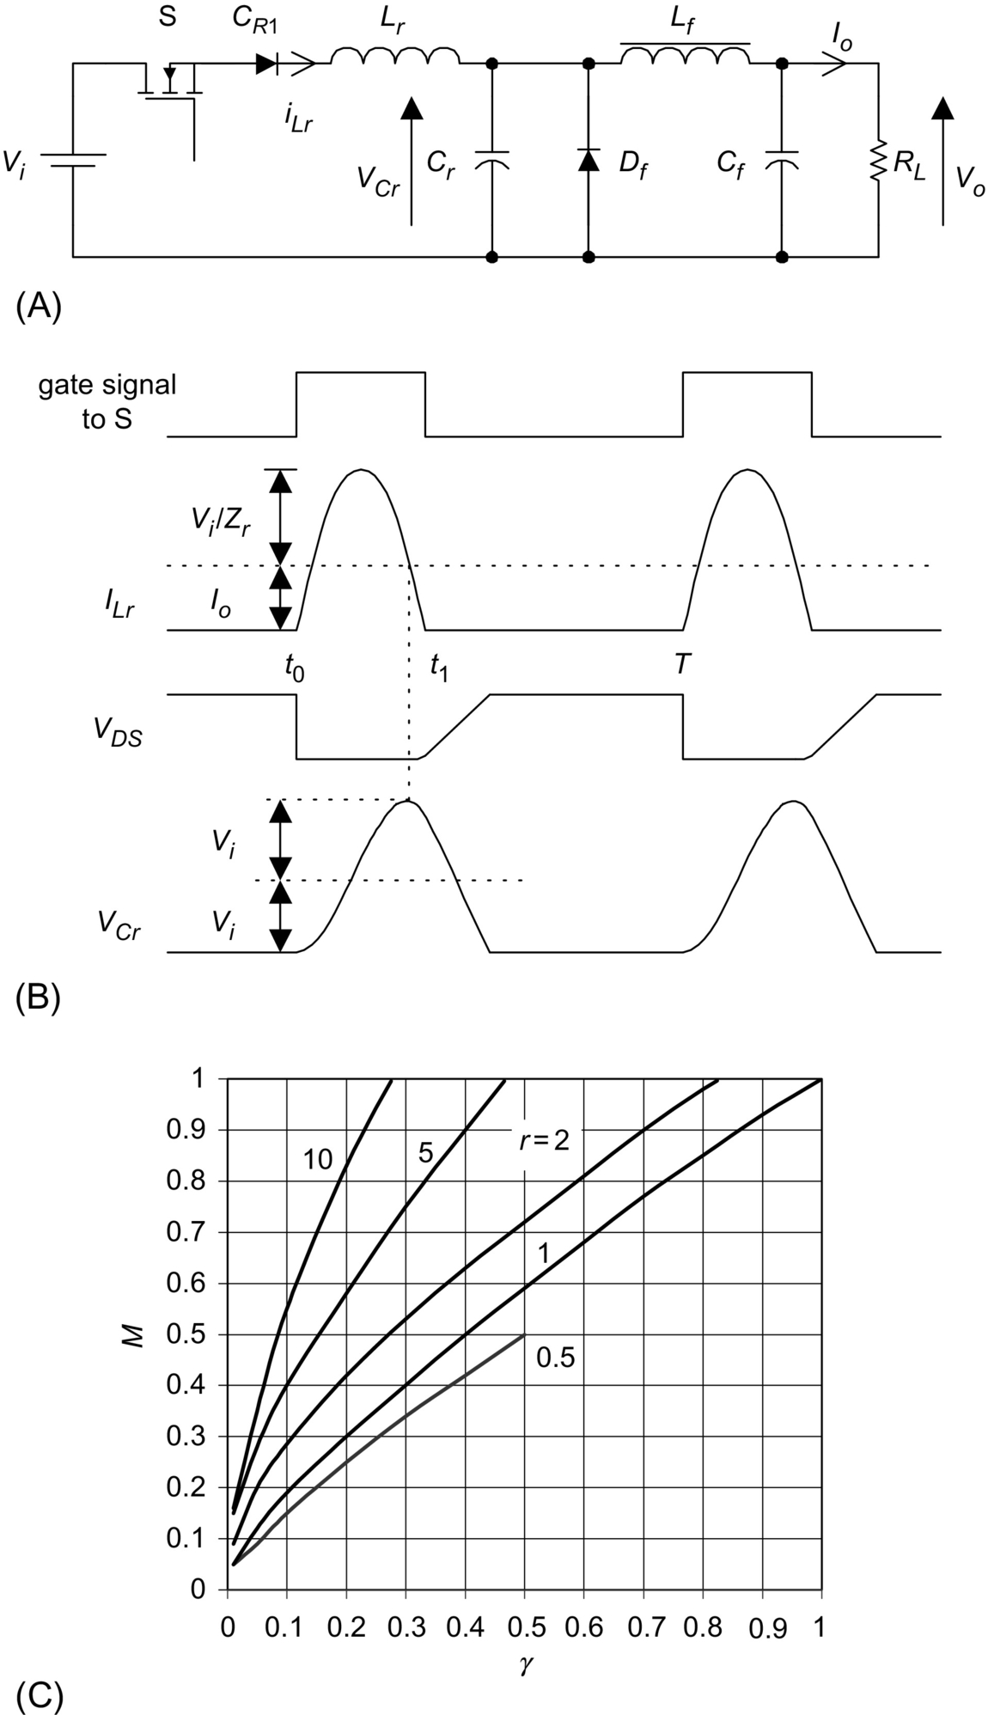

**FIG. 12.5** Half-wave, quasi-resonant buck converter with ZCS: (A) schematic diagram, (B) circuit waveforms, and (C) relationship between *M* and *γ*.

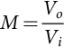 **(12.1A)**

**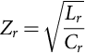** **(12.1B)**

**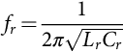** **(12.1C)**

**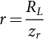** **(12.1D)**

**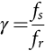** **(12.1E)**

It can be seen from the waveforms that if *Io>Vi*/*Zr*, *IS* will not come back to zero naturally and the switch will have to be forced off, thus resulting in turn-off losses.

The relationships between *M* and *γ* at different *r* are shown in [Fig. 12.5C](https://learning.oreilly.com/library/view/power-electronics-handbook/9780128114087/B978012811407000012X.xhtml#f0030). It can be seen that *M* is sensitive to the load variation. At light-load conditions, the unused energy is stored in *Cr*, leading to an increase in the output voltage. Thus, the switching frequency has to be controlled, in order to regulate the output voltage.

If an antiparallel diode is connected across the switch, the converter will be operating in *full-wave* mode. The circuit schematic is shown in [Fig. 12.6A](https://learning.oreilly.com/library/view/power-electronics-handbook/9780128114087/B978012811407000012X.xhtml#f0035). The circuit waveforms in steady state are shown in [Fig. 12.6B](https://learning.oreilly.com/library/view/power-electronics-handbook/9780128114087/B978012811407000012X.xhtml#f0035). The operation is similar to the one in *half-wave* mode. However, the inductor current is allowed to reverse through the antiparallel diode, and the duration for the resonant stage is lengthened. This permits excess energy in the resonant circuit at light loads to be transferred back to the voltage source *Vi*. This significantly reduces the dependence of *Vo* on the output load. The relationships between *M* and *γ* at different *r* are shown in [Fig. 12.6C](https://learning.oreilly.com/library/view/power-electronics-handbook/9780128114087/B978012811407000012X.xhtml#f0035). It can be seen that *M* is insensitive to load variation.

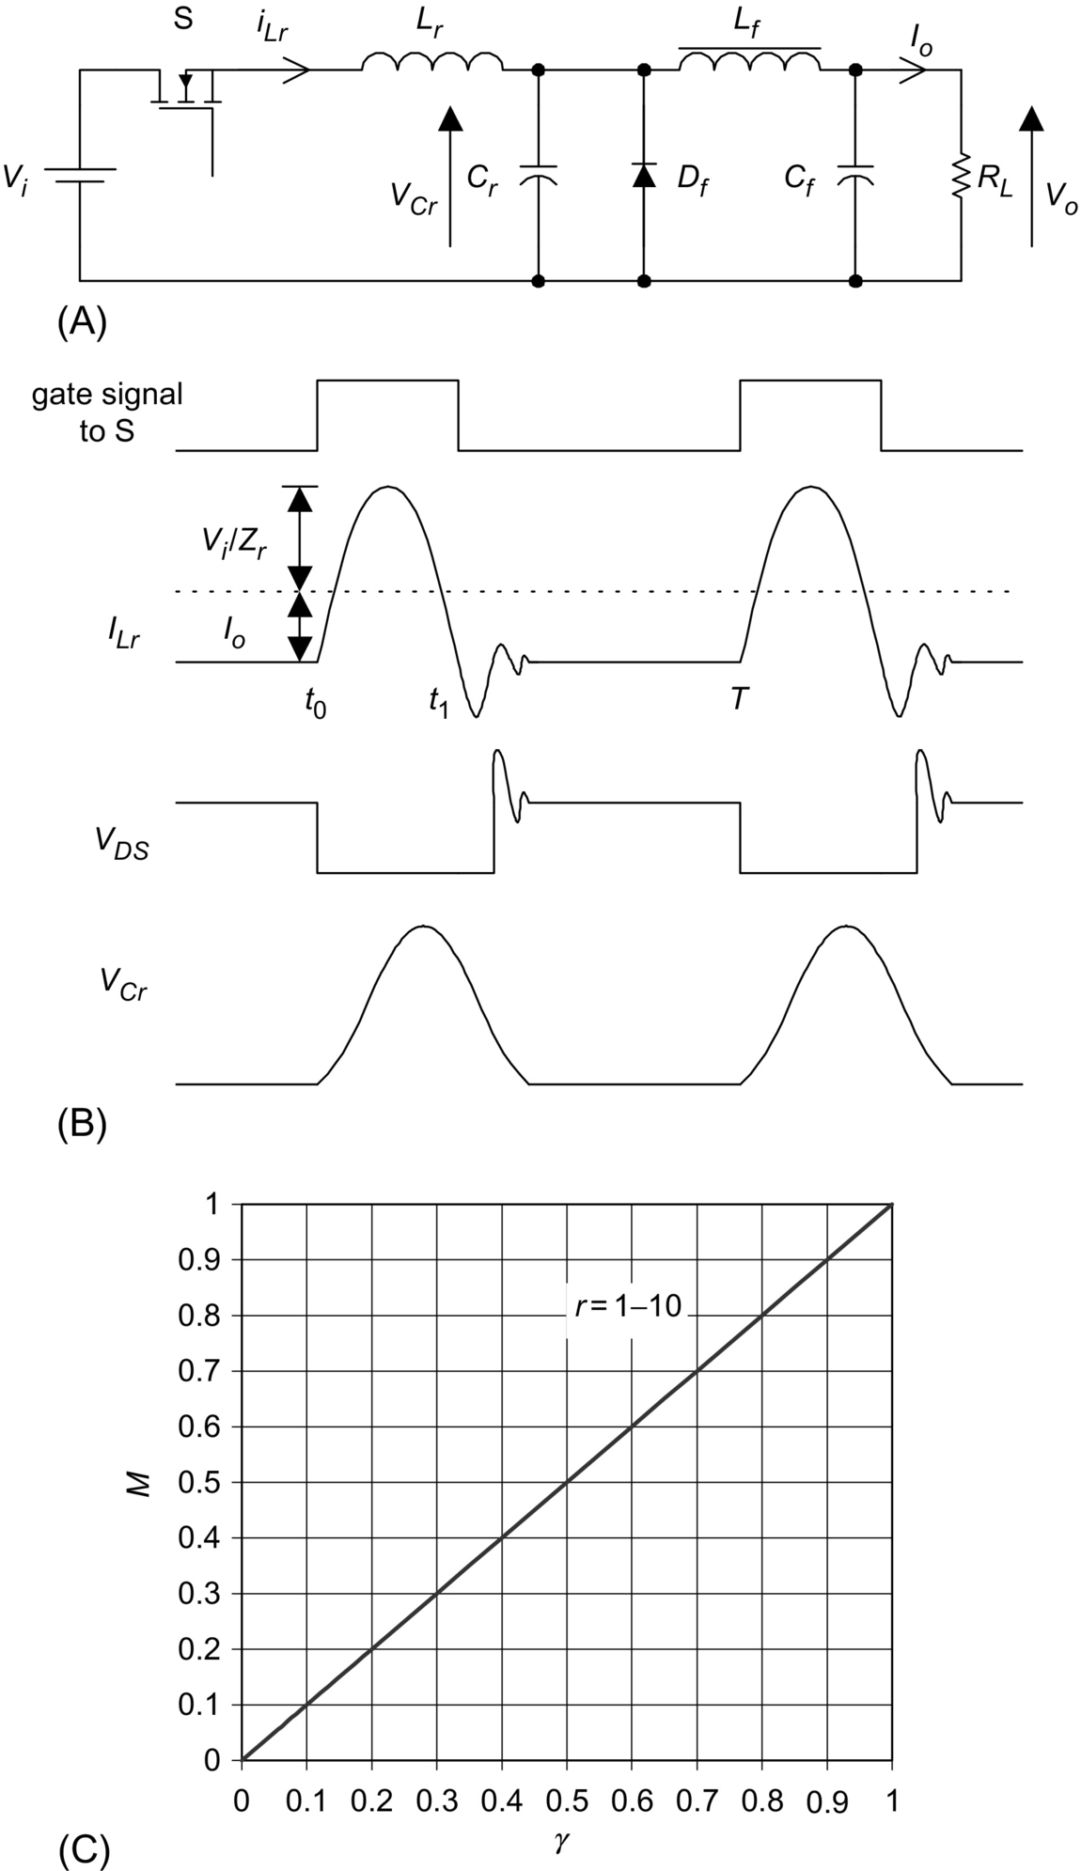

**FIG. 12.6** Full-wave, quasi-resonant buck converter with ZCS: (A) schematic diagram, (B) circuit waveforms, and (C) relationship between *M* and *γ*.

By replacing the switch in the conventional converters, a family of QRC [[9](https://learning.oreilly.com/library/view/power-electronics-handbook/9780128114087/B978012811407000012X.xhtml#bb0050)] with ZCS is shown in [Fig. 12.7](https://learning.oreilly.com/library/view/power-electronics-handbook/9780128114087/B978012811407000012X.xhtml#f0040).

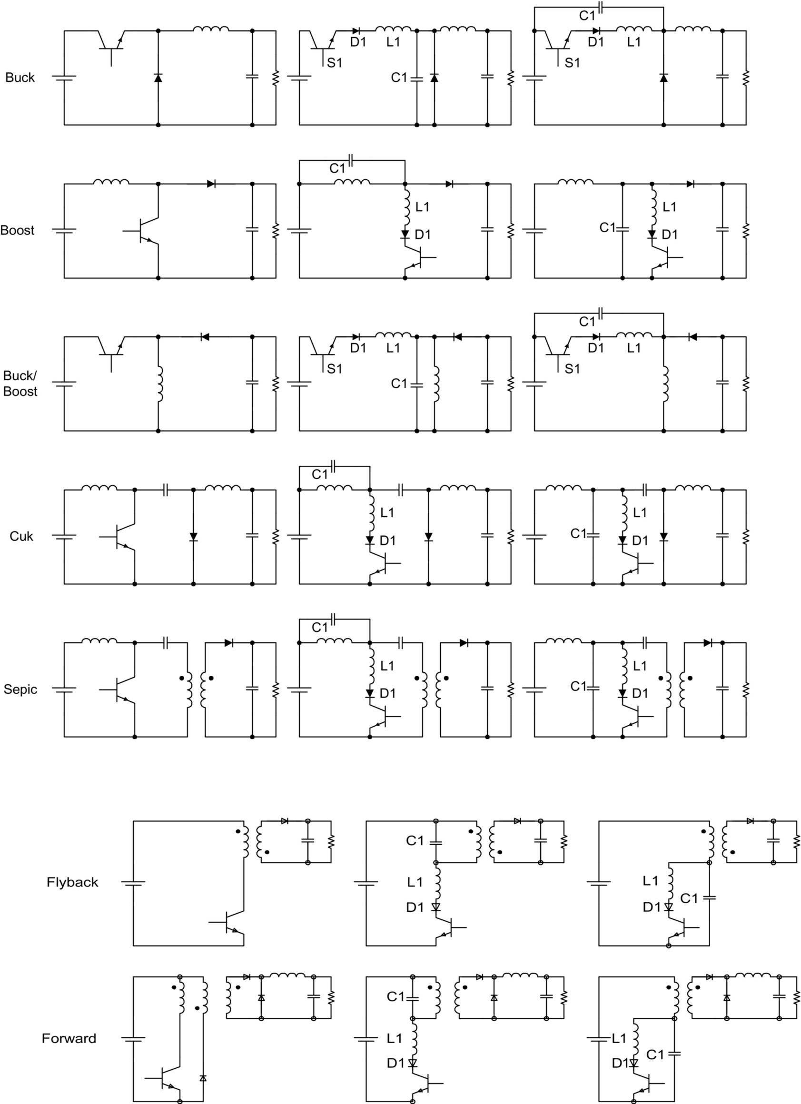

**FIG. 12.7** A family of quasi-resonant converter with ZCS.

### 12.4.2 ZVS-QRC

In these converters, the resonant capacitor provides a zero-voltage condition for the switch to turn on and off. A quasi-resonant buck converter designed for *half-wave* operation is shown in [Fig. 12.8A](https://learning.oreilly.com/library/view/power-electronics-handbook/9780128114087/B978012811407000012X.xhtml#f0045)—using a ZV resonant switch in [Fig. 12.4B](https://learning.oreilly.com/library/view/power-electronics-handbook/9780128114087/B978012811407000012X.xhtml#f0025). The steady-state circuit waveforms are shown in [Fig. 12.8B](https://learning.oreilly.com/library/view/power-electronics-handbook/9780128114087/B978012811407000012X.xhtml#f0045). Basic relations of ZVS-QRCs are given in Eqs. [(12.1A)](https://learning.oreilly.com/library/view/power-electronics-handbook/9780128114087/B978012811407000012X.xhtml#fo0010)–[(12.1E)](https://learning.oreilly.com/library/view/power-electronics-handbook/9780128114087/B978012811407000012X.xhtml#fo0030). When the switch S is turned on, it carries the output current *Io*. The supply voltage *Vi* reverse biases the diode *Df*. When the switch is zero-voltage (ZV) turned off, the output current starts to flow through the resonant capacitor *Cr*. When the resonant capacitor voltage *VCr* is equal to *Vi*, *Df* turns on. This starts the resonant stage. When *VCr* equals zero, the antiparallel diode turns on. The resonant capacitor is shorted, and the source voltage is applied to the resonant inductor *Lr*. The resonant inductor current *ILr* increases linearly until it reaches *Io*. Then, *Df* turns off. In order to achieve ZVS, S should be triggered during the time when the antiparallel diode conducts. It can be seen from the waveforms that the peak amplitude of the resonant capacitor voltage should be greater or equal to the input voltage (i.e., *IoZr>Vin*). From [Fig. 12.8C](https://learning.oreilly.com/library/view/power-electronics-handbook/9780128114087/B978012811407000012X.xhtml#f0045), it can be seen that the voltage conversion ratio is load-sensitive. In order to regulate the output voltage for different loads *r*, the switching frequency should also be changed accordingly.

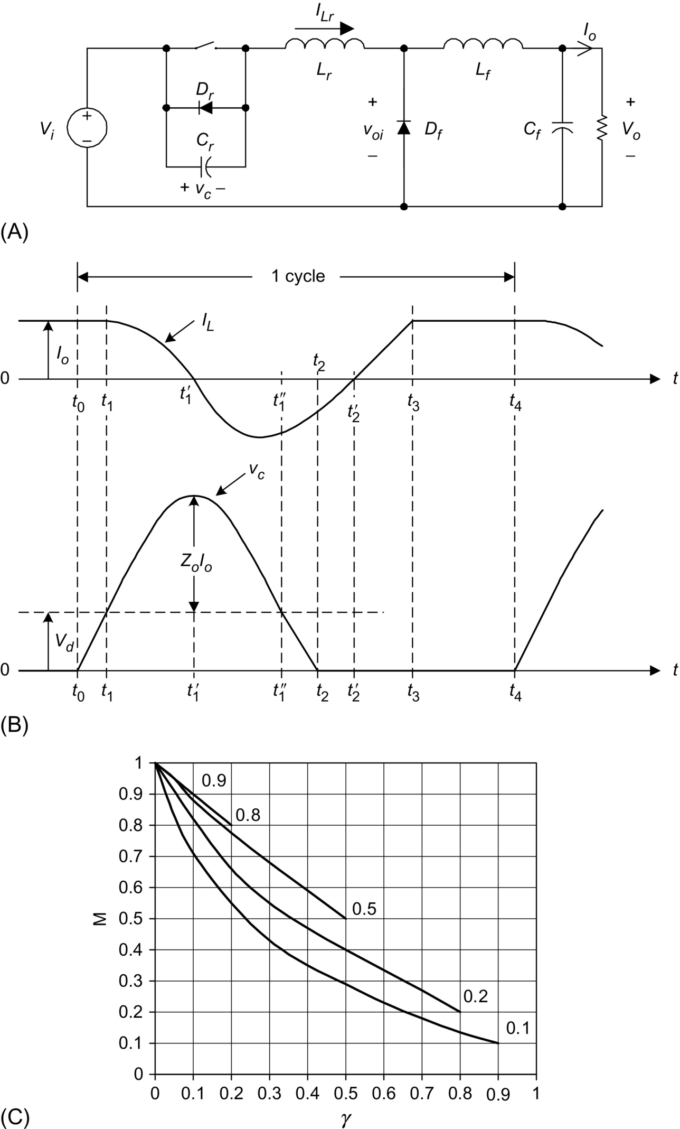

**FIG. 12.8** Half-wave, quasi-resonant buck converter with ZVS: (A) schematic diagram, (B) circuit waveforms, and (C) relationship between *M* and *γ*.

ZVS converters can be operated in *full-wave* mode. The circuit schematic is shown in [Fig. 12.9A](https://learning.oreilly.com/library/view/power-electronics-handbook/9780128114087/B978012811407000012X.xhtml#f0050). The circuit waveforms in steady state are shown in [Fig. 12.9B](https://learning.oreilly.com/library/view/power-electronics-handbook/9780128114087/B978012811407000012X.xhtml#f0050). The operation is similar to *half-wave* mode of operation, except that *VCr* can swing between positive and negative voltages. The relationships between *M* and γ at different *r* are shown in [Fig. 12.9C](https://learning.oreilly.com/library/view/power-electronics-handbook/9780128114087/B978012811407000012X.xhtml#f0050).

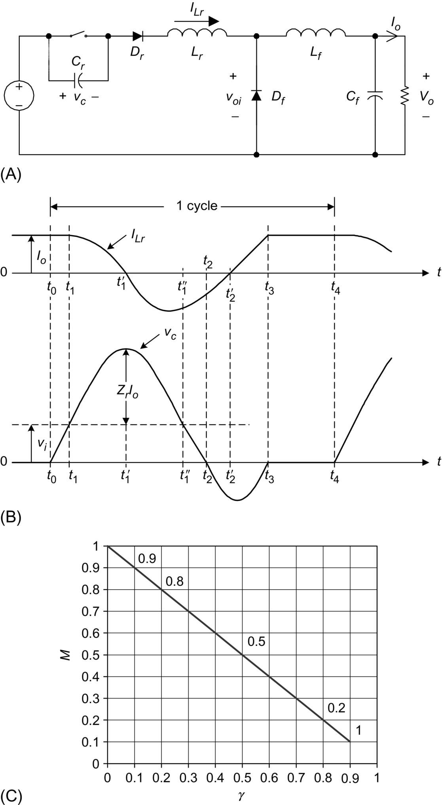

**FIG. 12.9** Full-wave, quasi-resonant buck converter with ZVS: (A) schematic diagram, (B) circuit waveforms, and (C) relationship between *M* and *γ*.

Comparing [Fig. 12.8C](https://learning.oreilly.com/library/view/power-electronics-handbook/9780128114087/B978012811407000012X.xhtml#f0045) with [Fig. 12.9C](https://learning.oreilly.com/library/view/power-electronics-handbook/9780128114087/B978012811407000012X.xhtml#f0050), it can be seen that *M* is load-insensitive in *full-wave* mode. This is a desirable feature. However, as the series diode limits the direction of the switch current, energy will be stored in the output capacitance of the switch and will dissipate in the switch during turn-on. Hence, the *full-wave* mode has the problem of capacitive turn-on loss and is less practical in high-frequency operation. In practice, ZVS-QRCs are usually operated in *half-wave* mode rather than *full-wave* mode.

By replacing the ZV resonant switch in the conventional converters, various ZVS-QRCs can be derived. They are shown in [Fig. 12.10](https://learning.oreilly.com/library/view/power-electronics-handbook/9780128114087/B978012811407000012X.xhtml#f0055).

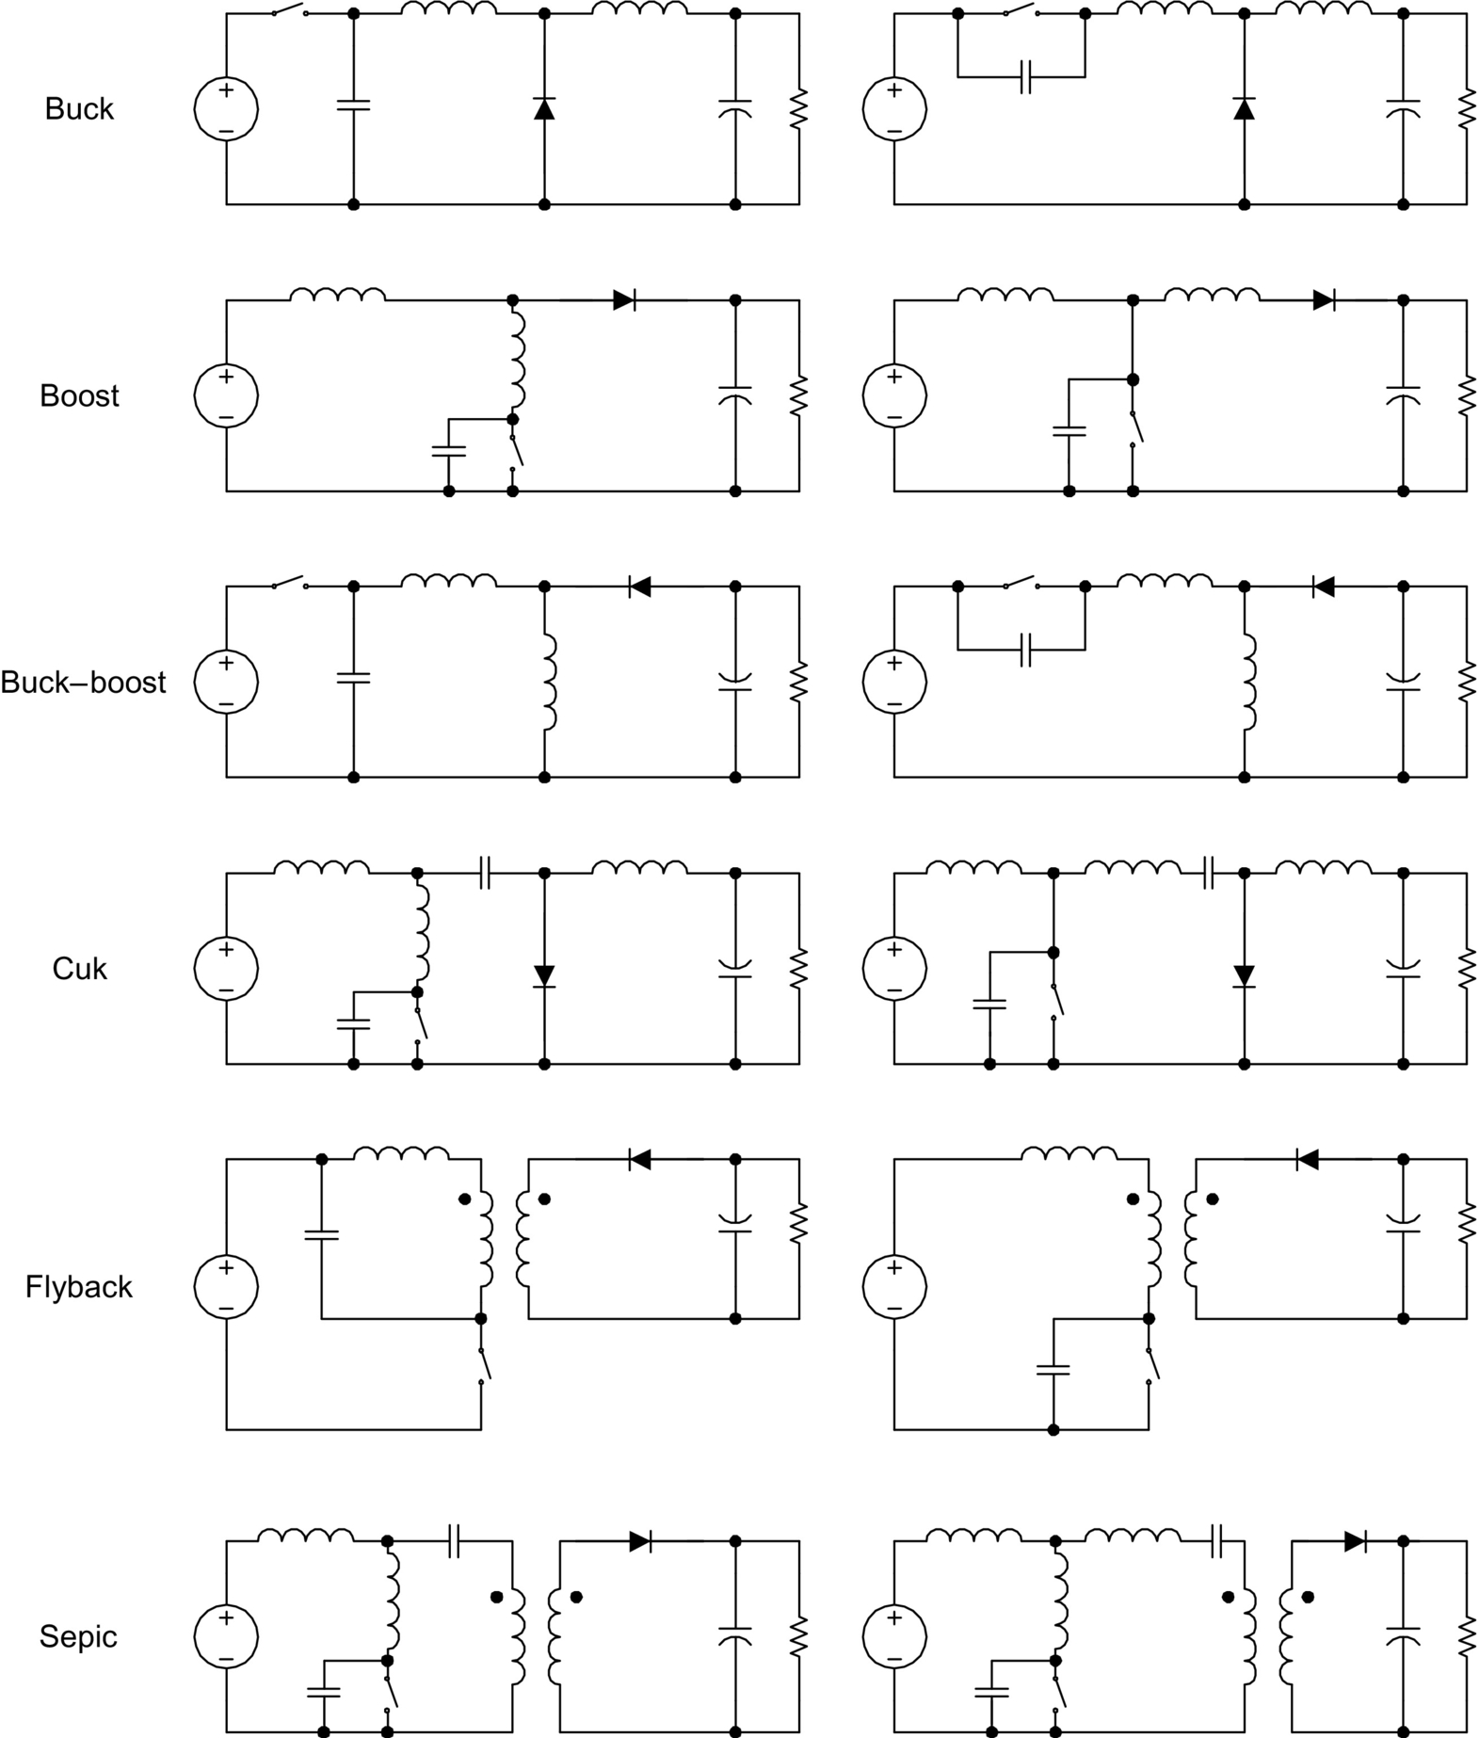

**FIG. 12.10** A family of quasi-resonant converter with ZVS.

### 12.4.3 COMPARISONS BETWEEN ZCS AND ZVS

ZCS can eliminate the switching losses at turnoff and reduce the switching losses at turn-on. As a relatively large capacitor is connected across the output diode during resonance, the converter operation becomes insensitive to the diode's junction capacitance. When power MOSFETs are zero-current switched on, the energy stored in the device's capacitance will be dissipated. This capacitive turn-on loss is proportional to the switching frequency. During turn-on, considerable rate of change of voltage can be coupled to the gate drive circuit through the Miller capacitor, thus increasing switching loss and noise. Another limitation is that the switches are under high current stress, resulting in higher conduction loss. However, it should be noted that ZCS is particularly effective in reducing switching loss for power devices (such as IGBT) with large tail current in the turn-off process.

ZVS eliminates the capacitive turn-on loss. It is suitable for high-frequency operation. For single-ended configuration, the switches could suffer from excessive voltage stress, which is proportional to the load. It will be shown in [Section 12.5](https://learning.oreilly.com/library/view/power-electronics-handbook/9780128114087/B978012811407000012X.xhtml#s0055) that the maximum voltage across switches in half-bridge and full-bridge configurations is clamped to the input voltage.

For both ZCS and ZVS, the output regulation of the resonant converters can be achieved by variable frequency control. ZCS operates with constant on-time control, while ZVS operates with constant off-time control. With a wide input and load range, both techniques have to operate with a wide switching frequency range, making it not easy to design resonant converters optimally.

## 12.5 ZVS in High Frequency Applications

By the nature of the resonant tank and ZCS, the peak switch current in resonant converters is much higher than that in the square-wave counterparts. In addition, a high voltage will be established across the switch in the off state after the resonant stage. When the switch is switched on again, the energy stored in the output capacitor will be discharged through the switch, causing a significant power loss at high frequencies and high voltages. This switching loss can be reduced by using ZVS.

ZVS can be viewed as square-wave power utilizing a constant off-time control. Output regulation is achieved by controlling the on-time or switching frequency. During the off time, the resonant tank circuit traverses the voltage across the switch from zero to its peak value and then back to zero again. At that ZV instant, the switch can be reactivated. Apart from the conventional single-ended converters, some other examples of converters with ZVS are illustrated in the following section.

### 12.5.1 ZVS WITH CLAMPED VOLTAGE

The high voltage stress problem in the single-switch configuration with ZVS can be avoided in half-bridge (HB) and full-bridge (FB) configurations [[14](https://learning.oreilly.com/library/view/power-electronics-handbook/9780128114087/B978012811407000012X.xhtml#bb0075)–[17](https://learning.oreilly.com/library/view/power-electronics-handbook/9780128114087/B978012811407000012X.xhtml#bb0090)]. The peak switch voltage can be clamped to the DC supply rail, thus reducing the switch voltage stress. In addition, the series transformer leakage and circuit inductance can form parts of the resonant path. Therefore, these parasitic components, which are undesirable in hard-switched converter, become useful components in ZVS ones. [Figs. 12.11](https://learning.oreilly.com/library/view/power-electronics-handbook/9780128114087/B978012811407000012X.xhtml#f0060) and [12.12](https://learning.oreilly.com/library/view/power-electronics-handbook/9780128114087/B978012811407000012X.xhtml#f0065) show the ZVS HB and FB circuits, respectively, together with the circuit waveforms. The resonant capacitor is equivalent to the parallel connection of the two capacitors (*Cr*/2) across the switches. The off-state voltage of the switches will not exceed the input voltage during resonance because they will be clamped to the supply rail by the antiparallel diode of the switches.

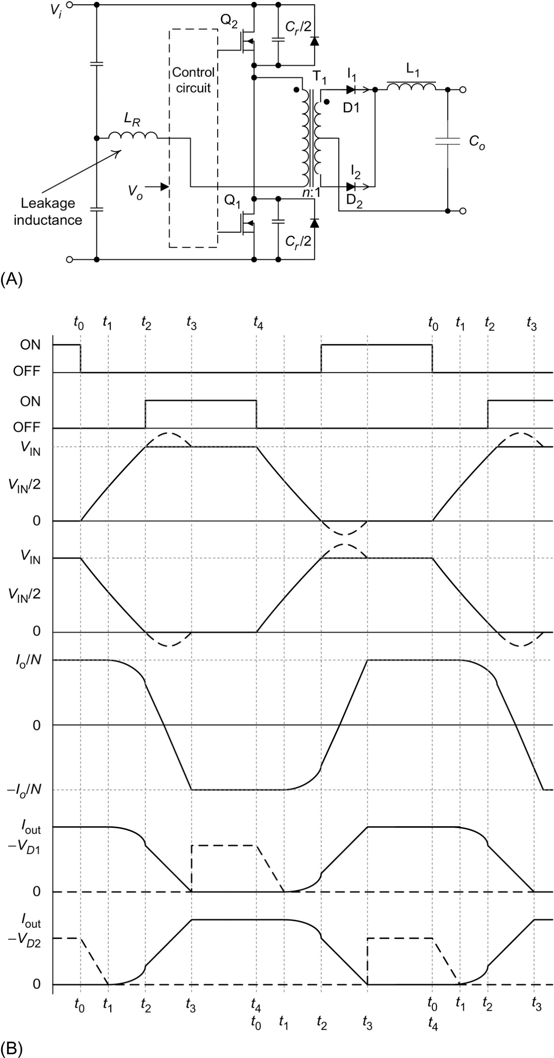

**FIG. 12.11** Half-bridge converter with ZVS: (A) circuit diagram and (B) circuit waveforms.

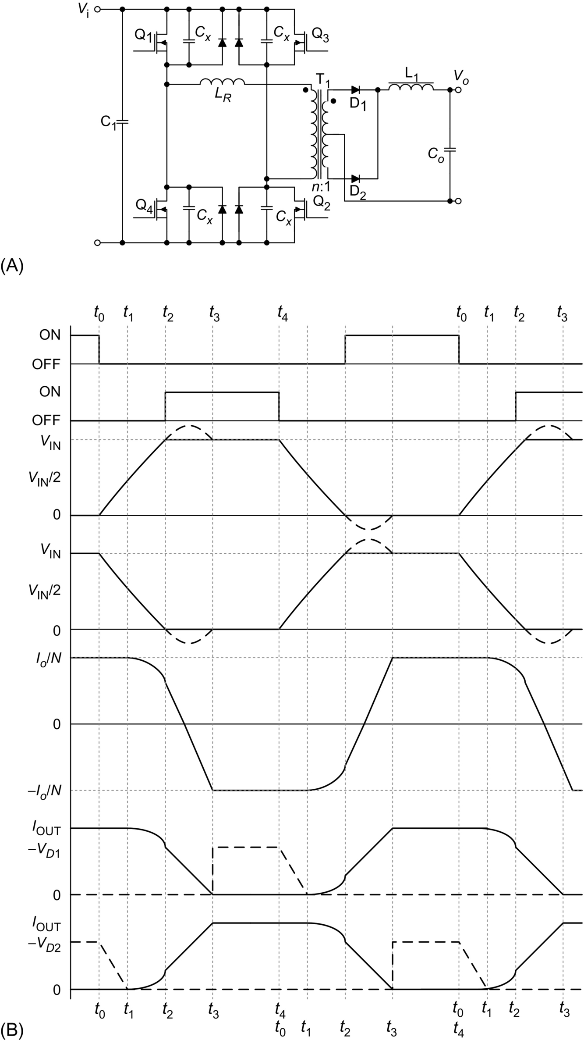

**FIG. 12.12** Full-bridge converter with ZVS: (A) circuit schematics and (B) circuit waveforms.

### 12.5.2 PHASE-SHIFTED CONVERTER WITH ZERO VOLTAGE TRANSITION

In a conventional FB converter, the two diagonal switch pairs are driven alternatively. The output transformer is fed with an AC rectangular voltage. By applying a phase-shifting approach, a deliberate delay can be introduced between the gate signals and the switches [[18](https://learning.oreilly.com/library/view/power-electronics-handbook/9780128114087/B978012811407000012X.xhtml#bb0095)]. The circuit waveforms are shown in [Fig. 12.13](https://learning.oreilly.com/library/view/power-electronics-handbook/9780128114087/B978012811407000012X.xhtml#f0070). Two upper or lower switches can be conducting (either through the switch or the antiparallel diode), yet the applied voltage to the transformer is zero. This zero-voltage condition appears in the interval [*t*1, *t*2] of *Vpri* in [Fig. 12.13](https://learning.oreilly.com/library/view/power-electronics-handbook/9780128114087/B978012811407000012X.xhtml#f0070). This operating stage corresponds to the required off time for that particular switching cycle. When the desired switch is turned off, the primary transformer current flows into the switch output capacitance causing the switch voltage to resonate to the opposite input rail. Effects of the parasitic circuit components are used advantageously to facilitate the resonant transitions. This enables a ZVS condition for turning on the opposite switch. Thus, varying the phase shift controls the effective duty cycle and hence the output power. The resonant circuit is necessary to meet the requirement of providing sufficient inductive energy to drive the capacitors to the opposite bus rail. The resonant transition must be achieved within the designed transition time.

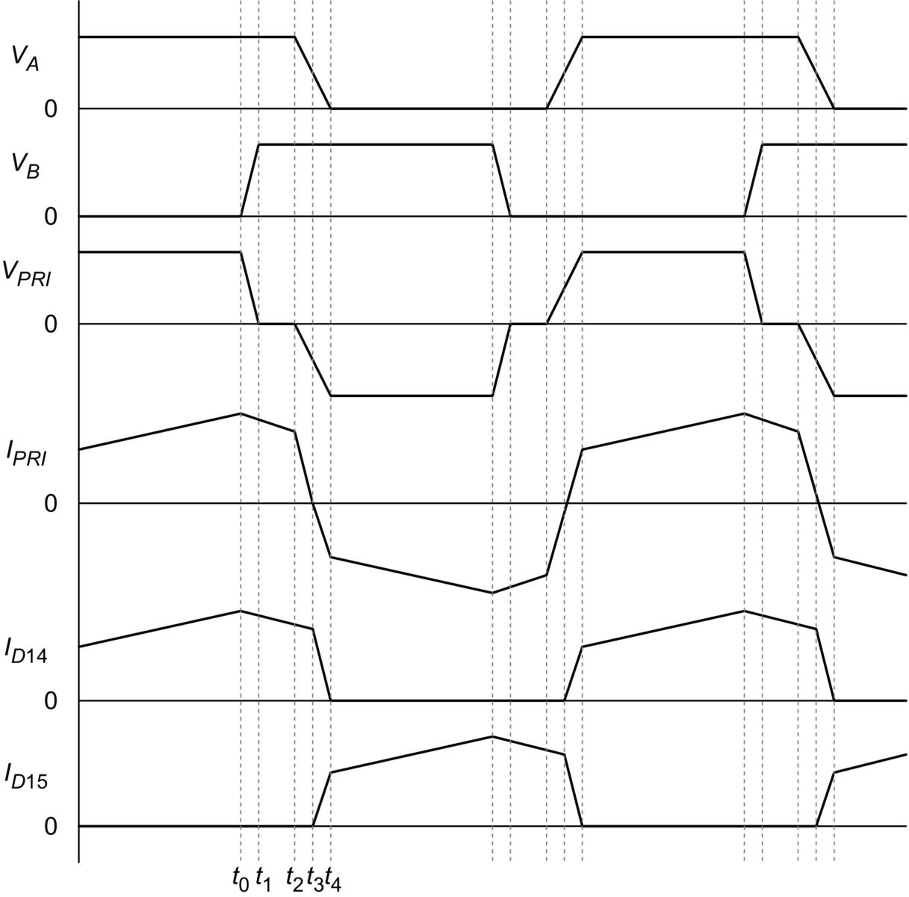

**FIG. 12.13** Circuit waveforms of the phase-shifted, ZVT FB converter.

## 12.6 Multi-resonant Converters

The ZCS-QRCs and ZVS-QRCs optimize the switching condition for either the active switch or the output diode only, but not for both of them simultaneously. Multiresonant switch concept, which is an extension of the concept of the resonant switch, has been developed to overcome such limitation. The zero-current multiresonant (ZC-MR) and zero-voltage multiresonant (ZV-MR) switches [[12](https://learning.oreilly.com/library/view/power-electronics-handbook/9780128114087/B978012811407000012X.xhtml#bb0065),[17](https://learning.oreilly.com/library/view/power-electronics-handbook/9780128114087/B978012811407000012X.xhtml#bb0090)] are shown in [Fig. 12.14](https://learning.oreilly.com/library/view/power-electronics-handbook/9780128114087/B978012811407000012X.xhtml#f0075).

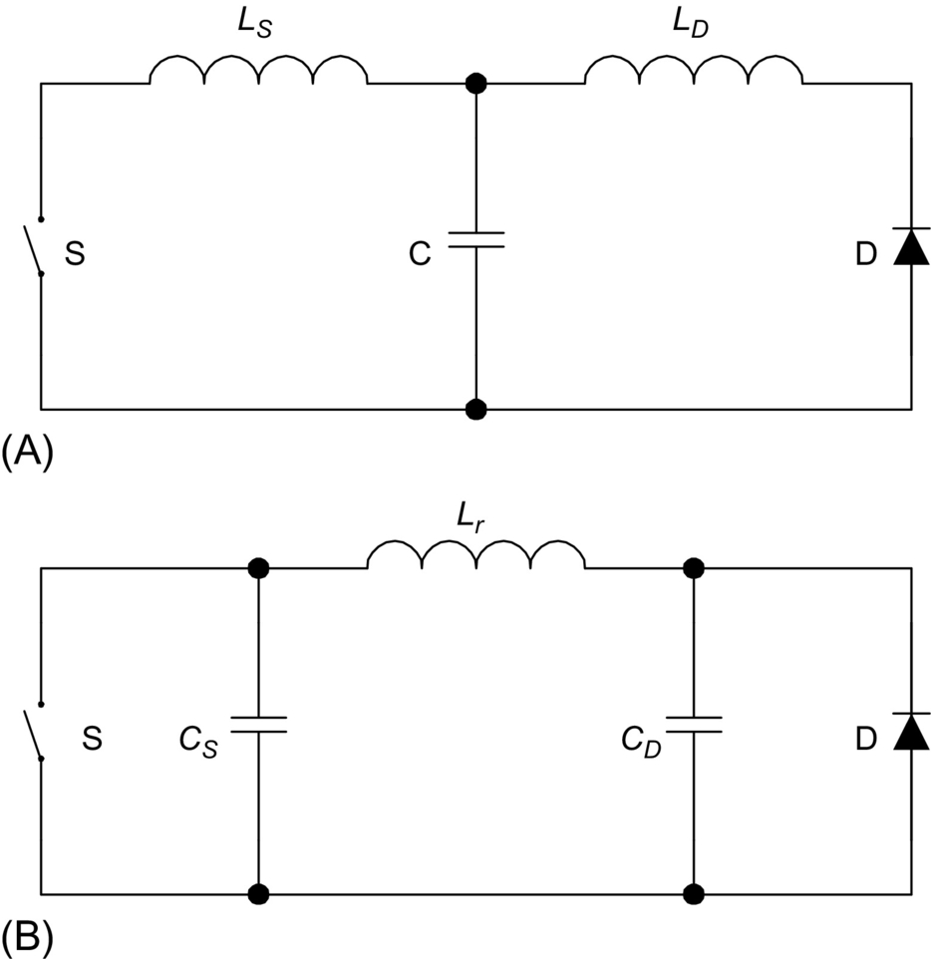

**FIG. 12.14** Multiresonant switches: (A) ZC-MR switch and (B) ZV-MR switch.

The multiresonant circuits incorporate all major parasitic components, including switch output capacitance, diode junction capacitance, and transformer leakage inductance into the resonant circuit. In general, ZVS (*half-wave* mode) is more favorable than ZCS in DC-DC converters for high-frequency operation because the parasitic capacitance of the active switch and the diode will form a part of the resonant circuit.

An example of a buck ZVS-MRC is shown in [Fig. 12.15](https://learning.oreilly.com/library/view/power-electronics-handbook/9780128114087/B978012811407000012X.xhtml#f0080). Depending on the ratio of the resonant capacitance *CD*/*CS*, two possible topological modes, namely, mode I and mode II, can be operated [[19](https://learning.oreilly.com/library/view/power-electronics-handbook/9780128114087/B978012811407000012X.xhtml#bb0100)]. The ratio affects the time at which the voltages across the switch S and the output diode *Df* become zero. Their waveforms are shown in [Fig. 12.16A and B](https://learning.oreilly.com/library/view/power-electronics-handbook/9780128114087/B978012811407000012X.xhtml#f0085), respectively. If diode voltage *VD* falls to zero earlier than the switch voltage *VS*, the converter will follow mode I. Otherwise, the converter will follow mode II.

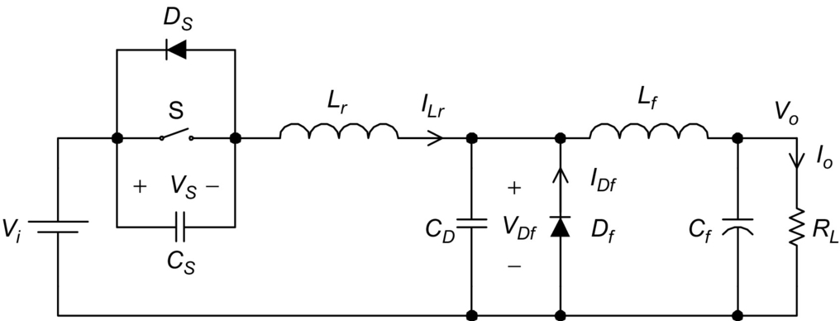

**FIG. 12.15** Buck ZVS-MRC.

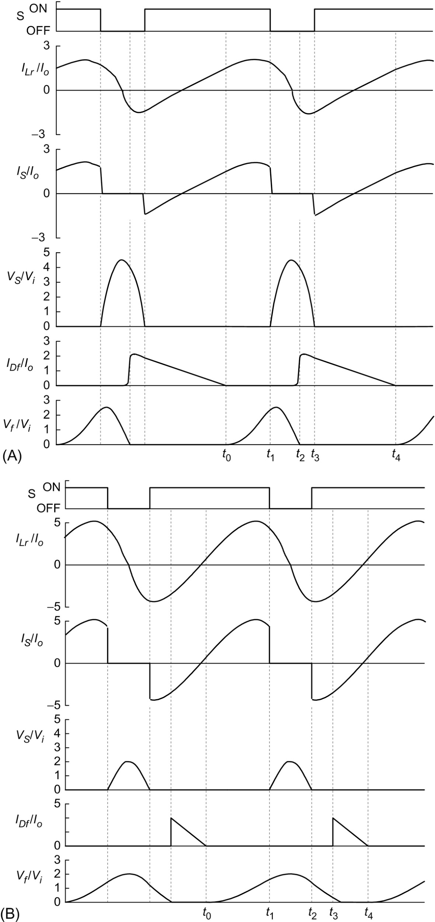

**FIG. 12.16** Possible modes of the buck ZVS-MRC: (A) mode I and (B) mode II.

Instead of having one resonant stage, there are three in this converter. The mode I operation in [Fig. 12.16A](https://learning.oreilly.com/library/view/power-electronics-handbook/9780128114087/B978012811407000012X.xhtml#f0085) is described first. Before the switch S is turned on, the output diode *Df* is conducting, and the resonant inductor current *ILr* is negative (flowing through the antiparallel diode of S). S is then turned on with ZVS. The resonant inductor current *ILr* increases linearly and *Df* is still conducting. When *ILr* reaches the output current *Io*, the first resonant stage starts. The resonant circuit is formed by the resonant inductor *Lr* and the capacitor *CD* across the output diode. This stage ends when *S* is turned off with ZVS. Then, a second resonant stage starts. The resonant circuit consists of *Lr*, *CD*, and the capacitor across the switch *Cs*. This stage ends when the output diode becomes forward-biased. A third resonant stage will then start. *Lr* and *Cs* form the resonant circuit. This stage ends and completes one operation cycle when the diode *Cs* becomes forward-biased.

The only difference between mode I and mode II in [Fig. 12.16B](https://learning.oreilly.com/library/view/power-electronics-handbook/9780128114087/B978012811407000012X.xhtml#f0085) is in the third resonant stage, in which the resonant circuit is formed by *Lr* and *CD*. This stage ends when *Df* becomes forward-biased. The concept of the multiresonant switch can be applied to conventional converters [[19](https://learning.oreilly.com/library/view/power-electronics-handbook/9780128114087/B978012811407000012X.xhtml#bb0100)–[21](https://learning.oreilly.com/library/view/power-electronics-handbook/9780128114087/B978012811407000012X.xhtml#bb0110)]. A family of multi-resonant converters (MRCs) are shown in [Fig. 12.17](https://learning.oreilly.com/library/view/power-electronics-handbook/9780128114087/B978012811407000012X.xhtml#f0090).

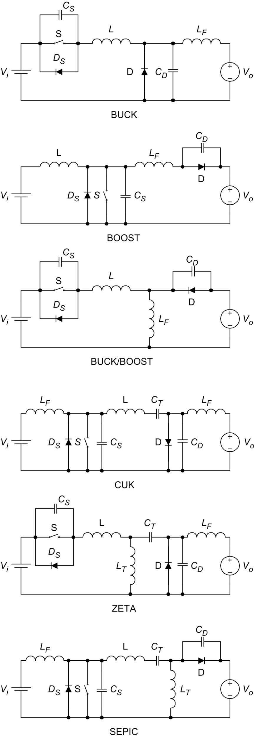

**FIG. 12.17** Use of the multiresonant switch in conventional PWM converters.

Although the variation of the switching frequency for regulation in MRCs is smaller than that of QRCs, a wideband frequency modulation is still required. Hence, the optimal design of magnetic components and the EMI filters in MRCs is not easy. It would be desirable to have a constant switching frequency operation. In order to operate the MRCs with constant switching frequency, the diode in [Fig. 12.14](https://learning.oreilly.com/library/view/power-electronics-handbook/9780128114087/B978012811407000012X.xhtml#f0075) can be replaced with an active switch S2 [[22](https://learning.oreilly.com/library/view/power-electronics-handbook/9780128114087/B978012811407000012X.xhtml#bb0115)]. A constant-frequency multiresonant (CF-MR) switch is shown in [Fig. 12.18](https://learning.oreilly.com/library/view/power-electronics-handbook/9780128114087/B978012811407000012X.xhtml#f0095). The output voltage is regulated by controlling the on-time of the two switches. This concept can be illustrated with the buck converter as shown in [Fig. 12.19](https://learning.oreilly.com/library/view/power-electronics-handbook/9780128114087/B978012811407000012X.xhtml#f0100), together with the gate drive waveforms and operating stages. S1 and S2 are turned on during the time when currents flow through the anti-parallel diodes of S1 and S2. This stage ends when S2 is turned off with ZVS. The first resonant stage is then started. *Lr* and *CS*2 form the resonant circuit. A second resonant stage begins. *Lr* resonates with *CS*1 and *CS*2. The voltage across *S*1 oscillates to zero. When *ILr* becomes negative, *S*1 will be turned on with ZVS. Then, *Lr* resonates with *CS*2. *S*2 will be turned on when current flows through *DS*2. As the output voltage is the average voltage across *S*2, output voltage regulation is achieved by controlling the conduction time of *S*2.

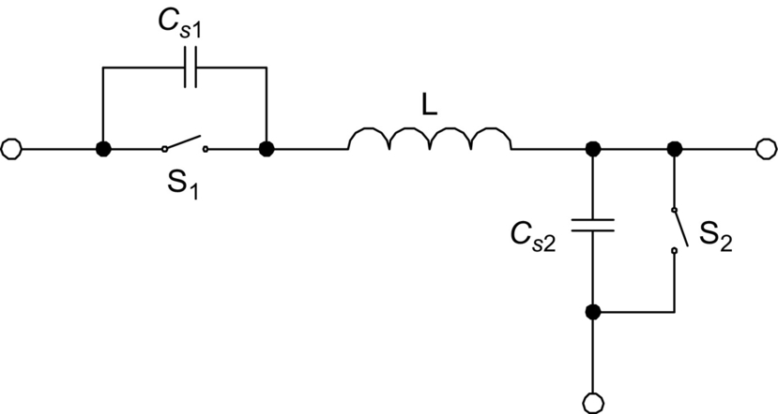

**FIG. 12.18** Constant frequency multiresonant switch.

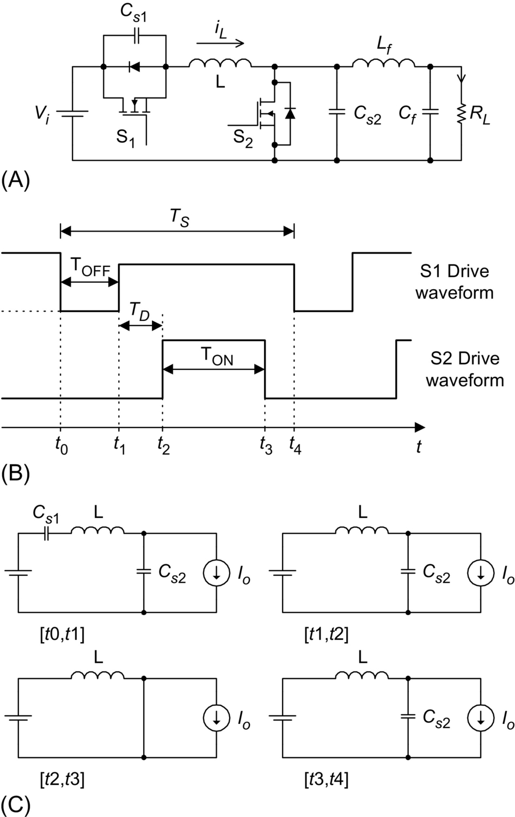

**FIG. 12.19** Constant frequency buck MRC: (A) circuit schematics, (B) gate drive waveforms, and (C) operating stages.

All switches in MRCs operate with ZVS, which reduces the switching losses and switching noise and eliminates the oscillation due to the parasitic effects of the components (such as the junction capacitance of the diodes). However, all switches are under high current and voltage stresses, resulting in an increase in the conduction loss.

## 12.7 Zero-voltage-transition Converters

By introducing a resonant circuit in parallel with the switches, the converter can achieve ZVS for both power switch and diode without significantly increasing their voltage and current stresses [[23](https://learning.oreilly.com/library/view/power-electronics-handbook/9780128114087/B978012811407000012X.xhtml#bb0120)]. [Fig. 12.20A](https://learning.oreilly.com/library/view/power-electronics-handbook/9780128114087/B978012811407000012X.xhtml#f0105) shows a buck-type ZVT-PWM converter, and [Fig. 12.20B](https://learning.oreilly.com/library/view/power-electronics-handbook/9780128114087/B978012811407000012X.xhtml#f0105) shows the associated waveforms. The converter consists of a main switch S and an auxiliary switch S1. It can be seen that the voltage and current waveforms of the switches are square-wave-like except during turn-on and turn-off switching intervals, where zero-voltage-transition (ZVT) takes place. The main switch and the output diode are under ZVS and are subjected to low voltage and current stresses. The auxiliary switch is under ZCS, resulting in low switching loss.

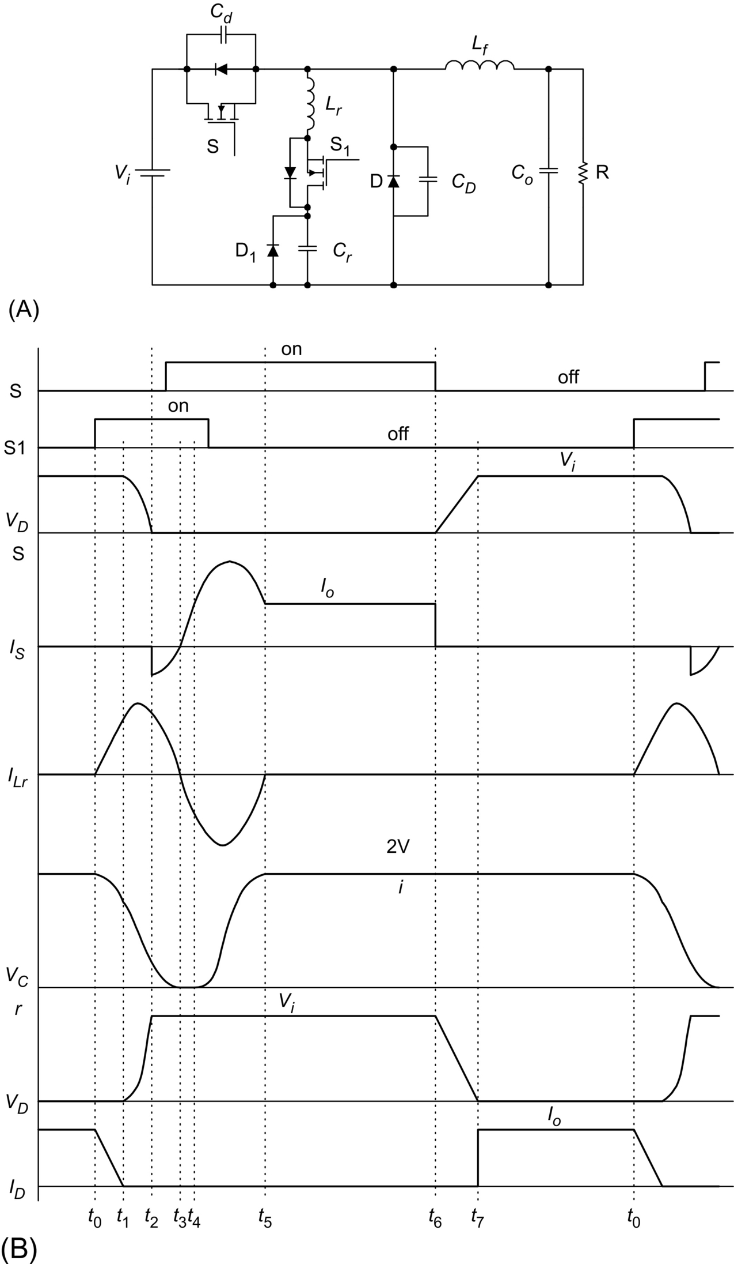

**FIG. 12.20** Buck ZVT-PWM converter: (A) circuit schematics and (B) waveforms.

The concept of ZVT can be extended to other PWM circuits by adding the resonant circuit. Some basic ZVT-PWM converters are shown in [Fig. 12.21](https://learning.oreilly.com/library/view/power-electronics-handbook/9780128114087/B978012811407000012X.xhtml#f0110).

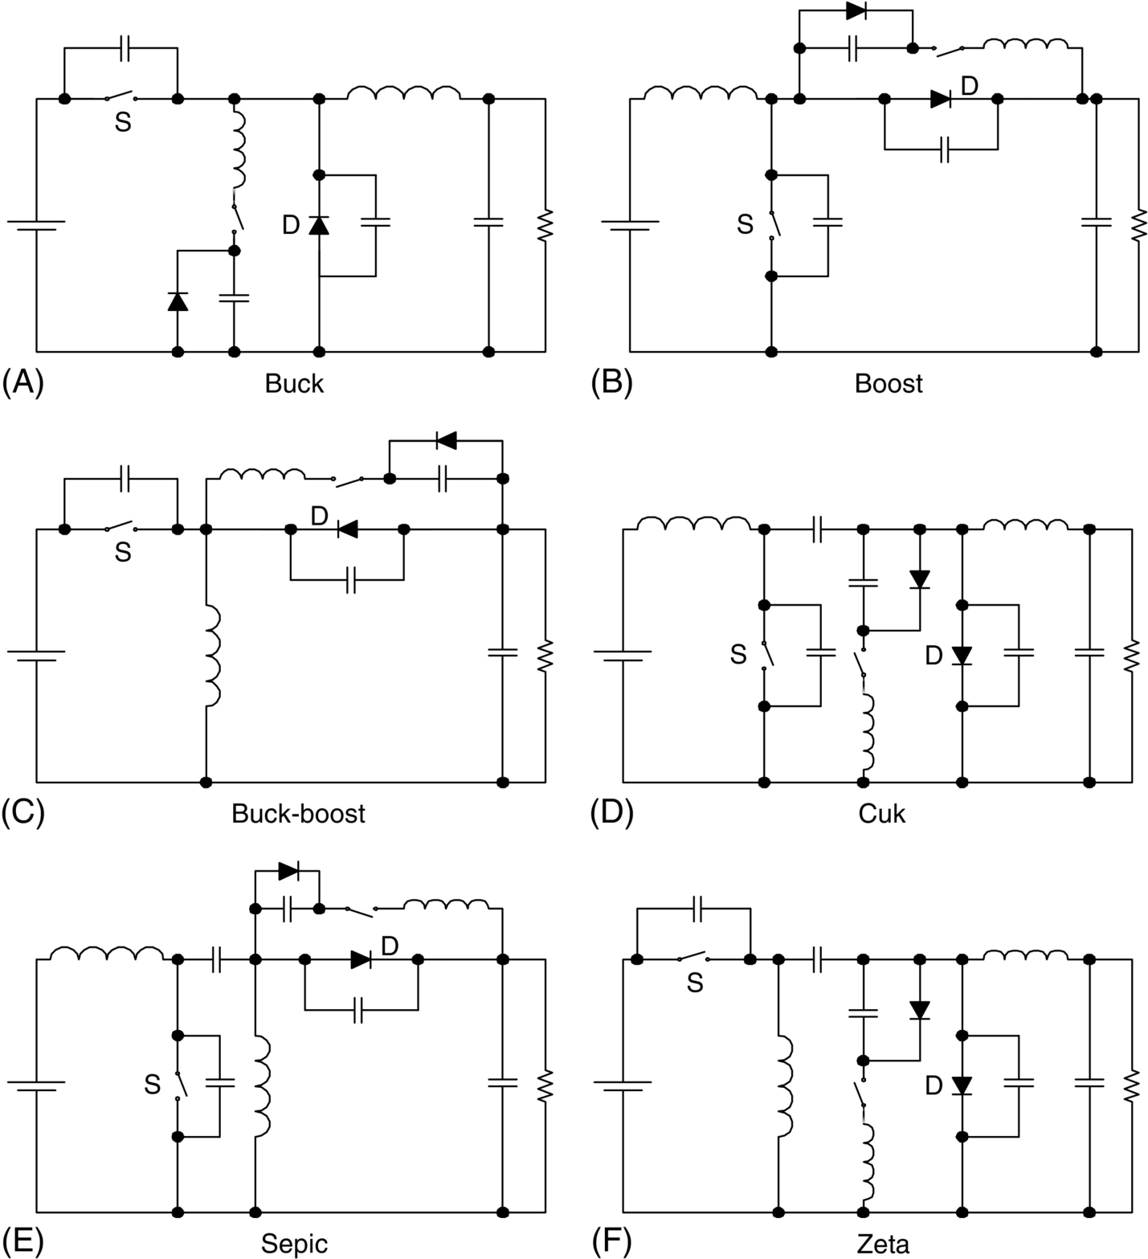

**FIG. 12.21** Conventional ZVT-PWM converters. (A) Buck converter. (B) Boost converter. (C) Buck-boost converter. (D) Cuk converter. (E) SEPIC. (F) ZETA converter.

## 12.8 Non-dissipative Active Clamp Network

The active-clamp circuit can utilize the transformer leakage inductance energy and can minimize the turn-off voltage stress in the isolated converters. The active-clamp circuit provides a means of achieving ZVS for the power switch and reducing the rate of change of the diode's reverse-recovery current. An example of a flyback converter with active clamp is shown in [Fig. 12.22A](https://learning.oreilly.com/library/view/power-electronics-handbook/9780128114087/B978012811407000012X.xhtml#f0115), and the circuit waveforms are shown in [Fig. 12.22B](https://learning.oreilly.com/library/view/power-electronics-handbook/9780128114087/B978012811407000012X.xhtml#f0115). Clamping action is obtained by using a series combination of an active switch (i.e., S2) and a large capacitor so that the voltage across the main switch (i.e., S1) is clamped to a minimum value. S2 is turned on with ZVS. However, S2 is turned off with finite voltage and current and has turn-off switching loss. The clamp-mode ZVS-MRCs is discussed in [[24](https://learning.oreilly.com/library/view/power-electronics-handbook/9780128114087/B978012811407000012X.xhtml#bb0125)–[26](https://learning.oreilly.com/library/view/power-electronics-handbook/9780128114087/B978012811407000012X.xhtml#bb0135)].

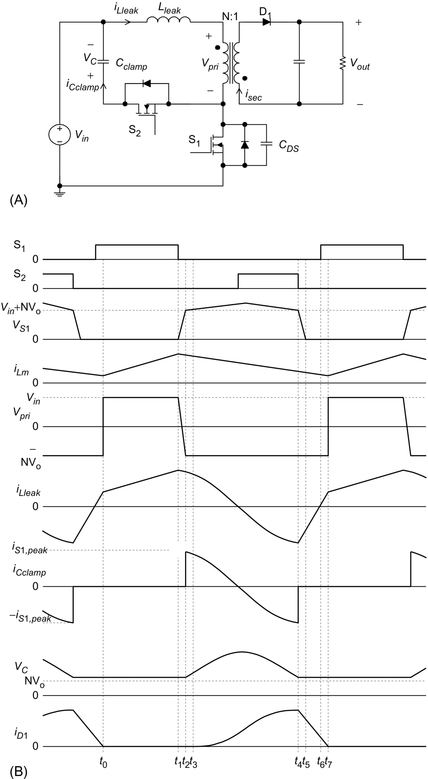

**FIG. 12.22** Active-clamp flyback converter: (A) circuit schematics and (B) circuit waveforms.

## 12.9 Load Resonant Converters

Load resonant converters (LRCs) have many distinct features over conventional power converters. Due to the soft commutation of the switches, no turn-off loss or stress is present. LRCs are especially suitable for high-power applications because they allow high-frequency operation for equipment size/weight reduction, without sacrificing the conversion efficiency and imposing extra stress on the switches. Basically, LRCs can be divided into three different configurations, namely, series resonant converters, parallel resonant converters, and series-parallel resonant converters.

### 12.9.1 SERIES RESONANT CONVERTERS

Series resonant converters (SRCs) have their load connected in series with the resonant tank circuit, which is formed by *Lr* and *Cr* [[15](https://learning.oreilly.com/library/view/power-electronics-handbook/9780128114087/B978012811407000012X.xhtml#bb0080),[27](https://learning.oreilly.com/library/view/power-electronics-handbook/9780128114087/B978012811407000012X.xhtml#bb0140)–[29](https://learning.oreilly.com/library/view/power-electronics-handbook/9780128114087/B978012811407000012X.xhtml#bb0150)]. The half-bridge configuration is shown in [Fig. 12.23](https://learning.oreilly.com/library/view/power-electronics-handbook/9780128114087/B978012811407000012X.xhtml#f0120). When the resonant inductor current *iLr* is positive, it flows through T1 if T1 is on; otherwise, it flows through the diode D2. When *iLr* is negative, it flows through T2 if T2 is on; otherwise, it flows through the diode D1. In the steady-state symmetrical operation, both the active switches are operated in a complementary manner. Depending on the ratio between the switching frequency *ωS* and the converter resonant frequency *ωr*, the converter has several possible operating modes.

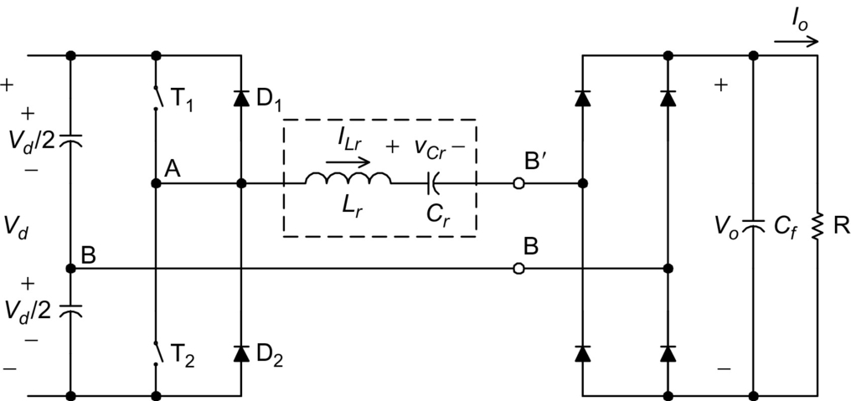

**FIG. 12.23** SRC half-bridge configuration.

#### **12.9.1.1 Discontinuous Conduction Mode With *ωS<*0.5*ωr***

[Fig. 12.24A](https://learning.oreilly.com/library/view/power-electronics-handbook/9780128114087/B978012811407000012X.xhtml#f0125) shows the waveforms of *iLr* and the resonant capacitor voltage *vCr* in this mode of operation. From 0 to *t*1, T1 conducts. From *t*1 to *t*2, the current in T1 reverses its direction. The current flows through D1 and back to the supply source. From *t*2 to *t*3, all switches are in the off state. From *t*3 to *t*4, T2 conducts. From *t*4 to *t*5, the current in T2 reverses its direction. The current flows through D2 and back to the supply source. T1 and T2 are switched on under ZCS condition, and they are switched off under zero-current and zero-voltage conditions. However, the switches are under high current stress in this mode of operation and thus have higher conduction loss.

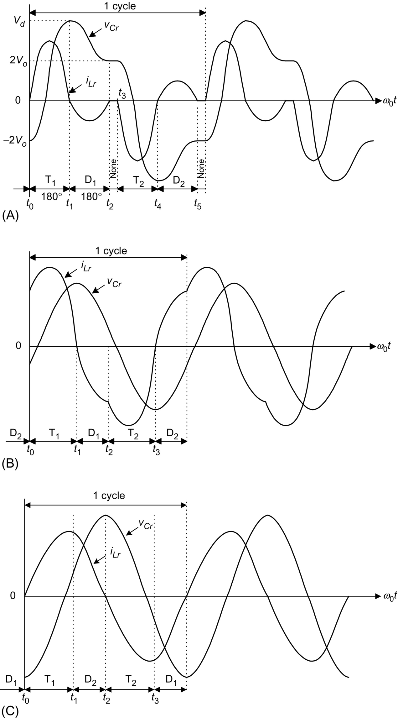

**FIG. 12.24** Circuit waveforms under different operating conditions: (A) *ωS<*0.5*ωr*, (B) 0.5 *ωr<ωS<ω*, and (C) *ωr<ωS*.

#### **12.9.1.2 Continuous Conduction Mode With 0.5*ωr<ωS<ωr***

[Fig. 12.24B](https://learning.oreilly.com/library/view/power-electronics-handbook/9780128114087/B978012811407000012X.xhtml#f0125) shows the circuit waveforms. From 0 to *t*1, *iLr* transfers from D2 to T1. T1 is switched on with finite switch current and voltage, resulting in turn-on switching loss. Moreover, the diodes must have good reverse-recovery characteristics in order to reduce the reverse-recovery current. From *t*1 to *t*2, D1 conducts and T1 is turned off softly with zero voltage and zero current. From *t*2 to *t*3, T2 is switched on with finite switch current and voltage. At *t*3, T2 is turned off softly and D2 conducts until *t*4.

#### **12.9.1.3 Continuous Conduction Mode With *ωr<ωS***

[Fig. 12.24C](https://learning.oreilly.com/library/view/power-electronics-handbook/9780128114087/B978012811407000012X.xhtml#f0125) shows the circuit waveforms. From 0 to *t*1, *iLr* transfers from D1 to T1. Thus, T1 is switched on with zero current and zero voltage. At *t*1, T1 is switched off with finite voltage and current, resulting in turn-off switching loss. From *t*1 to *t*2, D2 conducts. From *t*2 to *t*3, T2 is switched on with zero current and zero voltage. At *t*3, T2 is switched off. *iLr* transfers from T2 to D1. As the switches are turned on with ZVS, lossless snubber capacitors can be added across the switches.

The following parameters are defined: voltage conversion ratio *M*, characteristic impedance *Zr*, resonant frequency *fr*, normalized load resistance *r*, normalized switching frequency *γ*.

 **(12.2A)**

**** **(12.2B)**

**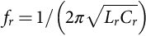** **(12.2C)**

**** **(12.2D)**

**** **(12.2E)**

**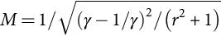** **(12.2F)**

The relationships between *M* and *γ* for different value of *r* are shown in [Fig. 12.25](https://learning.oreilly.com/library/view/power-electronics-handbook/9780128114087/B978012811407000012X.xhtml#f0130). The boundary between continuous conduction mode (CCM) and discontinuous conduction mode (DCM) is at *r*=1.27*γ*. When the converter is operating in DCM and 0.2*<γ<*0.5, *M*=1.27*rγ*.

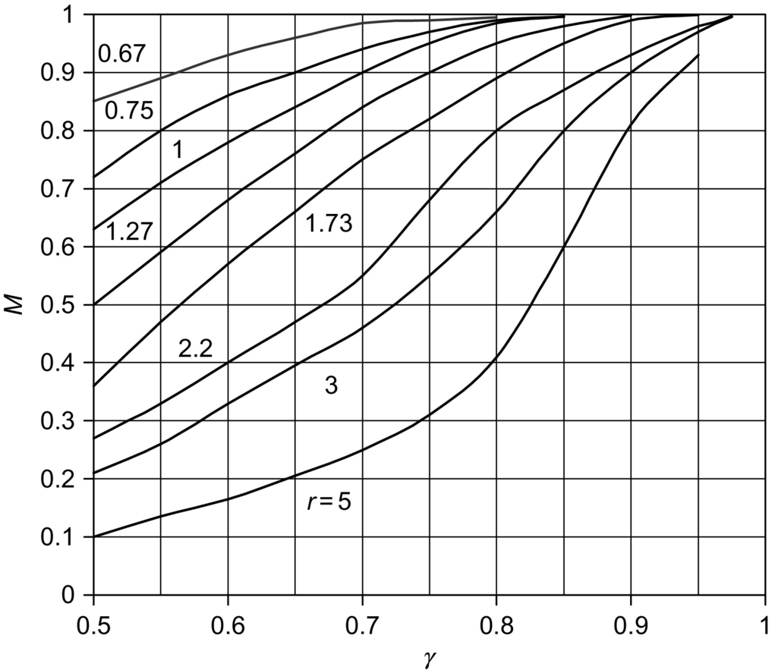

**FIG. 12.25** *M* vs *γ* in SRC.

The SRC has the following advantages. Transformer saturation can be avoided since the series capacitor can block the DC component. The light-load efficiency is high because the device current and conduction loss are low. However, the major disadvantages are that there is difficulty in regulating the output voltage under light-load and no-load conditions. Moreover, the output DC filter capacitor has to carry high ripple current, which could be a major problem in low-output-voltage and high-output-current applications [[29](https://learning.oreilly.com/library/view/power-electronics-handbook/9780128114087/B978012811407000012X.xhtml#bb0150)].

### 12.9.2 PARALLEL RESONANT CONVERTERS

Parallel resonant converters (PRCs) have their load connected in parallel with the resonant tank capacitor *Cr* [[27](https://learning.oreilly.com/library/view/power-electronics-handbook/9780128114087/B978012811407000012X.xhtml#bb0140)–[30](https://learning.oreilly.com/library/view/power-electronics-handbook/9780128114087/B978012811407000012X.xhtml#bb0155)]. The half-bridge configuration is shown in [Fig. 12.26](https://learning.oreilly.com/library/view/power-electronics-handbook/9780128114087/B978012811407000012X.xhtml#f0135). SRC behaves as a current source, whereas the PRC acts as a voltage source. For voltage regulation, PRC requires a smaller operating frequency range than the SRC to compensate for load variation.

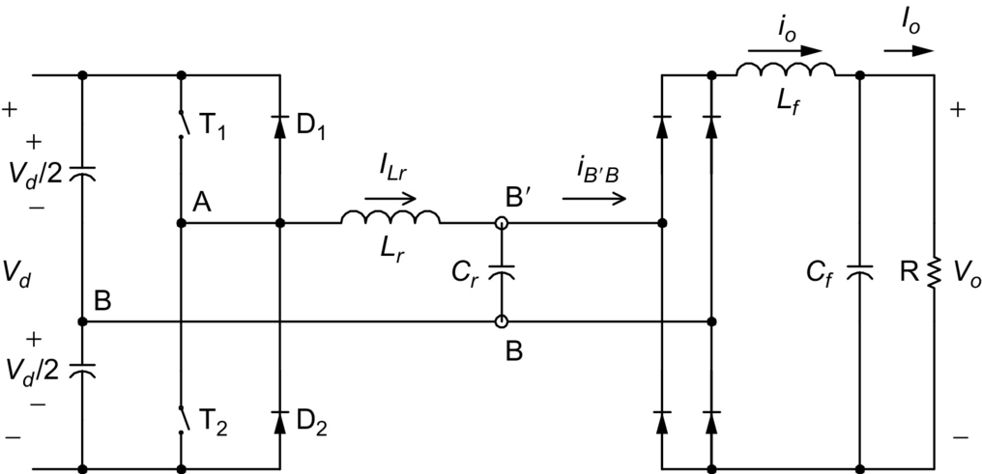

**FIG. 12.26** PRC half-bridge configuration.

#### **12.9.2.1 Discontinuous Conduction Mode**

The steady-state waveforms of the resonant inductor current *iLr* and the resonant capacitor voltage *vCr* are shown in [Fig. 12.27A](https://learning.oreilly.com/library/view/power-electronics-handbook/9780128114087/B978012811407000012X.xhtml#f0140). Initially, both *iLr* and *vCr* are zero. From 0 to *t*2, T1 conducts and is turned on with zero current. When *iLr* is less than the output current *Io*, *iLr* increases linearly from 0 to *t*1 and the output current circulates through the diode bridge. From *t*1 to *t*3, *Lr* resonates with *Cr*. Starting from *t*2, *iLr* reverses its direction and flows through D1. T1 is then turned off with zero current and zero voltage. From *t*3 to *t*4, *vCr* decreases linearly due to the relatively constant value of *Io*. At *t*4, when *vCr* equals zero, the output current circulates through the diode bridge again. Both *iLr* and *vCr* will stay at zero for an interval. From *t*5 to *t*9, the above operations will be repeated for T2 and D2. The output voltage is controlled by adjusting the time interval of [*t*4, *t*5].

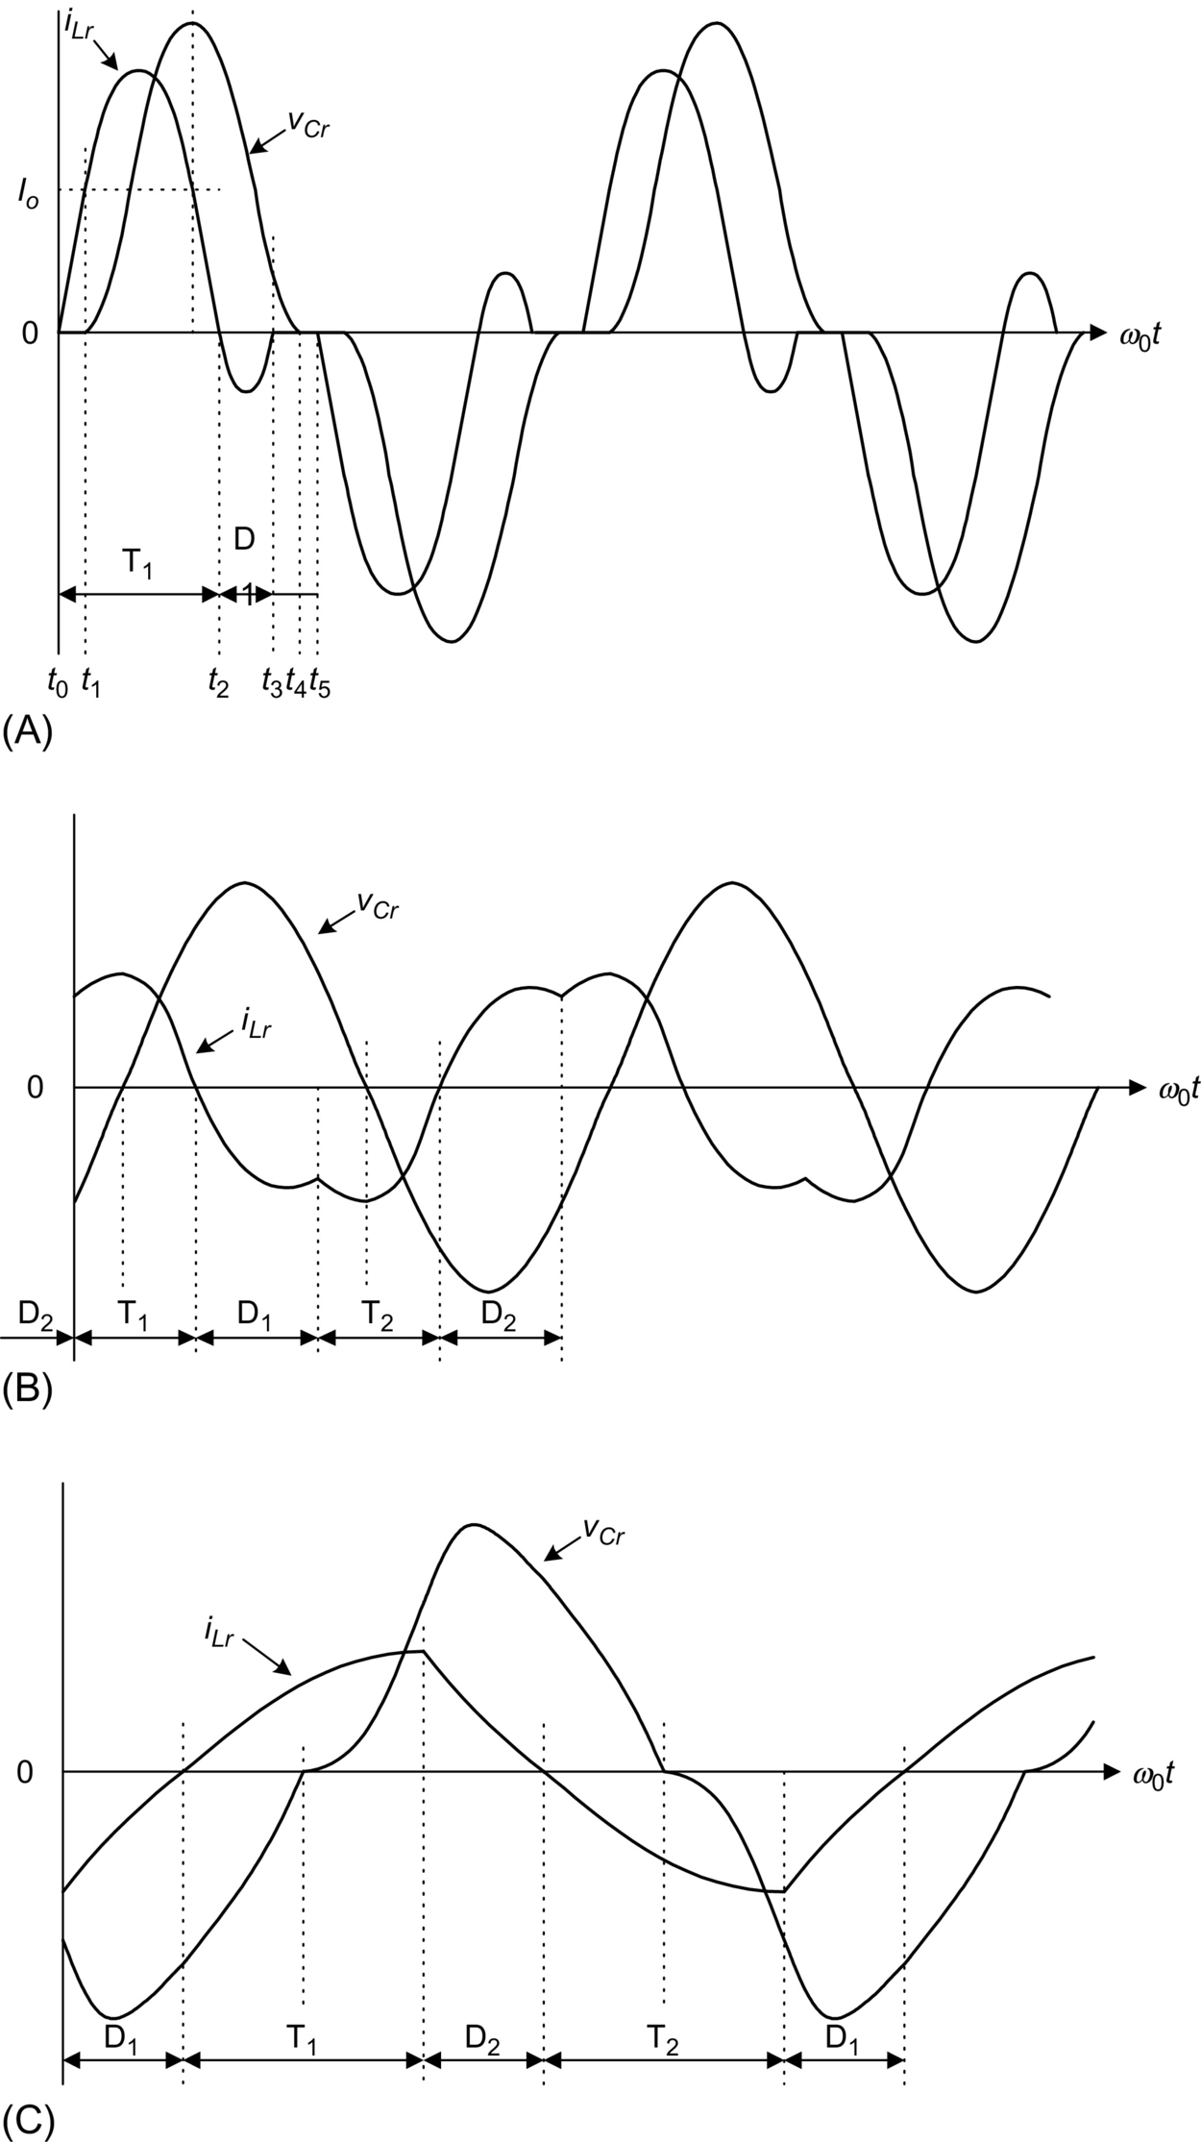

**FIG. 12.27** Circuit waveforms under different operating conditions: (A) discontinuous conduction mode, (B) continuous conduction mode *ωS<ωr*, and (C) continuous conduction mode *ωS>ωr*.

#### **12.9.2.2 Continuous Conduction Mode *ωS<ωr***

This mode is similar to the operation in the DCM but with a higher switching frequency. Both *iLr* and *vCr* become continuous. The waveforms are shown in [Fig. 12.27B](https://learning.oreilly.com/library/view/power-electronics-handbook/9780128114087/B978012811407000012X.xhtml#f0140). The switches T1 and T2 are hard turned on with finite voltage and current and are soft turned off with ZVS.

#### **12.9.2.3 Continuous Conduction Mode *ωS>ωr***

If the switching frequency is higher than *ωr* ([Fig. 12.27C](https://learning.oreilly.com/library/view/power-electronics-handbook/9780128114087/B978012811407000012X.xhtml#f0140)), the antiparallel diode of the switch will be turned on before the switch is triggered. Thus, the switches are turned on with ZVS. However, the switches are hard turned off with finite current and voltage.

The parameters defined in Eq. [(12.2)](https://learning.oreilly.com/library/view/power-electronics-handbook/9780128114087/B978012811407000012X.xhtml#fo0035) are applicable. The relationships between *M* and *γ* for various values of *r* are shown in [Fig. 12.28](https://learning.oreilly.com/library/view/power-electronics-handbook/9780128114087/B978012811407000012X.xhtml#f0145). During the DCM (i.e., *γ<*0.5), *M* is in linear relationship with *γ*. Output voltage regulation can be achieved easily. The output voltage is independent on the output current. The converter shows good voltage-source characteristics. It is also possible to step up and step down the input voltage.

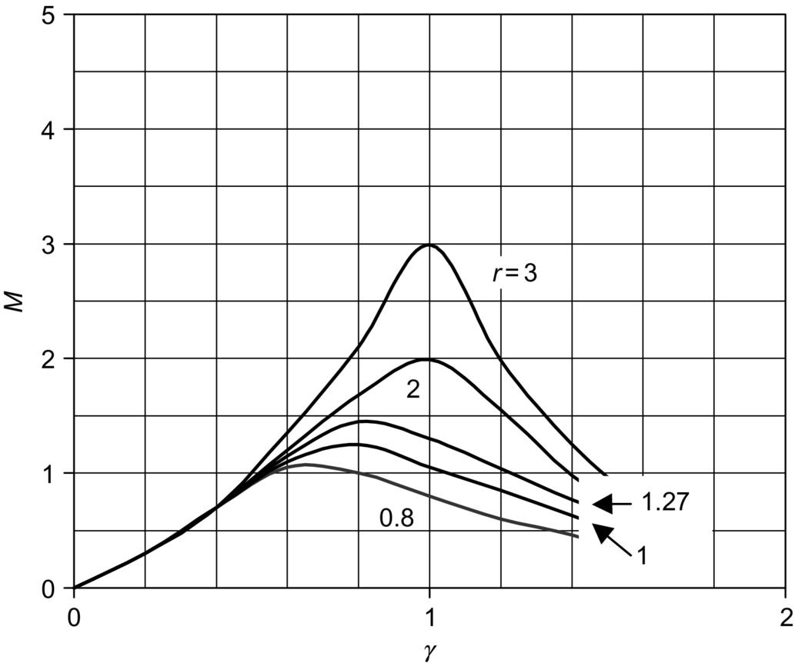

**FIG. 12.28** *M* versus *γ* in PRC.

The PRC has the advantages that the load can be short-circuited and the circuit is suitable for low-output-voltage, high-output-current applications. However, the major disadvantage of the PRC is the high device current. Moreover, since the device current does not decrease with the load, the efficiency drops with a decrease in the load [[29](https://learning.oreilly.com/library/view/power-electronics-handbook/9780128114087/B978012811407000012X.xhtml#bb0150)].

### 12.9.3 SERIES-PARALLEL RESONANT CONVERTER

Series-parallel resonant converter (SPRC) combines the advantages of the SRC and PRC. The SPRC has an additional capacitor or inductor connected in the resonant tank circuit [[29](https://learning.oreilly.com/library/view/power-electronics-handbook/9780128114087/B978012811407000012X.xhtml#bb0150)–[31](https://learning.oreilly.com/library/view/power-electronics-handbook/9780128114087/B978012811407000012X.xhtml#bb0160)]. [Fig. 12.29A](https://learning.oreilly.com/library/view/power-electronics-handbook/9780128114087/B978012811407000012X.xhtml#f0150) shows an LCC-type SPRC, in which an additional capacitor is placed in series with the resonant inductor. [Fig. 12.29B](https://learning.oreilly.com/library/view/power-electronics-handbook/9780128114087/B978012811407000012X.xhtml#f0150) shows an LLC-type SPRC, in which an additional inductor is connected in parallel with the resonant capacitor in the SRC. However, there are many possible combinations of the resonant tank circuit. Detailed analysis can be found in [[31](https://learning.oreilly.com/library/view/power-electronics-handbook/9780128114087/B978012811407000012X.xhtml#bb0160)].

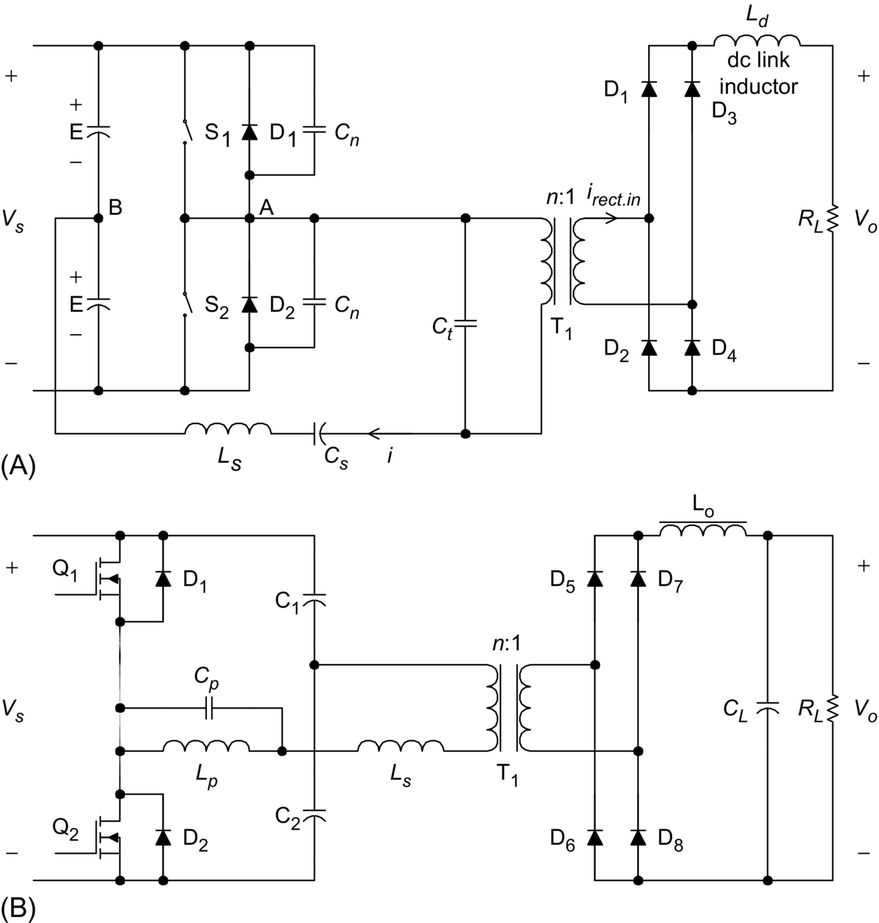

**FIG. 12.29** Different types of SPRC: (A) LCC-type and (B) LLC-type.

## 12.10 Control Circuits for Resonant Converters

Since the 1985s, various control integrated circuits (ICs) for resonant converters have been developed. Some common ICs for different converters are described in this section.

### 12.10.1 QRCS AND MRCS

Output regulations in many resonant-type converters, such as QRCs and MRCs, are achieved by controlling the switching frequency. ZCS applications require controlled switch-on times, while ZVS applications require controlled switch-off times. The fundamental control blocks in the IC include an error amplifier, voltage-controlled oscillator (VCO), one-shot generator with a zero wave-crossing detection comparator, and an output stage to drive the active switch. Typical ICs include UC1861-UC1864 for ZVS applications and UC 1865-UC 1868 for ZCS applications [[32](https://learning.oreilly.com/library/view/power-electronics-handbook/9780128114087/B978012811407000012X.xhtml#bb0165)]. [Fig. 12.30](https://learning.oreilly.com/library/view/power-electronics-handbook/9780128114087/B978012811407000012X.xhtml#f0155) shows the controller block diagram of UC 1864.

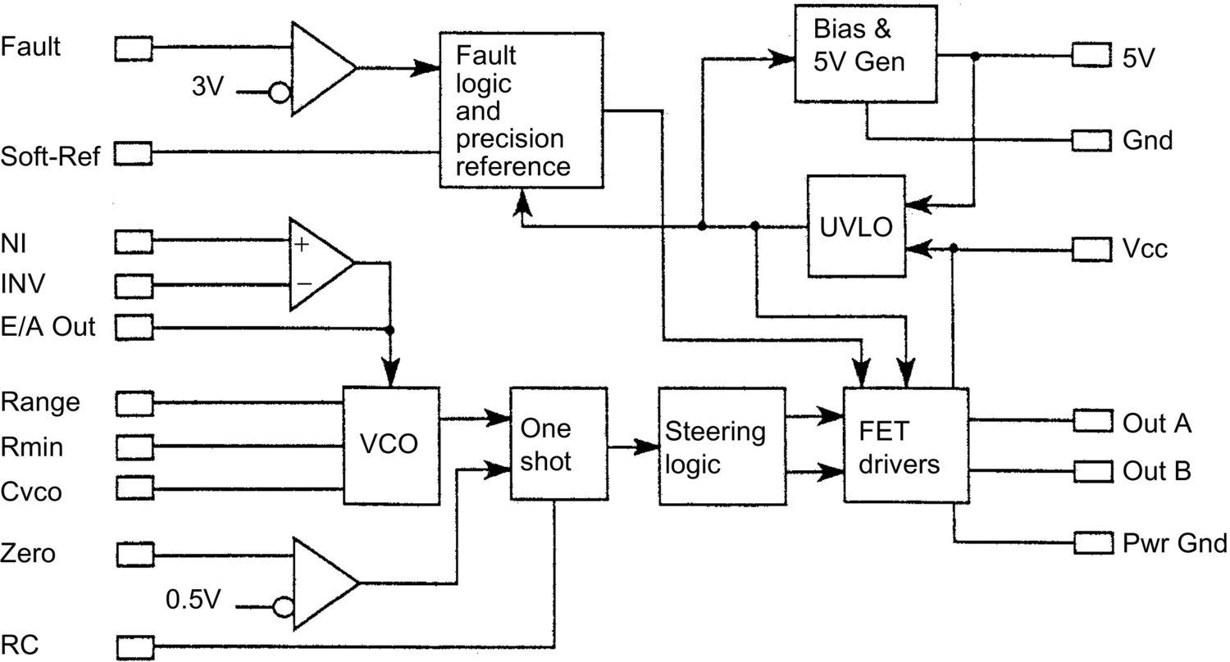

**FIG. 12.30** Controller block diagram of UC1864. Courtesy of Unitrode Corp. and Texas Instruments.

The maximum and minimum switching frequencies (i.e., *fmax* and *fmin*) are controlled by the resistors *Range* and *Rmin* and the capacitor *Cvco*. *fmax* and *fmin* can be expressed as

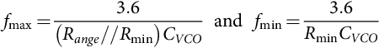 **(12.3)**

The frequency range Δ*f* is then equal to

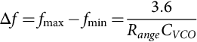 **(12.4)**

The frequency range of the ICs is from 10 kHz to 1 MHz. The output frequency of the oscillator is controlled by the error amplifier (E/A) output. An example of a ZVS-MR forward converter is shown in [Fig. 12.31](https://learning.oreilly.com/library/view/power-electronics-handbook/9780128114087/B978012811407000012X.xhtml#f0160).

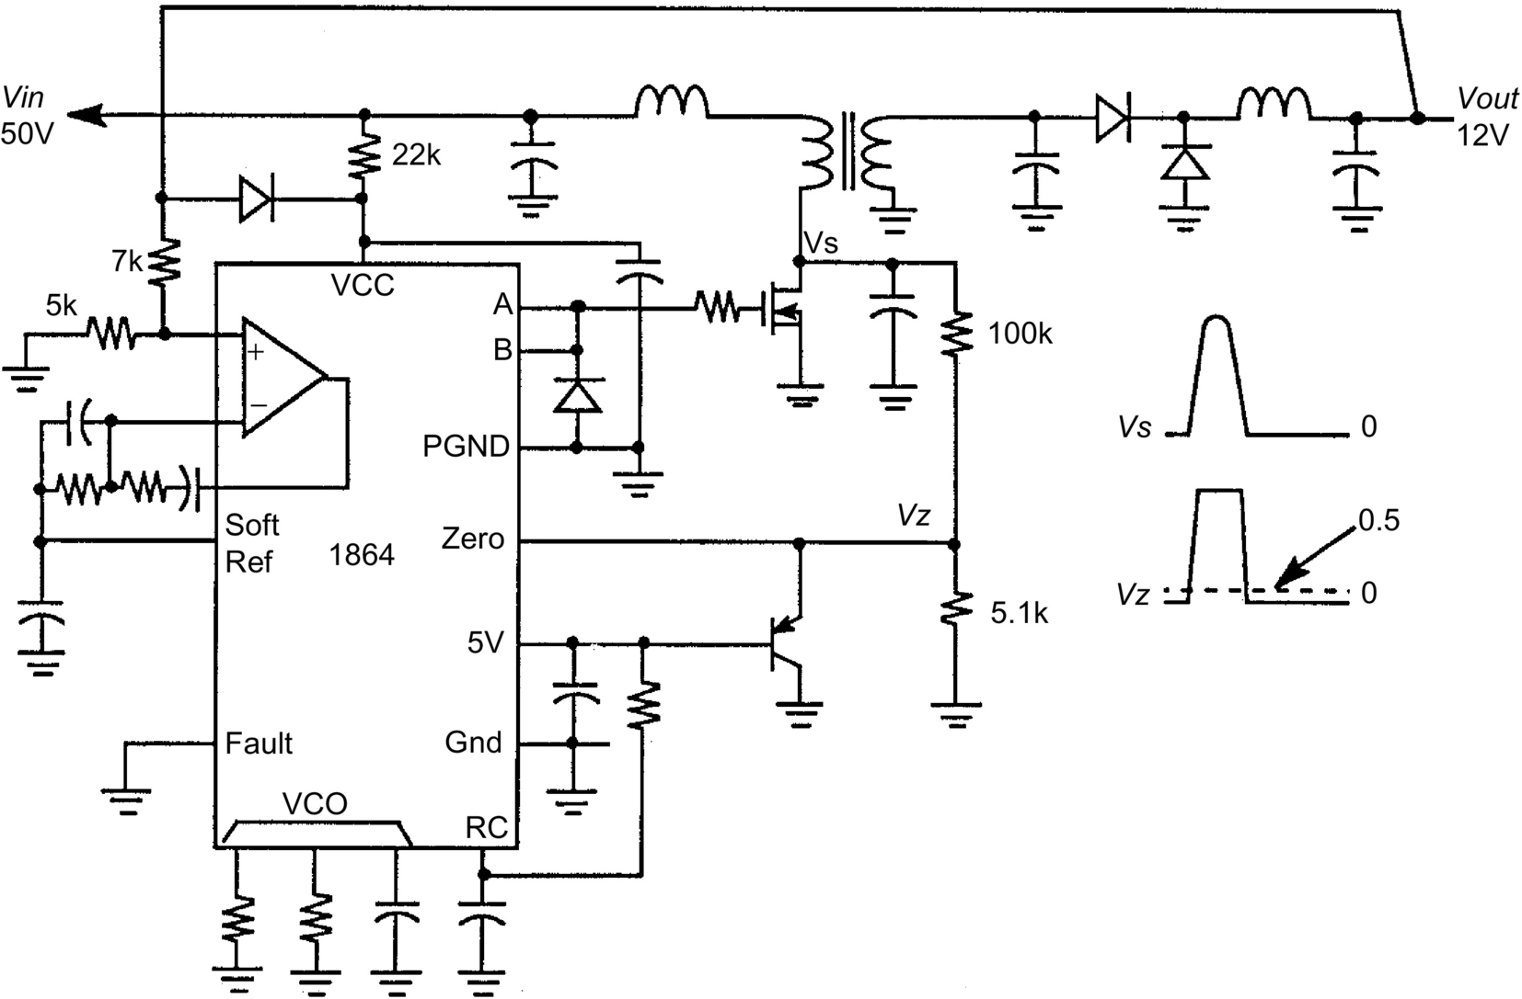

**FIG. 12.31** ZV-MR forward converter. Courtesy of Unitrode Corp. and Texas Instruments.

### 12.10.2 PHASE-SHIFTED, ZVT FB CIRCUIT

The UCC3895 is a phase-shift PWM controller that can generate a phase-shifting pattern of one half-bridge with respect to the other. The application diagram is shown in [Fig. 12.32](https://learning.oreilly.com/library/view/power-electronics-handbook/9780128114087/B978012811407000012X.xhtml#f0165).

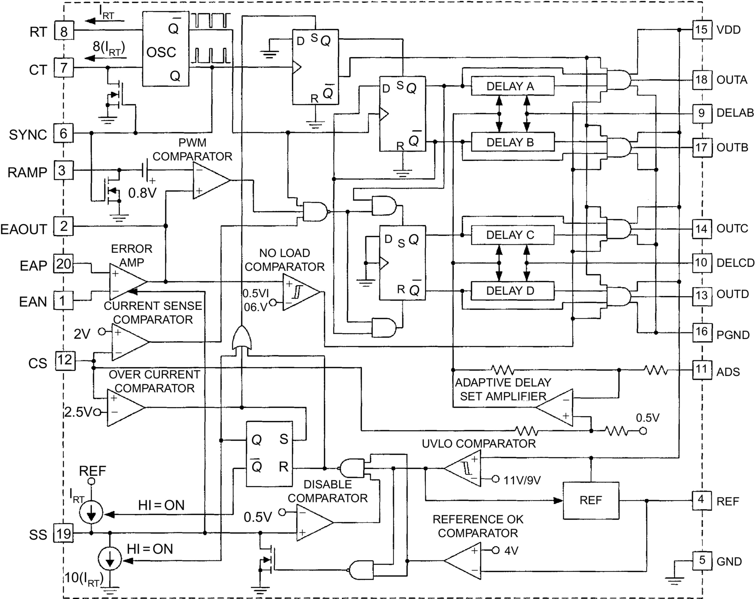

**FIG. 12.32** Application diagram of UCC3895. Courtesy of Unitrode Corp. and Texas Instruments.

The four outputs “OUTA,” “OUTB,” “OUTC,” and “OUTD” are used to drive the MOSFETs in the full-bridge. The dead time between “OUTA” and “OUTB” is controlled by “DELAB,” and the dead time between “OUTC” and “OUTD” is controlled by “DELCD.” Separate delays are provided for the two half-bridges to accommodate differences in resonant capacitor charging currents. The delay in each set is approximated by

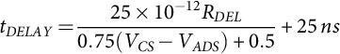 **(12.5)**

where *RDEL* is the resistor value connected between “DELAB” and “DELCD” to ground.

The oscillator period is determined by *RT* and *CT*. It is defined as

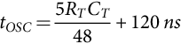 **(12.6)**

The maximum operating frequency is 1 MHz. The phase shift between the two sets of signals is controlled by the ramp voltage and the error amplifier output having a 7-MHz bandwidth.

## 12.11 Extended-Period Quasi-Resonant Converters

Generally, resonant and quasi-resonant converters operate with frequency control. The extended-period quasi-resonant (EP-QR) converters proposed by Barbi [[33](https://learning.oreilly.com/library/view/power-electronics-handbook/9780128114087/B978012811407000012X.xhtml#bb0170)] offer a simple solution to modify existing hard-switched converters into soft-switched ones with constant frequency operation. This makes both output filter design and control simple. [Fig. 12.33](https://learning.oreilly.com/library/view/power-electronics-handbook/9780128114087/B978012811407000012X.xhtml#f0170) shows a standard hard-switched boost-type PFC converter. In this hard-switched circuit, the main switch SW1 could be subject to significant switching stress because the reverse-recovery current of the diode *DF* could be excessive when SW1 is turned on. In practice, a small saturable inductor may be added in series with the power diode *DF* in order to reduce the *di*/*dt* of the reverse-recovery current. In addition, an optional *R*-*C* snubber may be added across SW1 to reduce the *dv*/*dt* of SW1. These extra reactance components can in fact be used in the EP-QR circuit to achieve soft switching, as shown in [Fig. 12.34](https://learning.oreilly.com/library/view/power-electronics-handbook/9780128114087/B978012811407000012X.xhtml#f0175). The resonant components *Lr* and *Cr* are of small values and can come from the snubber circuits of a standard hard-switched converter. Thus, the only additional component is the auxiliary switch Q2. The small resonant inductor is put in series with the main switch SW1 so that SW1 can be switched on under ZC condition and the *di*/*dt* problem of the reverse-recovery current be eliminated. The resonant capacitor *Cr* is used to store energy for creating condition for soft switching. Q2 is used to control the resonance during the main switch transition. It should be noted that all power devices including SW1, Q1, and main power diode *DF* are turned on and off under ZV and/or ZC conditions. Therefore, the large *di*/*dt* problem due to the reverse recovery of the power diode can be eliminated. The soft-switching method is an effective technique for EMI suppression.

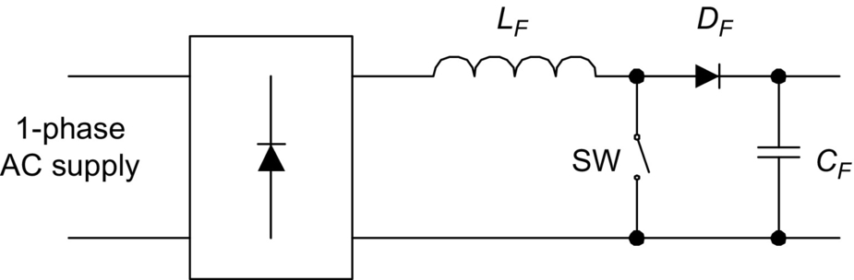

**FIG. 12.33** Boost-type AC-DC power factor correction circuit.

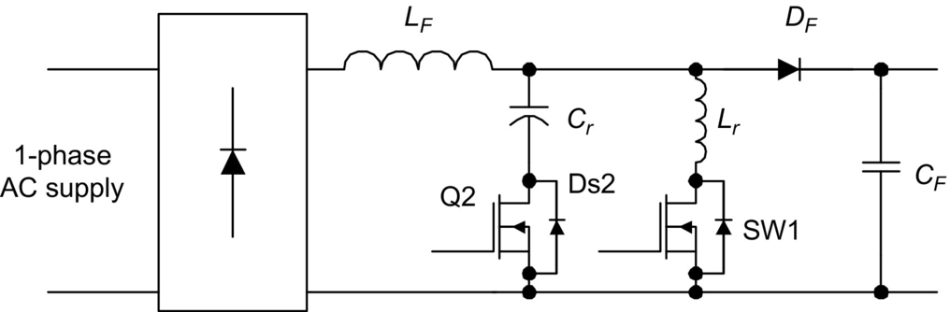

**FIG. 12.34** EP-QR boost-type AC-DC power factor correction circuit.

Together with power factor correction technique, soft-switching converters offer a complete solution to meet EMI regulations for both conducted and radiated EMI. The operation of the EP-QR boost PFC circuit [[34](https://learning.oreilly.com/library/view/power-electronics-handbook/9780128114087/B978012811407000012X.xhtml#bb0175),[35](https://learning.oreilly.com/library/view/power-electronics-handbook/9780128114087/B978012811407000012X.xhtml#bb0180)] can be described in six modes as shown in [Fig. 12.35](https://learning.oreilly.com/library/view/power-electronics-handbook/9780128114087/B978012811407000012X.xhtml#f0180). The corresponding idealized waveforms are included in [Fig. 12.36](https://learning.oreilly.com/library/view/power-electronics-handbook/9780128114087/B978012811407000012X.xhtml#f0185).

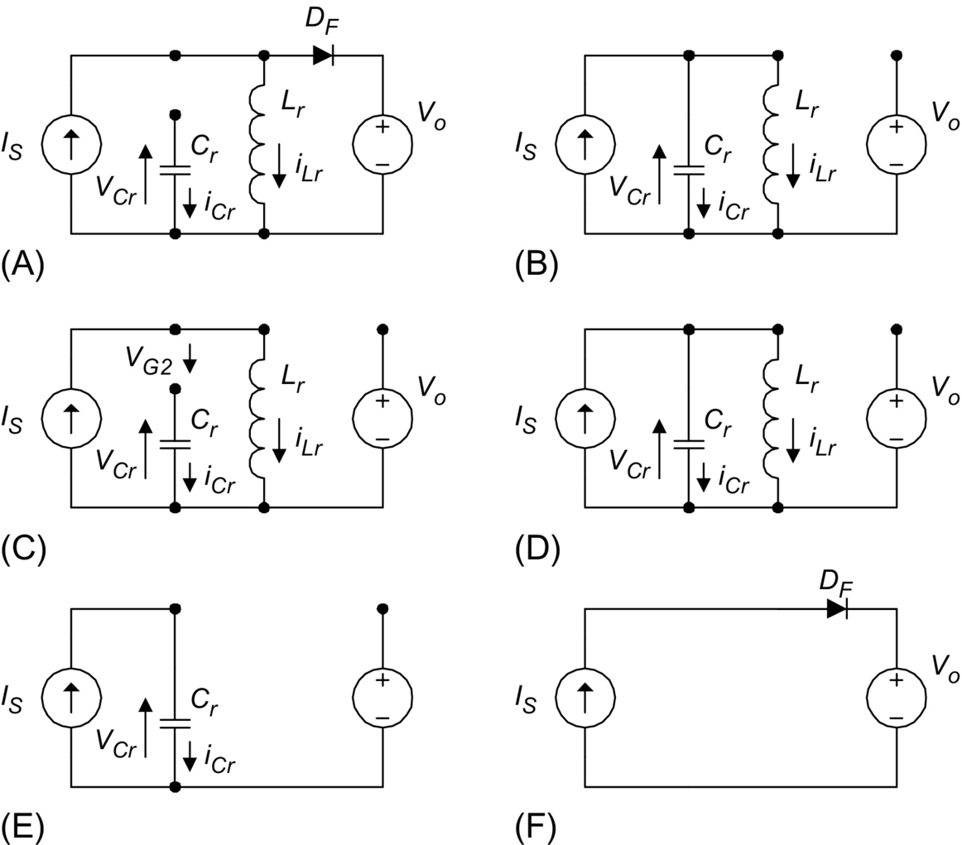

**FIG. 12.35** Operating modes of EP-QR boost-type AC-DC power factor correction circuit. (A) Mode I. (B) Mode II. (C) Mode III. (D) Mode IV. (E) Mode V. (F) Mode VI.

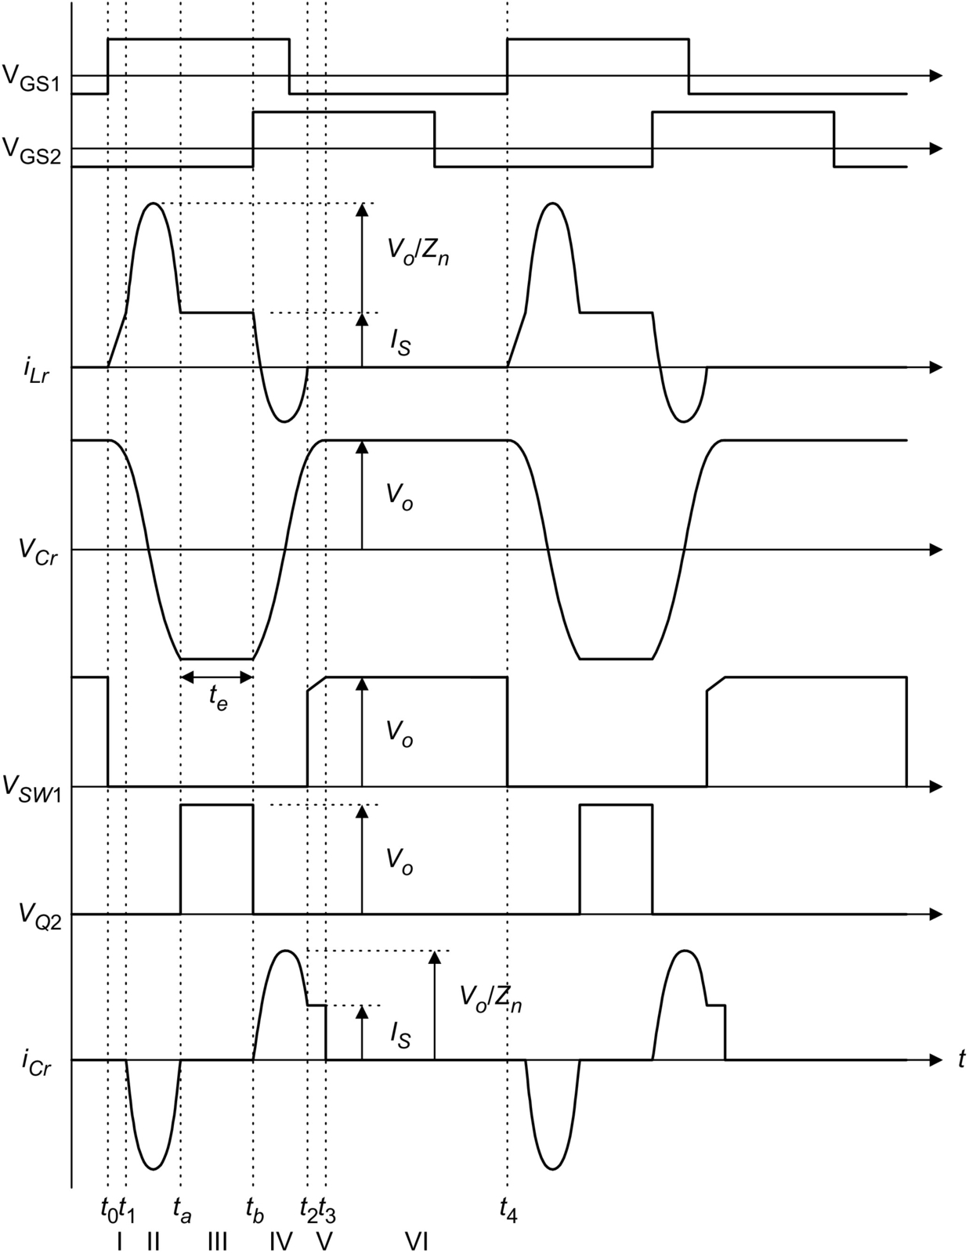

**FIG. 12.36** Idealized waveforms of EP-QR boost-type AC-DC power factor correction circuit.

#### **12.11.0.1 Circuit Operation**

*Interval I: (t0*−*t1)*. Due to the resonant inductor *Lr* limits the *di*/*dt* of the switch current, switch SW1 is turned on at zero-current condition with a positive gating signal *VGS*1 to start a switching cycle at *t*=*t*0. Current in *DF* is diverted to inductor L*r*. Because *DF* is still conducting during this short period, D*S*2 is still reverse-biased and is thus not conducting. The equivalent circuit topology for the conducting paths is shown in [Fig. 12.35A](https://learning.oreilly.com/library/view/power-electronics-handbook/9780128114087/B978012811407000012X.xhtml#f0180). Resonant switch Q2 remains off in this interval.

*Interval II: (t1*−*ta)*. When *DF* regains its blocking state, D*S*2 becomes forward-biased. The first half of the resonance cycle occurs and resonant capacitor *Cr* starts to discharge, and current flows in the loop *Cr*-Q2-*Lr*-*SW*1. The resonance half cycle stops at time *t*=*ta* because D*S*2 prevents the loop current *iCr* from flowing in the opposition direction. The voltage across *Cr* is reversed at the end of this interval. The equivalent circuit is shown in [Fig. 12.35B](https://learning.oreilly.com/library/view/power-electronics-handbook/9780128114087/B978012811407000012X.xhtml#f0180).

*Interval III: (ta*−*tb)*. Between *ta* and *tb*, current in *LF* and *Lr* continues to build up. This interval is the extended period for the resonance during which energy is pumped into *Lr*. The corresponding equivalent circuit is shown in [Fig. 12.35C](https://learning.oreilly.com/library/view/power-electronics-handbook/9780128114087/B978012811407000012X.xhtml#f0180).

*Interval IV: (tb*−*t2)*. [Fig. 12.35D](https://learning.oreilly.com/library/view/power-electronics-handbook/9780128114087/B978012811407000012X.xhtml#f0180) shows the equivalent circuit for this operating mode. Before SW1 is turned off, the second half of the resonant cycle needs to take place in order that a zero-voltage condition can be created for the turn-off process of SW1. The second half of the resonant cycle starts when auxiliary switch Q2 is turned on at *t*=*tb*. Resonant current then flows through the loop *Lr*-Q2-*Cr*-antiparallel diode of SW1. This current is limited by *Lr*, and thus, Q2 is turned on under zero-current condition. Since the antiparallel diode of SW1 is conducting, the voltage across SW1 is clamped to the on-state voltage of the antiparallel diode. SW1 can therefore be turned off at (near) zero-voltage condition before *t*=*t*2 at which the second half of the resonant cycle ends.

*Interval V: (t2*−*t3)*. During this interval, the voltage across *Cr* is less than the output voltage *Vo*. Therefore, *DF* is still reverse-biased. Inductor current *Is* flows into *Cr* until *VCr* reaches *Vo* at *t*=*t*3. The equivalent circuit is represented in [Fig. 12.35E](https://learning.oreilly.com/library/view/power-electronics-handbook/9780128114087/B978012811407000012X.xhtml#f0180).

*Interval VI: (t3*−*t4)*. During this period, the resonant circuit is not in action, and the inductor current *Is* charges the output capacitor *CF* via *DF*, as in the case of a classical boost-type PFC circuit. *Cr* is charged to *Vo*; therefore, Q2 can be turned off at zero-voltage and zero-current conditions. [Fig. 12.35F](https://learning.oreilly.com/library/view/power-electronics-handbook/9780128114087/B978012811407000012X.xhtml#f0180) shows the equivalent topology of this operating mode.

In summary, SW1, Q2, and *DF* are fully soft-switched. Since the two resonance half cycles take place within a closed loop outside the main inductor, the high resonant pulse will not occur in the inductor current, thus making a well-established averaged current mode control technique applicable for such QR circuit. For full soft switching in the turn-off process, the resonant components need to be designed so that the peak resonant current exceeds the maximum value of the inductor current. Typical measured switching waveforms and trajectories of SW1, Q2, and *DF* are shown in [Figs. 12.37](https://learning.oreilly.com/library/view/power-electronics-handbook/9780128114087/B978012811407000012X.xhtml#f0190), [12.38](https://learning.oreilly.com/library/view/power-electronics-handbook/9780128114087/B978012811407000012X.xhtml#f0195), and [12.39](https://learning.oreilly.com/library/view/power-electronics-handbook/9780128114087/B978012811407000012X.xhtml#f0200), respectively.

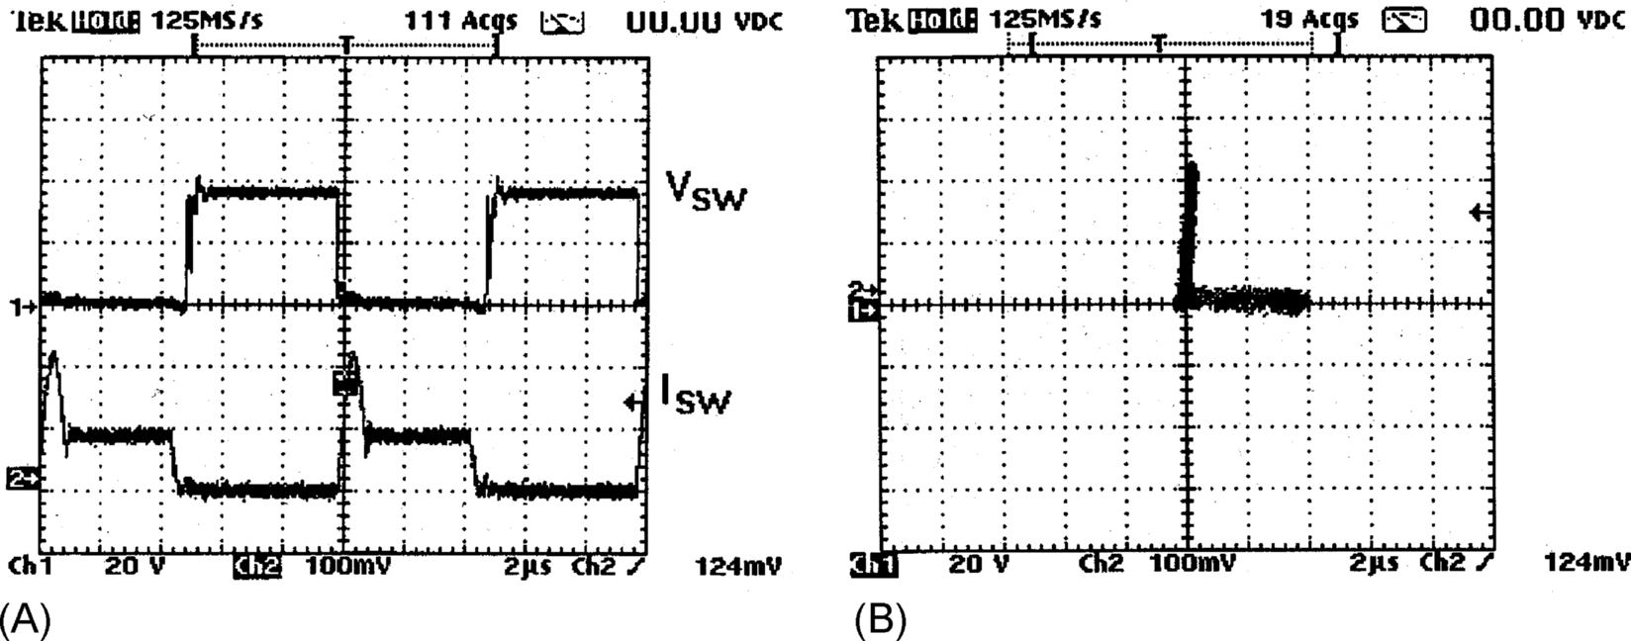

**FIG. 12.37** (A) Drain-source voltage and current of SW1 and (B) switching locus of SW1.

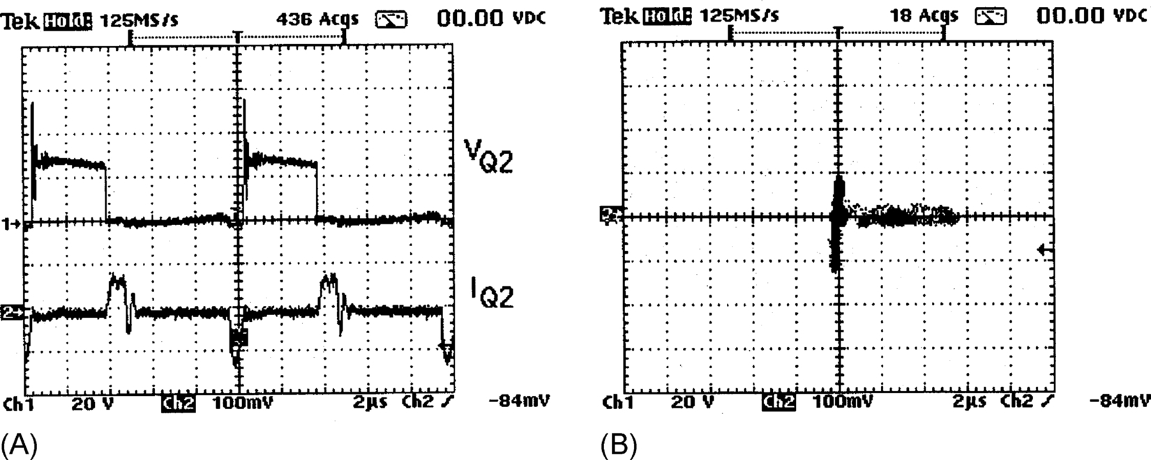

**FIG. 12.38** (A) Drain-source voltage and current of Q2 and (B) switching locus of Q2.

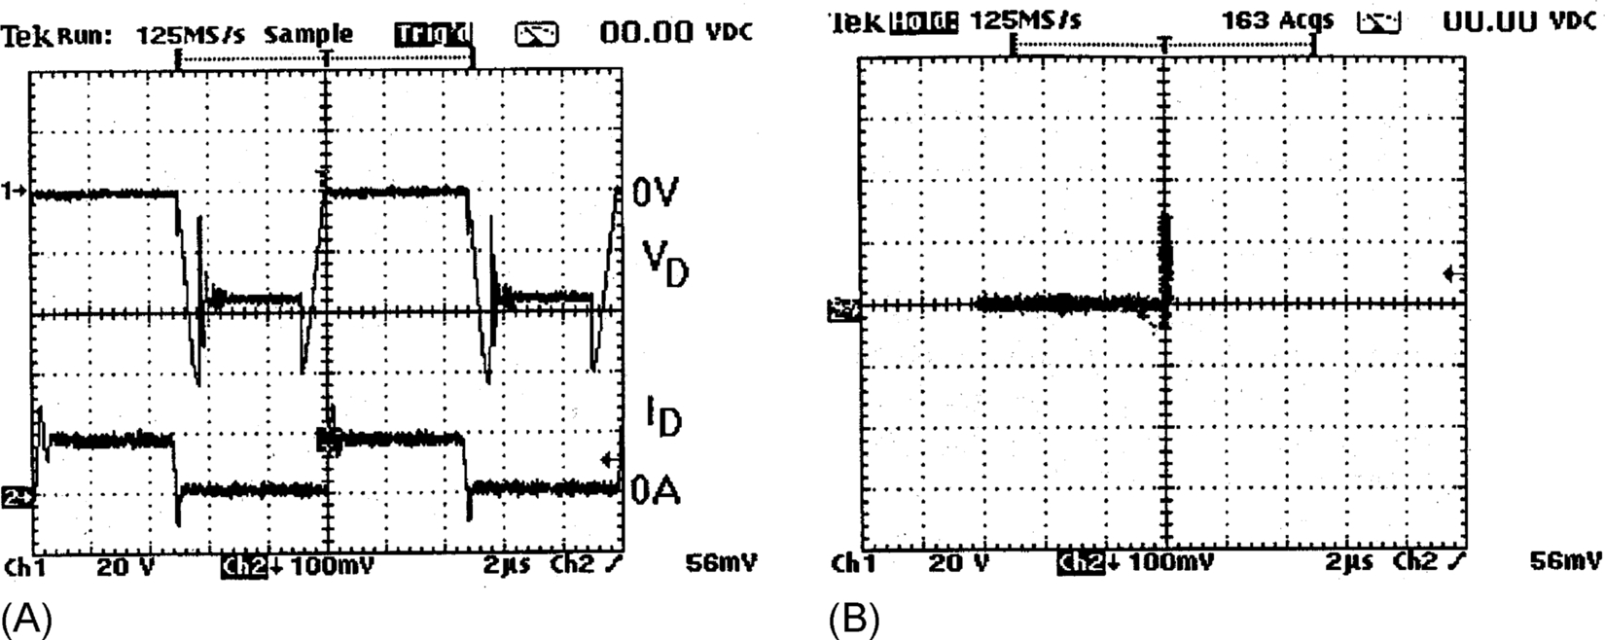

**FIG. 12.39** (A) Diode voltage and current and (B) switching locus of diode.

#### **12.11.0.2 Design Procedure**

Given: Input AC voltage=*Vs* (V)

Peak AC voltage=*Vs*(*max*) (V)

Nominal output DC voltage=*Vo* (V)

Switching frequency=*fsw* (Hz)

Output power=*Po* (W)

Input current ripple=Δ*I* (A)

Output voltage ripple=Δ*V* (V)

*(I) Resonant tank design*:

*Step 1*. Because the peak resonant current must be greater than the peak inductor current (same as peak input line current) in order to achieve soft turnoff, it is necessary to determine the peak input current *Is*(*max*). Assuming lossless AC-DC power conversion, *Is*(*max*) can be estimated from the following equation:

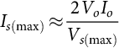 **(12.7)**

where *Io*=*Po*/*Vo* is the maximum output current.

*Step 2*. Soft-switching criterion is

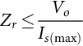 **(12.8)**

where 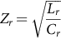 is the impedance of the resonant tank.

For a chosen resonant, frequency *fr*, *Lr*, and *Cr* can be obtained from

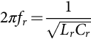 **(12.9)**

*(II) Filter component design*:

The minimum conversion ratio is

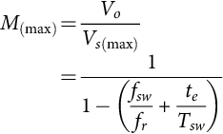 **(12.10)**

where *Tsw*=1/*fsw* and *te* is the extended period. From Eq. [(12.10)](https://learning.oreilly.com/library/view/power-electronics-handbook/9780128114087/B978012811407000012X.xhtml#fo0100), minimum *te* can be estimated.

The turn-on period of the SW1 is

 **(12.11)**

Inductor value *L* is obtained from

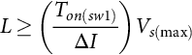 **(12.12)**

The filter capacitor value *C* can be determined from

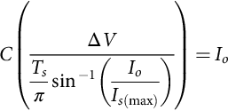 **(12.13)**

where *Ts*=1/*fs* is the period of the AC voltage supply frequency.

### 12.11.1 SOFT-SWITCHED DC-DC FLYBACK CONVERTER

A simple approach that can turn an existing hard-switched converter design into a soft-switched one is shown in [Fig. 12.40](https://learning.oreilly.com/library/view/power-electronics-handbook/9780128114087/B978012811407000012X.xhtml#f0205). The key advantage of the proposal is that many well proved and reliable hard-switched converter designs can be kept. The modification required is the addition of a simple circuit (consisting an auxiliary winding, a switch, and a small capacitor) to an existing isolated converter [[36](https://learning.oreilly.com/library/view/power-electronics-handbook/9780128114087/B978012811407000012X.xhtml#bb0185)]. This principle, which is the modified version of the EPQR technique for isolated converter, is demonstrated in an isolated soft-switched flyback converter with multiple outputs. Other advantageous features of the proposal are as follows:

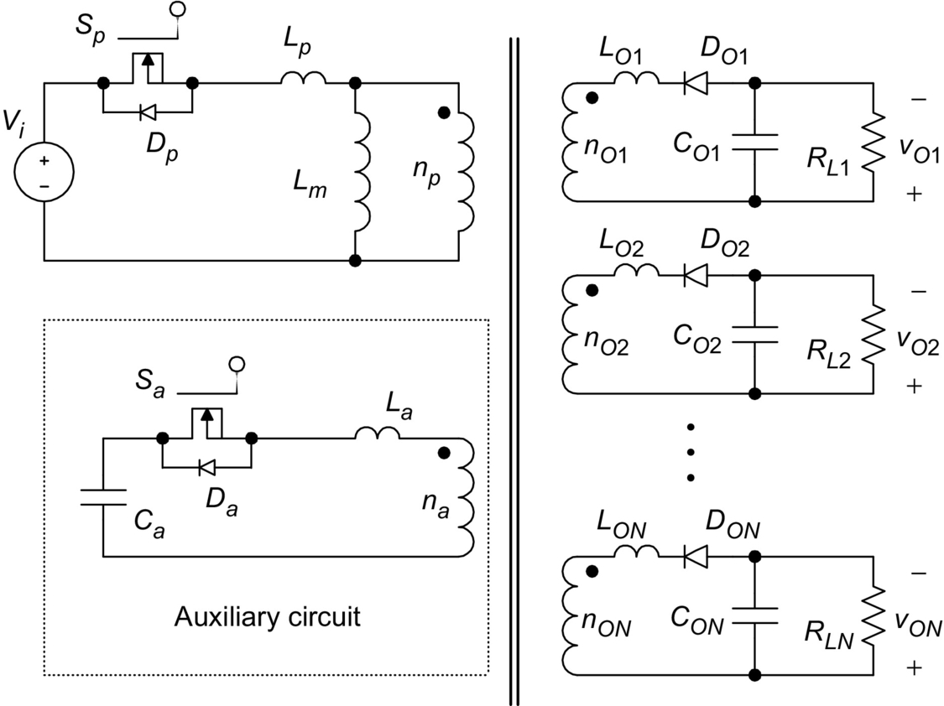

**FIG. 12.40** Fully soft-switched isolated flyback converter.

• All switches and diodes of the converter are “fully” soft-switched, that is, soft-switched at both turn-on and turn-off transitions under zero-voltage and/or zero-current conditions.

• The leakage inductance of each winding in the flyback transformer forms part of the resonant circuit for achieving ZVS and ZCS of all switches and diodes.

• The control technique is simply PWM-based as in standard hard-switched converters.

• The soft-switched technique is a proved method for EMI reduction [[37](https://learning.oreilly.com/library/view/power-electronics-handbook/9780128114087/B978012811407000012X.xhtml#bb0190)].

### 12.11.2 A ZCS BIDIRECTIONAL FLYBACK DC-DC CONVERTER

A bidirectional flyback DC-DC converter that uses one auxiliary circuit for both power flow directions is proposed in [Fig. 12.41](https://learning.oreilly.com/library/view/power-electronics-handbook/9780128114087/B978012811407000012X.xhtml#f0210) [[38](https://learning.oreilly.com/library/view/power-electronics-handbook/9780128114087/B978012811407000012X.xhtml#bb0195)]. The methodology is based on extending the unidirectional soft-switched flyback converter in Ref. [[36](https://learning.oreilly.com/library/view/power-electronics-handbook/9780128114087/B978012811407000012X.xhtml#bb0185)] and replacing the output diode with a controlled switch, which acts as either a rectifier [[39](https://learning.oreilly.com/library/view/power-electronics-handbook/9780128114087/B978012811407000012X.xhtml#bb0200)] or a power control switch in the corresponding power flow direction. An auxiliary circuit that consists of a winding in the coupled inductor, a switch, and a capacitor converts the hard-switched design into a soft-switched one. The operation is the same as [[36](https://learning.oreilly.com/library/view/power-electronics-handbook/9780128114087/B978012811407000012X.xhtml#bb0185)] in the forward mode. An extended-period resonant stage [[34](https://learning.oreilly.com/library/view/power-electronics-handbook/9780128114087/B978012811407000012X.xhtml#bb0175)] is introduced when the power control switch is on. Conversely, in the reverse mode, a complete resonant stage is initiated before the main switch is off. In both the power flow operations, the leakage inductance of the coupled inductor is used to create zero-current switching conditions for all switches.

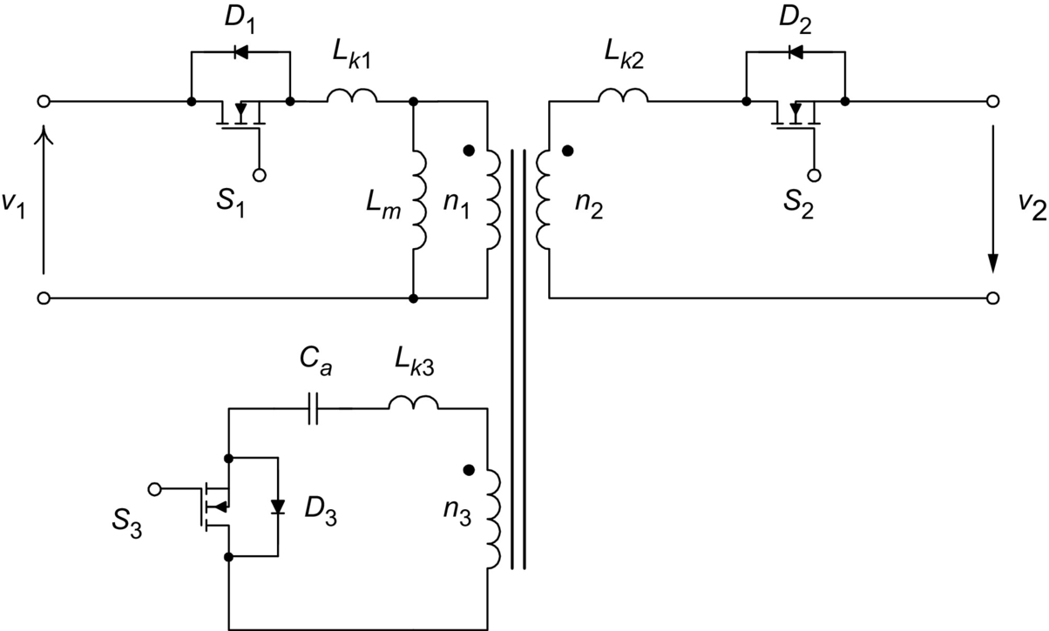

**FIG. 12.41** Bidirectional soft-switched isolated flyback converter.

## 12.12 Soft-Switching and EMI Suppression

A family of EP-QR converters are displayed in [Fig. 12.42](https://learning.oreilly.com/library/view/power-electronics-handbook/9780128114087/B978012811407000012X.xhtml#f0215). Their radiated EMI emissions have been compared with that from their hard-switched counterparts [[37](https://learning.oreilly.com/library/view/power-electronics-handbook/9780128114087/B978012811407000012X.xhtml#bb0190)]. [Fig. 12.43A and B](https://learning.oreilly.com/library/view/power-electronics-handbook/9780128114087/B978012811407000012X.xhtml#f0220) shows the conducted EMI emission from a hard-switched flyback converter and a soft-switched one, respectively. Their radiated EMI emissions are included in [Fig. 12.44](https://learning.oreilly.com/library/view/power-electronics-handbook/9780128114087/B978012811407000012X.xhtml#f0225). Both converters are tested at an output power of 50 W. No special filtering or shielding measures have been taken during the measurement. It is clear from the measurements that soft switching is an effective means to EMI suppression.

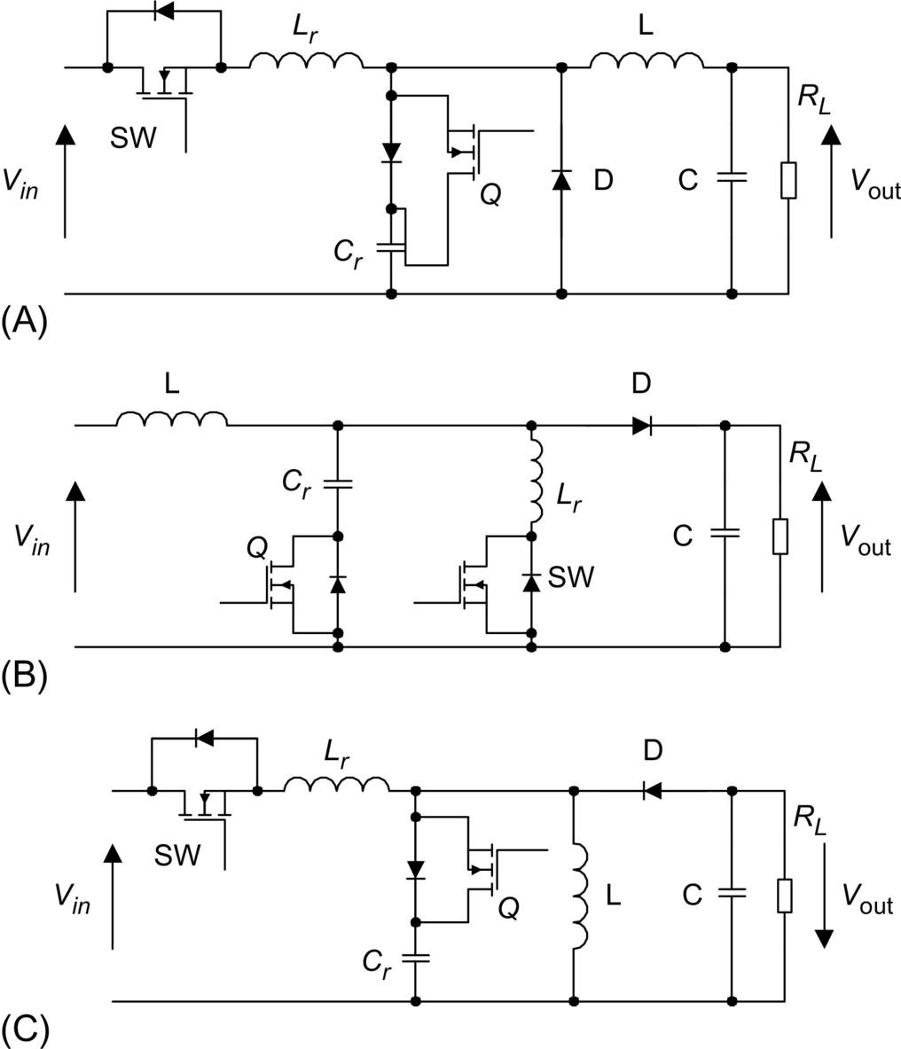

**FIG. 12.42** A family of EP-QR converters: (A) buck converter, (B) boost converter, and (C) flyback converter.

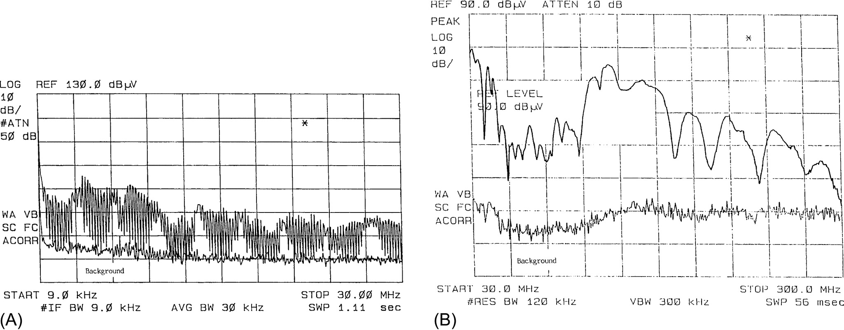

**FIG. 12.43** (A) Conducted EMI from hard-switched flyback converter and (B) radiated EMI from hard-switched flyback converter.

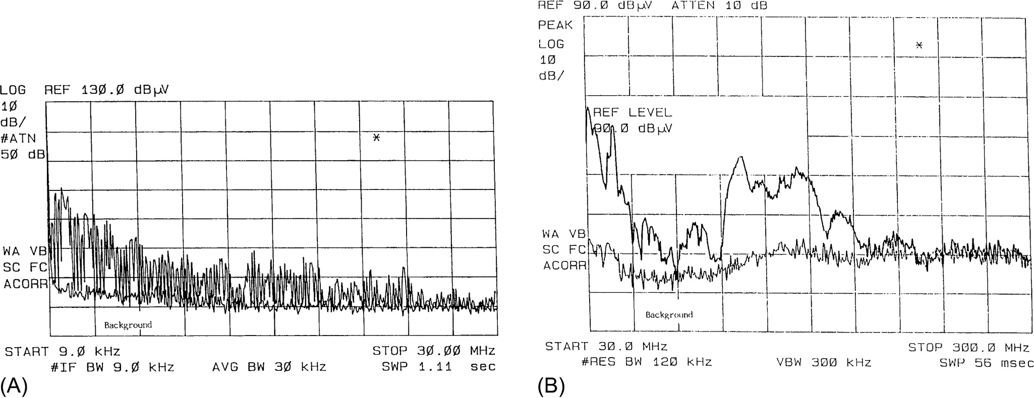

**FIG. 12.44** (A) Conducted EMI from soft-switched flyback converter and (B) radiated EMI from soft-switched flyback converter.

## 12.13 Snubbers and Soft-Switching for High Power Devices

Today, most of the medium power (up to 200 kVA) and medium voltage (up to 800 V) inverter are hard-switched. Compared with low-power switched-mode power supplies, the high voltage involved in the power inverters makes the *dv/dt*, *di/dt*, and the switching stress problems more serious. In addition, the reverse recovery of power diodes in the inverter leg may cause very sharp current spike, leading to severe EMI problem. It should be noted that some high-power devices such as GTO thyristors do not have a square safe operating area (SOA). It is therefore essential that the switching stress they undergone must be within their limits. Commonly used protective measures are to use snubber circuits for protecting high-power devices.

Among various snubbers, two snubber circuits are most well-known for applications in power inverters. They are the Undeland snubber [[40](https://learning.oreilly.com/library/view/power-electronics-handbook/9780128114087/B978012811407000012X.xhtml#bb0205)] ([Fig. 12.45](https://learning.oreilly.com/library/view/power-electronics-handbook/9780128114087/B978012811407000012X.xhtml#f0230)) and McMurray snubber circuits [[41](https://learning.oreilly.com/library/view/power-electronics-handbook/9780128114087/B978012811407000012X.xhtml#bb0210)] ([Fig. 12.46](https://learning.oreilly.com/library/view/power-electronics-handbook/9780128114087/B978012811407000012X.xhtml#f0235)). The Undeland snubber is an asymmetrical snubber circuit with one turn-on inductor and one turn-off capacitor. The turn-off snubber capacitor *Cs* is clamped by another capacitor *Cc*. At the end of each switching cycle, the snubber energy is dumped into *Cc* and then discharged into the DC bus via a discharge resistor. In order to reduce the snubber loss, the discharge resistor can be replaced by a switched-mode circuit. In this way, the Undeland snubber can become a snubber with energy recovery. The McMurray snubber is symmetrical. Both the turn-off snubber capacitors share current in parallel during turnoff. The voltage transient is limited by the capacitor closest to the turn-off device because the stray inductance to the other capacitor will prevent instantaneous current sharing. The turn-on inductors require midpoint connection. Snubber energy is dissipated into the snubber resistor. Like the Undeland snubber, the McMurray snubber can be modified into an energy recovery snubber. By using an energy recovery transformer as shown in [Fig. 12.47](https://learning.oreilly.com/library/view/power-electronics-handbook/9780128114087/B978012811407000012X.xhtml#f0240), this snubber becomes a regenerative one. Although other regenerative circuits have been proposed, their complexity makes them unattractive in industrial applications. Also, they do not necessarily solve the power diode reverse-recovery problems.

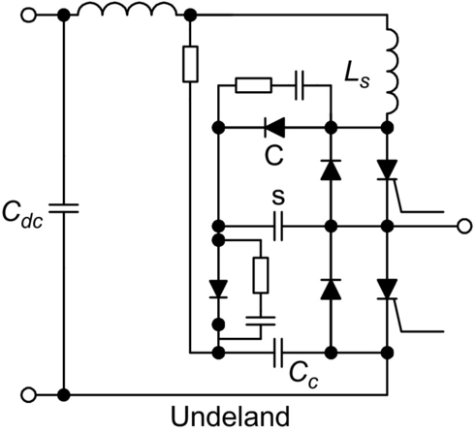

**FIG. 12.45** Undeland snubber.

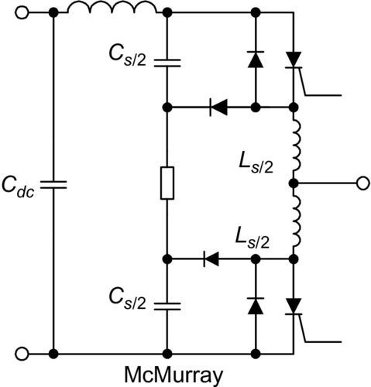

**FIG. 12.46** McMurray snubber.

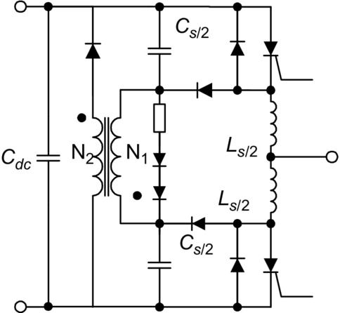

**FIG. 12.47** McMurray snubber with energy recovery.

Although the use of snubber circuits can reduce the switching stress in the power devices, the switching loss is actually damped into the snubber resistors unless regenerative snubbers are used. The switching loss is still a limiting factor to the high-frequency operation of power inverters. However, the advent of soft-switching techniques opens a new way to high-frequency inverter operation. Because the switching trajectory of a soft-switched switch is close to the voltage and current axis, faster power electronic devices with smaller SOAs can in principle be used. In general, both ZVS and ZCS can reduce switching loss in high-power power switches. However, for power switches with tail currents, such as IGBT, ZCS is more effective than ZVS.

## 12.14 Soft-Switching DC-AC Power Inverters

Soft-switching technique not only offers a reduction in switching loss and thermal requirement but also allows the possibility of high-frequency and snubberless operation. Improved circuit performance and efficiency and reduction of EMI emission can be achieved. For zero-voltage switching (ZVS) inverter applications, two major approaches that enable inverters to be soft-switched have been proposed. The first approach pulls the DC link voltage to zero momentarily so that the inverter's switches can be turned on and off with ZVS. Resonant DC link and quasi-resonant inverters belong to this category. The second approach uses the resonant pole idea. By incorporating the filter components into the inverter operation, resonance condition and thus zero-voltage/current conditions can be created for the inverter switches.

In this section, the following soft-switched inverters are described:

*Approach 1*: Resonant DC link inverters are as follows:

1. Resonant (pulsating) DC link inverters

2. Actively clamped resonant DC link inverters

3. Resonant inverters with minimum voltage stress

4. Quasi-resonant soft-switched inverter

5. Parallel resonant DC link inverter

*Approach 2*: Resonant pole inverters (RPIs) are as follows:

1. Resonant pole inverters

2. Auxiliary RPIs

3. Auxiliary resonant commutated pole inverters (ARCPIs)

Type 1 is the resonant DC link inverter [[42](https://learning.oreilly.com/library/view/power-electronics-handbook/9780128114087/B978012811407000012X.xhtml#bb0215)–[44](https://learning.oreilly.com/library/view/power-electronics-handbook/9780128114087/B978012811407000012X.xhtml#bb0225)] that sets the DC link voltage into oscillation so that the zero-voltage instants are created periodically for ZVS. Despite the potential advantages that this soft-switching approach can offer, a recent review on existing resonant-link topologies for inverters [[45](https://learning.oreilly.com/library/view/power-electronics-handbook/9780128114087/B978012811407000012X.xhtml#bb0230)] concludes that the resonant DC link system results in an increase in circuit complexity and the frequency spectrum is restricted by the need of using integral pulse-density modulation (IPDM) when compared with a standard hard-switched inverter. In addition, the peak pulsating link voltage of resonant-link inverters is twice the DC link voltage in a standard hard-switched inverter. Although clamp circuits (type 2) can be used to limit the peak voltage to 1.3–1.5 per unit [[44](https://learning.oreilly.com/library/view/power-electronics-handbook/9780128114087/B978012811407000012X.xhtml#bb0225)], power devices with higher than normal voltage ratings have to be used.

Circuits of types 3–5 employ a switched-mode front-stage circuit that pulls the DC link voltage to zero momentarily whenever inverter switching is required. This soft-switching approach does not cause extra voltage stress to the inverter, and hence, the voltage rating of the power devices is only 1 per unit. As ZVS conditions can be created at any time, there is virtually no restriction in the PWM strategies. Therefore, well-established PWM schemes developed in the last 2 decades can be employed. In some ways, this approach is similar to some DC-side commutation techniques proposed in the past for thyristor inverters [[46](https://learning.oreilly.com/library/view/power-electronics-handbook/9780128114087/B978012811407000012X.xhtml#bb0235),[47](https://learning.oreilly.com/library/view/power-electronics-handbook/9780128114087/B978012811407000012X.xhtml#bb0240)], although these DC-side commutation techniques were used for turning off thyristors in the inverter bridge and were not primarily developed for soft switching.

Circuits of type 6–8 retain the use of a constant DC link voltage. They incorporate the use of the resonant components and/or filter components into the inverter circuit operation. This approach is particularly useful for inverter applications in which output filters are required. Examples include uninterruptible power supplies (UPS) and inverters with output filters for motor drives. The LC filter components can form the auxiliary resonant circuits that create the soft-switching conditions. However, these tend to have high-power device count and require complex control strategy.

### 12.14.1 RESONANT (PULSATING) DC LINK INVERTER

Resonant DC link converter for DC-AC power conversion was proposed in 1986 [[42](https://learning.oreilly.com/library/view/power-electronics-handbook/9780128114087/B978012811407000012X.xhtml#bb0215)]. Instead of using a nominally constant DC link voltage, a resonant circuit is added to cause the DC link voltage to be pulsating at a high frequency. This resonant circuit theoretically creates periodic zero-voltage duration at which the inverter switches can be turned on or off. [Fig. 12.48](https://learning.oreilly.com/library/view/power-electronics-handbook/9780128114087/B978012811407000012X.xhtml#f0245) shows the schematics of the pulsating link inverter. Typical DC link voltage, inverter's phase voltage, and the line voltages are shown in [Fig. 12.49](https://learning.oreilly.com/library/view/power-electronics-handbook/9780128114087/B978012811407000012X.xhtml#f0250). Because the inverter switching can only occur at zero-voltage duration, integral pulse-density modulation (IPDM) has to be adopted in the switching strategy.

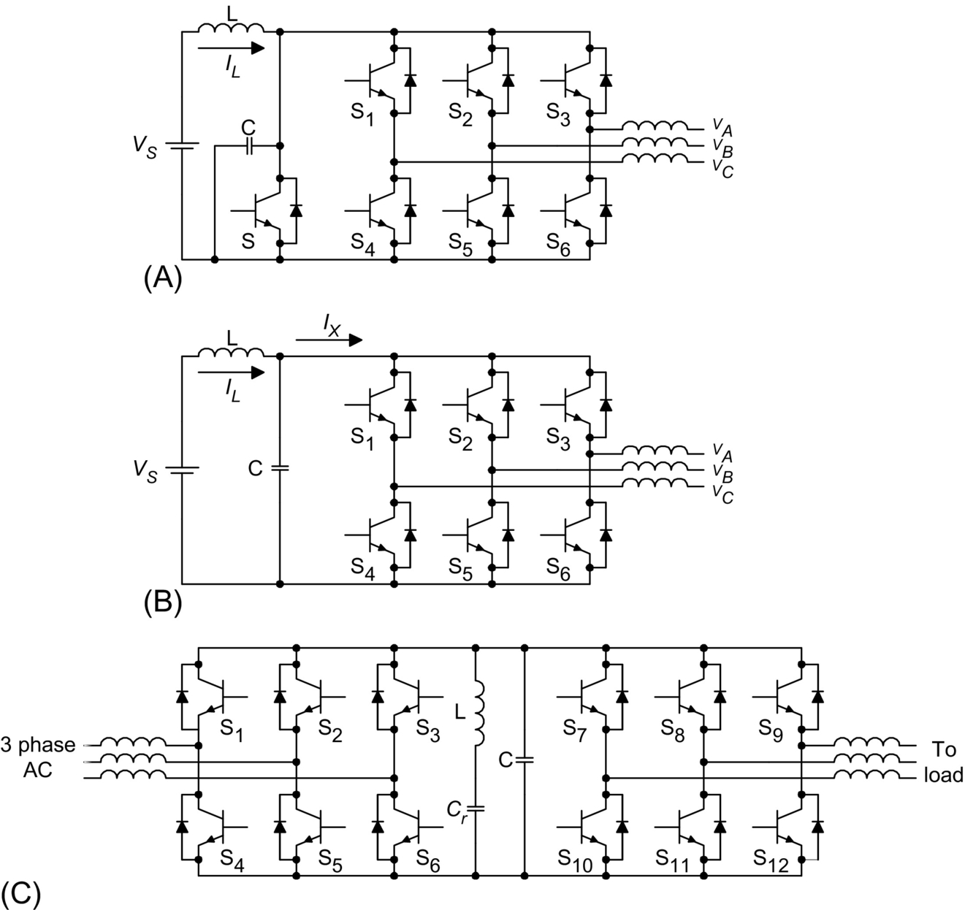

**FIG. 12.48** Resonant-link inverters. (A) With resonant switch in the DC link. (B) With resonant tank in the DC link. (C) With resonant tank in the tank for AC-DC-AC system.

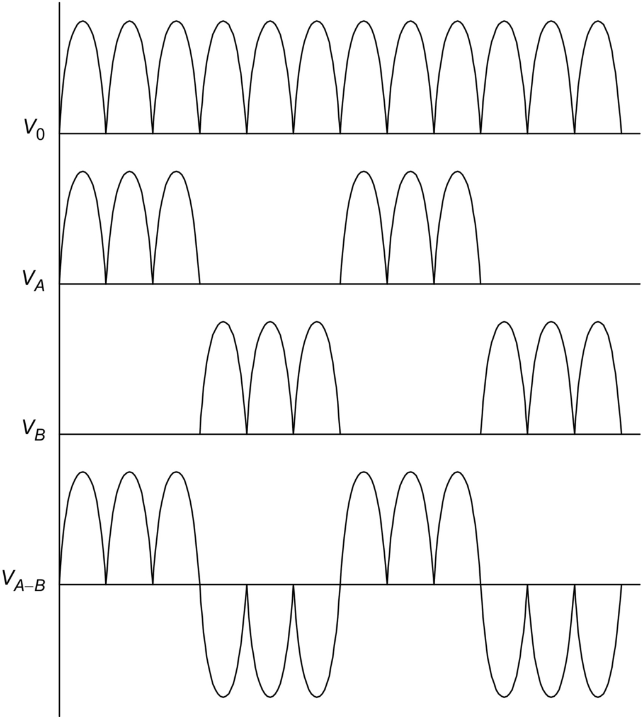

**FIG. 12.49** Typical DC link voltage (*V*0), phase voltages (*VA*,*VB*), and line voltage (*VAB*) of resonant-link inverters.

Analysis of the resonant DC link converter can be simplified by considering that the inverter system is highly inductive. The equivalent circuit is shown in [Fig. 12.50](https://learning.oreilly.com/library/view/power-electronics-handbook/9780128114087/B978012811407000012X.xhtml#f0255).

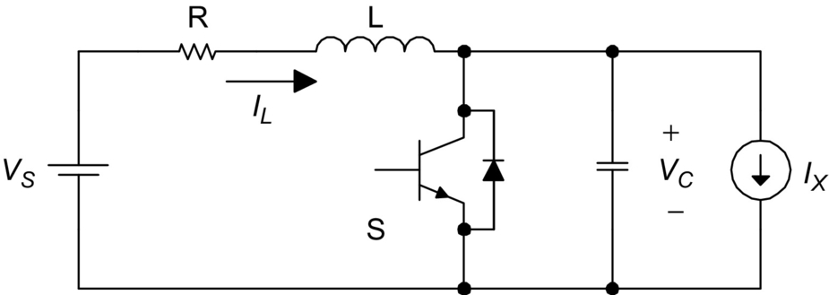

**FIG. 12.50** Equivalent circuit of resonant-link inverter.

The link current *Ix* may vary with the changing load condition but can be considered constant during the short resonant cycle. If switch S is turned on when the inductor current is *ILo*, the resonant DC link voltage can be expressed as

 **(12.14)**

and inductor current *iL* is

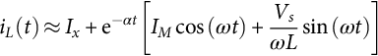 **(12.15)**

where

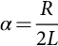 **(12.16)**

**** **(12.17)**

**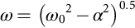** **(12.18)**

and

 **(12.19)**

The resistance in the inductor could affect the resonant behavior because it dissipates some energy. In practice, (*iL*−*Ix*) has to be monitored when S is conducting. S can be turned on when (*iL−Ix*) is equal to a desired value. The objective is to ensure that the DC link voltage can be resonated to zero-voltage level in the next cycle.

The pulsating DC link inverter has the following advantages:

• Reduction of switching loss.

• Snubberless operation.

• High switching frequency (*>*18 kHz) operation becomes possible, leading to the reduction of acoustic noise in inverter equipment.

• Reduction of heat sink requirements and thus improvement of power density.

This approach has the following limitations:

• The peak DC pulsating link voltage (2.0 per unit) is higher than the nominal DC voltage value of a conventional inverter. This implies that power devices and circuit components of higher voltage ratings must be used. This could be a serious drawback because power components of higher voltage ratings not only are more expensive but also usually have inferior switching performance than their low-voltage counterparts.

• Although voltage clamp can be used to reduce the peak DC link voltage, the peak voltage value is still higher than normal, and the additional clamping circuit makes the control more complicated.

• Integral pulse-density modulation has to be used. Many well-established PWM techniques cannot be employed.

Despite these advantages, this resonant converter concept has paved the way for other soft-switched converters to develop.

### 12.14.2 ACTIVE-CLAMP RESONANT DC LINK INVERTER

In order to solve the high voltage requirement in the basic pulsating DC link inverters, active-clamping techniques ([Fig. 12.51](https://learning.oreilly.com/library/view/power-electronics-handbook/9780128114087/B978012811407000012X.xhtml#f0260)) have been proposed. The active clamp can reduce the per unit peak voltage from 2.0 to about 1.3–1.5 [[44](https://learning.oreilly.com/library/view/power-electronics-handbook/9780128114087/B978012811407000012X.xhtml#bb0225)]. It has been reported that operating frequency in the range of 60–100 kHz has been achieved [[48](https://learning.oreilly.com/library/view/power-electronics-handbook/9780128114087/B978012811407000012X.xhtml#bb0245)] with an energy efficiency of 97% for a 50 kVA drive system.

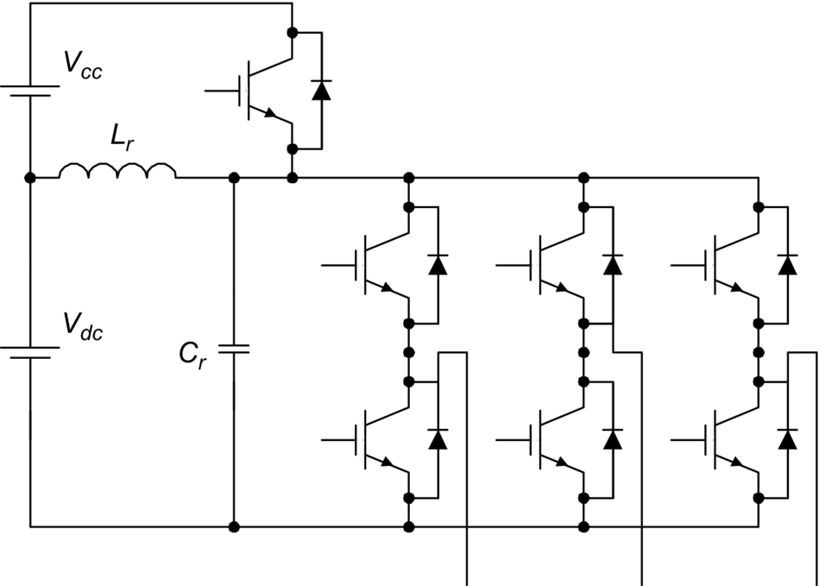

**FIG. 12.51** Active-clamp resonant-link inverter.

The design equations for active-clamp resonant-link inverter are

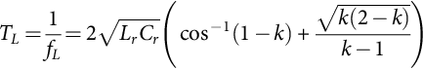 **(12.20)**

where *TL* is the minimum link period, *fL* is the maximum link frequency, and *k* is the clamping ratio. For the active-clamp resonant inverter, *k* is typically 1.3–1.4 per unit.

The rate of rise of the current in the clamping device is

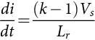 **(12.21)**

The peak clamping current required to ensure that the DC bus return to 0 V is

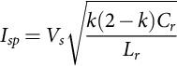 **(12.22)**

In summary, resonant (pulsating) DC link inverters offer significant advantages such as the following:

• High switching frequency operation

• Low *dv*/*dt* for power devices

• ZVS with reduced switching loss

• Suitable for 1–250 kW

• Rugged operation with few failure mode

### 12.14.3 RESONANT DC LINK INVERTER WITH LOW VOLTAGE STRESS [[49](https://learning.oreilly.com/library/view/power-electronics-handbook/9780128114087/B978012811407000012X.xhtml#bb0250)]

A resonant DC link inverter with low voltage stress is shown in [Fig. 12.52](https://learning.oreilly.com/library/view/power-electronics-handbook/9780128114087/B978012811407000012X.xhtml#f0265). It consists of a front-end resonant converter that can pull the DC link voltage down just before any inverter switching. This resonant DC circuit serves as an interface between the DC power supply and the inverter. It essentially retains all the advantages of the resonant (pulsating) DC link inverters. But it offers extra advantages such as the following:

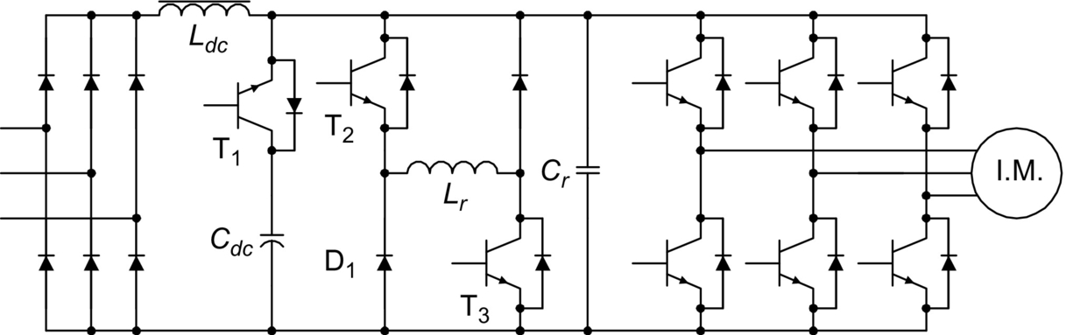

**FIG. 12.52** Resonant DC link inverter with low voltage stress.

• No increase in the DC link voltage when compared with conventional hard-switched inverter. That is, the DC link voltage is 1.0 per unit.

• The zero-voltage condition can be created at any time. The ZVS is not restricted to the periodic zero-voltage instants as in resonant DC link inverter.

• Well-established PWM techniques can be employed.

• Power devices of standard voltage ratings can be used.

The timing program and the six operating modes of this resonant circuit are as shown in [Figs. 12.53](https://learning.oreilly.com/library/view/power-electronics-handbook/9780128114087/B978012811407000012X.xhtml#f0270) and [12.54](https://learning.oreilly.com/library/view/power-electronics-handbook/9780128114087/B978012811407000012X.xhtml#f0275), respectively.

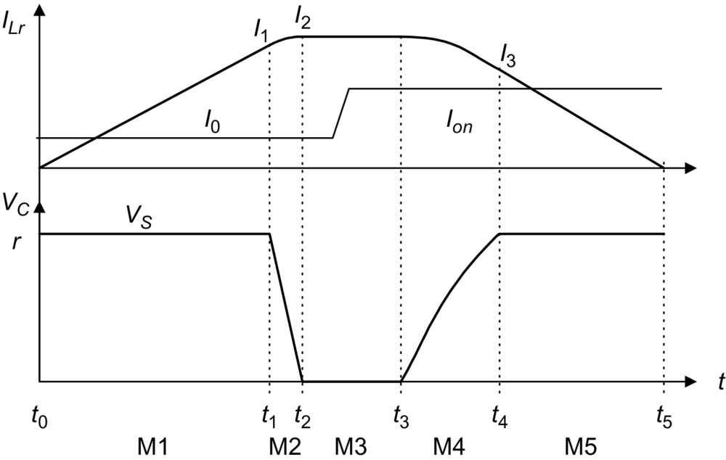

**FIG. 12.53** Timing diagram of resonant-link inverter with minimum voltage stress.

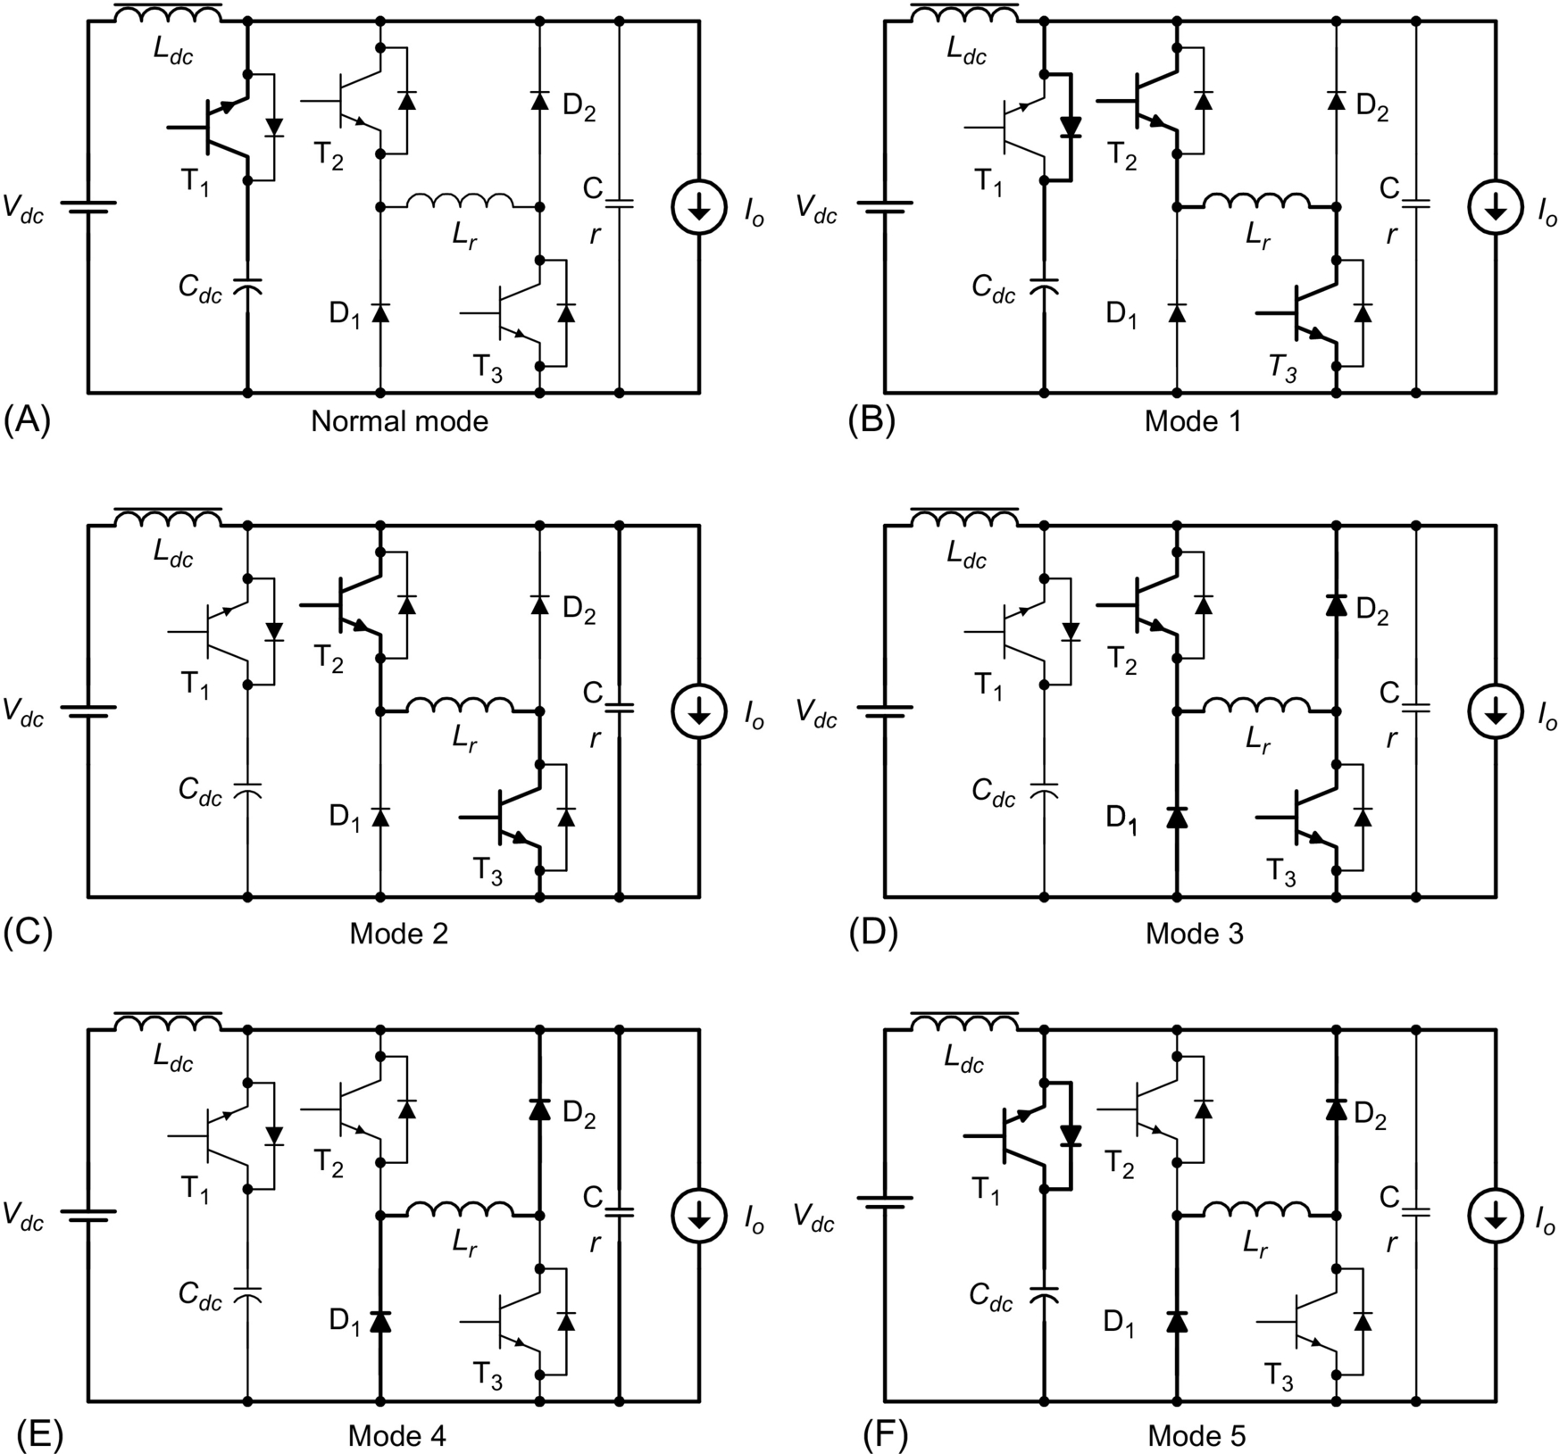

**FIG. 12.54** Operating modes of resonant-link inverter with minimum voltage stress. (A) Normal mode. (B) Mode 1. (C) Mode 2. (D) Mode 3. (E) Mode 4. (F) Mode 5.

(1) *Normal mode*

This is the standard PWM inverter mode. The resonant inductor current *iLr*(*t*) and the resonant voltage *Vcr*(*t*) are given by





where *Vs* is the nominal DC link voltage.

(2) *Mode 1 (Initiating mode): (t*0−*t*1*)*

At *t*0, mode 1 begins by switching on T2 and T3 on with zero current. *iLr*(*t*) increases linearly with a *di*/*dt* of *Vs*/*Lr*. If *iLr*(*t*) is equal to the initialized current *Ii*, T1 is zero-voltage turned off. If (*Is*−*Io*)*<Ii*, then the initialization is ended when *iLr* (*t*) is equal to *Ii*, where *Is* is the current flowing into the DC inductor *Ldc*. If (*Is*−*Io*)*>Ii*, then this mode continues until *iLr* (*t*) is equal to (*Is*−*Io*). The equations in this interval are

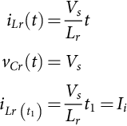

(3) *Mode 2 (Resonant mode): (t*1−*t*2*)*

After T1 is turned off under ZVS condition, resonance between *Lr* and *Cr* occurs. *Vcr* (*t*) decreases from *Vs* to 0. At *t*2, *iLr* (*t*) reaches the peak value in this interval. The equations are

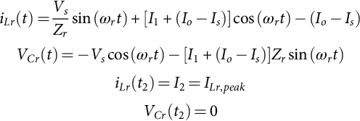

where

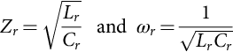

(4) *Mode 3 (Freewheeling mode): (t*2−*t*3*)*

The resonant inductor current flows through two freewheeling paths (T2-Lr-D2 and T3-D1-Lr). This duration is the zero-voltage period created for ZVS of the inverter and should be longer than the minimum on and off times of the inverter's power switches:





(5) *Mode 4 (Resonant mode): (t*3−*t*4*)*

This mode begins when T2 and T3 are switched off under ZVS. The second half of the resonance between *Lr* and *Cr* starts again. The capacitor voltage *Vcr* (*t*) increases back from 0 to *Vs* and is clamped to *Vs*. The relevant equations in this mode are

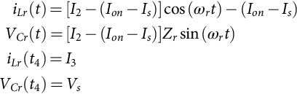

where *I*on is the load current after the switching state.

(6) *Mode 5 (Discharging mode): (t*4−*t*5*)*

In this period, T1 is switched on under ZV condition because *Vcr* (*t*)=*Vs*. The inductor current decreases linearly. This mode finishes when *iLr* (*t*) becomes zero:

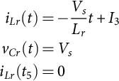

### 12.14.4 QUASI-RESONANT SOFT-SWITCHED INVERTER [[50](https://learning.oreilly.com/library/view/power-electronics-handbook/9780128114087/B978012811407000012X.xhtml#bb0255)]

#### **12.14.4.1 Circuit Operation**

Consider an inverter fed by a DC voltage source versus a front-stage interface circuit shown in [Fig. 12.55](https://learning.oreilly.com/library/view/power-electronics-handbook/9780128114087/B978012811407000012X.xhtml#f0280) can be added between the DC voltage source and the inverter. The front-stage circuit consists of a quasi-resonant circuit in which the first half of the resonance cycle is set to occur to create the zero-voltage condition whenever inverter switching is needed. After inverter switching has been completed, the second half of the resonance cycle takes place so that the DC link voltage is set back to its normal level. To avoid excessive losses in the resonant circuit, a small capacitor *Cr1* is normally used to provide the DC link voltage, while the large smoothing DC link capacitor *C*1 is isolated from the resonant circuit just before the zero-voltage duration. This method avoids the requirement for pulling the DC voltage of the bulk capacitor to zero.

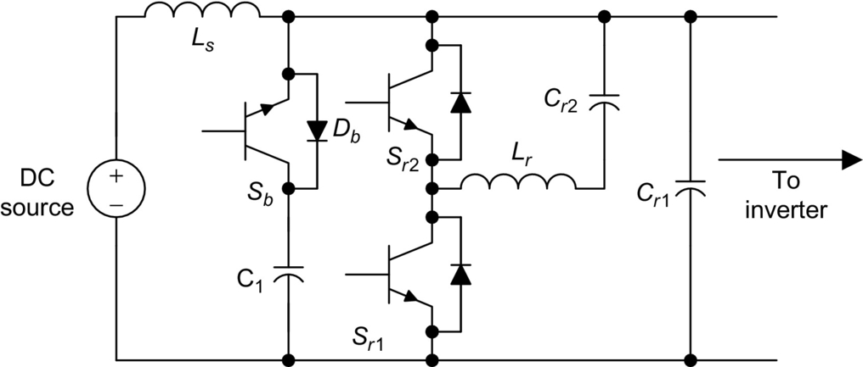

**FIG. 12.55** Quasi-resonant circuit for soft-switched inverter.

The period for this mode is from *t*0 to *t*1 in [Fig. 12.56](https://learning.oreilly.com/library/view/power-electronics-handbook/9780128114087/B978012811407000012X.xhtml#f0285). In this mode, switch S*b* is turned on, and switches S*r*1 and S*r*2 are turned off. The inverter in [Fig. 12.55](https://learning.oreilly.com/library/view/power-electronics-handbook/9780128114087/B978012811407000012X.xhtml#f0280) works like a conventional DC link inverter. In this mode, *Vcr*1=*Vc*1. The voltage across switch S*b* is zero. Before an inverter switching takes place, switch S*r*1 is triggered at *t*1 to discharge *Cr*1. This operating mode ends at t2 when *Vcr*1 approaches zero. The equivalent circuit in this mode is shown in [Fig. 12.57A](https://learning.oreilly.com/library/view/power-electronics-handbook/9780128114087/B978012811407000012X.xhtml#f0290). The switch S*b* must be turned off at zero voltage when switch S*r*1 is triggered. After S*r*1 is triggered, *Cr*1 will be discharged via the loop *Cr*1, *Cr*2, *Lr*, and *Sr*1. Under conditions of *Vcr*2≤0 and *Cr*1≤*Cr*2, the energy stored in *Cr*1 will be transferred to *Cr*2, and *Vcr*1 falls to zero in the first half of the resonant cycle in the equivalent circuit of [Fig. 12.57A](https://learning.oreilly.com/library/view/power-electronics-handbook/9780128114087/B978012811407000012X.xhtml#f0290). *Vcr*1 will be clamped to zero by the freewheel diodes in the inverter bridge and will not become negative. Thus, *Vcr*1 can be pulled down to zero for zero-voltage switching. When the current in inductor *Lr* becomes zero, switch *Sr*1 can be turned off at zero current.

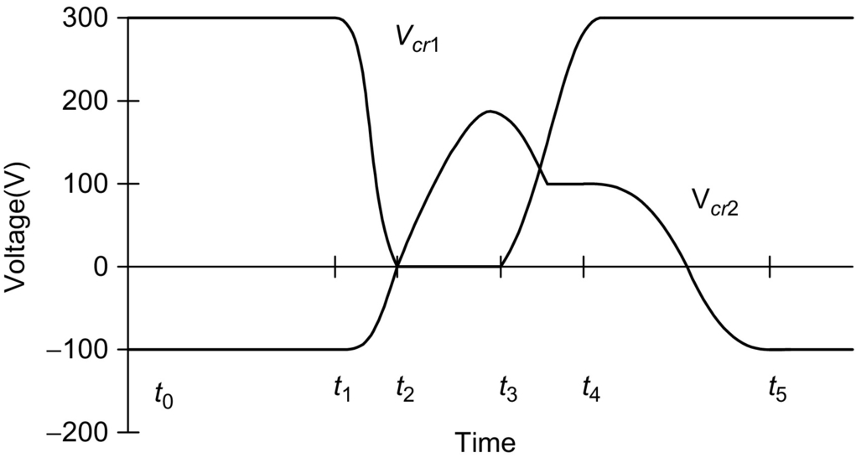

**FIG. 12.56** Typical waveforms for *Vcr*1 and *Vcr*2.

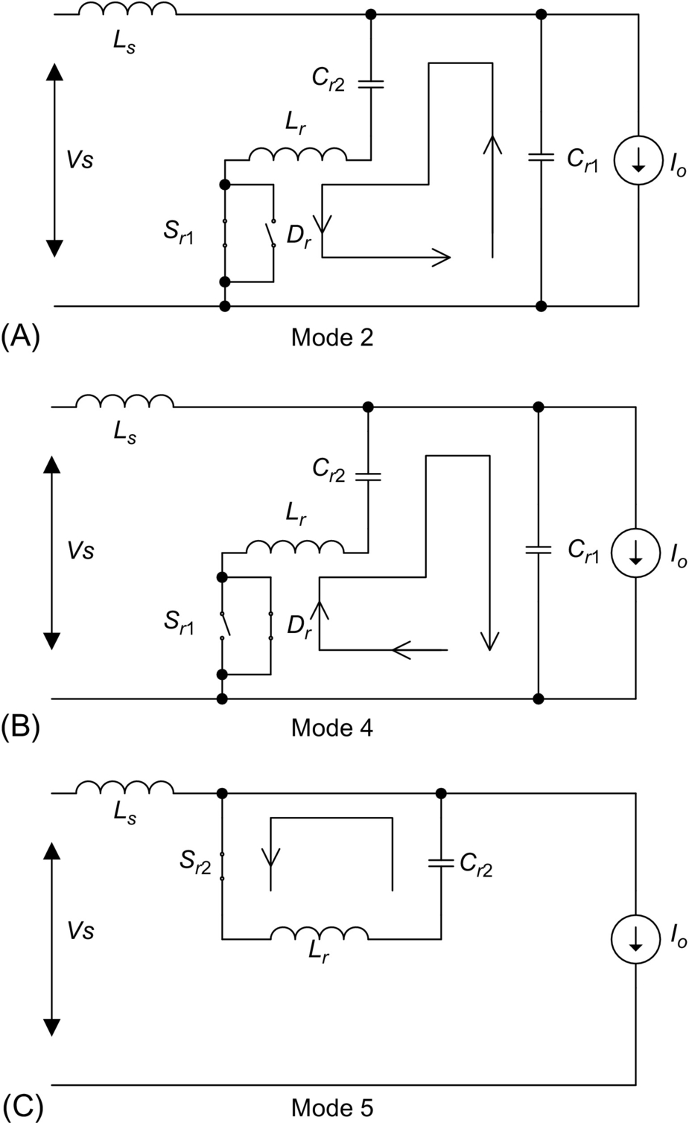

**FIG. 12.57** Equivalent circuits of the quasi-resonant circuit for different modes. (A) Mode 2. (B) Mode 4. (C) Mode 5.

Inverter switching can take place in the period from *t*2 to *t*3 in which *Vcr*1 remains zero. This period must be longer than the turn-on and turn-off times of the switches. When inverter switching has been completed, it is necessary to reset the voltage of capacitor *Cr*1. The equivalent circuit in this mode is shown in [Fig. 12.57B](https://learning.oreilly.com/library/view/power-electronics-handbook/9780128114087/B978012811407000012X.xhtml#f0290). The current in inductor *Lr* reaches zero at *t*3. Due to the voltage in *Vcr*2 and the presence of diode *Dr*, this current then flows in the opposite direction. *Cr*1 will be recharged via *Lr*, *Cr*2, *Cr*1, and *Dr*. The diode *Dr* turns off when the current in *Lr* becomes zero. *Vcr*1 will not go beyond 1 per unit because *Cr*1 is clamped to supply voltage by diode D*b*. The switch S*b* can be turned on again at zero-voltage condition when *Vcr*1 returns to normal DC supply voltage. After D*r* turns off, *Vcr*2 may not be zero. Some positive residual capacitor voltage remains in *C*2 at *t*4, as shown in [Fig. 12.56](https://learning.oreilly.com/library/view/power-electronics-handbook/9780128114087/B978012811407000012X.xhtml#f0285). In case *Vcr*2 is positive, *Vcr*1 cannot be pulled down to zero again in the next switching cycle. Therefore, S*r*2 should be triggered after *t*4 to reverse the residual voltage in *Cr*2. At time *t*5, S*r*2 turns off at zero-current condition, and *Vcr*2 is now reversed to negative. The equivalent circuit in this mode is shown in [Fig. 12.57C](https://learning.oreilly.com/library/view/power-electronics-handbook/9780128114087/B978012811407000012X.xhtml#f0290). When *Vcr*2≤0 and *Cr*1≤*Cr*2, *Vcr*1 can be pulled down to zero again before the next inverter switching. The operation can then be repeated in next switching cycle.

#### **12.14.4.2 Design Considerations**

(1) *Cr*1 and *Cr*2

The criterion for getting zero capacitor voltages *Vcr*1 is

 **(12.23)**

where

• *Vo*1 is the initial voltage of *Cr*1,

• *Vo*2 is the initial voltage of *Cr*2,

• *iL*0 is the initial current of inductor *Lr*,

• Δ*I*=*Io*−*Is* is the difference between load current and supply current. It is assumed to be a constant within a resonant cycle,

• *Rr* is the equivalent resistance in the resonant circuit,

• 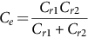

When Δ*I*≥0, the above criterion is always true under conditions of



The criterion for recharging voltage *Vcr*1 to 1 per unit DC link voltage is

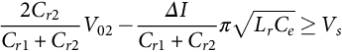 **(12.24)**

(2) Inductor *Lr*

The inductor *Lr* should be small so that the DC link voltage can be decreased to zero quickly. However, a small *Lr* could result in large peak resonant current and therefore requirement of power devices with large current pulse ratings. An increase in the inductance of *Lr* can limit the peak current in the quasi-resonant circuit. Because the resonant frequency depends on both the inductor and the capacitor, therefore, the selection of *Lr* can be considered together with the capacitors *Cr*1 and *Cr*2 and with other factors such as the current ratings of power devices, the zero-voltage duration, and the switching frequency required in the soft-switching circuit.

(3) Triggering instants of the switches

The correct triggering instants for the switches are essential for the successful operation of this soft-switched inverter. For the inverter switches, the triggering instants are determined from a PWM modulation. Let *Ts* be the time at which the inverter switches change states. To get the zero-voltage inverter switching, switch S*r*1 should be turned on half resonant cycle before the inverter switching instant. The turn-on instant of *Sr*1, which is *t*1 in [Fig. 12.56](https://learning.oreilly.com/library/view/power-electronics-handbook/9780128114087/B978012811407000012X.xhtml#f0285), can be written as

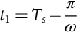 **(12.25)**

where 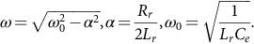 The switch S*b* is turned off at *t*1.

S*r*1 may be turned off during its zero-current period when diode D*r* is conducting. For easy implementation, its turn-off time can be selected as *Ts*+*π*/*ω*. Because the DC link voltage can be pulled down to zero in less than half resonant cycle, *Ts* should occur between *t*2 and *t*3.

At time *t*3 (the exact instant depends on the Δ*I*), the diode D*r* turns on in the second half of the resonant cycle to recharge *Cr*1. At *t*4, *Vcr*1 reaches 1 per unit and diode D*b* clamps *Vcr*1 to 1 per unit. The switch S*b* can be turned on again at *t*4, which is half resonant cycle after the start of *t*3:

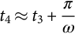 **(12.26)**

As *t*3 cannot be determined accurately, a voltage sensor in principle can be used to provide information for *t*4 so that S*b* can be turned on to reconnect *C*1 to the inverter. In practice, however, S*b* can be turned on a few microseconds (longer than *Ts*+*π*/*ω*) after *t*2 without using a voltage sensor (because it is not critical for S*b* to be on exactly at the moment *Vcr* reaches the nominal voltage). As for switch S*r*2, it can be turned on a few microseconds after *t*4. It will be turned off half of resonant cycle 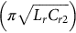 in the *Lr*−*Cr*2 circuit later. In practice, the timing of S*r*1, S*r*2, and S*b* can be adjusted in a simple tuning procedure for a given set of parameters. [Fig. 12.58](https://learning.oreilly.com/library/view/power-electronics-handbook/9780128114087/B978012811407000012X.xhtml#f0295) shows the measured gating signals of S*r*1, S*r*2, and S*b* with the DC link voltage *Vcr*1 in a 20-kHz switching inverter. [Figs. 12.59](https://learning.oreilly.com/library/view/power-electronics-handbook/9780128114087/B978012811407000012X.xhtml#f0300) and [12.60](https://learning.oreilly.com/library/view/power-electronics-handbook/9780128114087/B978012811407000012X.xhtml#f0305) show the measured waveforms of *Is*, *Io*, and *Vcr*1 under no-load condition and loaded condition, respectively.

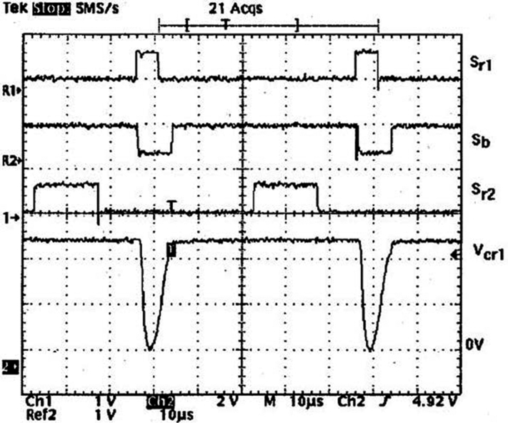

**FIG. 12.58** Gating signals for S*r*1, S*r*2, and S*b* with *Vcr*1.

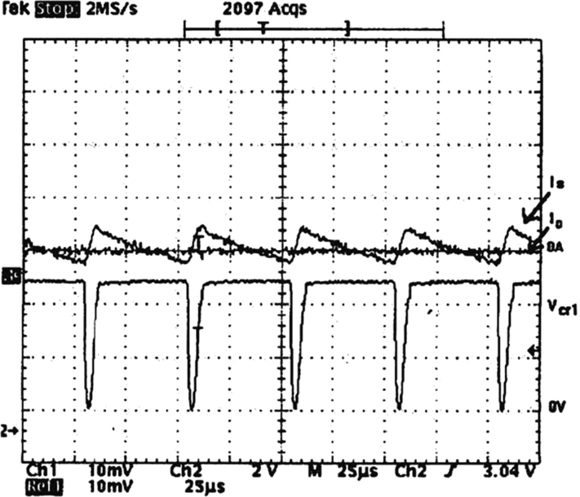

**FIG. 12.59** Typical *Is*, *Io*, and *Vcr*1 under no-load condition.

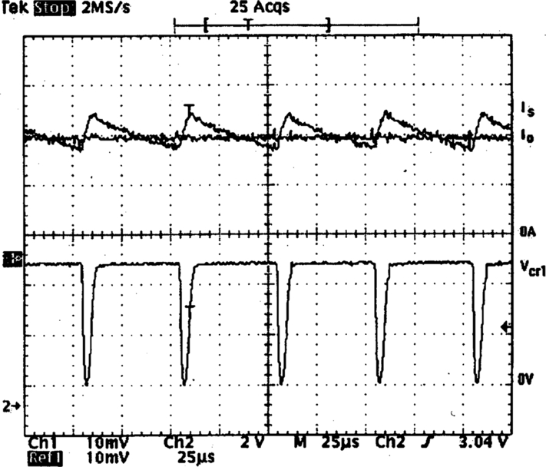

**FIG. 12.60** Typical *Is*, *Io*, and *Vcr*1 under loaded condition.

#### **12.14.4.3 Control of Quasi-Resonant Soft-Switched Inverter Using Digital Time Control [**[**51**](https://learning.oreilly.com/library/view/power-electronics-handbook/9780128114087/B978012811407000012X.xhtml#bb0260)**]**

Based on the zero-average-current error (ZACE) control concept, a digital time control (DTC) method has been developed for a current-controlled quasi-resonant soft-switched inverter. The basic ZACE concept is shown in [Fig. 12.61](https://learning.oreilly.com/library/view/power-electronics-handbook/9780128114087/B978012811407000012X.xhtml#f0310). The current error is obtained from the difference of a reference current and the sensed current. The idea is to make the areas of each transition (A1 and A2) equal. If the switching frequency is significantly greater than the fundamental frequency of the reference signal, the rising and falling current segments can be assumed to be linear. The following simplified equation can be established:

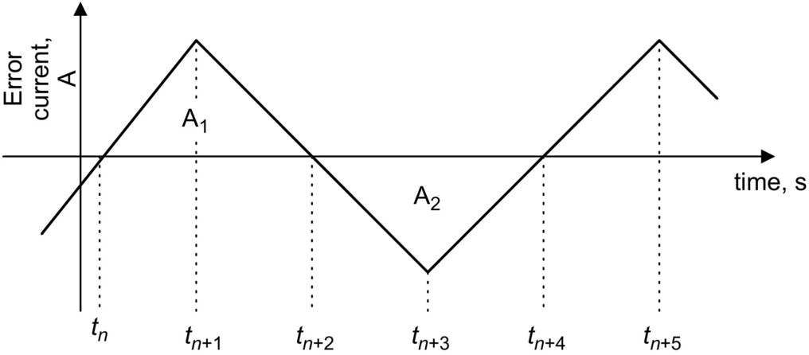

**FIG. 12.61** Zero-average-current error (ZACE) control concept.

 **(12.27)**

The control algorithm for the inverter is

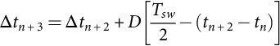 **(12.28)**

where 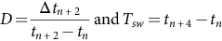.

The schematic of a digital signal processor (DSP)-based controller for the DTC method is shown in [Fig. 12.62](https://learning.oreilly.com/library/view/power-electronics-handbook/9780128114087/B978012811407000012X.xhtml#f0315). The duty cycle can be approximated from the reference sine wave by level shifting and scaling it between 0 and 1. The time *tn*+2−*tn* is the sum of Δ*tn*+1 and Δ*tn*+2. These data provide information for the calculation of the next switching time Δ*tn*+1.

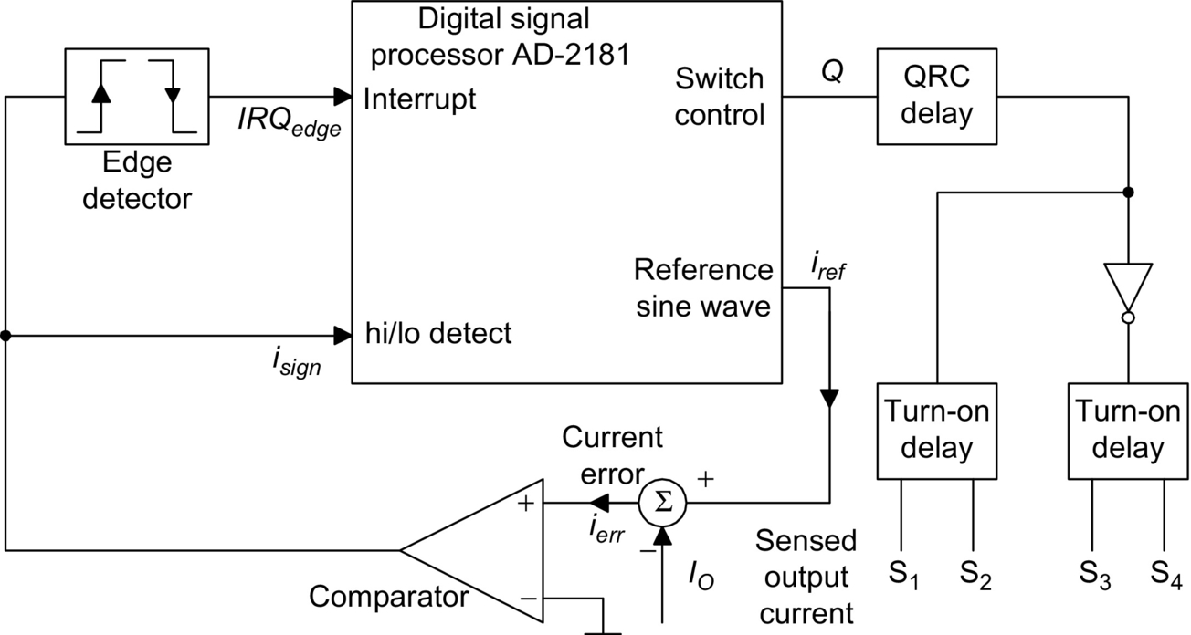

**FIG. 12.62** Implementation of DTC.

The switches are triggered by the changing edge of the switch control Q. Approximate delays are added to the individual switching signals for both the inverter switches and the quasi-resonant switches. Typical gating waveforms are shown in [Fig. 12.63](https://learning.oreilly.com/library/view/power-electronics-handbook/9780128114087/B978012811407000012X.xhtml#f0320). The use of the quasi-resonant soft-switched inverter is a very effective way in suppressing switching transient and EMI emission. [Fig. 12.64A and B](https://learning.oreilly.com/library/view/power-electronics-handbook/9780128114087/B978012811407000012X.xhtml#f0325) shows the inverter switch voltage waveforms of a standard hard-switched inverter and a quasi-resonant soft-switched inverter, respectively. It is clear that the soft-switched waveform has much less transient than the hard-switched waveform.

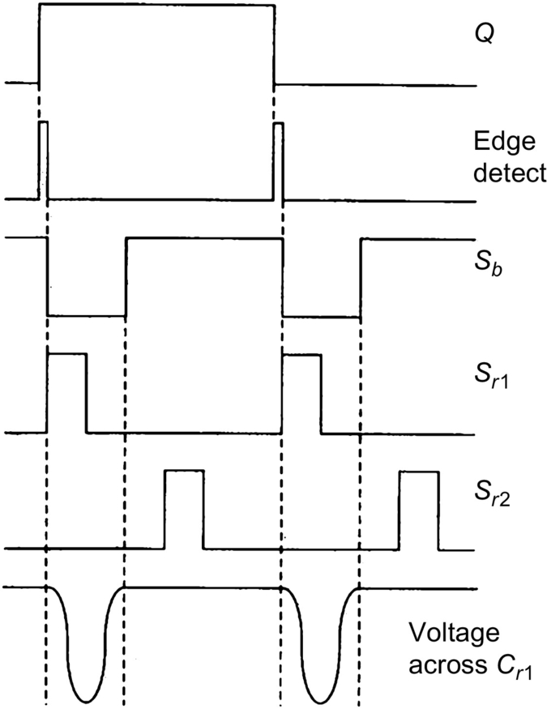

**FIG. 12.63** Timing diagrams for the gating signals.

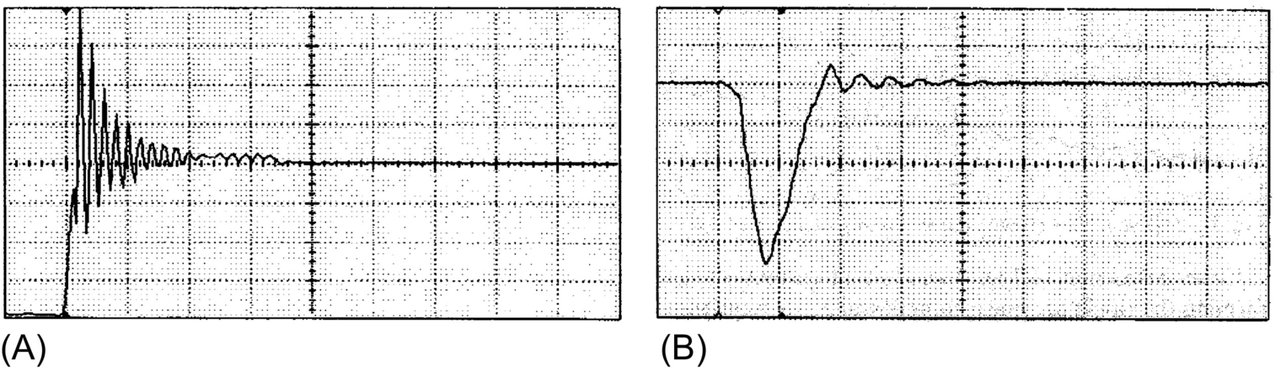

**FIG. 12.64** (A) Typical switch voltage under hard turnoff and (B) typical switch voltage under soft turnoff.

### 12.14.5 RPI AND ARCPI

The RPI integrates the resonant components with the output filter components *Lf* and *Cf*. The load is connected to the midpoint of the DC bus capacitors as shown in [Fig. 12.65](https://learning.oreilly.com/library/view/power-electronics-handbook/9780128114087/B978012811407000012X.xhtml#f0330). It should however be noted that the RPI can be described as a resonant inverter. [Fig. 12.66](https://learning.oreilly.com/library/view/power-electronics-handbook/9780128114087/B978012811407000012X.xhtml#f0335) shows a single-phase RPI. Its operation can be described with the timing diagram in [Fig. 12.67](https://learning.oreilly.com/library/view/power-electronics-handbook/9780128114087/B978012811407000012X.xhtml#f0340). The operating modes are included in [Fig. 12.68](https://learning.oreilly.com/library/view/power-electronics-handbook/9780128114087/B978012811407000012X.xhtml#f0345). The RPI provides soft switching for all power switches. But it has two disadvantages. First, the power devices have to be switched continuously at the resonant frequency determined by the resonant components. Second, the power devices in the RPI circuit require a 2.2–2.5 p.u. current turn-off capability.

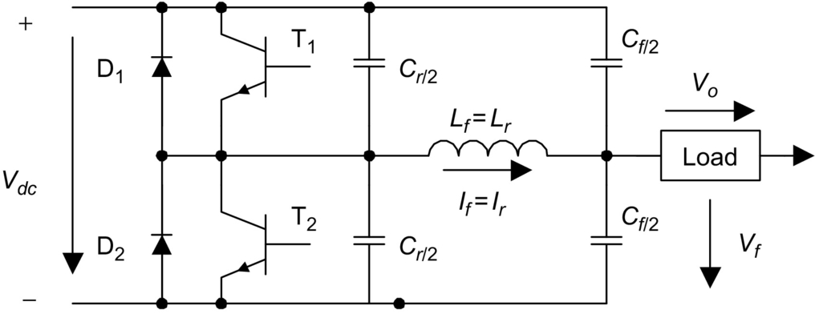

**FIG. 12.65** One leg of a resonant pole inverter.

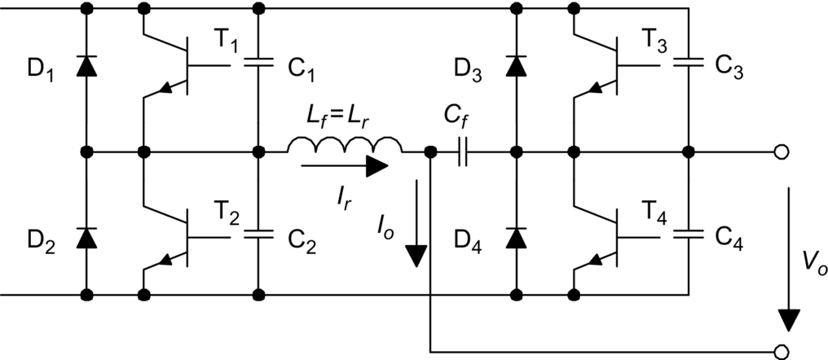

**FIG. 12.66** Single-phase resonant pole inverter.

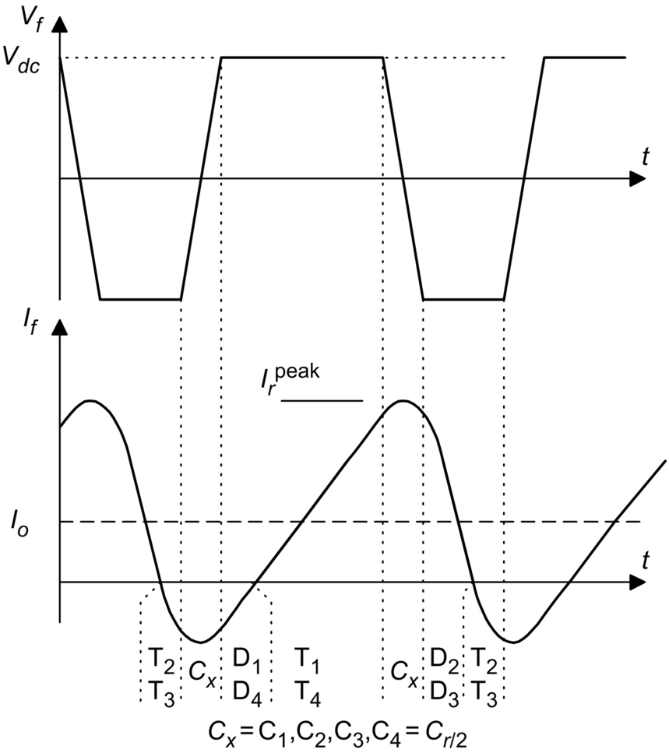

**FIG. 12.67** Timing diagram for a single-phase resonant pole inverter.

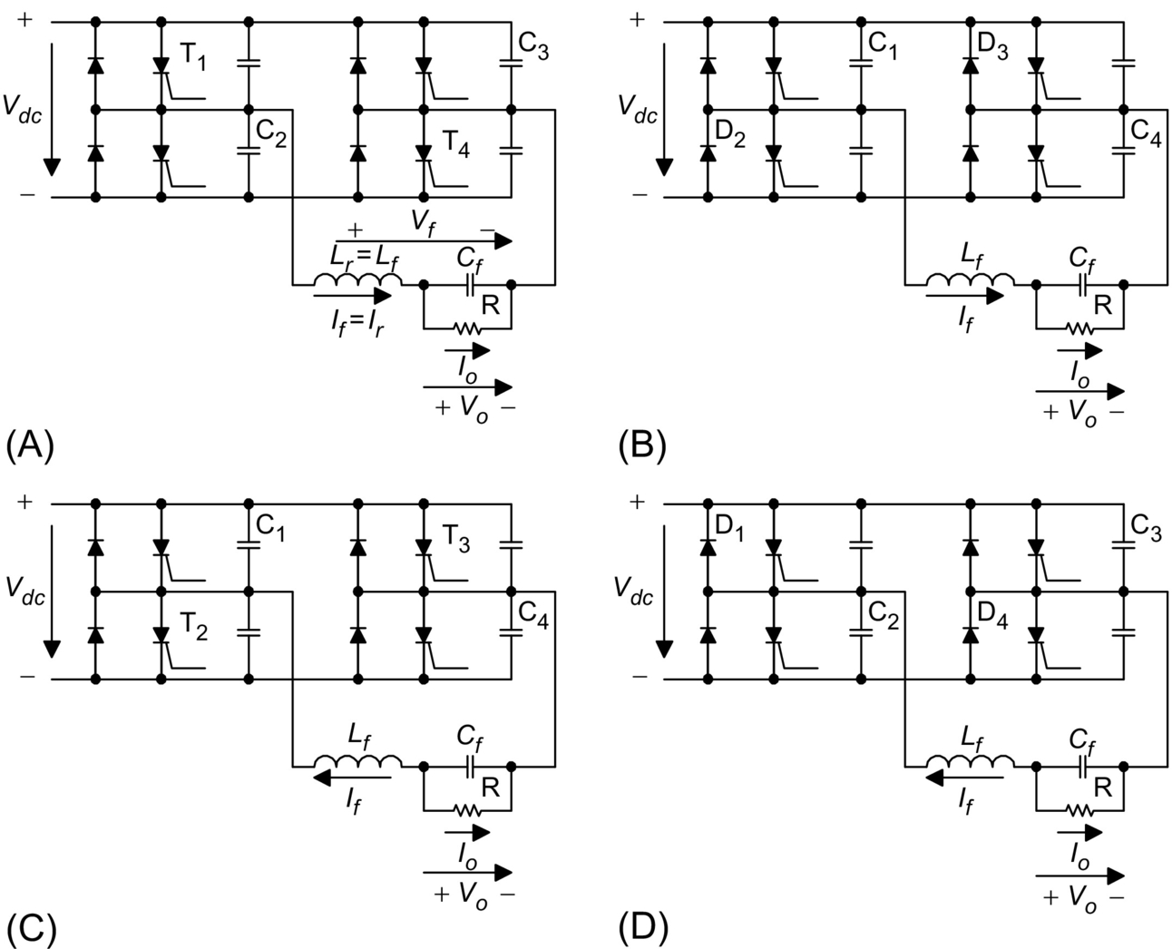

**FIG. 12.68** Operating modes of a single-phase resonant pole inverter. (A) Mode 1. (B) Mode 2. (C) Mode 3. (D) Mode 4.

An improved version of the RPI is the ARCPI. The ARCPI for one inverter leg is shown in [Fig. 12.69](https://learning.oreilly.com/library/view/power-electronics-handbook/9780128114087/B978012811407000012X.xhtml#f0350). Unlike the basic RPI, the ARCPI allows the switching frequency to be controlled. Each of the primary switches is closely paralleled with a snubber capacitor to ensure ZV turnoff. Auxiliary switches are connected in series with an inductor, ensuring that they operate under ZC conditions. For each leg, an auxiliary circuit comprising two extra switches A1 and A2, two freewheeling diodes, and a resonant inductor *Lr* is required. This doubles the number of power switches when compared with hard-switched inverters. [Fig. 12.70](https://learning.oreilly.com/library/view/power-electronics-handbook/9780128114087/B978012811407000012X.xhtml#f0355) shows the three-phase ARCPI system. Depending on the load conditions, three commutation modes are generally needed. The commutation methods at low and high current are different. This makes the control of the ARCPI very complex. The increase in control and circuit complexity represents a considerable cost penalty [[52](https://learning.oreilly.com/library/view/power-electronics-handbook/9780128114087/B978012811407000012X.xhtml#bb0265),[53](https://learning.oreilly.com/library/view/power-electronics-handbook/9780128114087/B978012811407000012X.xhtml#bb0270)].

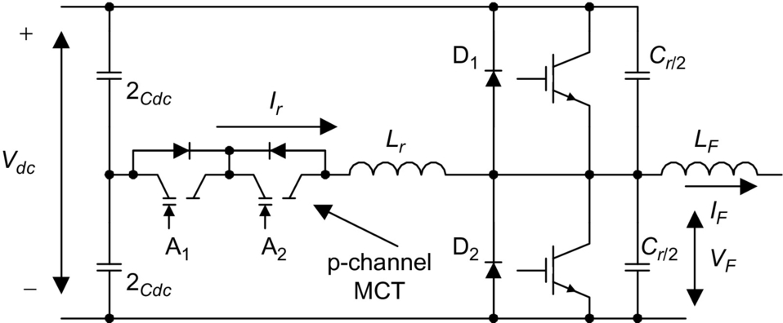

**FIG. 12.69** Improved resonant pole inverter leg.

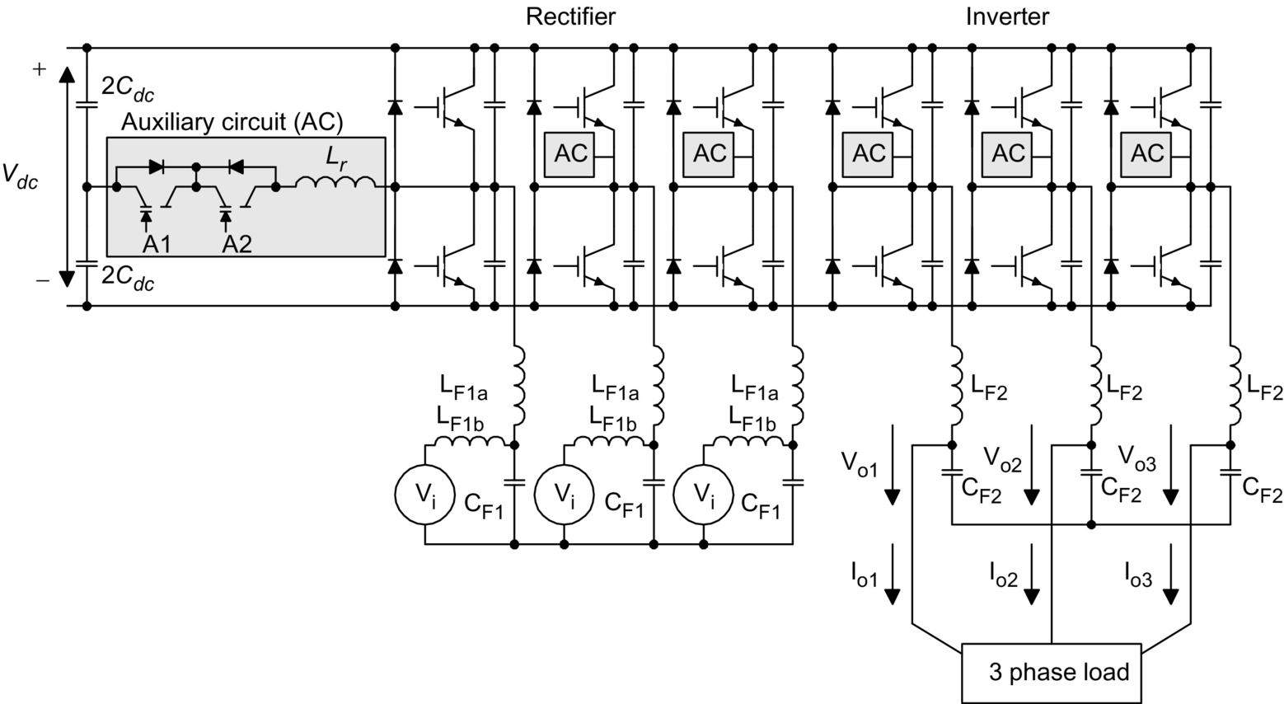

**FIG. 12.70** Three-phase auxiliary resonant commutated pole inverter (ARCPI).

## References

[1] Davis R.M. In: *Power Diode and Thyristor Circuits.* Herts: Peregrinus; . *IEE Monograph Series.* 1971;vol. 7.

[2] Mohan N., Undeland T., Robbins W. *Power Electronics, Converters, Applications, and Design.* Hoboken, NJ: John Wiley and Sons; 1995.

[3] Rashid M.H. *Power Electronics, Circuits, Devices, and Applications.* Upper Saddle River, NJ: Pearson/Prentice Hall; 2004.

[4] P. Vinciarelli, Forward Converter Switching at Zero Current. U.S. Patent 4,416,959, November 1983.

[5] Lee F.C. *High-Frequency Resonant, Quasi-Resonant and Multi-Resonant Converters.* Blacksburg, VA: Virginia Power Electronics Center; 1991.

[6] Lee F.C. *High-Frequency Resonant and Soft-Switching Converters.* Virginia Power Electronics Center; 1991.

[7] Kit Sum K. *Recent Developments in Resonant Converters.* Ventura, CA: Intertec Communication Press; 1988.

[8] Tarter R.E. *Solid-State Power Conversion Handbook.* New York: Wiley-Interscience publication; 1993.

[9] Liu K.H., Lee F.C. *Resonant switches—a unified approach to improve performances of switching converters.* In: Proceedings of the International Telecommunications Energy Conference; 1984:344–351.

[10] Liu K.H., Oruganti R., Lee F.C. *Resonant switches—topologies and characteristics.* In: Proceedings of the IEEE Power Electronics Specialists Conference; 1985:62–67.

[11] Ngo K.D.T. *Generalized of resonant switches and quasi-resonant DC-DC converters.* In: Proceedings of the IEEE Power Electronics Specialists Conference; 1986:58–70.

[12] Lee F.C. *High-frequency quasi-resonant and multi-resonant converter technologies.* In: Proceedings of the IEEE International Conference on Industrial Electronics; 1988:509–521.

[13] Liu K.H., Lee F.C. *Zero-voltage switching techniques in DC/DC converter circuits.* In: Proceedings of the IEEE Power Electronics Specialists Conference; 1986:58–70.

[14] Jovanovic M., Tabisz W., Lee F.C. *Zero-voltage switching technique in high frequency off-line converters.* In: Proceedings of the Applied Power Electronics Conference and Exposition; 1988:23–32.

[15] Steigerwald R. A comparison of half-bridge resonant converter topologies. *IEEE Trans. Power Electron.* 1988;3(2):174–182.

[16] Patterson O.D., Divan D.M. *Pseudo-resonant full-bridge DC/DC converter.* In: Proceedings of the IEEE Power Electronics Specialists Conference; 1987:424–430.

[17] Henze C.P., Martin H.C., Parsley D.W. *Zero-voltage switching in high frequency power converters using pulse width modulation.* In: Proceedings of the IEEE Applied Power Electronics Conference and Exposition; 1988:33–40.

[18] General Electric Company, Full-bridge lossless switching converters, U.S. Patent 4,864,479, 1989.

[19] Tabisz W.A., Lee F.C. *DC analysis and design of zero-voltage switched multi-resonant converters.* In: Proceedings of the IEEE Power Electronics Specialists Conference; 1989:243–251.

[20] Tabisz W.A., Lee F.C. Zero-voltage-switching multi-resonant technique—a novel approach to improve performance of high frequency quasi-resonant converters. *IEEE Trans. Power Electron.* 1989;4(4):450–458.

[21] Jovanovic M., Lee F.C. DC analysis of half-bridge zero-voltage-switched multi-resonant converter. *IEEE Trans. Power Electron.* 1990;5(2):160–171.

[22] Farrington R., Jovanovic M.M., Lee F.C. *Constant-frequency zero-voltage-switched multi-resonant converters: analysis, design, and experimental results.* In: Proceedings of the IEEE Power Electronics Specialists Conference; 1990:197–205.

[23] Hua G., Leu C.S., Lee F.C. *Novel zero-voltage-transition PWM converters.* In: Proceedings of the IEEE Power Electronics Specialists Conference; 1992:55–61.

[24] Watson R., Hua G., Lee F.C. Characterization of an active clamp flyback topology for power factor correction applications. *IEEE Trans. Power Electron.* 1996;11(1):191–198.

[25] Watson R., Lee F.C., Hua G. Utilization of an active-clamp circuit to achieve soft switching in flyback converters. *IEEE Trans. Power Electron.* 1996;11(1):162–169.

[26] Carsten B. *Design techniques for transformer active reset circuits at high frequency and power levels.* In: Proceedings of the High Frequency Power Conversion Conference; 1990:235–245.

[27] Johnson S.D., Witulski A.F., Erickson E.W. *A comparison of resonant technologies in high voltage DC applications.* In: Proceedings of the IEEE Applied Power Electronics Conference; 1987:145–166.

[28] Bhat A.K.S., Dewan S.B. A generalized approach for the steady state analysis of resonant inverters. *IEEE Trans. Ind. Appl.* 1989;25(2):326–338.

[29] Bhat A.K.S. A resonant converter suitable for 650V DC bus operation. *IEEE Trans. Power Electron.* 1991;6(4):739–748.

[30] Bhat A.K.S., Swamy M.M. Loss calculations in transistorized parallel converters operating above resonance. *IEEE Trans. Power Electron.* 1989;4(4):449–458.

[31] Bhat A.K.S. A unified approach for the steady-state analysis of resonant converter. *IEEE Trans. Ind. Electron.* 1991;38(4):251–259.

[32] Unitrode Corporation. *Applications Handbook.* Unitrode Corporation; 1999.

[33] Barbi I., Bolacell J.C., Martins D.C., Libano F.B. *Buck quasi-resonant converter operating at constant frequency: analysis, design and experimentation.* In: PESC’89; 1989:873–880.

[34] Cheng K.W.E., Evans P.D. *A family of extended-period circuits for power supply applications using high conversion frequencies.* In: EPE’91; 1991:4.225–4.230.

[35] Hui S.Y.R., Cheng K.W.E., Prakash S.R.N. A fully soft-switched extended-period quasi-resonant power correction circuit. *IEEE Trans. Power Electron.* 1997;12(5):922–930.

[36] Chung H.S.H., Hui S.Y.R., Wang W.H. A zero-current-switching PWM flyback converter with a simple auxiliary switch. *IEEE Trans. Power Electron.* 1999;14(2):329–342.

[37] Chung H.S.H., Hui S.Y.R. Reduction of EMI in power converters using fully soft-switching technique. *IEEE Trans. Electromag.* 1998;40(3):282–287.

[38] Chung H.S.H., Cheung W.L., Tang K.S. A ZCS bidirectional flyback converter. *IEEE Trans. Power Electron.* 2004;19(6):1426–1434.

[39] Zhang M.T., Jovanovic M.M., Lee F.C. Design considerations and performance evaluation of synchronous rectification in flyback converter. *IEEE Trans. Power Electron.* 1998;13(3):538–546.

[40] Undeland T. *Snubbers for pulse width modulated bridge converters with power transistors or GTOs.* In: IPEC Conference proceedings Tokyo; 313–323. 1983;vol. 1.

[41] McMurray. Efficient snubbers for voltage source GTO inverters. *IEEE Trans. Power Electron.* 1987;2(3):264–272.

[42] Divan D.M. The resonant dc link converter-A new concept in static power conversion. *IEEE Trans. Ind. Appl.* 1989;25(2):317–325.

[43] Lai Jin-Sheng, Bose B.K. An induction motor drive using an improved high frequency resonant DC link inverter. *IEEE Trans. Power Electron.* 1991;6(3):504–513.

[44] Divan D.M., Skibinski G. Zero-switching-loss inverters for high-power applications. *IEEE Trans. Ind. Appl.* 1989;25(4):634–643.

[45] Finney S.J., Green T.C., Williams B.W. Review of resonant link topologies for inverters. *IEE Proc. B.* 1993;140(2):103–114.

[46] Dewan S.B., Duff D.L. Optimum design of an input commutated inverter for AC motor control. *IEEE Trans. Indus. Gen. Appl.* 1969;IGA-5(6):699–705.

[47] Stefanov V.R., Bhagwat P. *A novel DC side commutated inverter.* In: IEEE PESC Record; 1980.

[48] Kurnia A., Cherradi H., Divan D. *Impact of IGBT behavior on design optimization of soft switching inverter topologies.* In: IEEE IAS Conference Record; 1993:140–146.

[49] Jung Y.C., Cho J.G., Cho G.H. *A new zero voltage switching resonant DC-link inverter with low voltage stress.* In: Proceedings of IEEE Industrial Electronics Conference; 1991:308–313.

[50] Hui S.Y.R., Gogani E.S., Zhang J. Analysis of a quasi-resonant circuit for soft-switched inverters. *IEEE Trans. Power Electron.* 1999;11(1):106–114.51.

[51] Baker D.M., Agelidis V.G., Meng C.W., Nayar C.V. Integrating the digital time control algorithm with DC-Bus “Notching” circuit based soft-switching inverter. *IEE Proc. Electric Power Appl.* 1999;146(5):524–529.

[52] Lee F.C., Borojevic D. *Soft-switching PWM converters and inverters, tutorial notes.* In: PESC’94; 1994.

[53] Divan D.M., De Doncker R.W. *Hard and soft-switching voltage source inverters, tutorial notes.* In: PESC’94; 1994.

**13**

# Multilevel Power Converters

Leon M. Tolbert The University of Tennessee, Knoxville, TN, United States

Xiaojie Shi The University of Tennessee, Knoxville, TN, United States

## Abstract

This chapter covers the fundamental multilevel converter structures and modulation paradigms. The basic principles of the four main different multilevel converters have been discussed methodically: (1) cascaded H-bridges, (2) diode clamp, (3) flying capacitors, and (4) modular multilevel converter. Various modulation schemes for multilevel converters are also covered including fundamental frequency switching and harmonic elimination and several carrier-based and space vector-based pulse-width modulation (PWM) methods. The chapter also includes significant content on the operation and control of modular multilevel converter (MMCs) including techniques to balance capacitor voltage and reduce circulating current in converter arms.

### KEYWORDS

Multilevel converter; Multilevel inverter; Cascaded H-bridges; Diode-clamped converter; Flying capacitor converter; Modular multilevel converter

13.1 [Introduction](https://learning.oreilly.com/library/view/power-electronics-handbook/9780128114087/B9780128114070000131.xhtml#s0010)

13.2 [Multilevel Power Converter Structures](https://learning.oreilly.com/library/view/power-electronics-handbook/9780128114087/B9780128114070000131.xhtml#s0015)

13.2.1 Cascaded H-Bridges

13.2.2 Diode-Clamped Multilevel Inverter

13.2.3 Flying-Capacitor Multilevel Inverter

13.2.4 Modular Mutilevel Inverter Structures

13.2.5 Other Multilevel Inverter Structures

13.3 [Multilevel Converter PWM Modulation Strategies](https://learning.oreilly.com/library/view/power-electronics-handbook/9780128114087/B9780128114070000131.xhtml#s0105)

13.3.1 Multilevel Carrier-Based PWM

13.3.2 Multilevel Space Vector PWM

13.3.3 Selective Harmonic Elimination

13.3.4 Other Modulation Strategies for Modular Multilevel Inverter

13.4 [Conclusion](https://learning.oreilly.com/library/view/power-electronics-handbook/9780128114087/B9780128114070000131.xhtml#s0165)

[References](https://learning.oreilly.com/library/view/power-electronics-handbook/9780128114087/B9780128114070000131.xhtml#bi0010)

## 13.1 Introduction

Numerous industrial applications require higher power apparatus in recent years. Some medium-voltage motor drives and utility applications require medium-voltage and megawatt power level converters. For a medium-voltage grid, it is troublesome to connect only one power semiconductor switch directly. Hence, a multilevel power converter structure has been introduced as an alternative in high-power and medium-voltage situations. A multilevel converter not only achieves high-power ratings but also enables the use of renewable energy sources. Renewable energy sources such as photovoltaics or wind turbines can be easily interfaced to a multilevel converter system for a high-power utility application [[1](https://learning.oreilly.com/library/view/power-electronics-handbook/9780128114087/B9780128114070000131.xhtml#bb0010)–[3](https://learning.oreilly.com/library/view/power-electronics-handbook/9780128114087/B9780128114070000131.xhtml#bb0020)].

The concept of multilevel converters has been introduced since 1975 [[4](https://learning.oreilly.com/library/view/power-electronics-handbook/9780128114087/B9780128114070000131.xhtml#bb0025)]. The term *multilevel* began with the three-level converter [[5](https://learning.oreilly.com/library/view/power-electronics-handbook/9780128114087/B9780128114070000131.xhtml#bb0030)]. Subsequently, several multilevel converter topologies have been developed [[6](https://learning.oreilly.com/library/view/power-electronics-handbook/9780128114087/B9780128114070000131.xhtml#bb0035)–[13](https://learning.oreilly.com/library/view/power-electronics-handbook/9780128114087/B9780128114070000131.xhtml#bb0070)]. However, the basic concept of a multilevel converter to achieve higher power is to use a series of power semiconductor switches with several lower voltage dc sources to perform the power conversion by synthesizing a staircase voltage waveform. Capacitors, batteries, and renewable energy voltage sources can be used as the multiple dc voltage sources. The commutation of the power switches aggregate these multiple dc sources to achieve high voltage at the output; however, the rated voltage of the power semiconductor switches depends only on the rating of the dc voltage sources to which they are connected.

A multilevel converter has several advantages over a conventional two-level converter that uses high switching frequency pulse-width modulation (PWM). The attractive features of a multilevel converter are summarized as follows:

• *Staircase waveform quality*: Multilevel converters not only can generate the output voltages with very low distortion but also can reduce the d*v*/d*t* stresses; therefore, electromagnetic compatibility (EMC) problems can be reduced.

• *Common-mode (CM) voltage*: Multilevel converters produce smaller CM voltage; therefore, the stress in the bearings of a motor connected to a multilevel motor drive can be reduced. Furthermore, CM voltage can be eliminated by using advanced modulation strategies such as that proposed in [[14](https://learning.oreilly.com/library/view/power-electronics-handbook/9780128114087/B9780128114070000131.xhtml#bb0075)].

• *Input current*: Multilevel converters can draw input current with low distortion.

• *Switching frequency*: Multilevel converters can operate at both fundamental switching frequency and high switching frequency PWM. It should be noted that lower switching frequency usually means lower switching loss and higher efficiency.

Unfortunately, multilevel converters do have some disadvantages. One particular disadvantage is the requirement of greater number of power semiconductor switches. Although lower voltage rated switches can be utilized in a multilevel converter, each switch requires a related gate-drive circuit. This may cause the overall system to be more expensive and complex.

Many multilevel converter topologies have been proposed during the last two decades. Contemporary research has engaged novel converter topologies and unique modulation schemes. Moreover, four different major multilevel converter structures have been reported in the literature: cascaded H-bridge converter with separate dc sources, diode clamp (neutral-clamped), flying capacitors (capacitor-clamped), and modular multilevel converter. Moreover, abundant modulation techniques and control paradigms have been developed for multilevel converters, such as sinusoidal pulse-width modulation (SPWM), selective harmonic elimination (SHE PWM), and space vector modulation (SVM). In addition, many multilevel converter applications focus on industrial medium-voltage motor drives [[11](https://learning.oreilly.com/library/view/power-electronics-handbook/9780128114087/B9780128114070000131.xhtml#bb0060),[15](https://learning.oreilly.com/library/view/power-electronics-handbook/9780128114087/B9780128114070000131.xhtml#bb0080)], utility interface for renewable energy systems [[16](https://learning.oreilly.com/library/view/power-electronics-handbook/9780128114087/B9780128114070000131.xhtml#bb0085)], flexible ac transmission system (FACTS) [[17](https://learning.oreilly.com/library/view/power-electronics-handbook/9780128114087/B9780128114070000131.xhtml#bb0090)], and traction drive systems [[18](https://learning.oreilly.com/library/view/power-electronics-handbook/9780128114087/B9780128114070000131.xhtml#bb0095)].

This chapter reviews the state of the art of multilevel power converter technology. Fundamental multilevel converter structures and modulation paradigms are discussed including the pros and cons of each. The main focus is on modern and more practical industrial applications of multilevel converters. Finally, the possible future developments of multilevel converter technology are noted.

## 13.2 Multilevel Power Converter Structures

As mentioned earlier, four different major multilevel converter structures have been used in industrial applications: cascaded H-bridge converter with separate dc sources, diode clamped, flying capacitors, and modular multilevel converter. It should be noted that the term *multilevel converter* refers to a power electronic circuit that could operate in an inverter or rectifier mode. The multilevel inverter structures are the focus of this chapter; however, the illustrated structures can be implemented for rectifying operation as well.

### 13.2.1 CASCADED H-BRIDGES

A single-phase structure of an *m*-level cascaded inverter is illustrated in [Fig. 13.1](https://learning.oreilly.com/library/view/power-electronics-handbook/9780128114087/B9780128114070000131.xhtml#f0010). Each separate dc source (SDCS) is connected to a single-phase full-bridge or H-bridge inverter.

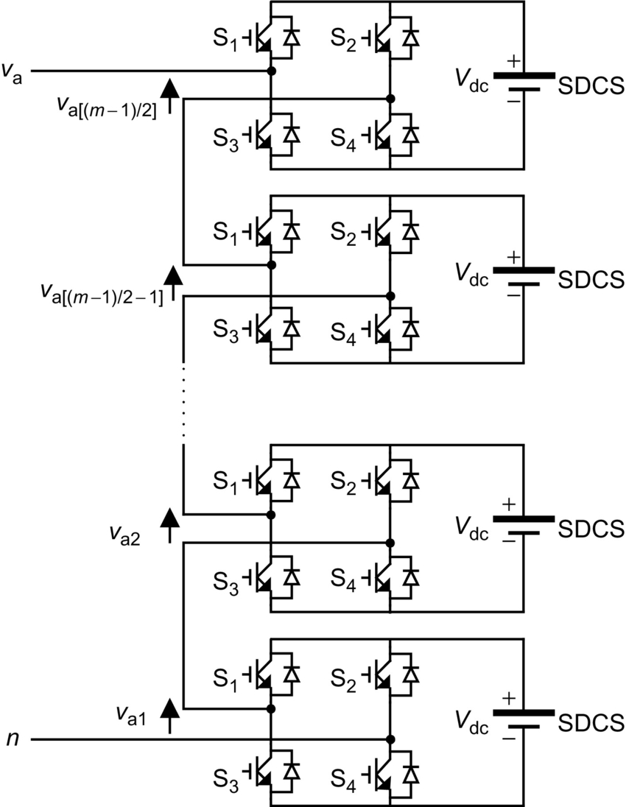

**FIG. 13.1** Single-phase structure of a multilevel cascaded H-bridge inverter.

Each inverter level can generate three different voltage outputs, , and , by connecting the dc source to the ac output by different combinations of the four switches: S1, S2, S3, and S4. To obtain , switches S1 and S4 are turned on, whereas to obtain , switches S2 and S3 are turned on. By turning on either S1 and S2 or S3 and S4, the output voltage will be zero. The ac outputs of each of the different full-bridge inverter levels are connected in series such that the synthesized voltage waveform is the sum of the inverter outputs. The number of output phase voltage levels, *m*, in a cascade inverter is defined by , where *s* is the number of separate dc sources. An example of phase voltage waveform for an 11-level cascaded H-bridge inverter with five SDCSs and five full bridges is shown in [Fig. 13.2](https://learning.oreilly.com/library/view/power-electronics-handbook/9780128114087/B9780128114070000131.xhtml#f0015). The phase voltage .

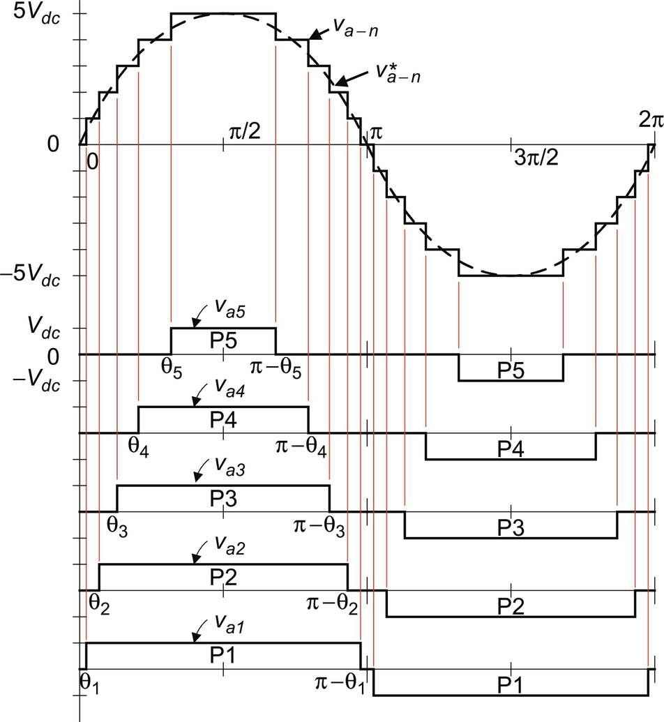

**FIG. 13.2** Output phase voltage waveform of an 11-level cascade inverter with five separate dc sources.

For a stepped waveform such as the one depicted in [Fig. 13.2](https://learning.oreilly.com/library/view/power-electronics-handbook/9780128114087/B9780128114070000131.xhtml#f0015) with *s* steps, the Fourier transform for this waveform follows [[14](https://learning.oreilly.com/library/view/power-electronics-handbook/9780128114087/B9780128114070000131.xhtml#bb0075),[18](https://learning.oreilly.com/library/view/power-electronics-handbook/9780128114087/B9780128114070000131.xhtml#bb0095)]:

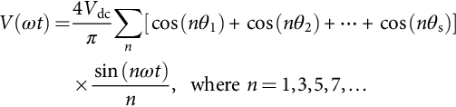 **(13.1)**

From Eq. [(13.1)](https://learning.oreilly.com/library/view/power-electronics-handbook/9780128114087/B9780128114070000131.xhtml#fo0010), the magnitudes of the Fourier coefficients when normalized with respect to *V*dc are as follows:

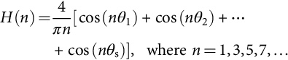 **(13.2)**

The conducting angles, *θ*1,*θ*2,…,*θ*s, can be chosen such that the voltage total harmonic distortion is minimum. Generally, these angles are chosen so that predominant lower frequency harmonics, 5, 7, 11, and 13 are eliminated [[19](https://learning.oreilly.com/library/view/power-electronics-handbook/9780128114087/B9780128114070000131.xhtml#bb0100)]. More details on harmonic elimination techniques will be discussed in the following section.

Multilevel cascaded inverters have been proposed for such applications as static var generation, an interface with renewable energy sources, and for battery-based applications.

Three-phase cascaded inverters can be connected in wye, as shown in [Fig. 13.3](https://learning.oreilly.com/library/view/power-electronics-handbook/9780128114087/B9780128114070000131.xhtml#f0020), or in delta. Peng et al. have demonstrated a prototype multilevel cascaded static var generator connected in parallel with an electric system that could supply or draw reactive current from an electric system [[20](https://learning.oreilly.com/library/view/power-electronics-handbook/9780128114087/B9780128114070000131.xhtml#bb0105)–[23](https://learning.oreilly.com/library/view/power-electronics-handbook/9780128114087/B9780128114070000131.xhtml#bb0120)]. The inverter could be controlled to regulate either the power factor of the current drawn from the source or the bus voltage of the electric system where the inverter was connected. Peng et al. [[20](https://learning.oreilly.com/library/view/power-electronics-handbook/9780128114087/B9780128114070000131.xhtml#bb0105)] and Joos et al. [[24](https://learning.oreilly.com/library/view/power-electronics-handbook/9780128114087/B9780128114070000131.xhtml#bb0125)] have also shown that a cascade inverter can be directly connected in series with the electric system for static var compensation. Cascaded inverters are ideal for connecting renewable energy sources with an ac grid because of the need for separate dc sources in applications such as photovoltaics or fuel cells.

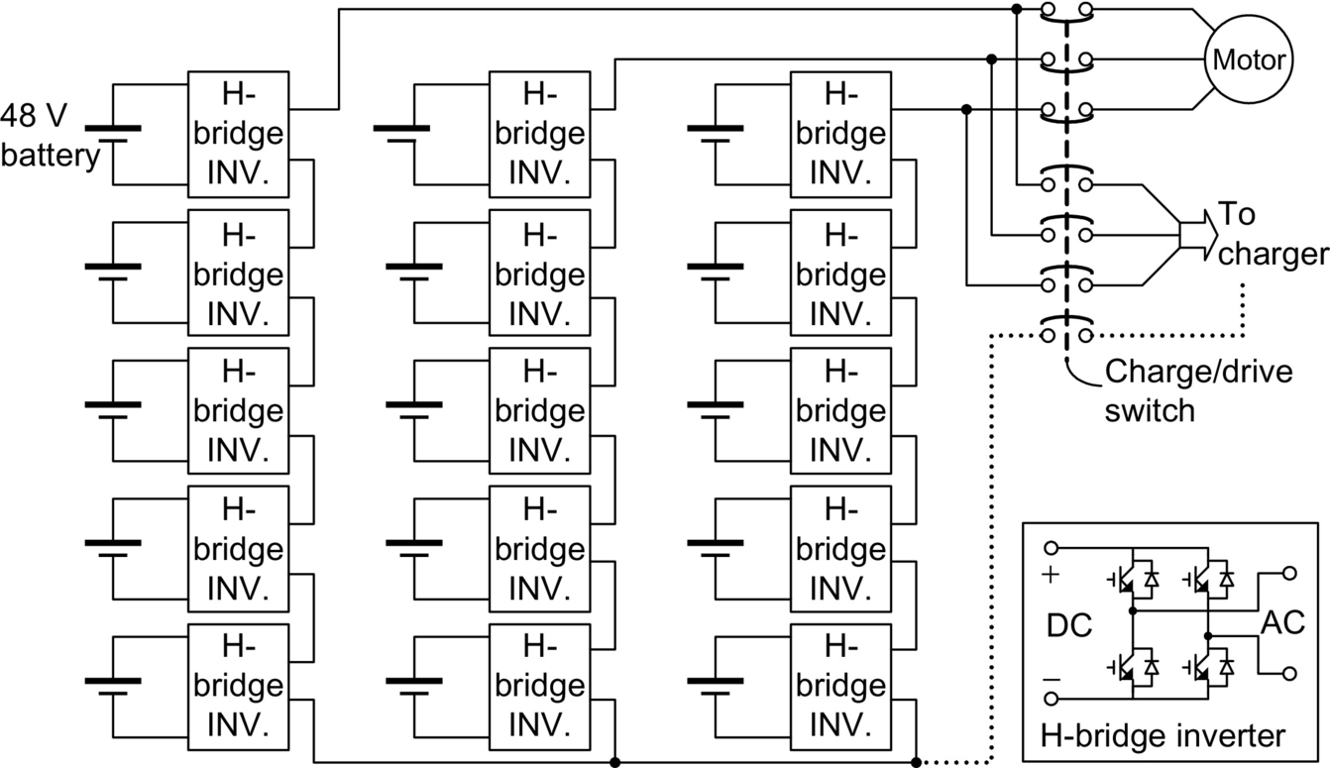

**FIG. 13.3** Three-phase wye-connection structure for electric vehicle motor drive and battery charging.

Cascaded inverters have also been proposed for use as the main traction drive in electric vehicles where several batteries or ultracapacitors are well suited to serve as SDCSs [[18](https://learning.oreilly.com/library/view/power-electronics-handbook/9780128114087/B9780128114070000131.xhtml#bb0095),[25](https://learning.oreilly.com/library/view/power-electronics-handbook/9780128114087/B9780128114070000131.xhtml#bb0130)]. The cascaded inverter could also serve as a rectifier or charger for the batteries of an electric vehicle while the vehicle was connected to an ac supply as shown in [Fig. 13.3](https://learning.oreilly.com/library/view/power-electronics-handbook/9780128114087/B9780128114070000131.xhtml#f0020). In addition, the cascade inverter can act as a rectifier in a vehicle that uses regenerative braking.

Manjrekar and Lipo have proposed a cascade topology that uses multiple dc levels, which instead of being identical in value are multiples of each other [[26](https://learning.oreilly.com/library/view/power-electronics-handbook/9780128114087/B9780128114070000131.xhtml#bb0135),[27](https://learning.oreilly.com/library/view/power-electronics-handbook/9780128114087/B9780128114070000131.xhtml#bb0140)]. They also used a combination of fundamental frequency switching for some of the levels and PWM switching for part of the levels to achieve the output voltage waveform. This approach enables a wider diversity of output voltage magnitudes; however, it also results in unequal voltage and current ratings for each of the levels and loses the advantage of being able to use identical modular units for each level.

The main advantages and disadvantages of multilevel cascaded H-bridge converters are as follows [[28](https://learning.oreilly.com/library/view/power-electronics-handbook/9780128114087/B9780128114070000131.xhtml#bb0145),[29](https://learning.oreilly.com/library/view/power-electronics-handbook/9780128114087/B9780128114070000131.xhtml#bb0150)]:

#### **13.2.1.1 Advantages**

• The number of possible output voltage levels is more than twice the number of dc sources .

• The series of H-bridges makes for modularized layout and packaging. This will enable the manufacturing process to be done more quickly and cheaply.

#### **13.2.1.2 Disadvantages**

• Separate dc sources are required for each of the H-bridges. This will limit its application to products that already have multiple SDCSs readily available.

Another kind of cascaded multilevel converter with transformers using standard three-phase bilevel converters has been proposed [[14](https://learning.oreilly.com/library/view/power-electronics-handbook/9780128114087/B9780128114070000131.xhtml#bb0075)]. The circuit is shown in [Fig. 13.4](https://learning.oreilly.com/library/view/power-electronics-handbook/9780128114087/B9780128114070000131.xhtml#f0025). The converter uses output transformers to add different voltages. In order to add up the converter output voltages, the outputs of the three converters need to be synchronized with a separation of  between each phase. For example, for obtaining a three-level voltage between outputs *a* and *b*, the output voltage can be synthesized by . An isolated transformer is used to provide voltage boost. With three converters synchronized, the voltages, , are all in phase, and thus, the output level can be tripled [[1](https://learning.oreilly.com/library/view/power-electronics-handbook/9780128114087/B9780128114070000131.xhtml#bb0010)].

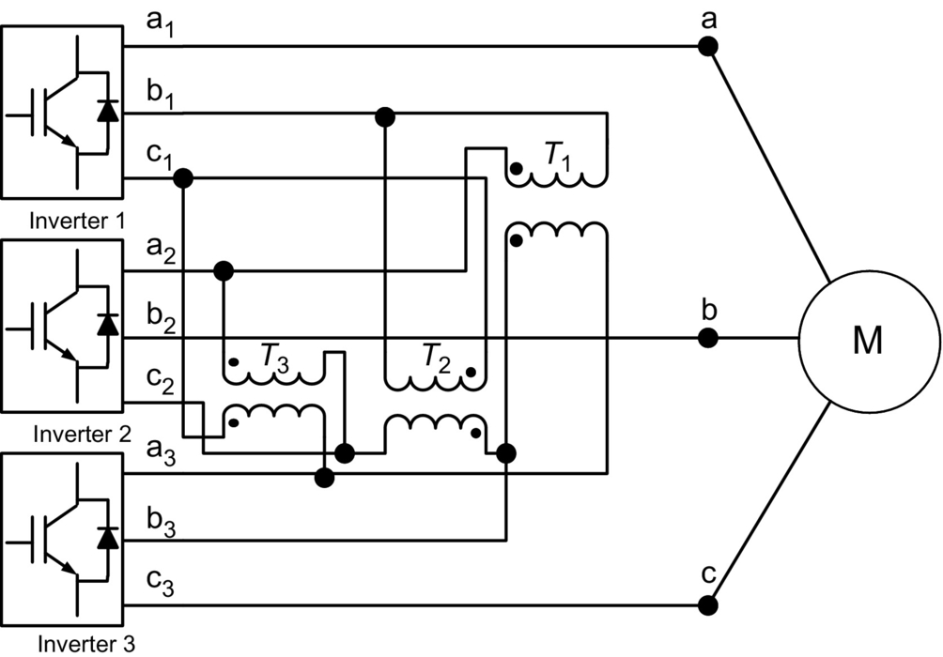

**FIG. 13.4** Cascaded multilevel converter with transformers using standard three-phase bilevel converters.

The advantage of the cascaded multilevel converters with transformers using standard three-phase bilevel converters is that the three converters are identical, and thus, control is more simple. However, the three converters need separate dc sources, and a transformer is needed to add up the output voltages.

### 13.2.2 DIODE-CLAMPED MULTILEVEL INVERTER

The neutral point converter proposed by Nabae, Takahashi, and Akagi in 1981 was essentially a three-level diode-clamped inverter [[5](https://learning.oreilly.com/library/view/power-electronics-handbook/9780128114087/B9780128114070000131.xhtml#bb0030)]. Several researchers published articles that have reported experimental results for four-, five-, and six-level diode-clamped converters for uses such as static var compensation, variable speed motor drives, and high-voltage system interconnections [[17](https://learning.oreilly.com/library/view/power-electronics-handbook/9780128114087/B9780128114070000131.xhtml#bb0090)–[30](https://learning.oreilly.com/library/view/power-electronics-handbook/9780128114087/B9780128114070000131.xhtml#bb0155)]. A three-phase six-level diode-clamped inverter is shown in [Fig. 13.5](https://learning.oreilly.com/library/view/power-electronics-handbook/9780128114087/B9780128114070000131.xhtml#f0030). Each of the three phases of the inverter shares a common dc bus, which has been subdivided by five capacitors into six levels. The voltage across each capacitor is *V*dc, and the voltage stress across each switching device is limited to *V*dc through the clamping diodes. [Table 13.1](https://learning.oreilly.com/library/view/power-electronics-handbook/9780128114087/B9780128114070000131.xhtml#t0010) lists the output voltage levels possible for one phase of the inverter with the negative dc rail voltage *V*0 as a reference. State condition 1 means the switch is on, and 0 means the switch is off. Each phase has five complementary switch pairs such that turning on one of the switches of the pair requires the other complementary switch to be turned off. The complementary switch pairs for phase-leg *a* are , and . [Table 13.1](https://learning.oreilly.com/library/view/power-electronics-handbook/9780128114087/B9780128114070000131.xhtml#t0010) also shows that in a diode-clamped inverter, the switches that are on for a particular phase leg are always adjacent and in series. For a six-level inverter, a set of five switches should be on at any given time.

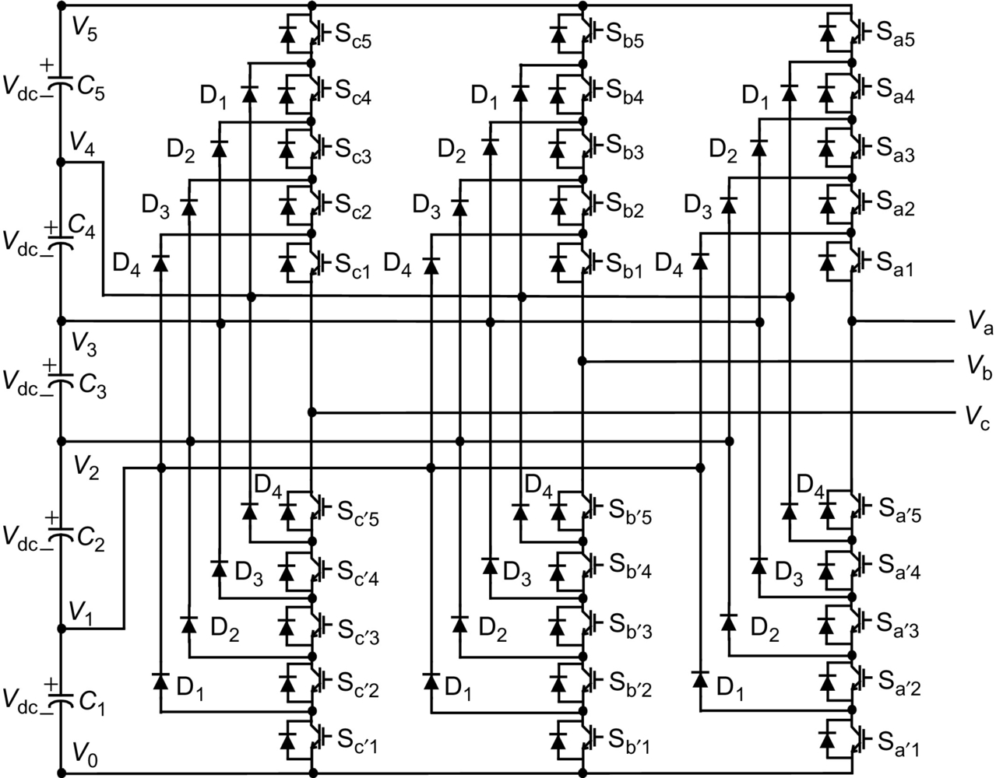

**FIG. 13.5** Three-phase six-level structure of a diode-clamped inverter.

**Table 13.1**

**Diode-clamped six-level inverter voltage levels and corresponding switch states**

|  |  |  |  |  |  |  |  |  |  |  |
| --- | --- | --- | --- | --- | --- | --- | --- | --- | --- | --- |
| **Voltage *V*a0** | **Switch state** | | | | | | | | | |
| **Sa5** | **Sa4** | **Sa3** | **Sa2** | **Sa1** | si13_e | si14_e | si15_e | si16_e | si17_e |
| si18_e | 1 | 1 | 1 | 1 | 1 | 0 | 0 | 0 | 0 | 0 |
| si19_e | 0 | 1 | 1 | 1 | 1 | 1 | 0 | 0 | 0 | 0 |
| si20_e | 0 | 0 | 1 | 1 | 1 | 1 | 1 | 0 | 0 | 0 |
| si21_e | 0 | 0 | 0 | 1 | 1 | 1 | 1 | 1 | 0 | 0 |
| si22_e | 0 | 0 | 0 | 0 | 1 | 1 | 1 | 1 | 1 | 0 |
| si23_e | 0 | 0 | 0 | 0 | 0 | 1 | 1 | 1 | 1 | 1 |

[Fig. 13.6](https://learning.oreilly.com/library/view/power-electronics-handbook/9780128114087/B9780128114070000131.xhtml#f0035) shows one of the three line-line voltage waveforms for a six-level inverter. The line voltage *V*ab consists of a phase-leg “a” voltage and a phase-leg “b” voltage. The resulting line voltage is an 11-level staircase waveform. This means that an *m*-level diode-clamped inverter has an *m*-level output phase voltage and a (2*m*−1)-level output line voltage.

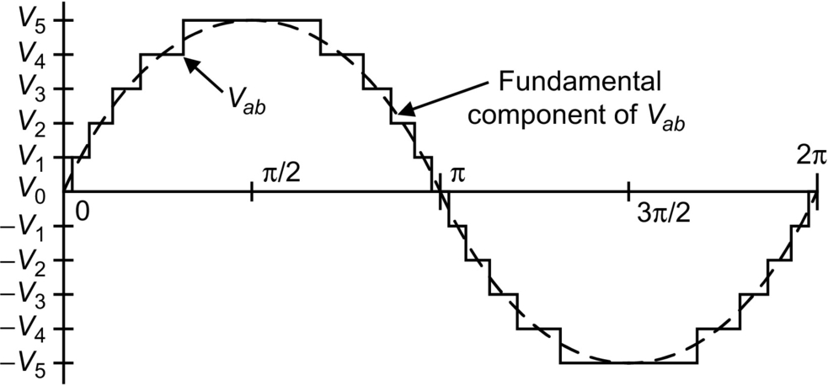

**FIG. 13.6** Line voltage waveform for a six-level diode-clamped inverter.

Although each active switching device is required to block only a voltage level of *V*dc, the clamping diodes require different ratings for reverse voltage blocking. Using phase *a* of [Fig. 13.5](https://learning.oreilly.com/library/view/power-electronics-handbook/9780128114087/B9780128114070000131.xhtml#f0030) as an example, when all the lower switches  through  are turned on, D4 must block four voltage levels or 4*V*dc. Similarly, D3 must block 3*V*dc, D2 must block 2*V*dc, and D1 must block *V*dc. If the inverter is designed such that each blocking diode has the same voltage rating as the active switches, Dn will require *n* diodes in series; consequently, the number of diodes required for each phase would be . Thus, the number of blocking diodes is quadratically related to the number of levels in a diode-clamped converter [[28](https://learning.oreilly.com/library/view/power-electronics-handbook/9780128114087/B9780128114070000131.xhtml#bb0145)].

One application of the multilevel diode-clamped inverter is an interface between a high-voltage dc transmission line and an ac transmission line [[29](https://learning.oreilly.com/library/view/power-electronics-handbook/9780128114087/B9780128114070000131.xhtml#bb0150)]. Another application would be a variable speed drive for high-power medium-voltage (2.4–13.8 kV) motors as proposed in [[3](https://learning.oreilly.com/library/view/power-electronics-handbook/9780128114087/B9780128114070000131.xhtml#bb0020),[6](https://learning.oreilly.com/library/view/power-electronics-handbook/9780128114087/B9780128114070000131.xhtml#bb0035),[19](https://learning.oreilly.com/library/view/power-electronics-handbook/9780128114087/B9780128114070000131.xhtml#bb0100),[28](https://learning.oreilly.com/library/view/power-electronics-handbook/9780128114087/B9780128114070000131.xhtml#bb0145)–[30](https://learning.oreilly.com/library/view/power-electronics-handbook/9780128114087/B9780128114070000131.xhtml#bb0155)]. Several authors have proposed for the diode-clamped converter that static var compensation is an additional function. The main advantages and disadvantages of multilevel diode-clamped converters are as follows [[1](https://learning.oreilly.com/library/view/power-electronics-handbook/9780128114087/B9780128114070000131.xhtml#bb0010)–[3](https://learning.oreilly.com/library/view/power-electronics-handbook/9780128114087/B9780128114070000131.xhtml#bb0020)].

#### **13.2.2.1 Advantages**

• All the phases share a common dc bus, which minimizes the capacitance requirements of the converter. For this reason, a back-to-back topology is not only possible but also practical for uses such as a high-voltage back-to-back interconnection or an adjustable speed drive.

• The capacitors can be precharged as a group.

• Efficiency is high for fundamental frequency switching.

#### **13.2.2.2 Disadvantages**

• Real power flow is difficult for a single inverter because the intermediate dc levels will tend to overcharge or discharge without precise monitoring and control.

• The number of clamping diodes required is quadratically related to the number of levels, which can be cumbersome for units with a high number of levels.

### 13.2.3 FLYING-CAPACITOR MULTILEVEL INVERTER

Meynard and Foch introduced a flying-capacitor-based inverter in 1992 [[31](https://learning.oreilly.com/library/view/power-electronics-handbook/9780128114087/B9780128114070000131.xhtml#bb0160)]. The structure of this inverter is similar to that of the diode-clamped inverter except that instead of using clamping diodes, the inverter uses capacitors. The circuit topology of the flying-capacitor multilevel inverter is shown in [Fig. 13.7](https://learning.oreilly.com/library/view/power-electronics-handbook/9780128114087/B9780128114070000131.xhtml#f0040). This topology has a ladder structure of dc side capacitors, where the voltage on each capacitor differs from that of the next capacitor. The voltage increment between two adjacent capacitor legs gives the size of the voltage steps in the output waveform.

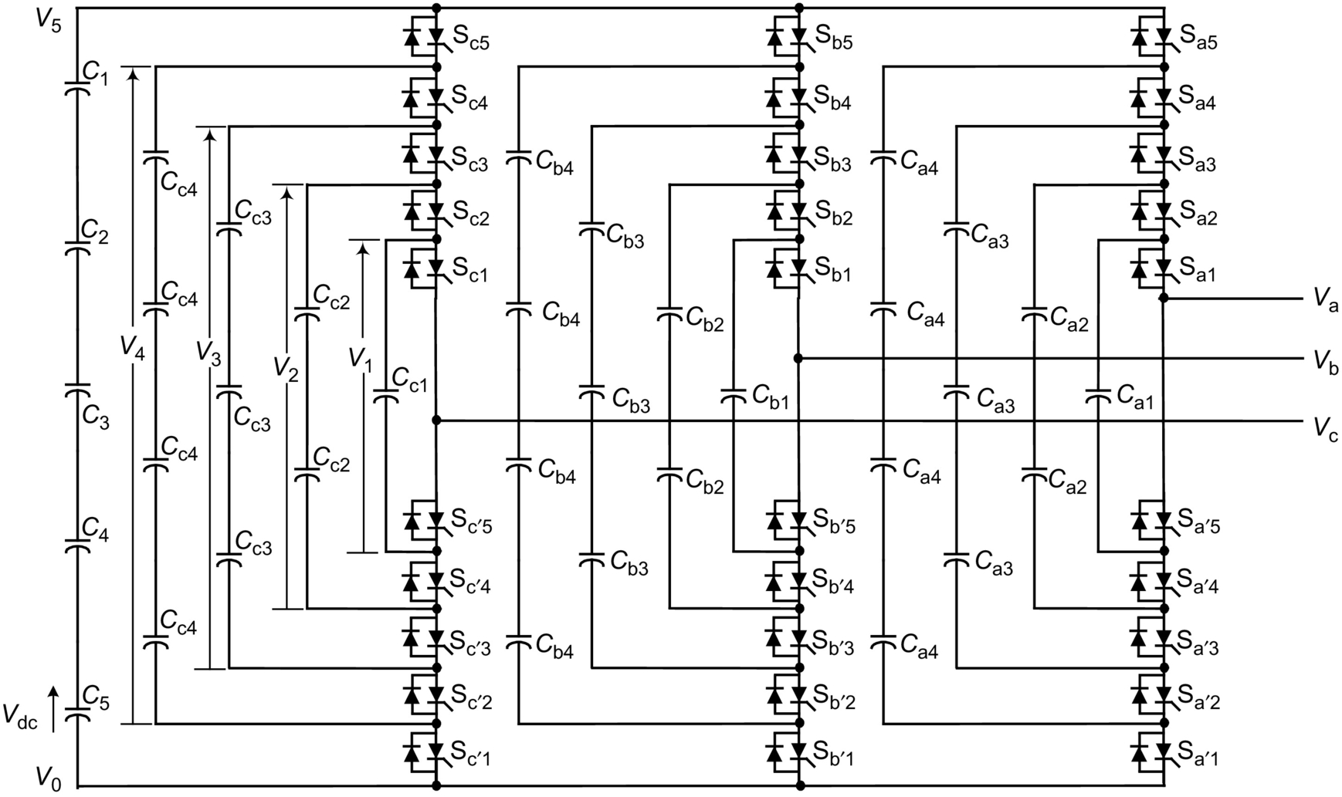

**FIG. 13.7** Three-phase six-level structure of a flying-capacitor inverter.

One advantage of the flying-capacitor-based inverter is that it has redundancies for inner voltage levels, that is, two or more valid switch combinations can synthesize an output voltage. [Table 13.2](https://learning.oreilly.com/library/view/power-electronics-handbook/9780128114087/B9780128114070000131.xhtml#t0015) shows a list of all the combinations of phase voltage levels that are possible for the six-level circuit shown in [Fig. 13.7](https://learning.oreilly.com/library/view/power-electronics-handbook/9780128114087/B9780128114070000131.xhtml#f0040). Unlike the diode-clamped inverter, the flying-capacitor inverter does not require all of the switches that are “on” (conducting) be in a consecutive series. Moreover, the flying-capacitor inverter has “phase” redundancies, whereas the diode-clamped inverter has only “line-line” redundancies [[2](https://learning.oreilly.com/library/view/power-electronics-handbook/9780128114087/B9780128114070000131.xhtml#bb0015),[3](https://learning.oreilly.com/library/view/power-electronics-handbook/9780128114087/B9780128114070000131.xhtml#bb0020),[32](https://learning.oreilly.com/library/view/power-electronics-handbook/9780128114087/B9780128114070000131.xhtml#bb0165)]. These redundancies allow a choice of charging or discharging specific capacitors and can be incorporated in the control system for balancing the voltages across the various levels.

**Table 13.2**

**Flying-capacitor six-level inverter redundant voltage levels and corresponding switch states**

|  |  |  |  |  |  |  |  |  |  |  |
| --- | --- | --- | --- | --- | --- | --- | --- | --- | --- | --- |
| **Voltage *V*a0** | **Switch state** | | | | | | | | | |
| **Sa5** | **Sa4** | **Sa3** | **Sa2** | **Sa1** | si13_e | si14_e | si15_e | si16_e | si17_e |
| si29_e | | | | | | | | | | |
| 5*V*dc | 1 | 1 | 1 | 1 | 1 | 0 | 0 | 0 | 0 | 0 |
| si30_e | | | | | | | | | | |
| si31_e | 1 | 1 | 1 | 1 | 0 | 0 | 0 | 0 | 0 | 1 |
| 4*V*dc | 0 | 1 | 1 | 1 | 1 | 1 | 0 | 0 | 0 | 0 |
| si32_e | 1 | 0 | 1 | 1 | 1 | 0 | 1 | 0 | 0 | 0 |
| si33_e | 1 | 1 | 0 | 1 | 1 | 0 | 0 | 1 | 0 | 0 |
| si34_e | 1 | 1 | 1 | 0 | 1 | 0 | 0 | 0 | 1 | 0 |
| si35_e | | | | | | | | | | |
| si36_e | 1 | 1 | 1 | 0 | 0 | 0 | 0 | 0 | 1 | 1 |
| si37_e | 0 | 1 | 1 | 1 | 0 | 1 | 0 | 0 | 0 | 1 |
| 3*V*dc | 0 | 0 | 1 | 1 | 1 | 1 | 1 | 0 | 0 | 0 |
| si38_e | 1 | 0 | 1 | 1 | 0 | 0 | 1 | 0 | 0 | 1 |
| si39_e | 1 | 1 | 0 | 0 | 1 | 0 | 0 | 1 | 1 | 0 |
| si40_e | 0 | 1 | 1 | 0 | 1 | 1 | 0 | 0 | 1 | 0 |
| si41_e | | | | | | | | | | |
| si42_e | 1 | 1 | 0 | 0 | 0 | 0 | 0 | 1 | 1 | 1 |
| si43_e | 1 | 0 | 0 | 0 | 1 | 0 | 1 | 1 | 1 | 0 |
| si44_e | 0 | 1 | 1 | 0 | 0 | 1 | 0 | 0 | 1 | 1 |
| si45_e | 0 | 1 | 0 | 0 | 1 | 1 | 0 | 1 | 1 | 0 |
| si46_e | 0 | 0 | 1 | 1 | 0 | 1 | 1 | 0 | 0 | 1 |
| si47_e | 0 | 0 | 1 | 0 | 1 | 1 | 1 | 0 | 1 | 0 |
| 2*V*dc | 0 | 0 | 0 | 1 | 1 | 1 | 1 | 1 | 0 | 0 |
| si48_e | | | | | | | | | | |
| si49_e | 1 | 0 | 0 | 0 | 0 | 0 | 1 | 1 | 1 | 1 |
| si50_e | 0 | 1 | 0 | 0 | 0 | 1 | 0 | 1 | 1 | 1 |
| si51_e | 0 | 0 | 1 | 0 | 0 | 1 | 1 | 0 | 1 | 1 |
| si52_e | 0 | 0 | 0 | 1 | 0 | 1 | 1 | 1 | 0 | 1 |
| *V*dc | 0 | 0 | 0 | 0 | 1 | 1 | 1 | 1 | 1 | 0 |
| si53_e | | | | | | | | | | |
| 0 | 0 | 0 | 0 | 0 | 0 | 1 | 1 | 1 | 1 | 1 |

In addition to the  dc link capacitors, the *m*-level flying-capacitor multilevel inverter will require  auxiliary capacitors per phase if the voltage rating of the capacitors is identical to that of the main switches. One application proposed in the literature for the multilevel flying capacitor is static var generation [[2](https://learning.oreilly.com/library/view/power-electronics-handbook/9780128114087/B9780128114070000131.xhtml#bb0015),[3](https://learning.oreilly.com/library/view/power-electronics-handbook/9780128114087/B9780128114070000131.xhtml#bb0020)]. The main advantages and disadvantages of multilevel flying-capacitor converters are as follows [[2](https://learning.oreilly.com/library/view/power-electronics-handbook/9780128114087/B9780128114070000131.xhtml#bb0015),[3](https://learning.oreilly.com/library/view/power-electronics-handbook/9780128114087/B9780128114070000131.xhtml#bb0020)]:

#### **13.2.3.1 Advantages**

• Phase redundancies are available for balancing the voltage levels of the capacitors.

• Real and reactive power flow can be controlled.

• The large number of capacitors enables the inverter to ride through short duration outages and deep voltage sags.

#### **13.2.3.2 Disadvantages**

• Control is complicated to track the voltage levels for all of the capacitors. Also, precharging all of the capacitors to the same voltage level and start-up is complex.

• Switching utilization and efficiency is poor for real power transmission.

• The large number of capacitors is both more expensive and bulky than clamping diodes in multilevel diode-clamped converters. Packaging is also more difficult in inverters with a high number of levels.

### 13.2.4 MODULAR MUTILEVEL INVERTER STRUCTURES

The modular multilevel converter (MMC) was first introduced by Marquardt in 2001 [[33](https://learning.oreilly.com/library/view/power-electronics-handbook/9780128114087/B9780128114070000131.xhtml#bb0170)]. The configuration of a MMC is shown in [Fig. 13.8A](https://learning.oreilly.com/library/view/power-electronics-handbook/9780128114087/B9780128114070000131.xhtml#f0045). Each phase leg of the MMC consists of one upper and one lower arm connected in series between the dc terminals. *N* series-connected SMs and one arm inductor *L*arm form an arm. Each SM can be realized by a half-bridge [[34](https://learning.oreilly.com/library/view/power-electronics-handbook/9780128114087/B9780128114070000131.xhtml#bb0175)] [[35](https://learning.oreilly.com/library/view/power-electronics-handbook/9780128114087/B9780128114070000131.xhtml#bb0180)], H-bridge [[36](https://learning.oreilly.com/library/view/power-electronics-handbook/9780128114087/B9780128114070000131.xhtml#bb0185)] [[37](https://learning.oreilly.com/library/view/power-electronics-handbook/9780128114087/B9780128114070000131.xhtml#bb0190)], or clamp-double [[38](https://learning.oreilly.com/library/view/power-electronics-handbook/9780128114087/B9780128114070000131.xhtml#bb0195)] circuit, as illustrated in [Fig. 13.8B–D](https://learning.oreilly.com/library/view/power-electronics-handbook/9780128114087/B9780128114070000131.xhtml#f0045).

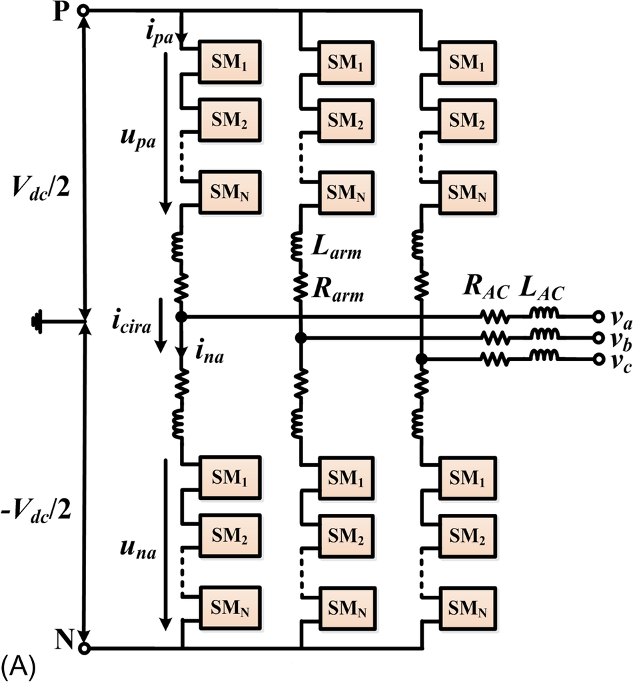

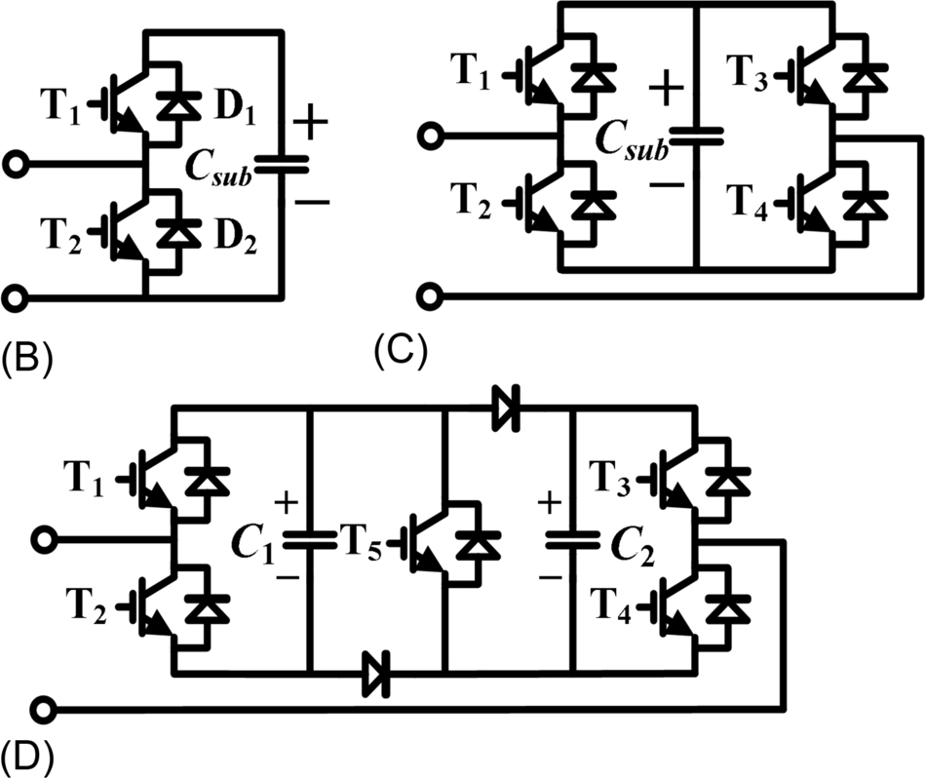

**FIG. 13.8** (A) Circuit configuration of a MMC with (B) half-bridge cell, (C) full-bridge cell, and (D) clamp-double cell.

Among these, the MMC with half-bridge SM does not have any intrinsic fault current-limiting or current-blocking capability. Under a dc short-circuit fault, the fault current can flow from the ac side to the faulted dc side through the antiparalleled diodes of the controllable power switches, even though these switches are turned off. Therefore, fast-acting dc breakers are necessary to protect the system from damage. On the other hand, the H-bridge SM is capable of generating negative capacitor voltage, which can be used to block the fault current. However, compared with the half-bridge SM, the H-bridge one has twice the number of semiconductor devices, leading to higher cost and operating losses. For the “clamp-double” SM in [Fig. 13.8D](https://learning.oreilly.com/library/view/power-electronics-handbook/9780128114087/B9780128114070000131.xhtml#f0045), power device T5 always conducts under normal operation conditions, making the clamp-double SM equivalent to two series-connected half-bridge SMs. Under a dc side fault, T5 is turned off, and dc voltage is inserted by both capacitors to minimize the dc fault current. Compared with the H-bridge SM, the output voltage of clamp-double SM can be doubled, with additional conduction loss of T5.

Due to the lower cost and higher efficiency, the MMC with half-bridge SMs is used for most of the commercial HVDC projects [[39](https://learning.oreilly.com/library/view/power-electronics-handbook/9780128114087/B9780128114070000131.xhtml#bb0200)]. Therefore, the basic operation principle of an MMC with half bridge will be introduced in this section. As illustrated in [Fig. 13.9B](https://learning.oreilly.com/library/view/power-electronics-handbook/9780128114087/B9780128114070000131.xhtml#f0050), each half-bridge SM contains two IGBTs as switching elements and a DC storage capacitor *Csub*. A SM is considered to be bypassed if the lower switch is closed and the upper switch is open, while if the lower switch is open and the upper switch is closed, the SM is inserted. Three different states are relevant for the proper operation of an SM, as illustrated in [Fig. 13.9](https://learning.oreilly.com/library/view/power-electronics-handbook/9780128114087/B9780128114070000131.xhtml#f0050):

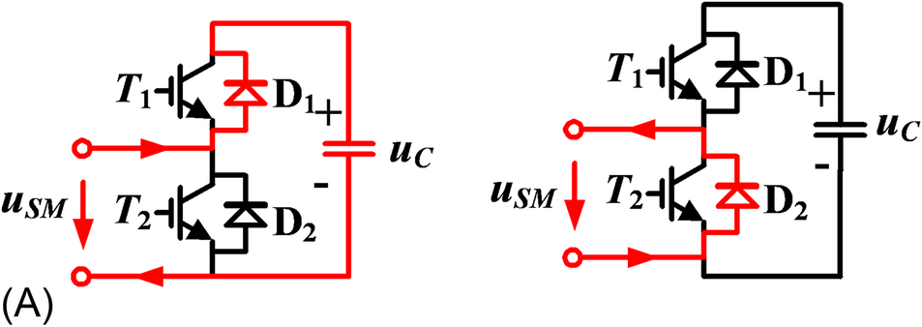

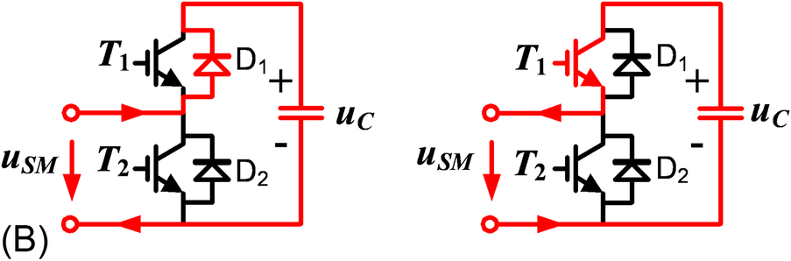

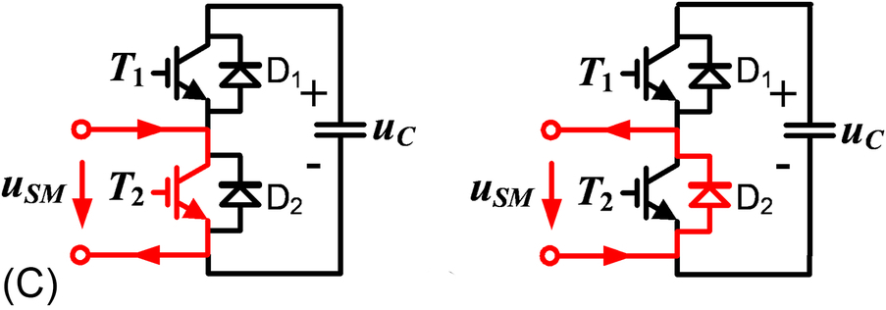

**FIG. 13.9** States and current paths of an SM in the MMC converter, (A) both IGBTs are switched off, (B) IGBT1 is switched on, IGBT2 is switched off, (C) IGBT1 is switched off, and IGBT2 is switched on.

1. Both IGBTs are switched off.

This case does not occur during normal operation with power transfer. Upon charging, that is, after closing the AC power switch, all SMs of the converter are under this condition. In the event of a serious failure, all SMs of the converter should return to this state. If the current flows from the AC terminal to the dc side during this state, the flow passes through diode D1 and charges the capacitor. When it flows in the opposite direction, the freewheeling diode D2 conducts and bypasses the capacitor.

2. IGBT1 (T1) is switched on, and IGBT2 (T2) is switched off.

Irrespective of the current flow direction, the voltage of the storage capacitor is applied to the terminals of the SM. Depending on the current direction, the current either flows through D1 and charges the SM capacitor or flows through T1 and discharges the SM capacitor.

3. IGBT1 is switched off, and IGBT2 is switched on.

In this case, the current flows through either T2 or D2 depending on its direction, which ensures that zero voltage is applied to the terminals of the SM. The voltage in the capacitor remains unchanged.

It is thereby possible to separately and selectively control each of the individual SMs in a converter leg. In principle, the two converter arms of each phase represent a controllable voltage source. In this arrangement, the total voltage generated by the upper and lower arm SMs in one phase unit should equal to the dc link voltage. By adjusting the output voltage of SMs in both arms, that is, inserting and bypassing of SM capacitors according to a switching pattern created by a modulator, the desired sinusoidal voltage at the AC terminal can easily be achieved.

[Fig. 13.10](https://learning.oreilly.com/library/view/power-electronics-handbook/9780128114087/B9780128114070000131.xhtml#f0055) illustrates the equivalent circuit of the MMC. *Larm* and *Rarm* are the arm inductance and equivalent arm resistance, respectively. *Vdc* and *Idc* are the total dc bus voltage and dc current individually. *uvj* is the converter output voltage of *j* phase at point *v*, whereas *ivj* is the corresponding line current. The arm voltages generated by the cascaded SMs are expressed as *upj* and *unj*, where the subscripts *p* and *n* denote the upper (positive) and lower (negative) arms, respectively. *ipj* and *inj* are the corresponding arm currents, which can be expressed as

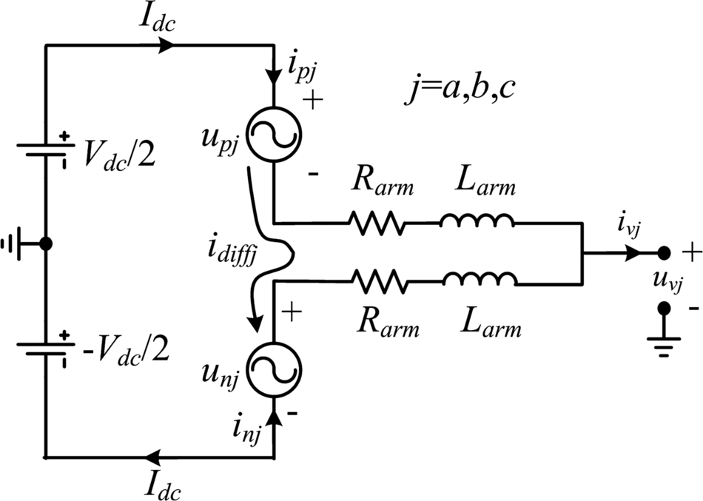

**FIG. 13.10** Single-phase equivalent circuit of the MMC.

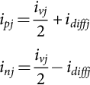 **(13.3)**

where *idiffj* denotes the inner circulating current of phase *j*, which flows through both the upper and lower arms and is given as

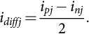 **(13.4)**

According to [[40](https://learning.oreilly.com/library/view/power-electronics-handbook/9780128114087/B9780128114070000131.xhtml#bb0205)], the MMC can be characterized by the following equations:

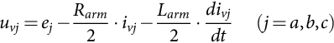 **(13.5)**

**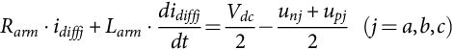** **(13.6)**

where *ej* in [(13.5)](https://learning.oreilly.com/library/view/power-electronics-handbook/9780128114087/B9780128114070000131.xhtml#fo0030) is the inner emf generated in a phase and

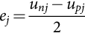 **(13.7)**

According to [(13.5)](https://learning.oreilly.com/library/view/power-electronics-handbook/9780128114087/B9780128114070000131.xhtml#fo0030), when *uvj* is regarded as the ac network voltage, the current *ivj* can be controlled directly by regulating the control variable *ej*. The inner dynamic performance of the MMC is characterized by [(13.6)](https://learning.oreilly.com/library/view/power-electronics-handbook/9780128114087/B9780128114070000131.xhtml#fo0035) and can be redefined as

 **(13.8)**

where *udiffj* is the inner unbalance voltage of phase *j*.

According to [(13.8)](https://learning.oreilly.com/library/view/power-electronics-handbook/9780128114087/B9780128114070000131.xhtml#fo0045), the circulating current *idiffj* can be controlled by regulating the unbalance voltage *udiffj*. Combining [(13.7)](https://learning.oreilly.com/library/view/power-electronics-handbook/9780128114087/B9780128114070000131.xhtml#fo0040) and [(13.8)](https://learning.oreilly.com/library/view/power-electronics-handbook/9780128114087/B9780128114070000131.xhtml#fo0045), the arm voltage references are

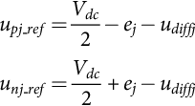 **(13.9)**

Because the same voltage *udiffj* is subtracted from *upj\_ref* and *unj\_ref*, according to [(13.5)](https://learning.oreilly.com/library/view/power-electronics-handbook/9780128114087/B9780128114070000131.xhtml#fo0030) and [(13.7)](https://learning.oreilly.com/library/view/power-electronics-handbook/9780128114087/B9780128114070000131.xhtml#fo0040), the resulting *ej* will not change, and thus, the ac side dynamics are not affected. As previously described, the reference of *ej* is generated from the traditional system control loops, whereas the inner unbalance voltage *udiffj* is used to control the MMC inner dynamic performance including the three-phase inner circulating currents.

Due to its unique structure, MMC has two typical issues, which will be discussed in the following sections.

(1) *SM capacitor voltage balancing*

According to the operating principle described above, the arm current in an MMC will only flow through the SM capacitor when the upper switch turns on and the SM is inserted. However, determined by various modulation schemes, the switching state for SMs is different from each other, leading to different charging/discharging times of the SM capacitors and thus voltage deviations. These unbalanced SM capacitor voltages generate the output voltage distortion and bring high-voltage stress to SM capacitors, as illustrated in [Fig. 13.11](https://learning.oreilly.com/library/view/power-electronics-handbook/9780128114087/B9780128114070000131.xhtml#f0060). To address this issue, several voltage-balancing control schemes have been proposed over the last decade.

In [[41](https://learning.oreilly.com/library/view/power-electronics-handbook/9780128114087/B9780128114070000131.xhtml#bb0210)], a voltage-balancing control consisting of an averaging control, individual-balancing control, and arm-balancing control was proposed for phase-shifted modulation schemes. The most widely accepted voltage-balancing control is based on a sorting method [[42](https://learning.oreilly.com/library/view/power-electronics-handbook/9780128114087/B9780128114070000131.xhtml#bb0215)] [[43](https://learning.oreilly.com/library/view/power-electronics-handbook/9780128114087/B9780128114070000131.xhtml#bb0220)]. The selection criteria are based on (1) SM capacitor voltages and (2) the direction of the arm currents. If the arm current is charging the capacitors, the SMs with the lowest capacitor voltages will be inserted. On the other hand, if the arm current is discharging the capacitors, the SMs with the highest capacitor voltages will be inserted. With this algorithm, the SM capacitor voltages can be well balanced. Here, the total SMs that need to be inserted can be calculated based on different modulation schemes introduced earlier.

The main disadvantage of the above algorithms is the unnecessary switching actions of the SMs. Even if the capacitor voltage deviation is quite low and/or the number of required on-state SMs keep the same within two consecutive control periods, the SM insertion and bypassing may still occur, leading to increased switching frequency and loss. A modified sorting method has been proposed in [[44](https://learning.oreilly.com/library/view/power-electronics-handbook/9780128114087/B9780128114070000131.xhtml#bb0225)] to avoid the high switching frequency, as shown in [Fig. 13.12](https://learning.oreilly.com/library/view/power-electronics-handbook/9780128114087/B9780128114070000131.xhtml#f0065). In this method, a voltage deviation threshold is set, and the SM switching states only vary under the following two cases:





**FIG. 13.11** SM capacitor voltages in well-balanced and poorly balanced conditions, (A) well-balanced capacitor voltage and (B) unbalanced capacitor voltage.



**FIG. 13.12** Modified sorting algorithm in Ref. [[44](https://learning.oreilly.com/library/view/power-electronics-handbook/9780128114087/B9780128114070000131.xhtml#bb0225)].

Case 1: The voltage deviation is larger than the predefined threshold (*Vth*).

Case 2: Different number of SMs need to be inserted.

In Case 1, two SM operation status will be changed based on the arm current direction. If the arm current is charging the capacitors, the SM with the highest capacitor voltage will be bypassed, and the SM with the lowest capacitor voltage will be inserted. If the current is discharging the capacitors in that arm, the SM with the lowest capacitor voltage is bypassed, and the SM with the highest capacitor voltage is inserted. For Case 2, an additional SM will be inserted or bypassed, and the same SM selection scheme in Case 1 is utilized. Due to its easy implementation and reduced switching losses, this modified sorting method with a capacitor voltage deviation threshold is widely used for MMC control.

(2) *Circulating current control*

According to [(13.6)](https://learning.oreilly.com/library/view/power-electronics-handbook/9780128114087/B9780128114070000131.xhtml#fo0035), if the SM capacitor voltage in [Fig. 13.8](https://learning.oreilly.com/library/view/power-electronics-handbook/9780128114087/B9780128114070000131.xhtml#f0045) equals to *Vdc*/*N* (*Vdc* is dc link voltage, and *N* is SM number per arm) all the time, no circulating current will be generated. However, in a real MMC converter, low-frequency voltage ripples exist due to alternating arm current. For modulation schemes assuming constant SM capacitor voltages, for example, the direct modulation in [[43](https://learning.oreilly.com/library/view/power-electronics-handbook/9780128114087/B9780128114070000131.xhtml#bb0220)], the inserted SM voltages in different half bridges could be different, inducing circulating current among the three phases. The circulating current will not affect the ac output voltage and currents. However, if it is not effectively suppressed, it increases the peak and RMS values of the arm currents, leading to high power losses and large SM capacitor voltage ripples. Under normal operation conditions, the dominant circulating current is negative sequence with second-order harmonic frequency [[45](https://learning.oreilly.com/library/view/power-electronics-handbook/9780128114087/B9780128114070000131.xhtml#bb0230),[46](https://learning.oreilly.com/library/view/power-electronics-handbook/9780128114087/B9780128114070000131.xhtml#bb0235)]. Although the circulating current can be effectively mitigated by increasing the arm inductance, active suppression control schemes are preferred for lower converter volume and cost. A comparative experimental result with and without circulating current suppression control is given in [Fig. 13.13](https://learning.oreilly.com/library/view/power-electronics-handbook/9780128114087/B9780128114070000131.xhtml#f0070) as an example.

Several circulating current suppressing control schemes have been proposed to reduce the circulating current in an MMC [[47](https://learning.oreilly.com/library/view/power-electronics-handbook/9780128114087/B9780128114070000131.xhtml#bb0240),[48](https://learning.oreilly.com/library/view/power-electronics-handbook/9780128114087/B9780128114070000131.xhtml#bb0245)]. The basic idea of these control schemes is injecting a common mode arm voltage to counteract the submodule capacitor voltage variation. In the indirect modulation schemes proposed in [[49](https://learning.oreilly.com/library/view/power-electronics-handbook/9780128114087/B9780128114070000131.xhtml#bb0250),[50](https://learning.oreilly.com/library/view/power-electronics-handbook/9780128114087/B9780128114070000131.xhtml#bb0255)], the sum of instantaneous capacitor voltages instead of the constant dc link voltage is used for insertion index calculation. In addition, the calculated or estimated total capacitor energy and the unbalanced arm energy are regulated, which inherently limit the circulating current. The second-order circulating current was transformed to d-q coordinates and controlled by a pair of PI controllers in [[47](https://learning.oreilly.com/library/view/power-electronics-handbook/9780128114087/B9780128114070000131.xhtml#bb0240)]. During normal conditions, the dominant negative sequence second-order circulating current becomes dc components under d-q coordinates and can be eliminated without steady-state error. However, under ac grid unbalanced conditions, positive and/or zero-sequence circulating current will also be generated, which are ac components under the previous d-q coordinates and cannot be completely removed [[51](https://learning.oreilly.com/library/view/power-electronics-handbook/9780128114087/B9780128114070000131.xhtml#bb0260)]. As a solution, proportional-resonant (PR)-based controllers were developed in [[52](https://learning.oreilly.com/library/view/power-electronics-handbook/9780128114087/B9780128114070000131.xhtml#bb0265),[53](https://learning.oreilly.com/library/view/power-electronics-handbook/9780128114087/B9780128114070000131.xhtml#bb0270)], targeting elimination of all second-order components in circulating current under abc or αβ coordinates.





**FIG. 13.13** Experimental results with *Larm*=1 mH and (A) circulating current suppressing control disabled and (B) circulating current suppressing control enabled.

#### **13.2.4.1 Advantages**

• The number of SMs in each arm depends on the HVDC voltage level and individual IGBT device voltage. For example, with *N* series-connected SMs per arm, voltage rating of devices is reduced to *Vdc*/*N* (*Vdc* is dc link voltage), which eliminates the direct series connection of devices in two- and three-level converters. Given that the IGBT ratings are in kV level and HVDC rating is typically in hundreds of kV, often several hundred SMs are used for one MMC [[54](https://learning.oreilly.com/library/view/power-electronics-handbook/9780128114087/B9780128114070000131.xhtml#bb0275)].

• Higher quality output voltage. With higher number of SMs in each arm (*N*), the output phase voltage of MMC becomes much more sinusoidal, which enables smaller ac filters, lower cost and compact converter footprint, as illustrated in [Fig. 13.14](https://learning.oreilly.com/library/view/power-electronics-handbook/9780128114087/B9780128114070000131.xhtml#f0075).







**FIG. 13.14** Output ac voltage of a (A) two-level converter, (B) three-level converter, and (C) MMC.

• Lower switching frequency and higher efficiency. The series connection of *N* SMs per arm can achieve an equivalent switching frequency of *Nfc* (*fc* represents carrier frequency of each device) in the output voltage. In practical applications, the device average switching frequency is generally below 200 Hz. Consequently, state-of-the-art MMC-HVDC has loss level about 1%, close to that of LCC.

• Lower high-frequency noise due to reduced *dv/dt* and *di/dt*.

• Modular design and inherent redundancy. The modular design of MMC contributes to lower cost, shorter manufacturing as well as maintenance period, and high extensibility for higher voltage and power applications. Furthermore, the system becomes more reliable since failed SMs can be easily replaced by redundant ones [[55](https://learning.oreilly.com/library/view/power-electronics-handbook/9780128114087/B9780128114070000131.xhtml#bb0280)].

The comparison of site footprint, building area, and building volumes for LCC-HVDC (Grita project, 500 MW and 400 kV), two-level VSC-HVDC, and half-bridge MMC-HVDC (EWIC project, 500 MW and ±200 kV) is presented in [Table 13.3](https://learning.oreilly.com/library/view/power-electronics-handbook/9780128114087/B9780128114070000131.xhtml#t0020), using the Grita project as the 100% reference [[56](https://learning.oreilly.com/library/view/power-electronics-handbook/9780128114087/B9780128114070000131.xhtml#bb0285)]. Different from LCC-HVDC, the converter reactors and dc yard equipment in VSC-HVDC are mounted in converter buildings, which provide more convenient maintenance, improved personal safety, lower high-frequency emissions and acoustic noise, and protection for equipment from adverse weather.

**Table 13.3**

**Comparison of site areas among LCC and two-level VSC- and MMC-based HVDC systems [**[**56**](https://learning.oreilly.com/library/view/power-electronics-handbook/9780128114087/B9780128114070000131.xhtml#bb0285)**]**

|  |  |  |  |  |  |  |
| --- | --- | --- | --- | --- | --- | --- |
|  | **Site footprint** | **Site area (%)** | **Max building height (%)** | **Converter building footprint** | **Converter building area (%)** | **Converter building volume (%)** |
| LCC-HVDC (reference) | 225 m×120 m | 27,000 m2 (100%) | 20 m (100%) | 35 m×20 m | 700 m2 (100%) | 14,000 m2 (100%) |
| Two-level VSC | 180 m×115 m | 20,700 m2 (77%) | 24 m (120%) | 38 m×35 m | 1330 m2 (190%) | 25,000 m2 (179%) |
| Half-bridge MMC-HVDC | 165 m×95 m | 15,675 m2 (58%) | 15 m (75%) | 70 m×45 m | 2730 m2 (390%) | 29,500 m2 (211%) |

Without the requirement for reactive power compensation, the overall site area for two-level VSC-HVDC is 77% of that for LCC-HVDC, in spite of its higher converter building footprint, height, and volume. By adopting MMC, the site area is further reduced to only 58% of the reference value, and lower building height is achieved because of a decreased internal suspension height of converter valves. The overall site area reduction of MMC-HVDC supplies a significant benefit, especially for locations with restricted available area and/or high land price.

#### **13.2.4.2 Disadvantages**

• To meet the requirement for capacitor voltage ripple, *Csub*/*N* should be constant, which makes the power stage dimensioning quite difficult, especially for a MMC with numerous SMs per arm. Each SM requires a gate drive, protection, capacitor voltage monitoring, and associated communication resources, which greatly increase the cost of the system.

• The control scheme becomes much more complicated than that in a two-level converter. In addition to the generic upper level control to meet the overall system behavior requirements (*Vdc*-Q, P-Q, etc.), the capacitor voltage-balancing control and circulating current suppression control are indispensable in a MMC for desirable operation performance, and to lower the voltage and current stress applied on semiconductor devices and passive components. Because of the demand for accurate capacitor voltage and arm current detection and/or high-speed communication, these control schemes will introduce considerable expense and computing burden to the control unit.

### 13.2.5 OTHER MULTILEVEL INVERTER STRUCTURES

Besides the four basic multilevel inverter topologies discussed earlier, other multilevel converter topologies have been proposed; however, most of these are “hybrid” circuits that are combinations of two of the basic multilevel topologies or slight variations to them. In addition, the combination of multilevel power converters can be designed to match with a specific application based on the basic topologies. In the interest of completeness, some of these will be identified and briefly described.

#### **13.2.4.1 Generalized Multilevel Topology**

Existing multilevel converters such as diode-clamped and capacitor-clamped multilevel converters can be derived from the generalized converter topology called P2 topology proposed by Peng [[57](https://learning.oreilly.com/library/view/power-electronics-handbook/9780128114087/B9780128114070000131.xhtml#bb0290)] as shown in [Fig. 13.15](https://learning.oreilly.com/library/view/power-electronics-handbook/9780128114087/B9780128114070000131.xhtml#f0080). The generalized multilevel converter topology can balance each voltage level by itself regardless of load characteristics, active or reactive power conversion, and without any assistance from other circuits at any number of levels automatically. Thus, the topology provides a complete multilevel topology that embraces the existing multilevel converters in principle.



**FIG. 13.15** Generalized P2 multilevel converter topology for one phase leg.

[Fig. 13.15](https://learning.oreilly.com/library/view/power-electronics-handbook/9780128114087/B9780128114070000131.xhtml#f0080) shows the P2 multilevel converter structure per phase leg. Each switching device, diode, or capacitor's voltage is 1*V*dc, for instance,  of the dc link voltage. Any converter with any number of levels, including the conventional bilevel converter, can be obtained using this generalized topology [[1](https://learning.oreilly.com/library/view/power-electronics-handbook/9780128114087/B9780128114070000131.xhtml#bb0010),[57](https://learning.oreilly.com/library/view/power-electronics-handbook/9780128114087/B9780128114070000131.xhtml#bb0290)].

#### **13.2.4.2 Mixed-Level Hybrid Multilevel Converter**

To reduce the number of separate dc sources for high-voltage, high-power applications with multilevel converters, diode-clamped or capacitor-clamped converters can be used to replace the full-bridge cell in a cascaded converter [[58](https://learning.oreilly.com/library/view/power-electronics-handbook/9780128114087/B9780128114070000131.xhtml#bb0295)]. An example is shown in [Fig. 13.16](https://learning.oreilly.com/library/view/power-electronics-handbook/9780128114087/B9780128114070000131.xhtml#f0085). The nine-level cascade converter incorporates a three-level diode-clamped converter as the cell. The original cascaded H-bridge multilevel converter requires four separate dc sources for one phase leg and 12 for a three-phase converter. If a five-level converter replaces the full-bridge cell, the voltage level is effectively doubled for each cell. Thus, to achieve the same nine voltage levels for each phase, only two separate dc sources are needed for one phase leg and six for a three-phase converter. The configuration has mixed-level hybrid multilevel units because it embeds multilevel cells as the building block of the cascade converter. The advantage of the topology is it needs less separate dc sources. The disadvantage for the topology is its control will be complicated due to its hybrid structure.



**FIG. 13.16** Mixed-level hybrid unit configuration using the three-level diode-clamped converter as the cascaded converter cell to increase the voltage levels.

#### **13.2.4.3 Soft-Switched Multilevel Converter**

Some soft-switching methods can be implemented for different multilevel converters to reduce the switching loss and to increase efficiency. For the cascaded converter, because each converter cell is a bilevel circuit, the implementation of soft switching is not at all different from that of conventional bilevel converters. For capacitor-clamped or diode-clamped converters, soft-switching circuits have been proposed with different circuit combinations. One of the soft-switching circuits is a zero-voltage-switching type that includes auxiliary resonant commutated pole (ARCP), coupled inductor with zero-voltage transition (ZVT), and their combinations [[1](https://learning.oreilly.com/library/view/power-electronics-handbook/9780128114087/B9780128114070000131.xhtml#bb0010),[59](https://learning.oreilly.com/library/view/power-electronics-handbook/9780128114087/B9780128114070000131.xhtml#bb0300)] as shown in [Fig. 13.17](https://learning.oreilly.com/library/view/power-electronics-handbook/9780128114087/B9780128114070000131.xhtml#f0090).



**FIG. 13.17** Zero-voltage-switching capacitor-clamped inverter circuit.

#### **13.2.4.4 Back-to-Back Diode-Clamped Converter**

Two multilevel converters can be connected in a back-to-back arrangement, and then, the combination can be connected to the electric system in a series-parallel arrangement as shown in [Fig. 13.18](https://learning.oreilly.com/library/view/power-electronics-handbook/9780128114087/B9780128114070000131.xhtml#f0095). Both the current demanded from the utility and the voltage delivered to the load can be controlled at the same time. This series-parallel active power filter has been referred to as a universal power conditioner [[60](https://learning.oreilly.com/library/view/power-electronics-handbook/9780128114087/B9780128114070000131.xhtml#bb0305)–[66](https://learning.oreilly.com/library/view/power-electronics-handbook/9780128114087/B9780128114070000131.xhtml#bb0335)] when used on electric distribution systems and as a universal power flow controller [[67](https://learning.oreilly.com/library/view/power-electronics-handbook/9780128114087/B9780128114070000131.xhtml#bb0340)–[71](https://learning.oreilly.com/library/view/power-electronics-handbook/9780128114087/B9780128114070000131.xhtml#bb0360)] when applied at the transmission level. Earlier, Lai and Peng [[29](https://learning.oreilly.com/library/view/power-electronics-handbook/9780128114087/B9780128114070000131.xhtml#bb0150)] proposed the back-to-back diode-clamped topology shown in [Fig. 13.19](https://learning.oreilly.com/library/view/power-electronics-handbook/9780128114087/B9780128114070000131.xhtml#f0100) for use as a high-voltage dc interconnection between two asynchronous ac systems or as a rectifier or inverter for an adjustable speed drive for high-voltage motors. The diode-clamped inverter has been chosen over the other two basic multilevel circuit topologies for use in a universal power conditioner for the following reasons:



**FIG. 13.18** Series-parallel connection to electric system of two back-to-back inverters.



**FIG. 13.19** Six-level diode-clamped back-to-back converter structure.

• All six phases (three on each inverter) can share a common dc link. Conversely, the cascade inverter requires that each dc level to be separate, and this is not conducive to a back-to-back arrangement.

• The multilevel flying-capacitor converter also shares a common dc link; however, each phase leg requires several additional auxiliary capacitors. These extra capacitors would add substantially to the cost and the size of the conditioner.

Because a diode-clamped converter acting as a universal power conditioner will be expected to compensate for harmonics and/or operate in low-amplitude modulation index regions, a more sophisticated higher frequency switch control than the fundamental frequency switching method will be needed. For this reason, multilevel space vector and carrier-based PWM approaches are compared in the next section and novel carrier-based PWM methodologies are given.

## 13.3 Multilevel Converter PWM Modulation Strategies

Pulse-width modulation strategies used in a conventional inverter can be modified to use in multilevel converters. The advent of the multilevel converter PWM modulation methodologies can be classified according to switching frequency as shown in [Fig. 13.20](https://learning.oreilly.com/library/view/power-electronics-handbook/9780128114087/B9780128114070000131.xhtml#f0105). The three multilevel PWM methods most discussed in the literature have been multilevel carrier-based PWM, selective harmonic elimination, and multilevel space vector PWM, which are all extensions of traditional two-level PWM strategies to several levels. Other multilevel PWM methods have been used to a much lesser extent by researchers; therefore, only the three major techniques will be discussed in detail in this chapter.



**FIG. 13.20** Classification of PWM multilevel converter modulation strategies.

On the other hand, for MMC with tens to hundreds of SMs, new modulation schemes, for example, nearest level control (NLC), have been proposed for lower switching frequency and easy implementation, which will also be introduced in this chapter.

### 13.3.1 MULTILEVEL CARRIER-BASED PWM

Several different two-level, carrier-based PWM techniques have been extended to multiple levels as a means for controlling the active devices in a multilevel converter. The most popular and easiest technique to implement uses several triangle carrier signals and one reference, or modulation, signal per phase. [Fig. 13.21](https://learning.oreilly.com/library/view/power-electronics-handbook/9780128114087/B9780128114070000131.xhtml#f0110) illustrates three major techniques used in a conventional inverter that can be applied in a multilevel inverter: sinusoidal PWM (SPWM), third-harmonic injection PWM (THPWM), and space vector PWM (SVM). SPWM is a very popular method in industrial applications.



**FIG. 13.21** Simulation of modulation signals and their line-line output voltage using five separate dc source (60 V for each dc source) cascaded multilevel inverter with three major conventional carrier-based PWM techniques at unity modulation index and 2 kHz switching frequency: (A) SPWM, (B) THPWM, and (C) SVM.

In order to achieve better dc link utilization at high modulation indexes, the sinusoidal reference signal can be injected by a third harmonic with a magnitude equal to 15% of the fundamental; its line-line output voltage is shown in [Fig. 13.21B](https://learning.oreilly.com/library/view/power-electronics-handbook/9780128114087/B9780128114070000131.xhtml#f0110). As can be seen in [Fig. 13.21B and C](https://learning.oreilly.com/library/view/power-electronics-handbook/9780128114087/B9780128114070000131.xhtml#f0110), the reference signals have some margin at unity amplitude modulation index. Obviously, the dc utilization of THPWM and SVM are better than SPWM in the linear modulation region. The dc utilization means the ratio of the output fundamental voltage to the dc link voltage. Other interesting carrier-based multilevel PWM are subharmonic PWM (SH-PWM) and switching frequency optimal PWM (SFO-PWM). Some particular aspects of these carrier-based methods are discussed as follows.

#### **13.3.1.1 Subharmonic PWM**

Carrara et al. [[72](https://learning.oreilly.com/library/view/power-electronics-handbook/9780128114087/B9780128114070000131.xhtml#bb0365)] extended SH-PWM to multiple levels as follows: for an *m*-level inverter,  carriers with the same frequency *f*c and the same amplitude *A*c are disposed such that the bands they occupy are contiguous. The reference waveform has peak-to-peak amplitude *A*m, a frequency *f*m, and its zero centered in the middle of the carrier set. The reference signal is continuously compared with each of the carrier signals. If the reference signal is greater than a carrier signal, then the active device corresponding to that carrier is switched on, and if the reference signal is lesser than a carrier signal, then the active device corresponding to that carrier is switched off.

In multilevel inverters, the amplitude modulation index, *m*a, and the frequency ratio, *m*f, are defined as

 **(13.10)**

**** **(13.11)**

[Fig. 13.22](https://learning.oreilly.com/library/view/power-electronics-handbook/9780128114087/B9780128114070000131.xhtml#f0115) shows a set of carriers  for a six-level diode-clamped inverter and a sinusoidal reference or modulation waveform, with an amplitude modulation index of 0.8. [Fig. 13.22](https://learning.oreilly.com/library/view/power-electronics-handbook/9780128114087/B9780128114070000131.xhtml#f0115) also shows the resulting output voltage of the inverter.



**FIG. 13.22** Multilevel carrier-based SH-PWM showing carrier bands, modulation waveform, and inverter output waveform .

#### **13.3.1.2 Switching Frequency Optimal PWM**

Another carrier-based method that was extended to multilevel applications by Menzies et al. is termed *SFO-PWM*, and it is similar to SH-PWM except that a zero-sequence (triplen harmonic) voltage is added to each of the carrier waveforms [[73](https://learning.oreilly.com/library/view/power-electronics-handbook/9780128114087/B9780128114070000131.xhtml#bb0370)]. This method takes the instantaneous average of the maximum and minimum of the three reference voltages  and subtracts this value from each of the individual reference voltages, that is,

 **(13.12)**

**** **(13.13)**

**** **(13.14)**

**** **(13.15)**

The addition of this triplen-offset voltage centers all of the three reference waveforms in the carrier band, which is equivalent to using space vector PWM [[74](https://learning.oreilly.com/library/view/power-electronics-handbook/9780128114087/B9780128114070000131.xhtml#bb0375),[75](https://learning.oreilly.com/library/view/power-electronics-handbook/9780128114087/B9780128114070000131.xhtml#bb0380)]. The analog equivalent of Eqs. [(13.12)](https://learning.oreilly.com/library/view/power-electronics-handbook/9780128114087/B9780128114070000131.xhtml#fo0065)–[(13.15)](https://learning.oreilly.com/library/view/power-electronics-handbook/9780128114087/B9780128114070000131.xhtml#fo0080) is shown in [Fig. 13.23](https://learning.oreilly.com/library/view/power-electronics-handbook/9780128114087/B9780128114070000131.xhtml#f0120) [[76](https://learning.oreilly.com/library/view/power-electronics-handbook/9780128114087/B9780128114070000131.xhtml#bb0385)]. The SFO-PWM is shown in [Fig. 13.24](https://learning.oreilly.com/library/view/power-electronics-handbook/9780128114087/B9780128114070000131.xhtml#f0125) for the same reference voltage waveform that was used in [Fig. 13.22](https://learning.oreilly.com/library/view/power-electronics-handbook/9780128114087/B9780128114070000131.xhtml#f0115). The resulting output voltage of the inverter is also shown in [Fig. 13.24](https://learning.oreilly.com/library/view/power-electronics-handbook/9780128114087/B9780128114070000131.xhtml#f0125). The SFO-PWM technique enables the modulation index to be increased by 15% before the overmodulation region is reached.



**FIG. 13.23** Analog circuit for zero-sequence addition in SFO-PWM.



**FIG. 13.24** Multilevel carrier-based SFO-PWM showing carrier bands, modulation waveform, and inverter output waveform .

For the SH-PWM and SFO-PWM techniques shown in [Figs. 13.22](https://learning.oreilly.com/library/view/power-electronics-handbook/9780128114087/B9780128114070000131.xhtml#f0115) and [13.24](https://learning.oreilly.com/library/view/power-electronics-handbook/9780128114087/B9780128114070000131.xhtml#f0125), the top and bottom switches are switched much more often than the intermediate devices. Methods to balance or reduce the device switchings without an adverse effect on a multilevel inverter's output voltage total harmonic distortion would be beneficial. The development of such methods is discussed in [[77](https://learning.oreilly.com/library/view/power-electronics-handbook/9780128114087/B9780128114070000131.xhtml#bb0390)]. A novel method to balance device switchings for all of the levels in a diode-clamped inverter has been demonstrated for SH-PWM and SFO-PWM by varying the frequency for the different triangle wave carrier bands as shown in [Fig. 13.25](https://learning.oreilly.com/library/view/power-electronics-handbook/9780128114087/B9780128114070000131.xhtml#f0130) [[77](https://learning.oreilly.com/library/view/power-electronics-handbook/9780128114087/B9780128114070000131.xhtml#bb0390)].



**FIG. 13.25** SFO-PWM where carriers have different frequencies ( for Band2,  ;  for Band1, ; Band0, ).

#### **13.3.1.3 Modulation Index Effect on Level Utilization**

For low-amplitude modulation indexes, a multilevel inverter will not make use of all of its levels, and at very low modulation indexes, it operates as if it is a traditional two-level inverter. [Fig. 13.26](https://learning.oreilly.com/library/view/power-electronics-handbook/9780128114087/B9780128114070000131.xhtml#f0135) shows two simulation results of what the output voltage waveform looks like at amplitude modulation indexes of 0.5 and 0.15. [Fig. 13.26A](https://learning.oreilly.com/library/view/power-electronics-handbook/9780128114087/B9780128114070000131.xhtml#f0135) shows how the bottom and top switches ( in [Fig. 13.5](https://learning.oreilly.com/library/view/power-electronics-handbook/9780128114087/B9780128114070000131.xhtml#f0030)) are unused for amplitude modulation indexes less than 0.6 in a six-level inverter. [Fig. 13.26B](https://learning.oreilly.com/library/view/power-electronics-handbook/9780128114087/B9780128114070000131.xhtml#f0135) shows how only the middle switches ( in [Fig. 13.5](https://learning.oreilly.com/library/view/power-electronics-handbook/9780128114087/B9780128114070000131.xhtml#f0030)) change states when a six-level inverter is operated at an amplitude modulation index less than 0.2. The output waveform in [Fig. 13.26B](https://learning.oreilly.com/library/view/power-electronics-handbook/9780128114087/B9780128114070000131.xhtml#f0135) appears to be that of a traditional two-level inverter rather than a multilevel inverter.



**FIG. 13.26** Level reduction in a six-level inverter at low modulation indexes: (A) SH-PWM,  and (B) SH-PWM, .

The minimum modulation index *m*a min, for which a multilevel inverter controlled with SH-PWM makes use of all of its levels, *m*, is

 **(13.16)**

[Table 13.4](https://learning.oreilly.com/library/view/power-electronics-handbook/9780128114087/B9780128114070000131.xhtml#t0025) lists the minimum modulation index in which a multilevel inverter uses all its constituent levels for both SH-PWM and SFO-PWM techniques. [Table 13.4](https://learning.oreilly.com/library/view/power-electronics-handbook/9780128114087/B9780128114070000131.xhtml#t0025) also shows that the maximum modulation index before pulse dropping (overmodulation) occurs is 1.000 for SH-PWM and 1.155 for SFO-PWM. As shown in [Table 13.4](https://learning.oreilly.com/library/view/power-electronics-handbook/9780128114087/B9780128114070000131.xhtml#t0025), when a multilevel inverter operates at modulation indexes much less than 1.000, not all of its levels are involved in the generation of the output voltage and simply remain in an unused state until the modulation index increases sufficiently. The table also shows that level usage is more likely to suffer to a greater extent as the number of levels in the inverter increases.

**Table 13.4**

**Modulation index ranges without level reduction (min) or pulse dropping because of overmodulation (max)**

|  |  |  |  |  |
| --- | --- | --- | --- | --- |
| **Levels** | **SH-PWM** | | **SFO-PWM** | |
| **Min** | **Max** | **Min** | **Max** |
| 3 | 0.000 | 1.000 | 0.000 | 1.155 |
| 4 | 0.333 | 1.000 | 0.385 | 1.155 |
| 5 | 0.500 | 1.000 | 0.578 | 1.155 |
| 6 | 0.600 | 1.000 | 0.693 | 1.155 |
| 7 | 0.667 | 1.000 | 0.770 | 1.155 |
| 8 | 0.714 | 1.000 | 0.825 | 1.155 |
| 9 | 0.750 | 1.000 | 0.866 | 1.155 |
| 10 | 0.778 | 1.000 | 0.898 | 1.155 |
| 11 | 0.800 | 1.000 | 0.924 | 1.155 |
| 12 | 0.818 | 1.000 | 0.945 | 1.155 |
| 13 | 0.833 | 1.000 | 0.962 | 1.155 |

One way to make use of the multiple levels, even during low modulation periods, is to take advantage of the redundant output voltage states by rotating level usage in the inverter after each modulation cycle. This will reduce the switching stresses on some of the inner levels by making use of those outer voltage levels that otherwise would go unused.

As mentioned earlier, diode-clamped inverters have redundant line-line voltage states for low modulation indexes but have no phase redundancies [[78](https://learning.oreilly.com/library/view/power-electronics-handbook/9780128114087/B9780128114070000131.xhtml#bb0395)]. For an output voltage state (*i*,*j*,*k*) in an *m*-level diode-clamped inverter, the number of redundant states available is given by

 **(13.17)**

As the modulation index decreases, more redundant states are available. [Table 13.5](https://learning.oreilly.com/library/view/power-electronics-handbook/9780128114087/B9780128114070000131.xhtml#t0030) shows the number of distinct and redundant line-line voltage states available in a six-level inverter for different output voltages.

**Table 13.5**

**Six-level inverter line-line voltage redundancies**

|  |  |  |  |
| --- | --- | --- | --- |
| **si54_e** | **Number of distinct states** | **Number of redundancies per distinct state** | **Total number of states** |
| 0 | 1 | 5 | 6 |
| 1 | 6 | 4 | 30 |
| 2 | 12 | 3 | 48 |
| 3 | 18 | 2 | 54 |
| 4 | 24 | 1 | 48 |
| 5 | 30 | 0 | 30 |
| Total | 91 | — | 216 |

In the next section, a carrier-based method is given that uses line-line redundancies in a diode-clamped inverter operating at a low modulation index so that active device usage is more balanced among the levels.

#### **13.3.1.4 Increasing Switching Frequency at Low Modulation Indexes**

For amplitude modulation indexes less than 0.5, the level usage in odd-level inverters can be sufficiently rotated so that the switching frequency can be doubled and still keep the thermal losses within the limits of the device. For inverters with an even number of levels, the modulation index at which frequency doubling can be accomplished varies with the levels as shown in [Table 13.6](https://learning.oreilly.com/library/view/power-electronics-handbook/9780128114087/B9780128114070000131.xhtml#t0035). This increase in switching frequency enables the inverter to compensate for higher frequency harmonics and yields a waveform that more closely tracks a reference.

**Table 13.6**

**Increased switching frequency possible at lower modulation indexes**

|  |  |  |  |
| --- | --- | --- | --- |
| **Inverter levels** | **Modulation index, *m*a** | | **Frequency multiplier** |
| **Min** | **Max** |
| 3 | 0.000 | 0.500 | 2si55_e |
| 4 | 0.000 | 0.333 | 3si55_e |
| 5 | 0.250 | 0.500 | 2si55_e |
|  | 0.000 | 0.250 | 4si55_e |
| 6 | 0.200 | 0.400 | 2si55_e |
|  | 0.000 | 0.200 | 5si55_e |
| 7 | 0.333 | 0.500 | 2si55_e |
|  | 0.167 | 0.333 | 3si55_e |
|  | 0.000 | 0.167 | 6si55_e |
| 8 | 0.285 | 0.428 | 2si55_e |
|  | 0.142 | 0.285 | 3si55_e |
|  | 0.000 | 0.142 | 7si55_e |
| 9 | 0.25 | 0.500 | 2si55_e |
|  | 0.125 | 0.250 | 4si55_e |
|  | 0.000 | 0.125 | 8si55_e |
| 10 | 0.333 | 0.444 | 2si55_e |
|  | 0.222 | 0.333 | 3si55_e |
|  | 0.111 | 0.222 | 4si55_e |
|  | 0.000 | 0.111 | 9si55_e |
| 11 | 0.333 | 0.500 | 2si55_e |
|  | 0.200 | 0.333 | 3si55_e |
|  | 0.000 | 0.200 | 5si55_e |
| 12 | 0.272 | 0.454 | 2si55_e |
|  | 0.181 | 0.272 | 3si55_e |
|  | 0.090 | 0.181 | 5si55_e |
|  | 0.000 | 0.090 | 11si55_e |
| 13 | 0.333 | 0.500 | 2si55_e |
|  | 0.250 | 0.333 | 3si55_e |
|  | 0.167 | 0.250 | 4si55_e |
|  | 0.0833 | 0.167 | 6si55_e |
|  | 0.000 | 0.0833 | 12si55_e |

As an example of how to accomplish this doubling of inverter frequency, an analysis of a seven-level diode-clamped inverter with an amplitude modulation index of 0.4 is conducted. During the first cycle, the reference waveform is centered in the upper three carrier bands, and during the next cycle, the reference waveform is centered in the lower three carrier bands as shown in [Fig. 13.27](https://learning.oreilly.com/library/view/power-electronics-handbook/9780128114087/B9780128114070000131.xhtml#f0140). This technique enables half of the switches to “rest” every other cycle and does not incur any switching losses. With this method, the switching frequency (or carrier frequency *f*c in the case of multilevel inverters) can effectively be doubled to 2*f*c, but the switches will have the same thermal losses as if they were switching at *f*c but every cycle.



**FIG. 13.27** Reference rotation among carrier bands at low modulation indexes .

This method is possible only for three-wire systems because the diode-clamped inverter has line-line redundancies and no phase redundancies. This means that at the discontinuity where the reference moves from one carrier band set to another, the transition has to be synchronized such that all three phases are moved from one carrier set to the next set at the same time. In the case of frequency doubling, all three phases add or subtract the following number of states (or levels) every other reference cycle:

 **(13.18)**

At modulation indexes closer to zero, the switching frequency can be increased even more. This is possible because the reference waveform can be rotated among the carrier bands for a few cycles before returning to a previous set of switches for use. The switches are allowed to “rest” for a few cycles and thus are able to absorb higher losses during the cycle they are switched. [Table 13.6](https://learning.oreilly.com/library/view/power-electronics-handbook/9780128114087/B9780128114070000131.xhtml#t0035) shows the possible increased switching frequencies available at lower amplitude modulation indexes for several different inverter levels.

Some additional switching loss is associated with the redundant switchings of the three phases at the end of each modulation cycle when rotating among carrier bands. For instance, for [Fig. 13.28](https://learning.oreilly.com/library/view/power-electronics-handbook/9780128114087/B9780128114070000131.xhtml#f0145), each of the three phases in the seven-level inverter will have three switch pairs that change states at the end of every reference cycle. However, compared with the switching loss associated with just the normal PWM switchings, this redundant switching loss is quite small, typically less than 5% of the total switching loss.



**FIG. 13.28** Preferred method of reference rotation among carrier bands with  carrier frequency at very low modulation indexes.

[Figs. 13.28](https://learning.oreilly.com/library/view/power-electronics-handbook/9780128114087/B9780128114070000131.xhtml#f0145) and [13.29](https://learning.oreilly.com/library/view/power-electronics-handbook/9780128114087/B9780128114070000131.xhtml#f0150) show two different methods of rotating the reference waveform among three different regions (top, middle, and bottom) for modulation indexes less than 0.333 in a seven-level inverter to enable the carrier frequency to be increased by a factor of three. The method shown in [Fig. 13.28](https://learning.oreilly.com/library/view/power-electronics-handbook/9780128114087/B9780128114070000131.xhtml#f0145) is preferred over that shown in [Fig. 13.29](https://learning.oreilly.com/library/view/power-electronics-handbook/9780128114087/B9780128114070000131.xhtml#f0150) because of less redundant state switching. The method shown in [Fig. 13.28](https://learning.oreilly.com/library/view/power-electronics-handbook/9780128114087/B9780128114070000131.xhtml#f0145) requires only four redundant state switchings for every three reference cycles, whereas the method shown in [Fig. 13.29](https://learning.oreilly.com/library/view/power-electronics-handbook/9780128114087/B9780128114070000131.xhtml#f0150) requires eight redundant switchings for every three reference cycles. In general, for any multilevel inverter regardless of the number of levels or number of rotation regions, using the preferred reference rotation method will have half of the redundant switching losses that the alternate method would have.



**FIG. 13.29** Alternate method of reference rotation among carrier bands with  carrier frequency at very low modulation indexes.

Unlike the diode-clamped inverter, the cascaded H-bridge inverter has phase redundancies in addition to the aforementioned line-line redundancies. Phase redundancies are much easier to exploit than line-line redundancies because the output voltage in each phase of a three-phase inverter can be generated independently of the other two phases when only phase redundancies are used. A method was given in [[18](https://learning.oreilly.com/library/view/power-electronics-handbook/9780128114087/B9780128114070000131.xhtml#bb0095)] that makes use of these phase redundancies in a cascaded inverter so that duty cycle of each active device is balanced over  modulation waveform cycles regardless of the modulation index. The same pulse rotation technique used for fundamental frequency switching of cascade inverters was used but with a PWM output voltage waveform [[79](https://learning.oreilly.com/library/view/power-electronics-handbook/9780128114087/B9780128114070000131.xhtml#bb0400)], which is a much more effective means of controlling a driven motor at low speeds than continuing to do fundamental frequency switching. The effect of this control is that the output waveform can have a high switching frequency, but the individual levels can still switch at a constant switching frequency of 60 Hz if desired.

#### **13.3.1.5 Multicarrier Modulation Techniques for MMC**

The multicarrier techniques have also been successfully extended for MMC by using multiple carriers to control power switches of the converter topologies. It is mainly divided into two types: (1) carrier phase-shifted PWM (CPS-PWM) and (2) carrier level-shifted PWM (CLS-PWM) [[80](https://learning.oreilly.com/library/view/power-electronics-handbook/9780128114087/B9780128114070000131.xhtml#bb0405),[81](https://learning.oreilly.com/library/view/power-electronics-handbook/9780128114087/B9780128114070000131.xhtml#bb0410)].

(1) *CPS-PWM*

For an MMC with 2N cells, the carrier waves (either sawtooth or triangular waveforms) with a phase shift of 360 degrees/*N* or 180 degrees/*N* can be employed to generate the staircase multilevel output waveform with low distortion. The modulation and output voltage waveforms for *N*+1 and 2*N*+1 levels (*N*=4) are given in [Figs. 13.30](https://learning.oreilly.com/library/view/power-electronics-handbook/9780128114087/B9780128114070000131.xhtml#f0155) and [13.31](https://learning.oreilly.com/library/view/power-electronics-handbook/9780128114087/B9780128114070000131.xhtml#f0160), respectively.

With *N*+1 level modulation scheme (phase shift of 360 degrees/*N* among carriers), *N* SMs per phase are inserted at all times, leading to a balanced capacitor voltage. In contrast, if 2*N*+1 level modulation scheme (phase shift of 180 degrees/*N* among carriers) is used, *N*+1 or *N*−1 SMs will be inserted at certain time, causing issues with the capacitor voltage self-balancing algorithm and requiring additional balancing control. Using PS-PWM modulation algorithm, the effective switching frequency of the load voltage will be much higher that of each cell (*Nfc* for *N*+1 level and 2*Nfc* for 2*N*+1 level, *fc* is the carrier frequency). This property allows low switching frequency of each SM, thus reducing switching losses. In addition, it enables a high degree of linearity, outstanding control performance, and other advantages.





**FIG. 13.30** Four cells in series connection with 360 degrees/*N* phase displacement in the carriers: (A) modulation waves and PWM signal for switches of the first SM and (B) simulation waveform of the output phase voltage.





**FIG. 13.31** Four cells in series connection with 180 degrees/*N* phase displacement in the carriers: (A) modulation waves and PWM signal for switches of the first SM and (B) simulation waveform of the output phase voltage.

(2) *CLS-PWM*

The carriers can also be arranged with shifts in amplitude, relating each carrier with the corresponding output voltage level generated by the multilevel inverter, which is the so-called level-shifted PWM (LS-PWM). Depending on the disposition of the carriers, three types of CLS-PWM have been developed: phase disposition (PD), phase opposition disposition (POD), and alternate phase opposition disposition (APOD), as shown in [Fig. 13.32](https://learning.oreilly.com/library/view/power-electronics-handbook/9780128114087/B9780128114070000131.xhtml#f0165).







**FIG. 13.32** Carrier waveforms for CLS-PWM: (A) PD, (B) POD, and (C) APOD.

The PD-PWM method is realized through a comparison between a sinusoidal reference wave with vertically shifted carrier waves. *N* carrier signals will be created to generate an output voltage with *N*+1 levels. The carrier signals have the same amplitude and frequency, and all signals are in phase. In the POD-PWM method, all carrier signals above the zero axis (positive region) are in phase, and those below zero axis (negative region) are also in phase but 180 degrees phase shifted from the carrier waves in positive region. The APOD-PWM scheme requires N−1 carrier signals with phase shift of 180 degrees from each other.

The LS-PWM methods can be adopted for any multilevel converter topology. However, they are not very suitable for CHB (cascaded H-bridge converter) and MMC inverters. According to the modulation principle, the uppermost SMs will be inserted for a short time, while the middle ones insert for most of the time during a fundamental cycle, producing an uneven power dissipation and large capacitor voltage differences among the SMs.

### 13.3.2 MULTILEVEL SPACE VECTOR PWM

Choi et al. [[82](https://learning.oreilly.com/library/view/power-electronics-handbook/9780128114087/B9780128114070000131.xhtml#bb0415)] were the first authors to extend the two-level space vector PWM technique to more than three levels for the diode-clamped inverter. [Fig. 13.33](https://learning.oreilly.com/library/view/power-electronics-handbook/9780128114087/B9780128114070000131.xhtml#f0170) shows how the space vector d-q plane looks like for a six-level inverter. [Fig. 13.34](https://learning.oreilly.com/library/view/power-electronics-handbook/9780128114087/B9780128114070000131.xhtml#f0175) represents the equivalent dc link of a six-level inverter as a multiplexer that connects each of the three output phase voltages to one of the dc link voltage tap points [[83](https://learning.oreilly.com/library/view/power-electronics-handbook/9780128114087/B9780128114070000131.xhtml#bb0420)]. Each integral point on the space vector plane represents a particular three-phase output voltage state of the inverter. For instance, the point (3, 2, and 0) on the space vector plane means that with respect to ground, “a” phase is at 3*V*dc, “b” phase is at 2*V*dc, and “c” phase is at 0*V*dc. The corresponding connections between the dc link and the output lines for the six-level inverter are also shown in [Fig. 13.34](https://learning.oreilly.com/library/view/power-electronics-handbook/9780128114087/B9780128114070000131.xhtml#f0175) for the point (3, 2, 0). An algebraic way to represent the output voltages in terms of the switching states and dc link capacitors is described in the following [[84](https://learning.oreilly.com/library/view/power-electronics-handbook/9780128114087/B9780128114070000131.xhtml#bb0425)]. For , where *m* is the number of levels in the inverter,



**FIG. 13.33** Voltage space vectors for a six-level inverter.



**FIG. 13.34** Multiplexer model of diode-clamped six-level inverter.

 **(13.19)**

where



and



where *h*a is the switch state and *j* is an integer from 0 to *n* and where  if  if .

Besides the output voltage state, the point (3, 2, 0) on the space vector plane can also represent the switching state of the converter. Each integer indicates how many upper switches in each phase leg are on for a diode-clamped converter. As an example, for , the *H*abc matrix for this particular switching state of a six-level inverter would be



Redundant switching states are those states for which a particular output voltage can be generated by more than one switch combination. Redundant states are possible at lower modulation indexes or at any point other than those on the outermost hexagon shown in [Fig. 13.33](https://learning.oreilly.com/library/view/power-electronics-handbook/9780128114087/B9780128114070000131.xhtml#f0170). Switch state (3, 2, 0) has redundant states (4, 3, 1) and (5, 4, 2). Redundant switching states differ from each other by an identical integral value, that is, (3, 2, 0) differs from (4, 3, 1) by (1, 1, 1) and from (5, 4, 2) by (2, 2, 2).

For an output voltage state (*x*,*y*,*z*) in an *m*-level diode-clamped inverter, the number of redundant states available is given by . As the modulation index decreases (or the voltage vector in the space vector plane gets closer to the origin), more redundant states are available. The number of possible zero states is equal to the number of levels, *m*. For a six-level diode-clamped inverter, the zero-voltage states are (0, 0, 0), (1, 1, 1), (2, 2, 2), (3, 3, 3), (4, 4, 4), and (5, 5, 5).

The number of possible switch combinations is equal to the cube of the level (*m*3). For this six-level inverter, there are 216 possible switching states. The number of distinct or unique states for an *m*-level inverter can be given by

 **(13.20)**

Therefore, the number of redundant switching states for an *m*-level inverter is . [Table 13.7](https://learning.oreilly.com/library/view/power-electronics-handbook/9780128114087/B9780128114070000131.xhtml#t0040) summarizes the available redundancies and distinct states for a six-level diode-clamped inverter.

**Table 13.7**

**Line-line redundancies of six-level three-phase diode-clamped inverter**

|  |  |  |  |
| --- | --- | --- | --- |
| **Redundancies** | **Distinct states** | **Redundant states** | **Unique state coordinates, (*a*,*b*,*c*), where si86_e** |
| 5 | 1 | 5 | (0,0,0) |
| 4 | 6 | 24 | (0,0,1),(0,1,0),(1,0,0),(1,0,1),(1,1,0),(0,0,1) |
| 3 | 12 | 36 | (*p*,0,2),(*p*,2,0),(0,*p*,2),(2,*p*,0),(0,2,*p*),(2,0,*p*), where si87_e |
| 2 | 18 | 36 | (0,3,*p*),(3,0,*p*),(*p*,3,0),(*p*,0,3),(3,*p*,0),(0,*p*,3), where si88_e |
| 1 | 24 | 24 | (0,4,*p*),(4,0,*p*),(*p*,4,0),(*p*,0,4),(4,*p*,0),(0,*p*,4), where si89_e |
| 0 | 30 | 0 | (0,5,*p*),(5,0,*p*),(*p*,5,0),(*p*,0,5),(5,*p*,0),(0,*p*,5), where si90_e |
| Total | 91 | 125 | 216 total states |

In two-level PWM, a reference voltage is tracked by selecting the two nearest voltage vectors and a zero vector and then by calculating the time required to be at each of these three vectors such that their sum equals the reference vector. In multilevel PWM, generally, the nearest three triangle vertices, *V*1,*V*2, and *V*3, to a reference point  are selected to minimize the harmonic components of the output line-line voltage [[85](https://learning.oreilly.com/library/view/power-electronics-handbook/9780128114087/B9780128114070000131.xhtml#bb0430)]. The respective time duration, *T*1,*T*2, and *T*3, required for these vectors is then solved from the following equations:

 **(13.21)**

**** **(13.22)**

where *T*s is the switching period. Eq. [(13.21)](https://learning.oreilly.com/library/view/power-electronics-handbook/9780128114087/B9780128114070000131.xhtml#fo0125) actually represents two equations, one with the real part of the terms and one with the imaginary part of the terms:

 **(13.23)**

**** **(13.24)**

Eqs. [(13.22)](https://learning.oreilly.com/library/view/power-electronics-handbook/9780128114087/B9780128114070000131.xhtml#fo0130)–[(13.25)](https://learning.oreilly.com/library/view/power-electronics-handbook/9780128114087/B9780128114070000131.xhtml#fo0145) can then be solved for *T*1,*T*2, and *T*3 as follows:

 **(13.25)**

Others have proposed space vector methods that did not use the nearest three vectors, but these methods generally add complexity to the control algorithm. [Fig. 13.35](https://learning.oreilly.com/library/view/power-electronics-handbook/9780128114087/B9780128114070000131.xhtml#f0180) shows what a sinusoidal reference voltage (circle of points) and the inverter output voltages look like in the d-q plane.



**FIG. 13.35** Sinusoidal reference and inverter output voltage states in d-q plane.

Redundant switch levels can be used to help manage the charge on the dc link capacitors [[86](https://learning.oreilly.com/library/view/power-electronics-handbook/9780128114087/B9780128114070000131.xhtml#bb0435)]. Generalizing from [Fig. 13.34](https://learning.oreilly.com/library/view/power-electronics-handbook/9780128114087/B9780128114070000131.xhtml#f0175), the equations for the currents through the dc link capacitors can be given as

 **(13.26)**

and

 **(13.27)**

The dc link currents for  would be . To see how redundant states affect the dc link currents, consider the two redundant states for (3, 2, 0). In state (4, 3, 1), the dc link currents would be ; and for the state (5, 4, 2), the dc link currents would be .

From this example, one can see that the choice of redundant switching states can be used to determine which capacitors will be charged/discharged or unaffected during the switching period. Although this control is helpful in balancing the individual dc voltages across the capacitors that make up the dc link, this method is quite complicated in selecting which of the redundant states to use. Constant use of redundant switching states also results in a higher switching frequency and lower efficiency of the inverter because of the extra switchings. Optimized space vector switching sequences for multilevel inverters have been proposed in [[87](https://learning.oreilly.com/library/view/power-electronics-handbook/9780128114087/B9780128114070000131.xhtml#bb0440)].

### 13.3.3 SELECTIVE HARMONIC ELIMINATION

#### **13.3.3.1 Fundamental Switching Frequency**

The selective harmonic elimination method is also called fundamental switching frequency method based on the harmonic elimination theory proposed by Patel and Hoft [[88](https://learning.oreilly.com/library/view/power-electronics-handbook/9780128114087/B9780128114070000131.xhtml#bb0445),[89](https://learning.oreilly.com/library/view/power-electronics-handbook/9780128114087/B9780128114070000131.xhtml#bb0450)]. A typical 11-level multilevel converter output with fundamental frequency switching scheme is shown in [Fig. 13.2](https://learning.oreilly.com/library/view/power-electronics-handbook/9780128114087/B9780128114070000131.xhtml#f0015). The Fourier series expansion of the output voltage waveform as shown in [Fig. 13.2](https://learning.oreilly.com/library/view/power-electronics-handbook/9780128114087/B9780128114070000131.xhtml#f0015) is expressed in Eqs. [(13.1)](https://learning.oreilly.com/library/view/power-electronics-handbook/9780128114087/B9780128114070000131.xhtml#fo0010) and [(13.2)](https://learning.oreilly.com/library/view/power-electronics-handbook/9780128114087/B9780128114070000131.xhtml#fo0015).

The conducting angles, *θ*1,*θ*2,…,*θ*s, can be chosen such that the voltage total harmonic distortion is a minimum. Normally, these angles are chosen so as to cancel the predominant lower frequency harmonics [[19](https://learning.oreilly.com/library/view/power-electronics-handbook/9780128114087/B9780128114070000131.xhtml#bb0100)].

For the 11-level case in [Fig. 13.2](https://learning.oreilly.com/library/view/power-electronics-handbook/9780128114087/B9780128114070000131.xhtml#f0015), the fifth, seventh, eleventh, and thirteenth harmonics can be eliminated with the appropriate choice of the conducting angles. One degree of freedom is used so that the magnitude of the fundamental waveform corresponds to the reference waveform's amplitude or modulation index, *m*a, which is defined as  is the amplitude command of the inverter for a sine wave output phase voltage, and *V*Lmax is the maximum attainable amplitude of the converter, that is, . The equations from Eq. [(13.2)](https://learning.oreilly.com/library/view/power-electronics-handbook/9780128114087/B9780128114070000131.xhtml#fo0015) will now be as follows:

 **(13.28)**

The above equations are nonlinear transcendental equations that can be solved by an iterative method such as the Newton-Raphson method. For example, using a modulation index of 0.8 obtains the following: . Thus, if the inverter output is symmetrically switched during the positive half cycle of the fundamental voltage to  at  at  at  at 45.14degrees and  at 62.24degrees and similarly in the negative half cycle to  at  at  at  at  at 242.24degrees, the output voltage of the 11-level inverter will not contain the 5th, 7th, 11th, and 13th harmonic components [[18](https://learning.oreilly.com/library/view/power-electronics-handbook/9780128114087/B9780128114070000131.xhtml#bb0095)]. Other methods to solve these equations include using genetic algorithms [[90](https://learning.oreilly.com/library/view/power-electronics-handbook/9780128114087/B9780128114070000131.xhtml#bb0455)] and resultant theory [[91](https://learning.oreilly.com/library/view/power-electronics-handbook/9780128114087/B9780128114070000131.xhtml#bb0460),[92](https://learning.oreilly.com/library/view/power-electronics-handbook/9780128114087/B9780128114070000131.xhtml#bb0465)].

Practically, the precalculated switching angles are stored as the data in memory (lookup table). Therefore, a microcontroller could be used to generate the PWM gate-drive signals. More recent methods have been developed that can generate the switching angles in real time using genetic algorithms.

#### **13.3.3.2 Selective Harmonic Elimination PWM**

In order to achieve a wide range of modulation indexes with minimized THD for the synthesized waveforms, a generalized selective harmonic modulation method [[93](https://learning.oreilly.com/library/view/power-electronics-handbook/9780128114087/B9780128114070000131.xhtml#bb0470),[94](https://learning.oreilly.com/library/view/power-electronics-handbook/9780128114087/B9780128114070000131.xhtml#bb0475)] was proposed, which is called virtual stage PWM [[90](https://learning.oreilly.com/library/view/power-electronics-handbook/9780128114087/B9780128114070000131.xhtml#bb0455)]. An output waveform is shown in [Fig. 13.36](https://learning.oreilly.com/library/view/power-electronics-handbook/9780128114087/B9780128114070000131.xhtml#f0185). The virtual stage PWM is a combination of the unipolar programmed PWM and the fundamental frequency switching scheme. The output waveform of unipolar programmed PWM is shown in [Fig. 13.37](https://learning.oreilly.com/library/view/power-electronics-handbook/9780128114087/B9780128114070000131.xhtml#f0190). When unipolar programmed PWM is employed on a multilevel converter, typically one dc voltage is involved, where the switches connected to the dc voltage are switched “on” and “off” several times per fundamental cycle. The switching pattern decides what the output voltage waveform looks like.



**FIG. 13.36** Output waveform of virtual stage PWM control.



**FIG. 13.37** Unipolar switching output waveform.

For fundamental switching frequency method, the number of switching angles is equal to the number of dc sources. However, for the virtual stage PWM method, the number of switching angles is not equal to the number of dc voltages. For example, in [Fig. 13.36](https://learning.oreilly.com/library/view/power-electronics-handbook/9780128114087/B9780128114070000131.xhtml#f0185), only two dc voltages are used, whereas there are four switching angles.

Bipolar programmed PWM and unipolar programmed PWM could be used for modulation indexes too low for the applicability of the multilevel fundamental frequency switching method. Virtual stage PWM can also be used for low modulation indexes. Virtual stage PWM will produce output waveforms with a lower THD most of the time [[90](https://learning.oreilly.com/library/view/power-electronics-handbook/9780128114087/B9780128114070000131.xhtml#bb0455)]. Therefore, virtual stage PWM provides another alternative to bipolar programmed PWM and unipolar programmed PWM for low modulation index control.

The major difficulty for selective harmonic elimination methods, including the fundamental switching frequency method and the virtual stage PWM method, is to solve the transcendental Eq. [(13.28)](https://learning.oreilly.com/library/view/power-electronics-handbook/9780128114087/B9780128114070000131.xhtml#fo0160) for switching angles. Newton's method can be used to solve Eq. [(13.28)](https://learning.oreilly.com/library/view/power-electronics-handbook/9780128114087/B9780128114070000131.xhtml#fo0160), but it needs good initial guesses, and solutions are not guaranteed. Therefore, Newton's method is not feasible to solving equations for large number of switching angles if good initial guesses are not available [[95](https://learning.oreilly.com/library/view/power-electronics-handbook/9780128114087/B9780128114070000131.xhtml#bb0480)].

The resultant method has been proposed in [[91](https://learning.oreilly.com/library/view/power-electronics-handbook/9780128114087/B9780128114070000131.xhtml#bb0460),[92](https://learning.oreilly.com/library/view/power-electronics-handbook/9780128114087/B9780128114070000131.xhtml#bb0465),[96](https://learning.oreilly.com/library/view/power-electronics-handbook/9780128114087/B9780128114070000131.xhtml#bb0485)] to solve the transcendental equations for switching angles. The transcendental equations characterizing the harmonic content can be converted into polynomial equations. Elimination resultant theory has been employed to determine the switching angles to eliminate specific harmonics, such as the 5th, 7th, 11th, and 13th. However, as the number of dc voltages or the number of switching angles increases, the degrees of the polynomials in these equations become bulky.

To overcome this problem, the fundamental frequency switching angle computation is solved by Newton's method. The initial guess can be provided by the results of lower order transcendental equations by the resultant method [[95](https://learning.oreilly.com/library/view/power-electronics-handbook/9780128114087/B9780128114070000131.xhtml#bb0480)].

### 13.3.4 OTHER MODULATION STRATEGIES FOR MODULAR MULTILEVEL INVERTER

Space vector control (SVC) fully utilizes the large number of voltage vectors generated by multilevel converters, which approximates the voltage reference to the closest available state vector. This principle enables SVC with fundamental switching frequency and thus lower switching losses. Meanwhile, different from SHE PWM, the switching sequence can be produced online, resulting in a relatively easy implementation of SVC in closed-loop and high-bandwidth applications. The time domain version of SVC is the nearest level control (NLC), which approximates the closet voltage level instead of vector that can be generated by the converter, as illustrated in [Fig. 13.38](https://learning.oreilly.com/library/view/power-electronics-handbook/9780128114087/B9780128114070000131.xhtml#f0195), where the inserted SM number equals to an integer closest to voltage reference *v*⁎ over SM capacitor voltage *vc*. The basic idea of NLC is to first calculate how many SMs should be inserted and which SMs will be determined by the capacitors' voltage sorting and the direction of the arm current.



**FIG. 13.38** Waveform synthesis using NLC.

Based on an approximation instead of a modulation, both SVC and NLC are suitable for inverters with a high number of levels. On the other hand, due to the low and variable switching frequency, these two methods suffer high total harmonic distortion (THD) when the voltage levels and/or modulation indexes are low.

In summary, each multilevel modulation scheme has its own uniqueness, making it more suitable for specific converter topologies and applications. In general, low switching frequency modulation methods are preferred for high-power applications due to lower switching loss, while high switching frequency algorithms enable better output power quality and higher bandwidth and thus are more suitable for high-dynamic-range applications.

## 13.4 Conclusion

This chapter has demonstrated the state of the art of multilevel power converter technology. Fundamental multilevel converter structures and modulation paradigms including the pros and cons of each technique have been discussed. Most of the chapter focuses on modern and more practical industrial applications of multilevel converters. The possible future enlargements of multilevel converter technology such as fault diagnosis system and renewable energy sources have been noted in earlier literature [[97](https://learning.oreilly.com/library/view/power-electronics-handbook/9780128114087/B9780128114070000131.xhtml#bb0490)]. The development of wide bandgap power devices, especially medium-voltage SiC MOSFETs, IGBTs, diodes, and thyristors, in the next several years is expected to open more applications for multilevel converters. It should be noted that this chapter could not cover all multilevel, power converter-related applications; however, the basic principles of different multilevel converters have been discussed methodically. The main objective of this chapter is to provide a general notion to readers who are interested in multilevel power converters and their applications.

## References

[1] Rodriguez J., Lai J.S., Peng F.Z. Multilevel inverters: survey of topologies, controls, and applications. *IEEE Trans. Ind. Appl.* 2002;49(4):724–738.

[2] Lai J.S., Peng F.Z. Multilevel converters—a new breed of power converters. *IEEE Trans. Ind. Appl.* 1996;32:509–517.

[3] Tolbert L.M., Peng F.Z., Habetler T. Multilevel converters for large electric drives. *IEEE Trans. Ind. Appl.* 1999;35:36–44.

[4] R. H. Baker, L. H. Bannister, Electric power converter, U.S. Patent 3,867,643, February 1975.

[5] Nabae A., Takahashi I., Akagi H. A new neutral-point clamped PWM inverter. *IEEE Trans. Ind. Appl.* 1981;IA-17:518–523.

[6] R.H. Baker, Bridge converter circuit, U.S. Patent 4,270,163, May 1981.

[7] P.W. Hammond, Medium voltage PWM drive and method, U.S. Patent 5,625,545, April 1977.

[8] F.Z. Peng, J.S. Lai, Multilevel cascade voltage-source inverter with separate DC source, U.S. Patent 5,642,275, June 24, 1997.

[9] P.W. Hammond, Four-quadrant AC-AC drive and method, U.S. Patent 6,166,513, December 2000.

[10] M.F. Aiello, P.W. Hammond, M. Rastogi, Modular multi-level adjustable supply with series connected active inputs, U.S. Patent 6,236,580, May 2001.

[11] M.F. Aiello, P.W. Hammond, M. Rastogi, Modular multilevel adjustable supply with parallel connected active inputs, U.S. Patent 6,301,130, October 2001.

[12] J.P. Lavieville, P. Carrere, T. Meynard, Electronic circuit for converting electrical energy and a power supply installation making use thereof, U.S. Patent 5,668,711, September 1997.

[13] T. Meynard, J.-P. Lavieville, P. Carrere, J. Gonzalez, O. Bethoux, Electronic circuit for converting electrical energy, U.S. Patent 5,706,188, January 1998.

[14] Cengelci E., Sulistijo S.U., Woom B.O., Enjeti P., Teodorescu R., Blaabjerg F. *A new medium voltage PWM inverter topology for adjustable speed drives.* In: Conf. Rec., IEEE Industry Applications Society Annual Meeting, St. Louis, MO, October; 1998:1416–1423.

[15] Escalante M.F., Vannier J.C., Arzande A. Flying capacitor multilevel inverters and DTC motor drive applications. *IEEE Trans. Ind. Electron.* 2002;49(4):809–815.

[16] Tolbert L.M., Peng F.Z. Multilevel converters as a utility interface for renewable energy systems. In: *Proceedings of 2000 IEEE Power Engineering Society Summer Meeting.* 1271–1274. 2000;vol. 1.

[17] Tolbert L.M., Peng F.Z., Habetler T.G. A multilevel converter-based universal power conditioner. *IEEE Trans. Ind. Appl.* 2000;36(2):596–603.

[18] Tolbert L.M., Peng F.Z., Habetler T.G. *Multilevel inverters for electric vehicle applications.* In: IEEE Workshop on Power Electronics in Trans., WPET, Dearborn, MI, October 22–23; 1998:1424–1431.

[19] Menzies R.W., Zhuang Y. Advanced static compensation using a multilevel GTO thyristor inverter. *IEEE Trans. Power Del.* 1995;10(2):732–738.

[20] Peng F.Z., Lai J.S., McKeever J.W., VanCoevering J. A multilevel voltage-source inverter with separate DC sources for static var generation. *IEEE Trans. Ind. Appl.* 1996;32(5):1130–1138.

[21] Peng F.Z., Lai J.S. Dynamic performance and control of a static var generator using cascade multilevel inverters. *IEEE Trans. Ind. Appl.* 1997;33(3):748–755.

[22] Peng F.Z., McKeever J.W., Adams D.J. *A power line conditioner using cascade multilevel inverters for distribution systems.* In: Conf. Record—IEEE Industry Applications Society 32nd Annual Meeting; 1316–1321. 1997;vol. 2.

[23] Peng F.Z., McKeever J.W., Adams D.J. *Cascade multilevel inverters for utility applications.* In: Proceedings of the 23rd International Conference on Industrial Electronics, Control, and Instrumentation; 437–442. 1997;vol. 2.

[24] Joos G., Huang X., Ooi B.T. *Direct-coupled multilevel cascaded series VAR compensators.* In: Conf. Record—IEEE Industry Applications Society 32nd Annual Meeting; 1608–1615. 1997;vol. 2.

[25] Tolbert L.M., Peng F.Z., Cunnyngham T., Chiasson J.N. Charge balance control schemes for multilevel converter in hybrid electric vehicles. *IEEE Trans. Ind. Electron.* 2002;49(5):1058–1065.

[26] Manjrekar M.D., Lipo T.A. *A hybrid multilevel inverter topology for drive applications.* In: IEEE Applied Power Electronics Conference; 523–529. 1998;vol. 2.

[27] Manjrekar M.D., Lipo T.A. A generalized structure of multilevel power converter. In: *IEEE Conf. Power Electronics, Drives, and Energy Systems.* Australia: PEDES; 1998:62–67.

[28] Hochgraf C., Lasseter R., Divan D., Lipo T.A. *Comparison of multilevel inverters for static var compensation.* In: Conf. Record—IEEE Industry Applications Society 29th Annual Meeting; 921–928. 1994;vol. 2.

[29] Lai J.S., Peng F.Z. Multilevel converters—a new breed of power converters. *IEEE Trans. Ind. Appl.* 1996;32(3):509–517.

[30] Corzine K., Familiant Y. A new cascaded multilevel H-bridge drive. *IEEE Trans. Power Electron.* 2002;17(1):125–131.

[31] Meynard T.A., Foch H. *Multi-level conversion: high voltage choppers and voltage-source inverters.* In: IEEE Power Electronics Specialists Conference; 397–403. 1992;vol. 1.

[32] Sinha G., Lipo T.A. *A new modulation strategy for improved DC bus utilization in hard and soft switched multilevel inverters.* In: IECON; 670–675. 1997;vol. 2.

[33] R. Marquardt, Stromrichterschaltungen mit verteilten Energiespeichern, German Patent DE 10,103,031/24.01. 2001, January 24, 2001.

[34] Shi X., Tolbert L., Wang F. *Modular multilevel converters with integrated arm inductors for high quality current waveforms.* In: Proceedings of the IEEE Energy Conversion Congress and Exposition Asia; 2013:636–642.

[35] Kolb J., Kammerer F., Braum M. *Dimensioning and design of a modular multilevel converter for drive applications.* In: Proceedings of the IEEE 15th International Power Electronics and Motion Control Conference; 2012:1–8.

[36] Thitichaiworakorn N., Hagiwara M., Akagi H. Experimental verification of a modular multilevel cascade inverter based on double-star bridge-cells (MMCI-DSBC). *IEEE Trans. Ind. Appl.* 2014;50(1):509–519.

[37] Akagi H. New trends in medium-voltage power converters and motor drives. In: *Proceedings of the IEEE International Symposium on Industrial Electronics (ISIE).* 2011:5–14.

[38] Marquardt R. Modular multilevel converter topologies with dc-short circuit current limitation. In: *Proceedings of the IEEE 8th International Conference on Power Electronics and ECCE Asia (ICPE & ECCE).* 2011:1425–1431.

[39] List of HVDC Projects, Wikipedia, <https://en.wikipedia.org/wiki/List_of_HVDC_projects>.

[40] Siemaszko D., Antonopoulos A., Ilves K., Vasiladiotis M., Ängquist L., Nee H.P. *Evaluation of control and modulation methods for modular multilevel converters.* In: IEEE International Power Electronics Conference; 2010:746–753.

[41] Hagiwara M., Akagi H. Control and experiment of pulsewidth-modulated modular multilevel converters. *IEEE Trans. Power Electron.* 2009;24(7):1737–1746.

[42] Rohner S., Bernet S., Hiller M., Sommer R. Modulation, losses, and semiconductor requirements of modular multilevel converters. *IEEE Trans. Ind. Electron.* 2010;57(8):2633–2642.

[43] Chaudhuri N., Chaudhuri B., Majumder R., Yazdani A. *Multi-Terminal Direct-Current Grids: Modeling, Analysis, and Control.* Wiley-IEEE Press; 2014.

[44] M. Dommaschk, Drive for a phase module branch of a multilevel converter, Int. Patent WO2008/086760A1, July 2008.

[45] Ilves K., Antonopoulos A., Harnefors L., Norrga S., Nee H.-P. Steady-state analysis of interaction between harmonic components of arm and line quantities of modular multilevel converters. *IEEE Trans. Power Electron.* 2012;27(1):57–68.

[46] Rohner S., Bernet S., Hiller M., Sommer R. *Analysis and simulation of a 6 kV, 6 MVA modular multilevel converter.* In: Proceedings of the IEEE Annual Conference Industrial Electronics; 2009:225–230.

[47] Tu Q., Xu Z., Xu L. Reduced switching-frequency modulation and circulating current suppression for modular multilevel converters. *IEEE Trans. Power Del.* 2013;26(3):2009–2017.

[48] Ilves K., Antonopoulos A., Harnefors L., Norrga S., Nee H.-P. Circulating current control in modular multilevel converters with fundamental switching frequency. In: *Proceedings of the 7th Power Electronics and Motion Control Conference.* 2012.

[49] Antonopoulos A., Angquist L., Nee H.-P. On dynamics and voltage control of the modular multilevel converter. In: *Proceedings of the European Conference Power Electronics and Applications (EPE).* 2009:1–10.

[50] Angquist L., Antonopoulos A., Siemaszko D., Ilves K., Vasiladiotis M., Nee H.-P. Open-loop control of modular multilevel converters using estimation of stored energy. *IEEE Trans. Ind. Appl.* 2011;47(6):2516–2524.

[51] Shi X., Wang Z., Liu B., Liu Y., Tolbert L., Wang F. Characteristic investigation and control of modular multilevel converter based HVDC system under single-line-to-ground fault conditions. *IEEE Trans. Power Electron.* 2015;30(1):408–421.

[52] Li Z., Wang P., Chu Z., Zhu H., Luo Y., Li Y. An inner current suppressing method for modular multilevel converters. *IEEE Trans. Power Electron.* 2013;28(11):4873–4879.

[53] Moon J.-W., Kim C.-S., Park J.-W., Kang D.-W., Kim J.-M. Circulating current control in mmc under the unbalanced voltage. *IEEE Trans. Power Del.* 2013;28(3):1952–1959.

[54] Jacobson B., Karlsson P., Asplund G., et al. *VSC-HVDC transmission with cascaded two-level converters.* In: Cigre 2010 Session. Paris, France; 2010.

[55] Dorn J., Gambach H., Strauss J., et al. *Trans bay cable—a breakthrough of VSC multilevel converters in HVDC transmission.* In: Cigre San Francisco Colloquium; 2012.

[56] Sellick R.L., Åkerberg M. *Comparison of HVDC light (VSC) and HVDC classic (LCC) site aspects, for a 500 MW 400kV HVDC transmission scheme.* In: Proceedings of the IET AC and DC Power Transmission; 2012:1–6.

[57] Peng F.Z. A generalized multilevel converter topology with self voltage balancing. *IEEE Trans. Ind. Appl.* 2001;37(2):611–618.

[58] Hill W.A., Harbourt C.D. *Performance of medium voltage multilevel converters.* In: Conf. Rec. IEEE Industry Applications Society Annual Meeting, Phoenix, AZ; 1999:1186–1192.

[59] Song B.M., Lai J.S. A multilevel soft-switching inverter with inductor coupling. *IEEE Trans. Ind. Appl.* 2001;37:628–636.

[60] Fujita H., Akagi H. The unified power quality conditioner: the integration of series- and shunt-active filters. *IEEE Trans. Power Electron.* 1998;13(2):315–322.

[61] Jeon S.-J., Cho G.-H. *A series-parallel compensated uninterruptible power supply with sinusoidal input current and sinusoidal output voltage.* In: IEEE Power Electronics Specialists Conference; 297–303. 1997;vol. 1.

[62] Kamran F., Habetler T.G. *A novel on-line UPS with universal filtering capabilities.* In: IEEE Power Electronics Specialists Conference; 500–506. 1995;vol. 1.

[63] Kamran F., Habetler T.G. Combined deadbeat control of a series-parallel converter combination used as a universal power filter. *IEEE Trans. Power Electron.* 1998;13(1):160–168.

[64] Moran L., Joos G. *Principles of active power filters.* In: IEEE Industry Applications Society Annual Meeting; 1998 Tutorial Course Notes.

[65] Muthu S., Kim J.M.S. *Steady-state operating characteristics of unified active power filters.* In: IEEE Applied Power Electronics Conference; 199–205. 1997;vol. 1.

[66] van Zyl A., Enslin J.H.R., Spee R. A new unified approach to power quality management. *IEEE Trans. Power Electron.* 1996;11(5):691–697.

[67] Chen Y., Mwinyiwiwa B., Wolanski Z., Ooi B.-T. *Unified power flow controller (UPFC) based on chopper stabilized multilevel converter.* In: IEEE Power Electronics Specialists Conference; 1997:331–337.

[68] Enslin J.H.R., Zhao J., Spee R. Operation of the unified power flow controller as harmonic isolator. *IEEE Trans. Power Electron.* 1996;11(6):776–784.

[69] Fujita H., Watanabe Y., Akagi H. *Control and analysis of a unified power flow controller.* In: IEEE Power Electronics Specialists Conference; 805–811. 1998;vol. 1.

[70] Gyugyi L. Dynamic compensation of AC transmission lines by solid-state synchronous voltage sources. *IEEE Trans. Power Del.* 1994;9(2):904–911.

[71] Gyugi L., Schauder C.D., Williams S.L., Reitman T.R., Torgerson D.R., Edris A. The unified power flow controller: a new approach to power transmission control. *IEEE Trans. Power Del.* 1995;10(2):1085–1093.

[72] Carrara G., Gardella S., Marchesoni M., Salutari R., Sciutto G. A new multilevel PWM method: a theoretical analysis. *IEEE Trans. Power Electron.* 1992;7(3):497–505.

[73] Menzies R.W., Steimer P., Steinke J.K. Five-level GTO inverters for large induction motor drives. *IEEE Trans. Ind. Appl.* 1994;30(4):938–944.

[74] Halasz S., Csonka G., Hassan A.A.M. *Sinusoidal PWM techniques with additional zero-sequence harmonics.* In: Proceedings of the 20th International Conf. Industrial Electronics, Control, and Instrumentation; 85–90. 1994;vol. 1.

[75] Holmes D.G. *The significance of zero space vector placement for carrier based PWM schemes.* In: Conf. Record—IEEE Industry Applications Society 30th Annual Meeting; 2451–2458. 1995;vol. 3.

[76] Bhattacharya S., Holmes D.G., Divan D.M. *Optimizing three phase current regulators for low inductance loads.* In: Conf. Record—IEEE Industry Applications Society 30th Annual Meeting; 2357–2364. 1995;vol. 3.

[77] Tolbert L.M., Habetler T.G. Novel multilevel inverter carrier-based PWM method. *IEEE Trans. Ind. Appl.* 1999;25(5):1098–1107.

[78] Peng F.Z., Lai J.S. *A static var generator using a staircase waveform multilevel voltage-source converter.* In: PCIM/Power Quality Conference Dallas, TX; 1994:58–66.

[79] Tolbert L.M., Peng F.Z., Habetler T.G. Multilevel PWM methods at low modulation indices. *IEEE Trans. Power Electron.* 2000;15(4):719–725.

[80] Zang C., Pei Z., He J., Guo T., Zhu J., Sun W. *Research on the application of CPS-SPWM technology in cascaded multilevel inverter.* In: IEEE International Conference on Electrical Machines and Systems (ICEMS); 2009:1–4.

[81] McGrath B.P., Holmes D.G. Multicarrier PWM strategies for multilevel inverters. *IEEE Trans. Ind. Electron.* 2002;49(4):858–867.

[82] Choi N.S., Cho J.G., Cho G.H. *A general circuit topology of multilevel inverter.* In: IEEE Power Electronics Specialists Conference; 1991:96–103.

[83] Sinha G., Lipo T.A. *A four-level inverter drive with passive front end.* In: IEEE Power Electronics Specialists Conference; 1997:590–596.

[84] Sinha G., Lipo T.A. *A four-level rectifier-inverter system for drive applications.* In: Conf. Record—IEEE Industry Applications Society 31st Annual Meeting; 980–987. 1996;vol. 2.

[85] Liu H.L., Choi N.S., Cho G.H. *DSP based space vector PWM for three-level inverter with DC-link voltage balancing”.* In: Proc. IECON '91 17th International Conf. Industrial Electronics, Control, and Instrumentation; 197–203. 1991;vol. 1.

[86] Sinha G., Lipo T.A. *A new modulation strategy for improved DC bus utilization in hard and soft switched multilevel inverters.* In: IECON; 670–675. 1997;vol. 2.

[87] McGrath B.P., Holmes D.G., Lipo T. Optimized space vector switching sequences for multilevel inverters. *IEEE Trans. Power Electron.* 2003;18(6):1293–1301.

[88] Patel H.S., Hoft R.G. Generalized harmonic elimination and voltage control in thyristor converters: part I—harmonic elimination. *IEEE Trans. Ind. Appl.* 1973;9:310–317.

[89] Patel H.S., Hoft R.G. Generalized harmonic elimination and voltage control in thyristor converters: part II—voltage control technique. *IEEE Trans. Ind. Appl.* 1974;10:666–673.

[90] K.J. McKenzie, Eliminating Harmonics in a Cascaded H-bridges Multilevel Converter using Resultant Theory, Symmetric Polynomials, and Power Sums, Master Thesis, The University of Tennessee, Knoxville, Tennessee, USA, 2004.

[91] Chiasson J.N., Tolbert L.M., McKenzie K.J., Du Z. A complete solution to the harmonic elimination problem. *IEEE Trans. Power Electron.* 2004;19(2):491–499.

[92] Chiasson J.N., Tolbert L.M., McKenzie K.J., Du Z. *A new approach to solving the harmonic elimination equations for a multilevel converter.* In: IEEE Industry Applications Society Annual Meeting. IAS, Salt Lake City, UT, October 12–16; 2003:640–645.

[93] Li L., Czarkowski D., Liu Y., Pillay P. Multilevel selective harmonic elimination PWM technique in series-connected voltage converters. *IEEE Trans. Ind. Appl.* 2000;36(1):160–170.

[94] Sirisukprasert S., Lai J.S., Liu T.H. Optimum harmonic reduction with a wide range of modulation indexes for multilevel converters. *IEEE Trans. Ind. Electron.* 2002;49(4):875–881.

[95] Z. Du, Active Harmonic Elimination in Multilevel Converters, Ph.D. Dissertation. The University of Tennessee, Knoxville, Tennessee, USA, pp. 33–36, 2005.

[96] Chiasson J.N., Tolbert L.M., McKenzie K.J., Du Z. Control of a multilevel converter using resultant theory. *IEEE Trans. Control System Theory.* 2003;11(3):345–354.

[97] Khomfoi S., Tolbert L.M. Multilevel Power Converters. In: *Power Electronics Handbook.* third ed. Elsevier; 2011:978-0-12-382036-5455–486 Chapter 17.

**14**

# AC-AC Converters

Mohammad Ali Aligarh Muslim University, Aligarh, India

Atif Iqbal Qatar University, Doha, Qatar

Mohammad Rizwan Khan Aligarh Muslim University, Aligarh, India

## Abstract

Ac-ac converters broadly define a set of power electronic topologies that are employed to obtain ac output of variable amplitude and frequency from fixed ac input without employment of bulky reactive components. A converter that gives variable amplitude ac is known as a voltage controller and that employed for variable-frequency ac is known as cycloconverter. Depending on the operation of thyristors, cycloconverters can be naturally commutated (NCC) or forcefully commutated (FCC). Variation of the frequency in the NCC is restricted to only half of the supply frequency. In contrast, FCC is employed for unrestricted frequency change but with less voltage transfer ratio. Matrix converter (MC) is a kind of FCC that employs fast switching bidirectional switches and is of two types, namely, direct (DMC) and indirect MC (IMC). New topologies in the field of MCs are multilevel MC, multimodular MC, and sparse MCs. Z-source DMC and IMC are considered as it boosts up in the voltage transfer ratio and reduces the commutation problems.

### KEYWORDS

Ac-ac conversion; Ac voltage controller; Frequency changer; Cycloconverter; Matrix converter

14.1 [Introduction](https://learning.oreilly.com/library/view/power-electronics-handbook/9780128114087/B9780128114070000143_1.xhtml#s0010)

14.2 [Single-Phase AC-AC Voltage Controller](https://learning.oreilly.com/library/view/power-electronics-handbook/9780128114087/B9780128114070000143_1.xhtml#s0015)

14.2.1 Phase-Controlled Single-Phase AC Voltage Controller

14.2.2 Single-Phase AC-AC Voltage Controller with On/Off Control

14.3 [Three-Phase AC-AC Voltage Controllers](https://learning.oreilly.com/library/view/power-electronics-handbook/9780128114087/B9780128114070000143_1.xhtml#s0030)

14.3.1 Phase-Controlled Three-Phase AC Voltage Controllers

14.3.2 Fully Controlled Three-Phase Three-Wire AC Voltage Controller

14.4 [Cycloconverters](https://learning.oreilly.com/library/view/power-electronics-handbook/9780128114087/B9780128114070000143_1.xhtml#s0045)

14.4.1 Single-Phase to Single-Phase Cycloconverter

14.4.2 Three-Phase Cycloconverters

14.4.3 Cycloconverter Control Scheme

14.4.4 Cycloconverter Harmonics and Input Current Waveform

14.4.5 Cycloconverter Input Displacement/Power Factor

14.4.6 Effect of Source Impedance

14.4.7 Simulation Analysis of Cycloconverter Performance

14.4.8 Power Quality Issues

14.4.9 Forced Commutated Cycloconverter

14.5 [Matrix Converter](https://learning.oreilly.com/library/view/power-electronics-handbook/9780128114087/B9780128114070000143_1.xhtml#s0105)

14.5.1 Operation and Control of Matrix Converter

14.5.2 Commutation and Protection Issues in a Matrix Converter

14.5.3 Multilevel Matrix Converter

14.5.4 Indirect Matrix Converters

14.5.5 Single-Phase Matrix Converters

14.6 [High Frequency Linked Single-Phase to Three-Phase Matrix Converters](https://learning.oreilly.com/library/view/power-electronics-handbook/9780128114087/B9780128114070000143_1.xhtml#s0135)

14.6.1 High Frequency Integral-Pulse Cycloconverter

14.6.2 High-Frequency Phase-Controlled Cycloconverter

14.7 [Applications of AC-AC Converters](https://learning.oreilly.com/library/view/power-electronics-handbook/9780128114087/B9780128114070000143_2.xhtml#s0150)

14.7.1 Applications of AC Voltage Controllers

14.7.2 Applications of Cycloconverters

14.7.3 Applications of Matrix Converters and New Developments

[References](https://learning.oreilly.com/library/view/power-electronics-handbook/9780128114087/B9780128114070000143_2.xhtml#bi0010)

## 14.1 Introduction

A power electronic ac-ac converter, in generic form, accepts electric power from one system and converts it for delivery to another ac system with waveforms of different amplitude, frequency, and phase. Conventionally, the input system is of single-phase or three-phase type depending on the power ratings of the load, and the output system is of single-phase or three-phase type. However, recent research trend shows considerable orientation toward multiphase systems as they exhibit decrement in time and space harmonics, reduction in per phase current, increment in fault tolerance and reliability, etc. The ac-ac converters employed to vary the rms voltage across the load at constant frequency are known as *ac voltage controllers or ac regulators*. The voltage control is accomplished either by (1) *phase control* under natural commutation using pairs of silicon-controlled rectifiers (SCRs) or triacs or (2) by *on*/*off control* under forced commutation/self-commutation using fully controlled self-commutated switches, such as gate turn-off thyristors (GTOs), power transisto/rs, integrated-gate bipolar transistor (IGBTs), MOS-controlled thyristors (MCTs), and integrated-gate-commutated thyristor (IGCTs). Employment of switches depends on the power that is to be delivered (and thus on the switching frequency range of the device). The ac-ac power converters in which ac power at one frequency is directly converted to ac power at another frequency without any intermediate dc conversion link (as in the case of conventionally employed rectifier-inverter or back-to-back configurations) are known as *cycloconverters*, the majority of which uses naturally commutated SCRs for their operation when the maximum output frequency is limited to a fraction of the input frequency. With rapid advancements of fast-acting fully controlled switches, forced commutated cycloconverters, or *matrix converters* with bidirectional on/off control switches provide independent control of the magnitude and the frequency of the generated output voltage, as well as sinusoidal modulation of output voltage and current.

Although typical applications of ac voltage controllers include lighting and heating control, online transformer tap changing, soft starting, and speed control of pump and fan drives, the cycloconverters are mainly used for high-power, low-speed, large ac motor drives for application in cement kilns, rolling mills, and ship propellers. The power circuits, control methods, and the operation of the ac voltage controllers, cycloconverters, and matrix converters are introduced in this chapter. A brief review is also made regarding their applications.

## 14.2 Single-Phase AC-AC Voltage Controller

The basic power circuit of a single-phase ac-ac voltage controller, as shown in [Fig. 14.1A](https://learning.oreilly.com/library/view/power-electronics-handbook/9780128114087/B9780128114070000143_1.xhtml#f0010), comprises a pair of SCRs connected back-to-back (also known as inverse-parallel or antiparallel) between the ac supply and the load. This connection provides a *bidirectional full*-*wave symmetrical* control, and the SCR pair can be replaced by a triac ([Fig. 14.1B](https://learning.oreilly.com/library/view/power-electronics-handbook/9780128114087/B9780128114070000143_1.xhtml#f0010)) for low-power applications. Alternate arrangements are shown in [Fig. 14.1C](https://learning.oreilly.com/library/view/power-electronics-handbook/9780128114087/B9780128114070000143_1.xhtml#f0010) with two diodes and two SCRs to provide a common cathode connection for simplifying the gating circuit without requiring isolation and in [Fig. 14.1D](https://learning.oreilly.com/library/view/power-electronics-handbook/9780128114087/B9780128114070000143_1.xhtml#f0010) with one SCR and four diodes to reduce the device cost but with increased device conduction loss. An SCR and diode combination known as *thyrode controller*, as shown in [Fig. 14.1E](https://learning.oreilly.com/library/view/power-electronics-handbook/9780128114087/B9780128114070000143_1.xhtml#f0010), provides a *unidirectional half*-*wave asymmetrical voltage* control with device economy but introduces dc component and more harmonics, and thus, it is not so practical to use except for very low-power-heating load.

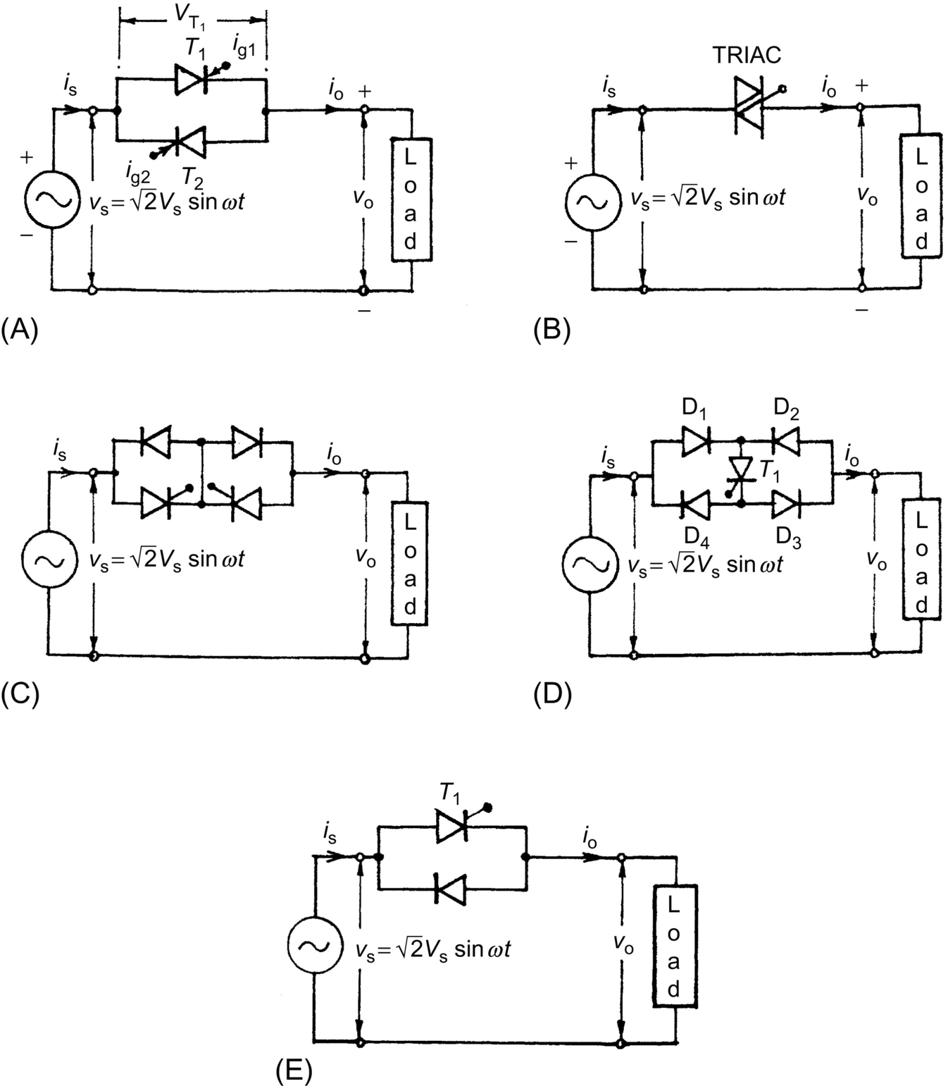

**FIG. 14.1** Single-phase ac voltage controllers: (A) full wave, two SCRs in inverse-parallel; (B) full wave with triac; (C) full wave with two SCRs and two diodes; (D) full wave with four diodes and one SCR; and (E) half wave with one SCR and one diode in antiparallel.

With phase control, the switches conduct the load current for a chosen period of each input cycle of voltage, and with on/off control, either the switches connect the load for a few cycles of input voltage and disconnect it for the next few cycles (*integral cycle control*) or the switches are turned on and off several times within alternate half cycles of input voltage (*ac chopper or pulse*-*width modulated* (*PWM*) *ac voltage controller*).

### 14.2.1 PHASE-CONTROLLED SINGLE-PHASE AC VOLTAGE CONTROLLER

For a full-wave symmetrical phase control, the SCRs *T*1 and *T*2 in [Fig. 14.1A](https://learning.oreilly.com/library/view/power-electronics-handbook/9780128114087/B9780128114070000143_1.xhtml#f0010) are gated at *α* and *π*+*α*, respectively, from the zero crossing of the input voltage; by varying *α*, the power flow to the load is controlled through voltage control in alternate half cycles. As long as one SCR is carrying current, the other SCR remains reverse-biased by the voltage drop across the conducting SCR. The principle of operation in each half cycle is similar to that of the controlled half-wave rectifier, and one can use the same approach for analysis of the circuit.

*Operation with R*-*load*. [Fig. 14.2](https://learning.oreilly.com/library/view/power-electronics-handbook/9780128114087/B9780128114070000143_1.xhtml#f0015) shows the typical voltage and current waveforms for the single-phase bidirectional phase-controlled ac voltage controller of [Fig. 14.1A](https://learning.oreilly.com/library/view/power-electronics-handbook/9780128114087/B9780128114070000143_1.xhtml#f0010) with a resistive load. The output voltage and current waveforms have half-wave symmetry and so no dc component.

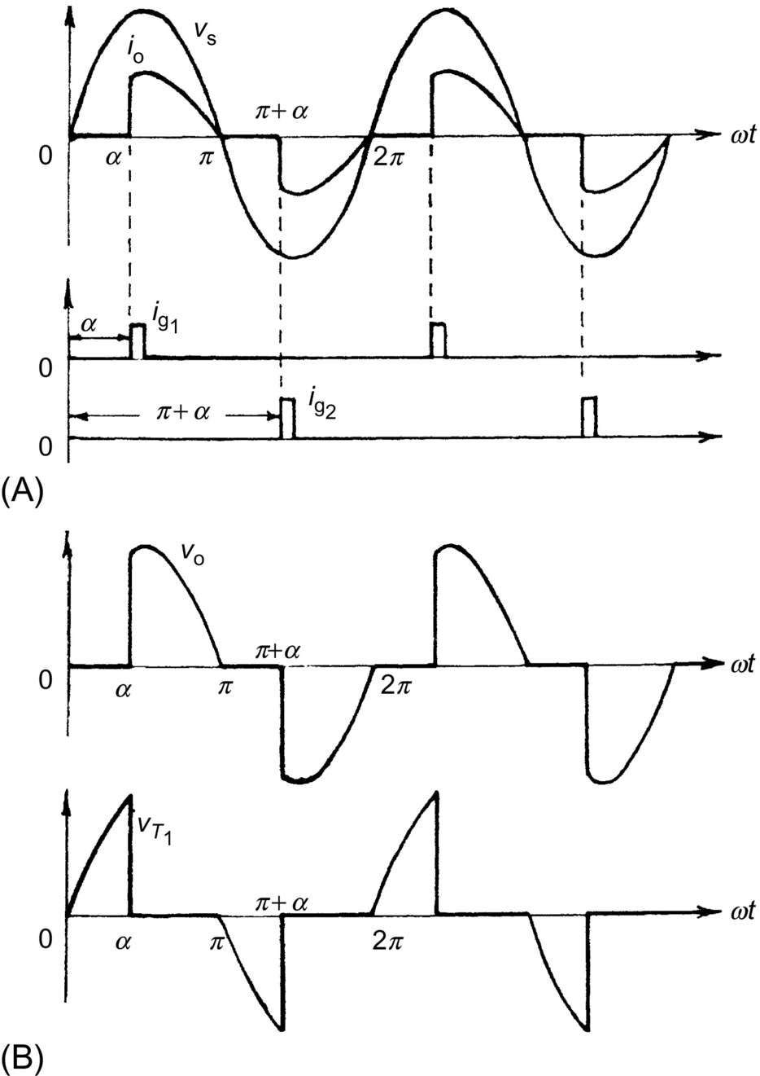

**FIG. 14.2** Waveforms for single-phase ac full-wave voltage controller with R-load.

If  is the source voltage, the rms output voltage with *T*1 triggered at *α* can be found from the half-wave symmetry as

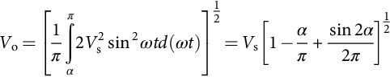 **(14.1)**

Note that *V*o can be varied from *V*s to 0 by varying *α* from 0 to *π*:

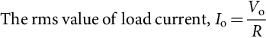 **(14.2)**

**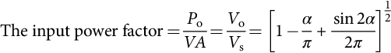** **(14.3)**

**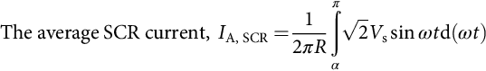** **(14.4)**

Since each SCR carries half the line current, the rms current in each SCR is

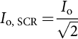 **(14.5)**

*Operation with RL Load*. [Fig. 14.3](https://learning.oreilly.com/library/view/power-electronics-handbook/9780128114087/B9780128114070000143_1.xhtml#f0020) shows the voltage and current waveforms for the controller in [Fig. 14.1A](https://learning.oreilly.com/library/view/power-electronics-handbook/9780128114087/B9780128114070000143_1.xhtml#f0010) with RL load. Due to the inductance, the current carried by the SCR *T*1 may not fall to zero at  when the input voltage goes negative and may continue till , the extinction angle, as shown. The conduction angle,

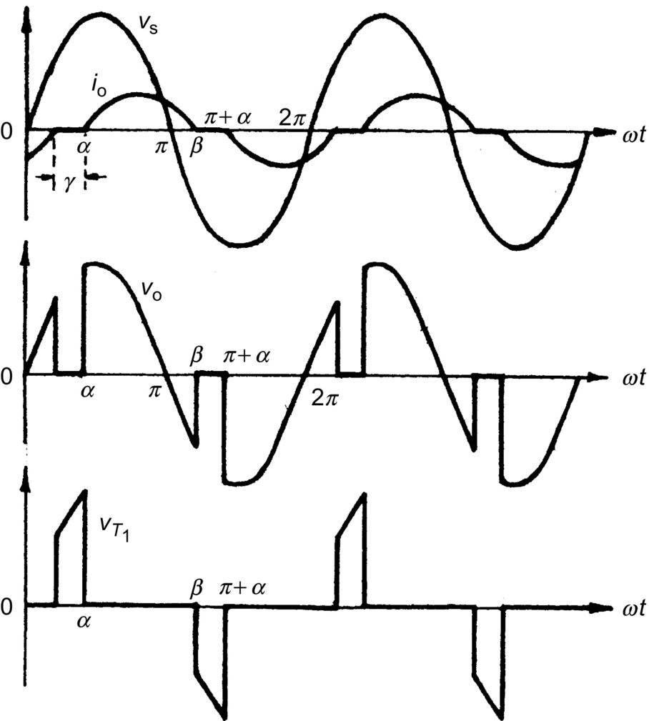

**FIG. 14.3** Typical waveforms of single-phase ac voltage controller with an RL load.

 **(14.6)**

of the SCR depends on the firing delay angle *α* and the load impedance angle *ϕ*.

The expression for the load current *I*o(*ωt*), when conducting from *α* to *β*, can be derived in the same way as that used for a phase-controlled rectifier in a discontinuous mode by solving the relevant Kirchhoff's voltage equation:

 **(14.7)**

where  and .

The angle *β*, when the current *i*o falls to zero, can be determined from the following transcendental equation resulted by using  in Eq. [(14.7)](https://learning.oreilly.com/library/view/power-electronics-handbook/9780128114087/B9780128114070000143_1.xhtml#fo0040):

 **(14.8)**

From Eqs. [(14.6)](https://learning.oreilly.com/library/view/power-electronics-handbook/9780128114087/B9780128114070000143_1.xhtml#fo0035) and [(14.8)](https://learning.oreilly.com/library/view/power-electronics-handbook/9780128114087/B9780128114070000143_1.xhtml#fo0045), one can obtain a relationship between *θ* and *α* for a given value of *ϕ*, as shown in [Fig. 14.4](https://learning.oreilly.com/library/view/power-electronics-handbook/9780128114087/B9780128114070000143_1.xhtml#f0025), which shows that as *α* is increased, the conduction angle *θ* decreases, and thus, the rms value of the current decreases.

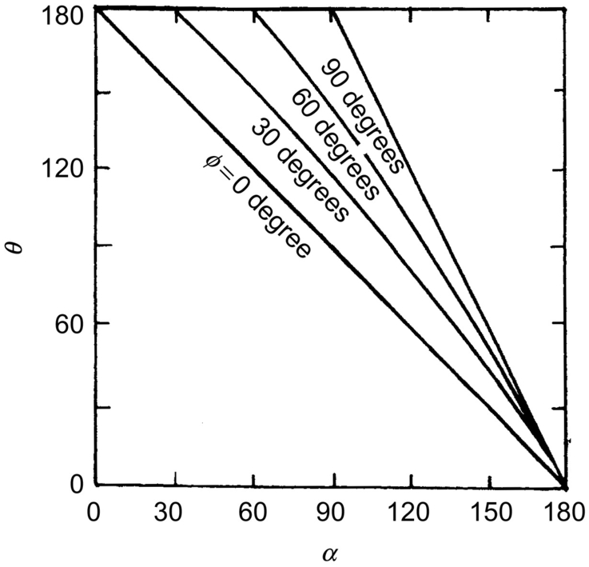

**FIG. 14.4** *θ* versus *α* curves for single-phase ac voltage controller with RL load.

The rms output voltage

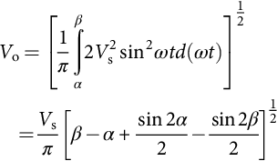 **(14.9)**

*V*o can be evaluated for two possible extreme values of  when , and  when , and the envelope of the voltage control characteristics for this controller is shown in [Fig. 14.5](https://learning.oreilly.com/library/view/power-electronics-handbook/9780128114087/B9780128114070000143_1.xhtml#f0030).

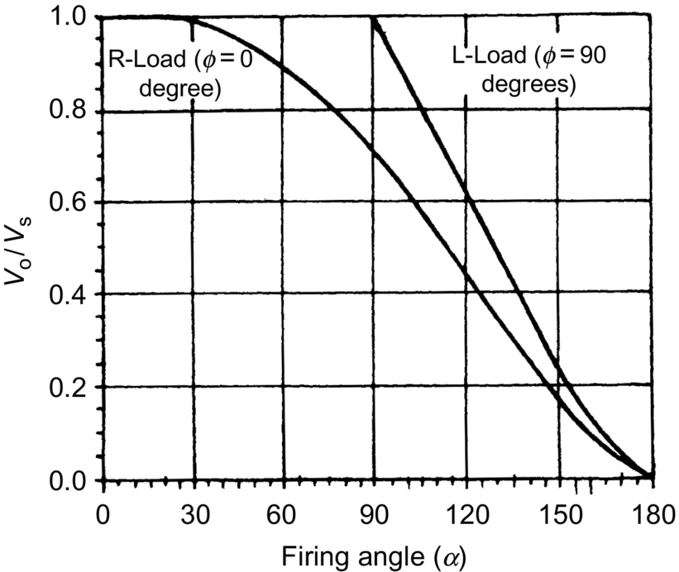

**FIG. 14.5** Envelope of control characteristics of a single-phase ac voltage controller with RL load.

The rms SCR current can be obtained from Eq. [(14.7)](https://learning.oreilly.com/library/view/power-electronics-handbook/9780128114087/B9780128114070000143_1.xhtml#fo0040) as follows:

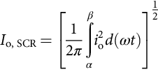 **(14.10)**

**** **(14.11)**

**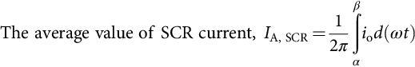** **(14.12)**

*Gating Signal Requirements*. For the inverse-parallel SCRs as shown in [Fig. 14.1A](https://learning.oreilly.com/library/view/power-electronics-handbook/9780128114087/B9780128114070000143_1.xhtml#f0010), the gating signals of SCRs must be isolated from one another because there is no common cathode. For R-load, each SCR stops conducting at the end of each half cycle and under this condition, single short pulses may be used for gating as shown in [Fig. 14.2](https://learning.oreilly.com/library/view/power-electronics-handbook/9780128114087/B9780128114070000143_1.xhtml#f0015). With RL load, however, this single short pulse gating is not suitable as shown in [Fig. 14.6](https://learning.oreilly.com/library/view/power-electronics-handbook/9780128114087/B9780128114070000143_1.xhtml#f0035). When SCR *T*2 is triggered at , SCR *T*1 is still conducting due to the load inductance. By the time the SCR *T*1 stops conducting at *β*, the gate pulse for SCR *T*2 has already ceased and *T*2 will fail to turn on resulting the converter to operate as a single-phase rectifier with conduction of *T*1 only. This necessitates the application of a sustained gate pulse in the form of either a continuous signal for the half-cycle period or better a train of pulses (carrier frequency gating) as the former results in increased dissipation in SCR gate circuit, and a large isolating pulse transformer is required.

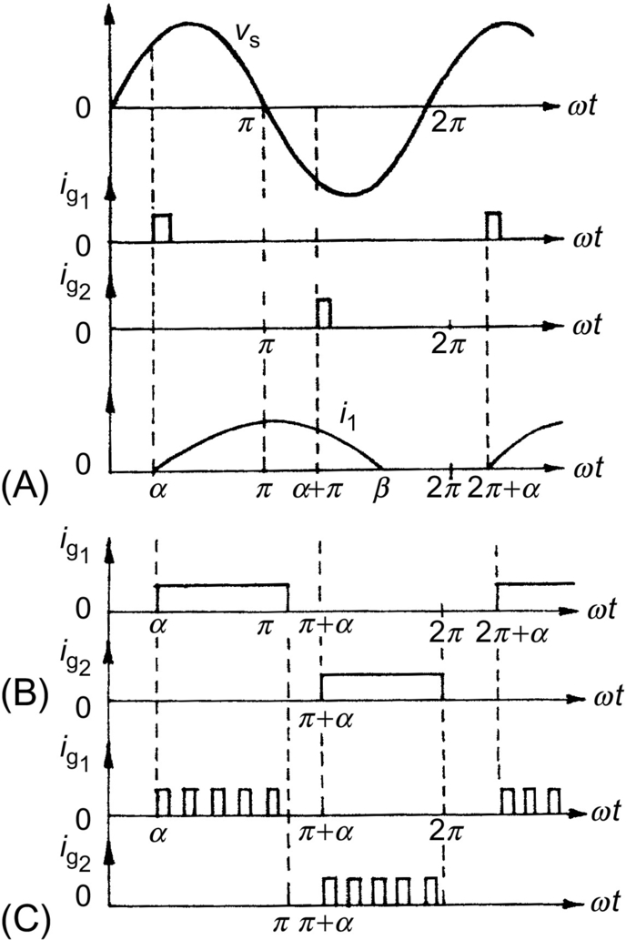

**FIG. 14.6** Single-phase full-wave controller with RL load: gate pulse requirements.

*Operation with* . If , then from Eq. [(14.8)](https://learning.oreilly.com/library/view/power-electronics-handbook/9780128114087/B9780128114070000143_1.xhtml#fo0045),

 **(14.13)**

and

 **(14.14)**

As the conduction angle *θ* cannot exceed *π* and the load current must pass through zero, the control range of the firing angle is . With narrow gating pulses and , only one SCR will conduct resulting in a rectifier action as shown. Even with a train of pulses, if , the changes in the firing angle will not change the output voltage and current but both the SCRs will conduct for the period *π* with *T*1 becoming on at  and *T*2 at .

The duration of this *dead zone* ( to *ϕ*), which varies with the load impedance angle *ϕ*, is not a desirable feature in closed-loop control schemes. An alternative approach to the phase control with respect to the input voltage zero crossing has been visualized in which the firing angle is defined with respect to the instant when it is the load current, not the input voltage, that reaches zero, this angle being called *the hold*-*off angle* (*γ*) *or the control angle* (as marked in [Fig. 14.3](https://learning.oreilly.com/library/view/power-electronics-handbook/9780128114087/B9780128114070000143_1.xhtml#f0020)). This method needs sensing the load current, which may otherwise be required in a closed-loop controller for monitoring or control purposes.

*Power Factor and Harmonics*. As in the case of phase-controlled rectifiers, the important limitations of the phase-controlled ac voltage controllers are the poor power factor and the introduction of harmonics in the source currents. As seen from Eq. [(14.3)](https://learning.oreilly.com/library/view/power-electronics-handbook/9780128114087/B9780128114070000143_1.xhtml#fo0020), the input power factor depends on *α*, and as *α* increases, the power factor decreases.

The harmonic distortion increases and the quality of the input current decreases with increase of firing angle. The variations of low-order harmonics with the firing angle as computed by Fourier analysis of the voltage waveform of [Fig. 14.2](https://learning.oreilly.com/library/view/power-electronics-handbook/9780128114087/B9780128114070000143_1.xhtml#f0015) (with R-load) are shown in [Fig. 14.7](https://learning.oreilly.com/library/view/power-electronics-handbook/9780128114087/B9780128114070000143_1.xhtml#f0040). Only odd harmonics exist in the input current because of half-wave symmetry.

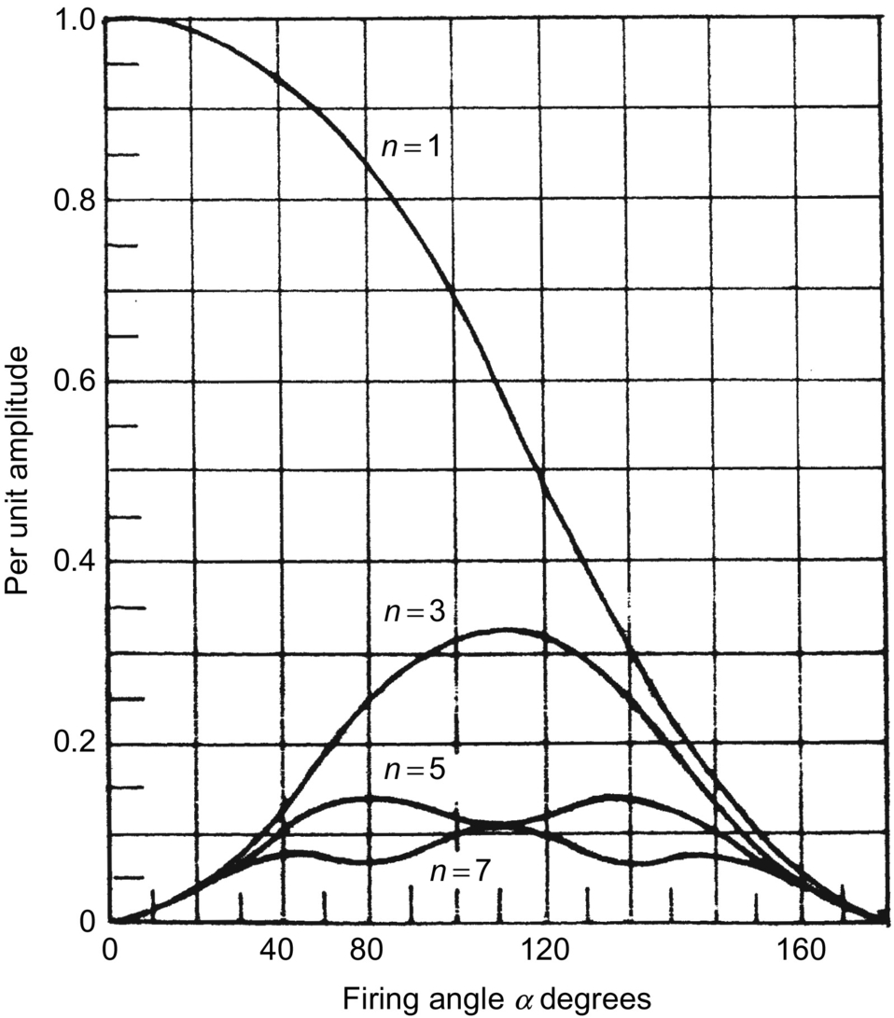

**FIG. 14.7** Harmonic content as a function of the firing angle for a single-phase voltage controller with RL load.

### 14.2.2 SINGLE-PHASE AC-AC VOLTAGE CONTROLLER WITH ON/OFF CONTROL

*Integral Cycle Control*. As an alternative to the phase control, the method of integral cycle control or burst firing is used for systems with large time constants, for example, heating loads. Here, the switch is turned on for a time *tn* with *n* integral cycles and turned off for a time *tm* with *m* integral cycles ([Fig. 14.8](https://learning.oreilly.com/library/view/power-electronics-handbook/9780128114087/B9780128114070000143_1.xhtml#f0045)). As the SCRs or triacs used here are turned on at the zero crossing of the input voltage and turn off occurs at zero current, supply harmonics and radio-frequency interference are very low.



**FIG. 14.8** Integral cycle control: (A) typical load voltage waveforms and (B) power factor with the duty cycle *k*.

However, subharmonic frequency components may be generated, which are undesirable because they may set up subharmonic resonance in the power supply system, cause lamp flicker, and may interfere with the natural frequencies of motor loads causing shaft oscillations.

For sinusoidal input voltage, , the rms output voltage

 **(14.15)**

**** **(14.16)**

which is poorer for lower values of the duty cycle *k*.

*PWM AC Chopper*. As in the case of controlled rectifier, the performance of ac voltage controllers can be improved in terms of harmonics, quality of output current, and input power factor by PWM control in PWM ac choppers; the circuit configuration of one such single-phase unit is shown in [Fig. 14.9](https://learning.oreilly.com/library/view/power-electronics-handbook/9780128114087/B9780128114070000143_1.xhtml#f0050). Here, fully controlled switches *S*1 and *S*2 connected in antiparallel are turned on and off many times during the positive and negative half cycles of the input voltage, respectively. *S*1′ and *S*2′ provide the freewheeling paths for the load current when *S*1 and *S*2 are off. An input capacitor filter may be provided to attenuate the high switching frequency currents drawn from the supply and also to improve the input power factor. [Fig. 14.10](https://learning.oreilly.com/library/view/power-electronics-handbook/9780128114087/B9780128114070000143_1.xhtml#f0055) shows the typical output voltage and load current waveform for a single-phase PWM ac chopper. It can be shown that the control characteristics of an ac chopper depend on the *modulation index M*, which theoretically varies from 0 to 1.



**FIG. 14.9** Single-phase PWM ac chopper circuit.



**FIG. 14.10** Typical output voltage and current waveforms of a single-phase PWM ac chopper.

Three-phase PWM choppers consist of three single-phase choppers connected in either delta or four-wire (star) configuration.

## 14.3 Three-Phase AC-AC Voltage Controllers

### **14.3.1 PHASE-CONTROLLED THREE-PHASE AC VOLTAGE CONTROLLERS**

*Various Configurations*. Several possible circuit configurations for three-phase phase-controlled ac regulators with star- or delta-connected loads are shown in [Fig. 14.11A–H](https://learning.oreilly.com/library/view/power-electronics-handbook/9780128114087/B9780128114070000143_1.xhtml#f0060).



**FIG. 14.11** Three-phase ac voltage controller circuit configurations.

The configurations in (A) and (B) can be realized by three single-phase ac regulators operating independently of each other, and they are easy to analyze. In (A), the SCRs are to be rated to carry line currents and withstand phase voltages, whereas in (B) they should be capable to carry phase currents and withstand the line voltage. In (B), the line currents are free from triplen harmonics while these are present in the closed delta. The power factor in (B) is slightly higher. The firing angle control range for both these circuits is 0–180 degrees for R-load.

The circuits in (C) and (D) are three-phase three-wire circuits and are complicated to analyze. In both these circuits, at least two SCRs, one in each phase, must be gated simultaneously to get the controller started by establishing a current path between the supply lines. This necessitates two firing pulses spaced at 60 degrees apart per cycle for firing each SCR. The operation modes are defined by the number of SCRs conducting in these modes. The firing control range is 0–150 degrees. The triplen harmonics are absent in both these configurations.

Another configuration is shown in (E) when the controllers are connected in delta and the load is connected between the supply and the converter. Here, current can flow between two lines even if one SCR is conducting so each SCR requires one firing pulse per cycle. The voltage and current ratings of SCRs are nearly the same as that of the circuit (B). It is also possible to reduce the number of devices to three SCRs in delta as shown in (F), connecting one source terminal directly to one load circuit terminal. Each SCR is provided with gate pulses in each cycle spaced at 120 degrees apart. In both (E) and (F), each end of each phase must be accessible. The number of devices in (F) is less, but their current ratings must be higher.

As in the case of single-phase phase-controlled voltage regulator, the total regulator cost can be reduced by replacing six SCRs by three SCRs and three diodes, resulting in three-phase *half*-*wave controlled* unidirectional ac regulators as shown in (G) and (H) for star- and delta-connected loads. The main drawback of these circuits is the large harmonic content in the output voltage—particularly, the second harmonic because of the asymmetry. However, the dc components are absent in the line. The maximum firing angle in the half-wave controlled regulator is 210 degrees.

### 14.3.2 FULLY CONTROLLED THREE-PHASE THREE-WIRE AC VOLTAGE CONTROLLER

*Star*-*connected Load with Isolated Neutral*. The analysis of operation of the full-wave controller with isolated neutral as shown in [Fig. 14.11C](https://learning.oreilly.com/library/view/power-electronics-handbook/9780128114087/B9780128114070000143_1.xhtml#f0060) is, as mentioned, quite complicated in comparison with that of a single-phase controller, particularly for an RL or motor load. As a simple example, the operation of this controller with a simple star-connected R-load is considered here. The six SCRs are turned on in the sequence 1-2-3-4-5-6 at 60 degrees intervals, and the gate signals are sustained throughout the possible conduction angle.

The output phase voltage waveforms for *α*=30, 75, and 120 degrees for a balanced three-phase R-load are shown in [Fig. 14.12](https://learning.oreilly.com/library/view/power-electronics-handbook/9780128114087/B9780128114070000143_1.xhtml#f0065). At any interval, either three SCRs or two SCRs or no SCRs may be on, and the instantaneous output voltages to the load are either a line-to-neutral voltage (three SCRs on) or one-half of the line-to-line voltage (two SCRs on) or zero (no SCR on).



**FIG. 14.12** Output voltage waveforms for a three-phase ac voltage controller with star-connected R-load: (A) *v*an for , (B) *v*an for , and (C) .

Depending on the firing angle *α*, there may be *three* operatin*g* modes:

*Mode I* (*also known as Mode 2*/*3*). 0 degrees≤*α*≤60 degrees; There are periods when *three* SCRs are conducting, one in each phase for either direction, and there are periods when just *two* SCRs conduct.

For example, with *α*=30 degrees in [Fig. 14.12A](https://learning.oreilly.com/library/view/power-electronics-handbook/9780128114087/B9780128114070000143_1.xhtml#f0065), assume that at , SCRs *T*5 and *T*6 are conducting, and the current through the R-load in a-phase is zero making . At , *T*1 receives a gate pulse and starts conducting; *T*5 and *T*6 remain on, and . The current in *T*5 reaches zero at 60 degrees, turning *T*5 off. With *T*1 and *T*6 staying on, . At 90 degrees, *T*2 is turned on, the three SCRs *T*1, *T*2, and *T*6 are then conducting, and . At 120 degrees, *T*6 turns off, leaving *T*1 and *T*2 on, so . Thus, with the progress of firing in sequence till *α*=60 degrees, the number of SCRs conducting at a particular instant alternates between two and three.

*Mode II* (*also known as Mode 2*/*2*). 60 degrees≤*α*≤90 degrees; Two SCRs, one in each phase, always conduct.

For *α*=75 degrees as shown in [Fig. 14.12B](https://learning.oreilly.com/library/view/power-electronics-handbook/9780128114087/B9780128114070000143_1.xhtml#f0065), just prior to *α*=75 degrees, SCRs *T*5 and *T*6 were conducting, and . At 75 degrees, *T*1 is turned on, and *T*6 continues to conduct, whereas *T*5 turns off as *v*CN is negative. . When *T*2 is turned on at 135 degrees, *T*6 is turned off, and . The next SCR to turn on is *T*3, which turns off *T*1, and . One SCR is always turned off when another is turned on in this range of *α*, and the output voltage is either one-half line-to-line voltage or zero.

*Mode III* (*also known as Mode 0*/*2*). 90 degrees≤*α*≤150 degrees, when *none* or *two* SCRs conduct.

For *α*=120 degrees, [Fig. 14.12C](https://learning.oreilly.com/library/view/power-electronics-handbook/9780128114087/B9780128114070000143_1.xhtml#f0065), earlier, no SCRs were on, and . At *α*=120 degrees, SCR *T*1 is given a gate signal, whereas *T*6 has a gate signal already applied. Since *v*AB is positive, *T*1 and *T*6 are forward-biased, and they begin to conduct, and . Both *T*1 and *T*6 turn off when *v*AB becomes negative. When a gate signal is given to *T*2, it turns on, and *T*1 turns on again.

For α>150 degrees, there is no period when two SCRs are conducting and the output voltage is zero at *α*=150 degrees. Thus, the range of the firing angle control is 0 degrees≤*α*≤150 degrees.

For *star*-*connected R*-*load*, assuming the instantaneous phase voltages as

 **(14.17)**

the expressions for the rms output phase voltage *V*o can be derived for the three modes as follows:

 **(14.18)**

**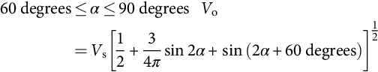** **(14.19)**

**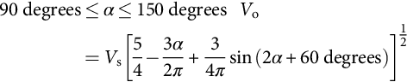** **(14.20)**

For *star*-*connected pure L*-*load*, the effective control starts at *α*>90 degrees, and the expressions for two ranges of *α* are as follows:

 **(14.21)**

**** **(14.22)**

The control characteristics for these two limiting cases (*ϕ*=0 for R-load and *ϕ*=90 degrees for L-load) are shown in [Fig. 14.13](https://learning.oreilly.com/library/view/power-electronics-handbook/9780128114087/B9780128114070000143_1.xhtml#f0070). Here also, like the single-phase case, the dead zone may be avoided by controlling the voltage with respect to the control angle or hold-off angle (*γ*) from the zero crossing of current in place of the firing angle *α*.



**FIG. 14.13** Envelope of control characteristics for a three-phase full-wave ac voltage controller.

*RL Load*. The analysis of the three-phase voltage controller with star-connected RL load with isolated neutral is quite complicated, since the SCRs do not cease to conduct at voltage zero, and the extinction angle *β* is to be known by solving the transcendental equation for the case. In this case, the mode II operation disappears [[1](https://learning.oreilly.com/library/view/power-electronics-handbook/9780128114087/B9780128114070000143_2.xhtml#bb0010)], and the operation shift from mode I to mode III depends on the so-called critical angle *α*crit [[2](https://learning.oreilly.com/library/view/power-electronics-handbook/9780128114087/B9780128114070000143_2.xhtml#bb0015),[3](https://learning.oreilly.com/library/view/power-electronics-handbook/9780128114087/B9780128114070000143_2.xhtml#bb0020)], which can be evaluated from a numerical solution of the relevant transcendental equations. Computer simulation by either PSPICE program [[4](https://learning.oreilly.com/library/view/power-electronics-handbook/9780128114087/B9780128114070000143_2.xhtml#bb0025),[5](https://learning.oreilly.com/library/view/power-electronics-handbook/9780128114087/B9780128114070000143_2.xhtml#bb0030)] or switching-variable approach coupled with an iterative procedure [[6](https://learning.oreilly.com/library/view/power-electronics-handbook/9780128114087/B9780128114070000143_2.xhtml#bb0035)] is a practical means of obtaining the output voltage waveform in this case. [Fig. 14.14](https://learning.oreilly.com/library/view/power-electronics-handbook/9780128114087/B9780128114070000143_1.xhtml#f0075) shows typical simulation results using the later approach [[6](https://learning.oreilly.com/library/view/power-electronics-handbook/9780128114087/B9780128114070000143_2.xhtml#bb0035)] for a three-phase voltage controller-fed RL load for *α*=60, 90, and 105 degrees, which agree with the corresponding practical oscillograms given in [[7](https://learning.oreilly.com/library/view/power-electronics-handbook/9780128114087/B9780128114070000143_2.xhtml#bb0040)].



**FIG. 14.14** Typical simulation results for three-phase ac voltage controller-fed RL load () for , 90*°*, and 105*°*.

*Delta*-*Connected R*-*Load*. The configuration is shown in [Fig. 14.11B](https://learning.oreilly.com/library/view/power-electronics-handbook/9780128114087/B9780128114070000143_1.xhtml#f0060). The voltage across an R-load is the corresponding line-to-line voltage when one SCR in that phase is on. [Fig. 14.15](https://learning.oreilly.com/library/view/power-electronics-handbook/9780128114087/B9780128114070000143_1.xhtml#f0080) shows the line and phase currents for *α*=130 and 90 degrees with an R-load. The firing angle *α* is measured from the zero crossing of the line-to-line voltage, and the SCRs are turned on in the sequence as they are numbered. As in the single-phase case, the range of firing angle is  degrees. The line currents can be obtained from the phase currents as follows:



**FIG. 14.15** Waveforms of a three-phase ac voltage controller with a delta-connected R-load: (A)  and (B) .

 **(14.23)**

The line currents depend on the firing angle and may be discontinuous as shown. Due to the delta connection, the triplen harmonic currents flow around the closed delta and do not appear in the line. The rms value of the line current varies between the range

 **(14.24)**

as the conduction angle varies from very small (large *α*) to 180 degrees ().

## 14.4 Cycloconverters

In contrast to the ac voltage controllers operating at constant frequency discussed so far, a cycloconverter operates as a direct ac-ac frequency changer with inherent voltage control feature. The basic principle of this converter to construct an alternating voltage wave of lower frequency from successive segment of voltage waves of higher frequency ac supply by a switching arrangement was conceived and patented in the 1920s. Grid-controlled mercury-arc rectifiers were used in these converters installed in Germany in the 1930s to obtain  single-phase supply for ac series traction motors from a three-phase 50 Hz system, while at the same time, a cycloconverter using 18 thyratrons supplying a 400 hp synchronous motor was in operation for some years as a power station auxiliary drive in the United States. However, the practical and commercial utilization of these schemes waited till the SCRs became available in the 1960s. With the development of large-power SCRs and microprocessor-based control, the cycloconverter today is a matured practical converter for application in large-power low-speed variable-voltage variable-frequency (VVVF) ac drives in cement and steel rolling mills and in variable-speed constant-frequency (VSCF) systems in aircrafts and naval ships.

A cycloconverter is a naturally commuted converter with inherent capability of bidirectional power flow, and there is no real limitation on its size unlike an SCR inverter with commutation elements. Here, the switching losses are considerably low, the regenerative operation at full power over complete speed range is inherent and it delivers a nearly sinusoidal waveform resulting in minimum torque pulsation and harmonic heating effects. It is capable of operating even with blowing out of individual SCR fuse (unlike inverter), and the requirements regarding turn-off time, current rise time, and *dv*/*dt* sensitivity of SCRs are low. The main limitations of a naturally commutated cycloconverter are (1) limited frequency range for subharmonic free and efficient operation and (2) poor input displacement/power factor, particularly at low-output voltages.

### 14.4.1 SINGLE-PHASE TO SINGLE-PHASE CYCLOCONVERTER

Though rarely used, the operation of a single-phase to single-phase cycloconverter is useful to demonstrate the basic principle involved. [Fig. 14.16A](https://learning.oreilly.com/library/view/power-electronics-handbook/9780128114087/B9780128114070000143_1.xhtml#f0085) shows the power circuit of a single-phase bridge type of cycloconverter, which has the same arrangement as that of a single-phase dual converter. The firing angles of the individual two-pulse two-quadrant bridge converters are continuously modulated here, so that each ideally produces the same fundamental ac voltage at its output terminals as marked in the simplified equivalent circuit in [Fig. 14.16B](https://learning.oreilly.com/library/view/power-electronics-handbook/9780128114087/B9780128114070000143_1.xhtml#f0085). Because of the unidirectional current-carrying property of the individual converters, it is inherent that the positive half cycle of the current is carried by the P-converter and the negative half cycle of the current by the N-converter regardless of the phase of the current with respect to the voltage. This means that for a reactive load, each converter operates in both rectifying and inverting region during the period of the associated half cycle of the low-frequency output current.



**FIG. 14.16** (A) Power circuit for a single-phase bridge cycloconverter and (B) simplified equivalent circuit of a cycloconverter.

*Operation with R*-*Load*. [Fig. 14.17](https://learning.oreilly.com/library/view/power-electronics-handbook/9780128114087/B9780128114070000143_1.xhtml#f0090) shows the input and output voltage waveforms with a pure R-load for a  cycloconverter. The P- and N-converters operate for alternate *T*o/2 periods. The output frequency (1/*T*o) can be varied by varying *T*o and the voltage magnitude by varying the firing angle *α* of the SCRs. As shown in the figure, three cycles of the ac input wave are combined to produce one cycle of the output frequency to reduce the supply frequency to one-third across the load.



**FIG. 14.17** Input and output waveforms of a  cycloconverter with RL load.

If *α*P is the firing angle of the P-converter, the firing angle of the N-converter *α*N is , and the average voltage of the P-converter is equal and opposite to that of the N-converter.

The inspection of [Fig. 14.17](https://learning.oreilly.com/library/view/power-electronics-handbook/9780128114087/B9780128114070000143_1.xhtml#f0090) shows that the waveform with *α* remaining fixed in each half cycle generates a square wave having a large low-order harmonic content. A near approximation to sine wave can be synthesized by a phase modulation of the firing angles as shown in [Fig. 14.18](https://learning.oreilly.com/library/view/power-electronics-handbook/9780128114087/B9780128114070000143_1.xhtml#f0095) for a 50–10 Hz cycloconverter. The harmonics in the load voltage waveform are less compared with earlier waveform. The supply current, however, contains a subharmonic at the output frequency for this case as shown.



**FIG. 14.18** Waveforms of a single-phase to single-phase cycloconverter (50–10 Hz) with RL load: (A) load voltage and load current and (B) input supply current.

*Operation with RL Load*. The cycloconverter is capable of supplying loads of any power factor. [Fig. 14.19](https://learning.oreilly.com/library/view/power-electronics-handbook/9780128114087/B9780128114070000143_1.xhtml#f0100) shows the idealized output voltage and current waveforms for a lagging power factor load where both the converters are operating as rectifier and inverter at the intervals marked. The load current lags the output voltage, and the load current direction determines which converter is conducting. Each converter continues to conduct after its output voltage changes polarity, and during this period, the converter acts as an inverter, and the power is returned to the ac source. Inverter operation continues till the other converter starts to conduct. By controlling the frequency of oscillation and the *depth of modulation* of the firing angles of the converters (as shown later), it is possible to control the frequency and the amplitude of the output voltage.



**FIG. 14.19** Idealized load voltage and current waveform for a cycloconverter with RL load.

The load current with RL load may be continuous or discontinuous depending on the load phase angle, *ϕ*. At light load inductance or for , there may be discontinuous load current with short zero-voltage periods. The current wave may contain even harmonics and subharmonic components. Further, as in the case of dual converter, although the mean output voltage of the two converters is equal and opposite, the instantaneous values may be unequal and a circulating current can flow within the converters. This circulating current can be limited by having a center-tapped reactor connected between the converters or can be completely eliminated by logical control similar to the dual converter case when the gate pulses to the converter remaining idle are suppressed, when the other converter is active. In practice, a zero-current interval of short duration is needed, in addition, between the operation of the P- and N-converters to ensure that the supply lines of the two converters are not short-circuited. With circulating current-free operation, the control scheme becomes complicated if the load current is discontinuous.

In the case of the circulating current scheme, the converters are kept in virtually continuous conduction over the whole range, and the control circuit is simple. To obtain reasonably good sinusoidal voltage waveform using the line-commutated two-quadrant converters and eliminate the possibility of the short circuit of the supply voltages, the output frequency of the cycloconverter is limited to a much lower value of the supply frequency. The output voltage waveform and the output frequency range can be improved further by using converters of higher pulse numbers.

### 14.4.2 THREE-PHASE CYCLOCONVERTERS

#### **14.4.2.1 Three-Phase Three-Pulse Cycloconverter**

[Fig. 14.20A](https://learning.oreilly.com/library/view/power-electronics-handbook/9780128114087/B9780128114070000143_1.xhtml#f0105) shows the schematic diagram of a three-phase half-wave (three-pulse) cycloconverter feeding a single-phase load and [Fig. 14.20B](https://learning.oreilly.com/library/view/power-electronics-handbook/9780128114087/B9780128114070000143_1.xhtml#f0105) the configuration of a three-phase half-wave (three-pulse) cycloconverter feeding a three-phase load. The basic process of a three-phase cycloconversion is illustrated in [Fig. 14.20C](https://learning.oreilly.com/library/view/power-electronics-handbook/9780128114087/B9780128114070000143_1.xhtml#f0105) at 15 Hz, 0.6 power factor lagging load from a 50 Hz supply. As the firing angle *α* is cycled from zero at “a” to 180 degrees at “j,” half a cycle of output frequency is produced (the gating circuit is to be suitably designed to introduce this oscillation of the firing angle). For this load, it can be seen that although the mean output voltage reverses at X, the mean output current (assumed sinusoidal) remains positive until Y. During XY, the SCRs A, B, and C in P-converter are “inverting.”



**FIG. 14.20** (A) Three-phase half-wave (three-pulse) cycloconverter supplying a single-phase load, (B) three-pulse cycloconverter supplying a three-phase load, and (C) output voltage waveform for one phase of a three-pulse cycloconverter operating at 15 Hz from a 50 Hz supply and 0.6 power factor lagging load.

A similar period exists at the end of the negative half cycle of the output voltage when D, E, and F SCRs in N-converter are “inverting.” Thus, the operation of the converter follows in the order of “rectification” and “inversion” in a cyclic manner; the relative durations are dependent on load power factor. The output frequency is that of the firing angle oscillation about a quiescent point of 90 degrees (condition when the mean output voltage, given by , is zero). For obtaining the positive half cycle of the voltage, firing angle *α* is varied from 90 to 0 degrees, and then to 90 degrees and, for the negative half cycle, from 90, to 180 degrees, and back to 90 degrees. Variation of *α* within the limits of 180 degrees automatically provides for “natural” line commutation of the SCRs. It is shown that a complete cycle of low-frequency output voltage is fabricated from the segments of the three-phase input voltage by using the phase-controlled converters. The P-converter or N-converter SCRs receive firing pulses, which are timed such that each converter delivers the same mean output voltage. This is achieved, as in the case of single-phase cycloconverter or the dual converter, by maintaining the firing angle constraints of the two groups as . However, the instantaneous voltages of two converters are not identical, and large circulating current may result unless limited by intergroup reactor as shown (*circulating current cycloconverter*) or completely suppressed by removing the gate pulses from the nonconducting converter by an intergroup blanking logic (*circulating current*-*free cycloconverter*).

*Circulating*-*Current Mode Operation*. [Fig. 14.21](https://learning.oreilly.com/library/view/power-electronics-handbook/9780128114087/B9780128114070000143_1.xhtml#f0110) shows typical waveforms of a three-pulse cycloconverter operating with circulating current. Each converter conducts continuously with rectifying and inverting modes as shown, and the load is supplied with an average voltage of two converters reducing some of the ripple in the process, the intergroup reactor behaving as a potential divider. The reactor limits the circulating current; the value of its inductance to the flow of load current is one-fourth of its value to the flow of circulating current as the inductance is proportional to the square of the number of turns. The fundamental wave produced by both the converters is the same. The reactor voltage is the instantaneous difference between the converter voltages, and the time integral of this voltage divided by the inductance (assuming negligible circuit resistance) is the circulating current. For a three-pulse cycloconverter, it can be observed that this current reaches its peak when  and .



**FIG. 14.21** Waveforms of a three-pulse cycloconverter with circulating current.

*Output Voltage Equation*. A simple expression for the fundamental rms output voltage of the cycloconverter and the required variation of the firing angle *α* can be derived with the following assumptions: (1) the firing angle *α* in successive half cycles is varied slowly resulting in a low-frequency output, (2) the source impedance and the commutation overlap are neglected, (3) the SCRs are ideal switches, and (4) the current is continuous and ripple-free. The average dc output voltage of a p-pulse dual converter with fixed *α* is

 **(14.25)**

For the p-pulse dual converter operating as a cycloconverter, the average phase voltage output at any point of the low frequency should vary according to the equation

 **(14.26)**

where *V*o1,max is the desired maximum value of the fundamental output of the cycloconverter.

Comparing Eq. [(14.25)](https://learning.oreilly.com/library/view/power-electronics-handbook/9780128114087/B9780128114070000143_1.xhtml#fo0130) with Eq. [(14.26)](https://learning.oreilly.com/library/view/power-electronics-handbook/9780128114087/B9780128114070000143_1.xhtml#fo0135), the required variation of *α* to obtain a sinusoidal output is given by

 **(14.27)**

where *r* is the ratio (*V*o1,max/*V*domax), the *voltage magnitude control ratio*.

Eq. [(14.27)](https://learning.oreilly.com/library/view/power-electronics-handbook/9780128114087/B9780128114070000143_1.xhtml#fo0140) shows *α* as a nonlinear function with  as shown in [Fig. 14.22](https://learning.oreilly.com/library/view/power-electronics-handbook/9780128114087/B9780128114070000143_1.xhtml#f0115).



**FIG. 14.22** Variations of the firing angle (*α*) with *r* in a cycloconverter.

However, the firing angle *α*P of the P-converter cannot be reduced to 0 degrees as this corresponds to  for the N-converter, which, in practice, cannot be achieved because of allowance for commutation overlap and finite turn-off time of the SCRs. Thus, the firing angle *α*P can be reduced to a certain finite value *α*min, and the maximum output voltage is reduced by a factor cos *α*min.

The fundamental rms voltage per phase of either converter is

 **(14.28)**

Though the rms values of the low-frequency output voltage of the P-converter and that of the N-converter are equal, the actual waveforms differ, and the output voltage at the midpoint of the circulating current-limiting reactor ([Fig. 14.21](https://learning.oreilly.com/library/view/power-electronics-handbook/9780128114087/B9780128114070000143_1.xhtml#f0110)), which is the same as the load voltage, is obtained as the mean of the instantaneous output voltages of the two converters.

*Circulating Current*-*free Mode Operation*. [Fig. 14.23](https://learning.oreilly.com/library/view/power-electronics-handbook/9780128114087/B9780128114070000143_1.xhtml#f0120) shows the typical waveforms for a three-pulse cycloconverter operating in this mode with RL load assuming *continuous*-*current* operation. Depending on the load current direction, only one converter operates at a time, and the load voltage is the same as the output voltage of the conducting converter. As explained earlier in the case of single-phase cycloconverter, there is a possibility of short circuit of the supply voltages at the crossover points of the converter unless taken care of in the control circuit. The waveforms drawn also neglect the effect of overlap due to the ac supply inductance. A reduction in the output voltage is possible by retarding the firing angle gradually at the points a, b, c, d, and e in [Fig. 14.23](https://learning.oreilly.com/library/view/power-electronics-handbook/9780128114087/B9780128114070000143_1.xhtml#f0120). (This can be easily implemented by reducing the magnitude of the reference voltage in the control circuit.) The circulating current is completely suppressed by blocking all the SCRs in the converter, which is not delivering the load current. A current sensor is incorporated in each output phase of the cycloconverter, which detects the direction of the output current and feeds an appropriate signal to the control circuit to inhibit or blank the gating pulses to the nonconducting converter in the same way as in the case of a dual converter for dc drives. The circulating current-free operation improves the efficiency and the displacement factor of the cycloconverter and also increases the maximum usable output frequency. The load voltage transfers smoothly from one converter to the other.



**FIG. 14.23** Waveforms for a three-pulse circulating current-free cycloconverter with RL load.

#### **14.4.2.2 Three-Phase Six-Pulse and Twelve-Pulse Cycloconverter**

A six-pulse cycloconverter circuit configuration is shown in [Fig. 14.24](https://learning.oreilly.com/library/view/power-electronics-handbook/9780128114087/B9780128114070000143_1.xhtml#f0125). Typical load voltage waveforms for 6-pulse (with 36 SCRs) and 12-pulse (with 72 SCRs) cycloconverters are shown in [Fig. 14.25](https://learning.oreilly.com/library/view/power-electronics-handbook/9780128114087/B9780128114070000143_1.xhtml#f0130), the 12-pulse converter being obtained by connecting two six-pulse configurations in series and appropriate transformer connections for the required phase shift. It may be seen that the higher pulse numbers will generate waveforms closer to the desired sinusoidal form and thus permit higher frequency output. The phase loads may be isolated from each other as shown or interconnected with suitable secondary winding connections.



**FIG. 14.24** Three-phase six-pulse cycloconverter with isolated loads.



**FIG. 14.25** Cycloconverter load voltage waveforms with lagging power factor load: (A) six-pulse connection and (B) twelve-pulse connection.

### 14.4.3 CYCLOCONVERTER CONTROL SCHEME

Various possible control schemes, analog and digital, for deriving trigger signals and for controlling the basic cycloconverter have been developed over the years.

Out of the several possible signal combinations, it has been shown [[8](https://learning.oreilly.com/library/view/power-electronics-handbook/9780128114087/B9780128114070000143_2.xhtml#bb0045)] that a sinusoidal reference signal () at desired output frequency *f*o and a cosine modulating signal () at input frequency *f*i is the best combination possible for comparison to derive the trigger signals for the SCRs ([Fig. 14.26](https://learning.oreilly.com/library/view/power-electronics-handbook/9780128114087/B9780128114070000143_1.xhtml#f0135) [[9](https://learning.oreilly.com/library/view/power-electronics-handbook/9780128114087/B9780128114070000143_2.xhtml#bb0050)]), which produces the output waveform with the lowest total harmonic distortion. The modulating voltages can be obtained as the phase-shifted voltages (B-phase for A-phase SCRs, C-phase voltage for B-phase SCRs, and so on) as explained in [Fig. 14.27](https://learning.oreilly.com/library/view/power-electronics-handbook/9780128114087/B9780128114070000143_1.xhtml#f0140), where at the intersection point “a”



**FIG. 14.26** Deriving firing signals for one converter group of a three-pulse cycloconverter.



**FIG. 14.27** Derivation of the cosine modulating voltages.



From [Fig. 14.27](https://learning.oreilly.com/library/view/power-electronics-handbook/9780128114087/B9780128114070000143_1.xhtml#f0140), the firing delay for A-phase SCR, 



The cycloconverter output voltage for continuous-current operation,

 **(14.29)**

in which the equation shows that the amplitude, frequency, and phase of the output voltage can be controlled by controlling corresponding parameters of the reference voltage, thus making the transfer characteristic of the cycloconverter linear. The derivation of the two complimentary voltage waveforms for the P-group or N-group converter “banks” in this way is illustrated in [Fig. 14.28](https://learning.oreilly.com/library/view/power-electronics-handbook/9780128114087/B9780128114070000143_1.xhtml#f0145). The final cycloconverter output wave shape is composed of alternate half-cycle segments of the complementary P-converter and the N-converter output voltage waveforms that coincide with the positive and negative current half cycles, respectively.



**FIG. 14.28** Derivation of P-converter and N-converter output voltages.

*Control Circuit Block Diagram*. [Fig. 14.29](https://learning.oreilly.com/library/view/power-electronics-handbook/9780128114087/B9780128114070000143_1.xhtml#f0150) [[10](https://learning.oreilly.com/library/view/power-electronics-handbook/9780128114087/B9780128114070000143_2.xhtml#bb0055)] shows a simplified block diagram of the control circuit for a circulating current-free cycloconverter implemented with ICs in the early seventies in the Power Electronics Laboratory at IIT Kharagpur in India. The same circuit is also applicable to a circulating current cycloconverter with the omission of the *converter group selection and blanking* circuit.



**FIG. 14.29** Block diagram for a circulating current-free cycloconverter control circuit.

The *synchronizing circuit* produces the modulating voltages (, , ), synchronized with the mains through step-down transformers and proper filter circuits.

The *reference source* produces variable-magnitude variable-frequency three-phase voltages (*e*ra, *e*rb, *e*rc) for comparison with the modulation voltages. Various ways, analog or digital, have been developed to implement this reference source as in the case of the PWM inverter. In one of the early analog schemes, [Fig. 14.30](https://learning.oreilly.com/library/view/power-electronics-handbook/9780128114087/B9780128114070000143_1.xhtml#f0155) [[10](https://learning.oreilly.com/library/view/power-electronics-handbook/9780128114087/B9780128114070000143_2.xhtml#bb0055)], for a three-pulse cycloconverter, a variable-frequency UJT relaxation oscillator of frequency 6*f*d triggers a ring counter to produce a three-phase square-wave output of frequency *f*d that is used to modulate a single-phase fixed frequency (*f*c) variable amplitude sinusoidal voltage in a three-phase full-wave transistor chopper. The three-phase output contains (), (), (), etc. frequency components from where the “wanted” frequency component () is filtered out for each phase using a low-pass filter. For example, with  and frequency of the relaxation oscillator varying between 2820 and 3180 Hz, a three-phase 0–30 Hz reference output can be obtained with the facility for phase sequence reversal.



**FIG. 14.30** Block diagram of a variable-voltage variable-frequency three-phase reference source.

The *logic and trigger circuit* for each phase involves comparators for comparison of the reference and modulating voltages and inverters acting as buffer stages. The outputs of the comparators are used to clock the flip-flops or latches whose outputs in turn feed the SCR gates through AND gates and pulse amplifying and isolation circuits; the second input to the AND gates is from the *converter group selection and blanking circuit*.

In the *converter group selection and blanking circuit*, the zero crossing of the current at the end of each half cycle is detected and is used to regulate the control signals to either P-group or N-group converters depending on whether the current goes to zero from negative to positive or positive to negative, respectively. However, in practice, the current being discontinuous passes through multiple zero crossings while changing direction, which may lead to undesirable switching of the converters. So, in addition to the current signal, the reference voltage signal is also used for the group selection, and a *threshold* band is introduced in the current signal detection to avoid inadvertent switching of the converters. Further, a delay circuit provides a blanking period of appropriate duration between the converter groups switching to avoid line-to-line short circuits [[10](https://learning.oreilly.com/library/view/power-electronics-handbook/9780128114087/B9780128114070000143_2.xhtml#bb0055)]. In some schemes, the delays are not introduced when a small circulating current is allowed during crossover instants limited by reactors of limited size, and this scheme operates in the so-called “dual mode”—circulating current and circulating current-free mode for minor and major portions of the output cycle, respectively. A different approach to the converter group selection, based on the closed-loop control of the output voltage where a bias voltage is introduced between the voltage transfer characteristics of the converters to reduce circulating current, is discussed in [[8](https://learning.oreilly.com/library/view/power-electronics-handbook/9780128114087/B9780128114070000143_2.xhtml#bb0045)].

*Improved Control Schemes*. With the development of microprocessors and PC-based systems, digital software control has taken over many tasks in modern cycloconverters, particularly in replacing the low-level reference waveform generation and analog signal comparison units. The reference waveforms can be easily generated in the computer, stored in the EPROMs, and accessed under the control of a stored program and microprocessor clock oscillator. The analog signal voltages can be converted to digital signals by using analog-to-digital converters (ADCs). The waveform comparison can then be made with the comparison features of the microprocessor system. The addition of time delays and intergroup blanking can also be achieved with digital techniques and computer software. A modification of the cosine firing control using communication principles, such as *regular sampling* in preference to the *natural sampling* (discussed so far) of the reference waveform, yielding a stepped sine wave before comparison with the cosine wave [[11](https://learning.oreilly.com/library/view/power-electronics-handbook/9780128114087/B9780128114070000143_2.xhtml#bb0060)] has been shown to reduce the presence of *subharmonics* (discussed later) in the circulating current cycloconverter and facilitate microprocessor-based implementation, as in the case of PWM inverter.

For a six-pulse noncirculating current cycloconverter-fed synchronous motor drive with a vector control scheme and a flux observer, a PC-based hybrid control scheme (a combination of analog and digital control) has been reported in [[12](https://learning.oreilly.com/library/view/power-electronics-handbook/9780128114087/B9780128114070000143_2.xhtml#bb0065)]. Here, the functions such as comparison, group selection, blanking between the groups and triggering signal generation, and filtering and phase conversion are left to the analog controller and digital controller that take care of more serious tasks such as voltage decoupling for current regulation; flux estimation using observer; speed, flux and field current regulators using PI-controllers; and position and speed calculation leading to an improvement of sampling time and design accuracy.

### 14.4.4 CYCLOCONVERTER HARMONICS AND INPUT CURRENT WAVEFORM

The exact wave shape of the output voltage of the cycloconverter depends on (1) the pulse number of the converter, (2) the ratio of the output to input frequency (*f*o/*f*i), (3) the relative level of the output voltage, (4) the load displacement angle, (5) the circulating current or circulating current-free operation, and (6) the method of control of the firing instants. The harmonic spectrum of a cycloconverter output voltage is different and more complex than that of a phase-controlled converter. It has been revealed [[8](https://learning.oreilly.com/library/view/power-electronics-handbook/9780128114087/B9780128114070000143_2.xhtml#bb0045)] that because of the continuous “to-and-fro” phase modulation of the converter firing angles, the harmonic distortion components (known as *necessary distortion terms*) have frequencies that are sums and differences between multiples of output and input supply frequencies.

*Circulating Current*-*Free Operation*. A derived general expression for the output voltage of a cycloconverter with circulating current-free operation [[8](https://learning.oreilly.com/library/view/power-electronics-handbook/9780128114087/B9780128114070000143_2.xhtml#bb0045)] shows the following spectrum of harmonic frequencies for the 3-pulse, 6-pulse, and 12-pulse cycloconverters employing cosine modulation technique:

 **(14.30)**

where *k* is any integer from 1 to infinity and *n* is any integer from 0 to infinity.

It may be observed that for certain ratios of *f*o/*f*i, the order of harmonics may be less or equal to the desired output frequency. All such harmonics are known as *subharmonics*, since they are not higher multiples of the input frequency. These subharmonics may have considerable amplitudes (e.g., with a 50 Hz input frequency and 35 Hz output frequency, a subharmonic of frequency  is produced whose magnitude is 12.5% of the 35 Hz component [[11](https://learning.oreilly.com/library/view/power-electronics-handbook/9780128114087/B9780128114070000143_2.xhtml#bb0060)]) and are difficult to filter and so objectionable. Their spectrum increase with the increase of the ratio *f*o/*f*i and so limits its value at which a tolerable waveform can be generated.

*Circulating*-*Current Operation*. For circulating current operation with continuous current, the harmonic spectrum in the output voltage is the same as that of the circulating current-free operation except that each harmonic family now terminates at a definite term, rather than having infinite number of components. They are

 **(14.31)**

The amplitude of each harmonic component is a function of the output voltage ratio for the circulating current cycloconverter and the output voltage ratio and the load displacement angle for the circulating current-free mode.

From the point of view of maximum useful attainable output-to-input frequency ratio (*f*i/*f*o) with the minimum amplitude of objectionable harmonic components, a guideline is available in [[8](https://learning.oreilly.com/library/view/power-electronics-handbook/9780128114087/B9780128114070000143_2.xhtml#bb0045)] for it as 0.33, 0.5, and 0.75 for 3-, 6-, and 12-pulse cycloconverter, respectively. However, with the modification of the cosine-wave modulation timings like *regular sampling* [[11](https://learning.oreilly.com/library/view/power-electronics-handbook/9780128114087/B9780128114070000143_2.xhtml#bb0060)] in the case of circulating current cycloconverters only and using a *subharmonic detection and feedback control concept* [[13](https://learning.oreilly.com/library/view/power-electronics-handbook/9780128114087/B9780128114070000143_2.xhtml#bb0070),[14](https://learning.oreilly.com/library/view/power-electronics-handbook/9780128114087/B9780128114070000143_2.xhtml#bb0075)] for both circulating and circulating current-free cases, the subharmonics can be suppressed, and useful frequency range for the naturally commutated cycloconverters can be increased.

*Other Harmonic Distortion Terms*. Besides the harmonics as mentioned, other harmonic distortion terms consisting of frequencies of integral multiples of desired output frequency appear if the transfer characteristic between the output and reference voltages is not linear. These are called *unnecessary distortion terms* that are absent when the output frequencies are much less than the input frequency. Further, some *practical distortion terms* may appear due to some practical nonlinearities and imperfections in the control circuits of the cycloconverter, particularly at relatively lower levels of output voltage.

*Input Current Waveform*. Although the load current, particularly for higher pulse cycloconverters can be assumed to be sinusoidal, the input current is more complex being made of pulses. Assuming the cycloconverter to be an ideal switching circuit without losses, it can be shown from the instantaneous power balance equation that in cycloconverter supplying a single-phase load, the input current has harmonic components of frequencies  called *characteristic harmonic frequencies* that are independent of pulse number, and they result in an oscillatory power transmittal to the ac supply system. In the case of cycloconverter feeding a balanced three-phase load, the net instantaneous power is the sum of the three oscillating instantaneous powers when the resultant power is constant, and the net harmonic component is much reduced compared with that of a single-phase load case. In general, the total rms value of the input current waveform consists of three components: in-phase, quadrature, and the harmonic. The in-phase component depends on the active power output, while the quadrature component depends on the net average of the oscillatory firing angle and is always lagging.

### 14.4.5 CYCLOCONVERTER INPUT DISPLACEMENT/POWER FACTOR

The input supply performance of a cycloconverter such as displacement factor or fundamental power factor, input power factor, and the input current distortion factor is defined similar to those of the phase-controlled converter. The harmonic factor for the case of a cycloconverter is relatively complex as the harmonic frequencies are not simple multiples of the input frequency but are sums and differences between multiples of output and input frequencies.

Irrespective of the nature of the load, leading, lagging, or unity power factor, the cycloconverter requires reactive power decided by the average firing angle. At low-output voltage, the average phase displacement between the input current and the voltage is large, and the cycloconverter has a low input displacement and power factor. Besides load displacement factor and output voltage ratio, another component of the reactive current arises due to the modulation of the firing angle in the fabrication process of the output voltage [[8](https://learning.oreilly.com/library/view/power-electronics-handbook/9780128114087/B9780128114070000143_2.xhtml#bb0045)]. In a phase-controlled converter supplying dc load, the maximum displacement factor is unity for maximum dc output voltage. However, in the case of the cycloconverter, the maximum input displacement factor is 0.843 with unity power factor load [[8](https://learning.oreilly.com/library/view/power-electronics-handbook/9780128114087/B9780128114070000143_2.xhtml#bb0045),[15](https://learning.oreilly.com/library/view/power-electronics-handbook/9780128114087/B9780128114070000143_2.xhtml#bb0080)]. The displacement factor decreases with reduction in the output voltage ratio. The distortion factor of the input current is given by (*I*1/*I*), which is always less than 1, and the resultant power factor (= distortion factor × displacement factor) is thus much lower (around 0.76 maximum) than the displacement factor, and this is a serious disadvantage of the naturally commutated cycloconverter (NCC).

### 14.4.6 EFFECT OF SOURCE IMPEDANCE

The source inductance introduces commutation overlap and affects the external characteristics of a cycloconverter similar to the case of a phase-controlled converter with the dc output. It introduces delay in transfer of current from one SCR to another and results in a voltage loss at the output and a modified harmonic distortion. At the input, the source impedance causes “rounding off” of the steep edges of the input current waveforms, resulting in reduction in the amplitudes of higher order harmonic terms and a decrease in the input displacement factor.

### 14.4.7 SIMULATION ANALYSIS OF CYCLOCONVERTER PERFORMANCE

The nonlinearity and discrete time nature of practical cycloconverter systems, particularly for discontinuous-current conditions, make an exact analysis quite complex, and a valuable design and analytic tool is a digital computer simulation of the system. Two general methods of computer simulation of the cycloconverter waveforms for RL and induction motor loads with circulating current and circulating current-free operation have been suggested in [[16](https://learning.oreilly.com/library/view/power-electronics-handbook/9780128114087/B9780128114070000143_2.xhtml#bb0085)] where one of the methods that is very fast and convenient is the *crossover point method* that gives the crossover points (intersections of the modulating and reference waveforms) and the conducting phase numbers for both P- and N-converters from which the output waveforms for a particular load can be digitally computed at any interval of time for a practical cycloconverter.

### 14.4.8 POWER QUALITY ISSUES

Degradation of power quality (PQ) in a cycloconverter-fed system due to subharmonics/interharmonics in the input and the output has been a subject of recent studies [[14](https://learning.oreilly.com/library/view/power-electronics-handbook/9780128114087/B9780128114070000143_2.xhtml#bb0075),[17](https://learning.oreilly.com/library/view/power-electronics-handbook/9780128114087/B9780128114070000143_2.xhtml#bb0090)]. In [[17](https://learning.oreilly.com/library/view/power-electronics-handbook/9780128114087/B9780128114070000143_2.xhtml#bb0090)], the study includes the impact of cycloconverter control strategies on the total harmonic distortion (THD), distribution transformers, and communication lines, while in [[14](https://learning.oreilly.com/library/view/power-electronics-handbook/9780128114087/B9780128114070000143_2.xhtml#bb0075)], the PQ indices are suitably defined and the effect on THD, input/output displacement factor, and input/output power factor for a cycloconverter-fed synchronous motor drive is studied together with a development of a simple feedback method of reduction of subharmonics/low-frequency interharmonics for the improvement of the power quality. The implementation of this scheme, detailed in [[14](https://learning.oreilly.com/library/view/power-electronics-handbook/9780128114087/B9780128114070000143_2.xhtml#bb0075)], requires a simple modification of the control circuit of the cycloconverter in contrast to the expensive power level active filters otherwise required for suppression of such harmonics [[18](https://learning.oreilly.com/library/view/power-electronics-handbook/9780128114087/B9780128114070000143_2.xhtml#bb0095)].

### 14.4.9 FORCED COMMUTATED CYCLOCONVERTER

The naturally commutated cycloconverter (NCC) with SCRs as devices, so far discussed, is sometimes referred to as a *restricted frequency changer*; in view of the allowance on the output voltage quality ratings, the maximum output voltage frequency is restricted (), as mentioned earlier. With devices replaced by fully controlled switches like forced commutated SCRs, power transistors, IGBTs, and GTOs, a forced commutated cycloconverter can be built where the desired output frequency is given by , where *f*s is the switching frequency, which may be larger or smaller than the *f*i. In the case when , the converter is called *unrestricted frequency changer* (*UFC*) and when , it is called a *slow switching frequency changer* (*SSFC*). The early FCC structures have been comprehensively treated in [[15](https://learning.oreilly.com/library/view/power-electronics-handbook/9780128114087/B9780128114070000143_2.xhtml#bb0080)]. It has been shown that in contrast with the NCC, where the input displacement factor (IDF) is always lagging, in UFC, it is leading when the load displacement factor is lagging and vice versa, and in SSFC, it is identical to that of the load. Further, with proper control in an FCC, the input displacement factor can be made unity displacement factor frequency changer (UDFFC) with concurrent composite voltage waveform or controllable displacement factor frequency changer (CDFFC), where P-converter and N-converter voltage segments can be shifted relative to the output current wave for control of IDF continuously from lagging via unity to leading.

In addition to allowing bilateral power flow, UFCs offer an unlimited output frequency range, offer good input voltage utilization, do not generate input current and output voltage subharmonics, and require only nine bidirectional switches ([Fig. 14.31](https://learning.oreilly.com/library/view/power-electronics-handbook/9780128114087/B9780128114070000143_1.xhtml#f0160)) for a three-phase to three-phase conversion. The main disadvantage of the structures treated in [[15](https://learning.oreilly.com/library/view/power-electronics-handbook/9780128114087/B9780128114070000143_2.xhtml#bb0080)] is that they generate large unwanted low-order input current and output voltage harmonics that are difficult to filter out, particularly for low-output voltage conditions. This problem has largely been solved with an introduction of an imaginative PWM voltage control scheme in [[19](https://learning.oreilly.com/library/view/power-electronics-handbook/9780128114087/B9780128114070000143_2.xhtml#bb0100)], which is the basis of the newly designated converter called the *matrix converter* (*also known as PWM cycloconverter*) that operates as a *generalized solid*-*state transformer* with significant improvement in voltage and input current waveforms resulting in sine-wave input and sine-wave output as discussed in the next section.



**FIG. 14.31** (A)  matrix converter circuit with input filter and clamp circuit; bidirectional switch configuration as (B) common emitter, (C) common collector, (D) transistor-diode bridge configuration, and (E) reverse blocking IGBT (RB-IGBT); and (F) switching matrix symbol for converter in (A).

## 14.5 Matrix Converter

The matrix converter (MC) is a development of the FCC that employs bidirectional fully controlled switches, incorporating PWM voltage control, as mentioned earlier. With the initial progress made by Venturini [[19](https://learning.oreilly.com/library/view/power-electronics-handbook/9780128114087/B9780128114070000143_2.xhtml#bb0100)–[21](https://learning.oreilly.com/library/view/power-electronics-handbook/9780128114087/B9780128114070000143_2.xhtml#bb0110)], it has received considerable attention in recent years as it provides a good alternative to the conventionally employed rectifier-inverter topology or the back-to-back topology, having the advantages of being a single-stage converter with only nine switches for three-phase to three-phase conversion and inherent bidirectional power flow, sinusoidal input/output waveforms with moderate switching frequency, possibility of a compact design due to the absence of bulky dc link reactive components, and controllable input power factor independent of the output load current. Along with these theoretical advantages, [[22](https://learning.oreilly.com/library/view/power-electronics-handbook/9780128114087/B9780128114070000143_2.xhtml#bb0115)] has mentioned advantages of MCs over conventional dc link variant as exhibition of better operation under high-temperature conditions, less voltage stress per switch, and less maintenance. The main disadvantages of the matrix converters developed so far are the inherent restriction of the *voltage transfer ratio* (0.866); more complex control, commutation, and protection strategy; and, above all, commercial nonavailability of a fully controlled bidirectional high frequency switch integrated in a silicon chip.

The power circuit diagram of the most practical three-phase to three-phase () matrix converter is shown in [Fig. 14.31A](https://learning.oreilly.com/library/view/power-electronics-handbook/9780128114087/B9780128114070000143_1.xhtml#f0160), which uses nine bidirectional switches so arranged that any of the three-input phases can be connected to any output phase as is shown symbolically in the switching matrix in [Fig. 14.31F](https://learning.oreilly.com/library/view/power-electronics-handbook/9780128114087/B9780128114070000143_1.xhtml#f0160). The circuit is called a *matrix converter* as it provides exactly one switch for each of the possible connections between the input and the output. The voltage at any input terminal may be made to appear at any output terminal or terminals, while the current in any phase of the load may be drawn from any phase or phases of the input supply under following restrictions:

(a) *Only one* switch of the output leg can be closed due to the presence of capacitors.

(b) *At least one* switch in the output leg must be closed, as the inductive nature of the load makes it impossible to interrupt the load current suddenly.

Thus, *one and* *only one switch* in the output leg is to be closed. With these constraints, it can be visualized that out of the possible 512  states of the converter, only 27 switch combinations are allowed as given in [Table 14.1](https://learning.oreilly.com/library/view/power-electronics-handbook/9780128114087/B9780128114070000143_1.xhtml#t0010), which includes the resulting output line voltages and input phase currents. These combinations are divided into three groups. Group I consists of six combinations when each output phase is connected to a different input phase. In group II, there are three subgroups each having six combinations with two-output phases short-circuited (connected to the same input phase). Group III includes three combinations with all output phases short-circuited. For the switches, the inverse-parallel combination of reverse blocking self-controlled devices like power MOSFETs or IGBTs or transistor-embedded diode bridge as shown in [Fig 14.3B–E](https://learning.oreilly.com/library/view/power-electronics-handbook/9780128114087/B9780128114070000143_1.xhtml#f0020) has been used so far. [Fig. 14.31B and C](https://learning.oreilly.com/library/view/power-electronics-handbook/9780128114087/B9780128114070000143_1.xhtml#f0160) are the conventionally employed common emitter and common collector configurations, respectively. These configurations allow *soft switching* from one bidirectional switch to other. The latter has an advantage that it requires less number of insulated power supplies to drive the switches than the former configuration [[23](https://learning.oreilly.com/library/view/power-electronics-handbook/9780128114087/B9780128114070000143_2.xhtml#bb0120)]. New perspective configuration of the bidirectional switch is to use two RB-IGBTs with reverse blocking capability in antiparallel (symbol of which is shown in [Fig 14.31E](https://learning.oreilly.com/library/view/power-electronics-handbook/9780128114087/B9780128114070000143_1.xhtml#f0160)). This configuration leads to elimination of external diodes, which results in reduction in conduction losses and the transistor size [[24](https://learning.oreilly.com/library/view/power-electronics-handbook/9780128114087/B9780128114070000143_2.xhtml#bb0125)].

**Table 14.1**

**Three-phase/three-phase matrix converter switching combinations**

|  |  |  |  |  |  |  |  |  |  |  |  |  |  |  |  |  |  |  |
| --- | --- | --- | --- | --- | --- | --- | --- | --- | --- | --- | --- | --- | --- | --- | --- | --- | --- | --- |
| **Group** | **a** | **b** | **c** | ***v*ab** | ***v*bc** | ***v*ca** | ***i*A** | ***i*B** | ***i*C** | ***S*Aa** | ***S*Ab** | ***S*Ac** | ***S*Ba** | ***S*Bb** | ***S*Bc** | ***S*Ca** | ***S*Cb** | ***S*Cc** |
| I | A | B | C | *v*AB | *v*BC | *v*CA | *i*a | *i*b | *i*c | 1 | 0 | 0 | 0 | 1 | 0 | 0 | 0 | 1 |
|  | A | C | B | si10_e | si11_e | si12_e | *i*a | *i*c | *i*b | 1 | 0 | 0 | 0 | 0 | 1 | 0 | 1 | 0 |
|  | B | A | C | si12_e | si10_e | si11_e | *i*b | *i*a | *i*c | 0 | 1 | 0 | 1 | 0 | 0 | 0 | 0 | 1 |
|  | B | C | A | *v*BC | *v*CA | *v*AB | *i*c | *i*a | *i*b | 0 | 1 | 0 | 0 | 0 | 1 | 0 | 1 | 0 |
|  | C | A | B | *v*CA | *v*AB | *v*BC | *i*b | *i*c | *i*a | 0 | 0 | 1 | 1 | 0 | 0 | 0 | 1 | 0 |
|  | C | B | A | si11_e | si12_e | si10_e | *i*c | *i*b | *i*a | 0 | 0 | 1 | 0 | 1 | 0 | 1 | 0 | 0 |
| II-A | A | C | C | si10_e | 0 | *v*CA | *i*a | 0 | si20_e | 1 | 0 | 0 | 0 | 0 | 1 | 0 | 0 | 1 |
|  | B | C | C | *v*BC | 0 | si11_e | 0 | *i*a | si20_e | 0 | 1 | 0 | 0 | 0 | 1 | 0 | 0 | 1 |
|  | B | A | A | si12_e | 0 | si12_e | si20_e | *i*a | 0 | 0 | 1 | 0 | 1 | 0 | 0 | 1 | 0 | 0 |
|  | C | A | A | *v*CA | 0 | si10_e | si20_e | 0 | *i*a | 0 | 0 | 1 | 1 | 0 | 0 | 1 | 0 | 0 |
|  | C | B | B | si11_e | 0 | *v*BC | 0 | si20_e | *i*a | 0 | 0 | 1 | 0 | 1 | 0 | 0 | 1 | 0 |
|  | A | B | B | *v*AB | 0 | si12_e | *i*a | si20_e | 0 | 1 | 0 | 0 | 0 | 1 | 0 | 0 | 1 | 0 |
| II-B | C | A | C | si10_e | si10_e | 0 | *i*b | 0 | si34_e | 0 | 0 | 1 | 1 | 0 | 0 | 0 | 0 | 1 |
|  | C | B | C | si11_e | *v*BC | 0 | 0 | *i*b | si34_e | 0 | 0 | 1 | 0 | 1 | 0 | 0 | 0 | 1 |
|  | A | B | A | *v*AB | si12_e | 0 | si34_e | *i*b | 0 | 1 | 0 | 0 | 0 | 1 | 0 | 1 | 0 | 0 |
|  | A | C | A | si10_e | *v*CA | 0 | si34_e | 0 | *i*b | 1 | 0 | 0 | 0 | 0 | 1 | 1 | 0 | 0 |
|  | B | C | B | *v*BC | si11_e | 0 | 0 | si34_e | *i*b | 0 | 1 | 0 | 0 | 0 | 1 | 0 | 1 | 0 |
|  | B | A | B | si12_e | *v*AB | 0 | *i*b | si34_e | 0 | 0 | 1 | 0 | 1 | 0 | 0 | 0 | 1 | 0 |
| II-C | C | C | A | 0 | *v*CA | si10_e | *i*c | 0 | si46_e | 0 | 0 | 1 | 0 | 0 | 1 | 1 | 0 | 0 |
|  | C | C | B | 0 | si11_e | *v*BC | 0 | *i*c | si46_e | 0 | 0 | 1 | 0 | 0 | 1 | 0 | 1 | 0 |
|  | A | A | B | 0 | *v*AB | si12_e | si46_e | *i*c | 0 | 1 | 0 | 0 | 1 | 0 | 0 | 0 | 1 | 0 |
|  | A | A | C | 0 | si10_e | *v*CA | si46_e | 0 | *i*c | 1 | 0 | 0 | 1 | 0 | 0 | 0 | 0 | 1 |
|  | B | B | C | 0 | *v*BC | si11_e | 0 | si46_e | *i*c | 0 | 1 | 0 | 0 | 1 | 0 | 0 | 0 | 1 |
|  | B | B | A | 0 | si12_e | *v*AB | *i*c | si46_e | 0 | 0 | 1 | 0 | 0 | 1 | 0 | 1 | 0 | 0 |
| III | A | A | A | 0 | 0 | 0 | 0 | 0 | 0 | 0 | 0 | 0 | 1 | 0 | 0 | 1 | 0 | 0 |
|  | B | B | B | 0 | 0 | 0 | 0 | 0 | 0 | 0 | 0 | 0 | 0 | 1 | 0 | 0 | 1 | 0 |
|  | C | C | C | 0 | 0 | 0 | 0 | 0 | 0 | 0 | 0 | 0 | 0 | 0 | 1 | 0 | 0 | 1 |

With a given set of input three-phase voltages, any desired set of three-phase output voltages can be synthesized by adopting a suitable switching strategy. However, it has been shown [[21](https://learning.oreilly.com/library/view/power-electronics-handbook/9780128114087/B9780128114070000143_2.xhtml#bb0110),[25](https://learning.oreilly.com/library/view/power-electronics-handbook/9780128114087/B9780128114070000143_2.xhtml#bb0130),[26](https://learning.oreilly.com/library/view/power-electronics-handbook/9780128114087/B9780128114070000143_2.xhtml#bb0135)] that regardless of the switching strategy, there are physical limits on the achievable output voltage with these converters as the maximum peak-to-peak output voltage cannot be greater than the minimum voltage difference between two phases of the input. To have complete control of the synthesized output voltage, the envelope of the three-phase reference or target voltages must be fully contained within the continuous envelope of the three-phase input voltages. Initial strategy with the output frequency voltages as references reported the limit as 0.5 of the input as shown in [Fig. 14.32A](https://learning.oreilly.com/library/view/power-electronics-handbook/9780128114087/B9780128114070000143_1.xhtml#f0165). This can be increased to 0.866 by adding a third harmonic voltage of input frequency (*V*i/4)cos3*ω*i*t* to all target output voltages and subtracting from them a third harmonic voltage of output frequency (*V*o/6)cos3*ω*o*t* as shown in [Fig. 14.32B](https://learning.oreilly.com/library/view/power-electronics-handbook/9780128114087/B9780128114070000143_1.xhtml#f0165) [[21](https://learning.oreilly.com/library/view/power-electronics-handbook/9780128114087/B9780128114070000143_2.xhtml#bb0110),[25](https://learning.oreilly.com/library/view/power-electronics-handbook/9780128114087/B9780128114070000143_2.xhtml#bb0130)]. The increase in amplitude is shown through line voltages (*v*ab) in [Fig. 14.32C](https://learning.oreilly.com/library/view/power-electronics-handbook/9780128114087/B9780128114070000143_1.xhtml#f0165). In fact, it is shown in [[26](https://learning.oreilly.com/library/view/power-electronics-handbook/9780128114087/B9780128114070000143_2.xhtml#bb0135)] that the above optimization can be extended to m×n matrix converter (where m and n are both odd) by adding *m*th and subtracting the *n*th harmonic from all the target output voltages. Details on multiphase matrix converters are given in [Chapter 16](https://learning.oreilly.com/library/view/power-electronics-handbook/9780128114087/B9780128114070000179.xhtml). However, this process involves considerable amount of additional computations in synthesizing the output voltages. The other alternative is to use the space vector modulation (SVM) strategy as used in PWM inverters without adding third harmonic components, but it also yields the maximum voltage transfer ratio as 0.866.



**FIG. 14.32** Output phase voltage waveforms for three-phase ac-ac matrix converter: (A) without the addition of harmonics, (B) with inclusion of third harmonic voltages of input and output frequency to the target voltages, and (C) output line voltages (*v*ab) of (A) and (B).

An ac input LC filter is used to eliminate the switching ripples generated in the converter, and the load is assumed to be sufficiently inductive to maintain continuity of the output currents. Work on input side filters can be seen in [[27](https://learning.oreilly.com/library/view/power-electronics-handbook/9780128114087/B9780128114070000143_2.xhtml#bb0140)–[29](https://learning.oreilly.com/library/view/power-electronics-handbook/9780128114087/B9780128114070000143_2.xhtml#bb0150)].

### 14.5.1 OPERATION AND CONTROL OF MATRIX CONVERTER

The converter in [Fig. 14.31](https://learning.oreilly.com/library/view/power-electronics-handbook/9780128114087/B9780128114070000143_1.xhtml#f0160) connects any input phase (A, B, and C) to any output phase (a, b, and c) at any instant. When connected, the voltages *v*an, *v*bn, and *v*cn at the output terminals are related to the input voltages *V*Ao, *V*Bo, and *V*Co as

 **(14.32)**

where *S*Aa through *S*Cc are the switching variables of the corresponding switches shown in [Fig. 14.31](https://learning.oreilly.com/library/view/power-electronics-handbook/9780128114087/B9780128114070000143_1.xhtml#f0160). For a balanced linear star-connected load at the output terminals, the input phase currents are related to the output phase currents by

 **(14.33)**

Note that the matrix of the switching variables in Eq. [(14.33)](https://learning.oreilly.com/library/view/power-electronics-handbook/9780128114087/B9780128114070000143_1.xhtml#fo0180) is a transpose of the respective matrix in Eq. [(14.32)](https://learning.oreilly.com/library/view/power-electronics-handbook/9780128114087/B9780128114070000143_1.xhtml#fo0175). The matrix converter should be controlled using a specific and appropriately timed sequence of the values of the switching variables, which will result in balanced output voltages having the desired frequency and amplitude, while the input currents are balanced and in phase (for unity IDF) or at an arbitrary angle (for controllable IDF) with respect to the input voltages. As the matrix converter, in theory, can operate at any frequency and at the output or input, including zero, it can be employed as a three-phase ac-dc converter, dc/three-phase ac converter, or even a buck/boost dc chopper and thus as a *universal power converter*.

The control methods adopted so far for the matrix converter are quite complex and are subjects of continuing research [[21](https://learning.oreilly.com/library/view/power-electronics-handbook/9780128114087/B9780128114070000143_2.xhtml#bb0110)–[39](https://learning.oreilly.com/library/view/power-electronics-handbook/9780128114087/B9780128114070000143_2.xhtml#bb0200)]. Out of several methods proposed for independent control of the output voltages and input currents, two methods are of wide use and will be briefly reviewed here: (1) the *Venturini* method based on a mathematical approach of transfer function analysis and (2) the *space vector modulation* (SVM) approach (as has been standardized now in the case of PWM control of the dc link inverter).

*Venturini Method*. Given a set of three-phase input voltages with constant amplitude *V*i and frequency , this method calculates a switching function involving the duty cycles of each of the nine bidirectional switches and generates the three-phase output voltages by sequential piecewise sampling of the input waveforms. These output voltages follow a predetermined set of reference or target voltage waveforms and with a three-phase load connected, a set of input currents *I*i and angular frequency *ω*i should be in phase for unity IDF or at a specific angle for controlled IDF.

A transfer function approach is used in [[36](https://learning.oreilly.com/library/view/power-electronics-handbook/9780128114087/B9780128114070000143_2.xhtml#bb0185)] to achieve the abovementioned features by relating the input and output voltages and the output and input currents as

 **(14.34)**

**** **(14.35)**

where the elements of the modulation matrix, *mij*(*t*), () represent the duty cycles of a switch connecting output phase *i* to input phase *j* within a sample switching interval. The elements of *mij*(*t*) are limited by the constraints discussed above and are mathematically written as



The set of three-phase target or reference voltages to achieve the maximum voltage transfer ratio for unity IDF is

 **(14.36)**

where *V*om and *V*im are the magnitudes of output and input fundamental voltages of angular frequencies *ω*o and *ω*i, respectively. With , a general formula for the duty cycles *mij*(*t*) is derived in [[36](https://learning.oreilly.com/library/view/power-electronics-handbook/9780128114087/B9780128114070000143_2.xhtml#bb0185)]. For unity IDF condition, a simplified formula is

 **(14.37)**

where  and .

The method developed as above is based on a *direct transfer function* (*DTF*) approach using a single modulation matrix for the matrix converter, employing the switching combinations of all the three groups in [Table 14.1](https://learning.oreilly.com/library/view/power-electronics-handbook/9780128114087/B9780128114070000143_1.xhtml#t0010). Another approach called *indirect transfer function* (*ITF*) approach [[30](https://learning.oreilly.com/library/view/power-electronics-handbook/9780128114087/B9780128114070000143_2.xhtml#bb0155),[31](https://learning.oreilly.com/library/view/power-electronics-handbook/9780128114087/B9780128114070000143_2.xhtml#bb0160)] considers the matrix converter as a combination of PWM voltage source rectifier-PWM voltage source inverter (VSR-VSI) and employs the already well-established VSR and VSI PWM techniques for MC control utilizing the switching combinations of group II and group III only of [Table 14.1](https://learning.oreilly.com/library/view/power-electronics-handbook/9780128114087/B9780128114070000143_1.xhtml#t0010). The drawback of this approach is that the IDF is limited to unity, and the method also generates higher and fractional harmonic components in the input and the output waveforms. This method can also be found in [[40](https://learning.oreilly.com/library/view/power-electronics-handbook/9780128114087/B9780128114070000143_2.xhtml#bb0205)].

A **simplified direct transfer function approach** at unity IDF can be developed. Eq. [(14.34)](https://learning.oreilly.com/library/view/power-electronics-handbook/9780128114087/B9780128114070000143_1.xhtml#fo0185) and the constraint equations can be rewritten as follows:

 **(14.38)**

*X* is the modulation vector, and the elements can be derived as

 **(14.39)**

*AA*T when solved will have terms  and , so, let  and . Each term of *X*, when [(14.39)](https://learning.oreilly.com/library/view/power-electronics-handbook/9780128114087/B9780128114070000143_1.xhtml#fo0215) is solved, is of similar pattern and can be shown as

 **(14.40)**

where *Mji* is the time-based index corresponding to the switch *Sji* that connects *j*-th output to the *i*-th input. The time duration for which this switch is on, is calculated by multiplying this index with sampling time. Further solving by considering *m* balanced input phases, and finally neglecting the terms with denominators with high value, solution for *m*×*n* matrix converter is written as

 **(14.41)**

A detailed simulation with this modulation scheme can be seen in [[41](https://learning.oreilly.com/library/view/power-electronics-handbook/9780128114087/B9780128114070000143_2.xhtml#bb0210)].

*SVM Method*. The space vector modulation is a well-documented inverter PWM control technique that yields high-voltage gain and less harmonic distortion compared with the other modulation techniques. Here, the three-phase input currents and output voltages are represented as space vectors, and SVM is simultaneously applied to the output voltage and input current space vectors, while the matrix converter is modeled as a rectifying and inverting stage by the *indirect modulation method* ([Fig. 14.33](https://learning.oreilly.com/library/view/power-electronics-handbook/9780128114087/B9780128114070000143_1.xhtml#f0170)). Applications of SVM algorithm to control of matrix converters have appeared extensively in the literature [[33](https://learning.oreilly.com/library/view/power-electronics-handbook/9780128114087/B9780128114070000143_2.xhtml#bb0170)–[38](https://learning.oreilly.com/library/view/power-electronics-handbook/9780128114087/B9780128114070000143_2.xhtml#bb0195),[42](https://learning.oreilly.com/library/view/power-electronics-handbook/9780128114087/B9780128114070000143_2.xhtml#bb0215)–[47](https://learning.oreilly.com/library/view/power-electronics-handbook/9780128114087/B9780128114070000143_2.xhtml#bb0240)] and shown to have inherent capability to achieve full control of the instantaneous output voltage vector and the instantaneous current displacement angle even under supply voltage disturbances. The algorithm is based on the concept that the MC output line voltages for each switching combination can be represented as a voltage space vector defined by



**FIG. 14.33** Indirect modulation model of a matrix converter: (A) VSR-VSI conversion, (B) output voltage switching vector hexagon, and (C) input current switching vector hexagon.

 **(14.42)**

Out of the three groups in [Table 14.1](https://learning.oreilly.com/library/view/power-electronics-handbook/9780128114087/B9780128114070000143_1.xhtml#t0010), only the switching combinations of group II and group III are employed for the SVM method. Group II consists of switching state voltage vectors having constant angular positions and are called *active* or *stationary* vectors. Each subgroup of group II determines the position of the resulting output voltage space vector and the six-state space voltage vectors form a six-sextant hexagon used to synthesize the desired output voltage vector. Group III comprises the *zero* vectors positioned at the center of the output voltage hexagon, and these are suitably combined with the active vectors for the output voltage synthesis.

The modulation method involves selection of the vectors and their on-time computation. At each sampling period *T*s, the algorithm selects four active vectors related to any possible combinations of output voltage and input current sectors in addition to the zero vector to construct a desired reference voltage. The amplitude and the phase angle of the reference voltage vector are calculated, and the desired phase angle of the input current vector is determined in advance. For computation of the on-time periods of the chosen vectors, these are combined into two sets leading to two new vectors adjacent to the reference voltage vector in the sextant and having the same direction as the reference voltage vector. Applying the standard SVM theory, the general formulas derived for the vector on-times that satisfy, at the same time, the reference output voltage and input current displacement angle in [[36](https://learning.oreilly.com/library/view/power-electronics-handbook/9780128114087/B9780128114070000143_2.xhtml#bb0185)] are

 **(14.43)**

where *q* is voltage transfer ratio, *ϕ*i is the input displacement angle chosen to achieve the desired input power factor (with , a maximum value of  is obtained), and *θ*o and *θ*i are the phase displacement angles of the output voltage and input current vectors, respectively, whose values are limited within the 0–60degrees range. The on-time of the zero vector is

 **(14.44)**

The integral value of the reference vector is calculated over one sample time interval as the sum of the products of the two adjacent vectors and their on-time ratios, and the process is repeated at every sample instant.

*Control Implementation and Comparison of the Two Methods*. Both the methods need a digital signal processor (DSP)-based system for their implementation. In one scheme [[36](https://learning.oreilly.com/library/view/power-electronics-handbook/9780128114087/B9780128114070000143_2.xhtml#bb0185)] for the Venturini method, the programmable timers, as available, are used to time out the PWM gating signals. The processor calculates the six-switch duty cycles in each sampling interval, converts them to integer counts, and stores them in the memory for the next sampling period. In the SVM method, an erasable programmable read-only memory (EPROM) is used to store the selected sets of active and zero vectors, and the DSP calculates the on-times of the vectors. Then, with an identical procedure as in the other method, the timers are loaded with the vector on-times to generate PWM waveforms through suitable output ports. The total computation time of the DSP for the SVM method has been found to be much less than that of the Venturini method. Comparison of the two schemes shows that while in the SVM method the switching losses are lower, the Venturini method shows better performance in terms of input current and output voltage harmonics.

A *direct control* method as used in conjunction with the voltage source converters has been developed recently and implemented with a 10 kVA matrix converter [[48](https://learning.oreilly.com/library/view/power-electronics-handbook/9780128114087/B9780128114070000143_2.xhtml#bb0245)]. Moreover, the voltage transfer ratio can be increased by going into overmodulation. Enhanced methods employing SVM are discussed in [[49](https://learning.oreilly.com/library/view/power-electronics-handbook/9780128114087/B9780128114070000143_2.xhtml#bb0250),[50](https://learning.oreilly.com/library/view/power-electronics-handbook/9780128114087/B9780128114070000143_2.xhtml#bb0255)] in which VTR of 0.92 is achieved.

### 14.5.2 COMMUTATION AND PROTECTION ISSUES IN A MATRIX CONVERTER

As the matrix converter has no dc link energy storage, any disturbance in the input supply voltage will affect the output voltage immediately, and a proper protection mechanism has to be incorporated, particularly against overvoltage from the supply and overcurrent in the load side. As mentioned, two types of bidirectional switch configurations have hitherto been used: one, the transistor (now IGBT) embedded in a diode bridge and, the other, the two IGBTs in antiparallel with reverse voltage blocking diodes (shown in [Fig. 14.31B and C](https://learning.oreilly.com/library/view/power-electronics-handbook/9780128114087/B9780128114070000143_1.xhtml#f0160)). In the latter configuration, each diode and IGBT combination operates in two quadrants only, which eliminates the circulating currents otherwise built up in the diode bridge configuration that can be limited by only bulky commutation inductors in the lines.

*Commutation*. The MC does not contain freewheeling diodes that usually achieve safe commutation in the case of other converters. To maintain the continuity of the output current as each switch turns off, the next switch in sequence must be immediately turned on. In practice, with bidirectional switches, a momentary short circuit may develop between the input phases when the switches cross over, and one solution for the configurations shown in [Fig. 14.31B, C, and E](https://learning.oreilly.com/library/view/power-electronics-handbook/9780128114087/B9780128114070000143_1.xhtml#f0160) is to use a *semisoft current commutation* using a multistepped switching procedure to ensure safe commutation [[51](https://learning.oreilly.com/library/view/power-electronics-handbook/9780128114087/B9780128114070000143_2.xhtml#bb0260)–[53](https://learning.oreilly.com/library/view/power-electronics-handbook/9780128114087/B9780128114070000143_2.xhtml#bb0270)]. This method requires independent control of each two-quadrant switches, sensing the direction of the load current and introducing a delay during the change of switching states. The switching rule for proper commutation from S1 to S2 of the arrangement shown in [Fig. 14.34](https://learning.oreilly.com/library/view/power-electronics-handbook/9780128114087/B9780128114070000143_1.xhtml#f0175) for  with the two-quadrant switches for *four*-*stepped commutation* [[51](https://learning.oreilly.com/library/view/power-electronics-handbook/9780128114087/B9780128114070000143_2.xhtml#bb0260),[53](https://learning.oreilly.com/library/view/power-electronics-handbook/9780128114087/B9780128114070000143_2.xhtml#bb0270)] is (a) turn off S1B, (b) turn on S2A, (c) turn off S1A, and (d) turn on S2B.



**FIG. 14.34** Safe commutation scheme.

Analogously, for , the switching rule will be (a) turn off S1A, (b) turn on S2B, (c) turn off S1B, and (d) turn on S2A. These steps for both the cases are shown diagrammatically in [Fig. 14.35](https://learning.oreilly.com/library/view/power-electronics-handbook/9780128114087/B9780128114070000143_1.xhtml#f0180).



**FIG. 14.35** Transition from one bidirectional switch to other employing *semisoft commutation*.

Typically, these commutation strategies are now implemented using programmable logic devices such as field-programmable gate array (FPGA) and programmable logic device (PLD) [[53](https://learning.oreilly.com/library/view/power-electronics-handbook/9780128114087/B9780128114070000143_2.xhtml#bb0270),[54](https://learning.oreilly.com/library/view/power-electronics-handbook/9780128114087/B9780128114070000143_2.xhtml#bb0275)]. Also, it is worth mentioning that the configuration shown in [Fig 14.31D](https://learning.oreilly.com/library/view/power-electronics-handbook/9780128114087/B9780128114070000143_1.xhtml#f0160) has to stick to two-step commutation that despite of having a considerable advantage of employing less number of switches will produce more spikes in the output voltages.

A robust voltage commutation scheme without sacrificing the line side current waveform quality and with minimal information requirement has been reported recently [[55](https://learning.oreilly.com/library/view/power-electronics-handbook/9780128114087/B9780128114070000143_2.xhtml#bb0280)]. Another way to achieve better commutation is by Z-sourcing the input of the matrix converter [[56](https://learning.oreilly.com/library/view/power-electronics-handbook/9780128114087/B9780128114070000143_2.xhtml#bb0285)].

*Protection Strategies*. A clamp capacitor (typically 2 μF for a 3 kW permanent magnet (PM) motor) connected through two three-phase full-bridge diode rectifiers involving additional 12 diodes as shown in [Fig. 14.31A](https://learning.oreilly.com/library/view/power-electronics-handbook/9780128114087/B9780128114070000143_1.xhtml#f0160) (a new configuration has been reported in [[57](https://learning.oreilly.com/library/view/power-electronics-handbook/9780128114087/B9780128114070000143_2.xhtml#bb0290)] where the number of additional diodes is reduced to six using the antiparallel switch diodes at the input and output lines of the MC) serves as a voltage clamp for possible voltage spikes under normal and fault conditions. A new passive protection strategy involving suppressor diodes and varistors for excellent overvoltage protection is discussed recently in [[58](https://learning.oreilly.com/library/view/power-electronics-handbook/9780128114087/B9780128114070000143_2.xhtml#bb0295)], which allows the removal of the large and expensive diode clamp. A snubberless solution for overvoltage protection is presented in [[59](https://learning.oreilly.com/library/view/power-electronics-handbook/9780128114087/B9780128114070000143_2.xhtml#bb0300)].

*Input Filter*. A three-phase single-stage LC filter at the input consisting of three capacitors in star and three inductors in the line is used to adequately attenuate the higher order harmonics and render sinusoidal input current. Typical values of *L* and *C* based on a 415 V converter with a maximum line current of 6.5 A and a switching frequency of 20 kHz are 3 mH and 1.5 μF only [[60](https://learning.oreilly.com/library/view/power-electronics-handbook/9780128114087/B9780128114070000143_2.xhtml#bb0305)]. The filter may cause minor phase shift in the input displacement angle that needs correction. Another filter designs can be seen in [[28](https://learning.oreilly.com/library/view/power-electronics-handbook/9780128114087/B9780128114070000143_2.xhtml#bb0145),[29](https://learning.oreilly.com/library/view/power-electronics-handbook/9780128114087/B9780128114070000143_2.xhtml#bb0150)]. Ref. [[61](https://learning.oreilly.com/library/view/power-electronics-handbook/9780128114087/B9780128114070000143_2.xhtml#bb0310)] lately has employed the input filter capacitors as an energy exchange devices to enhance the *ride*-*through capability* of the matrix converter. Ref. [[62](https://learning.oreilly.com/library/view/power-electronics-handbook/9780128114087/B9780128114070000143_2.xhtml#bb0315)] discusses the designing of an EMI filter for matrix converter applications.

[Fig. 14.36](https://learning.oreilly.com/library/view/power-electronics-handbook/9780128114087/B9780128114070000143_1.xhtml#f0185) shows typical experimental waveforms of output line voltage and line current of an MC. The output line current is mostly sinusoidal except a small ripple, when the switching frequency is around 1 kHz only.



**FIG. 14.36** Experimental waveforms for a matrix converter at 30 Hz frequency from a 50 Hz input: (A) output line voltage and (B) output line current.

### 14.5.3 MULTILEVEL MATRIX CONVERTER

Erickson and Al-Naseem [[63](https://learning.oreilly.com/library/view/power-electronics-handbook/9780128114087/B9780128114070000143_2.xhtml#bb0320)] introduced a multilevel matrix converter with four-quadrant dc link H-bridge switching cells as shown in [Fig 14.37](https://learning.oreilly.com/library/view/power-electronics-handbook/9780128114087/B9780128114070000143_1.xhtml#f0190) in 2001. These are suitable for medium- or high-voltage ac-to-ac power conversion. The use of four transistors in the switch cell of [Fig. 14.37A](https://learning.oreilly.com/library/view/power-electronics-handbook/9780128114087/B9780128114070000143_1.xhtml#f0190) allows the average current to be doubled, relative to the conventional matrix converter whose four-quadrant switches are realized using two transistors and two diodes. With dc capacitor, the switch cell is capable of producing instantaneous voltages , 0, . These converters can both increase and decrease the voltage amplitude with arbitrary power factors. With series connection of switch cells in each branch of the matrix, multilevel switching can be attained with device voltages locally clamped to dc capacitor voltages. Several types of multilevel matrix converter topologies have been proposed over the years, including a novel capacitor-clamped one and with a space vector modulation [[64](https://learning.oreilly.com/library/view/power-electronics-handbook/9780128114087/B9780128114070000143_2.xhtml#bb0325),[65](https://learning.oreilly.com/library/view/power-electronics-handbook/9780128114087/B9780128114070000143_2.xhtml#bb0330)]. In [[65](https://learning.oreilly.com/library/view/power-electronics-handbook/9780128114087/B9780128114070000143_2.xhtml#bb0330)], the converter utilizes flying capacitors to balance voltage distribution of series-connected bidirectional switches and provide middle-voltage levels.



**FIG. 14.37** Multilevel matrix converter: (A) configuration, (B) switch symbol, and (C) switch realization.

Recently, with cascaded combination of multiple matrix converter (MC) modules, principles of high-power multimodular matrix converters (MMMCs) built from three-input two-output matrix converter ( MC) have been presented in [[66](https://learning.oreilly.com/library/view/power-electronics-handbook/9780128114087/B9780128114070000143_2.xhtml#bb0335)] with modulation schemes to synthesize sinusoidal waveforms on both sides of the converters. Recent work on modulation strategies on MMMCs can be seen in [[67](https://learning.oreilly.com/library/view/power-electronics-handbook/9780128114087/B9780128114070000143_2.xhtml#bb0340)–[69](https://learning.oreilly.com/library/view/power-electronics-handbook/9780128114087/B9780128114070000143_2.xhtml#bb0350)]. The circuit shown in [Fig. 14.38](https://learning.oreilly.com/library/view/power-electronics-handbook/9780128114087/B9780128114070000143_1.xhtml#f0195) is known as MMMC-I. Another structure is discussed in these papers in which nine modules of 3×2 MCs are employed. This is an extension of the first topology and attains a multilevel structure for higher power output and better line side harmonic performance. These topologies feature modular design and bidirectional power flow and enable the use of low-voltage power devices. They may serve as potential candidates for high-power applications where regenerative capability and power density are of importance. However, the drawbacks of them are large number of devices and the use of the input transformer.



**FIG. 14.38** Multimodular matrix converter (MMMC-I) topology.

### 14.5.4 INDIRECT MATRIX CONVERTERS

A conventional matrix converter (CMC) as shown in [Fig. 14.31A](https://learning.oreilly.com/library/view/power-electronics-handbook/9780128114087/B9780128114070000143_1.xhtml#f0160) requires nine bidirectional switches, usually constructed using 18 IGBTs, to switch the three-input phases between the three-output phases. The indirect matrix converters (IMCs), as seen in [Fig. 14.40A](https://learning.oreilly.com/library/view/power-electronics-handbook/9780128114087/B9780128114070000143_1.xhtml#f0205) also have 18 controllable switches. The difference lies in the control of such a converter. This configuration is easier to implement as the control strategies of controlled rectifiers, and inverters can be directly implemented. This topology was first introduced in [[70](https://learning.oreilly.com/library/view/power-electronics-handbook/9780128114087/B9780128114070000143_2.xhtml#bb0355)] and later discussed in [[71](https://learning.oreilly.com/library/view/power-electronics-handbook/9780128114087/B9780128114070000143_2.xhtml#bb0360)]. It employs 18 controllable switches out 12 are used in rectification and 6 in inversion process. The sparse matrix converter (SMC) ([Fig. 14.39](https://learning.oreilly.com/library/view/power-electronics-handbook/9780128114087/B9780128114070000143_1.xhtml#f0200)) is derived from the IMC that is split into an input stage and output stage without any capacitance in the dc link. The input stage is arranged so that only nine switches are required, while the output stage has a standard six-switch configuration. Thus, the SMC has a total of 15 switches compared with 18 for a CMC and IMC. The functional equivalence, the controllability, and the operating range of the SMC are the same as CMC despite the reduced number of unipolar turn-off power switches [[72](https://learning.oreilly.com/library/view/power-electronics-handbook/9780128114087/B9780128114070000143_2.xhtml#bb0365)]. Further reduction of the number of IGBTs is possible with ultra sparse matrix converter (USMC) [[73](https://learning.oreilly.com/library/view/power-electronics-handbook/9780128114087/B9780128114070000143_2.xhtml#bb0370)], [Fig. 14.40](https://learning.oreilly.com/library/view/power-electronics-handbook/9780128114087/B9780128114070000143_1.xhtml#f0205) having 12 IGBTs, with restricted operation to a unidirectional power flow and controllability of the phase displacement of input voltage and current fundamental to  [[73](https://learning.oreilly.com/library/view/power-electronics-handbook/9780128114087/B9780128114070000143_2.xhtml#bb0370)]. Very recently, a space vector modulation scheme for an indirect three-level sparse matrix converter (I3 SMC), which is a combination of a three-level neutral-clamped voltage source inverter and an indirect matrix converter, has been discussed in [[74](https://learning.oreilly.com/library/view/power-electronics-handbook/9780128114087/B9780128114070000143_2.xhtml#bb0375)]. A 100 kHz SiC sparse matrix converter using 1300 V and 4 A SiC JFET cascade devices has been reported in [[75](https://learning.oreilly.com/library/view/power-electronics-handbook/9780128114087/B9780128114070000143_2.xhtml#bb0380)], which is suitable for aircraft applications where a low-volume/low-weight converter is desired. Ref. [[76](https://learning.oreilly.com/library/view/power-electronics-handbook/9780128114087/B9780128114070000143_2.xhtml#bb0385)] also introduced a topology with 12 switches employing unidirectional switches in the rectification process. Real-time implementation of an IMC employing SVM algorithms can be seen in [[77](https://learning.oreilly.com/library/view/power-electronics-handbook/9780128114087/B9780128114070000143_2.xhtml#bb0390)].



**FIG. 14.39** Indirect matrix converter (IMC).



**FIG. 14.40** Sparse matrix converter (SMC).

### 14.5.5 SINGLE-PHASE MATRIX CONVERTERS

The first single-phase matrix converter was studied by Zuckerberger in [[78](https://learning.oreilly.com/library/view/power-electronics-handbook/9780128114087/B9780128114070000143_2.xhtml#bb0395)]. In this paper, converter operation was shown to step down the voltage and step up the frequency. Later in [[79](https://learning.oreilly.com/library/view/power-electronics-handbook/9780128114087/B9780128114070000143_2.xhtml#bb0400)], step-up/down frequency operation with safe commutation strategy was developed. The limitation of above schemes lied in boosting of output voltages beyond input voltage. This was overcome by introducing single-phase Z-source matrix converter by Nguyen et al. shown in [Fig. 14.41](https://learning.oreilly.com/library/view/power-electronics-handbook/9780128114087/B9780128114070000143_1.xhtml#f0210), and step-up/step-down of both voltage and frequency was achieved [[80](https://learning.oreilly.com/library/view/power-electronics-handbook/9780128114087/B9780128114070000143_2.xhtml#bb0405)]. A family of high-frequency isolated single-phase Z-source matrix converter with safe commutation strategy is discussed in [[81](https://learning.oreilly.com/library/view/power-electronics-handbook/9780128114087/B9780128114070000143_2.xhtml#bb0410)]. Another single-phase matrix converter can be seen in [[82](https://learning.oreilly.com/library/view/power-electronics-handbook/9780128114087/B9780128114070000143_2.xhtml#bb0415)–[86](https://learning.oreilly.com/library/view/power-electronics-handbook/9780128114087/B9780128114070000143_2.xhtml#bb0435)]. An ac Z-source converter based on gamma structure with safe commutation is discussed in [[87](https://learning.oreilly.com/library/view/power-electronics-handbook/9780128114087/B9780128114070000143_2.xhtml#bb0440)]. A novel T-type single-phase ac-ac converter is proposed in [[88](https://learning.oreilly.com/library/view/power-electronics-handbook/9780128114087/B9780128114070000143_2.xhtml#bb0445)]. A single-phase ac-ac modular multilevel converter is discussed for railway traction purpose in [[89](https://learning.oreilly.com/library/view/power-electronics-handbook/9780128114087/B9780128114070000143_2.xhtml#bb0450)].



**FIG. 14.41** Single-phase Z-source matrix converter.

## 14.6 High Frequency Linked Single-Phase to Three-Phase Matrix Converters

Several kinds of single-phase to three-phase high frequency (typically, 20 kHz) cycloconverters (actually, matrix converters with MCT switches) using “soft switching” were reported for ac motor drive applications [[90](https://learning.oreilly.com/library/view/power-electronics-handbook/9780128114087/B9780128114070000143_2.xhtml#bb0455)–[92](https://learning.oreilly.com/library/view/power-electronics-handbook/9780128114087/B9780128114070000143_2.xhtml#bb0465)]. [Fig. 14.42](https://learning.oreilly.com/library/view/power-electronics-handbook/9780128114087/B9780128114070000143_1.xhtml#f0215) [[90](https://learning.oreilly.com/library/view/power-electronics-handbook/9780128114087/B9780128114070000143_2.xhtml#bb0455)] shows a typical configuration of such a converter in which an H-bridge inverter produces a high-frequency single-phase voltage, which is fed to the cycloconverter through a high-frequency transformer. The high frequency ac may be either sinusoidal generated by a resonant link inverter or quasisquare wave as shown. These systems have been developed at laboratories but not yet available commercially [Fig. 14.43](https://learning.oreilly.com/library/view/power-electronics-handbook/9780128114087/B9780128114070000143_1.xhtml#f0220) [[90](https://learning.oreilly.com/library/view/power-electronics-handbook/9780128114087/B9780128114070000143_2.xhtml#bb0455)].



**FIG. 14.42** Ultra sparse matrix converter (USMC).



**FIG. 14.43** High-frequency-linked single-phase to three-phase matrix converter.

### 14.6.1 HIGH FREQUENCY INTEGRAL-PULSE CYCLOCONVERTER

The input to these converters may be sinusoidal or quasi square wave, and it is possible to use integral half-cycle pulse-width modulation (IPM) principle to synthesize the output voltage waves. The advantage is that the devices can be switched at zero voltage reducing the switching loss. This converter can only work at output frequency, which are multiples of the input frequency [[90](https://learning.oreilly.com/library/view/power-electronics-handbook/9780128114087/B9780128114070000143_2.xhtml#bb0455)].

### 14.6.2 HIGH-FREQUENCY PHASE-CONTROLLED CYCLOCONVERTER

Here, phase control principle as explained earlier is used to synthesize the output voltage. A sawtooth carrier wave is compared with the sine modulating wave to generate the firing instants of the switches. The phase control provides switching at zero current reducing switching loss, but this scheme has more complex control circuit compared with the previous one. However, it can work at any frequency [[91](https://learning.oreilly.com/library/view/power-electronics-handbook/9780128114087/B9780128114070000143_2.xhtml#bb0460)].

## 14.7 Applications of AC-AC Converters

### **14.7.1 APPLICATIONS OF AC VOLTAGE CONTROLLERS**

AC voltage controllers are used either for control of the rms value of voltage or current in lighting control, domestic and industrial heating, speed control of fan, pump or hoist drives, soft starting of induction motors, etc. or as *static ac switches* (*on*/*off control*) in transformer tap changing, temperature control, speed stabilization of high-inertia induction motor drives like centrifuge, capacitor switching in static reactive power compensation, etc.

In *fan or pump drives* with induction motors, the torque varies as the square of the speed. So, the speed control is required in a narrow range, and an ac voltage controller is suitable for an induction motor with a full load slip of 0.1–0.2 in such applications. For these drives, braking or reverse operations are not needed, but for the crane hoist drive, both motoring and braking are needed, and a four-quadrant ac voltage controller can be obtained by a modification of the ac voltage controller circuit as shown in [Fig. 14.44](https://learning.oreilly.com/library/view/power-electronics-handbook/9780128114087/B9780128114070000143_2.xhtml#f0225). SCR pairs A, B, and C provide operation in quadrants I and IV and A, B, and C in quadrants II and III. While changing from one set of SCR pairs to another, care should be taken to ensure that the incoming pair is activated only after the outgoing pair is fully turned off.

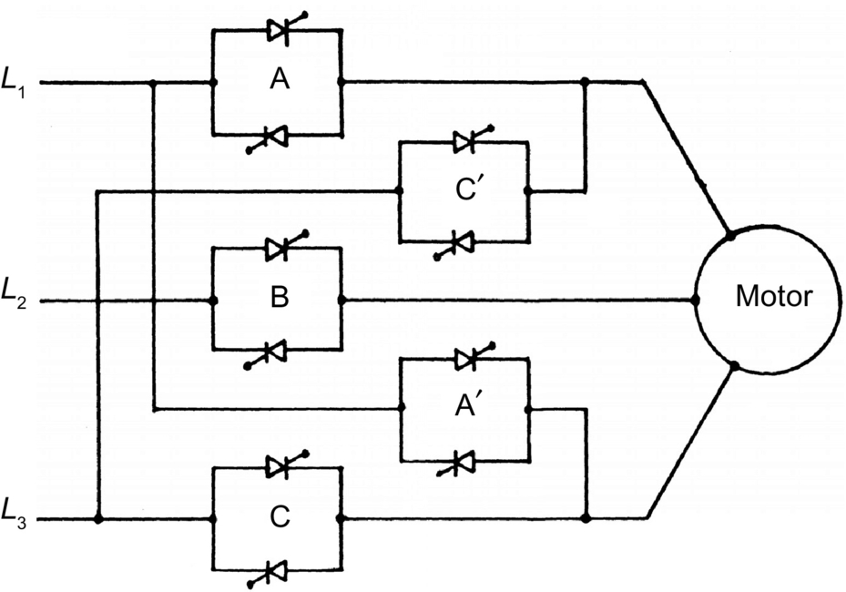

**FIG. 14.44** Four-quadrant ac voltage controller.

Ac voltage controllers are being increasingly used for *soft starting* of induction motors, as they have a number of advantages over the conventional starters such as smooth acceleration and deceleration, ease in implementation of current control, simple protection against single-phasing or unbalanced operation, reduced maintenance and losses, and the absence of current inrush. Even for the fixed-speed industrial applications, the voltage controllers can be used to provide a reduced stator voltage to an induction motor to improve its efficiency at light load and result in energy saving. Operation at an optimum voltage reduces the motor flux which, in turn, reduces the core loss and the magnetizing component of the stator copper loss. Considerable savings in energy can be obtained in applications where a motor operates at no load for a significant time such as in drills, machine tools, woodworking machines, and reciprocating air compressors. A popular approach to find an optimum operating voltage is to maximize the motor power factor by maintaining a minimum phase shift between the voltage and current after sensing them.

The ac switch with on/off control used in driving a high-inertia centrifuge involves switching on of the motor when the speed of the centrifuge drops below the minimum allowable level and switching off when the speed reaches the maximum allowable level—thus maintaining a constant average speed. An identical scheme of control is used with an ac switch for temperature control of an electric heater or air conditioner.

Integral cycle control is well suited to heating control while it may cause flicker in normal incandescent lighting control and speed fluctuations in motor control. However, with this control, less voltage distortion is produced in the ac supply system, and less radio-frequency interference is propagated when compared with the phase-controlled system.

### 14.7.2 APPLICATIONS OF CYCLOCONVERTERS

Cycloconverters as frequency changers essentially find well-established applications in (1) high-power low-speed reversible ac motor drives with constant-frequency input and (2) constant-frequency power supplies with a variable-frequency input as in variable-speed constant frequency (VSCF) system, whereas they find potential applications in (3) controllable volt-ampere reactive (VAR) generators for power factor correction, and (4) ac system interties linking two independent power systems as demonstrated in [[15](https://learning.oreilly.com/library/view/power-electronics-handbook/9780128114087/B9780128114070000143_2.xhtml#bb0080)].

*Variable Speed AC Drives*. In this category, the applications of cycloconverter-controlled induction motor and synchronous motor drives have been adequately reviewed in [[9](https://learning.oreilly.com/library/view/power-electronics-handbook/9780128114087/B9780128114070000143_2.xhtml#bb0050)]. Cycloconverter-fed synchronous motors are well suited for low-speed drives with high torque at standstill, and high-capacity gear-less cement mills (tube or ball mill above 5 MW) have been the first applications of these drives.

Since the 1960s, as developed by Siemens and Brown Boveri, one of the early installations employs a motor rating of 6.4 MW having a rotor diameter of 5 m and length of 18.5 m, whereas the stator construction is similar to that of a hydroelectric generator with 44 poles requiring 5.5 Hz for maximum speed of 15 rpm. The motor is flanged with the mill cylinder without additional bearings or “wrapped” directly around it, known as a *ring motor* [[93](https://learning.oreilly.com/library/view/power-electronics-handbook/9780128114087/B9780128114070000143_2.xhtml#bb0470)]. With the evolution of *field orientation* or *vector control*, cycloconverter-fed synchronous motors have replaced or are replacing the dc drives in the reversing rolling mills (2/4 MW) with extreme high-dynamic requirements for torque and speed control [[94](https://learning.oreilly.com/library/view/power-electronics-handbook/9780128114087/B9780128114070000143_2.xhtml#bb0475)–[96](https://learning.oreilly.com/library/view/power-electronics-handbook/9780128114087/B9780128114070000143_2.xhtml#bb0485)], in mine winders and haulage [[96](https://learning.oreilly.com/library/view/power-electronics-handbook/9780128114087/B9780128114070000143_2.xhtml#bb0485),[97](https://learning.oreilly.com/library/view/power-electronics-handbook/9780128114087/B9780128114070000143_2.xhtml#bb0490)] of similar high ratings and in icebreakers and ships equipped with diesel generators with power ratings of about 20 MW/unit [[98](https://learning.oreilly.com/library/view/power-electronics-handbook/9780128114087/B9780128114070000143_2.xhtml#bb0495)]. In these applications, the cycloconverter-fed synchronous motor is in *self*-*controlled* mode and known as *ac commutatorless motor* when the cycloconverter firing signals are derived from a rotor shaft position sensor, so that the frequency is slaved to the rotor speed and not vice versa with the result that the hunting and stability problems are eliminated, and the torque is not limited to pullout value. Further, with field control, the motor can be operated at leading power factor when the cycloconverter can operate with *load commutation* from the motor side at high speed in addition to the line commutation from the supply at low speed, thus providing speed control over a wide range. A cycloconverter-fed ac commutatorless motor is reported in [[99](https://learning.oreilly.com/library/view/power-electronics-handbook/9780128114087/B9780128114070000143_2.xhtml#bb0500)] where the cycloconverter is operated both in sinusoidal and trapezoidal mode—the latter is attractive for better system power factor and higher voltage output at the cost of increased harmonic content [[1](https://learning.oreilly.com/library/view/power-electronics-handbook/9780128114087/B9780128114070000143_2.xhtml#bb0010)]. A stator-flux-oriented vector control scheme for a six-pulse circulating current-free cycloconverter-fed synchronous motor with a flux observer suitable for a rolling mill drive (300–0–300 rpm) is reported in [[12](https://learning.oreilly.com/library/view/power-electronics-handbook/9780128114087/B9780128114070000143_2.xhtml#bb0065)]. A 12-pulse, 9.64 MVA, and 120/33.1 Hz cycloconverter-linear synchronous motor combination for Maglev Vehicle ML-500, a high-speed train, (517 km/h) is in the process of development in Japan since the early 1980s [[100](https://learning.oreilly.com/library/view/power-electronics-handbook/9780128114087/B9780128114070000143_2.xhtml#bb0505)]. Several recent projects involving very high-power (larger than 15 MW) semiautogenous grinding (SAG) mills with cycloconverter-fed synchronous motor drives in mining applications in Peru and Brazil are reported in [[101](https://learning.oreilly.com/library/view/power-electronics-handbook/9780128114087/B9780128114070000143_2.xhtml#bb0510)]. Latest technological advances, applications, and future trends of cycloconverters in industrial medium-voltage drives have been discussed in [[102](https://learning.oreilly.com/library/view/power-electronics-handbook/9780128114087/B9780128114070000143_2.xhtml#bb0515)].

Regarding cycloconverter-fed induction motors, early applications were for control of multiple run-out table motors of a hot strip mill, high-performance servo drives, and controlled slip-frequency drive for diesel electric locomotives. Slip-power-controlled drives in the form of static Scherbius drives with very high ratings using cycloconverter in the rotor of a doubly fed slip ring induction motor have been in operation for high-capacity pumps, compressors [[103](https://learning.oreilly.com/library/view/power-electronics-handbook/9780128114087/B9780128114070000143_2.xhtml#bb0520)], and even in a proton-synchrotron accelerator drive in CERN, Geneva [[104](https://learning.oreilly.com/library/view/power-electronics-handbook/9780128114087/B9780128114070000143_2.xhtml#bb0525)]. Though synchronous motors have been preferred for very high-capacity low-speed drives because of their high rating, ability to control power factor, and precisely set speed independent of supply voltage and load variations, induction motors, because of their absence of excitation control loop, simple structure, easy maintainability, and quick response, have been installed for cycloconverter-fed drives in Japan. For example, a seamless tube piercing mill [[105](https://learning.oreilly.com/library/view/power-electronics-handbook/9780128114087/B9780128114070000143_2.xhtml#bb0530)] where a squirrel cage six-pole 3 MW, 188/300 rpm, 9.6/15.38 Hz, and 2700 V motor is controlled by a cycloconverter bank of capacity 3750 KVA and output voltage 3190 V.

*Constant Frequency Power Supplies*. Some applications such as aircraft and naval ships need a well-regulated constant-frequency power output from a variable-frequency ac power source. For example, in aircraft power conversion, the alternator connected to the engine operating at a variable speed of 10,000–20,000 rpm provides a variable-frequency output power over 1200–2400 Hz range that can be converted to an accurately regulated fixed frequency output power at 400 Hz through a cycloconverter with a suitable filter placed within a closed loop. The output voltages of the cycloconverter are proportional to the fixed frequency (400 Hz) sine-wave reference voltage generator in the loop.

Both synchronous and induction motors can be used for VSCF generation. The static Scherbius system can be modified (known as Kramer drive) by feeding slip power through a cycloconverter to a shaft-mounted synchronous machine with a separate exciter for VSCF generation. A new application in very high power ratings of constant frequency variable speed motor generators with cycloconverter is in pumped storage schemes using reversible pump turbines for adaptation of the generated power to varying loads or keeping the ac system frequency constant. In 1993, a 400 MW variable speed pumped storage system was commissioned by Hitachi at Okhawachi hydropower plant [[106](https://learning.oreilly.com/library/view/power-electronics-handbook/9780128114087/B9780128114070000143_2.xhtml#bb0535)] in Japan where the field windings of a 20-pole generator/motor are excited with three-phase low-frequency ac current via slip rings by a 72 MVA, three-phase 12-pulse line-commuted cycloconverter. The armature terminals rated at 18 kV are connected to a 500 kV utility grid through a step-up transformer. The output frequency of the circulating current-free cycloconverter is controlled within , and the line frequency is 60 Hz. The variable speed system has a synchronous speed of 360 rpm with a speed range . The operational system efficiency in the pump mode is improved by 3% when compared with the earlier constant speed system.

*Static VAR Generation*. Cycloconverters with a high-frequency (HF) base, either an HF generator or an oscillating LC tank, can be used for reactive power generation and control, replacing synchronous condensers or switched capacitors as demonstrated in [[15](https://learning.oreilly.com/library/view/power-electronics-handbook/9780128114087/B9780128114070000143_2.xhtml#bb0080)]. If the cycloconverter is controlled to generate output voltage waves whose wanted components are in phase with the corresponding system voltages, reactive power can be supplied in either direction to the ac system by amplitude control of the cycloconverter output voltages. The cycloconverter will draw leading current from (i.e., it will supply lagging current to) the ac system when its output voltage is greater than that of the system voltage and vice versa.

*Interties between AC Power Systems*. The naturally commutated cycloconverter (NCC) was originally developed for this application to link a three-phase, 50-Hz ac system with a single-phase 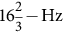 railway supply system in Germany in the 1930s. Applications involve slip-power-controlled motors with subsynchronous and supersynchronous speeds. The stator of the motor is connected to 50-Hz supply, which is connected to the rotor and through a cycloconverter, and the motor drives a single-phase synchronous generator feeding to  system [[107](https://learning.oreilly.com/library/view/power-electronics-handbook/9780128114087/B9780128114070000143_2.xhtml#bb0540),[108](https://learning.oreilly.com/library/view/power-electronics-handbook/9780128114087/B9780128114070000143_2.xhtml#bb0545)]. A static asynchronous intertie between two different systems of different frequency can be obtained by using two NCCs in tandem, each with its input terminals connected to a common HF base. As long as the base frequency is appropriately higher than that of the either system, two system frequencies can be either same or different. The power factor at either side can be maintained at any desired level [[15](https://learning.oreilly.com/library/view/power-electronics-handbook/9780128114087/B9780128114070000143_2.xhtml#bb0080)].

### 14.7.3 APPLICATIONS OF MATRIX CONVERTERS AND NEW DEVELOPMENTS

The practical applications of the matrix converters, as of now, are very limited. The main reasons are (1) nonavailability of the bilateral fully controlled monolithic switches capable of high-frequency operation, (2) complex control law implementation, (3) an intrinsic limitation of the output/input voltage ratio, and (4) commutation and protection of the switches. The switches are assembled from existing discrete devices resulting in increased cost and complexity, and only experimental circuits of conventional matrix converters (CMC) of capacity up to 150 kVA [[109](https://learning.oreilly.com/library/view/power-electronics-handbook/9780128114087/B9780128114070000143_2.xhtml#bb0550)] for a single unit have been built. However, with the advances in device technology, it is hoped that the problems will be solved eventually, and the MC will not only replace the NCCs in all the applications mentioned under [Section 14.7.2](https://learning.oreilly.com/library/view/power-electronics-handbook/9780128114087/B9780128114070000143_2.xhtml#s0160) but also take over from the PWM rectifier-inverters as well. Yaskawa has introduced several drives based on matrix converters, most of which are for industrial purposes. U1000 [[110](https://learning.oreilly.com/library/view/power-electronics-handbook/9780128114087/B9780128114070000143_2.xhtml#bb0555)] ([Fig 14.45](https://learning.oreilly.com/library/view/power-electronics-handbook/9780128114087/B9780128114070000143_2.xhtml#f0230)) is an industrial drive available in 200/400 V and power ranging from 5 to 500 hp. Another drive Z1000U [[112](https://learning.oreilly.com/library/view/power-electronics-handbook/9780128114087/B9780128114070000143_2.xhtml#bb0565)] is an HVAC drive available between 7.5 and 350 hp. AC7 [[111](https://learning.oreilly.com/library/view/power-electronics-handbook/9780128114087/B9780128114070000143_2.xhtml#bb0560)] is yet another smaller version with power range of 7.5–125 hp. AC7 is not commissioned in the Americas. Another interesting applications of multilevel and multicell matrix converters for medium-voltage high-power drives have been developed [[113](https://learning.oreilly.com/library/view/power-electronics-handbook/9780128114087/B9780128114070000143_2.xhtml#bb0570)] Super energy-saving multicell medium-voltage matrix converters (FSDrive-MX1S) of rating 3 kV, 200–3000 kVA or 6 kV, and 400–6000 kVA have been built by Yaskawa Electric, Japan [[114](https://learning.oreilly.com/library/view/power-electronics-handbook/9780128114087/B9780128114070000143_2.xhtml#bb0575)], where by intelligently phase shifting the carrier of each cell and combining them in the motor windings, medium voltages are achievable as shown in [Fig. 14.46](https://learning.oreilly.com/library/view/power-electronics-handbook/9780128114087/B9780128114070000143_2.xhtml#f0235). The salient features of these medium-voltage converters are as follows:

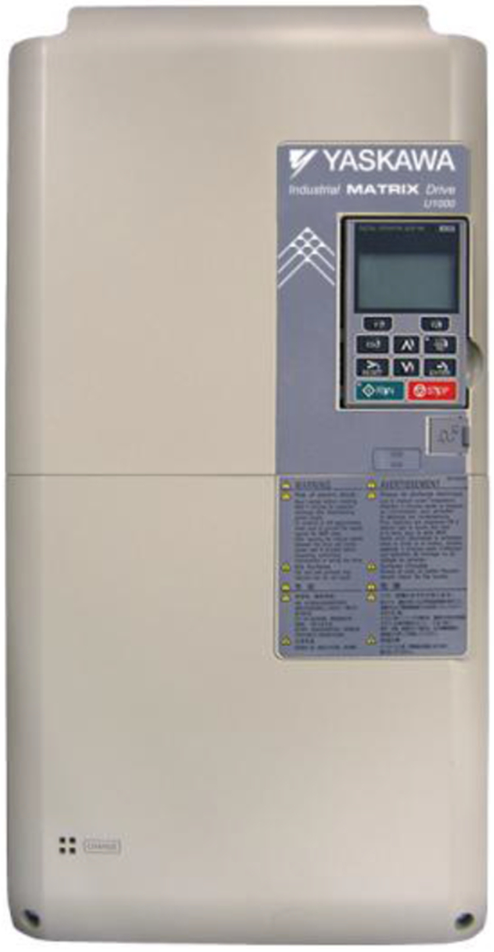

**FIG. 14.45** An industrial matrix converter variant by Yaskawa (U1000, variants available between 5 and 500 hp, [[111](https://learning.oreilly.com/library/view/power-electronics-handbook/9780128114087/B9780128114070000143_2.xhtml#bb0560)]).

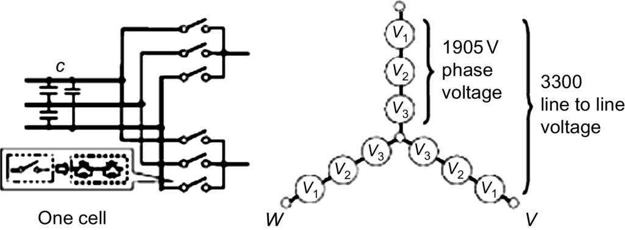

**FIG. 14.46** Schematic of a multicell matrix converter with three cells in series in each phase.

• Four-quadrant operation;

• Excellent input current waveform due to multiple phase shifting winding of the input transformer;

• Flexible design, three cells in series yielding 3.3 kV and 200–3000 kVA and six cells in series yielding 6 kV and 400–6000 kVA system;

• Excellent output voltage waveform due to multistep configuration.

The applications for these drives as recommended are as follows: with heavy loads that require regenerative energy such as steel manufacturing process lines or cargo handling machinery, and also that need power regeneration for a long period such as winders for paper [Fig. 14.47](https://learning.oreilly.com/library/view/power-electronics-handbook/9780128114087/B9780128114070000143_2.xhtml#f0240).

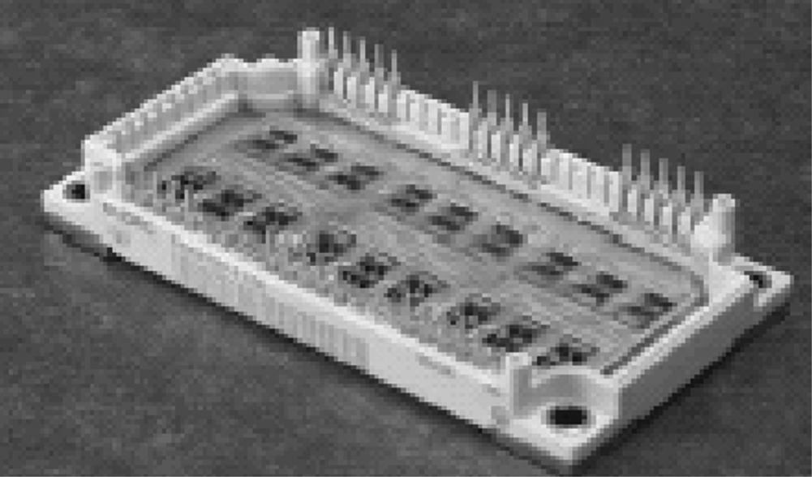

**FIG. 14.47** EconoMac matrix converter module by Eupec [[115](https://learning.oreilly.com/library/view/power-electronics-handbook/9780128114087/B9780128114070000143_2.xhtml#bb0580)].

Recently, reverse blocking IGBTs have opened up the possibility of bidirectional switch (BDS) construction for a practical matrix converter with just two back-to-back devices [[116](https://learning.oreilly.com/library/view/power-electronics-handbook/9780128114087/B9780128114070000143_2.xhtml#bb0585)–[118](https://learning.oreilly.com/library/view/power-electronics-handbook/9780128114087/B9780128114070000143_2.xhtml#bb0595)]. A compact full matrix converter power module EconoMac [[115](https://learning.oreilly.com/library/view/power-electronics-handbook/9780128114087/B9780128114070000143_2.xhtml#bb0580)] in a single package using 18 IGBT devices (35 A and 1200 V) and diodes in the common collector configuration ([Fig. 14.44](https://learning.oreilly.com/library/view/power-electronics-handbook/9780128114087/B9780128114070000143_2.xhtml#f0225)) is available with Eupec/Siemens, Germany. This packaging minimizes the stray inductance in the current commutation paths. Fuji and Powerex have developed engineering samples for matrix converter output leg in a module using RB-IGBTs. A new power electronic building block (PEBB) configuration for a low-cost MC has been proposed in [[119](https://learning.oreilly.com/library/view/power-electronics-handbook/9780128114087/B9780128114070000143_2.xhtml#bb0600)]. Recently, an efficient approach to design discrete packaging of bidirectional resonant power switch for matrix converters has been proposed by computing the magnetic field orientation inside the switching cell [[120](https://learning.oreilly.com/library/view/power-electronics-handbook/9780128114087/B9780128114070000143_2.xhtml#bb0605)]. Several new concepts in protection, commutation, switch design, and modulation strategy have been presented in [[121](https://learning.oreilly.com/library/view/power-electronics-handbook/9780128114087/B9780128114070000143_2.xhtml#bb0610)].

Several new methods like overmodulation [[122](https://learning.oreilly.com/library/view/power-electronics-handbook/9780128114087/B9780128114070000143_2.xhtml#bb0615)], adaptive rate regulation [[123](https://learning.oreilly.com/library/view/power-electronics-handbook/9780128114087/B9780128114070000143_2.xhtml#bb0620)], and two-side modulation control [[124](https://learning.oreilly.com/library/view/power-electronics-handbook/9780128114087/B9780128114070000143_2.xhtml#bb0625)] have been introduced with experimental results to achieve *higher voltage transfer ratio*. A matrix converter-based three-phase open-end winding ac machine drive having matrix converters, one at each side of the open-end winding with space vector PWN has been recently described in [[125](https://learning.oreilly.com/library/view/power-electronics-handbook/9780128114087/B9780128114070000143_2.xhtml#bb0630)] to achieve several simultaneous benefits, such as converter voltage gain up to 1.5, controllable grid power factor, and elimination of the high-frequency common-mode voltage at the machine terminals. A generalized scalar PWM (GSPWM) technique to reduce the common-mode voltage in matrix converter without degrading the input currents' quality has been studied in a recent paper [[126](https://learning.oreilly.com/library/view/power-electronics-handbook/9780128114087/B9780128114070000143_2.xhtml#bb0635)].

Design and loss comparison of matrix converters and dc link voltage source converters (VSC) have been discussed in [[127](https://learning.oreilly.com/library/view/power-electronics-handbook/9780128114087/B9780128114070000143_2.xhtml#bb0640),[128](https://learning.oreilly.com/library/view/power-electronics-handbook/9780128114087/B9780128114070000143_2.xhtml#bb0645)]. It is shown that although MC requires 50% more semiconductors and gate drives excluding clamp circuit, the active silicon area and the number of gate unit power supplies are comparable with that of VSC of the same power rating. The losses of both converter systems are roughly the same at the typical range of 40%–70% of rated torque and speed and a switching frequency of 10 kHz. The MC realizes a distinct better efficiency (92.5%–96%) at 100% torque compared with VSC for the same IGBT modules. Also, the maximum switching frequency of the MC (30 kHz at 250% rated torque) is also substantially higher. The low losses allow a reduction of current ratings (by 33%) of IGBT modules in MC. The extra harmonic losses due to use of a matrix converter for a motor drive with two commonly used modulation techniques have been computed and compared in [[129](https://learning.oreilly.com/library/view/power-electronics-handbook/9780128114087/B9780128114070000143_2.xhtml#bb0650)].

Various potential applications of matrix converters have been proposed, and experiments conducted in the field of VSCF systems such as wind turbine and microturbine [[130](https://learning.oreilly.com/library/view/power-electronics-handbook/9780128114087/B9780128114070000143_2.xhtml#bb0655)], switched mode power supplies [[131](https://learning.oreilly.com/library/view/power-electronics-handbook/9780128114087/B9780128114070000143_2.xhtml#bb0660)], doubly fed induction motor [[132](https://learning.oreilly.com/library/view/power-electronics-handbook/9780128114087/B9780128114070000143_2.xhtml#bb0665),[133](https://learning.oreilly.com/library/view/power-electronics-handbook/9780128114087/B9780128114070000143_2.xhtml#bb0670)] including wind power system applications [[134](https://learning.oreilly.com/library/view/power-electronics-handbook/9780128114087/B9780128114070000143_2.xhtml#bb0675)], and marine propulsion [[135](https://learning.oreilly.com/library/view/power-electronics-handbook/9780128114087/B9780128114070000143_2.xhtml#bb0680)]. Few modern solutions for industrial matrix converter applications including a new integrated matrix converter motor (MCM) have been reported [[136](https://learning.oreilly.com/library/view/power-electronics-handbook/9780128114087/B9780128114070000143_2.xhtml#bb0685),[137](https://learning.oreilly.com/library/view/power-electronics-handbook/9780128114087/B9780128114070000143_2.xhtml#bb0690)]. The range of published practical implementations varies from a 2 kW matrix converter using silicon carbide devices and switching at 150 kHz for aerospace applications built at ETH in Zurich, Switzerland, to a 150 kVA converter using 600 A IGBTs built at US army research labs in collaboration with the University of Nottingham, the United Kingdom [[54](https://learning.oreilly.com/library/view/power-electronics-handbook/9780128114087/B9780128114070000143_2.xhtml#bb0275),[109](https://learning.oreilly.com/library/view/power-electronics-handbook/9780128114087/B9780128114070000143_2.xhtml#bb0550)]. A matrix converter using MCTs with enhanced commutation times is described in [[138](https://learning.oreilly.com/library/view/power-electronics-handbook/9780128114087/B9780128114070000143_2.xhtml#bb0695)].

The complex control schemes of matrix converter demand higher test requirements, and one of the modern means of testing the controllers before final integration on actual apparatus is to make hardware-in-the-loop (HIL) real-time simulation tests as developed recently [[139](https://learning.oreilly.com/library/view/power-electronics-handbook/9780128114087/B9780128114070000143_2.xhtml#bb0700)].

Matrix converter-fed adjustable speed drives (ASDs) have the advantages of inherent four-quadrant operation, the absence of bulky dc link electrolytic capacitors, clean input power characteristics with high input power factor, and increased power density with the possibilities of operating at higher temperatures. However, due to the absence of the dc link, these are more susceptible to input power disturbances, and a *ride*-*through module* is needed to be added for these drives under short-term power interruption. Such a module as developed with minimal addition of hardware and software into a matrix converter (230 V and 3 kVA) has been reported in [[140](https://learning.oreilly.com/library/view/power-electronics-handbook/9780128114087/B9780128114070000143_2.xhtml#bb0705)]. A PWM modulation strategy for fault tolerant operation of the matrix-converter-based drives against opened switch, opened phase faults, and shorted winding failures has been proposed in [[141](https://learning.oreilly.com/library/view/power-electronics-handbook/9780128114087/B9780128114070000143_2.xhtml#bb0710)]. This can improve the reliability of the matrix converter drives as it is possible to keep continuous by regulating the two remaining phases after isolating the faulted phase.

A novel application of a three-phase matrix converter as the static conversion unit for a ground power supply unit for aircraft servicing has been presented in [[142](https://learning.oreilly.com/library/view/power-electronics-handbook/9780128114087/B9780128114070000143_2.xhtml#bb0715)] to provide a compact solution with no dc link and the capability to generate a high quality 400-Hz sinusoidal waveform in the steady state. Three-phase Z-source matrix converter is under consideration. The benefit of Z-sourcing is that firstly, a VTR more than 0.866, can be achieved. Ref. [[143](https://learning.oreilly.com/library/view/power-electronics-handbook/9780128114087/B9780128114070000143_2.xhtml#bb0720)] discusses a family of Z-sourced DMCs in which a VTR of 0.992 is achieved. Secondly, it helps in overcoming the commutation problem. Work on Z-source IMC is also being done [[144](https://learning.oreilly.com/library/view/power-electronics-handbook/9780128114087/B9780128114070000143_2.xhtml#bb0725)]. Comparative study on various Z-source and quasi-Z-source IMC is done in [[145](https://learning.oreilly.com/library/view/power-electronics-handbook/9780128114087/B9780128114070000143_2.xhtml#bb0730)]. A detailed evaluation on various Z-source DMCs and IMCs is recently done in [[56](https://learning.oreilly.com/library/view/power-electronics-handbook/9780128114087/B9780128114070000143_2.xhtml#bb0285)]. Z-source DMC and IMC are shown in [Fig. 14.48](https://learning.oreilly.com/library/view/power-electronics-handbook/9780128114087/B9780128114070000143_2.xhtml#f0245). A direct ac-ac current source matrix converter for applications in industrial power systems is introduced in [[146](https://learning.oreilly.com/library/view/power-electronics-handbook/9780128114087/B9780128114070000143_2.xhtml#bb0735)]. A dynamic voltage restorer (DVR) system employing matrix converter and flywheel storage has been proposed in [[147](https://learning.oreilly.com/library/view/power-electronics-handbook/9780128114087/B9780128114070000143_2.xhtml#bb0740)] to cope with voltage sag problem in power system. The proposed topology eliminates the dc link passive components resulting in reduced maintenance requirement and improved power density.

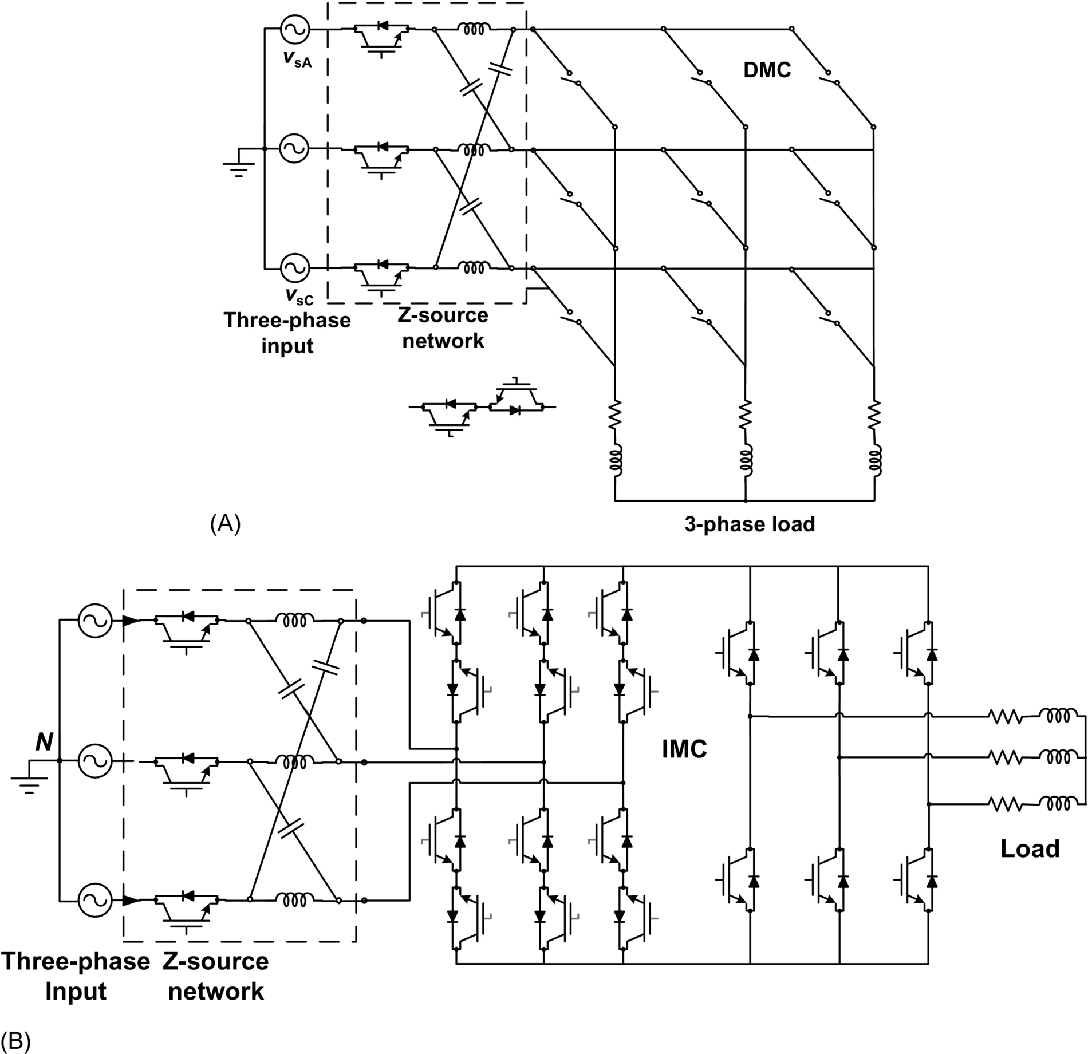

**FIG. 14.48** Three-phase Z-source matrix converters: (A) Z-source DMC and (B) Z-source IMC.

## References

[1] Rombaut C., Seguier G., Bausiere R. *Power Electronic Converters—AC/AC Conversion.* New York, NY: McGraw-Hill; 1987.

[2] Shepherd W. *Thyristor Control of AC Circuits.* Great Britain: Granada Publishing; 1975.

[3] Trzynadlowski A.M. *Introduction to Modern Power Electronics.* New York, NY: John Wiley; 1998.

[4] Rashid M. *Power Electronics: Circuits, Devices and Applications.* Upper Saddle River, NJ: Prentice Hall; 1993.

[5] Hart D.W. *Introduction to Power Electronics.* Upper Saddle River, NJ: Prentice Hall; 1997.

[6] Chattopadhyay A.K., Das S.P., Karchowdhury S. Computer simulation of three-phase thyristor regulator-fed static and induction motor loads-A generalised approach. *Electr. Machin. Power Sys.* 1993;21:329–342.

[7] Dewan S.B., Straughen A. *Power Semiconductor Circuits.* New York, NY: John Wiley; 1975.

[8] Pelly B.R. *Thyristor Phase-Controlled Converters and Cycloconverters.* New York, NY: John Wiley; 1971.

[9] Chattopadhyay A.K. Cycloconverters and cycloconverter-fed drives—a review. *J. Indian Inst. Sci.* 1997;77:397–419.

[10] Chattopadhyay A.K., Rao T.J. Simplified control electronics for a practical cycloconverter. *Int. J. Electronics.* 1977;43:137–150.

[11] Bird B.M., Ford J.S. *Improvements in phase-controlled circulating current cycloconverters using communication principles.* In: Proc. IEEE, vol. 121, no. 10; 1974:1146–1149.

[12] Das S.P., Chattopadhyay A.K. Observer based stator flux oriented vector control of cycloconverter-fed synchronous motor drive. *IEEE Trans. Ind. Appl.* 1997;IA-33(4):943–955.

[13] Syam P., Nandi P.K., Chattopadhyay A.K. An improvement feedback technique to suppress sub-harmonics in a naturally commutated cycloconverter. *IEEE Trans. Ind. Electron.* 1998;45(6):950–952.

[14] Syam P., Nandi P.K., Chattopadhyay A.K. Improvement in power quality and a simple method of subharmonic suppression for a cycloconverter-fed synchronous motor drive. *IEEE Proc. Electr. Power Appl.* 2002;149(4):292–303.

[15] Gyugi L., Pelly B.R. *Static Power Frequency Changers: Theory, Design and Applications.* New York, NY: Wiley-Interscience; 1976.

[16] Chattopadhyay A.K., Rao T.J. *Methods of digital computation of phase controlled cycloconverter performance.* In: Conf. Rec. IEEEIAS Ann. Meet; 1978:432–439.

[17] Lin Y., Heydt G.T., Chu R.F. The power quality impact of cycloconverter control strategies. *IEEE Trans. Power Deliv.* 2005;2(2):1711–1718.

[18] Loskarn M., Tost K.D., Unger C., Witzmann R. *Mitigation of Interharmonics due to large cycloconverter-fed mill drives.* In: Proc. ICHQP'98. Athens, Greece, October; 1998:122–126.

[19] Venturini M. *A new sine-wave in sine-wave out converter technique eliminates reactor elements.* In: Proc. POWERCON'80; . 1980;E3-1 E3-1–E3-15.

[20] Alesina A., Venturini M. *The generalised transformer: a new bidirectional waveform frequency converter with continuously adjustable input power factor.* In: Proc. IEEE -PESC'80; 1980:242–252.

[21] Alesina A., Venturini M. Analysis and design of optimum amplitude nine-switch direct ac-ac converters. *IEEE Trans. Power Electron.* 1989;4(1):101–112.

[22] Empringham L., Kolar J.W., Rodriguez J., Wheeler P.W., Clare J.C. Technological issues and industrial application of matrix converters: a review. *IEEE Trans. Ind. Electron.* 2013;60(10):4260–4271.

[23] Zarri L. *Control of Matrix Converters.* (Ph.D. thesis) Bologna, Italy: University of Bologna; 2007.

[24] Lindemann A. *A new IGBT with reverse blocking capability.* In: Proc. 9th European Conference on Power Electronics; 2001.

[25] Holmes D.G., Lipo T.A. Implementation of a controlled rectifier using ac-ac matrix converter theory. *IEEE Trans. Power Electron.* 1992;7(1):240–250.

[26] Ali M., Iqbal A., Khan M.R., Ayyub M., Anees M.A. Generalized theory and analysis of scalar modulation techniques for a m x n matrix converter. *IEEE Trans. Power Electron.* 2017;32(6):4864–4877.

[27] Wheeler P., Grant D. Optimised input filter design and low-loss switching techniques for a practical matrix converter. *IEEE Proc. Electr. Power Appl.* 1997;144(1):53–60.

[28] Trentin A., Zanchetta P., Clare J., Wheeler P. Automated optimal design of input filters for direct ac/ac matrix converters. *IEEE Trans. Ind. Electron.* 2012;59(7):2811–2823.

[29] Dasgupta A., Sensarma P. Filter design of direct matrix converter for synchronous applications. *IEEE Trans. Ind. Electron.* 2014;61(12):6483–6493.

[30] Ziogas P.D., Khan S.I., Rashid M. Some improved forced commutated cycloconverter structures. *IEEE Trans. Ind. Appl.* 1985;Ia-21:1242–1253.

[31] Ziogas P.D., Khan S.I., Rashid M. Analysis and design of forced commutated cycloconverter structures and improved transfer characteristics. *IEEE Trans. Ind. Electron.* 1986;IE-33(3):271–280.

[32] Neft C.L., Schauder C.D. *Theory and design of a 30 HP matrix converter.* In: Conf. Rec IEEE-IAS Ann. Meet; 1988:248–253.

[33] Ishiguru A., Furuhashi T., Okuma S. A novel control method of forced commutated cycloconverters using instantaneous values of input line voltages. *IEEE Trans. Ind. Electron.* 1991;38(3):166–172.

[34] Huber L., Borojevic D., Burany N. Analysis, design and implementation of the space-vector modulator for forced commutated cycloconverters. *IEEE Proc. B.* 1992;139(2):103–113.

[35] Huber L., Borojevic D. Space vector modulated three-phase to three-phase matrix converter with input power factor correction. *IEEE Trans. Ind. Appl.* 1995;31:1234–1246.

[36] Zhang L., Watthanasarn C., Shepherd W. Analysis and comparison of control strategies for ac-ac matrix converters. *IEEE Proc. Power Electr. Appl.* 1998;145(4):284–294.

[37] Casadei D., Serra G., Tani A. Reduction of the input current harmonic content in matrix converters under input/output unbalance. *IEEE Trans. Ind. Appl.* 1998;45(3):401–411.

[38] L. Zhang, C. Watthanasarn, An efficient space vector modulation algorithm for ac-ac matrix converters: Analysis and implementation, in: IEEE Conf Proc. 6th PEVD '96, 1996, pp. 103–113.

[39] Sayed M.A., Iqbal A. Pulse width modulation technique for a three- to-five phase matrix converter with reduced commutations. *IET Power Electron.* 2016;9(3):466–475.

[40] Szcześniak P. *Three-Phase AC-AC Power Converters Based on Matrix Converter Topology: Matrix-Reactance Frequency Converters Concept.* London: Springer-Verlag; 2013.

[41] Rodríguez J., Silva E., Blaabjerg F., Wheeler P., Clare J., Pontt J. Matrix converter controlled with the direct transfer function approach: analysis, modelling and simulation. *Int. J. Electron.* 2005;92(2):63–85.

[42] Wheeler P.W., Rodriguez J., Clare J.C., Emperngen L., Wenstein A. Matrix converters: a technology review. *IEEE Trans. Indust. Electron.* 2002;49(2):276–288.

[43] Casadei D., Serra G., Tani A., Zarri L. Matrix converter modulation strategies: a new general approach based on space vector representation of the switch state. *IEEE Trans. Ind. Electron.* 2002;49(2):370–381.

[44] Cha H.J., Enjeti P.N. *An approach to reduce common mode voltage in matrix converter.* IEEE Trans. Ind. Appl2003;39:1151–1159.

[45] Jussila M., Salo M., Tuusa H. *Realization of a three-phase indirect matrix converter with an indirect vector modulation method.* In: IEEE-PESC'2003; 689–694. 2003;2.

[46] Sun K., Huang L., Matsuse K., Ishida T. *Combined control of matrix converter fed induction motor drive system.* In: Proc. IEEE-IAS Ann. Meet, vol. 3; 2003:1723–1729.

[47] Havrila R., Dobrucky B., Balazovic P. *Space vector modulated three-phase to three-phase matrix converter with unity power factor.* In: EPE-PEMC2000 Conf. Rec., vol. 2. Kosice; 2000:103–108.

[48] Mutschler P., Marcks M. A direct control method for matrix converters. *IEEE Trans. Ind. Electron.* 2002;49(2):362–369.

[49] Qiankun D., Hongjuan G., Guangquan L. Over-modulation strategy of matrix converter based on multi-orbit vector weighted. *Trans. China Electrotech. Soc.* 2011;26(4):100–106.

[50] Xia Y., Zhang X., Qiao M., Yu F., Wei Y., Zhu P. Research on a new indirect space-vector overmodulation strategy in matrix converter. *IEEE Trans. Ind. Electron.* 2016;63(2):1130–1141.

[51] Burany N. *Safe control of four-quadrant switches.* In: Conf. Rec IEEE-IAS Ann Meet; 1989:1190–1194.

[52] Kwon B.H., Min B.D., Kim J.H. Novel commutation techniques of ac-ac converters. *IEEE Proc. Electr. Power Appl.* 1998;145(4):295–300.

[53] Sun Y., Xu F., Sun K. *Design of matrix converter with bidirectional switches.* In: Proc. IEEE-POWERCON'2002; 1034–1038. 2002;2.

[54] Clare J., Wheeler P. New technology: matrix converters. *Indust. Electron. Soc. Newslett.* 2005;52(1):10–12.

[55] Wei L., Lipo T.A., Chen H. *Robust voltage commutation of conventional matrix converter.* In: Proc. IEEE-PESC'03; 717–722. 2003;2.

[56] Ellabban O., Abu-Rub H., Bayhan S. Z-source matrix converter : an overview. *IEEE Trans. Power Electron.* 2016;31(11):7436–7450.

[57] Nielson P., Blabjerg F., Pederson J.K. New protection issues of a matrix converter: design considerations for adjustable-speed drives. In: 5; 1150–1161. *IEEE Trans. Ind. Appl.* 1999;35.

[58] Mahlein J., Bruckmann M., Braun M. Passive protection strategy for a drive system with a matrix converter and an induction machine. *IEEE Trans. Ind. Electr.* 2002;49(2):297–303.

[59] Simon O., Bruckmann M. *Control and protection strategies for matrix converters.* In: Proc. PCIM Conf. Rec. Nuremberg, Germany; 2000.

[60] Wheeler P., Grant D. Optimized input filter design and low-loss switching techniques for a practical matrix converter. *IEEE Proc. Electr. Power Appl.* 1997;144(1):53–59.

[61] Orser D., Mohan N. A matrix converter ride-through configuration using input filter capacitors as an energy exchange mechanism. *IEEE Trans. Power Electron.* 2015;30(8):4377–4385.

[62] Degano M. *EMI Filter Design for Matrix Converters in Airspace Applications.* (Ph.D. thesis) Nottingham, UK: University of Nottingham; 2012.

[63] Erickson R.W., Al-Naseem O.A. *A new family of matrix converters.* In: Proc. IEEE-IECON'01 Denver, Co; 1515–1520. 2001;2.

[64] Wheeler P., Lie X., Lee M.Y., Emperingham L., Kunpner C., Clare J. *A review of multi-level matrix converter technologies.* In: Proc. IET-PEMD'08; 2008:286–290.

[65] Shi Y., Yang X., He Q., Wang Z. Research on a novel capacitor clamped multilevel matrix converter. *IEEE Trans. Power Electron.* 2005;20(5):1055–1065.

[66] Wang J., Wu B., Xu D., Zargari N.R. Multimodular matrix converters with sinusoidal input and output waveforms. *IEEE Trans. Ind. Electron.* 2012;59(1):17–26.

[67] Wang J., Wu B., Xu D., Zargari N.R. Indirect space-vector-based modulation techniques for high-power multimodular matrix converters. *IEEE Trans. Ind. Electron.* 2013;60(8):3060–3071.

[68] Sun Y., Xiong W., Su M., Dan H., Li X., Yang J. Modulation strategies based on mathematical construction method for multimodular matrix converter. *IEEE Trans. Power Electron.* 2016;31(8):5423–5434.

[69] Sun Y., Xiong W., Su M., Li X., Dan H., Yang J. Carrier-based modulation strategies for multimodular matrix converters. *IEEE Trans. Ind. Electron.* 2016;63(3):1350–1361.

[70] Holtz J., Boelkens U. Direct frequency converter with sinusoidal line currents for speed-variable AC motors. *IEEE Trans. Ind. Electron.* 1989;36(4):475–479.

[71] Iimori K., Shinohara K., Tarumi O., Fu Z., Muroya M. *New current- controlled PWM rectifier- voltage source inverter without DC link components.* In: Proc. of PCC'97; 1997:783–786.

[72] Kolar J.W., Baumann M., Shafmeister F., Ertl H. *Novel three-phase AC-DC-AC sparse matrix converter—part 1: derivation, basic principle of operation, space vector modulation, dimensioning.* In: Proc IEEE-APEC'02; 2002:777–787.

[73] Kolar J.W., Schafmeister F., Round S.D., Ertl H. Novel three-phase AC-AC sparse matrix converters. *IEEE Trans. Power Electron.* 2007;22(5):1649–1661.

[74] Lee M.Y., Wheeler P., Klumpner C. Space vector modulated multilevel matrix converter. *IEEE Trans. Ind. Electr.* 2010;57(10):3385–3394.

[75] Friedli T., Round S.D., Kolar J.W. *A 100 kHz SiC sparse matrix converter.* In: Proc. IEEE -PESC'07; 2007:2148–2154.

[76] Kim S., Sui S., Lipo T.A. *AC to AC power conversion based on matrix converter topology with unidirectional switches.* In: IEEE-APEC; 1998:301–307.

[77] Hamouda M., Blanchette H.F., Al-Haddad K., Fnaiech F. An efficient DSP-FPGA-based real-time implementation method of SVM algorithms for an indirect matrix converter. *IEEE Trans. Ind. Electron.* 2011;58(11):5024–5031.

[78] Zuckerberger A., Weinstock D., Alexandrovitz A. Single-phase matrix converter. *IEEE Proc. Electr. Power Appl.* 1997;144(4):235–240.

[79] Gola A.K., Agarwal V. Implementation of an efficient algorithm for a single phase matrix converter. *J. Power Electron.* 2009;9(2):198–206.

[80] Nguyen M.-K., Jung Y.-G., Lim Y.-C., Kim Y.-M. A single-phase Z-source buck—boost matrix converter. *IEEE Trans. Power Electron.* 2010;25(2):453–462.

[81] Ahmed H.F., Cha H., Khan A.A., Kim H. A family of high-frequency isolated single-phase Z-source AC – AC converters with safe-commutation strategy. *IEEE Trans. Power Electron.* 2016;31(11):7522–7533.

[82] Jacobina C.B., Oliveira T.M., da Silva E.R.C. Control of the single-phase three-leg AC/AC converter. *IEEE Trans. Ind. Electron.* 2006;53(2):467–476.

[83] Ferreira Moreno Pinheiro Da Silva I.R., Brandão Jacobina C., Cunha Oliveira A. Single-phase AC-AC double-star chopper cells (DSCC) converter without common DC-link capacitor. *IEEE Trans. Ind. Appl.* 2015;51(6):4642–4652.

[84] Shin H.H., Cha H., Kim H.G., Yoo D.W. Novel single-phase PWM AC-AC converters solving commutation problem using switching cell structure and coupled inductor. *IEEE Trans. Power Electron.* 2015;30(4):2137–2147.

[85] Ahmed H.F., Cha H., Khan A.A., Kim J., Cho J. A single-phase buck-boost matrix converter with only six switches and without commutation problem. *IEEE Trans. Power Electron.* 2016;8993:1–13.

[86] Khan A.A., Cha H., Ahmed H.F. High-efficiency single-phase AC-AC converters without commutation problem. *IEEE Trans. Power Electron.* 2016;31(8):5655–5665.

[87] Banaei M.R., Alizadeh R., Jahanyari N., Seifi Najmi E. An AC Z-source converter based on gamma structure with safe-commutation strategy. *IEEE Trans. Power Electron.* 2016;31(2):1255–1262.

[88] Khodabandeh M., Shahbazi M., Zolghadri M.R., Noroozi N. T-type direct AC/AC converter structure. *IET Power Electron.* 2016;9(7):1426–1436.

[89] Chen X., Zhang K., Liu W., Xiong J. Simplified model and submodule capacitor voltage balancing of single-phase AC/AC modular multilevel converter for railway traction purpose. *IET Power Electron.* 2016;9(5):951–959.

[90] Hui L., Ozpineci B., Bose B.K. *A soft-switched high frequency non-resonant link integral pulse modulated dc-ac converter for ac motor drive.* In: Proc. IEEE-IECON, vol. 2, Aachen, Germany; 1998:726–732.

[91] Ozpineei B., Bose B.K. *Soft-switched performance based high frequency non-resonant link phase-controlled converter for ac motor drive.* In: Proc. IEEE-IECON, vol. 2, Aachen, Germany; 1998:733–739.

[92] Bose B.K. *Modern Power Electronics and AC Drives.* New Delhi: Pearson Education; 2002.

[93] Blauenstein E. The first gearless drive for a tube mill. *Brown Boveri Rev.* 1970;57:96–105.

[94] Timpe W. Cycloconverter for rolling mill drives. *IEEE Trans. Ind. Appl.* 1982;IA-18(4):401–404.

[95] Pallman R.P. First use of cycloconverter-fed ac motors in an aluminium hot strip mill. *Siemens Eng. Automat.* 1992;XIV(2):26–29.

[96] Lewis E.A. *Cycloconverter drive systems.* In: IEE Conf. Proc. PEVD'96; 1996:382–389.

[97] Madisetti K., Ramlu M.A. Trends in electronic control of mine hoists. *IEEE Trans. Ind. Appl.* 1986;IA-22(6):1105–1112.

[98] Hill A.W., Turton R.A.V., Dunzan R.L., Schwaln C.L. A vector controlled cycloconverter drive for an ice-breaker. *IEEE Trans. Ind. Appl.* 1987;IA-23:1036–1041.

[99] Das S.P., Chattopadhyay A.K. *Comparison of simulation and test results for an ac commutatorless motor drive.* In: IEE Conf. Proc. PEVD'96; 1996:294–299.

[100] Saijo T., Koike S., Takaduma S. Characteristics of linear synchronous motor drive cycloconverter for Maglev Vehicle ML-500 at Miyazaki test track. *IEEE Trans. Ind. Appl.* 1981;IA-17:533–543.

[101] Rodriguez J.R., Pontt J., Newman P., Musalem R., Miranda H., Moran L., Azamora G. Technical evaluation and practical experience of high power grinding mill drives in mine applications. In: 3; 866–873. *IEEE Trans. Ind. Appl.* 2005;41.

[102] Wu B., Pontt J., Rodriguez J., Bernett S., Kouro S. Current source converter and cycloconverter topologies for industrial medium-voltage drives. *IEEE Trans. Ind. Electr.* 2008;55(7):2786–2797.

[103] Weiss H.W. Adjustable speed ac drive systems for pump and compressor applications. *IEEE Trans. Ind. Appl.* 1975;IA-10(1):162–167.

[104] Dirr R., Neuffer I., Schluter W., Waldmann H. New electronic control equipment for doubly-fed induction motors of high rating. *Siemens Rev.* 1972;3:121–126.

[105] Sugi K., Naito Y., Kurosawa P., Kano Y., Katayama S., Yashida T. *A microcomputer based high capacity cycloconverter drive for main rolling mill.* In: Proc. IPEC, Tokyo; 1983:744–755.

[106] Mori S., Kita E., Kojima H., Sanematru T., Shiboya A., Bando A. *Commissioning of 400 MW adjustable speed pumped storage system at Okhawachi hydropower plant.* In: Proc. 1995 CIGRE Symp., no. 520–04; 1995.

[107] Stemmler H. High power industrial drives. *Proc. IEEE.* 1994;82(8):1266–1286.

[108] Stemmler H. Active and reactive load control for converters interconnecting 50 and 16 2/3 Hz, using a static frequency changer cascade. *Brown Boveri Rev.* 1978;65(9):614–618.

[109] Podlesak T.F., Katsis D.C., Wheeler P.W., Clare J.C., Empringham L., Bland M. A 150 -kVA vector controlled matrix converter induction motor drive. *IEEE Trans. Ind. Appl.* 2005;41(3):841–847.

[110] <https://www.yaskawa.com/pycprd/products/industrial-ac-drives/general-purpose-drives/u1000-industrial-matrix-drive/tab2/link20>.

[111] <https://www.yaskawa.com/pycprd/products/industrial-ac-drives/general-purpose-drives/ac7-matrix-drive/tab0/link02>.

[112] <https://www.yaskawa.com/pycprd/products/hvac-drives/drives/z1000u-matrix-drive/tab3/link32>.

[113] Swamy M., Kume T. *Present state and a Futuristic vision of motor drive technology.* In: Proc. Conf Optimization of Electrical and Electronic Equipment (OPTIM); 2008:XLV–LVI.

[114] <http://www.yaskawa.eu.com/en/products/robotic/motoman-robots/productdetail/product/fsdrivemx1s/>.

[115] Munzer M. *Economac-the first all in one IGBT module for matrix converters.* In: Proc. Drives and Control Conf., Sec. 3. London, CD-ROM; 2001.

[116] Klumpner C., Blaabjerg F. *Using reverse blocking IGBTs in power converters for adjustable speed drives.* In: IEEE-IAS Conf. Rec; 2003:1516–1523.

[117] Itoh J., Sato I., Odaka A., Ohguchi H., Kodatchi H., Eguchi N. *A novel approach to practical matrix converter motor drive system with reverse blocking IGBT.* In: IEEE-PESC 2004, vol. 3. Aachen, Germany; 2004:2380–2385.

[118] Itoh J.I., Odaka A., Sato I. High efficiency power conversion using a matrix converter. *Fuji Electr. Rev.* 2004;50(3):94–98.

[119] Klumpner C., Nielson P., Boldea I., Blaabjerg F. New solutions for a low cost power electronic building block for matrix converters. *IEEE Trans. Ind. Electr.* 2002;49(2):334–336.

[120] Blanchette H.F., Al-Haddad K. An efficient approach to design discrete packaging of Bidirectional resonant power switch for matrix converter applications. *IEEE Trans. Power Electron.* 2008;23(4):2195–2200.

[121] Mahlein J., Weigold J., Simon O. *New concepts for matrix converter design.* In: Proc. IEEE-Int. Conf. Ind. Electron., Control and Instrumentation, vol. 2, Denver; 2001:1044–1048.

[122] Mahlein J., Simon O., Braun M. *A matrix converter with space vector control enabling overmodulation.* In: Conf. Proc. EPE'99, Lussanne, September; 1999:1–11.

[123] Wang L., Sun K., Huang L. *A novel method to enhance the voltage transfer ratio of matrix converter.* In: Proc. 30th Ann. Meeting of IES. Busan, Korea: November 2–6; 2004:723–727.

[124] Chang J., Sun T., Wang A. Highly compact ac-ac converter achieving a high voltage transfer ratio. *IEEE Trans. Ind. Electr.* 2002;49(2):345–352.

[125] Gupta R.K., Mohapatra K.K., Somani A., Mohan N. *Direct-Matrix-Converter based drive for a three-phase open-end–winding ac machine with advanced features.* In: Proc IEEE-APEC 25th Annual Conf; 2010:901–908.

[126] Bradaschia F., Cavalcanti M.C., Ibarra E., Neves F.A.S., Bueno E. *Generalized pulse width modulation to reduce common voltage in matrix converters.* In: Proc IEEE-ECCE; 2009:3274–3281.

[127] Bernett S., Ponnaluri S., Teichmann R. Design and loss comparison of matrix converters and voltage-source converters for modern ac drives. *IEEE Trans. Ind. Electr.* 2002;49(2):304–314.

[128] T. Matsuo, S. Bernet, T.A. Lipo, Application of matrix converter to field oriented induction motor drives, WISPERC Report, University of Wisconsin, January 1996.

[129] Wheeler P.W., Clare J.C., Apap M., Bradley K.J. Harmonic loss due to operation of induction machines from matrix converters. *IEEE Trans. Ind. Electron.* 2008;55(2):809–816.

[130] Cha H., Enjeti P.N. *A three-phase ac/ac high frequency link matrix converter for VSCF applications.* In: IEEE-PESC 2003, vol. 4; 2003:1971–1976.

[131] Ratanapanaachote S., Cha H.J., Enjeti P.N. *A digitally controlled switch mode power supply.* In: IEEE-PESC 2004. Aachen, Germany; 2004:2237–2243.

[132] Chekhet E., Sobolev V., Shapoval I. *The steady state analysis of a doubly-fed induction motor (DIFM) with matrix converter.* In: Proc. EPE-PEMC 2000, vol. 5, Kosice; 2000:6–11.

[133] Dalal A.K., Syam P., Chattopadhyay A.K. *Use of matrix converter as slip-power regulator in a doubly-fed induction motor drive for improvement of power quality.* In: Proc. IEEE Power India Conf. 2006, 10–12 April; 2006. 6 p [www.ieeexplore.ieee.org](http://www.ieeexplore.ieee.org/).

[134] Jeong J., Ju Y., Han B. *Wind power system using doubly–fed induction generator and matrix converter with simple modulation scheme.* In: Proc. IEEE–PEMWA; 2009:1–6.

[135] Ciaramella K.M., Bucknall R.W.G. *Potential Use of Matrix Converters in Marine Propulsion Applications.* Edinburgh: IMAREST; 2003.

[136] Klumpner C., Nielson P., Boldea I., Blaabjerg F. A new matrix converter motor (MCM) for industry applications. *IEEE Trans. Ind. Electron.* 2002;49(2):325–335.

[137] Simon O., Mahlein J., Muenzer M.N., Bruckmann M. Modern solutions for industrial matrix-converter applications. *IEEE Trans. Ind. Electron.* 2002;49(2):401–406.

[138] Wheeler P., Chan J.C., Empringham L., Bland M., Kerris K.C. A vector controlled MCT matrix converter induction motor with minimized commutation times and enhanced waveform quality. *IEEE Ind. Appl. Magazine.* 2004;10(1):59–65.

[139] C. Dufour, L. Wei, T. A. Lipo, Real-time simulation of matrix converter drives, WEMPEC Research Report. University of Wisconsin, 2005–14.

[140] Cha H.J., Enjeti P.N. Matrix converter-fed ASDs. *IEEE Ind. Appl. Magazine.* 2004;10(4):33–39.

[141] Kwak S., Tolyat H.A. An approach to fault-tolerant three-phase matrix converter drives. *IEEE Trans. Energy Convers.* 2007;22(4):855–863.

[142] Arevalo S.L., Zanchetta P., Wheeler P.W., Trentin A., Empringham L. Control and implementation of a matrix-converter-based AC ground power-supply unit for Aircraft servicing. *IEEE Trans. Ind. Electron.* 2010;57(6):2076–2084.

[143] Ge B., Lei Q., Qian W., Peng F.Z. A family of Z-source matrix converters. *IEEE Trans. Ind. Electron.* 2012;59(1):35–46.

[144] Karaman E., Farasat M., Trzynadlowski A.M. A comparative study of series and cascaded z-source matrix converters. *IEEE Trans. Ind. Electron.* 2014;61(10):5164–5173.

[145] Liu S., Ge B., Jiang X., Abu-Rub H., Peng F.Z. Comparative evaluation of three z-source/quasi-z-source indirect matrix converters. *IEEE Trans. Ind. Electron.* 2015;62(2):692–701.

[146] Nikkhajoei H. *A current source matrix converter for high-power applications.* In: Proc. IEEE-PESC; 2007:2421–2516.

[147] Wang B., Venkataramnan G. Dynamic voltage restorer utilizing a matrix converter and flywheel energy storage. *IEEE Trans. Ind. Appl.* 2009;45(1):222–231.

**15**

# Multiphase Converters

Atif Iqbal Qatar University, Doha, Qatar

Shaikh Moinoddin Aligarh Muslim University, Aligarh, India

Salman Ahmad Aligarh Muslim University, Aligarh, India

Mohammad Ali Aligarh Muslim University, Aligarh, India

Adil Sarwar Aligarh Muslim University, Aligarh, India

Kishore N. Mude University of Porto, Porto, Portugal

Amrita Vishwa Vidyapeetham University, Bengaluru, India

## Abstract

Multiphase converters refer to converters with more than three phases and are the extension of three-phase converters by adding extra legs. From hardware point of view, as such there is no major difference between a three-phase and a multiphase converter except the number of legs. However, control becomes more flexible and complex, and higher degrees of redundancies are available. Multiphase power converters have gained popularity in the last decade because of the developments in the field of high-power switching devices and computational platforms such as high-speed digital signal processors (DSPs) and high-density field-programmable gate arrays (FPGAs). The major thrust in the area of multiphase converter is seen due to concern in developing clean transportation systems, renewable energy generation system (especially wind energy system), and high-reliability variable-speed electric drive system. Multiphase power converters are used in numerous applications depending upon their role as to convert AC to DC, DC to AC, AC to AC, or DC to DC. The major applications of DC to AC converters are found in adjustable-speed drives, while AC to AC and AC to DC are employed in multiphase renewable energy generation system. Multiphase DC-DC converter finds its application in automotive industry.

### KEYWORDS

Multiphase power converters; Pulse-width modulation; Space-vector PWM; High-power drives; Multiphase wind generation converters

15.1 [Introduction](https://learning.oreilly.com/library/view/power-electronics-handbook/9780128114087/B9780128114070000167_1.xhtml#s0010)

15.2 [Types and Topologies of Multiphase Converters](https://learning.oreilly.com/library/view/power-electronics-handbook/9780128114087/B9780128114070000167_1.xhtml#s0015)

15.2.1 Multiphase AC-DC Converters

15.2.2 Multiphase DC-DC Converters

15.2.3 Multiphase DC-AC Converters

15.2.4 Multiphase AC-AC Converters

15.3 [Multiphase Multipulse AC-DC Converters](https://learning.oreilly.com/library/view/power-electronics-handbook/9780128114087/B9780128114070000167_1.xhtml#s0040)

15.3.1 Five Phase Uncontrolled Full Wave Bridge Rectifier

15.3.2 Five-Phase Controlled Full Wave Bridge Rectifier

15.3.3 Multipulse Rectifiers

15.3.4 Single-Way Multiphase Systems Topologies

15.3.5 Six-Phase AC to DC Converters

15.4 [Multiphase DC-AC Converters](https://learning.oreilly.com/library/view/power-electronics-handbook/9780128114087/B9780128114070000167_1.xhtml#s0095)

15.4.1 Modeling and Control of a Five-Phase Voltage Source Inverter

15.4.2 Carrier-Based PWM

15.4.3 Modeling and Control of a Seven-Phase VSI-Square Wave Mode

15.4.4 Space Vector PWM Techniques for a Seven-Phase Voltage Source Inverter

15.5 [Multiphase AC-AC Converter](https://learning.oreilly.com/library/view/power-electronics-handbook/9780128114087/B9780128114070000167_3.xhtml#s0240)

15.5.1 Introduction

15.5.2 Brief Review

15.5.3 Defining the Voltage Transfer Ratio

15.5.4 Simplified Modulation Strategy

15.5.5 Other Control Techniques

15.5.6 Future Prospects

15.6 [Multiphase DC-DC Converter](https://learning.oreilly.com/library/view/power-electronics-handbook/9780128114087/B9780128114070000167_3.xhtml#s0325)

15.6.1 Multiphase Interleaved Buck Topology

15.6.2 Synchronous Multiphase Buck Topology

15.6.3 Multiphase Boost Converter

15.6.4 Coupled Inductor for Multiphase Buck

15.6.5 Advantages of Multiphase DC-DC Converters

[References](https://learning.oreilly.com/library/view/power-electronics-handbook/9780128114087/B9780128114070000167_4.xhtml#bi0010)

[Further Reading](https://learning.oreilly.com/library/view/power-electronics-handbook/9780128114087/B9780128114070000167_4.xhtml#fr0010)

## 15.1 Introduction

Multiphase converters refer to converters with more than three phases and are the extension of three-phase converters by adding extra legs. From hardware point of view, there is least difference. However, control becomes more flexible and complex, and higher degrees of redundancies are available. Multiphase power converters have gained popularity in the last decade because of the developments in the field of high-power switching devices and computational platform such as high-speed digital signal processors and high-density field-programmable gate arrays. The major push in the area of multiphase converter is seen due to concern in developing clean transportation systems, renewable energy generation system (especially wind energy system), and developing high-reliability variable-speed electric drive system. Multiphase power converters are used in numerous applications depending upon their role so as to convert AC to DC, DC to AC, AC to AC, or DC to DC. The major applications of DC to AC converters are found in adjustable-speed drives, while AC to AC and AC to DC are employed in multiphase renewable energy generation system. Multiphase DC-DC converter finds its application in automotive industry.

Multiphase power converter (DC-AC and AC-AC) fed adjustable-speed drives offer numerous advantages when compared with three-phase drives. The major advantages offered are enhanced torque density (since in concentrated winding multiphase electric machine low-order harmonics also contribute to the torque production unlike three-phase machines where only fundamental current components generate torque), lower torque pulsation, and higher frequency pulsation. The electromagnetic torque of inverter-fed induction motor drive possesses a considerable amount of ripple especially at low speed [[1](https://learning.oreilly.com/library/view/power-electronics-handbook/9780128114087/B9780128114070000167_4.xhtml#bb0010),[2](https://learning.oreilly.com/library/view/power-electronics-handbook/9780128114087/B9780128114070000167_4.xhtml#bb0015)]. This arises due to the interaction of higher-order current harmonics with fundamental air-gap flux and higher-order air-gap harmonics with fundamental current. Sixth-harmonic pulsating torque is dominant in a three-phase induction motor when inverter feeding the motor operated in six-step mode. In a five-phase drive the most dominant pulsating torque is a 10th harmonic and as such for *n*-phase it is 2*n*th harmonic torque. Other advantages are lower per-leg current rating for the same voltage rating (due to lower current rating series and parallel switch combination is not required and hence cheaper solution is achieved), greater fault tolerance (machine can start and run even with loss of one or more phase supply), lower dc link current harmonics and lower harmonic losses.

Multiphase electric machines are becoming more popular in the range of medium- and high-power applications [[1](https://learning.oreilly.com/library/view/power-electronics-handbook/9780128114087/B9780128114070000167_4.xhtml#bb0010)–[5](https://learning.oreilly.com/library/view/power-electronics-handbook/9780128114087/B9780128114070000167_4.xhtml#bb0030)]. Considering an inverter-fed high-power electric motor with power rating exceeding the available rating of power semiconductor switches, the designer has to increase the number of feeding inverters. This implies higher number of phases on the stator of the electric motor as well. Two solutions can be sought for segmenting the power, either increase the number of phases in multiple of three (parallel-connected multiple three-phase inverters) or increase the number of legs of inverter with each leg handling a power of P/*n* (P is the total power, and *n* is the number of phases). The design solutions are shown in [Fig. 15.1](https://learning.oreilly.com/library/view/power-electronics-handbook/9780128114087/B9780128114070000167_1.xhtml#f0010). The solutions given in [Fig. 15.1B](https://learning.oreilly.com/library/view/power-electronics-handbook/9780128114087/B9780128114070000167_1.xhtml#f0010) have *n* number of parallel-connected three-phase inverters each carrying power of P/*n*. The supplied motor has multiple three-phase windings with separate neutral points. The major advantage of these off-the-shelf standard three-phase inverters is to supply the motor with each inverter handling lower amount of power. However, the major issue of this drive topology is the circulating current due to the voltage mismatch of each three-phase inverter. The electric motor in this case is called asymmetrical or split-phase motor. This solution is preferred and most widely used in industries because of the fact that the three-phase system solution is well proved and a mature technology:

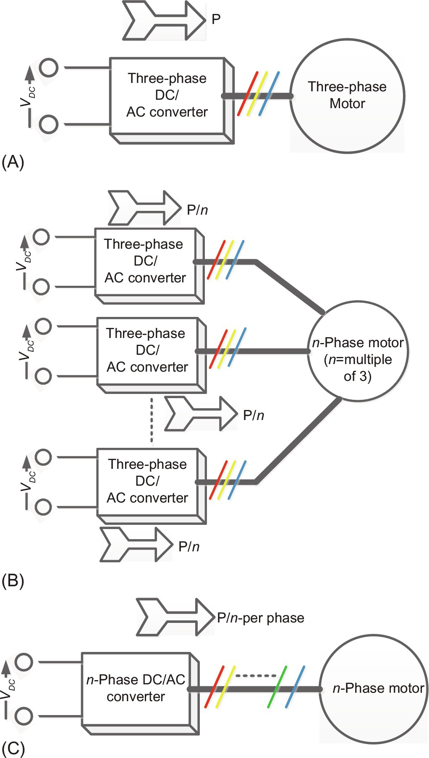

**FIG. 15.1** (A) Three-phase drive, (B) multiple three-phase drive, and (C) multiphase drive.

Solution of [Fig. 15.1C](https://learning.oreilly.com/library/view/power-electronics-handbook/9780128114087/B9780128114070000167_1.xhtml#f0010), in contrast to the previous solution, works with a single inverter of *n*-phases supplying electric motor of *n*-phase. Each phase or leg now handles P/*n* power, and the circulating current is absent. The electric motor in this case is called symmetrical *n*-phase motor. This solution is also employed in high-power marine drive applications [[6](https://learning.oreilly.com/library/view/power-electronics-handbook/9780128114087/B9780128114070000167_4.xhtml#bb0035)].

Reliability and fault tolerance are other driving forces leading to the development of multiphase system. Due to high phase number, fault tolerance is inherently guaranteed, which is of high importance in safety critical applications such as ship propulsion, more electric aircrafts, electric vehicles, and industrial setup where production loss is critical such as oil and gas plants and military. The multiphase motor drive guarantees continuous operation, however, with degraded performance under fault conditions. The higher the phase number, the better is the performance during faults. This make them highly attractive in applications mentioned above [[7](https://learning.oreilly.com/library/view/power-electronics-handbook/9780128114087/B9780128114070000167_4.xhtml#bb0040),[8](https://learning.oreilly.com/library/view/power-electronics-handbook/9780128114087/B9780128114070000167_4.xhtml#bb0045)].

According to classical electric machine theory, the air-gap flux harmonic content improves and becomes close to sinusoidal with the increase in the number of phases. The improved flux density waveform leads to: (i) reduced rotor losses due to flux pulsation and eddy currents (this has importance for high-speed permanent magnet machines since the eddy current losses are very high at high speed in such kind of machines) and (ii) improved torque quality with reduced amplitude of torque pulsation that occurs at higher frequency (this is very important when machine is subjected to high distorted current, and limits are enforced on the maximum allowable torque pulsation).

Multiphase generators, specially five phases and more, have started to find a slot in the market due to their advantages over three-phase counterpart [[9](https://learning.oreilly.com/library/view/power-electronics-handbook/9780128114087/B9780128114070000167_4.xhtml#bb0050),[10](https://learning.oreilly.com/library/view/power-electronics-handbook/9780128114087/B9780128114070000167_4.xhtml#bb0055)]. This multiphase system could be more suitable for direct drive wind energy, microturbines, and electric vehicle applications since the need for gears can be minimized. Multipulse rectifiers are employed, which have the ability to reduce the line current harmonic distortion and normally do not require any LC filters or power factor improvement devices. Multipulse DC can be obtained either by increasing the number of phases of the converter or by the use of phase-shifting transformer along with special secondary winding connections in the conventional six-pulse rectifiers. In drive application, the use of phase-shifting transformer provides an effective means to block common-mode voltages generated by the rectifier and inverter, which would otherwise appear on motor terminals, leading to a premature failure of machine winding insulation. Normally AC-DC converters are classified into power factor control rectifiers operated at high switching frequency and line-commutated rectifiers (uncontrolled or controlled) operated at power frequency or generated frequency. The multiphase line-commutated converter normally offers simple control, simple construction, and low cost but suffers from poor input power factor, low input current THD, and unidirectional current flow. The shortcoming of line-commutated rectifiers is overcome by the use of high-switching-frequency PWM rectifiers, voltage-source rectifiers, or current-source rectifiers, but the switch current and voltage limitation may restrict the use of PWM rectifiers in high-power applications.

Multiphase DC-AC voltage-source inverter is obtained from three-phase voltage-source inverter by adding extra legs (each leg has two switches in two-level inverter and a higher number of switches for multilevel inverter). The two switches of the same leg are complimentary in operation (i.e., when upper switch is on, the lower switch must be off and vice versa). The power switches can assume only two states, that is, *on* (called level 1) or *off* (called level 0). Hence, as such for *n*-phase inverter, there can be 2*n* number of switching states. Considering a three-phase inverter, the number of switching states are 8, and, for example, for a nine-phase inverter, the number of switching states are 29=512 [[5](https://learning.oreilly.com/library/view/power-electronics-handbook/9780128114087/B9780128114070000167_4.xhtml#bb0030)]. It is seen that the number of switching states increases significantly with the increase in the number of phases or legs. Higher numbers of switching states offer flexibility in devising control techniques. Thus, multiphase inverter control has several degrees of flexibility in control. Multiphase inverter can be controlled using different PWM techniques such as carrier-based sinusoidal PWM, harmonic injection PWM, selective harmonic PWM, hybrid PWM, and space-vector PWM. Each method can produce different output magnitudes. Simple carrier-based PWM for multiphase inverters works exactly the same as for three-phase inverters. The maximum possible output phase-to-neutral voltage is 0.5 *VDC*, where *VDC* is DC-link voltage magnitude for multiphase inverter [[1](https://learning.oreilly.com/library/view/power-electronics-handbook/9780128114087/B9780128114070000167_4.xhtml#bb0010)]. However, the output phase-to-neutral voltage magnitude varies for different phase numbers when using space-vector PWM. Nevertheless, the output phase-to-neutral voltage of multiphase inverters is less than that of a three-phase inverter. Multiphase inverter space vectors are transformed into multiple orthogonal planes, and control is implemented in order to regulate each plane vectors. In multiphase variable-speed drives (with distributed winding multiphase machine), torque is controlled only from one plane vector (d-q), and the rest of the plane vectors produce distortion and hence need to be minimized using PWM techniques. When concentrated winding multiphase machines are supplied using multiphase voltage-source inverters, all plane vectors are used to enhance the torque production. This is a unique feature of concentrated winding multiphase machine not available in three-phase machines. When implementing high-performance control such as vector control and direct torque control, higher control flexibility is available, and different solutions can be implemented.

Multiphase AC-AC converter more popularly known as multiphase matrix converter (MPMC) is also formulated by adding extra legs in three-phase matrix converter configuration. They are classified as direct matrix converters (DMC) and indirect matrix converters (IMC). Each converter leg has three bidirectional power switches each connected to one phase of the utility grid system, and at the output, load is connected. The input is fixed voltage and fixed frequency supply, while the output is of variable voltage and variable frequency. There are configurations where the number of input phases is three while the output phase are more than three and vice versa [[4](https://learning.oreilly.com/library/view/power-electronics-handbook/9780128114087/B9780128114070000167_4.xhtml#bb0025),[5](https://learning.oreilly.com/library/view/power-electronics-handbook/9780128114087/B9780128114070000167_4.xhtml#bb0030)]. The multiphase matrix converter encompasses the advantages of three-phase matrix converters and multiphase systems. The major application areas are envisaged in multiphase wind energy system. A matrix converter can be seen as an array of *m*×*n* bidirectional power semiconductor switches that can transform *m*-phase fixed voltage and fixed frequency input to *n*-phase variable voltage and variable frequency output without intermediate DC conversion stage. The input side of a matrix converter is voltage fed, while the output side is current fed, and hence, an inductive filter is required at the output side, and a capacitive filter is used at the input side. As the load is itself of inductive nature, the requirement of output filter diminishes. The size of the input filter used in matrix converter is significantly smaller than an equivalent voltage-source inverter.

Considering an *m*×*n* matrix converter, the number of switching states is 2*m*×*n*. Large numbers of switching states are produced; however, not all of them are useful. Due to the nature of input (being voltage source) and output (being current source), the input should not short-circuited, and the output should not be open-circuited. As a consequence, only one switch in each leg conducts at one instant of time, and hence, a usable number of switching states are *mn*. In matrix converter, the output (sinusoidal) is formed from input (sinusoidal), and hence, output can assume any level depending upon the instantaneous value of the input. This makes the switching logic of matrix converter quite complex. The output voltage of a three-phase input and three-phase output matrix converter is 86.6% of the input voltage. The output-voltage magnitude reduces for higher phase number of outputs; for example, for a three-phase input and five-phase output matrix converter, it is 78.86% [[11](https://learning.oreilly.com/library/view/power-electronics-handbook/9780128114087/B9780128114070000167_4.xhtml#bb0060)], and this value decreases further with increase in the output number of phases. The output voltage becomes higher than the input for *m*×*n* matrix converter for *m*>*n*; for example, for a five-phase input and three-phase output, it is 104.4%, and this value further increases as *m* is increased [[4](https://learning.oreilly.com/library/view/power-electronics-handbook/9780128114087/B9780128114070000167_4.xhtml#bb0025),[12](https://learning.oreilly.com/library/view/power-electronics-handbook/9780128114087/B9780128114070000167_4.xhtml#bb0065)].

Multiphase matrix converters are constructed from bidirectional power switches that are realized in the same way as a three-phase matrix converter. The modulation strategies are complex and can be built upon the concept of three-phase matrix converter. However, significant challenges exist in obtaining proper modulation technique for a multiphase matrix converter. Some modulation strategies discussed in the literature are carrier-based PWM, space-vector PWM, and direct-duty-ratio-based PWM [[13](https://learning.oreilly.com/library/view/power-electronics-handbook/9780128114087/B9780128114070000167_4.xhtml#bb0070)–[19](https://learning.oreilly.com/library/view/power-electronics-handbook/9780128114087/B9780128114070000167_4.xhtml#bb0100)].

Multiphase matrix converters find its application in wind energy generation [[20](https://learning.oreilly.com/library/view/power-electronics-handbook/9780128114087/B9780128114070000167_4.xhtml#bb0105)], power system [[21](https://learning.oreilly.com/library/view/power-electronics-handbook/9780128114087/B9780128114070000167_4.xhtml#bb0110),[22](https://learning.oreilly.com/library/view/power-electronics-handbook/9780128114087/B9780128114070000167_4.xhtml#bb0115)], and ship propulsion [[23](https://learning.oreilly.com/library/view/power-electronics-handbook/9780128114087/B9780128114070000167_4.xhtml#bb0120)]. When used in multiphase energy generation, usually the input side of the matrix converter is of higher phase, and the output side is three-phase connected to either utility grid or feeding isolated load. A 27-phase input and 3-phase output matrix converter of 100 MW power rating is presented in [[24](https://learning.oreilly.com/library/view/power-electronics-handbook/9780128114087/B9780128114070000167_4.xhtml#bb0125),[25](https://learning.oreilly.com/library/view/power-electronics-handbook/9780128114087/B9780128114070000167_4.xhtml#bb0130)].

Present-day advancement in powering processors invariably uses multiphase buck converter topology because of higher output current and low-voltage requirement. Single-phase buck converter works well for low-voltage applications with currents up to 25 A. Higher filtering requirement and efficiency issue limits the use of single-phase topology in applications such as voltage regulator module (VRM). Interleaving as technically known reduces ripple currents at the input and output. A multiphase buck converter reduces considerably the i2R current power dissipation in the controlled switches and inductors. The distribution of current in various paths in a multiphase converter reduces the current magnitude through the switches, thereby reducing the switching losses. The output filter requirement decreases in a multiphase implementation due to the higher frequency of ripple current as a result of ripple current cancelation in the power stage for each phase. The single-phase implementation has much higher ripple content. Load transient performance is also better because of the reduction in energy stored in each output inductor. The lower the ripple current is, the less the perturbation will be. The input capacitors supply all the input current to the buck converter if the input wire to the converter is inductive. Improvement in multiphase topologies and their control strategies promise improved performance compared to the conventional multiphase buck converter.

This chapter is organized into five different sections covering the topologies, operation, and control of different types of multiphase power converters. [Section 15.2](https://learning.oreilly.com/library/view/power-electronics-handbook/9780128114087/B9780128114070000167_1.xhtml#s0015) describes the types and classifications of different multiphase power converters. [Section 15.3](https://learning.oreilly.com/library/view/power-electronics-handbook/9780128114087/B9780128114070000167_1.xhtml#s0040) is dedicated to AC-DC converters considering multiphase and multipulse output. [Section 15.4](https://learning.oreilly.com/library/view/power-electronics-handbook/9780128114087/B9780128114070000167_1.xhtml#s0095) is devoted to DC-AC converters especially focusing on five-phase and seven-phase voltage-source inverter. [Section 15.5](https://learning.oreilly.com/library/view/power-electronics-handbook/9780128114087/B9780128114070000167_3.xhtml#s0240) covers the description of multiphase AC-AC converters, and multiphase DC-DC converters are discussed in [Section 15.6](https://learning.oreilly.com/library/view/power-electronics-handbook/9780128114087/B9780128114070000167_3.xhtml#s0325).

## 15.2 Types and Topologies of Multiphase Converters

The requirements for the current and voltage continue to increase with an increase in power level, and systems become more and more complex. The amount of current/voltage of power source to meet such requirements usually needs a combination of several power controllers to improve the thermal stress of the individual power components. The driving mechanism for this combination leaves one with two choices: single phase or multiphase.

Multiphase converters reduce the input and output current ripples by interleaving the two or more stages of power converters. By increasing the phase number, the output-voltage ripple and the input capacitor size can be curtailed without increasing the switching frequency of the power devices. Load dynamic performance is significantly improved during transients due to lower-output-voltage ripple and smaller output inductors. The low switching losses and driver circuit losses of power semiconductor devices at relatively low switching frequency and the reduced power losses due to equivalent series resistance (ESR) of the capacitors help achieve overall high efficiency of converters. For multioutput applications, multiphase converters may also provide the benefit of smaller input side capacitors.

Single-phase versus multiphase converters are as follows:

(1) Single-phase converters work well for low voltages and up to certain amount of current say about 25 A, but power dissipation and efficiency start to become an issue at higher currents. One suitable approach is to develop multiphase converters [[26](https://learning.oreilly.com/library/view/power-electronics-handbook/9780128114087/B9780128114070000167_4.xhtml#bb0135)].

(2) The output filter requirements decrease in multiphase implementation due to the reduced current in the power stage for each phase. Compared with single-phase approach, the inductance and inductor size are drastically reduced because of lower average current and lower saturation current.

(3) Ripple current cancelation in the output filter stage results in a reduced ripple voltage across the output capacitor compared with single-phase approach. This is another reason why a multiphase converter is preferred.

(4) Load transient performance is improved due to the reduction of energy stored in each output inductor. The reduction in ripple voltage as a result of current cancelation contributes to minimal output-voltage overshoot and undershoots because many cycles will pass before the loop responds. The lower the ripple current is, the less the perturbation will be.

Like single-phase or three-phase converters, multiphase converters are classified as AC-DC, DC-AC, DC-DC, and AC-AC converters. Multiphase converters are simple extension of three-phase converters. As far as hardware is concerned, there is not much difference. However, the control complexity increases manyfold with the increase in the number of phases. There are further classifications in these converters. The classification of multiphase converters is shown in respective section.

### 15.2.1 MULTIPHASE AC-DC CONVERTERS

A significant amount of work is done on developing novel topologies of multipulse AC-DC converters since they have huge potential applications for unidirectional and bidirectional power flow starting from six pulses to a large number of pulses. The major advantage of adopting a higher pulse number is the current ripple reduction.

The novel configurations in multiphase AC-DC converter were developed of unidirectional and bidirectional topologies with three or more number of phases. Classification of multiphase AC-DC converters is shown in [Fig. 15.2](https://learning.oreilly.com/library/view/power-electronics-handbook/9780128114087/B9780128114070000167_1.xhtml#f0015), which is based on power flow, number of pulse used, isolated and nonisolated topologies, and various techniques used to improve AC current profile and output DC voltage waveform [[27](https://learning.oreilly.com/library/view/power-electronics-handbook/9780128114087/B9780128114070000167_4.xhtml#bb0140)]. Based on the application and requirements, some systems require unidirectional power flow, and some require bidirectional power flow.



**FIG. 15.2** Multiphase AC-DC converter classification.

Unidirectional systems use diode rectifiers and transformer circuit configurations in isolated and nonisolated topologies. The unidirectional topologies have configurations of six pulses and its multiple. If the voltage difference is more between input and output, then isolated configuration is useful, and if the difference is less, nonisolated topologies are used. However, these are further classified as bridge and full-wave rectifiers. These types of full-wave multipulse converters (MPC) can also be further classified whether it uses double star or tapped polygon transformer secondary to create twelve phases to feed full-wave diode rectifiers. Both configurations have their own merits and demerits, but both MPC configurations show the same performance in terms of device and transformer utilization.

On the other hand, the bidirectional AC-DC converters have the power flow from AC mains to DC output or vice versa and normally use thyristors with phase angle control to obtain wide varying DC output voltages. These MPCs use multiple winding transformers to generate higher number of the phases. Like unidirectional, these MPCs are also divided as isolated and nonisolated. These are mainly used to feed DC motor drives and synchronous motor drives.

### 15.2.2 MULTIPHASE DC-DC CONVERTERS

Multiphase topologies can be configured as a step-down (buck), step-up (boost), buck boost, and even forward converter. A multiphase DC/DC converter according to the present invention includes a plurality of DC/DC converters whose outputs are connected in common to supply electric power to a load and a load state detection portion that detects a state of the load connected to the plurality of DC/DC converters and outputs a detection result. Multiphase DC-DC converters classification is shown in [Fig. 15.3](https://learning.oreilly.com/library/view/power-electronics-handbook/9780128114087/B9780128114070000167_1.xhtml#f0020).

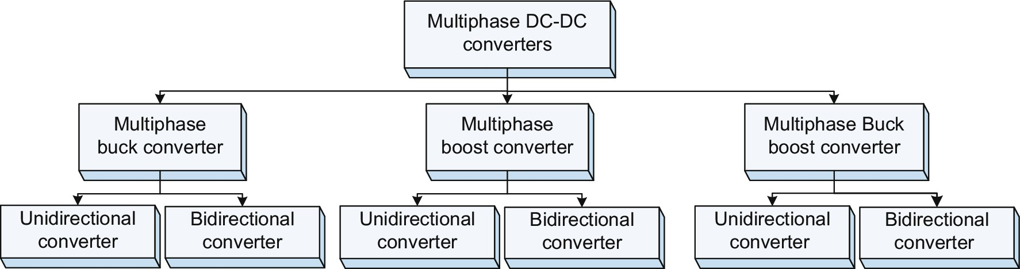

**FIG. 15.3** Multiphase DC-DC converter classification.

### 15.2.3 MULTIPHASE DC-AC CONVERTERS

Multiphase DC-AC converters are the main source of multiphase adjustable-speed drives. The major driving force behind the adoption of multiphase motor drive is due to the power segmentation in large number of converter legs. The power switching devices have limited voltage- and current-handling capabilities. Hence, when used in high-power application, series-and parallel combination of devices are required. This is cumbersome solution because of dynamic voltage sharing problem among the series-/parallel-connected power switching devices. Better solution is obtained when the power per phase or per leg is reduced by increasing the number of phases or number of legs, and this is termed as multiphase DC-AC inverters. Multiphase DC-AC inverters are simple in design as they are simple extension of three-phase DC-AC inverter. However, they offer large degree of switching redundancies and hence great flexibility in control. Although control becomes complex, the performance is improved manifold. Multiphase DC-AC inverters can be built in the same topologies as that of their three-phase counterparts and hence have the same calcifications and types. Multiphase AC-DC converters normally classified as shown in [Fig. 15.4](https://learning.oreilly.com/library/view/power-electronics-handbook/9780128114087/B9780128114070000167_1.xhtml#f0025).

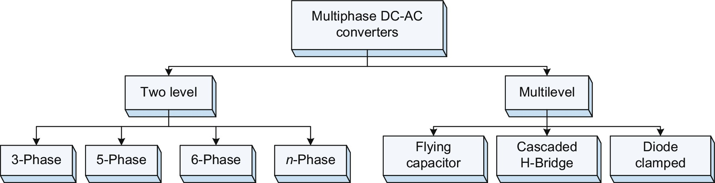

**FIG. 15.4** Multiphase DC-AC converter classifications.

First version of multiphase inverter technology is five-phase VSI fed to star-connected five-phase load. Five-phase VSI configuration found application for five-phase induction machine and synchronous machine drives. Six-phase inverter configuration was built with two two-level standard three-phase VSIs, with two separate DC sources fed to dual three-phase induction motor. Seven-phase VSI fed to star-connected seven-phase load based on multiple space-vector modulation and seven-phase VSI configuration found applications for seven-phase permanent magnet synchronous and synchronous reluctance motor drives. [Fig. 15.5](https://learning.oreilly.com/library/view/power-electronics-handbook/9780128114087/B9780128114070000167_1.xhtml#f0030) shows simple five-phase induction motor drive.

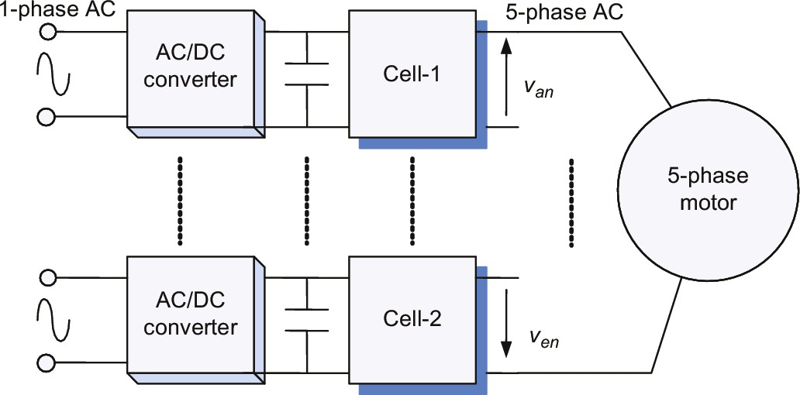

**FIG. 15.5** Simplified five-phase drive.

Multiphase inverters are also classified as cascaded H-bridge, diode clamped, and flying capacitor topologies. They can also be built in hybrid configuration. Multiphase impedance-source inverters (ZSI) and quasi impedance-source inverters (qZSI) are also reported in the literature [[28](https://learning.oreilly.com/library/view/power-electronics-handbook/9780128114087/B9780128114070000167_4.xhtml#bb0145)]. ZSI and qZSI are special inverters that have the capability of boosting the source voltage and inverting DC to AC simultaneously. The boosting can be as high as 200%–300%. They are popular in solar PV applications since boosting and inversion is done in a single stage. Multiphase ZSI/qZSI is used to feed multiphase motor drives.

### 15.2.4 MULTIPHASE AC-AC CONVERTERS

Multiphase AC-AC converters are generally classified as AC voltage controllers, matrix converters, and cycloconverters. [Fig. 15.6](https://learning.oreilly.com/library/view/power-electronics-handbook/9780128114087/B9780128114070000167_1.xhtml#f0035) shows various topologies of multiphase AC-AC converters. AC voltage regulators are further classified as phase-controlled converters and fully controlled voltage converters.



**FIG. 15.6** Multiphase AC-AC converter classification.

Three-phase cycloconverters are of several types. For example, there are the 3-pulse cycloconverters, 6-pulse cycloconverters, and 12-pulse cycloconverters. Typically, the three-pulse converter is built with the three single, and the six-pulse converter is generally the combination of two three-pulse converters and so on. The 12-pulse converter is obtained by connecting two six-pulse configurations in series and appropriate transformer connections for the required phase shifted. Multiphase AC-AC converter classification is shown in [Fig. 15.6](https://learning.oreilly.com/library/view/power-electronics-handbook/9780128114087/B9780128114070000167_1.xhtml#f0035). By using the knowledge of constructing a DC-modulated single-stage AC/AC converter, a multistage AC/AC converter can be easily obtained. Examples with complex structures are Luo converter, superlift Luo converter, and multistage cascaded boost converter. Using the same technique, one can construct DC-modulated multiphase AC/AC converters where they are classified as multiphase AC/AC buck, boost, and buck-boost converter.

Cycloconverters are broadly classified as naturally commutated and forced commutated. The later one is also known as matrix converter. Multiphase matrix converters are in study and are being studied in detail [[4](https://learning.oreilly.com/library/view/power-electronics-handbook/9780128114087/B9780128114070000167_4.xhtml#bb0025)]. [Fig. 15.7](https://learning.oreilly.com/library/view/power-electronics-handbook/9780128114087/B9780128114070000167_1.xhtml#f0040) shows some of the possible configurations of frequency changers. The one with a DC link is also commonly known as back-to-back (B2B) topology. Although B2B converter does the AC-AC conversion, it is sort of a paradigm to classify the topologies without the DC link under AC-AC converters. Also, the figure shows the possibility of research in the field of multiphase matrix converters.



**FIG. 15.7** Multiphase frequency changers. *VSR*, voltage source rectifier; *VSI*, voltage source inverter; *CSR*, current source rectifier; *CSI*, current source inverter; *MPMC*, multiphase matrix converter; *DMMC*, direct multiphase matrix converter; *IMMC*, indirect multiphase matrix converter; *SMC*, sparse matrix converter; *USMC*, ultra sparse matrix converter.

## 15.3 Multiphase Multipulse AC-DC Converters

Solid-state AC-DC converters are widely used in a number of applications such as adjustable-speed drives (ASDs), high-voltage DC (HVDC) transmission, and electrochemical processes such as electroplating, telecommunication power supplies, battery charging, uninterruptible power supplies (UPS), high-capacity magnet power supplies, high-power induction heating equipment, aircraft converter systems, plasma power supplies, and converters for renewable energy conversion systems. These converters, which are also known as rectifiers, are generally fed from three-phase AC supply in power rating above few kilowatts. They exhibit the problems of power quality in terms of injected harmonics, resulting in poor power factor, AC voltage distortion, and rippled DC outputs. Because of these problems in AC-DC conversion, several standards and guidelines are laid down, which are to be referred by designers, manufacturers, and users. Therefore, various methods are used to mitigate these problems in AC-DC converters. Normally, filters are recommended in already existing installations, which may be passive, active, or hybrid types depending upon rating and economic considerations. These filters have been developed from small to large power ratings to reduce the power quality problems of AC-DC converters. However, in some cases, the ratings of these filters are close to the converter rating, which not only increases the cost but also increases the losses and component count, resulting in reduced reliability of the system. However, in future installations, it is preferred to modify the converter structure at design stage either using active or passive (magnetic) wave shaping of input currents or using multipulse AC-DC converters by using multiphase system or different connections of standard three-phase six-pulse AC-DC converters. At higher power level, generally, multiphase system is preferred. It reduces the ripples in the line current and load voltages drastically, and thus, EMI reduces, and the harmonic filter requirements also become very nominal.

### 15.3.1 FIVE PHASE UNCONTROLLED FULL WAVE BRIDGE RECTIFIER

The circuit diagram of a simplified five-phase (ten pulses) uncontrolled rectifier consisting of 10 diodes (D1–D10) is shown in [Fig. 15.8](https://learning.oreilly.com/library/view/power-electronics-handbook/9780128114087/B9780128114070000167_1.xhtml#f0045), where *van*, *vbn*, *vcn*, *vdn*, and *ven* are the supply phase voltages having peak value of *Vm* given by Eq [(15.1)](https://learning.oreilly.com/library/view/power-electronics-handbook/9780128114087/B9780128114070000167_1.xhtml#fo0010):

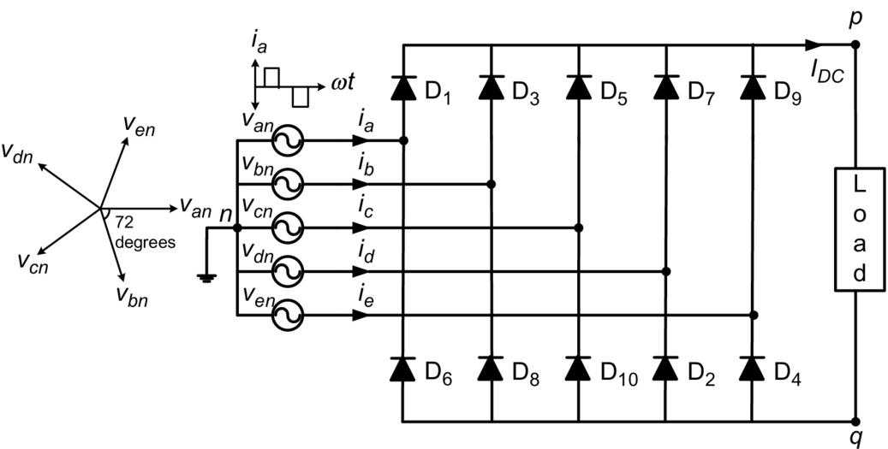

**FIG. 15.8** Five-phase full-wave uncontrolled rectifier circuit.

 **(15.1)**

The diodes are assumed ideal and are numbered according to their conduction sequence 1,2- ,3- 3,4- 4,5- 5,6- 6,7- 7,8- 8,9- 9,1.

The line voltages for adjacent phases will be different from that of nonadjacent phases. The line voltages for adjacent and nonadjacent phases can be obtained from the respective phasor diagrams shown in [Figs. 15.9](https://learning.oreilly.com/library/view/power-electronics-handbook/9780128114087/B9780128114070000167_1.xhtml#f0050) and [15.10](https://learning.oreilly.com/library/view/power-electronics-handbook/9780128114087/B9780128114070000167_1.xhtml#f0055), respectively, as follows:



**FIG. 15.9** Phasor diagram of the line voltages of adjacent phases.



**FIG. 15.10** Phasor diagram for the addition of nonadjacent phases.

For adjacent phases,

 **(15.2)**

For nonadjacent phases,

 **(15.3)**

[Fig. 15.11A](https://learning.oreilly.com/library/view/power-electronics-handbook/9780128114087/B9780128114070000167_1.xhtml#f0060) shows the waveforms of the maximum and minimum value of phase voltage in different intervals. The maximum phase voltage *Vpn* and minimum phase voltage *Vqn* described by Eq [(15.4)](https://learning.oreilly.com/library/view/power-electronics-handbook/9780128114087/B9780128114070000167_1.xhtml#fo0025) will appear at the output terminals *p* and *q*. Both the diodes in the same leg never conduct simultaneously, which avoids direct short circuit in the leg. In the upper leg, the diodes (odd numbered) having its anode connected with phase voltage of highest value among phases will conduct. Similarly, in the bottom leg, the diodes (even numbered) having its cathode connected with lowest phase voltage will conduct at any instant of time:



**FIG. 15.11** (A) Phase voltages w.r.t *p* and *q* points, (B) output voltage across the load, (C) phase “a” current, and (D) diode current.

 **(15.4)**

The output-voltage waveform shown in [Fig. 15.11B](https://learning.oreilly.com/library/view/power-electronics-handbook/9780128114087/B9780128114070000167_1.xhtml#f0060) is a 10-pulse waveform appearing across the load. For a purely resistive load, the waveform of the line current *ia* shown in [Fig. 15.11C](https://learning.oreilly.com/library/view/power-electronics-handbook/9780128114087/B9780128114070000167_1.xhtml#f0060) has two humps per half cycle of the supply frequency. The other four line currents, *ib*, *ic*, *id*, and *ie*, have the same waveform as *ia* but lag from *ia* by 2*π*/5, 4*π*/5, 6*π*/5, and 8*π*/5 radians, respectively. The average and rms value of output voltage at load can be calculated as

 **(15.5)**

**** **(15.6)**

For a resistive load, the harmonics of the output voltage can be found by using Fourier series analysis. To find the Fourier coefficients, we integrate *vbe* from −*π*/10 to +*π*/10. Considering the half-wave symmetry, the Fourier coefficients will be calculated as follows:

 **(15.7)**

**** **(15.8)**

If the frequency of the source voltage is *f*, the output voltage has harmonics at 10*f*, 20*f*, 30*f* …etc. Eq. [(15.8)](https://learning.oreilly.com/library/view/power-electronics-handbook/9780128114087/B9780128114070000167_1.xhtml#fo0045) is simplified as

 **(15.9)**

The DC component is found by putting *n*=0 in Eq. [(15.9)](https://learning.oreilly.com/library/view/power-electronics-handbook/9780128114087/B9780128114070000167_1.xhtml#fo0050), and its value is

 **(15.10)**

This is the same value as calculated in Eq. [(15.5)](https://learning.oreilly.com/library/view/power-electronics-handbook/9780128114087/B9780128114070000167_1.xhtml#fo0030). The Fourier series of the load voltage can be written as

 **(15.11)**

After substituting the values of the coefficients, we obtain

 **(15.12)**

**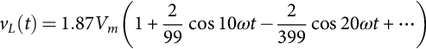** **(15.13)**

[Fig. 15.12](https://learning.oreilly.com/library/view/power-electronics-handbook/9780128114087/B9780128114070000167_1.xhtml#f0065) shows the load voltage harmonics profile. Since each diode conducts one fifth of the time, the average diode current is given by Eq. [(15.14)](https://learning.oreilly.com/library/view/power-electronics-handbook/9780128114087/B9780128114070000167_1.xhtml#fo0075).



**FIG. 15.12** Harmonics profile of output voltage.

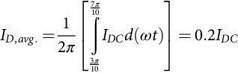 **(15.14)**

Eq. [(15.14)](https://learning.oreilly.com/library/view/power-electronics-handbook/9780128114087/B9780128114070000167_1.xhtml#fo0075) indicates that a five-phase rectifier will have switches with lower ratings as compared with the three-phase counterpart, provided that both are feeding the same load as average value of switch current in three-phase system is 33.33% and in this case it is 20% [[9](https://learning.oreilly.com/library/view/power-electronics-handbook/9780128114087/B9780128114070000167_4.xhtml#bb0050),[10](https://learning.oreilly.com/library/view/power-electronics-handbook/9780128114087/B9780128114070000167_4.xhtml#bb0055)]. The input phase current can be expressed as

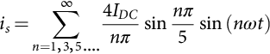 **(15.15)**

The fundamental component of input current is

 **(15.16)**

The rms value of the fundamental component of input current is

 **(15.17)**

**Problem 15.1**

A five-phase bridge rectifier delivers 60 A current at a voltage of 317.5 V to a purely resistive load. If the frequency of the source is 60 Hz, determine the following:

(a) Efficiency of rectification

(b) Form factor

(c) Ripple factor

(d) Peak inverse voltage (PIV) of each diode

(e) Peak current through a diode

**Solution**

Since *VDC*=1.87087*Vm* and *Vrms*=1.87101*Vm* and also *IDC*=*VDC*/*R* and *Irms*=*Vrms*/*R*,

(a) Efficiency of rectification 

(b) Form factor 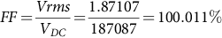

(c) Ripple factor 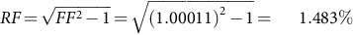

(d) Peak inverse voltage of each diode=1.902*Vm*

Also, since *VDC*=1.87087 *Vm* and peak value of phase voltage, 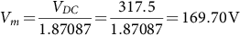

Hence, 

(e) The average DC current through each diode is



Also, 



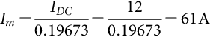

### 15.3.2 FIVE-PHASE CONTROLLED FULL WAVE BRIDGE RECTIFIER

Whenever a diode is in forward-biased condition, it conducts, but a thyristor (or controlled switch) requires a triggering signal for its conduction. If all the diodes of a 10-pulse full-wave uncontrolled converter are replaced by controlled switches (thyristors), it becomes a controlled converter. [Fig. 15.13](https://learning.oreilly.com/library/view/power-electronics-handbook/9780128114087/B9780128114070000167_1.xhtml#f0070) shows the basic power circuit of a fully controlled 10-pulse 5-phase AC-DC converter. In this case, the thyristors are switched at an interval of 36 degrees sequentially as shown in [Table 15.1](https://learning.oreilly.com/library/view/power-electronics-handbook/9780128114087/B9780128114070000167_1.xhtml#t0010). When *T*1 and *T*2 are conducting *van* and *vbn* voltages with respect to neutral appear at the load, that is, *vad*=*van*−*vdn*, which is the line voltage *VL* (). At *ωt*=*π*/2+*α*, *T*1 is commutated, as on this instant of time *vbn*>*van*, and the load current is transferred from *T*1 to *T*3. There are 10 voltage pulses, and the instantaneous output voltage may become negative for an RL load, but the *Vdc* will always have positive value, except for an active (RLE) load. It should be noted that the line voltage corresponding to the nonadjacent phase voltages is only appearing across the load. AC voltages applied to the rectifier is given by Eq. [(15.1)](https://learning.oreilly.com/library/view/power-electronics-handbook/9780128114087/B9780128114070000167_1.xhtml#fo0010).

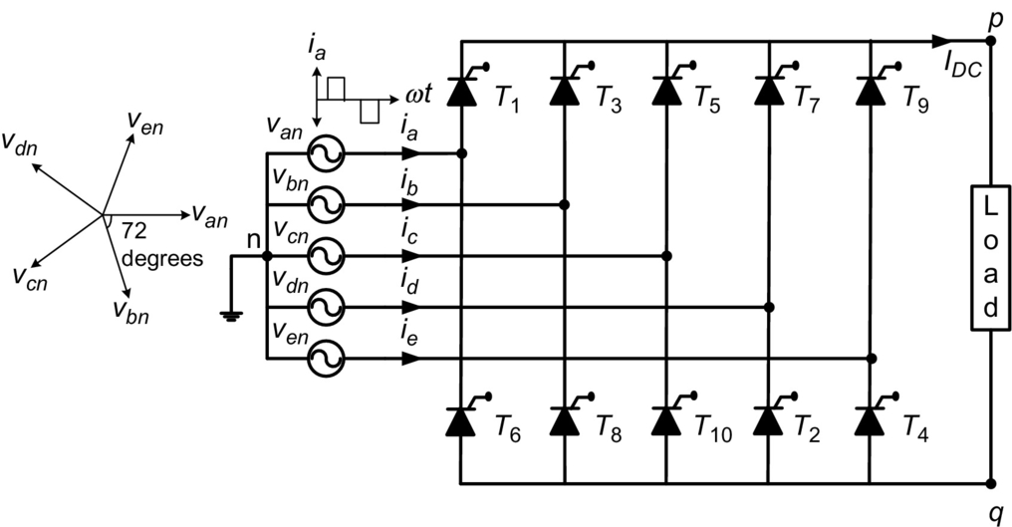

**FIG. 15.13** Five-phase full-wave bridge rectifier basic circuit.

**Table 15.1**

**Thyristor firing instants and output voltage across the load**

|  |  |  |  |
| --- | --- | --- | --- |
| **Time interval** | **Thyristor fired** | **Conducting thyristor** | **Output voltages across load** |
| [*π*/10+*α,* 3*π*/10+*α*] | *T*10 | *T*9 and *T*10 | si1_e |
| [3*π*/10+*α,* 5*π*/10+*α*] | *T*1 | *T*10 and *T*1 | si2_e |
| [5*π*/10+*α,* 7*π*/10+*α*] | *T*2 | *T*1 and *T*2 | si3_e |
| [7*π*/10+*α,* 9*π*/10+*α*] | *T*3 | *T*2 and *T*3 | si4_e |
| [9*π*/10+*α,* 1*π*/10+*α*] | *T*4 | *T*3 and *T*4 | si5_e |
| [11*π*/10+*α*, 13*π*/10+*α*] | *T*5 | *T*4 and *T*5 | si6_e |
| [13*π*/10+*α,* 15*π*/10+*α*] | *T*6 | *T*5 and *T*6 | si7_e |
| [15*π*/10+*α,* 17*π*/10+*α*] | *T*7 | *T*6 and *T*7 | si8_e |
| [17*π*/10+*α,* 19*π*/10+*α*] | *T*8 | *T*7 and *T*8 | si9_e |
| [19*π*/10+*α,* 21*π*/10+*α*] | *T*9 | *T*8 and *T*9 | si10_e |

The delay angle reference is taken from the point the thyristor would begin to conduct if it were a diode. Thus, the delay angle is an interval from the thyristor being forward-biased and till the gate signal is applied. The corresponding waveforms are shown in [Fig. 15.14A–H](https://learning.oreilly.com/library/view/power-electronics-handbook/9780128114087/B9780128114070000167_1.xhtml#f0075) [[9](https://learning.oreilly.com/library/view/power-electronics-handbook/9780128114087/B9780128114070000167_4.xhtml#bb0050),[10](https://learning.oreilly.com/library/view/power-electronics-handbook/9780128114087/B9780128114070000167_4.xhtml#bb0055)]. Since each voltage pulse corresponds to the line voltage and it appears for 1/10th period of the cycle 2*π*/10, the average output voltage corresponding to *vad* shown in [Table (15.1)](https://learning.oreilly.com/library/view/power-electronics-handbook/9780128114087/B9780128114070000167_1.xhtml#fo0010) is given by

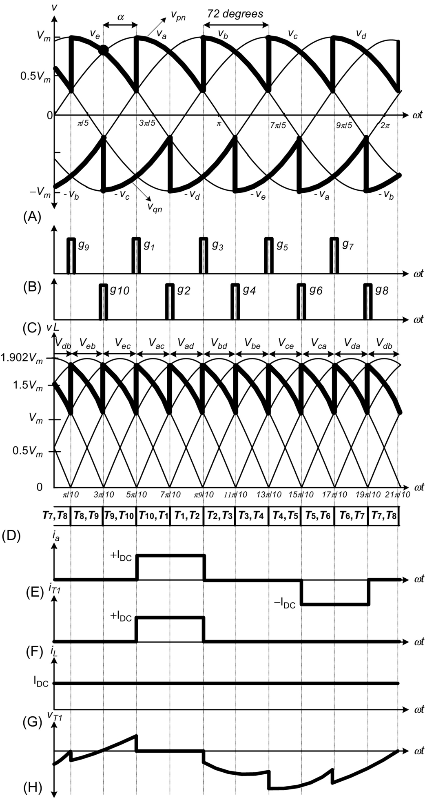

**FIG. 15.14** (A) Supply voltage with positive and negative waveforms, (B) gate pulses for firing upper-leg switches, (C) gate pulses for firing lower-leg switches, (D) output-voltage waveform, (E) supply current of phase a, (F) switch 1 current, (G) load current, and (H) voltage across switch 1.

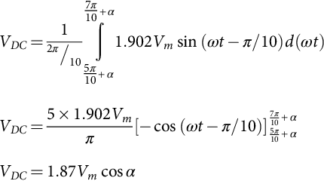 **(15.18)**

The rms output voltage is

 **(15.19)**

It is evident from [Fig. 15.14D](https://learning.oreilly.com/library/view/power-electronics-handbook/9780128114087/B9780128114070000167_1.xhtml#f0075) that the instantaneous output voltage is continuous for *α*<*π*/5; therefore, for any passive load, the load current will be continuous. For 3*π*/10<*α*>*π*/5, the continuity of load current depends on the phase angle of load (*φ*) and discontinuous for purely resistive load (*φ*=0). For *α*>3*π*/10, the load current will be always discontinuous for the passive load (*Vdc*>0), whereas for active load (RLE), there will be fourth-quadrant operation (*Vdc*<0 and *Idc*>0).

[Fig. 15.14E](https://learning.oreilly.com/library/view/power-electronics-handbook/9780128114087/B9780128114070000167_1.xhtml#f0075) shows the input phase current, which is a quasisquare wave. Since the instantaneous value of load current is assumed to be constant, so the phase current will be +*IDC* in the interval (3*π*/10+*α* and 7*π*/10+*α*) and −*IDC* in the interval (13*π*/10+*α* and 17*π*/10+*α*). Also, each phase currents will be displaced from each other by 2*π*/5, irrespective of thyristor firing angles. The input phase current *ia* can be expressed in Fourier series as

 **(15.20)**

where *In* is the rms value of *n*th harmonic component of the input current and is given by

 **(15.21)**

The *φn* is the *n*th harmonic phase shift and is given by

 **(15.22)**

Also, due to the symmetry of waveform,

 **(15.23)**

**** **(15.24)**

Similarly,

 **(15.25)**

Therefore, the rms value of *nth* harmonics current will be given by

 **(15.26)**

and

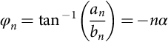 **(15.27)**

*n*=1 will give the rms value of fundamental component of the input current:

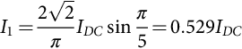 **(15.28)**

Hence, the input current can be given by

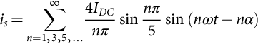 **(15.29)**

The fundamental input current, (substituting, *n*=1), is

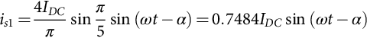 **(15.30)**

The rms value of the input current can be calculated as

 **(15.31)**

The total harmonic distortion (THD) is given by

 **(15.32)**

Displacement factor

 **(15.33)**

Power factor

 **(15.34)**

The load current is constant as the load is considered highly inductive; from [Fig. 15.14F](https://learning.oreilly.com/library/view/power-electronics-handbook/9780128114087/B9780128114070000167_1.xhtml#f0075), it is clear that each switch operates for 2*π*/5 period of time in one cycle; accordingly, the switch average current can be calculated as

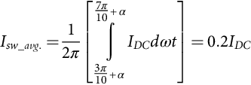 **(15.35)**

When calculated, the switch current is only 20% of DC-link current [[10](https://learning.oreilly.com/library/view/power-electronics-handbook/9780128114087/B9780128114070000167_4.xhtml#bb0055)]. The harmonic factor (*HFn*) is defined as the normalized harmonic current of the supply with respect to the fundamental component (*In*/*I*1) and is calculated using Eq. (6.36):

 **(15.36)**

**Problem 15.2**

A five-phase full-wave bridge-controlled rectifier has an AC input of 120 V rms at 60 Hz and 100 Ω load resistor. The delay angle is *α*=*π*/12 radians. Determine the following:

(a) Average current in the load

(b) Power absorbed by the load

(c) Efficiency of the rectifier

(d) The expression for the input current

(e) THD

(f) Power factor of the rectifier

(g) Form factor and ripple factor

**Solution**

(a) Average load voltage 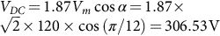

Average load current 

(b) Power absorbed by the load 

(c) The rms value of the output voltage 

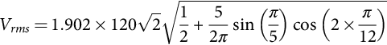



and 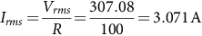

Therefore, efficiency 

(d) The expression for the input current 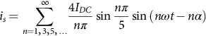

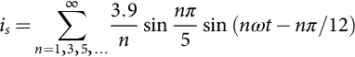

(e) The rms value of the input current 

The rms value of fundamental component of the input current





(f) The power factor 

(g) Form factor 

Ripple factor 

### 15.3.3 MULTIPULSE RECTIFIERS

The multipulse uncontrolled rectifiers are suitable for VSI-fed drives, while the controlled rectifiers are employed for CSI drives. As the number of pulses per cycle increases, the output waveform gets improved. There are identical multipulse rectifiers connected in either parallel, series, or separate modes to achieve higher pulses in the output. [Fig. 15.15](https://learning.oreilly.com/library/view/power-electronics-handbook/9780128114087/B9780128114070000167_1.xhtml#f0080) shows general layout of 12-, 18-, and 24-pulse rectifier circuits [[29](https://learning.oreilly.com/library/view/power-electronics-handbook/9780128114087/B9780128114070000167_4.xhtml#bb0150),[30](https://learning.oreilly.com/library/view/power-electronics-handbook/9780128114087/B9780128114070000167_4.xhtml#bb0155)]. If we employ 10-pulse rectifiers, then we can obtain 20, 30, and 40 pulses in the output.



**FIG. 15.15** Multipulse uncontrolled/controlled rectifier's arrangement.

#### **15.3.3.1 12-Pulse Series Type Controlled Rectifier**

Two six-pulse controlled rectifiers are powered by a phase-shifting transformer with two secondary windings in delta and star connections. Therefore, the phase angle between both secondary windings shifts 30 degrees each. In this case with 12 pulses per cycle, the quality of output-voltage waveform would definitely be improved with low ripple content [[29](https://learning.oreilly.com/library/view/power-electronics-handbook/9780128114087/B9780128114070000167_4.xhtml#bb0150)].

[Fig. 15.15](https://learning.oreilly.com/library/view/power-electronics-handbook/9780128114087/B9780128114070000167_1.xhtml#f0080) shows circuit configuration of a 12-pulse series-type controlled rectifier. A three-phase transformer with two secondary and one delta-connected primary feeds the two identical six-pulse controlled rectifiers. The upper three-phase bridge is fed from Y-connected secondary winding while lower with Δ-connected secondary winding. Therefore, this arrangement will result in the phase angle shifts between both secondary windings by 30 degrees. The outputs of the two six-pulse rectifiers are connected in series, and the conduction period of the line current for each converter is 120 degrees.

Consider an idealized 12-pulse rectifier where the line inductance *Ls* and the total leakage inductance *Llk* of the transformer are assumed to be zero and the magnitude of the current is constant (ripple-free) [[29](https://learning.oreilly.com/library/view/power-electronics-handbook/9780128114087/B9780128114070000167_4.xhtml#bb0150)]. In practical case, the ripple in the DC current will be relatively low due to the series connection of the two six-pulse rectifiers, where the leakage inductances of the secondary windings can be considered in series.

For the purpose of eliminating the dominate lower-order harmonics in the line current *ia*, the line-to-line voltage *va*1*b*1 of the Y-connected secondary winding (*N*2 turns) is in phase with the primary winding (*N*1 turns) voltage *vab*, while the Δ-connected secondary winding (*N*3 turns) voltage *va*2*b*2 leads *vab* by [[29](https://learning.oreilly.com/library/view/power-electronics-handbook/9780128114087/B9780128114070000167_4.xhtml#bb0150)]:

 **(15.37)**

For the sake of simplicity, let  (i.e., *N*1-*N*2-*N*3=1:0.5:0.866).

Therefore, the rms line-to-line voltage of each secondary winding will become

 **(15.38)**

Since the two rectifiers are series-connected, net output, or load, voltage *Vdc*=*Vdc*1+*Vdc*2 ; since the waveforms of *Vdc*1 and *Vdc*2 are phase shifted from each other by 30 degrees , therefore, the waveform of output voltage *Vdc* consists of 12 pulses per cycle of supply voltage. The current waveforms are illustrated in [Fig. 15.16](https://learning.oreilly.com/library/view/power-electronics-handbook/9780128114087/B9780128114070000167_1.xhtml#f0085), where *ia*1 and *ic*2*a*2 are the phase currents of secondary Y and Δ windings, respectively, and *i*′*a*1 and *i*′*c*2*a*2 are the currents referred from secondary side to the primary side. The waveforms of reflected current to primary side of secondary Y-connected winding *i*′*a*1 will be identical to that of *ia*1 except that the magnitude is changed in ratio of the number of turns of the two windings. However, when *ia*2 is referred to the primary side, the reflected waveform does not keep the same waveform and magnitude. This is due to phase displacements of the harmonic current when they are referred from Δ-Y windings. This phase displacement is advantageous as it will lead to the cancelation of low-order predominant fifth and seventh harmonics from the currents of transformer primary winding and does not appear in the line current, which is given by Eq. [(15.39)](https://learning.oreilly.com/library/view/power-electronics-handbook/9780128114087/B9780128114070000167_1.xhtml#fo0240):



**FIG. 15.16** Twelve-pulse series-type controlled rectifier connection circuit.

 **(15.39)**

The secondary (Y-connected) line current *ia*1 can be expressed by Eq. [(15.40)](https://learning.oreilly.com/library/view/power-electronics-handbook/9780128114087/B9780128114070000167_1.xhtml#fo0245):

 **(15.40)**

Since the waveform of current *ia*1 is of half-wave symmetry, it does not contain any even-order harmonics. Current *ia* does not contain any triple harmonics either due to the consideration of balanced three-phase system. The line current in Δ-connected secondary winding such as *ia*2 leads *ia*1 by 30 degrees, and the Fourier expression of current *ia*2 is given by Eq. [(15.41)](https://learning.oreilly.com/library/view/power-electronics-handbook/9780128114087/B9780128114070000167_1.xhtml#fo0250):

 **(15.41)**

Similar equations for *ib*2 and *ic*2 can be obtained. The current *i*′*a*1, which is identical to *ia*1 in wave shape, can be expressed in Fourier series by Eq. [(15.42)](https://learning.oreilly.com/library/view/power-electronics-handbook/9780128114087/B9780128114070000167_1.xhtml#fo0255):

 **(15.42)**

The phase currents in the Δ-connected secondary windings *ia*2*b*2, *ib*2*c*2, and *ic*2*a*2 can be obtained from its line currents using the transformation given in Eq. [(15.43)](https://learning.oreilly.com/library/view/power-electronics-handbook/9780128114087/B9780128114070000167_1.xhtml#fo0260):

 **(15.43)**

The phase currents in the Δ-connected secondary winding *ia*2*b*2, *ib*2*c*2, and *ic*2*a*2 have a stepped waveform, each step being of 60 degrees in width whereas *Id*/3 and 2*Id*/3 the heights. The expression for phase current in the Δ-connected secondary winding can be written as Eq. [(15.44)](https://learning.oreilly.com/library/view/power-electronics-handbook/9780128114087/B9780128114070000167_1.xhtml#fo0265).

 **(15.44)**

On simplification of Eq. [(15.44)](https://learning.oreilly.com/library/view/power-electronics-handbook/9780128114087/B9780128114070000167_1.xhtml#fo0265), we have

 **(15.45)**

Similarly, the expressions for the currents *ia*2*b*2 and *ib*2*c*2 can be obtained. The corresponding reflected current to the primary side can be obtained from Eq. [(15.45)](https://learning.oreilly.com/library/view/power-electronics-handbook/9780128114087/B9780128114070000167_1.xhtml#fo0270); by multiplying with turn ratio (), we can obtain Eq. [(15.46)](https://learning.oreilly.com/library/view/power-electronics-handbook/9780128114087/B9780128114070000167_1.xhtml#fo0275) [[31](https://learning.oreilly.com/library/view/power-electronics-handbook/9780128114087/B9780128114070000167_4.xhtml#bb0160)]:

 **(15.46)**

Therefore, the line current  can be written as given in Eq. [(15.47)](https://learning.oreilly.com/library/view/power-electronics-handbook/9780128114087/B9780128114070000167_1.xhtml#fo0280):

 **(15.47)**

Different current waveforms are shown in [Fig. 15.17](https://learning.oreilly.com/library/view/power-electronics-handbook/9780128114087/B9780128114070000167_1.xhtml#f0090). It is evident from Eq. [(15.47)](https://learning.oreilly.com/library/view/power-electronics-handbook/9780128114087/B9780128114070000167_1.xhtml#fo0280) that the two dominant harmonics, 5th and 7th, are absent along with 17th and 19th, which improves the THD of this type of converter configuration drastically.



**FIG. 15.17** Current waveforms of the 12-pulse series-connected controlled rectifier (*Ls*=*Llk*=0). (A) Output line/phase current in star-connected secondary winding. (B) Output line current in delta-connected secondary winding. (C) Output phase current in delta-connected secondary winding. (D) Delta-connected secondary winding phase current reflected to primary side. (E) Star-connected secondary winding phase current reflected to primary side. (F) Total current in the primary side.

#### **15.3.3.2 Pulse Parallel-Type Controlled Rectifier**

In this case, the outputs of the two six-pulse rectifiers are connected in parallel. [Fig. 15.18](https://learning.oreilly.com/library/view/power-electronics-handbook/9780128114087/B9780128114070000167_1.xhtml#f0095) shows circuit configuration of a 12-pulse parallel-type controlled rectifier. The circuit in the figure simply uses an isolation transformer with a Δ-connected primary, a Y-connected secondary, and a second Δ-connected secondary to obtain 30 degrees (electrical degrees) phase shift. Since the instantaneous outputs of the two rectifiers are not equal, an interphase reactor is necessary to support the difference in instantaneous rectifier output voltages and permit each rectifier to operate independently [[29](https://learning.oreilly.com/library/view/power-electronics-handbook/9780128114087/B9780128114070000167_4.xhtml#bb0150)]. The line current in primary winding of the transformer is the sum of reflected currents from the two secondary windings, and it becomes stepped due to 30 degrees phase shift in two secondary currents as discussed in [Section 15.3.3.1](https://learning.oreilly.com/library/view/power-electronics-handbook/9780128114087/B9780128114070000167_1.xhtml#s0060). Therefore, the harmonics and requirement of filter circuit parameters are reduced. Theoretically, input current harmonics for rectifier circuit is a function of pulse number and can be expressed as



**FIG. 15.18** Twelve-pulse parallel-type controlled rectifier connection circuit.

 **(15.48)**

where *N*=1, 2, 3… and p is pulse number.

For example, in a three-phase six-pulse rectifier, the input current will have harmonic components at 5, 7, 11, 13, 17, 19, 23, 25, 29, 31, etc. multiples of the fundamental frequency. For the 12-pulse system shown in [Fig. 15.16](https://learning.oreilly.com/library/view/power-electronics-handbook/9780128114087/B9780128114070000167_1.xhtml#f0085), the input current will have theoretical harmonic components at 11, 13, 23, 25, 35, 37, etc. multiples of the fundamental frequency as derived and discussed in [Section 15.3.3.1](https://learning.oreilly.com/library/view/power-electronics-handbook/9780128114087/B9780128114070000167_1.xhtml#s0060). Since the magnitude of each harmonic is proportional to the reciprocal of the harmonic order, the 12-pulse system naturally has a lower harmonic distortion in input current.

The problem with the parallel connection of the rectifiers is that the two rectifiers must share exactly equal current to achieve the desired reduction in harmonics. This would be achieved if output voltages of both secondary windings matches exactly. Because of the differences in the transformer secondary impedances and open-circuit output voltages, this can be practically accomplished for a given fixed load (typically rated load), but not for loads varying over a range. This is the main problem of the parallel 12-pulse configuration connection. Whereas in the case of series connection of two rectifiers, the problems associated with current sharing are avoided, and an interphase reactor is not required. Parallel connections are normally preferred for applications where high current ratings rather than harmonics are the issue [[32](https://learning.oreilly.com/library/view/power-electronics-handbook/9780128114087/B9780128114070000167_4.xhtml#bb0165)]. Generally, series connection of rectifiers is much simpler to implement than the parallel connection.

### 15.3.4 SINGLE-WAY MULTIPHASE SYSTEMS TOPOLOGIES

The structure of single-way, *m*-phase rectifier is shown in [Fig. 15.19](https://learning.oreilly.com/library/view/power-electronics-handbook/9780128114087/B9780128114070000167_1.xhtml#f0100). In single-way structures, only one diode conducts for single stage, and the remaining diodes are blocked. Due to this, single-way structures are more convenient while increasing the number of phases. In an *m*-phase, the diodes used in the rectifier circuits are divided into a number of groups in star connection. Each group will have three diodes, that is, for a six-diode rectifier, there will be two groups, and for a 12-diode rectifier, there will be four groups [[31](https://learning.oreilly.com/library/view/power-electronics-handbook/9780128114087/B9780128114070000167_4.xhtml#bb0160)]. In a normal connection, the star points will be connected together. But in this circuit, each group will have its all secondary windings, and instead of a direct connection, the star points will be connected through an interphase transformer. The common neutral point serves as the negative terminal of the DC output circuit.



**FIG. 15.19** *m*-Phase, single-way rectifier.

For single-way topologies, the number of output pulses is equal to the number of phases, that is, *p*=*m*, and the number of diodes are equal to *m*. Each diode is conducting for 2*π*/*m* electric radians. [Fig. 15.19](https://learning.oreilly.com/library/view/power-electronics-handbook/9780128114087/B9780128114070000167_1.xhtml#f0100) shows few pulses of output-voltage waveform for *m*-phase half-wave uncontrolled rectifier. In general, for an *m*-phase system, the average and rms value of the output voltage is expressed by Eqs. [(15.49)](https://learning.oreilly.com/library/view/power-electronics-handbook/9780128114087/B9780128114070000167_1.xhtml#fo0290) and [(15.50)](https://learning.oreilly.com/library/view/power-electronics-handbook/9780128114087/B9780128114070000167_1.xhtml#fo0295), respectively:

 **(15.49)**

*rms* voltage 

 **(15.50)**

The form factor and ripple factors are expressed by Eqs. [(15.51)](https://learning.oreilly.com/library/view/power-electronics-handbook/9780128114087/B9780128114070000167_1.xhtml#fo0300) and [(15.52)](https://learning.oreilly.com/library/view/power-electronics-handbook/9780128114087/B9780128114070000167_1.xhtml#fo0305), respectively. From these equations, it is evident that ,

 **(15.51)**

**** **(15.52)**

which implies that by increasing the number of phases in a multiphase, single-way rectifier, the output voltage is improved, that is, it becomes smoother. By connecting to a conventional three-phase mains distribution, it is possible to increase the number of “phases” by using transformers with *m* separated secondary coils. The secondary coils can be connected in a large number of ways. Also, by increasing the number of phases (as stated before, in single-way topologies, *m*=*p*), the ripple frequency increases, and its amplitude decreases. This fact simplifies the filter design to reduce the ripple in the load [[31](https://learning.oreilly.com/library/view/power-electronics-handbook/9780128114087/B9780128114070000167_4.xhtml#bb0160),[32](https://learning.oreilly.com/library/view/power-electronics-handbook/9780128114087/B9780128114070000167_4.xhtml#bb0165)]. The output waveform for *m*-phase half-wave diode rectifier is shown in [Fig. 15.20](https://learning.oreilly.com/library/view/power-electronics-handbook/9780128114087/B9780128114070000167_1.xhtml#f0105). For highly inductive load, the output DC current may be considered as constant (*IDC*).



**FIG. 15.20** Output waveform for *m*-phase half-wave diode rectifier.

The diode average current, rms current, and form factor can be obtained by Eqs. [(15.53)](https://learning.oreilly.com/library/view/power-electronics-handbook/9780128114087/B9780128114070000167_1.xhtml#fo0310)–[(15.55)](https://learning.oreilly.com/library/view/power-electronics-handbook/9780128114087/B9780128114070000167_1.xhtml#fo0320):

 **(15.53)**

**** **(15.54)**

**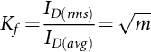** **(15.55)**

The values for *VDC* and some of the parameters have been calculated for *m*=6, *m*=12, and *m*=24 and are reported in [Fig. 15.21](https://learning.oreilly.com/library/view/power-electronics-handbook/9780128114087/B9780128114070000167_1.xhtml#f0110). It is clear from the figure (A)–(C) that the frequency of the ripple on the output is p times the mains frequency. As can be seen, passing from 6 to 12 pulses, one gets a 3.5% improvement in the rectified voltage, while passing from 12 to 24 pulses this improvement is less than 1%.

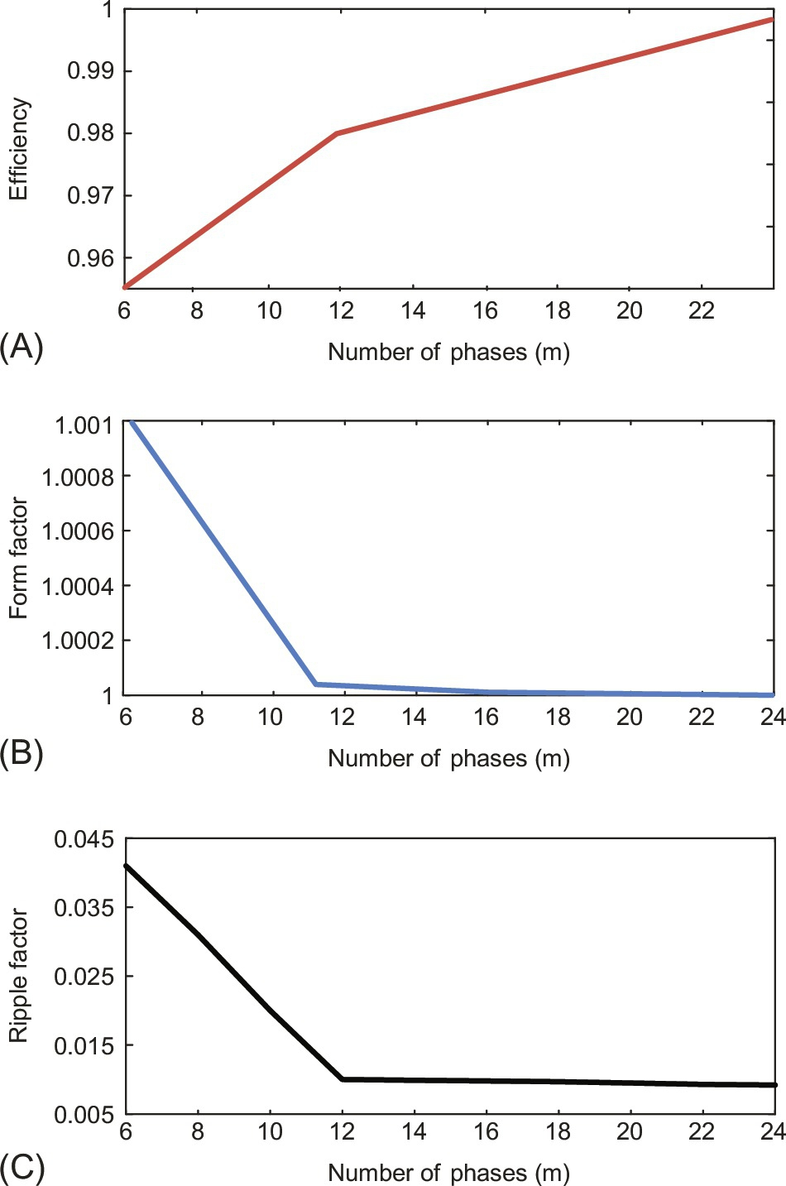

**FIG. 15.21** Characteristics of the number of phases versus (A) efficiency, (B) form factor, and (C) ripple factor.

In practice, for single-way connections, the maximum number of pulses is normally limited to 12 because of the growing complexity of the connections of the transformer's secondary windings. Higher number of pulses can be obtained by using the combination of bridge structures. The best transformer utilization factor (*TUF*) that can be achieved with a single-way connection is 0.79, while with a bridge configuration it is possible to reach higher values, up to 0.955.

### 15.3.5 SIX-PHASE AC TO DC CONVERTERS

Six-phase half-wave rectifiers generally have two configurations, namely, six phase with a neutral line circuit and double antistar with a balance-choke circuit.

#### **15.3.5.1 Six-Phase Half Wave With a Neutral Line Circuit**

The power supply of a six-phase balanced voltage source is given by Eq. [(15.56)](https://learning.oreilly.com/library/view/power-electronics-handbook/9780128114087/B9780128114070000167_1.xhtml#fo0325), and the waveform is shown in [Fig. 15.22](https://learning.oreilly.com/library/view/power-electronics-handbook/9780128114087/B9780128114070000167_1.xhtml#f0115); in this case, each phase is shifted by 60 degrees:

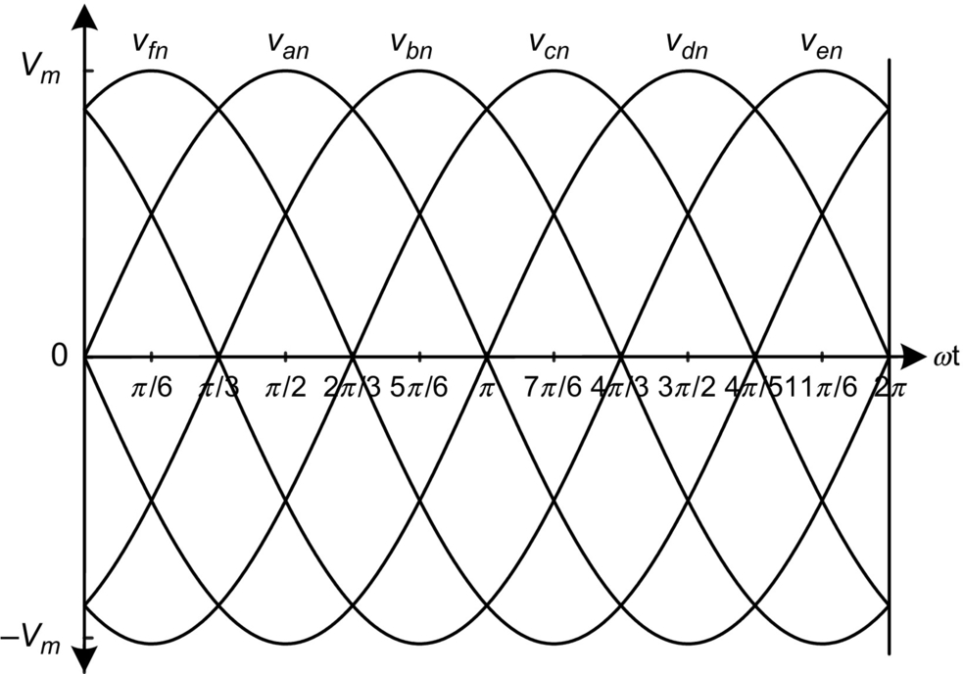

**FIG. 15.22** Six-phase supply waveforms.

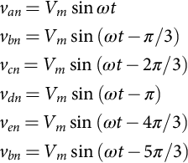 **(15.56)**

The six-phase half-wave rectifiers are shown in [Fig. 15.23](https://learning.oreilly.com/library/view/power-electronics-handbook/9780128114087/B9780128114070000167_1.xhtml#f0120). The first circuit is called a Y-Y circuit, and the second circuit is called a Δ/Y circuit. Each diode conducts for 60 degrees in a cycle.

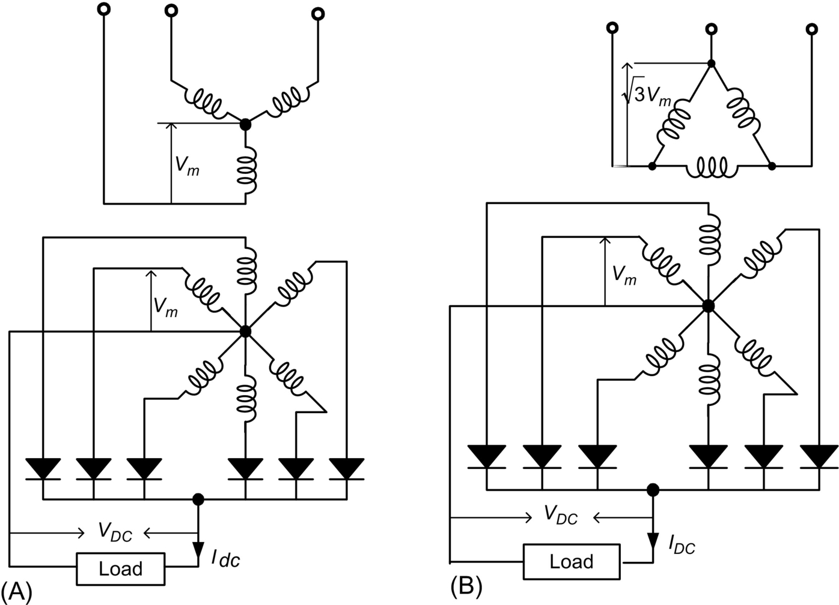

**FIG. 15.23** Six-phase half-wave diode rectifiers: (A) Y/Y circuit and (B) Δ/Y circuit.

 **(15.57)**

**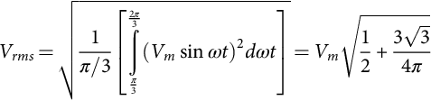** **(15.58)**

**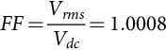** **(15.59)**

**** **(15.60)**

**** **(15.61)**

#### **15.3.5.2 Six-Phase Double-Bridge Full-Wave Uncontrolled Rectifiers**

Two circuits of the six-phase bridge full-wave diode rectifiers are shown in [Fig. 15.24](https://learning.oreilly.com/library/view/power-electronics-handbook/9780128114087/B9780128114070000167_1.xhtml#f0125) and are called as a six-phase bridge circuit and hexagon bridge circuit [[31](https://learning.oreilly.com/library/view/power-electronics-handbook/9780128114087/B9780128114070000167_4.xhtml#bb0160)]. In this case, each diode conducts for 60 degrees in a cycle. The average output voltage is given by Eq. [(15.62)](https://learning.oreilly.com/library/view/power-electronics-handbook/9780128114087/B9780128114070000167_1.xhtml#fo0355):

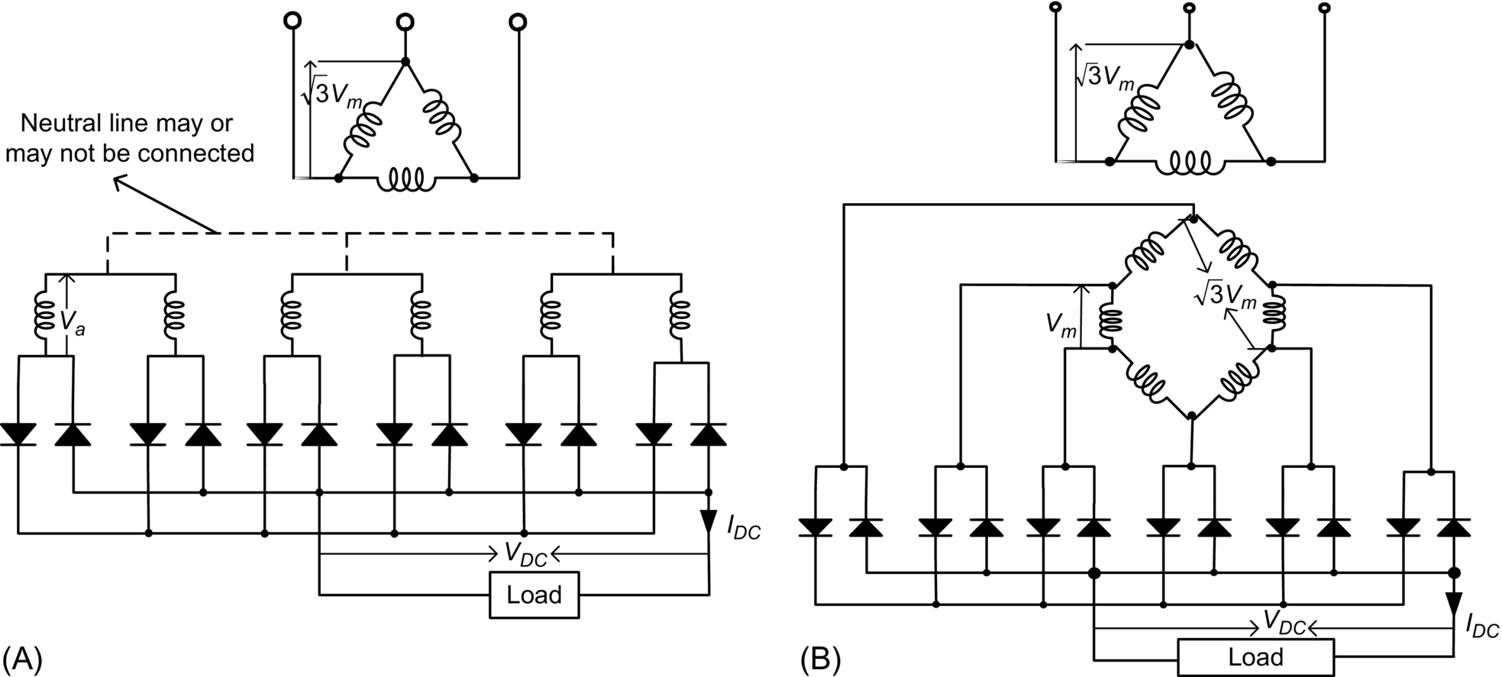

**FIG. 15.24** Six-phase full-wave uncontrolled rectifiers: (A) six-phase bridge circuit and (B) six-phase hexagon bridge circuit.

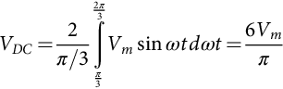 **(15.62)**

#### **15.3.5.3 Six-Phase Half-Wave Controlled Rectifiers**

The six-phase half-wave controlled rectifiers are shown in [Fig. 15.25](https://learning.oreilly.com/library/view/power-electronics-handbook/9780128114087/B9780128114070000167_1.xhtml#f0130) [[31](https://learning.oreilly.com/library/view/power-electronics-handbook/9780128114087/B9780128114070000167_4.xhtml#bb0160)]. Each thyristor conducts for *π*/3 radians in a cycle. The firing angle *α*=*ωt*−*π*/3 in the range of 0–2*π*/3. The average output voltage is



**FIG. 15.25** Six-phase half-wave controlled rectifiers: (A) Y/Y circuit and (B) Δ/Y circuit.

 **(15.63)**

**** **(15.64)**

**** **(15.65)**

**** **(15.66)**

**** **(15.67)**

From Eq. [(15.63)](https://learning.oreilly.com/library/view/power-electronics-handbook/9780128114087/B9780128114070000167_1.xhtml#fo0360), it is clear that the output voltage can have positive (*α*<*π*/2) and negative (*α*>*π*/2) values. When *α*<*π*/2, the output current is (*IDC*=*VDC*/*R*), and when the firing angle *α* is >*π*/2, the output voltage can have negative values, but the output current can only have positive values.

## 15.4 Multiphase DC-AC Converters

### **15.4.1 MODELING AND CONTROL OF A FIVE-PHASE VOLTAGE SOURCE INVERTER**

This section is devoted to the development of a comprehensive model of a five-phase voltage-source inverter based on space-vector theory [[32](https://learning.oreilly.com/library/view/power-electronics-handbook/9780128114087/B9780128114070000167_4.xhtml#bb0165),[33](https://learning.oreilly.com/library/view/power-electronics-handbook/9780128114087/B9780128114070000167_4.xhtml#bb0170)]. Proper modeling of voltage-source inverters is important in devising appropriate control algorithm. The complete model is broadly classified into two groups, namely, square-wave and PWM modes based on the operation of the inverter. The leg voltages and line voltages along with phase voltages are illustrated. The Fourier analysis of output phase-to-neutral voltages and nonadjacent voltages is performed for square-wave mode. The output phase-to-neutral voltage is shown to be essentially identical to those obtainable with a three-phase voltage-source inverter. At each step, simulation results are provided to support the analytic approach results. The relationship between the phase and line voltages for a five-phase system is also established.

For high-power application, stepped operation of inverter is preferred over PWM mode to avoid switching losses. Square-wave mode of operation is elaborated for 180 degrees conduction mode, and the performance is evaluated in terms of harmonic content of phase-to-neutral voltages.

#### **15.4.1.1 Modeling of a Five-Phase VSI**

Power circuit topology of a five-phase VSI is shown in [Fig. 15.26](https://learning.oreilly.com/library/view/power-electronics-handbook/9780128114087/B9780128114070000167_1.xhtml#f0135). Each switch in the circuit consists of two power semiconductor devices, connected in antiparallel. One of these is a fully controllable semiconductor, such as a bipolar transistor, MOSFET, or IGBT, while the second one is a diode. The input of the inverter is a DC voltage, which is regarded further on as being constant. The inverter outputs are denoted in [Fig. 15.26](https://learning.oreilly.com/library/view/power-electronics-handbook/9780128114087/B9780128114070000167_1.xhtml#f0135) with lowercase symbols (*a*, *b*, *c*, *d*, and *e*), while the points of connection of the outputs to inverter legs have symbols in capital letters (*A*,*B*,*C*,*D*,*E*). The basic operating principles of the five-phase VSI are developed in what follows assuming the ideal commutation and zero forward voltage drops.



**FIG. 15.26** Five-phase voltage-source inverter power circuit.

#### **15.4.1.2 Square Wave Mode of Operation**

Discrete switching of power switches in an inverter leads to stepped wave output termed as square-wave operation of the inverter. Conventionally, 180 degrees conduction mode is considered leading to 10-step output phase voltages from the inverter. Each switch conducts for half of the fundamental cycle, that is, 180 degrees. The operation of upper and lower switches is complimentary in operation, that is, when upper switch is on, the lower switch is off and vice versa. In real-time application, a dead time is provided between the turning on of lower switch and turning off of upper switch and vice versa. The incoming power switch cannot be turned on unless the outgoing switch is completely turned off. There is a finite time for complete turnoff of a power switching device, and hence, a dead time is to be provided. This is done in order to avoid short circuit of the source side.

##### **180 degrees conduction mode**

Each switch is assumed to conduct for 180 degrees(half of the fundamental cycle), and the phase delay between firing of two switches in any subsequent two phases is equal to 360/5 degrees=72 degrees. The driving control gate/base signals for the 10 switches of the inverter in [Fig. 15.26](https://learning.oreilly.com/library/view/power-electronics-handbook/9780128114087/B9780128114070000167_1.xhtml#f0135) are illustrated in [Fig. 15.27](https://learning.oreilly.com/library/view/power-electronics-handbook/9780128114087/B9780128114070000167_1.xhtml#f0140). One complete cycle of operation of the inverter can be divided into 10 distinct modes indicated in [Fig. 15.27](https://learning.oreilly.com/library/view/power-electronics-handbook/9780128114087/B9780128114070000167_1.xhtml#f0140) and summarized in [Table 15.2](https://learning.oreilly.com/library/view/power-electronics-handbook/9780128114087/B9780128114070000167_1.xhtml#t0015). It follows from these that at any instant in time there are five switches that are “ON” and five switches that are “OFF.” In the 10-step mode of operation, there are two conducting switches from the upper five and three from the lower five or vice versa.



**FIG. 15.27** Gating signals of a five-phase voltage-source inverter in square-wave mode.

**Table 15.2**

**Modes of operation of the five-phase voltage-source inverter (10-step operation)**

|  |  |  |
| --- | --- | --- |
| **Mode** | **Switches ON** | **Terminal polarity** |
| 1 | 9,10,1,2,3 | A+B+C-D-E+ |
| 2 | 10,1,2,3,4 | A+B+C-D-E- |
| 3 | 1,2,3,4,5 | A+B+C+D-E- |
| 4 | 2,3,4,5,6 | A-B+C+D-E- |
| 5 | 3,4,5,6,7 | A-B+C+D+E- |
| 6 | 4,5,6,7,8 | A-B-C+D+E- |
| 7 | 5,6,7,8,9 | A-B-C+D+E+ |
| 8 | 6,7,8,9,10 | A-B-C-D+E+ |
| 9 | 1,7,8,9,10 | A+B-C-D+E+ |
| 10 | 8,9,10,1,2 | A+B-C-D-E+ |

Space vector of phase voltages in stationary reference frame is defined, using power variant transformation [[33](https://learning.oreilly.com/library/view/power-electronics-handbook/9780128114087/B9780128114070000167_4.xhtml#bb0170)]:

 **(15.68)**

where *a*=exp(*j*2*π*/5), *a*2=exp(*j*4*π*/5), *a*⁎=exp(−*j*2*π*/5), *a*⁎2=exp(−*j*4*π*/5), and ⁎ stands for a complex conjugate.

Leg voltages (i.e., voltages between points *A*,*B*,*C*,*D*, and *E* and the negative rail of the DC bus N in [Fig. 15.26](https://learning.oreilly.com/library/view/power-electronics-handbook/9780128114087/B9780128114070000167_1.xhtml#f0135)) are considered first. The leg voltages from [Fig. 15.27](https://learning.oreilly.com/library/view/power-electronics-handbook/9780128114087/B9780128114070000167_1.xhtml#f0140) are substituted in expression [(15.68)](https://learning.oreilly.com/library/view/power-electronics-handbook/9780128114087/B9780128114070000167_1.xhtml#fo0385) to obtain their corresponding space vectors given as in Eq. [(15.69)](https://learning.oreilly.com/library/view/power-electronics-handbook/9780128114087/B9780128114070000167_1.xhtml#fo0390):

 **(15.69)**

It is seen that the leg voltages have magnitude of  and are 36 degrees apart forming a decagon. There are in total 25=32 switching states (base is taken as 2 because the switching states can only assume two values either 0 (indicate off state) or 1 (indicate on state)). The first 10 states are described above, and the remaining 22 switching states are discussed in the next section.

Phase-to-neutral voltages are discussed next. Phase-to-neutral voltages of the star-connected load are most easily found by defining a voltage difference between the star point *n* of the load and the negative rail of the DC bus *N*. The following correlation then holds true:

 **(15.70)**

Since the phase voltages in a star-connected load sum to zero (sum of five-phase sine wave at one instant of time is zero), the summation of Eq. [(15.70)](https://learning.oreilly.com/library/view/power-electronics-handbook/9780128114087/B9780128114070000167_1.xhtml#fo0395) produces

 **(15.71)**

Substitution of [(15.71)](https://learning.oreilly.com/library/view/power-electronics-handbook/9780128114087/B9780128114070000167_1.xhtml#fo0400) into [(15.70)](https://learning.oreilly.com/library/view/power-electronics-handbook/9780128114087/B9780128114070000167_1.xhtml#fo0395) produces phase-to-neutral voltages of the load in the following form:

 **(15.72)**

The phase voltages in different modes are obtained by substituting leg voltages into Eq. [(15.72)](https://learning.oreilly.com/library/view/power-electronics-handbook/9780128114087/B9780128114070000167_1.xhtml#fo0405), and their space vectors are determined using Eq. [(15.68)](https://learning.oreilly.com/library/view/power-electronics-handbook/9780128114087/B9780128114070000167_1.xhtml#fo0385). The space vectors of phase-to-neutral voltage are identical to the leg voltage space vectors. The phase-to-neutral voltages for various modes are given in [Fig. 15.28](https://learning.oreilly.com/library/view/power-electronics-handbook/9780128114087/B9780128114070000167_1.xhtml#f0145).



**FIG. 15.28** Phase-to-neutral voltages of the five-phase VSI in the square-wave mode of operation.

Fourier analysis of the voltage waveforms, which relates DC link voltage of the inverter with the output, is elaborated.

Using the definition of the Fourier series for a periodic waveform,

 **(15.73)**

where the coefficients of the Fourier series are given with

 **(15.74)**

Observing that the waveforms possess quarter-wave symmetry and can be conveniently taken as odd functions, one can represent phase-to-neutral voltages with the following expressions:

 **(15.75)**

In the case of the phase-to-neutral voltage *vb*, shown in [Fig. 15.28](https://learning.oreilly.com/library/view/power-electronics-handbook/9780128114087/B9780128114070000167_1.xhtml#f0145), one further has for the coefficients of the Fourier series:

 **(15.76)**

The expression in brackets of Eq. [(15.76)](https://learning.oreilly.com/library/view/power-electronics-handbook/9780128114087/B9780128114070000167_1.xhtml#fo0425) equals zero for all the harmonics whose order is divisible by five. For all the other harmonics, it equals 2.5. Hence, one can write the Fourier series of the phase-to-neutral voltage as

 **(15.77)**

From [(15.77)](https://learning.oreilly.com/library/view/power-electronics-handbook/9780128114087/B9780128114070000167_1.xhtml#fo0430), it follows that the fundamental component of the output phase-to-neutral voltage has an rms value equal to

 **(15.78)**

From [Fig. 15.28](https://learning.oreilly.com/library/view/power-electronics-handbook/9780128114087/B9780128114070000167_1.xhtml#f0145), mean square value is determined as

 **(15.79)**

**** **(15.80)**

Total harmonic rms voltage (per unit) is given by

 **(15.81)**

Hence, total harmonic distortion is

 **(15.82)**

This is the same voltage as obtainable with a three-phase VSI operating in six-step mode. It is important to note at this stage that the space vectors described by [(15.68)](https://learning.oreilly.com/library/view/power-electronics-handbook/9780128114087/B9780128114070000167_1.xhtml#fo0385) provides mapping of inverter voltages into a two-dimensional space. However, since five-phase inverter essentially requires description in a five-dimensional space, not all the harmonics contained in [(15.77)](https://learning.oreilly.com/library/view/power-electronics-handbook/9780128114087/B9780128114070000167_1.xhtml#fo0430) will be encompassed by the space vector of [(15.68)](https://learning.oreilly.com/library/view/power-electronics-handbook/9780128114087/B9780128114070000167_1.xhtml#fo0385). In particular, space vectors calculated using [(15.68)](https://learning.oreilly.com/library/view/power-electronics-handbook/9780128114087/B9780128114070000167_1.xhtml#fo0385) will only represent harmonics of the order , that is, the first, the ninth, the eleventh, and so on. Harmonics of the order  cannot appear due to the isolated neutral point. However, harmonics of the order  are present in [(15.77)](https://learning.oreilly.com/library/view/power-electronics-handbook/9780128114087/B9780128114070000167_1.xhtml#fo0430) but are not encompassed by the space-vector definition of [(15.68)](https://learning.oreilly.com/library/view/power-electronics-handbook/9780128114087/B9780128114070000167_1.xhtml#fo0385). These harmonics in essence appear in the second two-dimensional space, which requires introduction of the second space vector for the five-phase system.

Simulation is performed to obtain the harmonic spectrum of inverter phase voltage in 10-step mode of operation, shown in [Fig. 15.29](https://learning.oreilly.com/library/view/power-electronics-handbook/9780128114087/B9780128114070000167_1.xhtml#f0150). The DC voltage is kept at 1 p.u. The harmonic spectrum is in compliance with the expression [(15.77)](https://learning.oreilly.com/library/view/power-electronics-handbook/9780128114087/B9780128114070000167_1.xhtml#fo0430) and [(15.78)](https://learning.oreilly.com/library/view/power-electronics-handbook/9780128114087/B9780128114070000167_1.xhtml#fo0435).



**FIG. 15.29** Inverter phase “a” voltage time-domain waveform and its harmonic spectrum in frequency domain (fundamental frequency is 50 Hz, fundamental voltage 0.4504 (pu)).

The fundamental component is equal to 0.4504 pu, which is the same as what is obtainable with a three-phase VSI. The subharmonic components are third and seventh in [Fig. 15.29](https://learning.oreilly.com/library/view/power-electronics-handbook/9780128114087/B9780128114070000167_1.xhtml#f0150), and their magnitudes are 33.33% and 14.3%, respectively. These subharmonics will appear in the *x*-*y* plane and will cause distortion in the stator currents and consequently increase the losses in the machine. The lowest harmonic appearing on *d*-*q* plane are 9th and 11th with their magnitude as 11.1% and 9.1%, respectively. These harmonic will further add to the losses in addition to 10th-harmonic pulsating torque under steady-state conditions.

The line-to-line voltages are expanded next. There are two systems of line-to-line voltage, adjacent and nonadjacent, in contrast to a three-phase system where only one line-to-line voltage is defined. The adjacent line-to-line voltages at the output of the five-phase inverter are defined in [Fig. 15.30](https://learning.oreilly.com/library/view/power-electronics-handbook/9780128114087/B9780128114070000167_1.xhtml#f0155), for a fictitious load. Since each line-to-line voltage is a difference of corresponding two leg voltages, the values of nonadjacent line-to-line voltages will produce higher magnitude compared with the adjacent line voltages; hence, only former case is taken up in the thesis and later is omitted from further consideration.



**FIG. 15.30** Adjacent line-to-line voltages of a five-phase star-connected load.

There are two sets of nonadjacent line-to-line voltages. Due to symmetry, these two sets lead to the same values of the line-to-line voltage space vectors, with a different phase order. Only the set *vac*,*vbd*,*vce*,*vda*,*veb* is analyzed for this reason. [Table 15.3](https://learning.oreilly.com/library/view/power-electronics-handbook/9780128114087/B9780128114070000167_1.xhtml#t0020) lists the states and the values for these line-to-line voltages.

**Table 15.3**

**Nonadjacent line-to-line voltages for 180 degrees conduction mode**

|  |  |  |  |  |  |  |  |
| --- | --- | --- | --- | --- | --- | --- | --- |
| **Switching state** | **Switches ON** | **Space vector** | ***vac*** | ***vbd*** | ***vce*** | ***vda*** | ***veb*** |
| 1 | 9,10,1,2,3 | *v*1*ll* | *VDC* | *VDC* | −*VDC* | −*VDC* | 0 |
| 2 | 10,1,2,3,4 | *v*2*ll* | *VDC* | *VDC* | 0 | −*VDC* | −*VDC* |
| 3 | 1,2,3,4,5 | *v*3*ll* | 0 | *VDC* | *VDC* | −*VDC* | −*VDC* |
| 4 | 2,3,4,5,6 | *v*4*ll* | −*VDC* | *VDC* | *VDC* | 0 | −*VDC* |
| 5 | 3,4,5,6,7 | *v*5*ll* | −*VDC* | 0 | *VDC* | *VDC* | −*VDC* |
| 6 | 4,5,6,7,8 | *v*6*ll* | −*VDC* | −*VDC* | *VDC* | *VDC* | 0 |
| 7 | 5,6,7,8,9 | *v*7*ll* | −*VDC* | −*VDC* | 0 | *VDC* | *VDC* |
| 8 | 6,7,8,9,10 | *v*8*ll* | 0 | −*VDC* | −*VDC* | *VDC* | *VDC* |
| 9 | 7,8,9,10,1 | *v*9*ll* | *VDC* | −*VDC* | −*VDC* | 0 | *VDC* |
| 10 | 8,9,10,1,2 | *v*10*ll* | *VDC* | 0 | −*VDC* | −*VDC* | *VDC* |

Space vectors of nonadjacent line-to-line voltages are determined once more using the defining expression [(15.68)](https://learning.oreilly.com/library/view/power-electronics-handbook/9780128114087/B9780128114070000167_1.xhtml#fo0385) and are summarized as

 **(15.83)**

Time-domain waveforms of nonadjacent line-to-line voltages are illustrated in [Fig. 15.31](https://learning.oreilly.com/library/view/power-electronics-handbook/9780128114087/B9780128114070000167_1.xhtml#f0160).



**FIG. 15.31** Nonadjacent line-to-line voltages for 10-step operation of a five-phase VSI.

The Fourier analysis is further carried out for nonadjacent line-to-line voltage following the same procedure outlined in conjunction with Fourier analysis of phase voltages. The nonadjacent line voltages waveform possess quarter-wave odd symmetry; hence, the Fourier coefficient can be evaluated as



And the Fourier series of nonadjacent line-to-line voltage can be written as

 **(15.84)**

Thus, the peak of the fundamental is

 **(15.85)**

From [Fig. 15.31](https://learning.oreilly.com/library/view/power-electronics-handbook/9780128114087/B9780128114070000167_1.xhtml#f0160), mean square value is determined as

 **(15.86)**

**** **(15.87)**

Total harmonic rms voltage (pu) is given by

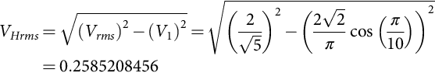 **(15.88)**

Hence, total harmonic distortion is

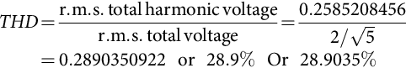 **(15.89)**

#### **15.4.1.3 Pulse Width Modulation Mode of Operation**

If a five-phase voltage-source inverter is operated in PWM mode, apart from the already described 10 states, there are additional 22 switching states. These remaining 22 switching states encompass three possible situations: all the states when four switches from upper (or lower) half and one from the lower (or upper) half of the inverter are on (states 11–20), two states when either all the five upper (or lower) switches are “on” (states 31 and 32), and the remaining states with three switches from the upper (lower) half and two switches from the lower (upper) half in conduction mode (states 21–30). The corresponding space vectors for 11–30 are obtained using Eq. [(15.68)](https://learning.oreilly.com/library/view/power-electronics-handbook/9780128114087/B9780128114070000167_1.xhtml#fo0385), and it is seen that the total of 32 space vectors, available in the PWM operation, fall into four distinct categories regarding the magnitude of the available output phase voltages. The phase voltage space vectors are summarized in [Table 15.4](https://learning.oreilly.com/library/view/power-electronics-handbook/9780128114087/B9780128114070000167_2.xhtml#t0025) for all 32 switching states and are shown in [Fig. 15.32](https://learning.oreilly.com/library/view/power-electronics-handbook/9780128114087/B9780128114070000167_2.xhtml#f0165).

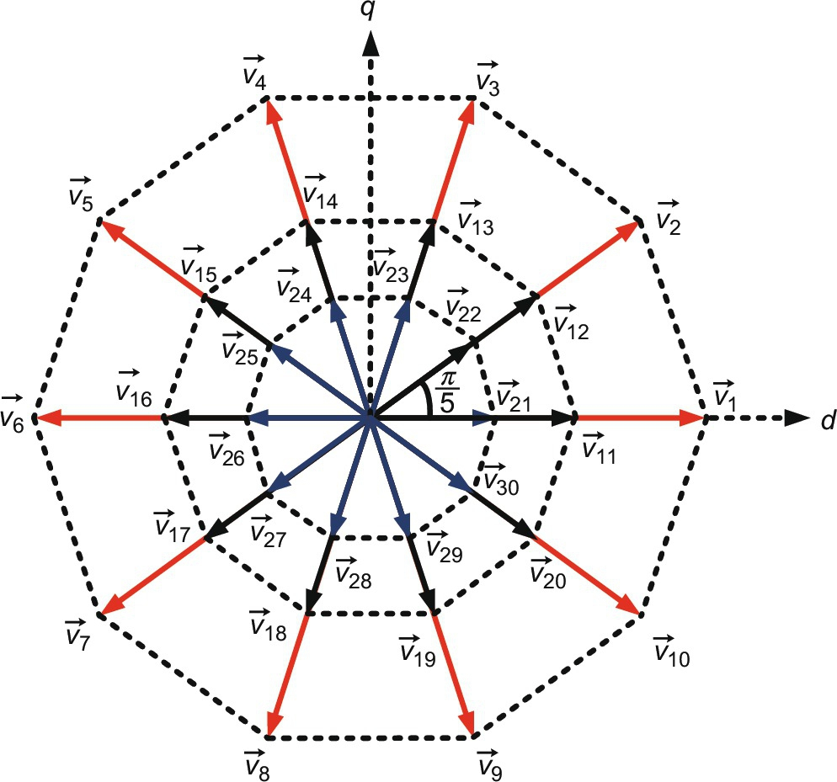

**FIG. 15.32** Phase-to-neutral voltage space vectors for states 1–32 (states 31–32 are at origin) in *d*-*q* plane.

**Table 15.4**

**Phase-to-neutral voltage space vectors for states 1–32**

|  |  |
| --- | --- |
| **Space vectors** | **Value of the space vectors** |
| *v*1*phase* to *v*10*phase* | si11_e |
| *v*11*phase* to *v*20*phase* | si12_e |
| *v*21*phase* to *v*30*phase* | si13_e |
| *v*31*phase* to *v*32*phase* | 0 |

Since adjacent line voltage yields lower output value, only nonadjacent line voltages are elaborated as well:

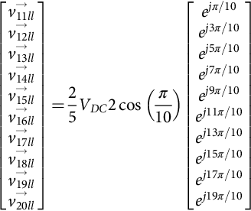 **(15.90)**

**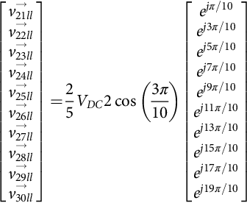** **(15.91)**

#### **15.4.1.4 Model Transformation Using Decoupling Matrix**

Since the system under discussion is a five-phase one, the complete model can be only be elaborated in five-dimensional space. The first two-dimensional spaces are *d*-*q*, the second one is named as *x*-*y*, and the last is zero-sequence components that are absent due to the assumption of isolated neutral. On the basis of the general decoupling transformation matrix for an *n*-phase system, inverter voltage space vectors in the second two-dimensional subspace (*x*-*y*) are determined with Eq. [(15.92)](https://learning.oreilly.com/library/view/power-electronics-handbook/9780128114087/B9780128114070000167_2.xhtml#fo0505):

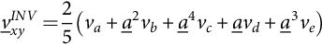 **(15.92)**

Thus, 32 space vectors of phase-to-neutral voltage in the *x*-*y* plane are obtained using Eq. [(15.92)](https://learning.oreilly.com/library/view/power-electronics-handbook/9780128114087/B9780128114070000167_2.xhtml#fo0505) and are demonstrated in [Fig. 15.33](https://learning.oreilly.com/library/view/power-electronics-handbook/9780128114087/B9780128114070000167_2.xhtml#f0170).

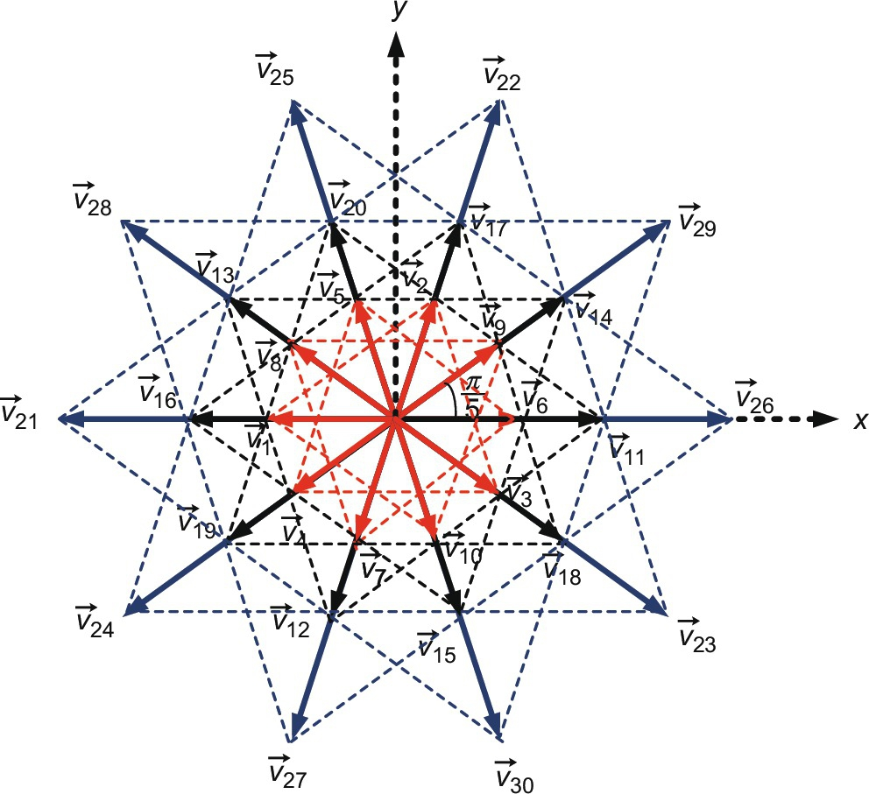

**FIG. 15.33** Phase-to-neutral voltage space vectors for states 1–32 (states 31–32 are at origin) in *x*-*y* plane.

It can be seen from [Figs. 15.32](https://learning.oreilly.com/library/view/power-electronics-handbook/9780128114087/B9780128114070000167_2.xhtml#f0165) and [15.33](https://learning.oreilly.com/library/view/power-electronics-handbook/9780128114087/B9780128114070000167_2.xhtml#f0170) that the outer decagon space vectors of the  plane map into the innermost decagon of the *x*-*y* plane, the innermost decagon of *d*-*q* plane forms the outer decagon of *x*-*y* plane while the middle decagon space vector map into the same region. Further, it is observed from the above mapping that the phase sequence *a*,*b*,*c*,*d*,*e* of  plane corresponds to *a*,*c*,*e*,*b*,*d* in *x*-*y* that are basically the third harmonic voltages.

#### **15.4.1.5 Hardware Implementation of a Five-Phase VSI in 180 Conduction Mode**

Hardware can be developed to implement the square-wave operation of a five-phase voltage-source inverter. The hardware can be developed using available power switch modules from different manufacturers such as Semikron, Mitsubishi, and Fairchild. The power switches are available in discrete form to implement inverter system. The gate driver circuit is also available from different manufacturers. The control can be implemented using microcontroller, digital signal processors (DSP), dSpace, and field-programmable gate arrays (FPGA). The control codes can be written in C/C++. Some of the DSPs and FPGAs are compatible with Matlab/Simulink, and hence, control codes can be implemented directly. In FPGA, system generator is used for writing the control code. System generator is a library in Matlab/Simulink software. The coding is done in the form of drag and drop in system generator.

#### **15.4.1.6 Hardware Set-up**

The control of inverter can be implemented using sophisticated controllers such as microcontroller, digital signal processors (DSP), dSpace, and field-programmable gate arrays (FPGA). The output voltages from these controllers are generally 3.3 V that is not enough for turning on the IGBTs/MOSFETs/BJT. Further to turn off the power switching devices, the gate capacitors are to be fully and rapidly discharged. Gate drive circuit is thus required to match the voltage level requirement of turning on the power switches (about 15 V), and a discharge path for the gate capacitor is needed. Hence, a gate drive circuit is needed to successfully turn on and turn off the power devices. The following section describes the implementation of the control, gate drive, and power circuit using analog devices. The complete block diagram is shown in [Fig. 15.34](https://learning.oreilly.com/library/view/power-electronics-handbook/9780128114087/B9780128114070000167_2.xhtml#f0175).

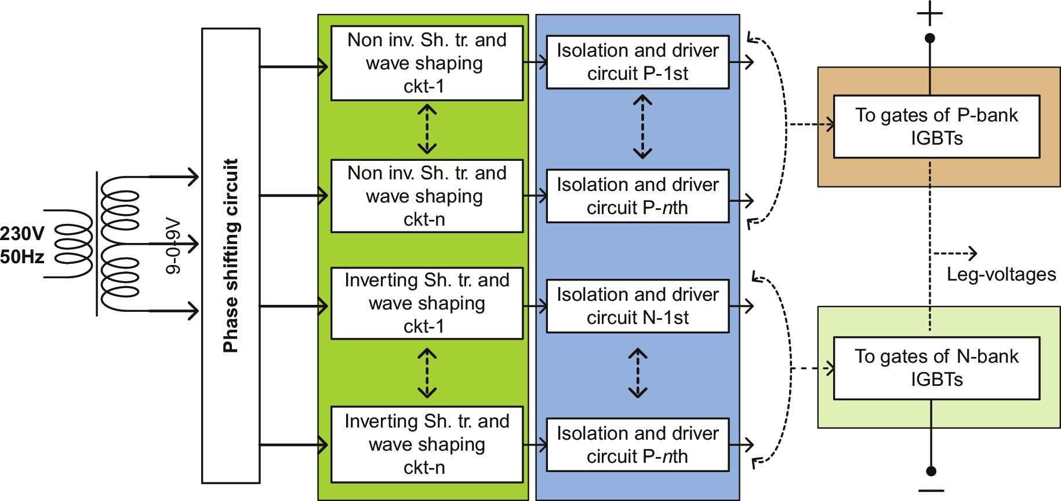

**FIG. 15.34** Block diagram of the control circuit.

Power supply is obtained from a single-phase grid and is converted to 9-0-9 V using a transformer. The converted voltage of (9-0-9 V) is fed to the phase-shifting circuit shown in [Fig. 15.35](https://learning.oreilly.com/library/view/power-electronics-handbook/9780128114087/B9780128114070000167_2.xhtml#f0180), to provide appropriate phase shift for operation at various conduction angle (the conduction angle refers to the conduction modes of inverter, e.g., 180, 144, and 108 degrees). The phase-shifted signal is then fed to the inverting/noninverting Schmitt trigger circuit and wave-shaping circuit ([Figs. 15.36](https://learning.oreilly.com/library/view/power-electronics-handbook/9780128114087/B9780128114070000167_2.xhtml#f0185) and [15.37](https://learning.oreilly.com/library/view/power-electronics-handbook/9780128114087/B9780128114070000167_2.xhtml#f0190)). The processed signal is then fed to the isolation and driver circuit shown in [Fig. 15.38](https://learning.oreilly.com/library/view/power-electronics-handbook/9780128114087/B9780128114070000167_2.xhtml#f0195). This is then finally given to the gate of IGBTs. There are two separate circuits for upper and lower legs of the inverter.

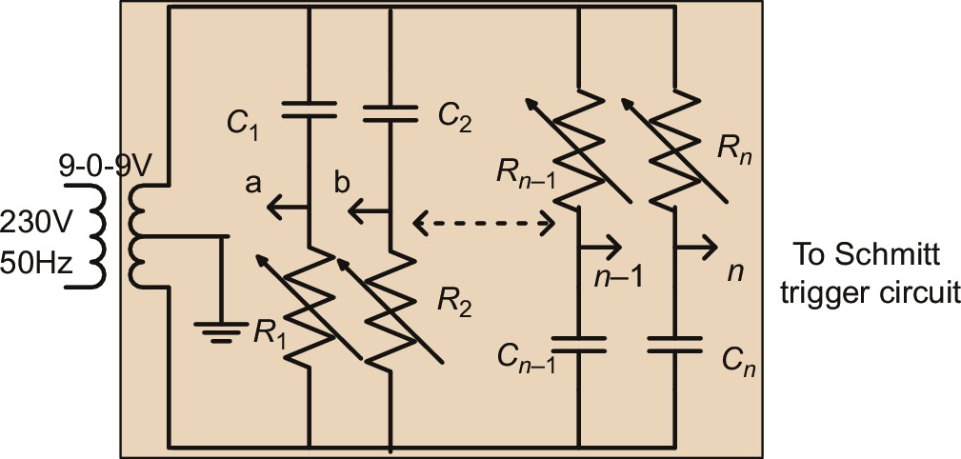

**FIG. 15.35** Phase-shifting circuit (PSC).

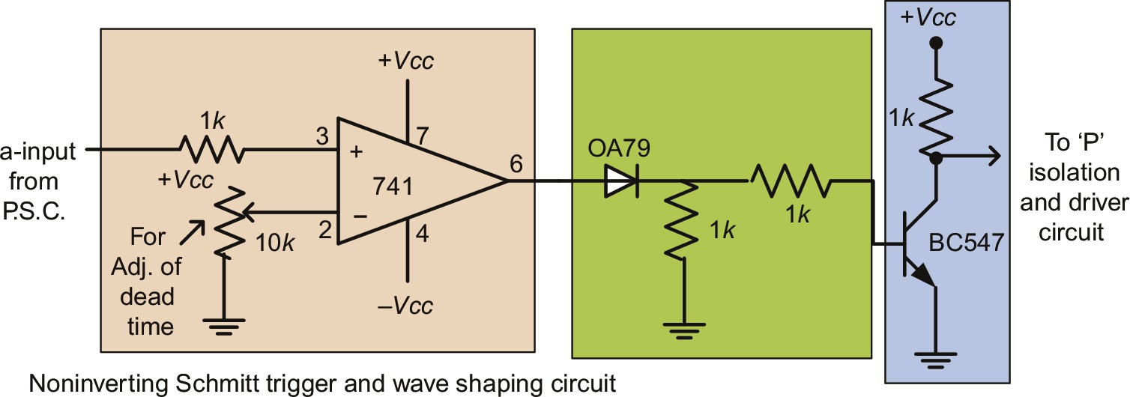

**FIG. 15.36** Noninverting Schmitt trigger and wave-shaping circuit.

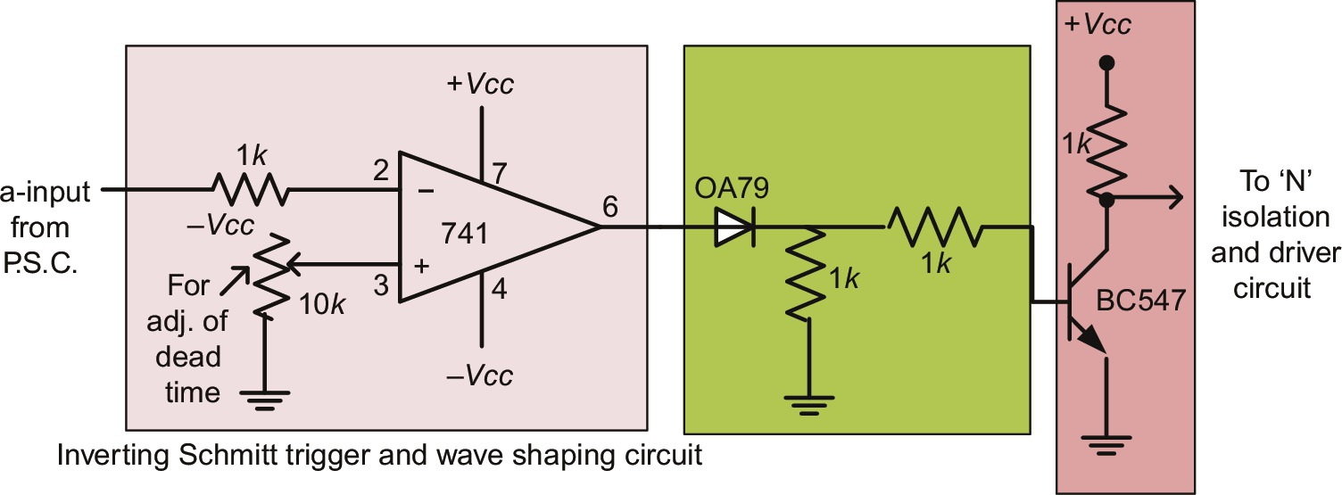

**FIG. 15.37** Inverting Schmitt trigger and wave-shaping circuit.

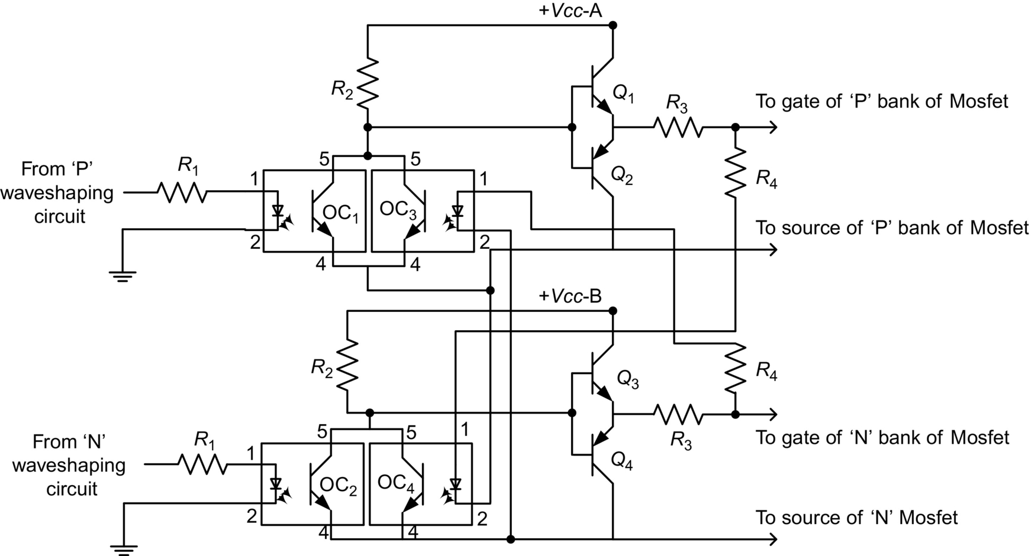

**FIG. 15.38** Gate driver circuit.

The power circuit is made up of IGBT SGW20N60 having a rating of 20 A and 600 V DC, with snubber circuit consisting of the series combination of a resistance and a capacitor with a diode in parallel with the resistance.

#### **15.4.1.7 Hardware Results**

Experiment can be conducted for stepped operation of inverter with 180 degrees conduction modes for star-connected five-phase resistive load. A single-phase supply can be given to the control circuit through the phase-shifting network. The output of the phase-shifting circuit provides the required five-phase output voltage by appropriately tuning it. These five-phase signals are then further processed to generate the gate drive circuit.

#### **15.4.1.8 Results of 180 Degrees Conduction Mode**

The output from the Schmitt trigger circuit is presented in [Fig. 15.39](https://learning.oreilly.com/library/view/power-electronics-handbook/9780128114087/B9780128114070000167_2.xhtml#f0200). The driving control gate/base signals for the 10-step mode for legs A–B of the inverter are illustrated in [Fig. 15.40](https://learning.oreilly.com/library/view/power-electronics-handbook/9780128114087/B9780128114070000167_2.xhtml#f0205). The corresponding phase voltage thus obtained is shown in [Fig. 15.41](https://learning.oreilly.com/library/view/power-electronics-handbook/9780128114087/B9780128114070000167_2.xhtml#f0210), keeping the DC-link voltage at 60 V. The output phase voltage is called 10 step in one fundamental cycle (1/5*Vdc*, 2/5*Vdc*, 1/5*Vdc*, 2/5*Vdc*, 1/5*Vdc*, −1/5*Vdc*, −2/5*Vdc*, −1/5*Vdc*, −2/5*Vdc*, and −1/5*Vdc*).

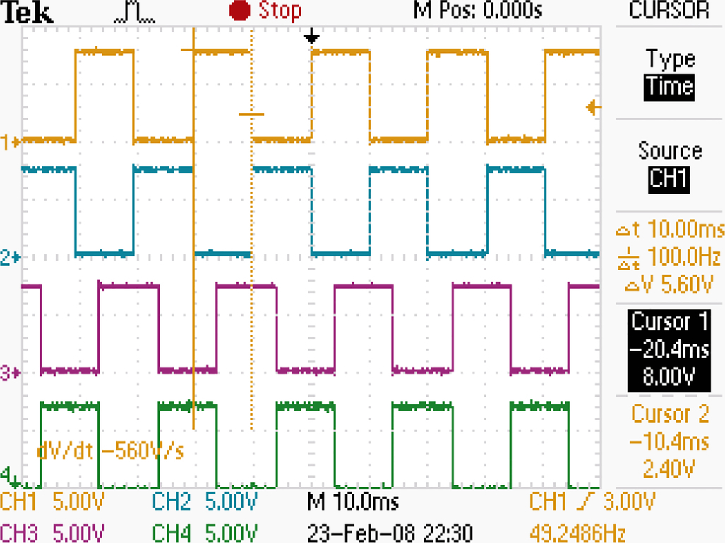

**FIG. 15.39** Output of wave-shaping circuit for 180 degrees conduction mode for leg A–B.

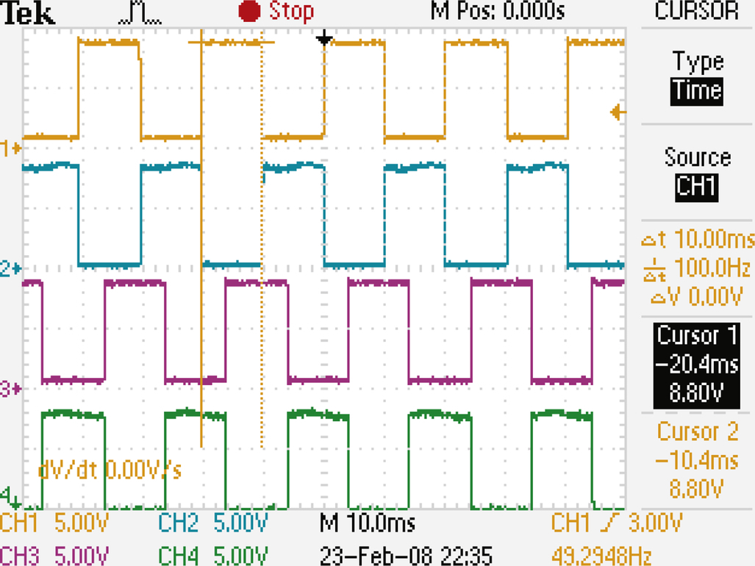

**FIG. 15.40** Gate drive signals for legs A–B for 180 degrees conduction mode.

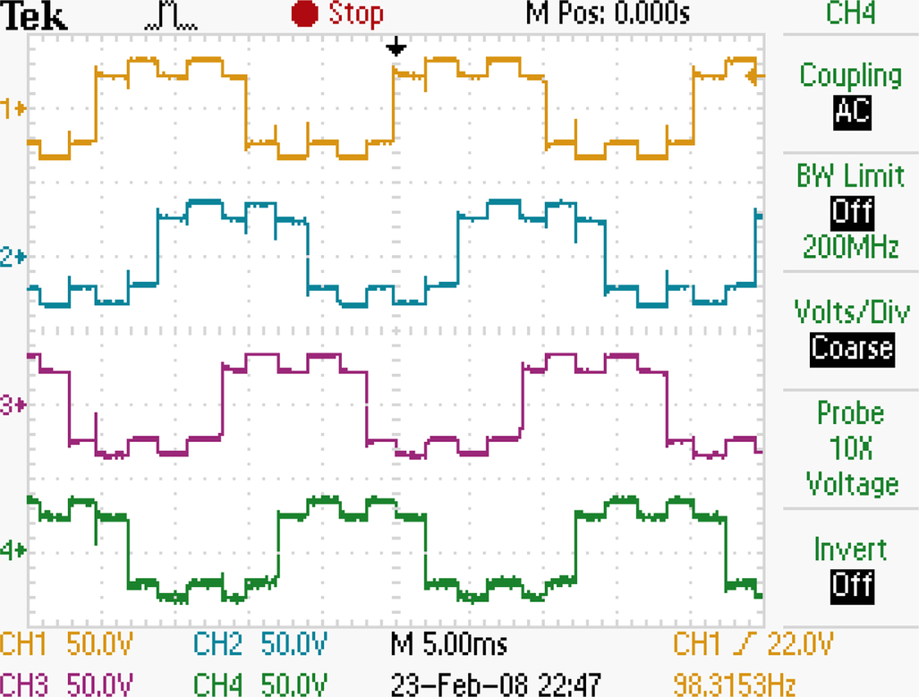

**FIG. 15.41** Output phase “a–d” voltages for 180 degrees conduction mode.

Nonadjacent line voltage obtained is shown in [Fig. 15.42](https://learning.oreilly.com/library/view/power-electronics-handbook/9780128114087/B9780128114070000167_2.xhtml#f0215). All currents are measured using AC/DC current probe giving the output of 100 mV/A.

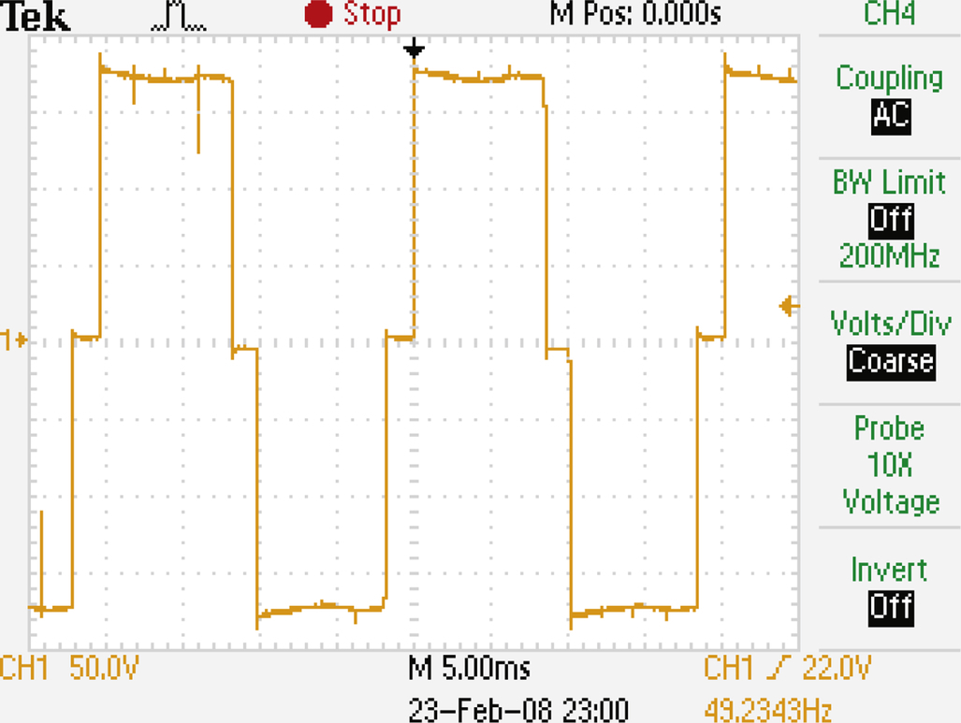

**FIG. 15.42** Nonadjacent line voltage for 180 degrees conduction mode with DC-link voltage equal to 180 V.

The AC side input current is also measured and is depicted in [Fig. 15.43](https://learning.oreilly.com/library/view/power-electronics-handbook/9780128114087/B9780128114070000167_2.xhtml#f0220). The analysis is presented in the last subsection.

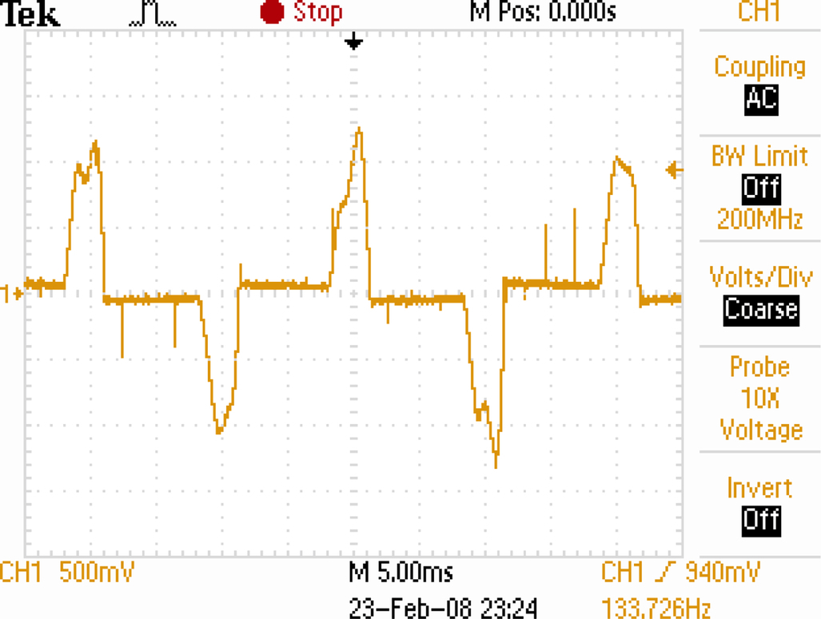

**FIG. 15.43** AC side input current for 180 degrees conduction mode.

#### **15.4.1.9 DSP Implementation of Step Mode of Operation**

The results obtained in [Section 15.4.1.9](https://learning.oreilly.com/library/view/power-electronics-handbook/9780128114087/B9780128114070000167_2.xhtml#s0150) are verified using implementation through TMS320F2812 DSP under the same operating conditions. Control code is written in C++ and run in PC. It is transferred to the DSP using serial communication cable RS232. The DSP generate 10 gating signals that are fed to the power module of the inverter. The detail experimental setup is provided in [Section 15.4.1.10](https://learning.oreilly.com/library/view/power-electronics-handbook/9780128114087/B9780128114070000167_2.xhtml#s0155). All the three conduction angles are implemented. The developed algorithm is verified using a star-connected resistive load and a five-phase induction machine.

#### **15.4.1.10 180 Degrees Conduction Mode**

The inverter is operated in 180 degrees conduction mode, and a five-phase star-connected resistive load is connected across the output terminal. The resulting phase voltage, nonadjacent line voltages are illustrated in [Figs. 15.44](https://learning.oreilly.com/library/view/power-electronics-handbook/9780128114087/B9780128114070000167_2.xhtml#f0225) and [15.45](https://learning.oreilly.com/library/view/power-electronics-handbook/9780128114087/B9780128114070000167_2.xhtml#f0230), respectively.

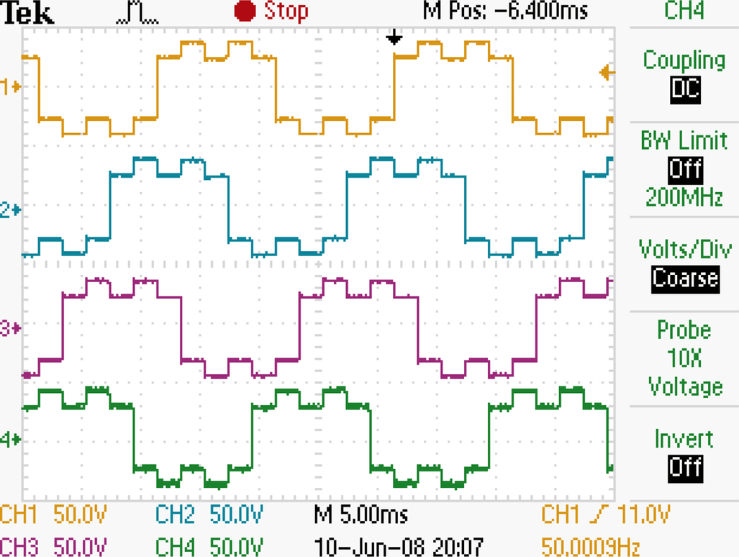

**FIG. 15.44** Output phase voltage for 180 degrees conduction mode.

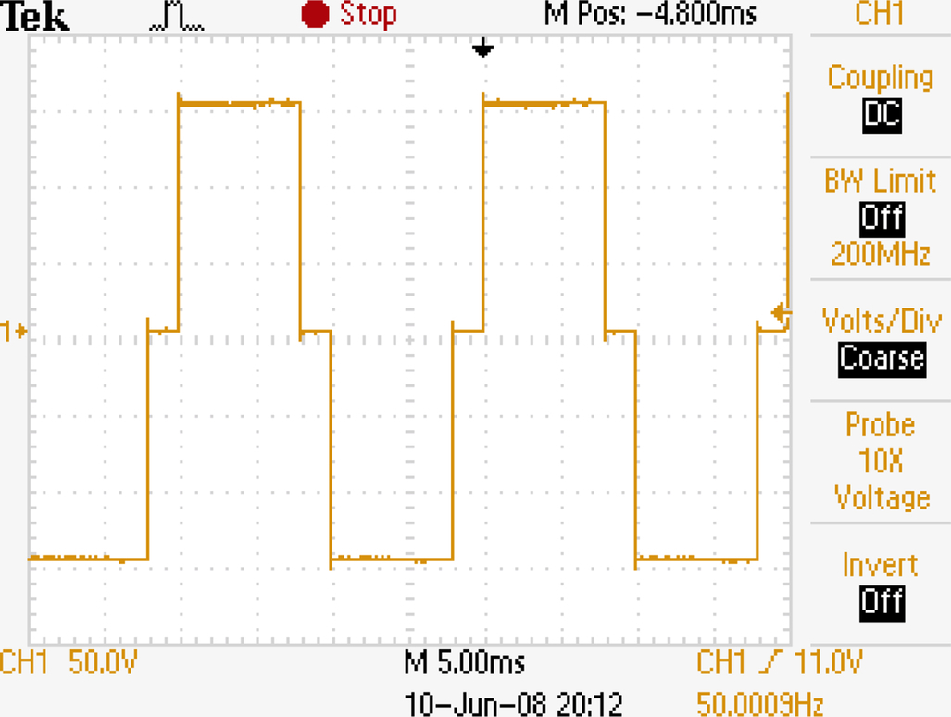

**FIG. 15.45** Nonadjacent line voltage for 180 degrees conduction mode.

It is observed that the phase voltage generated using cheap analog-circuit-based inverter shown in [Fig. 15.41](https://learning.oreilly.com/library/view/power-electronics-handbook/9780128114087/B9780128114070000167_2.xhtml#f0210) is identical to the one obtained using DSP as shown in [Fig. 15.44](https://learning.oreilly.com/library/view/power-electronics-handbook/9780128114087/B9780128114070000167_2.xhtml#f0225). Similarly, the nonadjacent line voltage of [Fig. 15.42](https://learning.oreilly.com/library/view/power-electronics-handbook/9780128114087/B9780128114070000167_2.xhtml#f0215) is identical to the one shown in [Fig. 15.45](https://learning.oreilly.com/library/view/power-electronics-handbook/9780128114087/B9780128114070000167_2.xhtml#f0230). This verifies the correct design of the analog-based inverter and also verifies the DSP code. The same study is carried out using a five-phase induction motor as a load. The resulting voltage and stator current waveforms are presented in [Fig. 15.46](https://learning.oreilly.com/library/view/power-electronics-handbook/9780128114087/B9780128114070000167_2.xhtml#f0235). The waveform is typical for such load.

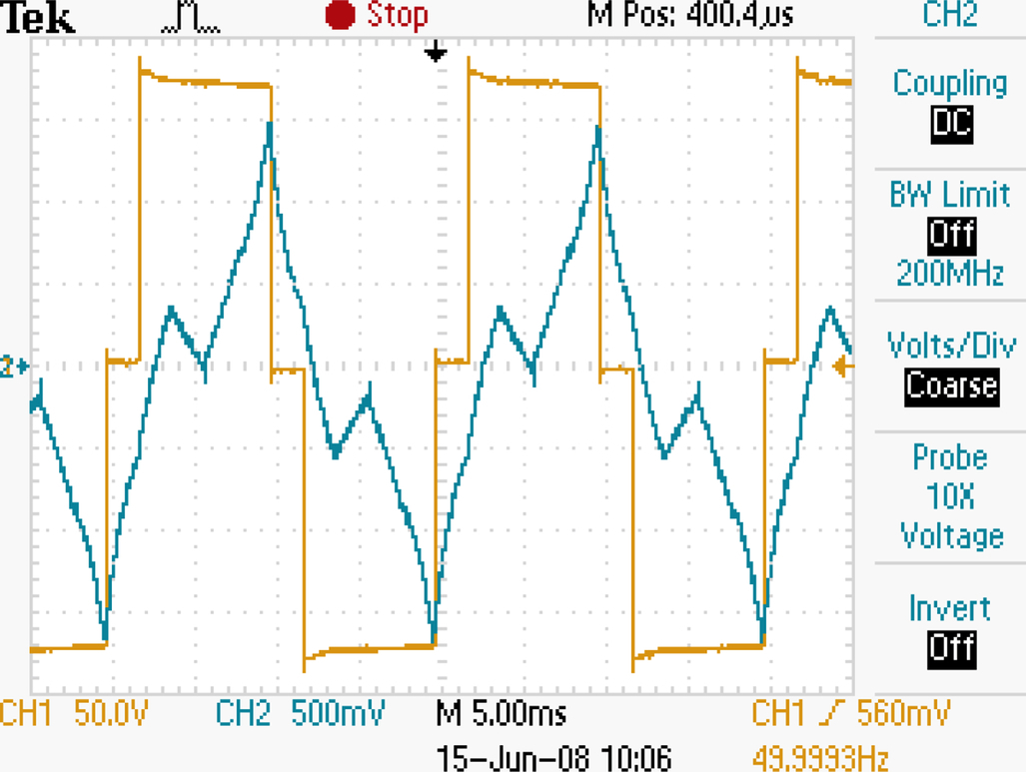

**FIG. 15.46** Nonadjacent line voltage and stator current.

### 15.4.2 CARRIER-BASED PWM

#### **15.4.2.1 With Zero Sequence Signal**

Carrier-based sinusoidal PWM is the most popular and widely used PWM technique because of their simple implementation in both analog and digital realization [[32](https://learning.oreilly.com/library/view/power-electronics-handbook/9780128114087/B9780128114070000167_4.xhtml#bb0165),[34](https://learning.oreilly.com/library/view/power-electronics-handbook/9780128114087/B9780128114070000167_4.xhtml#bb0175)]. The principle of carrier-based PWM true for a three-phase VSI is also applicable to a multiphase VSI. The PWM signal is generated by comparing a sinusoidal modulating signal with a triangular (double edge) or a saw-tooth (single edge) carrier signal. The frequency of the carrier is normally kept much higher compared to the modulating signal. The principle of operation of a carrier-based PWM modulator is shown in [Fig. 15.47](https://learning.oreilly.com/library/view/power-electronics-handbook/9780128114087/B9780128114070000167_2.xhtml#f0240), and generation of PWM waveform is illustrated in [Fig. 15.48](https://learning.oreilly.com/library/view/power-electronics-handbook/9780128114087/B9780128114070000167_2.xhtml#f0245). Modulation signals are obtained using five fundamental sinusoidal signals (displaced in time by ), which are summed with an appropriate zero-sequence signal. These modulation signals are compared with high-frequency carrier signal (saw-tooth or triangular shape), and all five switching functions for inverter legs are obtained directly. In general, modulation signal can be expressed as

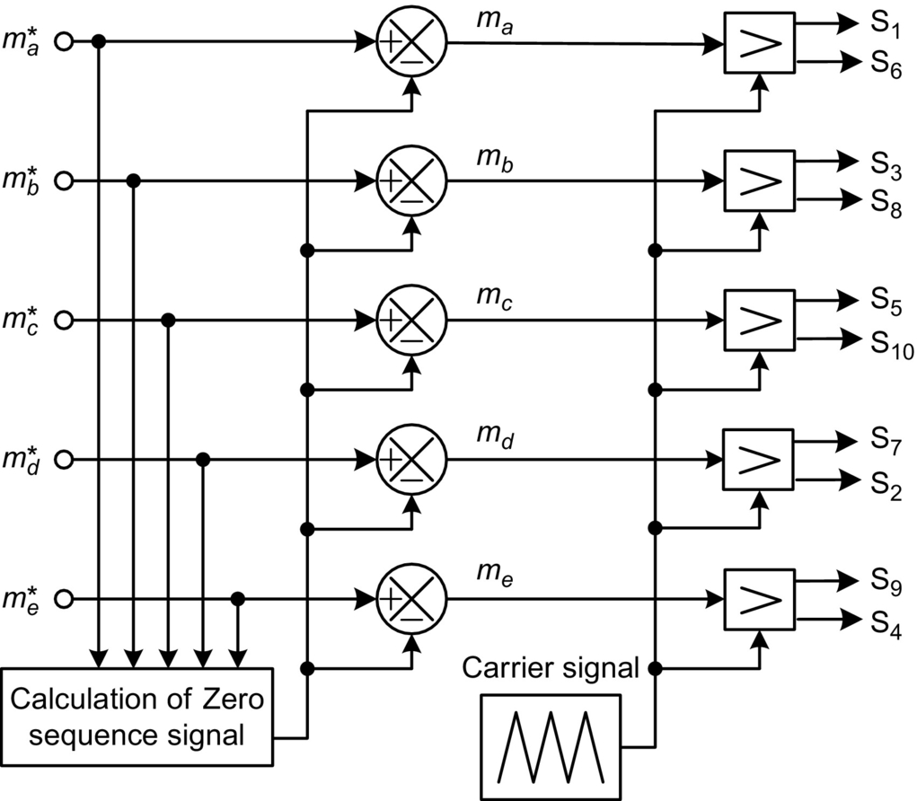

**FIG. 15.47** Principle of carrier-based PWM technique.

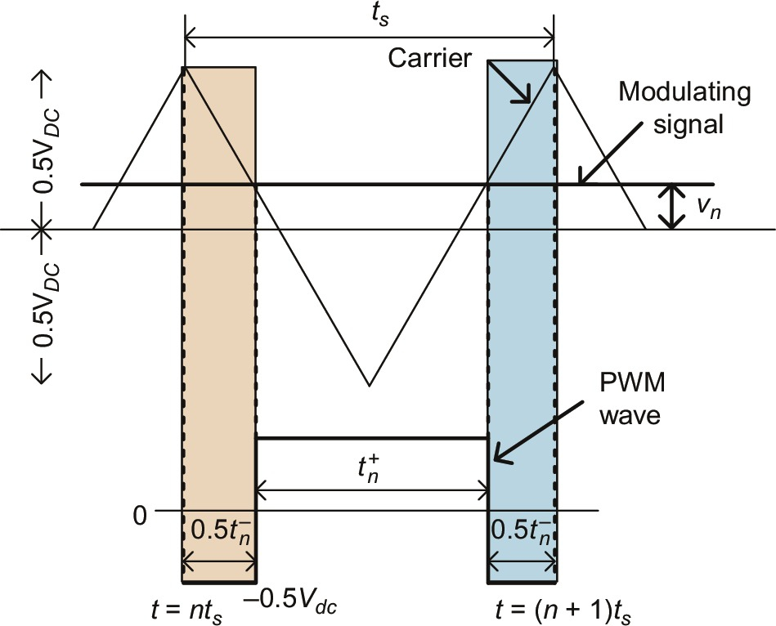

**FIG. 15.48** PWM waveform generation in carrier-based sinusoidal method.

 **(15.93)**

where  and *vnN* represents zero-sequence signal and *vi*⁎ is fundamental sinusoidal signals. Zero-sequence signal represents a degree of freedom that exits in the structure of a carrier-based modulator, and it is used to modify modulation signal waveforms and thus to obtain different modulation schemes. Continuous PWM schemes are characterized by the presence of switching activity in each of the inverter legs over the carrier signal period, as long as peak value of the modulation signal does not exceed the carrier magnitude.

The following relationship holds true in [Fig. 15.48](https://learning.oreilly.com/library/view/power-electronics-handbook/9780128114087/B9780128114070000167_2.xhtml#f0245):

 **(15.94)**

where

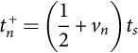 **(15.95)**

**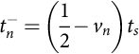** **(15.96)**

where  and  are the positive and negative pulse widths in the *n*th sampling interval, respectively, and *vn* is the normalized amplitude of modulation signal. The normalization is done with respect to *Vdc*. Eqs. [(15.95)](https://learning.oreilly.com/library/view/power-electronics-handbook/9780128114087/B9780128114070000167_2.xhtml#fo0520) and [(15.96)](https://learning.oreilly.com/library/view/power-electronics-handbook/9780128114087/B9780128114070000167_2.xhtml#fo0525) are referred as the equal volt-second principle as applied to a three-phase inverter [[32](https://learning.oreilly.com/library/view/power-electronics-handbook/9780128114087/B9780128114070000167_4.xhtml#bb0165),[35](https://learning.oreilly.com/library/view/power-electronics-handbook/9780128114087/B9780128114070000167_4.xhtml#bb0180),[36](https://learning.oreilly.com/library/view/power-electronics-handbook/9780128114087/B9780128114070000167_4.xhtml#bb0185)]. The normalized peak value of the triangular carrier wave is  in linear region of operation. Modulator gain has the unity value while operating in the linear region, and peak value of inverter output fundamental voltage is equal to the peak value of the fundamental sinusoidal signal. Thus, the maximum output phase voltages from a five-phase VSI are limited to 0.5 p.u. This is also evident in [[32](https://learning.oreilly.com/library/view/power-electronics-handbook/9780128114087/B9780128114070000167_4.xhtml#bb0165),[37](https://learning.oreilly.com/library/view/power-electronics-handbook/9780128114087/B9780128114070000167_4.xhtml#bb0190)]. Thus, the output phase voltage from a three-phase and a five-phase VSI are the same when utilizing carrier-based PWM.

#### **15.4.2.2 Sinusoidal Pulse Width Modulation (SPWM)**

The simplest continuous carrier-based PWM is obtained with the selection of the zero-sequence signal as . Modulation signals for all five inverter legs are equal to five sinusoidal fundamental signals. Thus, while operating in the linear region, maximum value of the modulation index of the SPWM has the unity value, . Modulation index is defined as the ratio of the fundamental component amplitude of the line-to-neutral inverter output voltage to one-half of the available DC bus voltage. Thus,

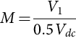 **(15.97)**

where *V*1 is the fundamental output phase voltage.

#### **15.4.2.3 Fifth Harmonic Injection PWM**

The effect of the addition of harmonic with reverse polarity in any signal is to reduce the peak of the reference signal. Aim here is to bring the amplitude of the reference as low as possible, so that the reference can then be pushed to make it equal to the carrier, resulting in the higher output voltage and better DC bus utilization. Using this principle, third harmonic injection PWM scheme is used in a three-phase VSI that results in increase in the fundamental output voltage to 0.575*Vdc* [[32](https://learning.oreilly.com/library/view/power-electronics-handbook/9780128114087/B9780128114070000167_4.xhtml#bb0165),[35](https://learning.oreilly.com/library/view/power-electronics-handbook/9780128114087/B9780128114070000167_4.xhtml#bb0180)]. Third harmonic voltages do not appear in the output phase voltages and are restricted to the leg voltages only. Following the same principle, fifth harmonic injection PWM scheme can be developed to increase the modulation index of a five-phase VSI.

The reference leg voltages are given as

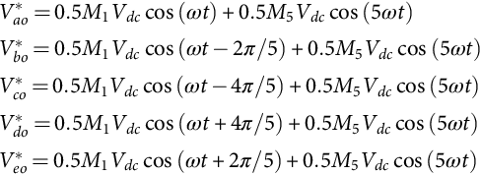 **(15.98)**

It is to be noted that fifth harmonic has no effect on the value of the reference waveform when , since  for all odd *k*. Thus, *M*5 is chosen to make the peak magnitude of the reference of [(15.98)](https://learning.oreilly.com/library/view/power-electronics-handbook/9780128114087/B9780128114070000167_2.xhtml#fo0535) that occurs where the fifth harmonic is zero. This ensures the maximum possible value of the fundamental component. The reference voltage reaches a maximum when

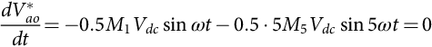 **(15.99)**

This yield

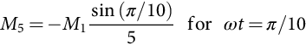 **(15.100)**

Thus, the maximum modulation index can be determined from

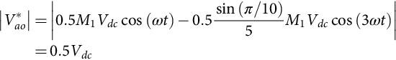 **(15.101)**

The above equation gives

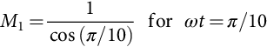 **(15.102)**

Thus, the output fundamental voltage is increased by 5.15% higher than the value obtainable using simple carrier-based PWM by injecting 6.18% fifth harmonic in fundamental. The fifth harmonic is in opposite phase to that of the fundamental.

#### **15.4.2.4 Offset or Triangular Zero-Sequence Injection PWM**

Another way of increasing the modulation index is to add an offset voltage to the references. This will effectively do the same function as above. The offset voltage is given as

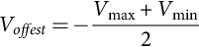 **(15.103)**

where  and . Note that this is the same as for a three-phase inverter.

In case of three-phase VSI, the offset voltage is simply third harmonic triangular wave of 25% magnitude of fundamental. The peak of the fundamental is 0.575 p.u., (0.406 p.u. rms), the peak of the resultant modulating signal is 0.5 p.u. (0.353 p.u. rms), and the peak of the offset is 0.147 p.u. (0.104 p.u. rms). Hence, offset peak is 25% of the fundamental peak.

In a five-phase VSI, the offset is found as the fifth-harmonic triangular wave of 9.55% of the fundamental input reference. This value has been established by simulations. Offset addition requires only addition operation and hence is suitable for practical implementation.

A generalized formula of offset voltage is obtained, which is to be injected along with the fundamental in case of five-phase VSI. The expression is

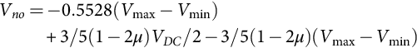

where *V*max is the maximum of the five-phase references, *V*min is the minimum of the five-phase references, and *μ* is the factor that decides the placement of the two zero-vector states. If it is 0.5, then the two zero states are placed equally, and this corresponds to symmetrical zero-vector placement.

It is important to note that not only the fifth harmonic but also all the additional 5*k* (*k*=1,3,5…) harmonics are included in the modulation signal in this technique. Maximum modulation index has the same value as in the previous case, . To illustrate the effects of fifth-harmonic and triangular signal injection, the overall modulating signals are shown in [Fig. 15.49](https://learning.oreilly.com/library/view/power-electronics-handbook/9780128114087/B9780128114070000167_2.xhtml#f0250).

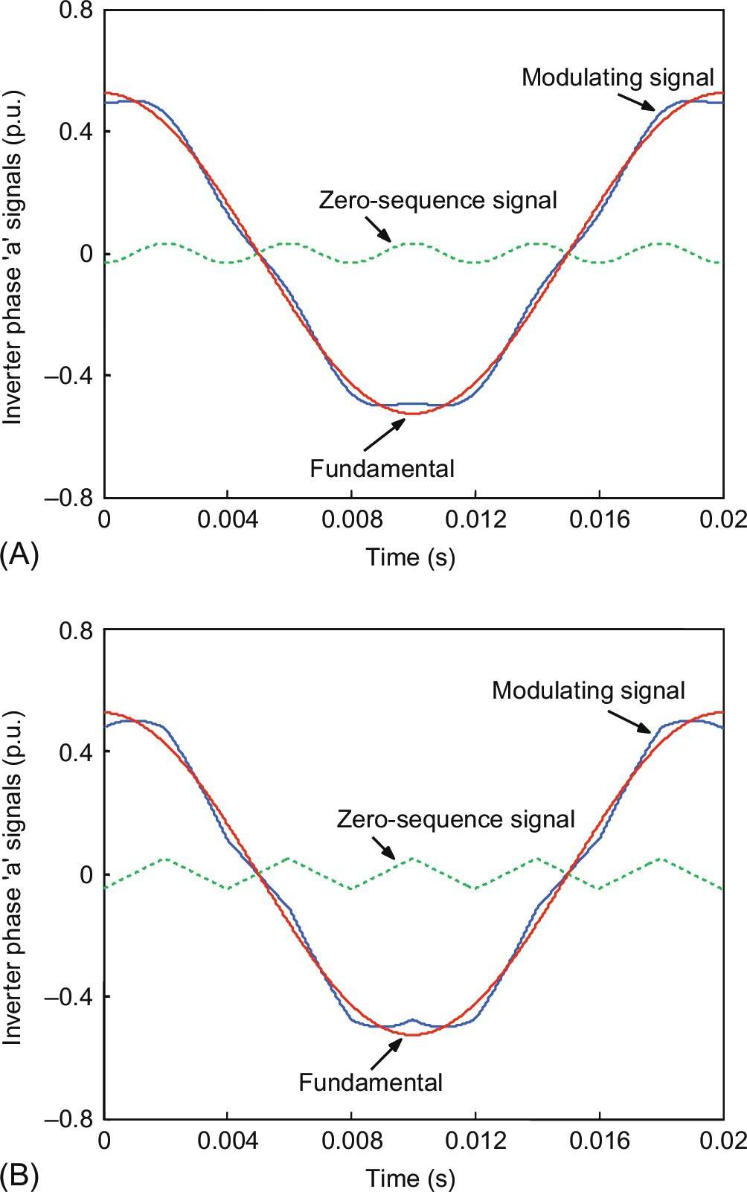

**FIG. 15.49** Characteristics signals of carrier-based PWM (A) with fifth-harmonic injection and (B) with triangular harmonic injection.

In general, an extension of the linear region is obtained through the repositioning of the peak value of the modulating signal. While sinusoidal fundamental signals have peak values at , zero sequence modifies this, and now, peak values of the modulating signals occur at  Hence, for five-phase carrier-based continuous PWM methods with zero-sequence signal addition, new peak values of modulating signals appear at angles . This allows the peak value of the fundamental signal to exceed unity, up to the value when peak of the modulating signal reaches saturation level (, in accordance with [(15.97)](https://learning.oreilly.com/library/view/power-electronics-handbook/9780128114087/B9780128114070000167_2.xhtml#fo0530)). It is obvious from [Fig. 15.49](https://learning.oreilly.com/library/view/power-electronics-handbook/9780128114087/B9780128114070000167_2.xhtml#f0250) that fifth-harmonic injection and offset injection have the same maximum value of the modulation index in the limit of the linear region.

#### **15.4.2.5 Space Vector Pulse Width Modulation**

Space-vector pulse-width modulation has become one of the most popular PWM techniques because of its easier digital implementation and higher DC bus utilization, when compared with the sinusoidal PWM method. The principle of SVPWM lies in the switching of inverter in a special way to apply a set of space vector for specific time. There is a lot of flexibility available in choosing the proper space-vector combination for an effective control of multiphase VSIs because of the large numbers of space vectors available in multiphase power converters.

##### **Advantages of space vector PWM:**

i. SVPWM increases fundamental output without distorting line-to-line waveform.

ii. The fundamental output of SVPWM is 94.02% that is 15.47% greater than sinusoidal PWM of 78.55% fundamental.

iii. SVPWM compares a single modulating wave with a carrier instead of using three waves.

iv. When the neutral of the load is connected to a DC supply voltage, SVPWM considers interaction among phases, whereas other PWM method does not.

v. Designing of heat sinks is an important factor for power dissipation. Power dissipation includes conduction and switching loss. Switching losses in sine PWM is difficult to compute that depend on modulation index, while computation is easier in space-vector PWM.

vi. SVPWM implementation is completely digital.

vii. Vector control implementation is completely digital, and thus, it is easy to implement SVPWM-based vector control scheme.

viii. Over modulation can easily be implemented.

ix. For high modulation index, the harmonics of current and torque of space-vector PWM will be much less than sine PWM.

In the case of a five-phase VSI, there are a total of 25=32 space vectors available, of which 30 are active state vectors and two are zero state vectors forming three concentric decagons. For the implementation of space-vector PWM in linear range, two different approaches can be adopted. One approach is the simple extension of method used in a three-phase inverter (use of two adjacent large length vectors) and second approach where four adjacent vectors are used (two large and two medium lengths). The first approach gives higher output voltage; however, the output voltages contain lower-order harmonics, more specifically, the third and seventh. The second approach offers sinusoidal output voltage; however, the magnitude is lower.

The first approach used only 10 outer large length vectors to implement the symmetrical SVPWM. Two neighboring active space vectors and two zero space vectors are utilized in one switching period to synthesize the input reference voltage. In total, 20 switchings take place in one switching period, so that the state of each switch is changed twice. The switching is done in such a way that, in the first switching half period, the first zero vector is applied, followed by two active state vectors and then by the second zero state vector. The second switching half period is the mirror image of the first one. The symmetrical SVPWM is achieved in this way. This method is the simplest extension of space-vector modulation of three-phase VSIs.

An ideal SVPWM of a five-phase inverter should satisfy a number of requirements. Firstly, in order to keep the switching frequency constant, each switch can change state only twice in the switching period (once “on” to “off” and once “off” to “on” or vice versa). Secondly, the rms value of the fundamental phase voltage of the output must be equal to the rms of the reference space vector. Thirdly, the scheme must provide full utilization of the available DC bus voltage. Finally, since the inverter is aimed at supplying the load with sinusoidal voltages, the low-order harmonic content needs to be minimized (this especially applies to the third and seventh harmonic). These criteria are used in assessing the merits and demerits of various SVPWM.

#### **15.4.2.6 Space Vector PWM for Sinusoidal Output**

The purpose here is to generate sinusoidal output phase voltages using space-vector PWM. Application of two neighboring medium active space vectors together with two large active space vectors in each switching period makes it possible to maintain zero average value in the second plane and consequently providing sinusoidal output. Use of four active space vectors per switching period requires the calculation of four application times, labeled here *tal*,*tbl*,*tam*,*tbm*. The expressions used for the calculation of dwell times of various space vector are [[32](https://learning.oreilly.com/library/view/power-electronics-handbook/9780128114087/B9780128114070000167_4.xhtml#bb0165),[38](https://learning.oreilly.com/library/view/power-electronics-handbook/9780128114087/B9780128114070000167_4.xhtml#bb0195)]

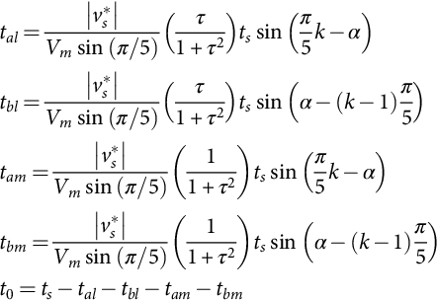 **(15.104)**

where . This is in essence allocates 61.8% more dwell times to large space vectors compared with medium space vector, thus satisfying the constraints of producing zero average voltage in the *x*-*y* plane. This can be more clearly seen from [Fig. 15.50](https://learning.oreilly.com/library/view/power-electronics-handbook/9780128114087/B9780128114070000167_2.xhtml#f0255).

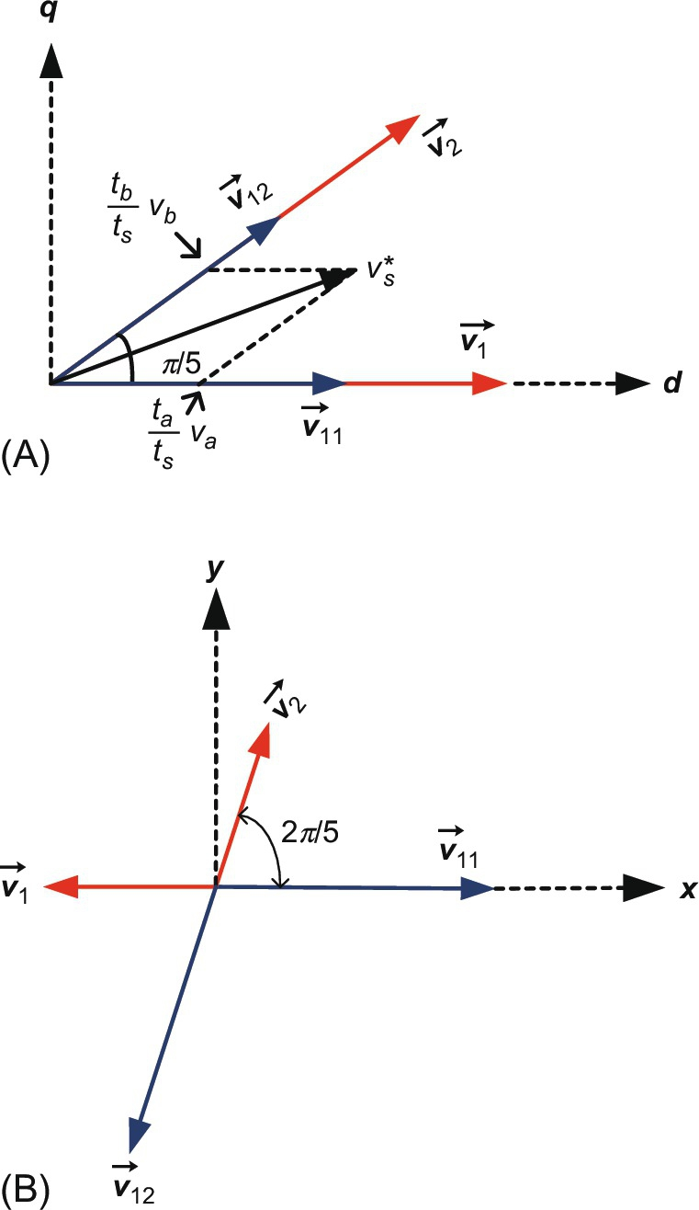

**FIG. 15.50** Principle of the calculation of vector application times, (A) *d*-*q* plane and (B) *x*-*y* plane.

It is seen from [Fig. 15.50](https://learning.oreilly.com/library/view/power-electronics-handbook/9780128114087/B9780128114070000167_2.xhtml#f0255) that the vectors in *x*-*y* plane are in such a position to cancel each other by using the dwell time Eq. [(15.104)](https://learning.oreilly.com/library/view/power-electronics-handbook/9780128114087/B9780128114070000167_2.xhtml#fo0570). The applications of active and zero space vectors are arranged in such a way as to obtain a symmetrical SVPWM. The space-vector disposition in sector I is illustrated in [Fig. 15.51](https://learning.oreilly.com/library/view/power-electronics-handbook/9780128114087/B9780128114070000167_2.xhtml#f0260). Modulation signals of SVPWM are identical to those obtained with offset addition. Switching pattern is a symmetrical PWM with two commutations per inverter leg. The space vectors are applied in odd sectors using sequence , while the sequence is  in even sectors.

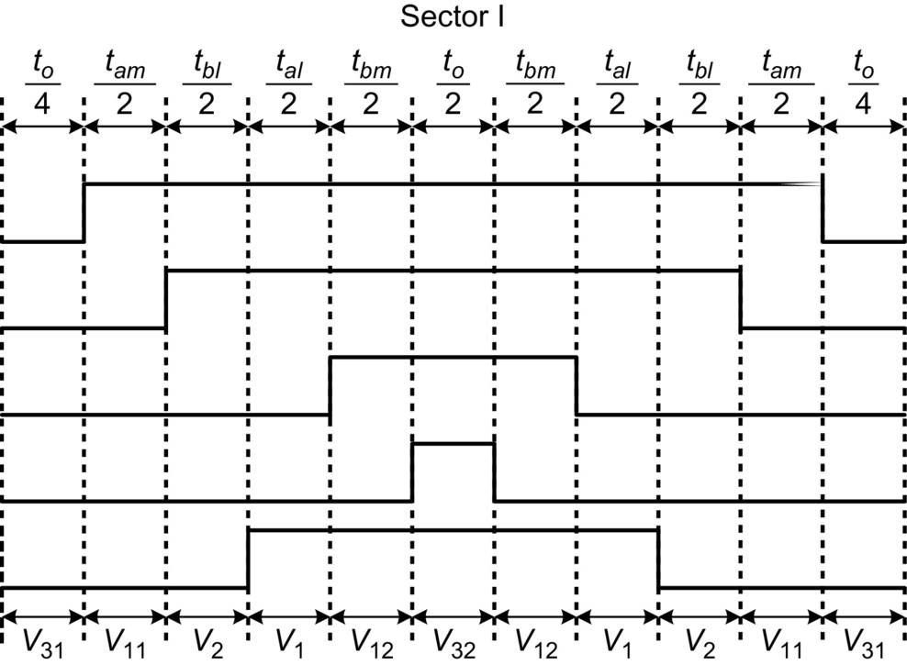

**FIG. 15.51** Switching pattern in sector I using large and medium space vectors.

It can be easily observed from Eq. [(15.104)](https://learning.oreilly.com/library/view/power-electronics-handbook/9780128114087/B9780128114070000167_2.xhtml#fo0570) that the zero-vector application time remains positive for . Thus, the output phase voltage from a VSI using this Space Vector PWM scheme is 0.5257*Vdc*, which is 5.15% higher compared with the output obtainable with carrier-based sinusoidal PWM without harmonic injection and equal to the output obtainable with zero-sequence (fifth-harmonic) signal injection.

Simulation is carried out using Matlab/Simulink to implement the SVPWM with application of four active and a zero vector. The resulting waveform and harmonic spectrum are shown in [Fig. 15.52](https://learning.oreilly.com/library/view/power-electronics-handbook/9780128114087/B9780128114070000167_2.xhtml#f0265). The average leg voltage is depicted in [Fig. 15.51](https://learning.oreilly.com/library/view/power-electronics-handbook/9780128114087/B9780128114070000167_2.xhtml#f0260), and it is observed that the leg voltage is now quite similar to one obtained in three-phase VSI. The phase voltage is completely sinusoidal without any low-order harmonics. The spectrum of phase voltage shows the maximum achievable output equals to 0.5257 p.u. (keeping DC-link voltage equals to unity).

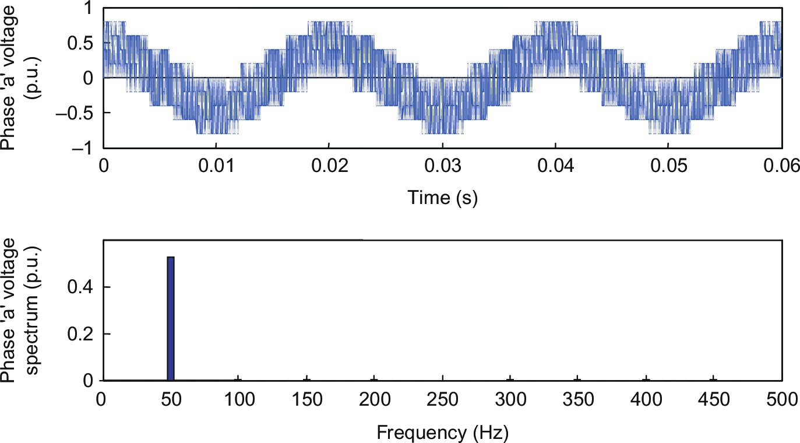

**FIG. 15.52** Spectrum of phase “a” voltage for sinusoidal output of SVPWM.

#### **15.4.2.7 Experimental Implementation**

Experimental setup is prepared in the laboratory to implement the carrier-based and space-vector PWM techniques discussed in the previous section. A five-phase voltage-source inverter is developed using intelligent power module. Texas Instrument DSP TMS320F2812 is used as the processor to implement the control algorithm. Since this DSP can be coded in C or C++, it is more user-friendly, and they have dedicated 16 hardware PINS to generate the desired PWM signals. The PWM circuits associated with compare units make it possible to generate up to eight PWM output channels (per Event Manger) with programmable dead band and polarity. This DSP is specifically meant for use in motor drive purposes, and it can control up to eight-phase two-level inverter. The control code is written in C++ language in Code composer studio 3.1 that runs in a PC. The control signal generated by PC is transferred to the DSP board through RS 232 cable connected in parallel printer port of the PC. The DSP board is connected to the power module through dedicated control cable. The DSP interfacing circuit along with required A/D and D/A converter is built on the DSP board itself procured from VI Microsystems.

Five-phase carrier-based PWM is implemented keeping the switching frequency equal to 10 kHz. The resulting waveform of leg voltage and corresponding phase voltage along with phase ‘a', ‘b', and ‘c' are shown in [Figs. 15.53](https://learning.oreilly.com/library/view/power-electronics-handbook/9780128114087/B9780128114070000167_2.xhtml#f0270) and [15.54](https://learning.oreilly.com/library/view/power-electronics-handbook/9780128114087/B9780128114070000167_2.xhtml#f0275), respectively.

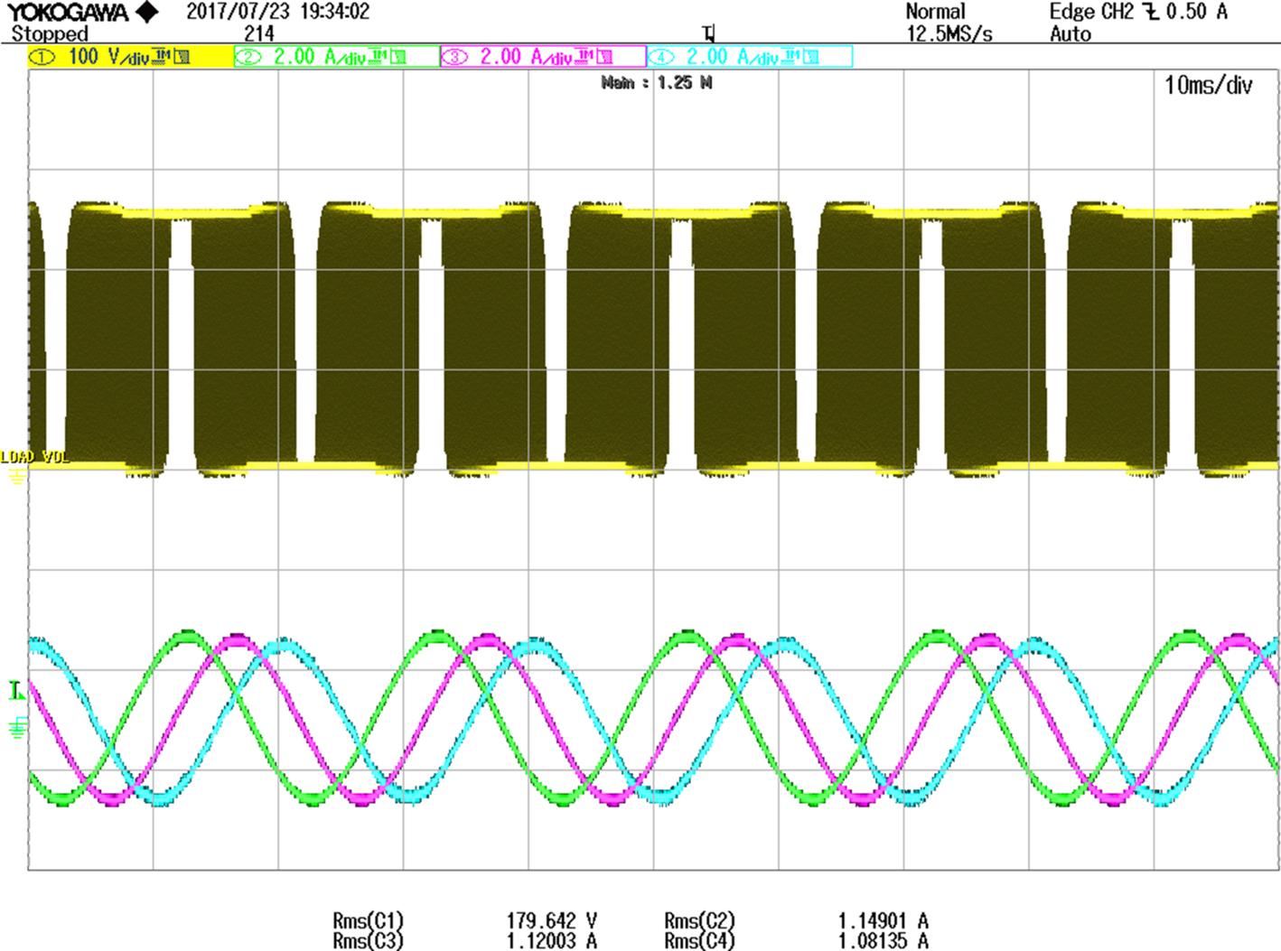

**FIG. 15.53** Unfiltered leg “A” voltage along with phase ‘a', ‘b', and ‘c' currents using carrier-based PWM.

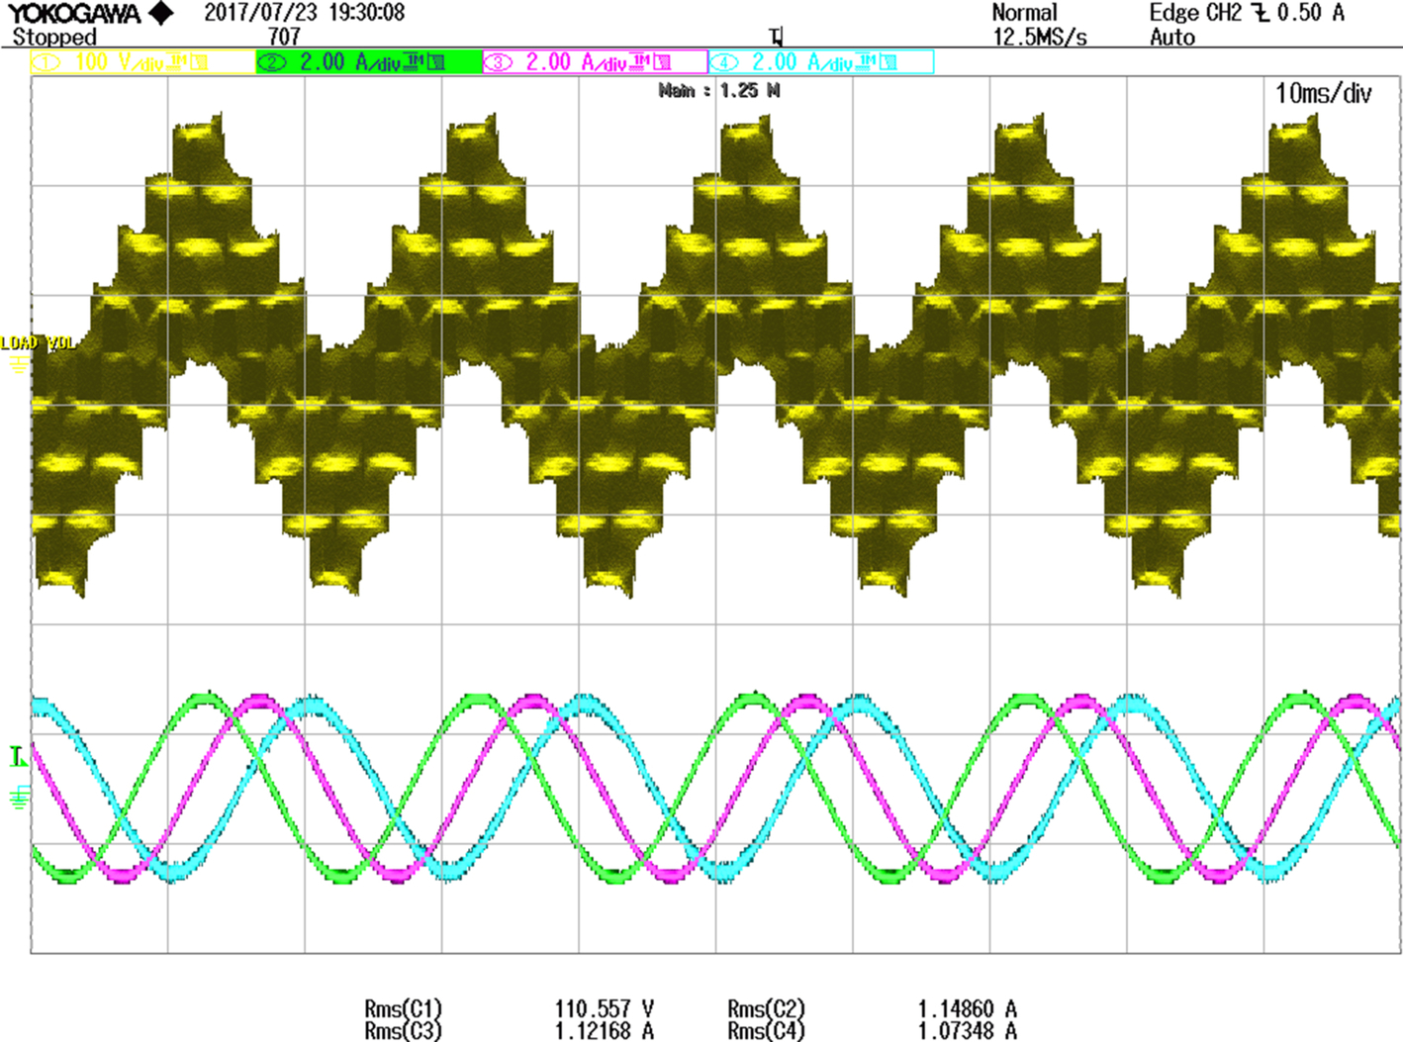

**FIG. 15.54** Unfiltered phase “a” voltage along with phase ‘a', ‘b', and ‘c' currents using carrier-based PWM.

Fifth-harmonic injection scheme is also implemented using DSP coding with fifth-harmonic signal equal to 0.0618 p.u. The resulting waveform of leg and corresponding phase voltage (unfiltered) are shown in [Figs. 15.55](https://learning.oreilly.com/library/view/power-electronics-handbook/9780128114087/B9780128114070000167_2.xhtml#f0280) and [15.56](https://learning.oreilly.com/library/view/power-electronics-handbook/9780128114087/B9780128114070000167_2.xhtml#f0285), respectively.

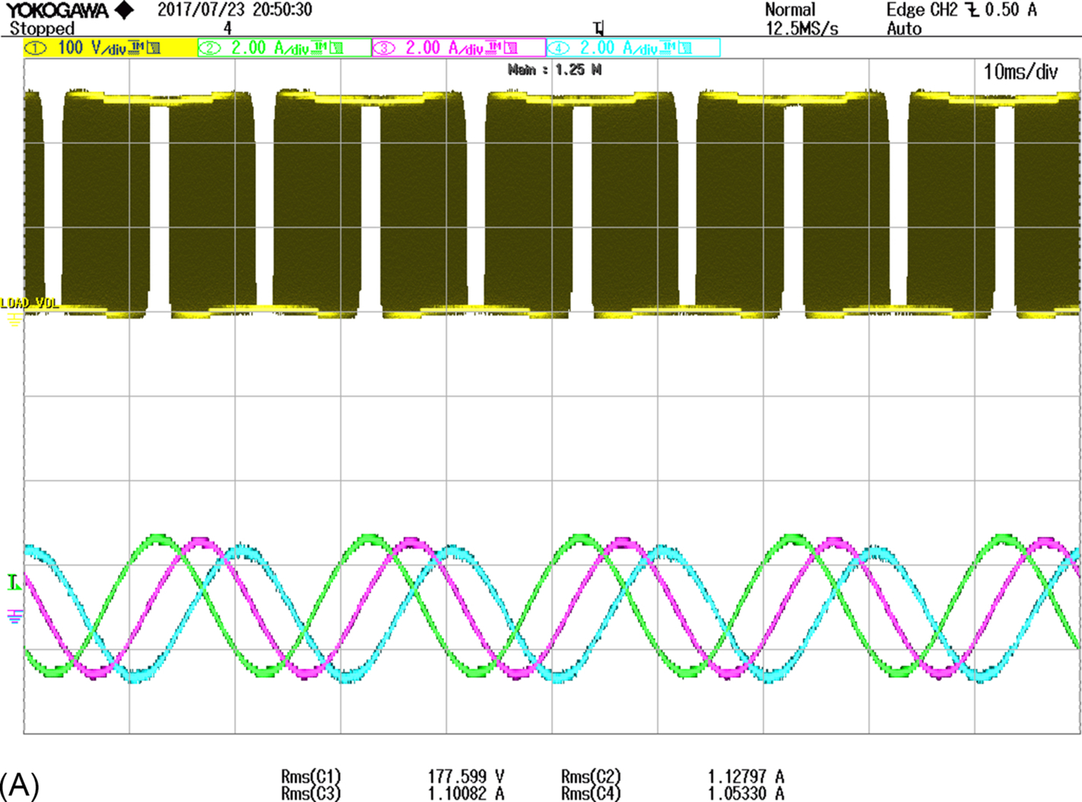

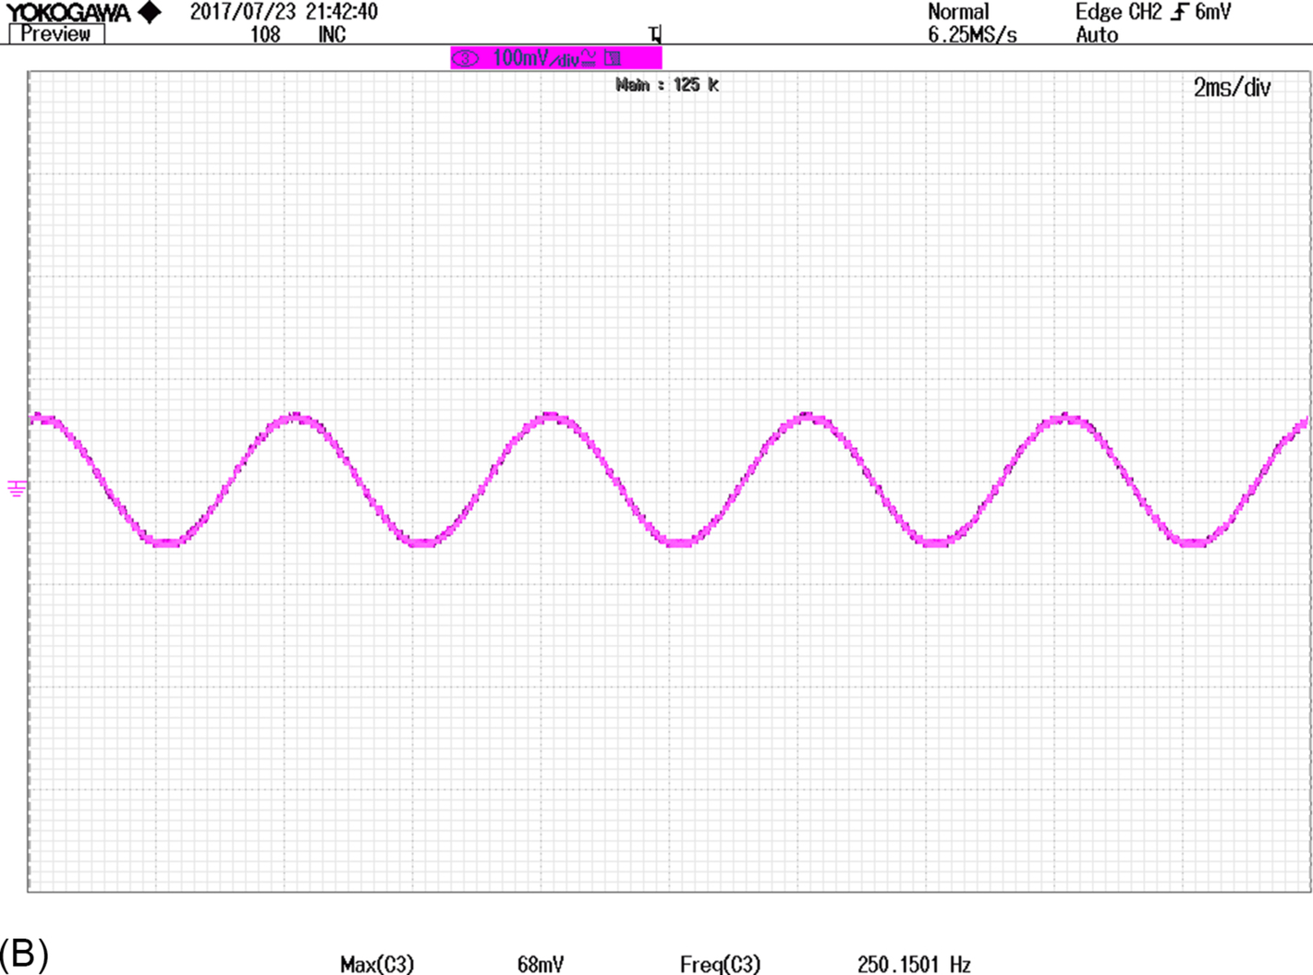

**FIG. 15.55** (A) Unfiltered leg “A” voltage along with phase ‘a', ‘b', and ‘c' currents using carrier-based PWM with fifth-harmonic injection. (B) Fifth harmonic signal injected in the carrier.

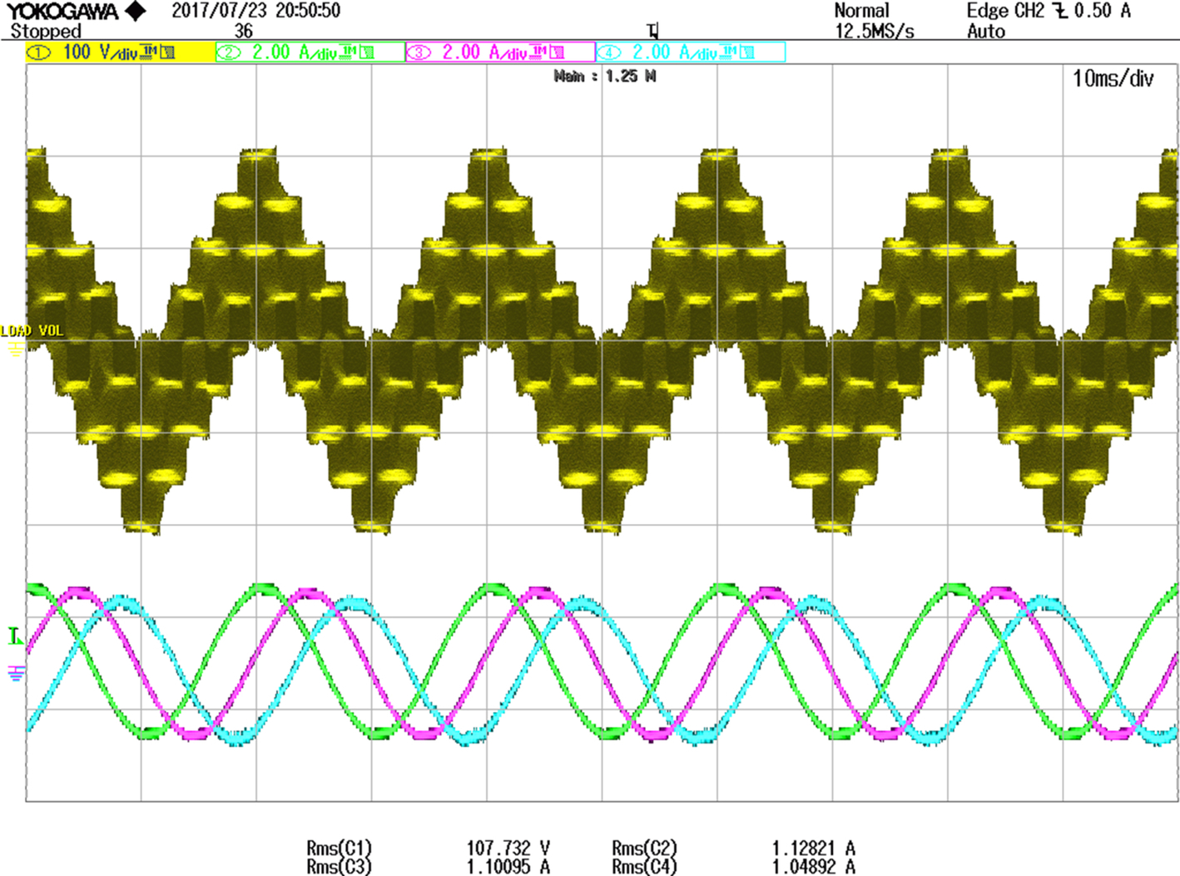

**FIG. 15.56** Unfiltered phase “a” voltage along with phase ‘a', ‘b', and ‘c' currents using fifth-harmonic signal injected in the carrier.

Triangular zero sequence injection PWM (TIPWM) is also implemented. The resulting waveform of phase voltage along with phase ‘a', ‘b', and ‘c' currents and triangular zero-sequence injection are shown in [Figs. 15.57](https://learning.oreilly.com/library/view/power-electronics-handbook/9780128114087/B9780128114070000167_2.xhtml#f0290) and [15.58](https://learning.oreilly.com/library/view/power-electronics-handbook/9780128114087/B9780128114070000167_2.xhtml#f0295), respectively.

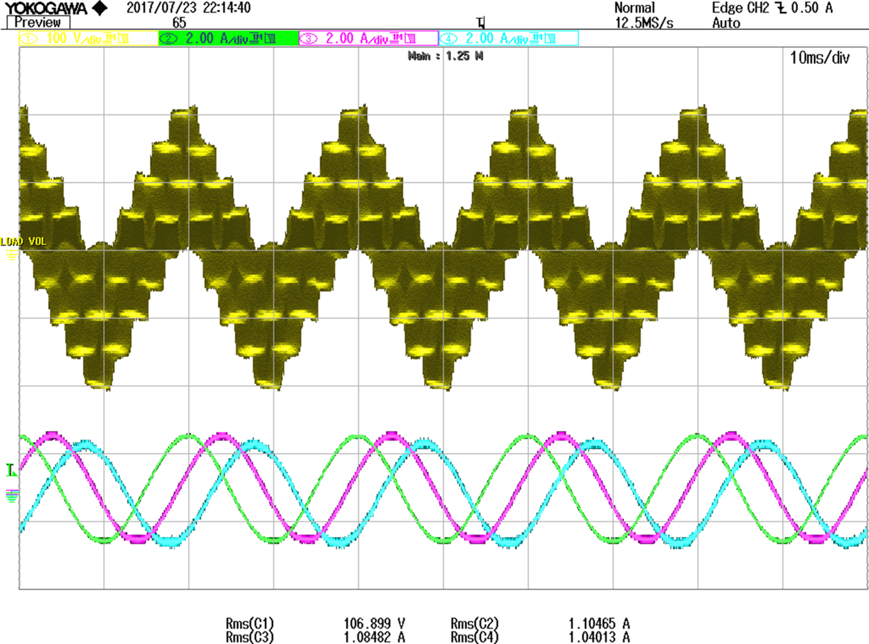

**FIG. 15.57** Phase voltage along with phase ‘a', ‘b', and ‘c' currents using triangular zero sequence injection PWM (TIPWM).

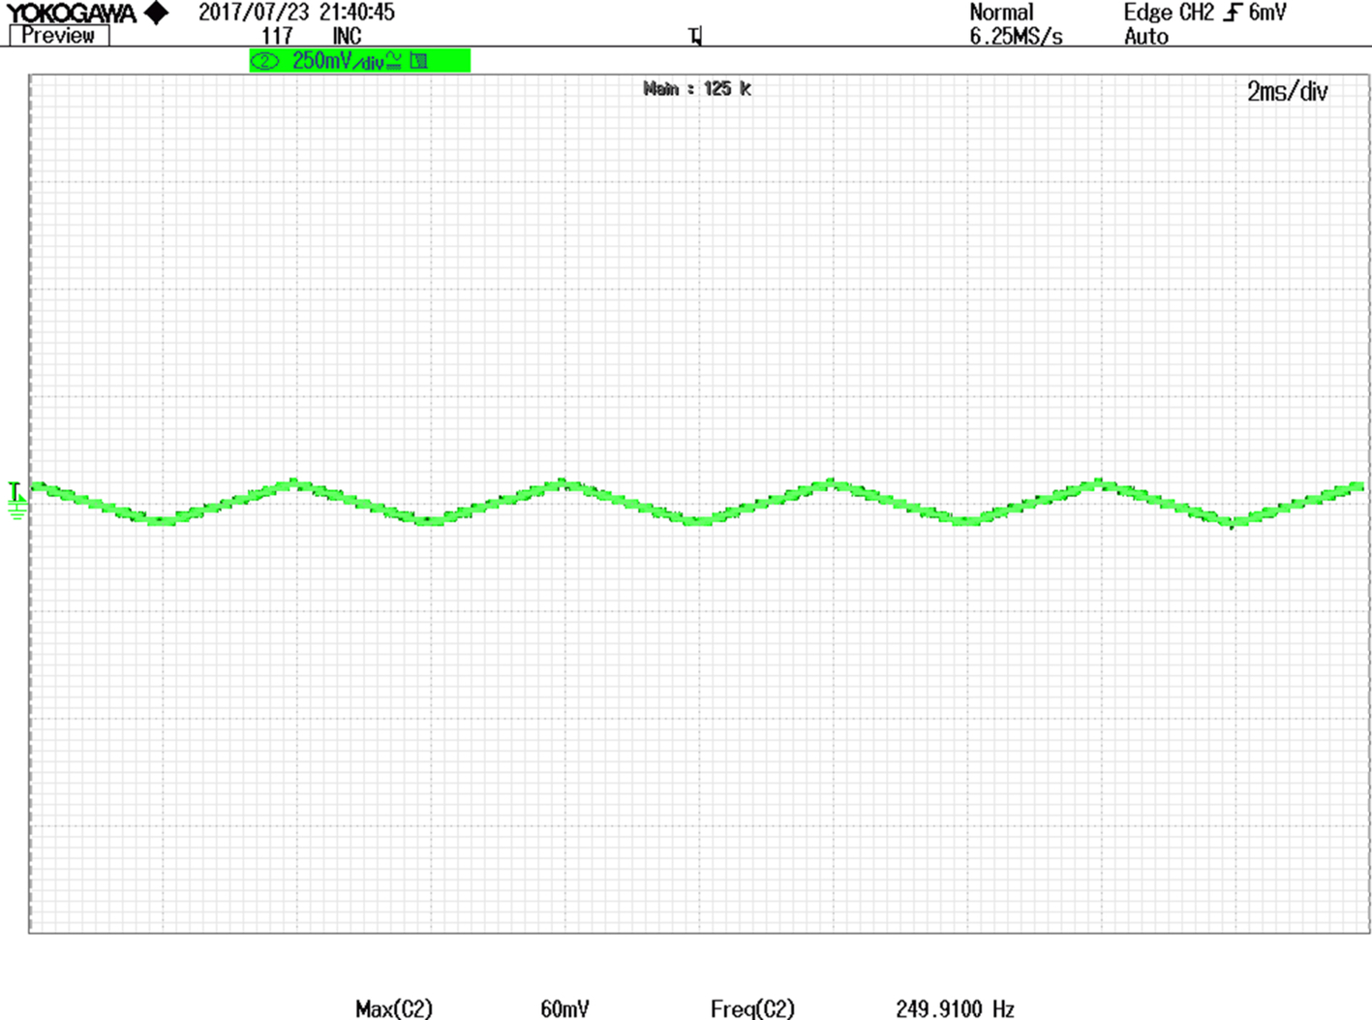

**FIG. 15.58** Triangular fifth harmonic zero sequence injected signal.

### 15.4.3 MODELING AND CONTROL OF A SEVEN-PHASE VSI-SQUARE WAVE MODE

This section details the modeling and control of a seven-phase VSI. The modeling of seven-phase VSI is done for 14-step operation using space-vector approach [[39](https://learning.oreilly.com/library/view/power-electronics-handbook/9780128114087/B9780128114070000167_4.xhtml#bb0200)]. The PWM operation mode is elaborated in [Section 15.4.4](https://learning.oreilly.com/library/view/power-electronics-handbook/9780128114087/B9780128114070000167_3.xhtml#s0225) [[40](https://learning.oreilly.com/library/view/power-electronics-handbook/9780128114087/B9780128114070000167_4.xhtml#bb0205),[41](https://learning.oreilly.com/library/view/power-electronics-handbook/9780128114087/B9780128114070000167_4.xhtml#bb0210)]. Conventional 180 degrees conduction mode is considered. The procedure adopted here follows from [Section 15.4.1](https://learning.oreilly.com/library/view/power-electronics-handbook/9780128114087/B9780128114070000167_1.xhtml#s0100). The analytic expressions for harmonic components and THD are derived for phase voltages and second nonadjacent line voltages. The same is then verified using simulation and experimental results.

[Section 15.4.3.2](https://learning.oreilly.com/library/view/power-electronics-handbook/9780128114087/B9780128114070000167_2.xhtml#s0215) deals with the modeling and control of a seven-phase voltage-source inverter in pulse-width modulation mode. There are a total of 128 switching state where the first 14 states lead to 14-step mode of operation and the rest of 114 switching states fall in PWM mode. Out of total 128 space vectors, two space vectors corresponding to the switching states 0000000 and 1111111 yield null vectors, and the rest 126 that produce finite length vectors are called active vectors. The model obtained is transformed into three different planes, namely, *d*-*q*, *x*1-*y*1, and *x*2-*y*2. Out of these three planes, only *d*-*q* produces torque in the machines supplied by the inverter, while the space vectors of other planes produce distortion in the stator currents. The complete model using space-vector approach is elaborated. The simulation results are included to validate the modeling procedure.

#### **15.4.3.1 Fourteen-Step Operation of a Seven-Phase Voltage Source Inverter**

Power circuit topology of a seven-phase VSI is shown in [Fig. 15.59](https://learning.oreilly.com/library/view/power-electronics-handbook/9780128114087/B9780128114070000167_2.xhtml#f0300). Each switch in the circuit consists of two power semiconductor devices, connected in antiparallel. One of these is a fully controllable semiconductor, such as a bipolar transistor or IGBT, while the second one is a diode. The input of the inverter is a DC voltage, which is regarded further on as being constant. The inverter outputs are denoted in [Fig. 15.59](https://learning.oreilly.com/library/view/power-electronics-handbook/9780128114087/B9780128114070000167_2.xhtml#f0300) with lowercase symbols (*a*,*b*,*c*,*d*,*e*,*f*,*g*), while the points of connection of the outputs to inverter legs have symbols in capital letters (*A*,*B*,*C*,*D*,*E*,*F*,*G*). The basic operating principles of the seven-phase VSI are developed in what follows assuming the ideal commutation and zero forward voltage drops. Each switch is assumed to conduct for 180 degrees, leading to the operation in the 14-step mode. Phase delay between firing of two switches in any subsequent two phases is equal to 360/7 degrees=51.43 degrees (approx.).

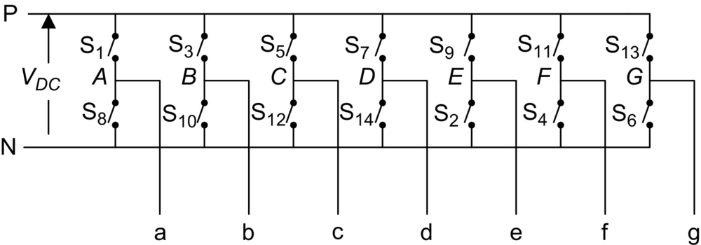

**FIG. 15.59** Seven-phase voltage-source inverter power circuit.

The driving control gate/base signals for the 14 switches of the inverter in [Fig. 15.59](https://learning.oreilly.com/library/view/power-electronics-handbook/9780128114087/B9780128114070000167_2.xhtml#f0300) are illustrated in [Fig. 15.60](https://learning.oreilly.com/library/view/power-electronics-handbook/9780128114087/B9780128114070000167_2.xhtml#f0305). One complete cycle of operation of the inverter can be divided into 14 distinct modes indicated in [Fig. 15.60](https://learning.oreilly.com/library/view/power-electronics-handbook/9780128114087/B9780128114070000167_2.xhtml#f0305) and summarized in [Table 15.5](https://learning.oreilly.com/library/view/power-electronics-handbook/9780128114087/B9780128114070000167_2.xhtml#t0030). It follows from [Fig. 15.60](https://learning.oreilly.com/library/view/power-electronics-handbook/9780128114087/B9780128114070000167_2.xhtml#f0305) and [Table 15.5](https://learning.oreilly.com/library/view/power-electronics-handbook/9780128114087/B9780128114070000167_2.xhtml#t0030) that at any instant of time there are seven switches that are “on” and seven switches that are “off.” In the 14-step mode of operation, there are three conducting switches from the upper 7 and 4 from the lower 7 or vice versa.

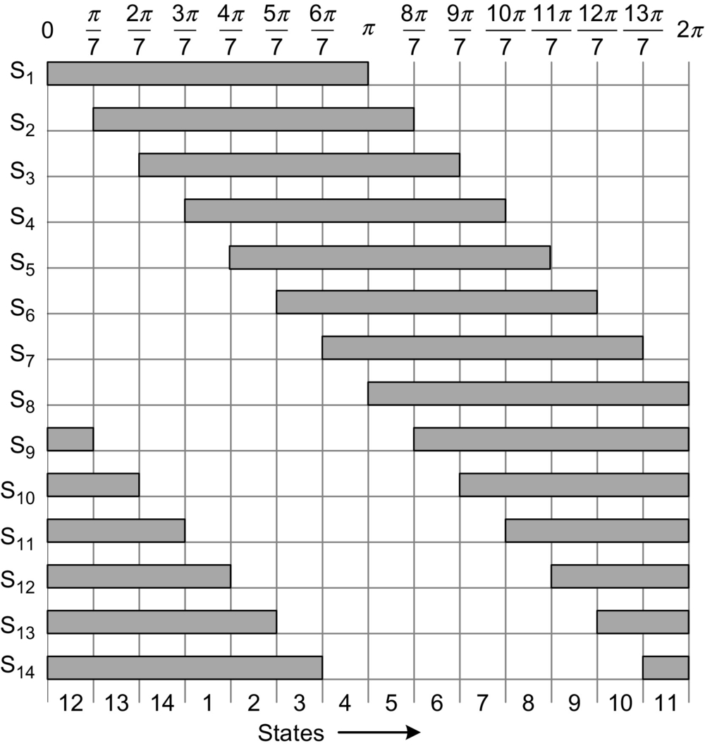

**FIG. 15.60** Driving switch signals for the 14-step mode.

**Table 15.5**

**Fourteen-step operation of a seven-phase VSI**

|  |  |  |
| --- | --- | --- |
| **States** | **Switches ON** | **Terminal polarity** |
| 12 | 1,9,10,11,12,13,14 | A+ B− C− D− E+ F+ G+ |
| 13 | 10,11,12,13,14,12 | A+ B− C− D− E− F+ G+ |
| 14 | 11,12,13,14,1,2,3 | A+ B+ C− D− E− F+ G+ |
| 1 | 12,13,14,1,2,3,4 | A+ B+ C− D− E− F− G+ |
| 2 | 13,14,1,2,3,4,5 | A+ B+ C+ D− E− F− G+ |
| 3 | 14,1,2,3,4,5,6 | A+ B+ C+ D− E− F− G− |
| 4 | 1,2,3,4,5,6,7 | A+ B+ C+ D+ E− F− G− |
| 5 | 2,3,4,5,6,7,8 | A− B+ C+ D+ E− F− G− |
| 6 | 3,4,5,6,7,8,9 | A− B+ C+ D+ E+ F− G− |
| 7 | 4,5,6,7,8,9,10 | A− B− C+ D+ E+ F− G− |
| 8 | 5,6,7,8,9,10,11 | A− B− C+ D+ E+ F+ G− |
| 9 | 6,7,8,9,10,11,12 | A− B− C− D+ E+ F+ G− |
| 10 | 7,8,9,10,11,12,13 | A− B− C− D+ E+ F+ G+ |
| 11 | 8,9,10,11,12,13,14 | A− B− C− D− E+ F+ G+ |

Leg voltages (i.e., voltages between points *A*,*B*,*C*,*D*,*E*,*F*,*G* and the negative rail of the DC bus N in [Fig. 15.59](https://learning.oreilly.com/library/view/power-electronics-handbook/9780128114087/B9780128114070000167_2.xhtml#f0300)) are considered first. The leg voltages obtained from the gate drive signal of [Fig. 15.60](https://learning.oreilly.com/library/view/power-electronics-handbook/9780128114087/B9780128114070000167_2.xhtml#f0305).

Space-vector model of the inverter is developed in the following subsection. Space vector of phase voltages in stationary reference frame is defined, using power invariant transformation, as

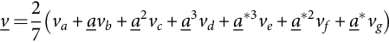 **(15.105)**

where *a*=exp(*j*2*π*/7), *a*2=exp(*j*4*π*/7), , *a*⁎=exp(−*j*2*π*/5), , , and ⁎ stands for a complex conjugate.

Space vectors of leg voltages are obtained using [Fig. 15.60](https://learning.oreilly.com/library/view/power-electronics-handbook/9780128114087/B9780128114070000167_2.xhtml#f0310) and Eq. [(15.105)](https://learning.oreilly.com/library/view/power-electronics-handbook/9780128114087/B9780128114070000167_2.xhtml#fo0575) and are given as in Eq. [(15.106)](https://learning.oreilly.com/library/view/power-electronics-handbook/9780128114087/B9780128114070000167_2.xhtml#fo0580).

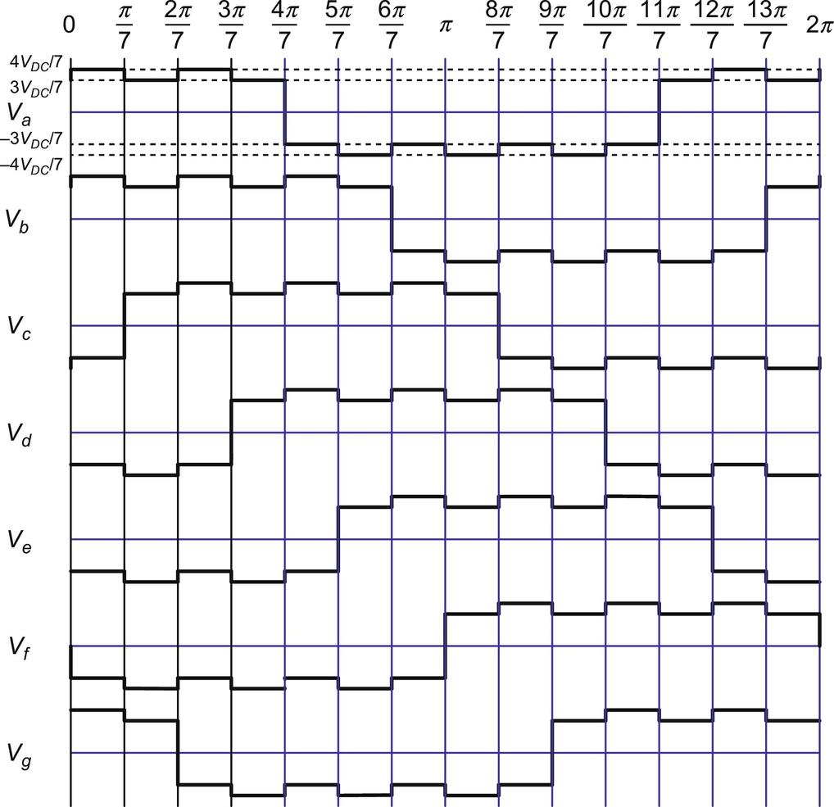

**FIG. 15.61** Phase-to-neutral voltages of the seven-phase VSI in the 14-step mode of operation.

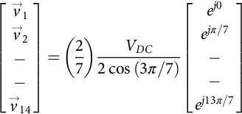 **(15.106)**

It is seen that the leg voltages have magnitude of (2/7)*VDC*(2 cos (π/7)) and are 25.7142857 degrees spatially apart.

Phase-to-neutral voltages of the star-connected load are most easily found by defining a voltage difference between the star point *n* of the load and the negative rail of the DC bus *N*. The following correlation then holds true:

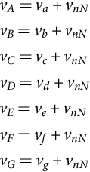 **(15.107)**

Since the phase voltages in a star-connected load sum to zero, the summation of Eq. [(15.107)](https://learning.oreilly.com/library/view/power-electronics-handbook/9780128114087/B9780128114070000167_2.xhtml#fo0580) yields

 **(15.108)**

Substitution of [(15.107)](https://learning.oreilly.com/library/view/power-electronics-handbook/9780128114087/B9780128114070000167_2.xhtml#fo0580) into [(15.108)](https://learning.oreilly.com/library/view/power-electronics-handbook/9780128114087/B9780128114070000167_2.xhtml#fo0585) yields phase-to-neutral voltages of the load in the following form:

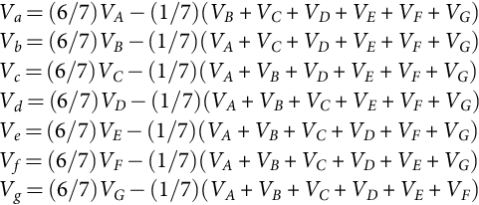 **(15.109)**

The phase voltages in different modes are obtained by substituting leg voltages into Eq. [(15.109)](https://learning.oreilly.com/library/view/power-electronics-handbook/9780128114087/B9780128114070000167_2.xhtml#fo0590), and their space vectors are determined using Eq. [(15.105)](https://learning.oreilly.com/library/view/power-electronics-handbook/9780128114087/B9780128114070000167_2.xhtml#fo0575). The waveform of phase voltages for seven phases is shown in [Fig. 15.61](https://learning.oreilly.com/library/view/power-electronics-handbook/9780128114087/B9780128114070000167_2.xhtml#f0310). The space vectors for the first 14 states are obtained as

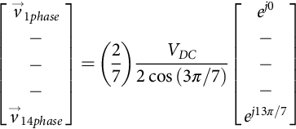 **(15.110)**

The Fourier analysis can be carried out, recognizing the quarter-wave symmetry; the waveform may be considered as odd function. The Fourier coefficients are obtained as

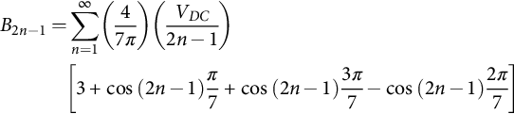 **(15.111)**

The expression in third bracket of Eq. [(15.111)](https://learning.oreilly.com/library/view/power-electronics-handbook/9780128114087/B9780128114070000167_2.xhtml#fo0600) equals to zero for all the harmonics whose order is divisible by seven. Hence, one can write the phase-to-neutral voltages as

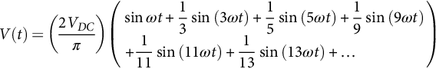 **(15.112)**

From [(15.112)](https://learning.oreilly.com/library/view/power-electronics-handbook/9780128114087/B9780128114070000167_2.xhtml#fo0605), it follows that the fundamental component of the output phase-to-neutral voltages has an rms value equal to

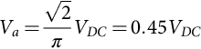 **(15.113)**

From [Fig. 15.61](https://learning.oreilly.com/library/view/power-electronics-handbook/9780128114087/B9780128114070000167_2.xhtml#f0310), the mean square value is determined as

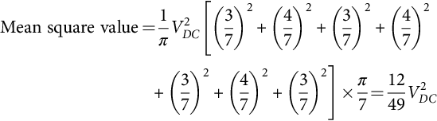 **(15.114)**

**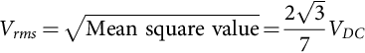** **(15.115)**

Total harmonic rms voltage (p.u.) is given by

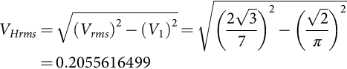 **(15.116)**

Hence, total harmonic distortion is

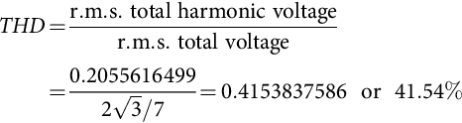 **(15.117)**

There are three systems of line-to-line voltage: adjacent, first nonadjacent and second nonadjacent, in contrast to a three-phase system where only one line-to-line voltage is defined and five-phase system where two systems of line voltages exist. The second nonadjacent line voltages yield highest magnitude, and hence, it is taken up for discussion, and the other two types are omitted. The values of line voltages are obtained as the difference between the leg voltages and are plotted in [Fig. 15.62](https://learning.oreilly.com/library/view/power-electronics-handbook/9780128114087/B9780128114070000167_2.xhtml#f0315).

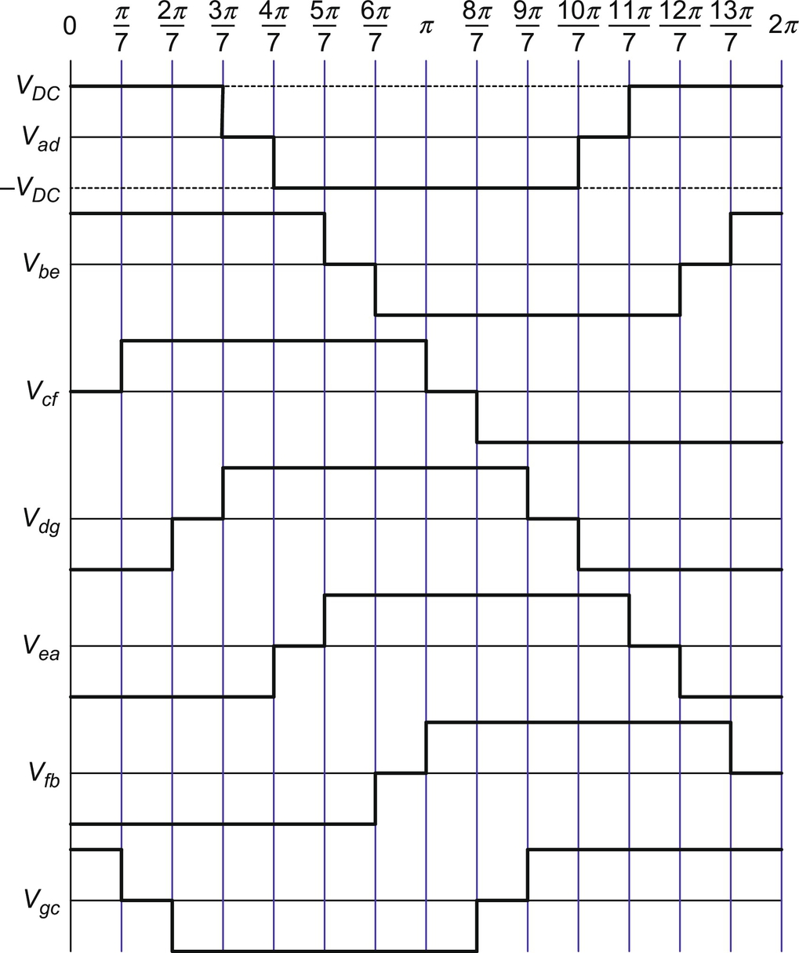

**FIG. 15.62** The second nonadjacent line-to-line voltages of seven-phase VSI for various modes.

The second nonadjacent line-line voltage space vectors are calculated by substituting the values from [Table 15.6](https://learning.oreilly.com/library/view/power-electronics-handbook/9780128114087/B9780128114070000167_2.xhtml#t0035) into the defining expression [(15.105)](https://learning.oreilly.com/library/view/power-electronics-handbook/9780128114087/B9780128114070000167_2.xhtml#fo0575) and are

**Table 15.6**

**Second nonadjacent line-to-line voltages of seven-phase VSI**

|  |  |  |  |  |  |  |  |  |  |
| --- | --- | --- | --- | --- | --- | --- | --- | --- | --- |
| **States** | **Switches ON** | **Space vectors** | ***Vad*** | ***Vbe*** | ***Vcf*** | ***Vdg*** | ***Vea*** | ***Vfb*** | ***Vgc*** |
| 1 | 12,13,14,1,2,3,4 | si14_e | *VDC* | *VDC* | 0 | -*VDC* | -*VDC* | -*VDC* | *VDC* |
| 2 | 13,14,1,2,3,4,5 | si15_e | *VDC* | *VDC* | *VDC* | -*VDC* | -*VDC* | -*VDC* | 0 |
| 3 | 14,1,2,3,4,5,6 | si16_e | *VDC* | *VDC* | *VDC* | 0 | -*VDC* | -*VDC* | *VDC* |
| 4 | 1,2,3,4,5,6,7 | si17_e | 0 | *VDC* | *VDC* | *VDC* | -*VDC* | -*VDC* | -*VDC* |
| 5 | 2,3,4,5,6,7,8 | si18_e | -*VDC* | *VDC* | *VDC* | *VDC* | 0 | -*VDC* | -*VDC* |
| 6 | 3,4,5,6,7,8,9 | si19_e | -*VDC* | 0 | *VDC* | *VDC* | *VDC* | -*VDC* | -*VDC* |
| 7 | 4,5,6,7,8,9,10 | si20_e | -*VDC* | -*VDC* | *VDC* | *VDC* | *VDC* | 0 | -*VDC* |
| 8 | 5,6,7,8,9,10,11 | si21_e | -*VDC* | -*VDC* | 0 | *VDC* | *VDC* | *VDC* | -*VDC* |
| 9 | 6,7,8,9,10,11,12 | si22_e | -*VDC* | -*VDC* | -*VDC* | *VDC* | *VDC* | *VDC* | 0 |
| 10 | 7,8,9,10,11,12,13 | si23_e | -*VDC* | -*VDC* | -*VDC* | 0 | *VDC* | *VDC* | *VDC* |
| 11 | 8,9,10,11,12,13,14 | si24_e | 0 | -*VDC* | -*VDC* | -*VDC* | *VDC* | *VDC* | *VDC* |
| 12 | 1,9,10,11,12,13,14 | si25_e | *VDC* | -*VDC* | -*VDC* | -*VDC* | 0 | *VDC* | *VDC* |
| 13 | 10,11,12,13,14,12 | si26_e | *VDC* | 0 | -*VDC* | -*VDC* | -*VDC* | *VDC* | *VDC* |
| 14 | 11,12,13,14,1,2,3 | si27_e | *VDC* | *VDC* | -*VDC* | -*VDC* | -*VDC* | 0 | *VDC* |

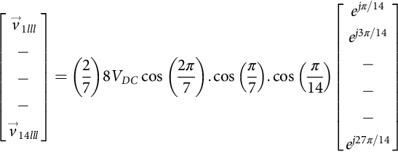 **(15.118)**

Fourier analysis can be done, and the resulting coefficients of the Fourier series for second nonadjacent line-to-line voltages, by considering odd quarter-wave symmetry, are

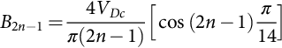 **(15.119)**

The series will be

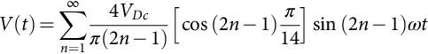 **(15.120)**

From [(15.120)](https://learning.oreilly.com/library/view/power-electronics-handbook/9780128114087/B9780128114070000167_2.xhtml#fo0645), it follows that the fundamental component of the output phase-to-neutral voltages has an rms value equal to

 **(15.121)**

From [Fig. 15.62](https://learning.oreilly.com/library/view/power-electronics-handbook/9780128114087/B9780128114070000167_2.xhtml#f0315), the mean square value is determined as

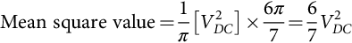 **(15.122)**

**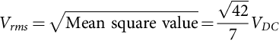** **(15.123)**

Total harmonic rms voltage (p.u.) is given by

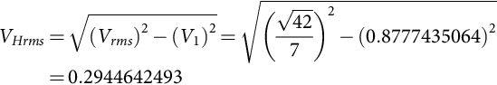 **(15.124)**

Hence, total harmonic distortion is

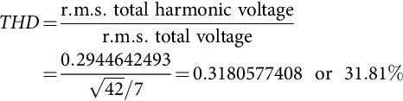 **(15.125)**

The distortion in the line voltages is quite high.

It is important to note at this stage that the space vectors described by [(15.105)](https://learning.oreilly.com/library/view/power-electronics-handbook/9780128114087/B9780128114070000167_2.xhtml#fo0575) provide mapping of inverter voltages into a two-dimensional space. However, since seven-phase inverter essentially requires description in a seven-dimensional space, not all the harmonics contained in [(15.111)](https://learning.oreilly.com/library/view/power-electronics-handbook/9780128114087/B9780128114070000167_2.xhtml#fo0600) and [(15.112)](https://learning.oreilly.com/library/view/power-electronics-handbook/9780128114087/B9780128114070000167_2.xhtml#fo0605) will be encompassed by the space vector of [(15.105)](https://learning.oreilly.com/library/view/power-electronics-handbook/9780128114087/B9780128114070000167_2.xhtml#fo0575). In particular, space vectors calculated using [(15.105)](https://learning.oreilly.com/library/view/power-electronics-handbook/9780128114087/B9780128114070000167_2.xhtml#fo0575) will only represent harmonics of the order 14*k*±1, *k*=0, 1,2,3….., that is, the 1st, the 13th, the 15th, and so on. Harmonics of the order 7*k*, *k*=1,2,3,…, cannot appear due to the isolated neutral point. However, harmonics of the order 7*k*±2 and 7*k*±4, *k*=1,3,5,… are present in [(15.111)](https://learning.oreilly.com/library/view/power-electronics-handbook/9780128114087/B9780128114070000167_2.xhtml#fo0600) and [(15.112)](https://learning.oreilly.com/library/view/power-electronics-handbook/9780128114087/B9780128114070000167_2.xhtml#fo0605) but are not encompassed by the space-vector definition of [(15.105)](https://learning.oreilly.com/library/view/power-electronics-handbook/9780128114087/B9780128114070000167_2.xhtml#fo0575). These harmonics in essence appear in the second and third two-dimensional space, which requires introduction of the second and third space vectors for the seven-phase system. This issue is addressed in [Section 15.4.3.3](https://learning.oreilly.com/library/view/power-electronics-handbook/9780128114087/B9780128114070000167_3.xhtml#s0220).

#### **15.4.3.2 PWM Mode of Operation**

If a seven-phase VSI is operated in PWM mode, apart from the already described 14 states, there will be additional 114 switching states. The number of possible switching states is in general equal to 2*n*, where *n* is the number of inverter legs (i.e., output phases). This correlation is valid for any two-level VSI. [Table 15.7](https://learning.oreilly.com/library/view/power-electronics-handbook/9780128114087/B9780128114070000167_2.xhtml#t0040) summarizes the additional switching states that are associated with PWM mode of operation and are absent in the 14-step mode of operation. Switches that are “on” and the corresponding terminal polarity are included in [Table 15.7](https://learning.oreilly.com/library/view/power-electronics-handbook/9780128114087/B9780128114070000167_2.xhtml#t0040) As can be seen from [Table 15.7](https://learning.oreilly.com/library/view/power-electronics-handbook/9780128114087/B9780128114070000167_2.xhtml#t0040), the remaining 114 switching states encompass four possible situations: all the states when four switches from upper (or lower) half and three from the lower (or upper) half of the inverter are “on” (states 1–14, 29–42, 43–56, 85–99, and 98–112); two states when either all the seven upper (or lower) switches are “on” (states 127 and 128); all the states when five switches from upper (or lower) and two from upper (or lower) half of the inverter are “on” (states 15–28, 57–70, and 113–126); and remaining states with six switches from the upper (or lower) half and one switch from the lower (or upper) half in conduction mode (states 71–84). The phase-to-neutral voltages are described using the same approach as that of the previous sections.

**Table 15.7**

**Modes of operation of seven-phase voltage-source inverter**

|  |  |  |
| --- | --- | --- |
| **States** | **Switches ON** | **Polarity of terminal** |
| 15 | 1,2,3,5,11,13,14 | A+B+C+D−E−F+G+ |
| 16 | 1,2,3,4,6,12,14 | A+B+C−D−E−F−G− |
| 17 | 1,2,3,4,5,7,13 | A+B+C+D+E−F−G+ |
| 18 | 2,3,4,5,6,8,14 | A−B+C+D−E−F−G− |
| 19 | 1,3,4,5,6,7,9 | A+B+C+D+E+F−G− |
| 20 | 2,4,5,6,7,8,10 | A−B−C+D+E−F−G− |
| 21 | 3,5,6,7,8,9,11 | A−B+C+D+E+F+G− |
| 22 | 4,6,7,8,9,10,12 | A−B−C−D+E+F−G− |
| 23 | 5,7,8,9,10,11,13 | A−B−C+D+E+F+G+ |
| 24 | 6,8,9,10,11,12,14 | A−B−C−D−E+F+G− |
| 25 | 7,9,10,11,12,13 | A+B−C−D+E+F+G+ |
| 26 | 2,8,10,11,12,13,14 | A−B−C−D−E−F+G+ |
| 27 | 1,3,9,11,12,13,14 | A+B+C−D−E+F+G+ |
| 28 | 1,2,4,10,12,13,14 | A+B−C−D−E−F−G+ |
| 29 | 1,2,4,5,10,13,14 | A+B−C+D−E−F+G+ |
| 30 | 1,2,3,5,6,11,14 | A+B+C+D−E−F+G− |
| 31 | 1,2,3,4,6,7,12 | A+B+C−D+E−F−G− |
| 32 | 2,3,4,5,7,8,13 | A−B+C+D+E−F−G+ |
| 33 | 3,4,5,6,8,9,14 | A−B+C+D−E+F−G− |
| 34 | 1,4,5,6,7,9,10 | A+B−C+D+E+F−G− |
| 35 | 2,5,6,7,8,10,11 | A−B−C+D+E−F+G− |
| 36 | 3,6,7,8,9,11,12 | A−B+C−D+E+F+G− |
| 37 | 4,7,8,9,10,12,13 | A−B−C−D+E+F−G+ |
| 38 | 5,8,9,10,11,13,14 | A−B−C+D−E+F+G+ |
| 39 | 1,6,9,10,11,12,14 | A+B−C−D−E+F+G− |
| 40 | 1,2,7,10,11,12,13 | A+B−C−D+E−F+G+ |
| 41 | 2,3,8,11,12,13,14 | A−B+C−D−E−F+G+ |
| 42 | 1,3,4,9,12,13,14 | A+B+C−D−E+F−G+ |
| 43 | 1,2,3,4,7,12,13 | A+B+C−D+E−F−G+ |
| 44 | 2,3,4,5,8,13,14 | A−B+C+D−E−F−G+ |
| 45 | 1,3,4,5,6,9,14 | A+B+C+D−E+F−G− |
| 46 | 1,2,4,5,6,7,10 | A+B−C+D+E−F−G− |
| 47 | 2,3,5,6,7,8,11 | A−B+C+D+E−F+G− |
| 48 | 3,4,6,7,8,9,12 | A−B+C−D+E+F−G− |
| 49 | 4,5,7,8,9,10,13 | A−B−C+D+E+F−G+ |
| 50 | 5,6,8,9,10,11,14 | A−B−C+D−E+F+G− |
| 51 | 1,6,7,9,10,11,12 | A+B−C−D+E+F+G− |
| 52 | 2,7,8,10,11,12,13 | A−B−C−D+E−F+G+ |
| 53 | 3,8,9,11,12,13,14 | A−B+C−D−E+F+G+ |
| 54 | 1,4,9,10,12,13,14 | A+B−C−D−E+F−G+ |
| 55 | 1,2,5,10,1,13,14 | A+B−C+D−E−F+G+ |
| 56 | 1,2,3,6,11,12,14 | A+B+C−D−E−F+G− |
| 57 | 2,3,4,8,12,13,14 | A−B+C−D−E−F−G+ |
| 58 | 1,3,4,5,9,13,14 | A+B+C+D−E+F−G+ |
| 59 | 1,2,4,5,6,10,14 | A+B−C+D−E−F−G− |
| 60 | 1,2,3,5,6,7,11 | A+B+C+D+E−F+G− |
| 61 | 2,3,4,6,7,8,12 | A−B+C−D+E−F−G− |
| 62 | 3,4,5,7,8,9,13 | A−B+C+D+E+F−G+ |
| 63 | 4,5,6,8,9,10,14 | A−B−C+D−E+F−G− |
| 64 | 1,5,6,7,9,10,11 | A−B−C+D+E+F+G− |
| 65 | 2,6,7,8,10,11,12 | A−B−C−D+E−F+G+ |
| 66 | 3,7,8,9,11,12,13 | A−B+C−D+E+F+G+ |
| 67 | 4,8,9,10,12,13,14 | A−B−C−D−E+F−G+ |
| 68 | 1,5,9,10,11,13,14 | A+B−C+D−E+F+G+ |
| 69 | 1,2,6,10,11,12,14 | A+B−C−D−E−F+G− |
| 70 | 1,2,3,7,11,12,13 | A+B+C−D+E−F+G+ |
| 71 | 1,2,4,6,10,12,14 | A+B−C−D−E−F−G− |
| 72 | 1,2,3,5,7,11,13 | A+B+C+D+E−F+G+ |
| 73 | 2,3,4,6,8,12,14 | A−B+C−D−E−F−G− |
| 74 | 1,3,4,5,7,9,13 | A+B+C+D+E+F−G+ |
| 75 | 2,4,5,6,8,10,14 | A−B−C+D−E−F−G− |
| 76 | 1,3,5,6,7,9,11 | A+B+C+D+E+F+G− |
| 77 | 2,4,6,7,8,10,12 | A−B−C−D+E−F−G− |
| 78 | 3,5,7,8,9,11,13 | A−B+C+D+E+F+G+ |
| 79 | 4,6,8,9,10,12,14 | A−B−C−D−E+F−G− |
| 80 | 1,5,7,9,10,11,13 | A+B−C+D+E+F+G+ |
| 81 | 2,6,8,10,11,12,14 | A−B−C−D−E−F+G− |
| 82 | 1,3,7,9,11,12,13 | A+B+C−D+E+F+G+ |
| 83 | 2,4,8,10,12,13,14 | A−B−C−D−E−F−G+ |
| 84 | 1,3,5,9,11,13,14 | A+B+C+D−E+F+G+ |
| 85 | 2,35,8,11,13,14 | A−B+C+D−E−F+G+ |
| 86 | 1,3,4,6,9,12,14 | A+B+C−D−E+F−G− |
| 87 | 1,2,4,5,7,10,13 | A+B−C+D+E−F−G+ |
| 88 | 2,3,5,6,8,11,14 | A−B+C+D−E−F+G− |
| 89 | 1,3,4,6,7,9,12 | A+B+C−D+E+F−G− |
| 90 | 2,4,5,7,8,10,13 | A−B−C+D+E−F−G+ |
| 91 | 3,5,6,8,9,11,14 | A−B+C+D−E+F+G− |
| 92 | 1,4,6,7,9,10,12 | A+B−C−D+E+F−G− |
| 93 | 2,5,7,8,10,11,13 | A−B−C+D+E−F+G+ |
| 94 | 3,6,8,9,11,12,14 | A−B+C−D−E+F+G− |
| 95 | 1,4,7,9,10,12,13 | A+B−C−D+E+F−G+ |
| 96 | 2,5,8,10,11,13,14 | A−B−C+D−E−F+G+ |
| 97 | 1,3,6,9,11,12,14 | A+B+C−D−E+F+G− |
| 98 | 1,2,4,7,10,12,13 | A+B−C−D+E−F−G+ |
| 99 | 1,2,5,6,10,11,14 | A+B−C+D−E−F+G− |
| 100 | 1,2,3,6,7,11,12 | A+B+C−D+E−F+G− |
| 101 | 2,3,4,7,8,12,13 | A−B+C−D+E−F−G+ |
| 102 | 3,4,5,8,9,13,14 | A−B+C+D−E+F−G+ |
| 103 | 1,4,5,6,9,10,14 | A+B−C+D−E+F−G− |
| 104 | 1,2,5,6,7,10,11 | A+B−C+D+E−F+G− |
| 105 | 2,3,6,7,8,11,12 | A−B+C−D+E−F+G− |
| 106 | 3,4,7,8,9,12,13 | A−B+C−D+E+F−G+ |
| 107 | 4,5,8,9,10,13,14 | A−B−C+D−E+F−G+ |
| 108 | 1,5,6,9,10,11,14 | A+B−C+D−E+F+G− |
| 109 | 1,2,6,7,10,11,12 | A+B−C−D+E−F+G− |
| 110 | 2,3,7,8,11,12,13 | A−B+C−D+E−F+G+ |
| 111 | 3,4,8,9,12,13,14 | A−B+C−D−E+F−G+ |
| 112 | 1,4,5,9,10,13,14 | A+B−C+D−E+F−G+ |
| 113 | 1,3,4,7,9,12,13 | A+B+C−D+E+F−G+ |
| 114 | 2,4,5,8,10,13,14 | A−B−C+D−E−F−G+ |
| 115 | 1,3,5,6,9,11,14 | A+B+C+D−E+F+G− |
| 116 | 1,2,4,6,7,10,12 | A+B−C−D+E−F−G− |
| 117 | 2,3,5,7,8,11,13 | A−B+C+D+E−F+G+ |
| 118 | 3,4,6,8,9,12,14 | A−B+C−D−E+F−G− |
| 119 | 1,4,5,7,9,10,13 | A+B−C+D+E+F−G+ |
| 120 | 2,5,6,8,10,11,14 | A−B−C+D−E−F+G− |
| 121 | 1,3,6,7,9,11,12 | A+B+C−D+E+F+G− |
| 122 | 2,4,7,8,10,12,13 | A−B−C−D+E−F−G+ |
| 123 | 3,5,8,9,11,13,14 | A−B+C+D−E+F+G+ |
| 124 | 1,4,6,9,10,12,14 | A+B−C−D−E+F−G− |
| 125 | 1,2,5,7,10,11,13 | A+B−C+D+E−F+G+ |
| 126 | 2,3,6,8,11,12,14 | A−B+C−D−E−F+G− |
| 127 | 2,4,6,8,10,12,14 | A−B−C−D−E−F−G− |
| 128 | 1,3,5,7,9,11,13 | A+B+C+D+E+F+G+ |

The phase voltage values are listed in [Table 15.8](https://learning.oreilly.com/library/view/power-electronics-handbook/9780128114087/B9780128114070000167_2.xhtml#t0045), and the corresponding space vectors for 15–126 can be obtained using Eq. [(15.105)](https://learning.oreilly.com/library/view/power-electronics-handbook/9780128114087/B9780128114070000167_2.xhtml#fo0575) and are given by expressions [(15.126)](https://learning.oreilly.com/library/view/power-electronics-handbook/9780128114087/B9780128114070000167_2.xhtml#fo0675)–[(15.133)](https://learning.oreilly.com/library/view/power-electronics-handbook/9780128114087/B9780128114070000167_2.xhtml#fo0710). The complete space-vector model of phase voltage is shown in [Fig. 15.63](https://learning.oreilly.com/library/view/power-electronics-handbook/9780128114087/B9780128114070000167_2.xhtml#f0320).

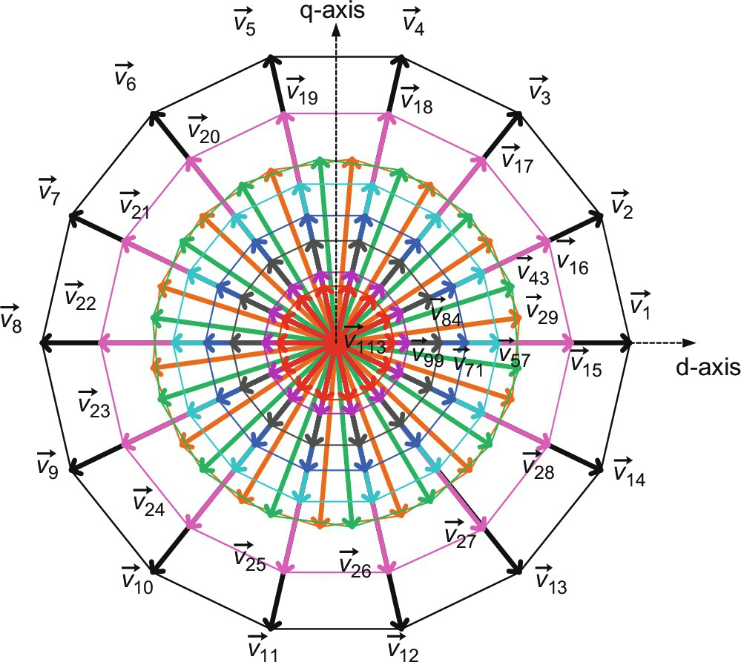

**FIG. 15.63** Phase-to-neutral voltage space vectors for states 1–128 (states 127–128 are at origin) in *d*-*q* plane.

**Table 15.8**

**Phase voltages (p.u.) values for PWM mode**

|  |  |  |  |  |  |  |  |  |  |
| --- | --- | --- | --- | --- | --- | --- | --- | --- | --- |
| **Switching states** | **Switches ON** | **Space vectors** | ***Va*** | ***Vb*** | ***Vc*** | ***Vd*** | ***Ve*** | ***Vf*** | ***Vg*** |
| 15 | 1,2,3,5,11,13,14 | si28_e | 2/7 | 2/7 | 2/7 | −5/7 | −5/7 | 2/7 | 2/7 |
| 16 | 1,2,3,4,6,12,14 | si29_e | 5/7 | 5/7 | −2/7 | −2/7 | −2/7 | −2/7 | −2/7 |
| 17 | 1,2,3,4,5,7,13 | si30_e | 2/7 | 2/7 | 2/7 | 2/7 | −5/7 | −5/7 | 2/7 |
| 18 | 2,3,4,5,6,8,14 | si31_e | −2/7 | 5/7 | 5/7 | −2/7 | −2/7 | −2/7 | −2/7 |
| 19 | 1,3,4,5,6,7,9 | si32_e | 2/7 | 2/7 | 2/7 | 2/7 | 2/7 | −5/7 | −5/7 |
| 20 | 2,4,5,6,7,8,10 | si33_e | −2/7 | −2/7 | 5/7 | 5/7 | −2/7 | −2/7 | −2/7 |
| 21 | 3,5,6,7,8,9,11 | si34_e | −5/7 | 2/7 | 2/7 | 2/7 | 2/7 | 2/7 | −5/7 |
| 22 | 4,6,7,8,9,10,12 | si35_e | −2/7 | −2/7 | −2/7 | 5/7 | 5/7 | −2/7 | −2/7 |
| 23 | 5,7,8,9,10,11,13 | si36_e | −5/7 | −5/7 | 2/7 | 2/7 | 2/7 | 2/7 | 2/7 |
| 24 | 6,8,9,10,11,12,14 | si37_e | −2/7 | −2/7 | −2/7 | −2/7 | 5/7 | 5/7 | −2/7 |
| 25 | 7,9,10,11,12,13 | si38_e | 2/7 | −5/7 | −5/7 | 2/7 | 2/7 | 2/7 | 2/7 |
| 26 | 2,8,10,11,12,13,14 | si39_e | −2/7 | −2/7 | −2/7 | −2/7 | −2/7 | 5/7 | 5/7 |
| 27 | 1,3,9,11,12,13,14 | si40_e | 2/7 | 2/7 | −5/7 | −5/7 | 2/7 | 2/7 | 2/7 |
| 28 | 1,2,4,10,12,13,14 | si41_e | 5/7 | −2/7 | −2/7 | −2/7 | −2/7 | −2/7 | 5/7 |
| 29 | 1,2,4,5,10,13,14 | si42_e | 4/7 | −3/7 | 4/7 | −3/7 | −3/7 | −3/7 | 4/7 |
| 30 | 1,2,3,5,6,11,14 | si43_e | 3/7 | 3/7 | 3/7 | −4/7 | −4/7 | 3/7 | −4/7 |
| 31 | 1,2,3,4,6,7,12 | si44_e | 4/7 | 4/7 | −3/7 | 4/7 | −3/7 | −3/7 | −3/7 |
| 32 | 2,3,4,5,7,8,13 | si45_e | −4/7 | 3/7 | 3/7 | 3/7 | −4/7 | −4/7 | 3/7 |
| 33 | 3,4,5,6,8,9,14 | si46_e | −3/7 | 4/7 | 4/7 | −3/7 | 4/7 | −3/7 | −3/7 |
| 34 | 1,4,5,6,7,9,10 | si47_e | 3/7 | −4/7 | 3/7 | 3/7 | 3/7 | −4/7 | −4/7 |
| 35 | 2,5,6,7,8,10,11 | si48_e | −3/7 | −3/7 | 4/7 | 4/7 | −3/7 | 4/7 | −3/7 |
| 36 | 3,6,7,8,9,11,12 | si49_e | −4/7 | 3/7 | −4/7 | 3/7 | 3/7 | 3/7 | −4/7 |
| 37 | 4,7,8,9,10,12,13 | si50_e | −3/7 | −3/7 | −3/7 | 4/7 | 4/7 | −3/7 | 4/7 |
| 38 | 5,8,9,10,11,13,14 | si51_e | −4/7 | −4/7 | 3/7 | −4/7 | −3/7 | −3/7 | −3/7 |
| 39 | 1,6,9,10,11,12,14 | si52_e | 4/7 | −3/7 | −3/7 | −3/7 | 4/7 | 4/7 | −3/7 |
| 40 | 1,2,7,10,11,12,13 | si53_e | 3/7 | −4/7 | −4/7 | 3/7 | −4/7 | 3/7 | 3/7 |
| 41 | 2,3,8,11,12,13,14 | si54_e | −3/7 | 4/7 | −3/7 | −3/7 | −3/7 | 4/7 | 4/7 |
| 42 | 1,3,4,9,12,13,14 | si55_e | 3/7 | 3/7 | −4/7 | −4/7 | 3/7 | −4/7 | 3/7 |
| 43 | 1,2,3,4,7,12,13 | si56_e | 3/7 | 3/7 | −4/7 | 3/7 | −4/7 | −4/7 | 3/7 |
| 44 | 2,3,4,5,8,13,14 | si57_e | −3/7 | 4/7 | 4/7 | −3/7 | −3/7 | −3/7 | 4/7 |
| 45 | 1,3,4,5,6,9,14 | si58_e | 3/7 | 3/7 | 3/7 | −4/7 | 3/7 | −4/7 | −4/7 |
| 46 | 1,2,4,5,6,7,10 | si59_e | 4/7 | −3/7 | 4/7 | 4/7 | −3/7 | −3/7 | −3/7 |
| 47 | 2,3,5,6,7,8,11 | si60_e | −4/7 | 3/7 | 3/7 | 3/7 | −4/7 | 3/7 | −4/7 |
| 48 | 3,4,6,7,8,9,12 | si61_e | −3/7 | 4/7 | −3/7 | 4/7 | 4/7 | −3/7 | −3/7 |
| 49 | 4,5,7,8,9,10,13 | si62_e | −4/7 | −4/7 | 3/7 | 3/7 | 3/7 | −4/7 | 3/7 |
| 50 | 5,6,8,9,10,11,14 | si63_e | −3/7 | −3/7 | 4/7 | −3/7 | 4/7 | 4/7 | −3/7 |
| 51 | 1,6,7,9,10,11,12 | si64_e | 3/7 | −4/7 | −4/7 | 3/7 | 3/7 | 3/7 | −4/7 |
| 52 | 2,7,8,10,11,12,13 | si65_e | −3/7 | −3/7 | −3/7 | 4/7 | −3/7 | 4/7 | 4/7 |
| 53 | 3,8,9,11,12,13,14 | si66_e | −4/7 | 3/7 | −4/7 | −4/7 | 3/7 | 3/7 | 3/7 |
| 54 | 1,4,9,10,12,13,14 | si67_e | 4/7 | −3/7 | −3/7 | −3/7 | 4/7 | −3/7 | 4/7 |
| 55 | 1,2,5,10,1,13,14 | si68_e | 3/7 | −4/7 | 3/7 | −4/7 | −4/7 | 3/7 | 3/7 |
| 56 | 1,2,3,6,11,12,14 | si69_e | 4/7 | 4/7 | −3/7 | −3/7 | −3/7 | 4/7 | −3/7 |
| 57 | 2,3,4,8,12,13,14 | si70_e | −2/7 | 5/7 | −2/7 | −2/7 | −2/7 | −2/7 | 5/7 |
| 58 | 1,3,4,5,9,13,14 | si71_e | 2/7 | 2/7 | 2/7 | −5/7 | 2/7 | −5/7 | 2/7 |
| 59 | 1,2,4,5,6,10,14 | si72_e | 5/7 | −2/7 | 5/7 | −2/7 | −2/7 | −2/7 | −2/7 |
| 60 | 1,2,3,5,6,7,11 | si73_e | 2/7 | 2/7 | 2/7 | 2/7 | −5/7 | 2/7 | −5/7 |
| 61 | 2,3,4,6,7,8,12 | si74_e | −2/7 | 5/7 | −2/7 | 5/7 | −2/7 | −2/7 | −2/7 |
| 62 | 3,4,5,7,8,9,13 | si75_e | −5/7 | 2/7 | 2/7 | 2/7 | 2/7 | −5/7 | 2/7 |
| 63 | 4,5,6,8,9,10,14 | si76_e | −2/7 | −2/7 | 5/7 | −2/7 | 5/7 | −2/7 | −2/7 |
| 64 | 1,5,6,7,9,10,11 | si77_e | 2/7 | −5/7 | 2/7 | 2/7 | 2/7 | 2/7 | −5/7 |
| 65 | 2,6,7,8,10,11,12 | si78_e | −2/7 | −2/7 | −2/7 | 5/7 | −2/7 | 5/7 | −2/7 |
| 66 | 3,7,8,9,11,12,13 | si79_e | −5/7 | 2/7 | −5/7 | 2/7 | 2/7 | 2/7 | 2/7 |
| 67 | 4,8,9,10,12,13,14 | si80_e | −2/7 | −2/7 | −2/7 | −2/7 | 5/7 | −2/7 | 5/7 |
| 68 | 1,5,9,10,11,13,14 | si81_e | 2/7 | −5/7 | 2/7 | −5/7 | 2/7 | 2/7 | 2/7 |
| 69 | 1,2,6,10,11,12,14 | si82_e | 5/7 | −2/7 | −2/7 | −2/7 | −2/7 | 5/7 | −2/7 |
| 70 | 1,2,3,7,11,12,13 | si83_e | 2/7 | 2/7 | −5/7 | 2/7 | −5/7 | 2/7 | 2/7 |
| 71 | 1,2,4,6,10,12,14 | si84_e | 6/7 | −1/7 | −1/7 | −1/7 | −1/7 | −1/7 | −1/7 |
| 72 | 1,2,3,5,7,11,13 | si85_e | 1/7 | 1/7 | 1/7 | 1/7 | −6/7 | 1/7 | 1/7 |
| 73 | 2,3,4,6,8,12,14 | si86_e | −1/7 | 6/7 | −1/7 | −1/7 | −1/7 | −1/7 | −1/7 |
| 74 | 1,3,4,5,7,9,13 | si87_e | 1/7 | 1/7 | 1/7 | 1/7 | 1/7 | −6/7 | 1/7 |
| 75 | 2,4,5,6,8,10,14 | si88_e | −1/7 | −1/7 | 6/7 | −1/7 | −1/7 | −1/7 | −1/7 |
| 76 | 1,3,5,6,7,9,11 | si89_e | 1/7 | 1/7 | 1/7 | 1/7 | 1/7 | 1/7 | −6/7 |
| 77 | 2,4,6,7,8,10,12 | si90_e | −1/7 | −1/7 | −1/7 | 6/7 | −1/7 | −1/7 | −1/7 |
| 78 | 3,5,7,8,9,11,13 | si91_e | −6/7 | 1/7 | 1/7 | 1/7 | 1/7 | 1/7 | 1/7 |
| 79 | 4,6,8,9,10,12,14 | si92_e | −1/7 | −1/7 | −1/7 | −1/7 | 6/7 | −1/7 | −1/7 |
| 80 | 1,5,7,9,10,11,13 | si93_e | 1/7 | −6/7 | 1/7 | 1/7 | 1/7 | 1/7 | 1/7 |
| 81 | 2,6,8,10,11,12,14 | si94_e | −1/7 | −1/7 | −1/7 | −1/7 | −1/7 | 6/7 | −1/7 |
| 82 | 1,3,7,9,11,12,13 | si95_e | 1/7 | 1/7 | −6/7 | 1/7 | 1/7 | 1/7 | 1/7 |
| 83 | 2,4,8,10,12,13,14 | si96_e | −1/7 | −1/7 | −1/7 | −1/7 | −1/7 | −1/7 | 6/7 |
| 84 | 1,3,5,9,11,13,14 | si97_e | 1/7 | 1/7 | 1/7 | −6/7 | 1/7 | 1/7 | 1/7 |
| 85 | 2,35,8,11,13,14 | si98_e | −4/7 | 3/7 | 3/7 | −4/7 | −4/7 | 3/7 | 3/7 |
| 86 | 1,3,4,6,9,12,14 | si99_e | 4/7 | 4/7 | −3/7 | −3/7 | 4/7 | −3/7 | −3/7 |
| 87 | 1,2,4,5,7,10,13 | si100_e | 3/7 | −4/7 | 3/7 | 3/7 | −4/7 | −4/7 | 3/7 |
| 88 | 2,3,5,6,8,11,14 | si101_e | −3/7 | 4/7 | 4/7 | −3/7 | −3/7 | 4/7 | −3/7 |
| 89 | 1,3,4,6,7,9,12 | si102_e | 3/7 | 3/7 | −4/7 | 3/7 | 3/7 | −4/7 | −4/7 |
| 90 | 2,4,5,7,8,10,13 | si103_e | −3/7 | −3/7 | 4/7 | 4/7 | −3/7 | −3/7 | 4/7 |
| 91 | 3,5,6,8,9,11,14 | si104_e | −4/7 | 3/7 | 3/7 | −4/7 | 3/7 | 3/7 | −4/7 |
| 92 | 1,4,6,7,9,10,12 | si105_e | 4/7 | −3/7 | −3/7 | 4/7 | 4/7 | −3/7 | −3/7 |
| 93 | 2,5,7,8,10,11,13 | si106_e | −4/7 | −4/7 | 3/7 | 3/7 | −4/7 | 3/7 | 3/7 |
| 94 | 3,6,8,9,11,12,14 | si107_e | −3/7 | 4/7 | −3/7 | −3/7 | 4/7 | 4/7 | −3/7 |
| 95 | 1,4,7,9,10,12,13 | si108_e | 3/7 | −4/7 | −4/7 | 3/7 | 3/7 | −4/7 | 3/7 |
| 96 | 2,5,8,10,11,13,14 | si109_e | −3/7 | −3/7 | 4/7 | −3/7 | −3/7 | 4/7 | 4/7 |
| 97 | 1,3,6,9,11,12,14 | si110_e | 3/7 | 3/7 | −4/7 | −4/7 | 3/7 | 3/7 | −4/7 |
| 98 | 1,2,4,7,10,12,13 | si111_e | 4/7 | −3/7 | −3/7 | 4/7 | −3/7 | −3/7 | 4/7 |
| 99 | 1,2,5,6,10,11,14 | si112_e | 4/7 | −3/7 | 4/7 | −3/7 | −3/7 | 4/7 | −3/7 |
| 100 | 1,2,3,6,7,11,12 | si113_e | 3/7 | 3/7 | −4/7 | 3/7 | −4/7 | 3/7 | −4/7 |
| 101 | 2,3,4,7,8,12,13 | si114_e | −3/7 | 4/7 | −3/7 | 4/7 | −3/7 | −3/7 | 4/7 |
| 102 | 3,4,5,8,9,13,14 | si115_e | −4/7 | 3/7 | 3/7 | −4/7 | 3/7 | −4/7 | 3/7 |
| 103 | 1,4,5,6,9,10,14 | si116_e | 4/7 | −3/7 | 4/7 | −3/7 | 4/7 | −3/7 | −3/7 |
| 104 | 1,2,5,6,7,10,11 | si117_e | 3/7 | −4/7 | 3/7 | 3/7 | −4/7 | 3/7 | −4/7 |
| 105 | 2,3,6,7,8,11,12 | si118_e | −3/7 | 4/7 | −3/7 | 4/7 | −3/7 | 4/7 | −3/7 |
| 106 | 3,4,7,8,9,12,13 | si119_e | −4/7 | 3/7 | −4/7 | 3/7 | 3/7 | −4/7 | 3/7 |
| 107 | 4,5,8,9,10,13,14 | si120_e | −3/7 | −3/7 | 4/7 | −3/7 | 4/7 | −3/7 | 4/7 |
| 108 | 1,5,6,9,10,11,14 | si121_e | 3/7 | −4/7 | 3/7 | −4/7 | 3/7 | 3/7 | −4/7 |
| 109 | 1,2,6,7,10,11,12 | si122_e | 4/7 | −3/7 | −3/7 | 4/7 | −3/7 | 4/7 | −3/7 |
| 110 | 2,3,7,8,11,12,13 | si123_e | −4/7 | 3/7 | −4/7 | 3/7 | −4/7 | 3/7 | 3/7 |
| 111 | 3,4,8,9,12,13,14 | si124_e | −3/7 | 4/7 | −3/7 | −3/7 | 4/7 | −3/7 | 4/7 |
| 112 | 1,4,5,9,10,13,14 | si125_e | 3/7 | −4/7 | 3/7 | −4/7 | 3/7 | −4/7 | 3/7 |
| 113 | 1,3,4,7,9,12,13 | si126_e | 2/7 | 2/7 | −5/7 | 2/7 | 2/7 | −5/7 | 2/7 |
| 114 | 2,4,5,8,10,13,14 | si127_e | −2/7 | −2/7 | 5/7 | −2/7 | −2/7 | −2/7 | 5/7 |
| 115 | 1,3,5,6,9,11,14 | si128_e | 2/7 | 2/7 | 2/7 | −5/7 | 2/7 | 2/7 | −5/7 |
| 116 | 1,2,4,6,7,10,12 | si129_e | 5/7 | −2/7 | −2/7 | 5/7 | −2/7 | −2/7 | −2/7 |
| 117 | 2,3,5,7,8,11,13 | si130_e | −5/7 | 2/7 | 2/7 | 2/7 | −5/7 | 2/7 | 2/7 |
| 118 | 3,4,6,8,9,12,14 | si131_e | −2/7 | 5/7 | −2/7 | −2/7 | 5/7 | −2/7 | −2/7 |
| 119 | 1,4,5,7,9,10,13 | si132_e | 2/7 | −5/7 | 2/7 | 2/7 | 2/7 | −5/7 | 2/7 |
| 120 | 2,5,6,8,10,11,14 | si133_e | −2/7 | −2/7 | 5/7 | −2/7 | −2/7 | 5/7 | −2/7 |
| 121 | 1,3,6,7,9,11,12 | si134_e | 2/7 | 2/7 | −5/7 | 2/7 | 2/7 | 2/7 | −5/7 |
| 122 | 2,4,7,8,10,12,13 | si135_e | −2/7 | −2/7 | −2/7 | 5/7 | −2/7 | −2/7 | 5/7 |
| 123 | 3,5,8,9,11,13,14 | si136_e | −5/7 | 2/7 | 2/7 | −5/7 | 2/7 | 2/7 | 2/7 |
| 124 | 1,4,6,9,10,12,14 | si137_e | 5/7 | −2/7 | −2/7 | −2/7 | 5/7 | −2/7 | −2/7 |
| 125 | 1,2,5,7,10,11,13 | si138_e | 2/7 | −5/7 | 2/7 | 2/7 | −5/7 | 2/7 | 2/7 |
| 126 | 2,3,6,8,11,12,14 | si139_e | −2/7 | 5/7 | −2/7 | −2/7 | −2/7 | 5/7 | −2/7 |

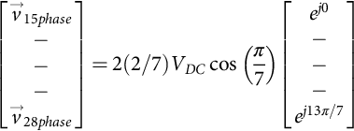 **(15.126)**

**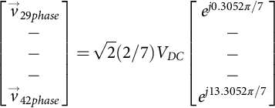** **(15.127)**

**** **(15.128)**

**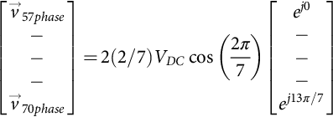** **(15.129)**

**** **(15.130)**

**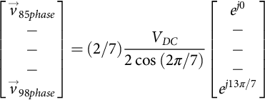** **(15.131)**

**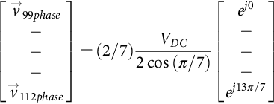** **(15.132)**

**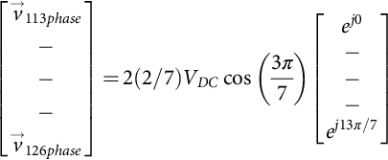** **(15.133)**

It can be seen that the total of 128 space vectors, available in the PWM operation, fall into 10 distinct categories regarding the magnitude of the available output phase voltages. The phase voltage space vectors are summarized in [Table 15.9](https://learning.oreilly.com/library/view/power-electronics-handbook/9780128114087/B9780128114070000167_2.xhtml#t0050) for all 128 switching states including 14-step operation.

**Table 15.9**

**Phase-to-neutral voltage space vectors for states 1–128**

|  |  |  |  |  |
| --- | --- | --- | --- | --- |
| **Space vectors** | **Set number in planes** | | | **Value of the space vectors in *d*-*q* plane** |
| ***d*-*q*** | ***x*1-*y*1** | ***x*2-*y*2** |
| *v*1*phase* to *v*14*phase* | 1 | 8 | 7 | si140_e |
| *v*15*phase* to *v*28*phase* | 2 | 5 | 9 | si141_e |
| *v*29*phase* to *v*42*phase* | 3 | 3 | 4 | si142_e |
| *v*43*phase* to *v*56*phase* | 4 | 4 | 3 | si143_e |
| *v*57*phase* to *v*70*phase* | 5 | 9 | 2 | si144_e |
| *v*71*phase* to *v*84*phase* | 6 | 6 | 6 | si145_e |
| *v*85*phase* to *v*98*phase* | 7 | 1 | 8 | si146_e |
| *v*99*phase* to *v*112*phase* | 8 | 7 | 1 | si147_e |
| *v*113*phase* to *v*126*phase* | 9 | 2 | 5 | si148_e |
| *v*127*phase* to *v*128*phase* | – | – | – | 0 |

#### **15.4.3.3 Model Transformation using Decoupling Matrix**

Since the system under discussion is a seven-phase one, the complete model can only be elaborated in seven-dimensional space. The first two-dimensional spaces are *d*-*q*, the second one is *x*1-*y*1, the third one is *x*2-*y*2, and the last is zero-sequence component that is absent due to the assumption of isolated neutral. On the basis of the general decoupling transformation matrix for an *n*-phase system, inverter voltage space vectors in the second two-dimensional subspace (*x*1-*y*1) and third two-dimensional subspace (*x*2-*y*2) are determined as

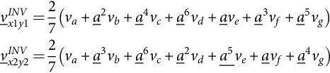 **(15.134)**

Thus, 128 space vectors of phase-to-neutral voltage in the *x*1-*y*1 and *x*2-*y*2 planes are obtained using Eq. [(15.134)](https://learning.oreilly.com/library/view/power-electronics-handbook/9780128114087/B9780128114070000167_2.xhtml#fo0715) and are illustrated in [Figs. 15.64](https://learning.oreilly.com/library/view/power-electronics-handbook/9780128114087/B9780128114070000167_3.xhtml#f0325) and [15.65](https://learning.oreilly.com/library/view/power-electronics-handbook/9780128114087/B9780128114070000167_3.xhtml#f0330). It can be seen from [Figs. 15.63](https://learning.oreilly.com/library/view/power-electronics-handbook/9780128114087/B9780128114070000167_2.xhtml#f0320)–[15.65](https://learning.oreilly.com/library/view/power-electronics-handbook/9780128114087/B9780128114070000167_3.xhtml#f0330) that the outermost, that is, first (black), second (pink), third (orange), fourth (green), fifth (turquoise), sixth (blue), seventh (gray 80%), eighth (violet), and ninth (red) tetradecagon space vectors of the *d*-*q* plane map into the eighth (violet), fifth (turquoise), fourth (green), third (orange), ninth (red), sixth (blue), first (black), seventh (gray 80%), and second (pink) of the tetradecagon (violet) of the *x*1-*y*1 plane, respectively, and seventh (gray 80%), ninth (red), fourth (green), third (orange), second (pink), sixth (blue), eighth (violet), first (black), and fifth (turquoise) of the tetradecagon (violet) of the *x*2-*y*2 plane, respectively. Further, it is observed from the above mapping that the phase sequence *a*,*b*,*c*,*d*,*e*,*f*,*g* of *d*-*q* plane corresponds to *a*,*c*,*e*,*g*,*b*,*d*,*f* of *x*1-*y*1 plane and *a*,*d*,*g*,*c*,*f*,*b*,*e* of *x*2-*y*2 plane, respectively. In the black and white version of [Figs. 15.63](https://learning.oreilly.com/library/view/power-electronics-handbook/9780128114087/B9780128114070000167_2.xhtml#f0320)–[15.65](https://learning.oreilly.com/library/view/power-electronics-handbook/9780128114087/B9780128114070000167_3.xhtml#f0330), they can be distinguished by the vector numbers of *d*-*q* plane mapped into *x*1-*y*1 and *x*2-*y*2 planes.

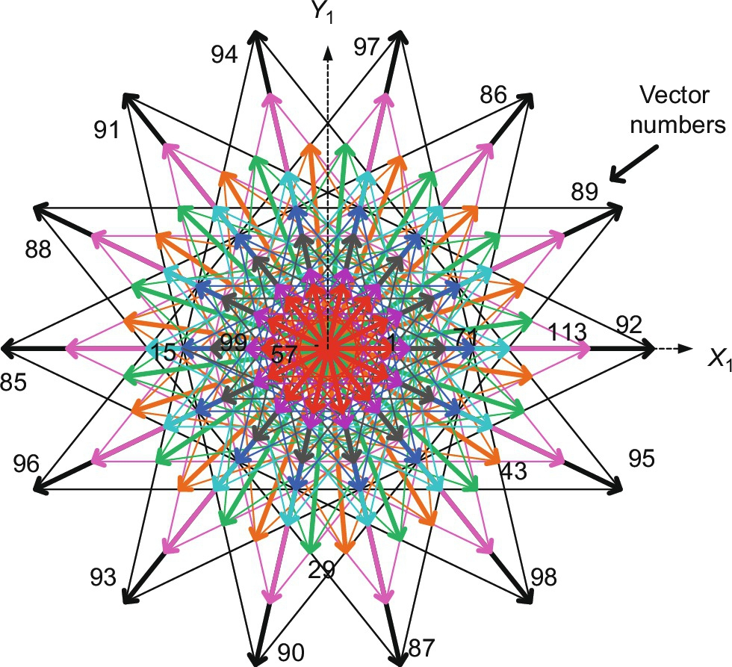

**FIG. 15.64** Phase-to-neutral voltage space vectors for states 1–128 (states 127–128 are at origin) in *x*1-*y*1 plane.

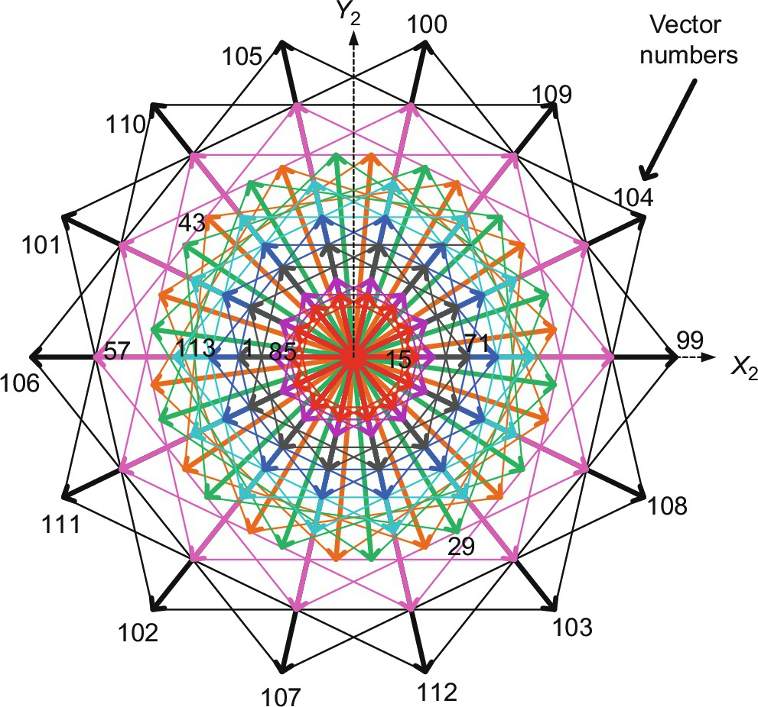

**FIG. 15.65** Phase-to-neutral voltage space vectors for states 1–128 (states 127–128 are at origin) in *x*2-*y*2 plane.

It is important to note at this stage that the harmonics of the order 14*k*±1, *k*=0, 1,2,3…, (1, 13, 15…) map into the *d*-*q* plane ([Fig. 15.63](https://learning.oreilly.com/library/view/power-electronics-handbook/9780128114087/B9780128114070000167_2.xhtml#f0320)), harmonics of the order 7*k*±2, *k*=1,3,5…, (5, 9, 19…) map into the *x*1-*y*1 plane ([Fig. 15.64](https://learning.oreilly.com/library/view/power-electronics-handbook/9780128114087/B9780128114070000167_3.xhtml#f0325)), and harmonics of the order 7*k*±4, *k*=1,3,5…, (3, 11, 17…) are encompassed by *x*2-*y*2 plane ([Fig. 15.65](https://learning.oreilly.com/library/view/power-electronics-handbook/9780128114087/B9780128114070000167_3.xhtml#f0330)) space vectors.

The second nonadjacent line voltages are elaborated next. The same procedure as that of 14-step mode is adopted to determine the line voltage space vectors for states 15–126 and are given by the expressions [(15.135)](https://learning.oreilly.com/library/view/power-electronics-handbook/9780128114087/B9780128114070000167_3.xhtml#fo0720)–[(15.142)](https://learning.oreilly.com/library/view/power-electronics-handbook/9780128114087/B9780128114070000167_3.xhtml#fo0755):

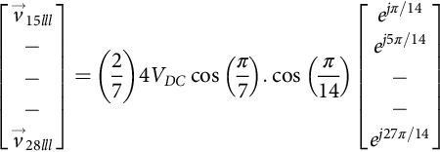 **(15.135)**

**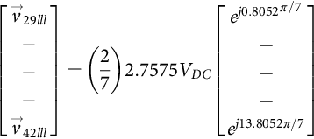** **(15.136)**

**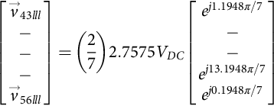** **(15.137)**

**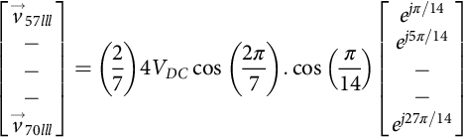** **(15.138)**

**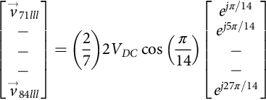** **(15.139)**

**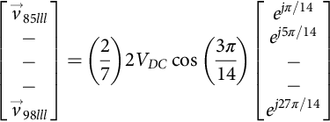** **(15.140)**

**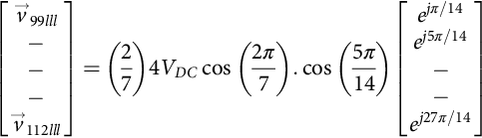** **(15.141)**

**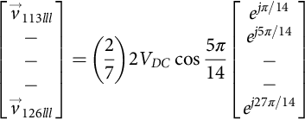** **(15.142)**

### 15.4.4 SPACE VECTOR PWM TECHNIQUES FOR A SEVEN-PHASE VOLTAGE SOURCE INVERTER

This section is devoted to the development of space-vector PWM for a seven-phase voltage-source inverter. The aim of this section is to describe a set of continuous SVPWM in linear modulation range. Four different schemes are defined with the aim to reduce or eliminate the low-order harmonics in the output phase voltages. The outer large length space vectors are used to implement the SVPWM method at first followed by using four and then six active space vectors. Two methods are devised with four active vectors, eliminating certain set of low-order harmonics in each method. The six active vector applications yield sinusoidal output voltages, and the other two methods produce low-order harmonics. The analysis is done in terms of quality of output voltages and the range of applicability of each space-vector PWM methods.

Simulation results are provided to support the analytic and theoretical findings. It is demonstrated in [Section 15.4.3](https://learning.oreilly.com/library/view/power-electronics-handbook/9780128114087/B9780128114070000167_2.xhtml#s0205) that there are a total of 14 distinct sectors with 25.714286 degrees (*π*/7 radians) spacing. The innermost space vectors in *d*-*q* plane are redundant and are therefore omitted from further discussion. This is in full compliance with observation where it is stated that only subset with maximum length vectors has to be used for any given combination of the switches that are “on” and “off” (3–4 and 4–3 in this case). The middle region space vectors correspond to two switches being “on” from upper (lower) set and five switches being “off” from lower (upper) set or vice versa and one switch being “on” from upper (lower) set and six switches being “off” from lower (upper) set or vice versa. It follows that, there are nine, 14sided regular polygons are formed by the vectors. The “*set number*” of vectors forming these polygons is already defined in [Table 15.9](https://learning.oreilly.com/library/view/power-electronics-handbook/9780128114087/B9780128114070000167_2.xhtml#t0050).

#### **15.4.4.1 Space Vector Pulse Width Modulation (SVPWM) With Sinusoidal Output**

This section develops SVPWM schemes for a seven-phase VSI. At first, the conventional method of using only set-1 vectors is taken up followed by set-1 plus set-2 and set-1 plus set-2 plus set-6 vectors (SVPWM with sinusoidal output) schemes.

The methods discussed in the preceding sections generate low-order harmonic since they utilize either two or four active vectors in one switching period. As emphasized in [[40](https://learning.oreilly.com/library/view/power-electronics-handbook/9780128114087/B9780128114070000167_4.xhtml#bb0205)], the number of applied active space vectors for multiphase VSI with an odd phase number should be equal to , *n* is the number of phases of inverter, for sinusoidal output. This means that one needs to apply six active vectors in each switching period, rather than two or four for obtaining sinusoidal output. Moreover, the dwell time of each vector should be chosen in such a way as to eliminate vectors of both *x*1-*y*1 and *x*2-*y*2 planes. Thus, six active vectors (in sector 1, active vectors no. 1, 2, 15, 16, 71, and 72 are used) and one zero vector are chosen to implement the SVPWM. The chosen vectors belong to the first, second, and sixth sets.

The switching pattern and the sequence of the space vectors for this scheme are illustrated in [Fig. 15.66](https://learning.oreilly.com/library/view/power-electronics-handbook/9780128114087/B9780128114070000167_3.xhtml#f0335). It is observed from the switching pattern of [Fig. 15.66](https://learning.oreilly.com/library/view/power-electronics-handbook/9780128114087/B9780128114070000167_3.xhtml#f0335) that the switching in all the phases is staggered, that is, all switches change state at different instants of time. The total number of switching in each switching period is still 28, thus preserving the requirement that each switch changes state only twice in a switching period. The selection of space vectors for other sectors is listed in [Table 15.10](https://learning.oreilly.com/library/view/power-electronics-handbook/9780128114087/B9780128114070000167_3.xhtml#t0055).

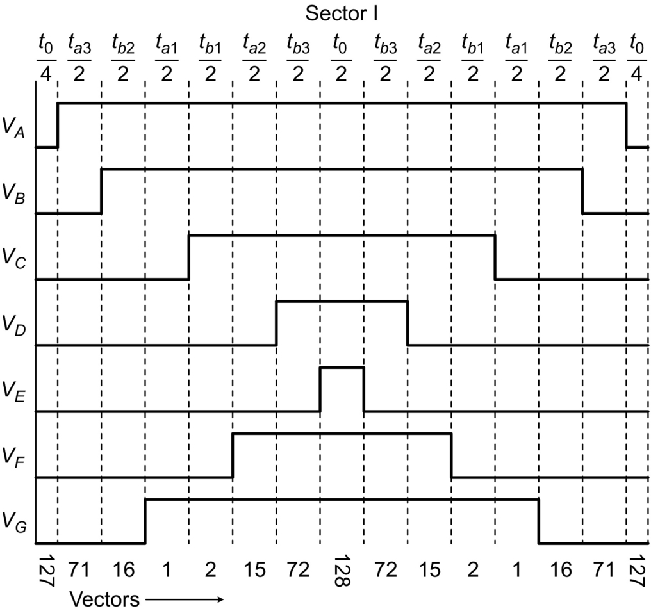

**FIG. 15.66** Switching pattern and space-vector disposition for one cycle of operation.

**Table 15.10**

**Sector-wise switching sequence when the first, second, and sixth set of vectors are applied**

|  |  |  |  |  |  |  |  |  |  |  |  |  |  |  |  |
| --- | --- | --- | --- | --- | --- | --- | --- | --- | --- | --- | --- | --- | --- | --- | --- |
| **Sector number** | **Sequence of vectors in operation** | | | | | | | | | | | | | | |
| I | 127 | 71 | 16 | 1 | 2 | 15 | 72 | 128 | 72 | 15 | 2 | 1 | 16 | 71 | 127 |
| II | 127 | 73 | 16 | 3 | 2 | 17 | 72 | 128 | 72 | 17 | 2 | 3 | 16 | 73 | 127 |
| III | 127 | 73 | 18 | 3 | 4 | 17 | 74 | 128 | 74 | 17 | 4 | 3 | 18 | 73 | 127 |
| IV | 127 | 75 | 18 | 5 | 4 | 19 | 74 | 128 | 74 | 19 | 4 | 5 | 18 | 75 | 127 |
| V | 127 | 75 | 20 | 5 | 6 | 19 | 76 | 128 | 76 | 19 | 6 | 5 | 20 | 75 | 127 |
| VI | 127 | 77 | 20 | 7 | 6 | 21 | 76 | 128 | 76 | 21 | 6 | 7 | 20 | 77 | 127 |
| VII | 127 | 77 | 22 | 7 | 8 | 21 | 78 | 128 | 78 | 21 | 8 | 7 | 22 | 77 | 127 |
| VIII | 127 | 79 | 22 | 9 | 8 | 23 | 78 | 128 | 78 | 23 | 8 | 9 | 22 | 79 | 127 |
| IX | 127 | 79 | 24 | 9 | 10 | 23 | 80 | 128 | 80 | 23 | 10 | 9 | 24 | 79 | 127 |
| X | 127 | 81 | 24 | 11 | 10 | 25 | 80 | 128 | 80 | 25 | 10 | 11 | 24 | 81 | 127 |
| XI | 127 | 81 | 26 | 11 | 12 | 25 | 82 | 128 | 82 | 25 | 12 | 11 | 26 | 81 | 127 |
| XII | 127 | 83 | 26 | 13 | 12 | 27 | 82 | 128 | 82 | 27 | 12 | 13 | 26 | 83 | 127 |
| XIII | 127 | 83 | 28 | 13 | 14 | 27 | 84 | 128 | 84 | 27 | 14 | 13 | 28 | 83 | 127 |
| XIV | 127 | 71 | 28 | 1 | 14 | 15 | 84 | 128 | 84 | 15 | 14 | 1 | 28 | 71 | 127 |

The vector disposition of sector I is shown in [Fig. 15.67](https://learning.oreilly.com/library/view/power-electronics-handbook/9780128114087/B9780128114070000167_3.xhtml#f0340) in all the three planes.

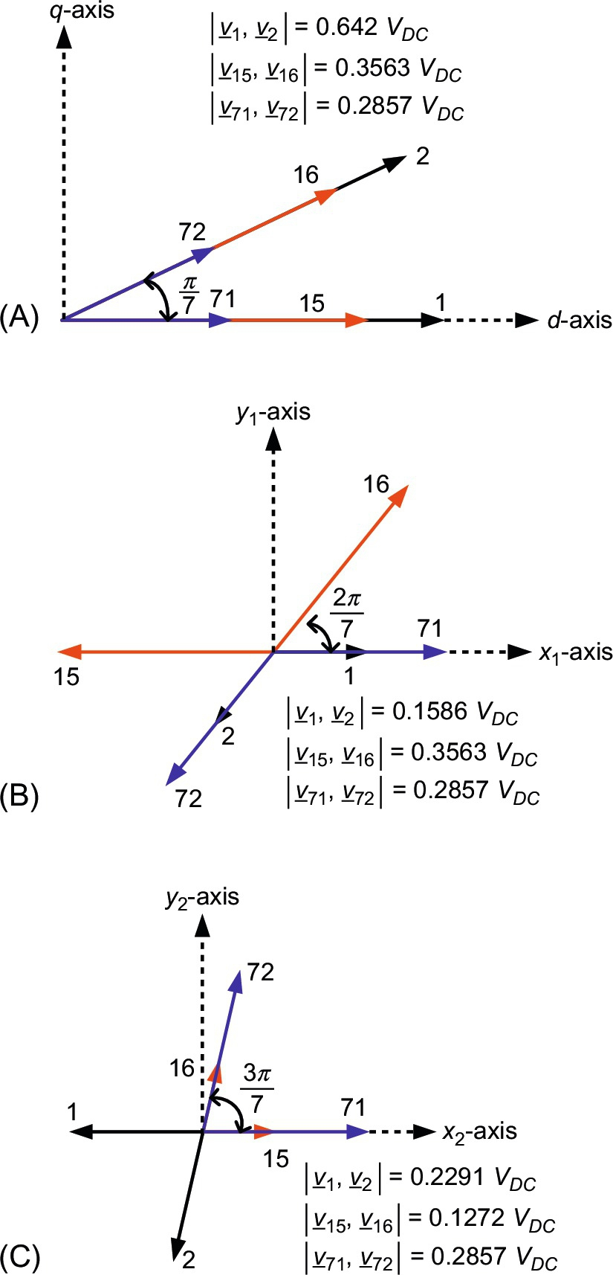

**FIG. 15.67** Space-vector disposition in sector I: (A) *d*-*q* plane, (B) *x*1-*y*1 plane, and (C) *x*2-*y*2 plane.

Using equal volt-second criterion, for sector I, the following is obtained:

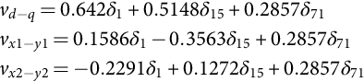 **(15.143)**

Or the above equations can be represented as

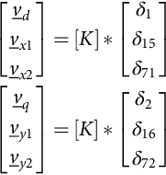

where

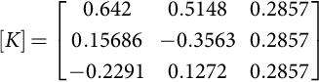

and *δ*1, *δ*15, *δ*71, *δ*2, *δ*16, and *δ*72 are duty cycles of vector numbers 1, 15, 71, 2, 16, and 72, respectively; their coefficiants are the respective magnitudes of the vectors and negative sign showing the opposite to normal direction.

Since [K] is nonsingular matrix, its inverse is existing (det[*K*]=−0.1634). Therefore, expressions for duty cycles can be written as

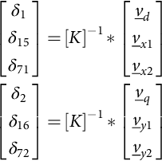 **(15.144)**

where 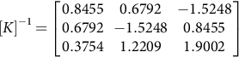

Solving for *δ*1, *δ*15, *δ*71, *δ*2, *δ*16, and *δ*72 by assuming  , from [(15.144)](https://learning.oreilly.com/library/view/power-electronics-handbook/9780128114087/B9780128114070000167_3.xhtml#fo0765), one gets

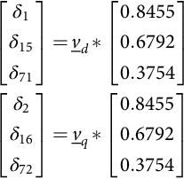 **(15.145)**

Expression for duty cycle of zero is given as

 **(15.146)**

Since , therefore,

 **(15.147)**

Subtituting the values of duty cycles from [(15.145)](https://learning.oreilly.com/library/view/power-electronics-handbook/9780128114087/B9780128114070000167_3.xhtml#fo0780) in [(15.147)](https://learning.oreilly.com/library/view/power-electronics-handbook/9780128114087/B9780128114070000167_3.xhtml#fo0790), one gets



Hence,

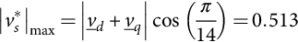 **(15.148)**

where *δ*1, *δ*15, and *δ*71 are duty cycles and suffixes denote the vector numbers; their coefficiants are their respective magnitudes and negative sign showing their directions that are opposite to normal direction. Solving Eq. [(15.143)](https://learning.oreilly.com/library/view/power-electronics-handbook/9780128114087/B9780128114070000167_3.xhtml#fo0765) for *δ*1, *δ*15, and *δ*71 by assuming  (maxium achievable output voltage) and  and  equal to zero, one gets , , and . Same dutycycles can be applied for vector numbers 2, 16, and 72, respectively.

The time of application of zero space vectors is now given as  where *ta*1, *ta*2, and *ta*3 are timings of vector number 1, 15, and 71, respectively, and *tb*1, *tb*2, and *tb*3 are timings of vector number 2, 16, and 72, respectively.

Once again, the same procedure as that of previous section can be adopted to determine the range of applicibility of proposed method. It is seen that the maximum available output voltage with this SVPWM method is 0.513*Vdc* . The simulation is done to obtain the maximum acheivable output value (0.513 p.u. peak), with the commanded input equal to 0.6259 p.u., thus ensuring the equality of the fundamental output magnitude and the reference magnitude. The other simulation conditions are identical to those in application of large medium vectors. The filtered phase voltages are shown in [Fig. 15.68](https://learning.oreilly.com/library/view/power-electronics-handbook/9780128114087/B9780128114070000167_3.xhtml#f0345) along with the harmonic spectrum for maximum achievable fundamental voltage shown in [Fig. 15.69](https://learning.oreilly.com/library/view/power-electronics-handbook/9780128114087/B9780128114070000167_3.xhtml#f0350).

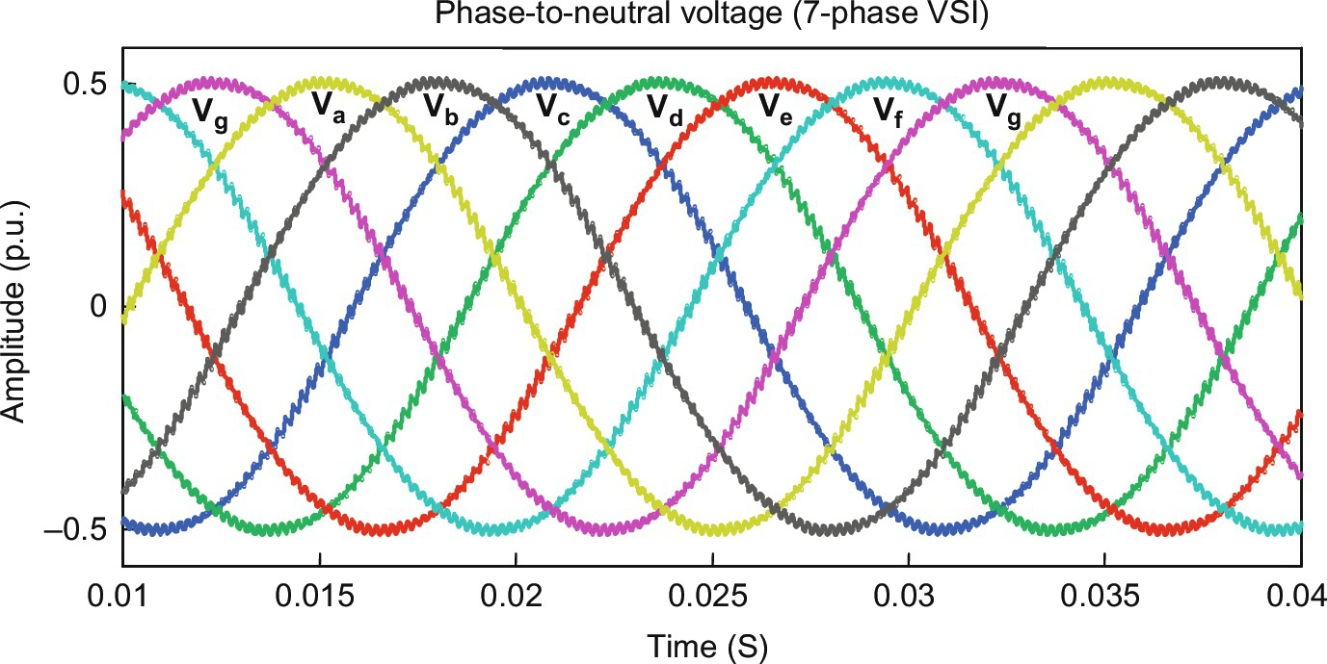

**FIG. 15.68** Output filtered phase voltage of VSI for the maximum achievable output fundamental voltage (82.14% of the one obtainable with set-1 vectors only).

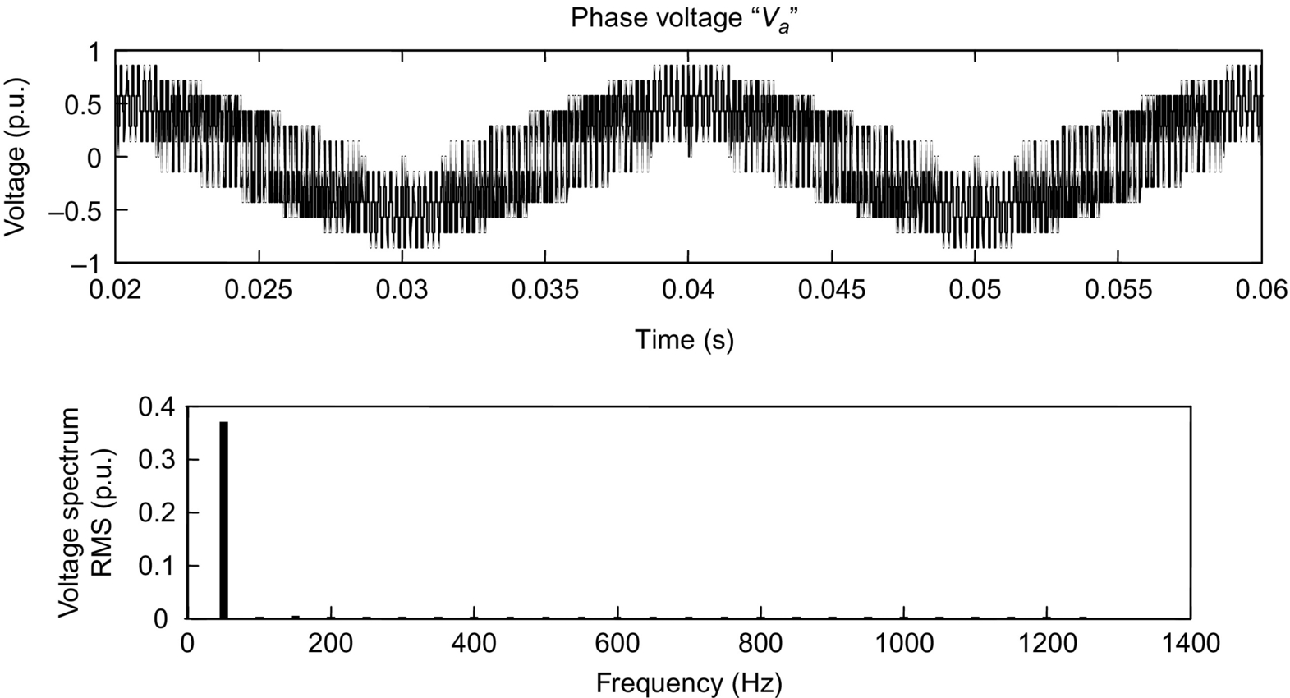

**FIG. 15.69** Time-domain and frequency-domain phase “a” voltage waveform for maximum output 0.513 p.u.

It is seen from [Fig. 15.69](https://learning.oreilly.com/library/view/power-electronics-handbook/9780128114087/B9780128114070000167_3.xhtml#f0350) that the spectrum contains fundamental (0.363551 p.u. rms or 0.514 p.u. peak, 50 Hz) component and harmonic only at multiple of switching frequency and low-order harmonics are completely eliminated. The ouptut is sinusoidal because of the fact that the proportion of time of application of the chosen space vectors is such that it cancels all the undesirable *x*1-*y*1 and *x*2-*y*2 components (as can be seen from [Fig. 15.67](https://learning.oreilly.com/library/view/power-electronics-handbook/9780128114087/B9780128114070000167_3.xhtml#f0340)). It is to be noted here that for lower values of the input reference phase voltage, the output phase voltages preserve the shape, while there will be a correponding reduction in amplitude.

#### **15.4.4.2 Summary**

[Section 15.4.1](https://learning.oreilly.com/library/view/power-electronics-handbook/9780128114087/B9780128114070000167_1.xhtml#s0100) develops a space-vector model of a five-phase voltage-source inverter, and it is shown that two sets of space vectors exist, namely, *d*-*q* and *x*-*y*. The second set of space vectors termed here as *x*-*y* space is essentially third harmonic of the space vector in *d*-*q* plane. Altogether, there exist 32 space vectors out of which 30 are active and 2 are zero vectors. Complete mapping of the space vectors are provided in [Section 15.4.1](https://learning.oreilly.com/library/view/power-electronics-handbook/9780128114087/B9780128114070000167_1.xhtml#s0100). Step operation of the inverter is elaborated in terms of different conduction mode, that is, 180 degrees is taken up as conduction angle. Fourier analysis is presented in terms of analytic expressions, and simulation results are provided to support the analytic expressions.

Carrier-based PWM and space-vector PWM schemes for a five-phase VSI are analyzed and compared using analytic, simulation and experimental approach. Relationship between modulation signal (fundamental and zero-sequence signal) and space vector is established, which indicates a transformation between arbitrary carrier-based PWM and space-vector modulation. A direct relationship is formulated between line-to-line voltage and space vector. It is found that the line-to-line voltage is determined by only active vectors and is independent of zero vectors. Relationship between modulation signals and space-vector sectors is identified. Analytic expressions of distribution of zero-vector application times for sinusoidal, fifth-harmonic injection, and triangular zero-sequence injection are determined. Equivalence between switching pattern of space-vector PWM and carrier type is highlighted. Performance of modulator in terms of THD of output phase voltages is determined for triangular and saw-tooth carrier signals, and the poor performance of saw-tooth carrier is indicated.

Four different space-vector PWM schemes for a seven-phase voltage-source inverter are described. At first, the conventional technique of using the largest set of space vectors is extended to a seven-phase inverter. This technique provides maximum DC bus utilization (0.6259), but the output phase voltages are distorted with significant amount of low-order harmonics especially third and fifth. These harmonics are due to free flow of *x*1-*y*1 and *x*2-*y*2 plane vectors. The second proposed method cancels the *x*1-*y*1 plane space vectors, and thus, the low-order harmonic more than three is eliminated in the output phase voltage waveform. Third method is investigated that eliminates vectors of *x*2-*y*2 plane. The modulation index is the same for the second and third methods with the elimination of different set of harmonics. The DC bus utilization is intermediate. The last method cancels all the space vectors *x*1-*y*1 and *x*2-*y*2 planes, thus providing a sinusoidal output voltage with least DC bus utilization. The experimental setup and the results are also provided.

## 15.5 Multiphase AC-AC Converter

### **15.5.1 INTRODUCTION**

AC-AC converter refers to a topology of converters in which the amplitude, frequency, and phase of the AC supply can be altered according to the requirement of the load without employing reactive DC link in between. As discussed in [Chapter 14](https://learning.oreilly.com/library/view/power-electronics-handbook/9780128114087/B9780128114070000143_1.xhtml), polyphase AC-AC converters can be classified as naturally commutated cycloconverters (NCC) and forced commutated cycloconverters (FCC). FCCs when implemented for low- and medium-power drives by employing high switching semiconductor bidirectional switches result in what is commonly known as *matrix converter* (MC). This section deals with the multiphase matrix converters (with phase numbers more than three) and the theory that pertains to it. It is observed that as number of phases increase, the number of vectors to be dealt with in space-vector modulation-based techniques is quite large. For an *m*×*n* MC, the *useful* number of states is *mn* [[4](https://learning.oreilly.com/library/view/power-electronics-handbook/9780128114087/B9780128114070000167_4.xhtml#bb0025)]. Thus, for a 3×7 MC, 2187 vectors are to be handled. Other way is to resort to classical methods in which output target voltages are defined and friendly harmonics are added to the target phase voltages such that the sinusoidal nature of line voltages are not altered. These target voltages are then fabricated from the input side voltages such that the average in one time sample follows the target voltage sample.

Multiphase matrix converters (MPMC) ([Fig. 15.70](https://learning.oreilly.com/library/view/power-electronics-handbook/9780128114087/B9780128114070000167_3.xhtml#f0355)) can be broadly classified into direct multiphase matrix converters (DMMC) and indirect multiphase matrix converters (IMMC). Although the maximum output voltage achievable is the same for both, the advantage with the indirect multiphase matrix converters is that the established modulation strategies employed for controlled rectifiers and inverters are readily applicable. In this section, the target is to present the theory on DMMC. The bidirectional switches that are employed for the multiphase matrix converters are the same as employed for conventional 3×3 matrix converter. Although the work on MPMCs is still in research domain and a statement of encouragement can be given to young researchers, possible applications of MPMCs can be wind energy systems (WES) employing multiphase generator sets, or multiphase motors can be interfaced with the existing three-phase grid using MPMCs.

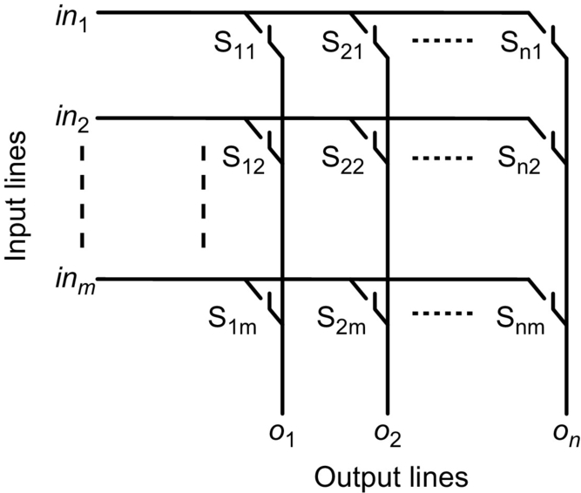

**FIG. 15.70** DMMC with *m* input lines and *n* input lines.

### 15.5.2 BRIEF REVIEW

A time line of research in the field of MPMC is shown in [Fig. 15.71](https://learning.oreilly.com/library/view/power-electronics-handbook/9780128114087/B9780128114070000167_3.xhtml#f0360). The first theory addressing MPMC for odd number of input and output phases was given way back in 1989 [[42](https://learning.oreilly.com/library/view/power-electronics-handbook/9780128114087/B9780128114070000167_4.xhtml#bb0215)]. The theory was recently extended to all configurations in [[12](https://learning.oreilly.com/library/view/power-electronics-handbook/9780128114087/B9780128114070000167_4.xhtml#bb0065)]. This paper also extends the Venturini method to 3×*n* case, where *n* can be even or odd. Further, it also presents a simplified modulation strategy for MPMC for any number of phases. The first work on the modulation strategy of MPMC was reported in [[18](https://learning.oreilly.com/library/view/power-electronics-handbook/9780128114087/B9780128114070000167_4.xhtml#bb0095)]. In this work, the authors use a continuous carrier and the predetermined duty ratio signals to directly generate the gating signals. This explains the origin of the name, that is, the “direct-duty-ratio-based PWM.” A duty ratio is calculated for each switch, and since this applies to each output phase independently, it can be used to supply multiphase loads. The input number of phases is restricted to three since the modulation requires identification of the values of the input voltages as the maximum, medium, and minimum. Another approach applied on 3×9 MC is shown by the same authors in [[16](https://learning.oreilly.com/library/view/power-electronics-handbook/9780128114087/B9780128114070000167_4.xhtml#bb0085)], named as carrier-based PWM scheme. Venturini method is also explored for 3×5 MC in [[11](https://learning.oreilly.com/library/view/power-electronics-handbook/9780128114087/B9780128114070000167_4.xhtml#bb0060),[43](https://learning.oreilly.com/library/view/power-electronics-handbook/9780128114087/B9780128114070000167_4.xhtml#bb0220)]. Space-vector approach is the most explored approach and is discussed for various configurations in [[17](https://learning.oreilly.com/library/view/power-electronics-handbook/9780128114087/B9780128114070000167_4.xhtml#bb0090),[44](https://learning.oreilly.com/library/view/power-electronics-handbook/9780128114087/B9780128114070000167_4.xhtml#bb0225)–[47](https://learning.oreilly.com/library/view/power-electronics-handbook/9780128114087/B9780128114070000167_4.xhtml#bb0240)]. Multiphase open-end loads can also be supplied through dual MPMCs and are practically assessed in [[48](https://learning.oreilly.com/library/view/power-electronics-handbook/9780128114087/B9780128114070000167_4.xhtml#bb0245),[49](https://learning.oreilly.com/library/view/power-electronics-handbook/9780128114087/B9780128114070000167_4.xhtml#bb0250)]. A 3×5 MC is discussed in [[50](https://learning.oreilly.com/library/view/power-electronics-handbook/9780128114087/B9780128114070000167_4.xhtml#bb0255)], in which a least number of commutations are employed in one time sample. This leads to the reduction in common-mode voltage. IMMC has recently received commendable attention in [[51](https://learning.oreilly.com/library/view/power-electronics-handbook/9780128114087/B9780128114070000167_4.xhtml#bb0260),[52](https://learning.oreilly.com/library/view/power-electronics-handbook/9780128114087/B9780128114070000167_4.xhtml#bb0265)]. The former paper gives carrier-based approach for a 3×5 MC that can also be realized employing space-vector approach. The later one discussed space-vector-based approach for a 3×5 MC in the overmodulation range and achieves a VTR of 0.923, which otherwise is 0.7886.

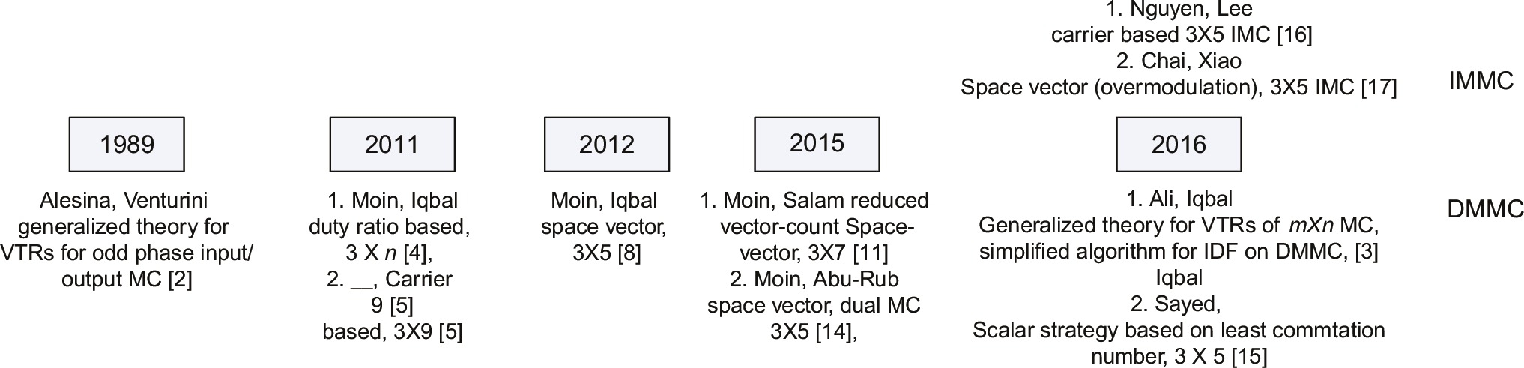

**FIG. 15.71** Year-wise development of MPMC.

### 15.5.3 DEFINING THE VOLTAGE TRANSFER RATIO

All modulation strategies whether scalar or space-vector-based require the understanding of maximum achievable output voltage, that is, the maximum voltage transfer ratio (VTRmax) and its implementation. In scalar methods, the output reference voltages are maneuvered by the addition of friendly harmonics in order to achieve VTRmax. For this, a detailed understanding of how to manipulate the sinusoids is required. Thus, in this section, the theory of VTRmax that is achievable in an MPMC is discussed, and expressions for all the possible cases are derived. The approach will be general for any number of input and output phases until and unless specified. Illustrations are mainly done for 3×5 MC.

#### **15.5.3.1 The Unutilized Region**

Consider initially, an *m*×1 converter. The *m*-phase input voltage set is defined as

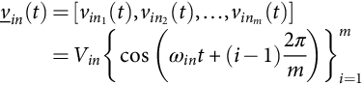 **(15.149)**

Let the duty cycles for which the output is connected to the inputs through switches *S*1, *S*2,…,*Sm* be

 **(15.150)**

The actual output voltage (w.r.t. input neutral) is obtained as

 **(15.151)**

The duty cycle of each switch is such calculated that in one time sample, the average of the actual output voltages follows the reference voltage. Thus, for all arbitrary output frequencies, the VTR for a three-input system can have a maximum reach up to 0.5. Generalizing this for multiple input phases, the VTRmax is given as

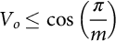 **(15.152)**

This leaves a region of 1−cos (*π*/*m*) unutilized. This region decreases with the increase in the number of input lines. The utilized and unutilized regions are shown for three-phase input case in [Fig. 15.72](https://learning.oreilly.com/library/view/power-electronics-handbook/9780128114087/B9780128114070000167_3.xhtml#f0365).

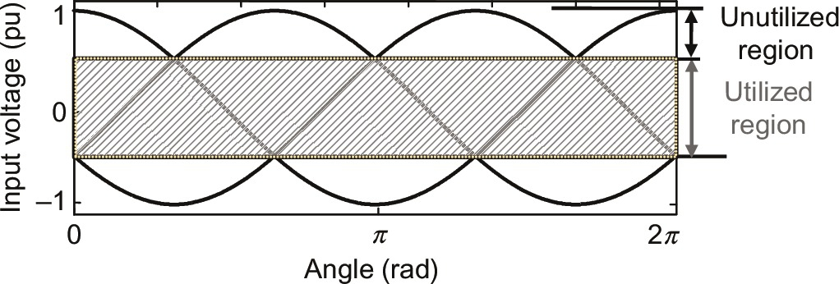

**FIG. 15.72** Region (shaded) in three-phase input MC where output-voltage references are defined.

For five-phase input set, according to [(15.151)](https://learning.oreilly.com/library/view/power-electronics-handbook/9780128114087/B9780128114070000167_3.xhtml#fo0820), approximately 19.1% of the input voltage space still remains unutilized. Now, consider an MPMC whose *n* output reference voltage set with respect to input neutral is expressed as

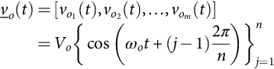 **(15.153)**

where *Vo* is limited by [(15.152)](https://learning.oreilly.com/library/view/power-electronics-handbook/9780128114087/B9780128114070000167_3.xhtml#fo0825). A periodic function is such added to [(15.152)](https://learning.oreilly.com/library/view/power-electronics-handbook/9780128114087/B9780128114070000167_3.xhtml#fo0825) that the amplitude of the output reference phase voltages and thus the line voltages increases, line voltages retain their sinusoidal nature, and the phase difference between voltages do not change. Let this function be *fh* (*t*). As this function is common to all the reference output voltages given in (15.5.5), the new output-voltage vector is expressed as

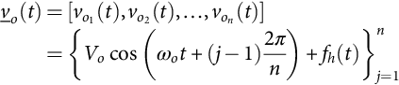 **(15.154)**

##### **Maximum utilizable region**

After acknowledging the fact that there is space in which the output phase voltages can expand, it is desirable to know maximum output-voltage level attainable. Before addressing the issue, terms pertaining to the discussion ahead are described. These terms are exhibited in [Fig. 15.73](https://learning.oreilly.com/library/view/power-electronics-handbook/9780128114087/B9780128114070000167_3.xhtml#f0370) as upper and lower bounds of input voltage set and upper and lower bounds of output-voltage set (*viu*, *vil*, *vou*, and *vol*, respectively). It is seen in [Fig. 15.73](https://learning.oreilly.com/library/view/power-electronics-handbook/9780128114087/B9780128114070000167_3.xhtml#f0370) that at every instant of time

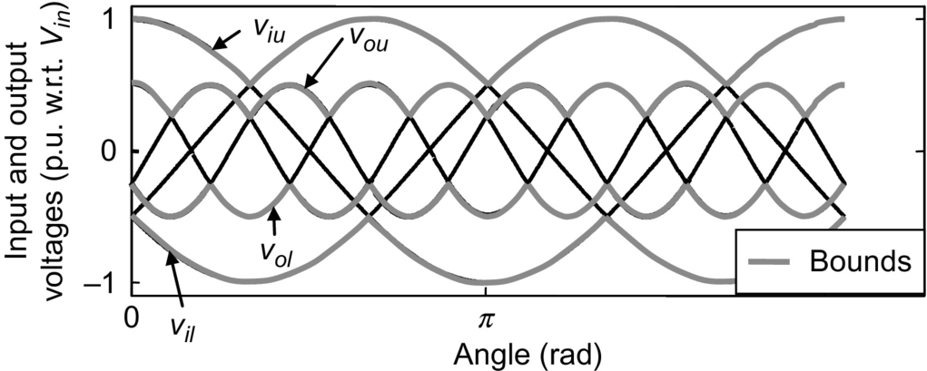

**FIG. 15.73** Bounds of input and output voltages (*fo*=3*fin*).

 **(15.155)**

Thus, the input voltage set creates an envelope in which the output target voltage has to remain. Also, as *fh* (*t*) is a common term, the difference between *vou*(*t*) and *vol*(*t*) does not contain *fh*(*t*). The maximum output voltage is attained when the minima of input voltage range coincide with the maxima of output-voltage range. If the maxima of the output-voltage range are more than the minima of the input voltage range, the condition of over modulation occurs. This condition is mathematically expressed as

 **(15.156)**

Next step is to find out how the waves are optimized. The conditions differ for odd and even number of phases. The analysis of both waves is shown one by one subsequently. The analysis given below is done on a set of phases, *ignoring the input*/*output terminology*.

The region of 0 to 2*π* for *x* odd phases is divided into 2*x* sectors. Six sectors of three-phase set are shown in [Fig. 15.74](https://learning.oreilly.com/library/view/power-electronics-handbook/9780128114087/B9780128114070000167_3.xhtml#f0375). The difference of the upper limit and lower limit generates the same wave in each sector exhibited by *vu*(*t*)−*vl*(*t*) with the same min{ *vu*(*t*)−*vl*(*t*)} and max{ *vu*(*t*)−*vl*(*t*)} values. According to the sequence of phases in [(15.153)](https://learning.oreilly.com/library/view/power-electronics-handbook/9780128114087/B9780128114070000167_3.xhtml#fo0830), the voltage that defines *vu*(*t*) is the first phase and *vl*(*t*) is defined by the 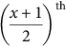 phase:

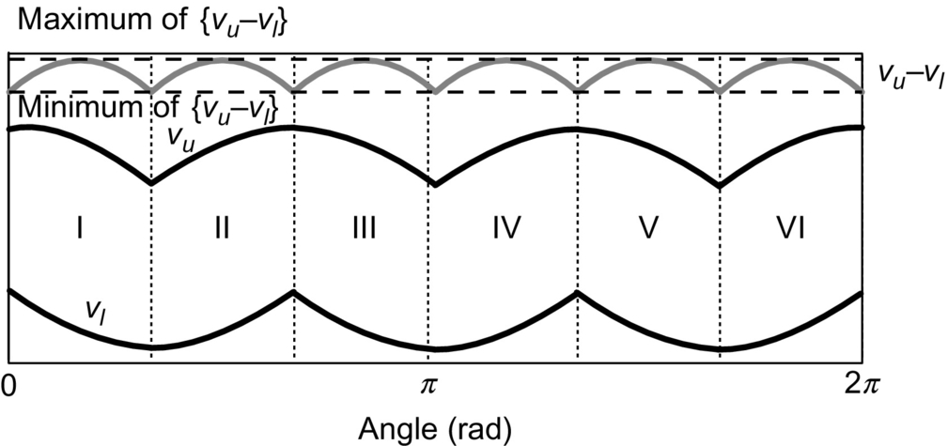

**FIG. 15.74** Sectors for odd number of phases (three-phase set).

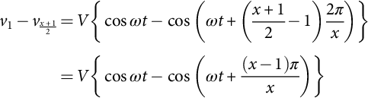 **(15.157)**

Now, the minimum value occurs at *ωt*=0; thus,

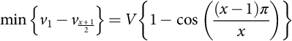 **(15.158)**

And as *x* is odd, *x*−1 is even, thus, 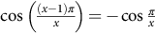, and so,

 **(15.159)**

Now, the max{*vu*(*t*)−*vl*(*t*)} occurs at *π*/2*x*. Thus,

 **(15.160)**

Now, particularization of [(15.158)](https://learning.oreilly.com/library/view/power-electronics-handbook/9780128114087/B9780128114070000167_3.xhtml#fo0855) and [(15.159)](https://learning.oreilly.com/library/view/power-electronics-handbook/9780128114087/B9780128114070000167_3.xhtml#fo0860) in terms of *m* inputs and *n* outputs and substitution in [(15.155)](https://learning.oreilly.com/library/view/power-electronics-handbook/9780128114087/B9780128114070000167_3.xhtml#fo0840) results in VTRmax as

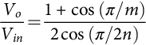 **(15.161)**

Now, if the analysis is done for even-phase set in similar fashion as above, *x*-phase set is furcated into *x* sectors, and this is exhibited for six-phase set in [Fig. 15.75](https://learning.oreilly.com/library/view/power-electronics-handbook/9780128114087/B9780128114070000167_3.xhtml#f0380). In the first sector, *vu*(*t*) is defined by the first phase, and *vl*(*t*) is defined by . This leads to

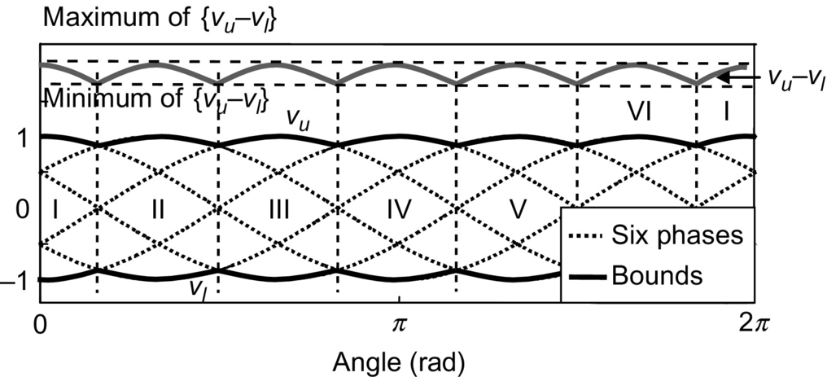

**FIG. 15.75** Sectors for even number of phases (six-phase set).

 **(15.162)**

The max{*vu*(*t*)−*vl*(*t*)} in this case in the first sector occurs at *ωt*=2*π*/*x* and the min{*vu*(*t*)−*vl*(*t*)} is at *ωt*=*π*/*x*. Thus,

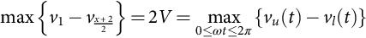 **(15.163)**

and

 **(15.164)**

Thus, if the analysis is extended to MC having both even input and output sets, then substituting [(15.162)](https://learning.oreilly.com/library/view/power-electronics-handbook/9780128114087/B9780128114070000167_3.xhtml#fo0875) and [(15.163)](https://learning.oreilly.com/library/view/power-electronics-handbook/9780128114087/B9780128114070000167_3.xhtml#fo0880) in [(15.155)](https://learning.oreilly.com/library/view/power-electronics-handbook/9780128114087/B9780128114070000167_3.xhtml#fo0840) will result in

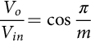 **(15.165)**

MC having odd input phase set and even output phase set, substituting [(15.158)](https://learning.oreilly.com/library/view/power-electronics-handbook/9780128114087/B9780128114070000167_3.xhtml#fo0855) and [(15.162)](https://learning.oreilly.com/library/view/power-electronics-handbook/9780128114087/B9780128114070000167_3.xhtml#fo0875) in [(15.155)](https://learning.oreilly.com/library/view/power-electronics-handbook/9780128114087/B9780128114070000167_3.xhtml#fo0840) results in

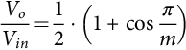 **(15.166)**

For a 3×6 converter, *Vo*=0.75*Vin*.

Lastly, if MC has even input phase set and odd output phase set, then employing [(15.159)](https://learning.oreilly.com/library/view/power-electronics-handbook/9780128114087/B9780128114070000167_3.xhtml#fo0860) and [(15.163)](https://learning.oreilly.com/library/view/power-electronics-handbook/9780128114087/B9780128114070000167_3.xhtml#fo0880) in [(15.155)](https://learning.oreilly.com/library/view/power-electronics-handbook/9780128114087/B9780128114070000167_3.xhtml#fo0840), VTRmax is expressed as

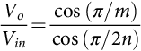 **(15.167)**

For a 6×3 converter *Vo*=*Vin*. Hence, unity VTR is achievable in a six-phase input and three-phase output MC. The VTRmax for various configurations of MCs are shown in [Table 15.11](https://learning.oreilly.com/library/view/power-electronics-handbook/9780128114087/B9780128114070000167_3.xhtml#t0060).

**Table 15.11**

**Maximum voltage transfer ratios for various configurations of MPMC**

|  |  |  |  |  |  |  |  |
| --- | --- | --- | --- | --- | --- | --- | --- |
| **Outputs→** | **3** | **4** | **5** | **6** | **7** | **8** | **9** |
| Inputs↓ |  |  |  |  |  |  |  |
| 3 | 0.866 | 0.750 | 0.788 | 0.750 | 0.769 | 0.750 | 0.762 |
| 4 | 0.816 | 0.707 | 0.743 | 0.707 | 0.750 | 0.707 | 0.718 |
| 5 | 1.044 | 0.904 | 0.951 | 0.905 | 0.928 | 0.904 | 0.918 |
| 6 | 1.000 | 0.866 | 0.911 | 0.866 | 0.888 | 0.866 | 0.879 |
| 7 | 1.098 | 0.950 | 0.999 | 0.950 | 0.975 | 0.950 | 0.965 |
| 8 | 1.067 | 0.924 | 0.971 | 0.924 | 0.948 | 0.924 | 0.938 |
| 9 | 1.120 | 0.970 | 1.020 | 0.970 | 0.995 | 0.970 | 0.985 |

#### **15.5.3.2 Target Output Voltages**

After analyzing the maximum output voltage achievable, it is necessary for one to derive the derivation of the expression for *fh* (*t*) described in [(15.153)](https://learning.oreilly.com/library/view/power-electronics-handbook/9780128114087/B9780128114070000167_3.xhtml#fo0830). This function depends on input and output frequencies. Analyzing [Fig. 15.75](https://learning.oreilly.com/library/view/power-electronics-handbook/9780128114087/B9780128114070000167_3.xhtml#f0380), it is easy to realize that *odd phase can only be manipulated*. This is because the occurrence of the min{*vul*} and the max{*vul*} is at different time instances. This aspect is beneficial in defining a periodic function such that the min{*vul*} is pulled up and the max{*vul*} is pulled down, as exhibited for three-phase set in [Fig. 15.76](https://learning.oreilly.com/library/view/power-electronics-handbook/9780128114087/B9780128114070000167_3.xhtml#f0385). On the contrary, the even-phase set is unalterable as the occurrence of the above stated condition occurs at the same time instant and, thus, cannot be pulled up or down employing a periodic function and hence extra region cannot be generated. Considering these facts, first of all, synthesis is done for *fh* (*t*) for the case when both input and output phase set is odd and for illustration 3×5 MC is considered. As both the voltage sets are to be optimized, the harmonic voltage, *fh*(*t*), contains a term that depends on input frequency and the other that depends on output frequency. Hence, *fh*(*t*) is written as , where  and  are optimizing functions for input and output voltages, respectively.

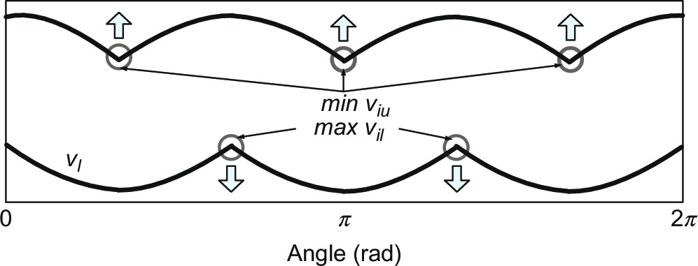

**FIG. 15.76** Illustration of min{*viu*} and max{*viu*}for odd number of phases (three-phase set).

#### **15.5.3.3 Input Voltage Optimization**

As stated, min{*viu*} and max{*vil*} are at different time instances, as shown for the three-phase set in [Fig. 15.76](https://learning.oreilly.com/library/view/power-electronics-handbook/9780128114087/B9780128114070000167_3.xhtml#f0385). Therefore, the difference between upper and lower limit is not symmetrical, and thus, optimization is needed so that symmetrical output waveforms are developed. Clamping up of max{*vil*} and clamping down of max{*vil*} are done and are exhibited in [Fig. 15.77](https://learning.oreilly.com/library/view/power-electronics-handbook/9780128114087/B9780128114070000167_3.xhtml#f0390). This is done by superimposing a periodic function whose frequency is *m* times the input frequency. Now, the amplitude of this harmonic is equal to the offset by which the *points* (*encircled in* [Fig. 15.76](https://learning.oreilly.com/library/view/power-electronics-handbook/9780128114087/B9780128114070000167_3.xhtml#f0385)) *are displaced*. Offset for three-phase set is 0.25 p.u., as it is the maximum to which the input voltage *points* must displace. For *m* input phases, the offset is

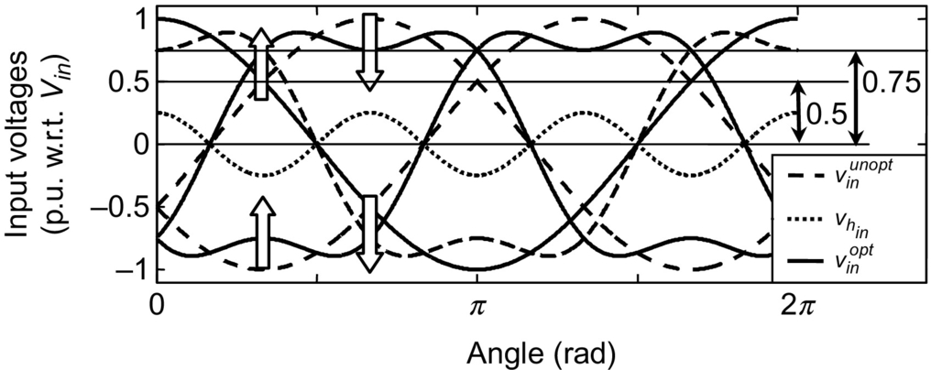

**FIG. 15.77** Optimization of three-phase input voltage set.

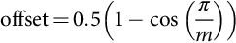 **(15.168)**

This leads to the following expression for :

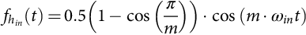 **(15.169)**

For three-phase input, . When this function is added to the input voltages, changes occur as illustrated in [Fig. 15.77](https://learning.oreilly.com/library/view/power-electronics-handbook/9780128114087/B9780128114070000167_3.xhtml#f0390).

It is seen that after *subtracting*  from the input voltages, the output voltage with 0.75*Vin* is accommodated instead of 0.5*Vin*. For *m*-phase input set, the condition of the peak is derived as

 **(15.170)**

As the input-voltage set is unalterable, the modification is done to output-voltage set by the *addition* of  to the reference output-voltage equations of [(15.152)](https://learning.oreilly.com/library/view/power-electronics-handbook/9780128114087/B9780128114070000167_3.xhtml#fo0825). So, new odd output reference voltage set, with the consideration of odd input phase set is given as

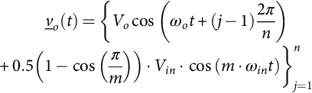 **(15.171)**

where, *Vo* is given by [(15.169)](https://learning.oreilly.com/library/view/power-electronics-handbook/9780128114087/B9780128114070000167_3.xhtml#fo0910). For 3×7 MC, [(15.170)](https://learning.oreilly.com/library/view/power-electronics-handbook/9780128114087/B9780128114070000167_3.xhtml#fo0915) is written as

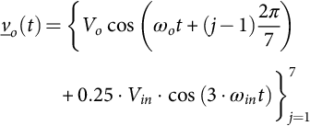

and *Vo*=0.75 *Vin*. Phase-1 voltage (*vo*1) of the above equation is illustrated in [Fig. 15.78A](https://learning.oreilly.com/library/view/power-electronics-handbook/9780128114087/B9780128114070000167_3.xhtml#f0395). It is found that *vo*1 is going beyond input voltage envelope. Thus, further optimization is needed in this case that is achieved by defining .

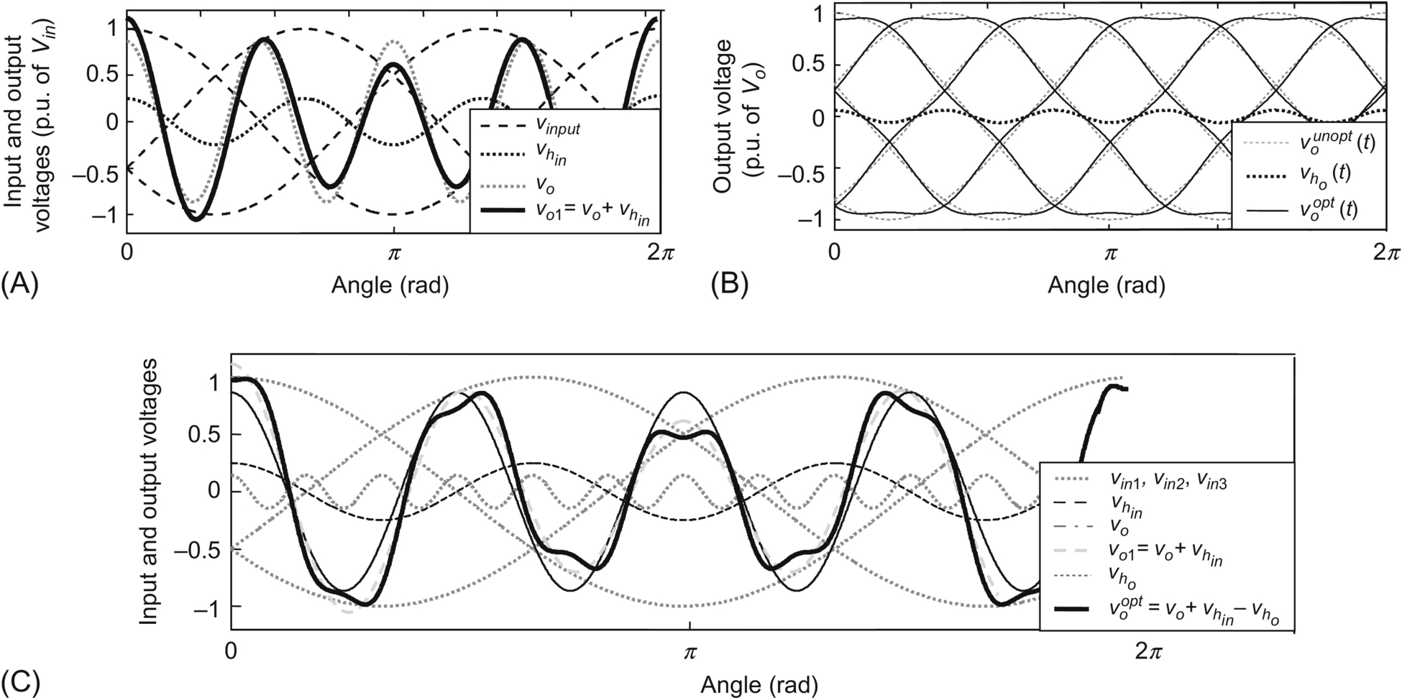

**FIG. 15.78** (A) Optimization of input voltages extended to *vo*1 of five-phase set (*fo*=4*fin*), (B) optimization of output voltages (five-phase set) at 50 Hz, and (C) final optimized phase voltage (*v*o1) of a five-phase set, *fo*=4*fin*.

##### **Output voltage optimization**

A periodic function is such defined that min{*vou*} is lifted upward and max {*vol*} is dragged downward. Obviously, the frequency of this function is *n* times the output frequency, where *fo* is the frequency of the reference output-voltage set. For five-phase output set, this must be 5*fo*. Let this function be defined as

 **(15.172)**

In order to calculate the amplitude of the function, consider the output voltage (*vo*1) with the addition of [(15.171)](https://learning.oreilly.com/library/view/power-electronics-handbook/9780128114087/B9780128114070000167_3.xhtml#fo0920) that is written as

 **(15.173)**

The value of the offset *a* is chosen such that a minimum value of max{*u*(*ωot*)} is achieved. Also, the coefficient *a* is negative to clamp down max{*vou*}. To find the magnitude of *a*, a condition that max{*u*(*ωot*)} is located where cos(*nωot*)=0 is imposed. This is done as follows:

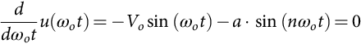 **(15.174)**

Now, taking cos (*nωot*)=0, *ωot*=*π*/2*n*, it is found that

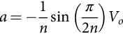 **(15.175)**

For five-phase output, *a*=−0.0618*Vo*. Substituting this value in [(15.171)](https://learning.oreilly.com/library/view/power-electronics-handbook/9780128114087/B9780128114070000167_3.xhtml#fo0920),

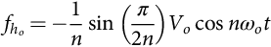 **(15.176)**

Now, max{*u*(*ωot*)} occurs when *ωot*=*π*/2*n*; therefore,

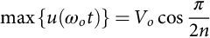 **(15.177)**

This value is 0.951*Vo* for five-phase output. [Fig. 15.78B](https://learning.oreilly.com/library/view/power-electronics-handbook/9780128114087/B9780128114070000167_3.xhtml#f0395) exhibits the optimization of five-phase output waves. It is seen, as derived in [(15.173)](https://learning.oreilly.com/library/view/power-electronics-handbook/9780128114087/B9780128114070000167_3.xhtml#fo0935), the maximum of the new wave occurs at *ωot*=*π*/10. As the optimization of input and output phase sets is done one by one, that is, while considering the output waves, it is considered that the input waves are unoptimized. That is why the output waves shown in [Fig. 15.78B](https://learning.oreilly.com/library/view/power-electronics-handbook/9780128114087/B9780128114070000167_3.xhtml#f0395) are shown with respect to Vo. Therefore, by considering input-voltage set as unoptimized and output-voltage set optimized, the condition for peak values by applying [(15.176)](https://learning.oreilly.com/library/view/power-electronics-handbook/9780128114087/B9780128114070000167_3.xhtml#fo0950) on [(15.155)](https://learning.oreilly.com/library/view/power-electronics-handbook/9780128114087/B9780128114070000167_3.xhtml#fo0840) is stated as

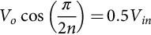 **(15.178)**

For five-phase output *Vo*=0.526*Vin*.

Now, considering input-voltage set and output-voltage set optimization, the peak value, by combining [(15.155)](https://learning.oreilly.com/library/view/power-electronics-handbook/9780128114087/B9780128114070000167_3.xhtml#fo0840), [(15.168)](https://learning.oreilly.com/library/view/power-electronics-handbook/9780128114087/B9780128114070000167_3.xhtml#fo0905), and [(15.176)](https://learning.oreilly.com/library/view/power-electronics-handbook/9780128114087/B9780128114070000167_3.xhtml#fo0950), is expressed as

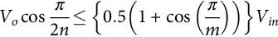 **(15.179)**

**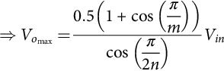** **(15.180)**

The VTRmax achievable for 3×5 MC from [(15.179)](https://learning.oreilly.com/library/view/power-electronics-handbook/9780128114087/B9780128114070000167_3.xhtml#fo0965) is 0.78859, which is in accordance with values shown in [Table 15.11](https://learning.oreilly.com/library/view/power-electronics-handbook/9780128114087/B9780128114070000167_3.xhtml#t0060).

The optimized output-voltage set is finally given by combining [(15.153)](https://learning.oreilly.com/library/view/power-electronics-handbook/9780128114087/B9780128114070000167_3.xhtml#fo0830), [(15.167)](https://learning.oreilly.com/library/view/power-electronics-handbook/9780128114087/B9780128114070000167_3.xhtml#fo0900), [(15.168)](https://learning.oreilly.com/library/view/power-electronics-handbook/9780128114087/B9780128114070000167_3.xhtml#fo0905), and [(15.175)](https://learning.oreilly.com/library/view/power-electronics-handbook/9780128114087/B9780128114070000167_3.xhtml#fo0945) as

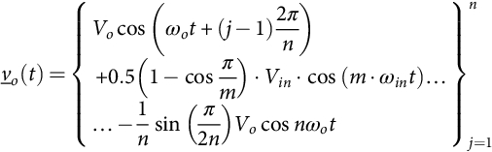 **(15.181)**

where *Vo* is given by [(15.79)](https://learning.oreilly.com/library/view/power-electronics-handbook/9780128114087/B9780128114070000167_1.xhtml#fo0440). [Fig. 15.78C](https://learning.oreilly.com/library/view/power-electronics-handbook/9780128114087/B9780128114070000167_3.xhtml#f0395) exhibits the implementation of [(15.180)](https://learning.oreilly.com/library/view/power-electronics-handbook/9780128114087/B9780128114070000167_3.xhtml#fo0970) for 3×5 converter for output phase 1 with respect to input neutral (*voopt*). All the phases of five-phase voltage set are shown in [Fig. 15.79](https://learning.oreilly.com/library/view/power-electronics-handbook/9780128114087/B9780128114070000167_3.xhtml#f0400).

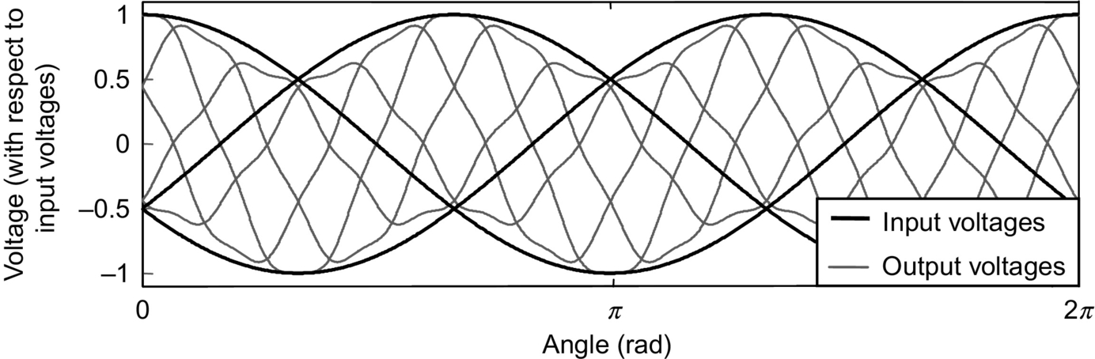

**FIG. 15.79** Optimized output voltages for 3×5 matrix converter (*q*=0.7886, *fo*=3*fin*).

#### **15.5.3.4 Other Cases**

This section deals with the remaining cases of MPMCs. As discussed in previous sections, the even-phase set cannot be optimized as its min{*viu*} and max{*vil*} occur at the same time, and hence, a periodic function that pushes both the points at the same instant is not feasible to obtain. Considering the configurations one by one, we have the following:

##### **Odd-phase input and even-phase output MC**

For this type of configuration of MC, only input-voltage set can be optimized, and thus, the even-phase output reference voltages are expressed as

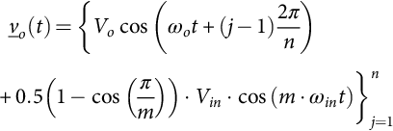 **(15.182)**

where *Vo*=(VTRmax)*Vin* is according to [(15.169)](https://learning.oreilly.com/library/view/power-electronics-handbook/9780128114087/B9780128114070000167_3.xhtml#fo0910). Taking 3×6 converter for illustration, the reference output voltages of [(15.181)](https://learning.oreilly.com/library/view/power-electronics-handbook/9780128114087/B9780128114070000167_3.xhtml#fo0975) for 3×6 MC is written as

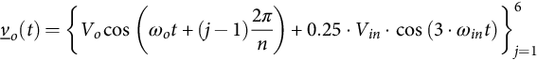

where *Vo*=(VTRmax)*Vin*, and VTRmax=0.75. The optimized output voltages for this case are seen in [Fig. 15.80](https://learning.oreilly.com/library/view/power-electronics-handbook/9780128114087/B9780128114070000167_3.xhtml#f0405).

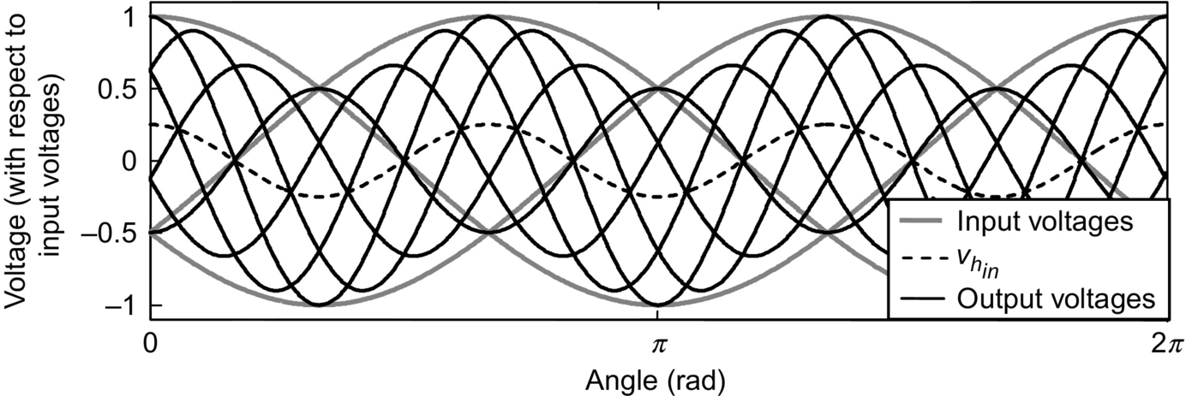

**FIG. 15.80** Optimized output voltages for 3×6 matrix converter (*q*=0.75, *fo*=3*fin*).

##### **Even-phase input and odd-phase output MC**

When inputs are even and outputs are odd, only output-voltage optimization is done. So in accordance with [(15.175)](https://learning.oreilly.com/library/view/power-electronics-handbook/9780128114087/B9780128114070000167_3.xhtml#fo0945), the reference output voltages are written as

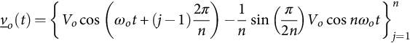 **(15.183)**

where *Vo*=(VTRmax)*Vin* and VTRmax is defined by (15.166). For 6×3 MC, [(15.182)](https://learning.oreilly.com/library/view/power-electronics-handbook/9780128114087/B9780128114070000167_3.xhtml#fo0980) is written as

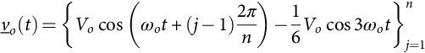

*Vo*=*qVin* and VTRmax=1. This is illustrated in [Fig. 15.81](https://learning.oreilly.com/library/view/power-electronics-handbook/9780128114087/B9780128114070000167_3.xhtml#f0410). The appreciable fact is that VTRmax is unity, which is 0.7321 only, if optimization is not done.

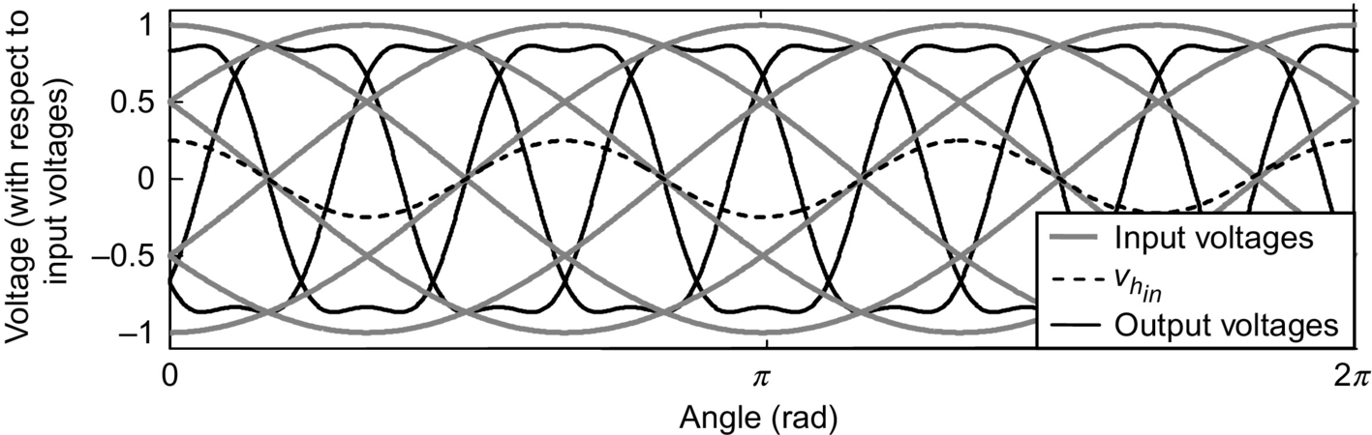

**FIG. 15.81** Optimized output voltages for 6×3 matrix converter (*q*=1, *fo*=3*fin*).

### 15.5.4 SIMPLIFIED MODULATION STRATEGY

This method is discussed in [[12](https://learning.oreilly.com/library/view/power-electronics-handbook/9780128114087/B9780128114070000167_4.xhtml#bb0065)] lately. It is simple and is applicable to any MC configuration. Moreover, unity input displacement factor (IDF) is achieved. The results clearly exhibit the IDF.

Matrix operations are done to derive the modulation matrix [*M*]*n*×*m*. Considering matrix *m*×*n* converter shown in [Fig. 15.70](https://learning.oreilly.com/library/view/power-electronics-handbook/9780128114087/B9780128114070000167_3.xhtml#f0355) and applying Kirchhoff's voltage law, combining with constraint equation is derived as

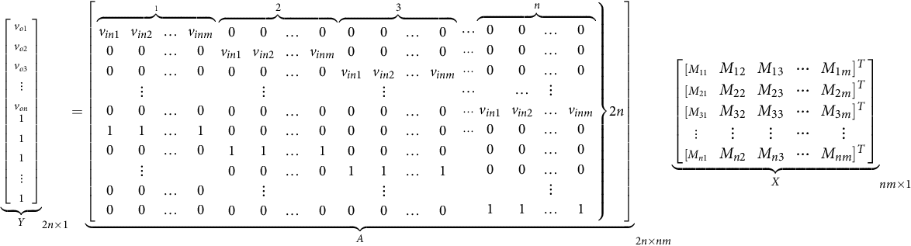 **(15.184)**

*X* denotes the modulation vector, and *Y* is the vector of desired output voltages. Now, *X* is derived as

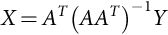 **(15.185)**

*AAT* when solved will have terms  and , so, let  and . Each term of *X* when Eq. [(15.184)](https://learning.oreilly.com/library/view/power-electronics-handbook/9780128114087/B9780128114070000167_3.xhtml#fo1000) is solved is of similar pattern and can be shown as

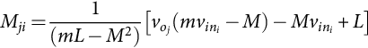 **(15.186)**

where *Mji* is the time-based index corresponding to the switch *Sji* that connects *j*th output to the *i*th input. The time duration for which this switch is on is calculated by multiplying this index with sampling time. Further solving by considering *m* balanced input phases and finally neglecting the terms with denominators with high value, solution for *m*×*n* matrix converter is written as

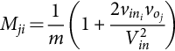 **(15.187)**

This formula is general for all input and output cases and does not carry any discrimination of odd or even. *voj* is the target output voltage, which for optimum output voltages are referred to expressions derived in previous sections. Experimental prototype of 3×9 MC is shown in [Fig. 15.82](https://learning.oreilly.com/library/view/power-electronics-handbook/9780128114087/B9780128114070000167_3.xhtml#f0415), and experimental results for 3×5 matrix converter obtained are shown in [Fig. 15.83](https://learning.oreilly.com/library/view/power-electronics-handbook/9780128114087/B9780128114070000167_3.xhtml#f0420).

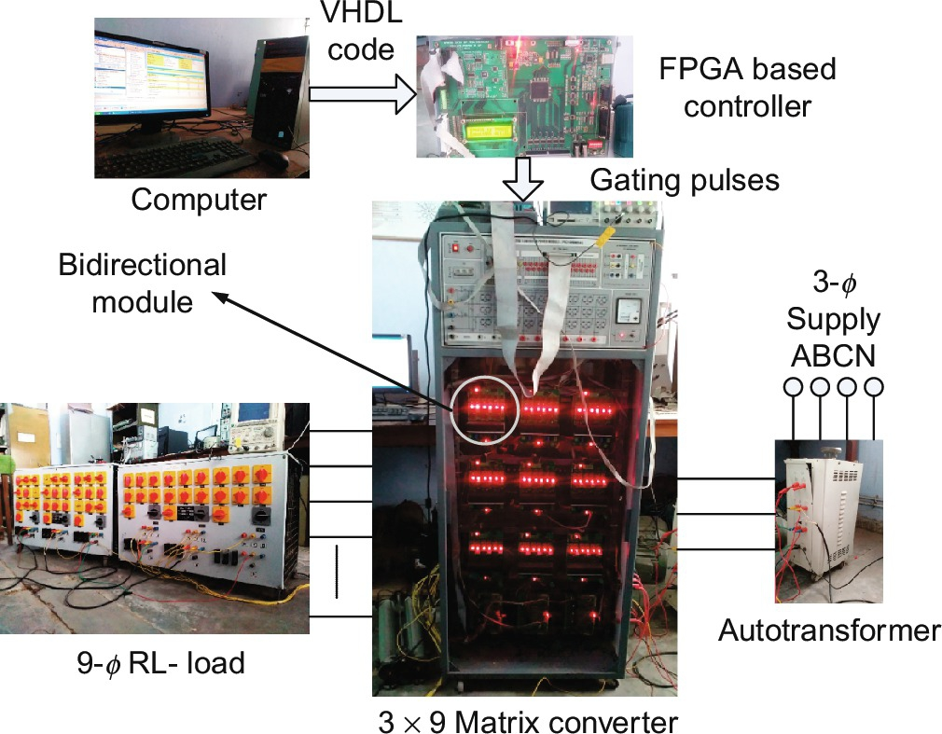

**FIG. 15.82** Experimental prototype of a 3×9 MC.

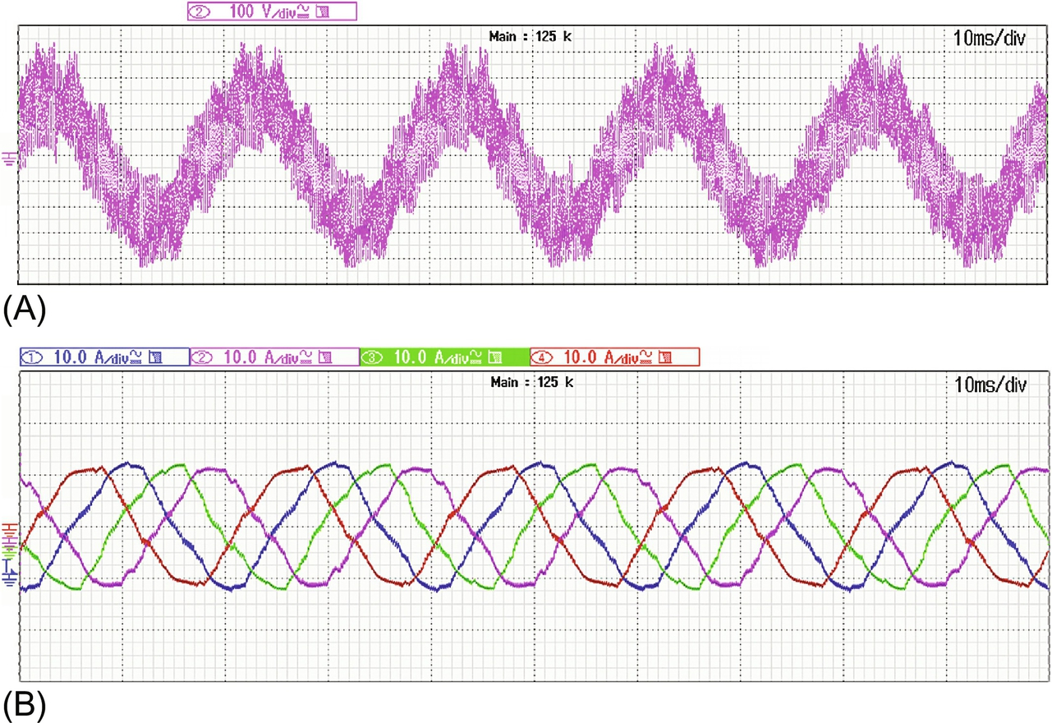

**FIG. 15.83** Experimental output (A) phase voltage and (B) currents (*f*o=50 Hz).

### 15.5.5 OTHER CONTROL TECHNIQUES

Other modulation strategies that are discussed for MPMCs are space-vector modulation [[17](https://learning.oreilly.com/library/view/power-electronics-handbook/9780128114087/B9780128114070000167_4.xhtml#bb0090)], sinusoidal carrier-based modulation [[16](https://learning.oreilly.com/library/view/power-electronics-handbook/9780128114087/B9780128114070000167_4.xhtml#bb0085)], and direct-duty-ratio-based method [[18](https://learning.oreilly.com/library/view/power-electronics-handbook/9780128114087/B9780128114070000167_4.xhtml#bb0095)]. Novel methods like reduced commutation method [[50](https://learning.oreilly.com/library/view/power-electronics-handbook/9780128114087/B9780128114070000167_4.xhtml#bb0255)] is also considered.

Space-vector PWM technique is highly recommended for VSIs as it increases the DC bus utilization and is easily digitally realized. This method is extended to multiphase matrix converters and is realized for 3×5 MC in [[17](https://learning.oreilly.com/library/view/power-electronics-handbook/9780128114087/B9780128114070000167_4.xhtml#bb0090)]. In this algorithm, the input currents and output line voltages are represented on space-vector planes as shown in [Fig. 15.84](https://learning.oreilly.com/library/view/power-electronics-handbook/9780128114087/B9780128114070000167_3.xhtml#f0425). The number of switching states for an *m*×*n* MC is 2*m*×*n*. However, after applying the constraints discussed in [Chapter 14](https://learning.oreilly.com/library/view/power-electronics-handbook/9780128114087/B9780128114070000143_1.xhtml), these reduce to *mn*. For example, for a 3×5 MC, a total number of combinations can be 215, that is, 32,768, and with constraints, this figure reduces to 35, that is, 243 combinations. However, in [[17](https://learning.oreilly.com/library/view/power-electronics-handbook/9780128114087/B9780128114070000167_4.xhtml#bb0090)], only 93 active and three zero vectors are utilized and are further categorized into 4 groups, namely, large vectors (30 vectors), medium vectors (30 vectors), small vectors (30 vectors), and zero vectors (3 vectors). [Fig. 15.84](https://learning.oreilly.com/library/view/power-electronics-handbook/9780128114087/B9780128114070000167_3.xhtml#f0425) exhibits input current and output line voltage space vectors in which only large (L) and medium (M) vectors are shown. The detailed calculations of the dwelling times can be seen in [[17](https://learning.oreilly.com/library/view/power-electronics-handbook/9780128114087/B9780128114070000167_4.xhtml#bb0090)]:

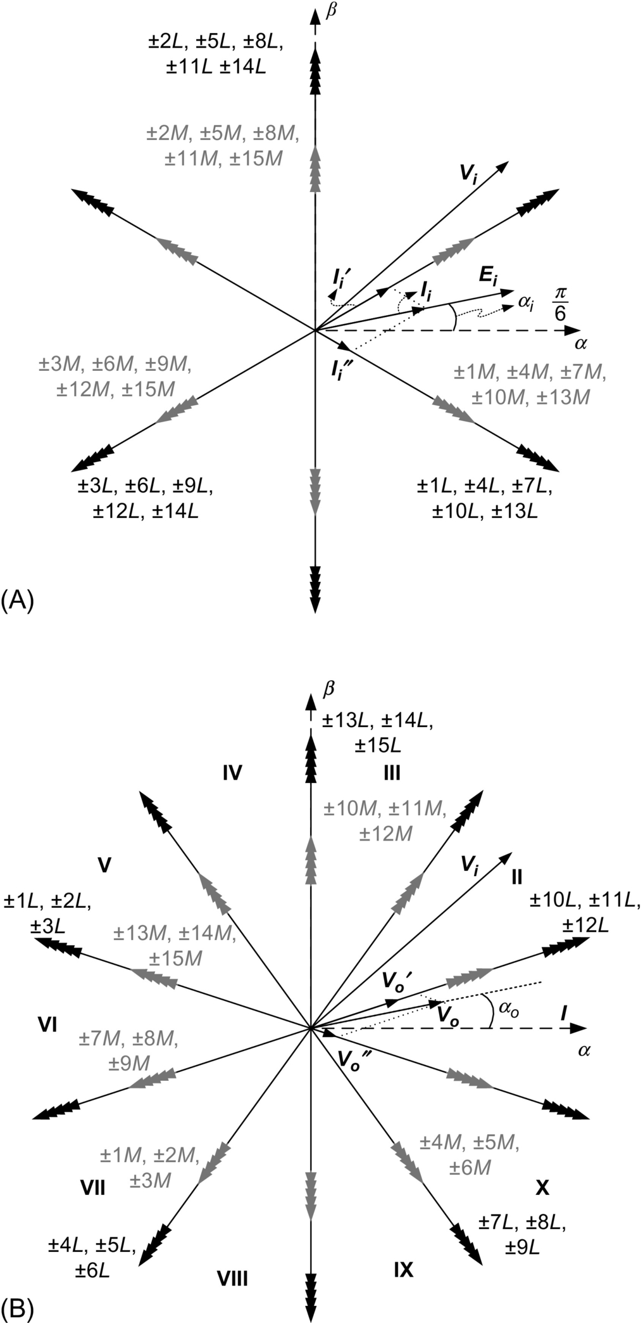

**FIG. 15.84** (A) Input current and (B) output-voltage space vectors corresponding to large and medium vectors [[17](https://learning.oreilly.com/library/view/power-electronics-handbook/9780128114087/B9780128114070000167_4.xhtml#bb0090)].

A new modulation technique is introduced in [[50](https://learning.oreilly.com/library/view/power-electronics-handbook/9780128114087/B9780128114070000167_4.xhtml#bb0255)], where least *commutation number* is achieved. According to normal SVPWM, Venturini or the method discussed in [Section 15.5.5](https://learning.oreilly.com/library/view/power-electronics-handbook/9780128114087/B9780128114070000167_3.xhtml#s0305), in one switching time cycle, the output voltage must ride on all input voltage, and the average of these samples must be equal to the reference output voltage. This leads to (*m*−1)×*n* commutations per switching cycle. For 3×5 MC, this will be 10 commutations and are shown in [Fig. 15.85A](https://learning.oreilly.com/library/view/power-electronics-handbook/9780128114087/B9780128114070000167_3.xhtml#f0430). However, the method proposed in [[50](https://learning.oreilly.com/library/view/power-electronics-handbook/9780128114087/B9780128114070000167_4.xhtml#bb0255)] employs only five commutations per cycle, as shown in [Fig 15.85B](https://learning.oreilly.com/library/view/power-electronics-handbook/9780128114087/B9780128114070000167_3.xhtml#f0430). This provides low THD in output voltages and reduction in the stress on the switches.

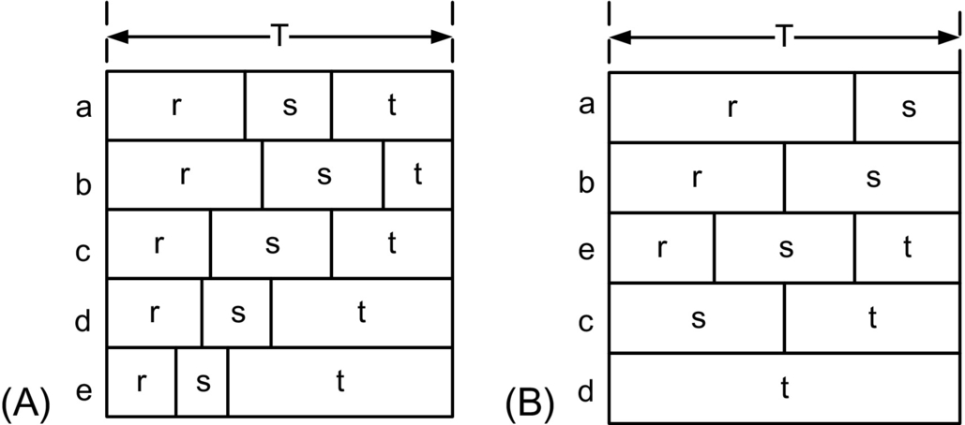

**FIG. 15.85** (A) Commutation in one time cycle with conventional schemes [[43](https://learning.oreilly.com/library/view/power-electronics-handbook/9780128114087/B9780128114070000167_4.xhtml#bb0220)] and (B) commutation in one time cycle observed in [[50](https://learning.oreilly.com/library/view/power-electronics-handbook/9780128114087/B9780128114070000167_4.xhtml#bb0255)].

### 15.5.6 FUTURE PROSPECTS

In the above sections, the main focus was on DMMC; however, IMMC is now getting considerable attention [[51](https://learning.oreilly.com/library/view/power-electronics-handbook/9780128114087/B9780128114070000167_4.xhtml#bb0260),[52](https://learning.oreilly.com/library/view/power-electronics-handbook/9780128114087/B9780128114070000167_4.xhtml#bb0265)]. Research on MPMCs is still under progress, and there is a lot of scope left in this area. The possible areas of research are summarized, which in conjunction with one another may create a new area of research:

In Terms of Topology

− Z-source DMMC and IMMC

− Multiphase multilevel MC

− Multiphase multimodular matrix converters

− Sparse and ultrasparse multiphase MC

In Terms of Control

− Overmodulation in DMMC

− Enhanced SVPWM techniques

− Reactive power control

− Predictive control

− Periodic control

− Low-switching-frequency PWM

There are many more areas to be considered. Moreover, filter design, EMI considerations, and consideration of faults and unbalanced supplies for MPMCs are also the areas of research.

## 15.6 Multiphase DC-DC Converter

A multiphase DC-DC converter consists of two or more DC-DC converters operating in parallel at the same frequency with a proper phase shift existing between each other. The parallel operating converters has a common DC source (battery, PV panel, etc.) that feeds power to a common load. Consequently, this type of circuit configuration enables the load to be subjected to an effective frequency that is a multiple of the converter frequency (*f*), thereby increasing the ripple frequency of the supply harmonic current. The filter requirement is reduced compared with a single-level implementation. The multiphase DC-DC step-down converter or buck converter offers a viable solution for the voltage regulator module (VRM), which is used to power the microprocessors in computers and other applications. At present, VRMs require output voltage less than 1 V and an output current of more than 100 A [[53](https://learning.oreilly.com/library/view/power-electronics-handbook/9780128114087/B9780128114070000167_4.xhtml#bb0270)].

Various topologies have been reported in literature with varying control strategy [[53](https://learning.oreilly.com/library/view/power-electronics-handbook/9780128114087/B9780128114070000167_4.xhtml#bb0270),[54](https://learning.oreilly.com/library/view/power-electronics-handbook/9780128114087/B9780128114070000167_4.xhtml#bb0275)]. The most common topologies are as follows:

1. Multiphase interleaved buck topology

2. Multiphase synchronous buck topology

3. Multiphase tapped-inductor buck topology

4. Multiphase interleaved boost topology

### 15.6.1 MULTIPHASE INTERLEAVED BUCK TOPOLOGY

[Fig. 15.86](https://learning.oreilly.com/library/view/power-electronics-handbook/9780128114087/B9780128114070000167_3.xhtml#f0435) shows an *n* phase multiphase interleaved buck converter. The individual phase ripple frequency is added to obtain an output current with high ripple frequency. The ripple cancellation of inductor current for a three phase converter is shown in [Fig. 15.87A](https://learning.oreilly.com/library/view/power-electronics-handbook/9780128114087/B9780128114070000167_3.xhtml#f0440). The inductor current ripples add up to give three times the ripple frequency with respect to the converter operating individually. The magnitude of output current also increases. The ripple cancellation of the output inductor current reduces the requirement of the output capacitance and consequently lowers the cost and reduces the power dissipation. The increased input ripple current frequency causes the multiphase buck converter to have reduced input ripple current magnitude ([Fig. 15.87B](https://learning.oreilly.com/library/view/power-electronics-handbook/9780128114087/B9780128114070000167_3.xhtml#f0440)), thereby reducing the size requirement of input capacitor and cost reduction of the overall system.

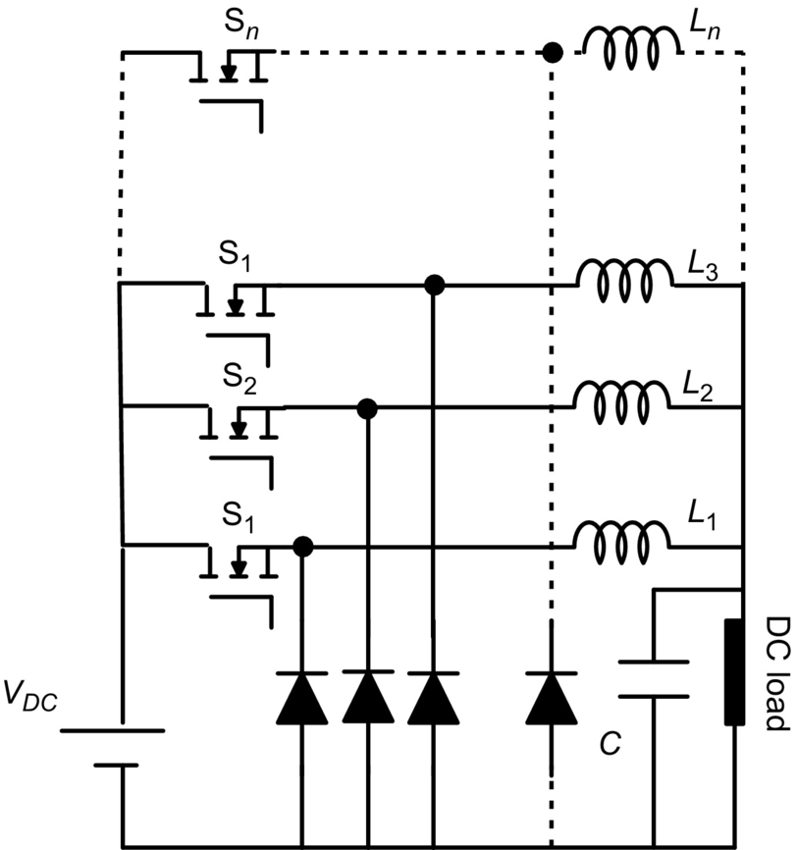

**FIG. 15.86** *n*-Phase interleaved buck converter.

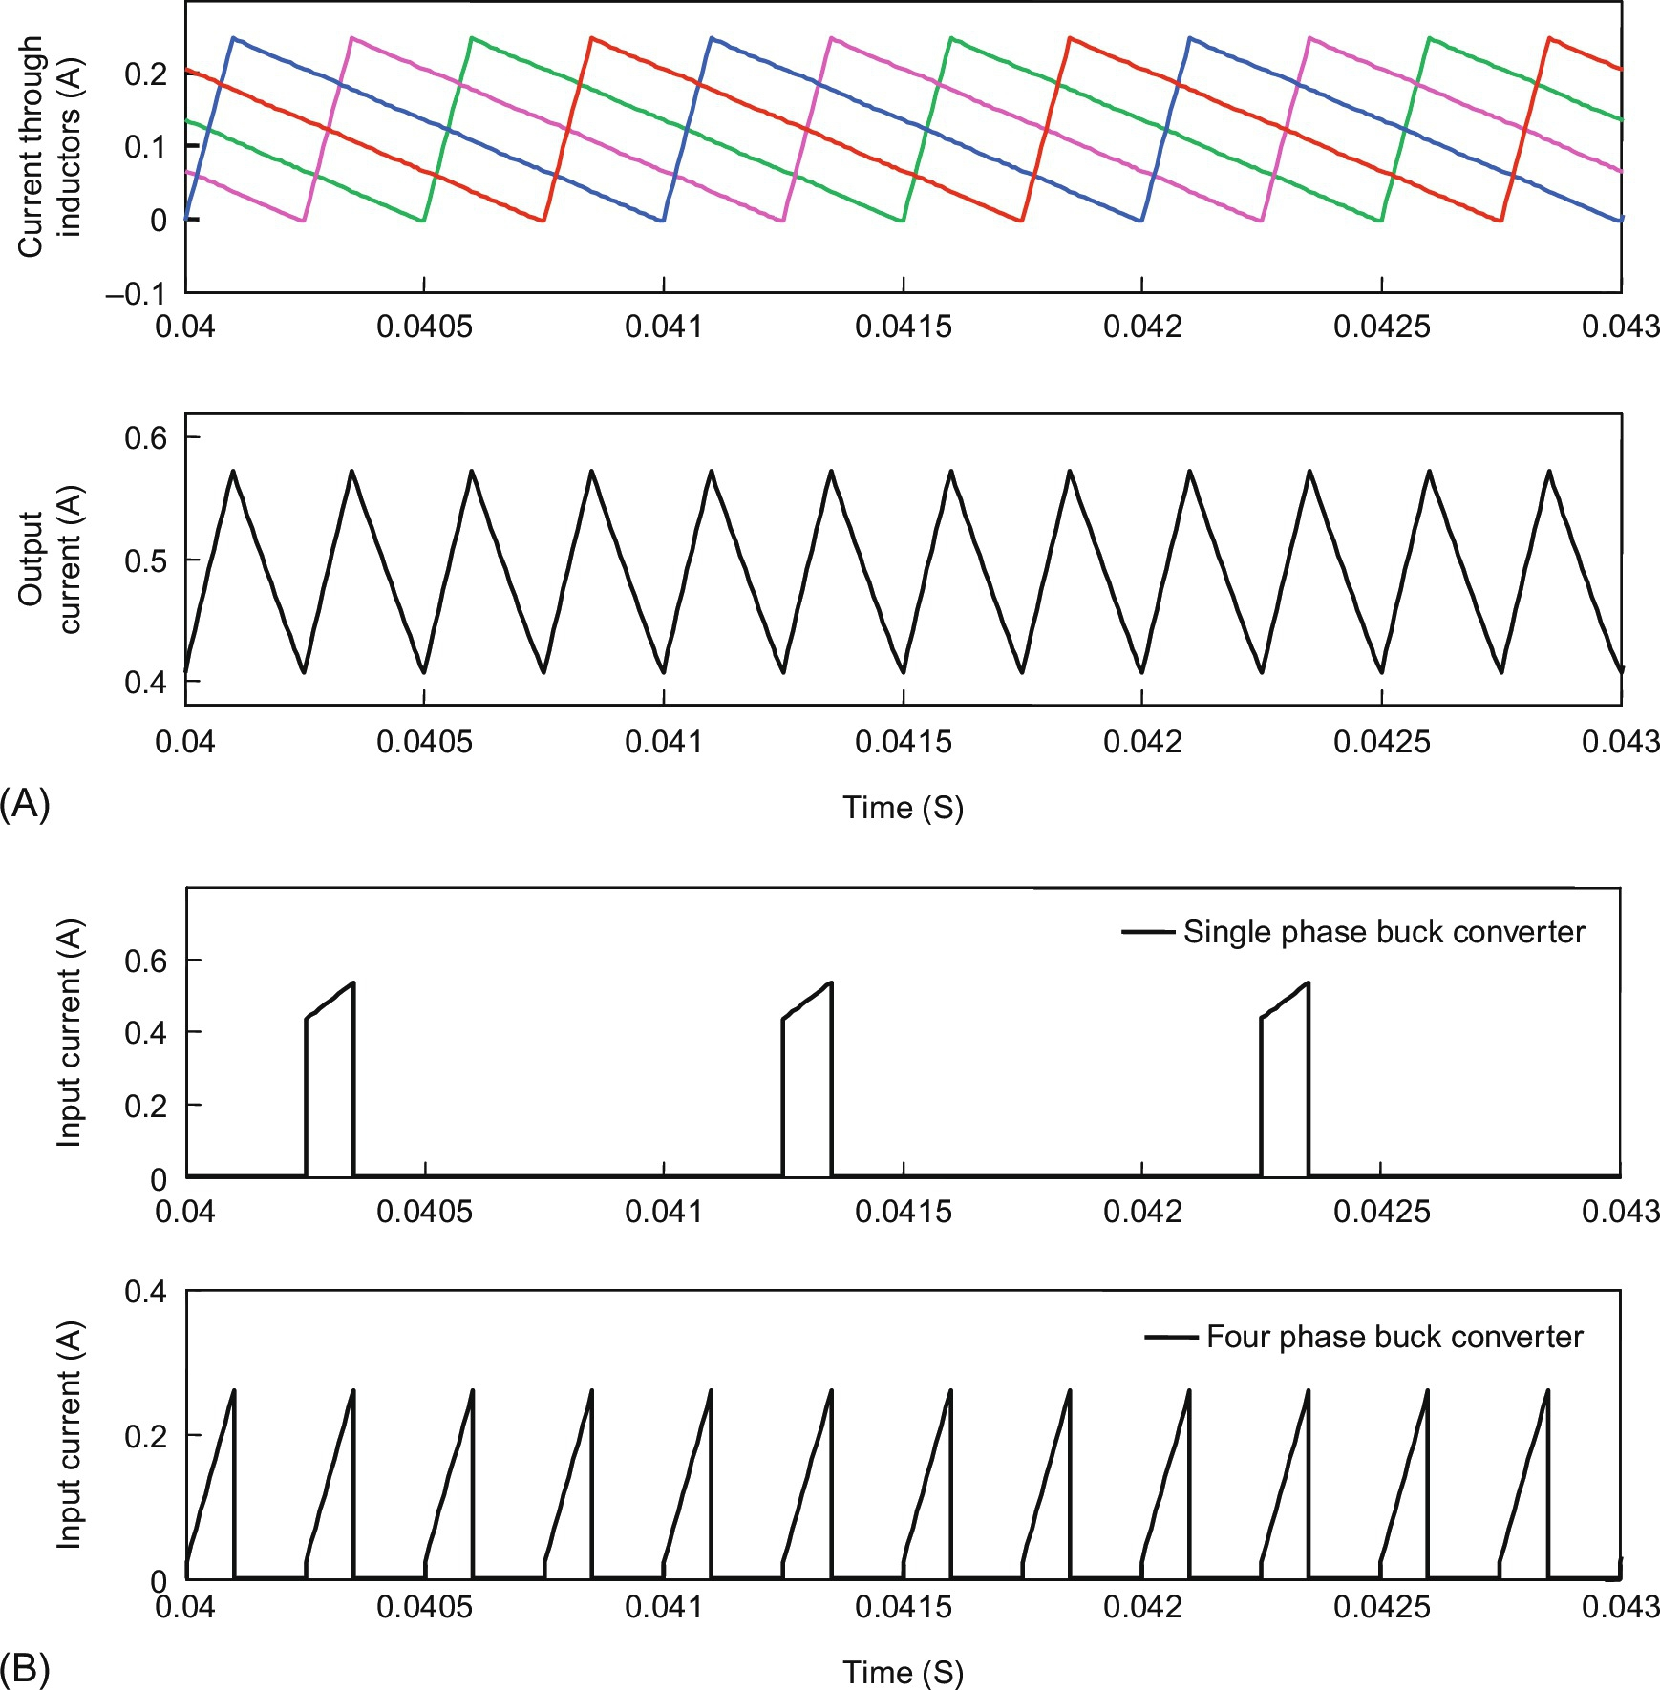

**FIG. 15.87** (A) Inductor current cancelation in a four-phase converter (simulation result) and (B) comparison of single-phase and four-phase input current (simulation result).

#### **15.6.1.1 Operation of Multiphase Buck Converter**

The operation of a two-phase interleaved buck converter ([Fig. 15.88](https://learning.oreilly.com/library/view/power-electronics-handbook/9780128114087/B9780128114070000167_3.xhtml#f0445)) has been discussed in detail. The operating principle remains the same in all higher phases of the converter. Inductors ensure that continuous current flows through the load and the resultant current through output is the sum of the current through each inductor. The frequency of ripples in the current through load is twice that of frequency of ripple current through each inductor. The sum of duty ratios of the two switches is less than or equal to 1.



**FIG. 15.88** Two-phase buck converter topology.

#### **15.6.1.2 Modes of Operation**

##### **Mode 1. S1 is on and S2 is off (*T*1)**

When S1 is on, current flows through the circuit as shown in [Fig. 15.89](https://learning.oreilly.com/library/view/power-electronics-handbook/9780128114087/B9780128114070000167_3.xhtml#f0450). The diode D1 is reverse-biased because of the polarity of inductor *L*1 and does not conduct, whereas the diode D2 is forward-biased and freewheels the current through *L*2. During the interval when S1 is turned on (*T*1), the current through *L*1 increases while the current through *L*2 decreases linearly.  and  varies according to the following relations:

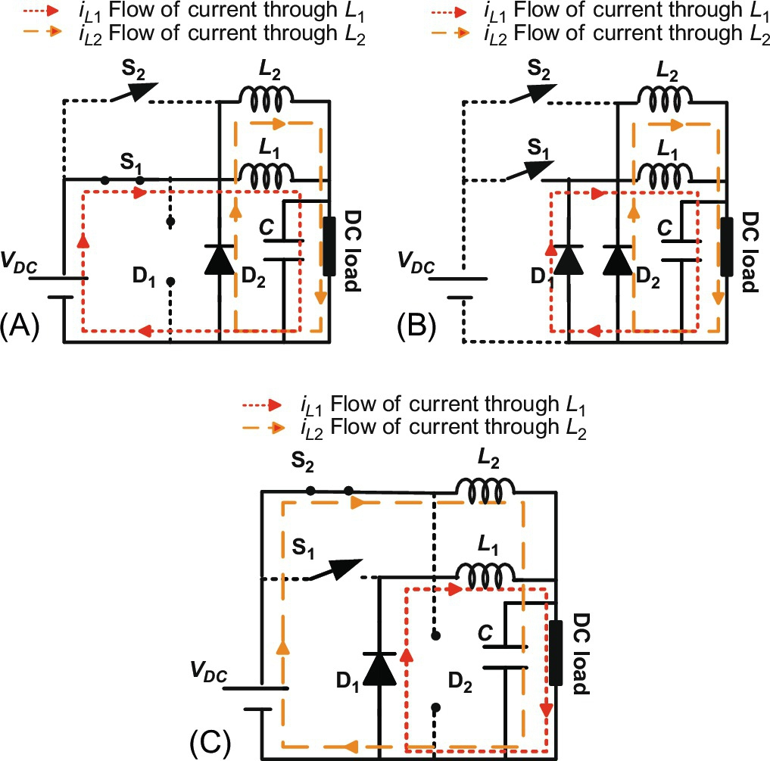

**FIG. 15.89** Switching diagrams under various modes of operation for a two-phase buck converter: (A) Mode 1, (B) Mode 2, and (C) Mode 3.

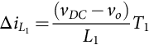 **(15.188)**

**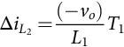** **(15.189)**

where *VDC* is the input side voltage and *vO* is the output side voltage.

##### **Mode 2. Both S1 and S2 are off (*T*2)**

The duty ratio for each phase of the converter operation is less than 0.5 which reduces for higher phase converter. During transition of switching from S1 to S2 both the switches will be off. In this mode, diodes D1 and D2 conduct. Inductors *L*1 and *L*2 release the energy stored in the previous modes to the load through the freewheeling diodes D1 and D2. The current through inductors *L*1 and *L*2, i.e.  and  decrease linearly.  and  varies according to the following relations:

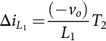 **(15.190)**

**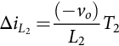** **(15.191)**

##### **Mode 3. S2 is on and S1 is off (*T*3)**

When S2 is on, current flows in the circuit as shown in [Fig. 15.89C](https://learning.oreilly.com/library/view/power-electronics-handbook/9780128114087/B9780128114070000167_3.xhtml#f0450). The diode D2 is reverse-biased because of the polarity of inductor *L*2 and does not conduct, whereas the diode D1 is forward-biased and freewheels the current through *L*1. While S2 is on, the inductor *L*2 gets charged while inductor *L*1 discharges through load.  and  (currents flowing through *L*1 and *L*2, respectively) during *T*3 are given by the equations:

 **(15.192)**

**** **(15.193)**

##### **State space analysis**

The converter system can be expressed in state equation of the form

 **(15.194)**

**** **(15.195)**

where the state-space variables are defined as







*V* is the output-voltage vector.

#### **15.6.1.3 Modes of Operation**

##### **Mode 1**

**** **(15.196)**

****

##### **Mode 2**

**** **(15.197)**

****

##### **Mode 3**

**** **(15.198)**

****

#### **15.6.1.4 State Space Averaging**

State-space averaging can be done to replace the above sets of state-space equations by a single equation that describe the system over one switching period:

 **(15.199)**

**** **(15.200)**

Assuming the duty ratio of mode 1 and 3 are same, then for mode 2, it is 

Therefore,

 **(15.201)**

**** **(15.202)**

#### **15.6.1.5 Small Signal Analysis**

In small-signal analysis, it is assumed that all variables are perturbed around steady-state operating point. Applying perturbations to above equation leads to

 **(15.203)**

Where average term is represented by a superscript while small signal term is represented by small letters. Neglecting the product of terms containing small signal and taking the derivative of steady-state component as zero simplify the above equation to

 **(15.204)**

Taking Laplace transform on both sides,

 **(15.205)**

**** **(15.206)**

where  and :

 **(15.207)**

Putting the value of Eq. [(15.204)](https://learning.oreilly.com/library/view/power-electronics-handbook/9780128114087/B9780128114070000167_3.xhtml#fo1130) into Eq. [(15.205)](https://learning.oreilly.com/library/view/power-electronics-handbook/9780128114087/B9780128114070000167_3.xhtml#fo1135), we have

 **(15.208)**

**** **(15.209)**

In the above analysis, ESR, ESL, and other parasitic parameters have been neglected. The detailed analysis including the parasitic parameters has been carried out by [[55](https://learning.oreilly.com/library/view/power-electronics-handbook/9780128114087/B9780128114070000167_4.xhtml#bb0280),[56](https://learning.oreilly.com/library/view/power-electronics-handbook/9780128114087/B9780128114070000167_4.xhtml#bb0285)]. The waveform of current through the inductors and the output current for a two-phase buck converter are shown in [Fig. 15.90](https://learning.oreilly.com/library/view/power-electronics-handbook/9780128114087/B9780128114070000167_3.xhtml#f0455). The frequency of ripple in output current is clearly seen to be twice compared with the single-phase counterpart.



**FIG. 15.90** Output current and gate pulses (simulated).

Small signal analysis can be extended for an *n* phase converter. The time-interleaved control will ensure higher-frequency ripple pulses, thereby lesser requirement of filtering. Moreover, the cost and space requirement will also come down.

#### **15.6.1.6 Discontinuous Conduction Mode**

When the value of L1 and L2 is small, the current through load could be discontinuous. This is undesirable as the output voltage then becomes function of inductance complicating the control operation [[55](https://learning.oreilly.com/library/view/power-electronics-handbook/9780128114087/B9780128114070000167_4.xhtml#bb0280)].

#### **15.6.1.7 Variation of Output Current Ripple With Duty Ratio and Design Consideration**

The main advantage of multiphase topology is the cancellation of ripple in the output current, which reduces the size of inductance and improves the transient response and the output capacitance requirement is minimized. The voltage tolerance criteria under varying load make multiphase buck converters working as VRMs use small inductance so that the power can be transferred quickly from the source side to the load side. However, small value of inductance causes large ripples in inductor current under steady state condition. So a compromise between the two has be taken into consideration while designing. The magnitude of inductor current ripples (considering inductance to be same in each buck converter loop) and the inductance value are related to each other by the equation:

 **(15.210)**

Multiphase buck converters interleave (alternate flow of current through the inductor in each of the converter cycle) the inductor currents in each converter operating in parallel, and hence drastically reduces the total ripples in the current which flows through the output capacitor. With the reduction in current ripple, the output voltage ripple is also greatly reduced. Therefore with lesser filter requirement, the transient response of the system improves. Hence, a smaller value of capacitance at the output can be used for meeting the transient requirement. Moreover, there is more space for variations in output voltage magnitude during load transient. Consequently, multiphase operation enhances the performance under load transient condition [[57](https://learning.oreilly.com/library/view/power-electronics-handbook/9780128114087/B9780128114070000167_4.xhtml#bb0290),[58](https://learning.oreilly.com/library/view/power-electronics-handbook/9780128114087/B9780128114070000167_4.xhtml#bb0295)].

In multiphase converters, the current ripple cancelation effect *Ki* can be defined as the ratio of the magnitudes of output current ripple (Δ*iO*) and inductor current ripple (Δ*iL*). For *n* phase buck converter, the current ripple cancellation factor *Ki* is defined as [[57](https://learning.oreilly.com/library/view/power-electronics-handbook/9780128114087/B9780128114070000167_4.xhtml#bb0290)]

 **(15.211)**

where , the maximum integer that does not exceed .

For a small duty ratio, the current ripple cancellation is poor. The output current ripples increases for small duty ratios further because of the increase in the individual inductor current ripples, which can be seen from the Eq. [(15.210)](https://learning.oreilly.com/library/view/power-electronics-handbook/9780128114087/B9780128114070000167_3.xhtml#fo1160). Substituting the Eq. [(15.210)](https://learning.oreilly.com/library/view/power-electronics-handbook/9780128114087/B9780128114070000167_3.xhtml#fo1160) into Eq. [(15.209)](https://learning.oreilly.com/library/view/power-electronics-handbook/9780128114087/B9780128114070000167_3.xhtml#fo1160), the output current ripples magnitude for multiphase buck converters can be derived, as follows [[57](https://learning.oreilly.com/library/view/power-electronics-handbook/9780128114087/B9780128114070000167_4.xhtml#bb0290)]

 **(15.212)**

[Fig. 15.91](https://learning.oreilly.com/library/view/power-electronics-handbook/9780128114087/B9780128114070000167_3.xhtml#f0460) shows the effect of duty ratio on the ripple of the output current for multiphase buck converters. Multiphase interleaved buck converters are basically governed by the same design equations as that of the single phase buck converter. There are *n* interleaved paths in a multiphase buck converter where the number of phases of the converter is represented by *n*. Each channel behaves as an independent buck converter. Let the output voltage and output current in a multiphase buck converter are denoted by *vo* and *io* respectively. The relation of output frequency and output current of multiphase converter with one phase of multiphase buck converter is given by



**FIG. 15.91** Variation of ripple with duty ratio and phases.

 **(15.213)**

where *fO* represents is the output current ripple frequency and *fS* represents the frequency of single phase ripple current. Volt second balance relationship can be used to develop the design equation for the inductor at the output.

 **(15.214)**

or

 **(15.215)**

where  = the ripple current through the output inductor of each channel.

For small change in *iL* we can comfortable consider *di* *=* Δ*iL* = the ripple current flowing through inductor at the output of each interleaved channel. During off cycle  where *TS* represents the switching period and *d* represents the duty ratio of the individual switch,

Eq. [(15.214)](https://learning.oreilly.com/library/view/power-electronics-handbook/9780128114087/B9780128114070000167_3.xhtml#fo1180) becomes

 **(15.216)**

or

 **(15.217)**

The output voltage is kept almost constant with the selection of proper output capacitor. Equivalent series resistance (ESR) and an equivalent series inductance (ESL) are added to the output capacitor to represent a real model. At high frequency switching, ESR is dominant over ESL. So, for the purpose of analysis ESL can be neglected. The minimum capacitance for a multiphase converter can then be given by the following equation

 **(15.218)**

### 15.6.2 SYNCHRONOUS MULTIPHASE BUCK TOPOLOGY

The disadvantage of a conventional multiphase buck converter is the significant power loss during the diode conduction period, which is the product of the forward voltage drop and its current. Synchronous buck topology has a better efficiency than standard multiphase interleaved buck converter. This is obtained by replacing the diodes of multiphase buck converter by MOSFETs. Theoretical study done by [[57](https://learning.oreilly.com/library/view/power-electronics-handbook/9780128114087/B9780128114070000167_4.xhtml#bb0290)] shows that the losses in a multiphase buck converter is more due to the forward conduction loss of the diode. The on-resistance (RDS,ON) of MOSFET connected in place of diode is in the milliohm range during conduction hence the losses during conduction is quite less compared to its conventional counterpart thus efficiency improves.

As shown in [Fig. 15.92A](https://learning.oreilly.com/library/view/power-electronics-handbook/9780128114087/B9780128114070000167_3.xhtml#f0465), a synchronous multiphase interleaved buck topology is obtained by replacing the diodes with MOSFET. Dead-times between (S1, S1’), (S2, S2’) and other switch pairs are introduced to prevent shoot-through. For a two phase synchronous converter, the current through the inductor continues to flow through internal body diode of MOSFET (S2) during the dead time. On application of gate signal on MOSFET (S2), the current through inductor flows through S2. As mentioned earlier, with technological advancement there is a requirement for larger current by the processors to meet the growing diverse application demand. The multiphase synchronous buck topology has been adopted in industry to handle such high current processors. The majority of VRC for laptop processor and embedded system board are using synchronous topology today instead of conventional buck. The Intel roadmap suggests that the voltage will be reduced by 0.6 fraction with each passing generation of processor. Currently, the input supply voltage to microprocessors embedded system board is in the range of 0.8–1.6 V [[58](https://learning.oreilly.com/library/view/power-electronics-handbook/9780128114087/B9780128114070000167_4.xhtml#bb0295)–[60](https://learning.oreilly.com/library/view/power-electronics-handbook/9780128114087/B9780128114070000167_4.xhtml#bb0305)]. But to generate a very low output voltage from higher output voltage, the duty ratio for multiphase synchronous buck converters should be very small. This increases the losses across the switches and the overall converter efficiency reduces. So a synchronous tapped inductor multiphase buck converter topology has been proposed [[57](https://learning.oreilly.com/library/view/power-electronics-handbook/9780128114087/B9780128114070000167_4.xhtml#bb0290)] to overcome this disadvantage. A synchronous tapped inductor multiphase buck converter is shown in [Fig. 15.92B](https://learning.oreilly.com/library/view/power-electronics-handbook/9780128114087/B9780128114070000167_3.xhtml#f0465). To realize a tapped inductor buck converter, only a minor modification in the original buck converter circuit is required.



**FIG. 15.92** (A) Synchronous multiphase buck converter and (B) synchronous tapped inductor multiphase buck converter.

### 15.6.3 MULTIPHASE BOOST CONVERTER

There is an increasing popularity for high power boost converters among power electronic designers in the industrial, automotive and telecom industries for high power application. For large power levels, efficiency becomes quite important in the power converter components. The multiphase boost converter is a viable option for such applications ([Fig. 15.93](https://learning.oreilly.com/library/view/power-electronics-handbook/9780128114087/B9780128114070000167_3.xhtml#f0470)). The ripple voltage and currents in both the input and output capacitors of a multiphase boost converter is very less. Therefore smaller components are required for filtering purpose. Thus, the requirement of bulky heat sinks and forced-air cooling is not there is case of multiphase boost converter [[61](https://learning.oreilly.com/library/view/power-electronics-handbook/9780128114087/B9780128114070000167_4.xhtml#bb0310),[62](https://learning.oreilly.com/library/view/power-electronics-handbook/9780128114087/B9780128114070000167_4.xhtml#bb0315)]. Hence, the efficiency of such converters are quite high. The direction of power flow is different in a multiphase buck and boost converter which otherwise have same circuit topology. The input of the buck converter and the output of the boost converter are pulsating type current. On the other hand, the output of the buck converter and the input to the boost converter are continuous currents.



**FIG. 15.93** Multiphase boost topology.

#### **15.6.3.1 Modes of Operation**

##### **Mode 1**

During mode 1, both the switches S1 and S2 are on, and the diodes D1 and D2 are in the off condition:

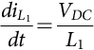 **(15.219)**

**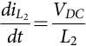** **(15.220)**

**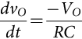** **(15.221)**

The coefficient matrix for this mode can be written as

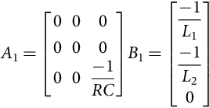 **(15.222)**

##### **Mode 2**

During mode 2, switch S1 is in on condition, switch S2 is in off condition, and the corresponding diodes are in the complementary switching states, that is, D1 is in off condition and D2 is in on condition, respectively:

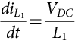 **(15.223)**

**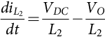** **(15.224)**

**** **(15.225)**

**** **(15.226)**

##### **Mode 3**

In mode 3, switch S1 is in off condition, switch S2 is in on condition, and the corresponding diodes D1 and D2 are in on and off conditions, respectively:

 **(15.227)**

**** **(15.228)**

**** **(15.229)**

**** **(15.230)**

##### **Mode 4**

During mode 4, the semiconductor switches S1 and S2 are in off condition, and the diodes D1 and D2 are in on condition:

 **(15.231)**

**** **(15.232)**

**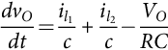** **(15.233)**

**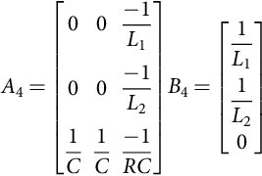** **(15.234)**

The coefficient matrix for the two-phase boost converter are defined as

 **(15.235)**

**** **(15.236)**

**** **(15.237)**

**** **(15.238)**

Expressions for *A*1, *A*2, *A*3, and *A*4 are defined above.

Output equation can be written as 

[Fig. 15.94](https://learning.oreilly.com/library/view/power-electronics-handbook/9780128114087/B9780128114070000167_3.xhtml#f0475) shows switching diagram for a multiphase boost converter while [Fig. 15.95](https://learning.oreilly.com/library/view/power-electronics-handbook/9780128114087/B9780128114070000167_3.xhtml#f0480) shows current through inductors and output current.





**FIG. 15.94** Switching diagram for multiphase boost converter: (A) Mode 1 and Mode 2, (B) Mode 3 and Mode 4.



**FIG. 15.95** Current through inductors and output with switching pulses.

### 15.6.4 COUPLED INDUCTOR FOR MULTIPHASE BUCK

Ripple cancelation in the output or input current for buck and boost operation, respectively, is one of the major advantage of interleaving technique. But, there is reduction in total input current and output current ripple only while large ripples are still present in the individual inductor present in each interleaved converter [[13](https://learning.oreilly.com/library/view/power-electronics-handbook/9780128114087/B9780128114070000167_4.xhtml#bb0070)]. Moreover, the large current ripples in the inductor causes large copper loss. These large conduction losses in inductors and switching losses in the switch cannot be resolved by interleaving technique. Therefore, in order to overcome this problem, multiphase interleaved buck and boost converters have coupled inductors. The equivalent inductances of the coupling inductor reduces in case of coupled inductor multiphase buck topology thereby reducing the ripple current in the coupled inductors. The transient response is not compromised. [Fig. 15.96](https://learning.oreilly.com/library/view/power-electronics-handbook/9780128114087/B9780128114070000167_3.xhtml#f0485) shows a two level Coupled inductor multiphase boost converter. In [Fig. 15.97](https://learning.oreilly.com/library/view/power-electronics-handbook/9780128114087/B9780128114070000167_3.xhtml#f0490), current flowing through inductors in case of coupled and uncoupled configuration has been compared.



**FIG. 15.96** Coupled inductor multiphase boost converter.



**FIG. 15.97** Input current waveforms for coupled inductor multiphase buck converter.

#### **15.6.4.1 Modes of Operation**

##### **Mode 1**

During mode 1, the switches S2 is on, and the diode D1 is conducting:

 **(15.239)**

**** **(15.240)**

In this case, inductances *L*1 and *L*2 are given by

 **(15.241)**

**** **(15.242)**

When *L*1=*L*2=*L*, equivalent inductance is

 **(15.243)**

##### **Mode 2**

During mode 2, switch S1 and switch S2 are in off condition, and the corresponding diodes are in on condition.

In this case, the equivalent inductance is given by

 **(15.244)**

**** **(15.245)**

When *L*1=*L*2=*L*, equivalent inductance is

 **(15.246)**

##### **Mode 3**

During mode 3, switch S1 is on, and the diode D2 is conducting.

The equivalent inductance will be same as in mode 1.

##### **Mode 4**

During mode 4, switch S1 and switch S2 are in off condition, and the corresponding diodes are in on condition. The equivalent inductance will be the same as in mode 2.

The peak-to-peak current in the case of coupled and uncoupled converter topologies are given by

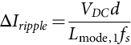 **(15.247)**

**** **(15.248)**

where *fs* is the switching frequency and *L*mode,1 and *L* are inductances of coupled and uncoupled converter. Clearly, the peak variation of input current in the case of coupled inductor is less compared with uncoupled inductor topology.

### 15.6.5 ADVANTAGES OF MULTIPHASE DC-DC CONVERTERS

Some of the advantages associated with multiphase DC-DC converters are listed below:

• Output ripple increases in multiplicity, reducing the filter requirements

• Reduction in the size and cost of output inductor and capacitor

• Reduction in the size and cost of input capacitor

• Reduced overall loss in the circuit compared with same rated single-phase counterpart

• Ideally suited for application requiring tight current regulation like VRM

• High-power and load current application like DC motor drives

## References

[1] Levi E., Bojoi R., Profumo F., Tolyat H.A., Williamson S. Multiphase induction motor drives – a technology status review. *Electr. Power Appl. IET.* 2007;1:489–516.

[2] Levi E. Multiphase electric machines for variable-speed applications. *IEEE Trans. Ind. Electron.* 2008;55:1893–1909.

[3] Bose B. Power electronics and motor drives: recent progress and perspective. *IEEE Trans. Ind. Electron.* Feb. 2009;56:581–588.

[4] Levi E. Advances in converter control and innovative exploitation of additional degrees of freedom for multiphase machines. *IEEE Trans. Ind. Electron.* 2016;63(1):433–448.

[5] Levi E., Bodo N., Dordevic O., Jones M. *Recent advances in power electronic converter control for multiphase drive systems.* In: 2013 IEEE Workshop on Electrical Machines Design, Control and Diagnosis (WEMDCD), Paris; 2013 pp. 158–167.

[6] McCoy T.J. *Trends in ship electric propulsion.* In: IEEE PES Summer Meeting, 25 July 2002, Chicago, IL; 2002:343–346.

[7] Tessarolo A., Zocco G., Tonello C. Design and testing of a 45-MW 100-Hz quadruple-star synchronous motor for a liquefied natural gas turbo-compressor drive. *IEEE Trans. Ind. Appl.* 2011;47(3):1210–1219.

[8] Tessarolo A. Experimental performance assessment of multiphase alternators supplying multiple AC/DC power converters. *J. Energy Power Eng.* 2010;4(12):43–50.

[9] Masoud M.I. *Five-phase uncontrolled line commutated rectifier: AC side compensation using shunt active power filter.* In: The Proceedings of 8th GCC Conference, 1–4 February, Muscat, Oman; 2015.

[10] Masoud M.I. Fully controlled 5-phase, 10-pulse, line commutated rectifier. *Alex. Eng. J.* 2015;54(4):1091–1104.

[11] Ali M., Khan M.R., Ayyub M. *Analysis of three-phase input to five-phase output matrix converter using direct transfer function approach.* In: IEEE RDCAPE; 2015:161–166.

[12] Ali M., Iqbal A., Khan M.R., Ayyub M., Anees M.A. Generalized theory and analysis of scalar modulation techniques for a m x n matrix converter. *IEEE Trans. Power Electron.* 2017;doi:10.1109/TPEL.2016.2600034.

[13] Tenti P., Malesani L., Rossetto L. Optimum control of N-input Koutputmatrix converters. *IEEE Trans. Power Electron.* 1992;7(4):707–713.

[14] Iqbal A., Abu-Rub H., Ahmed S.M., Khan M.R. *Carrier based PWM technique for a novel three-to-five phase matrix converter.* In: Proc. Power Conversion Intelligent Motion PCIM Europe, Nuremberg, Germany; 2010:998–1003.

[15] Ahmed S.M., Iqbal A., Abu-Rub H., Khan M. Rizwan. *Carrier-based PWM technique for a novel three-to-seven phase matrix converter.* In: Proc. Int. Conf. on Electrical Machines ICEM, Rome, Italy, CD-ROM paper RF 004944; 2010.

[16] Ahmed S.M., Iqbal A., Abu-Rub H., Rodriguez J., Rojas C.A., Saleh M. Simple carrier-based PWM technique for a three-to-nine-phase direct AC-AC converter. *IEEE Trans. Ind. Electron.* 2011;58(11):5014–5023.

[17] Iqbal A., Ahmed S.K.M., Abu-Rub H. Space vector PWM technique for a three-to-five phase matrix converter. *IEEE Trans. Ind. Appl.* 2012;48(2):697–707.

[18] Ahmed S.M., Iqbal A., Abu-Rub H. Generalized duty-ratio-based pulsewidth modulation technique for a three-to-k phase matrix converter. *IEEE Trans. Ind. Electron.* 2011;58(9):3925–3937.

[19] Li Y., Choi N.-S., Han B.-M., Kim K.M., Lee B., Park J.-H. Direct duty ratio pulse width modulation method for matrix converters. *Int. J Control Automat. Sys.* 2008;6(5):660–669.

[20] Ojo O., Abreham M., Karugaba S., Komolafe O.A. *Carrier-based modulation of non-square multi-phase AC-AC matrix converters.* In: Proc. IEEE Int. Symp. on Ind. Elec. ISIE, Bari, Italy; 2010:2141–2146.

[21] Szczepanik J., Sienko T. *A new concept of application of multiphase matrix converter in power systems.* In: Proc. The Int. Conf. on Computer as a Tool EUROCON, Warsaw, Poland; 2007:1535–1540.

[22] Szczepanik J. *Multiphase matrix converter for power systems application.* In: Proc. Int. Symp. on Power Electronics, Electrical Drives, Automation and Motion SPEEDAM, Ischia, Italy; 2008:772–777.

[23] Yi G., Xuekui Y. *Research on matrix converter control multiphase PMSM for all electric ship.* In: Proc. Int. Conf. on Electrical and Control Engineering ICECE, Yichang, China; 2011:3120–3123.

[24] Beguin A., Rufer A., Lacaze A. *Poly-phased matrix converter for large synchronous generators—design of the voltage surge protection.* In: Proc. 13th EPE, Barcelona, Spain; 2009:1–10 CD-ROM.

[25] Beguin A., Rufer A. *Poly-phased matrix converter—A 27 input phases to 3 output phases experimental set-up running with hard and soft commutation.* In: Proc. 14th EPE, Birmingham; 2011:1–10 CD-ROM.

[26] Baba D. *Benefits of a Multiphase Buck Converter.* Texas Instruments Incorporated: Analog Applications Journal; 2012.8–13.

[27] Singh B., Gairola S., Singh B.N., Chandra A., Al-Haddad K. Multipulse AC–DC converters for improving power quality: a review. *IEEE Trans. Power Electron.* 2008;51(3):641–660.

[28] Liu Y., Abu-Rub H., Ge B., Blaabjerg F., Ellabban O., Loh P. Chiang. *Impedance Source Power Electronic Converters.* Chichester, United Kingdom: IEEE-Wiley Press; 2016.

[29] Wu B. *High-Power Converters and AC Drives.* Piscataway, NJ: IEEE Press, Wiley-Interscience; 2006.

[30] Paice D.A. *Power Electronic Converter Harmonics: Multipulse Methods for Clean Power.* New York, NY: IEEE Press; 1996.

[31] Luo F.L., Ye H. *Power Electronics Advanced conversion technologies.* Boca Raton, FL: Taylor and Francis group; 2010.978-1-4200-9429-9.

[32] Iqbal A., Moinuddin S. Comprehensive Relationship Between Carrier-Based PWM and Space Vector PWM In a Five-Phase VSI. *IEEE Trans. Power Electron.* 2009;24(10):2379–2390.

[33] Moinuddin A. Iqbal, Khan M.R. *Space Vector Model of Five Phase Voltage Source Inverter.* In: Proceedings of IEEE International Conference on Industrial Technology, (ICIT 2006), Mumbai, India; 2006:488–493.

[34] Ojo O., Dong G. *Generalised discontinuous carrier-based PWM modulation scheme for multi-phase converter-machine systems.* In: Proc. IEEE Industry Applications Conference, 2005. 40th IAS Annual Meeting. Conference Record of the 2005, Hong Kong, vol. 2; 2005:1374–1381.

[35] Holmes G.D., Lipo T.A. Pulse Width Modulation for Power Converters-Principle and Practice. Piscataway, NJ: Wiley; 2003. *IEEE Press-Series on Power Engineering.*.

[36] Blasko V. Analysis of a hybrid PWM based on modified space vector and triangle comparison method. *IEEE Trans. Ind. Appl.* 1997;33(3):756–764. doi:10.1109/28.585866.

[37] Iqbal A., Levi E., Jones M., Vukosavic S.N. *Generalised sinusoidal PWM with harmonic injection for multi-phase VSIs.* In: Proc. IEEE Power Electron. Spec. Conf. (PESC), Jeju, Korea; 2006:2871–2877. doi:10.1109/PESC.2006.1712206.

[38] deSilva P.S.N., Fletcher J.E., Williams B.W. *Development of space vector modulation strategies for five-phase voltage source inverters.* In: Proc. Inst. Electr. Eng. Power Electron., Mach. Drives Conf. (PEMD), Edinburgh, vol. 2; 2004:650–655. doi:10.1049/cp:20040365.

[39] Kelly J.W., Strangas E.G., Miller J.M. Multiphase space vector pulse width modulation. *IEEE Trans. Energy Convers.* 2003;18(2):259–264. doi:10.1109/TEC.2003.811725.

[40] Moinuddin S., Iqbal A., Khan M.R. Space vector approach to model a seven-phase voltage source inverter. In: Proceedings of RACE, Bikaner, India; 2007:1050–1055. *2007.*.

[41] Moinuddin S., Iqbal A. Analysis of Space vector PWM for a seven-phase VSI. *I-Manger J. Eng. Technol.* 2007;1(2):53–63 ISSN Print: 0973 – 8835, ISSN Online: 2230-7176.

[42] Alesina A., Venturini M.G.B. Analysis and design of optimum-amplitude nine-switch direct AC-AC converters. *IEEE Trans. Power Electron.* 1989;4(1):101–112.

[43] Ali M., Khan M.R., Ayyub M. *Analysis of a three-to-five-phase matrix converter using DTFA.* In: IEEE-INDICON; 2015:1–6.

[44] Rahman K., Iqbal A., Al-Ammari R. *Space vector model of a three-phase to five-phase AC/AC converter.* In: IEEE-AFRICON; 2013.

[45] Abdelrahim O., Member I.S., Abu-rub H., Member I.S., Ahmed S.M. *Space vector PWM for a five to three matrix converter.* In: IEEE-APEC; 2013:3246–3250.

[46] Ahmed S.M., Salam Z., Abu-Rub H. An improved space vector modulation for a three-to-seven-phase matrix converter with reduced number of switching vectors. *IEEE Trans. Ind. Electron.* 2015;62(6):3327–3337.

[47] Iqbal A., Rahman K., Alammari R., Abu-Rub H. *Space Vector PWM for a Three-phase to Six- phase Direct AC/AC Converter.* 2015 pp. 1179–1184.

[48] Ahmed S.M., Member I., Abu-rub H., Senior I., Salam Z. *Dual matrix converters based seven-phase open-end winding drive.* In: IEEE-ISIE; 2014:2105–2110.

[49] Ahmed S.M., Abu-rub H., Salam Z. Common-mode voltage elimination in a three-to-five-phase dual matrix converter feeding a five-phase open-end drive using space-vector modulation technique. *IEEE Trans. Ind. Electron.* 2015;62(10):6051–6063.

[50] Sayed M.A., Iqbal A. Pulse width modulation technique for a three-to-five phase matrix converter with reduced commutations. *IET Power Electron.* 2016;9(3):466–475.

[51] Nguyen T.D., Lee H., Member S. Development of a three-to-five-phase indirect matrix converter with carrier-based pwm based on space-vector modulation analysis. *IEEE Trans. Ind. Electron.* 2016;63(1):13–24.

[52] Chai M., Xiao D., Dutta R., Fletcher J.E., Member S. Space vector PWM techniques for three-to-five-phase indirect matrix converter in the overmodulation region. *IEEE Trans. Ind. Electron.* 2016;63(1):550–561.

[53] Zhou Xunwei, Wong Pit-Leong, Xu Peng, Lee Fred C., Huang Alex Q. Investigation of candidate VRM topologies for future microprocessors. *IEEE Trans. Power Electron.* Nov 2000;15(6):1172–1182.

[54] Zhang X., Huang A.Q. *Investigation of VRM controllers.* In: Proceedings of 16th International Symposium on Power Semiconductor Devices & ICs; 2004:51–54.

[55] Jantharamin N., Zhang L. *Analysis of multiphase interleaved converter by using state-space averaging technique.* In: ECTI-CON; 2009:288–291.

[56] Schittler A.C., Pappis D., Rech C., Campos A., Dalla Costa M.A. *Generalized state-space model for the interleaved buck converter.* In: COBEP'11; 2011:451–457.

[57] Nguyen H. *Design, Analysis and Implementation of Multiphase Synchronous Buck DC-DC Converter for Transportable Processor.* (Master of science thesis) Virginia Tech; 2004 April.

[58] Garinto D. *A novel multiphase multi-interleaving buck converters for future microprocessors.* In: 12th International Power Electronics and Motion Control Conference, PEMC; 2006:82–87 Aug–Sep 2006.

[59] Wong P.L. *Performance Improvements of Multi-Channel Interleaving Voltage Regulator Modules with Integrated Coupling Inductors.* (Ph.D. dissertation) Virginia Tech; 2001 March.

[60] Xu P., Wei J., Lee F.C. Multiphase coupled-buck converter-a novel high efficient 12 V voltage regulator module. *IEEE Trans. Power Electron.* 2003;18:74–82.

[61] Soong T., Lehn P. *A transformerless high boost dc-dc converter for use in medium / high voltage applications.* In: IECON; 2012:174–179.

[62] Wang C. *Investigation on Interleaved Boost Converters and Applications.* (Ph.D. dissertation) Virginia Tech; 2009 July.

[63] Xu Peng. *Multiphase Voltage Regulator Modules with Magnetic Integration to Power Microprocessors.* (Ph.D. thesis) Virginia Polytechnic Institute and State University; 2002.

## Further Reading

[1] Panov Y., Jovanovic M.M. Design considerations for 12-V/1.5-V, 50-A voltage regulator modules. *IEEE Trans. Power Electron.* 2001;16(6):776–783.

**16**

# Power Factor Correction Circuits

Abdallah Kouzou Ziane Achour University of Djelfa, Djelfa, Algeria

## Abstract

This chapter presents an overview of various active harmonic reduction and power factor correction (PFC) techniques applied in single-phase power supply feeding DC-DC conversion stage that have been presented in the open literature up to date. The primary objective of writing this chapter is to give a brief introduction of these techniques and the basic topologies of DC-DC converters based on switched-mode topologies, especially those used in low and medium power level, where the main aim is to provide references for future researchers in this area. The discussion here includes some important points that are essential for understanding the PFC circuits in single-phase dedicated for DC power supply. This chapter starts with the presentation of the definition of total harmonics distortion (THD) and power factor (PF), the classical passive power factor correctors, and the basic circuit topologies of active power factor correctors. The second part of this chapter deals with the commonly used control strategies of active power factor correctors such as continuous conduction mode (CCM) shaping techniques, the discontinuous conduction mode (DCM) input technique, and the critical conduction mode (CRM) technique, where some applications on various types of converter topologies are presented. Finally, the possible future research trends are stressed in the summary section, and some selected literature references are presented for further reading.

### KEYWORDS

Power factor correction (PFC); Harmonics; Single-phase power supply; Power factor correctors; Continuous conduction mode for PFC; Discontinuous conduction mode for PFC; Critical conduction mode for PFC

16.1 [Introduction](https://learning.oreilly.com/library/view/power-electronics-handbook/9780128114087/B9780128114070000179.xhtml#s0010)

16.2 [Definition of PF and THD](https://learning.oreilly.com/library/view/power-electronics-handbook/9780128114087/B9780128114070000179.xhtml#s0015)

16.3 [Power Factor Correction](https://learning.oreilly.com/library/view/power-electronics-handbook/9780128114087/B9780128114070000179.xhtml#s0020)

16.3.1 Energy Balance in PFC Circuits

16.3.2 Passive Power Factor Corrector

16.3.3 Basic Circuit Topologies of Active Power Factor Correctors

16.3.4 System Configurations of PFC Power Supply

16.4 [CCM Shaping Technique](https://learning.oreilly.com/library/view/power-electronics-handbook/9780128114087/B9780128114070000179.xhtml#s0080)

16.4.1 Current Mode Control

16.4.2 Voltage Mode Control

16.5 [DCM Input Technique](https://learning.oreilly.com/library/view/power-electronics-handbook/9780128114087/B9780128114070000179.xhtml#s0140)

16.5.1 PFC Capabilities of the Basic Converter Topologies in DCM

16.5.2 AC-DC Power Supply with DCM Input Technique

16.5.3 CRM Technique

16.5.4 Other PFC Techniques

16.6 [Summary](https://learning.oreilly.com/library/view/power-electronics-handbook/9780128114087/B9780128114070000179.xhtml#s0205)

[References](https://learning.oreilly.com/library/view/power-electronics-handbook/9780128114087/B9780128114070000179.xhtml#bi0010)

## 16.1 Introduction

Today, there is an increased proliferation of power electronics converters, mainly in industrial and domestic applications due to their high inherent flexibility for ensuring the power conversion management at all power levels. Unfortunately, these converters are considered to be the major sources of power quality degradation in terms of current and voltage waveform distortion and power factor degradation. Indeed, power electronics converter is characterized by a nonlinear behavior which contributes to the pollution of the main utility power supply. On the other side, since ac electric energy is the most convenient form of energy to be generated, transmitted, and distributed through the main ac power systems, the stage of power conversion is primordial to ensure the required converted forms to the consumers in industry and residence applications. Therefore, the power electronics converter is unavoidable to be as an essential part of different power supply and a flexible control device in many applications. During the last years, large electricity consumers such as electrochemical and electrometallurgical industries applied capacitors as static var compensator (SVC) to their systems to ensure an effective cost solution by minimizing the demanded charges from utility companies and to ensure the dynamic voltage stabilization support, the efficiency, and the required reliability of the supply voltages. Indeed, this solution was highly recommended due to its low-cost, its high reliability, and its simple and easy integration within the existing and new infrastructures without the necessity of adding other new network extensions. As these capacitors present low impedance in the system, they contribute remarkably in drawing harmonic currents from the power supply. It is well evident that due to the nonzero system impedance along the lines, the circulating of the harmonic currents through these lines will create distorted drop voltages that will propagate. Consequently, the voltages at the points of different users' connection will be contaminated. The contaminative harmonics can decline power quality and affect the system performance in several ways [[1](https://learning.oreilly.com/library/view/power-electronics-handbook/9780128114087/B9780128114070000179.xhtml#bb0010)–[15](https://learning.oreilly.com/library/view/power-electronics-handbook/9780128114087/B9780128114070000179.xhtml#bb0080)]:

(a) The line *rms* current harmonics do not deliver any real power in watts to the load that is supplied by a sine waveform voltage, resulting in inefficient use of equipment capacity (i.e., low-power factor).

(b) Harmonics will increase conductor loss and iron loss in transformers of the transmission system. Therefore, the thermal problems will be increased, and the systems transmission system efficiency will be decreased.

(c) Beside the current unbalance in three-phase system, the odd harmonics are extremely harmful, contributing to the overload of the neutral conductor.

(d) The propagation of harmonics within the power system may cause oscillations that will absolutely affect the stability of system operation.

(e) High peak harmonic currents may cause automatic relay protection devices to mistrigger.

(f) Harmonics could cause other problems such as electromagnetic interference to interrupt communication, degrading reliability of electric equipment, increasing product defective ratio, insulation failure, and audible noise.

Perhaps the greatest impact of harmonic pollution appeared in the early 1970s when SVCs were extensively used for electric arc furnaces, metal rolling mills, and other high-power appliances. The harmonic currents produced by partial conduction of SVC are odd order, which are especially harmful to three-phase power system, especially for the star connection; if the star connection point is connected to the neutral line, this line will be overloaded; otherwise, this point will be supporting nonzero voltage. Harmonics can affect operations of other devices that are connected to the same system and, in some situation, the operations of themselves that generate the harmonics.

The ever deteriorated supply environment did not become a major concern until the early 1980s when the first technical standard IEEE519-1981 with respect to harmonic control at point of common coupling (PCC) was issued [[16](https://learning.oreilly.com/library/view/power-electronics-handbook/9780128114087/B9780128114070000179.xhtml#bb0085)]. The significance of issuing this standard was not only that it provided the technical reference for design engineers and manufactures but also that it opened the door of research area of harmonic reduction and power factor correction (PFC). These two main objectives are really meaning the input current shaping (ICS), although most researchers refer their work as PFC. This is why the term “PFC” is used through the whole chapter.

Stimulated by the harmonic control regulation, researchers and industry users started to develop low-cost devices and power electronic systems to reduce harmonics since it is neither economical nor necessary to eliminate the harmonics.

Research on harmonic reduction and PFC has become intensified in the early 1990s. With the rapid development in power semiconductor devices, power electronic systems have matured and expanded to new and wide application range from residential, commercial, and aerospace to military and others. Power electronic interfaces, such as switch-mode power supplies (SMPS), are now clearly superior over the traditional linear power supplies, resulting in more and more interfaces switched into power systems. While the SMPSs are highly efficient, but because of their nonlinear behavior, they draw distorted current from the line, resulting in high total harmonic distortion (THD) and low power factor (PF). To achieve a smaller output voltage ripple, practical SMPSs use a large electrolytic capacitor in the output side of the single-phase rectifier. Since the rectifier diodes conduct only when the line voltage is higher than the capacitor voltage, the power supply draws high *rms* pulsating line current. As a result, high THD and poor PF (usually less than 0.67) are present in such power systems [[1](https://learning.oreilly.com/library/view/power-electronics-handbook/9780128114087/B9780128114070000179.xhtml#bb0010),[7](https://learning.oreilly.com/library/view/power-electronics-handbook/9780128114087/B9780128114070000179.xhtml#bb0040),[8](https://learning.oreilly.com/library/view/power-electronics-handbook/9780128114087/B9780128114070000179.xhtml#bb0045),[17](https://learning.oreilly.com/library/view/power-electronics-handbook/9780128114087/B9780128114070000179.xhtml#bb0090)–[19](https://learning.oreilly.com/library/view/power-electronics-handbook/9780128114087/B9780128114070000179.xhtml#bb0100)].

Even though each device, individually, does not present much serious problem with the harmonic current, utility power supply condition could be deteriorated by the massive use of such systems. In recent years, declining power quality has become an important issue and continues to be recognized by government regulatory agencies. With the introduction of compulsory and more stringent technical standard such as IEC1000-3-2, more and more researchers from both industries and universities are focusing in the area of harmonic reduction and PFC, resulting in numerous circuit topologies and control strategies. Generally, the solution for harmonic reduction and PFC are classified into passive approach and active approach. The passive approach offers the advantages of high reliability, high-power-handling capability, and easy to design and maintain. However, the operation of passive compensation system is strongly dependent on the power system and does not achieve high PF. While the passive approach can be still the best choice in many high-power applications, the active approach dominates the low to medium power applications due to their extraordinary performance (PF and efficiency approach to 100%), regulation capabilities, and high density. With the power-handling capability of power semiconductor devices being extended to megawatts, the active power electronic systems tend to replace most of the passive power processing devices [[1](https://learning.oreilly.com/library/view/power-electronics-handbook/9780128114087/B9780128114070000179.xhtml#bb0010),[3](https://learning.oreilly.com/library/view/power-electronics-handbook/9780128114087/B9780128114070000179.xhtml#bb0020)–[5](https://learning.oreilly.com/library/view/power-electronics-handbook/9780128114087/B9780128114070000179.xhtml#bb0030)].

Actually, harmonics reduction and PFC techniques to improve the power quality within the network power supply are attracting very important researches in different applications for the lower power level, the medium power level, and the high-power level. Indeed power supply industries are undergoing the change of adopting more and more PFC techniques in all off-line power supplies. This chapter presents an overview of various active harmonic reduction and PFC techniques in the open literature up to date. The primary objective of writing this chapter is to give a brief introduction of these techniques and provide references for future researchers in this area. The discussion here includes definition of THD and PF, commonly used control strategies, and various types of converter topologies. Finally, the possible future research trends are stressed in the summary section.

## 16.2 Definition of PF and THD

*Power factor* is a very important parameter in power electronics because it gives a measure of how effective the real power utilization in the system is. It also represents a measure of distortion of the line voltage and the line current and phase shift between them. Referring to [Fig. 16.1A](https://learning.oreilly.com/library/view/power-electronics-handbook/9780128114087/B9780128114070000179.xhtml#f0010), the input PF at terminals  is defined as the ratio of the average of the instantaneous power or the real instantaneous power and the apparent power measured at terminals  as described in Eq. [(16.1)](https://learning.oreilly.com/library/view/power-electronics-handbook/9780128114087/B9780128114070000179.xhtml#fo0010) [[1](https://learning.oreilly.com/library/view/power-electronics-handbook/9780128114087/B9780128114070000179.xhtml#bb0010),[16](https://learning.oreilly.com/library/view/power-electronics-handbook/9780128114087/B9780128114070000179.xhtml#bb0085),[18](https://learning.oreilly.com/library/view/power-electronics-handbook/9780128114087/B9780128114070000179.xhtml#bb0095),[19](https://learning.oreilly.com/library/view/power-electronics-handbook/9780128114087/B9780128114070000179.xhtml#bb0100)]:

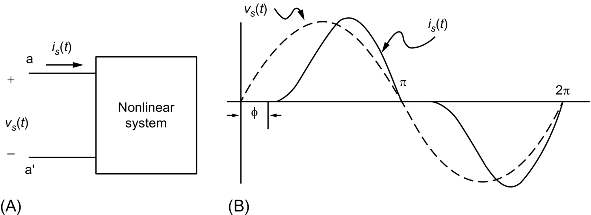

**FIG. 16.1** Nonlinear load draws distorted line current.

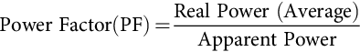 **(16.1)**

where the apparent power is defined as the product of *rms* values of instantaneous voltage *vs*(*t*) and instantaneous current *is*(*t*). It is well-known that if the load is linear, it draws purely sinusoidal current under sinusoidal voltage. In this case, the PF is only determined by the phase shift between *vs*(*t*) and *is*(*t*). Hence, Eq. [(16.1)](https://learning.oreilly.com/library/view/power-electronics-handbook/9780128114087/B9780128114070000179.xhtml#fo0010) becomes

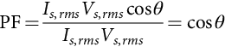 **(16.2)**

where *Is*,*rms* and *Vs*,*rms* are *rms* values of the current drawn by the load and the voltage applied to the load, respectively, and *θ* is the phase shift between instantaneous drawn current and instantaneous applied voltage. Hence, if the power system delivers a pure sine waveform voltage and the load is linear, the PF is simply equal to the cosine of the phase shift angle between the instantaneous current and instantaneous voltage. However, in power electronics system, due to the nonlinear behavior of active switching power devices, Eq. [(16.2)](https://learning.oreilly.com/library/view/power-electronics-handbook/9780128114087/B9780128114070000179.xhtml#fo0015) is not valid anymore, and the phase-angle representation alone is not enough for the calculation of the PF which becomes more delicate. [Fig. 16.1B](https://learning.oreilly.com/library/view/power-electronics-handbook/9780128114087/B9780128114070000179.xhtml#f0010) shows a typical distorted current drawn from the pure sinusoidal power source. It is obvious that the calculation of the PF for distorted waveforms of the current or/and voltage is more complex when compared with the sinusoidal current and voltage waveforms. If both line voltage and line current are distorted, in this case Eqs. [(16.3)](https://learning.oreilly.com/library/view/power-electronics-handbook/9780128114087/B9780128114070000179.xhtml#fo0020) and [(16.4)](https://learning.oreilly.com/library/view/power-electronics-handbook/9780128114087/B9780128114070000179.xhtml#fo0025) give the Fourier expansion representations for the instantaneous drawn current and instantaneous power source voltage, respectively [[1](https://learning.oreilly.com/library/view/power-electronics-handbook/9780128114087/B9780128114070000179.xhtml#bb0010)]:

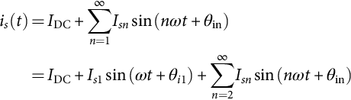 **(16.3)**

**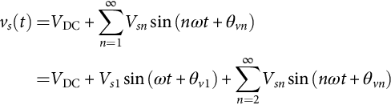** **(16.4)**

Practically, the two DC (average value) of the instantaneous current and voltage that are expected to be seen from the power supply side are equal to zero due to the symmetry of the positive and negative parts of the voltage and current during one period; therefore, *I*DC=*V*DC=0. Applying the definition of PF given in Eq. [(16.1)](https://learning.oreilly.com/library/view/power-electronics-handbook/9780128114087/B9780128114070000179.xhtml#fo0010) to the distorted current and voltage waveforms of Eqs. [(16.3)](https://learning.oreilly.com/library/view/power-electronics-handbook/9780128114087/B9780128114070000179.xhtml#fo0020) and [(16.4)](https://learning.oreilly.com/library/view/power-electronics-handbook/9780128114087/B9780128114070000179.xhtml#fo0025), PF may be expressed as:

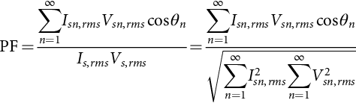 **(16.5)**

where *Vsn*,*rms* and *Isn*,*rms* are the *rms* values of the *n*th harmonic voltage and current, respectively, and *θn* is the phase shift between the instantaneous voltage and current corresponding to the nth harmonic .

Since most of power electronic systems draw their input voltage from a pure sine waveform power supply voltage *vs*(*t*), the above expression can be significantly simplified by assuming that the power supply voltage has a pure sine waveform and the distortion is only included in the instantaneous current *is*(*t*), that is,

 **(16.6)**

**** **(16.7)**

Then, it can be shown that the PF can be expressed as

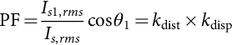 **(16.8)**

where

*θ*1: the phase-angle between the voltage *vs*(*t*) and the fundamental component of *is*(*t*),

*Is*1,*rms*: *rms* value of the fundamental component in line current,

*Is*,*rms*: total *rms* value of line current,

: distortion factor,

: displacement factor.

Another important parameter which measures the percentage of current distortion is known as the current total harmonic distortion (THD*i*), which is defined as follows:

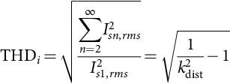 **(16.9)**

Conventionally, SMPSs use capacitive rectifiers in front of the ac line that results in the capacitor voltage *vc* and high *rms* pulsating line current *il*(*t*) as shown in [Fig. 16.2](https://learning.oreilly.com/library/view/power-electronics-handbook/9780128114087/B9780128114070000179.xhtml#f0015), when *vl*(*t*) is the line voltage. The typical input current harmonic distortion THD*i* for this kind of rectification is usually in the range of 55%–65%, and the PF is about 0.65 [[20](https://learning.oreilly.com/library/view/power-electronics-handbook/9780128114087/B9780128114070000179.xhtml#bb0105),[21](https://learning.oreilly.com/library/view/power-electronics-handbook/9780128114087/B9780128114070000179.xhtml#bb0110)]. It can be said also that the actual current wave shape and the resulting harmonics depend on the line impedance. This input current character creates several problems within the distribution network and consequently affecting the other electric apparatus in the vicinity of the rectifier. However, some solution has been proposed to overcome these drawbacks especially for high-power. The present chapter is focusing mainly on the study of the improvement of the current shape and PFC related to line current of single-phase rectifier followed by DC-DC converter that are mainly used for limited power level.

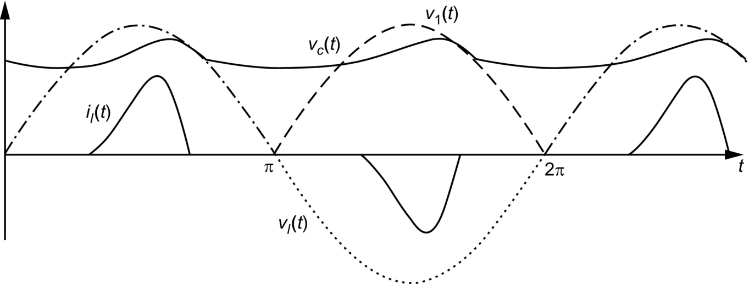

**FIG. 16.2** Typical waveforms in a poor PF system.

As we can see from Eqs. [(16.8)](https://learning.oreilly.com/library/view/power-electronics-handbook/9780128114087/B9780128114070000179.xhtml#fo0045) and [(16.9)](https://learning.oreilly.com/library/view/power-electronics-handbook/9780128114087/B9780128114070000179.xhtml#fo0050), PF and THD are related to distortion and displacement factors. Therefore, improvement in PF, that is, PFC, also implies harmonic reduction, especially the low order harmonics [[1](https://learning.oreilly.com/library/view/power-electronics-handbook/9780128114087/B9780128114070000179.xhtml#bb0010)].

## 16.3 Power Factor Correction

### **16.3.1 ENERGY BALANCE IN PFC CIRCUITS**

[Fig. 16.3](https://learning.oreilly.com/library/view/power-electronics-handbook/9780128114087/B9780128114070000179.xhtml#f0020) shows a diagram of an AC-DC PFC unit. Let *vi*(*t*) and *il*(*t*) be the line voltage (the power source voltage) and line current (the drawn current from the power source), respectively. For an ideal PFC unit (), we assume

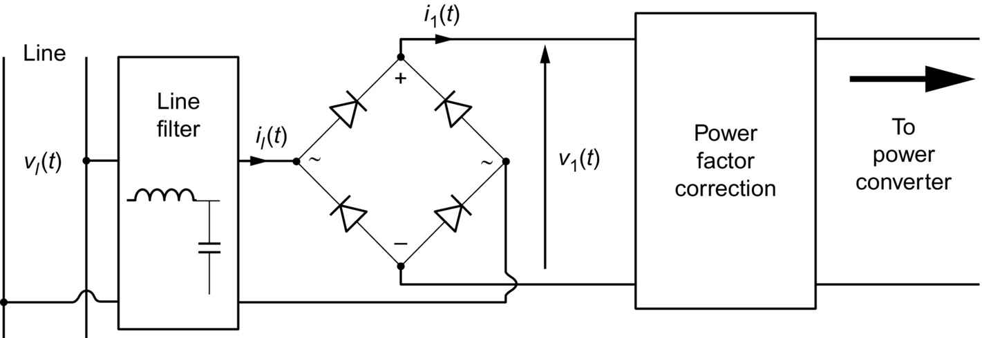

**FIG. 16.3** Block diagram of ac-dc PFC unit.

 **(16.10a)**

**** **(16.10b)**

where *Vlm* and *Ilm* are amplitudes of line voltage and line current, respectively, and *ωl* is the angular line frequency. The instantaneous input power is given by

 **(16.11)**

where  is constant value that is presenting the average of the instantaneous input power *p*in(*t*). It is important to clarify that only this part of power is contributing for the production of the effective energy that can be used by the load; therefore, it is often called the real power. On the other side, *p*in(*t*) possesses also an alternative component with frequency 2*ωl* as shown in [Fig. 16.4](https://learning.oreilly.com/library/view/power-electronics-handbook/9780128114087/B9780128114070000179.xhtml#f0025) (i.e., 100 or 120 Hz, following the used power supply 50 or 60 Hz, respectively). Therefore, the operation principle of a PFC circuit is to process the input power in a certain way that it stores the excessive input energy when *p*in(*t*) is greater than  and releases the stored energy when *p*in(*t*) is less than , where a compensation is achieved between the stored energy and the released energy in these two stages ([Fig. 16.4](https://learning.oreilly.com/library/view/power-electronics-handbook/9780128114087/B9780128114070000179.xhtml#f0025)). The average value between these two terms of energy is equal to zero. We can estimate the instantaneous excessive power as

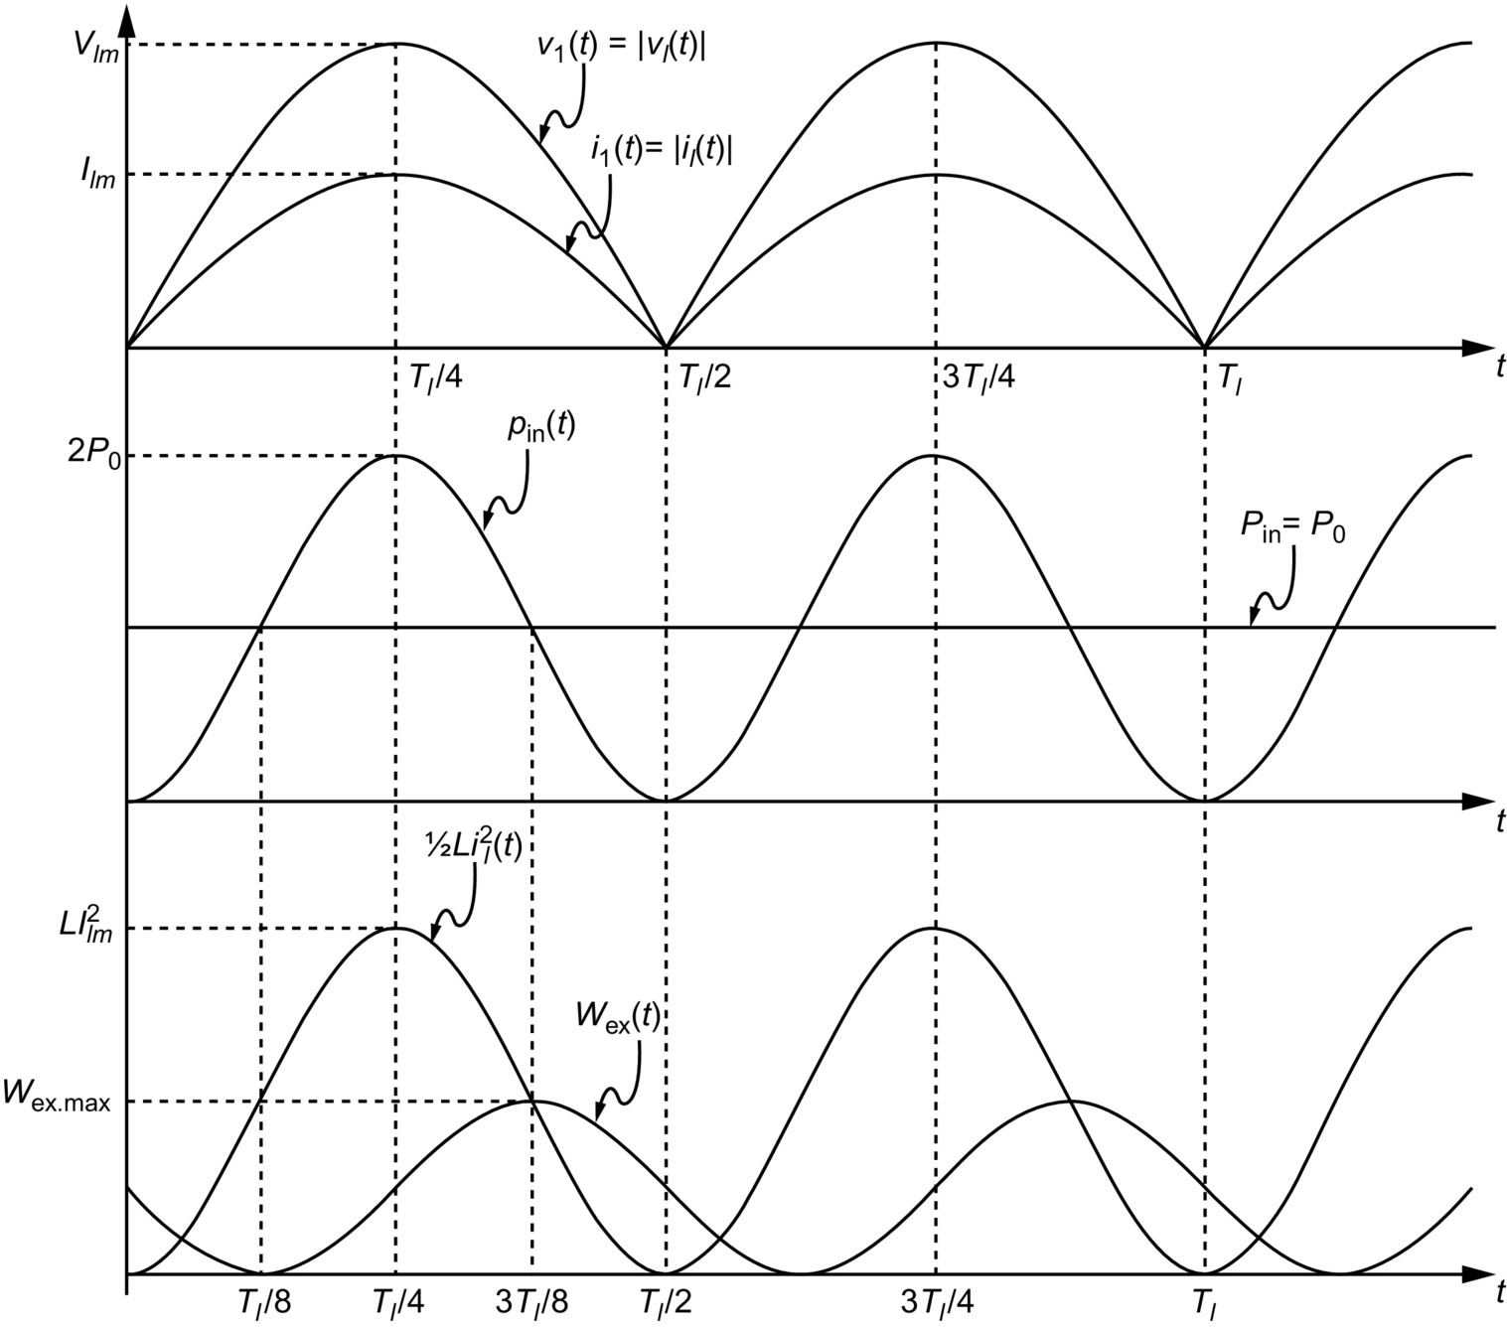

**FIG. 16.4** Energy balance in PF corrector.

 **(16.12)**

Hence, the instantaneous excessive input energy, *w*ex(*t*), is given by

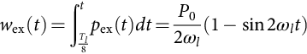 **(16.13)**

At  and , the excessive input energy is null, and at , the excessive input energy reaches the peak value

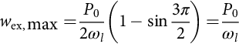 **(16.14)**

To achieve this concept of the dynamic behavior of the excessive input energy variation, the PFC circuit has to ensure this both functionality of storing the excessive energy and realizing the stored excessive energy by integrating the basic dynamic components (inductor and capacitor) in the PFC circuit. Indeed, in most of the PFC circuits that have been used in such applications, an input inductor is used to carry the line current. To obtain a unity PF, it is well obvious that the inductor current (or averaged inductor current in switch-mode PFC circuit) must be a pure sinusoidal and in phase with the line voltage. The energy stored in the inductor (1/2*LiL*2(*t*)) cannot completely match the change of the excessive energy as shown in [Fig. 16.4](https://learning.oreilly.com/library/view/power-electronics-handbook/9780128114087/B9780128114070000179.xhtml#f0025). Therefore, to maintain the output power constant, another energy storage component (usually the output capacitor) is needed [[1](https://learning.oreilly.com/library/view/power-electronics-handbook/9780128114087/B9780128114070000179.xhtml#bb0010)].

### 16.3.2 PASSIVE POWER FACTOR CORRECTOR

Because of their high reliability and high-power-handling capability, passive power factor correctors are normally used in high-power-line applications. Series-tuned *LC* harmonic filter is commonly used for heavy plant loads such as arc furnaces, metal rolling mills, and electric locomotives [[1](https://learning.oreilly.com/library/view/power-electronics-handbook/9780128114087/B9780128114070000179.xhtml#bb0010)]. [Fig. 16.5](https://learning.oreilly.com/library/view/power-electronics-handbook/9780128114087/B9780128114070000179.xhtml#f0030) shows a connection diagram of a selective low frequency harmonic filter together with line frequency switched reactor SVC. By tuning the filter branches to odd harmonic of low frequencies, the filter shunts the harmonic currents. Since each branch presents capacitive at line frequency, the filter also provides capacitive SVC for the system, whereas the integration of the thyristor-controlled reactor (TCR) in parallel with this selected group of low frequency filters keeps an optimized static var compensation for the system so that higher PF can be maintained.



**FIG. 16.5** Series-tuned *LC* harmonic filter PF corrector.

The design of the tuned filter PF corrector is particularly difficult because of the uncertainty of the system impedance and the characteristics of the harmonic sources. Besides, this method involves too many expensive components and takes huge space in comparison with the active PFC method.

For the applications where the power level is less than 10 kW, the tuned filter PF corrector may not be a better choice. The most common off-line passive PF corrector is the inductive-input filter, shown in [Fig. 16.6](https://learning.oreilly.com/library/view/power-electronics-handbook/9780128114087/B9780128114070000179.xhtml#f0035). This filter can operate either in the continuous conduction mode (CCM), in which the rectifier bridge is always conducting, or in the discontinuous conduction mode (DCM) where the rectifier is off during a portion of the line period [[22](https://learning.oreilly.com/library/view/power-electronics-handbook/9780128114087/B9780128114070000179.xhtml#bb0115),[23](https://learning.oreilly.com/library/view/power-electronics-handbook/9780128114087/B9780128114070000179.xhtml#bb0120)]. A conduction parameter *Kl* is defined in the literature based on the values of the filter parameters, the inductance *L*, the assumed resistor *R*, and the line input frequency *ωl* as follows:

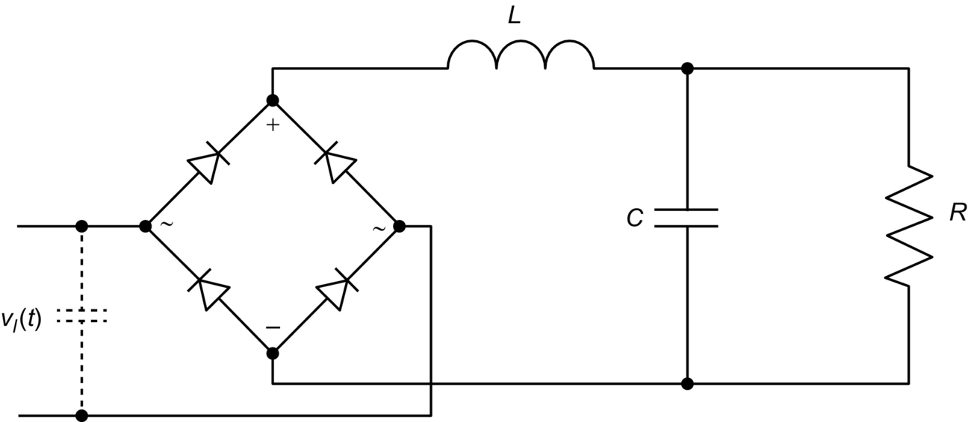

**FIG. 16.6** Inductive-input PF corrector.

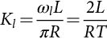 **(16.15)**

The assumed resistor represents the ratio between the average value of the voltage and the average value of the current at the output side of the filter.

For operation in CCM, the PF is defined as [[22](https://learning.oreilly.com/library/view/power-electronics-handbook/9780128114087/B9780128114070000179.xhtml#bb0115),[23](https://learning.oreilly.com/library/view/power-electronics-handbook/9780128114087/B9780128114070000179.xhtml#bb0120)]:

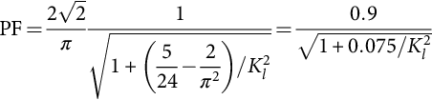 **(16.16)**

Depending on the filter inductance, this circuit can achieve a maximum PF of 90%, which is corresponding to the theoretical value of . On the other side, it was found in [[22](https://learning.oreilly.com/library/view/power-electronics-handbook/9780128114087/B9780128114070000179.xhtml#bb0115),[23](https://learning.oreilly.com/library/view/power-electronics-handbook/9780128114087/B9780128114070000179.xhtml#bb0120)] that the critical value of *Kl*(*Klcrit*) that makes the minimum of the inductor current reach the zero value is ; this value makes the PF to fall to the value of 73.2%. In case where , the current passes to the DCM [[23](https://learning.oreilly.com/library/view/power-electronics-handbook/9780128114087/B9780128114070000179.xhtml#bb0120)].

The PF corrector is simply a low-pass inductive filter as shown in [Fig. 16.7](https://learning.oreilly.com/library/view/power-electronics-handbook/9780128114087/B9780128114070000179.xhtml#f0040), whose transfer function and input impedance are given by [[1](https://learning.oreilly.com/library/view/power-electronics-handbook/9780128114087/B9780128114070000179.xhtml#bb0010)]

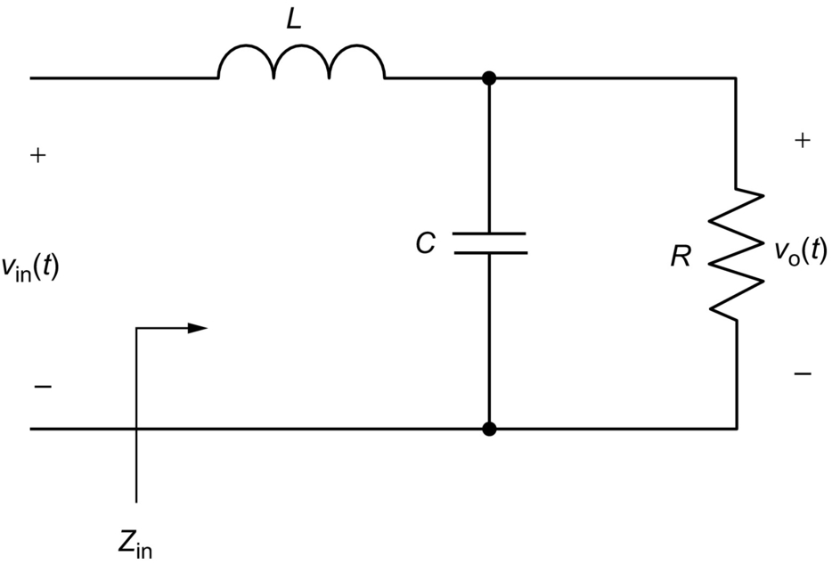

**FIG. 16.7** Low-pass inductive filter.

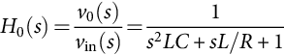 **(16.17)**

**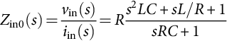** **(16.18)**

This kind of filter shown in [Fig. 16.6](https://learning.oreilly.com/library/view/power-electronics-handbook/9780128114087/B9780128114070000179.xhtml#f0035) is characterized by the following main advantages:

(a) It has a simple structure.

(b) It is reliable.

(c) The cost is very low because only a filter is required.

(d) The high-frequency switching losses are absent, and it is not sensitive to noises and surges.

(e) The equipments used in this circuit do not generate high-frequency EMI.

The above equations show that the unavoidable phase displacement is incurred in the inductive filter corrector. Because the filter frequency of operation is low (line frequency), large value inductor and capacitor have to be used. As a result, the following main disadvantages are presented in the most passive PF correctors:

(a) Only less than 0.9 PF can be achieved.

(b) The output voltage cannot be regulated under uncontrolled rectifier.

(c) The efficiency is low.

(d) THD is high.

(e) It cannot provide satisfactory results for wide load range.

(f) They are heavy and bulky, because, for achieving a better power factor, the size of the filter increases.

(g) The output is unregulated.

(h) The dynamic response is poor due to the time lag associated with the passive elements.

(i) They are sensitive to circuit parameters.

(j) Although by filtering the harmonics that can be filtered out, the fundamental component may get phase-shifted, thus reducing the power factor.

(k) The shape of input current is dependent upon what kind of load is connected.

(l) Optimization of the design is difficult.

### 16.3.3 BASIC CIRCUIT TOPOLOGIES OF ACTIVE POWER FACTOR CORRECTORS

In recent years, using the switched-mode topologies, many circuits and control methods are developed up to date to comply with certain standard (such as IEEE Std 519 and IEC1000-3-2). To achieve this, high-frequency switching techniques have been used to shape the input current waveform successfully [[1](https://learning.oreilly.com/library/view/power-electronics-handbook/9780128114087/B9780128114070000179.xhtml#bb0010)]. Basically, the active PF correctors that are used to accomplish the PFC function in single-phase power supply are based on the well-known basic converter topologies or their developed versions.

#### **16.3.3.1 The Buck Corrector**

[Fig. 16.8A](https://learning.oreilly.com/library/view/power-electronics-handbook/9780128114087/B9780128114070000179.xhtml#f0045) shows the buck PF corrector. By using PWM switch modeling technique [[24](https://learning.oreilly.com/library/view/power-electronics-handbook/9780128114087/B9780128114070000179.xhtml#bb0125)], the circuit topology can be modeled by the equivalent circuit shown in [Fig. 16.8B](https://learning.oreilly.com/library/view/power-electronics-handbook/9780128114087/B9780128114070000179.xhtml#f0045). It should be pointed out that the circuit model is a large signal model; therefore, analysis of PF performance based on this model is valid. It can be shown that the transfer function and input impedance are given by [[1](https://learning.oreilly.com/library/view/power-electronics-handbook/9780128114087/B9780128114070000179.xhtml#bb0010)]

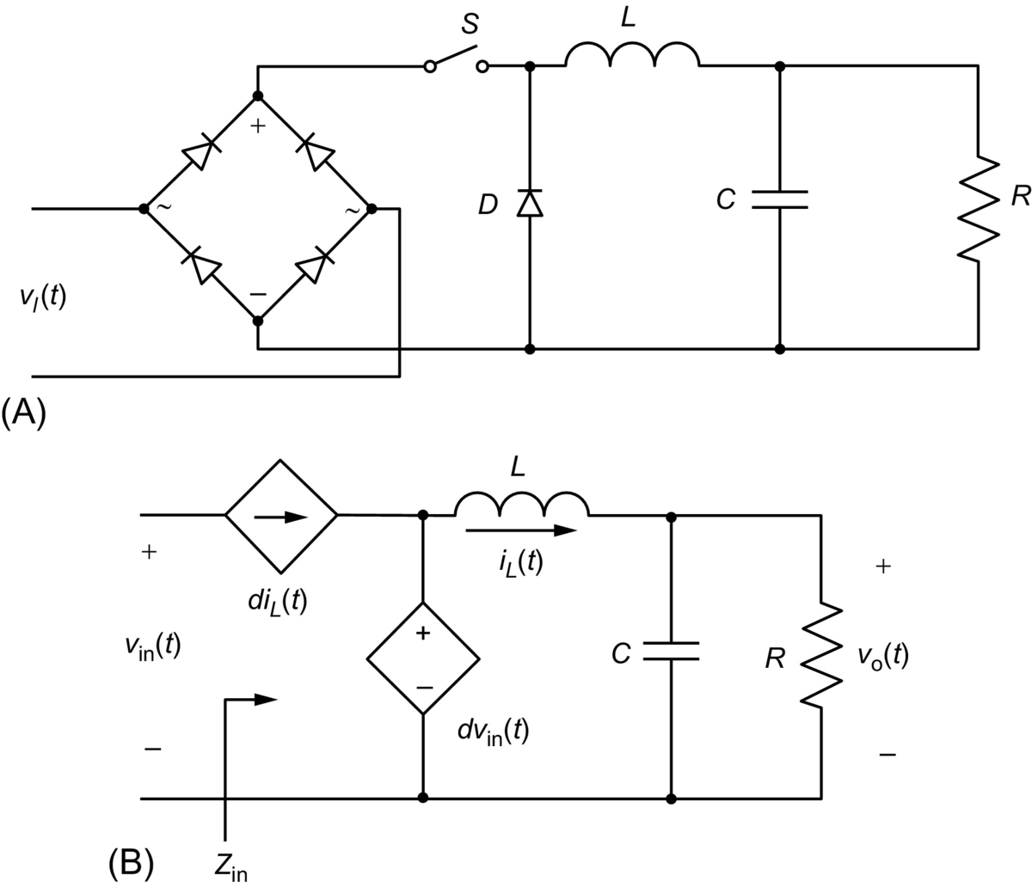

**FIG. 16.8** (A) Buck corrector and (B) PWM switch model for buck corrector.

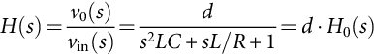 **(16.19)**

**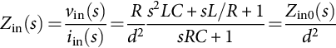** **(16.20)**

where *d* is the duty ratio of the switching signal.

Notice that Eqs. [(16.18)](https://learning.oreilly.com/library/view/power-electronics-handbook/9780128114087/B9780128114070000179.xhtml#fo0100) and [(16.19)](https://learning.oreilly.com/library/view/power-electronics-handbook/9780128114087/B9780128114070000179.xhtml#fo0105) are different from Eqs. [(16.16)](https://learning.oreilly.com/library/view/power-electronics-handbook/9780128114087/B9780128114070000179.xhtml#fo0090) and [(16.17)](https://learning.oreilly.com/library/view/power-electronics-handbook/9780128114087/B9780128114070000179.xhtml#fo0095), in that they have introduced the control variable *d*. By properly controlling the switching duty ratio to modulate the input impedance and the transfer function, a pure resistive input impedance and constant output voltage can be approached [[1](https://learning.oreilly.com/library/view/power-electronics-handbook/9780128114087/B9780128114070000179.xhtml#bb0010)]. Thereby, unity PF and output regulation can both be achieved. These control techniques will be discussed in the next section.

Comparing with the other type of high-frequency PFC circuits, the buck corrector offers inrush-current limiting, overload or short-circuit protection, and overvoltage protection for the converter due to the existence of the power switch in front of the line. Another advantage is that the output voltage is lower than the peak of the line voltage, which is usually the case normally desired. The drawbacks of using buck corrector may be summarized as follows [[1](https://learning.oreilly.com/library/view/power-electronics-handbook/9780128114087/B9780128114070000179.xhtml#bb0010)]:

(a) When the output voltage is higher than the line voltage, the converter draws no current from the line, resulting in significant line current distortion near the zero-across of the line voltage.

(b) The input current is discontinuous, leading to high differential mode EMI.

(c) The current stress on the power switch is high.

(d) The power switch needs a floating drive.

#### **16.3.3.2 The Boost Corrector**

The boost corrector and its equivalent PWM switch modeling circuit are shown in [Fig. 16.9A and B](https://learning.oreilly.com/library/view/power-electronics-handbook/9780128114087/B9780128114070000179.xhtml#f0050). Its transfer function and input impedance are given by [[1](https://learning.oreilly.com/library/view/power-electronics-handbook/9780128114087/B9780128114070000179.xhtml#bb0010)]

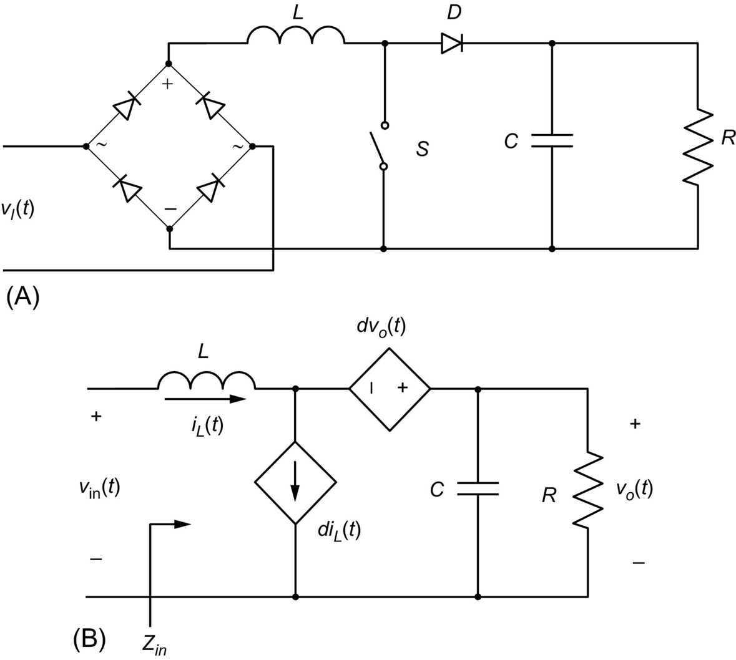

**FIG. 16.9** (A) Boost corrector and (B) PWM switch model of boost corrector.

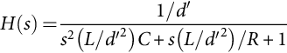 **(16.21)**

**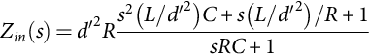** **(16.22)**

where .

Unlike in the buck case, it is interesting to note that in the boost case, the equivalent inductance is controlled by the switching duty ratio. Consequently, both the magnitude and the phase of the impedance, and both the dc gain and the pools of the transfer function are modulated by the duty ratio, which implies a tight control of the input current and the output voltage. Other advantages of boost corrector include less EMI and lower switch current and grounded drive. The shortcomings with the boost corrector are summarized as [[1](https://learning.oreilly.com/library/view/power-electronics-handbook/9780128114087/B9780128114070000179.xhtml#bb0010)]

(a) the output voltage must be higher than the peak of line voltage;

(b) inrush-current limiting, overload, and overvoltage protections are not available.

#### **16.3.3.3 The Buck-Boost Corrector**

The buck-boost corrector and its equivalent circuit are shown in [Fig. 16.10A and B](https://learning.oreilly.com/library/view/power-electronics-handbook/9780128114087/B9780128114070000179.xhtml#f0055). The expressions for transfer function and input impedance are [[1](https://learning.oreilly.com/library/view/power-electronics-handbook/9780128114087/B9780128114070000179.xhtml#bb0010)]

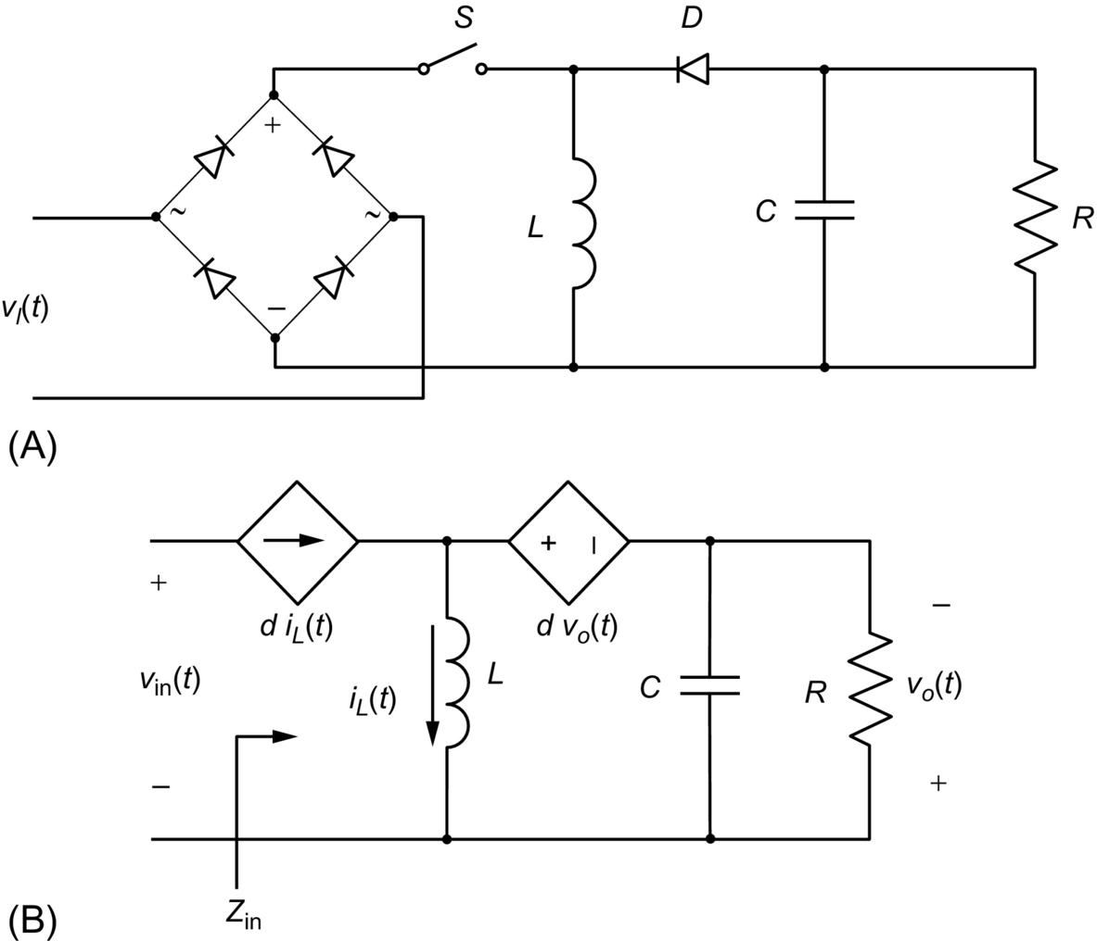

**FIG. 16.10** (A) Buck-boost corrector and (B) PWM switch model of buck-boost corrector.

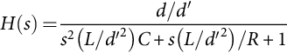 **(16.23)**

**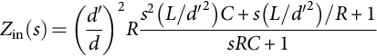** **(16.24)**

The buck-boost corrector combines some advantages of the buck corrector and the boost corrector. Like a buck corrector, it can provide circuit protections and step-down output voltage, and like a boost corrector its input current waveform and output voltage can be tightly controlled. However, the buck-boost corrector has the following disadvantages [[1](https://learning.oreilly.com/library/view/power-electronics-handbook/9780128114087/B9780128114070000179.xhtml#bb0010)]:

(a) The input current is discontinued by the power switch, resulting in high differential mode EMI.

(b) The current stress on the power switch is high.

(c) The power switch needs a floating drive.

(d) The polarity of output voltage is reversed.

#### **16.3.3.4 The Cuk, Sepic, and Zeta Correctors**

Unlike the previous converters, the Cuk, Sepic, and Zeta converters are fourth-order switching-mode circuits. Their circuit topologies for PFC are shown in [Fig. 16.11A–C](https://learning.oreilly.com/library/view/power-electronics-handbook/9780128114087/B9780128114070000179.xhtml#f0060), respectively. Because there are four energy storage components available to handle the energy balancing involved in PFC, second-harmonic output voltage ripples of these correctors are smaller when compared with the second-order buck, boost, and buck-boost topologies. These PF correctors are also able to provide overload protection. However, the increased count of components and current stress are undesired [[1](https://learning.oreilly.com/library/view/power-electronics-handbook/9780128114087/B9780128114070000179.xhtml#bb0010)].

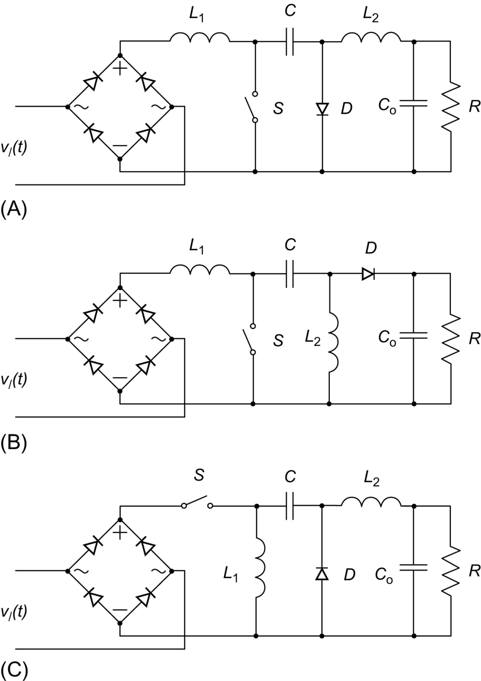

**FIG. 16.11** Fourth-order corrector: (A) Cuk corrector, (B) Sepic corrector, and (C) Zeta corrector.

#### **16.3.3.5 Flyback Corrector**

The flyback corrector allows to the input current to be shaped into a rectified sine wave, which is in phase with the input voltage, thus achieving a high PF and low harmonics content. Indeed, it is one of the most used active PFC converters, which has been widely used as an isolated front-stage PFC converter [[25](https://learning.oreilly.com/library/view/power-electronics-handbook/9780128114087/B9780128114070000179.xhtml#bb0130),[26](https://learning.oreilly.com/library/view/power-electronics-handbook/9780128114087/B9780128114070000179.xhtml#bb0135)] and as a single-stage PFC [[27](https://learning.oreilly.com/library/view/power-electronics-handbook/9780128114087/B9780128114070000179.xhtml#bb0140)–[32](https://learning.oreilly.com/library/view/power-electronics-handbook/9780128114087/B9780128114070000179.xhtml#bb0165)]. Indeed, this topology presents many advantages such as isolation between input and output, low-cost, and simple structure. However, the large voltage stress on the primary switch and the large current stress through the output diode have limited its application to low-power level [Fig. 16.12](https://learning.oreilly.com/library/view/power-electronics-handbook/9780128114087/B9780128114070000179.xhtml#f0065) [[33](https://learning.oreilly.com/library/view/power-electronics-handbook/9780128114087/B9780128114070000179.xhtml#bb0170)–[39](https://learning.oreilly.com/library/view/power-electronics-handbook/9780128114087/B9780128114070000179.xhtml#bb0200)].

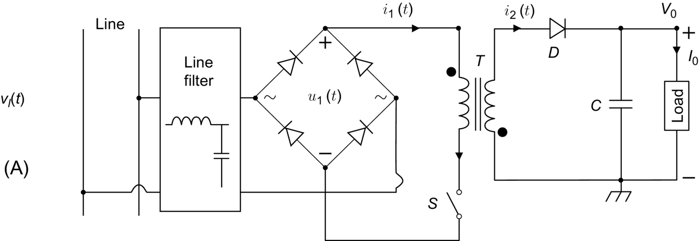

**FIG. 16.12** Flyback corrector.

The flyback PFC topology can operate under the three modes: continuous current mode (CCM), discontinuous current mode (DCM), and critical conduction mode (CRM). The operating mode is chosen upon the behavior of the freewheeling diode at the isolating transformer secondary side when the main switch “S” is turned off in one switch period.

The CCM operation of the flyback PFC converter requires two control loops. The first control loop is used to control the current to ensure the line current wave shape and a zero shift phase between the line voltage and line current, consequently a unity PF, can be obtained. The second control loop is used to control the output voltage to achieve its regulation. For DCM and CRM flyback PFC converters, only voltage control loop is required, which allows to obtained circuits that are simpler than that of CCM flyback PFC converter, this makes the DCM and CRM flyback PFC converters to be more widely used [[35](https://learning.oreilly.com/library/view/power-electronics-handbook/9780128114087/B9780128114070000179.xhtml#bb0180)–[42](https://learning.oreilly.com/library/view/power-electronics-handbook/9780128114087/B9780128114070000179.xhtml#bb0215)].

#### **16.3.3.6 Forward, Forward-Flyback Correctors**

The forward converter is presenting the simplest isolated buck-type converter, which has been widely applied for DC/DC conversions. The use of the basic topology and the practical topology shown in [Fig. 16.13A and B](https://learning.oreilly.com/library/view/power-electronics-handbook/9780128114087/B9780128114070000179.xhtml#f0070) of the forward converter for PFC applications include several disadvantages: (1) The typical single-ended forward converter requires a third additional auxiliary winding to ensure the transformer energy reset demagnetization [[43](https://learning.oreilly.com/library/view/power-electronics-handbook/9780128114087/B9780128114070000179.xhtml#bb0220)], (2) it has the same drawbacks and limits of the basic topology of the buck PFC converter [[43](https://learning.oreilly.com/library/view/power-electronics-handbook/9780128114087/B9780128114070000179.xhtml#bb0220)–[45](https://learning.oreilly.com/library/view/power-electronics-handbook/9780128114087/B9780128114070000179.xhtml#bb0230)], and (3) as shown in [Fig. 16.13A](https://learning.oreilly.com/library/view/power-electronics-handbook/9780128114087/B9780128114070000179.xhtml#f0070), when the output voltage *V0* is greater than the input rectified voltage *V*in, dead zones appear in the input current waveforms *i*in, that can degrade the PF and contribute to the increase of the harmonics content. These main disadvantages make the basic topology forward PFC difficult to be used in PFC applications. However, many works have presented improved topologies of this kind of converter to fulfill the requirement of decreased input current harmonics distortion and higher PF. One of such topologies that was proposed to overcome the main disadvantages of the basic topology of the forward converter is the forward-flyback PFC topology that combines the basic forward topology and the basic flyback topology, where only one common switch and one common transfer are used as shown in [Fig. 16.13C](https://learning.oreilly.com/library/view/power-electronics-handbook/9780128114087/B9780128114070000179.xhtml#f0070) [[46](https://learning.oreilly.com/library/view/power-electronics-handbook/9780128114087/B9780128114070000179.xhtml#bb0235)–[50](https://learning.oreilly.com/library/view/power-electronics-handbook/9780128114087/B9780128114070000179.xhtml#bb0255)]. In this topology, when the input voltage is not large enough to enable the forward operation, the flyback converter contributes to the power transfer. The main advantages of the proposed topology are the following [[24](https://learning.oreilly.com/library/view/power-electronics-handbook/9780128114087/B9780128114070000179.xhtml#bb0125),[46](https://learning.oreilly.com/library/view/power-electronics-handbook/9780128114087/B9780128114070000179.xhtml#bb0235)–[50](https://learning.oreilly.com/library/view/power-electronics-handbook/9780128114087/B9780128114070000179.xhtml#bb0255)]:

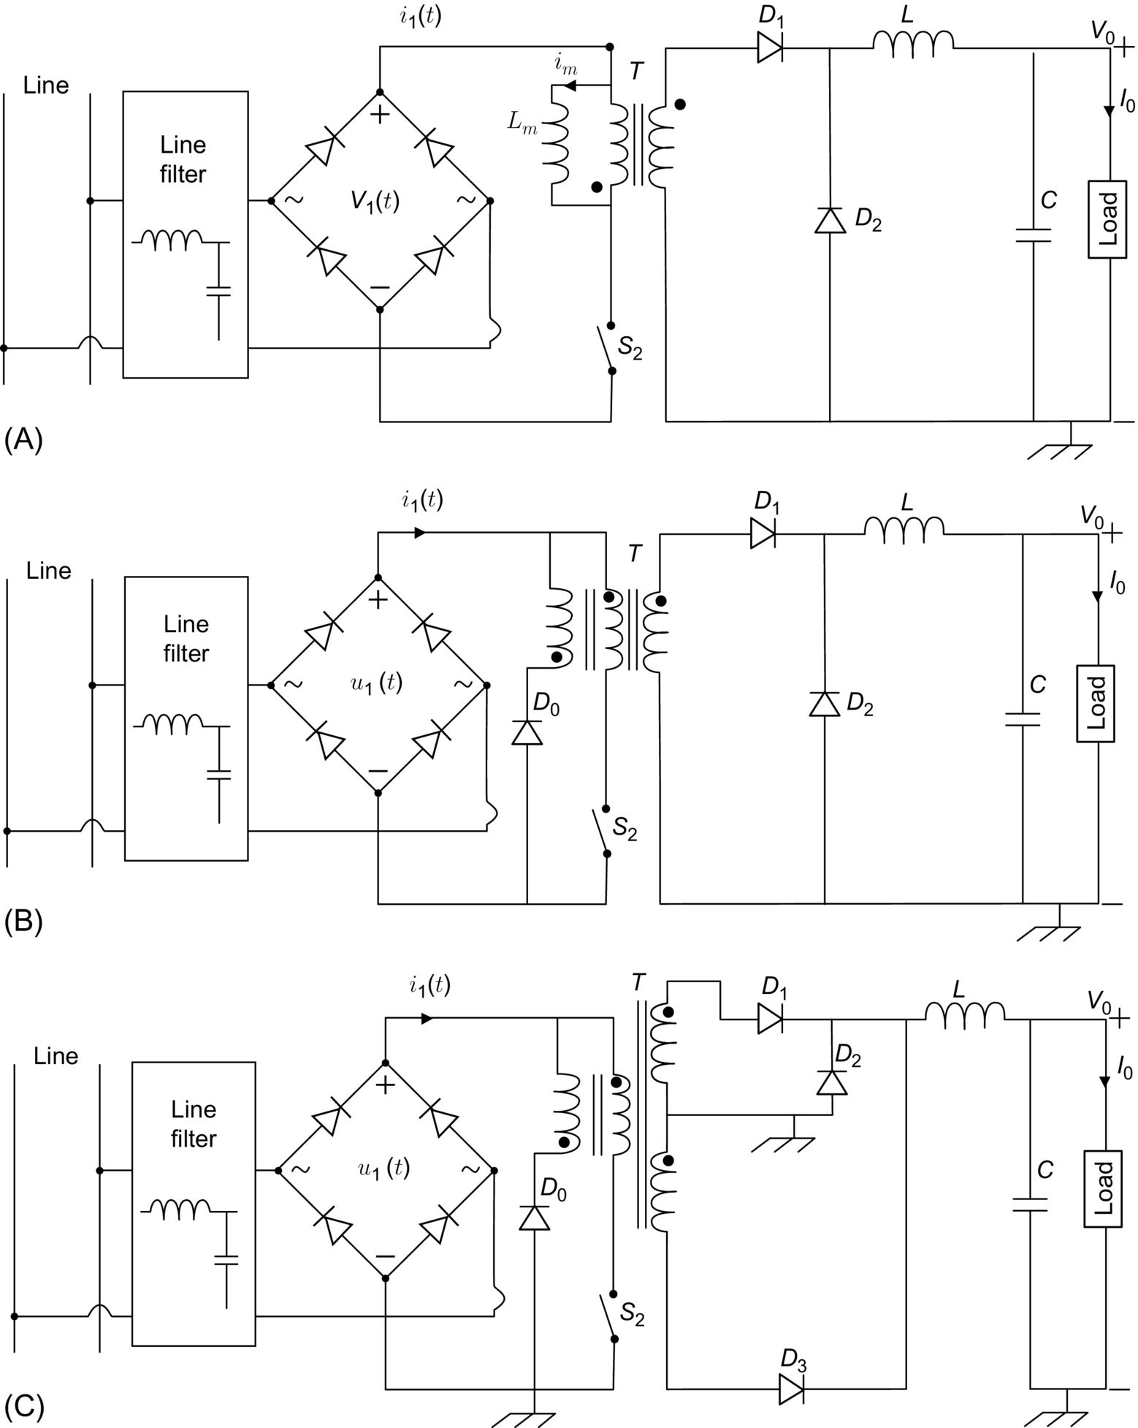

**FIG. 16.13** Forward converter topology, (A) forward converter basic topology, (B) forward converter practical topology, and (C) forward-flyback converter topology.

1. The dead zones existing in the convention forward PFC topology are eliminated.

2. The transformer is reset during the flyback converter operation.

3. The additional reset winding for the forward converter is no more needed.

#### **16.3.3.7 A Single-Stage Quasi *Z*-Source Corrector**

The quasi-Z-Source (qZS) topology and their different improved topologies have been introduced recently in several DC-DC converter applications [[51](https://learning.oreilly.com/library/view/power-electronics-handbook/9780128114087/B9780128114070000179.xhtml#bb0260)–[53](https://learning.oreilly.com/library/view/power-electronics-handbook/9780128114087/B9780128114070000179.xhtml#bb0270)]. The single-stage qZS converter topology was proposed to ensure the PFC converter in single-phase application [[54](https://learning.oreilly.com/library/view/power-electronics-handbook/9780128114087/B9780128114070000179.xhtml#bb0275),[55](https://learning.oreilly.com/library/view/power-electronics-handbook/9780128114087/B9780128114070000179.xhtml#bb0280)]. This topology, even it is different from the other topologies DC-DC converter topologies previously presented, but it has several features such as low-voltage stress on switches; lossless clamping, without using auxiliary switch; and duty-cycle-control scheme and improved efficiency. The circuit of this PFC converter is shown in [Fig. 16.14](https://learning.oreilly.com/library/view/power-electronics-handbook/9780128114087/B9780128114070000179.xhtml#f0075). The single-phase power supply provides the line input to the load via the qZS, the full-bridge diode rectifier, and the transformer and the second full-bridge diode rectifier. The same control strategies that are used for the other DC-DC converter topologies are used for these topologies with more or less modifications, where the main aim is to shape the input line current into a sinusoidal wave and in phase with the input line voltage to obtain a unity PF.

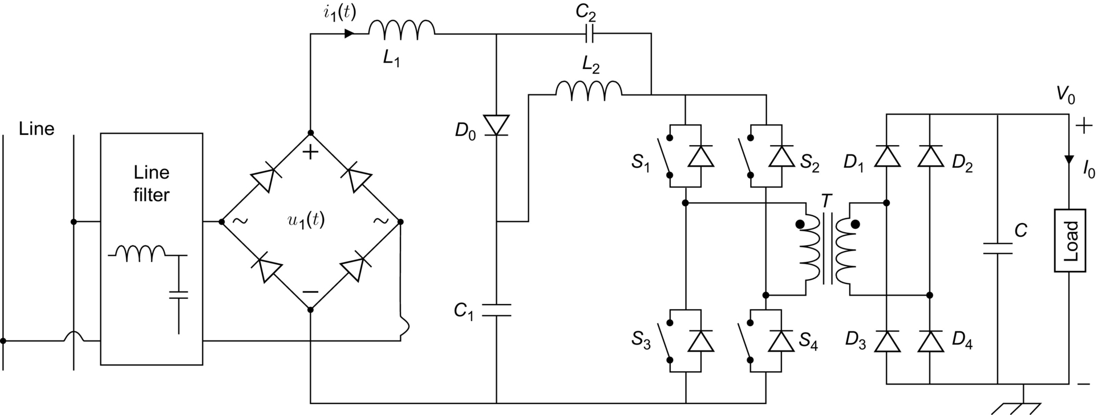

**FIG. 16.14** A single-stage quasi-Z-source corrector.

### 16.3.4 SYSTEM CONFIGURATIONS OF PFC POWER SUPPLY

The most common configurations of AC-DC power supply with PFC are two-stage scheme and one-stage (or single-stage) scheme. In two-stage scheme as shown in [Fig. 16.15A, a](https://learning.oreilly.com/library/view/power-electronics-handbook/9780128114087/B9780128114070000179.xhtml#f0080) nonisolated PFC AC-DC converter is connected to the line to create an intermediate DC bus. This DC bus voltage is usually full of second-harmonic ripple and which is followed by a cascaded DC-DC converter to provide electric isolation and tight voltage regulation. The advantage of two-stage structure PFC circuits is that the two power stages can be controlled separately, and thus, it makes it possible to have both converters optimized. The drawbacks of this scheme are lower efficiency due to twice processing of the input power, two control systems which leads to complex control circuits, higher cost, bulky due to the used intermediary circuits between the two stages, and low reliability. Although the two-stage scheme approach is commonly adopted in several industrial applications, it received limited attention by the common research, since the input stage and the output stage can be studied independently. One-stage scheme possesses a simplified structure that combines the PFC circuit and the power conversion circuit in one-stage as shown in [Fig. 16.15B](https://learning.oreilly.com/library/view/power-electronics-handbook/9780128114087/B9780128114070000179.xhtml#f0080). Therefore, this topology is potentially more efficient and is very attractive in low to medium power level applications, particularly in those cost-sensitive applications. The one-stage scheme, therefore, becomes the main stream of contemporary research due to the ever-increasing demands for inexpensive power supply applications, such as residential and office appliance [[1](https://learning.oreilly.com/library/view/power-electronics-handbook/9780128114087/B9780128114070000179.xhtml#bb0010)].

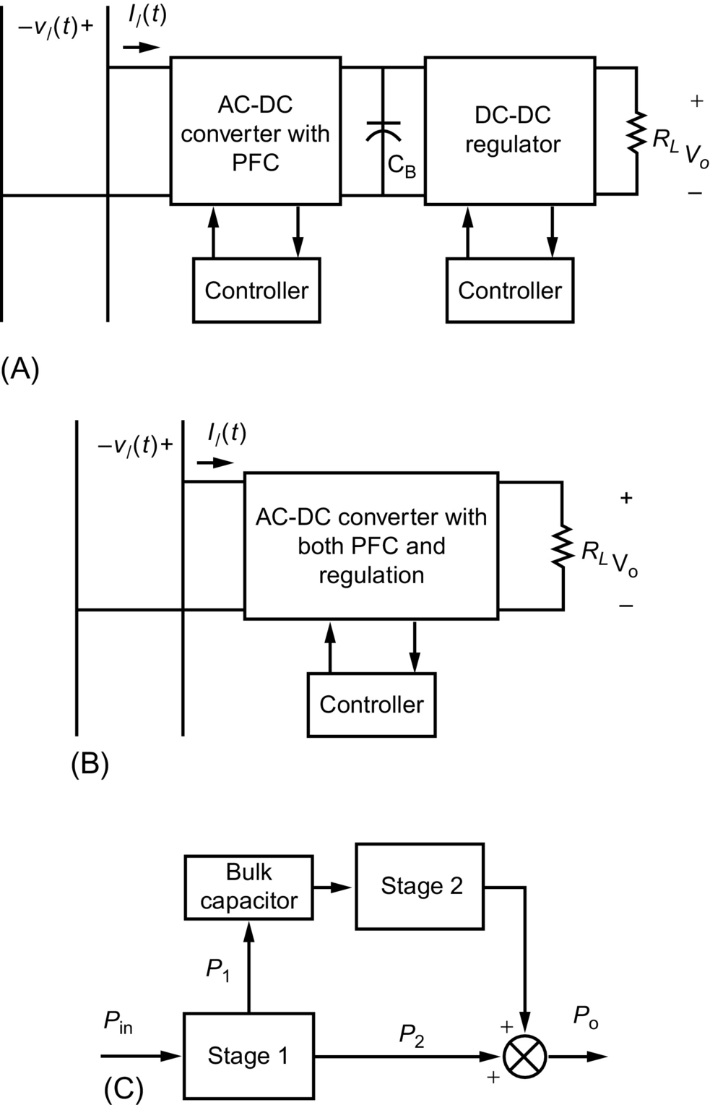

**FIG. 16.15** System configurations of PFC power supply: (A) two-stage scheme, (B) one-stage scheme, and (C) parallel scheme.

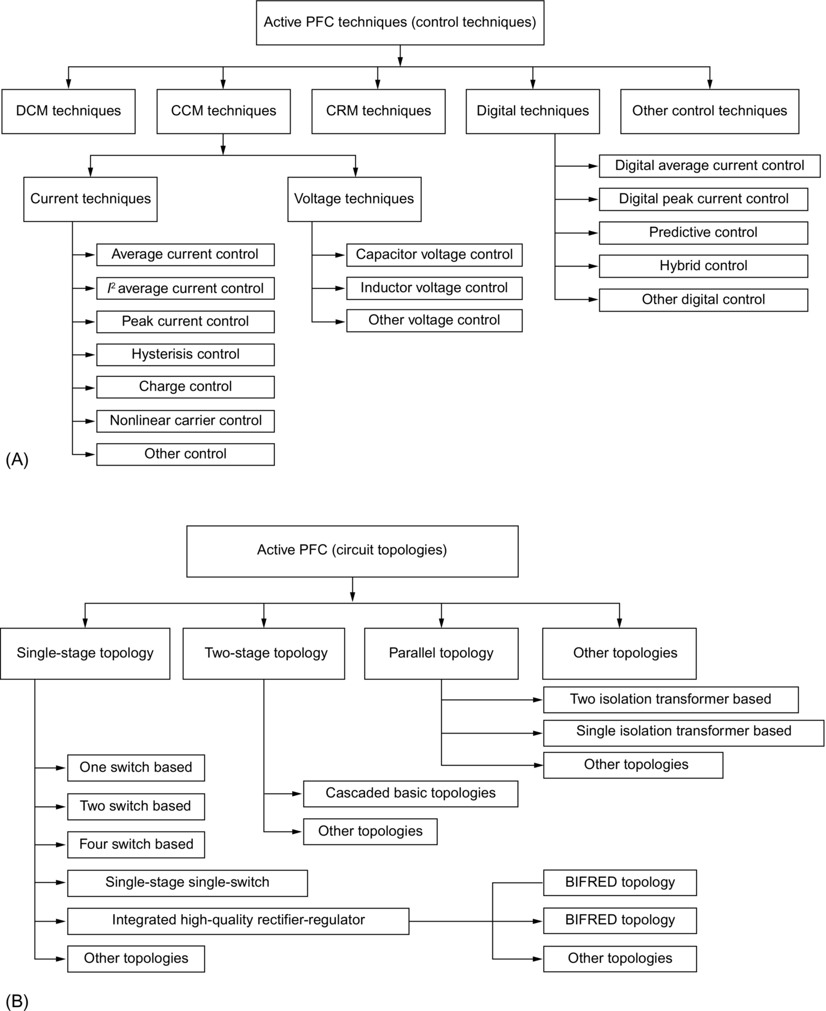

**FIG. 16.16** Overview of (A) PFC control techniques and (B) PFC circuit topologies.

For many single-stage PFC converters, one of the most important issues is the slow dynamic response under line and load changes. To remove the low frequency ripple caused by the line (120 or 100 Hz) from the output and keep a nearly constant operation duty ratio, a large volume output capacitor is normally used. Consequently, a low frequency pole (typically less than 20 Hz) must be introduced into the feedback loop. This results in very slow dynamic response of the system [[1](https://learning.oreilly.com/library/view/power-electronics-handbook/9780128114087/B9780128114070000179.xhtml#bb0010),[56](https://learning.oreilly.com/library/view/power-electronics-handbook/9780128114087/B9780128114070000179.xhtml#bb0285),[57](https://learning.oreilly.com/library/view/power-electronics-handbook/9780128114087/B9780128114070000179.xhtml#bb0290)].

The behavior of energy transfer in single-phase PFC converter and the behavior of the required storage decoupling element can be understood through the representation of the converter instantaneous input power and the average output power waveforms in more details as shown in [Fig. 16.17](https://learning.oreilly.com/library/view/power-electronics-handbook/9780128114087/B9780128114070000179.xhtml#f0090). It can be seen clearly that the converter has to transfer a peak power equals to twice the average output power, whereas this power has to be stored and then restored to the converter output side. Typically, an output capacitor (placed at the output side of the converter) is not the desired solution to store this energy for two reasons. Firstly, the output voltage possesses voltage fluctuation with double line frequency because tight output voltage regulation will require a small output capacitor. Secondly, the converter requires a holdup time. Therefore, the right solution is the use of a decoupling capacitor to ensure the main operation of storing and restoring the energy during the two stages. The location of the energy storage element becomes critical and general configuration of the topology will play an important role [[58](https://learning.oreilly.com/library/view/power-electronics-handbook/9780128114087/B9780128114070000179.xhtml#bb0295)]. The waveform presented in [Fig. 16.17](https://learning.oreilly.com/library/view/power-electronics-handbook/9780128114087/B9780128114070000179.xhtml#f0090) can be used to find the relation between *P1 and P2* based on the calculation of the areas corresponding to each power:

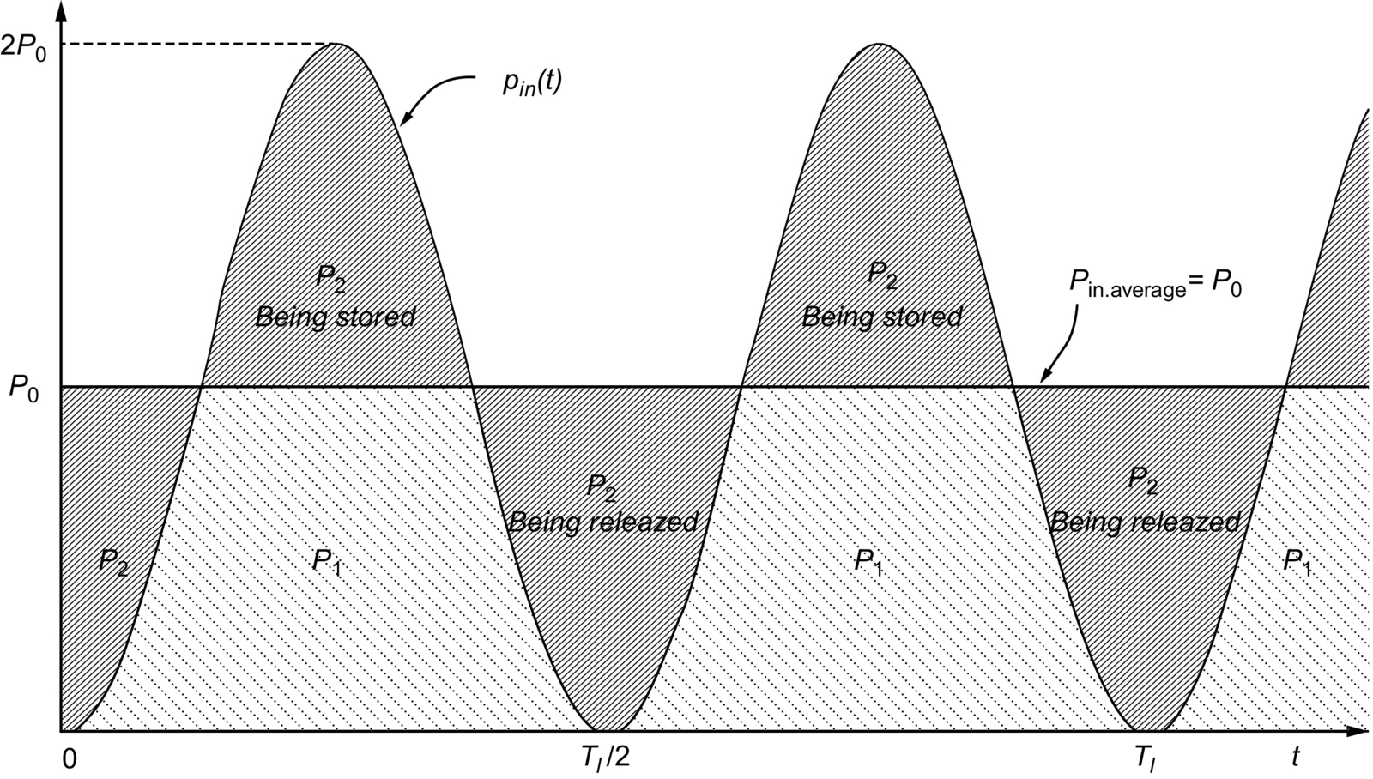

**FIG. 16.17** The instantaneous single-phase input power waveform.

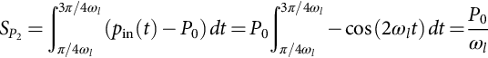 **(16.25)**

**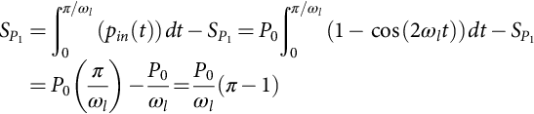** **(16.26)**

It is found that 68.17% 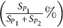 of the energy can be transferred directly to the output, and only 31.83% 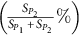 of the energy has to be stored and then reprocessed to the output.

It is obvious that the double frequency will be hidden from the output voltage ripple if *P*1 energy is directly transferred to the output due to the power storage excesses. Based on this analysis, improved and modified topologies of the basic converter topologies can be attained to achieve the direct energy transfer topology and the parallel energy transfer topology. Indeed, several works have been presented focusing mainly on the improvement of the PFC converter topology structure to ensure reduced number of components while delivering maximum energy directly to the output under enhanced efficiency [[58](https://learning.oreilly.com/library/view/power-electronics-handbook/9780128114087/B9780128114070000179.xhtml#bb0295)–[65](https://learning.oreilly.com/library/view/power-electronics-handbook/9780128114087/B9780128114070000179.xhtml#bb0330)].

To avoid twice power process in two-stage scheme, two converters can be connected in parallel to form so-called parallel PFC scheme (PPFC) as shown in [Fig. 16.18](https://learning.oreilly.com/library/view/power-electronics-handbook/9780128114087/B9780128114070000179.xhtml#f0095) [[66](https://learning.oreilly.com/library/view/power-electronics-handbook/9780128114087/B9780128114070000179.xhtml#bb0335),[67](https://learning.oreilly.com/library/view/power-electronics-handbook/9780128114087/B9780128114070000179.xhtml#bb0340)]. In parallel PFC circuit, power from the ac main to the load flows through two parallel paths, shown in [Fig. 16.15C](https://learning.oreilly.com/library/view/power-electronics-handbook/9780128114087/B9780128114070000179.xhtml#f0080). The main path is a rectifier, in which power is not processed twice for PFC (about 68% of the average input power), whereas the other path processes the input power twice for PFC purpose. It is shown that to achieve both unity PF and tight output voltage regulation, only the difference between the input and output power within a half cycle (about 32% of the average input power) needs to be processed twice [[1](https://learning.oreilly.com/library/view/power-electronics-handbook/9780128114087/B9780128114070000179.xhtml#bb0010),[66](https://learning.oreilly.com/library/view/power-electronics-handbook/9780128114087/B9780128114070000179.xhtml#bb0335),[67](https://learning.oreilly.com/library/view/power-electronics-handbook/9780128114087/B9780128114070000179.xhtml#bb0340)]. Therefore, high efficiency can be obtained by this method. In the PPFC topology, the common connection point of the two parallel paths appears at the output, where an isolation transformer is required for each stage ([Fig. 16.18](https://learning.oreilly.com/library/view/power-electronics-handbook/9780128114087/B9780128114070000179.xhtml#f0095)). Hence, this converter can be used effectively for the applications where the power level is high enough to justify the using of two isolations transformers that are too expensive and add more complexity to the converter topology [[67](https://learning.oreilly.com/library/view/power-electronics-handbook/9780128114087/B9780128114070000179.xhtml#bb0340)].

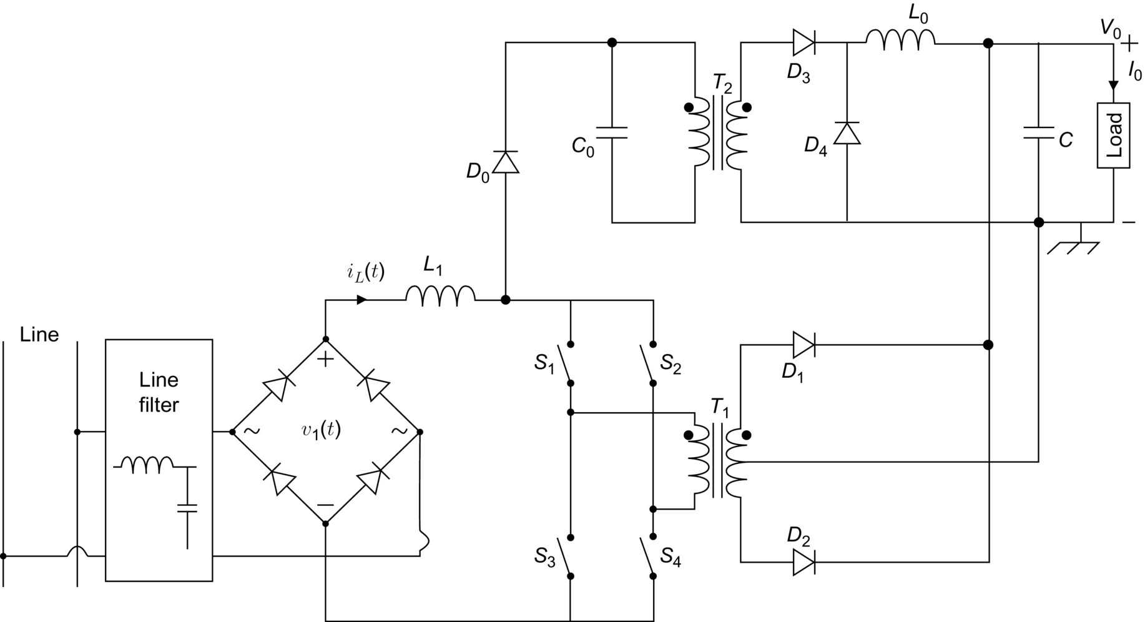

**FIG. 16.18** The parallel power factor corrector (PPFC).

An improved topology has been used to avoid the main disadvantages of the presented PPFC of [Fig. 16.18](https://learning.oreilly.com/library/view/power-electronics-handbook/9780128114087/B9780128114070000179.xhtml#f0095). It combines the auxiliary stage with the main stage, and, therefore, only one isolation transformer is required. This used PPFC topology power process transfer principle is shown in [Fig. 16.19](https://learning.oreilly.com/library/view/power-electronics-handbook/9780128114087/B9780128114070000179.xhtml#f0100), where only one power stage is used to transfer the input power (*P*in) and the extra 32% power (*P*2). Two application have been presented based on this PPFC topology, single-stage flyback PPFC converter and single-stage boost PPFC as shown in [Fig. 16.20A and B](https://learning.oreilly.com/library/view/power-electronics-handbook/9780128114087/B9780128114070000179.xhtml#f0105); both topologies are using only one isolation transformer [[67](https://learning.oreilly.com/library/view/power-electronics-handbook/9780128114087/B9780128114070000179.xhtml#bb0340)].

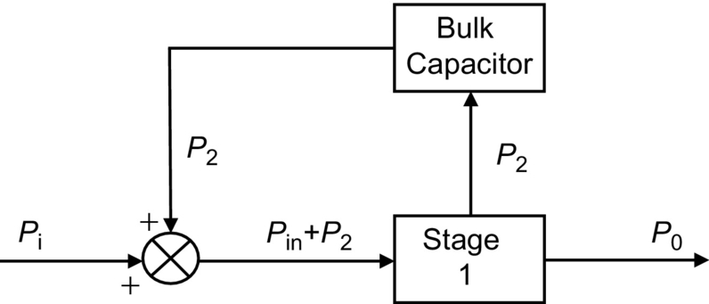

**FIG. 16.19** The power process transfer principle under the improved PPFC topology.

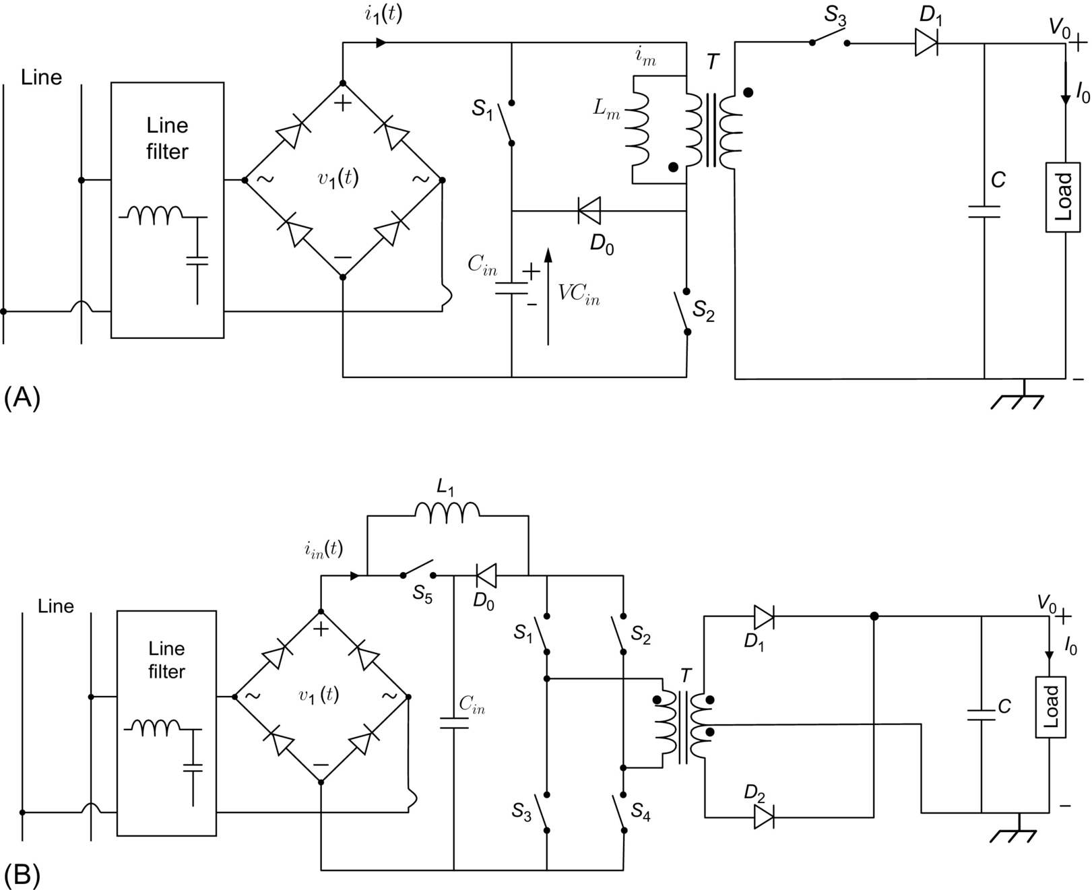

**FIG. 16.20** PPFC converters improved topologies, (A) single-stage flyback PPFC converter and (B) single-stage boost PPFC converter.

The continuous research in improving system PF up to date has resulted in countless circuit topologies and control strategies. Classified by their principles to realize PFC, they can be mainly categorized into three categories depending especially on the conduction current behavior of the input current of the converter that is related generally to the inductance of the equalizer PFC:

• Continuous conduction mode (CCM) that is based on the techniques of current shaping (current shaping technique (CST)) in [Fig. 16.21](https://learning.oreilly.com/library/view/power-electronics-handbook/9780128114087/B9780128114070000179.xhtml#f0110)

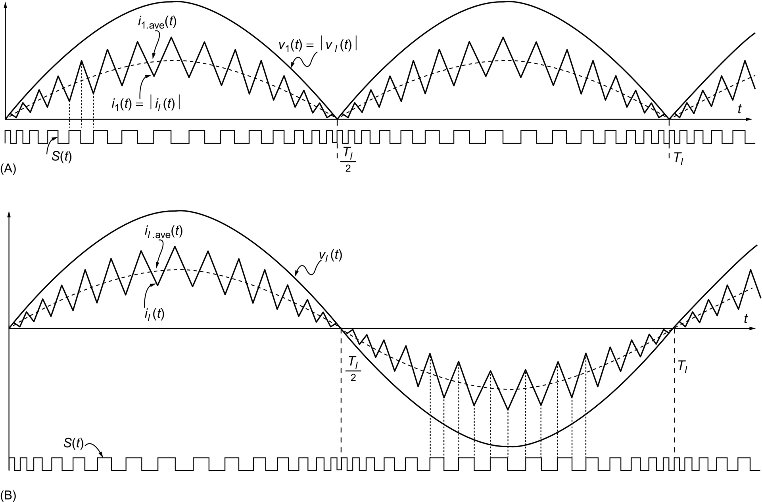

**FIG. 16.21** Continuous conduction mode (CCM) principle: (A) the input current waveform of the PFC circuit and (B) the line current waveform.

• Discontinuous conduction mode (DCM) that is based on current input control technique (CICT) in [Fig. 16.22](https://learning.oreilly.com/library/view/power-electronics-handbook/9780128114087/B9780128114070000179.xhtml#f0115)

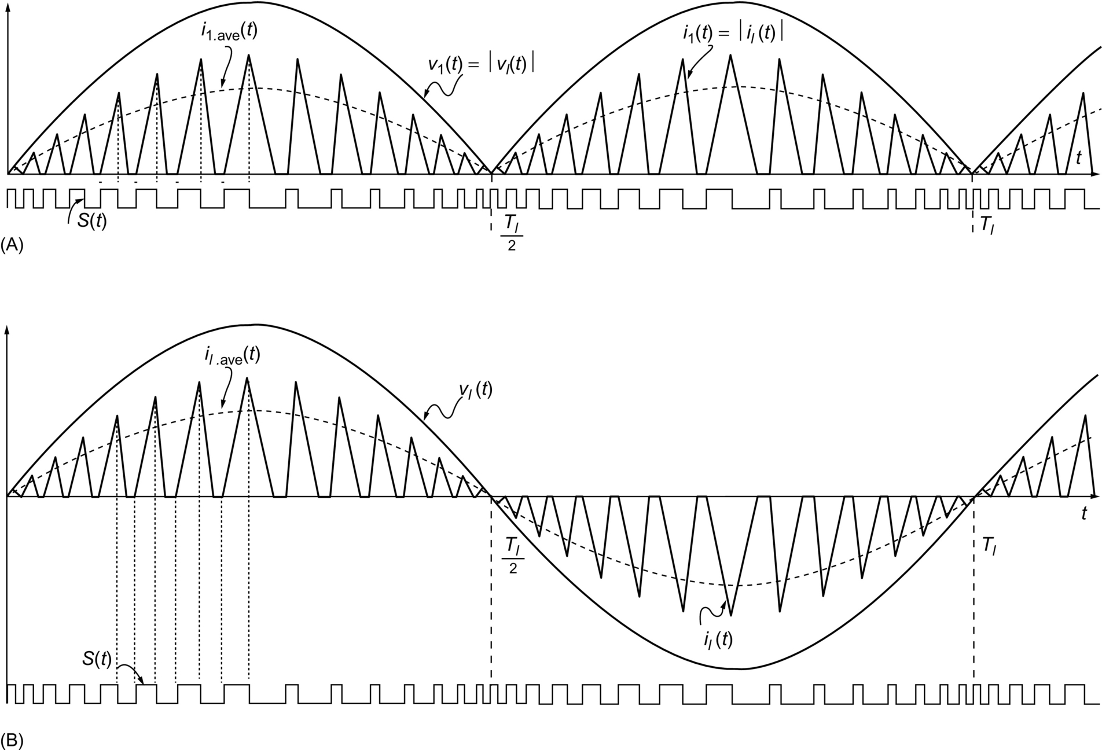

**FIG. 16.22** Discontinuous conduction mode (DCM) principle: (A) the input current waveform of the PFC circuit and (B) the line current waveform.

• Critical conduction mode (CRM) that is similar to boundary conduction mode (BCM) or transition mode (TM) in [Fig. 16.23](https://learning.oreilly.com/library/view/power-electronics-handbook/9780128114087/B9780128114070000179.xhtml#f0120)

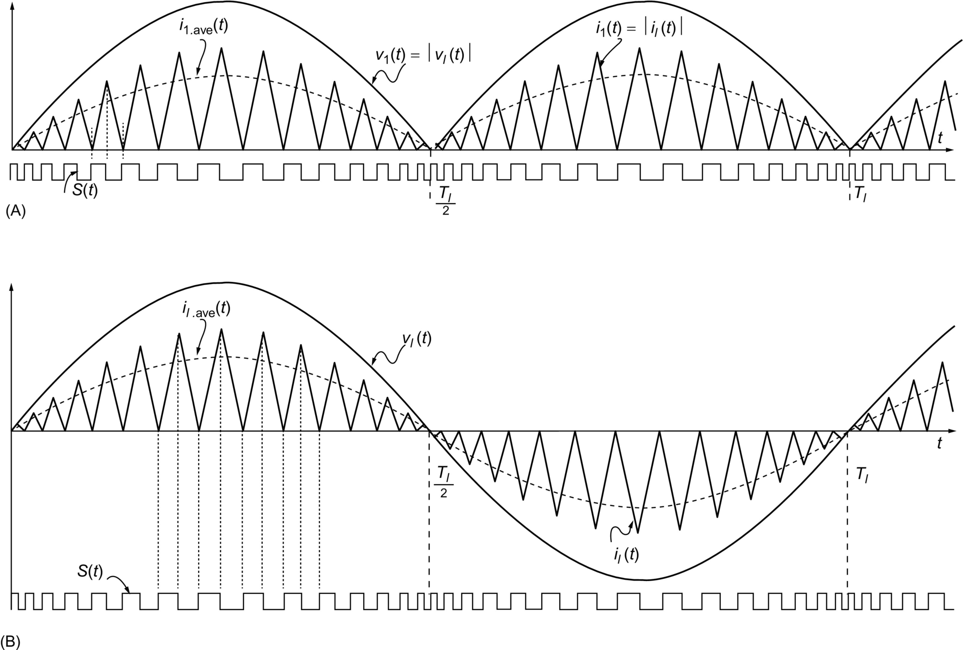

**FIG. 16.23** Critical conduction mode (CRM) principle: (A) the input current waveform of the PFC circuit and (B) the line current waveform.

The recent research interest in DCM input technique is focused on developing PFC circuit topologies with a single power switch, result in single-stage single-switch converter (so-called *S*4-converter) [[1](https://learning.oreilly.com/library/view/power-electronics-handbook/9780128114087/B9780128114070000179.xhtml#bb0010)]. The CCM shaping technique emphasizes on the used control strategies and on the improved topologies to achieve high input PF for medium and high-power levels. When this technique is applied for the control of a continuous flow of current, a fixed or a variable switching frequency can be used [[68](https://learning.oreilly.com/library/view/power-electronics-handbook/9780128114087/B9780128114070000179.xhtml#bb0345)].

The CRM technique is on the boundary between CCM and DCM techniques. It was proved that it can ensure moderate switch losses, and in the same time, it can reduce the eventual diode reverse-recovery problems. The two main CRM PFC controller strategies of voltage mode and current mode can be used; however, the need to the voltage or the current sensors, depending on the used control strategy, adds more complexity to the used circuits [[69](https://learning.oreilly.com/library/view/power-electronics-handbook/9780128114087/B9780128114070000179.xhtml#bb0350)].

The hot topics in this line of research are concentrated on degrading complexity of the control circuit and enhancing dynamic response of the system, resulting in some new control methods. [Fig. 16.16](https://learning.oreilly.com/library/view/power-electronics-handbook/9780128114087/B9780128114070000179.xhtml#f0085) shows an overview of these techniques based on conduction mode and system configuration types [[1](https://learning.oreilly.com/library/view/power-electronics-handbook/9780128114087/B9780128114070000179.xhtml#bb0010)]. It is obvious that the new developed and improved topologies based on the existing classical basic topologies can achieve the main objective of higher PF and lower THD than those of traditional topologies; this can be fulfilled by improving at the same time the control strategies for different modes of conduction.

## 16.4 CCM Shaping Technique

Like other power electronic apparatus, the core of a PFC unit is its converter, which can operate either in DCM, in CCM, or in CRM. As shall be discussed in the next section, the benefit from DCM technique is that low-cost power supply can be achieved because of its simplified control circuit. However, the peak input current of a DCM converter is at least twice as high as its corresponding average input current, which causes higher current stresses on switches than that in a CCM converter, resulting in intolerable conduction and switching losses and transformer copper losses in high-power applications. In practice, DCM technique is only suitable for low- to medium-level power application, whereas CCM is used in high-power cases. However, a converter operating in CCM does not have PFC ability inherently, that is, unless a certain control strategy is applied, the input current will not follow the waveform of line voltage. This is why most of the research activities in improving PF under CCM condition have been focused on developing new current shaping control strategies. Depending on the system variable being controlled (either current or voltage), PFC control techniques may be classified as current control and voltage control. Current control is the most common control strategy since the primary objective of PFC is to force the input current to trace the shape of line voltage [[1](https://learning.oreilly.com/library/view/power-electronics-handbook/9780128114087/B9780128114070000179.xhtml#bb0010)].

To achieve both PFC and output voltage regulation by using a converter operating in CCM, multiloop controls are generally used. [Fig. 16.24](https://learning.oreilly.com/library/view/power-electronics-handbook/9780128114087/B9780128114070000179.xhtml#f0125) shows the block diagram of AC-DC PFC converter with CCM shaping technique, where *Hl* is a line voltage compensator, *Hx* is a controlled variable compensator, and *x*(*t*) is the control variable that can be either current or voltage [[1](https://learning.oreilly.com/library/view/power-electronics-handbook/9780128114087/B9780128114070000179.xhtml#bb0010)].

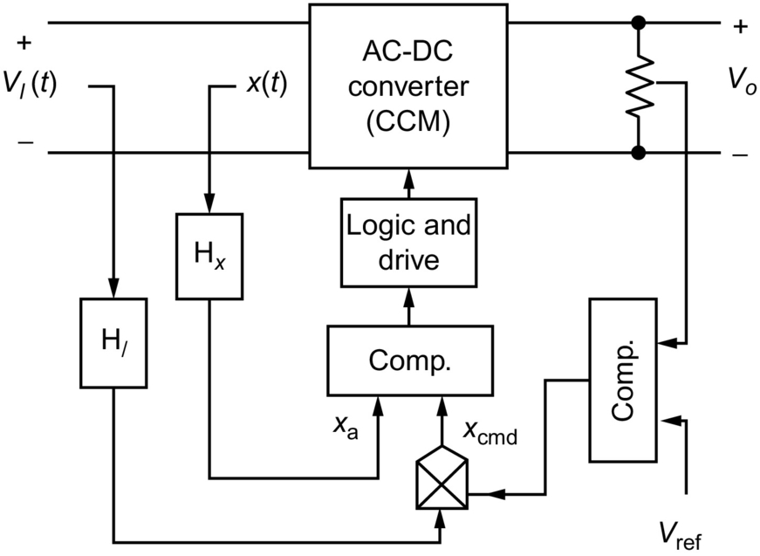

**FIG. 16.24** Block diagram of PFC converter with CCM shaping technique.

Normally, in order to obtain a sinusoidal line current and a constant dc output voltage, line voltage *vl*(*t*), output voltage *Vo*, and a controlled variable *x*(*t*) need to be sensed. Depending on whether the controlled variable *x*(*t*) is a current (usually the line current or the switch current) or a voltage (related to the line voltage or rectified line voltage), the control technique is called “current mode control” or “voltage mode control,” respectively. In [Fig. 16.24](https://learning.oreilly.com/library/view/power-electronics-handbook/9780128114087/B9780128114070000179.xhtml#f0125), two control loops have been applied: the feedforward loop and the feedback loops. The feedforward loop is also called “inner loop,” which keeps the line current to follow the line voltage in shape and phase, while the feedback loop (also called “outer loop”) keeps the output voltage to be tightly controlled. These two loops share the same control command generated by the product of output voltage error signal and the line voltage (or rectified line voltage) signal [[1](https://learning.oreilly.com/library/view/power-electronics-handbook/9780128114087/B9780128114070000179.xhtml#bb0010)].

### 16.4.1 CURRENT MODE CONTROL

Over many years, different current mode control techniques were developed. In this section, we will review several known methods.

#### **16.4.1.1 Average Current Control**

In average current control (ACM) strategy, the average line current of the converter is controlled to be shaped to a sine waveform which in phase with the line voltage. It is more desired than the other control strategies because the line current in a SMPS can be approximated by the average current (per switching cycle) through an input EMI filter. This control strategy is widely used in several industries due to the improved noise immunity, the lower input ripple, and the stable operation [[56](https://learning.oreilly.com/library/view/power-electronics-handbook/9780128114087/B9780128114070000179.xhtml#bb0285),[70](https://learning.oreilly.com/library/view/power-electronics-handbook/9780128114087/B9780128114070000179.xhtml#bb0355)–[73](https://learning.oreilly.com/library/view/power-electronics-handbook/9780128114087/B9780128114070000179.xhtml#bb0370)].

[Fig. 16.22](https://learning.oreilly.com/library/view/power-electronics-handbook/9780128114087/B9780128114070000179.xhtml#f0115) shows a boost PFC circuit using ACM strategy. In the feedforward loop, a low value resistor *Rs* is used to sense the line current. Through the op-amp network formed by *Ri*,*R*imo,*Rf*,*Cp*,*Cz*,and*A*2, average line current is detected and compared with the command current signal, *icmd*, which is generated by the product of line voltage signal and the output voltage error signal.

There is a common issue in CCM shaping technique, that is, when the line voltage increases, the line voltage sensor provides an increased sinusoidal reference for the feedforward loop. Since the response of feedback loop is much slow than the feedforward loop, both the line voltage and the line current increase, that is, the line current is heading to wrong changing direction (with the line voltage increasing, the line current should decrease). This results in excessive input power, causing overshoot in the output voltage. The square block, *x*2, in the line voltage-sensing loop shown in [Fig. 16.25](https://learning.oreilly.com/library/view/power-electronics-handbook/9780128114087/B9780128114070000179.xhtml#f0130) provides a typical solution for this problem. It squares the output of the low-pass filter (LPF), which is in proportion to the amplitude of the line voltage and provides the divider  with a squared line voltage signal for its denominator. As a result, the amplitude of the sinusoidal reference *icmd* is negatively proportional to the line voltage, that is, when the line voltage changes, the control circuit leads the line current to change in the opposite direction, which is the desired situation. The detailed analysis and design issues can be found in [[1](https://learning.oreilly.com/library/view/power-electronics-handbook/9780128114087/B9780128114070000179.xhtml#bb0010),[70](https://learning.oreilly.com/library/view/power-electronics-handbook/9780128114087/B9780128114070000179.xhtml#bb0355)–[72](https://learning.oreilly.com/library/view/power-electronics-handbook/9780128114087/B9780128114070000179.xhtml#bb0365)].

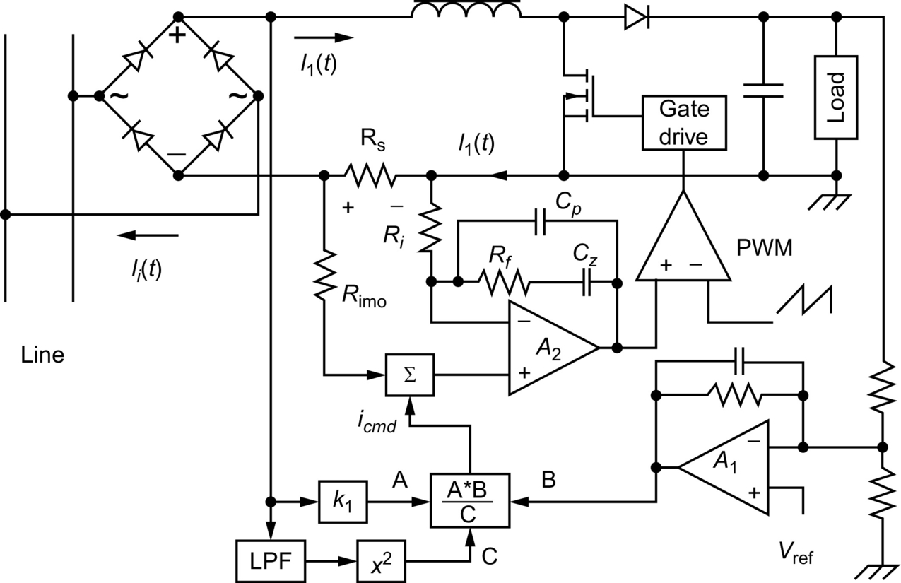

**FIG. 16.25** Boost corrector using average current control.

As it can be seen, the ACM is a very complicated control strategy. It requires sensing the inductor current, the input voltage, and the output voltage. An amplifier for calculating the average current and a multiplier are needed. Actually, due to the advances made in IC technology, these circuits are integrated in a single chip, where many control ICs are available from different manufacturers.

#### **16.4.1.2 I2 Average Current Mode Control**

This control technique is proposed to improve the transient response and the light load efficiency of the existing average current mode control [[74](https://learning.oreilly.com/library/view/power-electronics-handbook/9780128114087/B9780128114070000179.xhtml#bb0375)]. The main principle of this control technique is applied to buck converter as shown in [Fig. 16.26](https://learning.oreilly.com/library/view/power-electronics-handbook/9780128114087/B9780128114070000179.xhtml#f0135). It is based on the use of three loops, two current inner loops and one voltage outer loop. The first current loop presents a slow integral feedback that integrates the error between the output voltage of the voltage loop *Vc* and the current through *Ls*. The second current loop presents a fast direct feedback of the current through *Ls* without LPF that is compared with the integrator output of the first current loop to generate the PWM signal. The third loop is dedicated to ensure the output voltage regulation. As the current through *Ls* is measured once and it is used twice in the two control loops, the proposed control technique is named as *I*2 control. In general, this concept is applicable to constant frequency modulations and variable frequency modulations [[74](https://learning.oreilly.com/library/view/power-electronics-handbook/9780128114087/B9780128114070000179.xhtml#bb0375),[75](https://learning.oreilly.com/library/view/power-electronics-handbook/9780128114087/B9780128114070000179.xhtml#bb0380)].

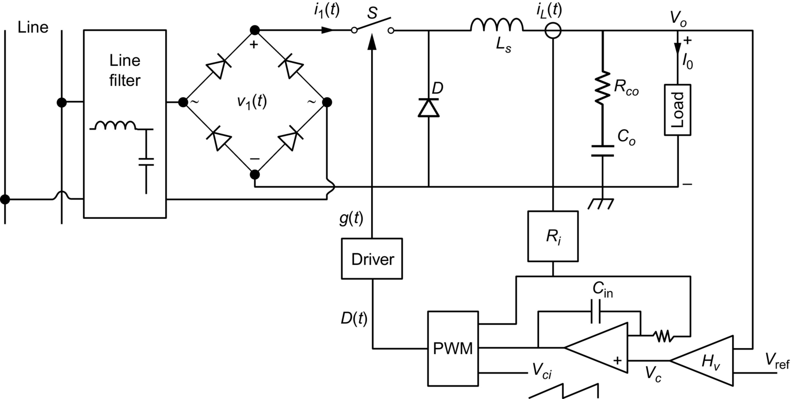

**FIG. 16.26** The concept of I2 average current mode control.

#### **16.4.1.3 Variable Frequency Peak Current Control**

Although the ACM is a more desired strategy, the peak current control has been widely accepted because it improves the converter efficiency and has a simpler control circuit [[57](https://learning.oreilly.com/library/view/power-electronics-handbook/9780128114087/B9780128114070000179.xhtml#bb0290),[76](https://learning.oreilly.com/library/view/power-electronics-handbook/9780128114087/B9780128114070000179.xhtml#bb0385)–[80](https://learning.oreilly.com/library/view/power-electronics-handbook/9780128114087/B9780128114070000179.xhtml#bb0405)]. In variable frequency peak control strategy, shown in [Fig. 16.27](https://learning.oreilly.com/library/view/power-electronics-handbook/9780128114087/B9780128114070000179.xhtml#f0140), the output error signal *k*(*t*) is fed back through its outer loop. This signal is multiplied by the line voltage signal *αv*1(*t*) to form a line current command signal *icmd*(*t*) (). The command signal *icmd*(*t*) is the desired line current shape since it follows the shape of the line voltage. The actual line current is sensed by a transducer, resulting in signal *βi*1(*t*) that must be reshaped to follow *icmd*(*t*) by feeding it back through the inner loop. After comparing the line current signal *βi*1(*t*) with the command signal *icmd*(*t*), the following control strategies can be realized, depending on its logic circuit [[1](https://learning.oreilly.com/library/view/power-electronics-handbook/9780128114087/B9780128114070000179.xhtml#bb0010)]:

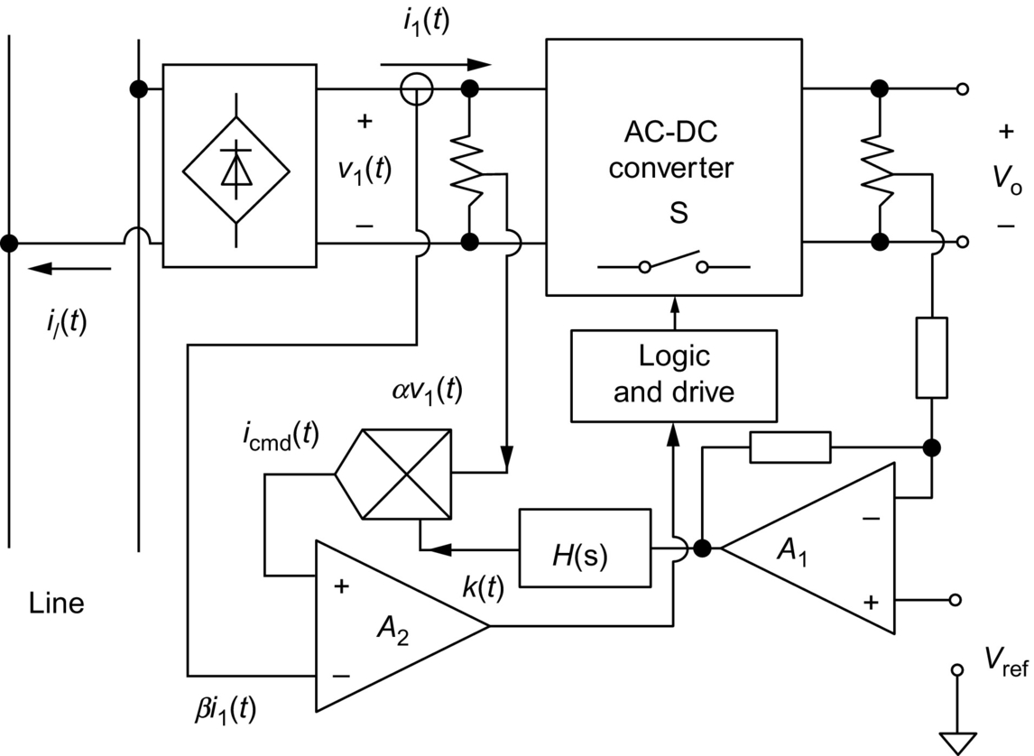

**FIG. 16.27** Block diagram for variable frequency peak current control.

*Constant on-time control:* Its input current waveform is given in [Fig. 16.28A](https://learning.oreilly.com/library/view/power-electronics-handbook/9780128114087/B9780128114070000179.xhtml#f0145). Letting the fixed on time to be *Ts*, the control rules are the following:

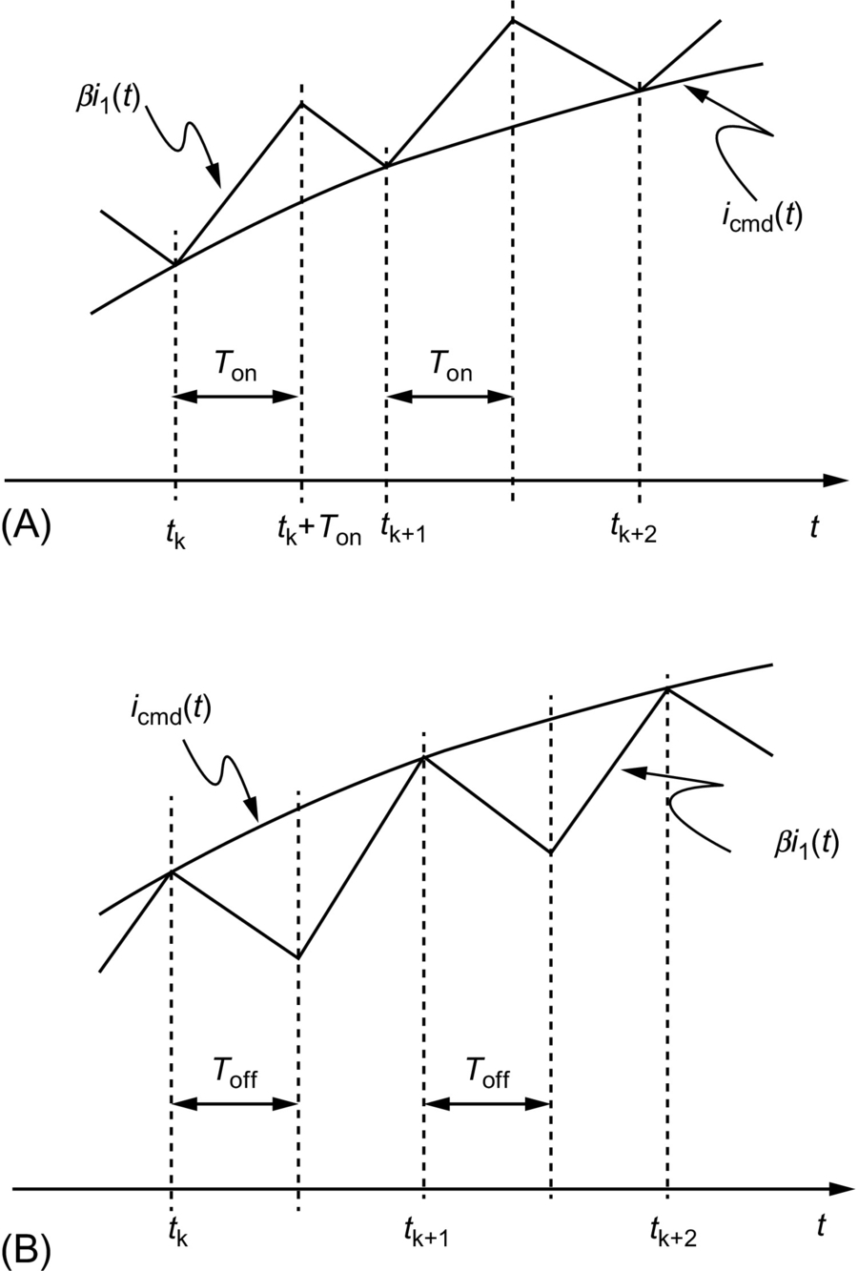

**FIG. 16.28** Input current waveforms for variable frequency peak current control: (A) constant on-time control and (B) constant off-time control.

• At  when , *S* is turned on.

• At , *S* is turned off.

*Constant off-time control:* The input current waveform is shown in [Fig. 16.28B](https://learning.oreilly.com/library/view/power-electronics-handbook/9780128114087/B9780128114070000179.xhtml#f0145). Assuming the offtime is *T*off, the control rules are the following:

• At  when , *S* is turned off.

• At , *S* is turned on.

#### **16.4.1.4 Constant Frequency Peak Current Control**

Generally speaking, to make it easier to design the EMI filter and to reduce harmonics, constant switching frequency AC-DC PFC converter is preferred. Based on the block diagram shown in [Fig. 16.29](https://learning.oreilly.com/library/view/power-electronics-handbook/9780128114087/B9780128114070000179.xhtml#f0150), with *Ts* is the switching period, the following control rules can be considered to realize a constant frequency peak current control (shown in [Fig. 16.30B](https://learning.oreilly.com/library/view/power-electronics-handbook/9780128114087/B9780128114070000179.xhtml#f0155)) [[1](https://learning.oreilly.com/library/view/power-electronics-handbook/9780128114087/B9780128114070000179.xhtml#bb0010)]:

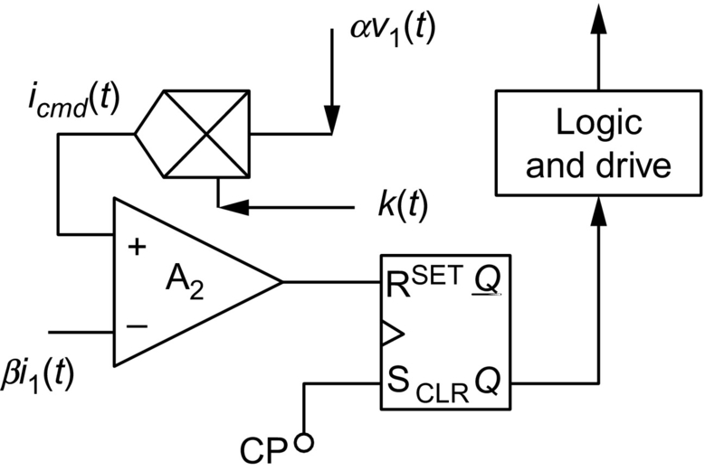

**FIG. 16.29** Logic circuit for constant frequency peak current control.

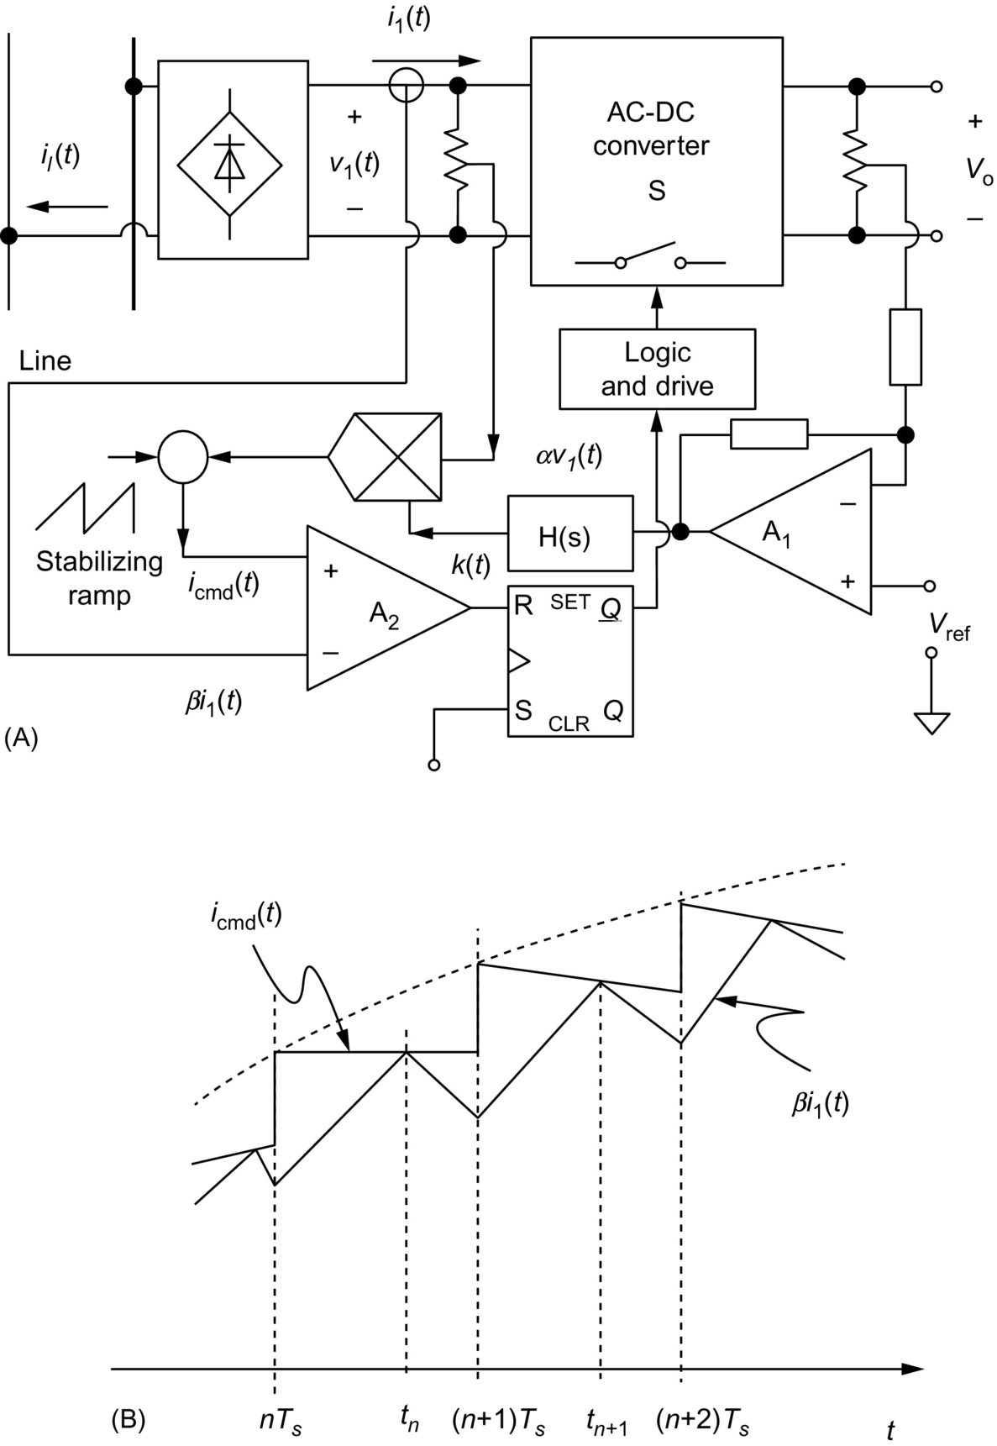

**FIG. 16.30** (A) Constant frequency peak current control with stabilizing ramp compensation and (B) line current waveform for constant frequency peak current control.

• At , *S* is turned on.

• At  when , *S* is turned off.

The logic circuit for the above control rules can be realized by using an R-S flip-flop with a constant frequency setting clock pulse (CP), as shown in [Fig. 16.29](https://learning.oreilly.com/library/view/power-electronics-handbook/9780128114087/B9780128114070000179.xhtml#f0150). Unfortunately, this logic circuit will result in instability when the duty ratio exceeds 50%. This problem can be solved by subtracting a stabilizing ramp signal from the original command signal. [Fig. 16.30A](https://learning.oreilly.com/library/view/power-electronics-handbook/9780128114087/B9780128114070000179.xhtml#f0155) shows a complete block diagram for typical constant frequency peak current control strategy. The line current waveform is shown in [Fig. 16.30B](https://learning.oreilly.com/library/view/power-electronics-handbook/9780128114087/B9780128114070000179.xhtml#f0155) [[1](https://learning.oreilly.com/library/view/power-electronics-handbook/9780128114087/B9780128114070000179.xhtml#bb0010)].

It should be noticed that in both variable frequency and constant frequency peak current control strategies, either the input current or the switch current could be controlled. Thus, it makes possible to apply these control methods to buck-type converters. There are several advantages of using peak current control [[1](https://learning.oreilly.com/library/view/power-electronics-handbook/9780128114087/B9780128114070000179.xhtml#bb0010)]:

• The peak current can be sensed by current transformer, resulting in reduced transducer loss.

• The current-error compensator for average control method has been eliminated.

• Low gain in the feedforward loop enhances the system stability.

• The instantaneous pulse-by-pulse current limit leads to increased reliability and response speed.

However, the three signals, line voltage, peak current, and output voltage signals, are still necessary to be sensed and multiplier is still needed in each of the peak current control method. Comparing with the ACM method, the input current ripple of these peak current control methods may be high when the line voltage is near the peak value. As a result, considerable line current distortion exists under high-line voltage and light low operation conditions [[1](https://learning.oreilly.com/library/view/power-electronics-handbook/9780128114087/B9780128114070000179.xhtml#bb0010)].

#### **16.4.1.5 Hysteresis Control**

Unlike the constant on-time (COT) and the constant off-time control, in which only one current command is used to limit either the minimum input current or the maximum input current, the hysteresis control has two current commands, *ihcmd*(*t*) and *ilcmd*(*t*) (); *δ*is the hysteresis band width which is supposed to be constant to limit both the minimum and the maximum of input current [[81](https://learning.oreilly.com/library/view/power-electronics-handbook/9780128114087/B9780128114070000179.xhtml#bb0410)–[84](https://learning.oreilly.com/library/view/power-electronics-handbook/9780128114087/B9780128114070000179.xhtml#bb0425)]. To achieve smaller ripple in the input current, we desire a narrow hysteresis band. However, with a reduced hysteresis band width a higher switching frequency is required. Therefore, the hysteresis bandwidth should be optimized based on circuit components such as switching devices and magnetic components. Moreover, the switching frequency varies with the change of line voltage, resulting in difficulty in the design of the EMI filter. The circuit diagram and input current waveform are given in [Fig. 16.31A and B](https://learning.oreilly.com/library/view/power-electronics-handbook/9780128114087/B9780128114070000179.xhtml#f0160), respectively. When , a negative pulse is generated by comparator *A*1 to reset the R-S flip-flop. When , a negative pulse is generated by comparator *A*2 to set the R-S flip-flop. The control rules are the following:

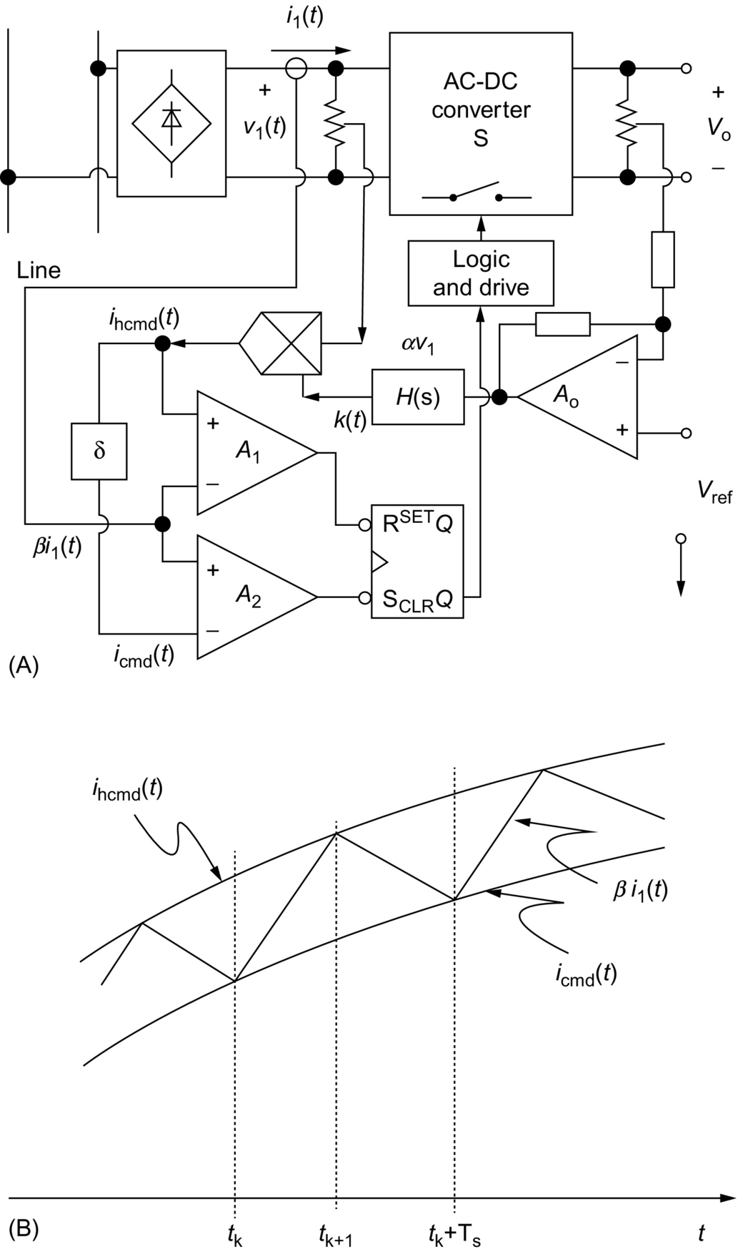

**FIG. 16.31** Hysteresis control: (A) block diagram for hysteresis control and (B) line current waveform of hysteresis control.

• At  when , *S* is turned on.

• At  when , *S* is turned off.

Like the above mentioned peak current control methods, the hysteresis control method has simpler implementation, enhanced system stability, and increased reliability and response speed. In addition, it has better control accuracy than that the peak current control methods have. However, this improvement is achieved on the penalty of wide range of variation in the switching frequency. It is also possible to improve the hysteresis control in a constant frequency operation [[85](https://learning.oreilly.com/library/view/power-electronics-handbook/9780128114087/B9780128114070000179.xhtml#bb0430),[86](https://learning.oreilly.com/library/view/power-electronics-handbook/9780128114087/B9780128114070000179.xhtml#bb0435)], but usually, this will increase the complexity of the control circuit [[1](https://learning.oreilly.com/library/view/power-electronics-handbook/9780128114087/B9780128114070000179.xhtml#bb0010)].

#### **16.4.1.6 Charge Control**

In order to make the average control method to be applicable for buck-derived topologies where the switch current instead of the inductor current needs to be controlled, an alternative method to realize ACM, namely, charge control was proposed in [[87](https://learning.oreilly.com/library/view/power-electronics-handbook/9780128114087/B9780128114070000179.xhtml#bb0440)–[89](https://learning.oreilly.com/library/view/power-electronics-handbook/9780128114087/B9780128114070000179.xhtml#bb0450)]. Since the total charge of the switch current per switching cycle is proportional to the average value of the switch current, the average current can be detected by a capacitor-switch network. [Fig. 16.32](https://learning.oreilly.com/library/view/power-electronics-handbook/9780128114087/B9780128114070000179.xhtml#f0165) shows a block diagram for charge control. The switch current is sensed by current transformer *T*1 and charges the capacitor *CT* to form average line current signal. As the switch current increases, the charge on capacitor *CT* also increases. When the voltage reaches the control command *vc*, the power switch turns off. At the same time, the switch *Sd* turns on to reset the capacitor. The next switching cycle begins with the power switch turning on and the switch *Sd* turning off by a CP [[1](https://learning.oreilly.com/library/view/power-electronics-handbook/9780128114087/B9780128114070000179.xhtml#bb0010)].

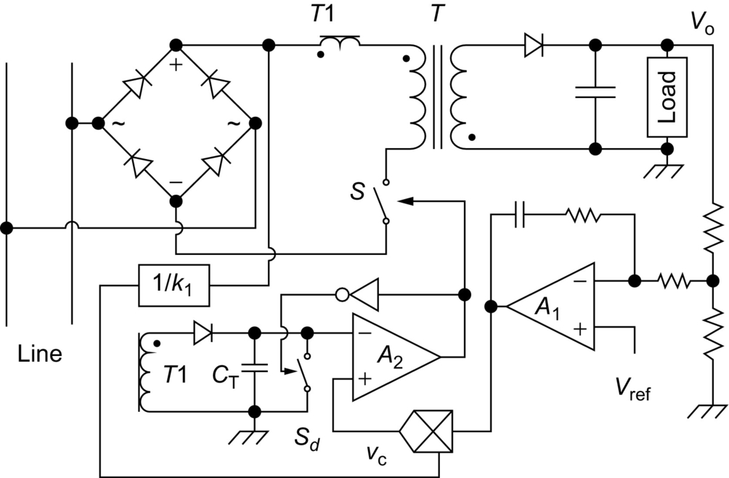

**FIG. 16.32** Flyback PFC converter using charge control.

The advantages of charge control are the following:

• Ability to control average switch current

• Better switching noise immunity than peak current control

• Good dynamic performance

• Elimination of turn-off failure in some converters (e.g., multiresonant converter) when the switch current reaches its maximum value

The disadvantages are the following:

• Synthesis of the reference *vc* still requires sensing both input and output voltage and use of a multiplier.

• Subharmonic oscillation may exist.

#### **16.4.1.7 Nonlinear-Carrier Control**

To further simplify the control circuitry, nonlinear-carrier (NLC) control methods were introduced [[90](https://learning.oreilly.com/library/view/power-electronics-handbook/9780128114087/B9780128114070000179.xhtml#bb0455),[91](https://learning.oreilly.com/library/view/power-electronics-handbook/9780128114087/B9780128114070000179.xhtml#bb0460)]. In CCM operation, since the input voltage is related to the output voltage through the conversion ratio, the input voltage information can be recovered by the sensed output voltage signal. Thus, the sensing of input voltage can be avoided, and therefore, the multiplier is not needed, resulting in significant simplification in the control circuitry. However, complicated NLC waveform generator and its designs are involved. [Fig. 16.33](https://learning.oreilly.com/library/view/power-electronics-handbook/9780128114087/B9780128114070000179.xhtml#f0170) shows the block diagram of the NLC charge control first introduced in [[90](https://learning.oreilly.com/library/view/power-electronics-handbook/9780128114087/B9780128114070000179.xhtml#bb0455),[1](https://learning.oreilly.com/library/view/power-electronics-handbook/9780128114087/B9780128114070000179.xhtml#bb0010)].

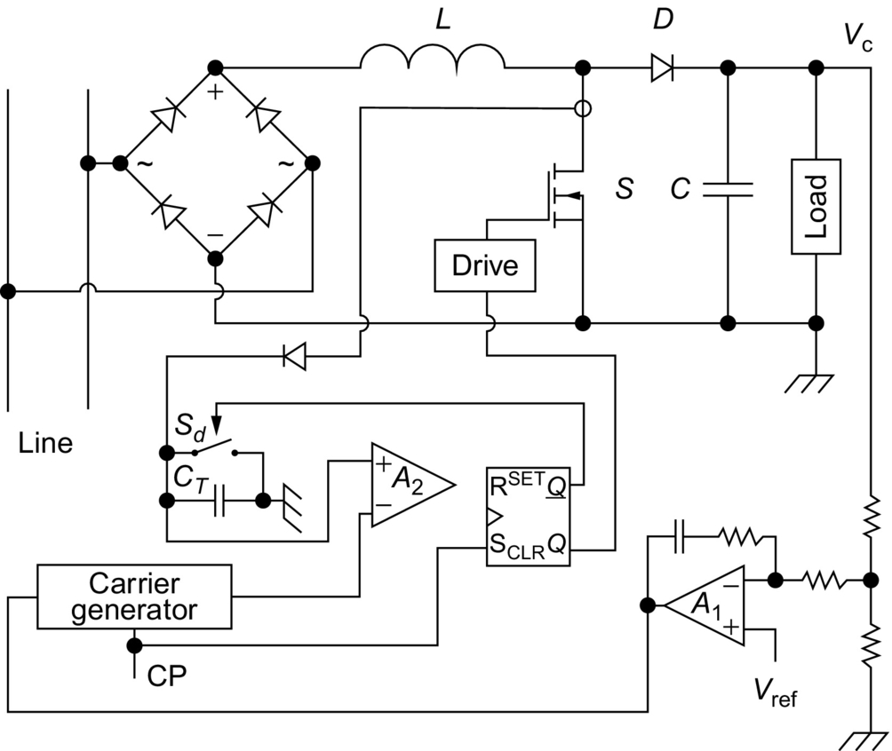

**FIG. 16.33** Boost PFC converter using NLC control.

### 16.4.2 VOLTAGE MODE CONTROL

Generally, current mode control is preferred in current source driven converters, as the boost converter. To develop controllers for voltage source driven converter, like the buck converter and to improve dynamic response, voltage mode control (VMC) strategy was proposed [[92](https://learning.oreilly.com/library/view/power-electronics-handbook/9780128114087/B9780128114070000179.xhtml#bb0465),[93](https://learning.oreilly.com/library/view/power-electronics-handbook/9780128114087/B9780128114070000179.xhtml#bb0470)]. [Fig. 16.34](https://learning.oreilly.com/library/view/power-electronics-handbook/9780128114087/B9780128114070000179.xhtml#f0175) shows the input circuit of an AC-DC converter and its phasor diagram representation, where *ϕ* is the phase shift between the line current and the capacitor voltage. An *LC* network could be added to the input either before a switch-mode rectifier (SMR) or after a passive rectifier to perform such kind of control. In boost type converter, the inductor *Li* is the input inductor. It can be seen from the phasor diagram that to keep the line current in phase with the line voltage, we can control either the capacitor voltage or the inductor voltage. If the capacitor voltage is chosen as controlled variable, the control strategy is known as delta modulation control [[1](https://learning.oreilly.com/library/view/power-electronics-handbook/9780128114087/B9780128114070000179.xhtml#bb0010)].

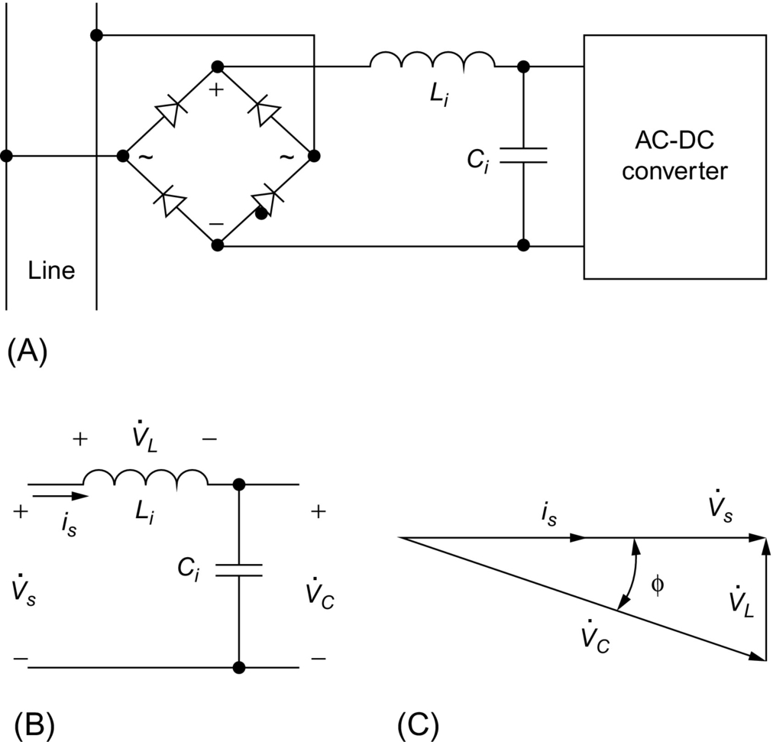

**FIG. 16.34** Input circuit and phasor diagram for voltage control: (A) input circuit of voltage control ac-dc converter, (B) simplified input circuit, and (C) phasor diagram.

#### **16.4.2.1 Capacitor Voltage Control**

[Fig. 16.35](https://learning.oreilly.com/library/view/power-electronics-handbook/9780128114087/B9780128114070000179.xhtml#f0180) gives a SMR with PFC using capacitor voltage control [[92](https://learning.oreilly.com/library/view/power-electronics-handbook/9780128114087/B9780128114070000179.xhtml#bb0465)]. The capacitor voltage *vc*1(*t*) is forced to track a sinusoidal command signal *vc*1⁎(*t*) to indirectly adjust the line current *il*(*t*) to be in phase with the line voltage *vl*(*t*). The command signal is the product of the line voltage signal with a phase shift of *ϕ* and the feedback error signal. The phase shift *ϕ* that has to be measured accurately is a function of the magnitudes of line voltage and line current; therefore, achieving the delta modulation control is not really simple. In addition, since *ϕ* is usually very small, a small change in capacitor voltage that may occur due to small load change or to small output voltage reference change *V*ref will cause a large change in the inductor voltage and hence in the line current. Thus, it makes the circuit very sensitive to parameter variations and perturbations [[1](https://learning.oreilly.com/library/view/power-electronics-handbook/9780128114087/B9780128114070000179.xhtml#bb0010)].

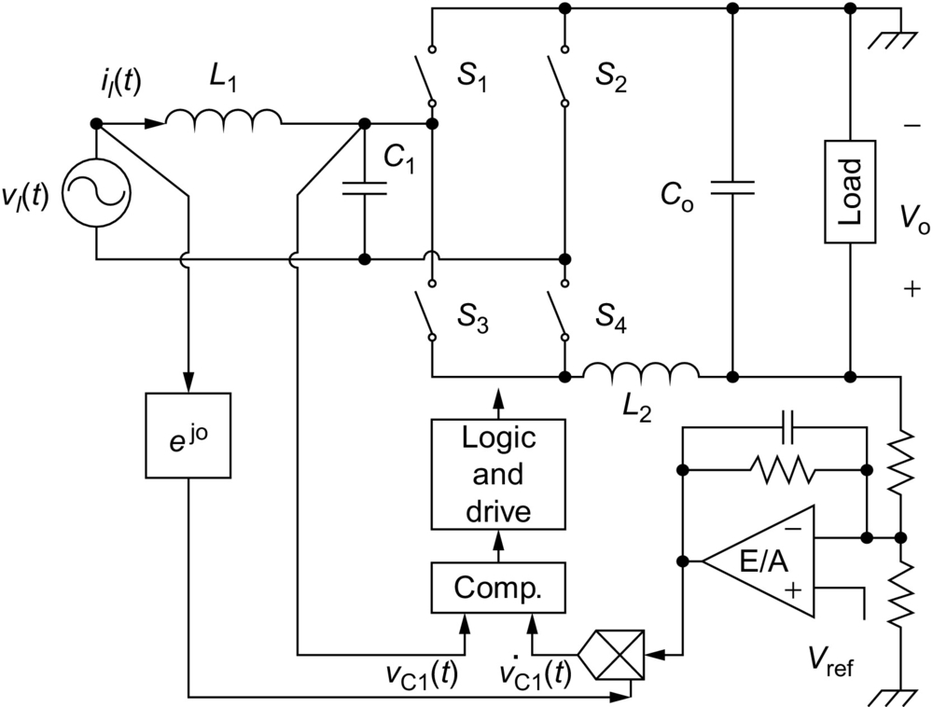

**FIG. 16.35** SMR using capacitor voltage control.

#### **16.4.2.2 Inductor Voltage Control**

To overcome the above shortcomings, inductor voltage control (IVC) strategies were reported in [[93](https://learning.oreilly.com/library/view/power-electronics-handbook/9780128114087/B9780128114070000179.xhtml#bb0470)]. [Fig. 16.36](https://learning.oreilly.com/library/view/power-electronics-handbook/9780128114087/B9780128114070000179.xhtml#f0185) shows an SMR with PFC using IVC. As the phase difference between the line voltage and the inductor voltage is fixed at 90 degrees ideally, the control circuit is simpler in implementation than that of capacitor voltage control. As the inductor voltage is sensitive to the phase shift *ϕ*, but not sensitive to the change in magnitude of reference, the IVC method is more effective in keeping the line current in phase with the line voltage. However, in the implementations of both the two kinds of voltage control methods hysteresis technique is normally used. Therefore, unlike the previous current mode control, variable frequency problem is encountered in these control methods [[1](https://learning.oreilly.com/library/view/power-electronics-handbook/9780128114087/B9780128114070000179.xhtml#bb0010)].

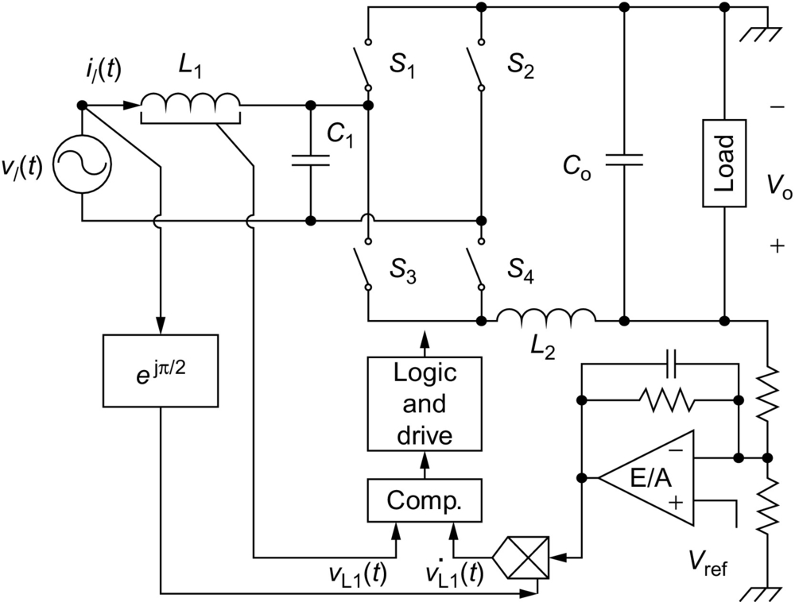

**FIG. 16.36** SMR using inductor voltage control.

Generally speaking, by using CCM shaping technique, the input current can trace the wave shape of the line voltage well. Hence, the PF can be improved efficiently. However, this technique involves in the designing of complicated control circuits. Multiloop control strategy is needed to perform ICS and output regulation. In most CCM shaping techniques, current sensor and multiplier are required, which result in higher cost in practical applications. In some cases, variable frequency control is inevitable, resulting in additional difficulties in its closed-loop design. [Table 16.1](https://learning.oreilly.com/library/view/power-electronics-handbook/9780128114087/B9780128114070000179.xhtml#t0010) gives a comparison among these control methods [[1](https://learning.oreilly.com/library/view/power-electronics-handbook/9780128114087/B9780128114070000179.xhtml#bb0010)].

**Table 16.1**

**Comparison of CCM shaping techniques**

|  |  |  |  |  |  |  |  |  |  |
| --- | --- | --- | --- | --- | --- | --- | --- | --- | --- |
|  | **Average current** | **I2 average current** | **VF peak current** | **CF peak current** | **Hysteresis** | **Charge** | **Nonlinear-carrier** | **Capacitor voltage** | **Inductor voltage** |
| Input ripple | Low | Low | High | High | Low | Low | Low | Low | Low |
| Switching frequency | Constant | Constant and variable | Variable | Constant | Variable | Constant | Constant | Variable | Variable |
| Dynamic response | Slow | Improved transient response | Slow | Slow | Fast | Fast | Fast | Fast | Fast |
| Control signal sensed for inner loop | Input current and input voltage | Two input current and input voltage | Input (or switch) current and input voltage | Input (or switch) current and input voltage | Input current and input voltage | Input (or switch) current and input voltage | Input (or switch) current | Input voltage and capacitor voltage | Input voltage and inductor voltage |
| Inner loop E/A | Yes | Yes | No | No | Yes | No | No | No | No |
| Multiplier | Yes | No | Yes | Yes | Yes | Yes | No | Yes | Yes |

## 16.5 DCM Input Technique

The DCM can be considered as a special case of the CCM. It presents more than one structural change during one switching period. To get rid of the complicated control circuit invoked by CCM shaping technique and reduce the cost of the electronic interface, DCM input technique can be adopted in low-power to medium power level application.

In DCM, the inductor current of the core converter is no longer a valid state variable since its state in a given switching cycle is independent of the value in the previous switching cycle [[94](https://learning.oreilly.com/library/view/power-electronics-handbook/9780128114087/B9780128114070000179.xhtml#bb0475)]. The peak of the inductor current is sampling the line voltage automatically, resulting in sinusoidal-like average input current (line current). This is why DCM input circuit is also called “voltage follower” or “automatic controller” [[1](https://learning.oreilly.com/library/view/power-electronics-handbook/9780128114087/B9780128114070000179.xhtml#bb0010)]. The benefit of using DCM input circuit for PFC is that no feedforward control loop is required, because with this approach, the internal current loop is completely eliminated, so that the switch is operated at COT and frequency. This is also the main advantage over a CCM PFC circuit, in which multiloop control strategy is essential. However, the input inductor operating in DCM cannot hold the excessive input energy because it must release all its stored energy before the end of each switching cycle. As a result, a bulky capacitor is used to balance the instantaneous power between the input and output. In addition, in DCM, the input current is normally a train of triangle pulses with nearly constant duty ratio. In this case, an input filter is necessary for smoothing the pulsating input current [[1](https://learning.oreilly.com/library/view/power-electronics-handbook/9780128114087/B9780128114070000179.xhtml#bb0010)]. With the converter working in DCM, the DCM PWM control technique allows unity PF when used with converter topologies like flyback, Cuk, and Sepic. Instead, with the boost PFC, this technique causes some harmonic distortion in the line current [[95](https://learning.oreilly.com/library/view/power-electronics-handbook/9780128114087/B9780128114070000179.xhtml#bb0480)].

### 16.5.1 PFC CAPABILITIES OF THE BASIC CONVERTER TOPOLOGIES IN DCM

The DCM input circuit can be one of the basic DC-DC converter topologies. However, when they are applied to the rectified line voltage, they may draw different shapes of average line current. In order to examine the PFC capabilities of the basic converters, we first investigate their input characteristics. Because the input currents of these converters are discrete when they are operating in DCM, only averaged input currents are considered. Since switching frequency is much higher than the line frequency, let's assume the line voltage is constant in a switching cycle. In steady state operation, the output voltage is nearly constant, and the variation in duty ratio is slight. Therefore, constant duty ratio is considered in deriving the input characteristics [[1](https://learning.oreilly.com/library/view/power-electronics-handbook/9780128114087/B9780128114070000179.xhtml#bb0010)]. To simplify the analysis of different topologies of converter working in DCM for achieving the main objective of current shaping, the following assumptions were made:

1. The converter is lossless.

2. The duty ratio of the converter is kept constant throughout the entire line cycle.

3. The switching frequency is much higher than the line frequency.

4. The leakage inductances of transformers are negligible.

5. Despite of slight changes in DC bus voltage, it is considered to be constant during each line cycle.

#### **16.5.1.1 Buck Converter**

The basic buck converter topology and its input current waveform when operating in DCM are shown in [Fig. 16.37A and B](https://learning.oreilly.com/library/view/power-electronics-handbook/9780128114087/B9780128114070000179.xhtml#f0190), respectively. The instantaneous output current of the rectifier is presented as follows:

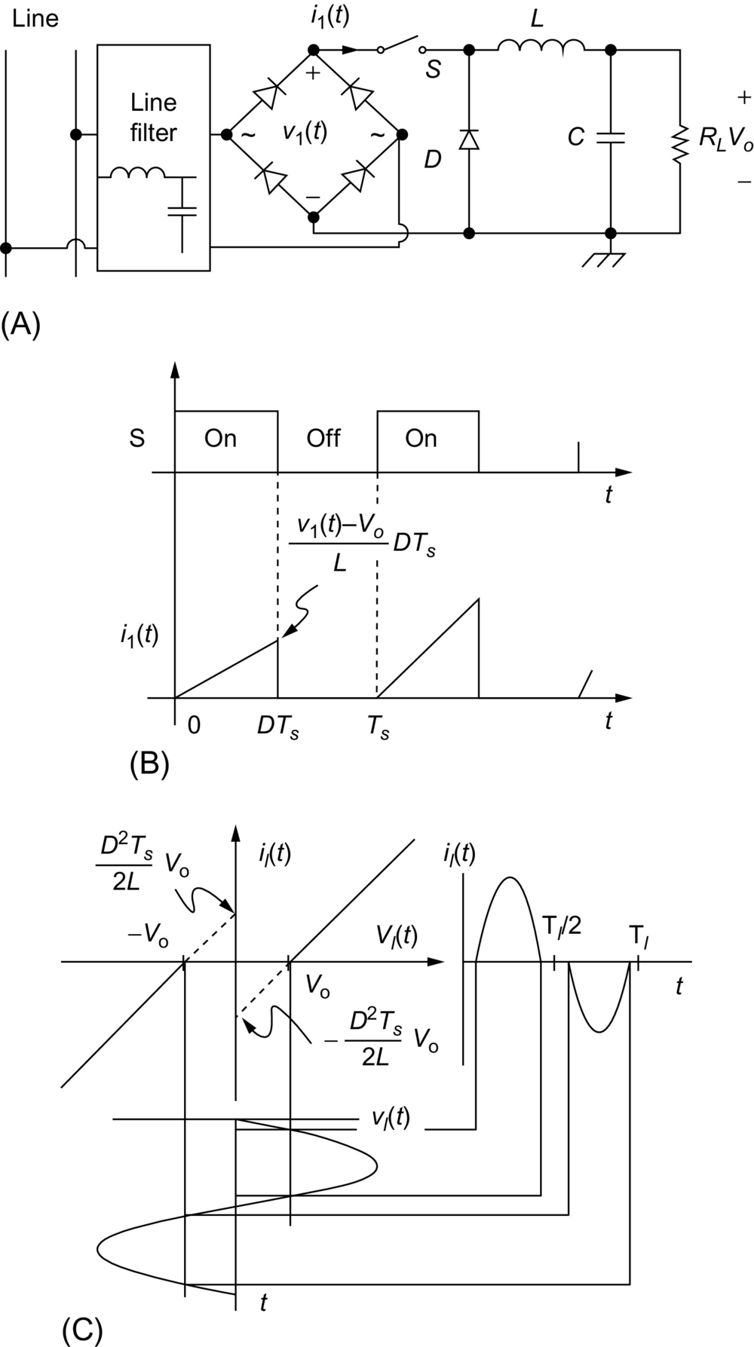

**FIG. 16.37** Input *I-V* characteristic of basic buck converter operating in DCM: (A) buck converter, (B) input current, and (C) input *I-V* characteristic.

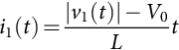 **(16.27)**

It can be shown that the average output current of the rectifier in one switching cycle is given by

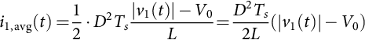 **(16.28)**

The average line current or the average input current of the rectifier during one switching cycle is given as follows:

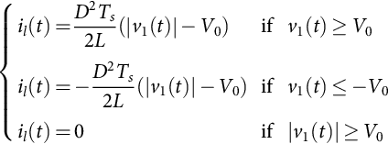 **(16.29)**

Where it is supposed that the input voltage waveform is sinusoidal and the drop voltage along the rectifier is neglected. Based on Eq. [(16.27)](https://learning.oreilly.com/library/view/power-electronics-handbook/9780128114087/B9780128114070000179.xhtml#fo0145), [Fig. 16.37C](https://learning.oreilly.com/library/view/power-electronics-handbook/9780128114087/B9780128114070000179.xhtml#f0190) shows that the input voltage-input current *I-V* characteristic consists of two straight lines in quadrants I and III. These straight lines that are presenting the average instantaneous input current versus the input voltage do not go through the origin. It is obvious that the instantaneous average value of the input current is equal to zero within the interval . When , positive input current would occurs when  and negative input current occurs. As a result, due to the zero regions of the input current as shown in [Fig. 16.37C](https://learning.oreilly.com/library/view/power-electronics-handbook/9780128114087/B9780128114070000179.xhtml#f0190). The input current is distorted simply because the buck converter can work only under the condition when the input voltage is larger than the output voltage. Therefore, the basic buck converter cannot fulfill the requirement of a good candidate that can be used to achieve the DCM input PFC.

#### **16.5.1.2 Boost Converter**

The basic boost converter and its input current waveform are shown in [Fig. 16.38A and B](https://learning.oreilly.com/library/view/power-electronics-handbook/9780128114087/B9780128114070000179.xhtml#f0195), respectively. This current can be presented by the following expression:

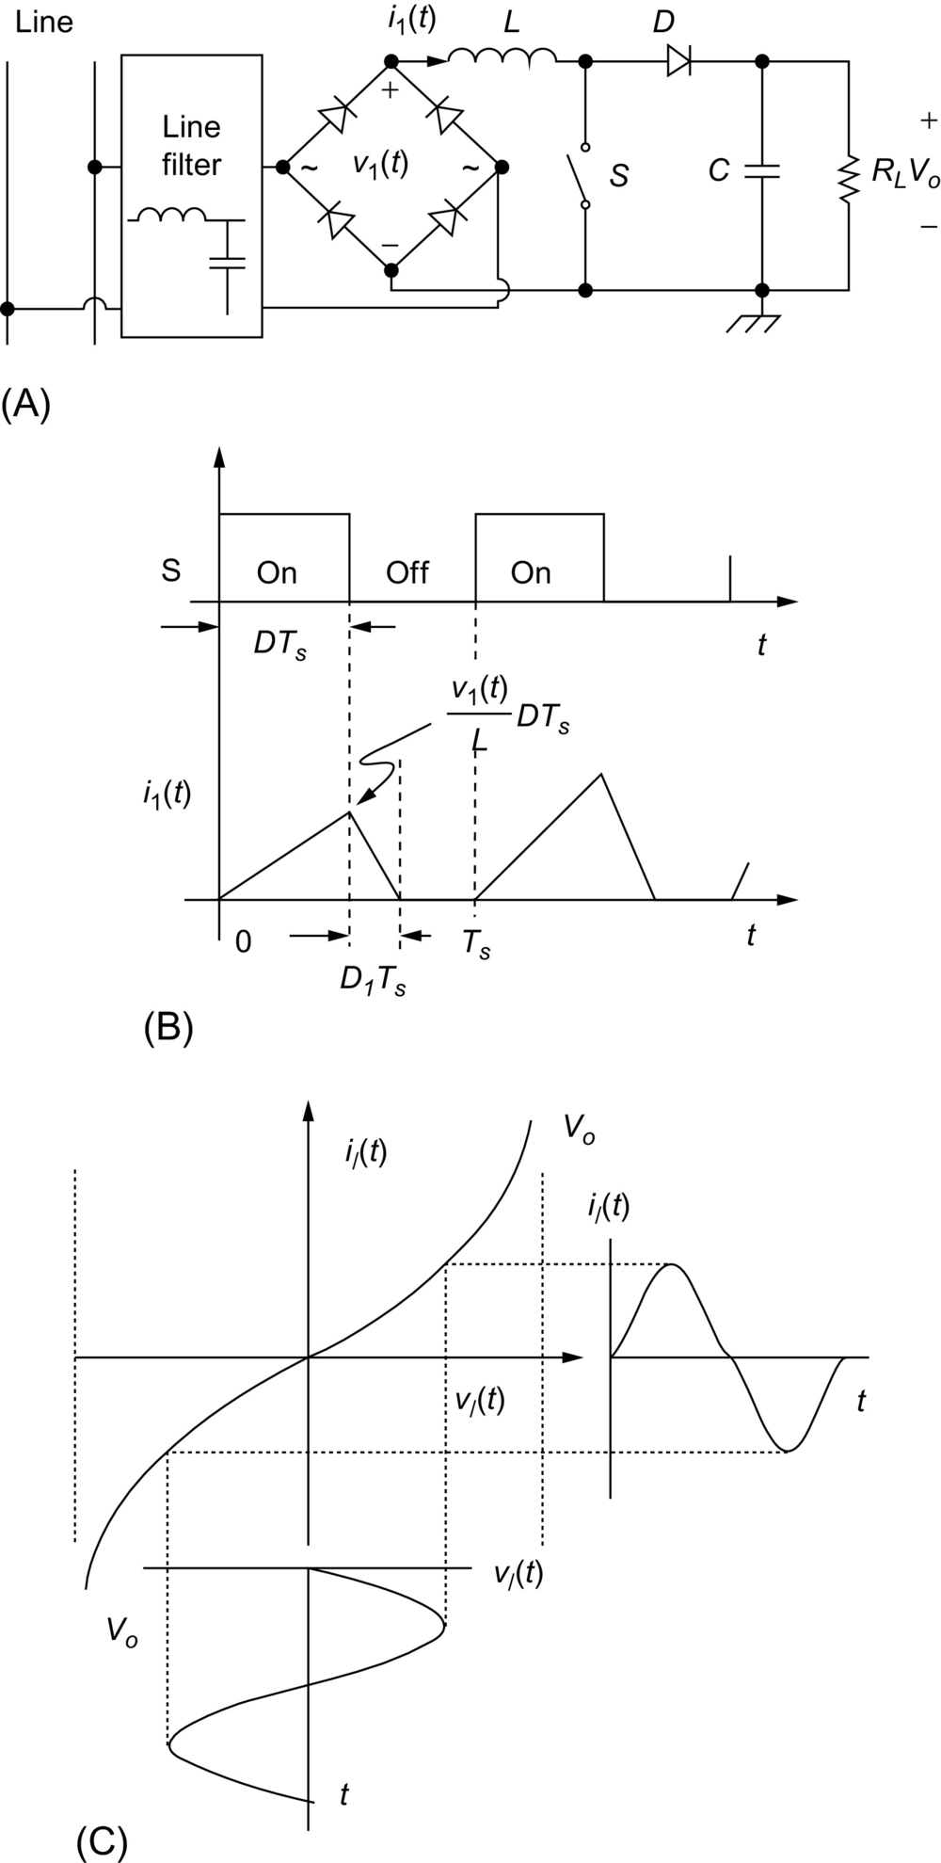

**FIG. 16.38** Input *I-V* characteristic of basic boost converter operating in DCM: (A) boost converter, (B) input current, and (C) input *I-V* characteristic.

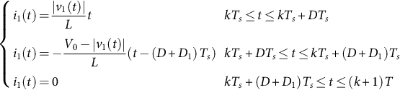 **(16.30)**

The average instantaneous input current of the boost converter in one switching cycle is given as follows:

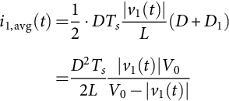 **(16.31)**

where *DTs* is the interval of time during which the inductor current increases from zero to the current peak and *D*1*Ts* is the time during which the inductor current decreases from the current peak to zero.

The average line current or the average input current of the rectifier during one switching cycle is given as follows:

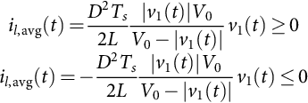 **(16.32)**

By plotting Eq. [(16.32)](https://learning.oreilly.com/library/view/power-electronics-handbook/9780128114087/B9780128114070000179.xhtml#fo0170), we obtain the input *I-V* characteristic curve as given in [Fig. 16.35C](https://learning.oreilly.com/library/view/power-electronics-handbook/9780128114087/B9780128114070000179.xhtml#f0180). As we can see that as long as the output voltage is larger than the peak value of the line voltage in certain range, the relationship between *v*1(*t*) and *i*1,avg(*t*) is nearly linear. When the boost converter is connected to the line, it will draw almost sinusoidal average input current from the line, shown as in [Fig. 16.38C](https://learning.oreilly.com/library/view/power-electronics-handbook/9780128114087/B9780128114070000179.xhtml#f0195) [[1](https://learning.oreilly.com/library/view/power-electronics-handbook/9780128114087/B9780128114070000179.xhtml#bb0010)].

Because of the above reasons, boost converter is comparably superior to most of the other converters when applied to do PFC. However, it should be noted that boost converter can operate properly only when the output voltage is higher than its input voltage. When low-voltage output is needed, a step-down DC-DC converter must be cascaded [[1](https://learning.oreilly.com/library/view/power-electronics-handbook/9780128114087/B9780128114070000179.xhtml#bb0010)].

#### **16.5.1.3 Buck-Boost Converter**

[Fig. 16.39A](https://learning.oreilly.com/library/view/power-electronics-handbook/9780128114087/B9780128114070000179.xhtml#f0200) shows a basic buck-boost converter topology; its input current waveform is shown in [Fig. 16.39B](https://learning.oreilly.com/library/view/power-electronics-handbook/9780128114087/B9780128114070000179.xhtml#f0200). This current can be presented by the following expression:

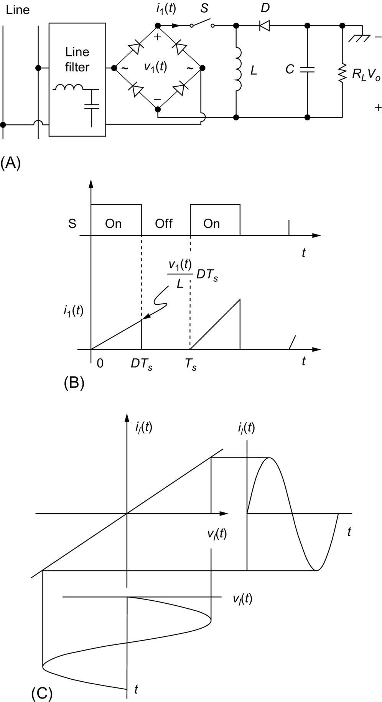

**FIG. 16.39** Input *I-V* characteristic of basic buck-boost converter operating in DCM: (A) buck-boost converter, (B) input current, and (C) input *I-V* characteristic.

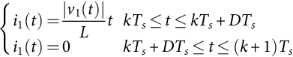 **(16.33)**

The averaged input current of this converter can be found according to Eq. [(16.33)](https://learning.oreilly.com/library/view/power-electronics-handbook/9780128114087/B9780128114070000179.xhtml#fo0175) as follows:

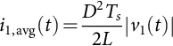 **(16.34)**

The average line current or the average input current of the rectifier during one switching cycle is given as follows:

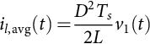 **(16.35)**

Eq. [(16.35)](https://learning.oreilly.com/library/view/power-electronics-handbook/9780128114087/B9780128114070000179.xhtml#fo0185) gives a perfect linear relationship between *il*,avg(*t*) and *v*1(*t*), which proves that the buck-boost topology has an excellent automatic PFC property. It is obvious that the input current of this kind of converter is independent of the discharging behavior of the inductor. Its input *I-V* characteristics and input voltage and current waveforms are shown in [Fig. 16.39C](https://learning.oreilly.com/library/view/power-electronics-handbook/9780128114087/B9780128114070000179.xhtml#f0200). Furthermore, the main objective of the buck-boost converter is to ensure an output voltage that can be either higher or lower than the input voltage; in the same time and due to the continuous linear relationship between *il*,avg(*t*) and *v*1(*t*) based on the DCM technique, this topology demonstrates strong availability to achieve a sine waveform of the input current and in phase with the input voltage that means a good PFC function.

Theoretically, buck-boost converter is a perfect candidate. Unfortunately, this topology has two limitations: (1) The polarity of its output voltage is reversed, that is, the input voltage and the output voltage cannot have the common ground, and (2) it needs floating drive for the power switch. The first limitation circumscribes this circuit into a very narrow scope of applications. As a result, it is not widely used [[1](https://learning.oreilly.com/library/view/power-electronics-handbook/9780128114087/B9780128114070000179.xhtml#bb0010)].

#### **16.5.1.4 Flyback Converter**

Flyback converter is an isolated converter whose topology is presented in [Fig. 16.40A](https://learning.oreilly.com/library/view/power-electronics-handbook/9780128114087/B9780128114070000179.xhtml#f0205); its input current waveform is shown in [Fig. 16.40B](https://learning.oreilly.com/library/view/power-electronics-handbook/9780128114087/B9780128114070000179.xhtml#f0205), and it is presented by the following equation:

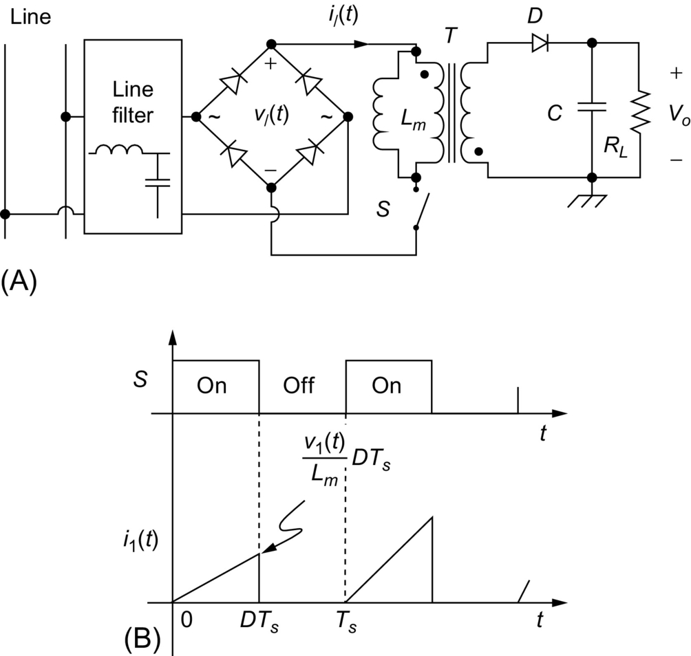

**FIG. 16.40** Input *I-V* characteristic of basic flyback converter operating in DCM: (A) flyback converter and (B) input current.

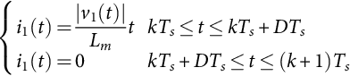 **(16.36)**

It can be seen clearly that this current is similar to the buck-boost converter input current, where *Lm* is the magnetizing inductance of the output transformer. The averaged input current of this converter can be found according to Eq. [(16.36)](https://learning.oreilly.com/library/view/power-electronics-handbook/9780128114087/B9780128114070000179.xhtml#fo0190) as follows:

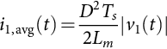 **(16.37)**

The average line current or the average input current of the rectifier during one switching cycle is given as follows:

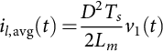 **(16.38)**

Therefore, the flyback converter topology has the same input *I-V* characteristic as the buck-boost converter topology, and hence, it has the same input voltage and input current waveforms as shown in [Fig. 16.40C](https://learning.oreilly.com/library/view/power-electronics-handbook/9780128114087/B9780128114070000179.xhtml#f0205).

Comparing with buck-boost converter, flyback converter has all the advantages of the buck-boost converter. What's more, input-output isolation can be provided by flyback converter. These advantages make flyback converter well suitable for PFC with DCM input technique. Comparing with boost converter, the flyback converter has better PFC, and the output voltage can be either higher or lower than the input voltage. However, due to the use of power transformer, the flyback converter has some drawbacks such as high *di/dt* noise, lower efficiency, and lower density (larger size and heavier weight) [[1](https://learning.oreilly.com/library/view/power-electronics-handbook/9780128114087/B9780128114070000179.xhtml#bb0010)].

#### **16.5.1.5 Forward Converter**

The forward converter topology is shown in [Fig. 16.41](https://learning.oreilly.com/library/view/power-electronics-handbook/9780128114087/B9780128114070000179.xhtml#f0210). In order to avoid transformer saturation, it is well-known that forward converter needs the third winding to demagnetize (reset) the transformer.

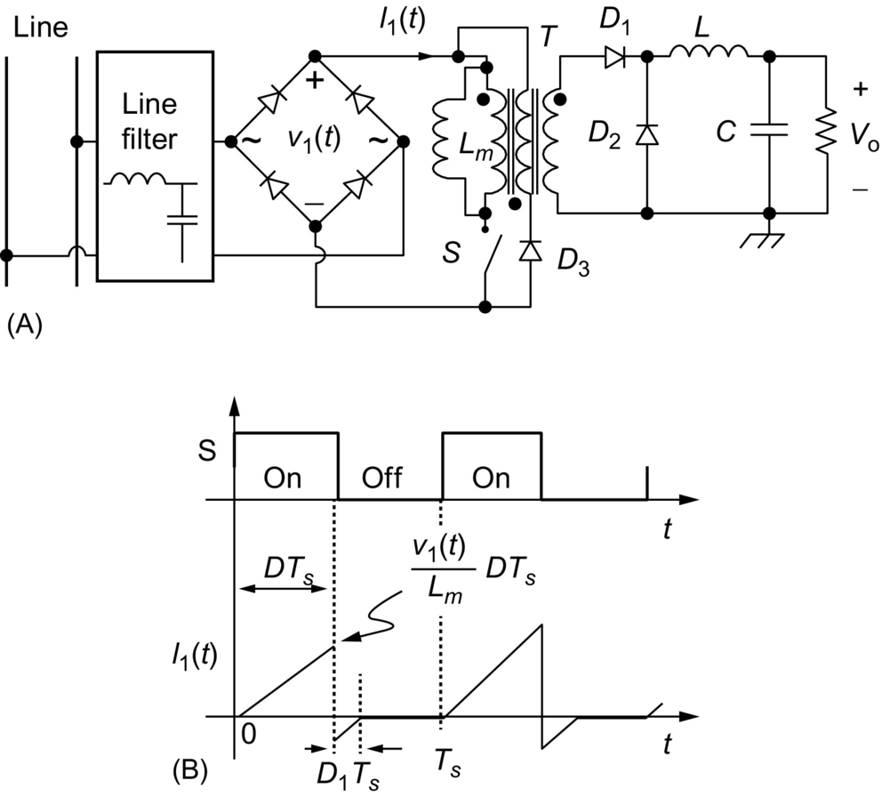

**FIG. 16.41** (A) Forward converter and (B) input current waveform.

The forward converter topology, when compared with the flyback topology, has the advantages of lower peak output current and less leakage energy-related problems; it is generally more energy efficient, and it is used for applications requiring little higher power output (in the range of 100–200 W). However, the circuit topology, especially the output filtering circuit, is not as simple as in the flyback converter, and when its basic topology is connected to the rectified line voltage, the path of the demagnetizing current through the third winding is blocked by the rectifier bridge diodes during the turn-off period of the main switch *S*. Moreover, energy transfer to output ceases during the interval when the rectified input voltage |*v*1(*t*)| is lower than the reflected output voltage on the primary (i.e., ), resulting in distorted input current. Therefore, this basic topology cannot be used to achieve the PFC purpose unless a certain circuit modification is applied such as forward converter with a resistor-capacitor-diode (RCD) clamp circuit, the forward converter with an active clamp (FAC).

#### **16.5.1.6 Cuk Converter and Sepic Converter**

It can be shown that Cuk converter and Sepic converter given in [Fig. 16.42A and B](https://learning.oreilly.com/library/view/power-electronics-handbook/9780128114087/B9780128114070000179.xhtml#f0215), respectively, have the same input *I-V* characteristic. Each of these converter topologies has two inductors, with one located at its input and the other at its output. Let's consider the case when the input inductor operates in DCM, while the output inductor operates in CCM. In this case, the capacitor *C*1 can be designed with large value to balance the instantaneous input/output power, resulting in high PF in the input and low second-harmonic ripple in the output voltage. To investigate the input characteristic of these converters, let's take the Cuk converter as an example. One should note that the results from the Cuk converter are also suitable for Sepic converter [[1](https://learning.oreilly.com/library/view/power-electronics-handbook/9780128114087/B9780128114070000179.xhtml#bb0010)].

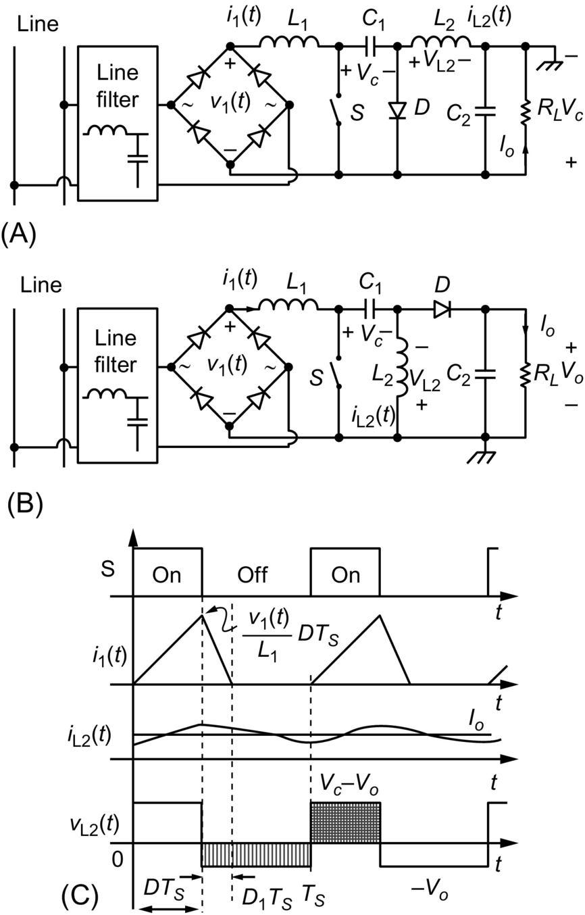

**FIG. 16.42** Input *I-V* characteristic of basic Cuk converter and Sepic converter operating in DCM: (A) Cuk converter, (B) Sepic converter, and (C) typical waveforms of Cuk converter with input inductor operating in DCM.

For the Cuk converter shown in [Fig. 16.42A](https://learning.oreilly.com/library/view/power-electronics-handbook/9780128114087/B9780128114070000179.xhtml#f0215), the waveforms for input inductor current (the same as the input current), output inductor current, and the voltage across the output inductor are depicted in [Fig. 16.42C](https://learning.oreilly.com/library/view/power-electronics-handbook/9780128114087/B9780128114070000179.xhtml#f0215) [[1](https://learning.oreilly.com/library/view/power-electronics-handbook/9780128114087/B9780128114070000179.xhtml#bb0010)]. Assume that the capacitor *C*1 is large enough to be considered as a voltage source *Vc*, in steady state, employing volt-second equilibrium principle on *L*2, we obtain

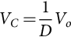 **(16.39)**

The input inductor current (the same as the input converter current) can be presented by the following expression:

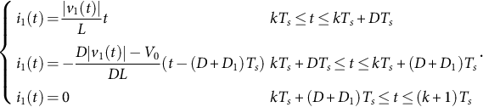 **(16.40)**

The input inductor current reset time ratio *D*1 is given by

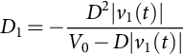 **(16.41)**

Therefore the averaged input current can be found as

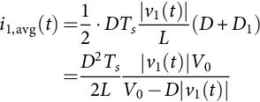 **(16.42)**

It can be seen that Eq. [(16.42)](https://learning.oreilly.com/library/view/power-electronics-handbook/9780128114087/B9780128114070000179.xhtml#fo0220) is very similar to Eq. [(16.32)](https://learning.oreilly.com/library/view/power-electronics-handbook/9780128114087/B9780128114070000179.xhtml#fo0170) except that the denominator in the former equation is () instead of (). This will lead to some improvement in that *I-V* characteristic in Cuk converter. Referring to the *I-V* characteristic shown in [Fig. 16.38C](https://learning.oreilly.com/library/view/power-electronics-handbook/9780128114087/B9780128114070000179.xhtml#f0195), Cuk converter has a curve more close to a straight line. Such improvement, however, is achieved at the expense of using more circuit components. It can be proved that the same results can be obtained by the Sepic converter [[1](https://learning.oreilly.com/library/view/power-electronics-handbook/9780128114087/B9780128114070000179.xhtml#bb0010)].

#### **16.5.1.7 Zeta Converter**

[Fig. 16.43A](https://learning.oreilly.com/library/view/power-electronics-handbook/9780128114087/B9780128114070000179.xhtml#f0220) gives a Zeta converter connected to the line. In DCM operation, the key waveforms are illustrated in [Fig. 16.43B](https://learning.oreilly.com/library/view/power-electronics-handbook/9780128114087/B9780128114070000179.xhtml#f0220), where we presume the capacitor being equivalent to a voltage source *Vc*. As we can see that the converter input current waveform is exactly the same as that drawn by a buck-boost converter [[1](https://learning.oreilly.com/library/view/power-electronics-handbook/9780128114087/B9780128114070000179.xhtml#bb0010)]. Thus, the instantaneous input current for the Zeta converter is identical to that for the buck-boost converter. It is expressed as follows:

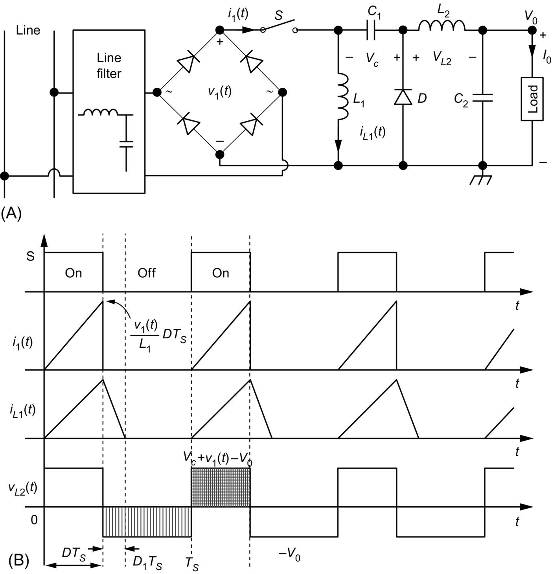

**FIG. 16.43** Input *I-V* characteristic of basic Zeta converter operating in DCM: (A) Zeta converter and (B) typical waveforms of Zeta converter with input inductor operating in DCM.

 **(16.43)**

The averaged input current of this converter can be found according to Eq. [(16.43)](https://learning.oreilly.com/library/view/power-electronics-handbook/9780128114087/B9780128114070000179.xhtml#fo0225) as follows:

 **(16.44)**

The average line current or the average input current of the rectifier during one switching cycle is given as follows:

 **(16.45)**

which is the same as the one given by Eq. [(16.33)](https://learning.oreilly.com/library/view/power-electronics-handbook/9780128114087/B9780128114070000179.xhtml#fo0175). As a result, the Zeta converter has as good automatic PFC capability as the buck-boost converter. The improvement achieved here is the noninverted output voltage. However, like the buck converter, floating drive is required for the power switch [[1](https://learning.oreilly.com/library/view/power-electronics-handbook/9780128114087/B9780128114070000179.xhtml#bb0010)].

Based on the above discussion, we may conclude that all the eight basic converters except forward converter have good inherent PFC capability and are available for DCM PFC usage. Among them, boost converter and flyback converter are especially suitable for single-stage PFC scheme because they have minimum component count and grounded switch drive, and their power switches are easy to be shared with the output DC-DC converter. Hence, these two converters are most preferable by the designers for PFC purpose. The other converters could also be used to perform certain function such as circuit protection and small output voltage ripple. The characteristics of the eight basic converter topologies are summarized in [Table 16.2](https://learning.oreilly.com/library/view/power-electronics-handbook/9780128114087/B9780128114070000179.xhtml#t0015) [[1](https://learning.oreilly.com/library/view/power-electronics-handbook/9780128114087/B9780128114070000179.xhtml#bb0010)].

**Table 16.2**

**Comparison of basic converter topologies operating for DCM input technique**

|  |  |  |  |  |  |  |  |
| --- | --- | --- | --- | --- | --- | --- | --- |
|  | **Buck** | **Boost** | **Buck-boost** | **Flyback** | **Forward**[**a**](https://learning.oreilly.com/library/view/power-electronics-handbook/9780128114087/B9780128114070000179.xhtml#tf0010) | **Cuk and Sepic** | **Zeta** |
| Line current waveform | t16-01-9780128114070 | t16-02-9780128114070 | t16-03-9780128114070 | t16-04-9780128114070 | – | t16-05-9780128114070 | t16-06-9780128114070 |
| Switch drive | Floating | Grounded | Floating | Grounded | Grounded | Grounded | Floating |
| Peak input current | High | Lower | High | High | — | Lower | High |
| Inrush and overload protection | Yes | No | Yes | Yes | — | Yes | Yes |
| Output voltage | si1_e | si2_e | Inverted | si1_e or si2_e | — | si1_e or si2_e; inverted for Cuk | si1_e or si2_e |
| Power level | Low to medium | Low to medium | Low to medium | Low | — | Low to medium | Low to medium |

[a](https://learning.oreilly.com/library/view/power-electronics-handbook/9780128114087/B9780128114070000179.xhtml#xtf0010) The standard forward converter is not recommended as a PF corrector since the rectifier at the input will block the demagnetizing current through the tertiary winding.

#### **16.5.1.8 Flyboost Converter**

Unlike the aforementioned converter used for PFC applications, the flyboost converter was proposed in [[96](https://learning.oreilly.com/library/view/power-electronics-handbook/9780128114087/B9780128114070000179.xhtml#bb0485),[97](https://learning.oreilly.com/library/view/power-electronics-handbook/9780128114087/B9780128114070000179.xhtml#bb0490)] to benefit simultaneously from the advantages of both flyback power transfer and boost power transfer. This proposed topology gains the features of the flyback and boost converter from point of view of power transfer process to achieve a unify PF and a very reduced input current harmonics. Indeed, it can be said that the difference of this topology from the basic topologies such as boost, SEPIC, buck-boost, Cuk, and buck is not so important; however, the operation principle is very different. It is obvious that there are only two operation modes for flyboost converter, the flyback mode and the boost mode. A derived flyboost converter topology has been used as shown in [Fig. 16.44](https://learning.oreilly.com/library/view/power-electronics-handbook/9780128114087/B9780128114070000179.xhtml#f0225). It consists mainly of one switch, a flyboost transformer *T*1, tow input transformer *T*2, two capacitor, an output inductor, and six diodes [[98](https://learning.oreilly.com/library/view/power-electronics-handbook/9780128114087/B9780128114070000179.xhtml#bb0495),[99](https://learning.oreilly.com/library/view/power-electronics-handbook/9780128114087/B9780128114070000179.xhtml#bb0500)]. This derived PFC topology has some advantages in comparison with other PFC topologies such as [[96](https://learning.oreilly.com/library/view/power-electronics-handbook/9780128114087/B9780128114070000179.xhtml#bb0485)]

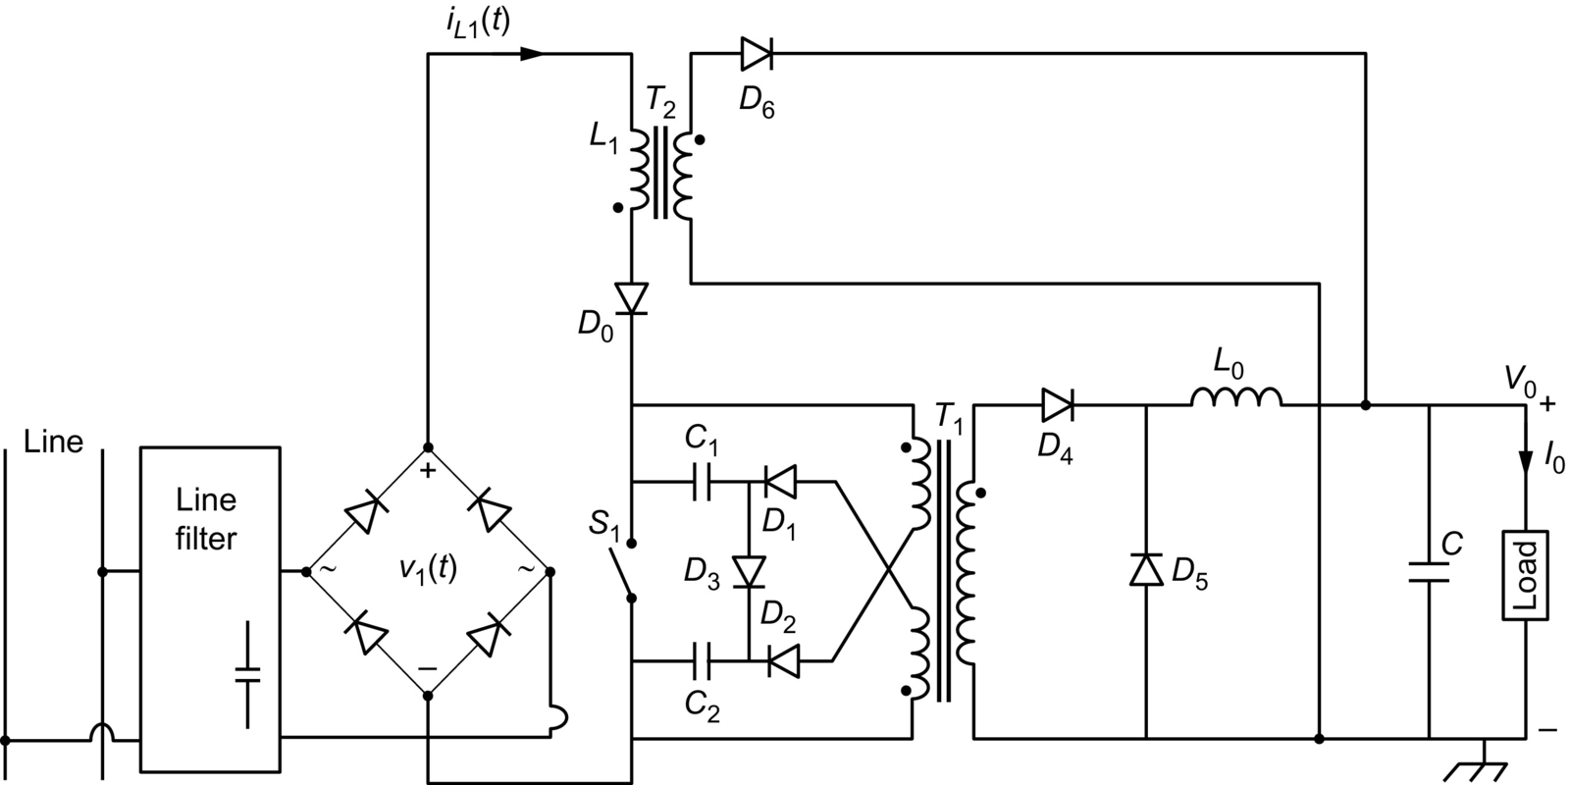

**FIG. 16.44** The improved topology of the flyboost converter.

• one switch is used that means easy control implementation,

• high-performance capability for power transfer process,

• high PF and high efficiency,

• automatic clamping of the intermediate dc bus voltage within a desirable range,

• relatively low-voltage stress on power devices,

• capability to support input inrush and to ensure self-surge current protection,

• can be used in medium power level with low-cost.

### 16.5.2 AC-DC POWER SUPPLY WITH DCM INPUT TECHNIQUE

In two-stage PFC power supply, the DCM converter is connected in front of the ac line to achieve high input PF and provide a roughly regulated dc bus voltage, as shown in [Fig. 16.45](https://learning.oreilly.com/library/view/power-electronics-handbook/9780128114087/B9780128114070000179.xhtml#f0230). This stage is also known as “preregulator.” The duty ratio of the preregulator should be maintained relatively stable so that high PF is ensured. To stabilize the dc bus voltage, a bank capacitor is used at the output of the preregulator. The second stage, followed by the preregulator, is a DC-DC converter, called postregulator, with its output voltage being tightly controlled. This stage can operate either in DCM or in CCM. However, CCM is normally preferred to reduce the output voltage ripple [[1](https://learning.oreilly.com/library/view/power-electronics-handbook/9780128114087/B9780128114070000179.xhtml#bb0010)].

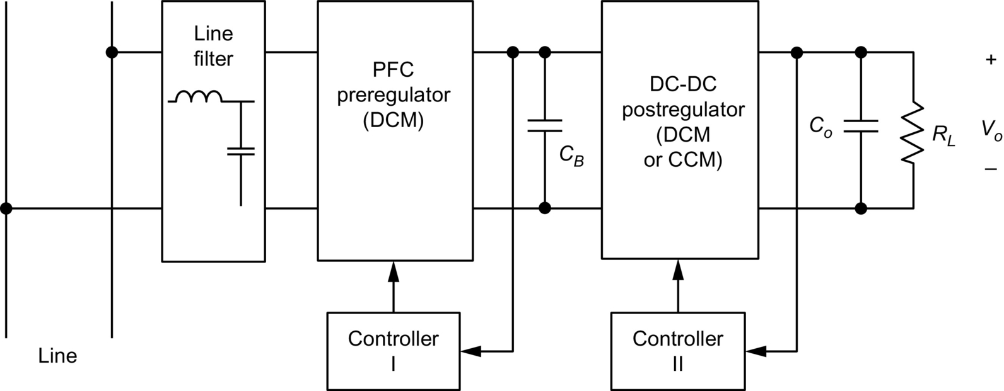

**FIG. 16.45** DCM input preregulator in two-stage ac-dc power supply.

DCM input technique has been widely used in one-stage PFC circuit configurations. Using a basic converter (usually boost or flyback converter) operating in DCM, combining it with another isolation converter can form a one-stage PFC circuit. A storage capacitor is generally required to hold the dc bus voltage in these combinations. Unlike the two-stage PFC circuit, in which the bus voltage is controlled, the single-stage PFC converter has only one feedback loop from the output. The input circuit and the output circuit must share the same control signal. In [[100](https://learning.oreilly.com/library/view/power-electronics-handbook/9780128114087/B9780128114070000179.xhtml#bb0505)–[102](https://learning.oreilly.com/library/view/power-electronics-handbook/9780128114087/B9780128114070000179.xhtml#bb0515)], a number of combinations have been studied. [Figs. 16.46](https://learning.oreilly.com/library/view/power-electronics-handbook/9780128114087/B9780128114070000179.xhtml#f0235) and [16.47](https://learning.oreilly.com/library/view/power-electronics-handbook/9780128114087/B9780128114070000179.xhtml#f0240) show a few examples of successful combinations. Since the input circuit and the output circuit are in a single-stage, it is possible for them to share the same power switch. Thus it results in single-stage single-switch PFC (*S*4-PFC) circuit, as shown in [Fig. 16.47](https://learning.oreilly.com/library/view/power-electronics-handbook/9780128114087/B9780128114070000179.xhtml#f0240) [[100](https://learning.oreilly.com/library/view/power-electronics-handbook/9780128114087/B9780128114070000179.xhtml#bb0505),[103](https://learning.oreilly.com/library/view/power-electronics-handbook/9780128114087/B9780128114070000179.xhtml#bb0520),[104](https://learning.oreilly.com/library/view/power-electronics-handbook/9780128114087/B9780128114070000179.xhtml#bb0525),[1](https://learning.oreilly.com/library/view/power-electronics-handbook/9780128114087/B9780128114070000179.xhtml#bb0010)].

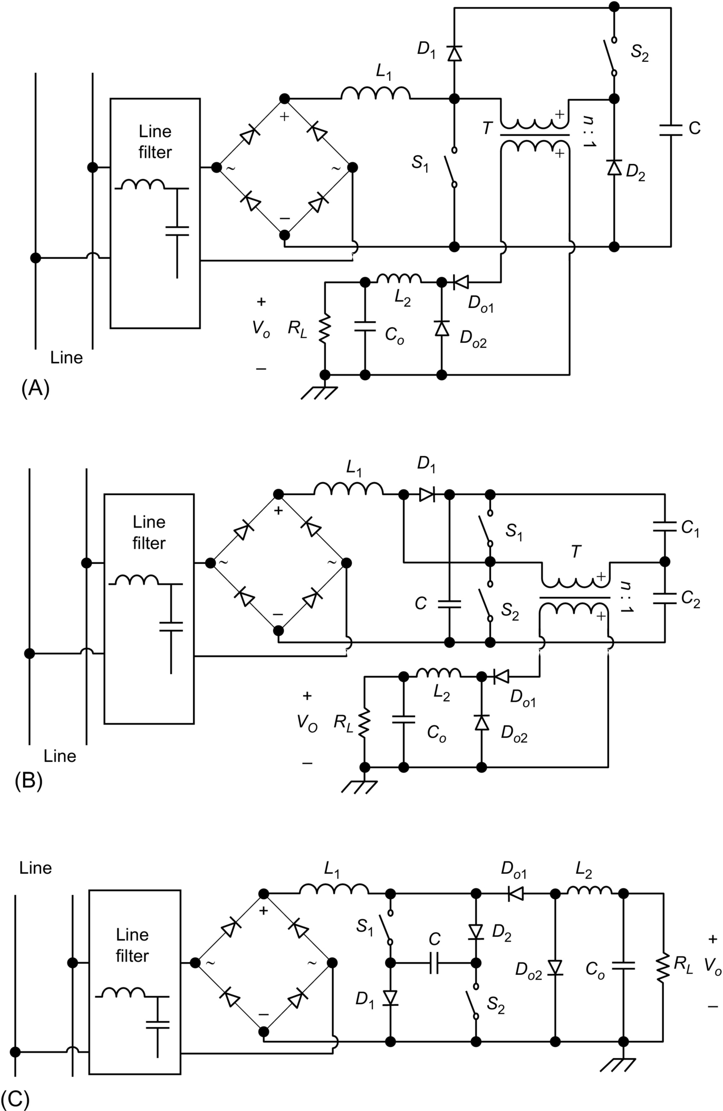

**FIG. 16.46** Two-switch single-stage power factor corrector: (A) boost-forward converter, (B) boost-half-bridge converter, and (C) Sheppard-Taylor converter.

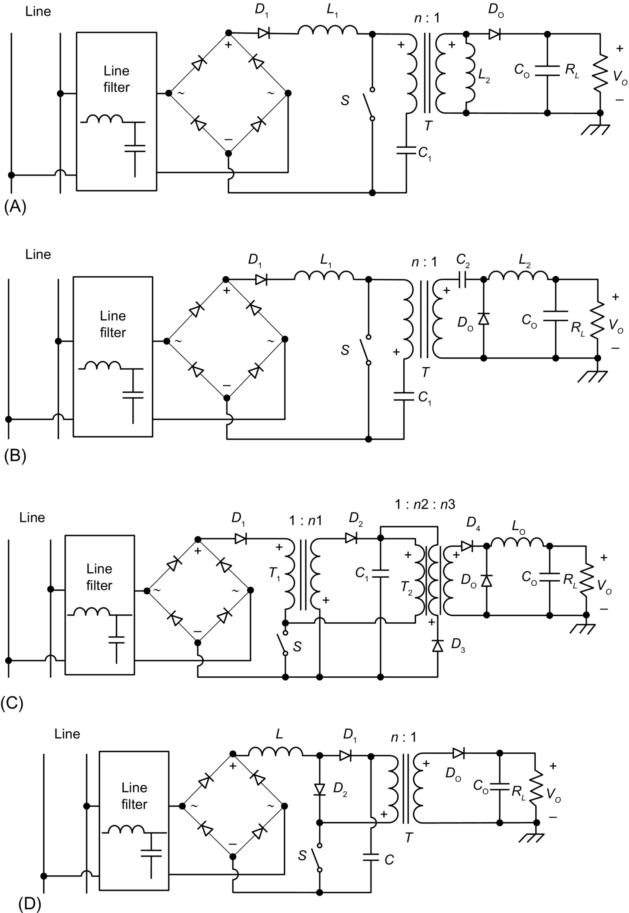

**FIG. 16.47** Single-stage single-switch PFC circuit: (A) boost-flyback combination circuit (BIFRED), (B) boost-buck combination circuit (BIBRED), (C) flyback-forward combination, and (D) boost-flyback combination.

The boost integrated with flyback rectifier/energy storage/dc-dc converter (BIFRED) and boost integrated with buck rectifier/energy storage/dc-dc converter (BIBRED) are two single-stage converters of the integrated high-quality rectifier-regulator (IHQRR) family that have been firstly presented by [[103](https://learning.oreilly.com/library/view/power-electronics-handbook/9780128114087/B9780128114070000179.xhtml#bb0520)–[106](https://learning.oreilly.com/library/view/power-electronics-handbook/9780128114087/B9780128114070000179.xhtml#bb0535)]. Both topologies are able to ensure an input current with a low harmonic content and, also, a regulated and isolated output voltage bus using only one switch. The two topologies of BIFRED and BIBRED are designed so that the input inductor and the output inductive element both operate in the DCM mode. It is obvious that BIFRED topology presents a strong similarity with the isolated version of the Sepic converter. Furthermore, the BIBRED topology resembles to the isolated version of the Cuk converter [[107](https://learning.oreilly.com/library/view/power-electronics-handbook/9780128114087/B9780128114070000179.xhtml#bb0540)]. As it was explained, the two topologies of the BIFRED and BIBRED converters are composed of two integrated converters, where only one switch is used. The BIFRED converter is an integration of a discontinuous conduction mode (DCM) boost converter and a flyback converter. In the BIBRED, the corresponding parts are a DCM boost converter and a forward converter. Schematics of the BIFRED and BIBRED converters are shown in [Fig. 16.47A and B](https://learning.oreilly.com/library/view/power-electronics-handbook/9780128114087/B9780128114070000179.xhtml#f0240), respectively.

Due to the simplicity and low-cost, DCM boost converter is most commonly used for unity PF operation. The main drawback of using boost converter is that it shows considerable distortion of the average line current owing to the slow discharging of the inductor after the switch is turned off [[1](https://learning.oreilly.com/library/view/power-electronics-handbook/9780128114087/B9780128114070000179.xhtml#bb0010)].

The output DC-DC converter can operate either in DCM or in CCM if small output ripple is desired. If the output circuit operates in CCM, there exists a power unbalance in *S*4-PFC converter when the load changes. Because the duty ratio is only sensitive to the output voltage in CCM operation, when the output power (output current) decreases, the duty ratio will keep unchanged. As both the input and the output circuit share the power switch, the input circuit will draw an unchanged power from the ac source. As a result, the input power is higher than the output power. The difference between the input power and the output power has to be stored in the storage capacitor, and hence, increase in the dc bus voltage occurs. With the dc bus voltage's rising, the duty ratio decreases. This process will be finished until a new power balance is built. As we can see, the new power balance is achieved at the penalty of increased voltage stress, resulting in high conduction losses in circuit components. Particularly, the high bus voltage causes difficulties in developing S4-converter for universal input (input line voltage *rms* value from ac 90–260 *V*) application [[1](https://learning.oreilly.com/library/view/power-electronics-handbook/9780128114087/B9780128114070000179.xhtml#bb0010)].

Recent research on solving this problem can be found in [[108](https://learning.oreilly.com/library/view/power-electronics-handbook/9780128114087/B9780128114070000179.xhtml#bb0545)–[116](https://learning.oreilly.com/library/view/power-electronics-handbook/9780128114087/B9780128114070000179.xhtml#bb0585)]. The circuit in [[108](https://learning.oreilly.com/library/view/power-electronics-handbook/9780128114087/B9780128114070000179.xhtml#bb0545)] uses two bulk capacitors that share the dc bus voltage change, shown in [Fig. 16.48A](https://learning.oreilly.com/library/view/power-electronics-handbook/9780128114087/B9780128114070000179.xhtml#f0245). As a result, lower voltage is present at each of the capacitor. Ref. [[109](https://learning.oreilly.com/library/view/power-electronics-handbook/9780128114087/B9780128114070000179.xhtml#bb0550)] proposed a modified boost-forward PFC converter, in which a negative current feedback is introduced to the input circuit by the coupled windings of forward transformer, shown in [Fig. 16.48B](https://learning.oreilly.com/library/view/power-electronics-handbook/9780128114087/B9780128114070000179.xhtml#f0245). In [[110](https://learning.oreilly.com/library/view/power-electronics-handbook/9780128114087/B9780128114070000179.xhtml#bb0555)], a series resonant circuit called charge pump circuit is introduced into *S*4-PFC circuit, shown in [Fig. 16.48C](https://learning.oreilly.com/library/view/power-electronics-handbook/9780128114087/B9780128114070000179.xhtml#f0245). As the load decrease, the charge pump circuit can suppress the dc bus voltage automatically [[1](https://learning.oreilly.com/library/view/power-electronics-handbook/9780128114087/B9780128114070000179.xhtml#bb0010)].

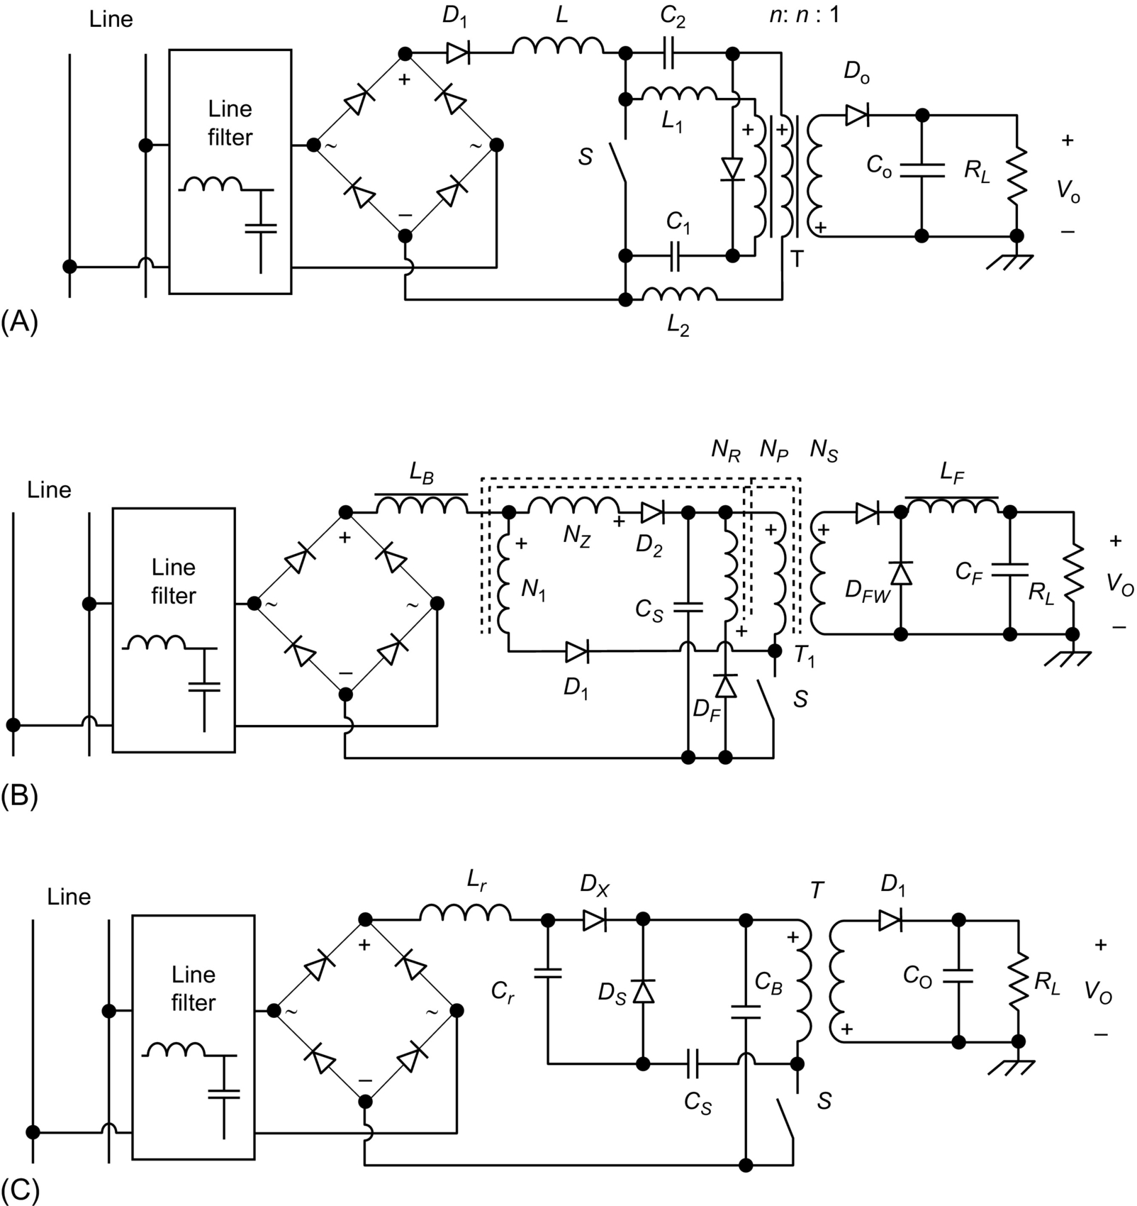

**FIG. 16.48** Improved S4-PFC converter: (A) boost-forward PFC circuit using two bulk capacitors, (B) boost-forward PFC circuit with reduced bus voltage, and (C) boost-flyback PFC circuit with charge pump circuit.

### 16.5.3 CRM TECHNIQUE

In this control technique, the switch is turned on when the inductor current falls to zero (when it reaches the time axis), where the switch is kept on for a constant duration during the line cycle and the switch off duration is controlled by a given signal loop. It is clear that the converter operates at the boundary between the continuous and discontinuous current mode (CCM-DCM) [[117](https://learning.oreilly.com/library/view/power-electronics-handbook/9780128114087/B9780128114070000179.xhtml#bb0590),[118](https://learning.oreilly.com/library/view/power-electronics-handbook/9780128114087/B9780128114070000179.xhtml#bb0595)]. It can be said that this type of control is a particular case of hysteretic control in which the lower current command is zero anywhere.

It was proved that the CRM technique has some interesting advantages when it is applied to the boost converter, where the line current is shaped to be sinusoid under COT control [[117](https://learning.oreilly.com/library/view/power-electronics-handbook/9780128114087/B9780128114070000179.xhtml#bb0590),[119](https://learning.oreilly.com/library/view/power-electronics-handbook/9780128114087/B9780128114070000179.xhtml#bb0600)]. Unfortunately, the CRM technique when it is applied to the buck and flyback converters and their derived topologies such as buck-boost, Sepic, and Cuk under COT control leads to a somewhat distorted line current. Hence, the application of CRM technique to these kinds of converters will not allow to meet the PF and THD requirements within the known standards [[117](https://learning.oreilly.com/library/view/power-electronics-handbook/9780128114087/B9780128114070000179.xhtml#bb0590),[119](https://learning.oreilly.com/library/view/power-electronics-handbook/9780128114087/B9780128114070000179.xhtml#bb0600),[120](https://learning.oreilly.com/library/view/power-electronics-handbook/9780128114087/B9780128114070000179.xhtml#bb0605)]. To overcome the drawbacks of the CRM control technique, variable on-time (VOT) control technique was proposed and applied to the buck PFC converter [[121](https://learning.oreilly.com/library/view/power-electronics-handbook/9780128114087/B9780128114070000179.xhtml#bb0610),[122](https://learning.oreilly.com/library/view/power-electronics-handbook/9780128114087/B9780128114070000179.xhtml#bb0615)] to achieve high PF and low THD requirement given by the standards. In the same way, based on the input voltage, an improved CRM technique is applied on flyback PFC converter by modulating the turn-on time, However, as the output voltage is not used to modulate the on-time of the switch, when output voltage is varying under constant output current power supply, unity PF is very difficult to be ensured [[123](https://learning.oreilly.com/library/view/power-electronics-handbook/9780128114087/B9780128114070000179.xhtml#bb0620)]. It is important to clarify that in this control technique, the inductor and switch peak currents are twice the ac system input current peak value. Therefore, the CRM technique is not suitable for high-power applications. However, the CRM technique is attractive in low-power applications such as the PFC for “electronic ballasts” where the following advantages can be achieved: (1) the switch can be easily oversized without increasing cost; (2) the switch operates under zero-current turn-on, avoiding turn-on losses and electromagnetic interference problems; and (3) the smaller sized inductor can be used to reduce the size and cost of the system.

### 16.5.4 OTHER PFC TECHNIQUES

Extensive research in PFC continues to yield countless new techniques [[58](https://learning.oreilly.com/library/view/power-electronics-handbook/9780128114087/B9780128114070000179.xhtml#bb0295),[61](https://learning.oreilly.com/library/view/power-electronics-handbook/9780128114087/B9780128114070000179.xhtml#bb0310),[124](https://learning.oreilly.com/library/view/power-electronics-handbook/9780128114087/B9780128114070000179.xhtml#bb0625)–[152](https://learning.oreilly.com/library/view/power-electronics-handbook/9780128114087/B9780128114070000179.xhtml#bb0765)]. The research topics are mainly focused on improvements of the PFC circuit performs such as fast performance, high efficiency, low-cost, small input current distortion, and output ripple. The classification of PFC techniques presented here can only cover those methods that are frequently documented in the open literature. There are still many PFC methods that do not fall into the specified categories. The following are some examples [[1](https://learning.oreilly.com/library/view/power-electronics-handbook/9780128114087/B9780128114070000179.xhtml#bb0010)]:

• *Second-harmonic-injected method* [[126](https://learning.oreilly.com/library/view/power-electronics-handbook/9780128114087/B9780128114070000179.xhtml#bb0635)]: In DCM input technique, even the converter operates at constant duty ratio, current distortion still exists. The basic idea of second-harmonic-injected method is compensating the duty ratio by injecting a certain amount of second-harmonic into the duty ratio to modify the input *I-V* characteristic of the input converter. However, the output voltage may be affected by the modified duty ratio.

• *Cycle control technique* [[127](https://learning.oreilly.com/library/view/power-electronics-handbook/9780128114087/B9780128114070000179.xhtml#bb0640)]: It is a new a method recently proposed for harmonics reduction in dc-dc converter that has the simplicity of voltage follower technique. In this technique, a periodic signal proportional to the rectified ac line voltage is used to modulate the duty-cycle of the power switch, where the main goal is to reduce the line current THD and to improve the PF; it offers the following advantages: (1) The generation of the injected signal is based on sensing the output voltage of the bridge rectifier that permits to have a simpler circuit without any additional circuit of phase detecting and phase synchronization, and (2) the modulation index can be used to obtain constant content of harmonics under a wide range of load variation, just with a simple PI controller, and (3) can have a good dynamic behavior under input voltage and load transients.

• *Interleaved method* [[128](https://learning.oreilly.com/library/view/power-electronics-handbook/9780128114087/B9780128114070000179.xhtml#bb0645)]: An interleaved PFC circuit composed of several input converters in parallel. The peak input current of these converters follow the line voltage and are interleaved. A sinusoidal total line current is obtained by superimposing all the input current of the converters. The advantage of this method is that the converter input current can be easily smoothed by input EMI filter.

• *Waveform synthesis method* [[129](https://learning.oreilly.com/library/view/power-electronics-handbook/9780128114087/B9780128114070000179.xhtml#bb0650)]: This method combines passive and active PFC techniques. Since the rectifier in the passive inductive-input PF corrector has a limited conduction angle, the input current is a single pulse around the peak of the line voltage, whereas the boost converter draws a nonzero current around the zero cross of the line voltage. By controlling the operation mode of the active switch (enable and disable the boost converter at certain line voltage), the waveforms of active and passive PFC circuits are tailored to extend the conduction angle of the rectifier. The resulting current waveform has a PF greater than 0.9 and a THD lower than 20%.

• *Digital PFC control technique* [[130](https://learning.oreilly.com/library/view/power-electronics-handbook/9780128114087/B9780128114070000179.xhtml#bb0655)–[152](https://learning.oreilly.com/library/view/power-electronics-handbook/9780128114087/B9780128114070000179.xhtml#bb0765)]: The digital control of PFC (DPFC) is expected to replace the analog PFC control, especially in medium- and high-power-level applications, due to its several advantages and to the great development in digital circuits. The main advantages of digital PFC control that push and motivate the application of the digital PFC control over other control techniques are mainly summarized in the following points [[135](https://learning.oreilly.com/library/view/power-electronics-handbook/9780128114087/B9780128114070000179.xhtml#bb0680)]:

a. Reduced sensitivity to circuits' parameter changes.

b. Reduced of analog electronics components.

c. An easy implementation of the controller.

d. An easy adjustment of control parameters.

e. An easy adaptation of the control against the changes of the measured or sensed variables.

f. Digital controller is less expensive compared with the analog controller.

g. Digital controller can be modified easily.

In this chapter, we are not focusing in digital PFC control; however, all the control techniques that have been presented in this chapter in DCM, CCM, and CRM modes can be furthermore extended to digital application for medium- and high-power-level applications (output power range between 200 and 2 kW) when high converter efficiency is desired. As an example, the following digital PFC control techniques have been already investigated:

1. Digital average current mode PFC control (DACM) [[135](https://learning.oreilly.com/library/view/power-electronics-handbook/9780128114087/B9780128114070000179.xhtml#bb0680)–[138](https://learning.oreilly.com/library/view/power-electronics-handbook/9780128114087/B9780128114070000179.xhtml#bb0695)]: In this PFC control, the instantaneous sensed variables of the rectified input voltage, the input/inductor current, and the output voltage are digitized. On the other side, a digital PWM (DPWM) is used for the output of the digital-current-loop compensator feeds, a DPWM that generates a discrete time gate driving waveform.

2. Predictive PFC control [[139](https://learning.oreilly.com/library/view/power-electronics-handbook/9780128114087/B9780128114070000179.xhtml#bb0700)–[141](https://learning.oreilly.com/library/view/power-electronics-handbook/9780128114087/B9780128114070000179.xhtml#bb0710)]: This control technique allows the computing of the next control value using the current sensed values based on the equations presenting the behavior of the concerned converter to fulfill the requirement of tracking the input reference current shape. The performance of this PFC control is depending on the used sampling frequency; therefore, under high sampling frequency, better result and performance are obtained.

3. Hybrid PFC control [[135](https://learning.oreilly.com/library/view/power-electronics-handbook/9780128114087/B9780128114070000179.xhtml#bb0680)–[146](https://learning.oreilly.com/library/view/power-electronics-handbook/9780128114087/B9780128114070000179.xhtml#bb0735)]: This control technique has several advantages that make it a very attractive technique. It is based on combining the digital and the analog techniques, where the analog technique is used for the current loop and the digital technique is used for the voltage loop. The HPFCC gains the merit of both techniques for obtaining improved performances for tracking the input current shape and the desired output voltage under ease and less cost of the hardware implementation, reduced control circuit, rapid dynamic response, and compacted topology.

4. Other digital PFC control techniques [[135](https://learning.oreilly.com/library/view/power-electronics-handbook/9780128114087/B9780128114070000179.xhtml#bb0680)–[152](https://learning.oreilly.com/library/view/power-electronics-handbook/9780128114087/B9780128114070000179.xhtml#bb0765)]: All the techniques mentioned in [Sections 16.4](https://learning.oreilly.com/library/view/power-electronics-handbook/9780128114087/B9780128114070000179.xhtml#s0080) and [16.5](https://learning.oreilly.com/library/view/power-electronics-handbook/9780128114087/B9780128114070000179.xhtml#s0140) can be used under the digital PFC control technique and under the hybrid PFC technique, where in all case the main aim is that the technical advantages and economical advantages have to be respected during the design of the appropriated PFC control technique for the concerned converter topology and the level of the required power.

## 16.6 Summary

To reduce losses and decrease weight and size associated with converting ac power to dc power in linear power supply, SMPSs were introduced. The high nonlinearity of this kind of power electronic systems that are connected to the power systems supply, handicaps itself by providing the utility power system with low PF and high THD. These unwanted harmonics are commonly corrected by incorporating PFC technique into the SMPS. This chapter gives a technical review of current research in high-frequency PFC, including the definition of PF and THD, configuration of PFC circuit, DCM input technique, CRM technique, and CCM shaping technique. The common issue of these techniques is to properly process the power flow so that the constant power dissipation at the output is reflected into ac power dissipation with two times the line frequency. Technically, PFC techniques encounter the following trade-offs:

(a) *Simplicity and accuracy*: Single-stage PFC circuit has simple topology and simple control circuit but has less control accuracy, while two-stage PFC circuit has the contrary performance.

(b) *Control simplicity and power-handling capability*: DCM input technique requires no input current control but has less power-handling capability, while CCM has multiloop control and has more power-handling capability;

(c) *Switching frequency and conversion efficiency*: To reduce weight and size of the PFC converter, higher switching frequency is desired. However, the associated switching losses result in decrease in conversion efficiency.

(d) *Frequency response and bandwidth*: To have good dynamic response, wider bandwidth is desired; however, to achieve high PF, bulk storage capacitor and output capacitor have to be used.

In the past decades, research in PFC techniques has led to the development of more efficient circuits and control strategies in order to optimize the design without compromising the above trade-offs. Moreover, since the growth in power electronics strongly relies on the development of semiconductor devices and the recent advent of higher rating power devices, it is believed that the switching-mode PF correctors will completely replace the existing passive reactive compensators in power system. In the distributed power system (DPS) where small size and high efficiency are of extreme importance, a new soft-switching technique has been used in designing PFC circuits. With the ever-increasing market demanding for ultrafast computer, the need for low output voltage (typically less than 1 *V*) with high output currents and high efficiency converters has never been greater. Research efforts in developing high-frequency high efficiency PFC circuits will continue to grow.

## References

[1] I. Batarseh, H. Wei, Chapter One: Power factor correction circuits, Power Electronics Handbook, third ed., pp. 517–541.

[2] Duffey C.K., Stratford R.P. Update of harmonic Standard IEEE-519: IEEE recommended practices and requirements for harmonic control in electric power systems. *IEEE Trans. Ind. Appl.* 1989;25(6):1025–1034.

[3] Bose B.K. Power electronics—a technology review. *Proc. IEEE.* 1992;80:1303–1334.

[4] Akagi H. Trends in active power line conditioners. *IEEE Trans. Power Electron.* 1994;9(3):263–268.

[5] McMurray W. *Power electronics in the 1990’s.* In: Proceedings of IEEE-IECON’90; 1990:839–843.

[6] McEachern A., Grady W.M., Moncrief W.A., Heydt G.T., McGranaghan M. Revenue and harmonics: an evaluation of some proposed rate structures. *IEEE Trans. Power Delivery.* 1995;10(1):474–480.

[7] Redl R., Tenti P., Dan van Wyk J. Power electronics’ polluting effects. *IEEE Spectr.* 1997;34(5):32–39.

[8] Kouzou A., Mahmoudi M.O., Boucherit M.S. The space vector modulation PWM control methods applied on four leg inverters. In: *Electric Machines and Drives.* InTech; 2011:978-953-307-548-8 Chapter 12.

[9] Kouzou A., Mahmoudi M.O., Boucherit M.S. Evaluation of the Shunt Active Power Filter apparent power ratio using particle swarm optimization. *Arch. Control Sci.* 2010;20(1):47–76.

[10] Kouzou A., Khaldi B.S., Mahmoudi M.O., Boucherit M.S. The effect of the zero sequence component on the evaluation of the series APF apparent power. *Int. Rev. Electr. Eng.* 2009;4(6):1357–1366.

[11] Kouzou A., Khaldi B.S., Mahmoudi M.O., Boucherit M.S. *The effect of the zero sequence component on the evaluation of the series APF apparent power.* In: ICEEE 2008, The International Conference on Electrical Engineering; 2008.

[12] Kouzou A., Khaldi B.S., Mahmoudi M.O., Boucherit M.S. *Apparent power evaluation of series active power filter with recent definitions.* In: IEEE SSD’08, The Fifth International Multi-Conferences on Systems, Signals, and Devices; 2008.

[13] Kouzou A., Khaldi B.S., Mahmoudi M.O., Boucherit M.S. *Shunt Active power filter apparent power for design process.* In: SPEEDAM 2008 International Symposium on Power Electronics, Electrical Drives; 2008:1402–1408.

[14] Kouzou A., Khaldi B.S., Mahmoudi M.O., Boucherit M.S. *Apparent power ratio of the shunt active power filter.* In: EPE-PEMC 2008, The 13th International Power Electronics and Motion Control Conference; 2008:1987–1994.

[15] Kouzou A., Abu Rub H., Mahmoudi M.O., Boucherit M.S., Kennel R. *Four wire Shunt Active Power Filter based on four-leg inverter.* In: International Aegean Conference on Electrical Machines and Power Electronics and Electromotion, Joint Conference (ACEMP); 2011:508–513.

[16] Lai J.S., Hurst D., Key T. *Switch-mode power supply power factor improvement via harmonic elimination methods.* In: Conference Record of IEEE-APEC’91; 1991:415–422.

[17] IEEE. *IEEE Guide for Harmonic Control and Reactive Compensation of Static Power Converters (IEEE Std. 519-1981).* ANSI/IEEE; 1981.

[18] Inc I.E.E.E. *IEEE Recommended Practices and Requirements for Harmonic Control in Electrical Power systems (IEEE Std. 519-1992).* ANSI/IEEE Inc.; 1993.

[19] I. Batarseh, Power Electronic Circuits, John Wiley & Sons (in press).

[20] Prasad A.R., Ziogas P.D., Manias S. A novel Passive wave-shaping method for single phase Diode Rectifiers. *IEEE Trans. Ind. Electron.* 1990;37(6):521–530.

[21] Dewan S.B. Optimum input and output filters for a single-phase rectifier power supply. *IEEE Trans. Ind. Appl.* 1981;IA-17(3):282–288.

[22] Tarter R.E. *Solid-State Power Conversion Handbook.* John Wiley & Sons; 1993.

[23] Electronics Group P. *Input-current-Shaped Ac-to-Dc ConvertersFinal Report.* NASA Lewis Research Center, California Institute of Technology; 1986.

[24] Vorperian V. Simplified analysis of PWM converters using the model of the PWM switch: parts I and II. *IEEE Trans. Aerosp. Electron. Syst.* 1990;26(3):490–505.

[25] Hwu K.I., Yau Y.T., Li-Ling L. Powering LED using high-efficiency SR flyback converter. *IEEE Trans. Ind. Electron.* 2011;47(1):376–386.

[26] Garcia J., Dalla-Costa M.A., Andre Luis Kirsten A., Gacio D., Calleja A. *A novel flyback-based input PFC stage for electronic ballasts in lighting applications.* In: Proceedings of the IEEE Industry Applications Society Annual Meeting (IAS), October 2011; 2011:1–6.

[27] Hao M., Yue J., Ye X. Design and analysis of single-stage power factor correction converter with a feedback winding. *IEEE Trans. Power Electron.* 2010;25(6):1460–1470.

[28] Jun Z., Lu D.D.C., Ting S. Flyback-based single-stage power-factor-correction scheme with time-multiplexing control. *IEEE Trans. Ind. Electron.* 2010;57(3):1041–1049.

[29] Chiu H.J., Lo Y.K., Lee H.C., et al. A single-stage soft-switching flyback converter for power-factor-correction applications. *IEEE Trans. Ind. Electron.* 2010;57(6):2187–2190.

[30] Athab H.S., Lu D.D.C., Ramar K. A single-switch AC/DC flyback converter using a CCM/DCM quasi-active power factor correction front-end. *IEEE Trans. Ind. Electron.* 2012;59(3):1517–1526.

[31] Duarte J., Lima L.R., Oliveira L., Mezaroba M., Michels L., Rech C. Modeling and digital control of a single-stage step-up/down isolated PFC rectifier. *IEEE Trans. Ind. Inf.* 2013;9(2):1017–1028.

[32] Xie X., Li J., Peng K., Zhao C., Lu Q. Study on the single-stage forward-flyback PFC converter with QR control. *IEEE Trans. Power Electron.* 2016;31(1):430–442.

[33] Gacio D., Marcos Alonso J., Calleja A.J., García J., Rico-Secades M. A universal-input single-stage high-power-factor power supply for HB-LEDs based on integrated buck–flyback converter. *IEEE Trans. Ind. Electron.* 2011;58(2).

[34] Dalla Costa M.A., Alonso J.M., Miranda J.C., Lamar D.G. A single-stage high power factor electronic ballast based on integrated buck flyback converter to supply metal halide lamps. *IEEE Trans. Ind. Electron.* 2008;55(3):1112–1122.

[35] Liuand H.F., Chang L.K. Flexible and low cost design for a flyback AC/DC converter with harmonic current correction. *IEEE Trans. Power Electron.* 2005;20(1):17–24.

[36] Leeand J.Y., Youn M.J. A single-stage power factor correction converter with simple link voltage suppressing circuit (LVSC). *IEEE Trans. Ind. Electron.* 2001;48(3):572–584.

[37] Lee J.J., Kwon J.M., Kim E.H., Choi W.Y., Kwon B.H. Single-stage single-switch PFC flyback converter using a synchronous rectifier. *IEEE Trans. Ind. Electron.* 2008;55(3):1352–1365.

[38] Lamar D.G., Arias M., Rodriguez A., Fernandez A., Hernando M.M., Sebastian J. Design-oriented analysis and performance evaluation of a low-cost high-brightness LED driver based on flyback power factor corrector. *IEEE Trans. Ind. Electron.* 2013;60(7):2614–2626.

[39] Siu K.-W., Lee Y.-S. A novel high-efficiency flyback power-factor-correction circuit with regenerative clamping and soft switching. *IEEE Trans. Circuits Syst. I, Fundam. Theory Appl.* 2000;47(3):350–356.

[40] Buso S., Spiazzi G., Tagliavia D. Simplified control technique for high-power-factor flyback Cuk and Sepic rectifiers operating in CCM. *IEEE Trans. Ind. Appl.* 2000;36(5):1413–1418.

[41] Zhang J., Zeng H., Jiang T. A primary-side control scheme for high-power-factor LED driver with TRIAC dimming capability. *IEEE Trans. Power Electron.* 2012;27(11):4619–4629.

[42] Zheng J.J., Shteynberg A., Zhou D., McCreary J. *A novel multimode digital control approach for single-stage flyback power supplies with power factor correction and fast output voltage regulation.* In: Proceedings of the IEEE APEC, March 2005; 2005:830–836.

[43] Yu-Kang L., Tsu-Shou K., Jing-Yuan L. Analysis and design of an interleaved active-clamping forward converter. *IEEE Trans. Ind. Electron.* 2007;54(4):2323–2332.

[44] Xinke W., Jianyou Y., Junming Z., Zhaoming Q. Variable on-time (VOT)-controlled critical conduction mode buck PFC converter for high-input AC/DC HB-LED lighting applications. *IEEE Trans. Power Electron.* 2012;27(11):4530–4539.

[45] Xiaogao X., Chen Z., Qiang L., Shirong L. A novel integrated buck-flyback nonisolated PFC converter with high power factor. *IEEE Trans. Ind. Electron.* 2013;60(12):5603–5612.

[46] Tacca H.E. Power factor correction using merged flyback-forward converters. *IEEE Trans. Power Electron.* 2000;15(4):585–594.

[47] Shet V.N. *A high power factor forward flyback converter with input current waveshaping.* In: Proceedings of the IEEE Power Electronics, Drives and Energy Systems (PEDES), December 2006; 2006:1–6.

[48] Yoon C., Moon-Hwan K., Sang-Kyoo H., Jeong-il K. *High efficiency and high power factor single-stage balanced forward-flyback converter.* In: Proceedings of the IEEE IECON, November 2013; 2013:822–827.

[49] Tsu-Hua A., Tsorng-Juu L., Jiann-Fuh C. *Line ripple suppressed flyback-forward converters with power factor correction.* In: IEEE Proceedings of the 4th Power Electronics and Drive Systems (PEDS), October 2001; 2001:152–156.

[50] Jung-Min K., Woo-Young C., Bong-Hwan K. Single-switch quasi-resonant converter. *IEEE Trans. Ind. Electron.* 2009;56(4):1158–1163.

[51] Vinnikov D., Roasto I., Strzelecki R., Adamowicz M. *Two-stage quasi-Z-source network based step-up DC/DC converter.* In: IEEE International Symposium on Industrial Electronics, 4–7 July 2010; 2010:1143–1148.

[52] Vinnikov D., Roasto I., Jalakas T. *An improved high-power DC/DC Converter for distributed power generation.* In: 10th International Conference on Electrical Power Quality and Utilisation (EPQU 2009), 15–17 September 2009; 2009:1–6.

[53] Honnyong C., Peng F.Z., Dongwook Y. *Z-source resonant DC-DC converter for wide input voltage and load variation.* In: 2010 International Power Electronics Conference (IPEC), 21-24 June 2010; 2010:995–1000.

[54] Trong Nha Q., Lin C.-Y., Mahmood Alamn M., Lo Y.-K., Chiu H.-J. *Implementation of a single-stage quasi Z-source AC-DC Power Factor Correction converter.* In: International Conference on Anti-Counterfeiting, Security and Identification (ASID); 2012.

[55] Trong Nha Q., Chiu H.-J., Lo Y.-K., Phu Hieu P., Mahmood Alam M. *Isolated quasi Z-source bridgeless power factor correction with coupled inductor.* In: The 1st International Future Energy Electronics Conference (IFEEC), 2013, 3–6 November 2013; 2013.

[56] Eissa M.O., Leeb S.B., Verghese G.C., Stankovic A.M. *A fast analog controller for a unity-power-factor AC/DC converter.* In: Conference Record of APEC’94; 1994:551–555.

[57] Liu R., Batarseh I., Lee C.Q. *Resonant power factor correction circuits with resonant capacitor-voltage and inductor-current-programmed controls.* In: Conference Record of IEEE-APEC’93; 1993:675–680.

[58] Rustom K.W. *Steady state and dynamic analysis and optimization of single-stage-power factor correction converters.* Orlando, FL: Department of Electrical Engineering and Computer Science in the College of Engineering and Computer Science at the University of Central Florida; 2007 PhD thesis.

[59] Vazquez N., Hernandez C., Cano R., Antonio J., Rodriguez E., Arau J. *An efficient single-switch voltage regulator.* In: Power Electronics Specialists Conference, vol. 2; 2002:811–816.

[60] Se C.K., Chow M.H.L., Cheung M.K.H. A family of PFC voltage regulator configurations with reduced redundant power processing. *IEEE Trans. Power Electron.* 2001;16:794–802.

[61] Sebastian J., Villegas P.J., Nuno F., Garcia O., Arau J. Improving dynamic response of power-factor preregulators by using two-input high-efficient postregulators. *IEEE Trans. Power Electron.* 1997;12:1007–1016.

[62] Garcia O., Cobos J.A., Prieto R., Alou P., Uceda J. *A new approach for single-stage AC/DC power factor correction converters with an improved energy processing.* In: Power Electronics Specialists Conference, vol. 2; 1998.

[63] Garcia O., Cobos J.A., Prieto R., Alou P., Uceda J. *Simple AC/DC converters to meet IEC 1000-3-2.* In: Applied Power Electronics Conference and Exposition, vol. 1; 2000:487–493.

[64] Lee J.Y. Single-stage power factor correction converter with parallel power processing for wide line and load changes. *Electron. Lett.* 2002;38:421–423.

[65] Kim S., Enjeti P.N. A parallel-connected single phase power factor correction approach with improved efficiency. *IEEE Trans. Power Electron.* 2004;19(1):87–93.

[66] Jiang Y., Lee F.C. *Single-stage single-phase parallel power factor correction scheme.* In: Conference Record IEEE-PESC’94; 1994:1145–1151.

[67] Jiang Y., Hua G.C., Tang W., Lee F.C. *A novel single-phase power factor correction scheme.* In: Proceedings of the IEEE Applied Power Electronics Conference; 1993:287–292.

[68] Mrozek M. Power factor correction algorithm in AC-DC converter. *Problemy Eksploatacj J.* 2013;2:129–138.

[69] Baek J., Shin J., Jang P., Cho B. *A critical conduction mode bridgeless flyback converter.* In: 8th International Conference on Power Electronics—ECCE Asia May 30-June 3, 2011, The Shilla Jeju, Korea; 2011.

[70] Dixon L. Average current mode control of switching power supplies. *Product & Applications Handbook 1993–94.* Unitrode Integrated Circuits Corporation; 1993 U140 pp. 9-457–9-470.

[71] Dixon L. *High power factor switching preregulator design optimization.* In: Unitrode Power Supply Design Seminar, Sem-1000; 1994:I3-1–I-12.

[72] Noon J.P., Dalal D. *Practical design issues for PFC circuits.* In: Conference Record of APEC’97; 1997:51–58.

[73] Mammano B. *Average current-mode control provides enhanced performance for a broad range of power topologies.* In: PCIM’92-Power Conversion, September 1992; 1992:205–213.

[74] Yan Y., Lee F.C., Mattavelli P., Liu P.-H. *I2 average current mode control for switching converters.* In: IEEE Applied Power Electronics Conference and Exposition (APEC), 2013 Twenty-Eighth Annual; 2013:229–236.

[75] He S., Nelms R.M. *Digital I2 average current mode control for switch-mode power supplies.* In: IEEE Applied Power Electronics Conference and Exposition (APEC), Charlotte, NC, USA; 2015:628–634.

[76] Gegner J.P., Lee C.Q. *Linear peak current mode control: a simple active power factor correction control technique for continuous conduction mode.* In: Conference Record of IEEE-PESC’96; 1996:196–202.

[77] Redl R., Erisman B.P. *Reducing distortion in peak-current-controlled boost power-factor corrector.* In: Conference Record of IEEE-APEC’94; 1994:576–583.

[78] Caneson C.A., Barbi I. *Analysis and design of constant-frequency peak-current-controlled high-power-factor boost rectifier with slope compensation.* In: Conference Record of IEEE-APEC’96; 1996:807–813.

[79] Prasad A.R., Ziogas P.D., Manias S. *A new active power factor correction method for single-phase buck-boost AC-DC converter.* In: Conference Record of IEEE-APEC’92; 1992:814–820.

[80] Costa A.V., Treviso C.H.G., Freitas L.C. *A new ZCS-ZVS-PWM boost converter with unit power factor operation”.* In: Conference Record of IEEE-APEC’94; 1994:404–410.

[81] Mahdavi J., Tabandeh M., Shahriari A.K. *Comparison of conducted RFI emission from different unity power factor AC/DC converters.* In: Conference Record of IEEE-PESC’96; 1996:1979–1985.

[82] Salmon J.C. Techniques for minimizing the input current distortion of current-controlled single-phase boost rectifiers. *IEEE Trans. Power Electron.* 1993;8(4):509–520.

[83] Srinivasan R., Oruganti R. A unity power factor converter using half-bridge boost topology. *IEEE Trans. Power Electron.* 1998;13(3):487–500.

[84] Barbi I., Oliveira da Silva S.A. *Sinusoidal line current rectification at unity power factor with boost quasi-resonant converters.* In: Conference Record of APEC’90; 1990:553–562.

[85] Kazerani M., Ziogas P.D., Joos G. A novel active current waveshaping technique for solid-state input power factor conditioners. *IEEE Trans. Ind. Electron.* 1991;38(1):72–78.

[86] Wu H.Y., Wang C., Yao K.W., Zhang J.F. *High power factor single-phase AC/DC converter with DC biased hysteresis control technique.* In: Conference Record of IEEE-APEC’97; 1997:83–93.

[87] Tang W., Lee F.C., Ridley R., Cohen I. *Charge control: modeling, analysis and design.* In: Conference Record of IEEE-PESC’92; 1992:503–511.

[88] Tang W., Leu C.S., Lee F.C. Charge control for zero-voltage-switching multiresonant converter. *IEEE Trans. Power Electron.* 1996;11(2):270–274.

[89] Watson R., Hua G.C., Lee F.C. *Characterization of an active clamp flyback topology for power factor correction applications.* In: Conference Record of IEEE-APEC’94; 1994:412–418.

[90] Maksimovic D., Jang Y., Erickson R.635–641. *Nonlinear-carrier control for high power factor boost rectifiers.* In: Conference Record of APEC’95; 1995:635–641.

[91] Zane R., Maksimovic D. *Nonlinear-carrier control for high-power-factor rectifiers based on flyback, Cuk or sepic converters.* In: Conference Record of APEC’96; 1996:814–820.

[92] Wu H.Y., Yuan X.M., Zhang J.F., Lin W.X. *Single-phase unity power factor current-source rectifiction with buck-type input.* In: Conference Record of IEEE-PESC’96; 1996:1149–1154.

[93] Oruganti R., Palaniapan M. *Inductor voltage controlled variable power factor buck-type Ac-Dc converter.* In: Conference Record of IEEE-PESC’96; 1996:230–237.

[94] Cuk S.M. *Modeling, Analysis, and Design of Switching Converters.* California Institute of Technology: Ph.D. dissertation; 1977.

[95] Kulshreshtha A., Saxena A.R., Wadhwani A.K. Average current control of DC-DC Cuk converters as power factor corrector. *Int. J. Eng. Res. Appl.* 2015;5(5(Part-1)):56–61.

[96] Luo S., Qiu W., Wu W., Batarseh I. Flyboost power factor correction cell and a new family of single-stage AC/DC converters. *IEEE Trans. Power Electron.* 2005;20(1).

[97] Luo S., Qiu W., Wu W., Issa B. *Flyboost power factor correction cell and its applications in single-tage ac/dc converters.* In: Proceedings of the IEEE PESC’02 Conference; 2002:1375–1380.

[98] Redl R. Power factor correction in single-phase switching-mode power supplies—an overview. *Int. J. Electron.* 1994;77(5):555–582.

[99] Weiand H., Bartarseh I., et al. A single-switch ac/dc converter with power factor correction. *IEEE Trans. Power Electron.* 2000;15(3):421–430.

[100] Redl R., Balogh L., Sokal N.O. *A new family of single-stage isolated power-factor correctors with fast regulation of the output voltage.* In: Conference Record of IEEE-PESC’94; 1994:1137–1144.

[101] Wu T.F., Yu T.H., Liu Y.C. *Principle of synthesizing single-stage converters for off-line applications.* In: Conference Record of IEEE-APEC’98; 1998:427–433.

[102] Berg M., Ferreira J.A. *A family of low EMI, unity power factor correctors.* In: Conference Record of IEEE-PECS’96; 1996:1120–1127.

[103] Madigan M., Erickson R., Ismail E. *Integrated high-quality rectifier-regulators.* In: Conference Record of IEEE-PESC’92; 1992:1042–1051.

[104] Kornetzky P., Wei H., Batarseh I. *A novel one-stage power factor correction converter.* In: Conference Record IEEE-APEC’97; 1997:251–258.

[105] Li Q., Lee F.C. Design consideration of the active-clamp forward converter with current mode control during large-signal transient. *IEEE Trans. Power Electron.* 2003;18(4):958–965.

[106] Madigan M.T., Erickson R.W., Ismail E.H. Integrated high-quality rectifier-regulators. *IEEE Trans. Ind. Electron.* 1999;46(4):749–758.

[107] Tuomainen V. *Low-Power PFC and Forward Converters Methods to Improve Performances.* Espoo, Finland: The Department of Electrical and Communications Engineering, Helsinki University of Technology; 2004 Dissertation for the degree of Doctor of Science.

[108] Kornetzky P., Wei H., Zhu G., Bartarseh I. *A single-switch Ac/Dc converter with power factor correction.* In: Conference. Record IEEE-PESC’97; 1997:527–535.

[109] Huber L., Jovanovic M.M. *Single-stage, single-switch, isolated power supply technique with input-current shaping and fast output-voltage regulation for universal input-voltage-range applications.* In: Conference Record IEEE-APEC’97; 1997:272–280.

[110] Qian J., Zhao Q., Lee F.C. *Single-stage single-switch power factor correction (S4-PFC) AC/DC converters with DC Bus voltage feedback for universal line applications.* In: Conference Record of IEEE-APEC’98; 1998:223–229.

[111] Qian J., Lee F.C. *A high efficient single stage single switch high power factor AC/DC converter with universal input.* In: Conference Record IEEE-APEC’97; 1997:281–287.

[112] Redl R. *Reducing distortion in boost rectifiers with automatic control.* In: Conference Record of IEEE-APEC’97; 1997:74–80.

[113] Lee Y.S., Siu K.W. *Single-switch fast-response switching regulators with unity power factor.* In: Conference Record of IEEE-APEC’96; 1996:791–796.

[114] Jovanovic M.M., Tsang D.M.C., Lee F.C. *Reduction of voltage stress in integrated high-quality rectifier-regulators by variable-frequency control.* In: Conference Record of IEEE-APEC’94; 1994:569–575.

[115] Li Q., Lee F.C., Jovanovic M.M. Large-signal transient analysis of forward converter with active-clamp reset. *IEEE Trans. Power Electron.* 2002;17(1):15–24.

[116] Wang J., Dunford W.G., Mauch K. *A fixed frequency, fixed duty cycle boost converter with ripple free input inductor current for unity power factor operation.* In: Conference Record of IEEE-PESC’96; 1996:1177–1183.

[117] Lai J.-S., Chen D. *Design consideration for power factor correction boost converter operating at the boundary of continuous conduction mode and discontinuous conduction mode.* In: Proceedings of the Applied Power Electronics Conference and Exposition, H. Discontinuous current PWM control; 1993:267–273.

[118] Georgakas K., Safacas A. *Power factor correction and efficiency investigation of AC–DC converters using forced commutation techniques.* In: ISIE Conference, Dubrovnik, June 20–23, 2005; 2005.

[119] Yan T., Xu J., Zhang F., Sha J., Dong Z. Variable on-time controlled critical conduction mode flyback PFC converter. *IEEE Trans. Ind. Electron.* 2014;61(11):6091–6099.

[120] C. Adragna, “Design equations of high-power-factor flyback converters based on the L6561,” ST Application Note, 2003.

[121] Sabzali A.J., Ismail E.H., Al-Saffar M.A., Fardoun A.A. *A new bridgeless PFC Sepic and Cuk rectifiers with low conduction and switching losses.* In: Proceedings of the Power Electronics and Drive Systems; 2009:550–556.

[122] Wu X., Yang J., Zhang J., Qian Z. Variable on-time (VOT)-controlled critical conduction mode buck PFC converter for high-input AC/DC HB-LED lighting applications. *IEEE Trans. Power Electron.* 2012;27(11):4530–4539.

[123] Wang Y., Zhang Y., Mo Q., Chen M., Qian Z. *An improved control strategy based on multiplier for CRM flyback PFC to reduce line current peak distortion.* In: Proceedings of the IEEE Energy Conversion Congress and Exposition, September 2010; 2010:901–905.

[124] Sebastian J., Villegas P., Nuno F., Hernando M.M. *Very efficient two-input DC-to-DC switching post-regulators.* In: Conference Record IEEE-PESC’96; 1996:874–880.

[125] Hwang J., Chee A. *Improving efficiency of a pre-/post-switching regulator (PFC/PWM) at light loads using green-mode function.* In: Conference Record IEEE-APEC’98; 1998:669–675.

[126] Weng D., Yuvarajan S. *Constant-switching frequency AC-DC second-harmonic-injected PWM.* In: Conference Record IEEE-APEC’95; 1995:642–646.

[127] Athab H.S. *A duty cycle control technique for elimination of line current harmonics in single-stage DCM boost PFC circuit.* In: TENCON 2008, International Technical Conference of IEEE Region 10, TENCON 2008, 19–21 Nov. 2008; 2008:19–21.

[128] Miwa A., Otten D.M., Schlecht M.F. *High efficiency power factor correction using interleaving techniques.* In: Conference Record IEEE-APEC’92; 1992:557–568.

[129] Elmore M.S., Peterson W.A., Sherwood S.D. *A power factor enhancement circuit.* In: Conference Record IEEE-APEC’91; 1991:407–414.

[130] Sebastian J., Villegas P., Hernando M.M., Ollero S. *High quality flyback power factor correction based on a two-input buck post-regulator.* In: Conference Record IEEE-APEC’97; 1997:288–294.

[131] Rajagopalan J., Cho J.G., Cho B.H., Lee F.C. *High performance control of single-phase power factor correction circuits using a discrete time domain control method.* In: Conference Record IEEE-APEC’95; 1995:647–653.

[132] Borle L.J., Nayar C.V. *Ramptime current control.* In: Conference Record IEEE-APEC’96; 1996:828–834.

[133] Dai S.Z., Lujara N.L., Ooi B.T. A unity power factor current-regulated SPWM rectifier with a notch feedback for stabilization and active filtering. *IEEE Trans. Power Electron.* 1992;7(2):356–363.

[134] Ohnuki T., Miyashita O., Haneyoshi T., Ohtsuji E. High power factor PWM rectifiers with an analog pulsewidth prediction controller. *IEEE Trans. Power Electron.* 1996;11(3):460–471.

[135] Mather B.A. *Digital Control Techniques for Single-Phase Power Factor Correction Rectifiers.* Colorado, USA: Department of Electrical, Computer and Energy Engineering, Faculty of the Graduate School of the University of Colorado; 2010 PhD thesis.

[136] Prodic A., Chen J., Maksimovic D., Erickson R.W. Self-tuning digitally controlled low-harmonic rectifier having fast dynamic response. *IEEE Trans. Power Electron.* 2003;18:420–428.

[137] Prodic A., Maksimovic D., Erickson R.W. Dead-zone digital controllers for improved dynamic response of low harmonic rectifiers. *IEEE Trans. Power Electron.* 2006;21:173–181.

[138] Buso S., Mattavelli P., Rossetto L., Spiazzi G. Simple digital control improving dynamic performance of power factor preregulators. *IEEE Trans. Power Electron.* 1998;13:814–823.

[139] Zhang W., Feng G., Lui Y., Wu B. A digital power factor correction (PFC) control strategy optimized for DSP. *IEEE Trans. Power Electron.* 2004;19:1474–1485.

[140] Chen J., Prodic A., Erickson R.W., Maksimovic D. Predictive digital current programmed control. *IEEE Trans. Power Electron.* 2003;18:411–419.

[141] Mattavelli P., Spiazzi G., Tenti P. Predictive digital control of power factor preregulators with input voltage estimation using disturbance observers. *IEEE Trans. Power Electron.* 2005;20:140–147.

[142] de Castro A., Zumel P., Garcia O., Riesgo T., Uceda J. Concurrent and simple digital controller of an AC/DC converter with a power factor correction based on an FPGA. 334–343. *IEEE Trans. Power Electron.* 2003;18.

[143] Henze C.P., Mohan N. *A digitally controlled AC to DC power conditioner that draws sinusoidal input current.* In: Proceedings of the IEEE Power Electronics Specialist Conference; 1986:531–540.

[144] Jakobsen L.T., Nielsen N., Wolf C., Anderson M.A.E. *Hybrid control method for a single phase PFC using low cost microcontroller.* In: Proceedings of the Applied Power Electronics Conference; 2005:1710–1715.

[145] Mitwalli A.H., Leeb S.B., Verghese G.C., Thottuvelil V.J. An adaptive digital controller for a unity power factor converter. *IEEE Trans. Power Electron.* 1996;11:374–382.

[146] Chen Y., He D., Nelms R.M. *Control of a single-phase PFC preregulator using an 8-bit microcontroller.* In: Proceedings of the Applied Power Electronics Conference; 2007:1454–1460.

[147] Azcondo F.J., de Castro A., Lopez V.M., Garcia O. Power factor correction without current sensor based on digital current rebuilding. *IEEE Trans. Power Electron.* 2010;25:1527–1536.

[148] Bibian S., Jin H. *Digital control with improved performance for boost power factor correction circuits.* In: Proceedings of the Applied Power Electronics Conference and Exposition vol. 1; 2001:67–73.

[149] Zumel P., de Castro A., Garcia O., Riesgo T., Uceda J. *A simple digital hardware to control a PFC converter.* In: Proceedings of Industrial Electronics Society; 2001:943–948.

[150] Peng H., Maksimovic D. *Digital current-mode controller for DC-DC converters.* In: Proceedings of Applied Power Electronics Conference and Exposition, vol. 2; 2005:899–905.

[151] Kim S., Enjeti P.N. Control of multiple single-phase PFC modules with a single low-cost DSP. *IEEE Trans. Ind. Appl.* 2003;39:1379–1385.

[152] Stefanutti W., Mattavelli P., Spiazzi G., Tenti P. Digital control of single-phase power factor preregulators based on current and voltage sensing at switch terminals. *IEEE Trans. Power Electron.* 2006;21:1356–1363.

**17**

# Magnetic Circuit Design for Power Electronics

William G. Hurley National University of Ireland, Galway, Ireland

Maeve C. Duffy National University of Ireland, Galway, Ireland

Jesus Acero University of Zaragoza, Zaragoza, Spain

Ziwei Ouyang Danish Technical University, Lyngby, Denmark

Jun Zhang Huawei Corporation, Shenzhen, China

## Abstract

The evolution of power electronics since the middle of the 20th century has largely depended on the introduction of semiconductor devices. The invention of the SCR in the late 1950s led to the expansion of the field of motor drives both DC and AC. The power MOSFET led to switch-mode power supplies and wide bandgap devices have enabled resonant converters. High-frequency transformers are at the heart of all these topologies and the need for techniques to deal with skin and proximity effects losses has become more acute. This chapter deals with all aspects of transformer design for power electronics applications.

### KEYWORDS

Transformers; Magnetics; High-frequency skin effect; Proximity effect; Litz wire; AC losses; Steinmetz equation; Fringing losses

17.1 [Introduction](https://learning.oreilly.com/library/view/power-electronics-handbook/9780128114087/B9780128114070000192.xhtml#s0010)

17.2 [Magnetic Materials and Characteristics](https://learning.oreilly.com/library/view/power-electronics-handbook/9780128114087/B9780128114070000192.xhtml#s0015)

17.2.1 Magnetic Material Properties

17.2.2 Comparison of Magnetic Material Types

17.2.3 Future Developments

17.3 [Magnetic Circuits](https://learning.oreilly.com/library/view/power-electronics-handbook/9780128114087/B9780128114070000192.xhtml#s0035)

17.3.1 Faraday's Magnetic Circuit Law

17.3.2 Ampere's Magnetic Circuit Law

17.3.3 Reluctance and Inductance

17.4 [Transformer Design](https://learning.oreilly.com/library/view/power-electronics-handbook/9780128114087/B9780128114070000192.xhtml#s0055)

17.4.1 Design Example: Push-Pull Converter

17.4.2 Step 1 Core Selection

17.4.3 Step 2 Winding Selection

17.4.4 Step 3 Losses

17.5 [High-Frequency Effects](https://learning.oreilly.com/library/view/power-electronics-handbook/9780128114087/B9780128114070000192.xhtml#s0080)

17.5.1 Example: Push-Pull Converter

17.5.2 Fringing Effect

17.5.3 High-Frequency Litz Wire

17.5.4 Interleaving

[Acknowledgment](https://learning.oreilly.com/library/view/power-electronics-handbook/9780128114087/B9780128114070000192.xhtml#ac0010)

[References](https://learning.oreilly.com/library/view/power-electronics-handbook/9780128114087/B9780128114070000192.xhtml#bi0010)

## Acknowledgment

The authors would like to acknowledge the contribution of Bin Zhao of the Chinese Academy of Sciences for his contribution to the preparation of the manuscript.

## 17.1 Introduction

The evolution of power electronics since the middle of the 20th century has largely depended on the introduction of semiconductor devices. The invention of the SCR in the late 1950s led to the expansion of the field of motor drives both DC and AC. The coming of age of the power MOSFET in the 1970s presaged the era of efficient switch-mode power supplies. This was followed by the insulated gate bipolar transistor (IGBT) that opened up the possibility of inverter variable speed drives and their ever-expanding range of application by combining the gate drive of a MOSFET with the current and voltage capability of the bipolar junction transistor. The new millennium saw innovation in wide bandgap materials such as the silicon carbon (SiC) devices and gallium nitride (GaN). The devices based on these materials have enabled further developments in resonant power supplies.

All of these innovations and advances along with their associated circuit and topology enhancements have placed the role of magnetics center stage. Furthermore, each device in turn has facilitated an increase in the frequency of operation with the result that magnetic components in the MHz range for power electronics applications are now the norm.

The most basic transformer equation informs us that the size of the transformer is directly reduced in proportion to increasing frequency. The reality of losses in the transformer winding and in the core material places limits on the size reduction. More recent developments in the movement to high-frequency operation have introduced additional losses in the form of fringing around air gaps. Multiple strands in conductors in the form of litz wire to mitigate high-frequency skin and proximity effects have in themselves introduced new sources of losses.

The switch-mode power supply greatly improved the overall converter efficiency; size reduction followed from the high operating frequency (up to 500 kHz). Of course losses during the turn-on and turn-off processes increased with frequency, and the presence of parasitic inductance and capacitance limited the turn-on and turn-off times, placing further restrictions on the upper operating frequency of the magnetic components. The advent of soft switching with zero voltage switching (ZVS) or zero-current switching (ZCS) coped with the switching losses and led to another leap in frequencies (and consequent reduction in the size of the magnetics). This conceptually removed the barrier to high-frequency operation. More advantages followed: reduced electromagnetic interference (EMI) and smaller filter components. Evidently, all roads lead to high-frequency operation.

Recall that the transformer performs three basic functions in an electric circuit: to provide isolation, to reduce voltage stress in a switching device by adjusting the voltage, and to allow operation at high-frequency to reduce size. Major losses occur in the magnetic materials and improvements in the materials must parallel improvements in topologies and devices. The main magnetic materials encountered in power electronics will be described in [Section 17.2](https://learning.oreilly.com/library/view/power-electronics-handbook/9780128114087/B9780128114070000192.xhtml#s0015), along with their characteristics. An understanding of the basic laws of electromagnetism is the essential starting point for magnetic design. The basic elements will be covered in [Section 17.3](https://learning.oreilly.com/library/view/power-electronics-handbook/9780128114087/B9780128114070000192.xhtml#s0035). Transformer design for modern power electronics will be the subject of [Section 17.4](https://learning.oreilly.com/library/view/power-electronics-handbook/9780128114087/B9780128114070000192.xhtml#s0055). The objective here is to establish a straightforward and robust set of equations to select the transformer core in applications ranging from switch-mode power supplies to resonant converters.

Selecting the core is just the starting point. Additional considerations are required for high-frequency effects including fringing around air gaps. The proper selection and use of litz wire where appropriate and mitigation techniques for winding losses such as interleaving will be treated in [Section 17.5](https://learning.oreilly.com/library/view/power-electronics-handbook/9780128114087/B9780128114070000192.xhtml#s0080).

By their very nature, circuits in power electronics that usually involve switching elements give rise to nonsinusoidal waveforms of voltage and current. Traditional definitions of power factor and loss mechanisms based on sinusoidal waveforms must be revisited and modified to take the nonsinusoidal waveforms into account in the design of magnetic components.

## 17.2 Magnetic Materials and Characteristics

The main purpose of magnetic core materials in power electronics is to provide a low reluctance path to magnetic flux produced by current flowing in inductors and transformers. Traditionally, iron-based silicon-steel materials performed this role in mains frequency transformers, and they continue to do so in existing power systems, although tape wound amorphous core materials are now being considered. For application at higher frequencies typical of switching mode power supplies (SMPS), eddy current losses are excessive and cannot be controlled without significantly reducing the thickness of silicon-steel sheets. For operation at mains frequencies, typical silicon sheet thicknesses are in the range of 0.2–0.5 mm [[1](https://learning.oreilly.com/library/view/power-electronics-handbook/9780128114087/B9780128114070000192.xhtml#bb0010)], and thinner forms are emerging to enable operation at frequencies up to several kHz [[2](https://learning.oreilly.com/library/view/power-electronics-handbook/9780128114087/B9780128114070000192.xhtml#bb0015)].

Ferrite and powdered (distributed air gap) materials have been developed specifically for application in high-frequency power electronic circuits, where their material structures are designed to limit eddy current loss by restricting the magnetic particle size within an insulating binder. For both material types, manufacturers provide different material grades that are optimized for operation within different frequency ranges to support standard applications up to 500 kHz. More recently, amorphous and nanocrystalline materials have emerged as potential competitor materials, due to their higher saturation flux density and low loss characteristics at frequencies up to approximately 100 kHz [[3](https://learning.oreilly.com/library/view/power-electronics-handbook/9780128114087/B9780128114070000192.xhtml#bb0020)]. Meanwhile, with the ongoing drive toward system integration in power-supply-in-package (PwrSiP) and power supply on chip (PwrSoC), the integration of magnetic materials within power supply packaging has driven developments in magnetic materials well into the MHz range. This includes electroplating and lamination of metal core layers within PCB's [[4](https://learning.oreilly.com/library/view/power-electronics-handbook/9780128114087/B9780128114070000192.xhtml#bb0025),[5](https://learning.oreilly.com/library/view/power-electronics-handbook/9780128114087/B9780128114070000192.xhtml#bb0030)] and electroplating and sputtering of magnetic films onto silicon [[6](https://learning.oreilly.com/library/view/power-electronics-handbook/9780128114087/B9780128114070000192.xhtml#bb0035)–[8](https://learning.oreilly.com/library/view/power-electronics-handbook/9780128114087/B9780128114070000192.xhtml#bb0045)]. Nanoparticle-based materials are also being developed for use as discrete miniaturized cores in PwrSiP and PwrSoC at frequencies up to 30 MHz [[9](https://learning.oreilly.com/library/view/power-electronics-handbook/9780128114087/B9780128114070000192.xhtml#bb0050)].

### 17.2.1 MAGNETIC MATERIAL PROPERTIES

Magnetic materials are highly nonlinear with many properties varying with magnetic field excitation level, operating frequency, and temperature, thereby complicating the design of magnetic components. For instance, the primary property of a magnetic material is its relative permeability, *μr*, which relates the magnetic flux density *B*, within the material to the magnetic field intensity *H*, according to

 **(17.1)**

where *μο*=4π ×10−7 H/m is the permeability of free space. However, the value of *μr* is dependent on the level of magnetic flux density *B* as shown in the *B-H* plot of a magnetic material in [Fig. 17.1](https://learning.oreilly.com/library/view/power-electronics-handbook/9780128114087/B9780128114070000192.xhtml#f0010). Indeed, it is seen that magnetic materials exhibit hysteretic behavior, where the interdependence between *B* and *H* depends not only on their relative levels but also on the rate of change of *B* with *H*; that is, the magnetic flux density level corresponding to a given value of magnetic field intensity *Hx* as it increases is different to that found for the same value as it decreases. This is illustrated in [Fig. 17.1](https://learning.oreilly.com/library/view/power-electronics-handbook/9780128114087/B9780128114070000192.xhtml#f0010), where *Bx*+ is the magnetic flux density at *Hx* as it increases, while *Bx*− corresponds to *Hx* as it decreases over the given *B-H* loop. This difference is due to magnetic coercivity, *Hc*, which is the minimum value of magnetic field intensity for which the material responds to a varying magnetic flux density. Alternatively, it is the value of magnetic field intensity remaining within a material after the applied magnetic flux density reduces to zero. Ideally, for soft magnetic materials, such as those used in inductors and transformers, *Hc* should be as small as possible, while it should be as high as possible in permanent magnet materials in order to preserve magnetism.

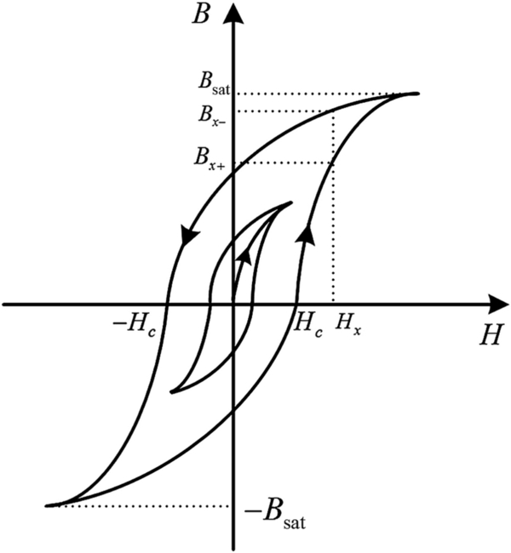

**FIG. 17.1** B-H loops of a magnetic material.

Practically, in magnetic component design for power electronics, a linear relationship between *B* and *H* is assumed between their peak applied values (as shown in [Fig. 17.1](https://learning.oreilly.com/library/view/power-electronics-handbook/9780128114087/B9780128114070000192.xhtml#f0010)) to enable definition of relative permeability based on the amplitude of applied magnetic flux density:

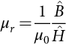 **(17.2)**

Examination of [Fig. 17.1](https://learning.oreilly.com/library/view/power-electronics-handbook/9780128114087/B9780128114070000192.xhtml#f0010) shows that due to the hysteretic behavior, *μr* typically increases with increasing amplitude of magnetic flux density, so long as this amplitude is lower than the saturation flux density, *B*sat. Beyond this value, there is no further increase in magnetic flux density with increasing magnetic field intensity, and therefore, magnetic saturation imposes a limit on the useful operating range of a magnetic material.

Similarly, under DC bias conditions, the relative permeability depends on both the DC and AC levels of magnetic flux density. As an aid to magnetic component design, the manufacturers of magnetic cores provide graphs to quantify the level of variation under typical application conditions levels. For example, ferrite materials can have relative permeability values that vary by up to 200% over a typical range of AC magnetic flux density.

In terms of operating frequency, relative permeability generally remains constant for frequencies up to the point where eddy current losses become dominant. For ferrite and powdered materials, this frequency is usually higher than the optimal one at which overall core losses can be tolerated, and therefore, variations in relative permeability are not significant. However, eddy current losses are more dominant in metal film cores, and therefore, variations the relative permeability with frequency may impact on designs based on metal film cores.

Loss in magnetic materials includes contributions from eddy current, hysteresis, and anomalous effects. Eddy current loss is conductive *I*2*R* loss produced by circulating currents induced in response to AC flux linkage, flowing against the internal resistance of the core. In ferrite materials, it is limited by restricting the size of individual ferrite particles within an insulating binder, while in metal film layers, its effect is limited so long as the film thickness is maintained smaller than the material skin depth *δ* where

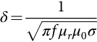 **(17.3)**

*f* is the operating frequency and *σ* is the conductivity of the material.

Hysteresis loss is thought to be due to frictional effects between magnetic domains within the material structure as they rotate in response to AC magnetic fields. Hysteresis loss per unit volume may be estimated in terms of the area enclosed by the material *BH* loop under given AC and DC conditions:

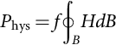 **(17.4)**

where the integral is performed over a complete cycle of the given magnetic flux density excitation levels.

Anomalous loss, also termed excess eddy current loss, is due to the presence of magnetic domains within magnetic material structures. The exact nature of this effect is not fully understood, but it is thought to be attributed to nonuniform magnetic flux density distributions produced within magnetic domains. However, a lack of understanding of the variation in magnetic domain sizes and orientations under field excitation further complicates its contribution [[10](https://learning.oreilly.com/library/view/power-electronics-handbook/9780128114087/B9780128114070000192.xhtml#bb0055)]. Anomalous loss is most prominent in tape wound and metal film core materials where classical eddy current loss is controlled by maintaining film thicknesses lower than the material skin depth.

Practically, total core loss per unit volume, *P*fe, may be estimated using the Steinmetz equation:

 **(17.5)**

for which manufacturers provide material parameters, *Kc*, *α* and *β*, that are based on measurements of loss characteristics performed over a range of sinusoidal magnetic flux density excitation levels and frequencies. Given that the loss parameters are based on measurements, the Steinmetz equation therefore accounts for the combined contributions of all loss effects.

In power electronics applications, voltage and current waveforms applied to magnetic components are more often rectangular than sinusoidal, and therefore, due to significant contributions of voltage/current harmonics, direct application of the Steinmetz equation does not produce accurate predictions of total core loss. Instead, the Steinmetz equation has been modified to account for nonsinusoidal waveforms, by recognizing the general dependence of core loss on both the magnetic flux density and the rate of change of magnetic flux density with respect to time in the generalized Steinmetz equation (GSE) [[11](https://learning.oreilly.com/library/view/power-electronics-handbook/9780128114087/B9780128114070000192.xhtml#bb0060)]. In a further development, the effects of minor *BH* loop excursions are incorporated in the improved generalized Steinmetz equation (iGSE):

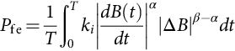 **(17.6)**

where

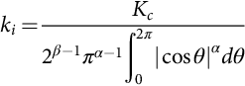 **(17.7)**

and where Δ*B* is the peak-to-peak amplitude of magnetic flux density over each minor loop as it contributes during the excitation waveform [[12](https://learning.oreilly.com/library/view/power-electronics-handbook/9780128114087/B9780128114070000192.xhtml#bb0065)]. A further modification to the Steinmetz equation has been proposed to account for the effects of magnetic relaxation effects during periods of zero applied voltage [[13](https://learning.oreilly.com/library/view/power-electronics-handbook/9780128114087/B9780128114070000192.xhtml#bb0070)]. However, it should be remembered that the Steinmetz parameters themselves are based on experimental data and that they vary over different operating frequency ranges. Therefore, the accuracy of models based on these parameters relates directly to the original manufacturers' measurement accuracy. Practically, Eqs. [(17.5)](https://learning.oreilly.com/library/view/power-electronics-handbook/9780128114087/B9780128114070000192.xhtml#fo0030) or Eqs. ([17.6](https://learning.oreilly.com/library/view/power-electronics-handbook/9780128114087/B9780128114070000192.xhtml#fo0035)–[17.7](https://learning.oreilly.com/library/view/power-electronics-handbook/9780128114087/B9780128114070000192.xhtml#fo0040)) are best applied to estimate initial values of core loss, with follow-up measurements recommended to confirm losses under applied operating conditions.

The temperature range and temperature stability of magnetic materials should be considered because standard ferrite and powdered material loss properties vary by up to 500% from room temperature to 140°C. Some ferrite grades are designed to have more stable loss properties with temperature variation, while others are optimized to have minimum loss at a standard operating temperature such as 140°C for automotive applications.

### 17.2.2 COMPARISON OF MAGNETIC MATERIAL TYPES

The properties of magnetic core materials used in switched-mode power electronic applications are compared in [Table 17.1](https://learning.oreilly.com/library/view/power-electronics-handbook/9780128114087/B9780128114070000192.xhtml#t0010), while power loss density values are compared in [Fig. 17.2](https://learning.oreilly.com/library/view/power-electronics-handbook/9780128114087/B9780128114070000192.xhtml#f0015). The most commonly applied material type is ferrite, which consists of a combination of metal oxide particles that are pressed and sintered together to form one of several standard core shapes (E, C, toroid, planar E, I, etc.). Owing to the small particle size (of the order of μm), eddy currents are restricted so that ferrites are characterized by high resistivity and high relative permeability, with the properties of each ferrite grade depending on the relative concentration and particle size of constituent metal oxides. Typically, Mn-Zn ferrites are most widely applied in power electronics applications, with manufacturers providing a range of grades having loss properties suitable for operation at frequencies up to 2 MHz. On the other hand, Ni-Zn grades are more suited to signal level applications at frequencies in the 1–10 MHz range. The main limitation of ferrites is their low saturation flux density of 300–450 mT, which is at least half that of silicon-steel.

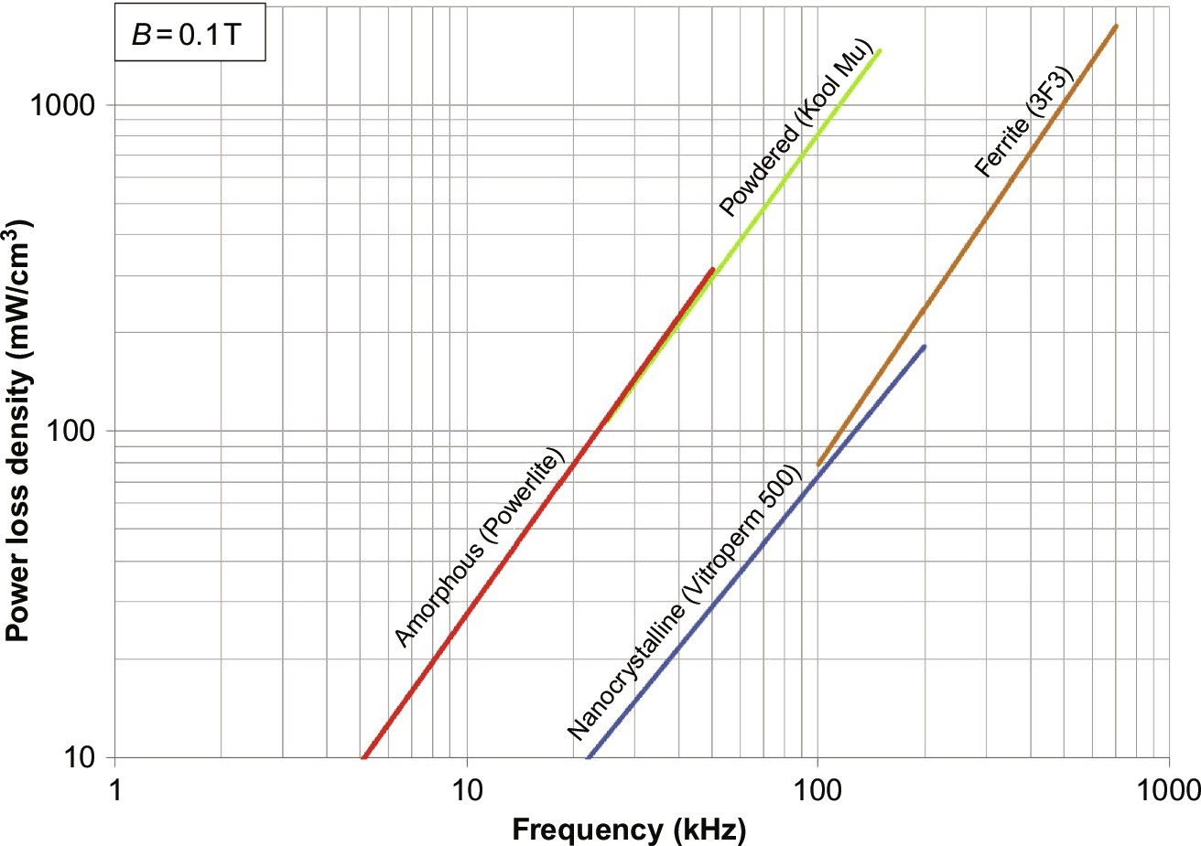

**FIG. 17.2** Core loss density versus frequency for common magnetic materials.

**Table 17.1**

**Properties of magnetic core materials commonly used in power electronics**

|  |  |  |  |  |  |  |
| --- | --- | --- | --- | --- | --- | --- |
| **Materials** | **Ferrites** | **Nanocrystalline** | **Amorphous** | **Si iron** | **Ni-Fe (permalloy)** | **Powdered iron** |
| Model | Ferroxcube 3F3 | VIROPERM 500 F | METGLAS 2605 | AK Oriented M-4 | MAGNETICS PERMALLOY 80 | MICROMETALS 35 μ |
| Permeability, *μi* | 2000–4500 | 15,000 | 10,000–150,000 | 5000–10,000 | 20,000 | 3–550 |
| *B*peak, T | 0.34–0.42 | 1.2 | 1.56 | 2.0 | 0.82 | 0.6–1.3 |
| *ρ*, μΩm | 2×106 | 1.15 | 1.3 | 0.51 | 0.57 | 106 |
| Curie temp. *Tc*, °C | 200 | 600 | 399 | 746 | 460 | 665 |
| *P*loss | 210 mW/cm3 at 0.1 T/200 kHz | 588 mW/cm3 at 0.3 T/100 kHz | 72 mW/cm3 at 0.2 T/25 kHz | 2.295–30.6 mW/cm3 at 1.5 T/50 Hz | 192.28 mW/cm3 at 0.2 T/5 kHz | 126–315 mW/cm3 at 0.1 T/10 kHz |

In inductor and transformer applications where the core is subjected to a DC bias field, magnetic powder materials provide a suitable alternative to ferrites. With ferrite, a lumped gap is generally needed to ensure that the material is not saturated under DC bias conditions. This results in a significantly reduced effective relative permeability and causes increased eddy current losses due to the interaction of fringing fields with windings placed in the vicinity of the gap (see [Section 17.5.2](https://learning.oreilly.com/library/view/power-electronics-handbook/9780128114087/B9780128114070000192.xhtml#s0085)). In powder materials, the gap is distributed throughout the bulk material, which consists of magnetic alloy grains bound together within an insulating material. Magnetic powder materials are therefore also known as distributed air gap material. They contribute little or no fringing field effects. Constituent magnetic alloys include various combinations of nickel, iron, silicon, aluminum, molybdenum, and boron. Relative permeability values are in the range of 10–550, which are comparable with the effective permeability of gapped ferrite cores, and saturation flux density can be as high as 1.6 T. While bulk core loss properties are not as competitive as ferrite (see [Fig. 17.2](https://learning.oreilly.com/library/view/power-electronics-handbook/9780128114087/B9780128114070000192.xhtml#f0015)), when the effects of eddy current losses in windings surrounding a discrete gap are accounted for, powder materials can provide an overall reduced loss design.

In the 1980s, the development of new rapid cooling methods for hot-spun melt magnetic tape materials led to the emergence of amorphous and nanocrystalline materials as competitors initially to silicon-steel and nickel-iron metal alloys in tape wound cores. With ongoing research, these material types have since been developed for application in common mode choke and other power electronic applications. Due to the similarity in their composition and manufacturing processes, both materials have similar structures and properties, much of which result from their nanoscale magnetic particle sizes (10–20 nm). They comprise various concentrations of iron, cobalt, and nickel, with silicon and boron included to ensure stabilization of the amorphous structure. After rapid cooling of the molten metal, a tape of amorphous material with a thickness of approximately 20 μm is produced. Nanocrystalline materials are amorphous tapes that have further heat treatment applied that provides them with superior loss and saturation properties. The materials are characterized by very high permeability values (100,000's), high saturation flux density (up to 1.7 T), and loss properties that are competitive to ferrites for power electronic applications in the range of 100–200 kHz. Research is continuing to develop these materials and core shapes for a wider range of applications.

### 17.2.3 FUTURE DEVELOPMENTS

Much of the latest research in magnetic materials is focused on the development of core materials suitable for operation in the multi-MHz range and on processes to integrate them into power electronics packaging, that is, within printed circuit boards (PCBs) or onto silicon. The main drivers are reduced size and improved response rate of low power applications, both of which are achieved by increased operating frequency. At a larger power scale, developments in SiC and GaN semiconductors are progressing to enable higher switching frequencies in high-voltage, smart grid, and renewable energy applications. This in turn will lead to developments in compatible core materials, where the high saturation flux density and competitive loss properties of amorphous and nanocrystalline materials make them the most suitable solutions.

## 17.3 Magnetic Circuits

Faraday's law and Ampere's law have built the relationship between the electric characteristics and magnetic characteristics and are key principles guiding the transformer and inductor design in power electronics. The typical analytic model for a magnetic circuit is the magnetic reluctance model that is based on a reluctance-resistance analogy.

### 17.3.1 FARADAY'S MAGNETIC CIRCUIT LAW

Faraday's law states that a time-varying magnetic flux *ø*(*t*) passing through the interior of a winding generates a voltage *v*(*t*) in the winding. [Fig. 17.3](https://learning.oreilly.com/library/view/power-electronics-handbook/9780128114087/B9780128114070000192.xhtml#f0020) illustrates time-varying flux *ø*(*t*) passing through the interior of a loop of wire and the voltage *v*(*t*) induced in the closed loop enclosing the flux.

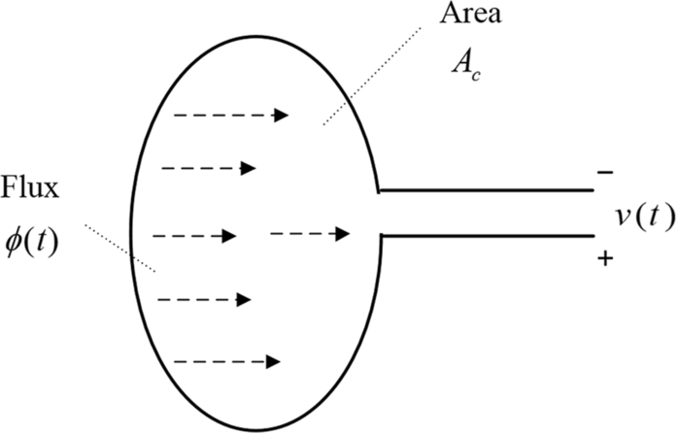

**FIG. 17.3** Illustration of Faraday's law.

The loop cross-sectional area is expressed by *Ac*. According to Faraday's law, the flux induces a voltage *v*(*t*) in the termination of the wire, given by

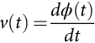 **(17.8)**

For a winding with *N* turns, the induced voltage can be expressed as

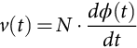 **(17.9)**

The induced flux *ø* may link with each turn of the winding, so that the flux linkage is

 **(17.10)**

For a uniform flux distribution, the expression [(17.9)](https://learning.oreilly.com/library/view/power-electronics-handbook/9780128114087/B9780128114070000192.xhtml#fo0050) can be rewritten as

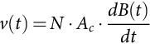 **(17.11)**

where *B*(*t*) is magnetic flux density passing through the winding.

Lenz's law states that the current induced in the closed loop due to the changing flux tends to oppose the flux change. [Fig. 17.4](https://learning.oreilly.com/library/view/power-electronics-handbook/9780128114087/B9780128114070000192.xhtml#f0025) shows an example of Lenz's law. The flux *ø*(*t*) induces current *i*(*t*), which in turn generates flux *ø’*(*t*) that tends to oppose changes in *ø*(*t*).

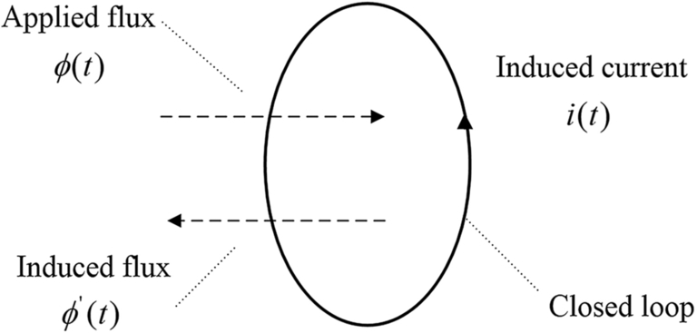

**FIG. 17.4** Illustration of Lenz's law in a closed loop.

The induced voltage opposes the creating flux by generating secondary currents called eddy currents. Lenz's law can well explain the eddy current effects in magnetic cores and in the winding conductors.

### 17.3.2 AMPERE'S MAGNETIC CIRCUIT LAW

Ampere's law states that a time-varying current *i*(*t*) induces a time-varying magnetic field *H*(*t*), as shown in [Fig. 17.5](https://learning.oreilly.com/library/view/power-electronics-handbook/9780128114087/B9780128114070000192.xhtml#f0030). The net magnetomotive force (MMF) in the core is equal to the total currents passing though the interior of the magnetic core loop. The line integral of *H* around any closed contour is equal to the total current enclosed by that contour, and it may be stated in the integral form:

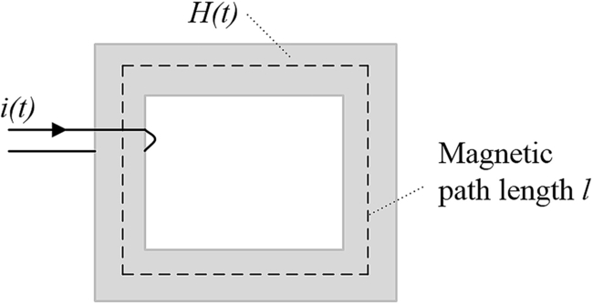

**FIG. 17.5** Illustration of Ampere's law.

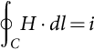 **(17.12)**

For the winding with *N* turns, Ampere's law is

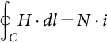 **(17.13)**

The magnetic field intensity *H* leads to a resulting magnetic flux density *B* due to the B-H characteristics of core materials. The nonlinearity of the characteristics is neglected in this section, and therefore, the relation of the *B-H* characteristic is given by Eq. [(17.1)](https://learning.oreilly.com/library/view/power-electronics-handbook/9780128114087/B9780128114070000192.xhtml#fo0010).

### 17.3.3 RELUCTANCE AND INDUCTANCE

When making an analogy between magnetic circuits and electric circuits, it is natural to regard the magnetomotive force (MMF) between the two terminations of the winding as analogous to the voltage and magnetic flux, *ø*, as analogous to the current. As shown in [Fig. 17.6](https://learning.oreilly.com/library/view/power-electronics-handbook/9780128114087/B9780128114070000192.xhtml#f0035), the MMF, *F*=*N·i*, is visualized as a force like quantity that pushes a magnetic flux, *ø*, around the magnetic circuit. Magnetic core reluctance, *R*, in a magnetic circuit is then the counterpart of resistance of an electric circuit. *ø*=*F/R*, directly corresponding to Ohm's law. The reluctance opposes the magnetic flux flow, similarly to the way the resistance opposes the electric current flow. Therefore, magnetic circuits described by Eq. [(17.14)](https://learning.oreilly.com/library/view/power-electronics-handbook/9780128114087/B9780128114070000192.xhtml#fo0075) can be solved in a similar manner as electric circuits described by Ohm's law.

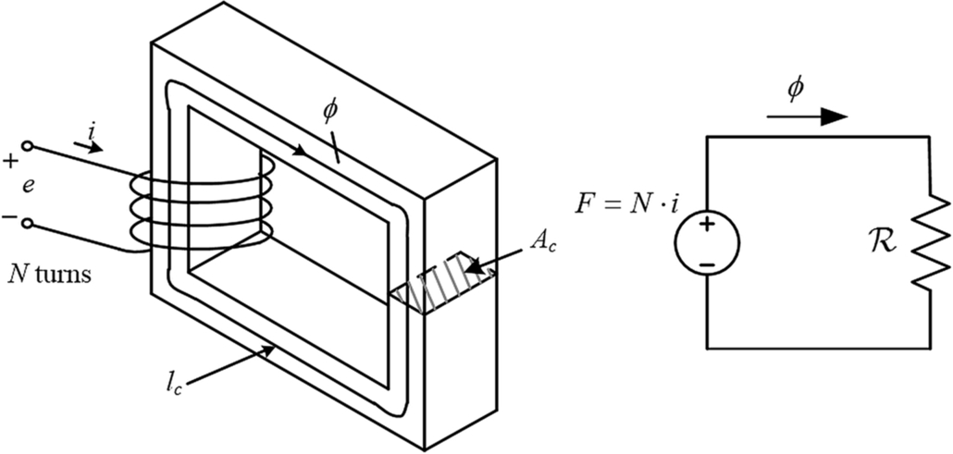

**FIG. 17.6** Example of magnetic circuit and equivalent magnetic reluctance circuit.

 **(17.14)**

[Fig. 17.6](https://learning.oreilly.com/library/view/power-electronics-handbook/9780128114087/B9780128114070000192.xhtml#f0035) illustrates a coil with *N* turns wound on a closed magnetic core of mean length *lc* and cross-sectional area *Ac.* The reluctance of a basic magnetic circuit element is given by

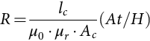 **(17.15)**

The self-inductance *L* relates the flux linkage produced by a coil to the current in that coil:

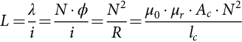 **(17.16)**

In fact, the *B-H* characteristic is a nonlinear function of the applied magnetic field intensity in ferromagnetic materials. In the magnetic core of [Fig. 17.6](https://learning.oreilly.com/library/view/power-electronics-handbook/9780128114087/B9780128114070000192.xhtml#f0035), the flux density *B* is limited by the core material, and a small current with sufficient turns can easily drive the magnetic core material into saturation. To avoid the core saturation, an air gap is often introduced into the core as shown in [Fig. 17.7](https://learning.oreilly.com/library/view/power-electronics-handbook/9780128114087/B9780128114070000192.xhtml#f0040), a larger current can pass through the winding without reaching saturation because of the increased reluctance. The analysis to follow also shows that the air gap gives rise to more energy storage.

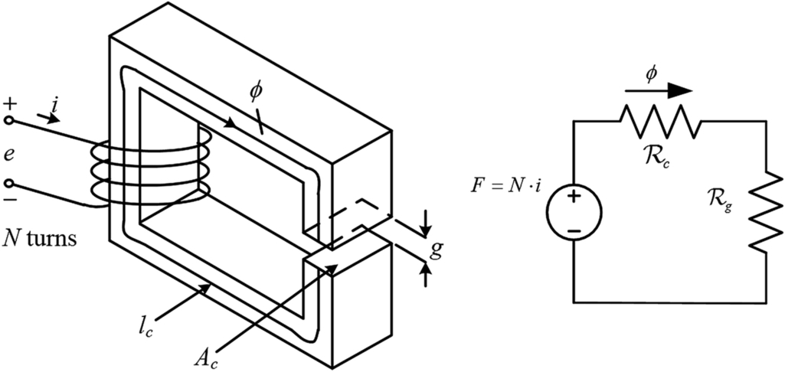

**FIG. 17.7** Example of magnetic circuit for gapped inductor.

In the structure of [Fig. 17.7](https://learning.oreilly.com/library/view/power-electronics-handbook/9780128114087/B9780128114070000192.xhtml#f0040), there are two reluctances in series, so,

 **(17.17)**

The individual reluctances are given by their respective physical properties of length and cross section; subscript *c* refers to the core and subscript *g* refers to the air gap. For the core reluctance,

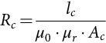 **(17.18)**

and for the air gap reluctance, *μr*=1,

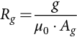 **(17.19)**

where *g* is the length of the air gap. Since *μr*≫*μ*0, the reluctance of the core *Rc* can be ignored, *Rc*≪*Rg*, invoking Eq. [(17.17)](https://learning.oreilly.com/library/view/power-electronics-handbook/9780128114087/B9780128114070000192.xhtml#fo0090) yields

 **(17.20)**

Therefore, the gapped inductance *L* is

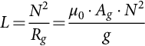 **(17.21)**

The air gap increases the total reluctance of the magnetic circuit and decreases the inductance.

## 17.4 Transformer Design

The basic transformer model is shown in [Fig. 17.8](https://learning.oreilly.com/library/view/power-electronics-handbook/9780128114087/B9780128114070000192.xhtml#f0045).

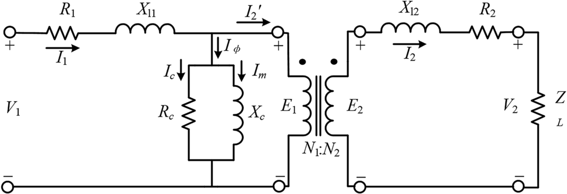

**FIG. 17.8** The basic electric circuit of a practical transformer.

This is a transformer with a turns ratio *a*:1. The winding resistance is *R*1 and *R*2 for the primary and secondary, respectively. *Xl*1 and *Xl*2 represent the leakage reactance in the primary windings and secondary windings, respectively. *Rc* represents the core loss and *Xc* represents the magnetizing inductance. For an ideal transformer, the permeability of the core material is considered infinite and the magnetizing current is negligible.

The voltage across the primary winding is [[14](https://learning.oreilly.com/library/view/power-electronics-handbook/9780128114087/B9780128114070000192.xhtml#bb0075)]

 **(17.22)**

where *f* is the frequency, *N*1 is the number of turns, *B*max is the maximum flux density in the core, and *Ac* is the cross-sectional area of the core. These are shown in [Fig. 17.9](https://learning.oreilly.com/library/view/power-electronics-handbook/9780128114087/B9780128114070000192.xhtml#f0050).

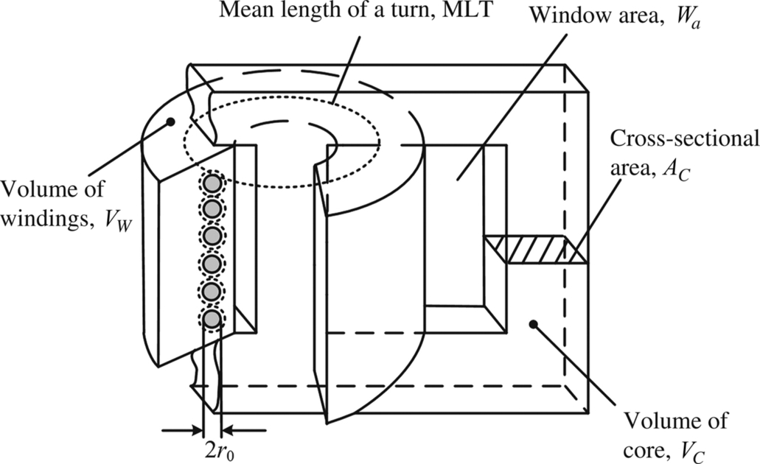

**FIG. 17.9** Physical dimensions of a transformer.

*Kv* depends on the shape of the voltage waveform. It has the value of 4.44 for sinusoidal waveforms and 4.0 for a square waveform. It may be calculated for any other waveform; the approach to calculate *Kv* will be outlined in an example later on.

The first step in developing the design methodology is to apply Eq. [(17.22)](https://learning.oreilly.com/library/view/power-electronics-handbook/9780128114087/B9780128114070000192.xhtml#fo0115) to each of *n* windings and calculate the total VA rating of all the windings.

It may be shown that in a magnetic component with multiple windings, the optimum layout of the coils in terms of wire size is to maintain a constant current density *Jo*. Taking *Awi* as the area of the conductor in winding *i* summing up the VA rating of each winding using Eq. [(17.22)](https://learning.oreilly.com/library/view/power-electronics-handbook/9780128114087/B9780128114070000192.xhtml#fo0115) yields

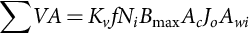 **(17.23)**

Define the window utilization factor *ku* as the rate of the window area *Wa* occupied by copper

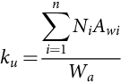 **(17.24)**

and Eq. [(17.23)](https://learning.oreilly.com/library/view/power-electronics-handbook/9780128114087/B9780128114070000192.xhtml#fo0120) becomes

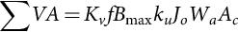 **(17.25)**

The product *Wa·Ac* is the window area product *Ap* of the core. This result establishes the connection between the transformer rating and core size. The next step is the establishment of the winding loss and the core loss.

The copper loss in each winding is *RI*2. At this point, we will take *R* to be the DC resistance and take the high-frequency skin and proximity effects into account later on. The mean length of a turn in the transformer winding is MLT and the total length of a coil *i* is *Ni*∙MLT. The copper loss is

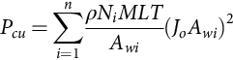 **(17.26)**

Invoking the definition of the window utilization factor, Eq. [(17.24)](https://learning.oreilly.com/library/view/power-electronics-handbook/9780128114087/B9780128114070000192.xhtml#fo0125) becomes

 **(17.27)**

MLT∙*Wa* is simply the volume of the windings, *Vw*.

Combining Eqs. [(17.26)](https://learning.oreilly.com/library/view/power-electronics-handbook/9780128114087/B9780128114070000192.xhtml#fo0135) and [(17.27)](https://learning.oreilly.com/library/view/power-electronics-handbook/9780128114087/B9780128114070000192.xhtml#fo0140) yields a new expression for the copper loss:

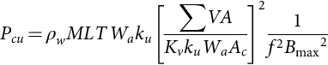 **(17.28)**

The core loss under sinusoidal excitation is given by the celebrated Steinmetz formula Eq. [(17.5)](https://learning.oreilly.com/library/view/power-electronics-handbook/9780128114087/B9780128114070000192.xhtml#fo0030):

 **(17.29)**

where *Kc*, *α* and *β* are constants supplied by the manufacturer. *Vc* is the volume of the core. Here,  is the amplitude of the sinusoidal flux density.

The total loss (at this point) is the sum of the two components given by Eqs. [(17.28)](https://learning.oreilly.com/library/view/power-electronics-handbook/9780128114087/B9780128114070000192.xhtml#fo0145) and [(17.29)](https://learning.oreilly.com/library/view/power-electronics-handbook/9780128114087/B9780128114070000192.xhtml#fo0150).

Evidently, the copper loss is inversely proportional to the product of frequency and maximum flux density Eq. [(17.28)](https://learning.oreilly.com/library/view/power-electronics-handbook/9780128114087/B9780128114070000192.xhtml#fo0145), and the core loss is proportional to frequency and maximum flux density Eq. [(17.29)](https://learning.oreilly.com/library/view/power-electronics-handbook/9780128114087/B9780128114070000192.xhtml#fo0150). These are illustrated in [Fig. 17.10](https://learning.oreilly.com/library/view/power-electronics-handbook/9780128114087/B9780128114070000192.xhtml#f0055) for two different frequencies, *f*2>*f*1.

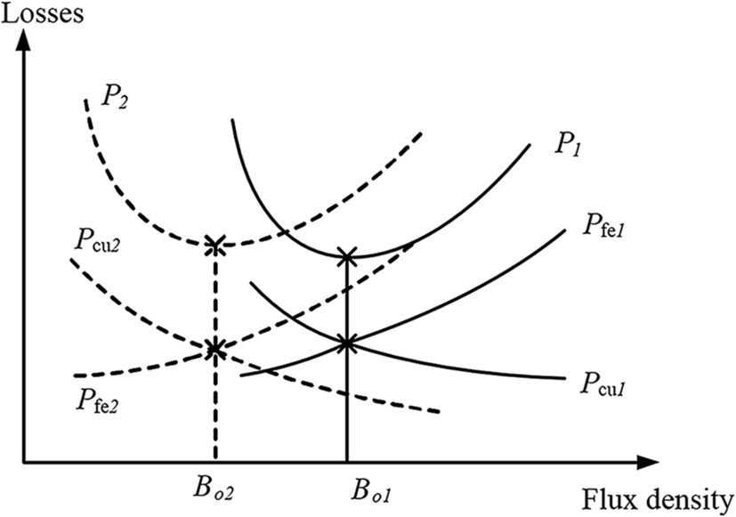

**FIG. 17.10** Core and winding losses as a function of frequency and maximum flux density.

The minimum value of the total losses occurs at

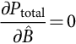 **(17.30)**

and for a given frequency

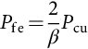 **(17.31)**

It follows that

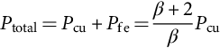 **(17.32)**

We can split the copper loss as follows:

 **(17.33)**

Combining Eqs. [(17.31)](https://learning.oreilly.com/library/view/power-electronics-handbook/9780128114087/B9780128114070000192.xhtml#fo0160) and [(17.32)](https://learning.oreilly.com/library/view/power-electronics-handbook/9780128114087/B9780128114070000192.xhtml#fo0165) with Eq. [(17.33)](https://learning.oreilly.com/library/view/power-electronics-handbook/9780128114087/B9780128114070000192.xhtml#fo0170) after some rearranging,

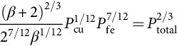 **(17.34)**

As a first step, we assume the heat loss from the surface of the transformer is predominately by convection

 **(17.35)**

where *h* is the coefficient of heat transfer by convection, *At* is the surface area of the transformer assembly and Δ*T* is the temperature rise in the transformer due to the losses. Taking this, Eqs. [(17.28)](https://learning.oreilly.com/library/view/power-electronics-handbook/9780128114087/B9780128114070000192.xhtml#fo0145) and [(17.29)](https://learning.oreilly.com/library/view/power-electronics-handbook/9780128114087/B9780128114070000192.xhtml#fo0150), and substituting them into Eq. [(17.34)](https://learning.oreilly.com/library/view/power-electronics-handbook/9780128114087/B9780128114070000192.xhtml#fo0175) yields

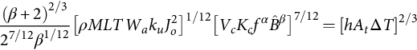 **(17.36)**

At this point, we need dimensional analysis to simplify Eq. [(17.36)](https://learning.oreilly.com/library/view/power-electronics-handbook/9780128114087/B9780128114070000192.xhtml#fo0185). The physical quantities, surface area *At*, the volume of the core *Vc* and the volume of the winding *Vw* are all related to the core window area product *Ap*=*Wa·Ac*.

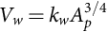 **(17.37)**

**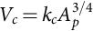** **(17.38)**

**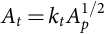** **(17.39)**

The constants *kw*, *kc*, and *kt* may be found from the dimensions of typical cores, and for the present purposes, *kw*=10, *kc*=5.6, and *kt*=40 would typify the cores used in modern power electronics.

Returning to Eq. [(17.36)](https://learning.oreilly.com/library/view/power-electronics-handbook/9780128114087/B9780128114070000192.xhtml#fo0185), with these dimensionless constants

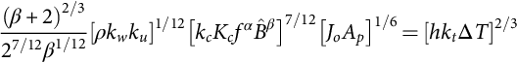 **(17.40)**

We need to return to Eq. [(17.25)](https://learning.oreilly.com/library/view/power-electronics-handbook/9780128114087/B9780128114070000192.xhtml#fo0130) to find an expression for *JoAp*

*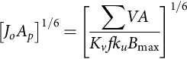* **(17.41)**

This result, substituted into Eq. [(17.40)](https://learning.oreilly.com/library/view/power-electronics-handbook/9780128114087/B9780128114070000192.xhtml#fo0205), yields an expression for *Bo* and *f* at the optimum point in [Fig. 17.10](https://learning.oreilly.com/library/view/power-electronics-handbook/9780128114087/B9780128114070000192.xhtml#f0055), that is, for minimum losses:

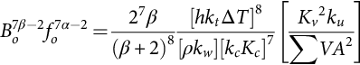 **(17.42)**

Note that *B*max in Eq. [(17.22)](https://learning.oreilly.com/library/view/power-electronics-handbook/9780128114087/B9780128114070000192.xhtml#fo0115) may include a DC component, but for the present purposes, we assume, it is the amplitude of the sinusoidal component, and we can adjust *Kv* if necessary.

The first and second terms on the right-hand side are fixed quantities. The third term is dependent on the circuit conditions and specifications. Normally, frequency is specified so this allows us to calculate the optimum value of maximum flux density in the core.

At this point, we need an expression for the current density in the windings. Taking Eq. [(17.32)](https://learning.oreilly.com/library/view/power-electronics-handbook/9780128114087/B9780128114070000192.xhtml#fo0165) with Eqs. [(17.27)](https://learning.oreilly.com/library/view/power-electronics-handbook/9780128114087/B9780128114070000192.xhtml#fo0140) and (19.35)

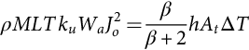 **(17.43)**

Adapting the dimensional analysis,

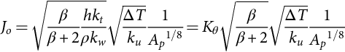 **(17.44)**

for *h*=10 W/m2°C, *kw*=10, *kt*=40, *ρ*=1.72×10−8 Ω-m, and *Kθ*=48.224×103.

Combining this expression for the current density with the optimum value of *foBo* given by Eq. [(17.42)](https://learning.oreilly.com/library/view/power-electronics-handbook/9780128114087/B9780128114070000192.xhtml#fo0215) in Eq. [(17.35)](https://learning.oreilly.com/library/view/power-electronics-handbook/9780128114087/B9780128114070000192.xhtml#fo0180) results in an expression for *Ap* that is found from the specifications of the circuit.

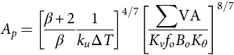 **(17.45)**

### 17.4.1 DESIGN EXAMPLE: PUSH-PULL CONVERTER

A 600 W push-pull converter operates at 80 kHz with a nominal DC input voltage of 325 V and the DC output voltage is 24 *V*. The allowable temperature rise is 50°C and the ambient temperature is 70°C. Using an EE ferrite core (N87 material), select the transformer core and calculate the copper loss in the windings and the core loss.

The push-pull converter and its associated waveforms are shown in [Figs. 17.11](https://learning.oreilly.com/library/view/power-electronics-handbook/9780128114087/B9780128114070000192.xhtml#f0060) and [17.12](https://learning.oreilly.com/library/view/power-electronics-handbook/9780128114087/B9780128114070000192.xhtml#f0065).

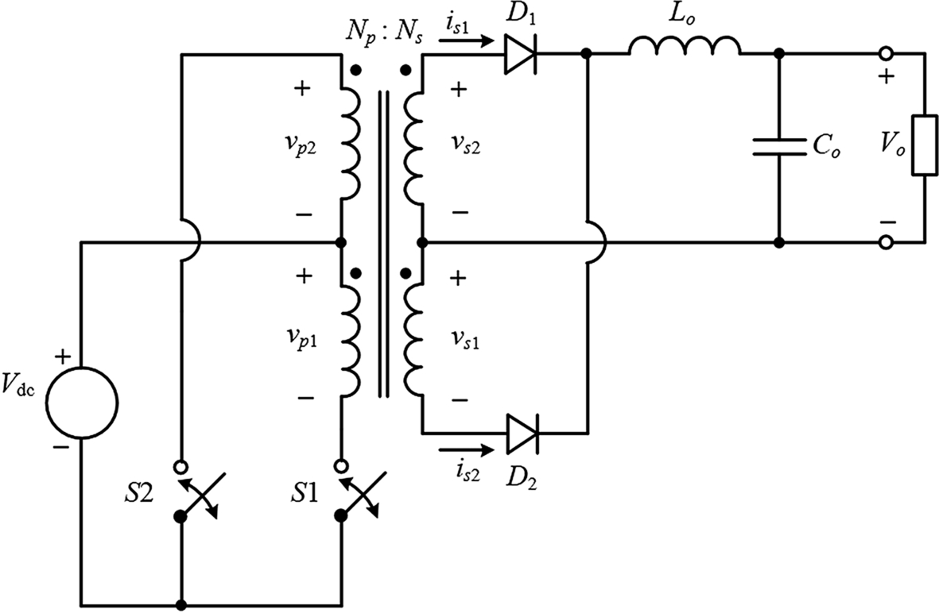

**FIG. 17.11** Push-pull converter.

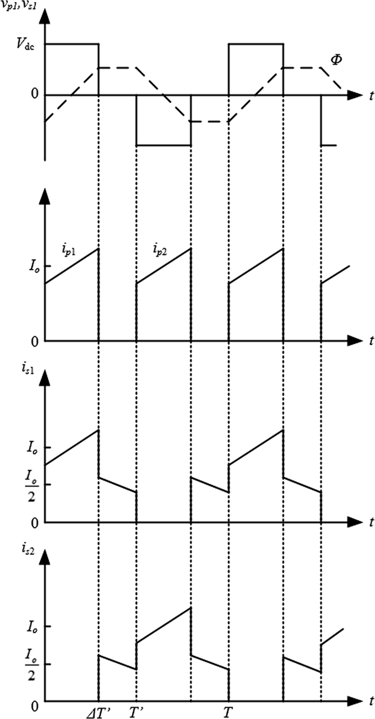

**FIG. 17.12** Push-pull converter waveforms.

The RMS value of the voltage waveform in the primary winding is

 **(17.46)**

Consider the time period 0-DT′:

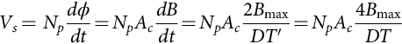 **(17.47)**

Combining Eqs. [(17.46)](https://learning.oreilly.com/library/view/power-electronics-handbook/9780128114087/B9780128114070000192.xhtml#fo0235) and [(17.47)](https://learning.oreilly.com/library/view/power-electronics-handbook/9780128114087/B9780128114070000192.xhtml#fo0240),

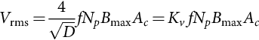 **(17.48)**

So by the definition in Eq. [(17.23)](https://learning.oreilly.com/library/view/power-electronics-handbook/9780128114087/B9780128114070000192.xhtml#fo0120),

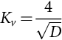 **(17.49)**

We also need the power factor of the input and output windings.

Input winding:

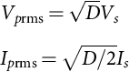 **(17.50)**

The average power delivered by each of the primary windings is

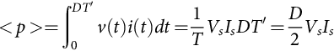 **(17.51)**

**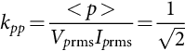** **(17.52)**

The power factor of the secondary winding is found by the same approach and is given by

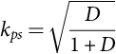 **(17.53)**

The switch stress parameter must be reduced by selecting a turns ratio of *a*=6, and the duty cycle ratio is then

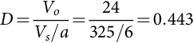 **(17.54)**

*Kv* from Eq. [(17.49)](https://learning.oreilly.com/library/view/power-electronics-handbook/9780128114087/B9780128114070000192.xhtml#fo0250) is 6.0.

We can now establish the VA rating for all the windings, noting that each winding carries half of the load on average.

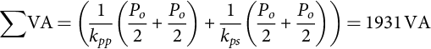 **(17.55)**

### 17.4.2 STEP 1 CORE SELECTION

EPCOS N87 Mn-Zn ferrite has constants *Kc*=16.9, *α*=1.25, and *β*=2.35. The saturation flux density is 0.4 T.

The first step is to find *Bo* from Eq. [(17.42)](https://learning.oreilly.com/library/view/power-electronics-handbook/9780128114087/B9780128114070000192.xhtml#fo0215) with *fo*=80 kHz, ΔT=50, *Kv*=6.0, ∑VA=1931 VA, *ku*=0.4, β=2.35, *h*=10 W/m2°C, *kw*=10, *kc*=5.6, and *kt*=40:



The window area product is given by Eq. [(17.45)](https://learning.oreilly.com/library/view/power-electronics-handbook/9780128114087/B9780128114070000192.xhtml#fo0230) with *Kθ*=48.224×103:



The EPCOS ETD 55/28/21 core meets the requirement with *AP*=9.723 cm4.

The core has the following physical dimensions:

*Wa*=2.77 cm2, *Ac*=3.51 cm2, and MLT=11.3 cm, and the volume of the core is *Vc*=43.5 cm3.

### 17.4.3 STEP 2 WINDING SELECTION

The number of turns in the primary winding is found from Eq. [(17.47)](https://learning.oreilly.com/library/view/power-electronics-handbook/9780128114087/B9780128114070000192.xhtml#fo0240)



With a 6:1 turns ratio, the secondary winding is 5 turns.

The current density in the windings is obtained from Eq. [(17.44)](https://learning.oreilly.com/library/view/power-electronics-handbook/9780128114087/B9780128114070000192.xhtml#fo0225)



The primary current is a pulsed waveform with duty cycle *D*/2, so the RMS value is

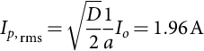 **(17.56)**

and the conductor area is *Aw*=*Ip*,rms/*Jo*=0.658 mm2.

This corresponds to a 0.915 mm diameter wire. The skin depth at 80 kHz is 0.233 mm and therefore the diameter of the wire should be less than 0.5 mm to avoid skin depth losses (see [Fig. 17.14](https://learning.oreilly.com/library/view/power-electronics-handbook/9780128114087/B9780128114070000192.xhtml#f0075)). Four 0.45 mm diameter parallel wires will suffice with a combined DC resistance of 27.0 mΩ/m at 20°C.

The secondary current must take into account the conduction when both switches are open; it follows from [Fig. 17.12](https://learning.oreilly.com/library/view/power-electronics-handbook/9780128114087/B9780128114070000192.xhtml#f0065)

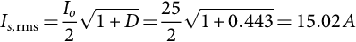 **(17.57)**

and the conductor area is *Aw*=*Is,*rms*/Jo*=5.035 mm2.

This is equivalent to a 2.5 mm diameter round conductor or a 0.2×24.5 mm copper foil. As the skin depth at 80 kHz is 0.233 mm, the round conductor is unsuitable, and the thickness of the foil should be less than 0.1 mm to avoid proximity effect losses (see [Fig. 17.16](https://learning.oreilly.com/library/view/power-electronics-handbook/9780128114087/B9780128114070000192.xhtml#f0085)). Two 0.1 mm foils in parallel will meet this requirement and with a combined DC resistance of 4.73 mΩ/m at 20°C.

### 17.4.4 STEP 3 LOSSES

The total DC resistance of each primary winding at the maximum operating temperature is

 **(17.58)**

With *T*amb=70°C, *Rp*=127.5 mΩ, and the copper loss in each primary winding is



The total DC resistance of each secondary winding at the maximum operating temperature is 3.723 mΩ, and the copper loss in each secondary winding is 2.792×10−3(15.02)2=0.831 W.

Later we will take the proximity effect into account in [Section 17.5](https://learning.oreilly.com/library/view/power-electronics-handbook/9780128114087/B9780128114070000192.xhtml#s0080).

Then total copper loss is 2.642 W.

The core loss is found from the Steinmetz equation Eq. [(17.29)](https://learning.oreilly.com/library/view/power-electronics-handbook/9780128114087/B9780128114070000192.xhtml#fo0150), *P*fe=0.599 W, so that the total loss is 3.241 W.

The thermal resistance of the core assembly, given by the manufacturer, is 10°C/W.

The maximum dissipation is then

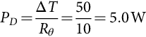 **(17.59)**

The design meets this specification; however, there will be additional high-frequency proximity effect losses to include later.

## 17.5 High-Frequency Effects

A major effect of high-frequency inductors and transformers is ac loss in windings, which include skin and proximity effect losses. Both effects can be alleviated, to a greater or lesser extent with careful design. Winding layers can be optimized to minimize the proximity effect loss. Interleaving can further reduce the loss associated with proximity effects. Both skin effect and proximity effects may be mitigated by the use of litz wire. Design of inductors and transformers with litz wire conductors encompasses different challenges such as the modeling and calculation of ac resistance, the selection of the number and diameter of strands, and the optimal balance between the cross-sectional copper area and the stranding level. Fringing of the flux field around air gaps interacts with the adjoining conductors in a proximity type effect and introduces further losses. All of these effects will be discussed in this section.

Skin effect arises in a conductor due to the varying magnetic field generated by the AC current in the conductor itself. Eddy currents flow to counter the AC field, and the net effect is to reduce the current in the center of the conductor and to increase it at the outer edges, with the overall current remaining the same.

This is illustrated in [Fig. 17.13](https://learning.oreilly.com/library/view/power-electronics-handbook/9780128114087/B9780128114070000192.xhtml#f0070) in a round conductor at three frequencies. At low frequency, the current is uniformly distributed over the conductor cross section. As the frequency increases, the current density increases toward the outside illustrated by the red band. At 1 MHz in the example shown, most of the current is in an annular ring at the outer radius of the conductor. [Fig. 17.14](https://learning.oreilly.com/library/view/power-electronics-handbook/9780128114087/B9780128114070000192.xhtml#f0075) shows the factor Φskin, which represents the increase of the resistance due to the skin effect, per unit of length, with respect to the ratio of the conductor radius, *r*s, to the skin depth. The skin depth is defined by Eq. [(17.3)](https://learning.oreilly.com/library/view/power-electronics-handbook/9780128114087/B9780128114070000192.xhtml#fo0020).

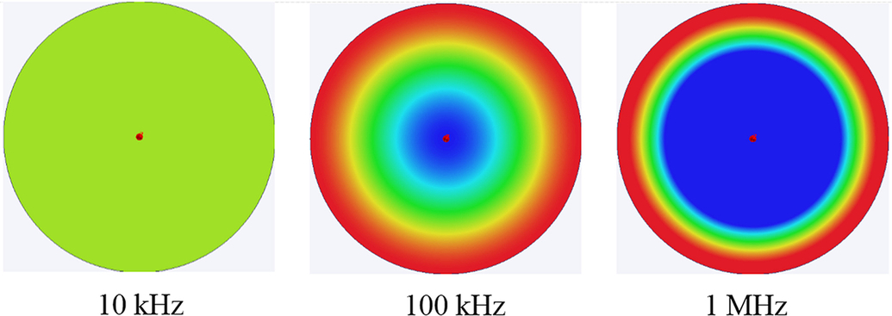

**FIG. 17.13** Current distribution in a round conductor.

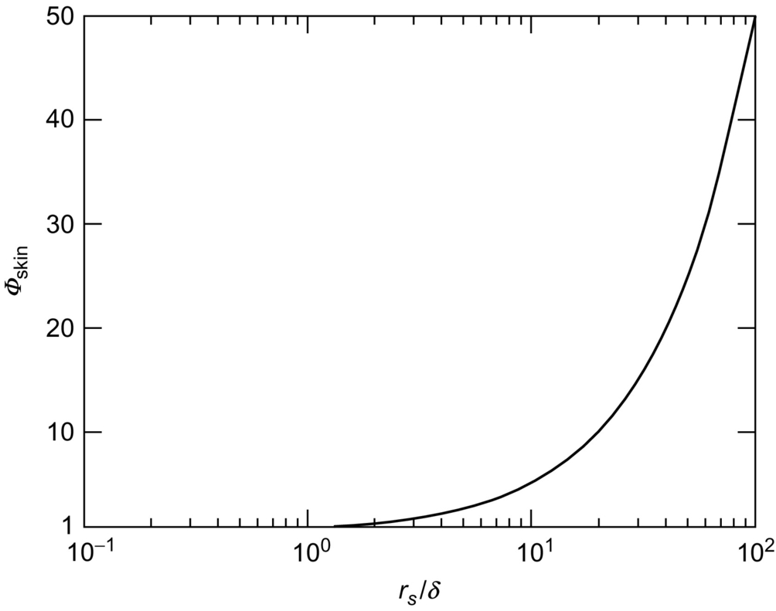

**FIG. 17.14** Skin effect loss of a round conductor with respect to the ratio of the strand radius to the skin depth.

Both DC resistance and skin effect may be represented by a resistive element called conduction resistance. The conduction resistance per unit of length of a round strand of radius *rs*, *R*cond, is

 **(17.60)**

where *R*dc is the dc resistance of the conductor. For round conductors, the exact expression of Φskin is [[15](https://learning.oreilly.com/library/view/power-electronics-handbook/9780128114087/B9780128114070000192.xhtml#bb0080)]

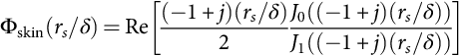 **(17.61)**

where *J*0 and *J*1 are the Bessel functions of the first kind and order 0 and 1, respectively.

For practical designs, the ratio *rs/δ* would be less than 2 to control the skin effect loss and a useful approximation is [[14](https://learning.oreilly.com/library/view/power-electronics-handbook/9780128114087/B9780128114070000192.xhtml#bb0075)]

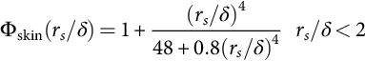 **(17.62)**

The proximity effect is more complicated and depends on the layout of the winding.

Consider the case illustrated in [Fig. 17.15](https://learning.oreilly.com/library/view/power-electronics-handbook/9780128114087/B9780128114070000192.xhtml#f0080). It consists of a transformer with a solenoidal winding with two turns in the primary and three turns in the secondary. In an ideal transformer with infinite permeability in the core, the magnetic field between the turns can be found from Ampere's law. The eddy currents flow as illustrated to counter the magnetic fields on each side of the conducting layer. The red band shows the region with the high current density. Dowell's formula [[16](https://learning.oreilly.com/library/view/power-electronics-handbook/9780128114087/B9780128114070000192.xhtml#bb0085)] was derived to deal with this case; the resistance due to proximity is

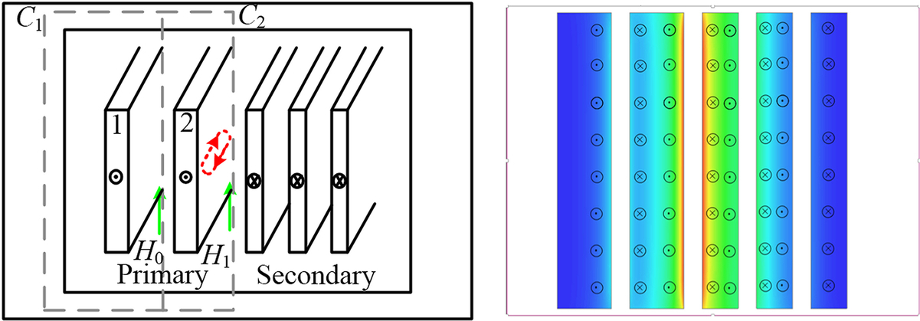

**FIG. 17.15** Proximity effect in a transformer winding.

 **(17.63)**

**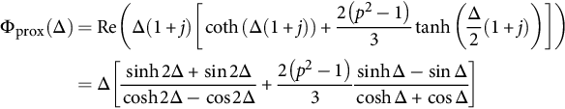** **(17.64)**

where *p* is the number of layers and Δ is the ratio *d/δ*, d being the thickness of the layer.

The nature of ϕprox is illustrated in [Fig. 17.16](https://learning.oreilly.com/library/view/power-electronics-handbook/9780128114087/B9780128114070000192.xhtml#f0085).

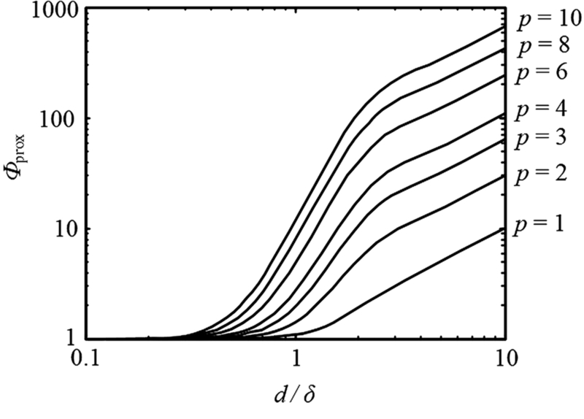

**FIG. 17.16** Proximity effect factor in a transformer winding.

As with the skin effect, as designers, we consider the region where Δ<2 and a useful approximation is

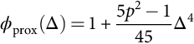 **(17.65)**

This result is applicable to sinusoidal waveforms, but in power electronics, there are nonsinusoidal waveforms.

Consider the general case where a current waveform is represented by its Fourier series:

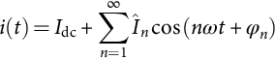 **(17.66)**

where *I*dc is the DC component and *În* is the amplitude of the *n*th harmonic. The derivative is

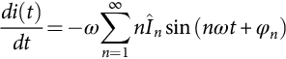 **(17.67)**

The rms value of these expressions may be found from their Fourier coefficients:

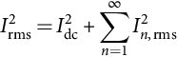 **(17.68)**

and

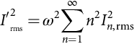 **(17.69)**

where

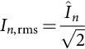 **(17.70)**

The proximity effect loss may be found by applying Dowell's formula to each frequency component. Using the approximation in Eq. [(17.65)](https://learning.oreilly.com/library/view/power-electronics-handbook/9780128114087/B9780128114070000192.xhtml#fo0355), with the definition of skin depth in Eq. [(17.3)](https://learning.oreilly.com/library/view/power-electronics-handbook/9780128114087/B9780128114070000192.xhtml#fo0020),

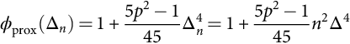 **(17.71)**

The effective resistance taking the harmonics into account is then

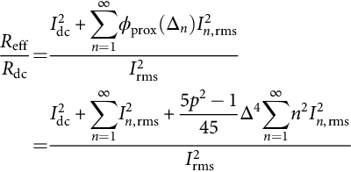 **(17.72)**

Simplifying with Eqs. [(17.68)](https://learning.oreilly.com/library/view/power-electronics-handbook/9780128114087/B9780128114070000192.xhtml#fo0370) and [(17.69)](https://learning.oreilly.com/library/view/power-electronics-handbook/9780128114087/B9780128114070000192.xhtml#fo0375),

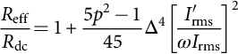 **(17.73)**

Define *Rδ* as the DC resistance of a layer of thickness *δ*, rewriting Eq. [(17.73)](https://learning.oreilly.com/library/view/power-electronics-handbook/9780128114087/B9780128114070000192.xhtml#fo0395)

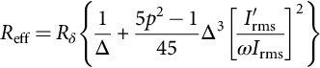 **(17.74)**

Recall that Δ is defined at the fundamental frequency of the periodic waveform.

A typical graph of effective resistance versus layer thickness for a periodic waveform is shown in [Fig. 17.17](https://learning.oreilly.com/library/view/power-electronics-handbook/9780128114087/B9780128114070000192.xhtml#f0090). For thin layers (less than a skin depth), the resistance is high and decreases as the thickness increases until the proximity effect kicks in and increases the effective resistance. There is an optimum thickness that minimizes the overall loss, and this may be found by taking the derivative of Eq. [(17.74)](https://learning.oreilly.com/library/view/power-electronics-handbook/9780128114087/B9780128114070000192.xhtml#fo0400) w.r.t. Δ to yield

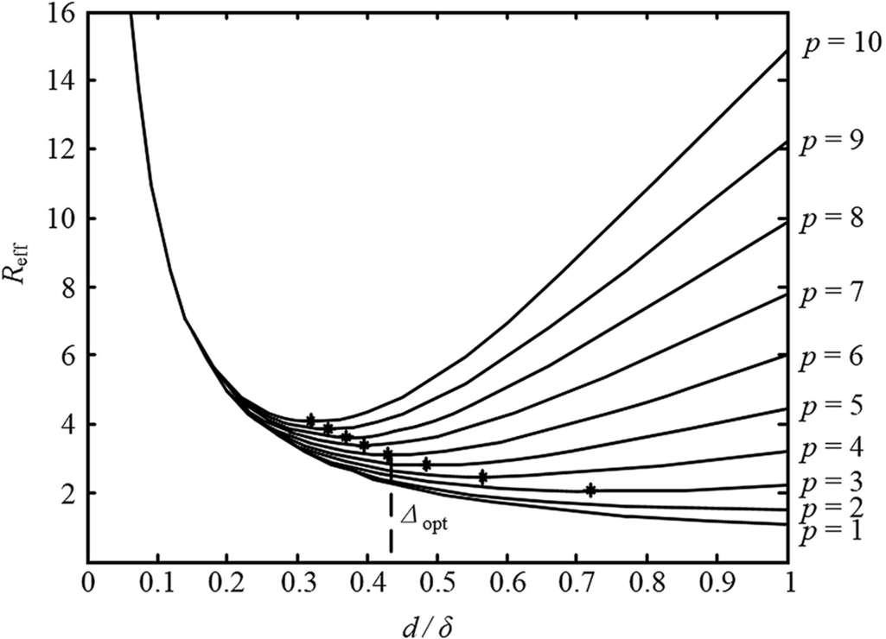

**FIG. 17.17** Effective resistance as a function of layer thickness.

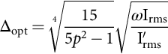 **(17.75)**

and at this optimum value of the layer thickness, the effective resistance is

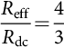 **(17.76)**

### 17.5.1 EXAMPLE: PUSH-PULL CONVERTER

In the push-pull converter design, we had a choice between the 2.5 mm diameter wire and the 24.5×0.2 mm foil in the secondary. We can approximate the current in the secondary to the pulsed waveform shown in [Fig. 17.18](https://learning.oreilly.com/library/view/power-electronics-handbook/9780128114087/B9780128114070000192.xhtml#f0095) with a finite rise time, and it may be easily established that

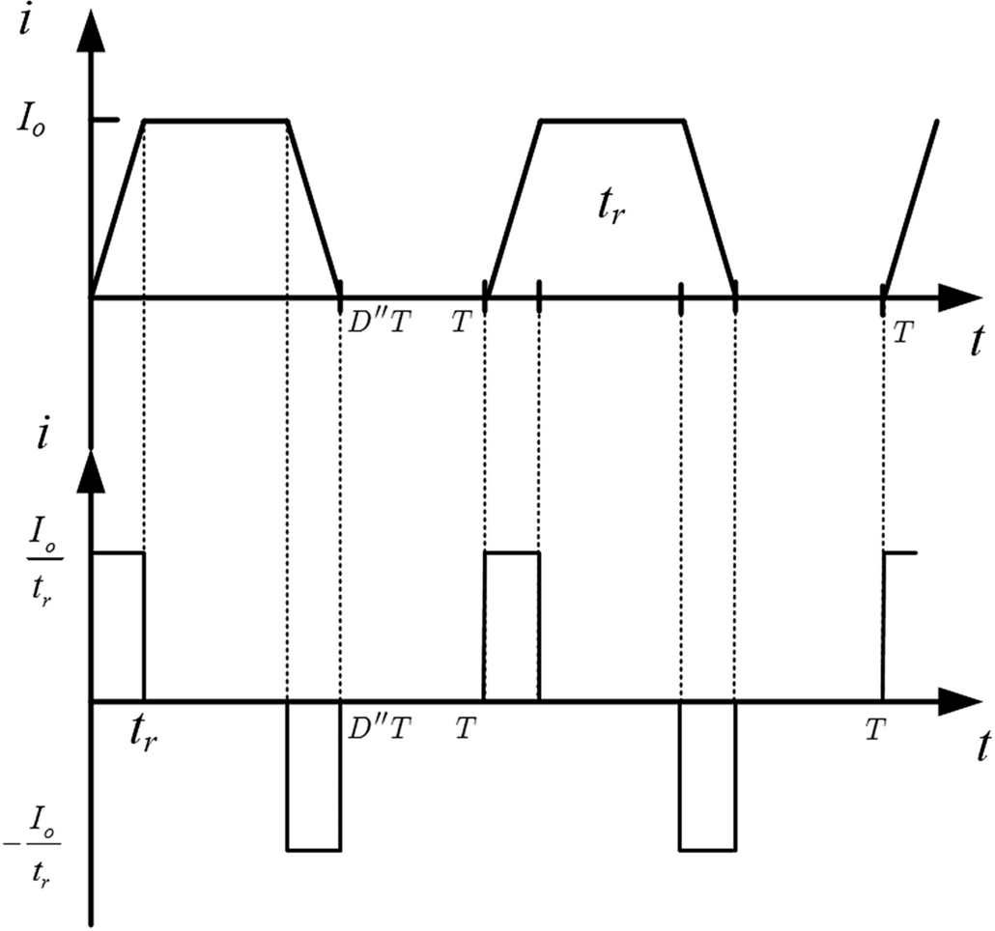

**FIG. 17.18** Pulsed waveform for the push-pull converter.

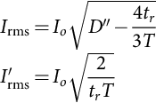 **(17.77)**

and

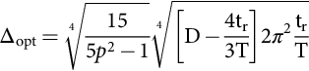 **(17.78)**

For a rise time of *tr*/*T*=2.5%, the optimum value of Δ is 0.459 and the optimum foil thickness at 80 kHz, with a skin depth of 0.233 mm, is 0.1 mm. This is the foil thickness we used in the example for the push-pull converter. The effective resistance is 4/3 times the DC resistance, so the total copper loss in the secondary windings is now (4/3)×0.831×2=2.216 W, bringing the total losses to 3.795 W.

If we had selected the 2.5 mm diameter wire, the AC resistance factor from Eq. [(17.62)](https://learning.oreilly.com/library/view/power-electronics-handbook/9780128114087/B9780128114070000192.xhtml#fo0340) is 3.0, and the total copper loss would be 3.738 W; coupled with the core loss, the total losses would have exceed the maximum dissipation of 5.0 W.

### 17.5.2 FRINGING EFFECT

In order to limit the maximum flux density in the magnetic core of an inductor, the air gap is usually placed in the core, as shown in [Fig. 17.11](https://learning.oreilly.com/library/view/power-electronics-handbook/9780128114087/B9780128114070000192.xhtml#f0060). Besides, the air gap is required even for the transformer applied in the LLC resonant converter to guarantee the proper magnetizing inductance. Basically, the reluctance of the air gap could be calculated based on the same cross-sectional area of the magnetic core and the actual gap length, as discussed in [Section 17.3](https://learning.oreilly.com/library/view/power-electronics-handbook/9780128114087/B9780128114070000192.xhtml#s0035). According to the magnetic field distribution between two different materials, that is, ferrite and air, derived by the Maxwell equations, the magnetic flux line around the air gap bulges out as presented in [Fig. 17.19](https://learning.oreilly.com/library/view/power-electronics-handbook/9780128114087/B9780128114070000192.xhtml#f0100), which is normally named the “fringing effect.” Due to the variation in the magnetic field of the component, the inductance must be evaluated with the fringing field taken into account which means the calculated method given in [Section 17.3](https://learning.oreilly.com/library/view/power-electronics-handbook/9780128114087/B9780128114070000192.xhtml#s0035) should be improved. The fringing field will increase the power loss of conductors near the air gap under AC conditions because the magnetic field around the conductor is not uniform. Consequently, the fringing effect is significant for the magnetic design.

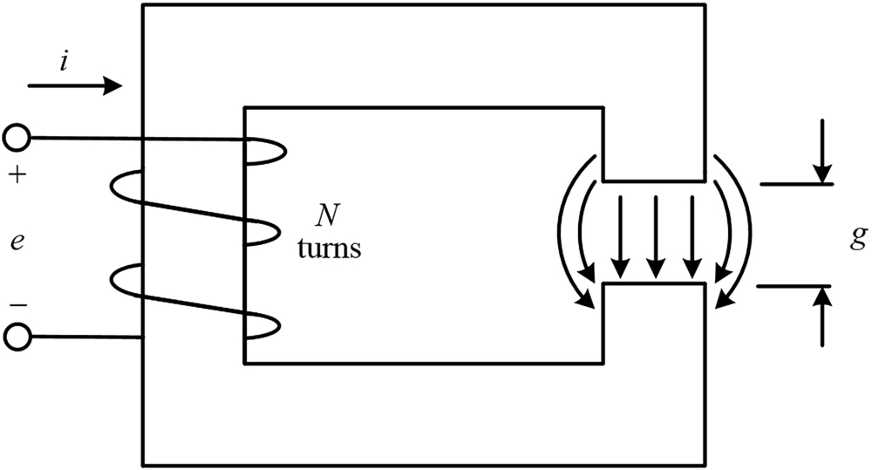

**FIG. 17.19** Fringing effect around the air gap.

The magnetic field around the air gap depends on the dimensions of the gap and the position in the core. Typically, finite element analysis (FEA) is the most accurate method to obtain the inductance. [Fig. 17.20](https://learning.oreilly.com/library/view/power-electronics-handbook/9780128114087/B9780128114070000192.xhtml#f0105) shows the fringing flux for an inductor with an air gap in the outer leg of the core.

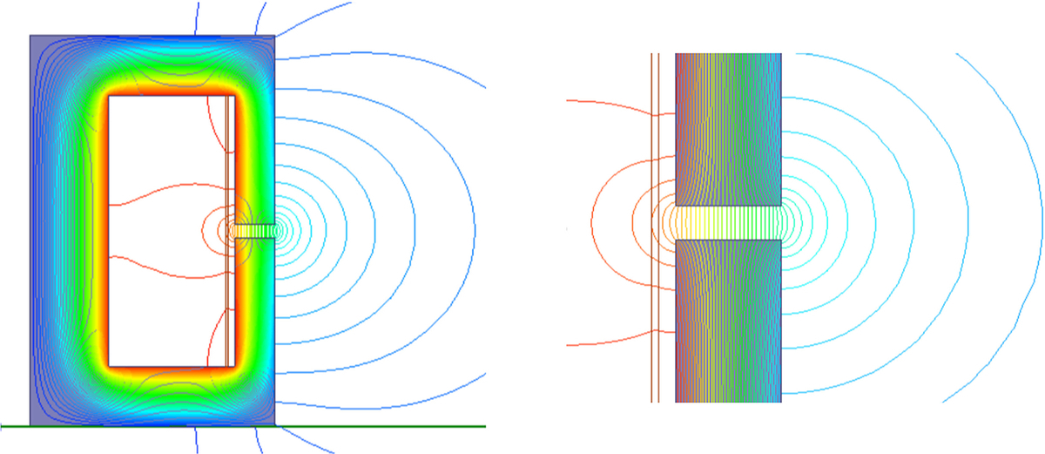

**FIG. 17.20** Fringing flux simulated by finite element analysis.

FEA simulation is resource and time-consuming. A simple and effective method to estimate the increase in inductance due to fringing is presented in [Fig. 17.21](https://learning.oreilly.com/library/view/power-electronics-handbook/9780128114087/B9780128114070000192.xhtml#f0110). The cross section of the gap is a rectangular area with dimensions *x* by *y*. Assuming the gap length is *g*, the equivalent cross-sectional area of the air gap can be set as (*x*+*g*) by (*y*+*g*) instead of *x* by *y* to calculate the inductance by the following equation:

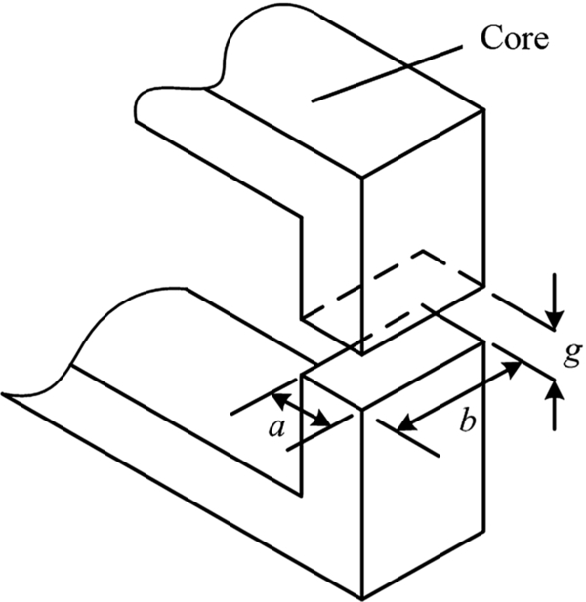

**FIG. 17.21** Inductor with an air gap in the core.

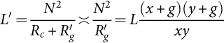 **(17.79)**

where *R*c and *Rg*′ are the reluctances of the core and the equivalent gap, *N* is the number of turns in the inductor and *L* is the inductance calculated by Eq. [(17.16)](https://learning.oreilly.com/library/view/power-electronics-handbook/9780128114087/B9780128114070000192.xhtml#fo0085).

The gap length would be very small in practice. With the assumption that *g* is much smaller than *x* or *y*, Eq. [(17.79)](https://learning.oreilly.com/library/view/power-electronics-handbook/9780128114087/B9780128114070000192.xhtml#fo0425) can be rewritten as

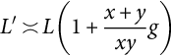 **(17.80)**

For a magnetic core with a square cross section, the inductance will be increased by the factor of (1+2 *g*/*x*). If the inductor has a circular core, the equivalent diameter of the air gap should be increased by *g*.

The fringing field will lead the nonuniform current density in the conductor near the air gap and result in extra loss in the winding. The winding loss due to the air gap is dependent on the operating frequency of the magnetic component. [Fig. 17.22](https://learning.oreilly.com/library/view/power-electronics-handbook/9780128114087/B9780128114070000192.xhtml#f0115) shows the current density in the conductor near the gap for the same inductor at frequencies of 1 and 100 kHz, respectively. It is obvious that the extra winding loss at high-frequency is significantly larger than it is at low frequency.

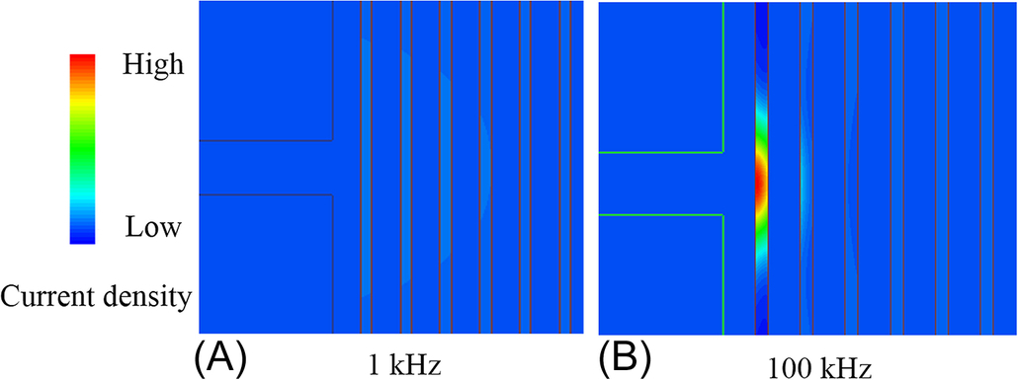

**FIG. 17.22** Inductor with an air gap in the core.

Due to the complex fringing field distribution around the gap, a simple and accurate analytic expression to evaluate the winding loss considering the fringing effect is not available. Several representative methods to calculate the fringing loss have been proposed [[17](https://learning.oreilly.com/library/view/power-electronics-handbook/9780128114087/B9780128114070000192.xhtml#bb0090)–[19](https://learning.oreilly.com/library/view/power-electronics-handbook/9780128114087/B9780128114070000192.xhtml#bb0100)]; all of these methods have substantial limitations. Simulation by finite element analysis is the most accurate method to evaluate the winding loss due to the air gap.

A number of proposals have emerged to reduce the fringing effect on the winding loss. The windings may be placed away from the air gap or may have a particular shape [[20](https://learning.oreilly.com/library/view/power-electronics-handbook/9780128114087/B9780128114070000192.xhtml#bb0105)]. The recommended distance between the conductor and the air gap should be larger than twice the gap length. The other frequently implemented method to reduce the fringing loss is to apply a distributed gap in the core to replace the discrete large air gap [[21](https://learning.oreilly.com/library/view/power-electronics-handbook/9780128114087/B9780128114070000192.xhtml#bb0110)].

### 17.5.3 HIGH-FREQUENCY LITZ WIRE

Litz wires consist of a number of fine strands that are twisted together, forming a compact bunch, and are externally connected in parallel. Insulated and enameled copper or aluminum strands are the most commonly used conductors. Multistranded cables are used in order to reduce the AC losses in thick conductors.

An easy process of manufacturing litz wires simply consists of twisting together a set of isolated strands. Other improved manufacturing methods can include some combination of braiding, twisting, or weaving processes. Ideally, strands should be equivalent in order to effectively share the currents and minimize the losses. However, equivalence of strands requires a carefully designed transposition pattern to guarantee that each strand occupies every place in the cross section for a periodic length of the cable *λc*, as it is schematically represented in [Fig. 17.23](https://learning.oreilly.com/library/view/power-electronics-handbook/9780128114087/B9780128114070000192.xhtml#f0120). Achieving the ideal litz wire structure becomes complicated in conventional implementations, especially for cables with a high number of strands.

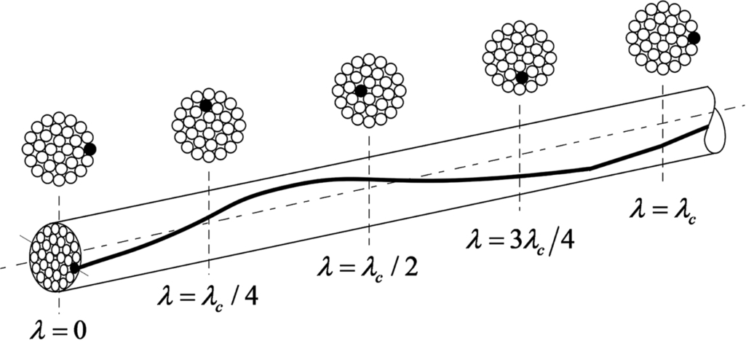

**FIG. 17.23** Litz wire ideal structure of a multistranded conductor.

Considering round conductors, skin and proximity effects are penalized when the ratio of radius to the skin depth is high. The nature of the skin effect was shown in [Section 17.5](https://learning.oreilly.com/library/view/power-electronics-handbook/9780128114087/B9780128114070000192.xhtml#s0080), where the increase of the dc resistance with respect to geometry and frequency was characterized by means of the factor Φskin. On the other hand, considering the proximity effect, the factor Φprox, shown in [Fig. 17.24](https://learning.oreilly.com/library/view/power-electronics-handbook/9780128114087/B9780128114070000192.xhtml#f0125), represents the induced losses on a round conductor per unit of length by an external alternating magnetic field (e.g., generated by nearby conductors), with respect to the ratio of the conductor radius to the skin depth. In both cases, the AC losses are strongly penalized when the ratio *r*s/*δ* is higher than one, which points the convenience of using multistranded conductors.

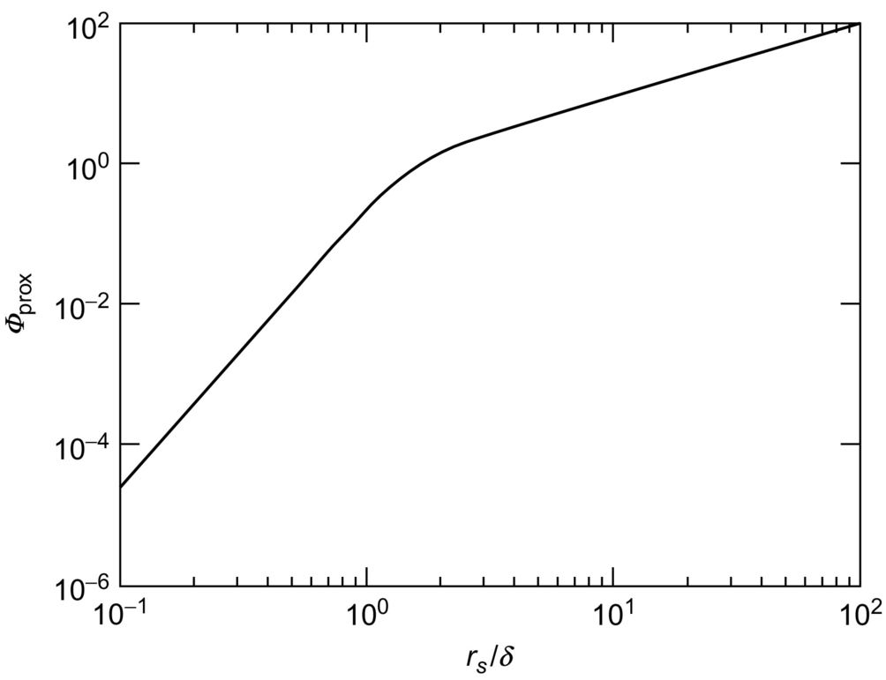

**FIG. 17.24** Proximity losses of a round conductor with respect to the ratio of the strand radius to the skin depth.

Apart from the reduction of ac losses, litz wires present some disadvantages, including the high cost with respect to round wires. In general, litz wire winding requires more space than the equivalent round wire implementation because the fill factor is deteriorated.

Losses in multistranded wire correspond to the sum of the losses in its individual strands. These loses comprise DC resistance and skin and proximity effects. Skin and proximity effects may be further divided into strand-level and bundle-level effects [[22](https://learning.oreilly.com/library/view/power-electronics-handbook/9780128114087/B9780128114070000192.xhtml#bb0115)], where the latter effects relate to unequal sharing of current in strands.

Bundle-level proximity effect loss can be controlled by simple twisting, that is, angular transposition. Bundle-level skin effect can be controlled by a complex transposition pattern that involves both radial and angular transposition of the strands. Radial transposition would involve each strand occupying all the other strand positions, whereas in angular transposition all the outside strands are transposed into other outside positions.

Simple twisting achieves angular transposition, but not radial transposition. In practice it is difficult to achieve radial transposition in a manufacturing environment. The skin effect at bundle-level is illustrated in [Fig. 17.25](https://learning.oreilly.com/library/view/power-electronics-handbook/9780128114087/B9780128114070000192.xhtml#f0130) with simple twisting, where to a large extent the wire acts like a solid conductor from the point of view of skin effect.

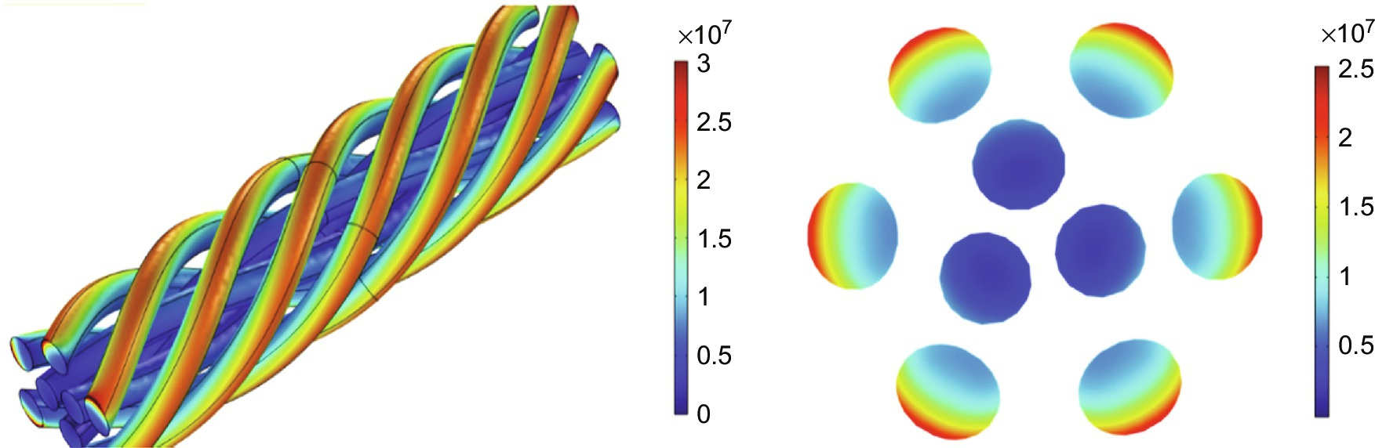

**FIG. 17.25** Bundle-level skin effect in a twisted litz wire.

Skin effect at the strand-level is covered in [Section 17.5](https://learning.oreilly.com/library/view/power-electronics-handbook/9780128114087/B9780128114070000192.xhtml#s0080) where each strand must meet the requirements of individual wires as discussed, that is, *rs/δs*<1. The proximity effect at strand-level has two components. The internal component takes into account the losses induced in a strand by the neighboring strands. The external component is generated by the other turns in a winding; this is analogous to the Dowell effect discussed in [Section 17.5](https://learning.oreilly.com/library/view/power-electronics-handbook/9780128114087/B9780128114070000192.xhtml#s0080). The external proximity effect is illustrated in [Fig. 17.26](https://learning.oreilly.com/library/view/power-electronics-handbook/9780128114087/B9780128114070000192.xhtml#f0135), where the Dowell effect is evident.

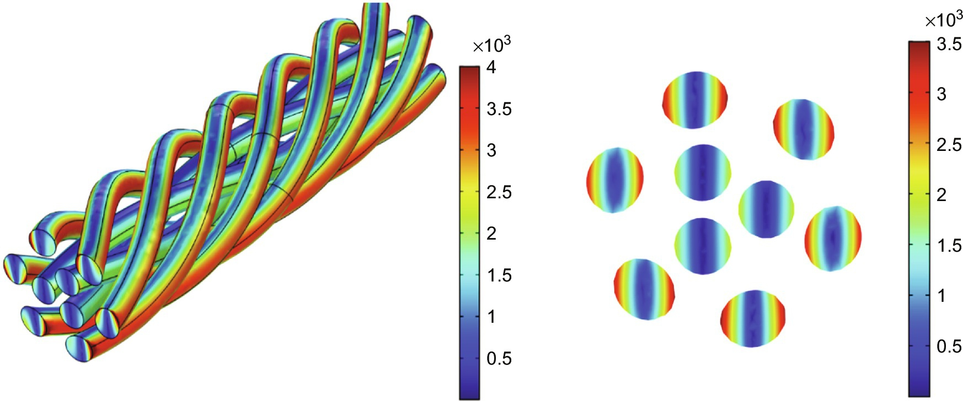

**FIG. 17.26** Strand-level external proximity effect in a twisted litz wire.

Several approaches to optimizing litz wire are available in the literature [[23](https://learning.oreilly.com/library/view/power-electronics-handbook/9780128114087/B9780128114070000192.xhtml#bb0120),[24](https://learning.oreilly.com/library/view/power-electronics-handbook/9780128114087/B9780128114070000192.xhtml#bb0125)]; it is difficult to generalize, but as a rule of thumb, the strand diameter should be less than *δs*/4.

Apart from the cost, winding volume restrictions should be taken into account when small strands are used because the copper utilization factor is deteriorated due to the isolation between strands. Values of the utilization factor *ku* with respect to the radius of strand were measured and are shown in some references [[14](https://learning.oreilly.com/library/view/power-electronics-handbook/9780128114087/B9780128114070000192.xhtml#bb0075)]. The fit to these values has the following expression:

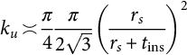 **(17.81)**

where *t*ins is the thickness of the insulation. An image of these values and the fit are shown in [Fig. 17.27](https://learning.oreilly.com/library/view/power-electronics-handbook/9780128114087/B9780128114070000192.xhtml#f0140). Needless to say, the final value of *ku* will be even smaller when the insulation to satisfy international standards on electric isolation between the windings is included. The sizing formula for *Ap* in Eq. [(17.45)](https://learning.oreilly.com/library/view/power-electronics-handbook/9780128114087/B9780128114070000192.xhtml#fo0230) shows that the reduced value of *ku* will greatly influence the overall core size, for example, a 40% reduction in the window utilization factor due to litz wire will result in a 30% increase in core size.

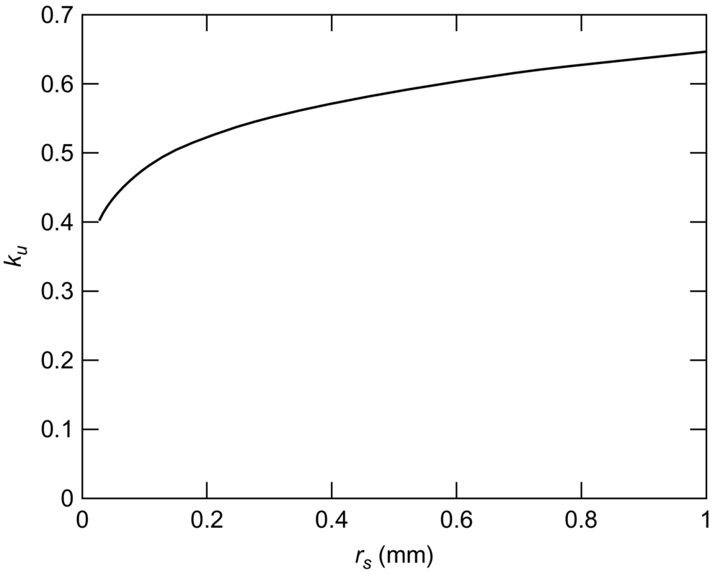

**FIG. 17.27** Copper utilization factor in litz wire.

### 17.5.4 INTERLEAVING

Another approach to reducing losses is to interleave the windings. Take the original transformer in [Fig. 17.28](https://learning.oreilly.com/library/view/power-electronics-handbook/9780128114087/B9780128114070000192.xhtml#f0145); the losses dominate the primary and secondary windings at the interface between the two windings, where the magnetic field intensity is highest.

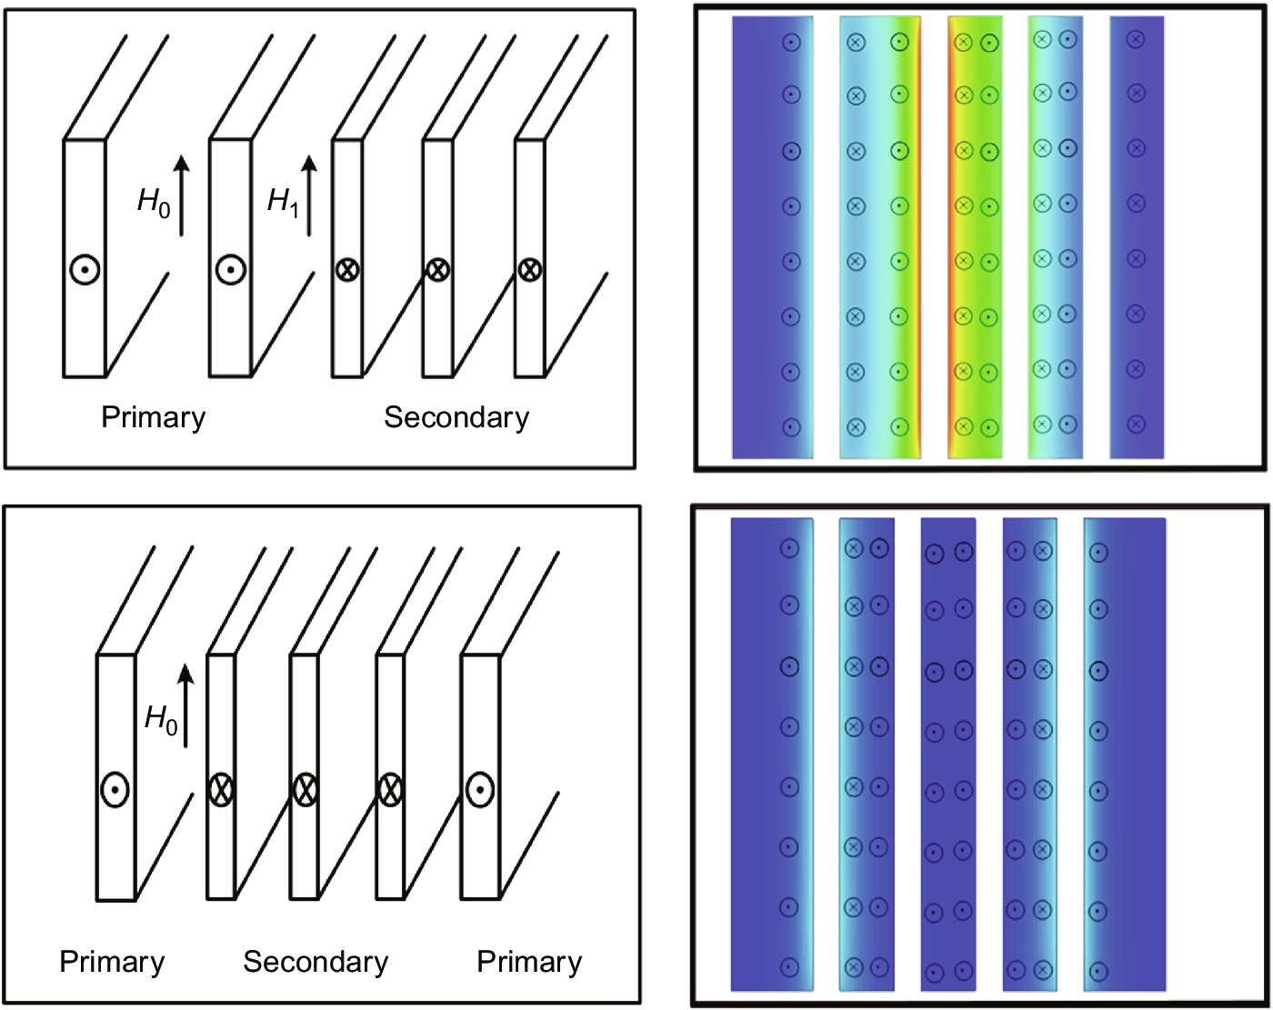

**FIG. 17.28** Interleaved windings to reduce proximity effect losses.

The plot of current density shows that the highest (red) values are at the interface of the primary and secondary winding; in the interleaved case, the maximum value of the magnetic field is reduced, and the current density is reduced accordingly.

## References

[1] Takamiya T., Hanazawa K., Suzuki T. *Recent Development of Grain-Oriented Electrical Steel in JFE SteelJFE Technical Report.* Available from: <http://www.jfe-steel.co.jp/en/research/report.html>. 2016 Accessed 23 February 2017.

[2] Lyons B.J., Hayes J.G., Egan M.G. *Experimental investigation of iron-based amorphous metal and 6.5% silicon steel for high-current inductors in low-medium frequency DC-DC converters.* In: Proceedings of the Industry Applications Conference, 2007, IEEE 42nd IAS Annual Meeting, New Orleans, LA; 2007:1781–1786.

[3] Herzer G. Modern soft magnets: amorphous and nanocrystalline materials. *Acta Mater.* 2013;61(3):718–734.

[4] Ludwig M., Duffy M., ODonnell T., McCloskey P., OMathuna S. Design study for ultra-flat PCB-integrated inductors for low-power conversion applications. *IEEE Trans. Magn.* 2003;39(5):3193–3195.

[5] Marxgut C., Muhlethaler J., Krismer F., Kolar J.W. Multiobjective optimization of ultraflat magnetic components with PCB-integrated core. *IEEE Trans. Power Electron.* 2013;28(7):3591–3602.

[6] Wang N., Miftakhutdinov R., Kulkarni S., O’Mathuna C. High efficiency on Si-integrated microtransformers for isolated power conversion applications. *IEEE Trans. Power Electron.* 2015;30(10):5746–5754.

[7] Kim J., Kim M., Herrault F., Park J., Allen M.G. Highly laminated soft magnetic electroplated CoNiFe thick films. *IEEE Magn. Lett.* 2013;4.

[8] Yao D., Levey C.G., Tian R., Sullivan C.R. Microfabricated V-groove power inductors using multilayer Co–Zr–O thin films for very-high-frequency DC–DC converters. *IEEE Trans. Power Electron.* 2013;28(9):4384–4394.

[9] Harburg D.V., Khan G.R., Herrault F., Kim J., Levey C.G., Sullivan C.R. *On-chip RF power inductors with nanogranular magnetic cores using prism-assisted UV-LED lithography.* In: Transducers & Eurosensors XXVII, 17th International Conference on Solid-State Sensors, Actuators and Microsystems, Barcelona; 2013:701–704.

[10] Overshott K. The causes of the anomalous loss in amorphous ribbon materials. *IEEE Trans. Magn.* 1981;17(6):2698–2700.

[11] Li J., Abdallah T., Sullivan C.R. *Improved calculation of core loss with nonsinusoidal waveforms.* In: Industry Applications Conference, 2001. Thirty-Sixth IAS Annual Meeting. Conference Record of the 2001 IEEE, Chicago, IL, USA; 2001:2203–2210.

[12] Venkatachalam K., Sullivan C.R., Abdallah T., Tacca H. *Accurate prediction of ferrite core loss with nonsinusoidal waveforms using only Steinmetz parameters.* In: Computers in Power Electronics, 2002. Proceedings. 2002 IEEE Workshop on; 2002:36–41.

[13] Muhlethaler J., Biela J., Kolar J.W., Ecklebe A. Improved core-loss calculation for magnetic components employed in power electronic systems. *IEEE Trans. Power Electron.* 2012;27(2):964–973.

[14] Hurley W.G., Wolfle W.H. *Transformers and Inductors for Power Electronics: Theory, Design and Applications.* first ed. West Sussex, UK: Wiley, Chichester; 2013.

[15] Carretero C., Acero J., ALonso R. TM-TE decomposition of power losses in multi-stranded litz-wires used in electronic devices. *Prog. Electromagn. Res.* 2012;123:83–103.

[16] Dowell P.L. Effects of eddy currents in transformer windings. *Proc. Inst. Electr. Eng.* 1966;113(8):1387–1394.

[17] Wallmeier P. Improved analytical modeling of conductive losses in gapped high-frequency inductors. *IEEE Trans. Ind. Appl.* 2001;37(4):1045–1054.

[18] Roshen W.A. Fringing field formulas and winding loss due to an air gap. *IEEE Trans. Magn.* 2007;43(8):3387–3394.

[19] Stadler A., Huber R., Stolzke T., Gulden C. Analytical calculation of copper losses in litz-wire windings of gapped inductors. *IEEE Trans. Magn.* 2014;50(2):81–84.

[20] Pollock J.D., Sullivan C.R. *Gapped-inductor foil windings with low AC and DC resistance.* In: Proceedings of the IEEE Industry Applications Conference; 2004:557.

[21] Kutkut N.H., Divan D.M. Optimal air-gap design in high-frequency foil windings. *IEEE Trans. Power Electron.* 1998;13(5):942–949.

[22] Lotfi A.W., Lee F.C. *A high frequency model for litz wire for switch-mode magnetics.* In: Proceedings of the 1993 IEEE Industry Applications Society Annual Meeting, (IAS), vol. 2; 1993:1169–1175.

[23] Sullivan C.R. Optimal choice for number of strands in a litz-wire transformer winding. *IEEE Trans. Power Electron.* 1999;14:283–291.

[24] Lope I., Acero J., Carretero C. Analysis and optimization of the efficiency of induction heating applications with litz-wire planar and solenoidal coils. *IEEE Trans. Power Electron.* 2016;31(7):5089–5101.

**SECTION III**

General Applications

**18**

# Solid-State Pulsed Power Modulators and Capacitor Charging Applications

José Fernando Silva Universidade de Lisboa, Lisboa, Portugal

Luis Redondo Instituto Superior de Engenharia de Lisboa, IPL, Pulsed Power Advanced Applications Research Group, Lisboa, Portugal

William C. Dillard Archangel Systems, Incorporated, Auburn, AL, United States

## Abstract

This chapter provides basic concepts and advanced technologies to generate repetitive high-voltage pulses using state-of-the-art power semiconductors. It starts with a review of power semiconductor devices used in solid-state-based high-voltage generators, including the newest silicon carbide (SiC) insulated-gate bipolar transistor (IGBT), metal-oxide-semiconductor field-effect transistor (MOSFET), and the latest gallium nitride (GaN) enhancement-mode high-electron-mobility transistor (E-HEMT). Several types of pulsed power applications are presented and their high-voltage modulator requirements are described. The most widespread semiconductor-based HV unipolar and bipolar pulse modulator topologies are analyzed, and solid-state device operation is explained. Capacitor charging applications are also presented.

### KEYWORDS

Pulsed power; Wide bandgap power semiconductors; Cascode switches; Marx switches; Solid-state Marx modulators; Solid-state Marx bipolar modulators; Capacitor charging

18.1 [Introduction](https://learning.oreilly.com/library/view/power-electronics-handbook/9780128114087/B9780128114070000209_1.xhtml#s0010)

18.2 [Power Semiconductors for PP](https://learning.oreilly.com/library/view/power-electronics-handbook/9780128114087/B9780128114070000209_1.xhtml#s0015)

18.2.1 High-Voltage PIN Diodes (Step Recovery Diodes SRD)

18.2.2 Metal-Oxide Semiconductor Technology Transistors

18.2.3 Thyristors and Turn-Off Thyristor Devices

18.2.4 Power JFETs and Derived Devices

18.2.5 Semiconductor Series Stacks and Generalized Cascodes, Semiconductor Parallel Stacks

18.2.6 Wide Band Gap Power Semiconductor Devices

18.3 [Load Types and Requirements](https://learning.oreilly.com/library/view/power-electronics-handbook/9780128114087/B9780128114070000209_1.xhtml#s0085)

18.3.1 Resistive (*R*) Loads

18.3.2 Capacitive (*C*) and *RC* Loads

18.3.3 Inductive (*L*) and *LR* Loads

18.4 [Solid-State PP Topologies](https://learning.oreilly.com/library/view/power-electronics-handbook/9780128114087/B9780128114070000209_1.xhtml#s0105)

18.4.1 Direct Switching

18.4.2 dc-dc Isolated Converters

18.4.3 Cascaded Topology

18.4.4 Solid-State Marx Generators

18.4.5 Solid-State Marx-Based High-Voltage Switches

18.4.6 Solid-State Marx-Based Bipolar Generators

18.4.7 Solid-State Marx-Based Multilevel Bipolar Generators

18.5 [Power Electronics in Capacitor Charging Applications](https://learning.oreilly.com/library/view/power-electronics-handbook/9780128114087/B9780128114070000209_2.xhtml#s0195)

18.5.1 Introduction

18.5.2 High-Voltage dc Power Supply With Charging Resistor

18.5.3 Resonance-Charging

18.5.4 Switching Converters

18.6 [Conclusions and Future Trends](https://learning.oreilly.com/library/view/power-electronics-handbook/9780128114087/B9780128114070000209_2.xhtml#s0220)

[Acknowledgments](https://learning.oreilly.com/library/view/power-electronics-handbook/9780128114087/B9780128114070000209_1.xhtml#ac0010)

[References](https://learning.oreilly.com/library/view/power-electronics-handbook/9780128114087/B9780128114070000209_2.xhtml#bi0010)

[Further Reading](https://learning.oreilly.com/library/view/power-electronics-handbook/9780128114087/B9780128114070000209_2.xhtml#fr0010)

## Acknowledgments

This work was supported by national funds through Fundação para a Ciência e a Tecnologia (FCT) with reference UID/CEC/50021/2013 and by CERN past projects.

## 18.1 Introduction

Pulsed power, PP, can be considered as the science and technology of accumulating electric energy over a relatively long period of time, followed by the subsequent energy release in very short pulses, a single one or a controlled repetitive sequence, thus increasing the instantaneous peak power. Supposing zero losses, the output energy *Eo*, delivered at power *Po* during *To*, equals the accumulated energy *Ei* at a power *Pi* during *Ti*, bringing

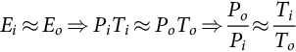 **(18.1)**

An example is shown in [Fig. 18.1](https://learning.oreilly.com/library/view/power-electronics-handbook/9780128114087/B9780128114070000209_1.xhtml#f0010), where a stored energy of 1 kJ can be discharged into a long pulse of 1 kW for 1 s or a short pulse of 1 GW for 1 μs, respectively, considering the ideal case of a lossless system.

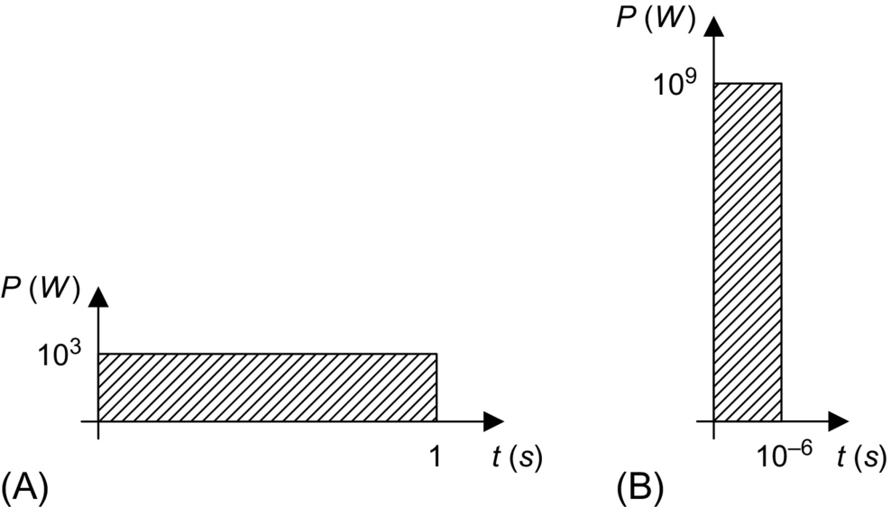

**FIG. 18.1** Discharge of 1 kJ energy: (A) 1 kW during 1 s pulse and (B) 1 GW during 1 μs pulse.

PP is a technique primarily developed for radars, accelerators, and military applications but with great potential for civil applications [[1](https://learning.oreilly.com/library/view/power-electronics-handbook/9780128114087/B9780128114070000209_2.xhtml#bb0010)]. In fact, there is a growing variety of environmental, biomedical, commercial, and industrial applications that use positive and/or negative high-voltage, HV, repetitive pulses, for enhancing the properties of a product or a technique [[2](https://learning.oreilly.com/library/view/power-electronics-handbook/9780128114087/B9780128114070000209_2.xhtml#bb0015)]. These pulses may last from hundreds of picoseconds to tens of seconds, being released as a single shot or as a repetitive sequence up to several tens of thousands per second.

What makes PP so unique is the concept that extremely high peak powers can be delivered during short times without the demand for highly powerful energetic power sources, custom direct, dc, or alternating, ac, voltage systems being suited.

In the past, the PP technology was dominated by vacuum or gas tubes (i.e., electronic valves) for switching the high-powers needed for military and large plant physical applications [[3](https://learning.oreilly.com/library/view/power-electronics-handbook/9780128114087/B9780128114070000209_2.xhtml#bb0020)]. With the technological advent of power semiconductors in the 1970s and particularly modern power semiconductors in the 1990s, developing PP generators based on power semiconductors was possible. Still, they were lower power rated compared with electronic valve generators but largely rewarded by the higher energetic efficiency and flexibility together with compactness and cost-effectiveness [[4](https://learning.oreilly.com/library/view/power-electronics-handbook/9780128114087/B9780128114070000209_2.xhtml#bb0025)].

Nowadays, the applications of PP are driving the need for technological advances in medical, environment, biological, energetic, and industrial applications, for example, in the reduction of pollution emissions from fossil fuels, in killing bacteria and organic pollutants, in melanoma cancer treatment, and in molding metals sheets [[5](https://learning.oreilly.com/library/view/power-electronics-handbook/9780128114087/B9780128114070000209_2.xhtml#bb0030)–[9](https://learning.oreilly.com/library/view/power-electronics-handbook/9780128114087/B9780128114070000209_2.xhtml#bb0050)].

This chapter provides basic concepts and advanced know-how on the generation of repetitive HV pulses using state-of-the-art power semiconductor technology. Apart from this introduction, in [Section 18.2](https://learning.oreilly.com/library/view/power-electronics-handbook/9780128114087/B9780128114070000209_1.xhtml#s0015), power semiconductor devices used in solid-state-based high-voltage generators are reviewed together with the latest silicon carbide (SiC) insulated-gate bipolar transistor (IGBT) and metal-oxide-semiconductor field-effect (MOSFET) through the latest gallium nitride (GaN) power junction field-effect transistors (JFET). In [Section 18.3](https://learning.oreilly.com/library/view/power-electronics-handbook/9780128114087/B9780128114070000209_1.xhtml#s0085), several types of PP applications are presented, and the type of load requirements they present to the high-voltage modulators is described. The most widespread semiconductor-based HV pulse modulator topologies are analyzed and discussed in terms of solid-state device operation in [Section 18.4](https://learning.oreilly.com/library/view/power-electronics-handbook/9780128114087/B9780128114070000209_1.xhtml#s0105). In [Section 18.5](https://learning.oreilly.com/library/view/power-electronics-handbook/9780128114087/B9780128114070000209_2.xhtml#s0195), capacitor charging applications are presented and described. The main conclusions about semiconductor use in high-voltage pulse generation are presented in [Section 18.6](https://learning.oreilly.com/library/view/power-electronics-handbook/9780128114087/B9780128114070000209_2.xhtml#s0220) and the future trends on this technology.

## 18.2 Power Semiconductors for PP

The demand for high-voltage modulators to generate repetitive high-voltage pulses with optimized performance and characteristics, based in solid-state technology, is being fulfilled through the enhancement of the volt-ampere capabilities and switching speed of modern power semiconductors.

Still, using power semiconductors in PP is a matter of optimizing their use, going beyond the present semiconductor ratings and taking advantage of usually nonuseful phenomena or nonideal characteristics, such as controlled avalanche breakdown (for avalanche transistors), diode reverse recovery sharpness that can generate inductive high-voltage pulses, Zener capacitances, peak currents, and unusual very short pulse behavior.

In the next sections, the particular characteristics of power semiconductors enabling their use in PP applications will be summarized, from silicon (Si) high-voltage diodes, silicon-controlled rectifier thyristors (SCR), gate turn-off thyristor (GTO), gate-controlled thyristor (GCT), integrated gate-commutated thyristor (IGCT), injection enhanced gate transistor (IEGT), insulated-gate bipolar transistor (IGBT), and metal-oxide-semiconductor field-effect transistors (MOSFET) to the latest silicon carbide (SiC) IGBTs or gallium nitride (GaN) power junction field-effect transistors (JFET) (also termed enhancement-mode high-electron-mobility transistor (E-HEMT)). To overcome the still limited hold-off voltages of power semiconductors and their current ratings ([Fig. 18.2](https://learning.oreilly.com/library/view/power-electronics-handbook/9780128114087/B9780128114070000209_1.xhtml#f0015)), regarding the electronic valves, some techniques will be described, including series and parallel semiconductor arrangements, and the source switching of a JFET using a low-voltage MOSFET (cascode stacks).

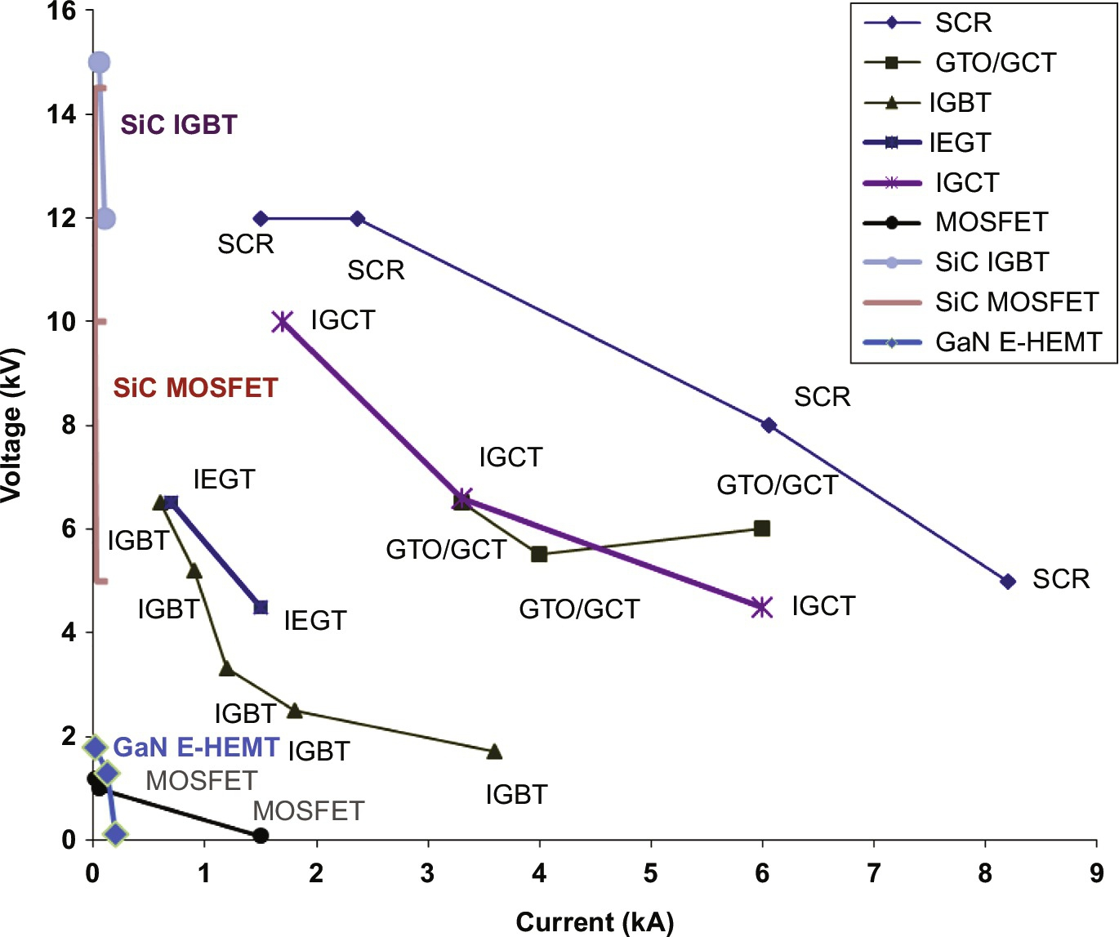

**FIG. 18.2** Maximum volt-ampere capabilities of current Si (SCR, GTO/MCT, IGCT, IEGT, IGBT, and MOSDET), SiC (MOSFET and IGBT), and GaN (E-HEMT) high-power semiconductors.

Much attention is being devoted to power semiconductors based on silicon carbide (SiC) structures, which can switch voltages in the tens of kV range and currents nearing the kA barrier. The 4H-SiC MOSFET is being investigated for 12–15 kV, while SiC IGBTs are now in the 15 kV range ([Fig. 18.2](https://learning.oreilly.com/library/view/power-electronics-handbook/9780128114087/B9780128114070000209_1.xhtml#f0015)). Alternative semiconductor materials, such as gallium nitride (GaN), are being investigated to build GaN enhancement-mode JFETs called HEMTs (available 650 V, 60 A, and 25 mΩ). GaN JFETs are expected to be faster devices (100 MHz switching frequency and 10 ns switching time) than SiC or Si power semiconductors. The cascode switch is expected to attain 10 kV blocking voltages.

Superjunction (SJ) transistors are being researched to build bipolar power transistors; super trench MOSFETs (STM), vertical deep trench (resurf diffusion MOS-VTR-DMOS), SJ DMOS, UMOS, JFET, and JFET-derived structures are also being considered [[4](https://learning.oreilly.com/library/view/power-electronics-handbook/9780128114087/B9780128114070000209_2.xhtml#bb0025)].

### 18.2.1 HIGH-VOLTAGE PIN DIODES (STEP RECOVERY DIODES SRD)

[Fig. 18.3A](https://learning.oreilly.com/library/view/power-electronics-handbook/9780128114087/B9780128114070000209_1.xhtml#f0020) shows the simplified structure of a typical Si high-voltage high-power diode with forward bias carriers in [Fig. 18.3A](https://learning.oreilly.com/library/view/power-electronics-handbook/9780128114087/B9780128114070000209_1.xhtml#f0020) [[10](https://learning.oreilly.com/library/view/power-electronics-handbook/9780128114087/B9780128114070000209_2.xhtml#bb0055)]. This type of diode has a heavily doped P+ anode and N+ substrate separated by a lightly doped N− (or near intrinsic, I) epitaxial layer, called drift region [[11](https://learning.oreilly.com/library/view/power-electronics-handbook/9780128114087/B9780128114070000209_2.xhtml#bb0060)]. The drift region, usually not found in low-power diodes, has to contain the thick depletion layer of the reverse-biased high-voltage PIN diode, establishing the diode reverse breakdown (or hold-off) voltage rating (punch-through diodes).

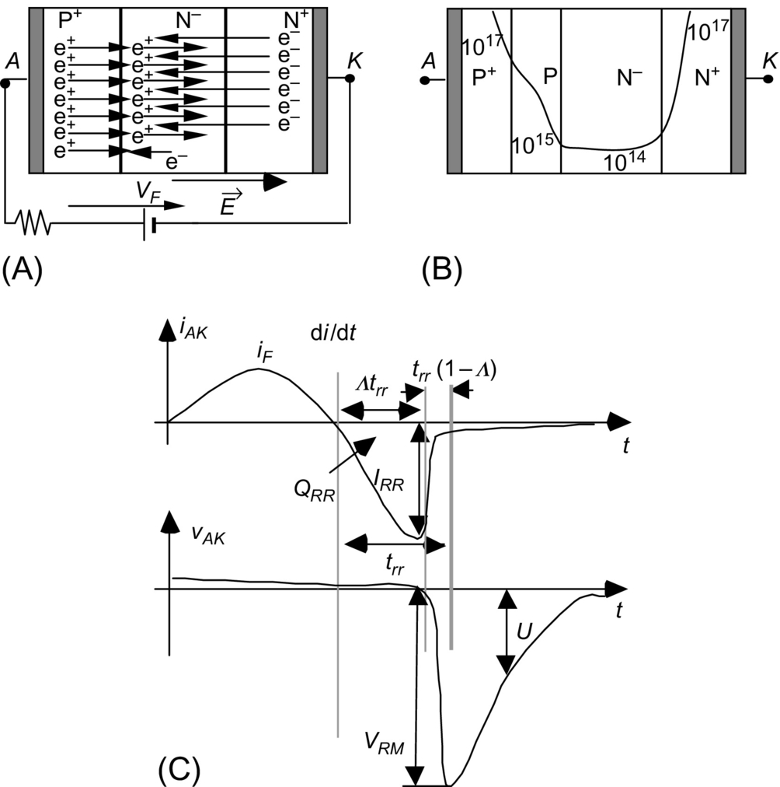

**FIG. 18.3** (A) Forward-biased PIN diode, (B) P+PN−N+ SOS diode structure and typical doping profile, and (C) SOS diode reverse-blocking behavior.

PIN diodes turn-on requires the depletion layer removal (forward voltage recovery, as the diode is reverse-biased prior to turn-on). Removal of the stored depletion charge needs a certain current and time. Forward conduction is dominated by high-level injection of holes (conductivity modulation) in the drift region, which becomes a virtual P region. The minority injected charge is positive if the diode is conducting, the forward current providing minority carriers at the rate they recombine. The *on*-state voltage is relatively high, the electric field extending through the drift region. This electric field is need to the transport of charge carriers from P to N region.

To turn-off the PIN diode, the stored excess carriers, mostly in the drift region, must be discharged before the diode reverse biases, the minority charge becoming negative (reverse recovery). Upon applying a reverse voltage *UR*, the forward current will decrease ([Fig. 18.3C](https://learning.oreilly.com/library/view/power-electronics-handbook/9780128114087/B9780128114070000209_1.xhtml#f0020)) at a rate of

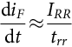 **(18.2)**

becoming negative to swept the excess carriers out of the drift region and charge the depletion capacitance *Ceqoff*, which is relatively small due to the wide drift region. At constant reverse *UR* voltage applied in inductive circuits (*LS* inductor), the diode reverse current rate of rise, considered constant, is

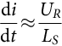 **(18.3)**

reaching the value *IRR*

*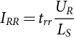* **(18.4)**

at the reverse recovery time *trr*

*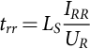* **(18.5)**

being the reverse recovery charge *QRR*

*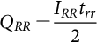* **(18.6)**

In LC oscillating circuits ([Fig. 18.4](https://learning.oreilly.com/library/view/power-electronics-handbook/9780128114087/B9780128114070000209_1.xhtml#f0025)), the PIN diode may become reverse-biased by a negative fast-rising voltage with high peak value *VRM*, which can be more than three times higher than the applied direct voltage *U* ([Fig. 18.3C](https://learning.oreilly.com/library/view/power-electronics-handbook/9780128114087/B9780128114070000209_1.xhtml#f0020)).

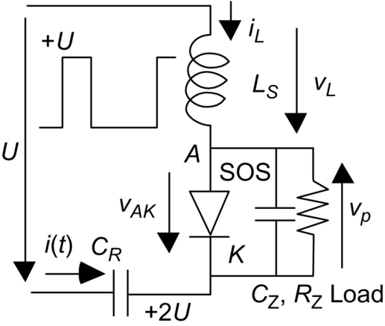

**FIG. 18.4** SOS pulse generation using magnetic energy storage.

At high reverse voltages, the pulse energy must be limited to avoid the impact ionization current destroying the diode by avalanche breakdown and excessive power dissipation. Therefore, PIN diodes should be used with very short pulses, sharpening and increasing the voltage amplitude of the applied pulses.

Semiconductor opening switches (SOS), also known as step recovery diodes (SRD), charge diodes or snap diodes, are modified PIN high-voltage diodes using a P+PN−N+ structure with gradually doped P layer ([Fig. 18.3B](https://learning.oreilly.com/library/view/power-electronics-handbook/9780128114087/B9780128114070000209_1.xhtml#f0020)) [[12](https://learning.oreilly.com/library/view/power-electronics-handbook/9780128114087/B9780128114070000209_2.xhtml#bb0065)]. The diode injected minority carriers must not have the time to recombine and should not diffuse too far from the junction before they are withdrawn under reverse bias with a reverse current. The minority carrier lifetime of the SOS diode determines the pulse length. SOS diodes are thus optimized to exhibit relatively slow reverse recovery (*Λtrr*≈50–100 ns) but abrupt recovery (very fast reverse current decay) (1−*Λ*)*trr*≈5 ns ([Fig. 18.3C](https://learning.oreilly.com/library/view/power-electronics-handbook/9780128114087/B9780128114070000209_1.xhtml#f0020)).

SOS diode characteristics depend not only on the pumping forward current (current density and very short time to avoid saturation) but also on the doping profile of the P+PN−N+ structure and carrier lifetime. The reverse recovery of SOS diodes (e.g., their opening) should differ from PIN diodes, since current interruption ought to occur mostly in the narrower P-doped layer, not in the drift layer. The SOS diode can switch high-currents (kA) in nanosecond opening times, with automatic uniform distribution of reverse voltage (kV) in series-connected SOS diodes during current decay. Series stacks of up to one thousand SOSs can be deployed to obtain working voltages near the megavolt level, peak currents of several kA, peak power of GW, and average powers of tens of kilowatts.

In a simplified circuit for SOS operation ([Fig. 18.4](https://learning.oreilly.com/library/view/power-electronics-handbook/9780128114087/B9780128114070000209_1.xhtml#f0025)), it is supposed that a rectangular prepulse with amplitude *U* and pulse length *TU* is generated and applied to the SOS in series with an inductor *LS* to charge the capacitor *CR*.

During the positive part of the prepulse, the forward pumping period, the SOS diode is forward-biased, and the inductor near-sinusoidal current rises to build up energy in the resonant *LSCR* circuit and excess carriers in the diode.

Supposing the *LSCR* with zero series resistor *rS* (*rS*→0), then this LC is underdamped (*ζ*<1), the inductor current being given as

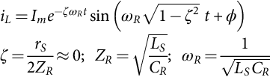 **(18.7)**

The *Im* and *ϕ* values are obtained from the initial conditions . Therefore,

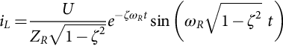 **(18.8)**

where *ZR* is the characteristic impedance

 **(18.9)**

of the *LSCR* resonant tank with oscillation frequency *ωR*, set to allow charging during *TU*:

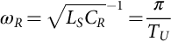 **(18.10)**

Charging must occur only during half the oscillation cycle; thus, *TU*=(2*π*/*ωR*)/2.

Neglecting losses (*LSCR* resonant tank damping factor nearly zero), parasitic effects and diode voltage drops, the diode forward current is obtained from

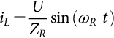 **(18.11)**

with peak value

 **(18.12)**

Since *rS*≈0, the capacitor *CR* voltage is

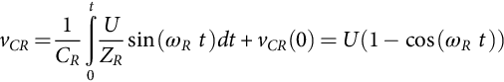 **(18.13)**

At *t*=*TU*=*π*/*ωR*, the *CR* capacitor will charge to nearly

 **(18.14)**

Neglecting the recombination decay time constant, the diode forward stored charge is nearly

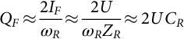 **(18.15)**

During the sinusoidal negative oscillation interval, the diode is still conducting, the prepulse voltage is nearly zero, and the inductor current goes negative. The SOS diode reverse recovery instant (opening) happens at nearly the *CR* discharge peak current

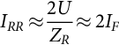 **(18.16)**

being the reverse recovery charge

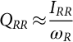 **(18.17)**

nearly equal to the forward injected charge. Thus, the reverse recovery current is nearly the double of the peak forward current *IRR*≈2*U*/*ZR*≈2*IF*, being

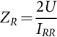 **(18.18)**

Supposing diode abrupt recovery and assuming energy conservation, the *vp* pulse voltage is dependent on the load capacitor *CZ* and resistor *RZ*; for underdamped *LSCZ*||*RZ* parallel circuits, (*ξ*<1) given as

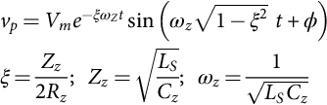 **(18.19)**

where the load *RZ* is in parallel with *ZZ*, being  the characteristic impedance of the second-order *LSCZ*||*RZ* parallel circuit with damping factor  and undamped resonant frequency  driven by the initial current *IRR* of inductor *LS*.

The *Vm* and *ϕ* values are obtained from the initial conditions *vp*(0)=0 and *iLs*(0)=*IRR*. Therefore,

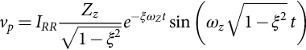 **(18.20)**

The maximum voltage *vpmax*=*VRM* occurs at *t*=*tpeak* and is

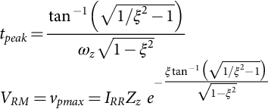 **(18.21)**

The *VRM* equation above can be used to determine the needed *IRR* and then, using Eq. [(18.18)](https://learning.oreilly.com/library/view/power-electronics-handbook/9780128114087/B9780128114070000209_1.xhtml#fo0095), the *ZR* value.

For near-optimum energy transfer to the load resistor *RZ*, a damping value slightly lower than the critical value should be used, the *vp* pulse being roughly sinusoidal. Pulse forming networks or lines can be used to almost square it [[12](https://learning.oreilly.com/library/view/power-electronics-handbook/9780128114087/B9780128114070000209_2.xhtml#bb0065)].

From the above equations, assuming a damping factor 0.7<*ξ*<0.9, the design SOS diode pulser follows the steps:

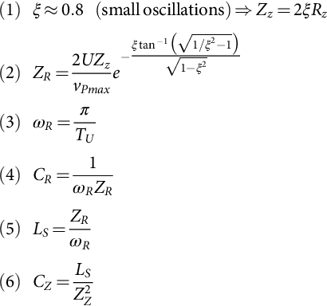 **(18.22)**

This design considers the SOS properties are suitable, assuming that SOS diode carrier lifetime is long enough to nearly conserve charge, abrupt reverse recovery and zero *on*-state voltages (regarding the *U* values). Often, *CZ* should account for the intrinsic SOS diode capacitance or nonabrupt diode recovery.

A simplified design, valid nearly for 0.75<*ξ*<1, leads to slightly higher *VRM* pulse voltages. Consider

 **(18.23)**

To obtain a near-critical damped load (0.7<*ξ*<0.9), it must be

 **(18.24)**

Then, from the required *VRM* and *IRR* the *ZR* value, it is

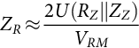 **(18.25)**

and

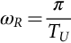

Then, the resonant tank has values

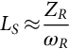 **(18.26)**

and

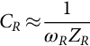 **(18.27)**

From *LS* and *ZZ*, the load parallel capacitor *CZ*, either added or stray capacitance or SOS *Ceqoff*, should be

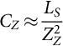 **(18.28)**

For a required *VRM* in load resistor *RZ* and capacitor *CZ*, the SOS diode must withstand

– forward current *IF*,

– pumping time *TU*,

– *VRM* reverse voltage,

– reverse recovery current *IRR*,

– reverse recovery charge *QRR*.

High peak voltages *VRM* and comparatively low values of *IRR* need very low values of the load (spurious) parallel capacitance *CZ*, or higher values of *IRR*.

**Example 18.1**

Determine the circuit parameters of [Fig. 18.4](https://learning.oreilly.com/library/view/power-electronics-handbook/9780128114087/B9780128114070000209_1.xhtml#f0025) to obtain a 30 ns 1 MV pulse in resistor *RZ*=1 kΩ (1 MW peak) paralleled with *CZ* capacitor, from a prepulse having *U*=300 kV and pulse length *TU*.

Solution

Supposing volts×second conservation at equal current, the prepulse length should be



Then, from the above equations, it is obtained



If it is assumed *ξ*=0.75, then



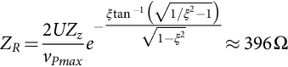





and



This is a low value considering the SOS diode (or diode association) equivalent off-depletion capacitance *Ceqoff*, not to forget stray capacitances. The SOS diode must withstand





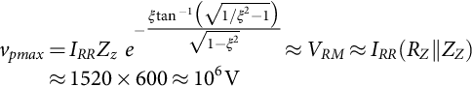



Excess carrier (holes) mean lifetime (reciprocal of recombination decay) should be higher than 1 μs and diode reverse recovery time should be



that is, nearly half of the forward pumping time.

Since the damped resonant frequency is

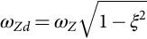

the pulse duration (settling time) is close to

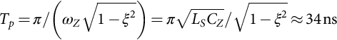

This is near the required 30 ns, as can be seen in [Fig. 18.5](https://learning.oreilly.com/library/view/power-electronics-handbook/9780128114087/B9780128114070000209_1.xhtml#f0030). Designs for higher *CZ* values require damping factors *ξ* toward 0.5, which increase SOS diode ratings (*IF*, *IRR*, and *QRR*) but would allow the doubling of *CZ* capacitances.

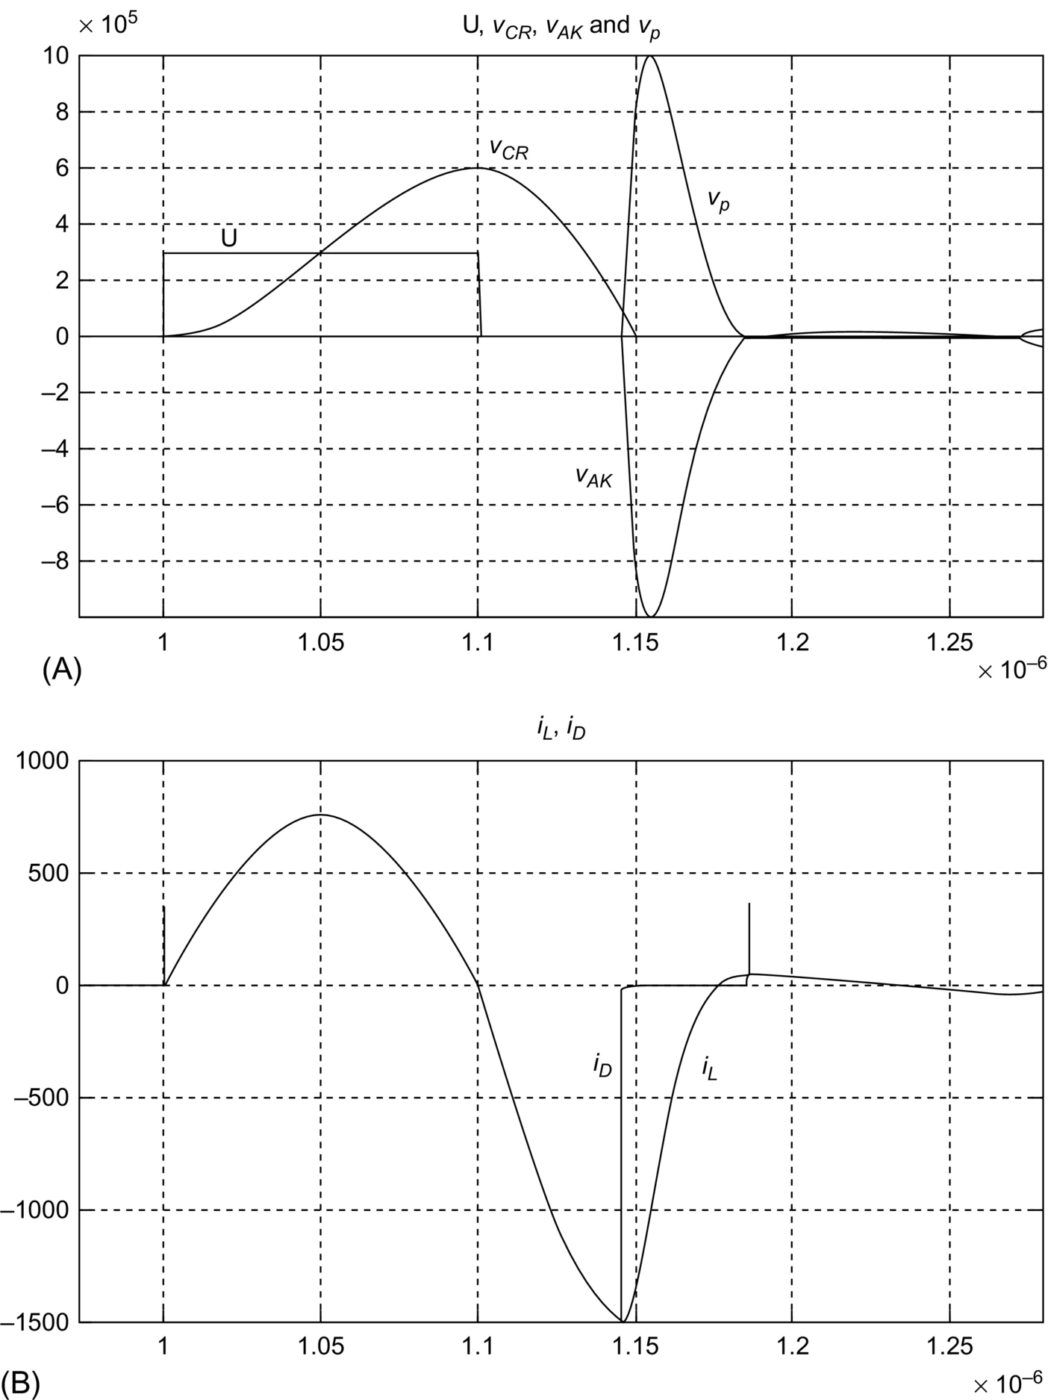

**FIG. 18.5** SOS *vp* pulse generated using magnetic energy storage. (A) Upper graph shows waveforms of *U*, *vCR*, *vAK*, and *vp* in volts and (B) waveforms of *iD* and *iL* in amperes in the lower graph.

This SOS pulse generator multiplies the incoming prepulse amplitude by a factor slightly higher than 3.

Given the present capabilities of SOS diodes (nearly 1 kA and 1 kV), this 1 MV pulse modulator would require

1. an array of some thousands of SOS diodes arranged in a series of few paralleled diodes;

2. oil isolation and cooling, complemented with water/air heat sinking;

3. special care to minimize parasitic inductances and capacitances.

Other SOS devices use unique diffusion techniques to achieve ultrafast switching times, such as the drift step recovery device (DSRD), the inverse recovery diode (IRD), and the delayed ionization device (DID). Each device is capable of producing pulses ranging from 1 to 10 kV, with rise times between 100 ps and 1 ns.

The PIN diode-based silicon avalanche sharpener (SAS) is a sharpening device that shortens the pulse rise time. Usually, it works reverse-biased, a slow rise time and short reverse pulse being applied to the SAS in order to avalanche it. When avalanche breakdown of the SAS drift layer occurs, a very short rise time pulse is applied to the load. Avalanche breakdown does not destroy the SAS if the input pulse is short enough.

### 18.2.2 METAL-OXIDE SEMICONDUCTOR TECHNOLOGY TRANSISTORS

#### **18.2.2.1 Metal-Oxide Semiconductor Field-Effect Transistors (MOSFET)**

MOSFETs are very fast unipolar-carrier enhancement-mode semiconductor devices controlled by the electric field associated to the *vGS* voltage applied at the gate-source terminals ([Fig. 18.6A](https://learning.oreilly.com/library/view/power-electronics-handbook/9780128114087/B9780128114070000209_1.xhtml#f0035)) [[10](https://learning.oreilly.com/library/view/power-electronics-handbook/9780128114087/B9780128114070000209_2.xhtml#bb0055)–[13](https://learning.oreilly.com/library/view/power-electronics-handbook/9780128114087/B9780128114070000209_2.xhtml#bb0070)]. Their speed is mostly due to the absence of carrier recombination since in N-type MOSFETs the carriers are almost only electrons. MOSFET semiconductor structure forms an N+N−PN+ shorted base-emitter bipolar transistor ([Fig. 18.6A](https://learning.oreilly.com/library/view/power-electronics-handbook/9780128114087/B9780128114070000209_1.xhtml#f0035)), which is often referred as behaving as an intrinsic antiparallel PIN diode ([Fig. 18.6B](https://learning.oreilly.com/library/view/power-electronics-handbook/9780128114087/B9780128114070000209_1.xhtml#f0035)).

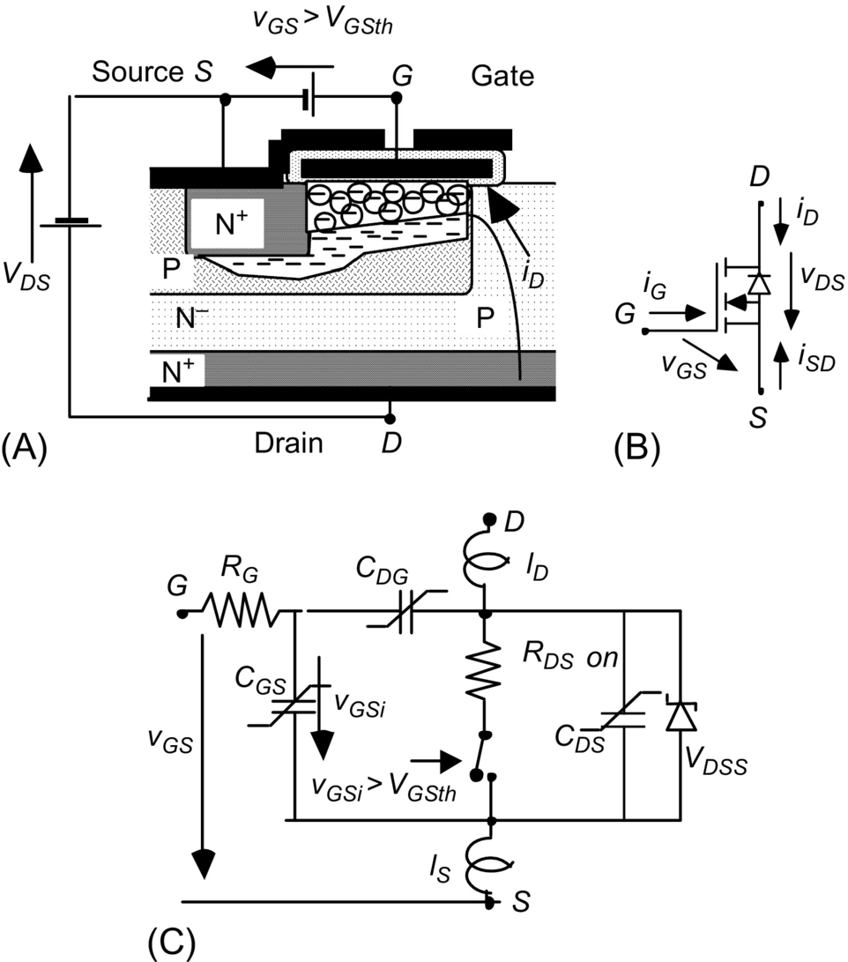

**FIG. 18.6** (A) MOSFET structure showing the DS current path, (B) electronic symbol including intrinsic diode, and (C) MOSFET model with parasitic components.

The MOSFET has the capabilities for high-speed switching in the nanosecond or subnanosecond range [[14](https://learning.oreilly.com/library/view/power-electronics-handbook/9780128114087/B9780128114070000209_2.xhtml#bb0075),[15](https://learning.oreilly.com/library/view/power-electronics-handbook/9780128114087/B9780128114070000209_2.xhtml#bb0080)].

In PP applications, MOSFETs should behave as ideal switches, being conductive (switched ON) if *vGS* exceeds the threshold value *VGSth*, while maintaining

 **(18.29)**

The ON MOSFET behaves almost like a resistor *RDSon*, with low value and positive temperature coefficient being the drop ON voltage

 **(18.30)**

The MOSFET stops conduction (opens) turning to the *off*-state if



Usually, the gate driver enforces *vGS*<0 with *vDS*>0, to have noise immunity.

If *vDS*<0, then the intrinsic diode starts to conduct (on voltage *VDS*=*−VPINon*), which is seldom advantageous since the internal PIN diode usually is not optimized for low-voltage drop or high-speed switching.

In this case, it is better that the gate driver turns on the MOSFET channel in order to prevent the PIN diode conduction, if *−RDSon ID*<*VPINon.*

The gate current after charging or discharging of gate stray capacitances is almost zero; therefore, the needed gate power is very low. In PP applications, fast switching is required; consequently, the circuit driving the *vGS* voltage must be designed to charge/discharge the MOSFET parasitic nonlinear capacitances taking into account the effects of device terminal inductances ([Fig. 18.6C](https://learning.oreilly.com/library/view/power-electronics-handbook/9780128114087/B9780128114070000209_1.xhtml#f0035)). The switching speed of existing MOSFETs is limited mainly by packaging (lead inductances) and drain and gate and source resistances together with intrinsic capacitances.

The switching times can be in the order of some nanoseconds or lower and are affected by the driver *RG* value.

Resistor *RG* dampens the RLC series circuit that contains *CGS*, *CDG*, and gate and source stray inductances *LS*. The gate resistor can be sized adopting a suitable value for the damping factor *ζ* of the RLC series circuit

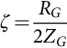 **(18.31)**

where

 **(18.32)**

and *CG* is the equivalent gate capacitor, being

 **(18.33)**

The equivalent gate capacitor *CG* can be known from the manufacturer datasheets:

 **(18.34)**

**** **(18.35)**

**** **(18.36)**

giving

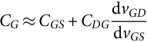 **(18.37)**

while the gate and source stray inductances *LS* can be estimated considering typical per unit values.

For printed circuit boards (striplines) or typical parallel wires, inductance *LS* is usually given nearly by 10 nH/cm times the current path total length in centimeters (typical TO220-packaged MOSFETs exhibit source terminal inductances of *lS*≈5 nH).

For twisted wire pairs, coaxial cables, or other low inductance connections, that value can be estimated as low as 3 nH/cm. The inductor estimation (and *CG* nonlinear capacitor calculation) does not need to be very precise since they only affect *RG* by their square root values.

**Example 18.2**

Calculate the gate resistor for a MOSFET with *CGS*≈800 pF and *CDG*≈40 pF, operating at a drain voltage of 800 V, driven by *vGS*=15 V through a printed circuit stripline of 5 cm total length.

Solution

For the given stripline length, it is obtained



The gate equivalent capacitance is

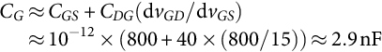

Therefore, the gate resistor is



As *CGS* and *CDG* are nonlinear-voltage-dependent capacitances, using *RG*≪*ZG* can establish gate-source overvoltages two to three times the applied *vGS* voltage, which can disrupt the gate insulation oxide if they exceed the breakdown voltage *VGSS*, destroying the MOSFET.

To minimize the *RG* value, for faster gate capacitor charging and switching, it is essential to strongly reduce the stray inductances (if *LS*→0, then *RG*→0).

##### **Fast driving using avalanche transistors**

Fast MOSFET drivers require low stray inductances and often must be based on avalanche transistors [[12](https://learning.oreilly.com/library/view/power-electronics-handbook/9780128114087/B9780128114070000209_2.xhtml#bb0065)] (switching bipolar transistors optimized to operate near their collector emitter breakdown voltage *VB* but at limited current) or resonant circuits [[13](https://learning.oreilly.com/library/view/power-electronics-handbook/9780128114087/B9780128114070000209_2.xhtml#bb0070)]. The avalanche transistors rapidly charge the capacitors *CGS* and *CDG*, by transferring capacitor charge from a capacitor reservoir *Ca* to *CGS* and *CDG* ([Fig. 18.7A](https://learning.oreilly.com/library/view/power-electronics-handbook/9780128114087/B9780128114070000209_1.xhtml#f0040)).

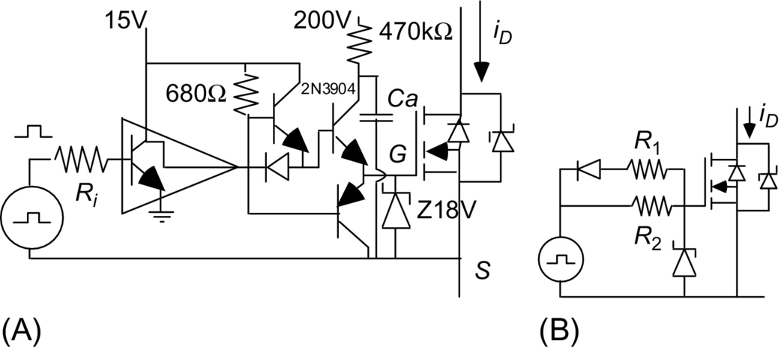

**FIG. 18.7** (A) Avalanche transistor MOSFET driver and (B) tailoring switching speed using two resistors.

Supposing charge continuity, the MOSFET gate voltage should be

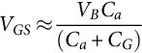 **(18.38)**

The Zener diode Z18V helps protect the gate oxide against disruption, but the Zener junction capacitance, if significant, should be added to the *CG* value above.

MOSFET switching behavior includes crossing the saturation zone (MOSFET active zone) where



being *KM* a MOSFET structural parameter dependent on width and length of the device channel and electron mobility [[16](https://learning.oreilly.com/library/view/power-electronics-handbook/9780128114087/B9780128114070000209_2.xhtml#bb0085)]. The crossing path may imply higher switching losses when switching PP capacitive loads.

Switch-on *ton* and switch-off *toff* times can be tailored using different resistive gate current paths to turn-on (*R*2) and to turn-off (*R*1||*R*2) ([Fig. 18.7B](https://learning.oreilly.com/library/view/power-electronics-handbook/9780128114087/B9780128114070000209_1.xhtml#f0040)), limiting the charging current and the drain voltage rise or fall rates, at the expense of increased switching losses.

Considering the on and off switching times (*ton* and *toff*), the dissipated switching power at the switching frequency *fS* in inductive loads is

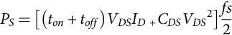 **(18.39)**

while in resistive loads, it can be quite smaller:

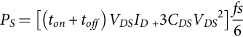 **(18.40)**

PP applications often need semiconductor *switch protection to limit load short-circuit current*. Since in MOSFETs *VDSon*≈*RDSonID* and *RDSon* is fairly constant, then short-circuit protection circuits can be based on the measured *VDSon* voltage ([Fig. 18.8A](https://learning.oreilly.com/library/view/power-electronics-handbook/9780128114087/B9780128114070000209_1.xhtml#f0045)) [[10](https://learning.oreilly.com/library/view/power-electronics-handbook/9780128114087/B9780128114070000209_2.xhtml#bb0055)]. Sensed by diode *Db*3, this voltage if low enough maintains the *Cz* voltage low preventing *Dz* to avalanche and maintaining *Qt*2 off. However, if *VDSon* rises then *Db*3 turns off, *Cz* voltage rises and *Dz* avalanches turning *Qt*2 into saturation that shorts the *vGS* voltage and turns off the MOSFET. Capacitor *Cz* acts as a memory, creating a delay that enables the MOSFET turn-on. [Fig. 18.8B and C](https://learning.oreilly.com/library/view/power-electronics-handbook/9780128114087/B9780128114070000209_1.xhtml#f0045) shows alternatives in which the rate of the *vGS* decay is slowed to lower the rate of rise of the *vDS* preventing this voltage to exceed the MOSFET hold-off (avalanche) voltage *VDSS*. [Fig. 18.8B](https://learning.oreilly.com/library/view/power-electronics-handbook/9780128114087/B9780128114070000209_1.xhtml#f0045) shows a capacitive method in which *Cg*≫*CG*, while in [Fig. 18.8C](https://learning.oreilly.com/library/view/power-electronics-handbook/9780128114087/B9780128114070000209_1.xhtml#f0045), the low-power P MOSFET *Mp*, in series with the main MOSFET gate, is turned off, putting the high-valued resistor *Rg*2 in the turn-off path to limit the *vGS* decay and *vDS* rate of rise.

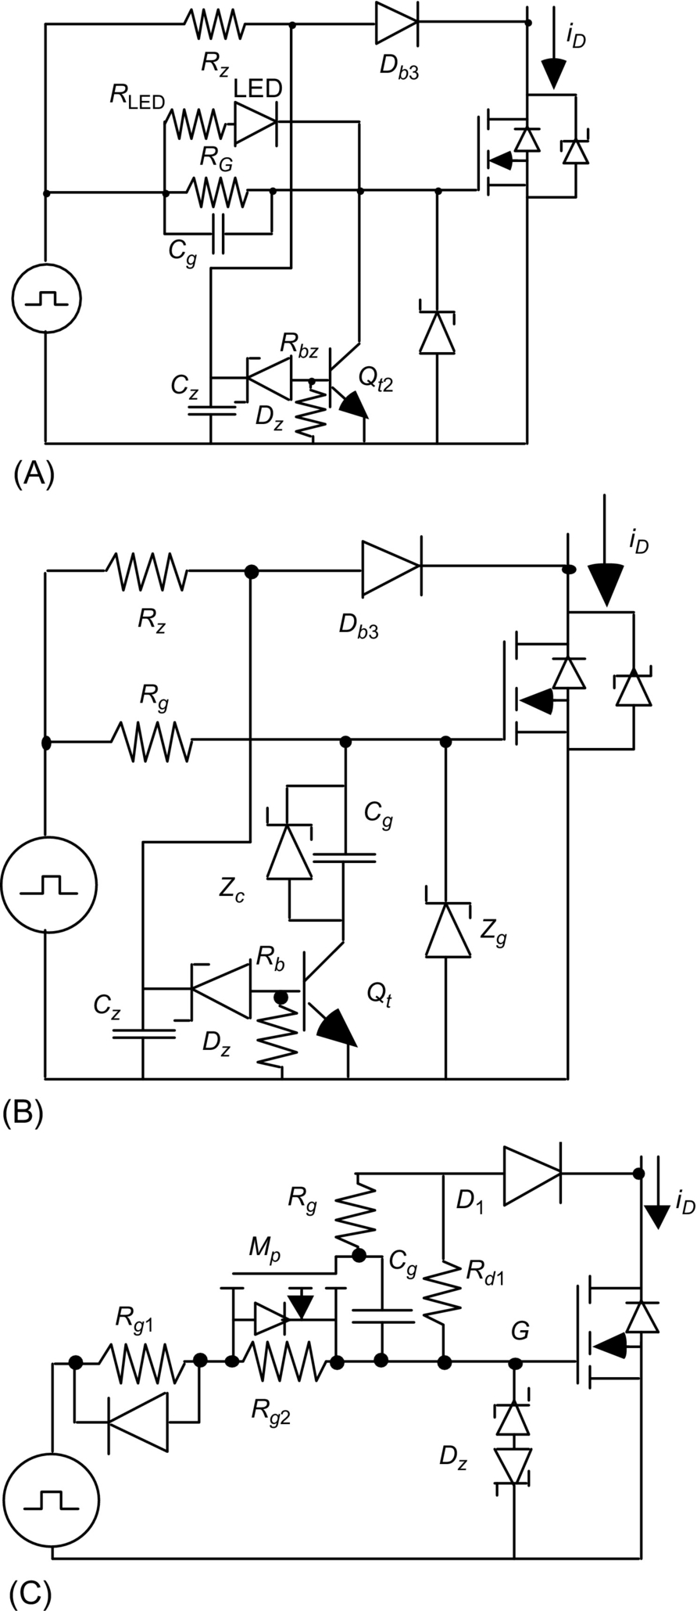

**FIG. 18.8** (A) Active protection against load short-circuits, (B) active protection including capacitive *v*DS rate limiter, and (C) active protection including resistive *vDS* rate limiter.

The maximum turn-off overvoltage can also be limited either by using MOSFET parallel connected Zeners (or voltage clamping metal oxide varistors (MOV)) or alternatively by using an avalanche diode (with avalanche voltage higher than the supply voltage but somewhat lower than maximum semiconductor voltage rating) in series with a blocking diode connected to the gate-drain terminals ([Fig. 18.9](https://learning.oreilly.com/library/view/power-electronics-handbook/9780128114087/B9780128114070000209_1.xhtml#f0050)).

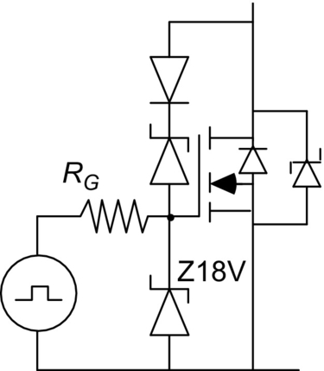

**FIG. 18.9** MOSFET overvoltage protection circuit.

#### **18.2.2.2 Insulated-Gate Bipolar Transistors (IGBT)**

IGBTs are MOS technology-based semiconductor devices with reduced *on*-state voltage drop, obtained by adding an extra P+ semiconductor layer in the drain side (punch-through IGBT) or by substituting the N+ by a P+ layer (nonpunch-through (NPT) or reverse-blocking IGBT (RB-IGBT)) [[10](https://learning.oreilly.com/library/view/power-electronics-handbook/9780128114087/B9780128114070000209_2.xhtml#bb0055),[11](https://learning.oreilly.com/library/view/power-electronics-handbook/9780128114087/B9780128114070000209_2.xhtml#bb0060),[13](https://learning.oreilly.com/library/view/power-electronics-handbook/9780128114087/B9780128114070000209_2.xhtml#bb0070)]. The P+ layer injects holes in the drift layer reducing voltage drop by conductivity modulation. The resulting device can be viewed as a low gain high-voltage PNP bipolar transistor driven by a power MOSFET ([Fig. 18.10](https://learning.oreilly.com/library/view/power-electronics-handbook/9780128114087/B9780128114070000209_1.xhtml#f0055)). Then, gate drivers for IGBTs are similar to those of MOSFETs.

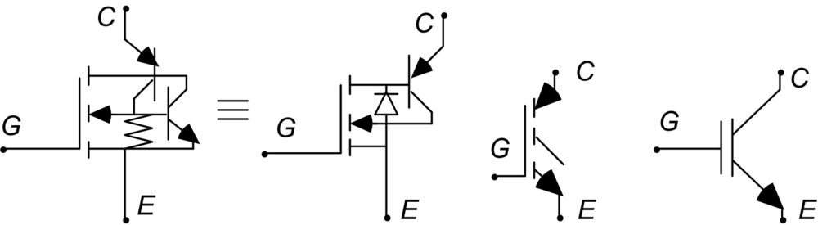

**FIG. 18.10** IGBT equivalent circuit and common symbols.

IGBTs can turn-on almost as fast as MOSFETs, using

 **(18.41)**

The *on*-state saturation voltage *VCEon*

** **(18.42)**

where *VCEsat@ICE* is the *on*-state voltage at current *ICE* and depends on the *IGE* value and increases rapidly for *VGE*<12 V, the device risks working into the active zone for lower *VGE* values.

Due to the injected minority recombination into the base, however, IGBTs are relatively slow turn-off devices and exhibit tail currents. Switching losses are higher than in MOSFETs.

However, Si IGBTs can withstand much higher hold-off voltages (up to 6.5 kV) and currents (up to 3 kA) than Si MOSFETs that are limited to nearly 1.2 kV, 100 A peak current. At 6 kV voltages and 3 kA currents, IGBTs *on*-state losses are significant, degrading efficiency and causing heat removal problems, yet they are being used in very high-voltage systems [[17](https://learning.oreilly.com/library/view/power-electronics-handbook/9780128114087/B9780128114070000209_2.xhtml#bb0090)–[20](https://learning.oreilly.com/library/view/power-electronics-handbook/9780128114087/B9780128114070000209_2.xhtml#bb0105)].

Most considerations about the MOSFET drive and protections are still valid for IGBTs. In particular, in shoot-through situations, the IGBT device can be protected by detecting desaturation voltage and then shutting down the IGBT using gate drive circuits similar to those in [Fig. 18.8](https://learning.oreilly.com/library/view/power-electronics-handbook/9780128114087/B9780128114070000209_1.xhtml#f0045).

#### **18.2.2.3 Injection Enhanced Gate Transistors (IEGT)**

IEGTs are IGBT-like structures with deep trench gates and wider cell widths. Hole concentration in the P layer under the gate electrode is enhanced due to hole accumulation, similar to the conductivity modulation of a PIN diode, lowering the *on*-state voltage and increasing the efficiency specially in high-voltage devices. The enhanced carrier distribution under the gate electrode leads to higher conductivity of the N-base region in the trench-gate IGBT structure, as the gate region extends into the N-base region below the P-base layer. This phenomenon has been called the injection enhancement effect in deep trench-gate IGBT structures and enables higher device voltage rating. As this phenomenon of carrier enhancement under the gate electrode occurs in all IGBT structures, including the planar-gate structures, the IEGT device is a kind of IGBT and can be viewed as such, although their particular physical structure enables them to withstand higher voltages and currents than planar IGBTs structures. The same is valid for similar proposed structures such as the carrier-stored trench-gate bipolar transistor (CSTBT-IGBT).

### 18.2.3 THYRISTORS AND TURN-OFF THYRISTOR DEVICES

High-voltage high-power *thyristors*, also termed silicon-controlled rectifiers (SCR), are PNIPN structures ([Fig. 18.11A](https://learning.oreilly.com/library/view/power-electronics-handbook/9780128114087/B9780128114070000209_1.xhtml#f0060)) that can be gated-on by injecting a relatively small gate current into the device gate terminal. In PP applications, thyristors can be used in capacitor discharging circuits, since they can be easily turned on by a small gate current [[10](https://learning.oreilly.com/library/view/power-electronics-handbook/9780128114087/B9780128114070000209_2.xhtml#bb0055),[11](https://learning.oreilly.com/library/view/power-electronics-handbook/9780128114087/B9780128114070000209_2.xhtml#bb0060),[13](https://learning.oreilly.com/library/view/power-electronics-handbook/9780128114087/B9780128114070000209_2.xhtml#bb0070)]. Thyristor turn-off behavior is not gate-controlled, being similar to the PIN diode and of little use in PP.

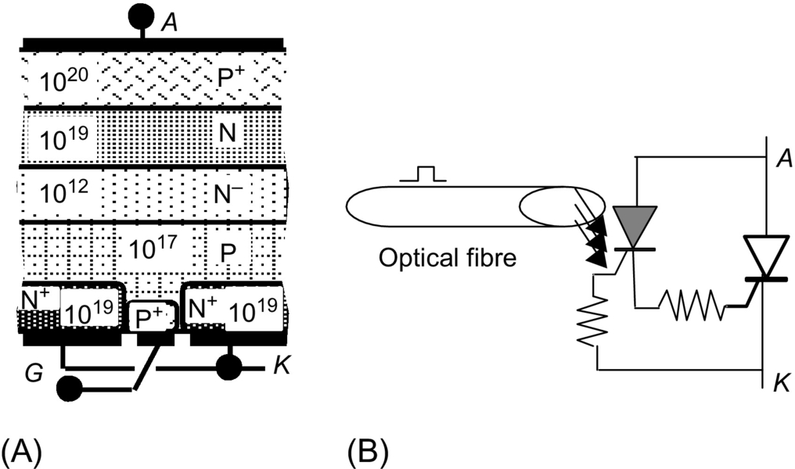

**FIG. 18.11** (A) High-voltage thyristor structure and (B) LTT operating principle.

Thyristors can block voltages near 12 kV (the silicon limit is near 15 kV) and can conduct currents up to 8 kA.

Modern thyristor structures like the light-activated silicon-controlled rectifier (LASCR) or the light-triggered thyristor (LTT) are optically triggered ([Fig. 18.11B](https://learning.oreilly.com/library/view/power-electronics-handbook/9780128114087/B9780128114070000209_1.xhtml#f0060)) using an optical fiber and can be valuable in high-voltage applications to enable reducing stray capacitances.

*Gate turn-off thyristors* (GTO and sometimes called gate-controlled thyristors (GCT)) are distributed gate thyristor structures, roughly equivalent to an NPN-PNP bipolar transistor association [[10](https://learning.oreilly.com/library/view/power-electronics-handbook/9780128114087/B9780128114070000209_2.xhtml#bb0055),[11](https://learning.oreilly.com/library/view/power-electronics-handbook/9780128114087/B9780128114070000209_2.xhtml#bb0060),[13](https://learning.oreilly.com/library/view/power-electronics-handbook/9780128114087/B9780128114070000209_2.xhtml#bb0070)]. As such, they have turn-on and turn-off gate capability, present low forward drop voltage, and maintain the PNIPN structure, which enable blocking voltages up to 6 kV and forward currents up to 6 kA.

The GTO, although turn-off controlled, is much slower than MOSFET or IGBTs, since it is a bipolar carrier device, and it needs high turn-off gate currents, only slightly lower than their anode currents, meaning their turn-off current gain is low (between 2 and 10). Therefore, the GTO use in pulse power is usually limited to the generation of relatively long prepulses to be applied, through transformers, in sharpening devices such as the SOS diode. Symmetrical GTO structures are even slower than asymmetrical GTOs, although they can block both forward and reverse voltages (symmetrical gate-controlled thyristor (SGCT)).

The GTO turn-on peak and back-porch gate currents are also significantly higher than in thyristors, since the PNP transistor must have low enough current gain to preserve the turn-off capability. Therefore, GTO gate drivers usually need roughly 100 times more power than the gate power needed by a MOSFET or IGBT.

Second breakdown of GTO bipolar junctions (transistors) and the distributed gate structure mean that the GTO needs turn-off (d*vAK*/d*t*) and usually turn-on snubbers (d*iAK*/d*t*) ([Fig. 18.12](https://learning.oreilly.com/library/view/power-electronics-handbook/9780128114087/B9780128114070000209_1.xhtml#f0065)). Considering an *RVLVCV* series circuit with *ξ*=1,

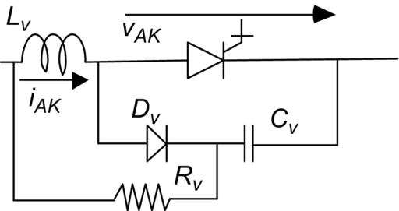

**FIG. 18.12** Typical GTO combined d*iAK*/d*t* and d*vAK*/d*t* snubbers.

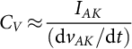 **(18.43)**

**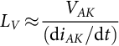** **(18.44)**

**** **(18.45)**

which dissipates relatively high-power, thus requiring the use of low GTO switching frequencies. GTO thyristors also exhibit current tail at turn-off.

The above drawbacks bound the application of GTO like semiconductor devices to high-voltage and high-current applications, where the low *on*-state voltage is mandatory for high efficiency, but the switching speed, gate drive power, and reliability are not at concern.

The GTO device is difficult to protect against short-circuit currents due to its long storage time, long turn-off delay, and comparatively low turn-off current capability.

Some GTO-derived devices, such as the *integrated gate-commutated thyristor* (IGCT) and sometimes the GCT, incorporate distributed gate drives in close association with the GTO, being a single device, thus improving reliability [[19](https://learning.oreilly.com/library/view/power-electronics-handbook/9780128114087/B9780128114070000209_2.xhtml#bb0100)]. This approach tries to circumvent the gate wiring inductances and enables accurate control of the turn-on speed. It is useful for series association of IGCTs, including overvoltage and short-circuit protections, together with redundancy. Still, the gate power is significant, and the IGCT needs a turn-on snubber.

Some GTO devices integrating MOSFET-based distributed gate turn-off drivers, with very low gate stray inductances, are sometimes called *MOS turn-off thyristors* (MTO) [[13](https://learning.oreilly.com/library/view/power-electronics-handbook/9780128114087/B9780128114070000209_2.xhtml#bb0070)] ([Fig. 18.13A](https://learning.oreilly.com/library/view/power-electronics-handbook/9780128114087/B9780128114070000209_1.xhtml#f0070)). They have the potential to block up to 9 kV and can be faster than the GTO itself, although they need hybrid gate drives to turn-on.

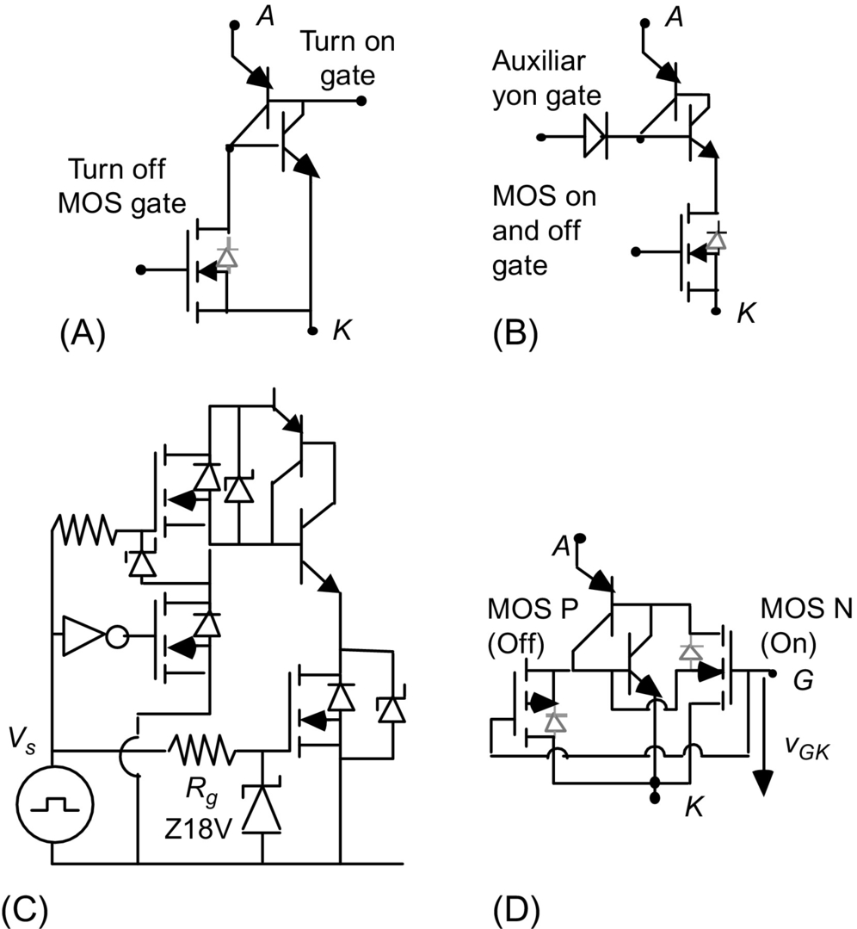

**FIG. 18.13** Functional equivalent models of (A) MTO, (B) ETO, (C) conceptual ETO driver, and (D) MCT.

If low-voltage high-current MOSFETs are connected in series with the GTO cathodes (cascode connection) and are used to turn-on and off the GTO, then the whole device is usually called the *emitter turn-off thyristor* (ETO) [Fig. 18.13B](https://learning.oreilly.com/library/view/power-electronics-handbook/9780128114087/B9780128114070000209_1.xhtml#f0070) [[13](https://learning.oreilly.com/library/view/power-electronics-handbook/9780128114087/B9780128114070000209_2.xhtml#bb0070)], which has higher switching speed, higher reliability, and easier gate drive than the GTO itself. The ETO *on*-state voltage can be lower than in a comparable IGBT and even lower than in IGCT/GTOs. Thus, emitter switched GTOs can present efficiencies and switching speeds higher than comparable high-voltage IGBTs or IGCTs at 4.5 kV and 4 kA, although at higher costs than IGBTs but lower than IGCTs or even GTOs. Like IGCTs, ETOs include a GTO and need a turn-on snubber but can be fully optical fiber controlled (stray and electromagnetic interference reduction). The ETO drivers can easily generate the needed gate power (self-gate-drive power) and include minimum on/off time generation needed by the GTO, voltage, current and temperature sensors, and easy overcurrent protection (MOS turn-off).

The *MOS-controlled thyristors* (MCT) [[13](https://learning.oreilly.com/library/view/power-electronics-handbook/9780128114087/B9780128114070000209_2.xhtml#bb0070)] are silicon fully integrated devices that try to improve GTOs, using integrated both turn-on and turn-off MOS devices, [Fig. 18.13D](https://learning.oreilly.com/library/view/power-electronics-handbook/9780128114087/B9780128114070000209_1.xhtml#f0070). They can have lower *on*-state losses than IGBTs, current densities higher than IGBTs, working temperatures up to 200°C and block forward voltages of few kV. Switching speed is higher than in the GTO or even in the higher voltage IGBTs. The MCT promises to withstand much higher values of d*vAK/*d*t* and d*iAK/*d*t* than GTOs, needing almost no snubbers and benefiting of simple MOSFET like gate drivers. As MOSFETs, MCTs can easily be connected in series or parallel associations to increase their voltage or current ratings.

### 18.2.4 POWER JFETS AND DERIVED DEVICES

Power junction field-effect transistors (JFET) ([Fig. 18.14](https://learning.oreilly.com/library/view/power-electronics-handbook/9780128114087/B9780128114070000209_1.xhtml#f0075)), also termed static induction transistors (SIT), are short-channel depletion-type junction field-effect devices operating in the prepunch-through zone [[13](https://learning.oreilly.com/library/view/power-electronics-handbook/9780128114087/B9780128114070000209_2.xhtml#bb0070)]. Their operation depends on the flow of majority carriers (electrons) only (unipolar device), and they have very low stray capacitances. Therefore, SITs have low switching losses and the potential to switch at very high frequencies, even higher than MOSFETs, up to the THz band.

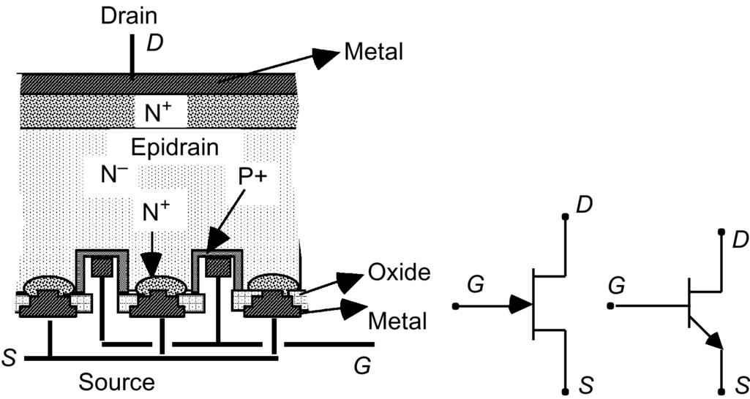

**FIG. 18.14** Power JFET structure and possible symbols.

The SIT is normally on a device (with *vGS*=0, it is in the *on*-state) that turns off by applying negative gate-source voltages *vGS*<0, up to several tens of volts. The *vGS* negative voltage reverse biases the PN gate-source junction, pinching off the conducting epidrain and interrupting the flow of majority carriers.

Unlike SCRs, GTOs, MOSFETs, or IGBTs, the SIT normally on property enables its used in high-speed pulse generation circuits similar to those of SOS diodes, the main difference being the controlled turn-off with a negative gate voltage *vGS*≈−*vDS*/*υ*, where *υ* is the SIT blocking gain:

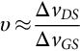

The normally on property of the SIT can increase its gate drive circuit complexity. A power JFET usually requires larger power and gate voltages compared with a similar MOSFET. These two SIT drawbacks can be advantageously solved using a cascode connection ([Fig. 18.15A](https://learning.oreilly.com/library/view/power-electronics-handbook/9780128114087/B9780128114070000209_1.xhtml#f0080)) in which a JFET is source-switched by a low-voltage high-current MOSFET.

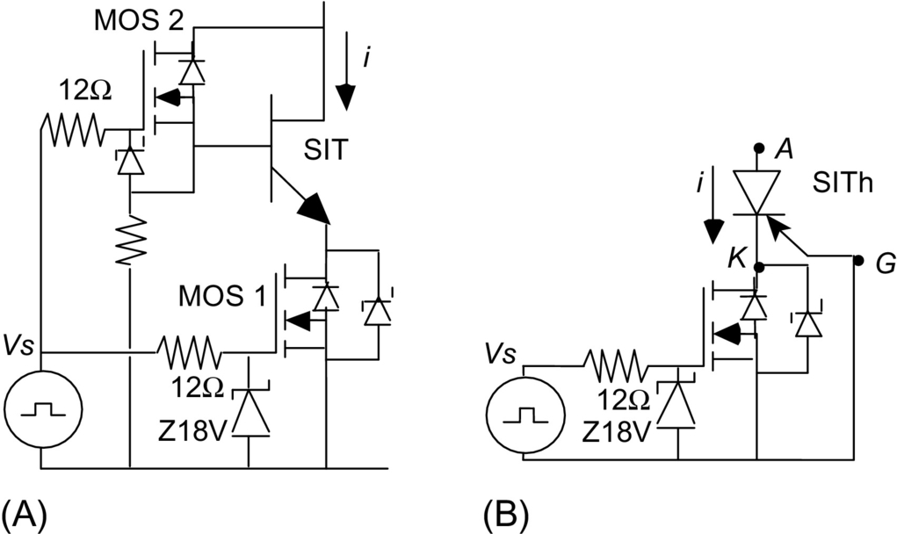

**FIG. 18.15** (A) JFET cascode using two MOSFETs. MOS2 can be used to operate the SIT in the bipolar mode and (B) SITh cascode.

The SIT device presents positive temperature coefficient, enabling easy paralleling like the MOSFET, and is a unipolar voltage-controlled device enabling relatively easy series connection. The SIT does not need turn-on or turn-off snubbers; simple RC clamping circuits ([Fig. 18.16](https://learning.oreilly.com/library/view/power-electronics-handbook/9780128114087/B9780128114070000209_1.xhtml#f0085)) are enough for stray inductance overvoltage protection.

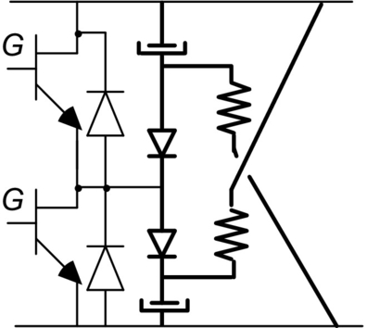

**FIG. 18.16** SIT voltage clamper.

The SIT can be operated in the bipolar mode (called bipolar mode SIT, BSIT, or BMSIT), if they are designed to allow positive gate currents to inject holes in the drain channel. The *on*-state of the BSIT is almost like that of a bipolar carrier device, increasing the turn-off time, but current density is much higher and useful phenomena for PP might occur [[10](https://learning.oreilly.com/library/view/power-electronics-handbook/9780128114087/B9780128114070000209_2.xhtml#bb0055),[11](https://learning.oreilly.com/library/view/power-electronics-handbook/9780128114087/B9780128114070000209_2.xhtml#bb0060),[13](https://learning.oreilly.com/library/view/power-electronics-handbook/9780128114087/B9780128114070000209_2.xhtml#bb0070)].

A SIT-derived structure, which is being used in PP, is the static induction thyristor (SITh) also called field-controlled thyristor (FCTh) or field-controlled diode (FCD). It includes ([Fig. 18.17](https://learning.oreilly.com/library/view/power-electronics-handbook/9780128114087/B9780128114070000209_1.xhtml#f0090)) a P+ layer (instead of the SIT drain N+ layer) to obtain a PN junction (hence the name pinched diode). Present SITh devices block 4 kV and can switch peak currents in the kA range, presenting long lifetimes.

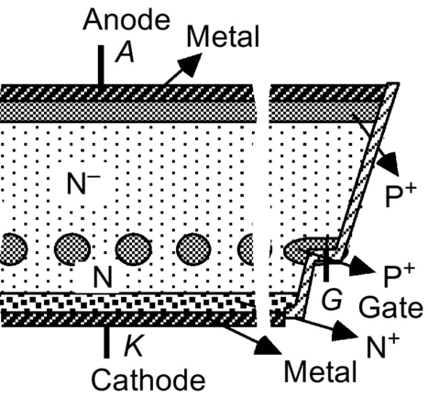

**FIG. 18.17** Typical SITh (GTO-SIT) structure.

The SITh behaves like a diode if *vGK*=0 (gate-cathode short). This diode can be turned off with almost no reverse recovery, making *vGK* negative. However, the depletion capacitance gate current to turn-off can be as high as half of the anode current, making the SITh gate driver difficult to design and operate. An alternative to ease the gate driver is to use a cascode connection ([Fig. 18.15B](https://learning.oreilly.com/library/view/power-electronics-handbook/9780128114087/B9780128114070000209_1.xhtml#f0080)).

The SITh is being used for pulse generation as an opening switch in inductive circuits ([Fig. 18.18](https://learning.oreilly.com/library/view/power-electronics-handbook/9780128114087/B9780128114070000209_1.xhtml#f0095)), much like the SOS diode (the SITh behaves as a controlled diode), and holds the pulse voltage *Vp* during the output phase. The gate current needed to extract carriers out of the device, to cause depletion and the off-state, is obtained by switching off the inductive current (with the cascode SITh) in a step-up autotransformer. The switching off induces the fast-rising negative *vGK* voltages necessary to extract SITh carriers and to apply the load pulse. Speed switching in this case can be enhanced by positive feedback, the fast gate current decay creating a depleted SITh that helps in turning off the current.

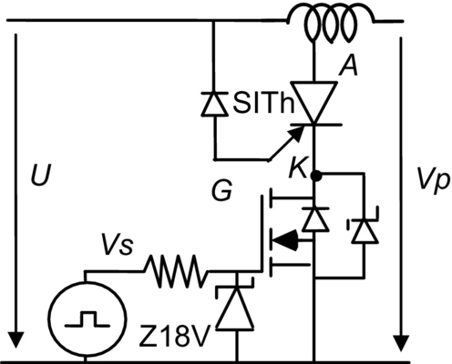

**FIG. 18.18** SITh cascode pulse generation using magnetic energy storage.

### 18.2.5 SEMICONDUCTOR SERIES STACKS AND GENERALIZED CASCODES, SEMICONDUCTOR PARALLEL STACKS

#### **18.2.5.1 Semiconductor Series Stacks**

For applications where the needed working voltage is higher than the available semiconductor ratings, one possible solution is to series connect several power devices. Steady-state and transient balance or sharing of the voltage between series semiconductor devices is very important, since most power semiconductor devices do not hold voltages above their rating and their reverse currents, and reverse recovered charges differ from device to device even within the same type and maker; the semiconductor with the least reverse leakage current will hold higher voltages.

**Example 18.3**

Consider a string of two series diodes, and suppose the total voltage *U*=10 kV, the two diodes both with nominal repetitive reverse voltage *VRRM*=6 kV but reverse leakage currents of *IRmax*=40 mA and *IRmin*=10 mA. Calculate the diode reverse voltages.

Solution

We can determine ([Fig. 18.19](https://learning.oreilly.com/library/view/power-electronics-handbook/9780128114087/B9780128114070000209_1.xhtml#f0100))

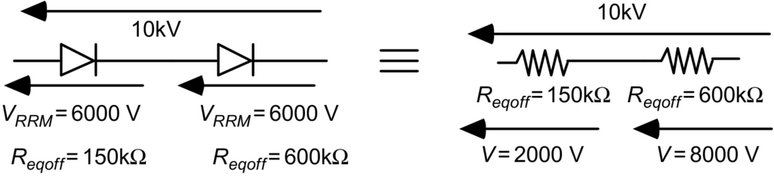

**FIG. 18.19** Series connection of power semiconductors.



and



Therefore, the diode with *Reqoffmin* would have the voltage



while the *Reqoffmax* diode



that exceeds the diode maximum rating. This diode would operate near its avalanche voltage (≈6 kV) that could be destructive.

From the above, *VReqoffmax* could be evaluated as

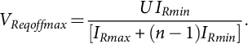 **(18.46)**

Steady-state balancing can be achieved using high-value parallel resistors *Rh*, so that the parallel of *Rh* with *Reqoffmin* or *Reqoffmax* should give a resistance able to maintain the semiconductor reverse voltage within acceptable limits.

Considering *n*-series-connected power semiconductors and one of them with



while the remaining *n*−1 has the typical value *Reqoff*, the total value *RT* of the string of resistors is ([Fig. 18.20](https://learning.oreilly.com/library/view/power-electronics-handbook/9780128114087/B9780128114070000209_1.xhtml#f0105))

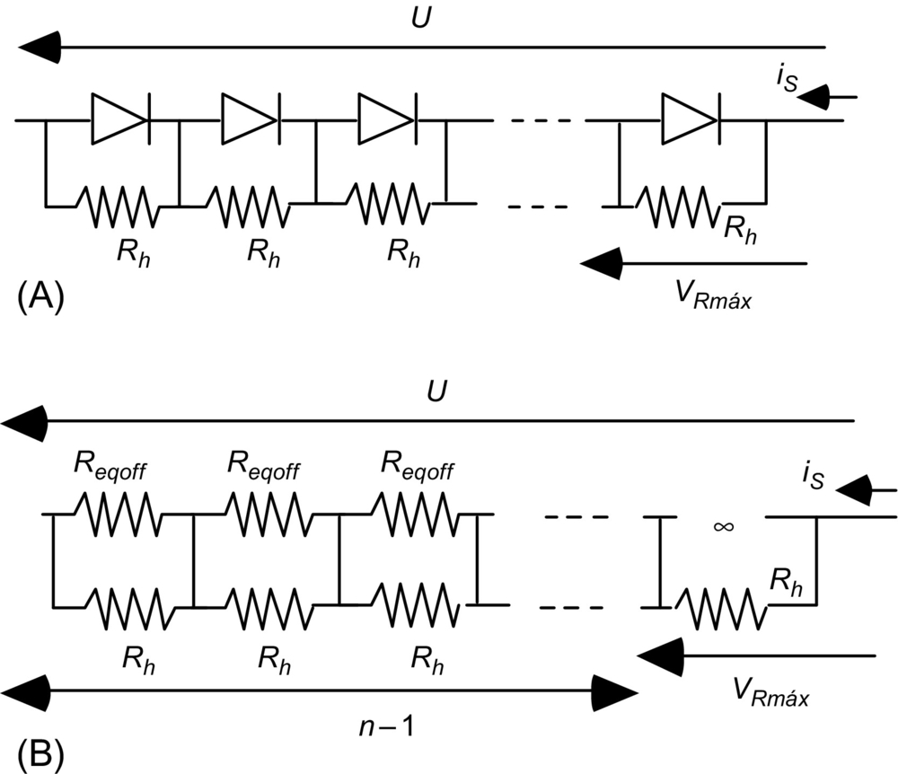

**FIG. 18.20** (A) Steady-state balancing of a series connection of power semiconductors and (B) equivalent model.

 **(18.47)**

The maximum voltage occurs in the diode with *Reqoffmax*≈∞ being

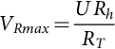 **(18.48)**

This value should observe a safety margin:

 **(18.49)**

where *κ*<1, giving

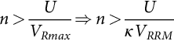 **(18.50)**

and

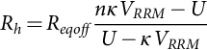 **(18.51)**

Note that

 **(18.52)**

The *Rh* resistors should be as high as possible to minimize their dissipated power. The maximum *Rh* value can be obtained considering the *IRmin* and *IRmax* semiconductor currents (instead of *IRmin*=0) to obtain

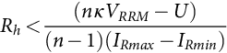 **(18.53)**

An alternative to the use of the dissipative resistors is to antiparallel avalanche or Zener diodes or metal MOV with each series device.

To help share the voltage during transients, *RSCS* parallel snubbers must be also included ([Fig. 18.21](https://learning.oreilly.com/library/view/power-electronics-handbook/9780128114087/B9780128114070000209_1.xhtml#f0110)). If they are designed just to balance the reverse recovered charge *QRR*, then the capacitor value can be given by

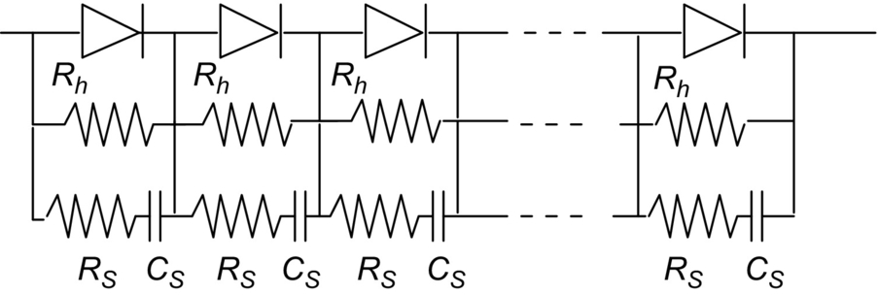

**FIG. 18.21** Dynamic and steady-state balancing of series-connected power semiconductors.

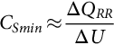 **(18.54)**

being Δ*U* the allowed voltage mismatch and Δ*QRR* the *QRR* variation among devices.

Resistor *RS* limits the discharge current when the power semiconductor turns on.

To operate the *RSCS* as a parallel snubber, then the circuit associated stray inductance *LS* should be estimated or measured. Then, assuming energy conservation, a rough estimation of the *CS* value is

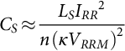 **(18.55)**

Resistor *RS* should define the damping factor *ξ* of the equivalent RLC series circuit, being

 **(18.56)**

For controlled turn-on and turn-off devices, the *RSCS* parallel snubber can be improved using an extra diode (*RVCVDV* in [Fig. 18.12](https://learning.oreilly.com/library/view/power-electronics-handbook/9780128114087/B9780128114070000209_1.xhtml#f0065), with *LV*=*LS*). To obtain near-balanced turn-on *tr* and turn-off *tf* times for each series semiconductor, with direct current *IAK*, hold-off voltage *κVDRM*, and pulse on minimum peak time *Tpmin*, *LS* should have the value

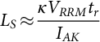 **(18.57)**

and

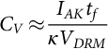 **(18.58)**

being

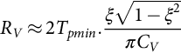 **(18.59)**

#### **18.2.5.2 Generalized Cascodes**

To use a series stack of controlled turn-off semiconductors such as MOSFETs, SITs, or even IGBTs, the generalized cascode association ([Fig. 18.22](https://learning.oreilly.com/library/view/power-electronics-handbook/9780128114087/B9780128114070000209_1.xhtml#f0115)) is a valuable alternative to the simple series connection [[10](https://learning.oreilly.com/library/view/power-electronics-handbook/9780128114087/B9780128114070000209_2.xhtml#bb0055),[14](https://learning.oreilly.com/library/view/power-electronics-handbook/9780128114087/B9780128114070000209_2.xhtml#bb0075),[15](https://learning.oreilly.com/library/view/power-electronics-handbook/9780128114087/B9780128114070000209_2.xhtml#bb0080)]. The simple series association of turn-off devices usually needs optical fiber isolated gate drivers using transformer isolated current source power inverters with series connection through closed-loop high-voltage cables, to assure the insulation between the voltage levels.

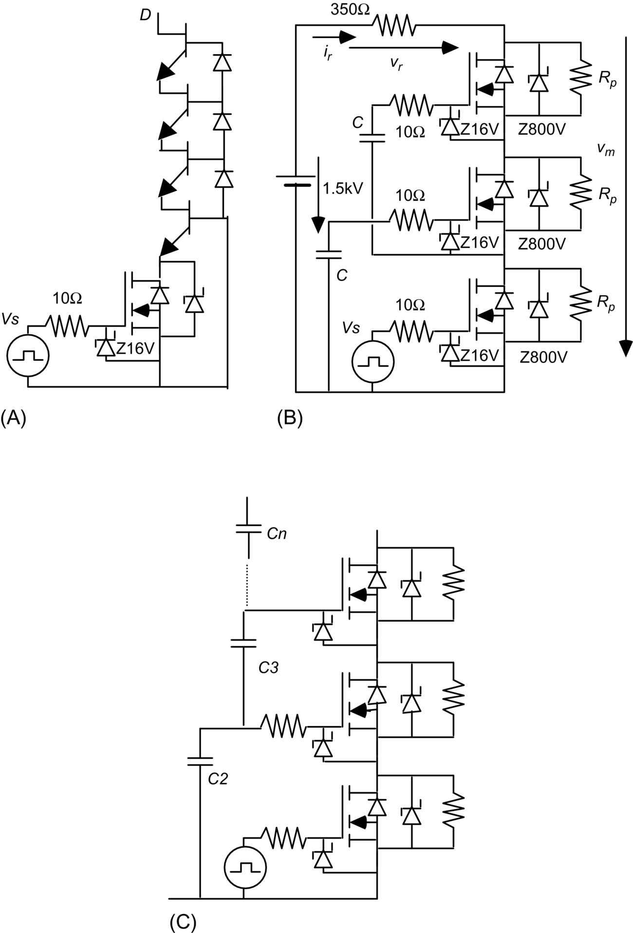

**FIG. 18.22** Generalized cascade associations: (A) using SIT devices, (B) using only MOSFETs, and (C) using alternative connection of gate capacitor.

The cascode association is faster than other associations when unipolar-carrier semiconductors such as MOSFETs or SITs are used. For MOSFET devices ([Fig. 18.22B](https://learning.oreilly.com/library/view/power-electronics-handbook/9780128114087/B9780128114070000209_1.xhtml#f0115)), the capacitor C must hold the charge to turn the MOSFET on, being

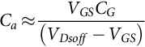 **(18.60)**

Zener diodes should be used to protect the gate-source oxide. In [Fig. 18.22B](https://learning.oreilly.com/library/view/power-electronics-handbook/9780128114087/B9780128114070000209_1.xhtml#f0115), the charge holding gate capacitors are placed in a configuration where the *m* capacitor *Cm* should have the value

 **(18.61)**

being *n* the total number of MOSFETs and *m*>1 [[15](https://learning.oreilly.com/library/view/power-electronics-handbook/9780128114087/B9780128114070000209_2.xhtml#bb0080)].

For stacking IGBTs, care must be taken when designing the drivers of the totem pole IGBTs [[21](https://learning.oreilly.com/library/view/power-electronics-handbook/9780128114087/B9780128114070000209_2.xhtml#bb0110),[22](https://learning.oreilly.com/library/view/power-electronics-handbook/9780128114087/B9780128114070000209_2.xhtml#bb0115)]. The positive voltage of each driver can be obtained from the capacitor of the below *RSCS* snubber through a blocking diode connecting the resistor *RS* to a turn-off MOSFET driving the IGBT [[21](https://learning.oreilly.com/library/view/power-electronics-handbook/9780128114087/B9780128114070000209_2.xhtml#bb0110),[22](https://learning.oreilly.com/library/view/power-electronics-handbook/9780128114087/B9780128114070000209_2.xhtml#bb0115)]. The *CS* capacitor should hold the charge to turn-on the IGBT.

When dealing with Cascodes, it is mandatory to minimize the source (or emitter) inductances as they can badly affect the charging rate of the gate capacitances. Bare chips (bare dice) and surface mount design should be used, instead of packaged MOSFETs, IGBTs, or SITs.

#### **18.2.5.3 Parallel Stacks**

Parallel associations of power devices can be used when the available semiconductors do not present the needed current ratings.

For positive temperature coefficient devices such as MOSFETs, SITs, and most of their derived structures, the devices can be just connected in parallel, taking care of symmetry to minimize stray inductances and capacitances and to balance junction temperatures. Individual gate drivers and protection circuits (except if stray effects are not a concern) should also be used. This is not valid for the MOSFET intrinsic diode, which must be disabled using channel conduction or extra external diodes.

For negative temperature coefficient devices such as diodes, thyristors, bipolar transistors, GTO, and other bipolar devices, several methods could be used:

(a) To select devices with very small relative parameter variations (matched devices) and to balance their junction temperatures by using a single heat sink and symmetrical disposition.

(b) To use current sharing transformers or coupled inductors ([Fig. 18.23](https://learning.oreilly.com/library/view/power-electronics-handbook/9780128114087/B9780128114070000209_1.xhtml#f0120)).

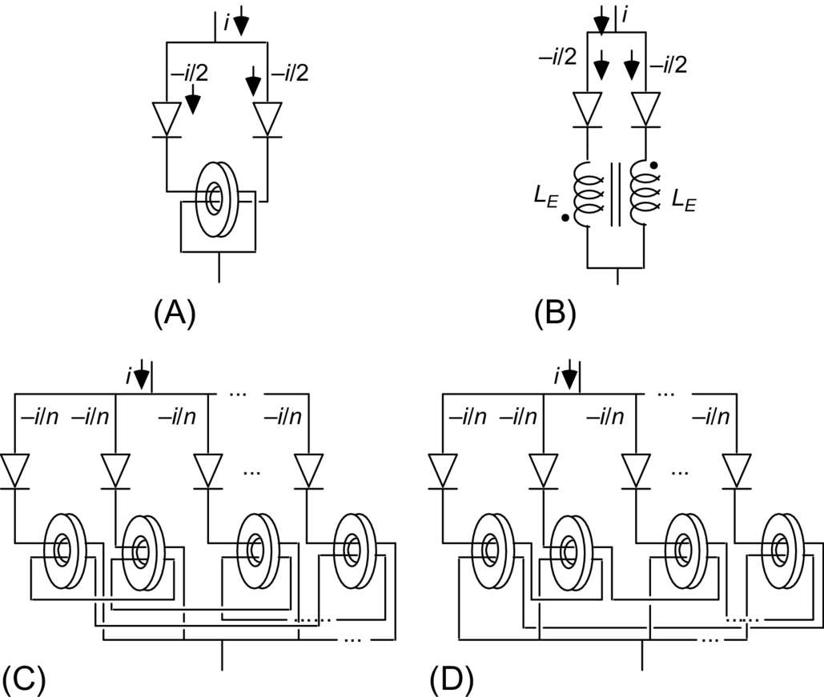

**FIG. 18.23** Using transformers or coupled inductors for paralleling power devices: (A) two diodes, (B) modeling the parallel connection of two diodes, and (C and D) alternatives to n-paralleled power semiconductors.

(c) To use current feedback control techniques [[23](https://learning.oreilly.com/library/view/power-electronics-handbook/9780128114087/B9780128114070000209_2.xhtml#bb0120)] if the paralleled devices have turn-off capability.

(d) To use small resistors in series with each power semiconductor device ([Fig. 18.24](https://learning.oreilly.com/library/view/power-electronics-handbook/9780128114087/B9780128114070000209_1.xhtml#f0125)), calculated upon the maximum, minimum, and typical device parameters. It is possible to show that a rough estimate for the series resistor *RE* is

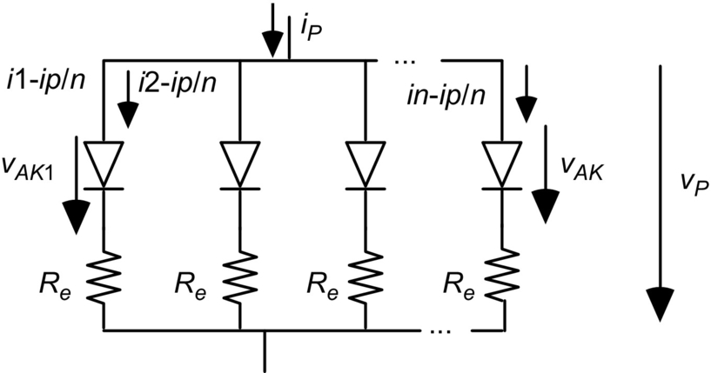

**FIG. 18.24** Parallel connection of power semiconductors using current sharing resistors.

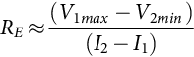 **(18.62)**

where *V*1*max* is the device family maximum on voltage at the minimum allowed current *I*1 and *V*2*min* is the device type minimum on voltage at the maximum allowed current *I*2 (*I*2>*I*1) [[10](https://learning.oreilly.com/library/view/power-electronics-handbook/9780128114087/B9780128114070000209_2.xhtml#bb0055)].

One of the previous approaches has to be selected upon the PP application to minimize costs and maximize performance.

### 18.2.6 WIDE BAND GAP POWER SEMICONDUCTOR DEVICES

Silicon carbide (SiC) and gallium nitride (GaN) are new semiconductor materials with wider bandgaps than silicon (nearly three times higher) resulting in a higher critical electric field and lower *on*-state resistance. In particular, the structure 4H-SiC presents high thermal conductivity (three times higher than Si), high electric field breakdown strength (10 times higher than Si), high maximum current density, very low thermal expansion coefficient, and higher electron saturation velocity. These properties allow higher switching frequency (ns switching time) and 10 times lower switching losses in power applications. Therefore, SiC is a much more promising semiconductor material than Si to build high-powered devices.

SiC allows a very low drift region resistance, enabling *on*-state current densities near 100 A/cm2 at 25°C with forward voltage drops at 3–4 V in SiC Schottky diodes and power MOSFETs rated at several kV. SiC devices would need approximately 20 times less area than corresponding Si devices, and could operate at higher temperatures and higher breakdown voltages than conventional Si devices.

Schottky barrier diodes use a suitable metal-semiconductor junction. Being unipolar-carrier devices show almost no minority recombination. SiC Schottky diodes have extremely low reverse recovery time, negligible switching losses, and 20 times lower reverse recovery charge than Si while needing a ringing correcting RC snubber, as the reverse-biased diode has a capacitive behavior, causing ringing with stray inductances. Since minority carrier injection is not present in SiC Schottky diodes and SiC transistors, they are expected to have fast switching characteristics, low switching losses, and high reliability.

To profit from the advantageous performance of high-voltage SiC devices, a gate driver design tailored for each particular device is required to provide fast switching for the SiC devices while preventing ringing. Some form of current sensing and limitation is absolutely needed and d*v*/d*t* limitation using dedicated gate drivers, RC parallel tuning, and protection Zeners. Gate voltages of nearly 20 V are usually needed for *on*-state, together with a suitable gate ON resistor to limit switching d*v*/d*t* and d*i*/d*t* and the turn-on current spike due to charge/discharge of the freewheeling Schottky barrier diode equivalent capacitance. A too small gate ON resistor can increase switching times and switching energy losses relatively to the optimum values, which are roughly 10 times lower than in the Si technology.

To turn off the SiC device, a negative voltage near −5 V should be applied through a gate OFF resistor, usually much smaller than the gate ON resistance.

High-voltage SiC devices feature *on*-state equivalent resistances with a positive thermal coefficient *θr* (*θr*≈0.001 Ω/°C). Their *on*-state resistance *RON* increases with junction temperature *Tj*, *Tj*∈(25 and 175°C):

 **(18.63)**

The SiC threshold voltage *VT* [(18.64)](https://learning.oreilly.com/library/view/power-electronics-handbook/9780128114087/B9780128114070000209_1.xhtml#fo0455) shows a negative thermal coefficient *θv* (*θv*≈−0.0015 V/°C) similar to the Si coefficient (−2 mV/°C). However the SiC *on*-state voltage increases with *Tj* [(18.65)](https://learning.oreilly.com/library/view/power-electronics-handbook/9780128114087/B9780128114070000209_1.xhtml#fo0460) for *ION* currents bigger than a few amps, as long as :

 **(18.64)**

**** **(18.65)**

This behavior is advantageous when needing to parallel SiC devices, since they will share the total current. However, for single devices, thermal runaway can occur when high-current is applied. A gate driver able to cope with this phenomenon may be advisable, and the heat sink should be designed to minimize temperature *Tj* for the required average and root mean square values of *ION*. The thermal runaway can further be mitigated by using SiC devices with extra P+ implantations in the device structure.

GaN enhancement-mode JFETs (E-HEMTs) are very fast unipolar-carrier devices controlled by the electric field associated to the *vGS* voltage applied at the gate-source terminals. These normally *off*-state GaN E-HEMTs are conductive with *vGS*≈6 V, while they are blocking with *vGS*=0 V if *vDS*>0. However, if *vDS*<0 with *vGS*=0 V, then device conducts in the reverse direction with zero reverse recovery charge. Negative gate bias *vGS*<0 V could be used for noise immunity in the *off*-state but increases reverse conduction losses, since the gate-drain voltage must exceed the gate threshold voltage. The gate turn-on resistor has values between 12 and 30 Ω for optimal performance, while the gate turn-off resistor should be 10 times smaller to almost cancel Miller voltage effects ([Fig. 18.7B](https://learning.oreilly.com/library/view/power-electronics-handbook/9780128114087/B9780128114070000209_1.xhtml#f0040)). It is claimed E-HEMTs have 1% switching losses of the corresponding Si transistor.

GaN E-HEMTs have a positive temperature coefficient *on*-state resistance that is useful to balance the current when paralleling several devices. However, given the fast switching speed, to minimize oscillations and to enable balanced dynamic current sharing, the driver circuit layout should be carefully designed to ensure circuit symmetry and to equalize the loop length of the gate drive striplines (using a star connection to all paralleled devices and adding an extra 10% gate resistor to each device).

Superjunction (SJ) transistors are being researched to build high-voltage bipolar power transistors with very short switching times and high base current gain. They present a low *on*-state voltage drop (less than 1 V) at current densities near 100 A/cm2, due to very low minority injected carries, the device acting nearly as a majority carrier device.

## 18.3 Load Types and Requirements

PP applications present some of the most demanding loads to the modulators in terms of pulse requirements, as, normally, almost rectangular pulses are needed to many applications in capacitive and inductive loads.

Nowadays, when evaluating a PP modulator topology, it is important to consider, in addition to cost, size, simplicity of operation, and efficiency, the flexibility for different operating conditions into various load conditions (i.e., resistive, capacitive, and inductive).

In fact, the growing variety of environmental, biological, medical, and industrial applications using positive or negative high-voltage repetitive pulses, for enhancing the characteristics of a product or method, impose various load conditions to the modulator circuits [[24](https://learning.oreilly.com/library/view/power-electronics-handbook/9780128114087/B9780128114070000209_2.xhtml#bb0125)].

For example, applications with plasmas or gases present normally capacitive behavior, like plasma implantation or air processing for pollution control [[25](https://learning.oreilly.com/library/view/power-electronics-handbook/9780128114087/B9780128114070000209_2.xhtml#bb0130),[26](https://learning.oreilly.com/library/view/power-electronics-handbook/9780128114087/B9780128114070000209_2.xhtml#bb0135)]. Applications that use coils present an inductive behavior, like electromagnetic forming, or whenever a high-voltage transformer is associated to the modulator to further increase the output voltage [[27](https://learning.oreilly.com/library/view/power-electronics-handbook/9780128114087/B9780128114070000209_2.xhtml#bb0140),[28](https://learning.oreilly.com/library/view/power-electronics-handbook/9780128114087/B9780128114070000209_2.xhtml#bb0145)]. In addition, food processing, water treatment present resistive behavior.

Pulse feeders distributed capacitance and inductance might be important to be considered in PP loads, often needing some sort of resistive compensation added to the PP load.

### 18.3.1 RESISTIVE (*R*) LOADS

Pure resistive-type loads are not common in PP applications, being the processing of liquids one of the exceptions, in applications such as liquid food sterilization, wastewater decontamination, and biomedical materials. However, resistive loads are used frequently as a load reference for testing and comparison the pulse voltage waveform between different types of modulators.

The problem is to find a resistor that can handle the generated power, the voltage level and, at the same time, without presenting inductive behavior. Although there are expensive commercially available types for HV and kW operation, alternatively, it is possible to fabricate, much cheaper, water resistors for any power and voltage needed.

A water resistor is essentially an insulator tube filed with an aqueous electrolytic solution and a metal electrode in each extremity, capable of dissipating the average power and holding the high-voltage from the modulator. Typically, it is made up of dilute solution of copper sulfate (CuSO4) in deionized water (a good electric insulator), which does not degrade the copper electrodes. The higher the CuSO4 concentration, the lower the resistance being the total resistance proportional to the length of the tube [[29](https://learning.oreilly.com/library/view/power-electronics-handbook/9780128114087/B9780128114070000209_2.xhtml#bb0150)].

The energy dissipated in the water produces a change in its temperature Δ*t*, which can be determined by knowing the specific heat of water, *Cp*,

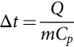 **(18.66)**

where *Q* is the change in thermal energy and *m* is the mass of the water resistance tube.

Nevertheless, the use of water resistances brings some limitations. First, with the temperature increase, air bubbles are formed that change the resistance value. Second, the CuSO4 molecule breakdown linked with electrolysis phenomenon has undesirable results: (i) With gas release that increases the pressure inside the tube, a gas release aperture is advisable in the tube edges to prevent the increase of the pressure inside the tube, and (ii) the metallic copper decomposition in the cathode (i.e., copper transport from the anode to the cathode) changes the test conditions. With time, the performance of a water resistance may change in consequence of these effects.

**Example 18.4**

Consider an HV pulse modulator that produces a 20 kV/10 A pulse during 10 μs with 100 Hz repetition rate. Calculate the temperature increment of *l*=1 m tube (made from insulating material) with an internal diameter of *d*=2.5 cm when used as a load to the modulator during 60 s.

Solution

The energy per pulse is



The energy in 60 s is



The volume of water inside of the tube is



Then, considering that 1 Cal=4.2 J, results in



Hence, for an initial water temperature at 25ºC, after 60 s, the temperature will increase to 30.8°C.

### 18.3.2 CAPACITIVE (*C*) AND *RC* LOADS

Pulse power applications associated with plasma and gas processing, and occasionally liquids, present typically capacitive behavior to the PP modulators. In fact, some of the most challenging operating conditions are related with the operation with plasmas.

A typical example is plasma-based ion implantation (PBII), where a target is immersed in a plasma, produced in a confined volume, and almost rectangular negative HV pulses are applied to it. This results into a high-current peak at the beginning of the pulse, rapidly decreasing to a much smaller value. The initial transient current that charges the main system capacitances can be several orders of magnitude greater than the stationary current at the pulse end, when the load imposes almost open-circuit impedance, presenting an additional challenge to the modulator. The above load dynamic characteristics can be represented in an RC electric equivalent circuit as in [Fig. 18.25](https://learning.oreilly.com/library/view/power-electronics-handbook/9780128114087/B9780128114070000209_1.xhtml#f0130) [[30](https://learning.oreilly.com/library/view/power-electronics-handbook/9780128114087/B9780128114070000209_2.xhtml#bb0155),[31](https://learning.oreilly.com/library/view/power-electronics-handbook/9780128114087/B9780128114070000209_2.xhtml#bb0160)].



**FIG. 18.25** Simplified electric equivalent circuit of a PBII load.

For plasma loads such as PBII, considering plasma characteristics and typical wanted results, the modulator requirements can be sought: (a) The voltage pulse waveform must be independent of the load impedance, (b) the pulse rise time must be in the order of the μs and small compared with the pulse width, (c) the pulse duty-cycle must be a few percent, (d) the pulse width and frequency should allow some load variation, (e) there must be a current limit in case of short-circuit, and (f) in order to be practical, the power supply cannot be too complex and bulky while including all the necessary protection systems for personnel and equipments.

In capacitive-type loads, it is extremely important, also, that the modulator topology has the capability to short-circuit the load after the HV pulse, quickly discharging all the load and parasitic capacitances to zero; otherwise, the load stays charged to almost full pulse voltage. Occasionally, this type of load must be compensated by adding parallel resistors.

### 18.3.3 INDUCTIVE (*L*) AND *LR* LOADS

Inductive-type loads are present when a pulse transformer is used to further increase the voltage level of a modulator or when voltage pulses are applied to inductive loads such as coils. An example of the last is electromagnetic metal forming application, EMF, where HV resonant topologies apply kA current pulses, during hundreds of μs, into very low inductance systems [[8](https://learning.oreilly.com/library/view/power-electronics-handbook/9780128114087/B9780128114070000209_2.xhtml#bb0045)].

For inductive operation, the modulator must clamp the load with an opposite polarity voltage after each HV pulse, during enough time to guarantee a zero average load voltage. In general, this is not accomplished with turn-off capability semiconductor switches but rather with freewheeling diodes. Also, the topology either can be dissipative or can send the energy stored in the magnetic circuit back to the power supply, increasing the efficiency of the modulator.

## 18.4 Solid-State PP Topologies

The use of innovative techniques, supported on dc-dc isolated converter topologies, brought from solid-state power electronics, taking advantage of all the capabilities of such devices, circumventing their limitations, is playing an important role to the expansion of pulse power technology to a wide range of new applications, needing compact, small size and efficient pulse modulators, spreading to almost every industrial and commercial fields, from food sterilization, biomedical applications and pollution control to surface engineering [[31](https://learning.oreilly.com/library/view/power-electronics-handbook/9780128114087/B9780128114070000209_2.xhtml#bb0160)–[37](https://learning.oreilly.com/library/view/power-electronics-handbook/9780128114087/B9780128114070000209_2.xhtml#bb0190)].

Nevertheless, each PP application represents a different challenge for the PP technology and the load requirements normally imposes limits to the use of each type of power converter topology. One important characteristic associated with many pulse power applications is the low duty ratio, *D*, pulse operation (i.e., usually lower than 5% [[1](https://learning.oreilly.com/library/view/power-electronics-handbook/9780128114087/B9780128114070000209_2.xhtml#bb0010),[2](https://learning.oreilly.com/library/view/power-electronics-handbook/9780128114087/B9780128114070000209_2.xhtml#bb0015)]), where the pulse width is much shorter than the pulse period, which reduces significantly the modulator average power and also the dissipated power into the load, as

 **(18.67)**

where *Vp* and *Ip* are, respectively, the pulse voltage and current amplitude, supposing a rectangular pulse with *D*=*ton/T* duty ratio.

In order to take the most of each topology and also to be able to extend these concepts to other topologies that have potential for high-voltage pulsed generation, it is important to understand the concepts and to know the advantages and limitations when using each topology.

In this section, several topologies capable of generating high-voltage pulses based on relatively low-voltage semiconductors devices are analyzed. The study begins with the most common configurations for pulse generation that switch the HV voltage directly into the load, using stacks of series semiconductors.

The dc-dc isolated converter topologies, forward, flyback, full-bridge, and half-bridge, which can be modified to produce high-voltage rectangular repetitive pulses, with techniques that enable the use of relatively low semiconductor devices, are presented next. Here, the use of a step-up transformer provides galvanic isolation and further increases the output voltage pulse amplitude, although the transformer presents limitations to its use. In order to overcome various technical hitches in assembling a unique high-voltage circuit, stacked associations of lower voltage topologies are also discussed with and without the use of output transformers. Finally, the mature Marx generator pulse power topology is discussed with the intensive use of semiconductors. This concept is also proposed for distributing the voltage in series stacks of semiconductors.

It is important to define some of the pulse parameters mentioned in the following sections, as shown in [Fig. 18.26](https://learning.oreilly.com/library/view/power-electronics-handbook/9780128114087/B9780128114070000209_1.xhtml#f0135) for the practical shape of unipolar voltage pulses.



**FIG. 18.26** Voltage pulse wave practical shape.

Considering [Fig. 18.26](https://learning.oreilly.com/library/view/power-electronics-handbook/9780128114087/B9780128114070000209_1.xhtml#f0135), the voltage pulse can be characterized by several parameters:

• Rise time, *tr*: period of time from 0.1 to 0.9*V*, where *V* is the plateau amplitude of the pulse

• Overshoot, Δ*Vs*: voltage excursion, after the rise time, above the pulse plateau *V*

• Width, Δ*t*: pulse duration in the 0.5 *V* region

• Undershoot, Δ*Vd*: voltage excursion, after the fall time, below minimum voltage, 0 V

• Droop, Δ*V*: in relation to the plateau amplitude *V*, Δ*V*=*V–Vf*

• Fall time, *tf*: period of time from 0.9 to 0.1*Vf*, where *Vf* is the final pulse voltage, different from *V* because of Δ*V*

• Tail: voltage descend during pulse fall

### 18.4.1 DIRECT SWITCHING

The most straightforward technique for high-voltage pulse generation consists in switching directly the voltage from a dc capacitor bank charged with high-voltage into the load, using a floating or a grounded switch, as shown in [Figs. 18.27](https://learning.oreilly.com/library/view/power-electronics-handbook/9780128114087/B9780128114070000209_1.xhtml#f0140) and [18.29](https://learning.oreilly.com/library/view/power-electronics-handbook/9780128114087/B9780128114070000209_1.xhtml#f0150), respectively.



**FIG. 18.27** Direct modulator simplified circuit with floating switch.

#### **18.4.1.1 Floating Switch**

Consider the circuit in [Fig. 18.27](https://learning.oreilly.com/library/view/power-electronics-handbook/9780128114087/B9780128114070000209_1.xhtml#f0140) where the HV power supply, PS, *Vdc* charges an energy storage capacitor bank *Cdc*. The PS internal resistance added by the switch and wiring ohmic resistances is represented by *Rdc* that limits the maximum charging current. Sometimes, a series inductor *Laux* is also added, which acts as a current limiter and causes some boost of the capacitor voltage during the charging period.

The voltage is modulated into the load by the series floating switch Sp, which operates with duty ratio *D*. The switch-*on* and *off* control applies the full bank voltage to the load with the pulse width and frequency being controlled by the gate trigger. Supposing *Cdc* charged with *Vdc*, when *Sm* is *on*, during *ton*, the *Cdc* capacitor applies a voltage *Vdc* into the load. During this period the inductance *Laux* limits the discharge of the Power Supply to the load.

If the load has capacitive behavior, an auxiliary circuit must be added to discharge the load capacitance to zero after the voltage pulse. For low duty ratio operation or low-power operation, a permanent parallel resistor *Ra*1 can be connected to the load, which must hold off the applied voltage. The *Ra*1 value depends on its average power dissipation

 **(18.68)**

and the required load voltage fall time.

As an alternative, for high duty ratio operation or high-power operation, it is preferable to use an auxiliary series switch *Sa* with *Ra*2 to short the load after the pulse. In this case, the value of *Ra*2 can be significantly reduced.

The main advantages of [Fig. 18.27](https://learning.oreilly.com/library/view/power-electronics-handbook/9780128114087/B9780128114070000209_1.xhtml#f0140) topology are associated with the generation of voltage pulses with low rise time, low-voltage droop, and also the flexibility to change the frequency and duty ratio operation. However, the pulse characteristics are limited by the energy stored in the capacitor bank and on the performance and power dissipated in the switches and also on the rate of charge of *Cdc*.

The energy initially stored in the *Cdc* capacitor is

 **(18.69)**

if the S *off* time, *T–ton*, is enough for the PS *Vdc* to charge *Cdc*. Following and during *ton*, the energy delivered to the load is

 **(18.70)**

For PP applications, only a small fraction of the stored energy should be transferred to the output during the pulse mode; otherwise, the pulse voltage has a typical RC discharge waveform, shown [Fig. 18.28](https://learning.oreilly.com/library/view/power-electronics-handbook/9780128114087/B9780128114070000209_1.xhtml#f0145), and not an almost rectangular shape, as shown in [Fig. 18.26](https://learning.oreilly.com/library/view/power-electronics-handbook/9780128114087/B9780128114070000209_1.xhtml#f0135).



**FIG. 18.28** Typical RC discharge waveform.

For a resistive load, the pulse voltage decay *Vdcf* can be calculated as

 **(18.71)**

Considering a resistive load *RL*, the capacitance of the *Cdc* capacitor ([Fig. 18.27](https://learning.oreilly.com/library/view/power-electronics-handbook/9780128114087/B9780128114070000209_1.xhtml#f0140) circuit) can be determined according to energy delivered to the load. For the required pulse voltage droop Δ*V*0,

 **(18.72)**

where  is the capacitor voltage at the end-of-pulse, *ton*, and  is the capacitors voltage immediately before the pulse. Considering Eq. [(18.70)](https://learning.oreilly.com/library/view/power-electronics-handbook/9780128114087/B9780128114070000209_1.xhtml#fo0505), the difference between Eqs. [(18.68)](https://learning.oreilly.com/library/view/power-electronics-handbook/9780128114087/B9780128114070000209_1.xhtml#fo0495), [(18.69)](https://learning.oreilly.com/library/view/power-electronics-handbook/9780128114087/B9780128114070000209_1.xhtml#fo0500) is the energy stored in the *Cdc* capacitor at end-of-pulse mode, :

 **(18.73)**

where Eq. [(18.71)](https://learning.oreilly.com/library/view/power-electronics-handbook/9780128114087/B9780128114070000209_1.xhtml#fo0510) for this case results in

 **(18.74)**

considering that . Equating [(18.72)](https://learning.oreilly.com/library/view/power-electronics-handbook/9780128114087/B9780128114070000209_1.xhtml#fo0515), the capacitor value should satisfy the condition

 **(18.75)**

Considering Eqs. [(18.68)](https://learning.oreilly.com/library/view/power-electronics-handbook/9780128114087/B9780128114070000209_1.xhtml#fo0495) through [(18.73)](https://learning.oreilly.com/library/view/power-electronics-handbook/9780128114087/B9780128114070000209_1.xhtml#fo0520), it is mandatory to store in *Cdc* an energy greater than five times the pulse energy in order to have an output voltage droop better than 10%, but if a 1% voltage droop is expected, a 50 times storage energy is required, which may impose limits to the design of the modulator.

In addition, the *Vdc* power supply must be able to recharge the *Cdc* capacitor with an energy equal to the delivered pulse energy, *E*0, plus losses, during the charging, *T–ton*, and pulse, *ton*, periods

 **(18.76)**

During the initial charging of the capacitor *Cdc*, the PS takes a longer time in order to limit the power dissipation in the *Rdc* resistor.

The main disadvantages associated with the circuit in [Fig. 18.27](https://learning.oreilly.com/library/view/power-electronics-handbook/9780128114087/B9780128114070000209_1.xhtml#f0140) are the *Sm* switch floating trigger terminals, resulting in a trigger signal that must be transmitted with galvanic isolation. Also, switch *Sm* must hold the total *Vdc* voltage during the *off* period, *T–ton*, and conduct the load current during the *on* period.

**Example 18.5**

Consider the HV pulse modulator of [Fig. 18.27](https://learning.oreilly.com/library/view/power-electronics-handbook/9780128114087/B9780128114070000209_1.xhtml#f0140) where *Vdc*=20 kV. Calculate the value of the capacitor *Cdc* for applying 50 μs and 1600 Hz into an *RL*=1 kΩ load and the minimum power of the power supply, *Vdc*, considering 20% losses during the charging and pulse modes.

Solution

Considering the capacitor *Cdc* initially charged with *Vdc* and a voltage droop of 5%, then Eq. [(18.72)](https://learning.oreilly.com/library/view/power-electronics-handbook/9780128114087/B9780128114070000209_1.xhtml#fo0515),



which results Eq. [(18.75)](https://learning.oreilly.com/library/view/power-electronics-handbook/9780128114087/B9780128114070000209_1.xhtml#fo0530)



Choosing a 1.2 μF, then, the energy stored in *Cdc* initially is



The energy delivered to the pulse is



This means that after the pulse, the energy stored in the *Cdc* capacitor is 220 J, corresponding to a final pulse voltage of 19.149 V that is 4.2% voltage droop.

Finally, the PS *Vdc* must recharge the 20 J and 4 J (i.e., 10% losses) in *T–ton*=625 μs, and then,



#### **18.4.1.2 Ground Switch**

It is possible to connect the switch *Sm* referenced to ground and the *Cdc* capacitor floating as shown in [Fig. 18.29](https://learning.oreilly.com/library/view/power-electronics-handbook/9780128114087/B9780128114070000209_1.xhtml#f0150). Considering this circuit, when *Sp* is *off*, the *Cdc* capacitor is charged through the load. Supposing *Cdc* charged with *Vdc*, when *Sm* turns on the positive terminal of *Cdc* is grounded and a voltage of *Vdc* is applied into the load.



**FIG. 18.29** Direct modulator simplified circuit with grounded switches.

The main advantage of [Fig. 18.29](https://learning.oreilly.com/library/view/power-electronics-handbook/9780128114087/B9780128114070000209_1.xhtml#f0150) configuration in relation to [Fig. 18.27](https://learning.oreilly.com/library/view/power-electronics-handbook/9780128114087/B9780128114070000209_1.xhtml#f0140) is that *Sm* is grounded, which makes easier the triggering process. However, in the [Fig. 18.29](https://learning.oreilly.com/library/view/power-electronics-handbook/9780128114087/B9780128114070000209_1.xhtml#f0150) circuit, during the pulse period *ton*, the *Vdc* power supply is shorted, increasing dramatically the power dissipation in *Rdc*, which is a significant disadvantage that limits the operation to very low duty ratios.

If inductive-type loads are to be connected in both circuits, it is mandatory to use a freewheeling diode in parallel with the load to reset it after the pulse and, also, to maintain the magnetic energy continuity.

#### **18.4.1.3 Series Stacks of Semiconductors**

Considering the dozens of kV range pulse amplitude in the majority of PP applications and the limited maximum reverse voltage of semiconductor switches, such as power BJT, MOSFET, IGBT, GTO, and IGCT, it is necessary to connect many semiconductors in series to assemble the *Sm* and *Sa* switches in [Figs. 18.27](https://learning.oreilly.com/library/view/power-electronics-handbook/9780128114087/B9780128114070000209_1.xhtml#f0140) and [18.29](https://learning.oreilly.com/library/view/power-electronics-handbook/9780128114087/B9780128114070000209_1.xhtml#f0150), as shown in [Fig. 18.30](https://learning.oreilly.com/library/view/power-electronics-handbook/9780128114087/B9780128114070000209_1.xhtml#f0155) [[38](https://learning.oreilly.com/library/view/power-electronics-handbook/9780128114087/B9780128114070000209_2.xhtml#bb0195)–[43](https://learning.oreilly.com/library/view/power-electronics-handbook/9780128114087/B9780128114070000209_2.xhtml#bb0220)].



**FIG. 18.30** Series-stacked semiconductor topology for high-voltage pulse generation.

As seen, sharing resistors for steady-state and *RCD* snubber circuits for transient voltage balance are needed for *on*-*off* controlled semiconductors. In addition, it is complex to synchronously trigger many devices in series, placed at different floating high-voltage potentials.

Gate-control delay techniques or generalized cascades are used to force the synchronized operation of semiconductors with mismatched switching *on*/*off* characteristics [[44](https://learning.oreilly.com/library/view/power-electronics-handbook/9780128114087/B9780128114070000209_2.xhtml#bb0225)].

Nevertheless, in order to prevent shutdown of a series-stacked semiconductor switch due to a defect arising in one semiconductor, redundant switches are, usually, included in the series, about 20% more, such that the surviving semiconductors share the voltage and the failed semiconductor is still able to carry the load current. This is true since the power switches used are built to short-circuit when failing [[45](https://learning.oreilly.com/library/view/power-electronics-handbook/9780128114087/B9780128114070000209_2.xhtml#bb0230)].

In order to decrease the voltage hold-off stress on the semiconductors, it is possible to add a high-voltage step-up pulse transformer in the output, further increasing the output voltage to the desired amplitude. However, several issues must be taking into consideration before designing the circuit [[44](https://learning.oreilly.com/library/view/power-electronics-handbook/9780128114087/B9780128114070000209_2.xhtml#bb0225)–[47](https://learning.oreilly.com/library/view/power-electronics-handbook/9780128114087/B9780128114070000209_2.xhtml#bb0240)]:

1. The parasitic elements (i.e., distributed capacitance and leakage inductance) normally associated with the assembling of the transformer impose limitations to the output pulse waveform, degrading the pulse rise time and voltage plateau.

2. The transformer core volt-second product limits the transformer flexibility to accommodate different operating conditions, such as duty ratio and frequency.

3. After the pulse, it is mandatory to reset the transformer core magnetic flux back to the initial status before the next pulse, which imposes an auxiliary circuit.

Some of the topologies used in power electronics, designed for dc-dc isolated converters, can be specially modified for pulse generation, where the addition of the transformer gives the galvanic insulation and contributes to the reduction of the hold-off voltage in the semiconductors as described in the following sections.

### 18.4.2 DC-DC ISOLATED CONVERTERS

The use of classic high-voltage modulator topologies, such as the ones described in the last section, substituting the hard-tube switches by stacked semiconductors is frequently not the best solution for high-voltage pulse generation when using semiconductors, due to the still high-voltage limitations of the devices and their sensibility to overvoltage and overcurrents.

Alternatively, it is advantageous to take into account the topologies that were originally designed for power semiconductors such as the dc-dc isolated converters. The literature refers the use of full-bridge, half-bridge, forward, and flyback converters in hard-switching and resonant topologies for applications such as rapid capacitor high-voltage charging, food processing, X-ray, plasma processing, and air and water pollution control [[33](https://learning.oreilly.com/library/view/power-electronics-handbook/9780128114087/B9780128114070000209_2.xhtml#bb0170)–[37](https://learning.oreilly.com/library/view/power-electronics-handbook/9780128114087/B9780128114070000209_2.xhtml#bb0190)].

The use of a transformer for galvanic isolation in the forward converter, derived from the buck dc-dc converter; the flyback converter, derived from the buck-boost dc-dc converter; and the bridge topologies can significantly reduce the voltage stress on the semiconductors. In this section, the focus is placed on the particular characteristics that enable high-voltage pulse generation, using relatively low-voltage semiconductor devices.

As the objective is to generate high-voltage pulses at the output, several changes must be introduced in the typical topologies and operating conditions of these circuits. The most obvious is the elimination of the output LC filter, used to keep the output voltage nearly constant.

In the following analysis, it is considered that the semiconductor switches have ideal switching behavior, instantaneous commutation times, zero voltage drop, and zero leakage current.

#### **18.4.2.1 Forward Topology**

The simplified forward-type circuit used to generate negative unipolar high-voltage pulses into a load is shown in [Fig. 18.31](https://learning.oreilly.com/library/view/power-electronics-handbook/9780128114087/B9780128114070000209_1.xhtml#f0160) and the theoretical key waveforms in [Fig. 18.32](https://learning.oreilly.com/library/view/power-electronics-handbook/9780128114087/B9780128114070000209_1.xhtml#f0165). For positive unipolar pulses, the ground should be placed on the opposite secondary transformer terminal. The auxiliary RCD voltage clamp circuit connected to the transformer primary winding is used to reset the transformer using the lowest constant voltage. Considering that the RCD clamp capacitance *Cs* is sufficiently large, the voltage *VC* across it can be assumed constant [[48](https://learning.oreilly.com/library/view/power-electronics-handbook/9780128114087/B9780128114070000209_2.xhtml#bb0245),[49](https://learning.oreilly.com/library/view/power-electronics-handbook/9780128114087/B9780128114070000209_2.xhtml#bb0250)].



**FIG. 18.31** Simplified layout of the pulsed power forward-type circuit used to generate negative high-voltage pulses to a load.



**FIG. 18.32** Theoretical key waveforms for the circuit in [Fig. 18.31](https://learning.oreilly.com/library/view/power-electronics-handbook/9780128114087/B9780128114070000209_1.xhtml#f0160), for a resistive load: (A) switch trigger signal *vgs*, (B) primary winding voltage *v*1, (C) switch voltage *vs*, (D) *D*2 reverse voltage, (E) *D*1 reverse voltage, and (F) load voltage *v*0.

For pulse generation, the circuit operation can be explained considering only three operating modes [[33](https://learning.oreilly.com/library/view/power-electronics-handbook/9780128114087/B9780128114070000209_2.xhtml#bb0170),[50](https://learning.oreilly.com/library/view/power-electronics-handbook/9780128114087/B9780128114070000209_2.xhtml#bb0255)]. In the first mode, the pulse mode, when the main switch *S* is turned *on* during Δ1*T*=*DT*=*ton*, where Δ1*T*=*D* and *T* are, respectively, the *S* duty ratio and operating period, the energy is transferred from the transformer primary winding circuit to the output. As the voltage applied to the transformer primary winding *N*1 is *Vdc*, the secondary winding *N*2 diode *D*2 is *on*; thus, the voltage applied to the load is

 **(18.77)**

where *N*2/*N*1 is the transformer turn ratio, *N*. In addition, the RCD diode *D*1 is *off*, with a reverse voltage of

 **(18.78)**

For a resistive load *RL*, the pulse amplitude is given by

 **(18.79)**

In the second mode, the reset mode, when the main switch *S* turns *off*, the RCD diode *D*1 goes *on* and the voltage applied to transformer primary winding is −*VC*, which resets the transformer core. During this time, Δ2*T*, the secondary diode *D*2 is *off*, holding off a reverse voltage of

 **(18.80)**

which results to a zero load voltage. From Eq. [(18.80)](https://learning.oreilly.com/library/view/power-electronics-handbook/9780128114087/B9780128114070000209_1.xhtml#fo0580), the lower the *VC* voltage and the transformer turns ratio *N*, the lower is the voltage hold-off by diode *D*2. In addition, the switch *S* must hold off a voltage

 **(18.81)**

where *VC* must be as low as possible to decrease this voltage.

Finally, in the third mode, the safety mode, following the transformer reset period, during Δ3*T*, still with *S off*, the voltage applied to *S* is

 **(18.82)**

and the voltage applied to the transformer is zero. It is important to have Δ3*T*>0 in order to guarantee a safety operating margin for the transformer core reset. For practical operation, values between 20% and 30% should be sufficient. This is done be increasing the *VC* clamp voltage above the calculated value.

The operation of the [Fig. 18.31](https://learning.oreilly.com/library/view/power-electronics-handbook/9780128114087/B9780128114070000209_1.xhtml#f0160) circuit for high-voltage pulse generation imposes several conditions:

1. The use of a step-up transformer in order to decrease the voltage on the devices connected on the primary side

2. A minimum reset voltage *VC* to guarantee the complete transformer core reset during the *S* off period, Δ3*T*>0, reducing at the same time the hold-off voltage of *D*2 Eq. [(18.80)](https://learning.oreilly.com/library/view/power-electronics-handbook/9780128114087/B9780128114070000209_1.xhtml#fo0580) and of *S* Eq. [(18.81)](https://learning.oreilly.com/library/view/power-electronics-handbook/9780128114087/B9780128114070000209_1.xhtml#fo0585)

Considering the last, it is important to understand the relation between the reset voltage *VC* with the operating conditions, such as the duty ratio *D*.

The reset voltage *VC* can be calculated by equating the integral of the primary winding voltage, *v*1, over one time period to zero

 **(18.83)**

where Δ2*T*=*τ* is the transformer core reset period.

For the boundary condition Δ3*T*=0 (i.e., Δ1*T*+Δ2*T*=*T* and Δ2=*D*), then, Eq. [(18.83)](https://learning.oreilly.com/library/view/power-electronics-handbook/9780128114087/B9780128114070000209_1.xhtml#fo0595) becomes

 **(18.84)**

substituting Eq. [(18.84)](https://learning.oreilly.com/library/view/power-electronics-handbook/9780128114087/B9780128114070000209_1.xhtml#fo0600) in Eq. [(18.80)](https://learning.oreilly.com/library/view/power-electronics-handbook/9780128114087/B9780128114070000209_1.xhtml#fo0580) the *vka* in diode *D*2 is:

 **(18.85)**

Considering Eqs. [(18.83)](https://learning.oreilly.com/library/view/power-electronics-handbook/9780128114087/B9780128114070000209_1.xhtml#fo0595), [(18.85),](https://learning.oreilly.com/library/view/power-electronics-handbook/9780128114087/B9780128114070000209_1.xhtml#fo0605) introducing the load voltage module |*V*0|, the ratio of *τ/toff*, the reset time and the time when switch *S* is *off* it is received:

 **(18.86)**

by simplifying becomes

 **(18.87)**

which can be represented graphically by [Fig. 18.33](https://learning.oreilly.com/library/view/power-electronics-handbook/9780128114087/B9780128114070000209_1.xhtml#f0170), where



**FIG. 18.33** Graphic representation of the reverse voltage of diode *D*2 as a function of the reset time and duty ratio of the forward topology ([Fig. 18.31](https://learning.oreilly.com/library/view/power-electronics-handbook/9780128114087/B9780128114070000209_1.xhtml#f0160)).

 **(18.88)**

with Δ1+Δ2+Δ3=1 and Δ1=*D*

The graphics in [Fig. 18.33](https://learning.oreilly.com/library/view/power-electronics-handbook/9780128114087/B9780128114070000209_1.xhtml#f0170) shows the maximum load voltage hold-off by diode *D*2 as a function of *S* duty ratio, *D*, and the transformer reset factor, *τ/toff*.

Various conditions can be presented for high-voltage pulse generation by forward converters using low-voltage solid-state devices:

1. If the switching duty ratio is only a few percent and the resetting time extends to almost all the main switch-*off* time (i.e., Δ2*T*+Δ3*T*), diode *D*2 holds off a small fraction of the output voltage.

2. If a step-up transformer is used, *N*≫1, this topology enables, also, the use of low hold-off voltage semiconductors in the primary transformer side, when compared with the output load voltage.

For safety reasons in order to ensure that the transformer core is fully reset, the transformer resetting time must end before the *off*-state of the *S* switch ends, Δ3*T*>0.

The short duty cycles required for generation HV pulses with low-voltage semiconductors are not a shortcoming, as most PP applications require short pulse widths and large recovery times.

Much care should be put in the design and assembling of the transformer as this element must sustain the HV between its terminals. In addition, this topology requires the polarity of the primary winding of the transformer to be identical to that of the secondary winding, and so, the energy of the load is obtained during the *on*-state of the switching device. Therefore, it behaves like a true transformer, wherein energy storage is undesirable, associated with the leakage inductance. However, the forward converter transformers have the poorest utilization and efficiency ratios, because neither the core nor the windings are used during the lengthy core reset interval.

Due to the low main switch *S* duty-cycle operation and transformer behavior, the RCD clamp voltage is designed for a low current, typically, a few % of the main circuit current.

The RCD clamp can be considered a buck-boost converter in discontinuous mode of operation, and designed so that, under any load conditions, during the *S* switch-*off* period the transformer core is fully reset [[49](https://learning.oreilly.com/library/view/power-electronics-handbook/9780128114087/B9780128114070000209_2.xhtml#bb0250)].

For resetting the transformer core, other solutions can be implementing, such as a third auxiliary winding, but the fact that this transformer is for HV pulse generation limits in terms of parasitic, assembling complexity and safety.

**Example 18.6**

Suppose the generation of −5 kV amplitude pulses with 5 μs and *f*=10 kHz (*D*=5%) from the circuit in [Fig. 18.31](https://learning.oreilly.com/library/view/power-electronics-handbook/9780128114087/B9780128114070000209_1.xhtml#f0160). The circuit is supplied from a mains transformer at *Vdc*=500 V, and an *N*=10 pulse transformer is used. Calculate the semiconductor switches *S*, *D*1, and *D*2 hold-off voltage.

Solution

Consider first boundary condition Eq. [(18.84)](https://learning.oreilly.com/library/view/power-electronics-handbook/9780128114087/B9780128114070000209_1.xhtml#fo0600), and then,

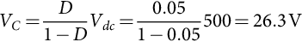

The semiconductors hold off 526.3 V for the *S* switch and diode *D*1 and 263 V for diode *D*2, respectively, 10.5% and 5.26% of the output voltage.

Consider now a reset factor of *τ/toff*≈65%, and then, Δ1=5%, Δ2≈62.5%, and Δ3≈32.5%. From [(18.83)](https://learning.oreilly.com/library/view/power-electronics-handbook/9780128114087/B9780128114070000209_1.xhtml#fo0595),



resulting in 540 V for the *S* switch and diode *D*1 and 400 V for diode *D*2, respectively, 10.8% and 8% of the output voltage.

Hence, for generating 5 kV pulse, 800 V semiconductors could be used, considering a 100% safety factor.

#### **18.4.2.2 Flyback Topology**

The simplified flyback-type circuit used to generate negative high-voltage pulses into a load is shown in [Fig. 18.34](https://learning.oreilly.com/library/view/power-electronics-handbook/9780128114087/B9780128114070000209_1.xhtml#f0175), for positive pulses the ground should be placed on the opposite terminal.



**FIG. 18.34** Simplified layout of the pulsed power flyback-type circuit used to generate negative high-voltage pulses to a load.

The circuit in [Fig. 18.34](https://learning.oreilly.com/library/view/power-electronics-handbook/9780128114087/B9780128114070000209_1.xhtml#f0175) is similar to the circuit in [Fig. 18.31](https://learning.oreilly.com/library/view/power-electronics-handbook/9780128114087/B9780128114070000209_1.xhtml#f0160), but the polarity of the diode *D*2 on the secondary winding is reversed. However, this simple change imposes completely different circuit behavior [[48](https://learning.oreilly.com/library/view/power-electronics-handbook/9780128114087/B9780128114070000209_2.xhtml#bb0245)].

Considering the circuit in [Fig. 18.34](https://learning.oreilly.com/library/view/power-electronics-handbook/9780128114087/B9780128114070000209_1.xhtml#f0175) and the theoretical key waveforms of [Fig. 18.35](https://learning.oreilly.com/library/view/power-electronics-handbook/9780128114087/B9780128114070000209_1.xhtml#f0180), for boundary conditions, when the main switch *S* turns *on*, the energy is stored in the transformer as magnetic flux, the transformer must act as a coil storing energy. The voltage applied to the transformer primary winding is *Vdc*, the RCD diode *D*1 and the secondary winding diode *D*2 are *off*, thus the voltage applied to the load is zero. The secondary diode *D*2 reverse voltage is



**FIG. 18.35** Theoretical key waveforms for the circuit in [Fig. 18.34](https://learning.oreilly.com/library/view/power-electronics-handbook/9780128114087/B9780128114070000209_1.xhtml#f0175), for a resistive load: (A) switch trigger signal *vgs*, (B) primary winding voltage *v*1, (C) Switch voltage *vs*, (D) *D*2 reverse voltage, (E) *D*1 reverse voltage, and (F) load voltage *v*0.

 **(18.89)**

and the RCD diode *D*1 reverse voltage is

 **(18.90)**

When the main switch *S* is turned *off*, the energy stored in the transformer is transferred to the output. The voltage applied to the transformer primary winding is −*VC*, and the RCD diode *D*1 and the secondary winding diode *D*2 are *on*, and voltage applied to the load is, approximately,

 **(18.91)**

The hold off voltage of the main switch *S* is

 **(18.92)**

The RCD clamp voltage has two purposes: (i) reduce the voltage spike that occurs due to the resonance between the transformer leakage inductance and the switch *S* output capacitance, in the *off*-state and (ii) establish the pulse voltage during the same period of time.

Considering the transformer primary winding voltage waveform given in [Fig. 18.35](https://learning.oreilly.com/library/view/power-electronics-handbook/9780128114087/B9780128114070000209_1.xhtml#f0180) the clamp voltage, *VC*, can be approximately derived by equating the integral of the primary winding voltage, *V*1, over one time period to zero

 **(18.93)**

similar to the *VC* voltage in the buck-boost topology Eq. [(18.84)](https://learning.oreilly.com/library/view/power-electronics-handbook/9780128114087/B9780128114070000209_1.xhtml#fo0600).

Regarding high-voltage pulse generation [[50](https://learning.oreilly.com/library/view/power-electronics-handbook/9780128114087/B9780128114070000209_2.xhtml#bb0255)], if the switching duty ratio is near 100%, *D*2 blocks only a small fraction of the output voltage. Additionally, if the RCD diode *D*1 is *on* during the *S* switch-*off* time, meaning the flyback circuit runs in continuous mode, the output voltage pulse is well defined by the RCD capacitors voltage *VC*. Moreover, with a step-up transformer (*N*≫1), this topology also enables relatively low-voltage semiconductor devices in the primary side.

For efficiency reasons, the flyback circuit parameters should be calculated in order that the circuit works at the boundary between the continuous and noncontinuous state. This is done by assuring that the RCD diode *D*1 turns *off* at the same instant the switch *S* turning *on*. The RCD clamp voltage is sized by the main circuit current due to the high duty ratio operation of switch *S* and the coil-like transformer behavior.

The flyback transformer design is more complex than the forward transformer, as the energy is supplied to the load during the *off*-state of the *S* switch, meaning that the transformer must be designed to store energy during the *on*-state of the *S* switch, behaving as a coupled inductor.

The *S* switch current interruption requirements and the coupled inductor design can be much more challenging in the flyback topology at power levels of interest and represent a limitation of this topology. This is normally the realm of much higher current devices such as the IGBT and GTO or the use of parallel semiconductors.

Nevertheless, the flyback circuit is much more fault tolerant to a short-circuit in the load or load faults since the switch *S* is in the *off*-state during the output pulse and will not see the fault current as would the forward converter topology.

Comparing the forward with flyback topologies for HV pulse generation for the same output voltage pulse amplitude, using the same turn ratio transformer, the forward circuits need a high-amplitude dc PS voltage *Vdc*, but the RCD voltage is lower, and the switch *S* duty ratio is low. Also, in the flyback topology, the voltage pulse width is not as well defined as in the forward, because it is generated by the RCD circuit.

The two topologies have problems in dealing with capacitive loads, because the dynamic variations in the load impedance mismatch the output of the transformer. The solution requires the use of a permanent dummy load, but this increases the power dissipation. Another possibility is the use of a switch dummy load, which will put a semiconductor device in the high-voltage region.

**Example 18.7**

Suppose the generation of −5 kV amplitude pulses with 5 μs and *f*=10 kHz (*D*=95%) from the circuit in [Fig. 18.34](https://learning.oreilly.com/library/view/power-electronics-handbook/9780128114087/B9780128114070000209_1.xhtml#f0175). The circuit is supplied at *Vdc*=25 V, and an *N*=10 pulse transformer is used. Calculate the semiconductor switches *S*, *D*1, and *D*2 hold-off voltage.

Solution

Consider Eq. [(18.93)](https://learning.oreilly.com/library/view/power-electronics-handbook/9780128114087/B9780128114070000209_1.xhtml#fo0655), and then,



The semiconductors hold off 526.3 V for the *S* switch and diode *D*1 and 263 V for diode *D*2, respectively, 10.5% and 5.26% of the output voltage.

Hence, for generating 5 kV pulse, 800 V semiconductors could be used, considering a 100% safety factor.

#### **18.4.2.3 Bridge Topologies**

The forward and flyback topologies are suitable for the generation of unipolar HV pulses. If bipolar pulses are needed, bridge configurations should be used, like the full- and half-bridge topologies with or without a step-up transformer [[33](https://learning.oreilly.com/library/view/power-electronics-handbook/9780128114087/B9780128114070000209_2.xhtml#bb0170),[34](https://learning.oreilly.com/library/view/power-electronics-handbook/9780128114087/B9780128114070000209_2.xhtml#bb0175),[36](https://learning.oreilly.com/library/view/power-electronics-handbook/9780128114087/B9780128114070000209_2.xhtml#bb0185),[37](https://learning.oreilly.com/library/view/power-electronics-handbook/9780128114087/B9780128114070000209_2.xhtml#bb0190)].

Considering a half-bridge topology, [Fig. 18.36A](https://learning.oreilly.com/library/view/power-electronics-handbook/9780128114087/B9780128114070000209_1.xhtml#f0185) shows the configuration for obtaining positive pulses, where the switch *S*1 applies the pulse to the load and switch *S*2 is capable of applying a zero voltage to the load, which can be important if the load is capacitive, as shown in [Fig. 18.36B](https://learning.oreilly.com/library/view/power-electronics-handbook/9780128114087/B9780128114070000209_1.xhtml#f0185), otherwise the load will stay charged. If antiparallel diodes are connected to the switches, pulses can be applied to inductive loads, where the *S*2 antiparallel diode reset the load after the pulse. For negative pulses, the circuit is presented in [Fig. 18.37A](https://learning.oreilly.com/library/view/power-electronics-handbook/9780128114087/B9780128114070000209_1.xhtml#f0190); similar operating behavior applies now for opposite polarity, as shown in [Fig. 18.37B](https://learning.oreilly.com/library/view/power-electronics-handbook/9780128114087/B9780128114070000209_1.xhtml#f0190).



**FIG. 18.36** Half-bridge topology for generating positive HV pulses: (A) simplified circuit and (B) output voltage, *V*0, for a capacitive load, *CL*||*RL*.



**FIG. 18.37** Half-bridge topology for generating negative HV pulses: (A) simplified circuit and (B) output voltage, *V*0, for a capacitive load, *CL*||*RL*.

The main limitation of this topology is the hold-off voltage of the semiconductors, which must block the same voltage as the dc HV power supply *Vdc*. If a transformer is connected in parallel with switch *S*2, its antiparallel diode can reset the transformer core after the pulse, but this is limited to low duty ratio operation due to the low reset voltage impose by the diode.

If positive and negative pulse (i.e., bipolar) need to be generated using a half-bridge topology, then two power supplies are required, as shown in [Fig. 18.38](https://learning.oreilly.com/library/view/power-electronics-handbook/9780128114087/B9780128114070000209_1.xhtml#f0195). In this case, each switch *Si* must hold off the sum of the two power supplies voltages, that is, 2*Vdc*. However, for capacitive-type loads, it is not possible to discharge the load capacitance after the pulse, as shown in [Fig. 18.38B](https://learning.oreilly.com/library/view/power-electronics-handbook/9780128114087/B9780128114070000209_1.xhtml#f0195), since both *S*1 and *S*2 must be off.



**FIG. 18.38** Half-bridge topology for generating positive and/or negative HV pulses: (A) simplified circuit and (B) output voltage, *V*0, for a capacitive load, *CL*||*RL*.

In order to decrease the switches' voltage hold-off, it is common to use instead the full-bridge topology, shown in [Fig. 18.39A](https://learning.oreilly.com/library/view/power-electronics-handbook/9780128114087/B9780128114070000209_1.xhtml#f0200), which also uses one less power supply. Each switch hold-off voltage is only *Vdc*. The use of more switches also increases the capability to deal with different load conditions, as shown in [Fig. 18.39B](https://learning.oreilly.com/library/view/power-electronics-handbook/9780128114087/B9780128114070000209_1.xhtml#f0200). In fact, with the full-bridge topology positive and/or negative pulses can be applied to any type of load. Nevertheless, depending on the flux of energy not all the controlled turn-off switches are always required.



**FIG. 18.39** Full-bridge topology for generating positive and/or negative HV pulses: (A) simplified circuit and (B) output voltage, *V*0, for a capacitive load, *CL*||*RL*.

These topologies are used in applications such as rapid high-voltage capacitor charging, food processing or air pollution control, where bipolar pulses enhance the process [[27](https://learning.oreilly.com/library/view/power-electronics-handbook/9780128114087/B9780128114070000209_2.xhtml#bb0140)–[31](https://learning.oreilly.com/library/view/power-electronics-handbook/9780128114087/B9780128114070000209_2.xhtml#bb0160)].

It is also possible to connect a transformer at the output terminals to increase the output voltage amplitude and to lower the hold-off voltage in the semiconductors switches if high-voltage pulses are to be generated, with the limitations already described. In order to limit the switches losses, it is common to use auxiliary inductors and capacitors in series or parallel configurations to couple the H-bridge to the HV transformer and also to guarantee a zero average voltage applied to the primary winding.

### 18.4.3 CASCADED TOPOLOGY

The assembling of a single modulator circuit with very HV can be a very complex task and result in a number of problems:

• Transformer assembled with very high turn ratio and voltage output

• Many semiconductors stacked in series

• The presence of HV in small distributed volume and safety distances

• Coupling parasitic capacitances and inductances between devices

In order to avoid these problems, it is possible to cascade single modulators circuits where the output voltage is the sum of the individual outputs. However, care is needed in the connection of each circuit as voltage sharing between them is essential.

#### **18.4.3.1 Modulators Without Output Transformers**

In the topology shown in [Fig. 18.40](https://learning.oreilly.com/library/view/power-electronics-handbook/9780128114087/B9780128114070000209_1.xhtml#f0205), there is no transformer between the energy storing capacitors and the load; the system is composed of basic pulse generator cells, made by a capacitor *Ci* and a switch *Si*, stacked in series. The challenge in this type of generator is the uniform distribution of the voltage between each cell due to the floating nature of each cells and the high d*v*/d*t* with respect to the ground occurring during the rise and falling time of the pulse. For this reason, great care must be taken in order to limit capacitance between each cell and the ground [[18](https://learning.oreilly.com/library/view/power-electronics-handbook/9780128114087/B9780128114070000209_2.xhtml#bb0095)].



**FIG. 18.40** Series-stacked modulator topology.

For proper operation, the capacitors in each cell of [Fig. 18.40](https://learning.oreilly.com/library/view/power-electronics-handbook/9780128114087/B9780128114070000209_1.xhtml#f0205) circuit need to be charged using a galvanically isolated power supply. One of the possible methods includes the use of floating transformer secondary windings connected to an ac-dc converter, as shown in [Fig. 18.40](https://learning.oreilly.com/library/view/power-electronics-handbook/9780128114087/B9780128114070000209_1.xhtml#f0205), using full-bridge converters operating as unity power factor rectifiers.

During the pulse period, the voltages of the individual cells are added up; hence, the output voltage is

 **(18.94)**

and the current through all the switches is almost the same.

The freewheeling diode *Di* in the output of each cell enables the switch of each cell *on* and *off* independently of other cells, which makes the system capable of adjusting the output voltage. This technique protects also the switches during the *on*-*off* commutation transient for any mismatch in the voltage distribution, where the *Ri* resistors help on equalizing the voltage in the *Si* switches during *off*-state (see [Section 18.2.5](https://learning.oreilly.com/library/view/power-electronics-handbook/9780128114087/B9780128114070000209_1.xhtml#s0060)).

#### **18.4.3.2 Modulators With Output Transformers**

The construction of a single high-voltage pulse transformer, needing a high enough turns ratio (*N*≫1) to increase the output voltage, is complex due to the transformer nonideal behavior leading to significant parasitic effects as the output voltage rises. To solve this problem, it is possible to stack series several pulse transformers with lower turns ratio, in order to have only a fraction of the total voltage in each one [[28](https://learning.oreilly.com/library/view/power-electronics-handbook/9780128114087/B9780128114070000209_2.xhtml#bb0145),[34](https://learning.oreilly.com/library/view/power-electronics-handbook/9780128114087/B9780128114070000209_2.xhtml#bb0175),[51](https://learning.oreilly.com/library/view/power-electronics-handbook/9780128114087/B9780128114070000209_2.xhtml#bb0260)]. With a careful design, the leakage inductance and distributed capacitances of the equivalent circuit are reduced as compared with one single equivalent transformer, leading to a better rise time performance [[52](https://learning.oreilly.com/library/view/power-electronics-handbook/9780128114087/B9780128114070000209_2.xhtml#bb0265)]. Another alternative is to use auxiliary windings in the transformer to couple leakage fluxes [[47](https://learning.oreilly.com/library/view/power-electronics-handbook/9780128114087/B9780128114070000209_2.xhtml#bb0240),[53](https://learning.oreilly.com/library/view/power-electronics-handbook/9780128114087/B9780128114070000209_2.xhtml#bb0270)].

The most common ways to associate pulse transformers are shown in [Fig. 18.41](https://learning.oreilly.com/library/view/power-electronics-handbook/9780128114087/B9780128114070000209_1.xhtml#f0210) [[54](https://learning.oreilly.com/library/view/power-electronics-handbook/9780128114087/B9780128114070000209_2.xhtml#bb0275)]. The autotransformer-type cascade layout is shown in [Fig. 18.41A](https://learning.oreilly.com/library/view/power-electronics-handbook/9780128114087/B9780128114070000209_1.xhtml#f0210), with three transformers, each one holding one-third of the output voltage *v*0:



**FIG. 18.41** Simplified transformers association: (A) cascade and (B) secondary windings in series.

 **(18.95)**

In this topology, power is supplied to *Tp*2 and *Tp*3 from the previous transformers. Transformer *Tp*1 and *Tp*2 have three secondary terminals, two of them to feed the primary of the next transformer, and the third to step-up the voltage of the next transformer. This configuration decreases significantly the distributed capacitive between windings.

The major advantage of the cascade association, of [Fig. 18.41A](https://learning.oreilly.com/library/view/power-electronics-handbook/9780128114087/B9780128114070000209_1.xhtml#f0210), is that the isolation voltage between windings of each transformer is the same and equal to *v*0/3. However:

• Considering transformers with equal turn ratio *N* and primary voltage, *vin*, as each transformer is fed by the previous one, each transformer has a different power. Considering [Fig. 18.41A](https://learning.oreilly.com/library/view/power-electronics-handbook/9780128114087/B9780128114070000209_1.xhtml#f0210), if the load power is *P*, neglecting the losses, in the first transformer, the input cascade power is *P*. The following transformer withstands 2*P*/3, and the third transformer withstands *P*/3, being the total installed transformer power 2*P*.

• Due to the inclusion of an extra terminal in the high-voltage side with different current ratings, the transformer assembling is complex.

Alternatively, [Fig. 18.41B](https://learning.oreilly.com/library/view/power-electronics-handbook/9780128114087/B9780128114070000209_1.xhtml#f0210) presents three transformers with the secondary windings in series, each one designed for one-third of the output voltage *v*0. In the primary side, windings are in parallel, supplied by *vin*, and referenced to ground. Hence, the isolation voltage between windings of each transformer is different.

Considering [Fig. 18.41B](https://learning.oreilly.com/library/view/power-electronics-handbook/9780128114087/B9780128114070000209_1.xhtml#f0210), while the secondary winding potential in transformer *Tp*2 and *Tp*3 is, respectively, increased by *v*0/3 and 2*v*0/3 through the secondary winding of transformer *Tp*1 and *Tp*2, in the primary windings, the reference potential stays constant. As a result, each transformer holds a different voltage between windings, depending on the series position of each transformer, which increases toward higher potentials. Thus, transformer galvanic isolation between windings must be designed to *v*0/3 for *Tp*1, 2*v*0/3 for *Tp*2, and *v*0 for *Tp*3.

The above drawback sets serious difficulties for pulse applications of the [Fig. 18.41B](https://learning.oreilly.com/library/view/power-electronics-handbook/9780128114087/B9780128114070000209_1.xhtml#f0210) circuit. Since the pulse transformers placed at higher potentials hold higher voltages, the isolation distance should be increased. Consequently, the pulse waveform is distorted due to the increase of the parasitic leakage inductance with the isolation distance.

To overcome this problem, it is possible to feed the primary windings of the pulse transformers with galvanic isolated power supplies. This can be achieved with the introduction of isolation transformers, in order to keep the secondary windings of the pulse transformers in series but with the same isolation voltage between windings. This solution has the immediate advantage that all the pulse transformers are similarly built, with the same minimum isolation distance, which helps to reduce the output pulse rise time. Two configurations can be considered ([Fig. 18.42](https://learning.oreilly.com/library/view/power-electronics-handbook/9780128114087/B9780128114070000209_1.xhtml#f0215)):



**FIG. 18.42** Simplified layout of series-connected secondary winding transformers fed by (A) independent isolation transformers and (B) cascade isolation transformers.

• Independent isolation transformers ([Fig. 18.42A](https://learning.oreilly.com/library/view/power-electronics-handbook/9780128114087/B9780128114070000209_1.xhtml#f0215))

• Cascade connected isolation transformers ([Fig. 18.42B](https://learning.oreilly.com/library/view/power-electronics-handbook/9780128114087/B9780128114070000209_1.xhtml#f0215))

For both circuits in [Fig. 18.42](https://learning.oreilly.com/library/view/power-electronics-handbook/9780128114087/B9780128114070000209_1.xhtml#f0215), the secondary windings of the pulsed transformer are series-connected, delivering each one (*Tp*1, *Tp*2, and *Tp*3) *v*0*/*3 of the total output voltage *v*0. In the circuit of [Fig. 18.42A](https://learning.oreilly.com/library/view/power-electronics-handbook/9780128114087/B9780128114070000209_1.xhtml#f0215), the primary windings of *Tp*1, *Tp*2, and *Tp*3 are fed, respectively, by the secondary windings of the isolation transformers *Ti*1, *Ti*2, and *Ti*3, these ones being fed by the input voltage *vin*. In this way, the pulse transformers *Tp*1, *Tp*2, and *Tp*3 can be assembled with the same structure and characteristics, for the same isolation voltage of *v*0/3. The voltage increase due to the secondary winding series connection of *Tp*2 and *Tp*3 is sustained by the isolation transformer *Ti*2 and *Ti*3. Then, for the worst running condition (considering a high capacitance between primary and secondary of the pulse transformers), the galvanic isolation of *Ti*2 and *Ti*3 must be predicted to hold, respectively, *v*0/3 and 2*v*0/3. The isolation transformer *Ti*1 is not necessary.

In the circuit of [Fig. 18.42B](https://learning.oreilly.com/library/view/power-electronics-handbook/9780128114087/B9780128114070000209_1.xhtml#f0215), the primary windings of *Tp*1, *Tp*2, and *Tp*3 are fed, respectively, by the secondary windings of *Ti*1, *Ti*2, and *Ti*3, with primary windings fed successively by the secondary windings of the previous transformer (i.e., *Ti*3 fed by *Ti*2, which is fed by *Ti*1, which is fed by *vin*). In this way, the pulse transformers *Tp*1, *Tp*2, and *Tp*3 can be assembled with the same structure and characteristics, for the same isolation voltage of *v*0/3. The voltage increase due to the secondary winding series connection of *Tp*2 and *Tp*3 is held by the isolation transformer *Ti*2 and *Ti*3. The isolation transformer *Ti*1 is not needed.

Taking into account the two circuits of [Fig. 18.42](https://learning.oreilly.com/library/view/power-electronics-handbook/9780128114087/B9780128114070000209_1.xhtml#f0215):

• In [Fig. 18.42A](https://learning.oreilly.com/library/view/power-electronics-handbook/9780128114087/B9780128114070000209_1.xhtml#f0215), considering a load power *P* and neglecting the losses in the transformers, each one is assembled for a power of *P*/3 (i.e., the power installed in all the transformers is 2*P*). However, in [Fig. 18.42B](https://learning.oreilly.com/library/view/power-electronics-handbook/9780128114087/B9780128114070000209_1.xhtml#f0215), the pulse transformers are assembled with a power of *P*/3, but the isolation transformers have successive powers of *P*, 2*P*/3, and *P*/3. The total power installed in all the transformers is 3*P*.

• In [Fig. 18.42B](https://learning.oreilly.com/library/view/power-electronics-handbook/9780128114087/B9780128114070000209_1.xhtml#f0215), all the transformers have the same isolation voltage, while in [Fig. 18.42A](https://learning.oreilly.com/library/view/power-electronics-handbook/9780128114087/B9780128114070000209_1.xhtml#f0215), the isolation voltage in isolation transformers is different.

Considering only the pulse transformers, the two topologies, in [Fig. 18.42](https://learning.oreilly.com/library/view/power-electronics-handbook/9780128114087/B9780128114070000209_1.xhtml#f0215), are equivalent. Hence, the choice between the two should be based on the characteristics preferred for the isolation transformers and the features desired for the pulse generator.

Regarding the last, it is considered a great advantage for the high-voltage pulse generator to be of modular construction, built upon several equal modules, where each one could occupy any position in the generator.

**Example 18.8**

Consider the generation of −15 kV pulse from a series stack of three −5 kV forward HV pulse generators based on the topology shown in [Fig. 18.31](https://learning.oreilly.com/library/view/power-electronics-handbook/9780128114087/B9780128114070000209_1.xhtml#f0160), with the operating conditions of [Example 18.6](https://learning.oreilly.com/library/view/power-electronics-handbook/9780128114087/B9780128114070000209_1.xhtml#en0035). Select the stack method to implement and draw the complete assembly, taking into consideration a modular perspective. Specify, also, the energy supply to the three stages, the selection of semiconductors and their triggering.

Solution

The modular high-voltage generator construction is based on three main principles:

• Distribute the total voltage of a high-voltage circuit by holding the potential of several points in the circuit relatively to ground.

• Distribute the total voltage for several transformers connected in series.

• Use isolation transformers to feed the primary of the series-connected transformers, as shown in [Fig. 18.42A](https://learning.oreilly.com/library/view/power-electronics-handbook/9780128114087/B9780128114070000209_1.xhtml#f0215).

The proposed circuit layout is shown in [Fig. 18.43](https://learning.oreilly.com/library/view/power-electronics-handbook/9780128114087/B9780128114070000209_1.xhtml#f0220). If positive pulses are desired, it is only necessary to invert the polarity of the secondary diodes *Dri*, where *i*∈{1, 2, …,*n*}. Power is supplied to the three modules via isolation transformers (1:1), *Tii*, which must hold off a maximum voltage of 1 kV between primary and secondary. These transformers are assembled with primary windings in parallel, connected to a dc-ac high-frequency inverter to reduce the size and increase the efficiency of the system. In addition, each secondary winding is connected to an ac-dc rectifier that produces the necessary *vdci* voltage to the forward converters.



**FIG. 18.43** Modular pulsed generator simplified layout for −15 kV output pulses.

Considering the −5 kV voltage at each individual forward pulse generator with the operating condition of [Example 18.3](https://learning.oreilly.com/library/view/power-electronics-handbook/9780128114087/B9780128114070000209_1.xhtml#en0020), then, 800 V semiconductors can be used. Hence, MOSFETs can be select for switches *Si*.

Considering the three modules, in [Fig. 18.43](https://learning.oreilly.com/library/view/power-electronics-handbook/9780128114087/B9780128114070000209_1.xhtml#f0220), with switch *Si on*, diodes *Dri* are conducting, and the voltage applied to the load is



considering three equal modules, *v*01=*v*02=*v*03=*v*0*i*. During this time, the voltage reference at the secondary terminal with a dot point of each pulse transformer is raised:







During the off time of switches *Si*, the voltage applied to the load goes to zero, diodes *Dri* in each module hold off only the reset voltage of their respective pulse transformer. Voltage sharing resistors, *Rsi*, are used to equally distribute the reset voltages of each module through diodes *Dri*. In order to hold the high-voltage potential in each module relative to ground, high-valued *Rdi* resistances can also be used.

Regarding the triggering of the MOSFETs in each stage, dc isolated power supplies are used in each stage to supply the necessary energy to the trigger drives that receives the signals by optical fiber from the ground control circuit.

### 18.4.4 SOLID-STATE MARX GENERATORS

The use of voltage multiplication techniques for generating HV repetitive pulses is not limited to the use of transformers. More complex methods can be used without the limitation of transformers. The most common is the Marx generator concept [[55](https://learning.oreilly.com/library/view/power-electronics-handbook/9780128114087/B9780128114070000209_2.xhtml#bb0280)].

The Marx generator concept is presented in the circuit of [Fig. 18.44](https://learning.oreilly.com/library/view/power-electronics-handbook/9780128114087/B9780128114070000209_2.xhtml#f0225), which comprises a number of modular stages constituted by an energy storage capacitor *Ci*, two impedances *Zi* (resistive and/or inductive) for charging and limiting the self-short-circuit capacitor paths and a switch *Si*, for *i*∈{1, 2, …,*n*}. During the charging period, a relatively low-voltage dc power supply *Vdc* charges the *Ci* capacitors in parallel through impedances *Zi*.

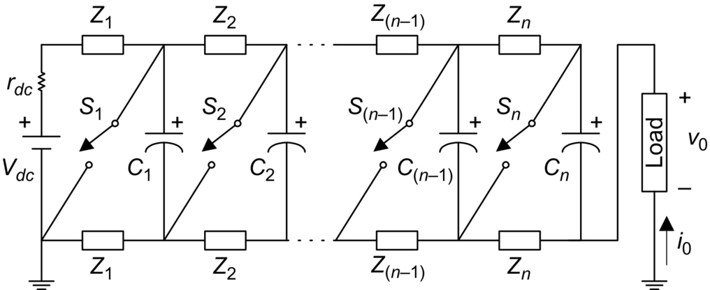

**FIG. 18.44** Marx generator topology for producing repetitive negative high-voltage pulses into a load.

When switches *Si* are turned *on*, the *Ci* capacitors are connected in series and apply a voltage into the load, equal to

 **(18.96)**

depending that the capacitors are charged to the power supply full voltage, *Vdc*. During this time, the bottom impedances *Zi* limit the self-short-circuit path of the *Ci* capacitors.

The circuit in [Fig. 18.44](https://learning.oreilly.com/library/view/power-electronics-handbook/9780128114087/B9780128114070000209_2.xhtml#f0225) is assembled in such a way that there is voltage modularity, meaning that each stage holds the power supply voltage *Vdc*. However, due to this parallel process, the first stages carry the total charging current, which sets different power requirements for the devices in each stage.

This concept has been used intensively through the years, with spark gaps used as switch *Si* for very high-voltages and powers, but the spark gap only turns *off* when the current goes to zero. Recent technological upgrades with the addition of solid-state switches and the replacement of most of the passive elements increased the lifetime of the modulator and allowed higher pulse repetition rates, meaning an improved performance [[22](https://learning.oreilly.com/library/view/power-electronics-handbook/9780128114087/B9780128114070000209_2.xhtml#bb0115),[56](https://learning.oreilly.com/library/view/power-electronics-handbook/9780128114087/B9780128114070000209_2.xhtml#bb0285)–[58](https://learning.oreilly.com/library/view/power-electronics-handbook/9780128114087/B9780128114070000209_2.xhtml#bb0295)].

#### **18.4.4.1 Generation of Negative Pulses**

During the last years, various semiconductor-based Marx and SM topologies have been described, with analogous characteristics in order to reduce the losses and increase the performance of the circuit for different types of applications and loads [[22](https://learning.oreilly.com/library/view/power-electronics-handbook/9780128114087/B9780128114070000209_2.xhtml#bb0115),[56](https://learning.oreilly.com/library/view/power-electronics-handbook/9780128114087/B9780128114070000209_2.xhtml#bb0285)–[58](https://learning.oreilly.com/library/view/power-electronics-handbook/9780128114087/B9780128114070000209_2.xhtml#bb0295)].

[Fig. 18.45](https://learning.oreilly.com/library/view/power-electronics-handbook/9780128114087/B9780128114070000209_2.xhtml#f0230) shows a typical SM topology, with *n* stages able to deliver negative high-voltage repetitive pulses into a load *RL*; the theoretical key waveforms are shown in [Fig. 18.46](https://learning.oreilly.com/library/view/power-electronics-handbook/9780128114087/B9780128114070000209_2.xhtml#f0235). Each stage of the SM consists of an energy storing capacitor *Ci*, a diode *Dci*, and two switches *Sci* and *Spi*, with antiparallel diodes, where the subscript *i*∈{1, 2, …, *n*−1, *n*, *n*+1}. The *Si* switches can be implemented with BJTs, GTOs, IGCTs, IGBTs, MOSFETS, or other *on-off* devices. The inclusion of *Sc*1 guarantees that during the pulse period, the dc charging power supply *Vdc* is not short-circuited, preventing high-current-load pulses through the power supply.

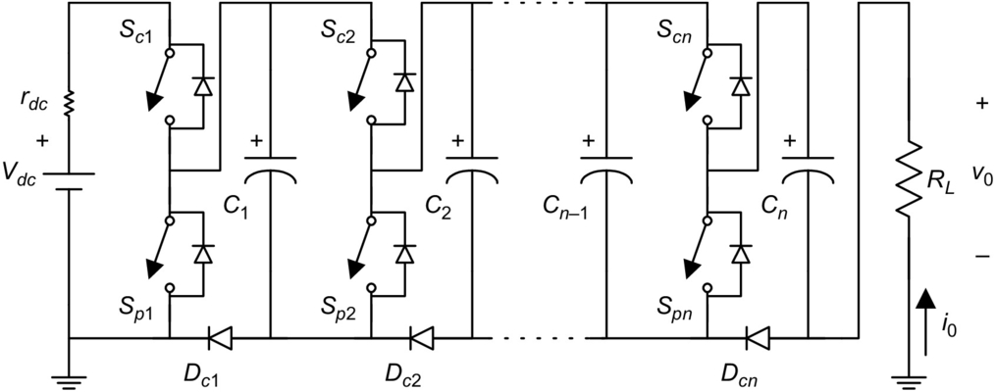

**FIG. 18.45** Circuit for applying HV negative repetitive pulses into resistive load.

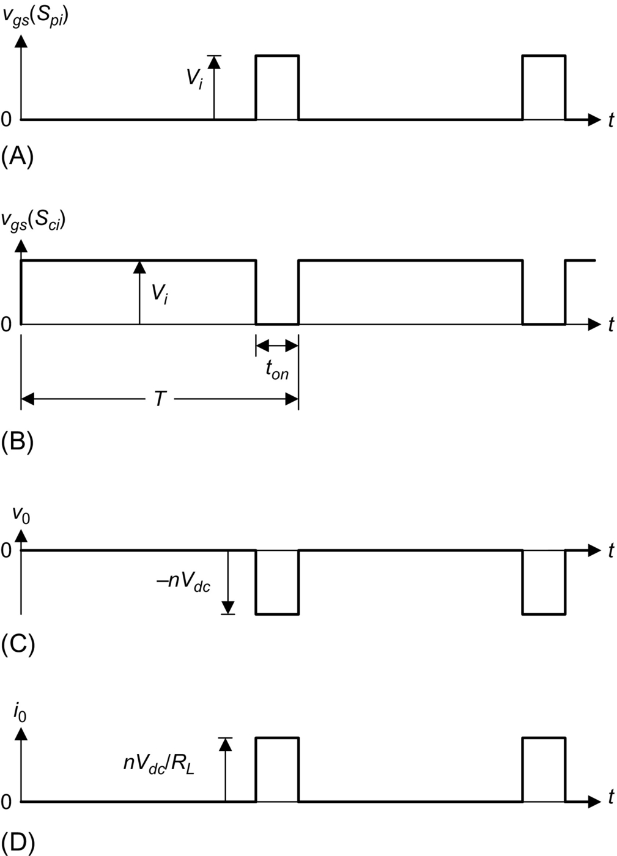

**FIG. 18.46** Theoretical waveform for the operation of the circuit in [Fig. 18.45](https://learning.oreilly.com/library/view/power-electronics-handbook/9780128114087/B9780128114070000209_2.xhtml#f0230): (A) trigger signal of switches *Spi*, *vgs*(*Spi*); (B) trigger signal of switches *Sci*, *vgs*(*Sci*); (C) output voltage, *v*0; and (D) output current, *i*0.

Considering resistive load, *RL*, the operation of the [Fig. 18.45](https://learning.oreilly.com/library/view/power-electronics-handbook/9780128114087/B9780128114070000209_2.xhtml#f0230) modulator can be understood considering two operating modes, for a switch duty ratio *D*=*ton*/*T*. In the first one, switches *Sci* and *Spi* are, respectively, turned *on* and turned *off*. During the charging period, (*T–ton*), capacitors *Ci* are charged from the dc charging power supply, *Vdc*, with current limited by the internal resistance of the semiconductors, the wires, and the dc charging power supply internal resistance (or externally added) *Rdc*, resulting in a small time constant that enables kHz operation. The *on*-state of *Dci* ensures that during this period, the voltage, *V*0, applied to the load is, approximately, zero.

In the second operating mode, switches *Sci* and *Spi* are, respectively, turned *off* and turned *on*. During the pulse mode, *ton*, capacitors *Ci* are connected in series and their voltage applied to the load. The load voltage *v*0 is proportional to the charging power supply:

 **(18.97)**

where *n* is the number of stages and *k*<1 characterizes the nonideal behavior of the passive and active elements in the circuit and operating conditions.

The *Dci* diodes guarantee, also, that the *Spi* switches only block a maximum voltage of *Vdc*, even in fault condition, such as the lack of synchronization. Considering [Fig. 18.45](https://learning.oreilly.com/library/view/power-electronics-handbook/9780128114087/B9780128114070000209_2.xhtml#f0230), for example, if switch *Tpn* is *off* during pulse mode, *Dcn* conducts and short-circuits the last stage, imposing an output voltage of

 **(18.98)**

The operation of [Fig. 18.45](https://learning.oreilly.com/library/view/power-electronics-handbook/9780128114087/B9780128114070000209_2.xhtml#f0230) circuit can be represented by its equivalent model during both operating modes, considering ideal switches and *Ci*=*C*. During the charging mode, the *Ci* capacitors are in parallel, and the circuit can be model as shown in [Fig. 18.47A](https://learning.oreilly.com/library/view/power-electronics-handbook/9780128114087/B9780128114070000209_2.xhtml#f0240), where *nC* is the equivalent capacitance, seen by the power supply, charged with *Vdc*. In addition, during pulse mode, the *Ci* capacitors are in series, where *C*/*n* is the equivalent capacitance, seen by the load, charged with *nVdc*, as shown in [Fig. 18.47B](https://learning.oreilly.com/library/view/power-electronics-handbook/9780128114087/B9780128114070000209_2.xhtml#f0240).

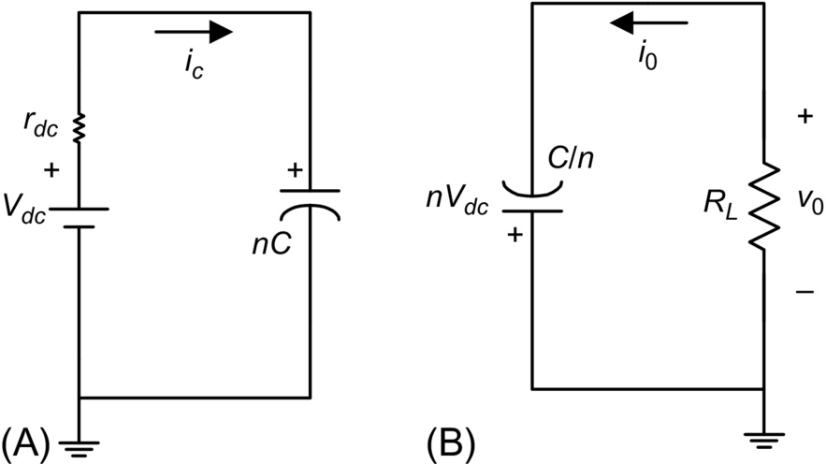

**FIG. 18.47** Equivalent circuit of [Fig. 18.45](https://learning.oreilly.com/library/view/power-electronics-handbook/9780128114087/B9780128114070000209_2.xhtml#f0230): (A) the charging mode and (B) the pulse mode, for negative output pulses.

The energy stored in the *Ci* capacitors, during *T–ton*, is

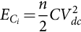 **(18.99)**

and the energy delivered to the load, during *ton*, is

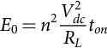 **(18.100)**

For pulse power applications, only a small fraction of the stored energy should be transferred to the output during the pulse mode, otherwise the pulse voltage has a typical RC discharge waveform, not an almost rectangular shape. Considering a resistive load *RL*, the capacitance of the *Ci* capacitors in [Fig. 18.45](https://learning.oreilly.com/library/view/power-electronics-handbook/9780128114087/B9780128114070000209_2.xhtml#f0230) circuit can be determined according to energy delivered to the load. For the required pulse voltage droop,

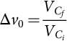 **(18.101)**

where  is the capacitor voltage at the end-of-pulse mode, *ton*, and  is the capacitors voltage immediately before pulse mode. Considering Eq. [(18.101)](https://learning.oreilly.com/library/view/power-electronics-handbook/9780128114087/B9780128114070000209_2.xhtml#fo0720), the difference between Eqs. [(18.99)](https://learning.oreilly.com/library/view/power-electronics-handbook/9780128114087/B9780128114070000209_2.xhtml#fo0710) and [(18.100)](https://learning.oreilly.com/library/view/power-electronics-handbook/9780128114087/B9780128114070000209_2.xhtml#fo0715) is the energy stored in the *Ci* capacitors at end-of-pulse mode, :

 **(18.102)**

where Eq. [(18.102)](https://learning.oreilly.com/library/view/power-electronics-handbook/9780128114087/B9780128114070000209_2.xhtml#fo0725) for this case results in

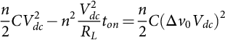 **(18.103)**

Assuming that , equating [(18.103)](https://learning.oreilly.com/library/view/power-electronics-handbook/9780128114087/B9780128114070000209_2.xhtml#fo0730), the capacitor value should satisfy the condition

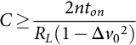 **(18.104)**

Considering Eqs. [(18.99)](https://learning.oreilly.com/library/view/power-electronics-handbook/9780128114087/B9780128114070000209_2.xhtml#fo0710) through [(18.104)](https://learning.oreilly.com/library/view/power-electronics-handbook/9780128114087/B9780128114070000209_2.xhtml#fo0735), it is mandatory to have storage energy greater than five times the pulse energy in order to have an output voltage droop better than 10%, but if a 1% voltage droop is expected, a 50 times storage energy is required, which impose limits to the design of the modulator.

The power dissipation in the switches and the capacitors charging time impose a high-voltage pulse frequency limitation. Therefore, this circuit operates better with low duty ratio, *D*, pulses as required in most PP applications.

In addition, the *Vdc* power supply must be able to charge the *Ci* capacitors with an energy equal to the delivered pulse energy, *E*0, plus losses during the charging time, *T–ton*:

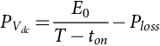 **(18.105)**

where the *Ploss* term represents the power dissipated in the circuit wiring and switches.

This determines the maximum power rating for the *Vdc* power supply that imposes the maximum operating frequency, pulse duty ratio, and load power to the modulator.

To build and operate the circuit of [Fig. 18.45](https://learning.oreilly.com/library/view/power-electronics-handbook/9780128114087/B9780128114070000209_2.xhtml#f0230), some design consideration must be considered. First, during start-up, when the energy storing capacitors are completely discharged, the charging voltage *Vdc* must be slowly increased in order to limit the charging current on the switches *Sci* and *Dci*, which is critical in the first stages due to the parallel charging topology of the capacitors.

Actually, in the parallel charging method, the semiconductor modules current loading is not equal. For instance, in the [Fig. 18.45](https://learning.oreilly.com/library/view/power-electronics-handbook/9780128114087/B9780128114070000209_2.xhtml#f0230) circuit, switch *Sc*1 conducts current required to capacitors *C*1, *C*2…, *Cn–*1, *Cn*, switch *Sc*2 conducts charging current for *C*2, *C*3…, *Cn*–1, *Cn*, and so forth. Thus, in practical implementation, modules with successive decreasing current ratings can be used, the benefits of standardization being somewhat compromised.

Also, the *Sci* and *Spi* switches conduct different current values, respectively, the discharge and pulse current. Hence, instead of switches needing to block unequal voltages, they are required to conduct unequal currents.

Consequently, when choosing semiconductors to implement the *S* switches, it is fundamental that the semiconductor current rating must be selected to guarantee that the devices work always in the saturation region inside the forward safe operating area. If not, during the first instants of the *on*-state (when the current is high) the semiconductors can operate in the active region where the voltage drop and losses are higher, which might destroy the devices.

The switches triggering is another important concern in these circuits. There are two drive signals, *vgs*(*Spi*) and *vgs*(*Sci*), respectively, to *Spi* and *Sci*, which should be triggered synchronously. Since all the semiconductor switches are at different high-voltage potentials, gate drive circuits with galvanic isolation are required (the use of optical fibers is mandatory to transmit the gate signals and to reduce stray capacitances to ground and neighbor cells), together with isolated power supplies to further process the transmitted gate signal and supply power to the gate drivers.

Several authors have come up with solutions to supply power to semiconductor triggering drivers for high-voltage applications. The most common include isolation transformers [[59](https://learning.oreilly.com/library/view/power-electronics-handbook/9780128114087/B9780128114070000209_2.xhtml#bb0300)], but diode strings are also described [[57](https://learning.oreilly.com/library/view/power-electronics-handbook/9780128114087/B9780128114070000209_2.xhtml#bb0290)].

The circuit in [Fig. 18.45](https://learning.oreilly.com/library/view/power-electronics-handbook/9780128114087/B9780128114070000209_2.xhtml#f0230) enables the use of typical half-bridge semiconductor structures currently integrated in modular packages, which is advantageous to assemble the circuit and trigger the semiconductors, since it allows bootstrap operation [[10](https://learning.oreilly.com/library/view/power-electronics-handbook/9780128114087/B9780128114070000209_2.xhtml#bb0055)].

However, the circuit topology shown in [Fig. 18.45](https://learning.oreilly.com/library/view/power-electronics-handbook/9780128114087/B9780128114070000209_2.xhtml#f0230) is not suitable for dealing with capacitive loads. In fact, if a capacitive-type load is connected to the circuit output, the load stays charged after the HV pulse with a negative voltage until the charging mode of the energy storing capacitors. However, during the charging period, the load is not shorted by the *Dci*, except if the energy stored in the load is very low and the charging current of capacitors *Ci* is sufficient to turn-on diodes *Dci*.

In order to guarantee the discharge of the load capacitances after the negative HV pulse, it is necessary to change the [Fig. 18.45](https://learning.oreilly.com/library/view/power-electronics-handbook/9780128114087/B9780128114070000209_2.xhtml#f0230) circuit topology for the one shown in [Fig. 18.48](https://learning.oreilly.com/library/view/power-electronics-handbook/9780128114087/B9780128114070000209_2.xhtml#f0245), which also produces negative HV pulses into the load.

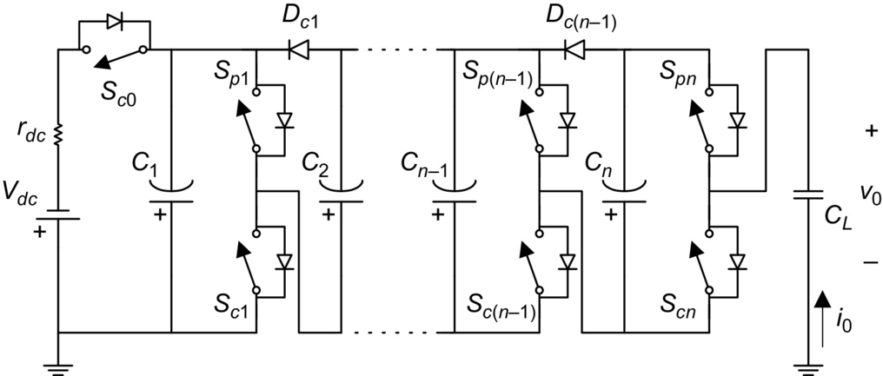

**FIG. 18.48** Circuit for applying HV negative repetitive pulses into a capacitive load, with a negative dc power supply, *Vdc*.

Considering the circuit in [Fig. 18.48](https://learning.oreilly.com/library/view/power-electronics-handbook/9780128114087/B9780128114070000209_2.xhtml#f0245), as the *Vdc* power supply is negative, it is necessary to change the topology in comparison with [Fig. 18.45](https://learning.oreilly.com/library/view/power-electronics-handbook/9780128114087/B9780128114070000209_2.xhtml#f0230) in order to maintain a similar operating behavior. The two main differences are the addition of an extra switch, *Sc*0, which guarantees that during the pulse period, the dc charging power supply *Vdc* does not participate in the pulse mode, *ton*. The most important regards the fact that during the charging period, *T–ton*, the *Sci* switches short-circuit the load discharging any capacitance, as the one shown in [Fig. 18.48](https://learning.oreilly.com/library/view/power-electronics-handbook/9780128114087/B9780128114070000209_2.xhtml#f0245).

Considering now the application of negative HV pulses into inductive loads, the circuit in [Fig. 18.45](https://learning.oreilly.com/library/view/power-electronics-handbook/9780128114087/B9780128114070000209_2.xhtml#f0230) requires an additional half-bridge switching structure that connects to the load, as shown in [Fig. 18.49](https://learning.oreilly.com/library/view/power-electronics-handbook/9780128114087/B9780128114070000209_2.xhtml#f0250).

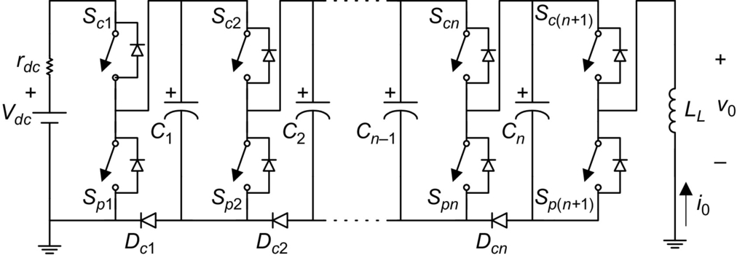

**FIG. 18.49** Circuit for applying HV negative repetitive pulses into an inductive load.

As shown in [Fig. 18.50](https://learning.oreilly.com/library/view/power-electronics-handbook/9780128114087/B9780128114070000209_2.xhtml#f0255), the operation of the circuit in [Fig. 18.49](https://learning.oreilly.com/library/view/power-electronics-handbook/9780128114087/B9780128114070000209_2.xhtml#f0250) in comparison with circuit of [Fig. 18.45](https://learning.oreilly.com/library/view/power-electronics-handbook/9780128114087/B9780128114070000209_2.xhtml#f0230), has some changes, which includes one additional time period for enabling the reset of the inductive load by the freewheeling diodes, *Tab*, besides the charging, *Tc*, and pulse modes, *ton*, in order to impose a zero average voltage to the load.

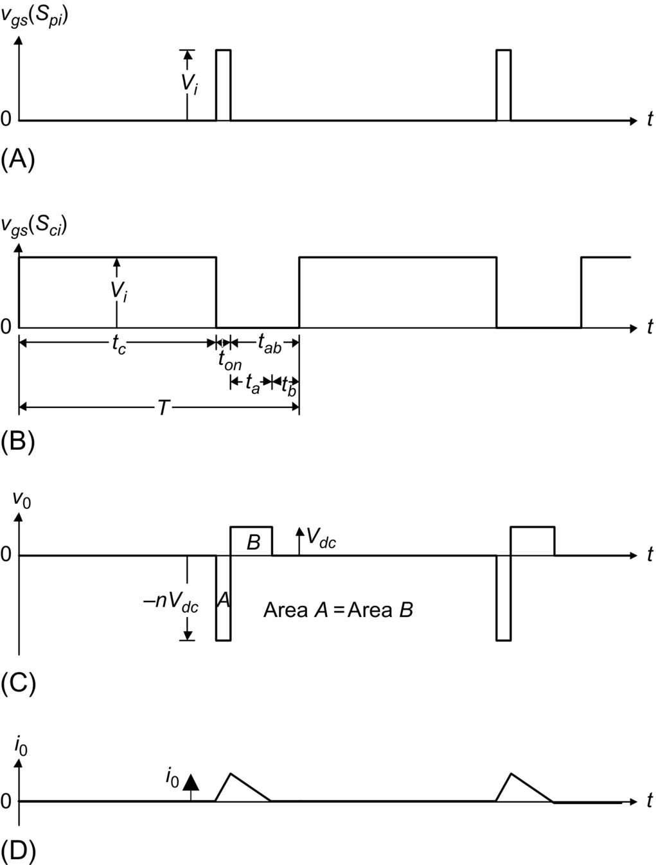

**FIG. 18.50** Theoretical waveform for the operation of the circuit in [Fig. 18.49](https://learning.oreilly.com/library/view/power-electronics-handbook/9780128114087/B9780128114070000209_2.xhtml#f0250): (A) trigger signal of switches *Spi*, *vgs*(*Spi*); (B) trigger signal of switches *Sci*, *vgs*(*Sci*); (C) output voltage, *v*0; and (D) output current, *I*0.

During the charging period, the *on*-state of *Dci* and the *Sp*(*n*+1) antiparallel diode ensures that the output voltage, *V*0, applied to the load is approximately zero.

After the HV negative pulse, *ton*, the *Sci* and *Spi* switches are turned *off*, but in order to conserve energy, the inductive load current, *i*0, must have an alternative path. This path is set by freewheeling diodes (*Sci* antiparallel diodes and *Dci* diodes) and the capacitor with the lowest voltage, which is charged. Normally, *Cn* has the lowest voltage; thus, the current path is through the *Sc*(*n*+1) antiparallel diode *DB*, capacitor *Cn*, and diodes *Dc*1–*Dcn*. During this time, *Ta*, the voltage applied to the load is, about, *Vdc* (voltage in capacitor *Cn*), resetting the inductive load. Capacitor *Cn* is charged until its voltage is equal to the capacitor *Cn*–1 voltage, after which, if there is still energy in the load, the current path changes to capacitor *Cn*–1. As the maximum clamping voltage is *Vdc*, the higher the number of stages the longer the resetting time.

In this way, most of the load magnetic energy is sent back to energy storing capacitors *Ci*, after which the load current *i*0 goes to zero, and it can be imposed again the charging mode of operation. It is important to have a safety time *tb* in order to guarantee the completely reset of the load. Due to this load energy recovery method, the power supply energy needed to charge the capacitors after each pulse is lower, and the yield of this modulator can be higher.

**Example 18.9**

A negative solid-state Marx generator needs to be assembled for delivering −9 kV and 25 μs pulses into a 900 Ω resistive load, with less than 20% voltage droop. Considering the existing equipment, there are two alternatives: (1) *Vdc*=1.5 kV, *n*=6, and *Ci*=1 μF and (2) *Vdc*=1 kV, *n*=9, and *Ci*=1 μF. Determine which is the best alternative.

Solution

Considering the capacitance of 1 μF in each stage, then, the pulse voltage droop can be determined by Eq. [(18.104)](https://learning.oreilly.com/library/view/power-electronics-handbook/9780128114087/B9780128114070000209_2.xhtml#fo0735). Hence, for the first alternative,

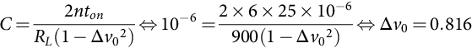

and for the second alternative,

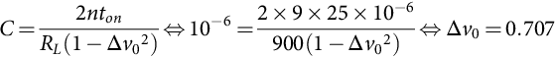

which gives, respectively, 18.35% and 29.23% voltage droop, meaning that after the pulse the capacitors stay charged with about Eq. [(18.101)](https://learning.oreilly.com/library/view/power-electronics-handbook/9780128114087/B9780128114070000209_2.xhtml#fo0720), respectively, 1224.7 and 707.1 V. Hence, only the first alternative keeps the pulse voltage droop below 20%. In this case, the energy stored in the capacitors is Eq. [(18.99)](https://learning.oreilly.com/library/view/power-electronics-handbook/9780128114087/B9780128114070000209_2.xhtml#fo0710) 6.75 J, three times bigger than the energy delivered to the load during each pulse Eq. [(18.100)](https://learning.oreilly.com/library/view/power-electronics-handbook/9780128114087/B9780128114070000209_2.xhtml#fo0715) 2.25 J.

#### **18.4.4.2 Generation of Positive Pulses**

The solid-state Marx modulators for generating positive HV pulses, with different load conditions, have equivalent properties as the ones for negative pulses, shown in the last section, besides the necessary modifications to enable the change in the output polarity. Thus, [Fig. 18.51](https://learning.oreilly.com/library/view/power-electronics-handbook/9780128114087/B9780128114070000209_2.xhtml#f0260) shows the basic topology of the SM, with *n* stages, able to deliver positive high-voltage repetitive pulses into resistive and capacitive loads, *RLCL*.

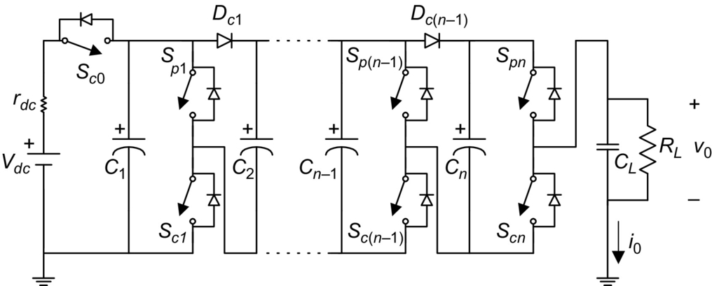

**FIG. 18.51** Circuit for applying HV positive repetitive pulses into resistive and capacitive loads.

During the pulse mode, *ton*, the switches *Sci* and *Spi* are, respectively, turned *off* and turned *on*. Capacitors *Ci* are connected in series and their voltage applied to the load. The load voltage *v*0 is proportional to the charging power supply:

 **(18.106)**

where *n* is the number of stages and *k*<1 characterizes the nonideal behavior of the passive and active elements in the circuit and operating conditions. Also, in this topology, for example, if *Spn* is *off* during pulse mode, the antiparallel *Scn* diode conducts and short-circuits the last stage, imposing an output voltage of

 **(18.107)**

Actually, the [Fig. 18.51](https://learning.oreilly.com/library/view/power-electronics-handbook/9780128114087/B9780128114070000209_2.xhtml#f0260) circuit is equivalent to [Fig. 18.45](https://learning.oreilly.com/library/view/power-electronics-handbook/9780128114087/B9780128114070000209_2.xhtml#f0230) circuit, whereas in this case with a positive *Vdc* power supply, it can produce positive HV pulses for both resistive and capacitive loads. The capacitive load can be driven, given that during the charging mode of capacitors *Ci*, the load is short-circuited by the *Sci* switches, stray inductances limiting the discharge rate.

Considering now the application of positive HV pulses into inductive loads, the circuit in [Fig. 18.51](https://learning.oreilly.com/library/view/power-electronics-handbook/9780128114087/B9780128114070000209_2.xhtml#f0260) requires an additional switch *Sp*0 and diode *D*0 at the input, as shown in [Fig. 18.52](https://learning.oreilly.com/library/view/power-electronics-handbook/9780128114087/B9780128114070000209_2.xhtml#f0265).

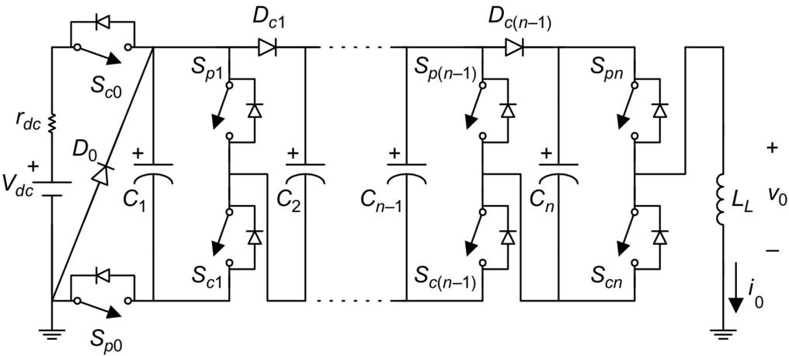

**FIG. 18.52** Circuit for applying HV positive repetitive pulses into an inductive load.

The circuit operation requires, also, an additional time period for resetting the inductive load by the added freewheeling diodes, *tab*, in addition to the charging, *tc*, and pulse modes, *ton*, in order to impose a zero average voltage to the load.

Considering an inductive load, after the HV positive pulse, the *Sci* and *Spi* switches are *off*, and the path for the inductive current *i*0 is set by the capacitor *Cn*, which usually has the lowest voltage, the *Sci* antiparallel diode and diode *DB*. During this time, the voltage applied to the load is approximately −*Vdc* (the voltage in capacitor *Cn*), resetting the inductive load. After the load current *i*0 goes to zero, the charging mode of operation can be imposed.

### 18.4.5 SOLID-STATE MARX-BASED HIGH-VOLTAGE SWITCHES

The solid-state Marx generator concept described in the last section can be used for distributing the voltage in series-stacked semiconductors. Further, the Marx generator circuit can be used as a series switch, maintaining some intrinsic properties, which are desirable for the use with relatively low-voltage semiconductors, such as equal voltage distribution between stages and the fact the semiconductors in each stage hold off only the stage voltage capacitor.

The Marx series switch, based on the solid-state Marx of [Fig. 18.51](https://learning.oreilly.com/library/view/power-electronics-handbook/9780128114087/B9780128114070000209_2.xhtml#f0260), for positive voltages, is shown in [Fig. 18.53](https://learning.oreilly.com/library/view/power-electronics-handbook/9780128114087/B9780128114070000209_2.xhtml#f0270) not to apply voltage but to hold it between its terminals. Therefore, the input power supply *Vdc* is removed, and the *Spi* switches are replaced by diodes *Dpi*. Also, resistors *Rci* are connected in parallel with the *Dci* diodes in order to balance the voltage in the capacitors *Ci*.

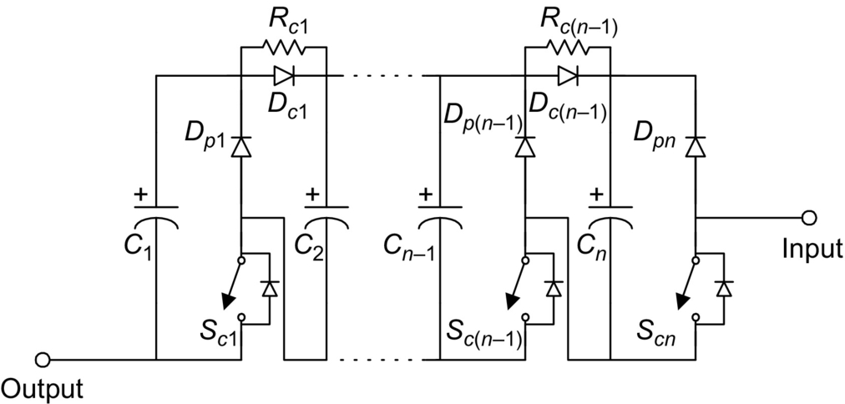

**FIG. 18.53** Series switch for positive voltages based on the Marx concept.

Consider the common HV pulse power topology of [Fig. 18.54](https://learning.oreilly.com/library/view/power-electronics-handbook/9780128114087/B9780128114070000209_2.xhtml#f0275), where switches *S*1 and *S*2 commutate alternately. A HV power supply, *Vdc*, charges an energy storage capacitor *Cdc*, with current limited by resistor *Rdc*. The switch *S*1 applies the capacitor *Cdc* voltage *vc* to the capacitive load *CL*||*RL*, during the pulse period, *ton*. Subsequently, switch *S*2 discharges the load and other circuit parasitic capacitances to zero.

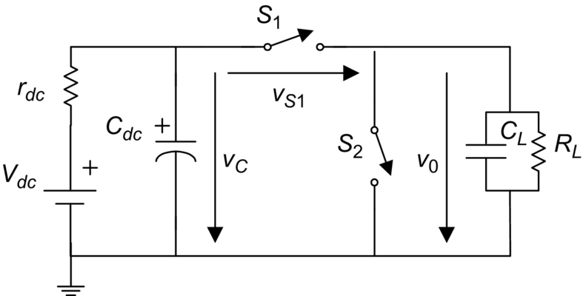

**FIG. 18.54** Proposed pulsed power HV topology for describing the operation of the series switch (buck type) of [Fig. 18.53](https://learning.oreilly.com/library/view/power-electronics-handbook/9780128114087/B9780128114070000209_2.xhtml#f0270).

Taking into account the proposed operating scheme, each switch *Si*, where *i*∈{1, 2}, holds a maximum voltage equal to the power supply voltage amplitude, *Vdc*, considering that the capacitor *Cdc* is charged with the voltage *Vdc*. When *S*1 is conducting, *S*2 holds off the voltage *Vdc*, and when *S*2 is conducting, *S*1 holds off the voltage *Vdc*. Hence, if the voltage *Vdc* is greater than a couple of kV, a solid-state switch comprising series-stacked semiconductors is mandatory for implementing switches *S*1 and *S*2.

The switching frequency of *S*1 and *S*2 and the pulse *on* time depend on the energy stored in the *Cdc* capacitor, on the load consumption, and on the power dissipated in the switches during commutation.

The proposed PP topology in [Fig. 18.54](https://learning.oreilly.com/library/view/power-electronics-handbook/9780128114087/B9780128114070000209_2.xhtml#f0275) implemented with the series switch of [Fig. 18.53](https://learning.oreilly.com/library/view/power-electronics-handbook/9780128114087/B9780128114070000209_2.xhtml#f0270) as series switch *S*1 (Marx 1) and *S*2 (Marx 2) is shown in [Fig. 18.55](https://learning.oreilly.com/library/view/power-electronics-handbook/9780128114087/B9780128114070000209_2.xhtml#f0280).

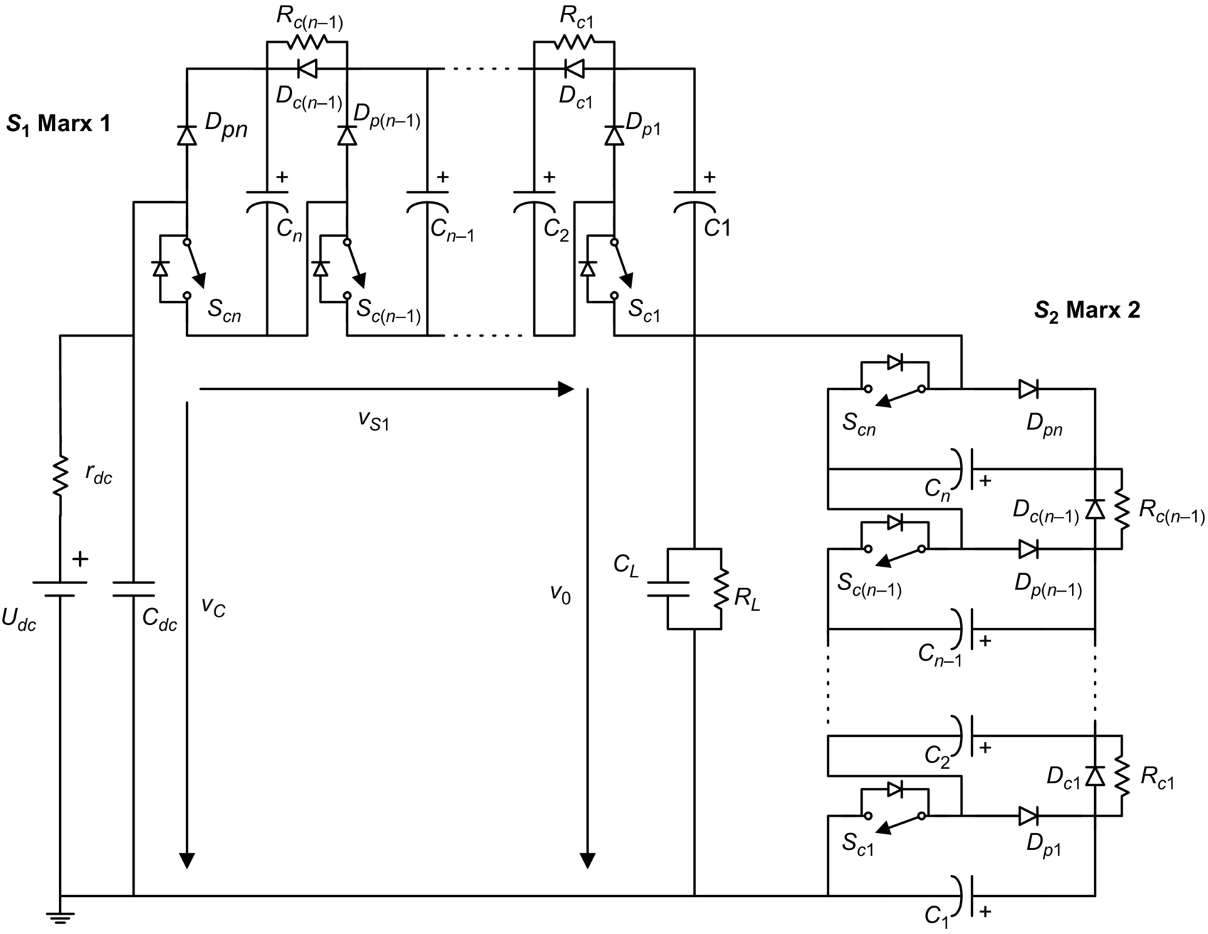

**FIG. 18.55** Proposed pulsed power topology for testing the new series switches.

The operation of [Fig. 18.55](https://learning.oreilly.com/library/view/power-electronics-handbook/9780128114087/B9780128114070000209_2.xhtml#f0280) circuit can be understood considering the concept presented in [Fig. 18.53](https://learning.oreilly.com/library/view/power-electronics-handbook/9780128114087/B9780128114070000209_2.xhtml#f0270) and the voltage waveforms presented in [Fig. 18.57](https://learning.oreilly.com/library/view/power-electronics-handbook/9780128114087/B9780128114070000209_2.xhtml#f0290). For the first operating mode, during time *ton*, the *Sci* switches in Marx 1 are *on*, the *Ci* capacitors in Marx 1 are in parallel, and the *Sci* switches in Marx 2 are *off*, as shown in [Fig. 18.56A](https://learning.oreilly.com/library/view/power-electronics-handbook/9780128114087/B9780128114070000209_2.xhtml#f0285). The capacitor *Cdc* voltage, *vc*, is applied into the load, *v*0, and the *Ci* capacitors in Marx 2 are stacked in series, through the *Dpi* diodes, distributing the voltage across the *Sci* switches, in parallel with the load.

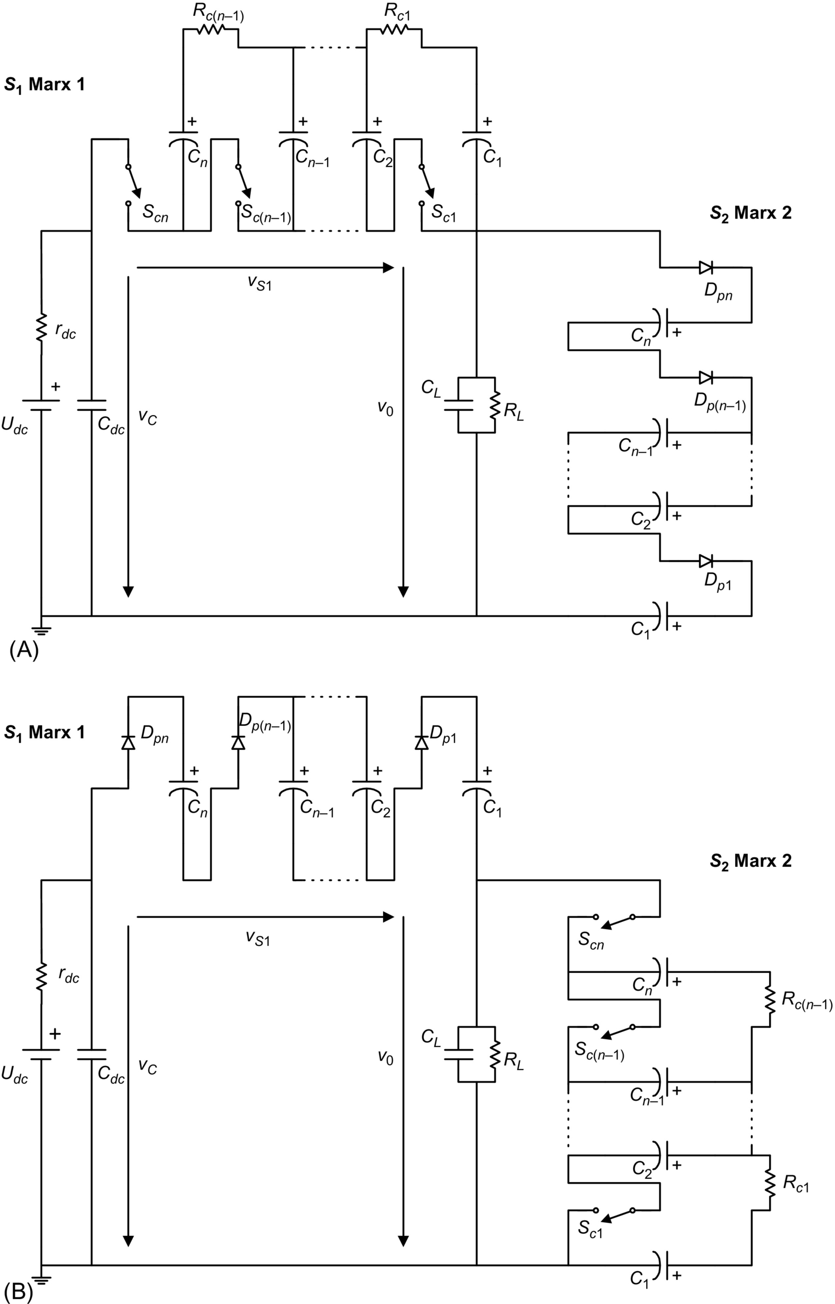

**FIG. 18.56** Operating modes for the [Fig. 18.55](https://learning.oreilly.com/library/view/power-electronics-handbook/9780128114087/B9780128114070000209_2.xhtml#f0280) circuit: (A) voltage applied to the load and (B) load discharge.



**FIG. 18.57** Theoretical waveforms for [Fig. 18.55](https://learning.oreilly.com/library/view/power-electronics-handbook/9780128114087/B9780128114070000209_2.xhtml#f0280) circuit operation: (A) Marx 1 *Sci* drive signal, (B) Marx 2 *Sci* drive signal, (C) load voltage *v*0, and (D) Marx 1 voltage *Vs*1.

Subsequently, in the second operating mode, during time *T–ton*, the *Sci* switches in Marx 1 are *off* and the *Sci* switches in Marx 2 are *on*, and the load is discharged to zero, as shown in [Fig. 18.56B](https://learning.oreilly.com/library/view/power-electronics-handbook/9780128114087/B9780128114070000209_2.xhtml#f0285). The *vc* voltage appears between the Marx 1 terminals as shown in [Fig. 18.57D](https://learning.oreilly.com/library/view/power-electronics-handbook/9780128114087/B9780128114070000209_2.xhtml#f0290), where this voltage is sustained by the *Ci* capacitors in series through the *Dpi* diodes, distributing the voltage across the *Sci* switches.

Unlike in a typical Marx generator, the *Ci* capacitors in both Marx 1 and Marx 2 of [Fig. 18.55](https://learning.oreilly.com/library/view/power-electronics-handbook/9780128114087/B9780128114070000209_2.xhtml#f0280) can suffer from voltage imbalance problems due to the fact that the *Ci* capacitors are charged in series: (i) in Marx 1 during period *T–ton* when the load is short-circuited and the voltage *vC* appears between the Marx 1 terminals, *vS*1, and (ii) in Marx 2 during period *ton* when the voltage is applied to the load and the voltage *VC* appears between the Marx 2 terminals.

Two main causes contribute to this voltage imbalance: (i) The *Ci* capacitance values are not equal, and (ii) the *Ci* capacitors placed near the *Vdc* power supply are charged with a higher voltage due to the voltage droop in the semiconductors in each stage. Considering the last, the *Dci* diodes do not conduct, and *Rci* are used in parallel to uniformly distribute the voltage between the *Ci* capacitors during (i) *ton* in the Marx 1 switch and (ii) *T–ton* in Marx 2 switch. Alternatively, extra switches can be placed in antiparallel with diodes *Dci*.

### 18.4.6 SOLID-STATE MARX-BASED BIPOLAR GENERATORS

The Marx generator concept was extended in Ref. [[60](https://learning.oreilly.com/library/view/power-electronics-handbook/9780128114087/B9780128114070000209_2.xhtml#bb0305)] to allow the generation of positive and/or negative pulses. This bipolar Marx generator is shown in [Fig. 18.58](https://learning.oreilly.com/library/view/power-electronics-handbook/9780128114087/B9780128114070000209_2.xhtml#f0295), based in *n* modules with four controlled semiconductors *Tfi*, *Tei*, *Tai*, *Tbi*, (*i*∈{1,2,…,*n*}), two diodes *Dhi*, *Dgi*, and energy storage capacitor *Ci*.

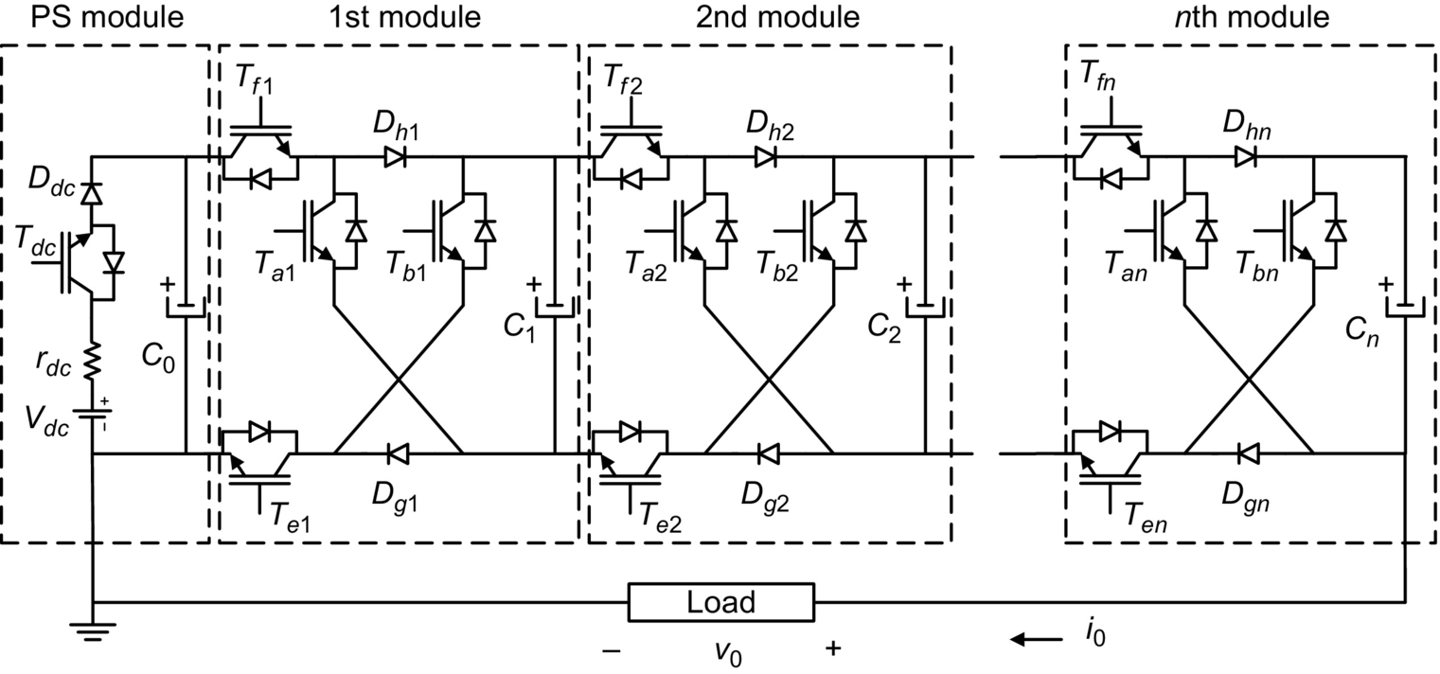

**FIG. 18.58** Solid-state Marx-type bipolar generator topology, with n modules of four switches, enabling unipolar or bipolar pulse generation [[60](https://learning.oreilly.com/library/view/power-electronics-handbook/9780128114087/B9780128114070000209_2.xhtml#bb0305)].

During the charging period, the dc power supply *Vdc* charges the *Ci* capacitors in parallel from the power supply and *C*0 capacitor by turning ON switches *Tdc*, *Ddc*, *Tfi*, and *Tei*, through diodes *Dhi* and *Dgi* ([Fig. 18.59](https://learning.oreilly.com/library/view/power-electronics-handbook/9780128114087/B9780128114070000209_2.xhtml#f0300)). The *on*-state of *Tei* and *Dgi* switches, during this period, may guarantee a near-zero value to the load voltage, *V*0, provided the charging current is bigger than the load current.



**FIG. 18.59** Charging mode in the solid-state Marx-type bipolar generator [[60](https://learning.oreilly.com/library/view/power-electronics-handbook/9780128114087/B9780128114070000209_2.xhtml#bb0305)].

To obtain positive pulses, only switches *Tfi* and *Tai* are driven *on* ([Fig. 18.60](https://learning.oreilly.com/library/view/power-electronics-handbook/9780128114087/B9780128114070000209_2.xhtml#f0305)). For negative pulses, only switches *Tbi* and *Tei* are driven *on* ([Fig. 18.61](https://learning.oreilly.com/library/view/power-electronics-handbook/9780128114087/B9780128114070000209_2.xhtml#f0310)).



**FIG. 18.60** Positive pulse operation in the solid-state Marx-type bipolar generator [[60](https://learning.oreilly.com/library/view/power-electronics-handbook/9780128114087/B9780128114070000209_2.xhtml#bb0305)].



**FIG. 18.61** Negative pulse generation in the solid-state Marx-type bipolar topology [[60](https://learning.oreilly.com/library/view/power-electronics-handbook/9780128114087/B9780128114070000209_2.xhtml#bb0305)].

### 18.4.7 SOLID-STATE MARX-BASED MULTILEVEL BIPOLAR GENERATORS

Some of the previous presented Marx modulators may be used to generate staircase like voltage waveforms with multiple voltage levels, which can be useful to reduce electromagnetic interference since the rate of change of the pulse voltage is reduced regarding the two level voltage pulse.

The solid-state Marx-based high-voltage switch of [Fig. 18.55](https://learning.oreilly.com/library/view/power-electronics-handbook/9780128114087/B9780128114070000209_2.xhtml#f0280) can be enhanced by adding an antiparallel transistor to diodes *Dpi*, to obtain one of the 2(*n*−1) modules of the multilevel bipolar generator in [Fig. 18.62A](https://learning.oreilly.com/library/view/power-electronics-handbook/9780128114087/B9780128114070000209_2.xhtml#f0315), able to output *n* voltage levels [[61](https://learning.oreilly.com/library/view/power-electronics-handbook/9780128114087/B9780128114070000209_2.xhtml#bb0310)]. The extra transistor and the *Dk-*1*,k* module interconnecting diode enable a better control of the charge/discharge of the storage capacitors *Ck*, since they can be connected in series with the capacitors in other modules to charge/discharge, or in parallel with some other capacitors to balance their voltages [Fig. 18.62B](https://learning.oreilly.com/library/view/power-electronics-handbook/9780128114087/B9780128114070000209_2.xhtml#f0315), provided diode *Dk-*1,*k* is forward-biased [[61](https://learning.oreilly.com/library/view/power-electronics-handbook/9780128114087/B9780128114070000209_2.xhtml#bb0310)].

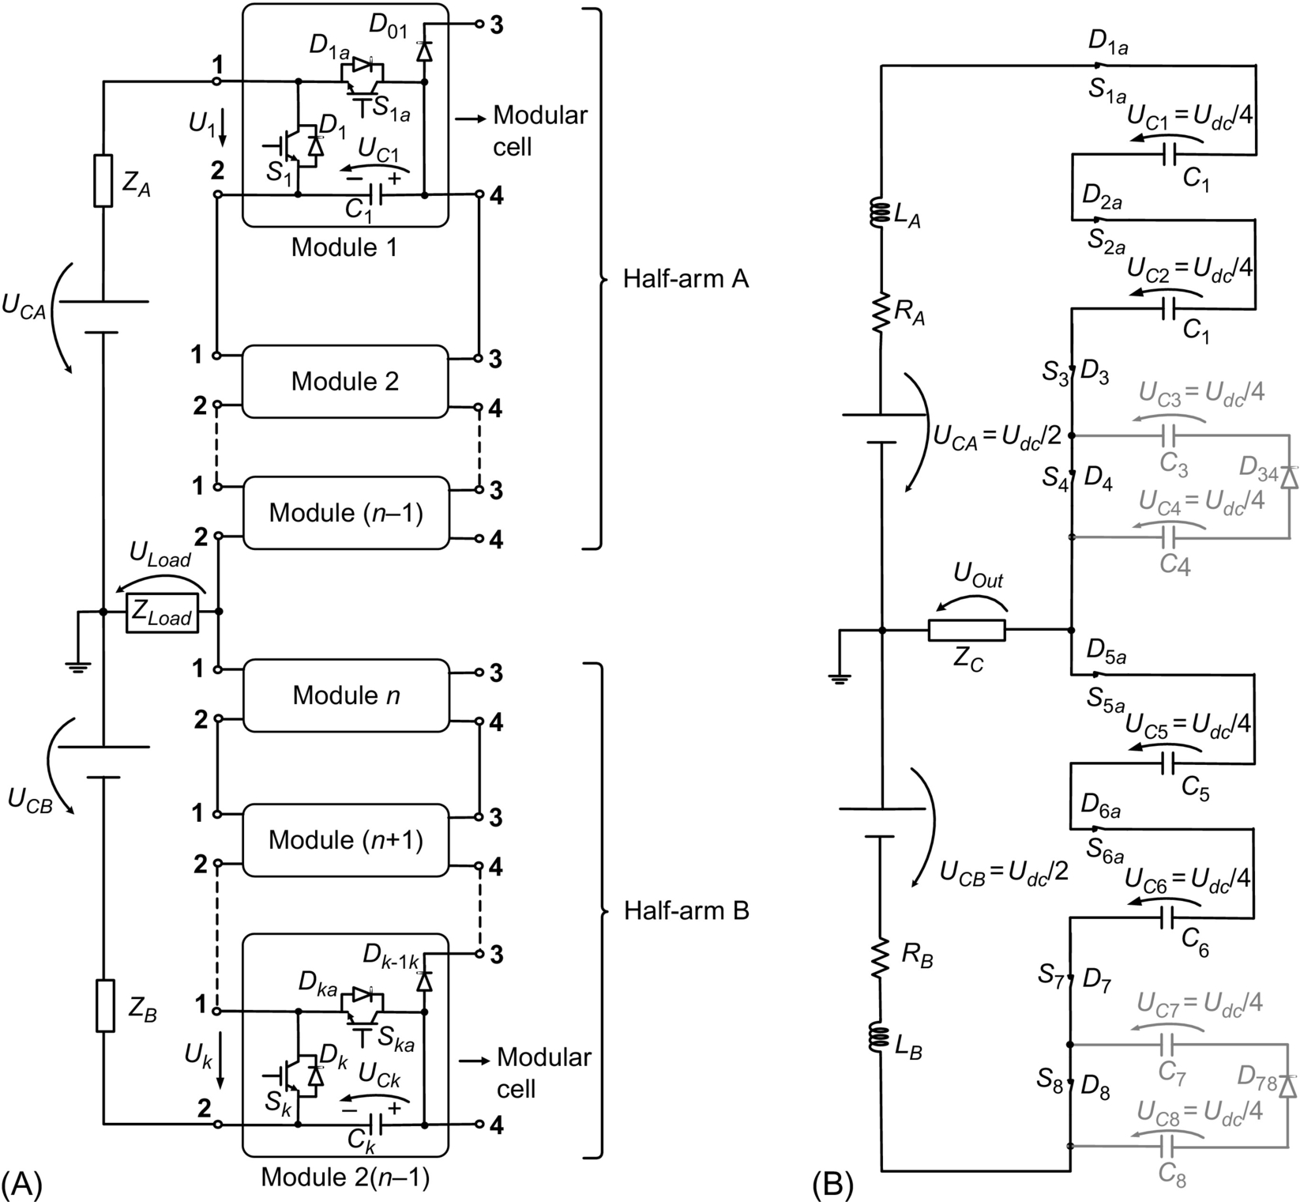

**FIG. 18.62** (A) Solid-state Marx-based multilevel bipolar generator with *n* levels using 2(*n*−1) modules and (B) five-level generator with level 0 V, *UOut*=0 V, showing one possibility of series and parallel connection of energy storage capacitors.

The *Ck* capacitors are charged in series (being *UCk*≈*Udc*/(*n*−1)).

Considering a boolean switching function *γk*, the voltage *Uk* of each module is written as

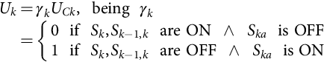 **(18.108)**

Neglecting parasitic voltage drops, the load pulse voltage *ULoad* is

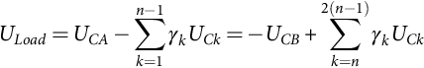 **(18.109)**

Supposing *UCA*=*UCB*=*Udc*/2, summing and subtracting the two previous equations, it can be obtained:

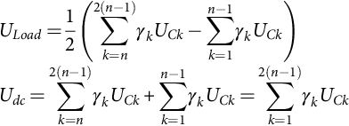 **(18.110)**

To obtain the maximum output voltage *ULoadmax*=*Udc*/2, it must be , which from the second equation of [(18.110)](https://learning.oreilly.com/library/view/power-electronics-handbook/9780128114087/B9780128114070000209_2.xhtml#fo0775) means . Supposing balanced capacitor voltages, then, each capacitor voltage is . To generate the minimum voltage, *ULoadmin*=−*Udc*/2, and then, , being . These relationships show that each generator half arm must hold off the high-voltage *Udc*. From , which must be used to define the *γk* values needed for each level *n*. This means that half of the total 2(*n*−1) modules must have *γk*=1, while the remaining half must have *γk*=0. The *γk* values can create redundant states that must be used to balance the *Ck* capacitor voltages [[61](https://learning.oreilly.com/library/view/power-electronics-handbook/9780128114087/B9780128114070000209_2.xhtml#bb0310)].

[Fig. 18.63](https://learning.oreilly.com/library/view/power-electronics-handbook/9780128114087/B9780128114070000209_2.xhtml#f0320) shows the simulated output voltage of a seven levels (500 V each) 12 modules bipolar generator, including the zero voltage level.

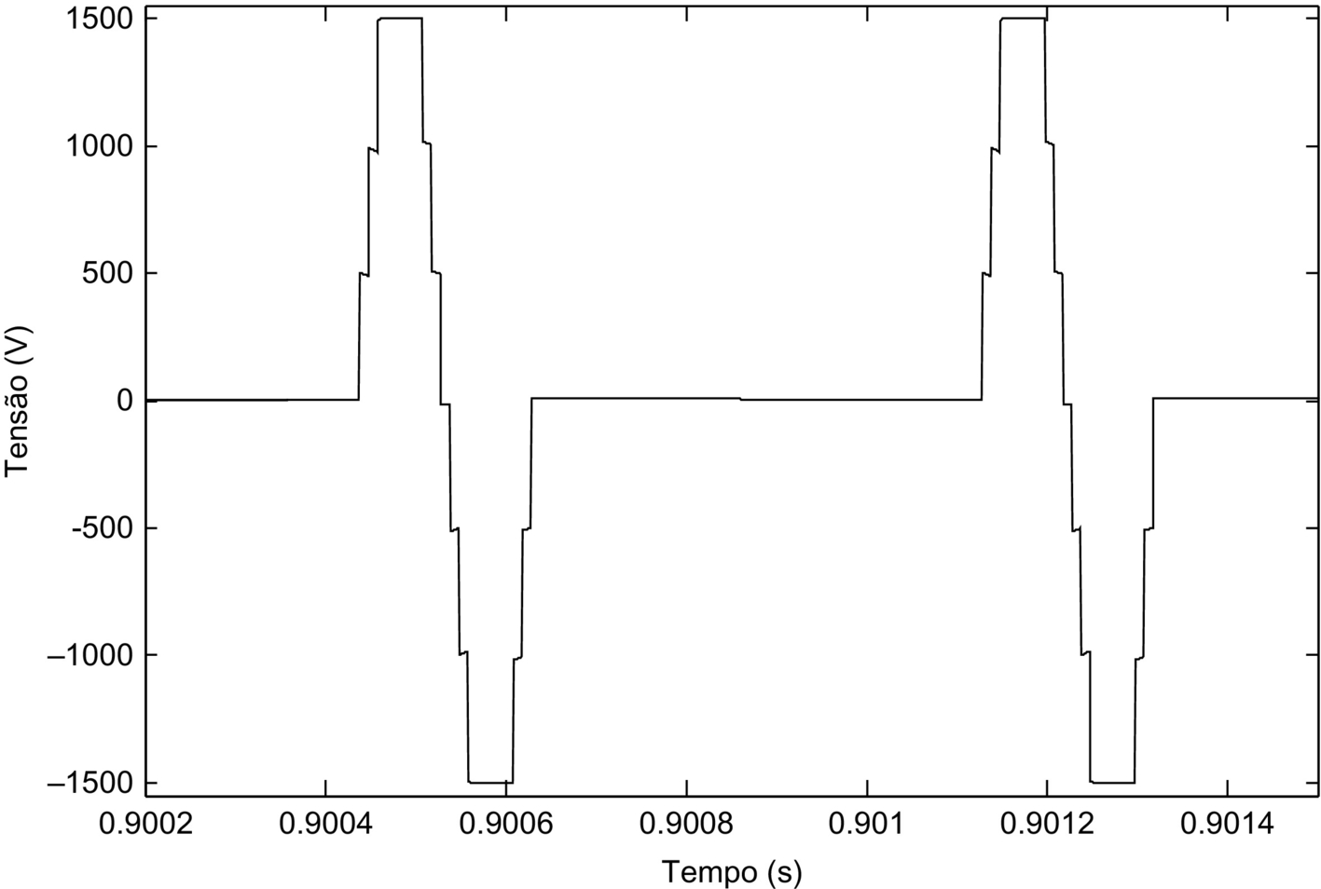

**FIG. 18.63** Seven-level bipolar pulse obtained using the Marx-based multilevel bipolar generator (500 V/div and 200 μs/div).

## 18.5 Power Electronics in Capacitor Charging Applications

### **18.5.1 INTRODUCTION**

Conventional dc power supplies operate at a given dc output voltage into a constant or near-constant load. However, pulse loads such as lasers, flashlamps, rail guns, and radar require short but intense bursts of energy. Typically, this energy is stored in a capacitor and then released into the load. The rate at which the capacitor is charged and discharged is called the repetition rate, *T*, and may vary from 0.01 Hz for large capacitor banks to a few kHz for certain lasers. Recharging the capacitor voltage to a specified voltage is tasked to a capacitor charging power supply (CCPS). The role of power electronics devices, topologies, and charging strategies for capacitor charging applications is presented in this chapter.

[Fig. 18.64](https://learning.oreilly.com/library/view/power-electronics-handbook/9780128114087/B9780128114070000209_2.xhtml#f0325) shows the voltage across the energy storage capacitor connected to the output of a CCPS. This figure shows that the CCPS has three modes of operation. The first mode is the charging mode in which the capacitor is charged from an initial voltage of zero to a specified final voltage. The duration of the charging mode is determined by the capacitance of the energy storage capacitor and the rate at which the CCPS delivers energy. The next mode of operation is the refresh mode, which can be considered a “standby mode,” where the stored energy is simply maintained. When the output voltage drops below a predetermined value, the CCPS should turn-on and deliver the energy necessary to compensate for capacitor leakage. Since energy is lost during the refresh mode, the duration of the refresh mode should be as brief as possible. Issues that lead to nonzero refresh times include safety margins for worst-case charging and discharging mode times and SOA requirements of switching devices. The final mode of operation is the discharge mode in which the load is actively discharging the capacitor. The CCPS does not supply any energy to the load in this mode. The amount of time the CCPS remains in this mode is determined by how quickly the load can discharge the capacitor.

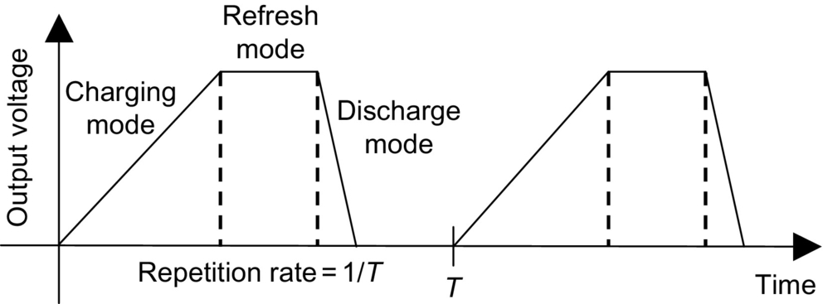

**FIG. 18.64** Three modes of operation of a capacitor charging power supply.

The instantaneous output power for a CCPS varies over a wide range in comparison to a conventional dc power supply that supplies a near-constant power to its load. This is shown in [Fig. 18.65](https://learning.oreilly.com/library/view/power-electronics-handbook/9780128114087/B9780128114070000209_2.xhtml#f0330); the output power for the PP load is drawn as linear for illustration purposes only. The charging mode is characterized by high peak power. At the beginning of this mode, the output power is zero (i.e., there is no voltage present but current is flowing). Thus, the load capacitor is equivalent to a short-circuit. In addition, at the end of the charging mode, the output power is again zero (i.e., there is an output voltage present but no current is flowing). Now, the load capacitor is equivalent to an open-circuit. The refresh mode is typically a low-power mode because the current required to compensate for capacitor leakage is small. The CCPS does not supply any power during the discharge mode when the energy storage capacitor is being discharged by the pulsed load.

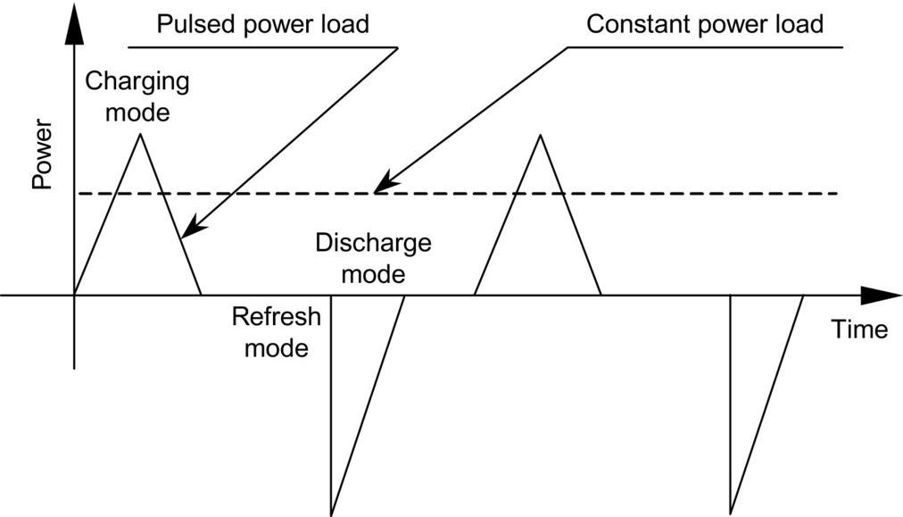

**FIG. 18.65** Power requirements for pulsed power and constant power loads.

The average output power for a CCPS depends on the discharge mode energy and the repetition rate of the load. It is maximum when the energy storage capacitor is discharged at the end of the charging mode (large voltage and current), which corresponds to operation without a refresh mode. Because the CCPS power is not constant, the rating of a CCPS is often given in kJ/s instead of kW. The kJ/s rating can be written as



where *WLOAD* is the energy delivered to the load per charging cycle and *T* is the repetition rate. In the optimum case with no refresh and instantaneous discharge, the kJ/s rating is limited to how fast a particular capacitor can be charged by its specified voltage.

### 18.5.2 HIGH-VOLTAGE DC POWER SUPPLY WITH CHARGING RESISTOR

In this technique, the energy storage capacitor is charged by a high-voltage dc power supply through a charging resistor as shown in [Fig. 18.66](https://learning.oreilly.com/library/view/power-electronics-handbook/9780128114087/B9780128114070000209_2.xhtml#f0335). The charging mode ends when the capacitor voltage equals the output voltage of the power supply. The capacitor is continually refreshed by the power supply. During the discharge mode, the charging resistor isolates the power supply from the pulse load. The advantages of this technique are its simplicity, reliability, and low cost.

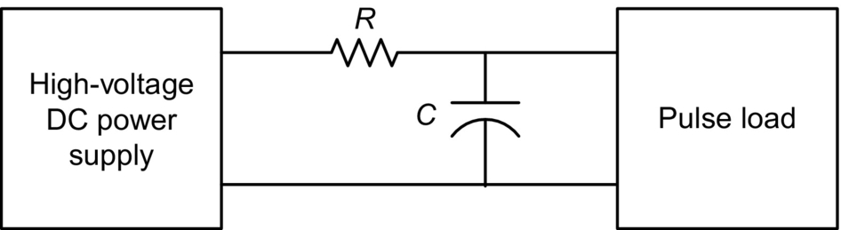

**FIG. 18.66** High-voltage dc power supply and charging resistor.

The major disadvantage of this technique is its poor efficiency. In the charging mode, the energy dissipated in the charging resistor is equal to the energy stored in the capacitor in the ideal case; therefore, the maximum efficiency is 50%. As a result, this technique is utilized only in applications where the charge rate is low, that is, 200 J/s. Another disadvantage of this technique is related to the charging time, which is determined by the RC time constant. Some laser applications require that the output voltage be within 0.1% of a target voltage. For this technique, more than five time constants are required for the capacitor voltage to meet this voltage specification.

### 18.5.3 RESONANCE-CHARGING

The basic resonance-charging technique is shown in [Fig. 18.67](https://learning.oreilly.com/library/view/power-electronics-handbook/9780128114087/B9780128114070000209_2.xhtml#f0340). An ac input voltage is stepped up with a transformer, rectified, and filtered with capacitor *C*2 to produce a high dc voltage *V*0. In this circuit, *C*2 is much greater than *C*1. Thyristor *T*1 is gated and current flows through the inductor and diode *D*1 is transferring energy from *C*2 to *C*1. The voltage *v*(*t*) and current *i*(*t*) are described by the following equations assuming that . The charge time, *tc*, for this circuit can be calculated by finding the time at which the current, described by Eq. [(18.112)](https://learning.oreilly.com/library/view/power-electronics-handbook/9780128114087/B9780128114070000209_2.xhtml#fo0790), reaches zero and is given below. The voltage *v*(*t*) has a value of 2*V*0 at the end of the charging mode:



**FIG. 18.67** Resonance-charging.

 **(18.111)**

**** **(18.112)**

**** **(18.113)**

**** **(18.114)**

Even though this technique is simple and efficient, it is not without its limitations. A high-voltage capacitor with a large capacitance value is needed for *C*2, which increases the cost. A single thyristor is shown in [Fig. 18.67](https://learning.oreilly.com/library/view/power-electronics-handbook/9780128114087/B9780128114070000209_2.xhtml#f0340). Multiple thyristors connected in series or a thyratron may be required depending on the voltage level. The repetition rate of the pulse load should be such that *C*1 is fully charged and *i*(*t*) has reached zero before the load discharges to prevent latch up of *T*1. It is not possible for this circuit to operate in the refresh mode because of the switch characteristics; therefore, *v*(*t*) will drift due to capacitor leakage. The charge time is a function of the circuit parameters and will drift as they change with temperature or due to aging.

Because all of the energy stored in *C*1 is transmitted from *C*2 in a single pulse, it can be difficult to achieve precise voltage regulation with the resonance-charging technique. However, regulation can be improved with the addition of a dequeing circuit as shown in [Fig. 18.68](https://learning.oreilly.com/library/view/power-electronics-handbook/9780128114087/B9780128114070000209_2.xhtml#f0345). The voltage *v*(*t*) is monitored with a sensing network. Before *v*(*t*) reaches the desired level, thyristor *T*2 is fired, which terminates the charging mode. The remaining energy stored in the inductor is dissipated in *R*. The addition of the dequeing circuit reduces the circuit efficiency and increases the circuit complexity and cost but still does not enable a refresh mode to compensate for capacitor leakage.



**FIG. 18.68** Resonance-charging with dequeing.

Boost charging, a variation on the resonance-charging technique, is shown in [Fig. 18.69](https://learning.oreilly.com/library/view/power-electronics-handbook/9780128114087/B9780128114070000209_2.xhtml#f0350) [[62](https://learning.oreilly.com/library/view/power-electronics-handbook/9780128114087/B9780128114070000209_2.xhtml#bb0315)]. An extra switch is added to the circuit of [Fig. 18.67](https://learning.oreilly.com/library/view/power-electronics-handbook/9780128114087/B9780128114070000209_2.xhtml#f0340), allowing energy to be stored in both *C*2 and *L*. This can be modeled as an increase in the voltage gain of the CCPS. With switches *S*1 and *S*2 closed, the current *i*(*t*) is given by



**FIG. 18.69** Boost charging.

 **(18.115)**

When , *S*2 is opened, and the current is now described by

 **(18.116)**

where

 **(18.117)**

is the inductor current initial value at *t*on. The voltage *v*(*t*) is then

 **(18.118)**

The time required for the current to reach zero and for the voltage *v*(*t*) to reach its peak value can be calculated from

 **(18.119)**

This is also the charge time, *tc*, or the length of the charging mode. Note from Eq. [(18.119)](https://learning.oreilly.com/library/view/power-electronics-handbook/9780128114087/B9780128114070000209_2.xhtml#fo0825) that the charge time depends on *t*on, which is the on-time of switch *S*2. In addition, the peak capacitor voltage is a function of *t*on. The peak capacitor voltage is limited to 2*V*0 without *S*2; voltage gains as high as 20 are possible with the addition of S2 [[62](https://learning.oreilly.com/library/view/power-electronics-handbook/9780128114087/B9780128114070000209_2.xhtml#bb0315)].

The switching elements in [Figs. 18.67](https://learning.oreilly.com/library/view/power-electronics-handbook/9780128114087/B9780128114070000209_2.xhtml#f0340) and [18.68](https://learning.oreilly.com/library/view/power-electronics-handbook/9780128114087/B9780128114070000209_2.xhtml#f0345) are realized with thyristors. Simple switches are shown for the boost charging technique in [Fig. 18.69](https://learning.oreilly.com/library/view/power-electronics-handbook/9780128114087/B9780128114070000209_2.xhtml#f0350). Switch *S*1 could be implemented with a thyristor. The boost capability provided by switch *S*2 is best realized with a gate-controlled semiconductor device such as a GTO or an IGBT.

### 18.5.4 SWITCHING CONVERTERS

The poor efficiency when charging a capacitor through a resistor from a high-voltage power supply limits its application to low charging rates. In the resonance-charging concepts, the energy is transferred to the load capacitor in a single pulse, and it is not possible to compensate for capacitor leakage. Energy storage capacitors may be charged utilizing the same power electronic technology that has been applied in switching converters for constant power loads. Instead of charging the energy storage capacitor with a single pulse, switching converters can charge the capacitor with a series of pulses or pulse train. The peak current is reduced when charging with a series of pulses, thus improving the efficiency of the charging process. In addition, soft-switching techniques may be used in the switching converter to increase the efficiency. The regulation of the output voltage is also improved with the pulse train because the energy is passed to the energy storage capacitor as small packets. Common control techniques such as pulse width modulation can be used to control the size of the energy packet. This capability to control the size of the energy packet permits the CCPS to operate in the refresh mode and compensate for capacitor leakage. As a result, the CCPS may operate over a broad range of load repetition rates and still maintain tight output voltage regulation during refresh mode. During the refresh mode, energy lost due to capacitor leakage may be replaced in a burst fashion [[63](https://learning.oreilly.com/library/view/power-electronics-handbook/9780128114087/B9780128114070000209_2.xhtml#bb0320)] or in a continuous fashion similar to trickle charging a battery [[64](https://learning.oreilly.com/library/view/power-electronics-handbook/9780128114087/B9780128114070000209_2.xhtml#bb0325)].

In the switching converter, semiconductor switches may be operated on the lower side of the transformer permitting the use of MOSFETs or IGBTs in the CCPS. Because the CCPS begins the charging mode with a short-circuit across its output, the switching converter must be capable of operating under this severe load condition. This may require the implementation of a current limiting scheme in the converter control circuit.

One switching converter as shown in [Fig. 18.70](https://learning.oreilly.com/library/view/power-electronics-handbook/9780128114087/B9780128114070000209_2.xhtml#f0355) consists of a resonant converter. Note that the MOSFETs and resonant components *Lr* and *Cr* are connected on the low-voltage side of the transformer. Only the rectifier diodes and energy storage capacitor must have high-voltage ratings. When the output rectifier is conducting, the energy storage capacitor *C*1 is connected in series with the resonant capacitor *Cr*. For a transformer turn ratio of 1/*N*, reflecting *C*1 through the transformer yields a capacitance of *N*2*C*1. Since *N* is typically large, this reflected capacitance is much larger than *Cr*, thus the resonant frequency, which is defined in Eq. [(18.120)](https://learning.oreilly.com/library/view/power-electronics-handbook/9780128114087/B9780128114070000209_2.xhtml#fo0830), is not affected by *C*1. For high-voltage, high-frequency operation, the leakage inductance of the transformer may be utilized as *Lr*. Thus, the resonant frequency can be expressed as



**FIG. 18.70** Series resonant converter.

 **(18.120)**

One characteristic of this converter, which makes it attractive for capacitor charging, is the ability to operate under the short-circuit conditions present at the beginning of the charging mode. The voltage across *C*1 is zero at the beginning of this mode. The current in the switches is limited by the input voltage and impedance *Z*0 as is defined in Eq. [(18.121)](https://learning.oreilly.com/library/view/power-electronics-handbook/9780128114087/B9780128114070000209_2.xhtml#fo0835).

 **(18.121)**

Another method for current limiting is to vary the ratio of *fs*, the switching frequency of the MOSFETs, and the resonant frequency, *fr*, which is *ωr*/2*π*. This effectively controls the flow of energy from the source to *C*1. The ratio *fs*/*fr* may be set to a low value at the beginning of the charging mode and increased toward unity as the voltage across *C*1 increases. This limits the current when the voltage across *C*1 is low and allows increased energy transfer as the voltage approaches the target voltage. The disadvantage of this approach is that variable frequency operation complicates device and component selection and degrades EMI/EMC performance of the CCPS.

The flyback converter, shown in [Fig. 18.71](https://learning.oreilly.com/library/view/power-electronics-handbook/9780128114087/B9780128114070000209_2.xhtml#f0360), also may be utilized for capacitor charging applications [[65](https://learning.oreilly.com/library/view/power-electronics-handbook/9780128114087/B9780128114070000209_2.xhtml#bb0330),[66](https://learning.oreilly.com/library/view/power-electronics-handbook/9780128114087/B9780128114070000209_2.xhtml#bb0335)]. When the MOSFET is turned on, current increases in the primary winding, storing energy in the magnetic field. When it reaches a specified level, the MOSFET is turned off and the energy is transferred from the magnetic field to *C*1. This energy transfer is terminated when the MOSFET is turned on again.



**FIG. 18.71** Flyback converter.

In cases where precise output regulation is not required and the packet energy is low, the diode in [Fig. 18.71](https://learning.oreilly.com/library/view/power-electronics-handbook/9780128114087/B9780128114070000209_2.xhtml#f0360) can be replaced with a Zener diode with a Zener voltage of



where *VO*,*nom* is the nominal value of *VO* [[67](https://learning.oreilly.com/library/view/power-electronics-handbook/9780128114087/B9780128114070000209_2.xhtml#bb0340)]. Once *VO*,*nom* is reached, the next energy packet will force the diode into a brief period of breakdown with the excess energy partially recycled to the input circuit. If the packet energy is small enough, the breakdown is not destructive and *VO* is limited to



where *VO*,*Ω* is the small excess voltage caused by the last energy packet.

Sokal and Redl [[68](https://learning.oreilly.com/library/view/power-electronics-handbook/9780128114087/B9780128114070000209_2.xhtml#bb0345)] have investigated different control schemes for charging capacitors using the flyback converter. Their recommendation is to charge *C*1 with current pulses that are nearly flat-topped. This strategy results in higher average current for a given peak current. The capacitor is charged faster because the charge delivered to it during a pulse is directly proportional to the average current. This desired pulse shape is achieved by turning on the MOSFET to terminate the transfer of energy to *C*1 soon after the MOSFET is turned off, which increases the switching frequency. When the primary current rises to a preset minimum level, the MOSFET is again turned off. This switching strategy is essentially hysteretic current mode control, in which the switch current is limited between two preset bounds.

Another converter for capacitor charging applications is the Ward converter [[69](https://learning.oreilly.com/library/view/power-electronics-handbook/9780128114087/B9780128114070000209_2.xhtml#bb0350)–[71](https://learning.oreilly.com/library/view/power-electronics-handbook/9780128114087/B9780128114070000209_2.xhtml#bb0360)] shown in [Fig. 18.72](https://learning.oreilly.com/library/view/power-electronics-handbook/9780128114087/B9780128114070000209_2.xhtml#f0365). When the MOSFET is turned on, energy is stored in the inductor, and capacitor *Ca* transfers energy into the energy storage capacitor *C*1 and capacitor *Cb*. The energy stored in the inductor is transferred to *Ca* when the MOSFET is turned off. The leakage inductance of the transformer and *Ca* resonate producing a sinusoidal current that flows in the primary winding of the transformer and the MOSFET. When the primary current reaches zero and starts negative, the diode turns on, which allows the MOSFET to be turned off efficiently at zero-current.



**FIG. 18.72** Ward converter.

In some converter operating conditions, the voltage across *Ca* is very small because most of the energy has been transferred from *Ca* to *C*1. The energy stored in *Ca* may be too small to ensure zero-current turnoff of the MOSFET. In this case, the energy stored in *Cb* helps to ensure that the amplitude of the current is large enough for zero-current turnoff of this device.

## 18.6 Conclusions and Future Trends

This chapter reviewed some of the most typical semiconductors and topologies used for generating repetitive unipolar and bipolar high-voltage pulses based on semiconductor devices for various load conditions. These topologies have in common the techniques for limiting the high-voltage stress onto the power semiconductor switches, still relatively low-voltage devices, considering the tens of kV needed for pulse power applications. High-voltage techniques spread from the series (and parallel) stacks of semiconductors switches to generalized cascodes, passing through the modified dc-dc isolated converters for pulse generation and their cascade association, to the Marx-type solid-state generators topologies and Marx-derived bipolar generators.

With semiconductor-based generators, pulse power applications have expanded into many new fields such as material modification, environment protection, and biological and medical developments. The presented topologies can bring a completely new extent of capability in repetition rate, efficiency, lifetime, compactness, and portability.

In addition to the methods to generate high-voltage pulse, the performances of the semiconductor switches determine the performance of the pulse power generators. In this way, power semiconductor devices have made significant progress in both power capability and operation speed. Various semiconductor switching units have become commercially available and have been used in various pulse power applications. The most typical devices such as SOS diodes, GTOs, IGBTs MOSFETs, SIThs, and the emerging devices based on SiC or GaN technology, such as SiC MOSFETs, JFETs, cascode JFETs, IGBTs, and GaN E-HEMTs, were described. As the performance of SiC devices continues to improve, it is expected they will replace the existing switching Si devices in high-voltage applications, reducing the number of needed stages.

State-of-the-art HV pulse generators must use several stages to obtain the desired final high-voltage pulse: the first stage can use SCRs and start at 1–2 kV, and then, intermediate full-bridge resonant stage using IGBTs or full-bridge associations can boost this voltage to 4–10 kV, which is applied to HV high-frequency or pulse transformers to obtain 50–100 kV in the secondary. Diode polyphase rectifiers in the transformer secondary windings or saturated pulse transformers can boost the voltage roughly to 300 kV. If needed, a final stage using a SOS or SAS diode can boost the voltage up to 1 MV. Alternatively, other solutions such as solid-state Marx generators are being used, each Marx module operating at 2–10 kV (using SiC semiconductors or series stacks if needed). The required number of Marx modules should be minimized and arranged in shielded groups, the groups being connected to obtain the full HV generator. Droop voltage control and balancing may be necessary to design a practical HV pulse generator. Power generators based in existing power electronics converters are also used to charge capacitors for high-voltage pulse generators.

The future of solid-state pulse power is linked to the capability of making semiconductor-based high-voltage generators with better characteristics in compactness, weight, cost, efficiency, modularity, and portability, very important to deal with future applications near the consumer.

## References

[1] Kristiansen M. *Pulsed power applications.* In: Proceedings of IEEE International Pulsed Power Conference; 1993:6–10.

[2] Levy S., et al. *Commercial applications for modulators and pulse power technology.* In: Proceedings of IEEE Power Modulator Symposium; 1992:8–14.

[3] Schamiloglu E. Scanning the technology. *Proc. IEEE.* 2004;92(7):1014–1020.

[4] Jiang W., et al. Compact solid-state switched pulsed power and its applications. *Proc. IEEE.* 2004;92(7):1180–1196.

[5] Akiyama H., Sakai S., Sakugawa T., Namihira T. Environmental applications of repetitive pulsed power. *IEEE Trans. Dielectr. Electr. Insul.* 2007;14(4):825–833.

[6] Schoenbach K.H., et al. Ultrashort electrical pulses open a new gateway into biological cells. *Proc. IEEE.* 2004;92(7):1122–1137.

[7] Raso-Pueyo J., Heinz V. *Pulsed Electric Fields Technology for the Food Industry—Fundamentals and Applications.* first ed. USA: Springer-Verlag; 2006.

[8] Daehn G.S. *ASM Handbook, Volume 14B, Metalworking: Sheet Forming.* Novelty, OH, USA: ASM International; 2006 ISBN: 978-0-87170-710-9.

[9] Neau E.L. Environmental and industrial applications of pulsed power systems. *IEEE Trans. Plasma Sci.* 1994;22(1):2–10.

[10] Fernando Silva J. *Electrónica Industrial: Semicondutores e Conversores de Potência, série Manuais Universitários.* Lisboa: Fundação Calouste Gulbenkian; 2013.978-972-31-1499-7 740 pp.

[11] Mohan N., Undeland T., Robbins W. *Power Electronics: Converters, Applications, and Design.* third ed. New York: John Wiley; 2002.

[12] Mankowski J., Kristiansen M. A review of short pulse generator technology. *IEEE Trans. Plasma Sci.* 2000;2(1):102–108.

[13] Rashid M.H., ed. *Power Electronics Handbook.* second ed. USA: Academic Press, Elsevier; 2007 1172 pp., ISBN 13:978-0-12-088479-7, ISBN 10:0-12-088479-8.

[14] Baker R.J., Johnson B.P. Applying the Marx bank circuit configuration to power MOSFETS. *Electron. Lett.* 1993;29(1):56–57.

[15] Baker R.J., Ward S.T. Designing nanosecond high voltage pulse generators using power MOSFETs. *Electron. Lett.* 1994;30(20):1634–1635.

[16] Jayant Baliga B. *Modern Power Devices.* USA: Wiley-Interscience; 1987.

[17] Burkhart C., et al. *ILC Marx modulator development program status.* In: Presented in Linear Accelerator Conference, 29 Victoria, British Columbia, Canada, September 2008; 2008.

[18] Cook E.G. *Review of solid-state modulators.* In: Presented at the XX International Linac Conference, Monterey, CA, 21–25 August 2000; 2000.

[19] Welleman A., Waldmeyer J., Ramezani E. *Solid state switches for pulse power modulators.* In: Proceedings of Linear Particle Accelerator; 2002:707–709.

[20] Leyh G. *Prototype development progress toward a 500 kV solid state Marx modulator.* In: Proceedings of IEEE Power Electronics Specialists Conference; 2004:831–834.

[21] Kim J., Min B., Shenderey S., Rim G. High voltage marx generator implementation using IGBT stacks. *IEEE Trans. Dielectr. Electr. Insul.* 2007;14(4):931–936.

[22] Wu Y., Liu K., Qiu J., Liu X., Xiao H. Repetitive and high voltage Marx generator using solid-state devices. *IEEE Trans. Dielectr. Electr. Insul.* 2007;14(4):937–940.

[23] Silva J.F., Pinto S.F. Advanced control of switching power converters. In: Rashid H., ed. *Power Electronics Handbook.* third ed. Chennai: Butterworth Heinemann, Elsevier; 2011:1037–1114.

[24] Kempkes M.A., Casey J.A., Gaudreau M.P.J., Hawkey T.A., Roth I.S. *Solid-state modulators for commercial pulsed power systems.* In: Proceedings of IEEE International Power Modulator Symposium, and High-Voltage Work; 2002:689–693.

[25] Pelletier J., Anders A. Plasma-based ion implantation and deposition: a review of physics, technology and applications. *IEEE Trans. Plasma Sci.* 2005;33(6):1944–1959.

[26] Smulders E.H.W.M., Van Heesch B.E.J.M., Van Paasen S.S.V.B. Pulsed power corona discharges for air pollution control. *IEEE Trans. Plasma Sci.* 1998;26(5):1476–1484.

[27] Meriched A., Féliachi M., Mohellebi H. Electromagnetic forming of thin metal sheets. *IEEE Trans. Magn.* 2000;36(4):1808–1811.

[28] Redondo L.M., Fernando Silva J., Margato E. Analysis of a modular generator for high-voltage, high-frequency pulsed applications, using low voltage semiconductors (<1 kV) and series connected step-up (1: 10) transformers. *Rev. Sci. Instrum.* 2007;78(3):034702.

[29] Jim Lux's web site, High-voltage, high voltage resistors, water resistance, 2003. <http://home.earthlink.net/~jimlux/hv/rwater.htm>. (Accessed 23 February 2017).

[30] Brutscher J. A 100 kV 10A high voltage pulse generator for plasma immersion ion implantation. *Rev. Sci. Instrum.* 1996;67(7):2621–2625.

[31] Anders A., Goebel D.M. Pulse technology. *Handbook of Plasma Immersion Ion Implantation & Deposition.* first ed. USA: John Wiley & Sons; 2000 (Chapter 8).

[32] Wang C., Zhang Q.H. *EMI and its elimination in an integrated high voltage (12 kV) pulse generator.* In: Proceedings of IEEE Industrial Electronics Society; 2000:1044–1049.

[33] Redondo L.M., Margato E., Fernando Silva J. A new method to build a high-voltage pulse supply using only semiconductor switches for plasma-immersion ion implantation. *Surf. Coat. Technol.* 2001;136:51–54.

[34] Tian X., Wang X., Tang B., Chu P.K., Ko P.K., Cheng Y.C. Special modulator for high frequency, low-voltage plasma immersion ion implantation. *Rev. Sci. Instrum.* 1999;70(3):1824–1828.

[35] Redondo L.M., Silva J.F., Tavares P., Margato E. *All Silicon Marx-bank topology for high-voltage, high-frequency rectangular pulses.* In: 2005 IEEE 36th Power Electronics Specialists Conference; 2005:1170–1174.

[36] Wang F., Kuthi A., Jiang C., Zhou Q., Gundersen M. *Flyback resonant charger for high repetition rate pseudospark pulse generator.* In: Proceedings of Power Modulator Conference Symposium; 2004:85–88.

[37] Giesselman M., Heeren T. *Rapid capacitor charger.* In: Proceedings of Power Modulator Conference Symposium; 2002:146–149.

[38] Petr R., Reilly D., Freshman J., Orozco N., Pham D., Ngo L., Mangano J. Solid-state pulsed power for driving a high-power dense plasma focus x-ray source. *Rev. Sci. Instrum.* 2000;71(3):1360–1362.

[39] Jiang W., et al. *Development of repetitive pulsed power generators using power semiconductor devices.* In: Proceedings of International Symposium on Power Semiconductor Devices and ICs; 2005:1167–1172.

[40] Gaudreau M.P.J., Hawkey T., Petry J., Kempkes M. *A solid state pulsed power system for food processing.* In: Proceedings of Pulsed Power Plasma Science, vol. 2; 2001:1174–1177.

[41] Welleman A., Fleischmann W., Kaesler W. *Solid state on-off switches using IGCT technology.* In: Proceedings of Pulsed Power Conference; 2007:1025–1028.

[42] Jiang W. Fast high voltage switching using stacked MOSFETs. *IEEE Trans. Dielectr. Electr. Insul.* 2007;14(4):947–950.

[43] Kim J., Min B., Shenderey S., Rim G.-H. High voltage pulsed power supply using IGBT stacks. *IEEE Trans. Dielectr. Electr. Insul.* 2007;14(4):921–926.

[44] Williams B.W. Power electronics. In: Williams B.W., ed. *Series and Parallel Device Operation, Protection, and Interference.* USA: Palgrave Macmillan; 2005 (Chapter 10).

[45] Gunturi S., Assal J., Schneider D., Eicher S. *Innovative metal system for IGBT press pack modules.* In: Proceedings of International Symposium on Power Semiconductor Devices and ICs; 2003:110–113.

[46] Goebel D.M. Pulse technology. In: Anders A., ed. *Handbook of Plasma Immersion Ion Implantation & Deposition.* first ed. USA: John Wiley & Sons; 2000 (Chapter 8).

[47] Redondo L.M., Silva J.F., Margato E. Pulse shape improvement in core-type high-voltage pulse transformers with auxiliary windings. *IEEE Trans. Magn.* 2007;43(5):1973–1982.

[48] Rashid M.H. *Power Electronics: Circuits, Devices and Applications.* USA: Prentice Hall; 2003.

[49] Leu C.S., Hua G., Lee F.C., Zhou C. *Analysis and design of a R-C-D clamp Forward converter.* In: Proceedings of High Frequency Power Conversion Conference; 1992:198–208.

[50] Redondo L.M., Fernando Silva J. Flyback versus Forward switching power supply topologies for unipolar pulsed power applications. *IEEE Trans. Plasma Sci.* 2009;37(1):171–178.

[51] Klein J., Padberg M. A modular low-cost, high-voltage pulse generator that is highly effective in terms of pulse energy and repetition frequency. *Meas. Sci. Technol.* 1995;6(5):550–555.

[52] Smith W. *Transient Electronics—Pulsed Circuit Technology.* USA: Wiley; 2002.

[53] Redondo L.M., Margato E., Silva J.F. Rise time reduction in high-voltage pulse transformers using auxiliary windings. *IEEE Trans. Power Electron.* 2002;17(2):196–206.

[54] Kostenko, Piotrovski L. *Electrical Machines.* Rev ed. Moscow: Central Books; 1980.

[55] Willis W.L. Pulse-voltage circuits. In: Dollinger R.E., Sarjeant W.J., eds. *High Power Electronics.* first ed. PA, USA: Tab Books; 1989 (Chapter 3).

[56] Gregory K., Stevenson P., Burke R. Four-stage Marx generator using thyristors. *Rev. Sci. Instrum.* 1998;69(11):3996–3997.

[57] Cassel R.L. *An all solid state pulsed Marx type modulator for Magnetrons and Klystrons.* In: Proceedings of IEEE International Power Modular Conference; 2004:836–838.

[58] Redondo L.M., Fernando Silva J. Repetitive high-voltage solid-state Marx modulator design for various load conditions. *IEEE Trans. Plasma Sci.* 2009;37(8):1632–1637.

[59] Keith W.D., Pringle D., Rice P., Birke P.V. Distributed magnetic coupling synchronizes a stacked 25-kV MOSFET switch. *IEEE Trans. Power Electron.* 2000;15(1):58–61.

[60] Canacsinh H., Redondo L.M., Silva J.F. Marx-type solid-state bipolar modulator topologies: performance comparison. *IEEE Trans. Plasma Sci.* 2012;40(10):2603–2610.

[61] Rocha L., Silva J.F., Redondo L. Seven levels unipolar/bipolar pulsed power generator. *IEEE Trans. Plasma Sci.* 2016;44(10):2060–2064.

[62] Bhadani P.K. Capacitor-charging power supply for laser pulsers using a boost circuit. *Rev. Sci. Instrum.* 1989;60(4):605–607.

[63] Lippincott A.C., Nelms R.M. A capacitor-charging power supply using a series-resonant topology, constant on-time/variable frequency control, and zero current switching. *IEEE Trans. Ind. Electron.* 1991;38(6):438–447.

[64] Strickland B.E., Garbi M., Cathell F., Eckhouse S., Nelms M. *2 kJ/sec 25-kV high-frequency capacitor-charging power supply using MOSFET switches.* In: Proceedings of 1990 Nineteenth Power Modulator Symposium; 1990:531–534.

[65] Newsom R.L., Dillard W.C., Nelms R.M. Digital power-factor correction for a capacitor-charging power supply. *IEEE Trans. Ind. Electron.* 2002;49(5):1146–1153.

[66] Dawson F.P., Dewan S.B. *A subresonant flyback converter for capacitor charging.* In: Proceedings of Second Annual IEEE Applied Power Electronics Conference, March 1987; 1987:274–283.

[67] Dillard W.C., Nelms R.M. *A digitally-controlled, low-cost driver for piezoceramic flight control surfaces in small unmanned air- craft and munitions.* In: Seventeenth Annual Applied Power Electronics Conference Exposition, APEC '02; 2002:1154–1160.

[68] Sokal N.O., Redl R. Control algorithms and circuit designs for optimally flyback-charging an energy-storage capacitor (e.g. for flash lamp or defibrillator). *IEEE Trans. Power Electron.* 1997;12(5):885–894.

[69] M.A.V. Ward, DC to DC converter current pump, U.S. Patent Number 4,868,730, September 1989.

[70] Chryssis G.C. *High-Frequency Switching Power Supplies: Theory and Design.* New York: McGraw-Hill Publishing; 1989.

[71] Nelms R.M., Schatz J.E. A capacitor charging power supply utilizing a ward converter. *IEEE Trans. Ind. Electron.* 1992;39(5):421–428.

**19**

# Uninterruptible Power Supplies

Adel Nasiri; Seyed Ahmad Hamidi University of Wisconsin-Milwaukee, Milwaukee, WI, United States

## Abstract

Power distortions such as power interruptions, voltage sags and swells, voltage spikes, and voltage harmonics can cause severe impacts on sensitive loads in the electric systems. Uninterruptible power supply (UPS) systems are used to provide uninterrupted, reliable, and high-quality power for these sensitive loads. Applications of UPS systems include medical facilities, life-supporting systems, data storage and computer systems, emergency equipment, telecommunications, industrial processing, and online management systems (Karve, 2000; Carle, 1995; Krishnan and Srinivasan, 1993). The UPS systems are especially required in places where power outages and fluctuations occur frequently. A UPS provides a backup power circuitry to supply vital systems when a power outage occurs. In situations where short-time power fluctuations or disturbed voltage occur, a UPS provides constant power to keep the important loads running. During extended power failures, a UPS provides backup power to keep the systems running long enough so that they can be gracefully powered down.

### KEYWORDS

Uninterruptible power supply; Inverter; Rectifier; Pulse-width modulation; Control; Energy storage: battery

19.1 [Introduction](https://learning.oreilly.com/library/view/power-electronics-handbook/9780128114087/B9780128114070000210.xhtml#s0010)

19.2 [Classifications](https://learning.oreilly.com/library/view/power-electronics-handbook/9780128114087/B9780128114070000210.xhtml#s0015)

19.2.1 Standby UPS

19.2.2 On-Line UPS System

19.2.3 Line-Interactive UPS

19.2.4 Universal UPS

19.2.5 Rotary UPS

19.2.6 Hybrid Static/Rotary UPS

19.2.7 DC UPS

19.2.8 Comparison of UPS Configurations

19.3 [Performance Evaluation](https://learning.oreilly.com/library/view/power-electronics-handbook/9780128114087/B9780128114070000210.xhtml#s0060)

19.4 [Applications](https://learning.oreilly.com/library/view/power-electronics-handbook/9780128114087/B9780128114070000210.xhtml#s0065)

19.5 [Control Techniques](https://learning.oreilly.com/library/view/power-electronics-handbook/9780128114087/B9780128114070000210.xhtml#s0070)

19.6 [Energy Storage Devices](https://learning.oreilly.com/library/view/power-electronics-handbook/9780128114087/B9780128114070000210.xhtml#s0075)

19.6.1 Battery

19.6.2 Flywheel

19.6.3 Fuel Cell

[References](https://learning.oreilly.com/library/view/power-electronics-handbook/9780128114087/B9780128114070000210.xhtml#bi0010)

## 19.1 Introduction

Power distortions such as power interruptions, voltage sags and swells, voltage spikes, and voltage harmonics can cause severe impacts on sensitive loads in the electric systems. Uninterruptible power supply (UPS) systems are used to provide uninterrupted, reliable, and high-quality power for these sensitive loads. Applications of UPS systems include medical facilities, life-supporting systems, data storage and computer systems, emergency equipment, telecommunications, industrial processing, and online management systems [[1](https://learning.oreilly.com/library/view/power-electronics-handbook/9780128114087/B9780128114070000210.xhtml#bb0010)–[3](https://learning.oreilly.com/library/view/power-electronics-handbook/9780128114087/B9780128114070000210.xhtml#bb0020)]. The UPS systems are especially required in places where power outages and fluctuations occur frequently. A UPS provides a backup power circuitry to supply vital systems when a power outage occurs. In situations where short-time power fluctuations or disturbed voltage occur, a UPS provides constant power to keep the important loads running. During extended power failures, a UPS provides backup power to keep the systems running long enough so that they can be gracefully powered down.

Most of the UPS systems also suppress line transients and harmonic disturbances. Generally, an ideal UPS should be able to simultaneously deliver uninterrupted power and provide the necessary power conditioning for the particular power application. Therefore, an ideal UPS should have the following features: regulated sinusoidal output voltage with low total harmonic distortion (THD) independent from the changes in the input voltage or in the load, online operation that means zero transition time from normal to backup mode and vice versa, low THD sinusoidal input current and unity power factor, high reliability, high efficiency, low EMI and acoustic noise, electric isolation, low maintenance, low cost, weight, and size. Obviously, there is not a single configuration that can provide all of these features. Different configurations of UPS systems emphasize on some of the features mentioned above. Classifications of UPS systems are described in [Section 19.2](https://learning.oreilly.com/library/view/power-electronics-handbook/9780128114087/B9780128114070000210.xhtml#s0015).

## 19.2 Classifications

### **19.2.1 STANDBY UPS**

This configuration of UPS system is also known as “off-line UPS” or “line-preferred UPS” [[4](https://learning.oreilly.com/library/view/power-electronics-handbook/9780128114087/B9780128114070000210.xhtml#bb0025),[5](https://learning.oreilly.com/library/view/power-electronics-handbook/9780128114087/B9780128114070000210.xhtml#bb0030)]. [Fig. 19.1](https://learning.oreilly.com/library/view/power-electronics-handbook/9780128114087/B9780128114070000210.xhtml#f0010) shows the configuration of a typical standby UPS system. It consists of an AC/DC converter, a battery bank, a DC/AC inverter, and a static switch. A passive low-pass filter may also be used at the output of the UPS or inverter to remove the switching frequency from the output voltage. The static switch is on during the normal mode of operation. Therefore, load is supplied from the AC line directly without any power conditioning. At the same time, the AC/DC rectifier charges the battery set. This converter is rated at a much lower power rating than the power demand of the load. When a power outage occurs or the primary power is out of a given preset tolerance, the static switch is opened and the DC/AC inverter provides power to the load from the battery set for the duration of the preset backup time or till the AC line is back again. This inverter is rated at 100% of the load power demand. It is connected in parallel to the load and stays standby during the normal mode of operation. The transition time from the AC line to DC/AC inverter is usually about one-quarter of the line cycle, which is enough for most of the applications such as personal computers. The main advantages of this topology are simple design, low cost, and small size. On the other hand, the lack of real isolation of the load from the AC line, no output voltage regulation, long switching time, poor performance with nonlinear loads, and no line conditioning are the main disadvantages of this configuration.

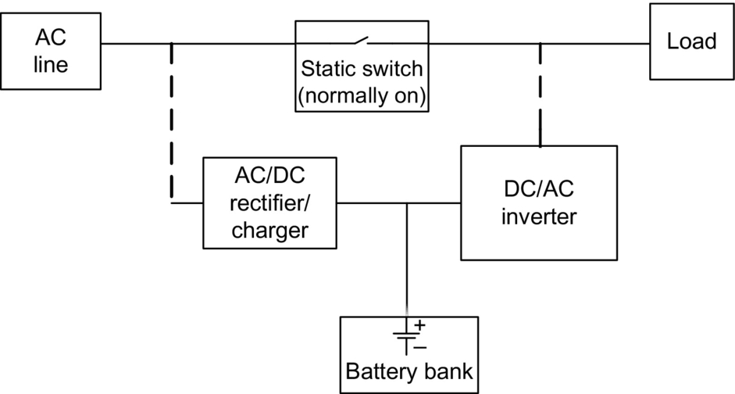

**FIG. 19.1** Configuration of a typical standby UPS system.

Different configurations of AC/DC rectifiers such as linear or switching may be used in this system. To reduce the cost, a simple diode-bridge rectifier with a capacitor at the front end is used. A full-bridge or half-bridge full controlled converter is also used to charge the battery bank. Two typical topologies for a single-phase UPS system are shown in [Fig. 19.2](https://learning.oreilly.com/library/view/power-electronics-handbook/9780128114087/B9780128114070000210.xhtml#f0015). The full controlled topologies can provide power factor correction (PFC) to meet the corresponding standards. To optimize the charging process, the charging cycle is divided into “constant current” and “constant voltage” modes. In the constant current mode, the converter injects a constant current into the battery till the battery is charged up to about 95% of its capacity. After this mode, the constant voltage mode starts that applies a constant voltage on the battery. In this mode, the input current of the battery declines exponentially until it is fully charged.

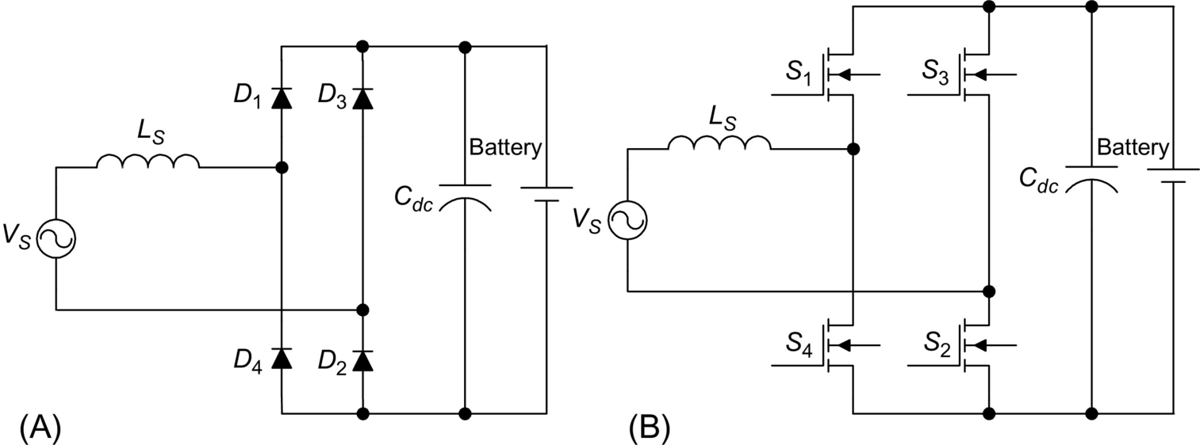

**FIG. 19.2** Two simple topologies of AC/DC rectifier: (A) full-bridge diode rectifier and (B) full-bridge full controlled topology.

The purpose of the DC/AC inverter is to provide high-quality AC power to the load when the static switch is opened. A full- or half-bridge topology is used for this inverter. [Fig. 19.3](https://learning.oreilly.com/library/view/power-electronics-handbook/9780128114087/B9780128114070000210.xhtml#f0020) shows two simple single-phase topologies for the DC/AC inverter.

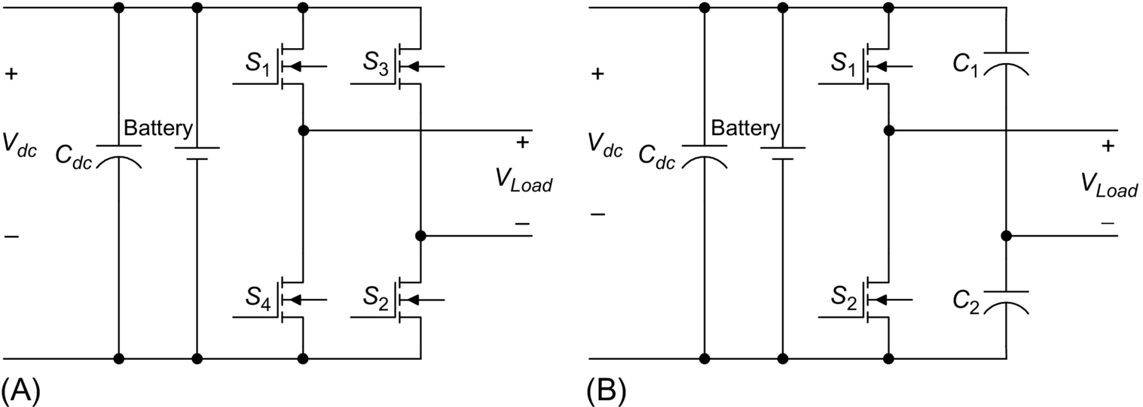

**FIG. 19.3** Two simple single-phase topologies for the DC/AC inverter: (A) full bridge and (B) half bridge.

In some topologies of standby UPS systems, an isolating transformer is used at the output stage of the UPS. This topology is called ferroresonant standby UPS system. The transformer also acts as a low-pass filter that cancels out switching frequency from the output voltage of the DC/AC inverter. On the other hand, the transformer stores electromagnetic energy in the core and acts as a buffer when a power outage occurs. For a short time, the transformer provides power to the load and protects sensitive equipment from being affected during the transfer time from the input AC to the UPS. [Fig. 19.4](https://learning.oreilly.com/library/view/power-electronics-handbook/9780128114087/B9780128114070000210.xhtml#f0025) shows the configuration of a ferroresonant standby UPS system. Since the transformer is bulky and expensive, this configuration is more appropriate for high-power applications.

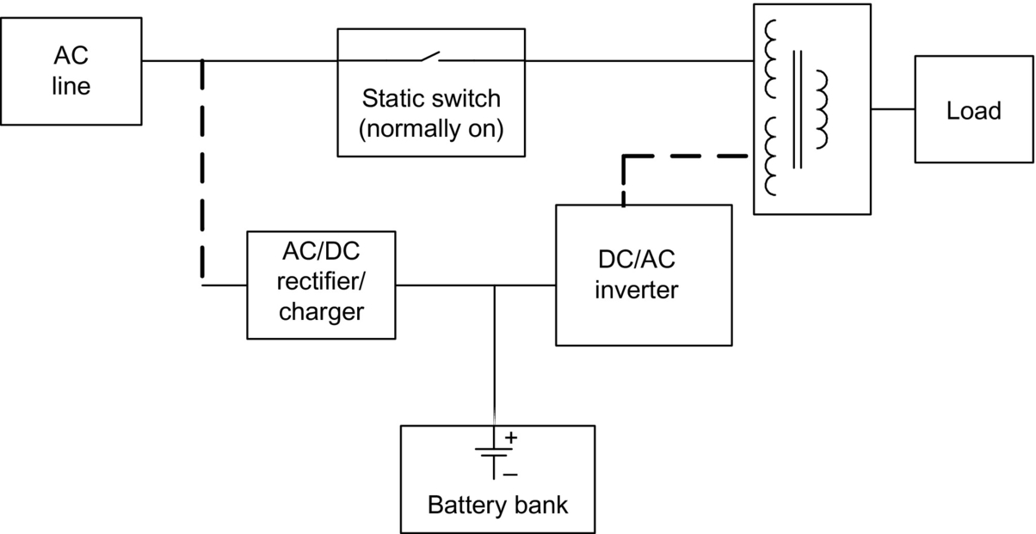

**FIG. 19.4** Typical configuration of ferroresonant standby UPS system.

### 19.2.2 ON-LINE UPS SYSTEM

Similar to standby UPS systems, online UPS systems also consist of a rectifier/charger, a battery set, an inverter, and a static switch (bypass). Other names for this configuration are “true UPS,” “inverter-preferred UPS,” and “double-conversion UPS” [[6](https://learning.oreilly.com/library/view/power-electronics-handbook/9780128114087/B9780128114070000210.xhtml#bb0035),[7](https://learning.oreilly.com/library/view/power-electronics-handbook/9780128114087/B9780128114070000210.xhtml#bb0040)]. [Fig. 19.5](https://learning.oreilly.com/library/view/power-electronics-handbook/9780128114087/B9780128114070000210.xhtml#f0030) shows the block diagram of a typical online UPS. The rectifier/charger continuously supplies power to the DC bus. The power rating of this converter must be designed appropriately to supply power to the load and charge the battery bank at the same time. The batteries are rated in order to supply full power to the load during the backup time. The duration of this time varies in different applications. The inverter is rated at 100% of the load power since it must supply the load during the normal mode of operation and during the backup time. It is connected in series with the load; hence, there is no transfer time associated with the transition from normal mode to stored energy mode. This is the main advantage of online UPS systems. The static switch provides redundancy of the power source in the case of UPS malfunction or overloading. The AC line and load voltages must be in phase in order to use the static switch. This can be achieved easily by a phase-locked loop control. During the normal mode of operation, the power to the load is continuously supplied via the rectifier/charger and inverter. In fact, a double conversion from AC to DC and then from DC to AC takes place. This configuration of the UPS allows good power conditioning. The AC/DC converter charges the battery set and also supplies power to the load via the inverter. Therefore, it has the highest power rating in this topology, thereby increasing the cost. When the AC input voltage is outside the preset tolerance, the inverter and battery maintain continuity of power to the load. The duration of this mode is the duration of preset UPS backup time or till the AC line returns within the preset tolerance.

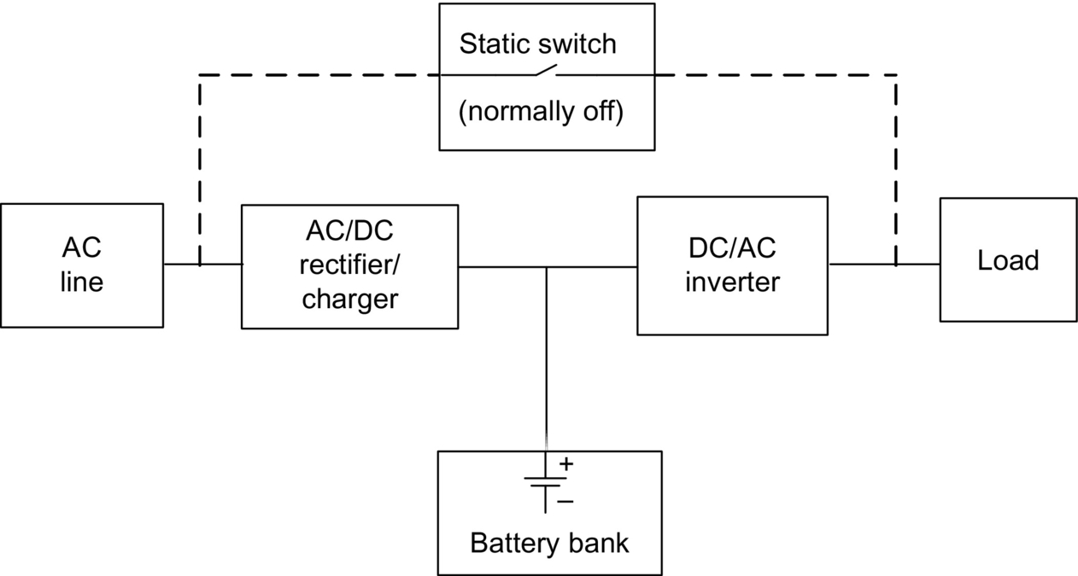

**FIG. 19.5** Block diagram of an online UPS system.

The main advantages of online UPS are very wide tolerance to the input voltage variation and very precise regulations of output voltage. In addition, there is no transfer time during the transition from normal to stored energy modes. It is also possible to regulate or change the output frequency [[8](https://learning.oreilly.com/library/view/power-electronics-handbook/9780128114087/B9780128114070000210.xhtml#bb0045)]. The main disadvantages of this topology are low-power factor, high THD at the input, and low efficiency. The input current is distorted by the rectifier unless an extra PFC circuit is added; but, this adds to the cost of the UPS system [[9](https://learning.oreilly.com/library/view/power-electronics-handbook/9780128114087/B9780128114070000210.xhtml#bb0050)].

As mentioned for the standby UPS system, different topologies are employed for the AC/DC rectifier and DC/AC inverter. Unlike standby UPS system, in this system, these converters provide power to the load continuously. Therefore, more care should be given to the quality of the input current and output voltage and the efficiency of the system. [Fig. 19.6](https://learning.oreilly.com/library/view/power-electronics-handbook/9780128114087/B9780128114070000210.xhtml#f0035) shows the configuration of a three-phase online UPS system. The proper switching method such as pulse-width modulation (PWM) is employed for the AC/DC rectifier to minimize the input current harmonics and provide regulated DC bus voltage. A low-pass filter at the output of the system removes the switching frequency from the output voltage.

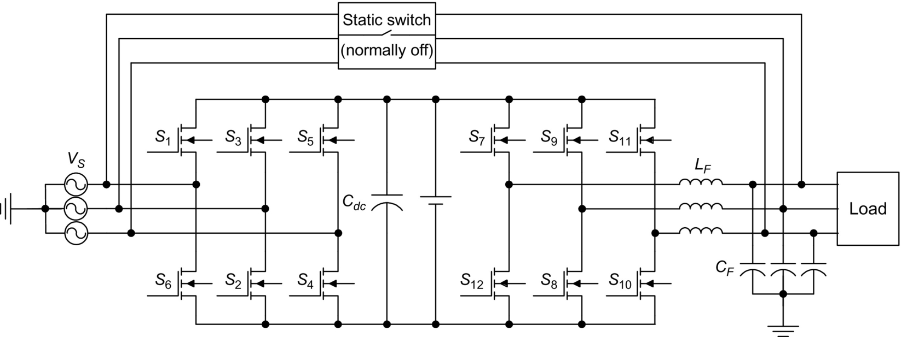

**FIG. 19.6** Configuration of a three-phase online UPS system.

### 19.2.3 LINE-INTERACTIVE UPS

Line-interactive UPS systems consist of a static switch, a series inductor, a bidirectional converter, and a battery bank. An optional passive filter can be added at the output of the bidirectional converter or at the input side of the load. A line-interactive UPS can operate either as an online UPS or as an off-line UPS. For an off-line line-interactive UPS, the series inductor is not required. However, most of the line-interactive UPS systems operate online in order to either improve the power factor of the load or regulate the output voltage for the load. When the AC line is within the preset tolerance, it feeds the load directly. The AC/DC converter is connected in parallel with the load and charges the battery. This converter may also be used to improve the power factor of the system and compensate the load current harmonics [[10](https://learning.oreilly.com/library/view/power-electronics-handbook/9780128114087/B9780128114070000210.xhtml#bb0055),[11](https://learning.oreilly.com/library/view/power-electronics-handbook/9780128114087/B9780128114070000210.xhtml#bb0060)]. Typical configuration of a line-interactive UPS is shown in [Fig. 19.7](https://learning.oreilly.com/library/view/power-electronics-handbook/9780128114087/B9780128114070000210.xhtml#f0040).

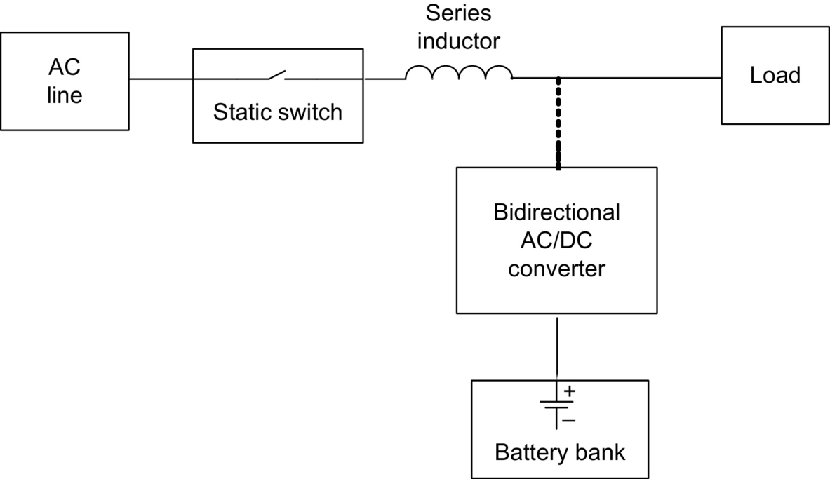

**FIG. 19.7** A typical configuration of a line-interactive UPS system.

When a power outage occurs or input voltage falls outside the preset tolerance, the system goes to bypass mode. In this mode, the bidirectional converter operates as a DC/AC inverter and supplies power to the load from the battery set. The static switch disconnects the AC line in order to prevent back-feed from the inverter. The main advantages of the line-interactive UPS systems are simple design and, as a result, high reliability and lower cost compared with the online UPS systems. They also have good harmonic suppression for the input current. Since this is a single-stage conversion topology, the efficiency is higher than online UPS system. The main disadvantage is the lack of effective isolation of the load from the AC line. Employing a transformer in the output can eliminate this; but, it will add to the cost, size, and weight of the UPS system. Furthermore, the output voltage conditioning is not good because the inverter is not connected in series with the load. In addition, since the AC line supplies the load directly during the normal mode of operation, there is no possibility for regulation of the output frequency.

### 19.2.4 UNIVERSAL UPS

This type of UPS is also called “series parallel” or “delta conversion.” Its topology is derived from unified power quality conditioner topology and combines the advantages of both online and line-interactive UPS systems [[12](https://learning.oreilly.com/library/view/power-electronics-handbook/9780128114087/B9780128114070000210.xhtml#bb0065),[13](https://learning.oreilly.com/library/view/power-electronics-handbook/9780128114087/B9780128114070000210.xhtml#bb0070)]. It can achieve unity power factor, precise regulation of the output voltage, and high efficiency simultaneously. Its configuration is shown in [Fig. 19.8](https://learning.oreilly.com/library/view/power-electronics-handbook/9780128114087/B9780128114070000210.xhtml#f0045). It consists of two bidirectional converters connected to a common battery set, a static switch, and a series transformer. The series bidirectional converter is rated at about 20% of the output power of the UPS system, and it is connected via a transformer in series with the AC line. The second bidirectional converter is the usual inverter for a line-interactive UPS connected in parallel to the load and rated at 100% of the output power.

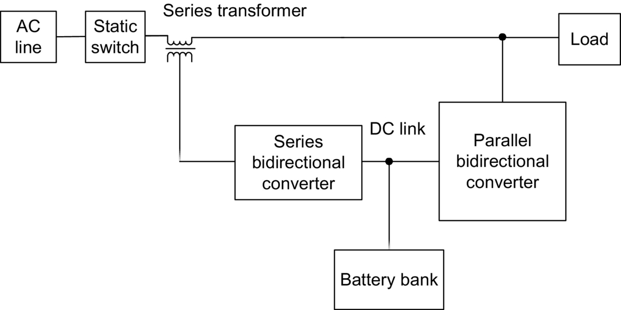

**FIG. 19.8** Block diagram of a universal UPS system.

When the input voltage is in the acceptable range, the system is in the bypass mode. In this mode, parallel converter deals with current-based distortions. It mitigates load current harmonics and improves input power factor. At the same time, it charges the battery pack. Series converter deals with voltage-based distortions. It cancels input voltage harmonics and compensates voltage sags and swells. Most of the power is supplied directly from the AC line to the load. Only a small percentage of the input power is absorbed by parallel converter. This power is used to compensate the differences between input and reference voltages and to charge the battery pack. On the other hand, when the input voltage shuts down, the static switch separates the source and the load, and the system goes to backup mode. In this situation, the parallel inverter acts as a DC/AC inverter and supplies power to the load. Since a large portion of the power flows without any conversion from the AC line to the load, the efficiency is higher than that of an online UPS system. Having eliminated the main drawback of double-conversion UPS systems, the universal UPS topology appears to be a strong competitor of online UPS systems in many applications. [Fig. 19.9](https://learning.oreilly.com/library/view/power-electronics-handbook/9780128114087/B9780128114070000210.xhtml#f0050) shows the topology of a three-phase universal UPS system.

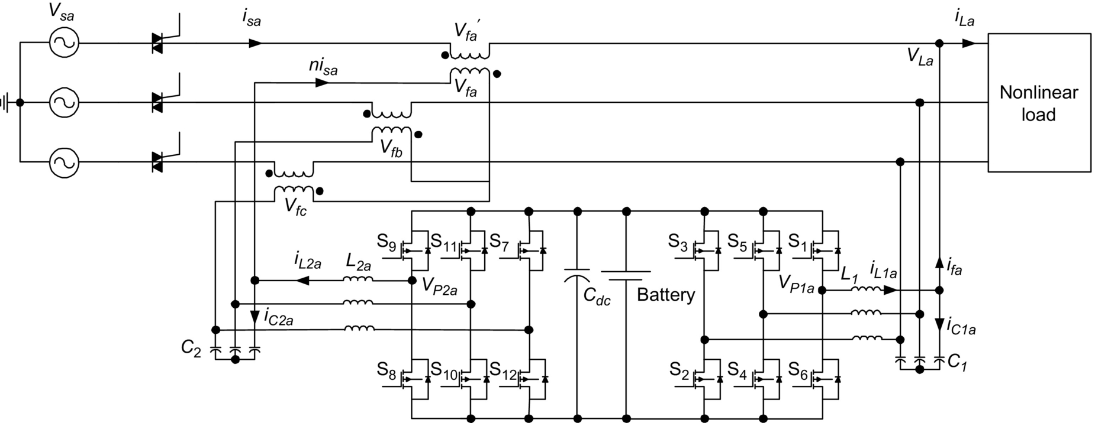

**FIG. 19.9** A universal UPS topology based on two three-leg bidirectional converters.

### 19.2.5 ROTARY UPS

Rotary UPS systems use the stored kinetic energy in the electric machines to provide power to the load when a power outage occurs. There are different configurations for rotary UPS systems. The simplest topology consists of an AC motor and an AC generator, which are mechanically coupled. A flywheel is also used on the shaft of the machines to store more kinetic energy in the system. In normal operation, the input AC line provides power to the AC motor, and this AC motor drives the AC generator. The configuration of this system is shown in [Fig. 19.10A](https://learning.oreilly.com/library/view/power-electronics-handbook/9780128114087/B9780128114070000210.xhtml#f0055). In backup mode, the kinetic energy stored in the motor, flywheel, and generator is converted to electric power and supplies the load. This simple topology is designed to provide short-time backup power to the load (typically less than 2 s) in case of power interruption. In another configuration of rotary UPS system that is shown in [Fig. 19.10B](https://learning.oreilly.com/library/view/power-electronics-handbook/9780128114087/B9780128114070000210.xhtml#f0055), an AC motor, a DC machine, an AC generator, and a battery bank are used. During the normal mode of operation, the AC line supplies the AC motor, which drives the DC machine. The DC machine drives the AC generator, which supplies the load. During the backup mode of operation, the battery bank supplies the DC machine, which, in turn, drives the AC generator and the AC generator supplies the load. This system can provide long-time backup power to the load depending on the capacity of the battery set. These two rotary UPS systems are much more reliable than the static UPS systems and provide complete electric isolation between the load and input AC line. Yet, they require more maintenance and have much bigger size and weight. Therefore, they are usually used for high-power applications [[14](https://learning.oreilly.com/library/view/power-electronics-handbook/9780128114087/B9780128114070000210.xhtml#bb0075),[15](https://learning.oreilly.com/library/view/power-electronics-handbook/9780128114087/B9780128114070000210.xhtml#bb0080)]. The configuration of a standby rotary UPS system is shown in [Fig. 19.10C](https://learning.oreilly.com/library/view/power-electronics-handbook/9780128114087/B9780128114070000210.xhtml#f0055). This system does not provide electric isolation between the load and input AC. There is also a transition delay for switching from main AC to backup AC generator. However, it can provide power to the load as long as needed.

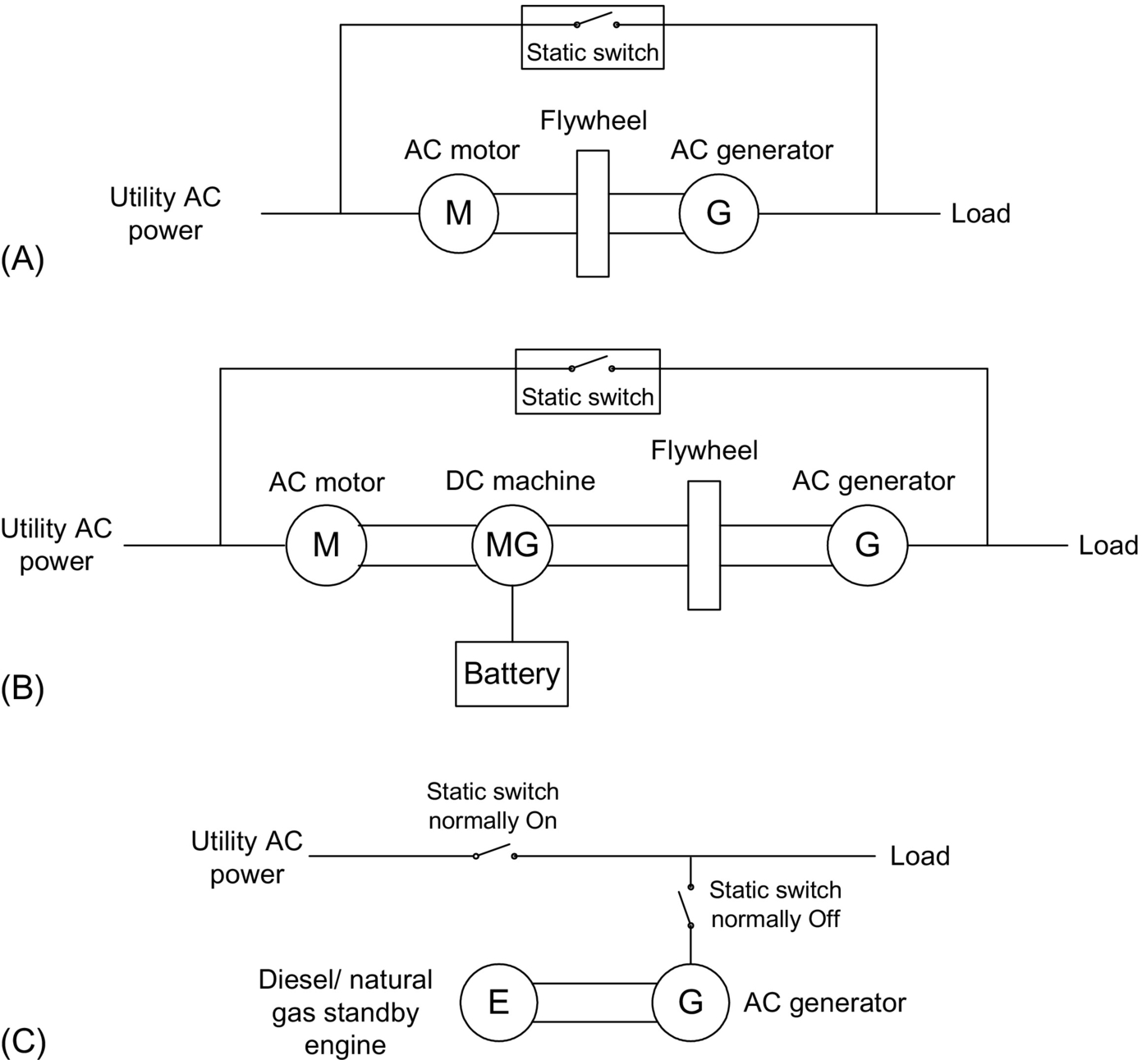

**FIG. 19.10** Different configuration of rotary UPS systems: (A) motor-generator set, (B) rotary UPS with battery backup, and (C) rotary UPS with standby diesel/natural gas engine.

### 19.2.6 HYBRID STATIC/ROTARY UPS

Hybrid static/rotary UPS systems combine the main features of both static and rotary UPS systems. They have low output impedance, high reliability, excellent frequency stability, and low maintenance requirements [[16](https://learning.oreilly.com/library/view/power-electronics-handbook/9780128114087/B9780128114070000210.xhtml#bb0085)]. Typical configurations of hybrid static/rotary UPS are depicted in [Fig. 19.11](https://learning.oreilly.com/library/view/power-electronics-handbook/9780128114087/B9780128114070000210.xhtml#f0060). They are usually used in high-power applications. In the system shown in [Fig. 19.11A](https://learning.oreilly.com/library/view/power-electronics-handbook/9780128114087/B9780128114070000210.xhtml#f0060), during normal operation, the input AC power feeds the AC motor. The power is provided to the load from the AC generator, which is driven by the AC motor. In case of low input power quality or power interruption, the bidirectional AC/DC converter acts as an inverter and feeds the AC motor from battery pack. Configuration of a hybrid UPS system with power conditioning at the input is shown in [Fig. 19.11B](https://learning.oreilly.com/library/view/power-electronics-handbook/9780128114087/B9780128114070000210.xhtml#f0060). [Fig. 19.11C](https://learning.oreilly.com/library/view/power-electronics-handbook/9780128114087/B9780128114070000210.xhtml#f0060) shows the configuration of a more complicated hybrid UPS system. This system has three operation modes. In normal operation, the load is directly supplied by the main AC input, and the AC motor is rotated at no-load. In the case of short power interruption, main breaker and generator breaker are opened and the inverter breaker is closed. The DC/AC inverter provides power to the load from the kinetic energy stored in the AC machine. If power is not restored in the short term, the diesel engine is turned on, which provides power to the load through the AC generator. In this mode, the main breaker and inverter breaker remain open. One of the advantages of this topology is operation without a battery set to minimize cost, space, and required maintenance. The second advantage is avoiding double power conversion in long-term power interruption.

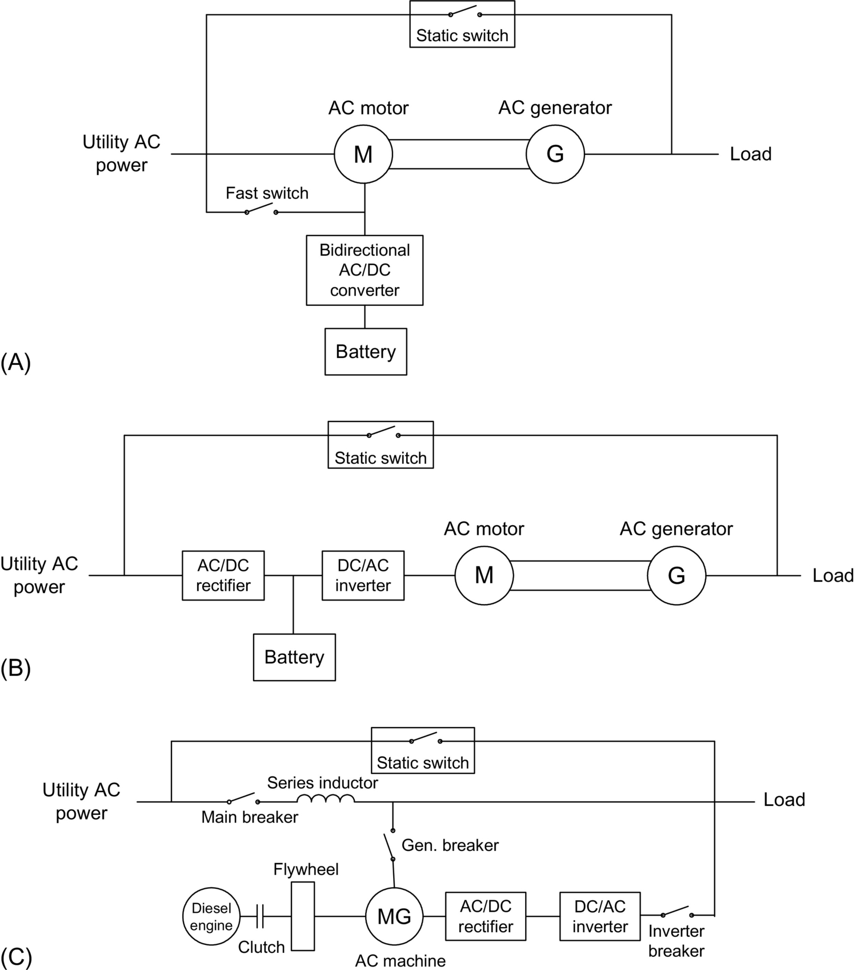

**FIG. 19.11** Three configurations of hybrid rotary-static UPS systems: (A) motor-generator set with battery backup, (B) motor-generator set with power conditioning at input side, and (C) batteryless hybrid UPS system.

### 19.2.7 DC UPS

All the aforementioned UPS configurations systems, including static, rotary, and hybrid UPS systems, are AC-based UPS systems as most UPS systems currently are available in the industry. In these systems, the AC main source directly or through several power conversions is connected to the load, and the power exchanged between different parts of the system has an AC format, except for the battery. The DC UPS system is based on the DC concept where the power flow in the system has DC characteristics, or in other words, the system shares power through a DC bus that connects all main parts, including source, loads, and energy storage, while in AC system, this link is an AC bus. The DC UPS system has several advantages with respect to the online three-phase UPS that is extensively used in industry, such as lower size, cost, and weight due to replacing the three-phase dual converter in the online UPS system with a single-stage single-phase DC/DC converter, and thus, higher efficiency is expected.

[Fig. 19.12](https://learning.oreilly.com/library/view/power-electronics-handbook/9780128114087/B9780128114070000210.xhtml#f0065) illustrates the block diagram of the DC line-interactive UPS system. This UPS shares a DC bus between the attached sources and loads. The DC link is also integrated with a battery pack through a DC/DC bidirectional power converter. The DC UPS consists of an AC/DC rectifier, a DC/DC bidirectional converter, and the battery pack. This UPS configuration is designed for pulse loads where frequent high-power pulses with short-time duration, that is, less than 10 s, are required. The DC/DC converter regulates the DC link voltage and controls the charging and discharging processes of the battery pack. The AC/DC rectifier operates in such a way to provide unity power factor. The rectifier is designed to supply the load average power plus the battery charging power while the DC/DC converter rated for the load peak power.

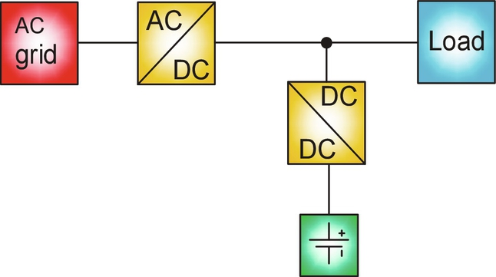

**FIG. 19.12** Block diagram of the proposed DC line-interactive UPS system.

The DC UPS system will also provide load leveling feature for the main AC/DC rectifier that has not been offered by conventional AC UPS systems. It applies load power smoothing to reduce the rating of the incoming AC line and consequently reduce the installation cost and time.

The DC UPS, as shown in [Fig. 19.12](https://learning.oreilly.com/library/view/power-electronics-handbook/9780128114087/B9780128114070000210.xhtml#f0065), is integrated with safe and high-power-density battery, which links to the DC link through a bidirectional DC/DC converter. In case of utility power disruptions, the proposed system provides power from the battery to directly energize the DC section and ensure continue and reliable operation.

The DC UPS system operates in four different modes, which are defined based on the load profile, battery pack status, and connection of the main AC source. These modes include high-rate discharging mode, a so-called load leveling mode, the standby mode, online mode, and UPS or islanded mode. The first mode is the high-rate discharging mode in which the load requires a pulsed peak power provided by the battery though DC/DC converter, following by a rest time in which battery is charged from the grid power. The third mode begins when the battery is fully charged during second mode. Finally, the fourth mode is when the AC main source is not available and the entire power provided by the battery pack.

### 19.2.8 COMPARISON OF UPS CONFIGURATIONS

[Table 19.1](https://learning.oreilly.com/library/view/power-electronics-handbook/9780128114087/B9780128114070000210.xhtml#t0010) provides the comparison between the characteristics of different types of UPS systems.

**Table 19.1**

**Performance comparison of different configurations of UPS systems**

|  |  |  |  |  |  |  |  |
| --- | --- | --- | --- | --- | --- | --- | --- |
| **Parameter** | **Online** | **Line interactive** | **Off-line** | **Universal** | **Rotary** | **Hybrid** | **DC** |
| Surge protection | Excellent | Good | Good | Good | Excellent | Excellent | Good |
| Transition time | Excellent | Good | Poor | Good | Excellent | Excellent | Good |
| Line conditioning | Poor | Good | Poor | Excellent | Good | Good | Good |
| Backup duration | Depends on battery | Depends on battery | Depends on battery | Depends on battery | Typically 0.1–0.5 s | Depends on battery | Depends on battery |
| Efficiency | Low around 80% | High up to 95% | High | High up to 95% | High typically above 85% | High typically around 95% | High up to 95% |
| Input/output isolation | Poor | Poor | Poor | Poor | Perfect | Perfect | Good |
| Load leveling | No | No | No | No | No | No | Excellent |
| Cost | High | Medium-high | Low | High | Very high | Very high | Low-medium |

## 19.3 Performance Evaluation

There are four criteria for evaluating the performance of a UPS system: quality of output voltage, input PFC and current harmonic cancellation, transition time, and efficiency.

The quality of output voltage is the most important factor. The output voltage of an AC UPS system should be sinusoidal with low THD in different loading conditions even with nonlinear loads. The control system should have small transient responses to provide appropriate line conditioning in different loading profiles. Typically, rotary UPS systems, which employ an AC generator at the load side, have better output voltage quality than static UPS systems. In these systems, there is no converter switching frequency present at the output voltage. Among the static UPS systems, online UPS configuration provides better output voltage quality. In this system, output voltage is provided by a DC/AC inverter regardless of input voltage quality. Usually, a PWM method is used to regulate the output voltage. This kind of UPS should be designed to have minimum switching frequency at the output and provide pure sinusoidal voltage at different loading conditions. Followed by online UPS system are universal and line-interactive configurations. In universal topology, during normal mode of operation, the series converter provides voltage conditioning and regulates output voltage. In the backup mode, the parallel converter provides the load with sinusoidal voltage. In the line-interactive topology, during normal operation mode, input voltage directly supplies the load and no voltage conditioning is provided. In the backup mode, the DC/AC inverter provides the load with sinusoidal voltage.

The second criterion is transition time from normal mode of operation to stored energy mode. Online rotary, DC, and static UPS systems have superior performance in this regard. The output voltage is always provided by the output generator or output converter, and there is no transition time between operation modes of the systems. However, some of the rotary and hybrid configurations shown in [Figs. 19.10](https://learning.oreilly.com/library/view/power-electronics-handbook/9780128114087/B9780128114070000210.xhtml#f0055) and [19.11](https://learning.oreilly.com/library/view/power-electronics-handbook/9780128114087/B9780128114070000210.xhtml#f0060) can only provide power to the load for a limited time. This time is determined by the amount of kinetic energy stored in the mechanical system. The transfer time in universal and line-interactive topologies depends on the time necessary for converting the power flow from the battery bank through the inverter to the load. Improved performance is achieved by choosing the DC bus capacitor voltage at the battery side to be slightly higher than the floating voltage of the batteries. Therefore, when the AC line fails, it is not necessary to sense the failure because the DC bus voltage will immediately fall under the floating voltage of the batteries and the power flow will naturally turn to the load. For off-line UPS systems, the transfer time is the longest. It depends upon the speed of sensing the failure of the AC line and starting the inverter.

The next important factor is the input power factor and the ability of the system to provide conditioning for load power. Universal UPS system has better performance followed by line-interactive and online UPS in this regard. During normal mode of operation, the parallel converter acts as an active filter and compensates reactive current and current harmonics generated by the load. In the line-interactive system, the bidirectional AC/DC converter performs this task. In an online UPS system, an additional system must be added to improve PFC and mitigate current harmonics.

The last criterion for performance evaluation is efficiency. To emphasize this factor, it should be noted that losses in UPS systems represent about 5%–12% of all the energy consumed in data centers. Efficiency in rotary and hybrid configurations depends on the topology of the system, but typically, for low-power application due to mechanical loss in the motor and generator, the efficiency is not very high. Among the static UPS systems, online UPS system has the poorest efficiency due to double conversion. Line-interactive and universal topologies provide higher efficiencies since most of the power directly flows from the input AC to the load during normal operation. The DC UPS has efficiency close to the line-interactive UPS type and higher than online UPS due to lower number of power conversion stages between source and load.

## 19.4 Applications

The UPS systems have wide applications in a variety of industries. Their common applications range from small power rating for personal computer systems to medium power rating for medical facilities, life-supporting systems, data storage, and emergency equipment and high power rating for telecommunications, industrial processing, and online management systems. Different considerations should be taken into account for these applications. For emergency systems and lighting, the UPS should support the system for at least 90 min. Except for emergency systems, the UPS is designed to provide backup power to sensitive loads for 15–20 min. After this time, if the power is not restored, the system will be gracefully shut down. If a longer backup period is considered, a larger battery with higher cost and space is required. For process equipment and high-power applications, some UPS systems are designed to provide enough time for the secondary power sources such as diesel generators to start up.

For industrial applications, it should be noted that UPS systems add to the complexity of the electric system. They also add installation and ongoing maintenance costs. They may also add nonlinearity to the system, decrease the efficiency, and deteriorate the input PFC mechanism. The power rating of the UPS should be appropriately selected considering the existing load and future extensions. For many applications, input voltage surges and spikes cause more damage than power outages. For these systems, another device instead of UPS can be utilized. Load characteristics should also be considered in UPS selection. For motor loads, the inrush current, which is sometimes 2.5 times of the rated current, should be considered. A good UPS for the motor loads is the one with higher transient overloads. For nonlinear loads such as switching power supplies, the input current is not sinusoidal. Therefore, the instantaneous current is higher than the RMS current. This high instantaneous current should be considered in UPS selection.

For a power distribution network, two different approaches are taken to support sensitive loads. In a distributed approach, which is more suitable for highly proliferated loads such as medical equipment, data processing, and telecommunications, many separate UPS units operate in parallel to supply critical loads. UPS units are placed flexibly in the system to form a critical load network. A typical online distributed UPS system is shown in [Fig. 19.13](https://learning.oreilly.com/library/view/power-electronics-handbook/9780128114087/B9780128114070000210.xhtml#f0070). High flexibility and redundancy are the main advantages of distributed systems. Individual load increase can be supported by adding more UPS systems. Consideration for future extension can also be delayed until the loads are added. On the other side, this method has some disadvantages. The load sharing between different UPS units is a difficult task. Complicated digital control methods and communication between units are required to perform optimal load sharing. The second disadvantage is that the monitoring of the whole system is difficult and requires specially trained staff.

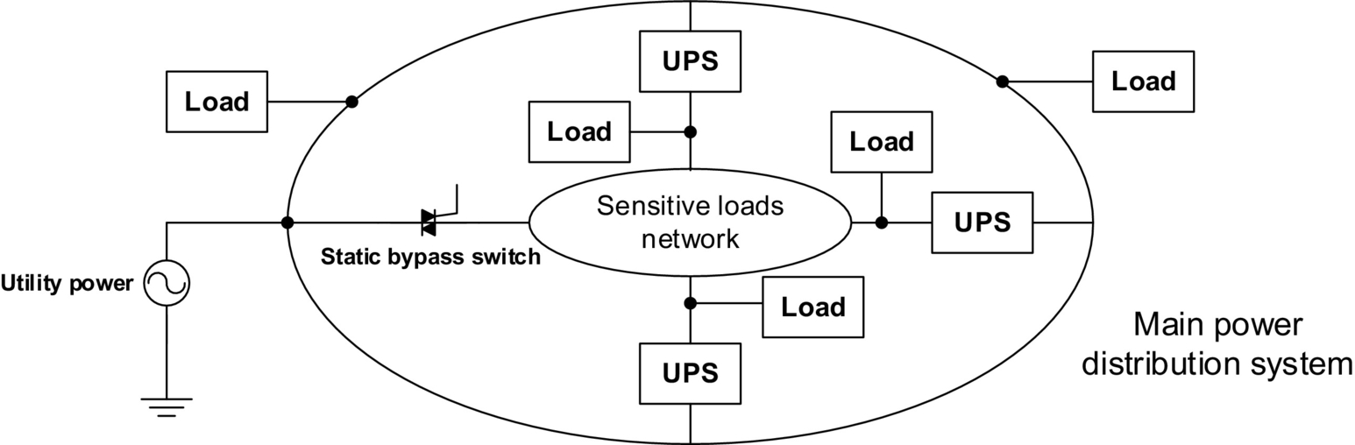

**FIG. 19.13** Typical configuration of a distributed UPS network.

The other method to support distributed loads is to use a large UPS unit to supply all the critical loads in a centralized approach. This approach is more desirable for industrial and utility applications. The advantage of this method is easier maintenance and troubleshooting. The disadvantages on the other side are the lack of redundancy and high installation cost. In addition, consideration for system expansion should be taken into account when the original UPS unit is selected.

## 19.5 Control Techniques

The main task of the control system in an UPS unit is to minimize the output voltage THD in different loading profiles. In addition, it should provide the proper mechanism to recharge the battery set and maintain high input power factor and low total input current harmonic distortion. Other factors considered for a good control technique are nearly zero steady-state inverter output voltage error, good voltage regulation, robustness, fast transient response, and protection of the inverter against overload under linear/nonlinear loads.

The most common switching technique is sinusoidal PWM. This method can be utilized for both single-phase and three-phase systems. The advantage of this method is low output voltage harmonic and robustness. This strategy uses a single feedback loop to provide well-regulated output voltage with low THD. The feedback control can be continuous or discontinuous. Analog techniques are used in continuous approach. The sinusoidal PWM (SPWM) can be of natural sampling type, average type, or instantaneous type [[17](https://learning.oreilly.com/library/view/power-electronics-handbook/9780128114087/B9780128114070000210.xhtml#bb0090),[18](https://learning.oreilly.com/library/view/power-electronics-handbook/9780128114087/B9780128114070000210.xhtml#bb0095)].

In natural sampling type, the peak value of the output voltage is detected and compared with a reference voltage in order to obtain the error, which is used to control the reference to the modulator. The average approach is basically the same; but, the sensed voltage is converted to an average value and, after that, is compared with a reference signal. These approaches control only the amplitude of the output voltage and are good only at high frequencies. In an instantaneous voltage feedback SPWM control, the output voltage is continuously compared with the reference signal improving the dynamic performance of the UPS inverter.

A typical block diagram of a three-phase DC/AC inverter for UPS systems and SPWM switching control technique is shown in [Fig. 19.14](https://learning.oreilly.com/library/view/power-electronics-handbook/9780128114087/B9780128114070000210.xhtml#f0075). The disadvantage of this method is lack of flexibility for nonlinear loads. Other programmed PWM techniques such as selective harmonic elimination, minimum THD, minimum loss, minimum current ripple, and reduced acoustic noise may be used for the inverter.

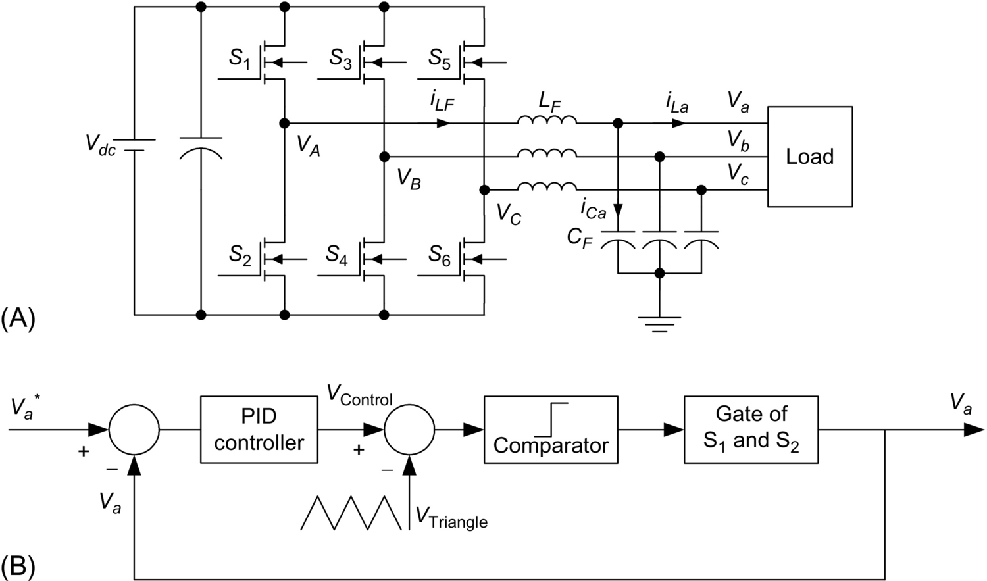

**FIG. 19.14** (A) Configuration of a three-phase DC/AC inverter for UPS systems and (B) simple voltage controller using PWM technique.

Better performance even with nonlinear and step-changing loads can be achieved by multiple control loop strategies [[19](https://learning.oreilly.com/library/view/power-electronics-handbook/9780128114087/B9780128114070000210.xhtml#bb0100)]. As shown in [Fig. 19.15](https://learning.oreilly.com/library/view/power-electronics-handbook/9780128114087/B9780128114070000210.xhtml#f0080), there are two-control loops: an outer and an inner. The outer control loop uses the output voltage as a feedback signal, which is compared with a reference signal. The error is compensated by a PI integrator to achieve stable output voltage under steady-state operation. This error is also used as a reference signal for the inner current regulator loop, which uses the inductor or the capacitor output filter current as the feedback signal. The minor current loop ensures fast dynamic responses enabling good performance with nonlinear or step-changing loads. The basic current regulators employed as minor current loop are hysteresis regulators, sinusoidal PWM regulator, and predictive regulators. In a typical hysteresis regulator, the reference signal is compared with the feedback signal. The sign and predetermined amplitude of the error determine the output of the modulator. The duration between two successive levels is determined by the slope of the reference signal. The output voltage tracks the reference signal within the upper and lower boundary levels. This hysteresis control has fast transient response; but, the switching frequency varies widely [[20](https://learning.oreilly.com/library/view/power-electronics-handbook/9780128114087/B9780128114070000210.xhtml#bb0105)].

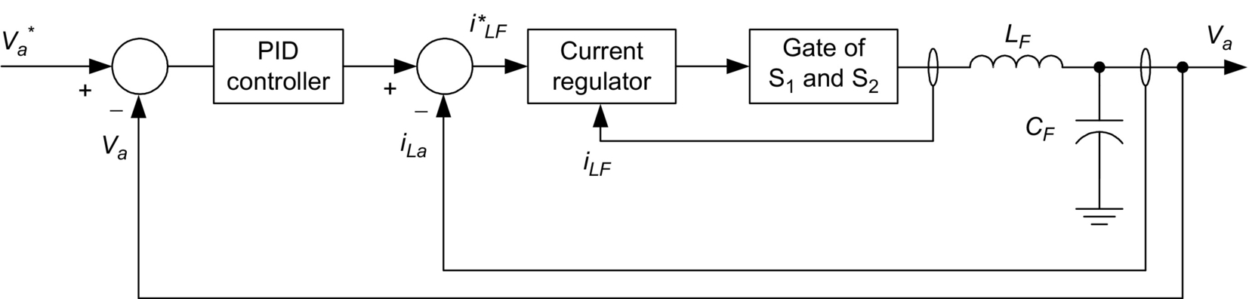

**FIG. 19.15** Typical current and voltage control loops for UPS inverter.

In SPWM control technique, the output voltage feedback is compared with a sine reference signal, and the error voltage is compensated by a PI regulator to produce the current reference. The current through the inductor or the capacitor is sensed and compared with the reference signal. After being compensated by a PI regulator, the error signal is compared with a triangular waveform to generate SPWM signal for switching control. The SPWM current control has a constant switching frequency and also provides fast dynamic responses. In predictive current control method, the switching instants are determined by suitable error boundaries. When the current vector touches the boundary line, the next switching state vector is determined by prediction and optimization in order to minimize the error. Predictive current control requires a good knowledge of the load parameters. All these current regulators are typically used as an inner loop to regulate the current in the filter inductor. The current reference for the current regulator is obtained by summing together the error in an outer voltage loop with the actual load current to yield the rated output voltage.

With the increase of speed and reliability of digital processors and a decrease in their cost, digital processors have been facing an enormous growth of popularity in control applications in the past few years. Many digital and discrete control techniques such as deadbeat control [[21](https://learning.oreilly.com/library/view/power-electronics-handbook/9780128114087/B9780128114070000210.xhtml#bb0110)], dissipativity-based control [[22](https://learning.oreilly.com/library/view/power-electronics-handbook/9780128114087/B9780128114070000210.xhtml#bb0115)], sliding-mode control [[23](https://learning.oreilly.com/library/view/power-electronics-handbook/9780128114087/B9780128114070000210.xhtml#bb0120)], space vector-based control [[24](https://learning.oreilly.com/library/view/power-electronics-handbook/9780128114087/B9780128114070000210.xhtml#bb0125)], and multiple-feedback loop [[25](https://learning.oreilly.com/library/view/power-electronics-handbook/9780128114087/B9780128114070000210.xhtml#bb0130)] have been developed using digital signal processors.

In this section, fundamental analysis of a deadbeat control method is explained for the three-phase UPS configuration shown in [Fig. 19.14A](https://learning.oreilly.com/library/view/power-electronics-handbook/9780128114087/B9780128114070000210.xhtml#f0070). The state-space equations of one phase of this system in the continuous time domain are as follows:

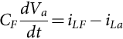 **(19.1)**

**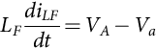** **(19.2)**

Considering *Va* and *iLF* as state variables, the state-space equation of the system is as follows:

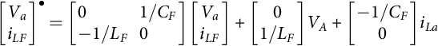 **(19.3)**

These continuous time-domain state-space equations are converted to the discontinuous time domain with a sampling period of *Ts* [[26](https://learning.oreilly.com/library/view/power-electronics-handbook/9780128114087/B9780128114070000210.xhtml#bb0135)]:

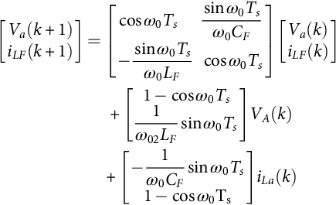 **(19.4)**

where *ω*0 is the angular resonance frequency of *LF* and *CF*. The sampling frequency of the system is always considered much higher than the resonance frequency of *LF* and *CF*. With this assumption, Eq. [(19.4)](https://learning.oreilly.com/library/view/power-electronics-handbook/9780128114087/B9780128114070000210.xhtml#fo0025) is simplified to Eq. [(19.5)](https://learning.oreilly.com/library/view/power-electronics-handbook/9780128114087/B9780128114070000210.xhtml#fo0030). This conversion is valid for almost :

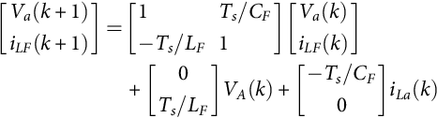 **(19.5)**

The current equation according to Eq. [(19.5)](https://learning.oreilly.com/library/view/power-electronics-handbook/9780128114087/B9780128114070000210.xhtml#fo0030) is given by

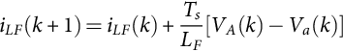 **(19.6)**

Alternatively, this equation can be achieved by converting Eq. [(19.2)](https://learning.oreilly.com/library/view/power-electronics-handbook/9780128114087/B9780128114070000210.xhtml#fo0015) from a differential equation to a difference equation. The same suggestion of  has to be made for this conversion as well. If *Va* and *iLF*⁎ are considered constant over the next switching period, the output voltage of the inverter, which corrects the error of *iLF* after two sampling periods, is described by

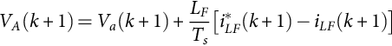 **(19.7)**

A linear estimation of  can be achieved from previous values:

 **(19.8)**

By substituting Eqs. [(19.8)](https://learning.oreilly.com/library/view/power-electronics-handbook/9780128114087/B9780128114070000210.xhtml#fo0045) and [(19.10)](https://learning.oreilly.com/library/view/power-electronics-handbook/9780128114087/B9780128114070000210.xhtml#fo0055) in Eq. [(19.9)](https://learning.oreilly.com/library/view/power-electronics-handbook/9780128114087/B9780128114070000210.xhtml#fo0050) and updating reference current for *iLF* in every two sampling periods, the deadbeat digital control for series converter is described by

 **(19.9)**

Eq. [(19.9)](https://learning.oreilly.com/library/view/power-electronics-handbook/9780128114087/B9780128114070000210.xhtml#fo0050) ensures that the current error between *iLF* and *iLF*⁎ at time *k*+2 goes to zero with a delay of two sampling periods. Avoiding interaction between voltage and current control loops, load voltage, *Va*, is sampled at half of the current sampling frequency. The voltage equation according to Eq. [(19.5)](https://learning.oreilly.com/library/view/power-electronics-handbook/9780128114087/B9780128114070000210.xhtml#fo0030) is as follows:

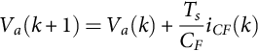 **(19.10)**

**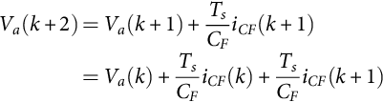** **(19.11)**

As current control is suggested to be deadbeat with a delay of two sampling periods, capacitor current at time *k* and (*k*+1) are given by

 **(19.12)**

Substituting Eq. [(19.12)](https://learning.oreilly.com/library/view/power-electronics-handbook/9780128114087/B9780128114070000210.xhtml#fo0065) in Eq. [(19.11)](https://learning.oreilly.com/library/view/power-electronics-handbook/9780128114087/B9780128114070000210.xhtml#fo0060) and updating the reference current at each of the two sampling periods,  is given by

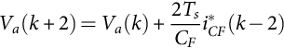 **(19.13)**

The current of *iCF*⁎ at time *k* that corrects the voltage error of *Va* at time *k*+4 is as follows:

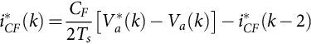 **(19.14)**

A block diagram of the implementation of voltage and current control of the inverter is shown in [Fig. 19.16](https://learning.oreilly.com/library/view/power-electronics-handbook/9780128114087/B9780128114070000210.xhtml#f0085). Block diagram of the current and voltage controller for the inverter is also shown in [Fig. 19.17](https://learning.oreilly.com/library/view/power-electronics-handbook/9780128114087/B9780128114070000210.xhtml#f0090). Voltage regulator is a pure deadbeat controller with a delay of two sampling periods including the consumed time for calculation. *G*1 is the time delay needed for calculations and analog-to-digital conversions. *G*2 is the time delay caused by the PWM inverter, and *G*3 is the transfer function of the low-pass filter. Current regulator is also considered as a pure delay. The output voltage of the inverter follows its reference with four sampling periods of delay. In practice, the dynamics of the current regulator is not a pure delay and shows some deviation from the deadbeat controller.

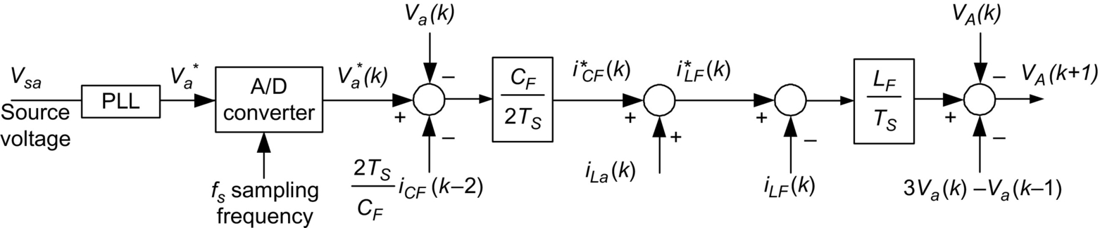

**FIG. 19.16** Implementation of the current and voltage control for the inverter shown in [Fig. 19.13A](https://learning.oreilly.com/library/view/power-electronics-handbook/9780128114087/B9780128114070000210.xhtml#f0070).

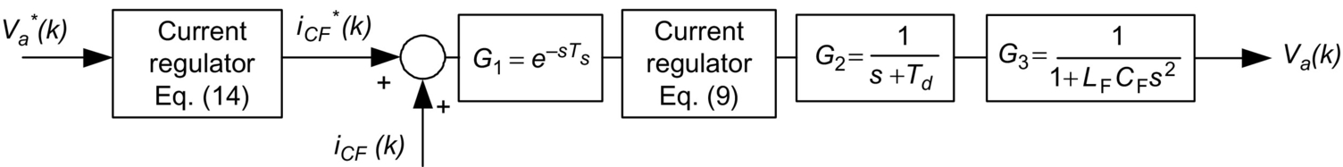

**FIG. 19.17** Block diagram of the current and voltage controller for the inverter shown in [Fig. 19.13A](https://learning.oreilly.com/library/view/power-electronics-handbook/9780128114087/B9780128114070000210.xhtml#f0070).

[Fig. 19.18](https://learning.oreilly.com/library/view/power-electronics-handbook/9780128114087/B9780128114070000210.xhtml#f0095) shows the schematic of the DC UPS. The system consists of two main converters, an AC/DC converter that manages power flow from grid to the DC bus and a DC/DC converter that regulates the DC bus voltage and also manages battery charging/discharging process. The goal for the grid-tied AC/DC rectifier is to deliver constant power to the DC link. In order to satisfy the goal, the rectifier operates on current mode and is controlled by the direct power control (DPC) method [[27](https://learning.oreilly.com/library/view/power-electronics-handbook/9780128114087/B9780128114070000210.xhtml#bb0140)]. In the direct power control scheme, the direct and quadrature components of the grid currents are used to control active and reactive power independently. [Fig. 19.19](https://learning.oreilly.com/library/view/power-electronics-handbook/9780128114087/B9780128114070000210.xhtml#f0100) illustrates the block diagrams of the AC/DC converter and the control technique.

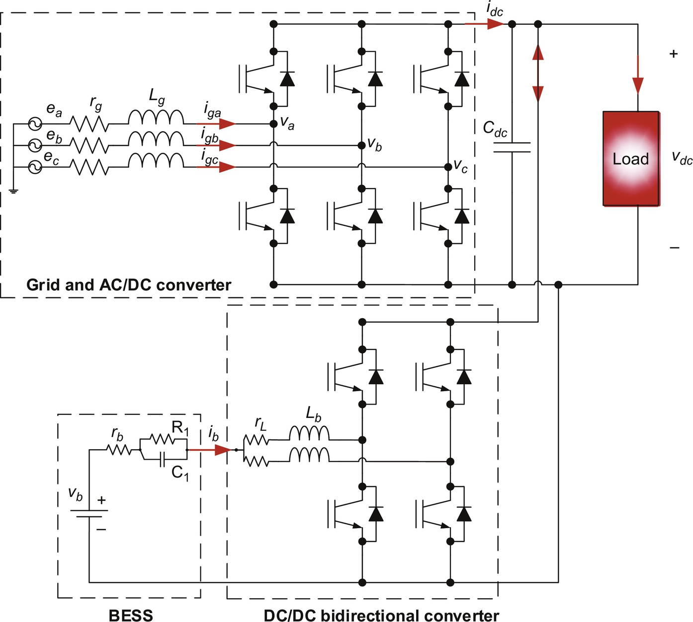

**FIG. 19.18** Schematic of the DC UPS system.

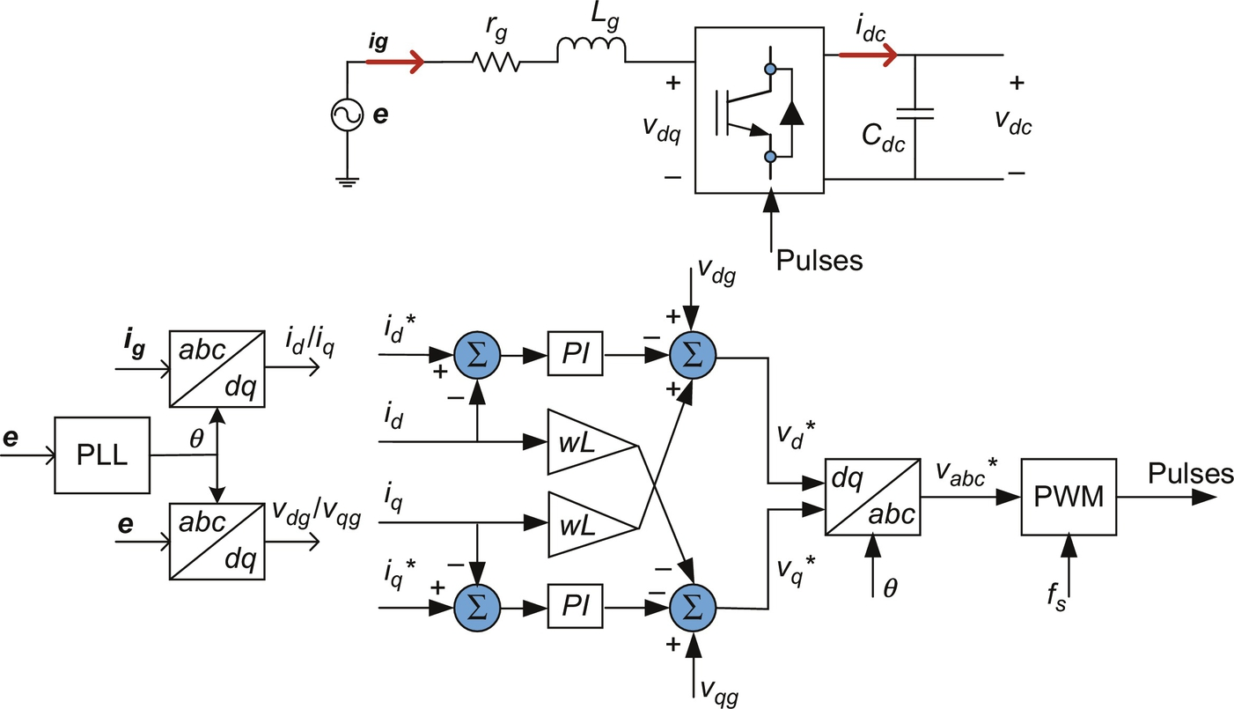

**FIG. 19.19** Block diagram of the grid-tied AC/DC rectifier and controller scheme. Direct power control method is used to control the rectifier.

A two-control loop method is used to manage the DC/DC converter. The controller consists of two main loops, an inner current loop and an outer voltage loop to monitor battery current while regulating the DC link voltage. [Fig. 19.20](https://learning.oreilly.com/library/view/power-electronics-handbook/9780128114087/B9780128114070000210.xhtml#f0105) depicts the block diagram of the two-loop control technique. *Gvd* is the transfer functions of DC link voltage versus duty ratio of the DC/DC converter, and *Gid* is the transfer function of battery current versus duty ratio of the converter. *Gci* and *Gvi* are the compensations, which need to be designed appropriately. There are several ways to design the compensators, such as desired pole/zero placement, step response, or frequency response. The frequency response characteristics are desired phase margin and crossover frequency (*wwc*). It is desired for the system to have a crossover frequency 5–10 times lower than switching frequency and a phase margin of equal or greater than 40 degrees to have enough marginal stability.

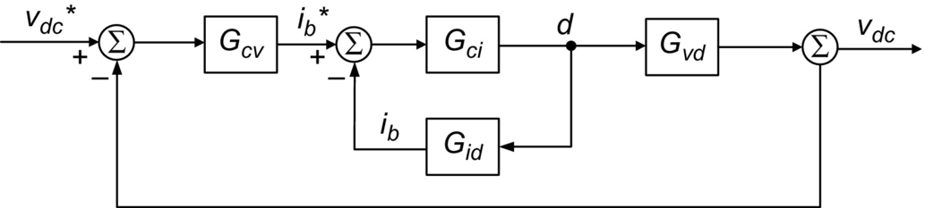

**FIG. 19.20** Block diagram of the two-control loop method used to manage the DC/DC converter in the DC UPS.

## 19.6 Energy Storage Devices

In this section, three dominant main energy storage devices for the existing and future UPS systems are described. These energy storage devices are battery, flywheel, and fuel cell.

### 19.6.1 BATTERY

Battery is the energy storage component of current static UPS systems. It determines the capacity and run time of the UPS. For small units, it is the size of battery that determines the size of the UPS. Different types of batteries are used in UPS systems, but the most commonly used types are lead-acid, nickel-cadmium, and lithium-ion batteries. The lead-acid batteries used in this application are the same as the ones used in the cars. However, there is one small difference. Car batteries generate electricity by the reaction of sulfuric acid on lead plates that are drowned under the liquid. These types of battery cells are not suitable for UPS applications because there is a chance of acid spillage from them. In addition, during the charging process, they release hydrogen that is explosive and dangerous in a closed environment. Lead-acid batteries used in UPS systems are a special kind called sealed or valve-regulated. The nickel-cadmium batteries are another popular type of batteries used in UPS systems. They usually provide higher energy and power density compared with lead-acid batteries. The nominal voltage of nickel-cadmium cells is 1.2 V, which is smaller than 1.5 V of lead-acid batteries. However, the cell voltage variation throughout different charge levels is less than lead-acid batteries. These batteries also have less series resistance and can provide higher surge currents.

Lithium-ion batteries have much higher energy density. This kind of battery can be molded into different shapes. They have a nominal voltage of 4.2 V. These batteries have higher power and energy densities compared with lead-acid batteries. A long life cycle without memory effect, together with high columbic efficiency and low self-discharge characteristics, makes this type of battery the preferred energy storage choice for a wide variety of applications including UPS systems.

The electrode material greatly influences the battery specifications in terms of power and energy density, voltage characteristics, lifetime, and safety. A typical cathode, that is, the positive active electrode, is made of a lithium metal oxide and common materials such as cobalt (LiCoO2 or LCO) and manganese (LiMn2O4 or LMO). Combined chemistries including nickel-cobalt-aluminum (NCA), nickel-manganese-cobalt (NMC), and iron phosphate (LFP) are also employed for the cathode. Graphite and lithium titanate (Li4Ti5O12 or LTO) are the typical choices for the anode, that is, the negative active electrode [[28](https://learning.oreilly.com/library/view/power-electronics-handbook/9780128114087/B9780128114070000210.xhtml#bb0145)]. [Fig. 19.21](https://learning.oreilly.com/library/view/power-electronics-handbook/9780128114087/B9780128114070000210.xhtml#f0110) compares different Li-ion batteries with lead-acid and ultracapacitor.

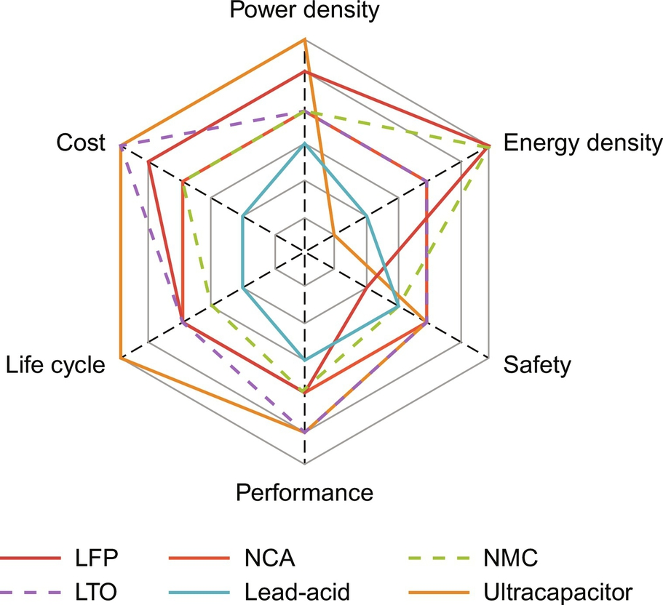

**FIG. 19.21** Comparison of different Li-ion batteries, lead-acid, and ultracapacitor.

### 19.6.2 FLYWHEEL

Flywheel is simply a mechanical mass that is placed on the shaft of a motor-generator set and stores mechanical energy in the form of kinetic energy. When the electric power is required, this kinetic energy is converted to electricity by the generator coupled with the flywheel. Flywheels are the oldest type of energy storage devices. The advantages of flywheel energy storage systems are high efficiency, high energy and power density, and long life. On the other hand, flywheels are more expensive and require more space than batteries and fuel cells. There are also some safety concerns about flywheels rotating at high speeds.

### 19.6.3 FUEL CELL

Due to high efficiency and low emissions, fuel cell systems have been gaining popularity in recent years. A fuel cell uses hydrogen as fuel and produces electricity, heat, and water from the reaction between hydrogen and oxygen. Each cell consists of an electrolyte and two electrodes as anode and cathode. [Fig. 19.22](https://learning.oreilly.com/library/view/power-electronics-handbook/9780128114087/B9780128114070000210.xhtml#f0115) shows the configuration of a typical fuel cell system. There are different kinds of fuel cell system depending on the types of electrolyte and hydrogen sources. Some fuel cell systems have an onboard fuel reformer and generate hydrogen from natural gas, methanol, and other hydrocarbons. Recent technology development in this field has made fuel cells a more reliable and cost-effective alternative for batteries. Fuel cells currently have a variety of applications in automotive, electric utility, and portable power industries. [Table 19.2](https://learning.oreilly.com/library/view/power-electronics-handbook/9780128114087/B9780128114070000210.xhtml#t0015) provides a comparison between the most popular types of fuel cells.

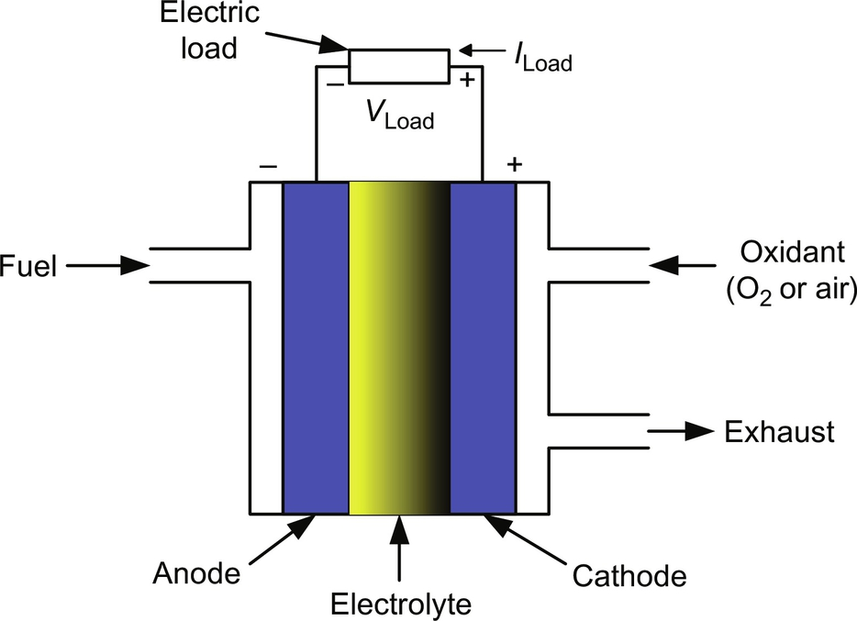

**FIG. 19.22** Configuration of a typical fuel cell system.

**Table 19.2**

**A comparison between the different types of fuel cell system**

|  |  |  |  |
| --- | --- | --- | --- |
| **Fuel cell type** | **Applications** | **Advantages** | **Disadvantages** |
| Proton exchange membrane (PEM) | • Electric utility  • Portable power  • Automotive | • Solid electrolyte reduces corrosion and management problems  • Low temperature  • Quick start-up | • Expensive catalysts  • High sensitivity to fuel impurities |
| Alkaline (AFC) | • Military  • Space | • High performance | • Expensive removal of CO2 from fuel and air streams required |
| Phosphoric acid (PAFC) | • Electric utility  • Automotive | • Up to 85% efficiency in cogeneration of electricity and heat  • Can use impure H2 as fuel | • Expensive catalysts  • Low power  • Large size/weight |
| Molten carbonate (MCFC) | • Electric utility | • High efficiency  • Fuel flexibility  • Can use a variety of catalysts | • High temperature enhances corrosion and breakdown of cell components |
| Solid oxide fuel cell (SOFC) | • Electric utility | • High efficiency  • Fuel flexibility  • Can use a variety of catalysts  • Solid electrolyte reduces corrosion and management problems  • Low temperature  • Quick start-up | • High temperature enhances the breakdown of cell components |
| Direct alcohol fuel cell (DAFC) | • Automotive  • Portable power | • Compactness  • High energy density | • Lower efficiency  • Alcohol passing between electrodes without reacting |

## References

[1] Karve S. Three of a kind. *IEE Rev.* 2000;46(2):27–31.

[2] Carle R.H. UPS applications: mill perspective. *IEEE Ind. Appl. Mag.* 1995;1(6):12–17.

[3] Krishnan R., Srinivasan S. *Topologies for uninterruptible power supplies.* In: Proc. IEEE International Symposium on Industrial Electronics, Hungary; 1993:122–127.

[4] Kamran F., Habetler T.G. A novel on-line UPS with universal filtering capabilities. *IEEE Trans. Power Electron.* 1998;13(2):366–371.

[5] Choi J.H., Kwon J.M., Jung J.H., Kwon B.H. High-performance online UPS using three-leg-type converter. *IEEE Trans. Ind. Electron.* 2005;52(3):889–897.

[6] Pinheiro H., Jain P.K., Joos G. A comparison of UPS for powering hybrid fiber/coaxial networks. *IEEE Trans. Power Electron.* 2002;17(3):389–397.

[7] Youichi I., Satoru I., Isao T., Hitoshi H. *New power conversion technique to obtain high performance and high efficiency for single-phase UPS.* In: Proc. 36th IEEE Industry Applications Conference, vol. 4; 2001:2383–2388.

[8] Gueldner H., Wolf H., Blacha N. *Single phase UPS inverter with variable output voltage and digital state feedback control.* In: Proc. IEEE International Symposium on Industrial Electronics, vol. 2; 2001:1089–1094.

[9] Lee J., Chang Y., Liu F. A new UPS topology employing a PFC boost rectifier cascaded high-frequency tri-port converter. *IEEE Trans. Ind. Electron.* 1999;46(4):803–813.

[10] Kamran F., Habetler T.G. A novel on-line UPS with universal filtering capabilities. *IEEE Trans. Power Electron.* 1998;13(3):410–418.

[11] Kwon B., Choi J., Kim T. Improved single-phase line-interactive UPS. *IEEE Trans. Ind. Electron.* 2001;48(4):804–811.

[12] Nasiri A., Bekiarov S., Emadi A. *Reduced parts three-phase series-parallel UPS system with active filter capabilities.* In: Proc. IEEE 38th Industry Applications Conference, vol. 2; 2003:963–969.

[13] da Silva S., Donoso-Garcia P.F., Cortizo P.C., Seixas P.F. A three-phase line-interactive UPS system implementation with series-parallel active power-line conditioning capabilities. *IEEE Trans. Ind. Appl.* 2002;38(6):1581–1590.

[14] Kuskoand A., Fairfax S. *Survey of rotary uninterruptible power supplies.* In: Proc. 18th International Telecommunications Energy Conference; 1996:416–419.

[15] Windhorn A. A hybrid static/rotary UPS system. *IEEE Trans. Ind. Appl.* 1992;28(3):541–545.

[16] Hung W.W., McDowell G.W.A. Hybrid UPS for standby power systems. *Power Eng. J.* 1990;4(6):281–291.

[17] Bowes S.R. Advanced regular-sampled PWM control techniques for drives and static power converters. *IEEE Trans. Ind. Electron.* 1995;42(4):367–373.

[18] Rech C., Grundling H.A., Pinheiro J.R. *Comparison of discrete control techniques for UPS applications.* In: Proc. IEEE Industry Applications Conference; 2000:2531–2537.

[19] Chen J., Chu C. Combination voltage-controlled and current-controlled PWM inverters for UPS parallel operation. *IEEE Trans. Power Electron.* 1995;10(5):547–558.

[20] Mattavelli P., Stefanutti W. *Fully digital hysteresis modulation with switching time prediction.* In: Proc. 19th Applied Power Electronics Conference and Exposition; 2004:493–499.

[21] Mattavelli P. An improved deadbeat control for UPS using disturbance observers. *IEEE Trans. Ind. Electron.* 2005;52(1):206–212.

[22] Valderrama G.E., Stankovic A.M., Mattavelli P. Dissipativity-based adaptive and robust control of UPS in unbalanced operation. *IEEE Trans. Power Electron.* 2003;18(4):1056–1062.

[23] Tai T., Chen J. UPS inverter design using discrete-time sliding-mode control scheme. *IEEE Trans. Ind. Electron.* 2002;49(1):67–75.

[24] Burup U., Enjeti P.N., Blaabjerg F. A new space-vector-based control method for UPS systems powering nonlinear and unbalanced loads. *IEEE Trans. Ind. Appl.* 2001;37(6):1864–1870.

[25] Abdel-Rahim N.M., Quaicoe J.E. Analysis and design of a multiple feedback loop control strategy for single-phase voltage-source UPS inverters. *IEEE Trans. Power Electron.* 1996;11(4):532–541.

[26] Nasiri A., Emadi A. *Digital control of a three-phase series-parallel uninterruptible power supply/active filter system.* In: Proc. IEEE 35th Annual Power Electronics Specialists Conference; 2004:4115–4120.

[27] Teodorescu R., Liserre M., Rodríguez P. *Grid Converters for Photovoltaic and Wind Power Systems.* John Wiley & Sons, Ltd; 2011.978-0-470-05751-3.

[28] Hamidi S.A., Ionel Dan M., Nasiri Adel. Modeling and management of batteries and ultracapacitors for renewable energy support in electric power systems—an overview. *J. Electr. Power Compon. Syst.* 2015;43(12):1434–1452.

**20**

# Power Supplies

Yuk M. Lai The Hong Kong Polytechnic University, Kowloon, Hong Kong

## Abstract

This chapter describes the power supplies that are commonly used in electric equipment, namely, linear regulators and switching regulators. Their properties, performances, operating principles, and characteristics of these regulators will also be given in this chapter.

### KEYWORDS

Power supplies; Linear regulators; Switching regulators; Pulse-width modulation

20.1 [Introduction](https://learning.oreilly.com/library/view/power-electronics-handbook/9780128114087/B9780128114070000222.xhtml#s0010)

20.2 [Linear Series Voltage Regulator](https://learning.oreilly.com/library/view/power-electronics-handbook/9780128114087/B9780128114070000222.xhtml#s0015)

20.2.1 Regulating Control

20.2.2 Current Limiting and Overload Protection

20.3 [Linear Shunt Voltage Regulator](https://learning.oreilly.com/library/view/power-electronics-handbook/9780128114087/B9780128114070000222.xhtml#s0030)

20.4 [Integrated Circuit Voltage Regulators](https://learning.oreilly.com/library/view/power-electronics-handbook/9780128114087/B9780128114070000222.xhtml#s0035)

20.4.1 Fixed Positive and Negative Linear Voltage Regulators

20.4.2 Adjustable Positive and Negative Linear Voltage Regulators

20.4.3 Applications of Linear IC Voltage Regulators

20.5 [Switching Regulators](https://learning.oreilly.com/library/view/power-electronics-handbook/9780128114087/B9780128114070000222.xhtml#s0055)

20.5.1 Single-Ended Isolated Flyback Regulators

20.5.2 Single-Ended Isolated Forward Regulators

20.5.3 Half-Bridge Regulators

20.5.4 Full-Bridge Regulators

20.5.5 Control Circuits and Pulse-Width Modulation

[Further Reading](https://learning.oreilly.com/library/view/power-electronics-handbook/9780128114087/B9780128114070000222.xhtml#bi0010)

## 20.1 Introduction

Power supplies are used in most electric equipment. Their applications cut across a wide spectrum of product types, ranging from consumer appliances to industrial utilities, from milliwatts to megawatts, and from handheld tools to satellite communications.

By definition, a power supply is a device that converts the output from an ac power line to a steady dc output or multiple outputs. The ac voltage is first rectified to provide a pulsating dc and then filtered to produce a smooth voltage. Finally, the voltage is regulated to produce a constant output level despite variations in the ac line voltage or circuit loading. [Fig. 20.1](https://learning.oreilly.com/library/view/power-electronics-handbook/9780128114087/B9780128114070000222.xhtml#f0010) illustrates the process of rectification, filtering, and regulation in a dc power supply. The transformer, rectifier, and filtering circuits are discussed in other chapters. In this chapter, we will concentrate on the operation and characteristics of the regulator stage of a dc power supply.

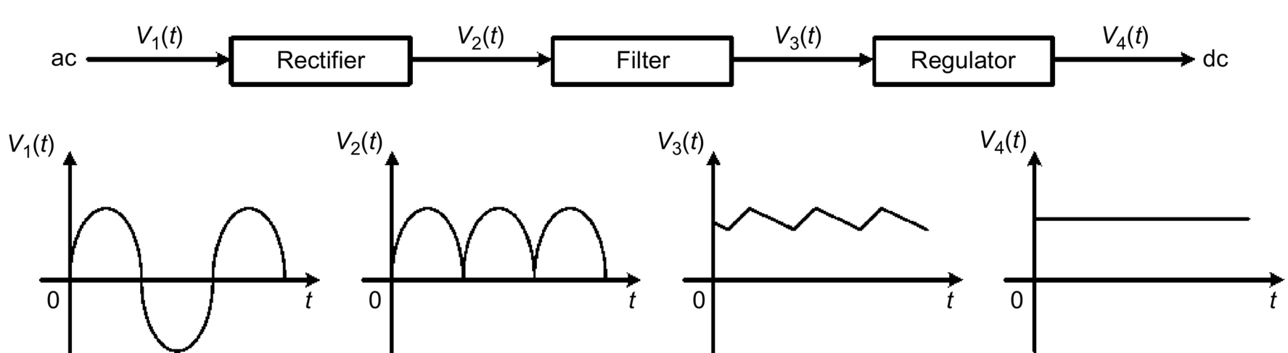

**FIG. 20.1** Block diagram of a dc power supply.

In general, the regulator stage of a dc power supply consists of a feedback circuit, a stable reference voltage, and a control circuit to drive a pass element (a solid-state device such as transistor and MOSFET). The regulation is done by sensing variations appearing at the output of the dc power supply. A control signal is produced to drive the pass element to cancel any variation. As a result, the output of the dc power supply is maintained essentially constant. In a transistor regulator, the pass element is a transistor, which can be operated in its active region or as a switch, to regulate the output voltage. When the transistor operates at any point in its active region, the regulator is referred to as a *linear voltage regulator*. When the transistor operates only at cutoff and at saturation, the circuit is referred to as a *switching regulator*.

Linear voltage regulators can be further classified as either series or shunt types. In a series regulator, the pass transistor is connected in series with the load as shown in [Fig. 20.2](https://learning.oreilly.com/library/view/power-electronics-handbook/9780128114087/B9780128114070000222.xhtml#f0015). Regulation is achieved by sensing a portion of the output voltage through the voltage divider network *R*1 and *R*2 and comparing this voltage with the reference voltage *V*REF to produce a resulting error signal that is used to control the conduction of the pass transistor. This way, the voltage drop across the pass transistor is varied and the output voltage delivered to the load circuit is essentially maintained constant.

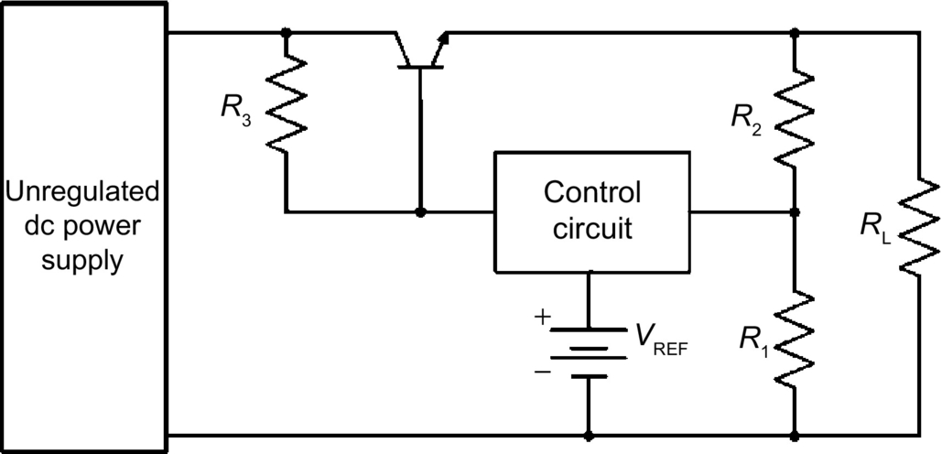

**FIG. 20.2** A linear series voltage regulator.

In the shunt regulator shown in [Fig. 20.3](https://learning.oreilly.com/library/view/power-electronics-handbook/9780128114087/B9780128114070000222.xhtml#f0020), the pass transistor is connected in parallel with the load, and a voltage-dropping resistor *R*3 is connected in series with the load. Regulation is achieved by controlling the current conduction of the pass transistor such that the current through *R*3 remains essentially constant. This way, the current through the pass transistor is varied, and the voltage across the load remains constant.

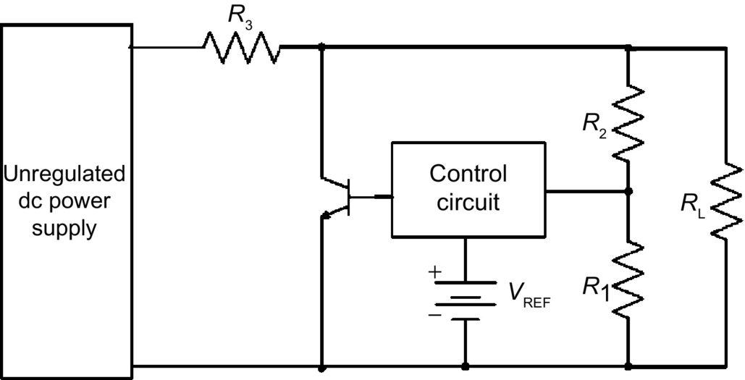

**FIG. 20.3** A linear shunt voltage regulator.

As opposed to linear voltage regulators, switching regulators employ solid-state devices, which operate as switches: either completely *on* or completely *off*, to perform power conversion. Because the switching devices are not required to operate in their active regions, switching regulators enjoy a much lower power loss than those of linear voltage regulators. [Fig. 20.4](https://learning.oreilly.com/library/view/power-electronics-handbook/9780128114087/B9780128114070000222.xhtml#f0025) shows a switching regulator in a simplified form. The high-frequency switch converts the unregulated dc voltage from one level to another dc level at an adjustable duty cycle. The output of the dc supply is regulated by means of a feedback control that employs a pulse-width modulator (PWM) controller, where the control voltage is used to adjust the duty cycle of the switch.

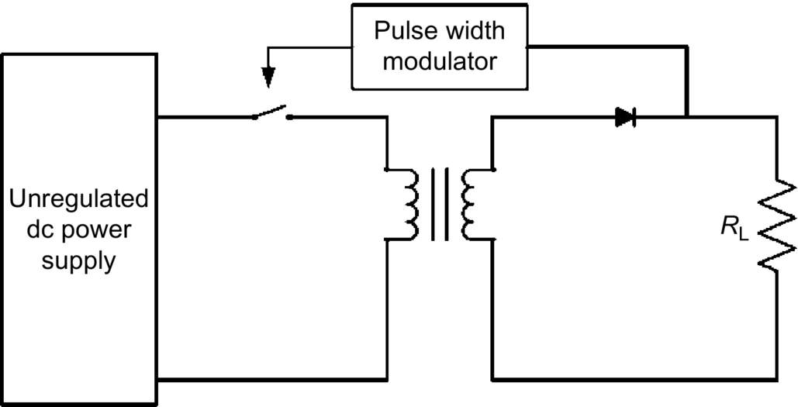

**FIG. 20.4** A simplified form of a switching regulator.

Both linear and switching regulators are capable of performing the same function of converting an unregulated input into a regulated output. However, these two types of regulators have significant differences in properties and performances. In designing power supplies, the choice of using certain type of regulator in a particular design is significantly based on the cost and performance of the regulator itself. In order to use the more appropriate regulator type in the design, it is necessary to understand the requirements of the application and select the type of regulator that best satisfies those requirements. Advantages and disadvantages of linear regulators, as compared with switching regulators, are given below:

1. Linear regulators exhibit efficiency of 20%–60%, whereas switching regulators have a much higher efficiency, typically 70%–95%.

2. Linear regulators can only be used as a step-down regulator, whereas switching regulators can be used in both step-up and step-down operations.

3. Linear regulators require a mains frequency transformer for off-the-line operation. Therefore, they are heavy and bulky. On the other hand, switching regulators use high-frequency transformers and can therefore be small in size.

4. Linear regulators generate little or no electric noise at their outputs, whereas switching regulators may produce considerable noise if they are not properly designed.

5. Linear regulators are more suitable for applications of less than 20 W, whereas switching regulators are more suitable for large-power applications.

In this chapter, we will examine the circuit operation, characteristics, and applications of linear and switching regulators. In [Section ***20.2***](https://learning.oreilly.com/library/view/power-electronics-handbook/9780128114087/B9780128114070000222.xhtml#s0015), we will look at the basic circuits and properties of linear series voltage regulators. Some current-limiting techniques will be explained. In [Section ***20.3***](https://learning.oreilly.com/library/view/power-electronics-handbook/9780128114087/B9780128114070000222.xhtml#s0030), linear shunt regulators will be covered. The important characteristics and uses of linear integrated circuit (IC) regulators will be discussed in [Section ***20.4***](https://learning.oreilly.com/library/view/power-electronics-handbook/9780128114087/B9780128114070000222.xhtml#s0035). Finally, the operation and characteristics of switching regulators will be discussed in [Section ***20.5***](https://learning.oreilly.com/library/view/power-electronics-handbook/9780128114087/B9780128114070000222.xhtml#s0055). Important design guidelines for switching regulators will also be given in this section.

## 20.2 Linear Series Voltage Regulator

A zener diode regulator can maintain a fairly constant voltage across a load resistor. It can be used to improve the voltage regulation and reduce the ripple in a power supply. However, the regulation is poor, and the efficiency is low because of the nonzero resistance in the zener diode. To improve the regulation and efficiency of the regulator, we have to limit the zener current to a smaller value. This can be accomplished by using an amplifier in series with the load as shown in [Fig. 20.5](https://learning.oreilly.com/library/view/power-electronics-handbook/9780128114087/B9780128114070000222.xhtml#f0030). The effect of this amplifier is to limit the variation of the current *I*D through the zener diode Dz. This circuit is known as a linear series voltage regulator because the transistor is in series with the load.

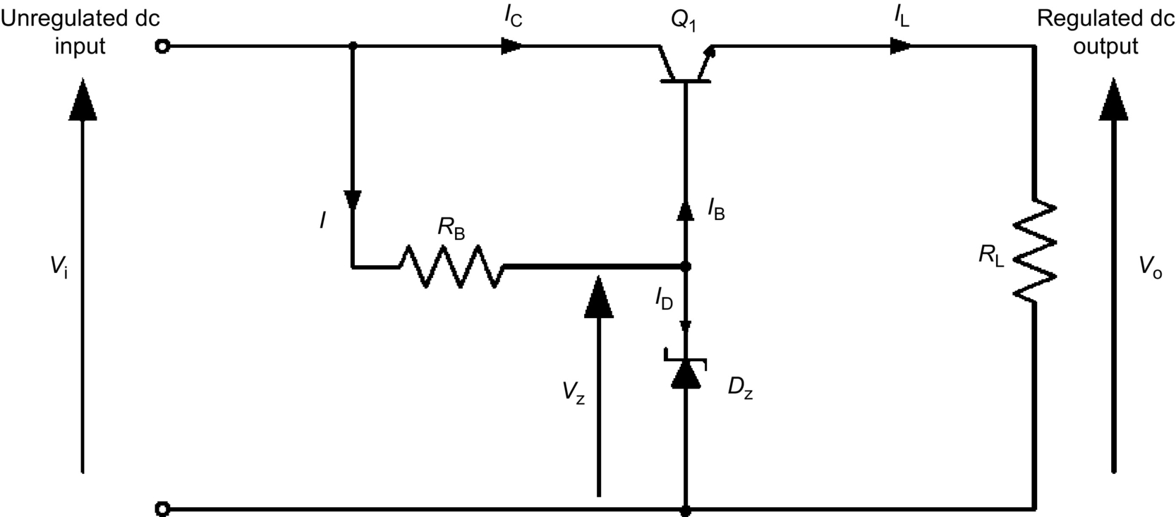

**FIG. 20.5** Basic circuit of a linear series regulator.

Because of the current-amplifying property of the transistor, *I*D is reduced by a factor of , where *β* is the dc current gain of the transistor. Hence, there is a small voltage drop across the diode resistance, and the zener diode approximates an ideal voltage source. The output voltage *V*o of the regulator is

 **(20.1)**

where *V*z is the zener voltage and *V*BE is the base-to-emitter voltage of the transistor. The change in output voltage is

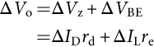 **(20.2)**

where *r*d is the dynamic resistance of the zener diode and *r*e is the output resistance of the transistor. Assume that *V*i and *V*z are constant. With , the change in output voltage is then

 **(20.3)**

If *V*i is not constant, then the current *I* will change with the input voltage. In calculating the change in output voltage, this current change must be absorbed by the zener diode.

In designing linear series voltage regulators, it is imperative that the series transistor must work within the rated safe operation area (SOA) and be protected from excess heat dissipation because of current overload. The emitter-to-collector voltage *V*CE of Q1 is given by

 **(20.4)**

Thus, with specified output voltage, the maximum allowable *V*CE for a given Q1 is determined by the maximum input voltage to the regulator. The power dissipated by Q1 can be approximated by

 **(20.5)**

Consequently, the maximum allowable power dissipated in Q1 is determined by the combination of the input voltage *V*i and the load current *I*L of the regulator. For a low output voltage and a high loading current regulator, the power dissipated in the series transistor is about 50% of the power delivered to the output.

In many high-current high-voltage regulator circuits, it is necessary to use a Darlington-connected transistor pair so that the voltage, current, and power ratings of the series element are not exceeded. The method is shown in [Fig. 20.6](https://learning.oreilly.com/library/view/power-electronics-handbook/9780128114087/B9780128114070000222.xhtml#f0035). An additional desirable feature of this circuit is that the reference diode dissipation can be reduced greatly. The maximum base current *I*B1 is then , where *β*1 and *β*2 are the dc current gain of Q1 and Q2, respectively. This current is usually of the order of less than 1 mA. Consequently, a low-power reference diode can be used.

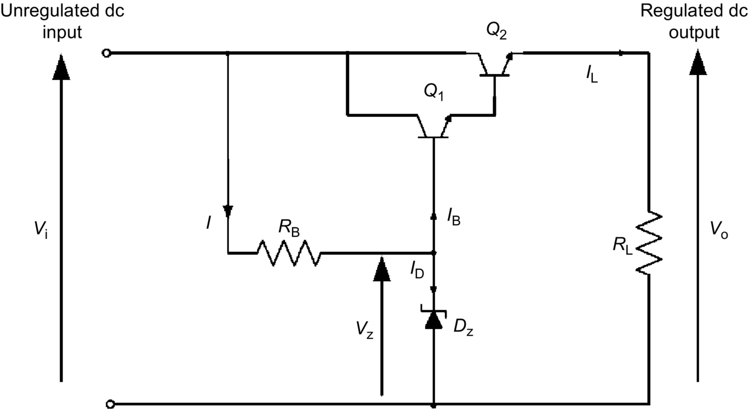

**FIG. 20.6** A linear series regulator with Darlington-connected amplifier.

### 20.2.1 REGULATING CONTROL

The series regulators shown in [Figs. 20.5](https://learning.oreilly.com/library/view/power-electronics-handbook/9780128114087/B9780128114070000222.xhtml#f0030) and [20.6](https://learning.oreilly.com/library/view/power-electronics-handbook/9780128114087/B9780128114070000222.xhtml#f0035) do not have feedback loop. Although they provide satisfactory performance for many applications, their output resistances and ripples cannot be reduced. [Fig. 20.7](https://learning.oreilly.com/library/view/power-electronics-handbook/9780128114087/B9780128114070000222.xhtml#f0040) shows an improved form of the series regulator, in which negative feedback is employed to improve the performance. In this circuit, transistors Q3 and Q4 form a single-ended differential amplifier, and the gain of this amplifier is established by *R*6. Here, Dz is a stable zener diode reference, biased by *R*4. For higher accuracy, Dz can be replaced by an IC reference such as REF series from Burr-Brown. Resistors *R*1 and *R*2 form a voltage divider for output voltage sensing. Finally, transistors Q1 and Q2 form a Darlington pair output stage. The operation of the regulator can be explained as follows. When Q1 and Q2 are on, the output voltage increases, and hence, the voltage *V*A at the base of Q3 also increases. During this time, Q3 is off and Q4 is on. When *V*A reaches a level that is equal to the reference voltage *V*REF at the base of Q4, the base-emitter junction of Q3 becomes forward-biased. Some Q1 base current will divert into the collector of Q3. If the output voltage *V*o starts to rise above *V*REF, Q3 conduction increases to further decrease the conduction of Q1 and Q2, which will in turn maintain output voltage regulation. [Fig. 20.8](https://learning.oreilly.com/library/view/power-electronics-handbook/9780128114087/B9780128114070000222.xhtml#f0045) shows another improved series regulator that uses an operational amplifier to control the conduction of the pass transistor.

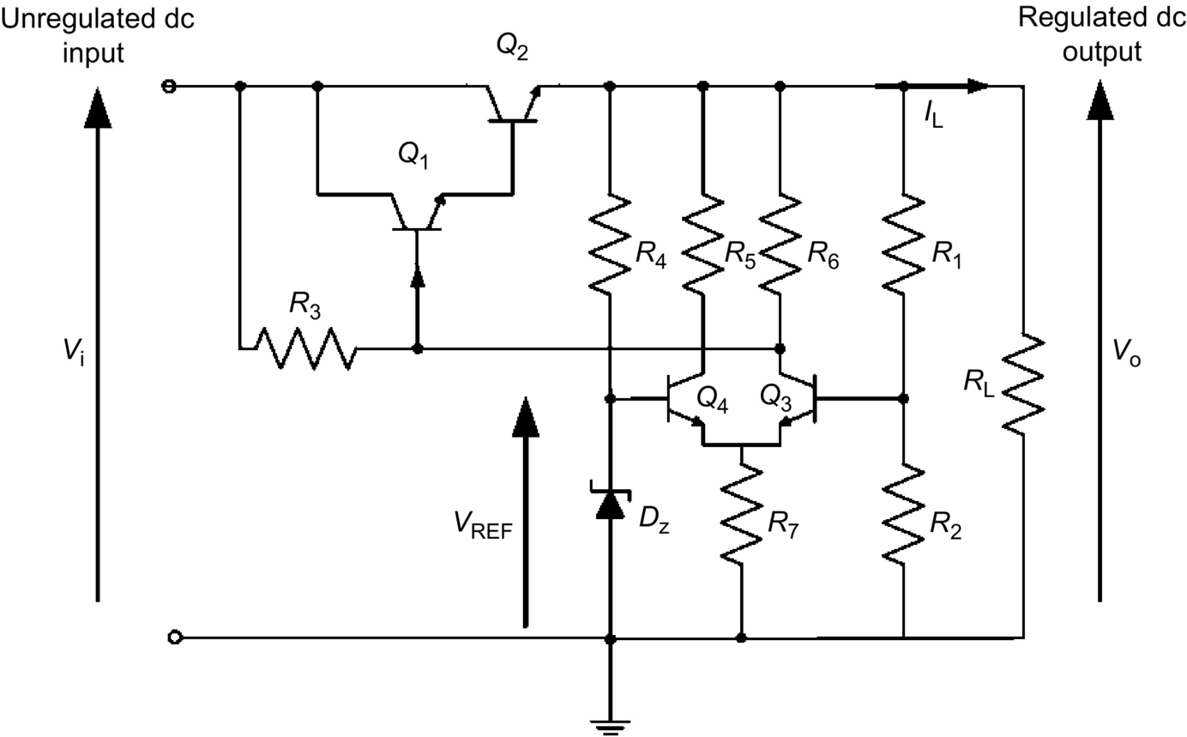

**FIG. 20.7** An improved form of discrete component series regulator.

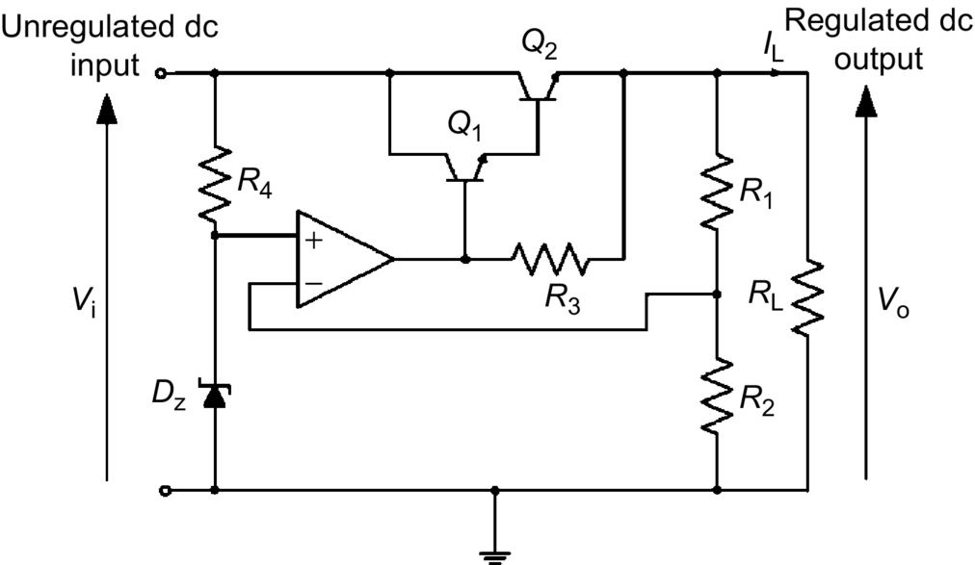

**FIG. 20.8** An improved form of op-amp series regulator.

One of the problems in the design of linear series voltage regulators is the high-power dissipation in the pass transistors. If an excess load current is drawn, the pass transistor can be quickly damaged or destroyed. In fact, under short-circuit conditions, the voltage across Q2 in [Fig. 20.7](https://learning.oreilly.com/library/view/power-electronics-handbook/9780128114087/B9780128114070000222.xhtml#f0040) will be the input voltage *V*i, and the current through Q2 will be greater than the rated full-load output current. This current will cause Q1 to exceed its rated SOA unless the current is reduced. In the next section, some current-limiting techniques will be presented to overcome this problem.

### 20.2.2 CURRENT LIMITING AND OVERLOAD PROTECTION

In some series voltage regulators, overloading causes permanent damage to the pass transistors. The pass transistors must be kept from excessive power dissipation under current overloads or short-circuit conditions. A current-limiting mechanism must be used to keep the current through the transistors at a safe value as determined by the power rating of the transistors. The mechanism must be able to respond quickly to protect the transistor and yet permit the regulator to return to normal operation as soon as the overload condition is removed. One of the current-limiting techniques to prevent current overload, called the constant current-limiting method, is shown in [Fig. 20.9A](https://learning.oreilly.com/library/view/power-electronics-handbook/9780128114087/B9780128114070000222.xhtml#f0050). Current limiting is achieved by the combined action of the components shown inside the dashed line. The voltage developed across the current-limit resistor *R*3 and the base-to-emitter voltage of current-limit transistor Q3 is proportional to the circuit output current *I*L. During current overload, *I*L reaches a predetermined maximum value that is set by the value of *R*3 to cause Q3 to conduct. As Q3 starts to conduct, Q3 shunts a portion of the Q1 base current. This action, in turn, decreases and limits *I*L to a maximum value *I*L(max). Since the base-to-emitter voltage *V*BE of Q3 cannot exceed above 0.7 V, the voltage across *R*3 is held at this value and *I*L(max) is limited to

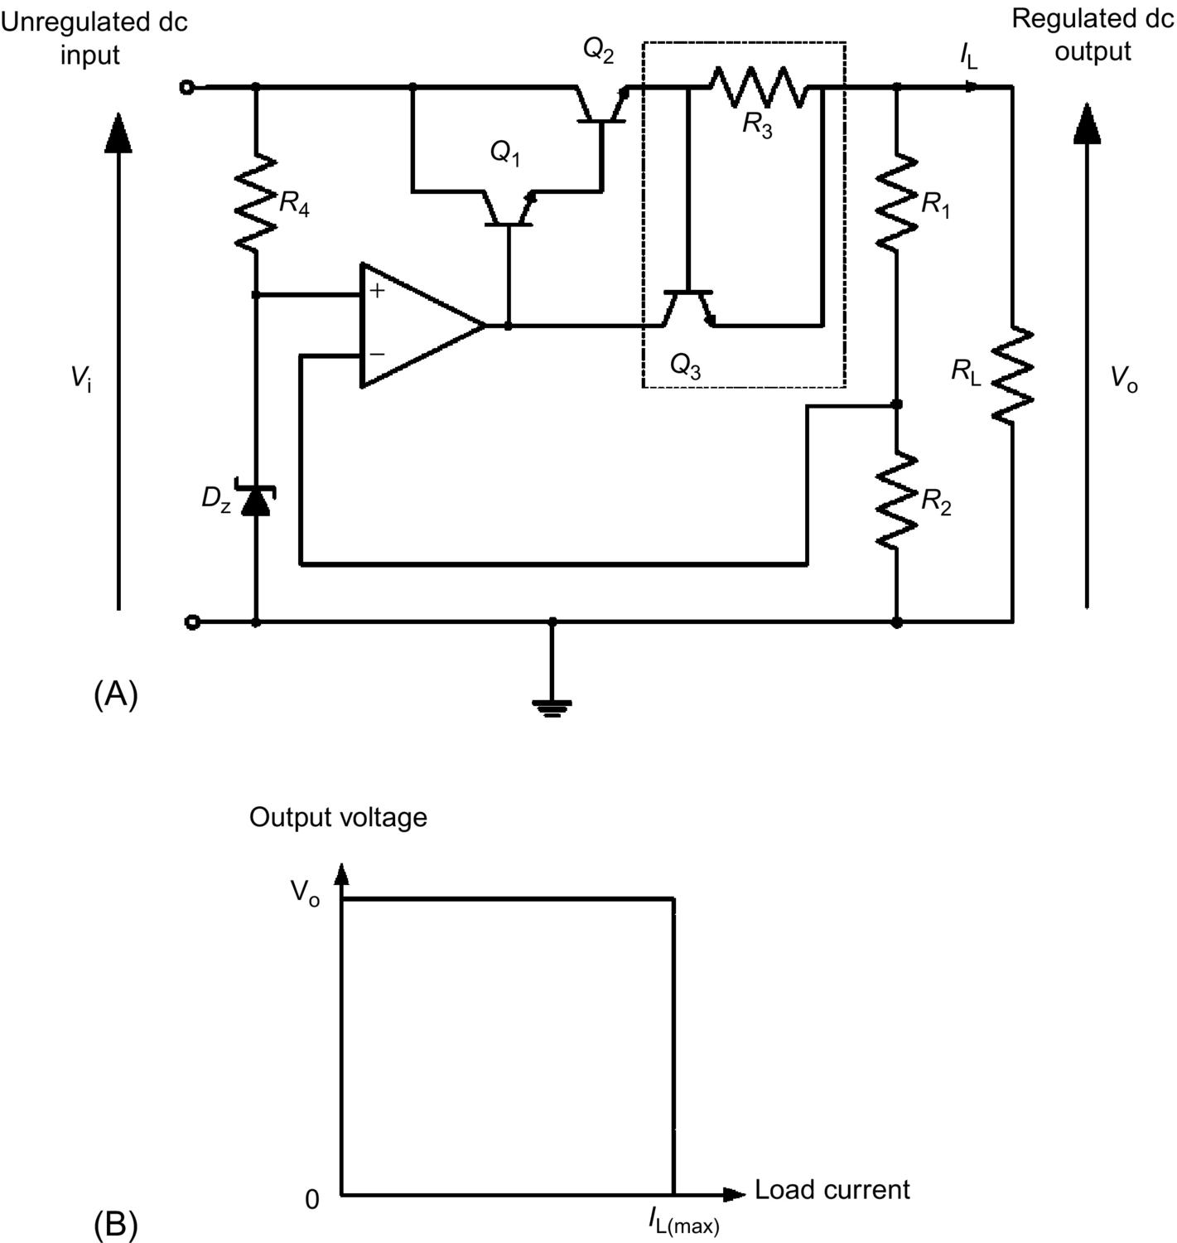

**FIG. 20.9** Series regulator with constant current limiting: (A) circuit and (B) voltage-current characteristic.

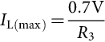 **(20.6)**

Consequently, the value of the short-circuit current is selected by adjusting the value of *R*3. The voltage-current characteristic of this circuit is shown in [Fig. 20.9B](https://learning.oreilly.com/library/view/power-electronics-handbook/9780128114087/B9780128114070000222.xhtml#f0050).

In many high-current regulators, foldback current limiting is always used to protect against excessive current. This technique is similar to the constant current-limiting method, except that as the output voltage is reduced as a result of load impedance moving toward zero, the load current is also reduced. Therefore, a series voltage regulator that includes a foldback current-limiting circuit has the voltage-current characteristic shown in [Fig. 20.10](https://learning.oreilly.com/library/view/power-electronics-handbook/9780128114087/B9780128114070000222.xhtml#f0055). The basic idea of foldback current limiting, with reference to [Fig. 20.11](https://learning.oreilly.com/library/view/power-electronics-handbook/9780128114087/B9780128114070000222.xhtml#f0060), can be explained as follows. The foldback current-limiting circuit (in dashed outline) is similar to the constant current-limiting circuit, with the exception of resistors *R*5 and *R*6. At low output current, the current-limit transistor Q3 is cutoff.

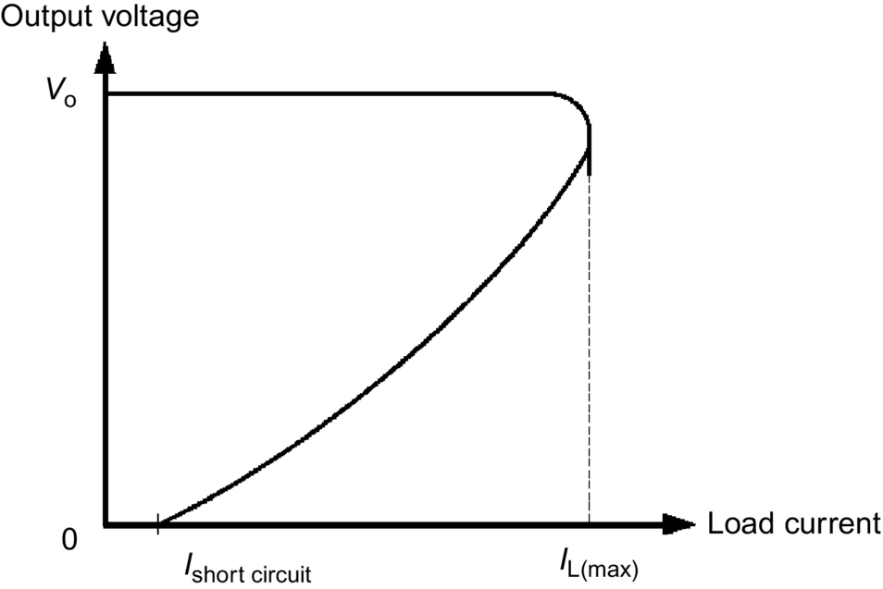

**FIG. 20.10** Voltage-current characteristic of foldback current limit.

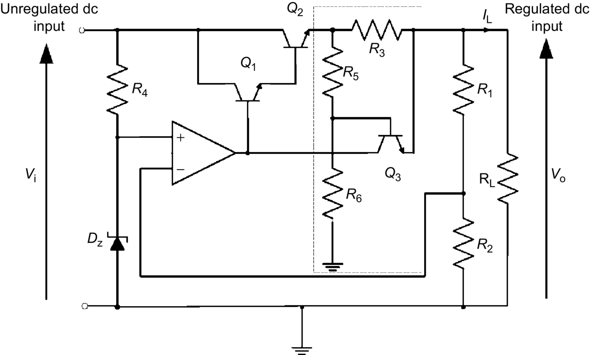

**FIG. 20.11** Series regulator with foldback current limiting.

A voltage proportional to the output current *I*L is developed across the current-limit resistor *R*3. This voltage is applied to the base of Q3 through the divider network *R*5 and *R*6. At the point of transition into current limit, any further increase in *I*L will increase the voltage across *R*3 and hence across *R*5, and Q3 will progressively be turned on. As Q1 conducts, it shunts a portion of the Q1 base current. This action, in turn, causes the output voltage to fall. As the output voltage falls, the voltage across *R*6 decreases and the current in *R*6 also decreases, and more current is shunted into the base of Q3. Hence, the current required in *R*3 to maintain the conduction state of Q3 is also decreased. Consequently, as the load resistance is reduced, the output voltage and current fall, and the current-limit point decreases toward a minimum when the output voltage is short-circuited. In summary, any regulator using foldback current limiting can have peak load current up to *I*L(max). But when the output becomes shorted, the current drops to a lower value to prevent overheating of the series transistors.

## 20.3 Linear Shunt Voltage Regulator

The second type of linear voltage regulator is the shunt regulator. In the basic circuit shown in [Fig. 20.12](https://learning.oreilly.com/library/view/power-electronics-handbook/9780128114087/B9780128114070000222.xhtml#f0065), the pass transistor Q1 is connected in parallel with the load. A voltage-dropping resistor *R*3 is in series with this parallel network. The operation of the circuit is similar to that of the series regulator, except that regulation is achieved by controlling the current through Q1. The operation of the circuit can be explained as follows. When the output voltage tries to increase because of a change in load resistance, the voltage at the noninverting terminal of the operational amplifier also increases. This voltage is compared with a reference voltage, and the resulting difference voltage causes Q1 conduction to increase. With constant *V*i and *V*o, *I*L will decrease, and *V*o will remain constant. The opposite action occurs when *V*o tries to decrease. The voltage appearing at the base of Q1 causes its conduction to decrease. This action offsets the attempted decrease in *V*o and maintains it at an almost constant level.

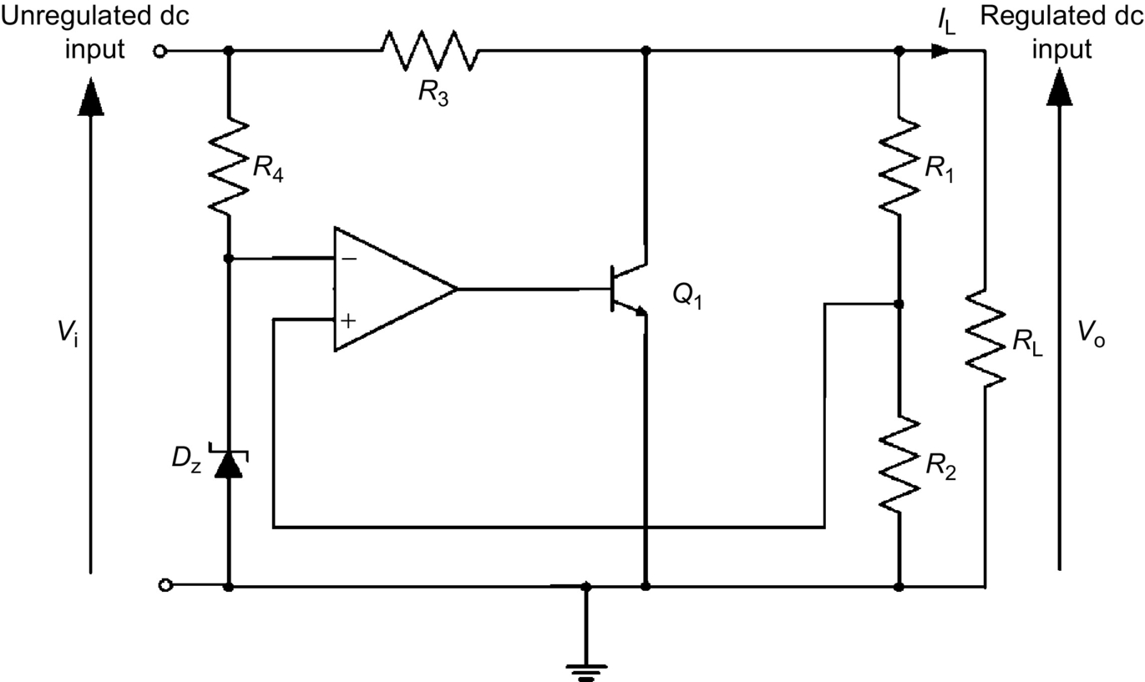

**FIG. 20.12** Basic circuit of a linear shunt regulator.

Analytically, the current flowing in *R*3 is

 **(20.7)**

and

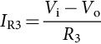 **(20.8)**

With *I*L and *V*o constant, a change in *V*i will cause a change in :

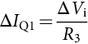 **(20.9)**

With *V*i and *V*o constant,

 **(20.10)**

Eq. [(20.10)](https://learning.oreilly.com/library/view/power-electronics-handbook/9780128114087/B9780128114070000222.xhtml#fo0055) shows that if *I*Q1 increases, *I*L decreases and vice versa. Although shunt regulators are not as efficient as series regulators for most applications, they have the advantage of greater simplicity. This topology offers inherently short-circuit protection. If the output is shorted, the load current is limited by the series resistor *R*3 and is given by

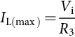 **(20.11)**

The power dissipated by Q1 can be approximated by

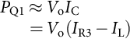 **(20.12)**

For a low value of *I*L, the power dissipated in Q1 is large, and the efficiency of the regulator may drop to 10% under this condition.

To improve the power handling of the shunt transistor, one or more transistors connected in the common-emitter configuration in parallel with the load can be employed, as shown in [Fig. 20.13](https://learning.oreilly.com/library/view/power-electronics-handbook/9780128114087/B9780128114070000222.xhtml#f0070).

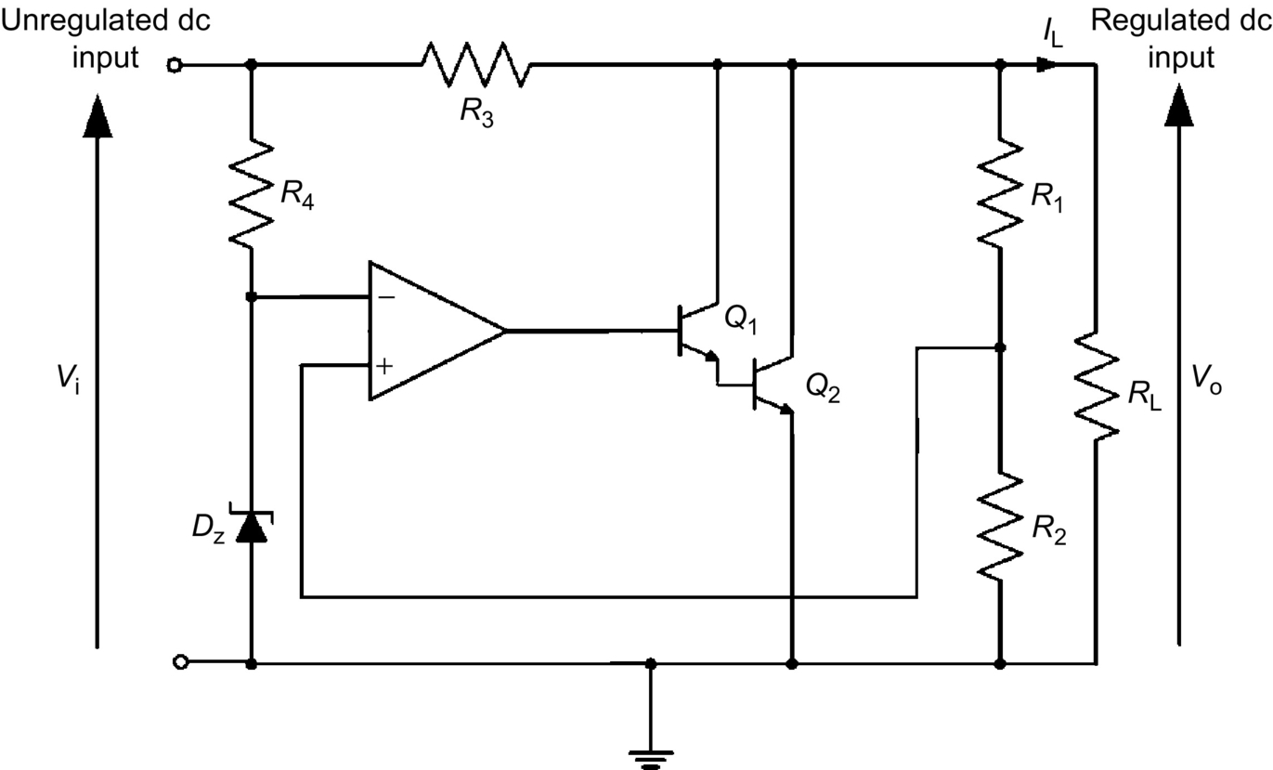

**FIG. 20.13** Linear shunt regulator with two transistors as shunt element.

## 20.4 Integrated Circuit Voltage Regulators

The linear series and shunt voltage regulators presented in the previous sections have been developed by various solid-state device manufacturers and are available in integrated circuit (IC) form. Like discrete voltage regulators, linear IC voltage regulators maintain an output voltage at a constant value despite variations in load and input voltage.

In general, linear IC voltage regulators are three-terminal devices that provide regulation of a fixed positive voltage, a fixed negative voltage, or an adjustable set voltage. The basic connection of a three-terminal IC voltage regulator to a load is shown in [Fig. 20.14](https://learning.oreilly.com/library/view/power-electronics-handbook/9780128114087/B9780128114070000222.xhtml#f0075). The IC regulator has an unregulated input voltage *V*i applied to the input terminals, a regulated voltage *V*o at the output, and a ground connected to the third terminal. Depending on the selected IC regulator, the circuit can be operated with load currents ranging from milliamperes to tens of amperes and output power from milliwatts to tens of watts. Note that the internal construction of IC voltage regulators may be somewhat more complex and different from that previously described for discrete voltage regulator circuits. However, the external operation is much the same. In this section, some typical linear IC regulators are presented, and their applications are also given.

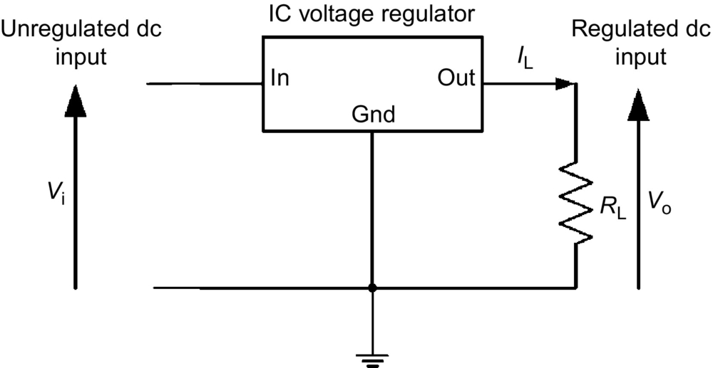

**FIG. 20.14** Basic connection of a three-terminal IC voltage regulator.

### 20.4.1 FIXED POSITIVE AND NEGATIVE LINEAR VOLTAGE REGULATORS

The 78XX series of regulators provide fixed regulated voltages from 5 to 24 V. The last two digits of the IC part number denote the output voltage of the device. For example, a 7824 IC regulator produces a +24 V regulated voltage at the output. The standard configuration of a 78XX fixed positive voltage regulator is shown in [Fig. 20.15](https://learning.oreilly.com/library/view/power-electronics-handbook/9780128114087/B9780128114070000222.xhtml#f0080). The input capacitor *C*1 acts as a line filter to prevent unwanted variations in the input line, and the output capacitor *C*2 is used to filter the high-frequency noise that may appear at the output. In order to ensure proper operation, the input voltage of the regulator must be at least 2 V above the output voltage. [Table 20.1](https://learning.oreilly.com/library/view/power-electronics-handbook/9780128114087/B9780128114070000222.xhtml#t0010) shows the minimum and maximum input voltages of the 78XX series fixed positive voltage regulator.

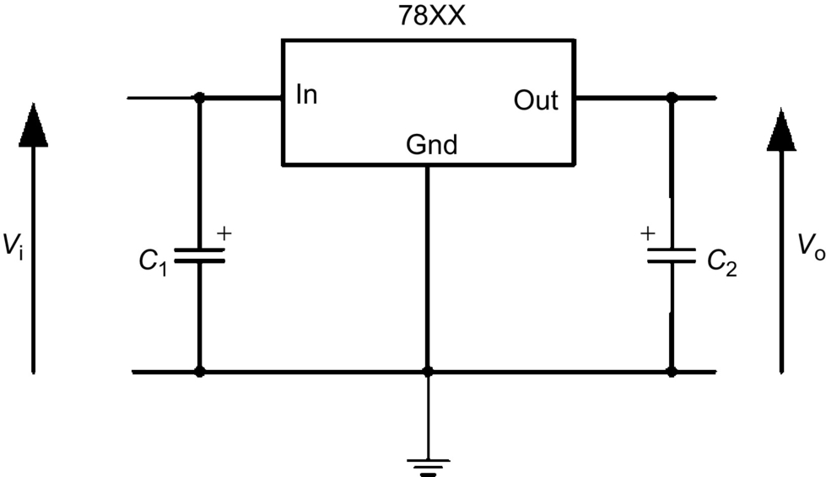

**FIG. 20.15** The 78XX series fixed positive voltage regulator.

**Table 20.1**

**Minimum and maximum input voltages for 78XX series regulators**

|  |  |  |  |
| --- | --- | --- | --- |
| **Type number** | **Output voltage *V*o (V)** | **Minimum *V*i (V)** | **Maximum *V*i (V)** |
| 7805 | +5 | 7 | 20 |
| 7806 | +6 | 8 | 21 |
| 7808 | +8 | 10.5 | 25 |
| 7809 | +9 | 11.5 | 25 |
| 7812 | +12 | 14.5 | 27 |
| 7815 | +15 | 17.5 | 30 |
| 7818 | +18 | 21 | 33 |
| 7824 | +24 | 27 | 38 |

The 79XX series voltage regulator is identical to the 78XX series except that it provides negative regulated voltages instead of positive ones. [Fig. 20.16](https://learning.oreilly.com/library/view/power-electronics-handbook/9780128114087/B9780128114070000222.xhtml#f0085) shows the standard configuration of a 79XX series voltage regulator. A list of 79XX series regulators is provided in [Table 20.2](https://learning.oreilly.com/library/view/power-electronics-handbook/9780128114087/B9780128114070000222.xhtml#t0015). The regulation of the circuit can be maintained as long as the output voltage is at least 2–3 V greater than the input voltage.

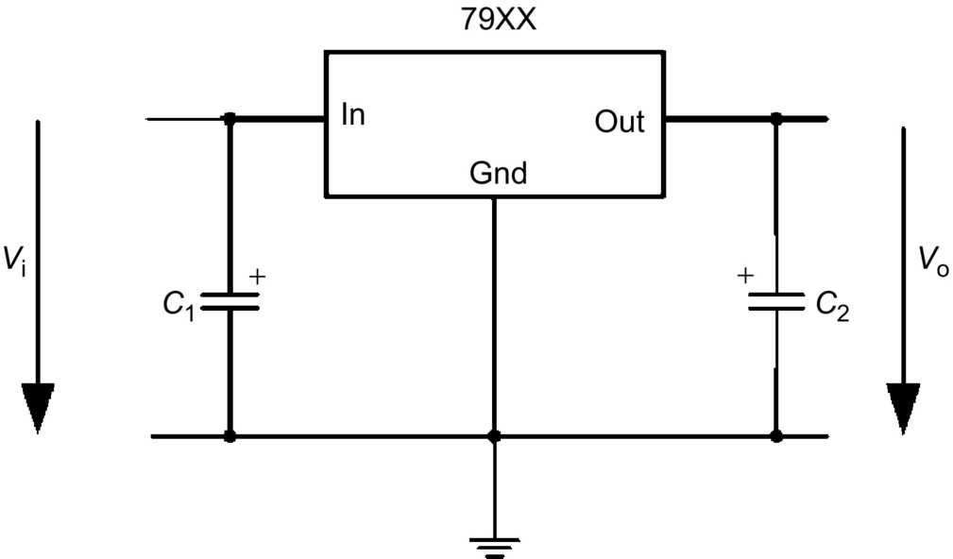

**FIG. 20.16** The 79XX series fixed negative voltage regulator.

**Table 20.2**

**Minimum and maximum input voltages for 79XX series regulators**

|  |  |  |  |
| --- | --- | --- | --- |
| **Type number** | **Output voltage *V*o (V)** | **Minimum *V*i (V)** | **Maximum *V*i (V)** |
| 7805 | −5 | −7 | −20 |
| 7806 | −6 | −8 | −21 |
| 7808 | −8 | −10.5 | −25 |
| 7809 | −9 | −11.5 | −25 |
| 7812 | −12 | −14.5 | −27 |
| 7815 | −15 | −17.5 | −30 |
| 7818 | −18 | −21 | −33 |
| 7824 | −24 | −27 | −38 |

### 20.4.2 ADJUSTABLE POSITIVE AND NEGATIVE LINEAR VOLTAGE REGULATORS

The IC voltage regulators are also available in circuit configurations that allow the user to set the output voltage to a desired regulated value. The LM317 adjustable positive voltage regulator, for example, is capable of supplying an output current of more than 1.5 A over an output voltage range of 1.2–37 V. [Fig. 20.17](https://learning.oreilly.com/library/view/power-electronics-handbook/9780128114087/B9780128114070000222.xhtml#f0090) shows how the output voltage of an LM317 can be adjusted by using two external resistors *R*1 and *R*2. The capacitors *C*1 and *C*2 have the same function as those in the fixed linear voltage regulator.

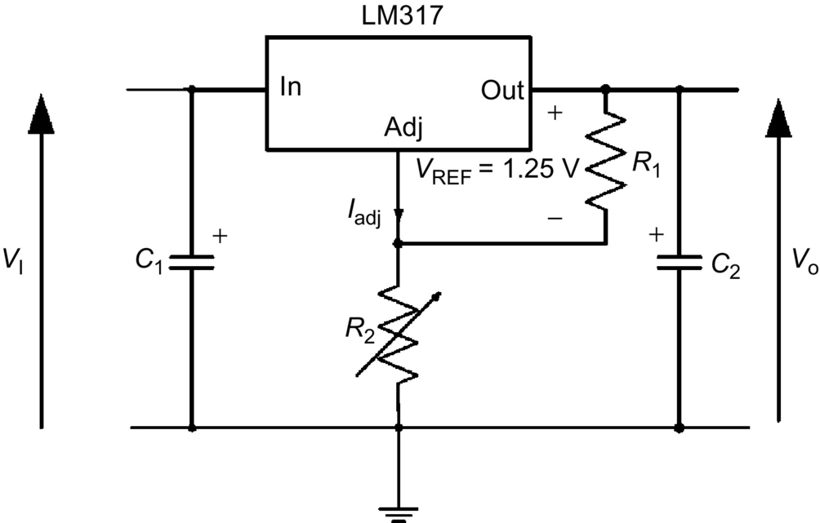

**FIG. 20.17** The LM317 adjustable positive voltage regulator.

As indicated in [Fig. 20.17](https://learning.oreilly.com/library/view/power-electronics-handbook/9780128114087/B9780128114070000222.xhtml#f0090), the LM317 has a constant 1.25 V reference voltage, *V*REF, across the output and the adjustment terminals. This constant reference voltage produces a constant current through *R*1 regardless of the value of *R*2. The output voltage *V*o is given by

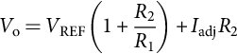 **(20.13)**

where *I*adj is a constant current into the adjustment terminal and has a value of approximately 50 μA for the LM317. As can be seen from Eq. [(20.13)](https://learning.oreilly.com/library/view/power-electronics-handbook/9780128114087/B9780128114070000222.xhtml#fo0070), with fixed *R*1, *V*o can be adjusted by varying *R*2.

The LM337 adjustable voltage regulator is similar to the LM317 except that it provides negative regulated voltages instead of positive ones. [Fig. 20.18](https://learning.oreilly.com/library/view/power-electronics-handbook/9780128114087/B9780128114070000222.xhtml#f0095) shows the standard configuration of an LM337 voltage regulator. The output voltage can be adjusted from −1.2 to −37 V, depending on the external resistors *R*1 and *R*2.

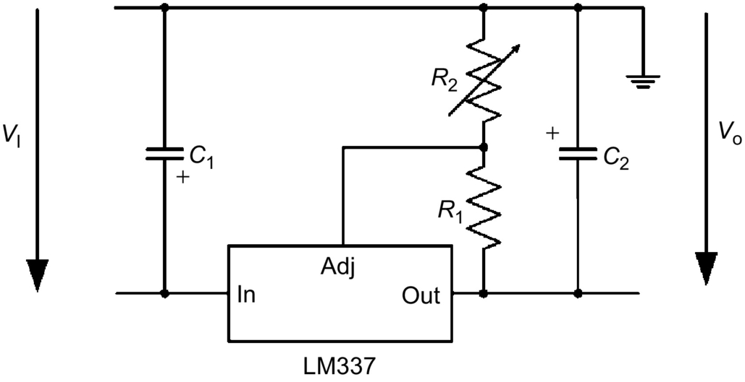

**FIG. 20.18** The LM337 adjustable negative voltage regulator.

### 20.4.3 APPLICATIONS OF LINEAR IC VOLTAGE REGULATORS

Most IC regulators are limited to an output current of 2.5 A. If the output current of an IC regulator exceeds its maximum allowable limit, its internal pass transistor will dissipate an amount of energy more than it can tolerate. As a result, the regulator will be shutdown.

For applications that require more than the maximum allowable current limit of a regulator, an external pass transistor can be used to increase the output current. [Fig. 20.19](https://learning.oreilly.com/library/view/power-electronics-handbook/9780128114087/B9780128114070000222.xhtml#f0100) illustrates such a configuration. This circuit has the capability of producing higher current to the load but still preserving the thermal shutdown and short-circuit protection of the IC regulator.

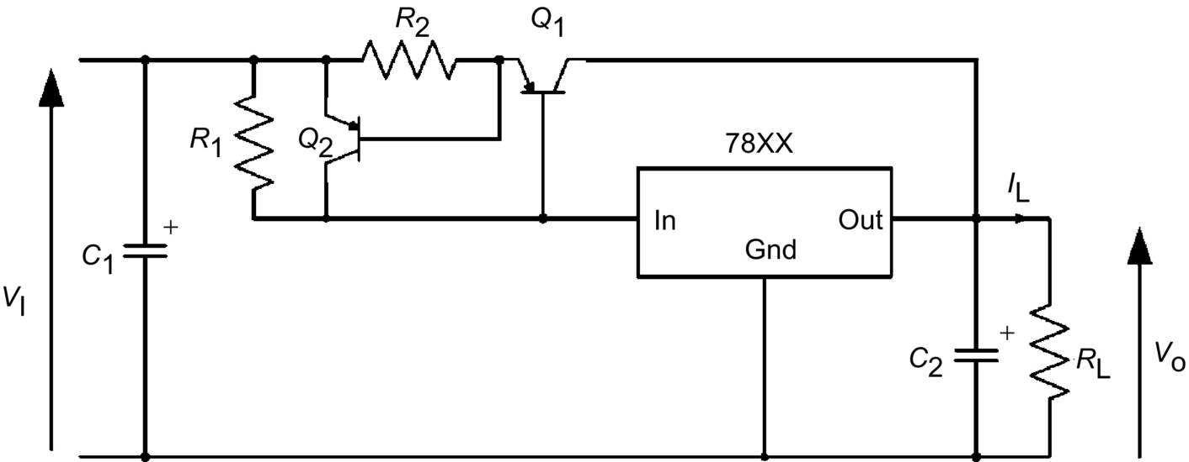

**FIG. 20.19** A 78XX series regulator with an external pass transistor.

A constant current-limiting scheme, as discussed in [Section 20.2.2](https://learning.oreilly.com/library/view/power-electronics-handbook/9780128114087/B9780128114070000222.xhtml#s0025), is implemented by using the transistor Q2 and the resistor *R*2 to protect the external pass transistor Q1 from excessive current under current-overload or short-circuit conditions. The value of the external current-sensing resistor *R*1 determines the value of current at which Q1 begins to conduct. As long as the current is less than the value set by *R*1, the transistor Q1 is off, and the regulator operates normally as shown in [Fig. 20.15](https://learning.oreilly.com/library/view/power-electronics-handbook/9780128114087/B9780128114070000222.xhtml#f0080). But when the load current *IL* starts to increase, the voltage across *R*1 also increases. This turns on the external transistor Q1 and conducts the excess current. The value of *R*1 is determined by

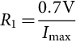 **(20.14)**

where *I*max is the maximum current that the voltage regulator can handle internally.

## 20.5 Switching Regulators

The linear series and shunt regulators have control transistors that are operating in their linear active regions. Regulation is achieved by varying the conduction of the transistors to maintain the output voltage at a desirable level. The switching regulator is different in that the control transistor operates as a switch, either in cutoff or saturation region. Regulation is achieved by adjusting the on-time of the control transistor. In this mode of operation, the control transistor does not dissipate as much power as that in the linear types. Therefore, switching voltage regulators have a much higher efficiency and can provide greater load currents at low voltage than linear regulators.

Unlike their linear counterparts, switching regulators can be implemented by many different topologies such as forward and flyback. In order to select an appropriate topology for an application, it is necessary to understand the merits and drawbacks of each topology and the requirements of the application. Basically, most topologies can work for various applications. Therefore, we have to determine from the factors such as cost, performances, and application that make one topology more desirable than the others. However, no matter which topology we decide to use, the basic building blocks of an off-the-line switching power supply are the same, as depicted in [Fig. 20.1](https://learning.oreilly.com/library/view/power-electronics-handbook/9780128114087/B9780128114070000222.xhtml#f0010).

In this section, some popular switching regulator topologies, namely, flyback, forward, half-bridge, and full-bridge topologies, are presented. Their basic operation is described, and the critical waveforms are shown and explained. The merits, drawbacks, and application areas of each topology are discussed. Finally, the control circuitry and PWM of the regulators will also be discussed.

### 20.5.1 SINGLE-ENDED ISOLATED FLYBACK REGULATORS

An isolated flyback regulator consists of four main circuit elements: a power switch, a rectifier diode, a transformer, and a filter capacitor. The power switch, which can be either a power transistor or a MOSFET, is used to control the flow of energy in the circuit. A transformer is placed between the input source and the power switch to provide dc isolation between the input and the output circuits. In addition to being an energy storage element, the transformer also performs a stepping up or down function for the regulator. The rectifier diode and filter capacitor form an energy transfer mechanism to supply energy to maintain the output voltage of the supply. Note that there are two distinct operating modes for flyback regulators: *continuous* and *discontinuous.* However, both modes have an identical circuit. It is only the transformer magnetizing current that determines the operating mode of the regulator. [Fig. 20.20A](https://learning.oreilly.com/library/view/power-electronics-handbook/9780128114087/B9780128114070000222.xhtml#f0105) shows a simplified isolated flyback regulator. The associated steady-state waveforms, resulting from a discontinuous-mode operation, are shown in [Fig. 20.20B](https://learning.oreilly.com/library/view/power-electronics-handbook/9780128114087/B9780128114070000222.xhtml#f0105). As shown in the figure, the voltage regulation of the regulator is achieved by a control circuit, which controls the conduction period or duty cycle of the switch, to keep the output voltage at a constant level. For clarity, the schematics and operation of the control circuit will be discussed in a separate section.

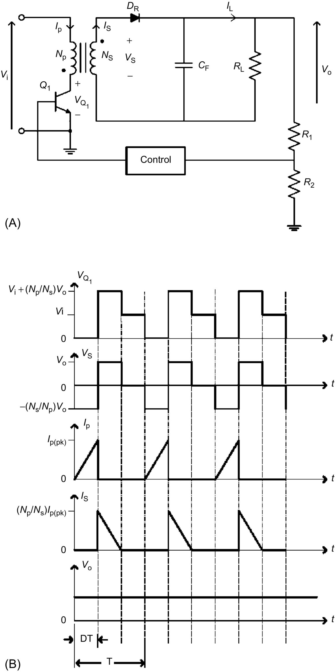

**FIG. 20.20** A simplified isolated flyback regulator: (A) circuit and (B) the associated waveforms.

#### **20.5.1.1 Discontinuous-Mode Flyback Regulators**

Under steady-state conditions, the operation of the regulator can be explained as follows. When the power switch Q1 is on, the primary current *I*p starts to build up and stores energy in the primary winding. Because of the opposite polarity arrangement between the input and output windings of the transformer, the rectifier diode DR is reverse-biased. In this period of time, there is no energy transferred from the input to the load *R*L. The output voltage is supported by the load current *I*L, which is supplied from the output filter capacitor *C*F. When Q1 is turned off, the polarity of the windings reverses as a result of the fact that *I*p cannot change instantaneously. This causes DR to turn on. Now, DR is conducting, charging the output capacitor *C*F, and delivering current to *R*L. This charging action ends at the point where all the magnetic energy stored in the secondary winding during the first half cycle is emptied. At this point, DR will cease to conduct and *R*L absorbs energy just from *C*F until Q1 is switched on again.

During the Q1 on-time, the voltage across the primary winding of the transformer is *V*i. The current in the primary winding *I*p increases linearly and is given by

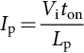 **(20.15)**

where *L*p is the primary magnetizing inductance. At the end of the on-time, the primary current reaches a value equal to *I*p(pk) and is given by

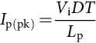 **(20.16)**

where *D* is the duty cycle and *T* is the switching period. Now, when Q1 turns off, the magnetizing current in the transformer forces the reversal of polarities on the windings. At the instant of turnoff, the amplitude of the secondary current *I*s(pk) is

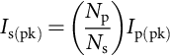 **(20.17)**

This current decreases linearly at the rate of

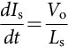 **(20.18)**

where *L*s is the secondary magnetizing inductance.

In the discontinuous-mode operation, *I*s(pk) will decrease linearly to zero before the start of the next cycle. Since the energy transfer from the source to the output takes place only in the first half cycle, the power drawn from *V*i is then

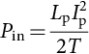 **(20.19)**

Substituting Eq. [(20.15)](https://learning.oreilly.com/library/view/power-electronics-handbook/9780128114087/B9780128114070000222.xhtml#fo0080) into Eq. [(20.19)](https://learning.oreilly.com/library/view/power-electronics-handbook/9780128114087/B9780128114070000222.xhtml#fo0100), we have

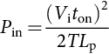 **(20.20)**

The output power *P*o may be written as

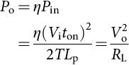 **(20.21)**

where *η* is the efficiency of the regulator. Then, from Eq. [(20.21)](https://learning.oreilly.com/library/view/power-electronics-handbook/9780128114087/B9780128114070000222.xhtml#fo0110), the output voltage *V*o is related to the input voltage *V*i by

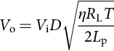 **(20.22)**

Since the collector voltage *V*Q1 of *Q*1 is maximum when *V*i is maximum, the maximum collector voltage *V*Q1(max), as shown in [Fig. 20.20B](https://learning.oreilly.com/library/view/power-electronics-handbook/9780128114087/B9780128114070000222.xhtml#f0105), is given by

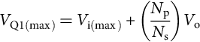 **(20.23)**

The primary peak current *I*p(pk) can be found in terms of *P*o by combining Eq. [(20.16)](https://learning.oreilly.com/library/view/power-electronics-handbook/9780128114087/B9780128114070000222.xhtml#fo0085) and Eq. [(20.21)](https://learning.oreilly.com/library/view/power-electronics-handbook/9780128114087/B9780128114070000222.xhtml#fo0110) and then eliminating *L*p as

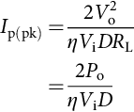 **(20.24)**

The maximum collector current *I*C(max) of the power switch Q1 at turn on is

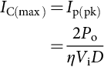 **(20.25)**

As can be seen from Eq. [(20.21)](https://learning.oreilly.com/library/view/power-electronics-handbook/9780128114087/B9780128114070000222.xhtml#fo0110), *V*o will be maintained constant by keeping the product *V*i*t*on constant. Since maximum on-time *t*on(max) occurs at minimum supply voltage *V*i(min), the maximum allowable duty cycle for the discontinuous mode can be found from Eq. [(20.22)](https://learning.oreilly.com/library/view/power-electronics-handbook/9780128114087/B9780128114070000222.xhtml#fo0115) as

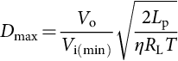 **(20.26)**

and *V*o at *D*max is then

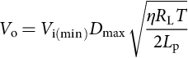 **(20.27)**

#### **20.5.1.2 Continuous-Mode Flyback Regulators**

In the continuous-mode operation, the power switch is turned on before all the magnetic energy stored in the secondary winding empties itself. The primary and secondary current waveforms have a characteristic appearance as shown in [Fig. 20.21](https://learning.oreilly.com/library/view/power-electronics-handbook/9780128114087/B9780128114070000222.xhtml#f0110). This mode produces a higher-power capability without increasing the peak currents. During the on-time, the primary current *I*p rises linearly from its initial value *I*p(0) and is given by

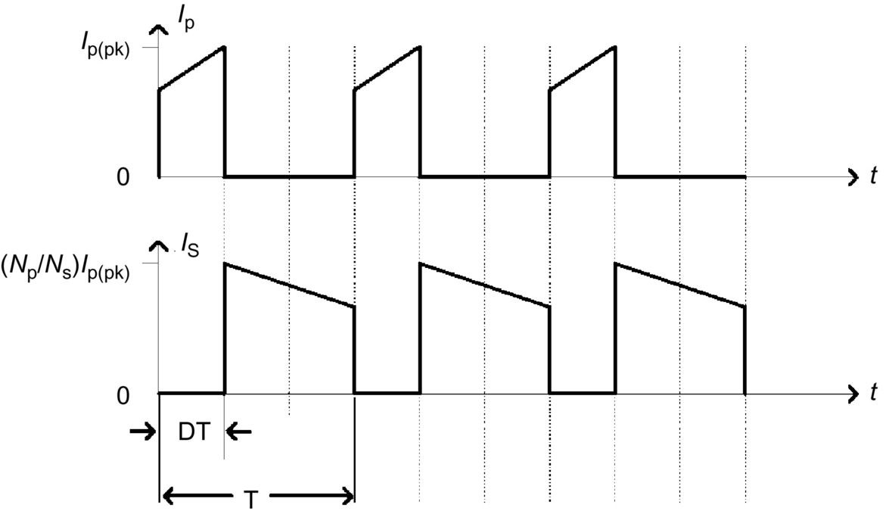

**FIG. 20.21** The primary and secondary winding currents of a flyback regulator operated in the continuous mode.

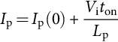 **(20.28)**

At the end of the on-time, the primary current reaches a value equal to *I*p(pk) and is given by

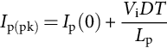 **(20.29)**

In general, ; thus, Eq. [(20.29)](https://learning.oreilly.com/library/view/power-electronics-handbook/9780128114087/B9780128114070000222.xhtml#fo0150) can be written as

 **(20.30)**

The secondary current *I*s at the instant of turn off is given by

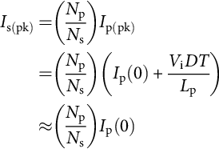 **(20.31)**

This current decreases linearly at the rate of

 **(20.32)**

The output power *P*o is equal to *V*o times the time average of the secondary current pulses and is given by

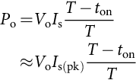 **(20.33)**

or

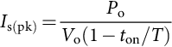 **(20.34)**

For an efficiency of *η*, the input power *P*in is

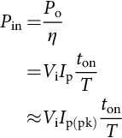 **(20.35)**

or

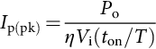 **(20.36)**

Combining Eqs. [(20.31)](https://learning.oreilly.com/library/view/power-electronics-handbook/9780128114087/B9780128114070000222.xhtml#fo0160), [(20.34)](https://learning.oreilly.com/library/view/power-electronics-handbook/9780128114087/B9780128114070000222.xhtml#fo0175), and [(20.36)](https://learning.oreilly.com/library/view/power-electronics-handbook/9780128114087/B9780128114070000222.xhtml#fo0185) and solving for *V*o, we have

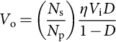 **(20.37)**

The output voltage at *D*max is then

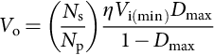 **(20.38)**

The maximum collector current *I*C(max) for the continuous mode is then given by

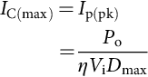 **(20.39)**

The maximum collector voltage of Q1 is the same as that in the discontinuous mode and is given by

 **(20.40)**

The maximum allowable duty cycle for the continuous mode can be found from Eq. [(20.38)](https://learning.oreilly.com/library/view/power-electronics-handbook/9780128114087/B9780128114070000222.xhtml#fo0195) and is given by

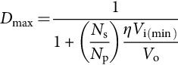 **(20.41)**

At the transition from the discontinuous mode to continuous mode (or from continuous mode to discontinuous mode), the relationships in Eqs. [(20.27)](https://learning.oreilly.com/library/view/power-electronics-handbook/9780128114087/B9780128114070000222.xhtml#fo0140) and [(20.38)](https://learning.oreilly.com/library/view/power-electronics-handbook/9780128114087/B9780128114070000222.xhtml#fo0195) must hold. Thus, equating these two equations, we have

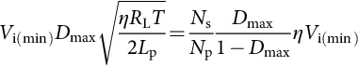 **(20.42)**

Solving this equation for *L*p to give the critical inductance , at which the transition occurs, we have

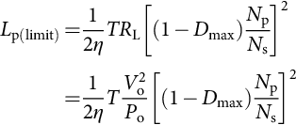 **(20.43)**

Replacing *V*o with Eq. [(20.38)](https://learning.oreilly.com/library/view/power-electronics-handbook/9780128114087/B9780128114070000222.xhtml#fo0195) and solving for *L*p(limit), we have

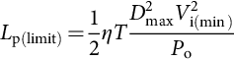 **(20.44)**

Then, for a given *D*max, input, and output quantities, the inductance value *L*p(limit) in Eq. [(20.44)](https://learning.oreilly.com/library/view/power-electronics-handbook/9780128114087/B9780128114070000222.xhtml#fo0225) determines the mode of operation for the regulator. If , then the circuit is operated in the discontinuous mode. Otherwise, if , the circuit is operated in the continuous mode.

In designing flyback regulators, regardless of their operating modes, the power switch must be able to handle the peak collector voltage at turnoff and the peak collector currents at turn-on as shown in Eqs. [(20.23)](https://learning.oreilly.com/library/view/power-electronics-handbook/9780128114087/B9780128114070000222.xhtml#fo0120), [(20.25)](https://learning.oreilly.com/library/view/power-electronics-handbook/9780128114087/B9780128114070000222.xhtml#fo0130), [(20.39)](https://learning.oreilly.com/library/view/power-electronics-handbook/9780128114087/B9780128114070000222.xhtml#fo0200), and [(20.40)](https://learning.oreilly.com/library/view/power-electronics-handbook/9780128114087/B9780128114070000222.xhtml#fo0205). The flyback transformer, because of its unidirectional use of the *B-H* curve, has to be designed so that it will not be driven into saturation. To avoid saturation, the transformer needs a relatively large core with an air gap in it.

Although the continuous and discontinuous modes have an identical circuit, their operating properties differ significantly. As opposed to the discontinuous mode, the continuous mode can provide higher-power capability without increasing the peak current *I*p(pk). It means that, for the same output power, the peak currents in the discontinuous mode are much higher than those operated in the continuous mode. As a result, a higher current rating and, therefore, a more expensive power transistor are needed. Moreover, the higher secondary peak currents in the discontinuous mode will have a larger transient spike at the instant of turnoff. However, despite all these problems, the discontinuous mode is still much more widely used than its continuous-mode counterpart. There are two main reasons. First, the inherently smaller magnetizing inductance gives the discontinuous mode a quicker response and a lower transient output voltage spike to sudden changes in load current or input voltage. Second, the continuous mode has a right-half-plane zero in its transfer function, which makes the feedback control circuit more difficult to design.

The flyback configuration is mostly used in applications with output power below 100 W. It is widely used for high output voltages at relatively low power. The essential attractions of this configuration are its simplicity and low cost. Since no output filter inductor is required for the secondary, there is a significant saving in cost and space, especially for multiple output power supplies. Since there is no output filter inductor, the flyback exhibits high ripple currents in the transformer and at the output. Thus, for higher-power applications, the flyback becomes an unsuitable choice. In practice, a small *LC* filter is added after the filter capacitor *C*F in order to suppress high-frequency switching noise spikes.

As mentioned previously, the collector voltage of the power transistor must be able to sustain a voltage as defined in Eq. [(20.23)](https://learning.oreilly.com/library/view/power-electronics-handbook/9780128114087/B9780128114070000222.xhtml#fo0120). In cases where the voltage is too high for the transistor to handle, the double-ended flyback regulator shown in [Fig. 20.22](https://learning.oreilly.com/library/view/power-electronics-handbook/9780128114087/B9780128114070000222.xhtml#f0115) may be used. The regulator uses two transistors that are switched on or off simultaneously. The diodes DR1 and DR2 are used to restrict the maximum collector voltage to *V*i. Therefore, the transistors with a lower voltage rating can be used in the circuit.

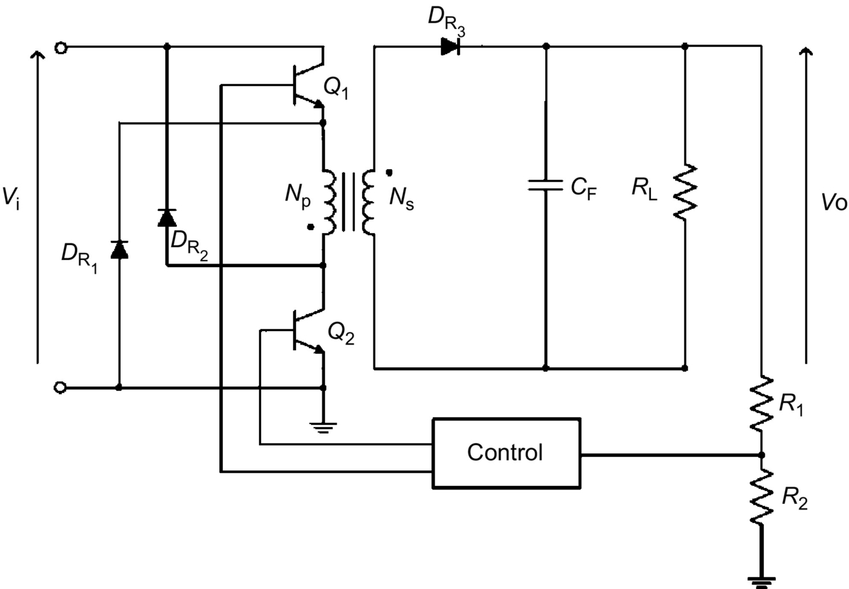

**FIG. 20.22** A double-ended flyback regulator.

### 20.5.2 SINGLE-ENDED ISOLATED FORWARD REGULATORS

Although the general appearance of an isolated forward regulator resembles that of its flyback counterpart, their operations are different. The key difference is that the dot on the secondary winding of the transformer is so arranged that the output diode is forward-biased when the voltage across the primary is positive, that is, when the transistor is *on*. Energy is thus not stored in the primary inductance as it was for the flyback. The transformer acts strictly as a transformer. An inductive energy storage element is required at the output for proper and efficient energy transfer.

Unlike the flyback, the forward regulator is very suitable for working in the continuous mode. In the discontinuous mode, the forward regulator is more difficult to control because of a double pole at the output filter. Thus, it is not as much used as the continuous mode. In view of it, only the continuous mode will be discussed here.

[Fig. 20.23](https://learning.oreilly.com/library/view/power-electronics-handbook/9780128114087/B9780128114070000222.xhtml#f0120) shows a simplified isolated forward regulator and the associated steady-state waveforms for the continuous-mode operation. Again, for clarity, the details of the control circuit are omitted from the figure. Under steady-state condition, the operation of the regulator can be explained as follows. When the power switch Q1 turns on, the primary current *I*p starts to build up and stores energy in the primary winding. Because of the same polarity arrangement of the primary and secondary windings, this energy is forward transferred to the secondary and onto the *L*1*C*F filter and the load *R*L through the rectifier diode DR2, which is forward-biased. When Q1 turns off, the polarity of the transformer winding voltage reverses. This causes DR2 to turn off and DR1 and DR3 to turn on. Now, DR3 is conducting and delivering energy to *R*L through the inductor *L*1. During this period, the diode DR2 and the tertiary winding provide a path for the magnetizing current returning to the input.

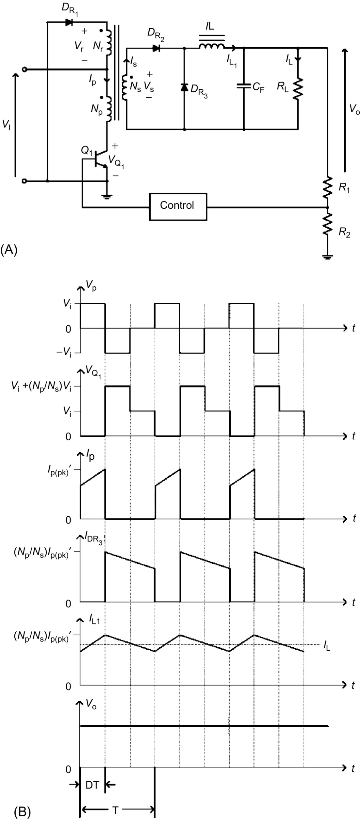

**FIG. 20.23** A simplified isolated forward regulator: (A) circuit and (B) the associated waveforms.

When the transistor Q1 is turned on, the voltage across the primary winding is *V*i. The secondary winding current is reflected into the primary, and the reaction current *I*p, as shown in [Fig. 20.24](https://learning.oreilly.com/library/view/power-electronics-handbook/9780128114087/B9780128114070000222.xhtml#f0125), is given by

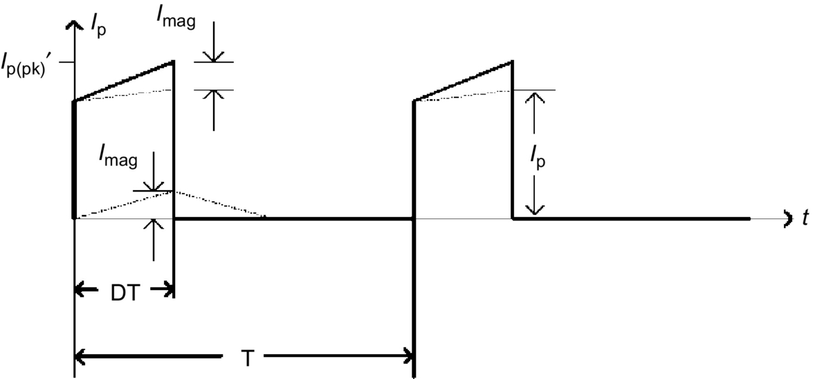

**FIG. 20.24** The current components in the primary winding.

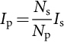 **(20.45)**

The magnetizing current in the primary has a magnitude of *I*mag and is given by

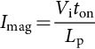 **(20.46)**

The total primary current *I*p′ is then

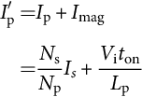 **(20.47)**

The voltage developed across the secondary winding *V*s is

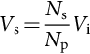 **(20.48)**

Neglecting diode voltage drops and losses, the voltage across the output inductor is . The current in *L*1 increases linearly at the rate of

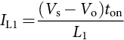 **(20.49)**

At the end of the on-time, the total primary current reaches a peak value equal to *I*′p(pk) and is given by

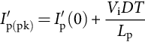 **(20.50)**

The output inductor current *I*L1 is

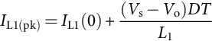 **(20.51)**

At the instant of turn-on, the amplitude of the secondary current has a value of *I*s(pk) and is given by

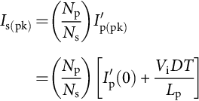 **(20.52)**

During the off-time, the current *I*L1 in the output inductor is equal to the current *I*DR3 in the rectifier diode DR3, and both decrease linearly at the rate of

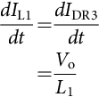 **(20.53)**

The output voltage *V*o can be found from the time integral of the secondary winding voltage over a time equal to *DT* of the switch Q1. Thus, we have

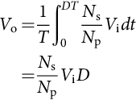 **(20.54)**

The maximum collector current *I*C(max) at turn-on is equal to *I*′p(pk) and is given by

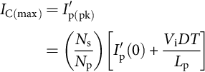 **(20.55)**

The maximum collector voltage  at turnoff is equal to the maximum input voltage *V*i(max) plus the maximum voltage *V*r(max) across the tertiary winding and is given by

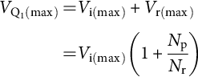 **(20.56)**

The maximum duty cycle for the forward regulator operated in the continuous mode can be determined by equating the time integral of the input voltage when Q1 is on and the clamping voltage *V*r when Q1 is off.

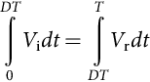 **(20.57)**

that leads to

 **(20.58)**

Grouping the *D* terms in Eq. [(20.58)](https://learning.oreilly.com/library/view/power-electronics-handbook/9780128114087/B9780128114070000222.xhtml#fo0295) and replacing *V*r/*V*i with *N*r/*N*p, we have

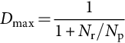 **(20.59)**

Thus, the maximum duty cycle depends on the turn ratio between the demagnetizing winding and the primary one.

In designing forward regulators, the duty cycle must be kept below the maximum duty cycle *D*max to avoid saturating the transformer. It should also be noted that the transformer magnetizing current must be reset to zero at the end of each cycle. Failure to do so will drive the transformer into saturation, which can cause damage to the transistor. There are many ways of implementing the resetting function. In the circuit shown in [Fig. 20.23A, a](https://learning.oreilly.com/library/view/power-electronics-handbook/9780128114087/B9780128114070000222.xhtml#f0120) tertiary winding is added to the transformer so that the magnetizing current will return to the input source *V*i when the transistor turns off. The primary current always starts at the same value under the steady-state condition.

Unlike flyback regulators, forward regulators require a minimum load at the output. Otherwise, excess output voltage will be produced. One commonly used method to avoid this situation is to attach a small load resistance at the output terminals. Of course, with such an arrangement, a certain amount of power will be lost in the resistor.

Because forward regulators do not store energy in their transformers, for the same output power level, the transformer can be made smaller than for the flyback type. The output current is reasonably constant owing to the action of the output inductor and the flywheel diode; as a result, the output filter capacitor can be made smaller, and its ripple current rating can be much lower than that required for the flybacks.

The forward regulator is widely used with output power below 200 W, though it can be easily constructed with a much higher output power. The limitation comes from the capability of the power transistor to handle the voltage and current stresses if the output power were to increase. In this case, a configuration with more than one transistor can be used to share the burden. [Fig. 20.25](https://learning.oreilly.com/library/view/power-electronics-handbook/9780128114087/B9780128114070000222.xhtml#f0130) shows a double-ended forward regulator. Like the double-ended flyback counterpart, the circuit uses two transistors that are switched on and off simultaneously. The diodes are used to restrict the maximum collector voltage to *V*i. Therefore, the transistors with low voltage rating can be used in the circuit.

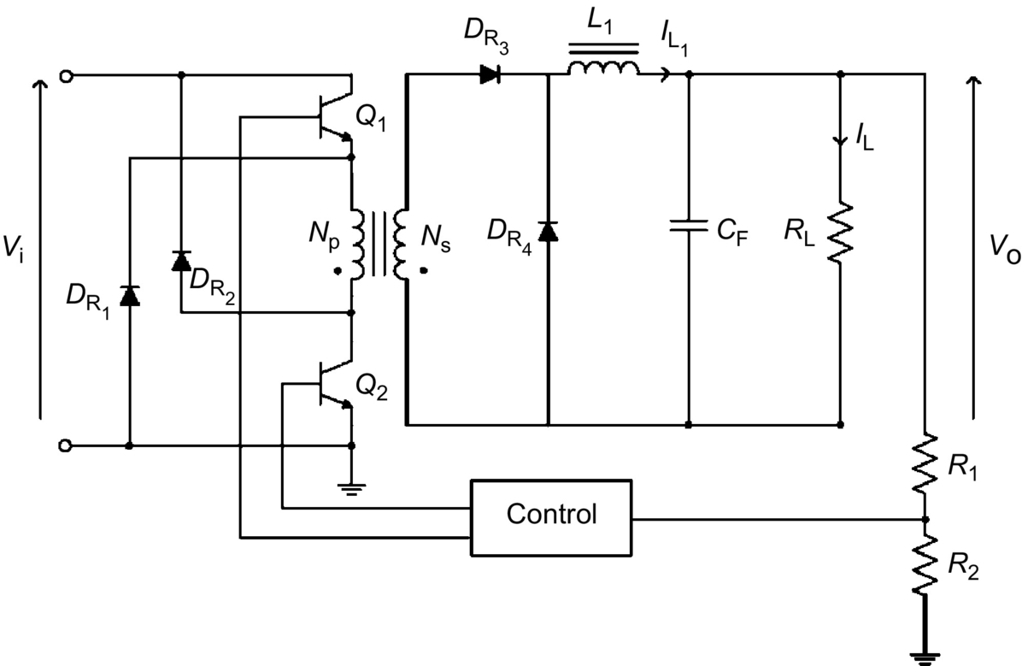

**FIG. 20.25** Double-ended forward regulator.

### 20.5.3 HALF-BRIDGE REGULATORS

The half-bridge regulator is another form of an isolated forward regulator. When the voltage on the power transistor in the single-ended forward regulator becomes too high, the half-bridge regulator is used to reduce the stress on the transistor. In a half-bridge regulator, the voltage stress imposed on the power transistors is subject to only the input voltage and is only half of that in a forward regulator. Thus, the output power of a half bridge is double to that of a forward regulator for the same semiconductor devices and magnetic core.

[Fig. 20.26](https://learning.oreilly.com/library/view/power-electronics-handbook/9780128114087/B9780128114070000222.xhtml#f0135) shows the basic configuration of a half-bridge regulator and the associated steady-state waveforms. As seen in [Fig. 20.26A](https://learning.oreilly.com/library/view/power-electronics-handbook/9780128114087/B9780128114070000222.xhtml#f0135), the half-bridge regulator can be viewed as two back-to-back forward regulators, fed by the same input voltage, each delivering power to the load at each alternate half cycle. The capacitors *C*1 and *C*2 are placed between the input and ground terminals. As such, the voltage across the primary winding is always half the input voltage. The power switches Q1 and Q2 are switched on and off alternatively to produce a square-wave ac at the input of the transformer. This square wave is either stepped down or up by the isolation transformer and then rectified by the diodes DR1 and DR2. Subsequently, the rectified voltage is filtered to produce the output voltage *V*o.

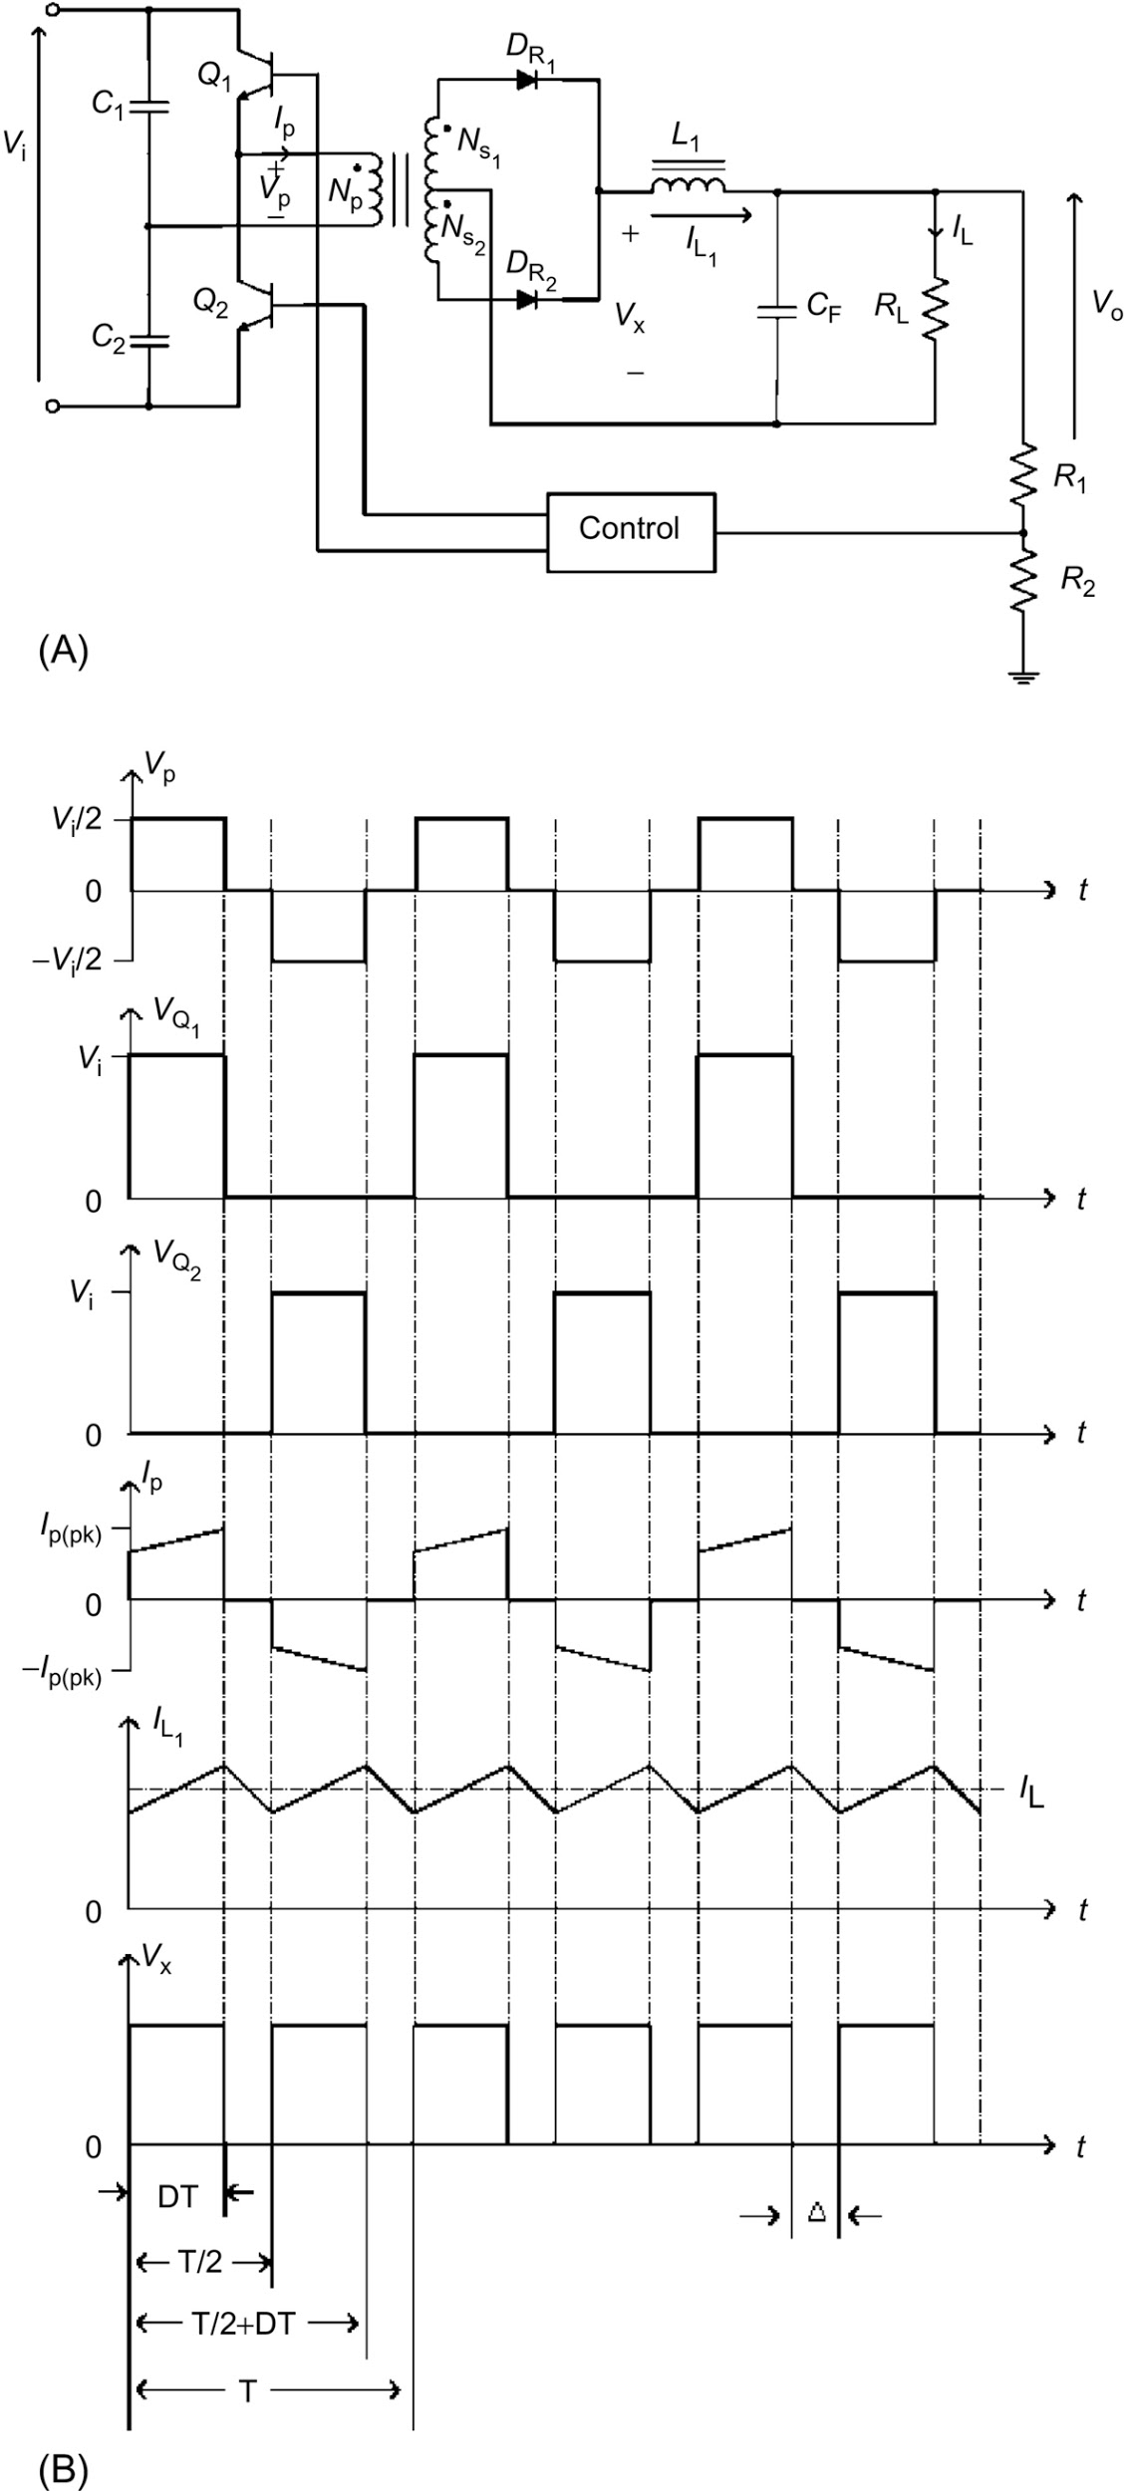

**FIG. 20.26** A simplified half-bridge regulator: (A) circuit and (B) the associated waveforms.

Under steady-state condition, the operation of the regulator can be explained as follows. When Q1 is on and Q2 off, DR1 conducts and DR2 is reverse-biased. The primary voltage *V*p is *V*i/2. The primary current *I*p starts to build up and stores energy in the primary winding. This energy is forward transferred to the secondary and onto the *L*1*C* filter and the load *R*L, through the rectifier diode DR1. During the time interval Δ, when both Q1 and Q2 are off, DR1 and DR2 are forced to conduct to carry the magnetizing current that resulted in the interval during which Q1 is turned on. The inductor current *I*L1 in this interval is equal to the sum of the currents in DR1 and DR2. This interval terminates at half of the switching period *T*, when Q2 is turned on. When Q2 is on and Q1 off, DR1 is reverse-biased and DR2 conducts. The primary voltage *V*p is now . The circuit operates in a likewise manner as during the first half cycle.

With Q1 on, the voltage across the secondary winding is

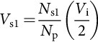 **(20.60)**

Neglecting diode voltage drops and losses, the voltage across the output inductor is then given by

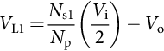 **(20.61)**

In this interval, the inductor current *I*L1 increases linearly at the rate of

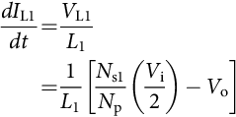 **(20.62)**

At the end of Q1 on-time, *I*L1 reaches a value that is given by

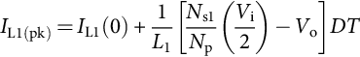 **(20.63)**

During the interval Δ, *I*L1 is equal to the sum of the rectifier diode currents. Assuming the two secondary windings are identical, *I*L1 is given by

 **(20.64)**

This current decreases linearly at the rate of

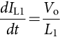 **(20.65)**

The next half cycle repeats with Q2 on and for the interval Δ.

The output voltage can be found from the time integral of the inductor voltage over a time equal to *T*. Thus, we have

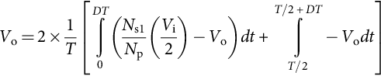 **(20.66)**

Note that the multiplier of 2 appears in Eq. [(20.66)](https://learning.oreilly.com/library/view/power-electronics-handbook/9780128114087/B9780128114070000222.xhtml#fo0335) because of the two alternate half cycles. Solving Eq. [(20.66)](https://learning.oreilly.com/library/view/power-electronics-handbook/9780128114087/B9780128114070000222.xhtml#fo0335) for *V*o, we have

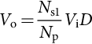 **(20.67)**

The output power *P*o is given by

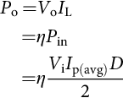 **(20.68)**

or

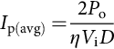 **(20.69)**

where *I*p(avg) has the value of the primary current at the center of the rising or falling ramp. Assuming the reaction current *I*p′ reflected from the secondary is much greater than the magnetizing current, then the maximum collector currents for Q1 and Q2 are given by

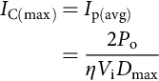 **(20.70)**

As mentioned, the maximum collector voltages for Q1 and Q2 at turnoff are given by

 **(20.71)**

In designing half-bridge regulators, the maximum duty cycle can never be greater than 50%. When both the transistors are switched on simultaneously, the input voltage is short-circuited to ground. The series capacitors *C*1 and *C*2 provide a dc bias to balance the volt-second integrals of the two switching intervals. Hence, any mismatch in devices would not easily saturate the core. However, if such a situation arises, a small coupling capacitor can be inserted in series with the primary winding. A dc bias voltage proportional to the volt-second imbalance is developed across the coupling capacitor. This balances the volt-second integrals of the two switching intervals.

One problem in using half-bridge regulators is related to the design of the drivers for the power switches. Specifically, the emitter of Q1 is not at ground level, but is at a high ac level. The driver must therefore be referenced to this ac level. Typically, transformer-coupled drivers are used to drive both switches, thus solving the grounding problem and allowing the controller to be isolated from the drivers.

The half-bridge regulator is widely used for medium-power applications. Because of its core-balancing feature, the half bridge becomes the predominant choice for output power ranging from 200 to 400 W. Since the half bridge is more complex, for application below 200 W, the flyback or forward regulator is considered to be a better choice and more cost-effective. Above 400 W, the primary and switch currents of the half bridge become very high. Thus, it becomes unsuitable.

### 20.5.4 FULL-BRIDGE REGULATORS

The full-bridge regulator is yet another form of isolated forward regulator. Its performance is improved over that of the half-bridge regulator because of the reduced peak collector current. The two series capacitors that appeared in half-bridge circuits are now replaced by another pair of transistors of the same type. In each switching interval, two of the switches are turned on and off simultaneously such that the full input voltage appears at the primary winding. The primary and the switch currents are only half that of the half bridge for the same power level. Thus, the maximum output power of this topology is twice that of the half bridge.

[Fig. 20.27](https://learning.oreilly.com/library/view/power-electronics-handbook/9780128114087/B9780128114070000222.xhtml#f0140) shows the basic configuration of a full-bridge regulator and the associated steady-state waveforms. Four power switches are required in the circuit. The power switches Q1 and Q4 turn on and off simultaneously in one of the half cycles. Q2 and Q3 also turn on and off simultaneously in the other half cycle but with opposite phase as Q1 and Q4. This produces a square-wave ac with a value of  at the primary winding of the transformer. Like the half bridge, this voltage is stepped down, rectified, and then filtered to produce a dc output voltage. The capacitor *C*1 is used to balance the volt-second integrals of the two switching intervals and prevent the transformer from being driven into saturation.

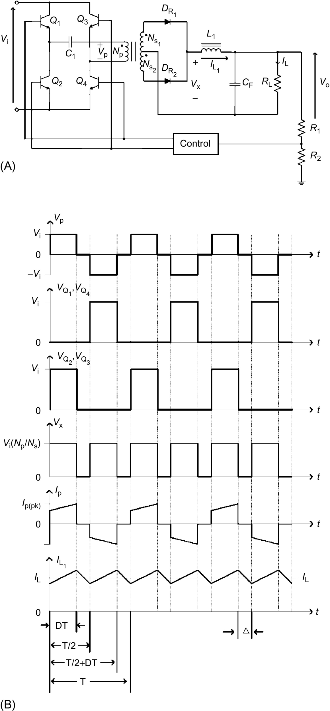

**FIG. 20.27** A simplified full-bridge regulator: (A) circuit and (B) the associated waveforms.

Under steady-state conditions, the operation of the full bridge is similar to that of the half bridge. When Q1 and Q4 turn on, the voltage across the secondary winding is

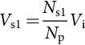 **(20.72)**

Neglecting diode voltage drops and losses, the voltage across the output inductor is then given by

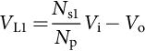 **(20.73)**

In this interval, the inductor current *I*L1 increases linearly at the rate of

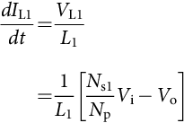 **(20.74)**

At the end of Q1 and Q4 on-time, *I*L1 reaches a value that is given by

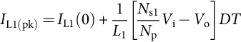 **(20.75)**

During the interval Δ, *I*L1 decreases linearly at the rate of

 **(20.76)**

The next half cycle repeats with Q2 and Q3 on, and the circuit operates in a similar manner as in the first half cycle.

Again, as in the half bridge, the output voltage can be found from the time integral of the inductor voltage over a time equal to *T*. Thus, we have

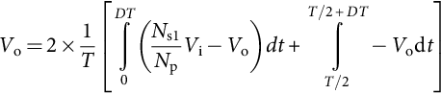 **(20.77)**

Solving Eq. [(20.77)](https://learning.oreilly.com/library/view/power-electronics-handbook/9780128114087/B9780128114070000222.xhtml#fo0390) for *V*o, we have

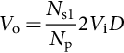 **(20.78)**

The output power *P*o is given by

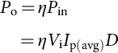 **(20.79)**

or

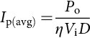 **(20.80)**

where *I*p(avg) has the same definition as in the half-bridge case.

Comparing Eq. [(20.80)](https://learning.oreilly.com/library/view/power-electronics-handbook/9780128114087/B9780128114070000222.xhtml#fo0405) with Eq. [(20.69)](https://learning.oreilly.com/library/view/power-electronics-handbook/9780128114087/B9780128114070000222.xhtml#fo0350), we see that the output power of a full bridge is twice that of a half bridge with same input voltage and current. The maximum collector currents for Q1, Q2, Q3, and Q4 are given by

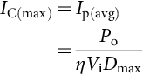 **(20.81)**

Comparing Eq. [(20.81)](https://learning.oreilly.com/library/view/power-electronics-handbook/9780128114087/B9780128114070000222.xhtml#fo0410) with Eq. [(20.70)](https://learning.oreilly.com/library/view/power-electronics-handbook/9780128114087/B9780128114070000222.xhtml#fo0355), for the same output power, the maximum collector current is only half that of the half bridge.

As mentioned, the maximum collector voltage for Q1 and Q2 at turnoff is given by

 **(20.82)**

The design of the full bridge is similar to that of the half bridge. The only difference is the use of four power switches instead of two in the full bridge. Therefore, additional drivers are required by adding two more secondary windings in the pulse transformer of the driving circuit.

For high-power applications ranging from several hundred to thousand kilowatts, the full-bridge regulator is an inevitable choice. It has the most efficient use of magnetic core and semiconductor switches. The full bridge is complex and therefore expensive to build and is only justified for high-power applications, typically over 500 W.

### 20.5.5 CONTROL CIRCUITS AND PULSE-WIDTH MODULATION

In previous subsections, we presented several popular voltage regulators that may be used in a switching mode power supply. This section discusses the control circuits that regulate the output voltage of a switching regulator by constantly adjusting the conduction period *t*on or duty cycle *d* of the power switch. Such adjustment is called *pulse-width modulation* (PWM).

The duty cycle is defined as the fraction of the period during which the switch is on, that is,

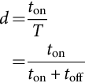 **(20.83)**

where *T* is the switching period, that is, . By adjusting either *t*on or *t*off or both, *d* can be modulated. Thus, PWM controlled regulators can operate at variable frequency and fixed frequency.

Among all types of PWM controllers, the fixed-frequency controller is by far the most popular choice. There are two main reasons for their popularity. First, low-cost fixed-frequency PWM IC controllers have been developed by various solid-state device manufacturers, and most of these IC controllers have all the features that are needed to build a PWM switching power supply using a minimum number of components. Second, because of their fixed-frequency nature, fixed-frequency controllers do not have the problem of unpredictable noise spectrum associated with variable frequency controllers. This makes EMI control much easier.

There are two types of fixed-frequency PWM controllers, namely, *the voltage-mode controller* and the *current-mode controller*. In its simplified form, a voltage-mode controller consists of four main functional components: an adjustable clock for setting the switching frequency, an output voltage error amplifier for detecting deviation of the output from the nominal value, a ramp generator for providing a sawtooth signal that is synchronized to the clock, and a comparator that compares the output error signal with the sawtooth signal. The output of the comparator is the signal that drives the controlled switch. [Fig. 20.28](https://learning.oreilly.com/library/view/power-electronics-handbook/9780128114087/B9780128114070000222.xhtml#f0145) shows a simplified PWM voltage-mode controlled forward regulator operating at fixed frequency and its associated driving signal waveform. As shown, the duration of the on-time *t*on is determined by the time between the reset of the ramp generator and the intersection of the error voltage with the positive-going ramp signal.

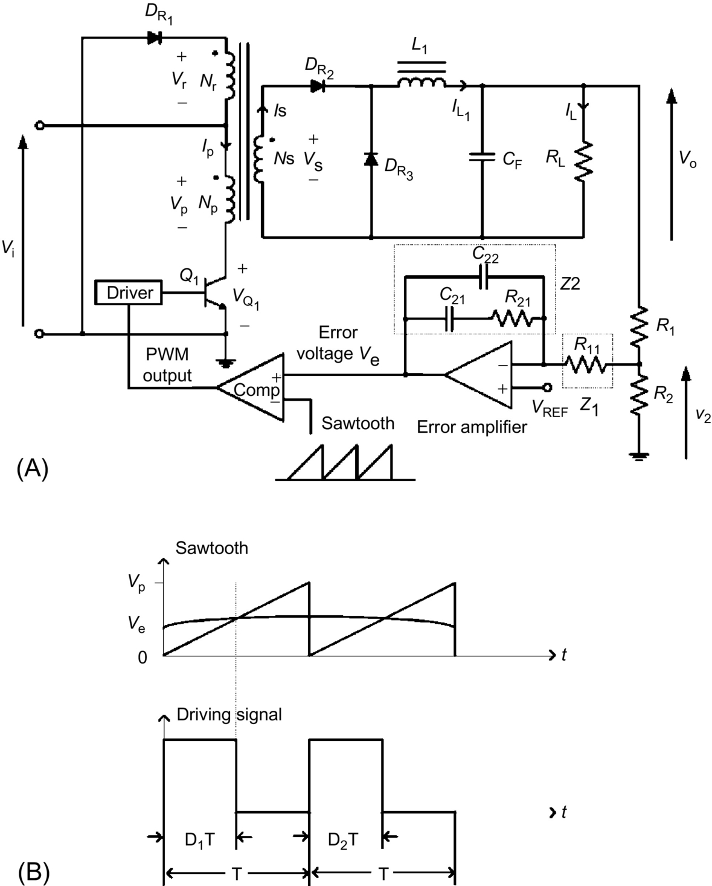

**FIG. 20.28** A simplified voltage-mode controlled forward regulator: (A) circuit and (B) the associated driving signal waveform.

The error voltage *v*e is given by

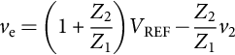 **(20.84)**

From Eq. [(20.84)](https://learning.oreilly.com/library/view/power-electronics-handbook/9780128114087/B9780128114070000222.xhtml#fo0425), the small-signal term can be separated from the dc operating point by

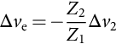 **(20.85)**

The dc operating point is given by

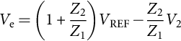 **(20.86)**

Inspecting the waveform of the sawtooth and the error voltage shows that the duty cycle is related to the error voltage by

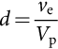 **(20.87)**

where *V*p is the peak voltage of the sawtooth.

Hence, the small-signal duty cycle is related to the small-signal error voltage by

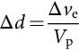 **(20.88)**

The operation of the fixed-frequency voltage-mode controller can be explained as follows. When the output is lower than the nominal dc value, a high error voltage is produced. This means that Δ*v*e is positive. Hence, Δ*d* is positive. The duty cycle is increased to cause a subsequent increase in output voltage. The feedback dynamics (stability and transient response) is determined by the operational amplifier circuit that consists of Z1 and Z2. Some of the popular voltage-mode control ICs are SG1524/25/26/27, TL494/5, and MC34060/63.

The current-mode control makes use of the current information in a regulator to achieve output voltage regulation. In its simplest form, current-mode control consists of an inner loop that samples the inductance current value and turns the switches off as soon as the current reaches a certain value set by the outer voltage loop. In this way, the current-mode control achieves faster response than the voltage mode. There are two types of fixed-frequency PWM current-mode control, namely, the *peak current-mode control* and the *average current-mode control*.

In the peak current-mode control, no sawtooth generator is needed. In fact, the inductance current waveform is itself a sawtooth. The voltage analog of the current may be provided by a small resistance or by a current transformer. Also, in practice, the switch current is used since only the positive-going portion of the inductance current waveform is required. [Fig. 20.29](https://learning.oreilly.com/library/view/power-electronics-handbook/9780128114087/B9780128114070000222.xhtml#f0150) shows a peak current-mode controlled flyback regulator.

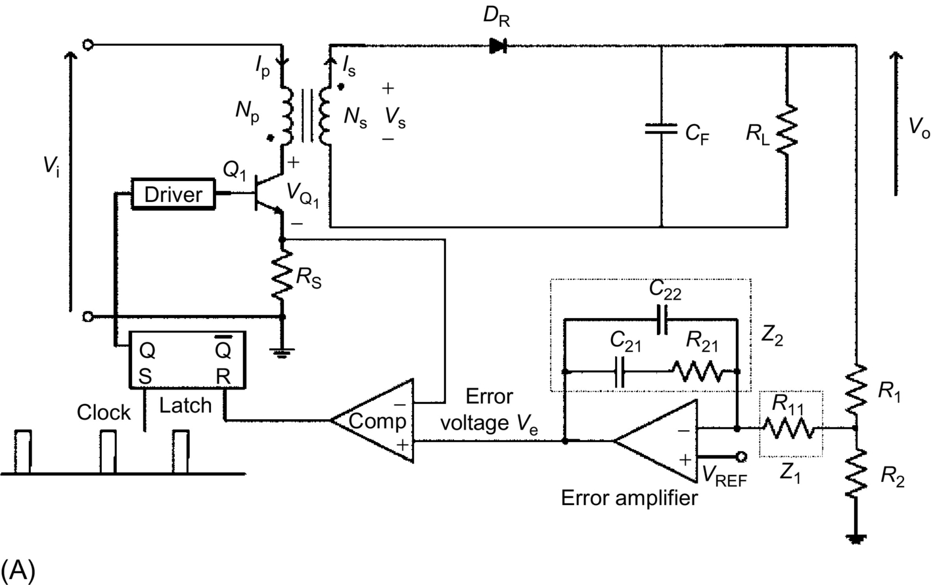

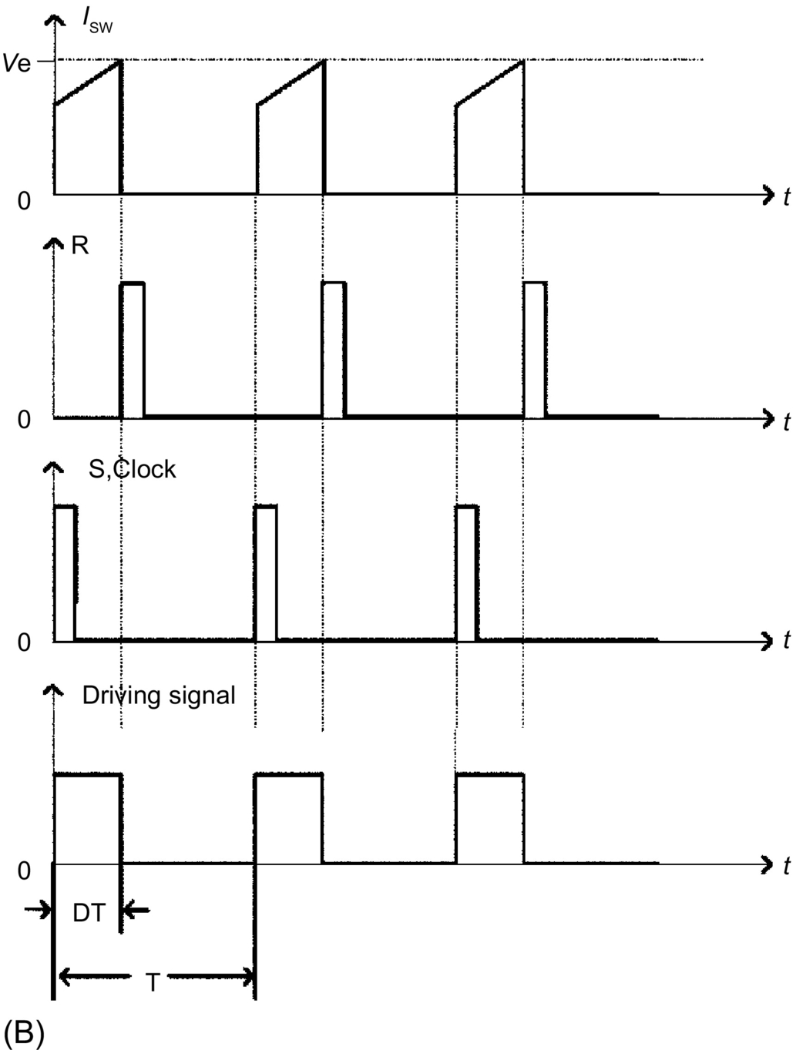

**FIG. 20.29** A simplified peak current-mode controlled flyback regulator: (A) circuit and (B) the associated waveforms.

In [Fig. 20.29](https://learning.oreilly.com/library/view/power-electronics-handbook/9780128114087/B9780128114070000222.xhtml#f0150), the regulator operates at fixed frequency. Turn-on is synchronized with the clock pulse, and turnoff is determined by the instant at which the input current equals the error voltage *V*e.

Because of its inherent peak current-limiting capability, the peak current-mode control can enhance reliability of power switches. The dynamic performance is improved because of the use of the additional current information. One main disadvantage of the peak current-mode control is that it is extremely susceptible to noise, since the current ramp is usually small compared with the reference signal. A second disadvantage is its inherent instability property at duty cycle exceeding 50%, which results in subharmonic oscillation. Typically, a compensating ramp is required at the comparator input to eliminate this instability. The third disadvantage is that it has a nonideal loop response because of the use of the peak, instead of the average current sensing.

[Fig. 20.30](https://learning.oreilly.com/library/view/power-electronics-handbook/9780128114087/B9780128114070000222.xhtml#f0155) shows an average current-mode controlled flyback regulator. In the circuit, a PWM modulator (instead of a clocked SR latch in the peak current-mode control) is employed to compare the current error with an externally generated sawtooth signal to formulate the desired control signal. The main advantages of this method over the peak current control are that it has excellent noise immunity property, it is stable at duty cycle exceeding 50%, and it provides good tracking of average current. However, since there are three compensation networks (*Z*1, *Z*2, and *Z*3), the analysis and optimal design of these networks are nontrivial. This is a major obstacle for adopting the average current-mode control.

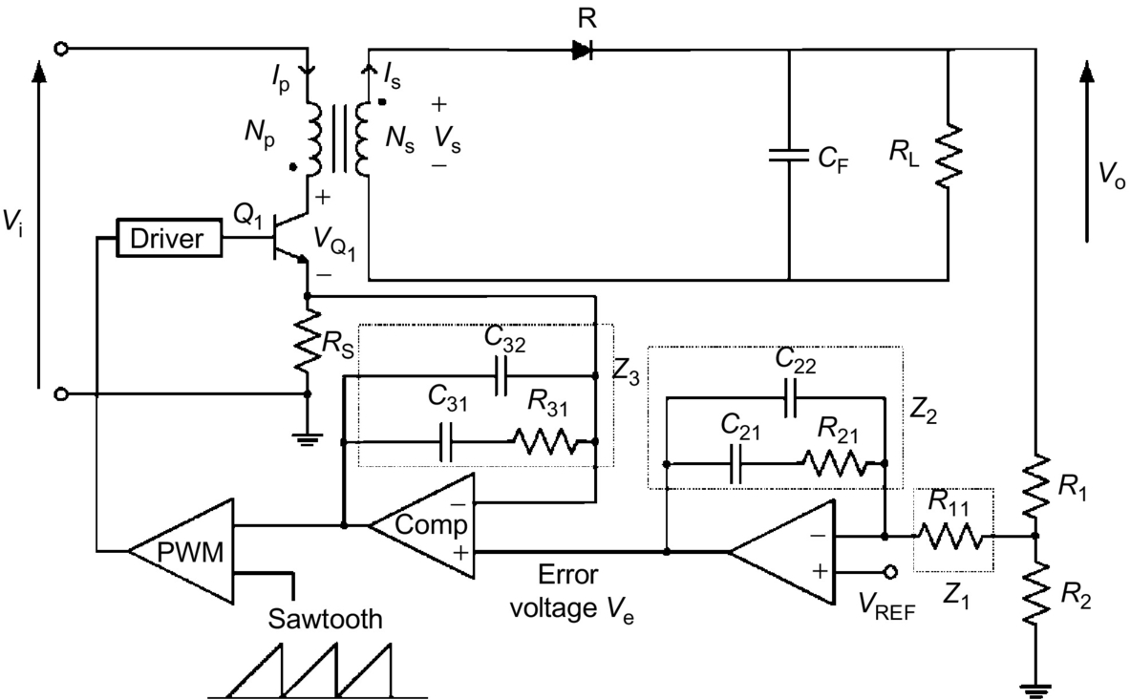

**FIG. 20.30** A simplified average current-mode controlled flyback regulator: (A) circuit and (B) the associated waveforms.

It should be noted that current-mode control is particularly effective for the flyback and boost-type regulators that have an inherent right-half-plane zero. Current-mode control effectively reduces the system to first order by forcing the inductor current to be related to the output voltage, thus achieving faster response. In the case of the buck-type regulator, current-mode control presents no significant advantage because the current information can be derived from the output voltage, and hence, faster response can still be achieved with a proper feedback network. Some of the popular current-mode control ICs are UC3840/2, UC3825, MC34129, and MC34065.

## Further Reading

[1] Pressman A.I. *Switching Power Supply Design.* second ed. New York: McGraw-Hill; 1999.

[2] Brown M. *Practical Switching Power Supply Design.* second ed. New York: McGraw-Hill; 1999.

[3] Krein P.T. *Elements of Power Electronics.* first ed. Cambridge: Oxford University Press; 1998.

[4] Kassakian J.G., Schlecht M.R., Verghese G.C. *Principles of Power Electronics.* first ed. Reading, MA: Addison-Wesley; 1991.

[5] Chryssis G. *High-Frequency Switching Power Supplies.* first ed. New York: McGraw-Hill; 1984.

[6] Rashid M.H. *Power Electronics—Circuits, Devices, and Applications.* second ed. Upper Saddle River, NJ: Prentice-Hall; 1993.

[7] Floyd T.L., Buchla D. *Fundamentals of Analog Circuits.* first ed. Upper Saddle River, NJ: Prentice-Hall; 1999.

**21**

# Electronic Ballasts

Jose Marcos Alonso University of Oviedo, Oviedo, Spain

## Abstract

Electronic ballasts, also called solid-state ballasts, are those power electronic converters used to supply discharge lamps. The modern age of electronic ballasts began with the introduction of power bipolar transistors with low storage time, allowing to supply fluorescent lamps at frequencies of several kilohertz and increasing lamp luminous efficacy by operating at these high frequencies. Later, electronic ballasts became very popular with the development of low-cost power MOSFETs, with unique features that make them very attractive to implement solid-state ballasts. The main benefits of electronic ballasts are the increase in the lamp and ballast overall efficiency, increase in lamp life, reduction of ballast size and weight, and improvement in lighting quality. This chapter attempts to give a general overview about the more important topics related to this type of power converters.

### KEYWORDS

Discharge lamps; Lamp ballast; Electronic ballasts; Lamp modeling; Fluorescent lamps; Inverters; Resonant inverters; Power factor correction; THD; ZVS; Lumens

21.1 [Introduction](https://learning.oreilly.com/library/view/power-electronics-handbook/9780128114087/B9780128114070000234.xhtml#s0010)

21.1.1 Basic Notions

21.1.2 Discharge Lamps

21.1.3 Electromagnetic Ballasts

21.2 [High Frequency Supply of Discharge Lamps](https://learning.oreilly.com/library/view/power-electronics-handbook/9780128114087/B9780128114070000234.xhtml#s0030)

21.2.1 General Block Diagram of Electronic Ballasts

21.2.2 Classification of Electronic Ballast Topologies

21.3 [Discharge Lamp Modeling](https://learning.oreilly.com/library/view/power-electronics-handbook/9780128114087/B9780128114070000234.xhtml#s0065)

21.4 [Resonant Inverters for Electronic Ballasts](https://learning.oreilly.com/library/view/power-electronics-handbook/9780128114087/B9780128114070000234.xhtml#s0070)

21.4.1 Current-Fed Resonant Inverters

21.4.2 Voltage-Fed Resonant Inverters

21.4.3 Design Issues

21.5 [High-Power Factor Electronic Ballasts](https://learning.oreilly.com/library/view/power-electronics-handbook/9780128114087/B9780128114070000234.xhtml#s0105)

21.5.1 Harmonic Limiting Standards

21.5.2 Passive Solutions

21.5.3 Active Solutions

21.6 [Applications](https://learning.oreilly.com/library/view/power-electronics-handbook/9780128114087/B9780128114070000234.xhtml#s0125)

21.6.1 Portable Lighting

21.6.2 Emergency Lighting

21.6.3 Automotive Lighting

21.6.4 Home and Industrial Lighting

21.6.5 Microprocessor-Based Lighting

[References](https://learning.oreilly.com/library/view/power-electronics-handbook/9780128114087/B9780128114070000234.xhtml#bi0010)

## 21.1 Introduction

Electronic ballasts, also called solid-state ballasts, are those power electronic converters used to supply discharge lamps. The modern age of electronic ballasts began with the introduction of power bipolar transistors with low storage time, allowing to supply fluorescent lamps at frequencies of several kilohertz and increasing lamp luminous efficacy by operating at these high frequencies. Later, electronic ballasts became very popular with the development of low-cost power MOSFETs, with unique features that make them very attractive to implement solid-state ballasts. The main benefits of electronic ballasts are the increase in the lamp and ballast overall efficiency, increase in lamp life, reduction of ballast size and weight, and improvement in lighting quality. This chapter attempts to give a general overview about the more important topics related to this type of power converters.

### 21.1.1 BASIC NOTIONS

Discharge lamps generate electromagnetic radiation by means of an electric current passing through a gas or metal vapor. This radiation is discrete, as opposed to the continuous radiation emitted by an incandescent filament. [Fig. 21.1](https://learning.oreilly.com/library/view/power-electronics-handbook/9780128114087/B9780128114070000234.xhtml#f0010) shows the electromagnetic spectrum of an electric discharge, which consists of a number of separate spectral lines.

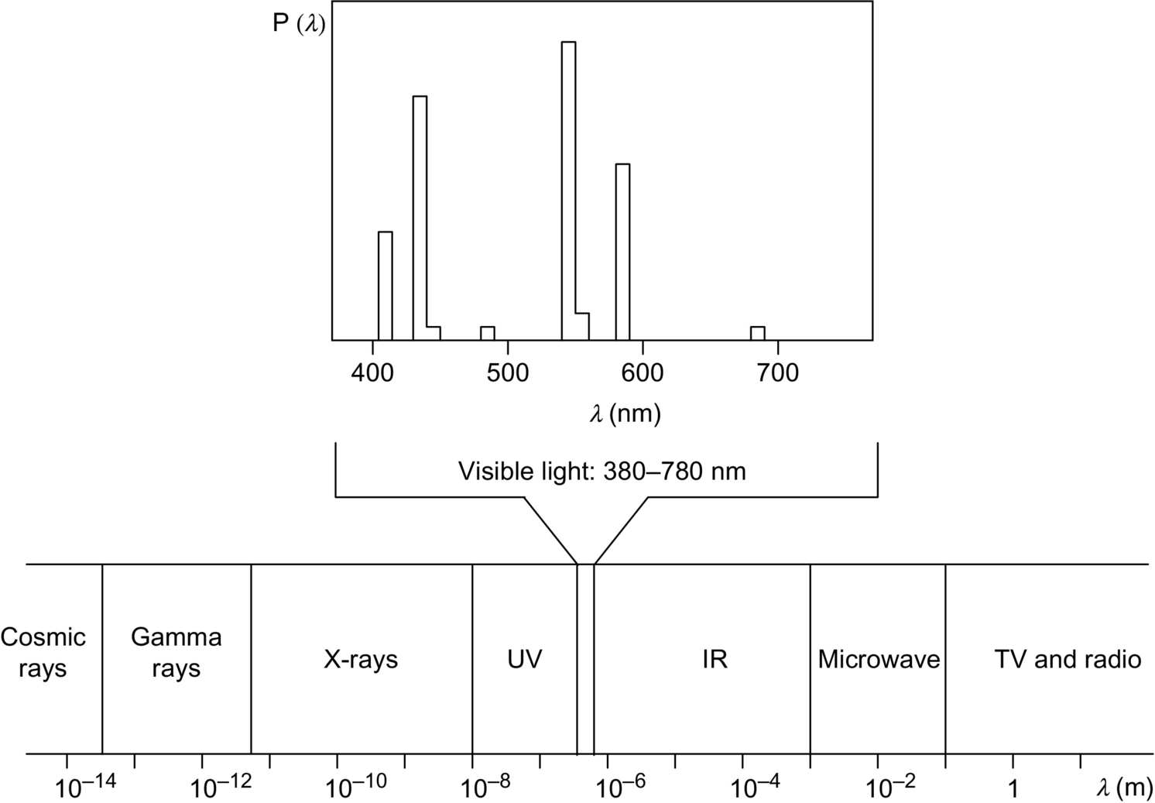

**FIG. 21.1** Spectral energy distribution of an arc discharge and radiant energy spectrum.

As can be seen in [Fig. 21.1](https://learning.oreilly.com/library/view/power-electronics-handbook/9780128114087/B9780128114070000234.xhtml#f0010), only the electromagnetic radiation emitted within the visible region (380–780 nm) of the radiant energy spectrum is useful to provide lighting. The total power in watts emitted by an electric discharge can be obtained by integrating the spectral energy distribution. However, this is not a suitable parameter to measure the amount of light emitted by a discharge lamp.

The human eye presents different responses to the different types of electromagnetic waves within the visible range. As illustrated in [Fig. 21.2](https://learning.oreilly.com/library/view/power-electronics-handbook/9780128114087/B9780128114070000234.xhtml#f0015), there exist two response curves. First, the photopic curve, also called *V*(*λ*), is the characteristic used to represent the human eye under normal illuminating level conditions or daylight vision. Second, the scotopic curve *V*′(*λ*) is the response of the human eye for situations with low illuminating levels, also known as nocturnal vision. The reason for this different behavior is physiological. The human eye consists of two types of photoreceptors: rods and cones. Rods are much more sensitive at low lighting levels than cones, but they are not sensitive to the different light colors. On the other hand, cones are responsible for normal color vision at higher lighting levels. Normally, only the photopic function is considered in lighting design and used to calibrate photometers [[1](https://learning.oreilly.com/library/view/power-electronics-handbook/9780128114087/B9780128114070000234.xhtml#bb0010),[2](https://learning.oreilly.com/library/view/power-electronics-handbook/9780128114087/B9780128114070000234.xhtml#bb0015)].

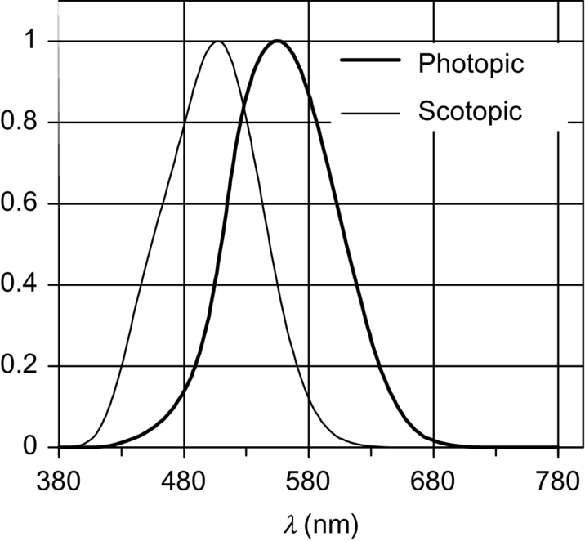

**FIG. 21.2** Spectral luminous efficiency functions for standard photopic and scotopic observers.

Since the human eye responds in different ways to the different wavelengths or colors, the output power of a lamp, measured in watts, is no longer applicable to represent the amount of light generated. Thus, a new unit is used to incorporate the human eye response, which is called *lumen*. The total light output of a lamp is then measured in lumens, and it is known as luminous flux of the lamp, which is obtained by integrating the radiant power as follows:

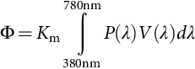 **(21.1)**

where *K*m represents the maximal spectral luminous efficacy, which is equal to 683 lm/W (at *λ*=555 nm) for photopic vision and 1700 lm/W (at *λ*=507 nm) for scotopic vision. The standard photopic and scotopic functions were defined by the International Commission on Illumination (CIE) in 1924 and 1951, respectively.

The measurement of the total luminous flux of the lamp is very useful to know whether the lamp is working properly. This can be measured by means of an integrating sphere and using the substitution method. The integrating sphere, also known as Ulbricht photometer, is internally coated with a perfectly diffusing material. Thus, the integral of the sphere is performed in Eq. [(21.1)](https://learning.oreilly.com/library/view/power-electronics-handbook/9780128114087/B9780128114070000234.xhtml#fo0010), and the illuminance on the internal surface is proportional to the total luminous flux. A photometer with a *V*(*λ*) filter is placed so that the internal illuminance can be measured, and a baffle is located to avoid direct illumination of the photometer probe by the lamp. The measurement is made in two steps, one with the lamp under test in place and the other with a standard lamp of known total luminous flux. From the two measurements, the total luminous flux of the lamp under test is deduced by linear relationship. [Fig. 21.3](https://learning.oreilly.com/library/view/power-electronics-handbook/9780128114087/B9780128114070000234.xhtml#f0020) illustrates an integrating sphere photometer.

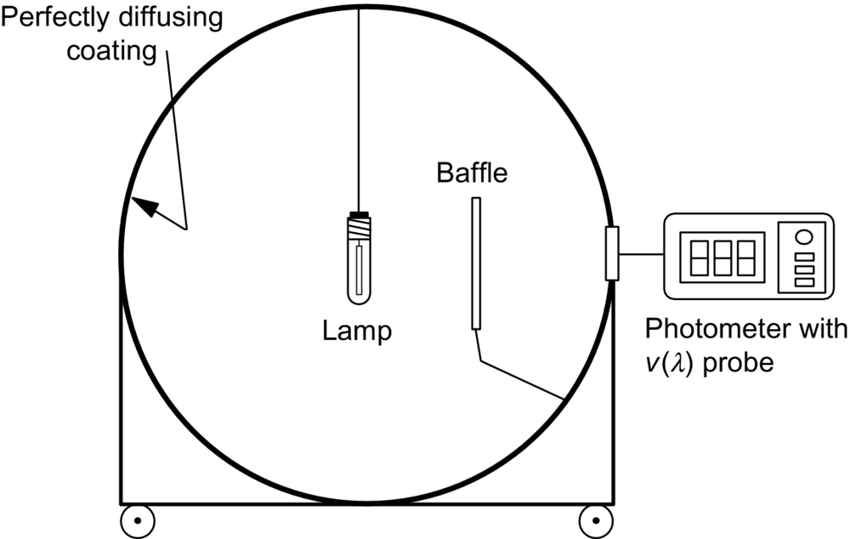

**FIG. 21.3** Integrating sphere used for measurement of the lamp total luminous flux.

An important parameter related to the supply of discharge lamps is the *luminous efficacy*. Luminous efficacy is defined as the rate of the lamp total luminous flux to the total electric power consumed by the lamp, usually expressed in lumens per watt. The luminous efficacy of a discharge lamp can be increased by proper designing of the electronic ballast, which finally results in energy saving.

### 21.1.2 DISCHARGE LAMPS

Basically, discharge lamps consist of a discharge tube inside, which the electric energy is transformed into electromagnetic radiation. The discharge tube is made of a transparent or translucent material with two sealed-in electrodes placed at both ends, as shown in [Fig. 21.4](https://learning.oreilly.com/library/view/power-electronics-handbook/9780128114087/B9780128114070000234.xhtml#f0025). The discharge tube is filled with an inert gas and a metal vapor. The electrodes generate free electrons, which are accelerated by the electric field existing in the discharge. These accelerated electrons collide with the gas atoms, resulting in both elastic and inelastic collisions depending on the electron kinetic energy. The basic processes inside the discharge tube are illustrated in [Fig. 21.4](https://learning.oreilly.com/library/view/power-electronics-handbook/9780128114087/B9780128114070000234.xhtml#f0025). They are as follows [[3](https://learning.oreilly.com/library/view/power-electronics-handbook/9780128114087/B9780128114070000234.xhtml#bb0020)]:

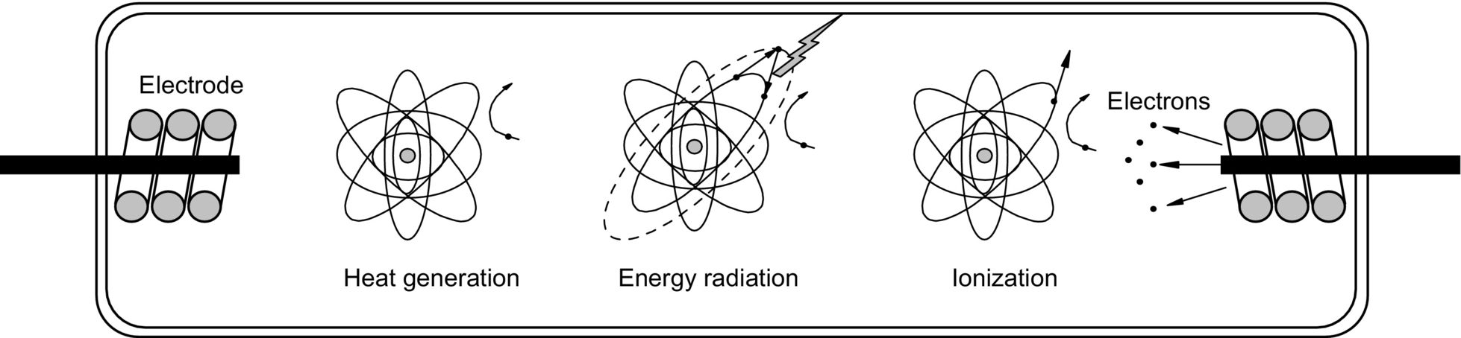

**FIG. 21.4** Basic processes inside the discharge tube.

1. *Heat generation*. When the kinetic energy of the electron is low, an elastic collision takes place, and only a small part of the electron energy is transferred to the gas atom. The result of this type of collisions is an increase in the gas temperature. In this case, the electric energy is consumed to produce heat dissipation. However, this is also an important process because the discharge has to be set in its optimum operating temperature.

2. *Gas atom excitation*. Some electrons can have a high kinetic energy so that the energy transferred in the collision is used to send an electron of the gas atom to a higher orbit. This state is unstable, and the electron tends to recover its original level, emitting the absorbed energy in the form of electromagnetic radiation. This radiation is used to directly generate visible light, or in other case, ultraviolet radiation is first generated and then transformed into visible radiation by means of a phosphor coating existing in the inside wall of the discharge tube.

3. *Gas atom ionization*. In some cases, electrons have gained such high kinetic energy that during the collision with the gas atom, an electron belonging to the gas atom is freed, resulting in a positively charged ion and a free electron. This freed electron can play the same roles as those generated by the electrodes. This process is especially important during both discharge ignition and normal running because ionized atoms and electrons are necessary to maintain the electric current through the lamp.

The number of free electrons in the discharge can increase rapidly due to continuing ionization, producing an unlimited current and finally a short circuit. This is illustrated in [Fig. 21.5](https://learning.oreilly.com/library/view/power-electronics-handbook/9780128114087/B9780128114070000234.xhtml#f0030), which shows how the voltage-current characteristics of a gas discharge exhibit a negative differential resistance. Therefore, in order to limit the discharge current, the use of an auxiliary supply circuit is mandatory. This circuit is called *ballast*.

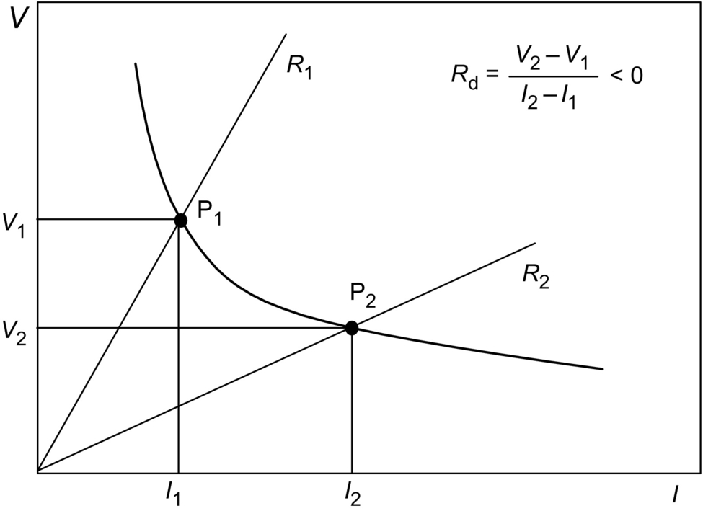

**FIG. 21.5** Voltage-current characteristics of a gas discharge.

Focusing on discharge lamps, the complete stabilization process consists of two main phases:

1. *Breakdown phase*. Most of the gases are very good insulators, and an electric discharge is only possible if a sufficient concentration of charged particles is present. Normally, a high voltage is used to provide electricity carriers and to initiate the discharge. The minimum voltage applied to initiate the discharge is called *starting voltage*. The starting voltage mainly depends on the type of gas, gas pressure, and distance between electrodes. [Fig. 21.6A](https://learning.oreilly.com/library/view/power-electronics-handbook/9780128114087/B9780128114070000234.xhtml#f0035) represents the starting voltage as a function of the gas pressure multiplied by electrode distance, for different gases. These functions are known as Paschen curves.

Usually, auxiliary inert gases are used to decrease the starting voltage. Particularly, there exist some special inert gas mixtures presenting a very low starting voltage, which are called *Penning mixtures*. These Penning mixtures are very often used as initial starting gas. [Fig. 21.6A](https://learning.oreilly.com/library/view/power-electronics-handbook/9780128114087/B9780128114070000234.xhtml#f0035) shows a typical Penning mixture constituted by neon with 0.1% of argon.

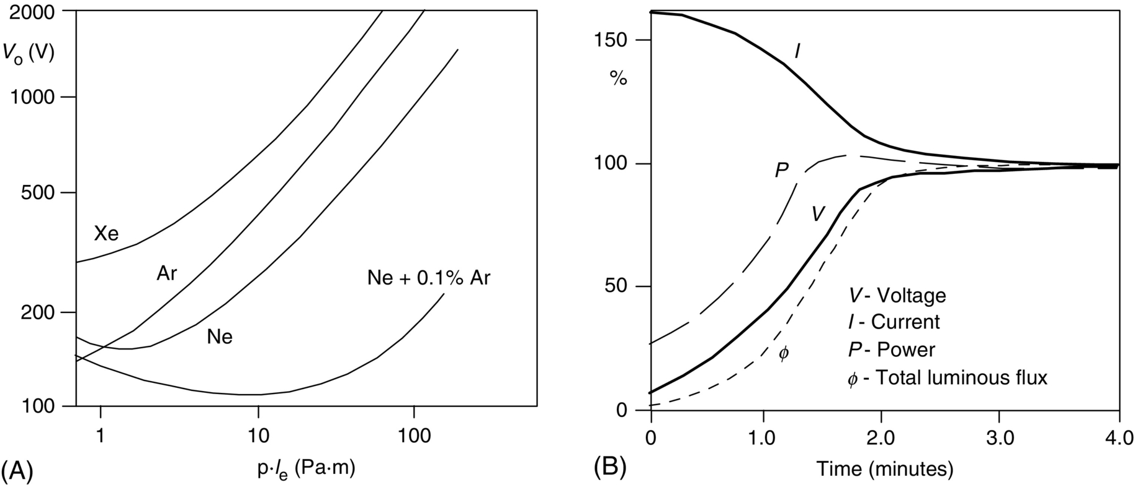

**FIG. 21.6** (A) Paschen curves for different inert gases and (B) stabilization curve of a discharge lamp.

2. *Warm-up phase*. Once the lamp is ignited, the collisions between free electrons and atoms generate heat, and discharge temperature increases until reaching the normal operation conditions. During this phase, the heat is used to evaporate the metal atoms existing in the discharge tube, and the emitted electromagnetic radiation has the characteristics of a metal vapor discharge instead of an inert gas discharge. From the electric point of view, the discharge warm-up phase shows initially low discharge voltage and high discharge current. As long as more and more metal atoms are evaporated, the discharge voltage increases, and the discharge current decreases. Finally, an equilibrium is reached at steady-state operation with the normal values of voltage and current. The time constant of the warm-up phase strongly depends on the lamp type. It varies from seconds for fluorescent lamps to minutes for high-intensity discharge lamps. [Fig. 21.6B](https://learning.oreilly.com/library/view/power-electronics-handbook/9780128114087/B9780128114070000234.xhtml#f0035) illustrates some discharge waveforms during the warm-up phase.

The basic elements used in lamps to generate radiation in the visible part of the spectrum are sodium and mercury. The former generates radiation directly within the visible part of the spectrum; the latter generates radiation mainly in the ultraviolet region, but this radiation can be easily transformed to visible radiation by means of a phosphor coating on the internal wall of the discharge tube. Besides the element used, a very important parameter related to the efficiency and richness of the emitted radiation is the discharge pressure. For the sodium and mercury elements, there exist two pressure values around which the luminous efficacy of the discharge is higher. The first is obtained at quite low pressures, about 1 Pa, and the second at higher pressures around 105 Pa (1 at). This is the reason why there exist two main types of discharge lamps:

1. *Low-pressure discharge lamps*. This type of lamps operates with pressures around 1 Pa, and they feature low current density inside the discharge and low power/unit of discharge length. Therefore, these lamps present normally a quite large discharge volume with low power rating. Most representative examples are low-pressure mercury lamps, also known as fluorescent lamps and low-pressure sodium lamps.

2. *High-pressure discharge lamps*. The operating pressure in this type of lamps is around 105 Pa and higher, in order to achieve a considerable increase in the luminous efficacy of the discharge. These lamps present a high current density in the discharge and a high power/discharge length ratio, thus showing much smaller discharge tubes. Examples of these lamps are high-pressure sodium lamps, high-pressure mercury lamps, and metal halide lamps.

Finally, to characterize the light produced by a discharge lamp, it is necessary to know two important concepts: the correlated color temperature (CCT) and the color rendering index (CRI).

The CCT is defined as the temperature of the blackbody radiator whose perceived color most closely resembles that of the discharge lamp. The color of an incandescent body changes from deep red to orange, yellow, and finally white as its temperature rises. Thus, a cool-white fluorescent lamp has a CCT around 3500 K, and it is perceived as a white source of light, whereas a high-pressure sodium lamp presents a CCT of about 2000 K, and it appears as yellow.

The CRI of a light source is the effect that the source has on the color appearance of the objects under it, when compared with their appearance under a reference source of equal CCT. The measurement gives a value lower than 100, and the higher the CRI, the better the color rendition. For example, daylight and incandescent lamps have a CRI equal to 100.

To conclude this introduction on the discharge lamps, some comments regarding the most important types of discharge lamps will be given. [Table 21.1](https://learning.oreilly.com/library/view/power-electronics-handbook/9780128114087/B9780128114070000234.xhtml#t0010) provides some additional data on the different discharge lamps for comparison.

**Table 21.1**

**Comparison of different discharge lamps**

|  |  |  |  |  |  |
| --- | --- | --- | --- | --- | --- |
| **Lamp** | **Wattage (W)** | **Luminous efficacy (lm/W−1)** | **Life (h)** | **CCT (K)** | **CRI** |
| Fluorescent | 4–100 | 62 | 20,000 | 4200 | 62 |
| Compact fluorescent | 7–30 | 60–80 | 10,000 | 2700–5000 | 82 |
| Low-pressure sodium | 50–150 | 110–180 | 15,000 | 1800 | <0 |
| Mercury vapor | 50–1000 | 40–70 | 24,000 | 4000–6000 | 15–50 |
| Metal halide | 40–15,000 | 80–125 | 10,000 | 4000 | 65 |
| HPS | 35–1000 | 65–140 | 24,000 | 2000 | 22 |
| HPS (amalgam) | 35–1000 | 45–85 | 10,000 | 2200 | 65 |

1. *Fluorescent lamps*. These lamps belong to the category of low-pressure mercury vapor discharge lamps. The discharge generates two main lines at 185 and 253.7 nm and other weak lines in the visible range of the spectrum. A fluorescent powder on the inside wall of the discharge tube converts the ultraviolet radiation into visible radiation, resulting in a broadband spectral distribution and good color rendition. In these lamps, the optimum mercury vapor pressure (which gives the maximum luminous efficacy) is 0.8 Pa. For the tube diameters normally used, this pressure is reached at a wall temperature of about 40°C, not much higher than typical ambient temperature. The heat generated inside the discharge is sufficient to attain the required operating temperature without using an outer bulb. However, this structure causes a great variation of the lamp lumen output with the temperature, which is one important drawback of the fluorescent lamps. One solution to this problem is the addition of amalgams to stabilize the light output. This is specially used in compact fluorescent lamps.

2. *Low-pressure sodium lamps*. These lamps are the most efficient source of light. The reason is the almost monochromatic radiation that they generate, with two main lines at 589 and 589.6 nm, very close to the maximum human eye sensitivity. Therefore, color rendition of these lamps is very poor; however, contrasts are seen more clearly under this light. This is the reason for using these lamps in situations where the recognition of objects and contours is essential for safety, such as motorway bridges, tunnels, and intersections. The optimum pressure for the low-pressure sodium discharge is about 0.4 Pa, which is attained in normal discharge tubes at a temperature of 260°C. An outer bulb is normally used to reach and maintain this temperature.

3. *High-pressure mercury vapor lamps*. The increase in the pressure of the mercury vapor produces a radiation richer in spectral lines; some of them are in the visible part of the spectrum (405, 436, 546, and 577/579 nm). This leads to an increase in the luminous efficacy, reaching values of 40–60 lm/W at pressures 105–107 Pa (1–100 at). These lamps operate with unsaturated mercury vapor, which means that all the mercury in the discharge tube has evaporated and the number of mercury atoms/unit volume remains constant. Thus, the operation of this type of lamps is more independent of the temperature than most other discharge lamps. One drawback of these lamps is the lack of spectral lines in the long wavelengths (reds) of the spectrum, thus showing low CRI. An increase of the color rendition can be obtained by adding metal halide compounds into the discharge tube, in order to generate radiation all over the visible spectrum. These lamps are known as *metal halide lamps*.

4. *High-pressure sodium lamps*. This is a very popular source of light due to its high luminous efficacy and long life. The increase in the sodium vapor pressure produces a very widening spectrum, with good color rendition compared with the low-pressure sodium lamps. This also leads to a lower luminous efficacy, but it is still higher than the other high-intensity discharge lamps. Some of these lamps also incorporate mercury in the form of sodium amalgam to increase the field strength of the discharge, thus decreasing the discharge current. A lower lamp current and a higher lamp voltage allow to reduce the size and cost of the ballast. However, the addition of sodium amalgam strongly reduces the life of the lamp.

### 21.1.3 ELECTROMAGNETIC BALLASTS

Electromagnetic ballasts are commonly used to stabilize the lamp at the required operating point by limiting the discharge current. The operating point of the lamp is given by the intersection of both lamp and ballast characteristics, as shown in [Fig. 21.7](https://learning.oreilly.com/library/view/power-electronics-handbook/9780128114087/B9780128114070000234.xhtml#f0040). The ballast line is the characteristic that shows the variation of the lamp power versus lamp voltage for a constant line voltage, and it can be measured during the warm-up phase of the lamp. The lamp line is the characteristic that gives the variation of the lamp power as a function of the lamp voltage for different line voltages, and it can be measured by varying the line voltage. Some lamps, such as high-pressure sodium lamps, exhibit a great variation of lamp voltage with changes in the lamp wattage. Because of this characteristic, trapezoids have been established that define maximum and minimum permissible lamp wattage versus lamp voltage for purposes of ballast design, as shown in [Fig. 21.7](https://learning.oreilly.com/library/view/power-electronics-handbook/9780128114087/B9780128114070000234.xhtml#f0040).

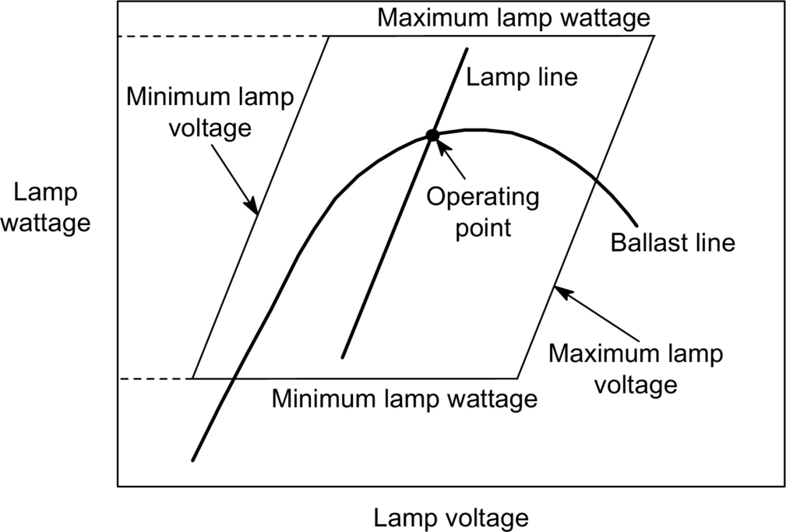

**FIG. 21.7** Lamp and ballast characteristics.

[Fig. 21.8](https://learning.oreilly.com/library/view/power-electronics-handbook/9780128114087/B9780128114070000234.xhtml#f0045) shows a basic electromagnetic ballast used to supply low- and high-pressure lamps at line frequencies (50–60 Hz). [Fig. 21.8A](https://learning.oreilly.com/library/view/power-electronics-handbook/9780128114087/B9780128114070000234.xhtml#f0045) illustrates the typical circuit used to supply fluorescent lamps with preheating electrodes, which basically uses a series inductor to limit the current through the discharge. Initially, the glow switch is closed, and the short circuit current flows through the circuit, heating the electrodes. A fraction of a second later, the glow switch is opened, and the energy stored in the ballast inductor causes a voltage spike between the lamp electrodes (about 800 V), which finally produces the discharge breakdown. Once ignited, the lamp voltage is lower than the line voltage, and the glow switch remains open during the normal lamp operation. Typical glow switches are based on two bimetal strips inside a small tube filled with an inert gas. An external capacitor of about 10 nF is used to enhance the glow-switch operation and also to reduce radio interference during lamp starting. Finally, in this type of inductive ballasts, a capacitor placed across the line input is mandatory to achieve a reasonable value of the input power factor.

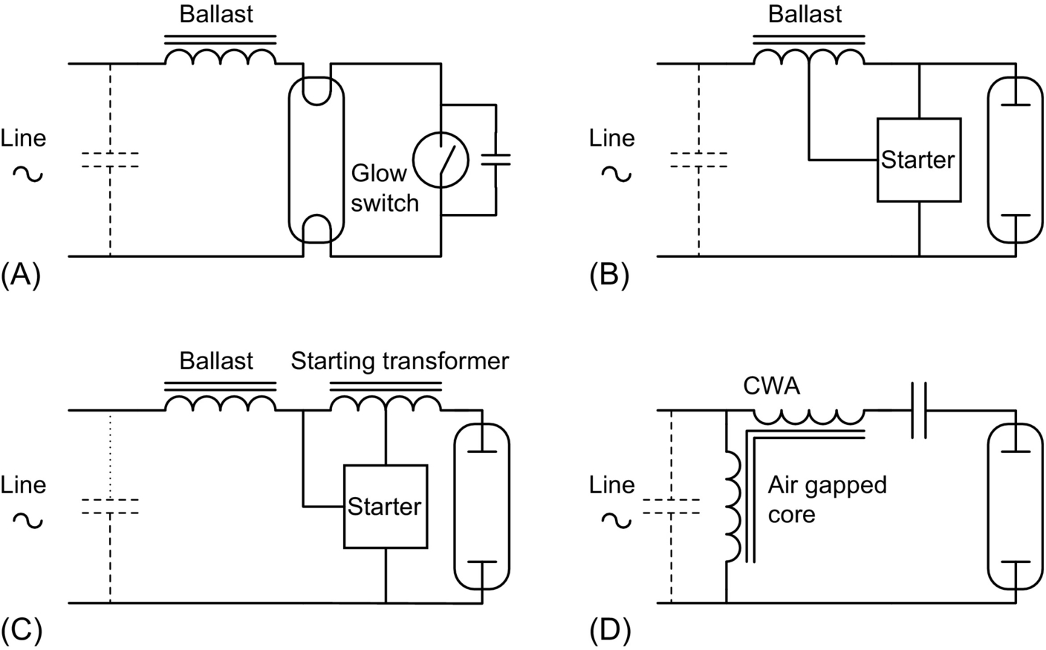

**FIG. 21.8** Typical electromagnetic ballast used to supply discharge lamps at low frequency.

Starting voltages of high-pressure discharge lamps are normally higher than low-pressure discharge lamps and can range from 2500 V for a lamp at room temperature to 30–40 kV to reignite a hot lamp. Thus, the simple ignition system based on the glow switch is no longer applicable for these lamps. [Fig. 21.8B and C](https://learning.oreilly.com/library/view/power-electronics-handbook/9780128114087/B9780128114070000234.xhtml#f0045) shows two typical arrangements to supply high-intensity discharge lamps. A series inductor is also used to limit the lamp current at steady-state operation, but autotransformers are used to attain higher voltage spikes for lamp ignition. For higher line voltages and short distances between starter and lamp, the inductor ballast can be used as an ignition transformer as shown in [Fig. 21.8B](https://learning.oreilly.com/library/view/power-electronics-handbook/9780128114087/B9780128114070000234.xhtml#f0045). In other cases, a separate igniting transformer is needed to provide higher voltage spikes and to avoid the effect of parasitic capacitance of connection cables ([Fig. 21.8C](https://learning.oreilly.com/library/view/power-electronics-handbook/9780128114087/B9780128114070000234.xhtml#f0045)).

The inductive ballast provides low-lamp-power regulation against line voltage variation, and therefore, it is only recommended in those installations with low voltage fluctuations. When a good lamp power regulation is necessary, the circuit shown in [Fig. 21.8D](https://learning.oreilly.com/library/view/power-electronics-handbook/9780128114087/B9780128114070000234.xhtml#f0045) is normally used. This circuit is commonly named as constant wattage autotransformer (CWA) and incorporates a capacitor in series with the lamp to limit the discharge current. Compared with the normal inductive ballast, the CWA also exhibits higher input power factor, lower line extinguishing voltage, and lower line starting currents.

The main advantage of electromagnetic ballasts is their simplicity, which in turn provides low cost and high reliability. However, since they operate at line frequencies, typically 50–60 Hz, they also feature high size and weight. Other important drawbacks of electromagnetic ballasts are as follows:

• Low efficiency especially for those ballasts featuring good lamp-power regulation against line voltage variation.

• Low reliability for ignition and reignition. If the voltage spike is not well located within the line period, the ignition of the lamp can fail.

• Difficult to control the lamp luminous flux (dimming).

• Lamp operating point changes due to lamp aging process, thus reducing lamp life.

• Low input power factor and high harmonic distortion. Large capacitors are needed across the line input to increase power factor.

• Overcurrent risk due to ballast saturation caused by rectifying effect of some discharge lamps, especially at the end of their life.

• *Flickering* and *stroboscopic effect* due to low frequency supply. The energy radiated by the lamp is a function of the instantaneous input power. Therefore, when supplied from an ac line, an instantaneous variation of the light output occurs, which is called *flicker*. For a line frequency of 60 Hz, the resulting light frequency is 120 Hz. This variation is too fast for the human eye, but when rapidly moving objects are viewed under these lamps, the objects seem to move slowly or even halted. This is called *stroboscopic effect*, and it can be very dangerous in industrial environments. A flicker index is defined with values from 0 to 1.0 [[4](https://learning.oreilly.com/library/view/power-electronics-handbook/9780128114087/B9780128114070000234.xhtml#bb0025)]. The higher the flicker index the higher is the possibilities of noticeable stroboscopic effect.

• Unsuitable for dc applications (emergency lighting, automobile lighting, etc.).

## 21.2 High Frequency Supply of Discharge Lamps

### **21.2.1 GENERAL BLOCK DIAGRAM OF ELECTRONIC BALLASTS**

[Fig. 21.9](https://learning.oreilly.com/library/view/power-electronics-handbook/9780128114087/B9780128114070000234.xhtml#f0050) shows the general block diagram of a typical electronic ballast. The main stages are the following:

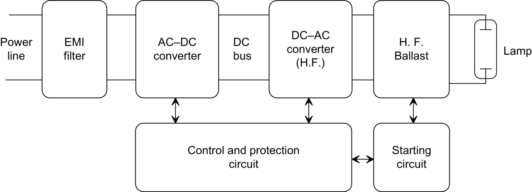

**FIG. 21.9** Block diagram of a typical electronic ballast.

• *EMI filter*. This filter is mandatory for commercial electronic ballast. Usually, it consists of two coupled inductors and a capacitor. The input filter is used to attenuate the electromagnetic interference (EMI) generated by the high-frequency stages of the ballasts. It also protects the ballast against possible line transients.

• *AC-DC converter*. This stage is used to generate a dc voltage level from the ac line. Normally, a full-bridge diode rectifier followed by a filter capacitor is used. However, this simple rectifier provides low input power factor and poor voltage regulation. In order to obtain a higher power factor and a regulated bus voltage, active converters can be used as expounded later in this chapter.

• *DC-AC inverter and high-frequency ballast*. These stages are used to supply the lamp at high frequency. The inverter generates a high-frequency waveform, and the ballast is used to limit the current through the discharge. Both inductors and capacitors can be used to perform this function, with the advantage of low size and weight, because they operate at high frequencies.

• *Starting circuit*. In most electronic ballast, especially those for low-pressure discharge lamps, the high-frequency ballast is used to both ignite the lamp and limit the lamp current at steady state. Therefore, no extra starting circuit is necessary. However, when supplying high-pressure discharge lamps, the starting voltages are quite higher, and separate ignition circuits are needed, especially if hot reignition is pursued.

• *Control and protection circuit*. This stage includes the main oscillator, error amplifiers to regulate lamp current or power, output overvoltage protection, timers to control the ignition times, overcurrent protection, and lamp failure protection. It can vary from very simple circuits, those used in self-oscillating ballasts, to very complicated ones, which sometimes include a microprocessor-based control circuit.

There are several important topics when designing electronic ballasts:

• *Operating frequency*. The operating frequency should be high in order to take benefit of the lower size and weight of the reactive elements used to stabilize the discharge. Usually, the operating frequency should be higher than 20 kHz to avoid audible frequencies, which can produce annoying noises. On the other hand, a higher frequency produces higher switching losses, and the practical limit of the switching frequency is about 100 kHz when using MOSFET switches. It is also important to avoid frequencies in the range of 30–40 kHz because these frequencies are normally used in IR remote controls and could generate some kind of interference.

• *Lamp current waveform*. In order to attain the maximum lamp life, it is important to drive the lamp with symmetrical alternating currents, thus making use of both the lamp electrodes alternately. Also, an important parameter is the *lamp current crest factor* (CF), which is the ratio of the peak value to the rms value of the lamp current. In case of electronic ballasts, the ratio of the peak value of the low-frequency-modulated envelope to the rms value should be used. The higher the CF, the lower the lamp life. The ideal situation is to supply the lamp with a pure sinusoidal waveform. Usually, a CF lower than 1.7 is recommended to avoid early aging of the lamp [[5](https://learning.oreilly.com/library/view/power-electronics-handbook/9780128114087/B9780128114070000234.xhtml#bb0030)].

• *Lamp starting procedure*. This is a very important issue when developing commercially available electronic ballasts. The reason is that the life of the lamp greatly depends on how well the lamp starting is performed, especially for hot-cathode fluorescent lamps. During the starting process, electrodes must be warmed up to the emission temperature, about 800°C, and no high voltage should be applied until their temperature is sufficiently high, thus avoiding sputtering damage. Once the electrodes reach the emission temperature, the starting voltage can be applied to ignite the lamp. For lamps with cold cathodes, the starting voltage must be applied rapidly to prevent harmful glow discharge and cathode sputtering. In any case, starting voltage must be limited to the minimum value to ignite the lamp, since higher voltages could provide undesirable starting conditions that would reduce the life of the lamp.

• *Dimming*. This is an important feature, which allows the ballast to control lamp power and thereby lighting output. Usually, the switching frequency is used in solid-state ballasts as a control parameter to provide dimming capability. Variations in frequency affect the high-frequency ballast impedance and allow to change the discharge current. For example, if an inductor is used as high-frequency ballast, a frequency increase yields an increase in the ballast impedance, thus decreasing lamp current. Dimming should be carried out smoothly, avoiding abrupt changes in lamp power when passing from one level to another. In an eventual power cutoff, the lamp should be restarted at maximum lighting level and then slowly reduced to the required output level.

• *Acoustic resonance*. The HID lamps exhibit an unstable operation when they are supplied at high frequency. At certain operating frequencies, the arc fluctuates and becomes unstable, which can be observed as a high flicker due to important changes in the lamp power and thus in the lighting output. This can be explained by the dependence of the damping of acoustic waves on the plasma composition and pressure. More information about this topic can be found in [[6](https://learning.oreilly.com/library/view/power-electronics-handbook/9780128114087/B9780128114070000234.xhtml#bb0035)]. The avoidance of acoustic resonance is mandatory to implement commercial electronic ballasts. This can be performed by selecting the operating frequency in a range free of acoustic resonances, typically below 1 kHz and over 100 kHz. Other methods are frequency modulation, square-wave operation, and sine-wave superposed with the third harmonic frequency [[7](https://learning.oreilly.com/library/view/power-electronics-handbook/9780128114087/B9780128114070000234.xhtml#bb0040),[8](https://learning.oreilly.com/library/view/power-electronics-handbook/9780128114087/B9780128114070000234.xhtml#bb0045)].

### 21.2.2 CLASSIFICATION OF ELECTRONIC BALLAST TOPOLOGIES

Typical topologies used to supply discharge lamps at high frequency can be classified into two main groups: nonresonant ballasts and resonant ballasts.

#### **21.2.2.1 Nonresonant Ballasts**

These topologies are usually obtained by removing the output diode of dc-to-dc converters, in order to supply alternating current to the lamp. Current mode control is normally employed to limit the discharge lamp current. The lamp is supplied with a square current waveform, which can exhibit a dc level in some cases. A small capacitor is used to initially ignite the lamp, but its effect at steady-state operation can be neglected.

Examples of nonresonant electronic ballasts are shown in [Fig. 21.10](https://learning.oreilly.com/library/view/power-electronics-handbook/9780128114087/B9780128114070000234.xhtml#f0055). [Fig. 21.10A and b](https://learning.oreilly.com/library/view/power-electronics-handbook/9780128114087/B9780128114070000234.xhtml#f0055) illustrates a boost-based and a flyback-based ballast, respectively. Other topologies, which can supply symmetrical alternating current through the lamp, are shown in [Fig. 21.10C](https://learning.oreilly.com/library/view/power-electronics-handbook/9780128114087/B9780128114070000234.xhtml#f0055) (symmetrical boost) and [Fig. 21.10D](https://learning.oreilly.com/library/view/power-electronics-handbook/9780128114087/B9780128114070000234.xhtml#f0055) (push-pull).

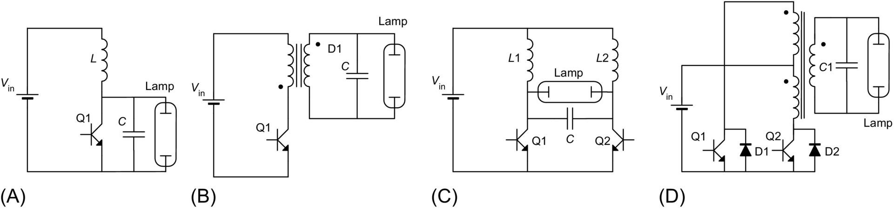

**FIG. 21.10** Nonresonant electronic ballasts.

These topologies present several drawbacks such as high-voltage spikes across the switch, which necessitates the use of high-voltage transistors, and high switching losses due to hard switching, which gives low efficiency especially for high powers. Besides, since the ideal situation is the lamp being supplied with a sine wave, these circuits produce an early aging of the lamp. To conclude, typical applications of these topologies are portable and emergency equipments, in which lamp power is low and the number of ignitions during its life is not very high. Some applications of these circuits can be found in [[9](https://learning.oreilly.com/library/view/power-electronics-handbook/9780128114087/B9780128114070000234.xhtml#bb0050)–[12](https://learning.oreilly.com/library/view/power-electronics-handbook/9780128114087/B9780128114070000234.xhtml#bb0065)].

#### **21.2.2.2 Resonant Ballasts**

These ballasts use a resonant tank circuit to supply the lamp. The resonant tank filters the high-order harmonics, thus obtaining a sine current waveform through the lamp. Resonant ballasts can be classified into two categories:

##### **Current-Fed resonant ballasts**

These ballasts are supplied with a dc current source, usually obtained by means of a choke inductor in series with the input dc voltage source. The dc current is transformed into an alternating square current waveform by switching power transistors. Typical topologies of this type of ballasts are shown in [Fig. 21.11](https://learning.oreilly.com/library/view/power-electronics-handbook/9780128114087/B9780128114070000234.xhtml#f0060).

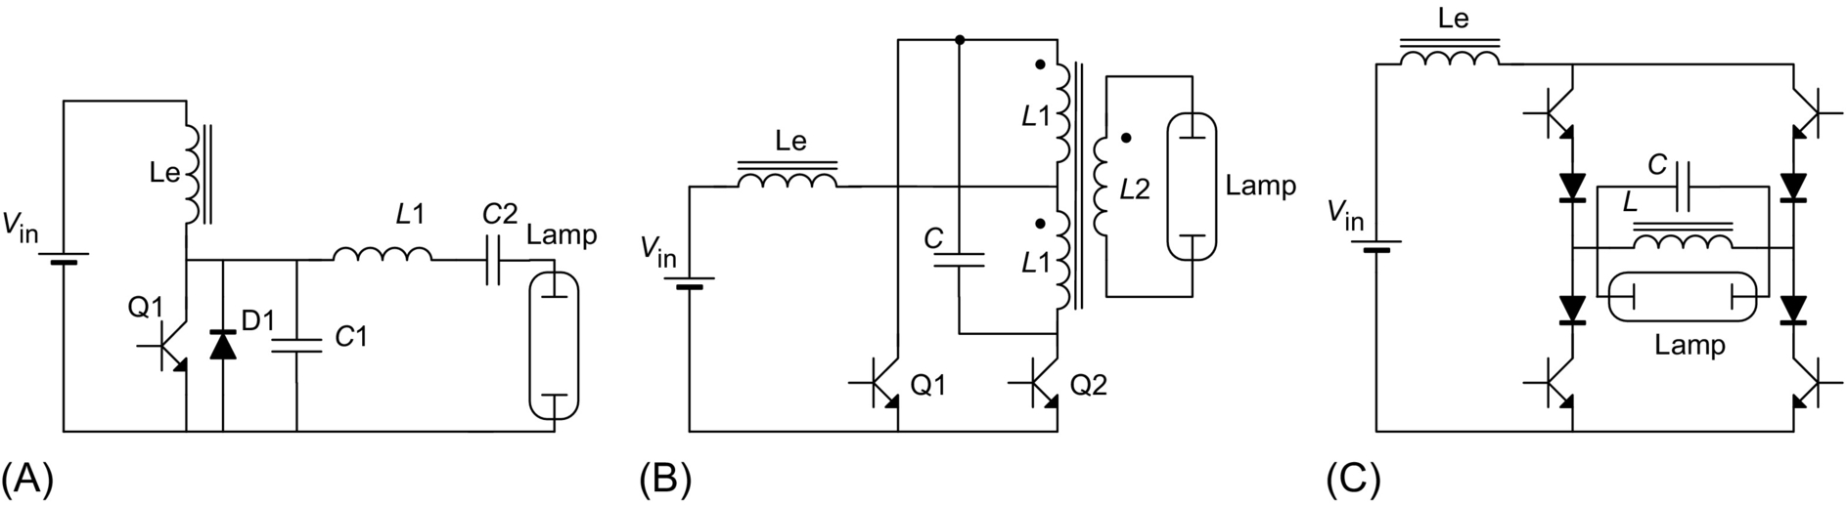

**FIG. 21.11** Three typical current-fed resonant inverters: (A) class E inverter, (B) current-fed push-pull inverter, and (C) current-fed full-bridge resonant inverter.

The topology shown in [Fig. 21.11A](https://learning.oreilly.com/library/view/power-electronics-handbook/9780128114087/B9780128114070000234.xhtml#f0060) corresponds to a class E inverter. Inductor Le is used to obtain a dc input current with low current ripple. This current supplies the resonant tank through the power switch formed by Q1-D1. The resonant tank used in this topology can vary from one ballast to another; the circuit shown in [Fig. 21.11A](https://learning.oreilly.com/library/view/power-electronics-handbook/9780128114087/B9780128114070000234.xhtml#f0060) is the one, which is normally used. The main advantage of this topology is that zero voltage switching (ZVS) can be attained in the power switch, thus reducing the switching losses and making the operation at very high frequencies, which can reach several megahertz. This allows to drastically reduce the size and weight of the ballast. However, the adjustment of the circuit parameters to obtain the optimum operation results is quite difficult, especially for mass production. Another important drawback is the high voltage stress across the switch, which can reach values of three times the dc input voltage. For these reasons, the main applications of this circuit are battery-supplied ballasts with low input voltage and low lamp power, as those used in emergency lighting and portable equipment. Typical power range of this ballast varies from 5 to 30 W. Applications of this circuit can be found in [[13](https://learning.oreilly.com/library/view/power-electronics-handbook/9780128114087/B9780128114070000234.xhtml#bb0070),[14](https://learning.oreilly.com/library/view/power-electronics-handbook/9780128114087/B9780128114070000234.xhtml#bb0075)].

Another typical topology in this group is the current-fed push-pull inverter shown in [Fig. 21.11B](https://learning.oreilly.com/library/view/power-electronics-handbook/9780128114087/B9780128114070000234.xhtml#f0060). In this circuit, a dc input current is obtained by means of choke inductor Le. Transistors are operated with a 50% duty cycle, thus providing a current square wave, which supplies the current-fed parallel resonant circuit formed by the mutual inductance of the transformer and capacitor *C*. This circuit has the advantage of being relatively easy to implement in a self-oscillating configuration, avoiding the use of extra control circuits and thereby reducing the cost. Also, ZVS can be obtained in the power switches. However, the switches also present a high voltage stress, about three times the dc input voltage, which makes this topology unsuitable for power line applications. This circuit is also normally used in battery-operated applications in a self-oscillating arrangement. The typical power range is 4–100 W. Applications based on this circuit can be found in [[15](https://learning.oreilly.com/library/view/power-electronics-handbook/9780128114087/B9780128114070000234.xhtml#bb0080),[16](https://learning.oreilly.com/library/view/power-electronics-handbook/9780128114087/B9780128114070000234.xhtml#bb0085)].

Finally, [Fig. 21.11C](https://learning.oreilly.com/library/view/power-electronics-handbook/9780128114087/B9780128114070000234.xhtml#f0060) shows a current-fed full-bridge resonant inverter, which can be used for higher power rating. Also, this circuit allows to control the output power at constant frequency by switching the devices of the same leg simultaneously, generating a quasi-square current wave through the resonant tank [[17](https://learning.oreilly.com/library/view/power-electronics-handbook/9780128114087/B9780128114070000234.xhtml#bb0090)].

##### **Voltage-fed resonant ballasts**

At present, electronic ballast manufacturers mostly use voltage-fed resonant ballasts, especially for applications supplied from the ac mains. The circuit is fed from a dc voltage source, normally obtained by line voltage rectifying. A square-wave voltage waveform is then obtained by switching the transistors with a 50% duty cycle and is used to feed a series resonant circuit. This resonant tank filters the high-order harmonics and supplies the lamp with a sine current waveform. One advantage of the voltage-fed series resonant circuit is that the starting voltage can be easily obtained without using extra ignition capacitors by operating close to resonant tank frequency. [Fig. 21.12](https://learning.oreilly.com/library/view/power-electronics-handbook/9780128114087/B9780128114070000234.xhtml#f0065) shows electric diagrams of typical voltage-fed resonant ballasts.

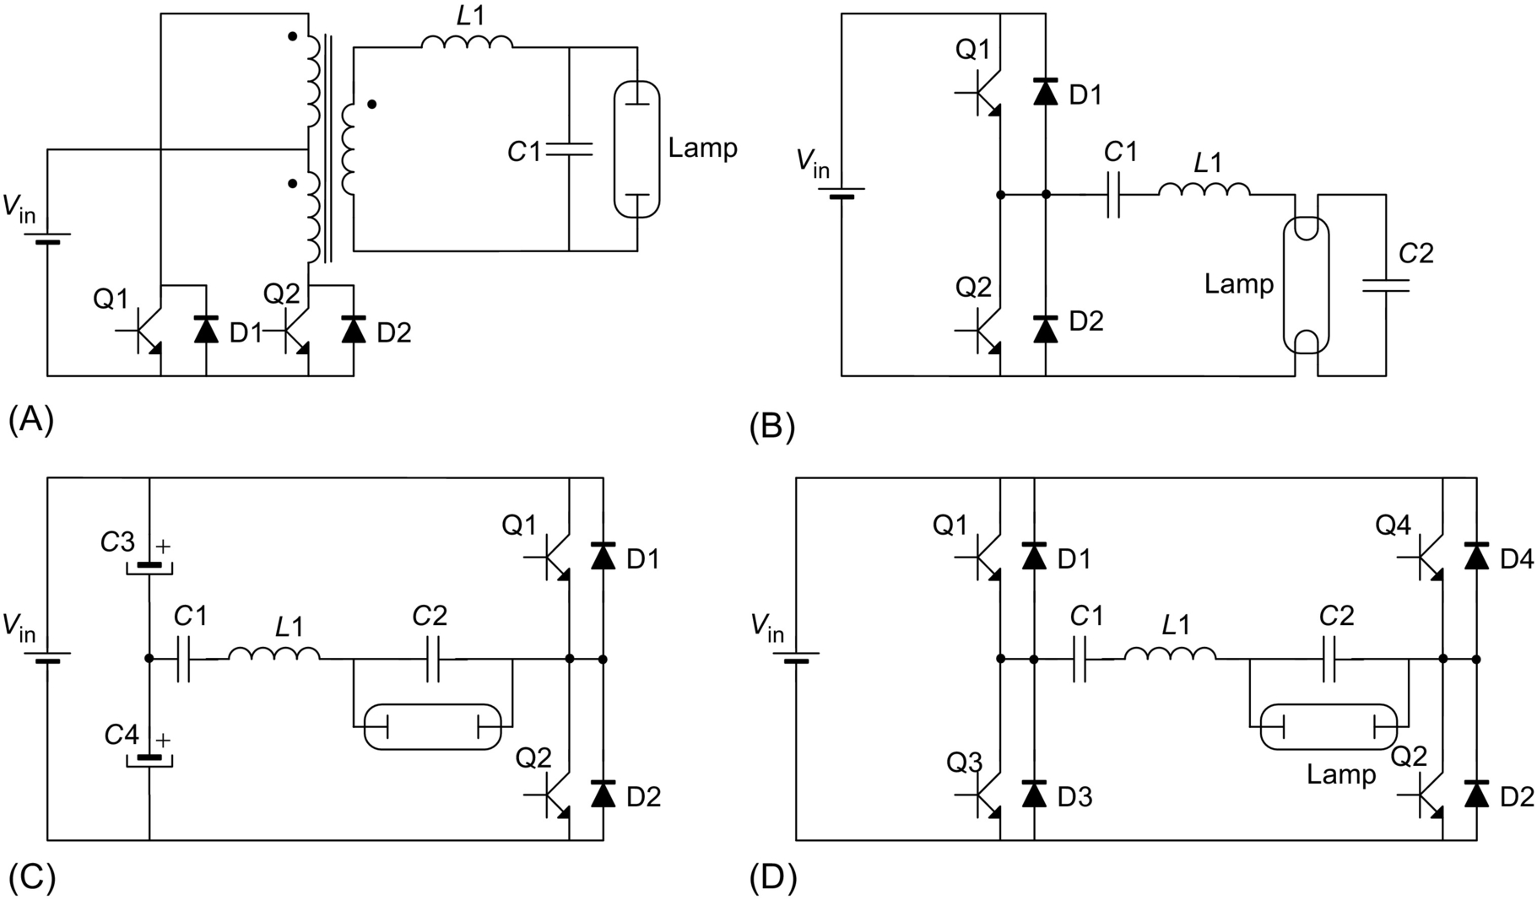

**FIG. 21.12** Typical voltage-fed resonant inverters: (A) push-pull, (B)–(C) half-bridge, and (D) full-bridge.

The voltage-fed version of the push-pull inverter is illustrated in [Fig. 21.12A](https://learning.oreilly.com/library/view/power-electronics-handbook/9780128114087/B9780128114070000234.xhtml#f0065). This inverter includes a transformer, which can be used to step up or down the input voltage in order to obtain an adequate rms value of the output square-wave voltage. This not only provides higher design flexibility but also increases the cost. One disadvantage is that the voltage across transistors is twice the input voltage, which can be quite high for line applications. Therefore, this inverter is normally used for low-voltage applications. Another important drawback of this voltage-fed inverter is that any asymmetry in the two primary windings (different number of turns) or in the switching times of power transistors would provide an undesirable dc level in the transformer magnetic flux, which in turn could saturate the core or decrease the efficiency due to the circulation of dc currents.

[Fig. 21.12B and C](https://learning.oreilly.com/library/view/power-electronics-handbook/9780128114087/B9780128114070000234.xhtml#f0065) illustrates two possible arrangements for the voltage-fed half-bridge resonant inverter. The former is normally referred as asymmetrical half bridge, and it uses one of the resonant tank capacitors (*C*1 in the figure) to block the dc voltage level of the square wave generated by the bridge. This means that capacitor *C*1 will exhibit a dc level equal to half the dc input voltage superimposed to its normal alternating voltage. A transformer can also be used in this inverter to step up or down the input voltage to the required level for each application. In this case, the use of the series capacitor *C*1 prevents any dc current from circulating through the primary winding, thus avoiding transformer saturation. This topology is widely used by ballast manufacturers to supply fluorescent lamps, especially in the self-oscillating version, which allows to drastically reduce the cost. When supplying hot-cathode fluorescent lamps, the parallel capacitor *C*2 is normally placed across two electrodes, as shown in [Fig. 21.12B](https://learning.oreilly.com/library/view/power-electronics-handbook/9780128114087/B9780128114070000234.xhtml#f0065), in order to provide a preheating current for the electrodes and achieve soft ignition. [Fig. 21.12C](https://learning.oreilly.com/library/view/power-electronics-handbook/9780128114087/B9780128114070000234.xhtml#f0065) shows another version of the half-bridge topology, using two bulk capacitors to provide a floating voltage level equal to half the input voltage. In this case, capacitor *C*1 is no longer used to block a dc voltage, thus showing lower voltage stress.

Finally, for the high power range (>200 W), the full-bridge topology shown in [Fig. 21.12D](https://learning.oreilly.com/library/view/power-electronics-handbook/9780128114087/B9780128114070000234.xhtml#f0065) is normally used. The transistors of each half bridge are operated with a 50% duty cycle, and their switching signals are phase-shifted by 180 degrees. Thus, when switches Q1 and Q2 are activated, direct voltage *V*in is applied to the resonant tank; when switches Q3 and Q4 are activated, the reverse voltage−*V*in is obtained across the resonant circuit. One of the advantages of this circuit is that the switching signals of the two branches can be phase-shifted by angles between 0 and 180 degrees, thus controlling the rms voltage applied to the resonant tank ranging from 0 to *V*in. This provides an additional parameter to control the output power at constant frequency, which is useful to implement dimming ballast.

## 21.3 Discharge Lamp Modeling

The low frequency of the mains is not an adequate power source for supplying discharge lamps. At these low frequencies, electrons and ionized atoms have enough time to recombine at each current reversal. For this reason, the discharge must be reignited twice within each line period. [Fig. 21.13A](https://learning.oreilly.com/library/view/power-electronics-handbook/9780128114087/B9780128114070000234.xhtml#f0070) illustrates the current and voltage waveforms and the *I*–*V* characteristics of a 150 W HPS lamp operated with an inductive ballast at 50 Hz. As can be seen, the reignition voltage spike is nearly 50% higher than the normal discharge voltage, which is constant during the rest of the half cycle.

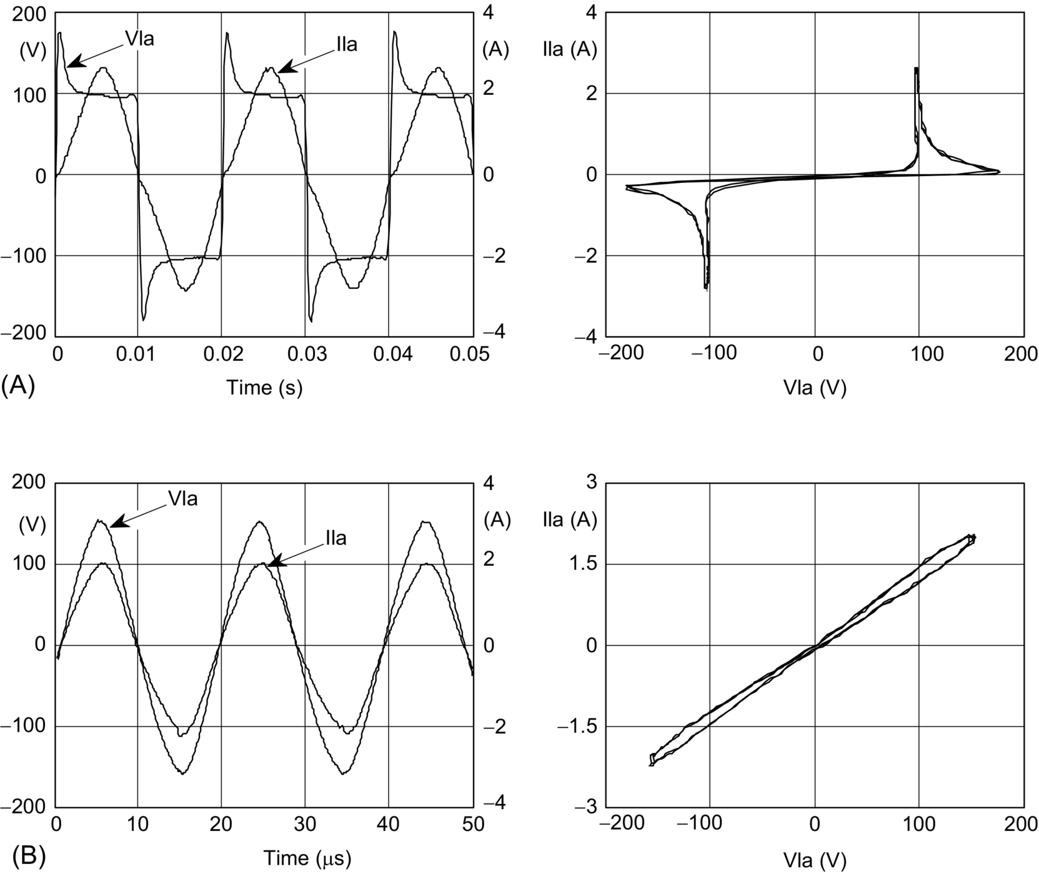

**FIG. 21.13** 150 W HPS lamp waveforms and *I*–*V* characteristics at (A) 50 Hz and (B) 50 kHz.

When lamps are operated at higher frequencies (above 5 kHz), electrons and ions do not have enough time to recombine. Therefore, charge carrier density is sufficiently high at each current reversal, and no extra power is needed to reignite the lamp. The result is an increase in the luminous flux compared with that at low frequencies, which is especially high for fluorescent lamps (10%–15%).

[Fig. 21.13B](https://learning.oreilly.com/library/view/power-electronics-handbook/9780128114087/B9780128114070000234.xhtml#f0070) shows the lamp waveforms and *I*–*V* characteristics for the same 150 W HPS lamp when supplied at 50 kHz. It also shows how the reignition voltage spikes disappear, and the lamp behavior is nearly resistive.

[Fig. 21.14](https://learning.oreilly.com/library/view/power-electronics-handbook/9780128114087/B9780128114070000234.xhtml#f0075) illustrates how the voltage waveforms change in a fluorescent lamp when increasing the supply frequency. As can be seen, at a frequency of 1 kHz, the voltage is already nearly sinusoidal, and the lamp exhibits a resistive property.

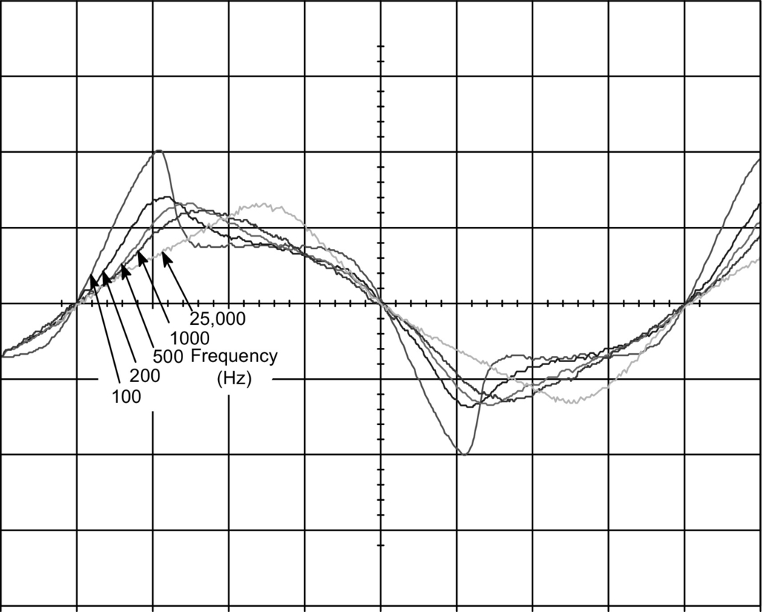

**FIG. 21.14** Voltage waveforms for a 36 W linear fluorescent lamp supplied through a resistive ballast at nominal power and different operating frequencies. Vertical scale, 100 V/DIV.

Therefore, a resistor can be used to model the lamp at high frequencies for ballast design purposes. However, most lamp manufacturers provide only lamp data for operating at low frequencies, where the lamp acts as a square-wave voltage source. [Table 21.2](https://learning.oreilly.com/library/view/power-electronics-handbook/9780128114087/B9780128114070000234.xhtml#t0015) shows the low-frequency electric data of different discharge lamps provided by the manufacturer and the measured values at high frequency for the same lamps. As can be seen, a power factor close to unity is obtained at high frequency.

**Table 21.2**

**Electric data of different discharge lamps**

|  |  |  |  |  |  |  |  |  |
| --- | --- | --- | --- | --- | --- | --- | --- | --- |
| **Lamp**[**a**](https://learning.oreilly.com/library/view/power-electronics-handbook/9780128114087/B9780128114070000234.xhtml#tf0010) | **Manufacturer at 50 Hz** | | | | **Measured at H. F.** | | | |
| ***V* (Vrms)** | ***I* (Arms)** | ***P* (W)** | **PF** | ***V* (Vrms)** | ***I* (Arms)** | ***P* (W)** | **PF** |
| Fluorescent (TLD-36 W) | 103 | 0.44 | 36 | 0.79 | 83.2 | 0.46 | 36 | 0.94 |
| Compact fluorescent (PLC-26 W) | 105 | 0.31 | 26 | 0.80 | 82 | 0.32 | 26 | 0.99 |
| Low-pressure sodium (SOX-55 W) | 109 | 0.59 | 55 | 0.86 | 75 | 0.76 | 56 | 0.98 |
| Mercury vapor (HPLN-125 W) | 125 | 1.15 | 125 | 0.87 | 132 | 0.92 | 120 | 0.99 |
| Metal halide (MHN-TD-150 W) | 90 | 1.80 | 150 | 0.93 | 92 | 1.63 | 146 | 0.97 |
| High-pressure sodium (SON-T-150 W) | 100 | 1.80 | 150 | 0.83 | 105 | 1.42 | 148 | 0.99 |

[a](https://learning.oreilly.com/library/view/power-electronics-handbook/9780128114087/B9780128114070000234.xhtml#xtf0010) Lamps aged for 100 h.

The equivalent lamp resistance at high frequencies can be easily estimated from the low-frequency data. Lamp power at any operating frequency can be expressed as follows:

 **(21.2)**

where *V*LA and *I*LA are the rms values of lamp voltage and current and *FP*LA is the lamp power factor.

At line frequencies, the lamp power factor is low (typically 0.8), due to the high distortion in the lamp voltage waveform. However, at high frequencies, the lamp power factor reaches nearly 1.0. Then, lamp voltage and current at high frequency (*V*LA,hf and *I*LA,hf) can be estimated from the following equation:

 **(21.3)**

where *P*LA is the nominal lamp power provided by the manufacturer.

As can be seen in [Table 21.2](https://learning.oreilly.com/library/view/power-electronics-handbook/9780128114087/B9780128114070000234.xhtml#t0015), fluorescent lamps tend to maintain nearly the same rms current at low and high frequency, whereas high-pressure discharge lamps tend to maintain nearly the same rms voltage. Based on these assumptions, the equivalent lamp resistance at high frequency estimated from the low frequency values is shown in [Table 21.3](https://learning.oreilly.com/library/view/power-electronics-handbook/9780128114087/B9780128114070000234.xhtml#t0020).

**Table 21.3**

**Estimated electric data of discharge lamps at high frequency**

|  |  |  |  |
| --- | --- | --- | --- |
| Lamp | *V*LA,hf | *I*LA,hf | *R*LA,hf |
| Fluorescent lamps | *P*LA/*I*LA,lf | *I*LA,lf | *P*LA/*I*LA,lf2 |
| High-pressure lamps | *V*LA,lf | *P*LA/*V*LA,lf | *V*LA,lf2/*P*LA |

Low-pressure sodium lamps maintain neither voltage nor current constant at high frequency, and they also exhibit an equivalent resistance quite dependent on the frequency. Therefore, their equivalent resistance can only be obtained by laboratory testing.

Note that the values given in [Table 21.3](https://learning.oreilly.com/library/view/power-electronics-handbook/9780128114087/B9780128114070000234.xhtml#t0020) are only an approximation to the real value, which should be obtained by measurement at the laboratory. This can be used as the first starting point in the design of the electronic ballast, but final adjustments should be made at the laboratory.

Another important issue is that the lamp equivalent resistance is strongly dependent on power delivered to the lamp, which is especially important for designing electronic ballasts with dimming feature. The characteristic lamp resistance versus lamp power is different for each discharge lamp type and must be obtained by laboratory testing. One of the best possibilities to fit the lamp resistance versus power characteristic is the hyperbolic approximation. For example, Mader and Horn propose in [[18](https://learning.oreilly.com/library/view/power-electronics-handbook/9780128114087/B9780128114070000234.xhtml#bb0095)] the following simple approximation:

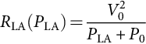 **(21.4)**

where *R*LA is the equivalent lamp resistance, *P*LA is the average lamp power, and *V*0 and *P*0 are two parameters that depend on each lamp. This characteristic has been plotted in [Fig. 21.15](https://learning.oreilly.com/library/view/power-electronics-handbook/9780128114087/B9780128114070000234.xhtml#f0080) for a particular lamp with *V*0=100 V and *P*0=1 W.

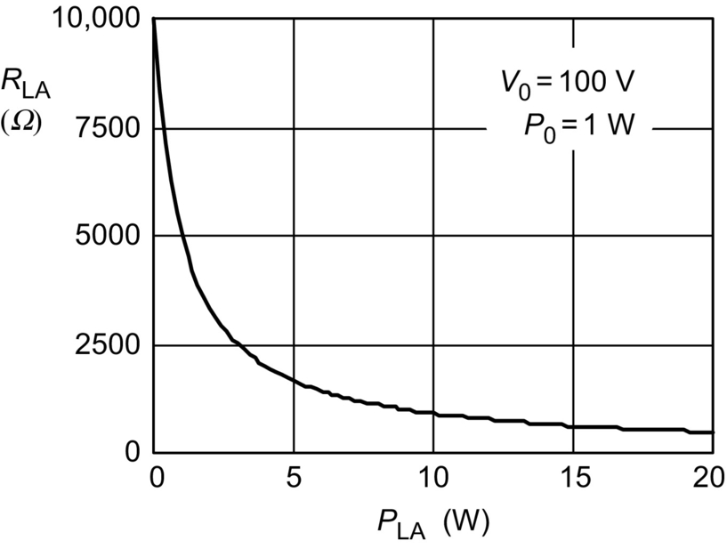

**FIG. 21.15** Lamp resistance versus lamp power characteristic.

This model can be implemented very easily in circuit simulation programs, such as SPICE-based programs. [Fig. 21.16](https://learning.oreilly.com/library/view/power-electronics-handbook/9780128114087/B9780128114070000234.xhtml#f0085) shows the electric circuit and the description used to model the characteristic of lamp in a SPICE-based simulation program. The voltage-controlled voltage source EL is used to model the resistive property of the lamp. The voltage source Vs is used to measure the lamp current, so that the instantaneous and average lamp current can be calculated; for this reason, its voltage value is equal to zero. GP is a voltage-controlled current source used to calculate the instantaneous lamp power, which is then filtered by RP and CP in order to obtain the averaged lamp power. Finally, the hyperbolic relationship between the lamp resistance and power is implemented by means of the voltage-controlled voltage source EK. The time constant *τ*=RP·CP is related to the ionization constant of the discharge.

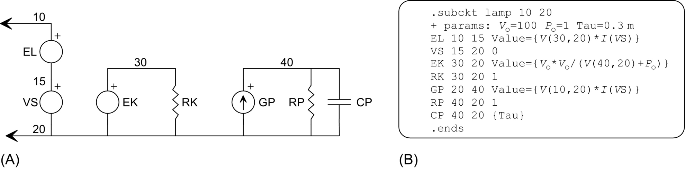

**FIG. 21.16** (A) Mader-Horn linear model for discharge lamps and (B) SPICE description of the model.

[Fig. 21.17](https://learning.oreilly.com/library/view/power-electronics-handbook/9780128114087/B9780128114070000234.xhtml#f0090) illustrates some simulation results at low frequency when the lamp is supplied from a sinusoidal voltage source and stabilized with an inductive ballast.

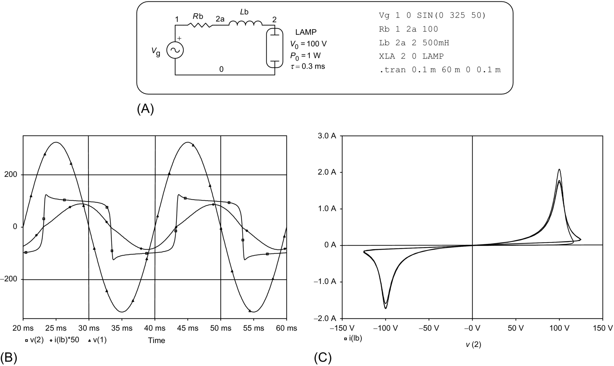

**FIG. 21.17** (A) Example of simulation with an inductive ballast at low frequency, (B) operating waveforms, and (C) lamp *I*–*V* characteristics.

The Mader-Horn model can also be used at high frequencies, which makes the lamp resistive. The equivalent lamp resistance at high frequency will also exhibit a hyperbolic variation with the averaged lamp power and with a time constant given by *τ*. This model is then useful to simulate an electronic ballast with dimming feature.

Discharge lamp modeling has become an important subject, since its results are very useful to optimize the electronic ballast performance. Some improvements on the Mader-Horn model and other interesting models can be found in the literature [[18](https://learning.oreilly.com/library/view/power-electronics-handbook/9780128114087/B9780128114070000234.xhtml#bb0095)–[20](https://learning.oreilly.com/library/view/power-electronics-handbook/9780128114087/B9780128114070000234.xhtml#bb0105)].

## 21.4 Resonant Inverters for Electronic Ballasts

Most modern domestic and industrial electronic ballasts use resonant inverters to supply discharge lamps. They can be implemented in two basic ways: current-fed resonant inverters and voltage-fed resonant inverters.

### 21.4.1 CURRENT-FED RESONANT INVERTERS

One of the most popular topologies belonging to this category is the current-fed push-pull resonant inverter, previously shown in [Fig. 21.11](https://learning.oreilly.com/library/view/power-electronics-handbook/9780128114087/B9780128114070000234.xhtml#f0060). For this reason, this inverter will be studied here to illustrate the operation of the current-fed resonant ballasts.

The current-fed push-pull inverter uses an input choke to obtain a dc input current with low current ripple. This current is alternatively conducted by the switches so that a parallel resonant tank can be supplied with a current square wave. [Fig. 21.18](https://learning.oreilly.com/library/view/power-electronics-handbook/9780128114087/B9780128114070000234.xhtml#f0095) shows the equivalent circuit and the operating waveforms of a current-fed parallel resonant inverter.

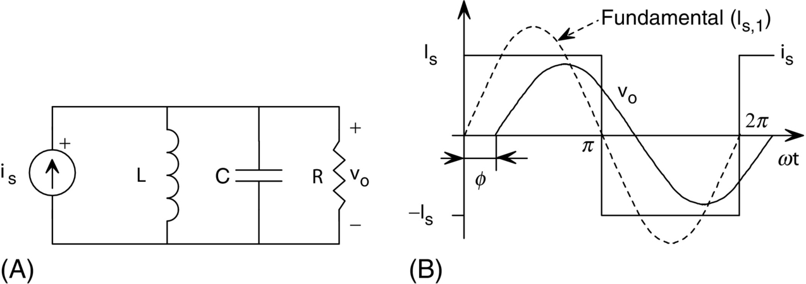

**FIG. 21.18** (A) Equivalent circuit of a current-fed parallel resonant inverter and (B) operating waveforms.

The input current can be expressed as a Fourier series in the following way:

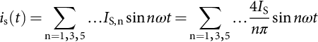 **(21.5)**

*I*S,n being the peak value of each current harmonic and *I*S the DC input current of the inverter. The output voltage for each current harmonic is obtained by multiplying the input current *I*S,n by the equivalent parallel impedance *Z*E,n, which is given below:

 **(21.6)**

Usually, normalized values are employed in order to provide more general results. Then, the output voltage can be expressed as follows:

 **(21.7)**

where *Z*B is the base impedance of the resonant tank, *Q* is the normalized load, Ω is the normalized frequency, and *ω*0 is the natural frequency of the resonant circuit, given by

 **(21.8)**

From Eq. [(21.7)](https://learning.oreilly.com/library/view/power-electronics-handbook/9780128114087/B9780128114070000234.xhtml#fo0040), the peak output voltage *V*0,n and phase angle *φ*n can be obtained for each harmonic as follows:

 **(21.9)**

**** **(21.10)**

The total harmonic distortion (THD) of the output voltage can be calculated as follows:

 **(21.11)**

Based on these equations, the analysis and design of the current-fed resonant inverter can be performed. Normally, the circuit operates close to the natural frequency *ω*0, and the effect of the high frequency harmonics can be neglected. To probe this, [Fig. 21.19A](https://learning.oreilly.com/library/view/power-electronics-handbook/9780128114087/B9780128114070000234.xhtml#f0100) obtained by plotting Eq. [(21.11)](https://learning.oreilly.com/library/view/power-electronics-handbook/9780128114087/B9780128114070000234.xhtml#fo0060) illustrates the THD of the output voltage as a function of the normalized load and frequency. As can be seen, for values of *Q* higher than 1 and for operation close to the natural frequency (Ω=1), the THD is low, which means that the output voltage is nearly a sinusoidal waveform. However, for low values of *Q*, the output voltage tends to be a square waveform, and the THD tends to the value of about 48%, corresponding to the THD of a square waveform. [Fig. 21.19B](https://learning.oreilly.com/library/view/power-electronics-handbook/9780128114087/B9780128114070000234.xhtml#f0100) illustrates the normalized output voltage for the fundamental component.



**FIG. 21.19** Characteristics of the current-fed parallel resonant inverter: (a) THD and (b) fundamental output voltage.

As stated previously, when used as lamp ballast, the current-fed parallel resonant inverter operates at the natural frequency of the resonant tank to both ignite the lamp and limit the current at normal running. Neglecting the effect of high-order harmonics, the rms output voltage is given by the fundamental component and can be obtained using Ω=1 in Eq. [(21.9)](https://learning.oreilly.com/library/view/power-electronics-handbook/9780128114087/B9780128114070000234.xhtml#fo0050) as follows:

 **(21.12)**

In a current-fed resonant inverter, the dc input current *I*S is supplied from a dc voltage source *V*in with a series choke, as stated previously. Then, the dc input current can be obtained, assuming 100% efficiency, by equaling input and output power as follows:

 **(21.13)**

And then,

 **(21.14)**

Using Eq. [(21.14)](https://learning.oreilly.com/library/view/power-electronics-handbook/9780128114087/B9780128114070000234.xhtml#fo0075) in Eq. [(21.12)](https://learning.oreilly.com/library/view/power-electronics-handbook/9780128114087/B9780128114070000234.xhtml#fo0065) and solving for the output voltage,

 **(21.15)**

As can be seen, when operating at the natural frequency, the rms output voltage is independent of the resonant tank load. The peak output voltage is equal to *πV*in/2. This value is directly related to the peak voltage stress in the switches. For a full-bridge topology, as shown in [Fig. 21.11C](https://learning.oreilly.com/library/view/power-electronics-handbook/9780128114087/B9780128114070000234.xhtml#f0060), this value is equal to the switch voltage stress. However, for the current-fed push-pull inverter, the voltage stress is twice this value, which is *πV*in, due to the presence of the transformer. This gives a very high voltage stress for the switches in this topology, which is the reason why the current-fed push-pull is mainly used to implement low-input-voltage ballasts.

On the other hand, lamp starting voltage can vary from 5 to 10 times the lamp voltage in normal discharge mode. This makes the use of the current-fed parallel resonant inverter at constant frequency to both ignite the lamp and supply it at steady state difficult, since the output voltage is independent of the resonant tank load.

One solution to this problem is to ignite the lamp at the resonant tank natural frequency and then change the frequency to decrease the output voltage and output current to the normal running values of the lamp. This solution makes the use of extra circuitry to control the frequency necessary, normally in closed loop to avoid lamp instabilities, which increase the ballast cost.

Another solution, very often used in low-cost ballasts, is to design the parallel resonant tank to ignite the lamp and limit the lamp current in discharge mode by using an additional reactive element in series with the lamp. Normally, a capacitor is used to limit the lamp current in order to minimize the cost of the ballast. This solution is used in combination with the self-oscillating technique, which assures the operation at a constant frequency equal to the natural frequency of the resonant tank. [Fig. 21.20A](https://learning.oreilly.com/library/view/power-electronics-handbook/9780128114087/B9780128114070000234.xhtml#f0105) illustrates this circuit. Normally, the effect of the series capacitor is neglected, and the resonant tank is assumed to act as a sinusoidal voltage source during both ignition and normal operation, as shown in [Fig. 21.20B](https://learning.oreilly.com/library/view/power-electronics-handbook/9780128114087/B9780128114070000234.xhtml#f0105). The high lamp starting voltage is obtained by means of a step-up transformer, which is the reason why typically a push-pull topology is used. If *V*in is the dc input voltage and *V*ig is the lamp ignition voltage, then the necessary transformer turn ratio is given by the following expression:



**FIG. 21.20** (A) Typical parallel resonant circuit used to supply discharge lamps and (B) equivalent circuit.

 **(21.16)**

The rms lamp current in discharge mode can be approximated as follows:

 **(21.17)**

where *R* is the equivalent resistance of the lamp. From Eq. [(21.17)](https://learning.oreilly.com/library/view/power-electronics-handbook/9780128114087/B9780128114070000234.xhtml#fo0090), the necessary value of the series capacitor *C*S, used to limit the lamp current to the nominal value *I*LA, can be easily obtained.

Finally, [Fig. 21.21A and B](https://learning.oreilly.com/library/view/power-electronics-handbook/9780128114087/B9780128114070000234.xhtml#f0110) illustrates a typical ballast based on a current-fed resonant inverter and its equivalent circuit, respectively.

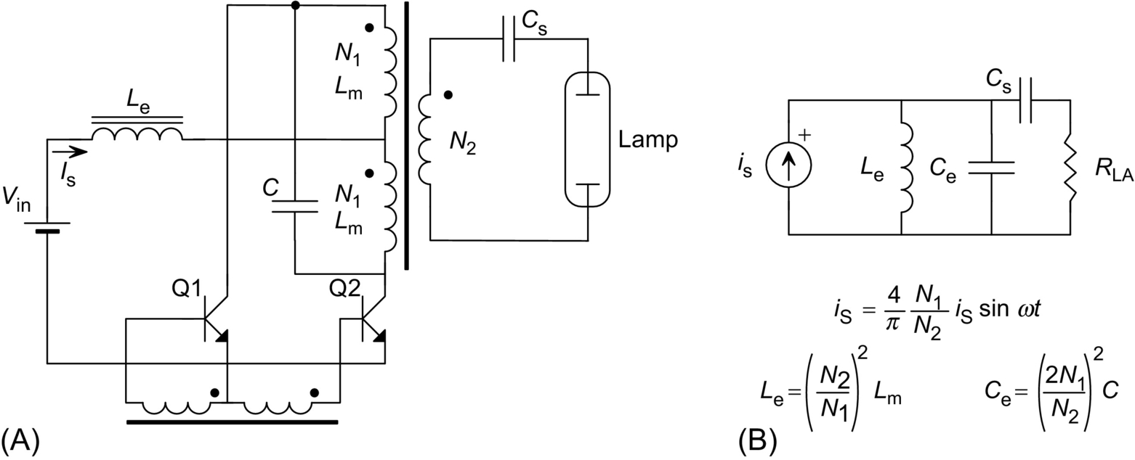

**FIG. 21.21** (A) Self-oscillating current-fed push-pull electronic ballast and (B) equivalent circuit.

### 21.4.2 VOLTAGE-FED RESONANT INVERTERS

Some voltage-fed resonant inverters used to supply discharge lamps were previously shown in [Fig. 21.12](https://learning.oreilly.com/library/view/power-electronics-handbook/9780128114087/B9780128114070000234.xhtml#f0065). Basically, they use two or more switches to generate a square voltage waveform. The different topologies are mainly given by the type of resonant tank used to filter this voltage waveform. There are three typical resonant tanks; their equivalent circuits are shown in [Fig. 21.22](https://learning.oreilly.com/library/view/power-electronics-handbook/9780128114087/B9780128114070000234.xhtml#f0115). These circuits are the series-loaded resonant tank ([Fig. 21.22A](https://learning.oreilly.com/library/view/power-electronics-handbook/9780128114087/B9780128114070000234.xhtml#f0115)), the parallel-loaded resonant tank ([Fig. 21.22B](https://learning.oreilly.com/library/view/power-electronics-handbook/9780128114087/B9780128114070000234.xhtml#f0115)), and the series-parallel-loaded resonant tank ([Fig. 21.22C](https://learning.oreilly.com/library/view/power-electronics-handbook/9780128114087/B9780128114070000234.xhtml#f0115)). The typical operating waveforms are shown in [Fig. 21.22D](https://learning.oreilly.com/library/view/power-electronics-handbook/9780128114087/B9780128114070000234.xhtml#f0115).



**FIG. 21.22** (A–C) Equivalent circuits of voltage-fed resonant inverters and (D) typical operating waveforms.

Similar to the current-fed resonant inverter, the input voltage can be expressed as a Fourier series in the following way:

 **(21.18)**

*V*S,n being the peak value of each voltage harmonic and *V*S the dc input voltage of the inverter. The same methodology as that used to analyze the current-fed resonant inverter will be used here to study the property of the three basic voltage-fed resonant inverters.

#### **21.4.2.1 Series-Loaded Resonant Circuit**

The output voltage corresponding to the *n*-order harmonic is easily obtained as follows:

 **(21.19)**

where *Q*S and Ω are the normalized load and switching frequency given by the following expressions:

 **(21.20)**

[Fig. 21.23A](https://learning.oreilly.com/library/view/power-electronics-handbook/9780128114087/B9780128114070000234.xhtml#f0120) shows the THD of the series-loaded circuit, and [Fig. 21.23B](https://learning.oreilly.com/library/view/power-electronics-handbook/9780128114087/B9780128114070000234.xhtml#f0120) shows the fundamental output voltage, which is normally considered for design purposes.



**FIG. 21.23** Characteristics of series-loaded resonant inverter: (A) THD and (B) fundamental output voltage.

In this circuit, the input and output currents are equal and can be calculated by dividing the output voltage by the load impedance. This current is also circulating through the inverter switches and therefore represents an important parameter for the design. Another important parameter is the phase angle of the input current, which defines the type of commutations in the inverter switches. For the fundamental harmonic, the phase angle of the current circulating through the resonant tank can be calculated as follows:

 **(21.21)**

At the natural frequency (*ω*0), the input voltage and current will be in phase, which means that there is no reactive energy handled by the circuit and all the input energy is transferred to the load at steady-state operation. For frequencies higher than *ω*0, the current is lagged, and some reactive energy will be handled. In this case, the inverter switches will present ZVS [[21](https://learning.oreilly.com/library/view/power-electronics-handbook/9780128114087/B9780128114070000234.xhtml#bb0110)]. For frequencies lower than *ω*0, the current is in advance, and also some reactive energy will be handled. In this case, the inverter switches will present zero current switching (ZCS).

As can be seen in [Fig. 21.23A](https://learning.oreilly.com/library/view/power-electronics-handbook/9780128114087/B9780128114070000234.xhtml#f0120), the THD is lower for the lower values of the normalized load and for frequencies close to the natural frequency of the resonant tank. For the higher values of *Q*S, the THD tends to the value corresponding to a square wave. The output voltage is always lower than the input voltage, and for frequencies around the natural frequency, the circuit acts as a voltage source, especially for the high values of *Q*S. This means that the lamp cannot be ignited and supplied in discharge mode, maintaining a constant switching frequency. This property is similar to that encountered for the current-fed resonant inverter. The use of step-up transformers is mandatory to achieve lamp ignition, especially for the low input voltages. In order to maintain the operating frequency constant, a series element will be necessary to limit the lamp current at normal discharge operation. A capacitor can also be used as expounded in the previous section. In summary, this circuit is mainly used in high input voltage and low-current applications, and it is not very frequently used to implement electronic ballasts.

#### **21.4.2.2 Parallel-Loaded Resonant Circuit**

In this circuit, the output voltage corresponding to the *n*-order harmonic is given by the following expression:

 **(21.22)**

where

 **(21.23)**

The THD and fundamental output voltage are shown in [Fig. 21.24](https://learning.oreilly.com/library/view/power-electronics-handbook/9780128114087/B9780128114070000234.xhtml#f0125). This circuit has characteristics very much useful to implement electronic ballasts than the series-loaded resonant circuit. First, the THD of the output voltage around the natural frequency is in general quite lower than that of the series circuit. For the lower values of *Q*P, the THD tends to a value of 12%, which corresponds to the THD of a triangular wave. As a result, the lamp voltage and current waveforms will be very similar to a sine wave, which is an adequate waveform to supply the lamp. Second, the frequency response of the output voltage ([Fig. 21.24B](https://learning.oreilly.com/library/view/power-electronics-handbook/9780128114087/B9780128114070000234.xhtml#f0125)) makes it possible to both ignite the lamp and limit the lamp current at steady state, maintaining a constant operating frequency. During ignition, the lamp shows a very high impedance, thus giving a high value of *Q*P. Under these conditions, the parallel circuit can generate a very high output voltage, provided that the operating frequency is close to the natural frequency. Once the lamp is ignited, the normalized load *Q*P decreases, and the circuit can limit the lamp current without changing the operating frequency. In fact, the parallel circuit operating close to the natural frequency acts as a current source for the load, as will be shown later. This is adequate to supply discharge lamps because it assures a good discharge stability, avoiding the lamp being easily extinguished by transitory power fluctuations.



**FIG. 21.24** Characteristics of parallel-loaded resonant inverter: (A) THD and (B) fundamental output voltage.

The maximum value of the voltage gain shown in [Fig. 21.24](https://learning.oreilly.com/library/view/power-electronics-handbook/9780128114087/B9780128114070000234.xhtml#f0125) can be calculated to be equal to , and it appears at a frequency . This means that a maximum is only present if *Q*P is greater than . For the higher values of *Q*P, the maximum gain can be approximated to *Q*P, and the frequency of maximum gain can be approximated to the natural frequency *ω*0.

The input current of the parallel resonant circuit is another important parameter to calculate the current handled by the inverter switches. Since the operating frequency is normally around resonance, only the fundamental component is considered. The value of this fundamental current and its phase angle can be obtained as follows:

 **(21.24)**

**** **(21.25)**

The condition for the input voltage being in phase with the input current can be obtained by equaling Eq. [(21.25)](https://learning.oreilly.com/library/view/power-electronics-handbook/9780128114087/B9780128114070000234.xhtml#fo0130) to zero. This gives a value of the normalized frequency, which is . For a frequency greater than that value, the input current will lag the input voltage, and the inverter switches will present ZVS. For frequencies lower than that value, the current will be in advance, and zero current switching is obtained. The output voltage gain at that frequency is equal to *Q*P.

Finally, it is very interesting to study the characteristic of this circuit for frequencies close to the natural frequency *ω*0 (Ω=1), since this is the normal region selected to operate for ballast applications. At this frequency, the output voltage gain is equal to *Q*P, and then, the output current will be *V*S,1/*Z*B. This means that when operated at the natural frequency, the parallel circuit acts as a current source, whose value only depends on the input voltage. At the natural frequency, the input current is equal to , and the phase angle is equal to tan−1(−1/*Q*P). The circuit is always inductive, with ZVS, and the phase angle decreases when *Q*P increases, which means that less reactive energy is handled by the circuit.

#### **21.4.2.3 Series-Parallel-Loaded Resonant Circuit**

This circuit is also very widely used to implement electronic ballasts. The fundamental output voltage is given by the following expression:

 **(21.26)**

where

 **(21.27)**

and *C*E=*C*S*C*P/(*C*S+*C*P) is the series equivalent of the two capacitors present in this resonant circuit.

The fundamental input current and its phase angle are the following:

 **(21.28)**

**** **(21.29)**

[Fig. 21.25](https://learning.oreilly.com/library/view/power-electronics-handbook/9780128114087/B9780128114070000234.xhtml#f0130) shows the characteristics corresponding to the THD of the output voltage and the fundamental output voltage for *α*=0.5. As can be seen, the THD is also very low around the natural frequency, especially for the higher values of the normalized load *Q*SP. Regarding the output voltage, this circuit acts as a parallel circuit around the natural frequency *ω*0, with a maximum gain voltage of about *Q*SP/*α*. Around the natural frequency of the series circuit given by *L* and *C*S, , the circuit acts as a series-loaded circuit with a maximum voltage gain equal to unity.



**FIG. 21.25** Characteristics of series-parallel-loaded resonant inverter: (A) THD and (B) fundamental output voltage.

The series-parallel circuit can also be used to both ignite and supply the lamp at constant frequency, since it also acts as a current source at the natural frequency. Besides, this circuit allows to limit the ignition voltage by means of the factor *α*, thus avoiding sputtering damage of lamp electrodes. Also, the series capacitor can be used to block any dc component of the inverter square output voltage, as that existing in the asymmetrical half bridge. In summary, the series-parallel circuit combines the best features of the series-loaded and the parallel-loaded; this is the reason why it is used widely to implement electronic ballasts.

When operated at frequency *ω*0, the output voltage gain is equal to *Q*SP/*α*, and then, the circuit acts as a current source equal to *V*S,1/*αZ*B, which is independent of the load. As stated previously, this current source behavior is adequate to supply discharge lamps because it allows the lamp current to be limited all the time. The input current phase angle at this frequency is equal to tan−1(−*α*/*Q*SP), and the input current always lags the input voltage, thus showing ZVS operation.

Finally, the condition to have input current in phase with the input voltage can be obtained by equaling Eq. [(21.27)](https://learning.oreilly.com/library/view/power-electronics-handbook/9780128114087/B9780128114070000234.xhtml#fo0140) to zero. This gives the following value:

 **(21.30)**

Eq. [(21.30)](https://learning.oreilly.com/library/view/power-electronics-handbook/9780128114087/B9780128114070000234.xhtml#fo0155) defines the borderline between the ZVS and the ZCS modes. The output voltage gain in this borderline can be obtained by using Eq. [(21.30)](https://learning.oreilly.com/library/view/power-electronics-handbook/9780128114087/B9780128114070000234.xhtml#fo0155) in Eq. [(21.26)](https://learning.oreilly.com/library/view/power-electronics-handbook/9780128114087/B9780128114070000234.xhtml#fo0135), and it is equal to .

### 21.4.3 DESIGN ISSUES

The design methodology of a resonant inverter for discharge lamp supply can be very different depending on the lamp type and characteristics, inverter topology, design goals, etc. Some guidelines, especially focused for supplying fluorescent lamps with voltage-fed resonant inverters, are presented in this section to illustrate the basic design methodology.

A typical starting process for a hot-cathode fluorescent lamp is shown in [Fig. 21.26](https://learning.oreilly.com/library/view/power-electronics-handbook/9780128114087/B9780128114070000234.xhtml#f0135). Initially, lamp electrodes are heated up to the emission temperature. During this phase, the inverter should assure a voltage applied to the lamp not high enough to produce sputtering damage in lamp electrodes, thus avoiding premature aging of the lamp. Once electrodes reach the emission temperature, the lamp can be ignited by applying the necessary starting voltage. Following this procedure, a soft starting is achieved, and a long lamp life is assured.



**FIG. 21.26** Typical starting process of discharge lamps.

The best method to perform this soft starting is to control the inverter switching frequency, so that the lamp voltage and current are always under control. During the heating process, the operating frequency is adjusted to a value above the natural frequency of the resonant tank. In this way, the heating current can be adjusted to the necessary value, maintaining a lamp voltage quite lower than the starting voltage. Since normally MOSFET or bipolar transistors are used, the operation over the natural frequency is preferable because they provide ZVS, and the slow parasitic diodes existing in these transistors can be used. After a short period of time, the switching frequency is reduced until the starting voltage is obtained, and then, the lamp is ignited. Normally, the final operating point at steady-state operation is adjusted to be at a switching frequency equal to the natural frequency, so that a very stable operation for the lamp is assured.

[Fig. 21.27A](https://learning.oreilly.com/library/view/power-electronics-handbook/9780128114087/B9780128114070000234.xhtml#f0140) shows a fluorescent lamp supplied using a series-parallel-loaded resonant tank. The input data for the design are normally the fundamental input voltage *V*S, the switching frequency in normal discharge operation (running) *f*S, the lamp voltage and current at high frequency *V*LA and *I*LA, the electrode heating current *I*H, the maximum lamp voltage during heating process *V*H, and the lamp starting voltage *V*IG.



**FIG. 21.27** (A) Fluorescent lamp supplied with a series-parallel circuit, (B) equivalent circuit during heating and ignition, and (C) equivalent circuit during normal discharge mode.

The equivalent circuit during the heating and ignition phase is shown in [Fig. 21.27B](https://learning.oreilly.com/library/view/power-electronics-handbook/9780128114087/B9780128114070000234.xhtml#f0140). The current circulating in this circuit is the electrode heating current, which can be calculated by using *Q*SP=∞ in Eq. [(21.24)](https://learning.oreilly.com/library/view/power-electronics-handbook/9780128114087/B9780128114070000234.xhtml#fo0125):

 **(21.31)**

where the electrode resistance has been neglected for simplicity. For a given heating current *I*H, the necessary switching frequency is obtained from Eq. [(21.31)](https://learning.oreilly.com/library/view/power-electronics-handbook/9780128114087/B9780128114070000234.xhtml#fo0160) as follows:

 **(21.32)**

Regarding the heating voltage, it can be calculated from Eq. [(21.26)](https://learning.oreilly.com/library/view/power-electronics-handbook/9780128114087/B9780128114070000234.xhtml#fo0135) using *Q*SP=∞, and the following value is obtained:

 **(21.33)**

The frequency at which the starting voltage is achieved can also be obtained using *Q*SP=∞ in Eq. [(21.26)](https://learning.oreilly.com/library/view/power-electronics-handbook/9780128114087/B9780128114070000234.xhtml#fo0135), giving the following value:

 **(21.34)**

Once the lamp is ignited, the new operation circuit is shown in [Fig. 21.27C](https://learning.oreilly.com/library/view/power-electronics-handbook/9780128114087/B9780128114070000234.xhtml#f0140). Normally, the switching frequency is selected to be very close to the natural frequency, and the circuit characteristics can be obtained by using Ω=1. Thus, as stated previously, the circuit acts as a current source of the following value:

 **(21.35)**

From this equation, the impedance *Z*B needed to provide a lamp current equal to *I*LA is easily obtained:

 **(21.36)**

Using Eqs. [(21.31)](https://learning.oreilly.com/library/view/power-electronics-handbook/9780128114087/B9780128114070000234.xhtml#fo0160)–[(21.36)](https://learning.oreilly.com/library/view/power-electronics-handbook/9780128114087/B9780128114070000234.xhtml#fo0185), the design procedure can be performed as follows:

*Step 1* Steady-state operation. Choose a value for the factor *α*; normally, a value of 0.8–0.9 will be adequate for most applications. From Eq. [(21.36)](https://learning.oreilly.com/library/view/power-electronics-handbook/9780128114087/B9780128114070000234.xhtml#fo0185), calculate the value of *Z*B for the resonant tank. Since the natural frequency is equal to the switching frequency, the reactive elements of the resonant tank can be calculated as follows:

 **(21.37)**

*Step 2* Heating phase. From Eq. [(21.32)](https://learning.oreilly.com/library/view/power-electronics-handbook/9780128114087/B9780128114070000234.xhtml#fo0165), calculate the switching frequency for a given heating current *I*H. Then, calculate the value of the heating voltage *V*H from Eq. [(21.33)](https://learning.oreilly.com/library/view/power-electronics-handbook/9780128114087/B9780128114070000234.xhtml#fo0170).

*Step 3* Check if the heating voltage is lower than the maximum value allowed to avoid electrode sputtering. If the voltage is too high, choose a lower value of *α* and repeat steps 1 and 2. Also, the maximum heating frequency can be limited to avoid excessive frequency variation. The lower the *α*, the lower is the frequency variation from heating to ignition, since the output voltage characteristics are narrower for the lower values of *α*.

The described procedure to achieve lamp soft ignition requires the use of a voltage-controlled oscillator to control the switching frequency. This can increase the cost of the ballast. A similar soft ignition can be achieved using the resonant circuit shown in [Fig. 21.28](https://learning.oreilly.com/library/view/power-electronics-handbook/9780128114087/B9780128114070000234.xhtml#f0145). This circuit is very often used in self-oscillating ballasts, where the switches are driven from the resonant current using a current transformer [[22](https://learning.oreilly.com/library/view/power-electronics-handbook/9780128114087/B9780128114070000234.xhtml#bb0115)].



**FIG. 21.28** Resonant circuit using a PTC resistor.

In the circuit shown in [Fig. 21.28](https://learning.oreilly.com/library/view/power-electronics-handbook/9780128114087/B9780128114070000234.xhtml#f0145), the PTC is initially cold, and capacitor *C*P1 is practically short-circuited by the PTC. The resonant tank under these conditions is formed by *L*-*C*S-*C*P2, which can be designed to heat the lamp electrodes with a heating voltage low enough to avoid lamp cold ignition. Since the PTC is also heated by the circulating current, after a certain period of time, it reaches the threshold temperature and trips. At this moment, the new resonant tank is formed by *L*, *C*S, and the series equivalent of *C*P1 and *C*P2. This circuit can be designed to generate the necessary ignition voltage and to supply the lamp in normal discharge mode. Once the lamp is ignited, the PTC maintains its high impedance since the dominant parallel capacitor in this phase is *C*P1 (usually *C*P1≪*C*P2).

## 21.5 High-Power Factor Electronic Ballasts

As commented in a previous section, when electronic ballasts are supplied from the ac line, an ac-dc stage is necessary to provide the dc input voltage of the resonant inverter (see [Fig. 21.9](https://learning.oreilly.com/library/view/power-electronics-handbook/9780128114087/B9780128114070000234.xhtml#f0050)). Since the introduction of harmonic regulations, as IEC 1000-3-2, the use of a full-bridge diode rectifier followed by a filter capacitor is no longer applicable for this stage due to the high harmonic content of the input current. Therefore, the use of an ac-dc stage showing a high input power factor (PF) and a low total harmonic distortion (THD) of the input current is mandatory. The inclusion of this stage can significantly increase the cost of the complete ballast, and therefore, the search for low-cost high-power-factor electronic ballasts is presently an important field of research.

[Fig. 21.29A](https://learning.oreilly.com/library/view/power-electronics-handbook/9780128114087/B9780128114070000234.xhtml#f0150) shows a first possibility to increase the input power factor of the ballast by removing the filter capacitor across the diode rectifier. However, since there are no low-frequency storage elements inside the resonant inverter, the output power instantaneously follows the input power, thus producing an annoying light flicker. Besides, the resulting lamp current crest factor is very high, which considerably decreases lamp life.



**FIG. 21.29** High-power-factor ballasts.

In order to avoid flicker and increase lamp current crest factor, continuous power must be delivered to the lamp. This can only be accomplished by using a PFC stage with a low-frequency storage element. This solution is shown in [Fig. 21.29B](https://learning.oreilly.com/library/view/power-electronics-handbook/9780128114087/B9780128114070000234.xhtml#f0150), where capacitor *C*0 is used as energy storage element. The main drawback of this solution is that the input power is handled by the two stages, which reduces the efficiency of the complete electronic ballast.

### 21.5.1 HARMONIC LIMITING STANDARDS

The standards IEC 1000-3-2 and EN 61000-3-2 [[23](https://learning.oreilly.com/library/view/power-electronics-handbook/9780128114087/B9780128114070000234.xhtml#bb0120)] are the most popular regulations regarding the harmonic pollution produced by electronic equipment connected to the mains. These standards are a new version of the previous IEC 555-2 regulation, and they are applicable to the equipment with less than 16 A/phase and supplied from low voltage lines of 220/380 V, 230/400 V, and 240/415 V at 50 or 60 Hz. Limits for equipment supplied from voltages lower than 220 V have not yet been established.

This regulation divides the electric equipment in several classes from class A to class D. Class C is especially for lighting equipment, including dimming devices; the harmonic limits for this class are shown in [Table 21.4](https://learning.oreilly.com/library/view/power-electronics-handbook/9780128114087/B9780128114070000234.xhtml#t0025). As shown in [Table 21.4](https://learning.oreilly.com/library/view/power-electronics-handbook/9780128114087/B9780128114070000234.xhtml#t0025), this regulation establishes a maximum amplitude for each input harmonic as a percentage of the fundamental harmonic component. The harmonic content established in [Table 21.4](https://learning.oreilly.com/library/view/power-electronics-handbook/9780128114087/B9780128114070000234.xhtml#t0025) is quite restrictive, which means that the input current wave must be quite similar to a pure sine wave. For example, for a typical input power factor equal to 0.9, the THD calculated from [Table 21.1](https://learning.oreilly.com/library/view/power-electronics-handbook/9780128114087/B9780128114070000234.xhtml#t0010) is only 32%.

**Table 21.4**

**IEC 1000-3-2. Harmonic limits for class C equipment**

|  |  |
| --- | --- |
| **Harmonic order *n*** | **Maximum permissible harmonic current expressed as a percentage of the input current at the fundamental frequency (%)** |
| 2 | 2 |
| 3 | 30*λ*[a](https://learning.oreilly.com/library/view/power-electronics-handbook/9780128114087/B9780128114070000234.xhtml#tf0015) |
| 5 | 10 |
| 7 | 7 |
| 9 | 5 |
| 11≤*n*≤39 | 3 |
| (odd harmonics only) |  |

[a](https://learning.oreilly.com/library/view/power-electronics-handbook/9780128114087/B9780128114070000234.xhtml#xtf0015) *λ* is the circuit power factor.

### 21.5.2 PASSIVE SOLUTIONS

A first possibility to increase the ballast power factor and to decrease the harmonic content of the input current is the use of passive solutions. [Fig. 21.30](https://learning.oreilly.com/library/view/power-electronics-handbook/9780128114087/B9780128114070000234.xhtml#f0155) shows two typical passive solutions, which can be used to improve the input power factor of electronic ballasts.



**FIG. 21.30** Passive circuits to improve input power factor: (A) LC filter and (B) tuned LC filter.

[Fig. 21.30A](https://learning.oreilly.com/library/view/power-electronics-handbook/9780128114087/B9780128114070000234.xhtml#f0155) shows the most common passive solution based on a filter inductor *L*. Using a large inductance *L*, a square input current can be obtained, with an input power factor of 0.9 and a THD of about 48%. However, a square input waveform does not satisfy the IEC 1000-3-2 requirements, and then, it is not a suitable solution. The addition of capacitor *C* across the ac terminals can increase the power factor up to 0.95, but still, the standard requirements are difficult to fulfill.

A simple variation of this circuit is shown in [Fig. 21.30B](https://learning.oreilly.com/library/view/power-electronics-handbook/9780128114087/B9780128114070000234.xhtml#f0155), where a parallel circuit tuned to the third harmonic of the line frequency is used to improve the shape of the line current. The input power factor obtained with this circuit can be close to unity.

A third possible solution, known as valley-fill circuit, is shown in [Fig. 21.31A](https://learning.oreilly.com/library/view/power-electronics-handbook/9780128114087/B9780128114070000234.xhtml#f0160). The typical filter capacitor following the diode rectifier is split into two different capacitors that are alternately charged using three extra diodes. The addition of a small series resistor improves the power factor by about two points, maintaining a low cost for the circuit. An inductor in place of the resistor can also be used to improve the power factor but with a higher cost penalty. [Fig. 21.31B](https://learning.oreilly.com/library/view/power-electronics-handbook/9780128114087/B9780128114070000234.xhtml#f0160) shows the output voltage and input current of the valley-fill circuit. The main disadvantage of this circuit is the high ripple of the output voltage, which produces lamp power and luminous flux fluctuation and high lamp current crest factor.



**FIG. 21.31** Valley-fill circuit: (A) electric diagram and (B) waveforms.

Passive solutions are reliable, rugged, and cheap. However, the size and weight of these solutions are high, and their design to fulfill the IEC 1000-3-2 requirements is usually difficult. Therefore, they are normally applied in the lower power range.

### 21.5.3 ACTIVE SOLUTIONS

Active circuits are the most popular solutions to implement high-power-factor electronic ballasts. They use controlled switches to correct the input power factor and in some cases to include galvanic isolation via high-frequency transformers. Active circuits normally used in electronic ballasts operate at a switching frequency well above the line frequency and over the audible range.

Some typical active circuits used in electronic ballasts are shown in [Fig. 21.32](https://learning.oreilly.com/library/view/power-electronics-handbook/9780128114087/B9780128114070000234.xhtml#f0165). Buck-boost and flyback converters shown in [Fig. 21.32A and B](https://learning.oreilly.com/library/view/power-electronics-handbook/9780128114087/B9780128114070000234.xhtml#f0165), respectively, can be operated in discontinuous conduction mode (DCM) with constant frequency and constant duty cycle in order to obtain an input power factor close to unity [[24](https://learning.oreilly.com/library/view/power-electronics-handbook/9780128114087/B9780128114070000234.xhtml#bb0125)].



**FIG. 21.32** Power factor correction circuits for ballasts: (A) buck-boost, (B) flyback, and (C) boost.

[Fig. 21.32C](https://learning.oreilly.com/library/view/power-electronics-handbook/9780128114087/B9780128114070000234.xhtml#f0165) shows the boost converter, which is one of the most popular active circuits used to correct the input power factor of electronic ballasts [[25](https://learning.oreilly.com/library/view/power-electronics-handbook/9780128114087/B9780128114070000234.xhtml#bb0130)–[27](https://learning.oreilly.com/library/view/power-electronics-handbook/9780128114087/B9780128114070000234.xhtml#bb0140)]. If the boost converter is operated in DCM, an input power factor close to unity is obtained, provided that the output voltage is about twice the peak input voltage [[25](https://learning.oreilly.com/library/view/power-electronics-handbook/9780128114087/B9780128114070000234.xhtml#bb0130)]. The main disadvantage of DCM operation, when compared with the CCM mode, is the high distortion of the input current (due to the discontinuous high-frequency current) and the higher current and voltage stresses in the switches. Therefore, the DCM operation is only used for the lower power range.

For the medium power range, the operation of the boost converter at the DCM-CCM borderline is preferred. In this solution, the on time of the controlled switch is maintained constant within the whole line period, and the switching frequency is adjusted to allow the input current to reach zero at the end of the switching period. The typical control circuit used and the input current waveform are shown in [Fig. 21.33A and B](https://learning.oreilly.com/library/view/power-electronics-handbook/9780128114087/B9780128114070000234.xhtml#f0170), respectively. The inductor current is sensed using a resistor in series with the switch, and the peak inductor current is programmed to follow a sine wave using a multiplier. A comparator is employed to detect the zero crossing of the inductor current in order to activate the switch. Most IC manufacturers provide a commercial version of this circuit to be used for electronic ballast applications.



**FIG. 21.33** (A) Boost power factor corrector with borderline control and (B) input current waveform.

The boost circuit operating with borderline control provides a continuous input current, which is easier to filter. Besides, it presents low switch turn-on losses and low recovery losses in the output diode. The main disadvantages are the variable switching frequency and the high output voltage, which must be higher than the peak line voltage.

For the higher power range, the boost converter can be operated in continuous conduction mode (CCM) to correct the input power factor. The input current in this scheme is continuous with very low distortion and easy to filter. The current stress in the switch is also lower, which means that more power can be handled maintaining a good efficiency. The normal efficiency obtained with a boost circuit operating either in the DCM-CCM borderline or in CCM can be as high as 95%.

## 21.6 Applications

Electronic ballasts are widely used in lighting applications, such as portable lighting, emergency lighting, automotive applications, home lighting, and industrial lighting. They provide low volume and size, making it possible to reduce the luminaire size as well, which is a very interesting new trend in lighting design.

### 21.6.1 PORTABLE LIGHTING

In this application, a battery is used as power source, and then, a low input voltage is available to supply the lamp. Examples are hand lanterns and backlightings for laptop computers. Typical input voltages in these applications range from 1.5 to 48 V. Therefore, a step-up converter is necessary to supply the discharge lamp, and then, electronic ballasts are the only suitable solution. Since the converter is supplied from a battery, the efficiency of the ballast should be as high as possible in order to optimize the use of the battery energy, thus increasing the operation time of the portable lighting. Typical topologies used are the class E inverter and the push-pull resonant inverter, obtaining efficiencies up to 95%.

### 21.6.2 EMERGENCY LIGHTING

Emergency lightings are used to provide a minimum lighting level in case of a main supply cutoff. Batteries are employed to store energy from the mains and to supply the lamp in case of a main supply failure. A typical block diagram is shown in [Fig. 21.34](https://learning.oreilly.com/library/view/power-electronics-handbook/9780128114087/B9780128114070000234.xhtml#f0175). An ac-dc converter is used as a battery charger to store energy during normal line operation. A control circuit continuously measures the line voltage and activates the inverter in case of a main supply failure. Normally, a minimum operating time of 1 h is required for the system in emergency state. Thus, the use of highly efficient electronic ballasts is mandatory to reduce the battery size and cost. Typical topologies used include class E inverters, push-pull resonant inverters, and half-bridge resonant inverters. Fluorescent lamps are mainly used in emergency ballasts, but high-intensity discharge lamps, such as metal halide lamps or high-pressure sodium lamps, are also used in some special applications.



**FIG. 21.34** Block diagram of an emergency lighting.

### 21.6.3 AUTOMOTIVE LIGHTING

Electronic ballasts are used in automotive applications such as automobiles, buses, trains, and aircrafts. Normally, a low-voltage dc bus is available to supply the lamps. These applications are similar to portable and emergency lightings previously commented. In modern aircrafts, a 120/208 V, 400 Hz, three-phase electric system is also available and can be employed for lighting. Fluorescent lamps are typically used for automotive indoor lighting, whereas high-intensity discharge lamps are preferred in the exterior lighting, for example, in automobile headlights.

### 21.6.4 HOME AND INDUSTRIAL LIGHTING

Electronic ballasts, especially for fluorescent lamps, are also very often used in home and industrial applications. The higher efficiency of fluorescent lamps supplied at high frequency provides an interesting energy saving when compared with incandescent lamps. A typical application is the use of compact fluorescent lamps with the electronic ballast inside the lamp base, which can directly substitute an incandescent lamp reducing the energy consumption four or five times. A self-oscillating half-bridge inverter is typically used in these energy saving lamps, since it allows to reduce the size and cost. The power of these lamps is normally below 25 W.

Other applications for higher power include more developed ballasts based on a power factor correction stage followed by a resonant inverter. Hot-cathode fluorescent lamps are mostly used in these electronic ballasts. Also, with the development of modern HID lamps such as metal halide lamps and very-high-pressure sodium lamps (both showing very good color rendition), the use of HID lamps is being more and more frequent in home, commercial, and industrial lighting.

### 21.6.5 MICROPROCESSOR-BASED LIGHTING

The use of microprocessors in combination with electronic ballasts is very interesting from the point of view of energy saving [[28](https://learning.oreilly.com/library/view/power-electronics-handbook/9780128114087/B9780128114070000234.xhtml#bb0145)–[30](https://learning.oreilly.com/library/view/power-electronics-handbook/9780128114087/B9780128114070000234.xhtml#bb0155)]. The inclusion of microprocessor circuits allows to incorporate control strategies for dimming, such as scheduling, task tuning, and daylighting [[31](https://learning.oreilly.com/library/view/power-electronics-handbook/9780128114087/B9780128114070000234.xhtml#bb0160)]. Using these strategies, the achieved energy saving can be as high as 35%–40%. Another advantage of using microprocessors is the possibility of detecting lamp failure or bad operation, thus increasing the reliability and decreasing the maintenance cost of the installation. Most advanced electronic ballasts can include a communication stage to send and receive information regarding the state of the lighting to or from a central control unit. In some cases, communications can be performed via power line, thus reducing the installation costs. [Fig. 21.35](https://learning.oreilly.com/library/view/power-electronics-handbook/9780128114087/B9780128114070000234.xhtml#f0180) shows the block diagram of a microprocessor-based electronic ballast.



**FIG. 21.35** Block diagram of a microprocessor-based lighting.

## References

[1] Wyszecki G., Stiles W.S. *Color Science: Concepts and Methods, Quantitative Data and Formulae.* Second Edition: John Wiley & Sons; 1982.

[2] Borton J.A., Daley K.A. A comparison of light sources for the petrochemical industry. *IEEE Ind. Appl. Mag.* 1997;54–62.

[3] Chr. Meyer, H. Nienhuis, Discharge Lamps. Philips Technical Library, 1988.

[4] Illuminating Engineering Society of North America. *IES Lighting Handbook, 1984 Reference Volume.* New York: IESNA; 1984.

[5] Alling W.R. Important design parameters for solid-state ballasts. *IEEE Trans. Ind. Appl.* 1989;25(2):203–207.

[6] De Groot J., Van Vliet J. *The High-Pressure Sodium Lamp.* Philips Technical Library, Macmillan Education; 1986.

[7] Koshimura Y., Aoike N., Nomura O. *Stable high frequency operation of high intensity discharge lamps and their ballast design.* In: Proc. CIE 20th Session'83; 1983 E36/1–E36/2.

[8] Laskai L., Enjeti P.N., Pitel I.J. White-noise modulation of high-frequency high-intensity discharge lamp ballasts. *IEEE Trans. Ind. Appl.* 1998;34(3):597–605.

[9] Simoes A.S., Silva M.M., Anunciada A.V. A boost-type converter for DC-supply of fluorescent lamps. *IEEE Trans. Ind. Electron.* 1994;41(2):251–255.

[10] Vasiljevic D.M. The design of a battery-operated fluorescent lamp. *IEEE Trans. Ind. Electron.* 1989;36(4):499–503.

[11] Hernando M., Blanco C., Alonso J.M., Rico M. *Fluorescent lamps supplied with dc current and controlled in current mode.* In: Proceedings of European Power Electronics Conference (EPE), Firenze; 1991:1/499–1/503.

[12] Corominas E.L., Alonso J.M., Calleja A.J., Ribas J., Rico M. *Analysis of tapped-inductor inverters as low-power fluorescent lamp ballast supplied from a very low input voltage.* In: PESC Conference Record; 1999:1103–1108.

[13] Duarte J.L., Wijntjens J., Rozenboom J. *Getting more from fluorescent lamps through resonant converters.* In: Proceedings of IECON, San Diego; 1992.

[14] Ponce M., Arau J., Alonso J.M., Rico-Secades M. *Electronic ballast based on class E amplifier with a capacitive inverter and dimming for photovoltaic applications.* In: Proceedings of APEC; 1998:1156–1162.

[15] Gulko M., Ben-Yaakov S. Current-sourcing push-pull parallel-resonance inverter (CS-PPRI): theory and application as a discharge lamp driver. *IEEE Trans. Ind. Electron.* 1994;41(3):285–291.

[16] Lin M.-S., Ho W.-J., Shih F.-Y., Chen D.-Y., Wu Y.-P. A cold-cathode fluorescent lamp driver circuit with synchronous primaryside dimming control. *IEEE Trans. Ind. Electron.* 1998;45(2):249–255.

[17] Rashid M.H. *Power Electronics. Circuits, Devices, and Applications.* second ed. New Jersey: Prentice Hall; 1993.

[18] Mader U., Horn P. *A dynamic model for the electrical characteristics of fluorescent lamps.* In: IEEE Industry Applications Society Meeting Conference; 1992:1928–1934 Records.

[19] Sun M., Hesterman B.L. Pspice high-frequency dynamic fluorescent lamp model. *IEEE Trans. Power Electron.* 1998;13(2):261–272.

[20] Tseng K.J., Wang Y., Vilathgamuwa D.M. An experimentally verified hybrid Cassie-Mayr electric arc model for power electronics simulations. *IEEE Trans. Power Electron.* 1997;12(3):429–436.

[21] Alonso J.M., Blanco C., López E., Calleja A.J., Rico M. Analysis, design and optimization of the LCC resonant inverter as a high-intensity discharge lamp ballast. *IEEE Trans. Power Electron.* 1998;13(3):573–585.

[22] Electronics Ballasts for Fluorescent Lamps Using BUL770/791 Transistors. Application Report, Texas Instruments, 1992.

[23] IEC 1000-3-2 (1995-03) standards on electromagnetic compatibility (EMC), Part 3, Section 2: Limits for harmonic current emissions. International Electrotechnical Commission, Switzerland: Geneva, April 1995.

[24] Alonso J.M., Calleja A.J., López E., Ribas J., Rico M. A novel single-stage constant-wattage high-power-factor electronic ballast. *IEEE Trans. Ind. Electron.* 1999;46(6):1148–1158.

[25] Liu K.-H., Lin Y.-L. *Current waveform distortion in power factor correction circuits employing discontinuous-mode boost converters.* In: Power Electronics Specialists Conference proceedings; 1989:825–829.

[26] Lai J.S., Chen D. *Design consideration for power factor correction boost converter operating at the boundary of continuous conduction mode and discontinuous conduction mode.* In: Applied Power Electronics Conference Proceedings; 1993:267–273.

[27] Blanco C., Alonso J.M., López E., Calleja A.J., Rico M. *A single-stage fluorescent lamp ballast with high power factor.* In: IEEE APEC'96 proceedings; 1996:616–621.

[28] Alling W.R. The integration of microcomputers and controllable output ballasts—a new dimension in lighting control. *IEEE Trans. Ind. Appl.* 1984;1198–1205.

[29] Alonso J.M., Díaz J., Blanco C., Rico M. A microcontroller-based emergency ballast for fluorescent lamps. *IEEE Trans. Ind. Electron.* 1997;44(2):207–216.

[30] Alonso J.M., Ribas J., Calleja A.J., López E., Rico M. *An intelligent neuron-chip-based fluorescent lamp ballast for indoor applications.* In: Conference Proceedings of the IEEE Industry Applications Society Annual Meeting (IAS'97), New Orleans, Louisiana; 1997:2388–2394.

[31] Illuminating Engineering Society of North America. *IES Lighting Handbook, 1984 Application Volume.* New York: IESNA; 1987.

**22**

# Wireless Power Transfer

Mohammad Etemadrezaei North Carolina State University, Raleigh, NC, United States

## Abstract

This chapter covers different methods of wireless power transfer (WPT) with the main focus on weakly coupled inductive WPT systems. Such systems are increasingly getting popular due to the advantages they bring compared with wired power transfer. A typical two-coil inductive WPT system is analyzed, and the system parameters such as magnetic link efficiency are derived. Various WPT resonance topologies for both primary (transmitter) and secondary (receiver) coils are reviewed. Main elements of the system including high-frequency (MHz region) inverters such as class-D and class-E are explained. The WPT systems with multiple coils in primary, secondary, or in between them are covered. And the effects of coil size, shape, and alignment on the link efficiency are studied. The chapter concludes by exploring various coil components such as winding type, ferrite pad, and metal shielding plate for high-frequency and high-quality-factor coils.

### KEYWORDS

Wireless power transfer (WPT); Inductive power transfer (IPT); Resonance; Magnetic link efficiency; Weakly coupled systems; Loosely coupled systems; Quality factor; Coupling factor; Misalignment; Class-D and class-E inverters

22.1 [Introduction](https://learning.oreilly.com/library/view/power-electronics-handbook/9780128114087/B9780128114070000246.xhtml#s0010)

22.2 [Methods of Wireless Power Transfer](https://learning.oreilly.com/library/view/power-electronics-handbook/9780128114087/B9780128114070000246.xhtml#s0015)

22.3 [Inductive WPT System Applications](https://learning.oreilly.com/library/view/power-electronics-handbook/9780128114087/B9780128114070000246.xhtml#s0020)

22.4 [Resonant Inductive WPT System Design](https://learning.oreilly.com/library/view/power-electronics-handbook/9780128114087/B9780128114070000246.xhtml#s0025)

22.4.1 System Components

22.4.2 Operating Field Region

22.4.3 Efficiency Equations

22.5 [WPT Systems With Multiple Coils](https://learning.oreilly.com/library/view/power-electronics-handbook/9780128114087/B9780128114070000246.xhtml#s0045)

22.5.1 Single Transmitter and Receiver With Multiple Coils in Between

22.5.2 Multiple Transmitters and Single Receiver

22.5.3 Single Transmitter and Multiple Receivers

22.6 [A Glance Into WPT Power Source Converter](https://learning.oreilly.com/library/view/power-electronics-handbook/9780128114087/B9780128114070000246.xhtml#s0065)

22.6.1 Class-D Inverter

22.6.2 Class-E Inverter

22.7 [Efficient Magnetic Link Design](https://learning.oreilly.com/library/view/power-electronics-handbook/9780128114087/B9780128114070000246.xhtml#s0080)

22.7.1 Effect of Link Dimension

22.7.2 Effect of Coil Shape and Alignment

22.7.3 Effect of Ferrite Core

22.7.4 Effect of Coil Winding

22.8 [Summary](https://learning.oreilly.com/library/view/power-electronics-handbook/9780128114087/B9780128114070000246.xhtml#s0105)

[References](https://learning.oreilly.com/library/view/power-electronics-handbook/9780128114087/B9780128114070000246.xhtml#bi0010)

## 22.1 Introduction

Wireless power transfer (WPT), in its general term, has been around us for decades in applications such as telemetry, satellite communications, and radio frequency identification (RFID) tags. Most of these applications transfer low amounts of power, in the range of microwatts to milliwatts, for data transfer. For higher-power applications, from few watts to several kilowatts, over moderate distances, the WPT has recently been the focus of the industrial developments. The most common method of high power WPT is through inductive coupling that was invented by Nikola Tesla more than a century ago. The recent developments in semiconductor industry for high frequency and high-power applications have paved the path for high-power inductive WPT improvements. Inductive WPT offers several benefits over the wired connection and is applied in numerous applications such as wearable electronics, health care, and automotive industry. This chapter starts by reviewing various methods of WPT, followed by the design and analysis of inductive WPT. The overall inductive WPT is studied step by step and component by component; therefore, it is recommended to refer to the references for detailed analysis and information.

## 22.2 Methods of Wireless Power Transfer

There are different methods to wirelessly transfer power between a source and a receiver. Each method has its own characteristics that are useful for certain applications. Here, the most common methods of wireless power transfer are briefly discussed.

*Radio frequency waves.* Radio frequency (RF) is the most common way of transmitting data as the waves can propagate through vacuum ([Fig. 22.1A](https://learning.oreilly.com/library/view/power-electronics-handbook/9780128114087/B9780128114070000246.xhtml#f0010)). RF waves can also be used to transmit power such as in microwave oven and in RF heater and welding machines. The operating principle of RF transmitting and receiving antennas is based on the interaction of electric and magnetic inductions determined by the full set of Maxwell's equations [[1](https://learning.oreilly.com/library/view/power-electronics-handbook/9780128114087/B9780128114070000246.xhtml#bb0010)].

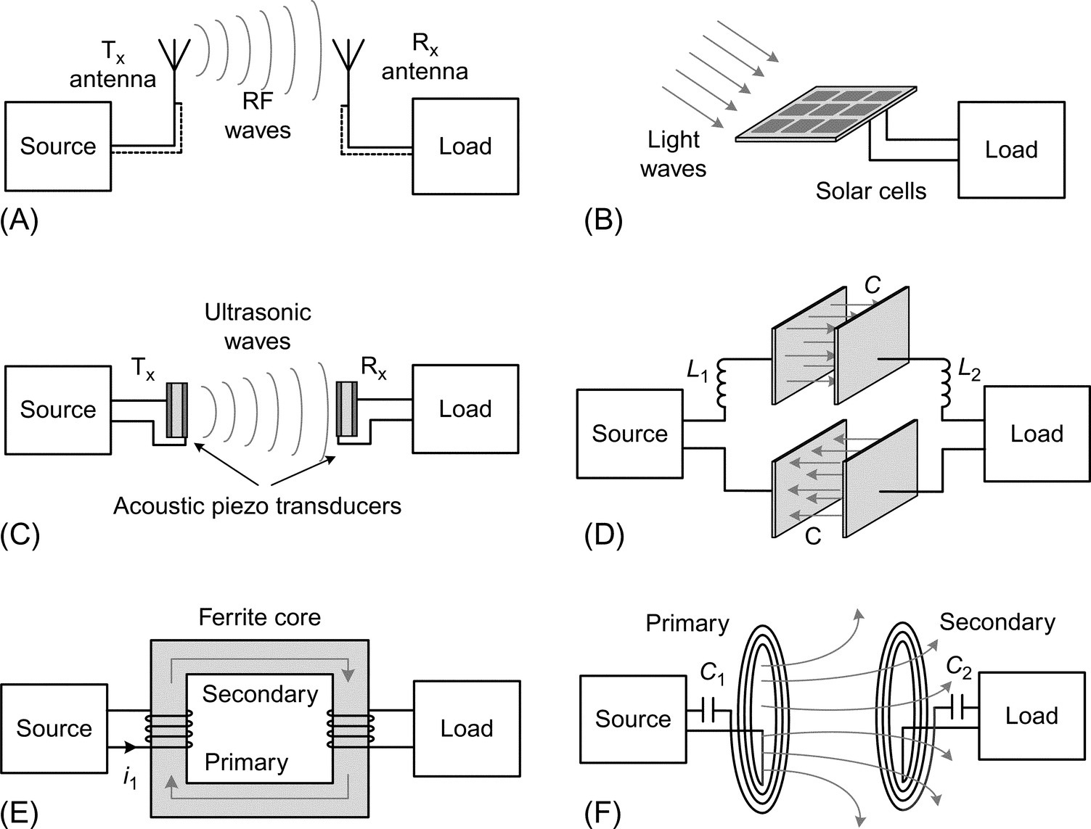

**FIG. 22.1** Several methods of wireless power transfer. (A) WPT in radio-frequency waves, (B) solar radiation in optical WPT, (C) WPT using ultrasonic waves, (D) capacitive power transfer, (E) tightly coupled inductive power transfer, and (F) loosely coupled resonant inductive power transfer.

*Optical link.* Optical links use the light—in the ultraviolet, visible, and infrared regions of electromagnetic frequency spectrum—to transfer energy between source and receiver over long distances ([Fig. 22.1B](https://learning.oreilly.com/library/view/power-electronics-handbook/9780128114087/B9780128114070000246.xhtml#f0010)). The light-emitting source can be sun or power laser diodes for high power delivery and LED for data transmission [[2](https://learning.oreilly.com/library/view/power-electronics-handbook/9780128114087/B9780128114070000246.xhtml#bb0015)]. The receiver unit is a light-sensitive device such as photovoltaic converter, solar cell, or photodiode. The optical link can be free space, air, fiber optics (it can be considered a wireless link due to the absence of conductive materials), etc. Although the optical links have been mostly used for data transmission, higher power in the form of solar and laser can also be transmitted [[3](https://learning.oreilly.com/library/view/power-electronics-handbook/9780128114087/B9780128114070000246.xhtml#bb0020)]. One application is laser power transfer through optical fiber that has the advantage of electric isolation between the source and receiver.

*Ultrasound.* Ultrasonic waves propagate in a physical medium such as air, water, metal pipe, human tissue, etc., by exchanging in between kinetic and potential energies inside the medium ([Fig. 22.1C](https://learning.oreilly.com/library/view/power-electronics-handbook/9780128114087/B9780128114070000246.xhtml#f0010)). The ultrasound frequency is above the hearing limit of humans, about 20 kHz, and goes up to several megahertz. The ultrasound power delivery has been mostly applied in low power data transmission, nondestructive testing, remote sensing, and navigation systems [[4](https://learning.oreilly.com/library/view/power-electronics-handbook/9780128114087/B9780128114070000246.xhtml#bb0025)]; however, higher power transfer for biomedical implants and consumer electronics has gained notable attention recently [[5](https://learning.oreilly.com/library/view/power-electronics-handbook/9780128114087/B9780128114070000246.xhtml#bb0030)]. The ultrasound wave can be converted to electricity and vice versa, using piezoelectric crystal [[6](https://learning.oreilly.com/library/view/power-electronics-handbook/9780128114087/B9780128114070000246.xhtml#bb0035)]. One of the advantages of ultrasound power delivery is the ability to travel long distances (depending on the attenuation in the link medium) and through the nontraditional curved power paths. In addition, the low propagation speed of ultrasound wave leads to a more achievable design of directional transceivers compared with RF waves.

*Capacitive power transfer.* Capacitive power transfer (CPT) uses time-varying electric field between capacitor electrodes to transfer power wirelessly ([Fig. 22.1D](https://learning.oreilly.com/library/view/power-electronics-handbook/9780128114087/B9780128114070000246.xhtml#f0010)). The coupling capacitance and the transferred power are limited to the available area and the minimum distance between the electrodes. The CPT has mostly been applied to low power and data transmission systems such as in biomedical implants, bioinstruments, integrated circuits, and the isolated power supply due to galvanic isolation of the source and receiver. The CPT can be implemented in different circuit topologies such as resonance to achieve higher power transfer with increased efficiency [[7](https://learning.oreilly.com/library/view/power-electronics-handbook/9780128114087/B9780128114070000246.xhtml#bb0040)].

*Inductive power transfer.* Inductive power transfer (IPT) uses time-varying magnetic field between mutually coupled coils to transfer power wirelessly. As the amount of transferred power depends on the mutual coupling between the coils, IPT systems are divided into two categories, namely loosely and tightly coupled systems. In the tightly coupled systems, the coupling factor (coupling coefficient) is close to unity; therefore, the transferred power efficiency is quite high. A well-known application for tightly coupled systems is a power transformer ([Fig. 22.1E](https://learning.oreilly.com/library/view/power-electronics-handbook/9780128114087/B9780128114070000246.xhtml#f0010)). In loosely or weakly coupled systems, the coupling factor is quite low; depending on the application, it can range between 0.01 and 0.5. The main reasons for the low coupling coefficient are the large distance between the coupled coils compared with the coil sizes and/or the absence of high permeable magnetic path connecting them. The low coupling coefficient reduces the power transfer efficiency; therefore, the receiving coil needs to be resonated to increase the efficiency. This chapter is mainly focused on loosely coupled inductive WPT systems ([Fig. 22.1F](https://learning.oreilly.com/library/view/power-electronics-handbook/9780128114087/B9780128114070000246.xhtml#f0010)).

## 22.3 Inductive WPT System Applications

Inductive WPT systems are increasingly getting popular in applications where (a) the flexibility of relative movement between source and load is an advantage, (b) there is limited space for energy storage elements in the load, (c) there is limited access to the load side, and (d) cordless connection improves safety. Some applications that use inductive WPT include the following:

*Consumer electronics.* As the power density and usage of consumer electronic devices such as notebook, smartphone, and wearables keep increasing, the wireless power connection to the device is a significant advantage. The WPT in consumer electronics is a fast pace industry, and with several standards already in place, the time from product development to the market is short compared with health care and automotive sectors.

*Health care.* As medical therapies are getting more dependent on implantable electronics, WPT becomes a promising technology in health-care devices [[8](https://learning.oreilly.com/library/view/power-electronics-handbook/9780128114087/B9780128114070000246.xhtml#bb0045)]. One such application is ventricular assist device (VAD) that circulates the blood inside the body as a pump. The use of inductive WPT eliminates the wire connection between the power source (outside the body) and the VAD (inside the body) [[9](https://learning.oreilly.com/library/view/power-electronics-handbook/9780128114087/B9780128114070000246.xhtml#bb0050)], which is beneficial to the patient in many aspects.

Another benefit of WPT in electronic implants is the possible reduction or elimination of energy storage element in the implant. This leads to smaller size and lighter weight electronics that brings comfort to the patient. It also reduces the costs and risks associated with the replacement of the energy storage device inside the body. One such application is in retinal implants with the WPT device powering a chip implanted in the eye that (partially) restores vision to the patients with specific retinal diseases.

*Electric vehicles.* Wireless inductive charging for electric vehicles (EVs) is a step forward toward the mainstream adaptation of EVs as the main transportation systems. The EVs can get the wireless power while in motion (dynamic charging) [[10](https://learning.oreilly.com/library/view/power-electronics-handbook/9780128114087/B9780128114070000246.xhtml#bb0055)] or in parked position (stationary charging). The dynamic charging can be applied by implementing numerous transmitter coils along the driving path, all connected to each other in parallel and fed by a single source [[11](https://learning.oreilly.com/library/view/power-electronics-handbook/9780128114087/B9780128114070000246.xhtml#bb0060)]. This is currently most applicable for EVs with predetermined driving path such as electric busses. In the stationary charging, the EV gets the wireless power by having the receiver and transmitter coils aligned and stationary. Since a slight misalignment of the coils would drop the efficiency, specific coil arrangements or multiple coils can be used to make the WPT more tolerant to misalignment [[12](https://learning.oreilly.com/library/view/power-electronics-handbook/9780128114087/B9780128114070000246.xhtml#bb0065)].

## 22.4 Resonant Inductive WPT System Design

### **22.4.1 SYSTEM COMPONENTS**

[Fig. 22.2](https://learning.oreilly.com/library/view/power-electronics-handbook/9780128114087/B9780128114070000246.xhtml#f0015) shows an inductive WPT system block diagram. The power source feeding the WPT system typically consists of AC-DC-AC (rectification-inversion) stages. The transmitter coil can be compensated to increase the overall system efficiency and reduce the volt-ampere rating of power source. However, this compensation (assuming loss-less) does not affect the magnetic link efficiency, *ηlink*, defined from power source output up to the receiver rectification.

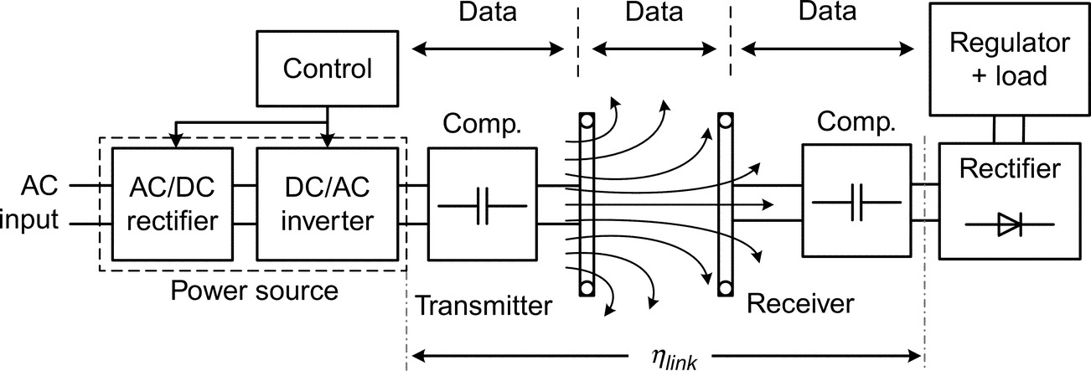

**FIG. 22.2** Block diagram of a two-coil inductive WPT system.

The power is transmitted from the source coil (transmitter) to the load coil (receiver) using Faraday's law of induction. Having the two mutually coupled coils, the higher the coupling coefficient between them, the higher the power transfer efficiency. The transmitter and receiver coils can be made up of various components. Magnetic core can be used to shape the flux path, increase the inductance, and enhance the coupling. Metallic shields can be used to reduce the high frequency magnetic fields around the system and reduce the electromagnetic interference (EMI). However, there will be eddy current losses inside the coil conductor and the metallic shield in addition to the magnetic core losses, which bring up the significance of efficient coil design in WPT systems. The high quality factor and highly coupled coils will be discussed in more details later in the chapter.

The wireless power is delivered to the load through the receiver coil, reactive compensation, and electronic rectification for DC loads. The link efficiency depends on the receiver coil compensation and the value of load resistance. The feedback control electronic sensors are used in order to operate the WPT system reliably and efficiently.

### 22.4.2 OPERATING FIELD REGION

The electromagnetic power transfer is based on Maxwell's equations. For a coil used in WPT system, the governing Maxwell's equations would have exact or simplified formats depending on the coil material, operating frequency, and the power transfer distance, leading the system to operate in one of the three near, Fresnel, or far-field regions [[1](https://learning.oreilly.com/library/view/power-electronics-handbook/9780128114087/B9780128114070000246.xhtml#bb0010)] ([Fig. 22.3](https://learning.oreilly.com/library/view/power-electronics-handbook/9780128114087/B9780128114070000246.xhtml#f0020)). In the near-field region, the reactive energy storage is dominant, and there is negligible radiative power transfer. The transition from near-field in to far-field is through the Fresnel region where the reactive energy storage is still dominant but the coil has radiation patterns. At distances far from the coil, the system operation is in the far-field region where the coil has radiation patterns and the power is transmitted through radiation resistance, for example, RF WPT. In the far-field region, the coil electromagnetic fields are based on the exact set of Maxwell's equations.

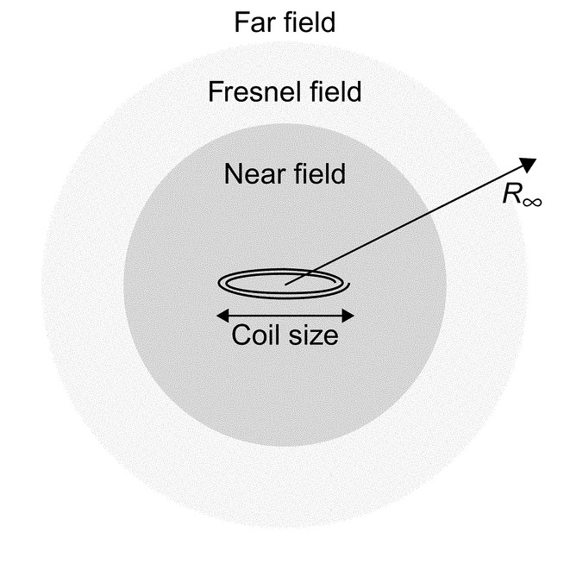

**FIG. 22.3** The classification of electromagnetic field regions, inductive WPT systems are in the near-field region.

For coils (antennas) much smaller than the electromagnetic wavelength *λ*, the transition happens from the near-field in to far-field, and the Frensel region may not exist. This boundary is typically defined at the distance *λ*/2*π* from the coil. In the inductive WPT systems focused in this chapter, the frequency and the distance between the transmitter and receiver coils are small enough (up to several megahertz in frequency and from several millimeters to few meters in distance) for the system to remain in the near-field region.

### 22.4.3 EFFICIENCY EQUATIONS

There are different methods for the analysis of inductive WPT systems depending on the complexity of the system and accuracy of the analysis. The most accurate method is mesh theory that uses the resistance, inductance, and capacitance matrices to solve for the voltage and current in the system: 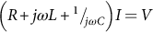. This method is beneficial for systems with multiple coils (including transmitter, receiver, or repeaters), as the inductance matrix contains the self and mutual inductances for all the coils. The mutual capacitance (capacitive coupling) between the coils is neglected in inductive WPT systems, and the capacitance matrix is a diagonal matrix with compensating capacitors as the diagonal elements of that matrix.

The other method is based on the impedance reflection and is useful for simple WPT systems such as a two-coil system (can be modified to single transmitter/receiver system with repeaters/resonators in between). The advantage of this method is the ability to derive closed-form formulas for different variables such as voltage gain, input/output impedances, and link/system efficiencies. The focus of this section is on a typical two-coil inductive WPT system. [Fig. 22.4](https://learning.oreilly.com/library/view/power-electronics-handbook/9780128114087/B9780128114070000246.xhtml#f0025) shows the equivalent circuit of the two-coil WPT system. The power dissipations inside the remote electronics, rectifier, regulator, and the load are included in the equivalent AC load *RL*.

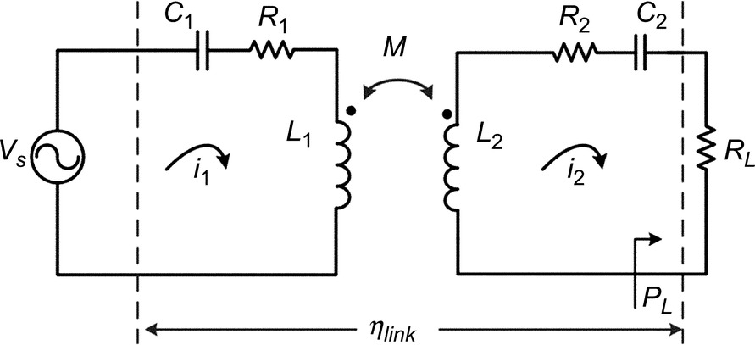

**FIG. 22.4** A two-coil inductive WPT system equivalent circuit.

In the WPT system, the amount of impedance seen by the power source inverter is a key parameter that directly contributes to the inverter, link, and system efficiencies, along with voltage gain and maximum wireless power transfer. In order to find this impedance, all the impedances in the secondary side need to be reflected to the primary side. In a two mutually coupled coils with mutual inductance of *M*, the reflected impedance to the primary side is 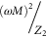 in which *Z*2 is the total impedance in the secondary coil, . When the secondary side is resonant at  (*Z*2 is real), the reflective impedance to the primary side is pure resistive and is defined by

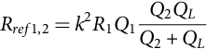 **(22.1)**

In the Eq. [(22.1)](https://learning.oreilly.com/library/view/power-electronics-handbook/9780128114087/B9780128114070000246.xhtml#fo0010), *k* is the coupling coefficient between the primary and secondary coils, and *R*1 and *Q*1 are the primary coil resistance and quality factor, respectively. And *QL* is the secondary coil load quality factor that is defined by . Using the reflected impedance approach, the link efficiency is then defined by

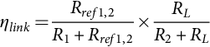 **(22.2)**

Eq. [(22.2)](https://learning.oreilly.com/library/view/power-electronics-handbook/9780128114087/B9780128114070000246.xhtml#fo0015) is valid for both resonant and nonresonant secondary coils. In order to increase the link efficiency, the transmitter side efficiency that is the first term in Eq. [(22.2)](https://learning.oreilly.com/library/view/power-electronics-handbook/9780128114087/B9780128114070000246.xhtml#fo0015) needs to be maximized by increasing the reflected resistance. As the reflected resistance is limited by the low coupling factor in weakly coupled inductive systems, resonating the secondary tank helps increasing the reflected resistance. This is the main reason to resonate the secondary side to increase the link efficiency.

There are three common optimization objectives for inductive WPT system design [[13](https://learning.oreilly.com/library/view/power-electronics-handbook/9780128114087/B9780128114070000246.xhtml#bb0070)]. First, increasing the link efficiency that is the objective used in this chapter. Second, desensitizing the link gain versus coupling factor *k* variations. For example, in a bell-shaped link gain versus *k*, the maximum gain that corresponds to *kcritical* has the least sensitivity to *k* variations. The disadvantage of this method is that the theoretical limit for the link efficiency is reduced. Third, stagger tuning that is the combination of the first two objectives to have higher limits for link efficiency while the link gain is not very sensitive to coupling factor changes.

The two-coil inductive WPT system, in its basic configuration, can have six different compensation topologies depending on the type of resonance in the primary and secondary coils ([Fig. 22.5](https://learning.oreilly.com/library/view/power-electronics-handbook/9780128114087/B9780128114070000246.xhtml#f0030)). The secondary coil is assumed to be resonated at  in series or parallel. The series-resonant secondary has current output type and is suitable for small values of *RL*. The parallel-resonant secondary, in the other hand, has voltage output type and is suitable for large loads. The advantage of parallel-resonant secondary is that the coil parasitic capacitance can be included in the compensating capacitor in parallel. The disadvantage of parallel resonance is that resonant frequency depends on the value of *RL*.

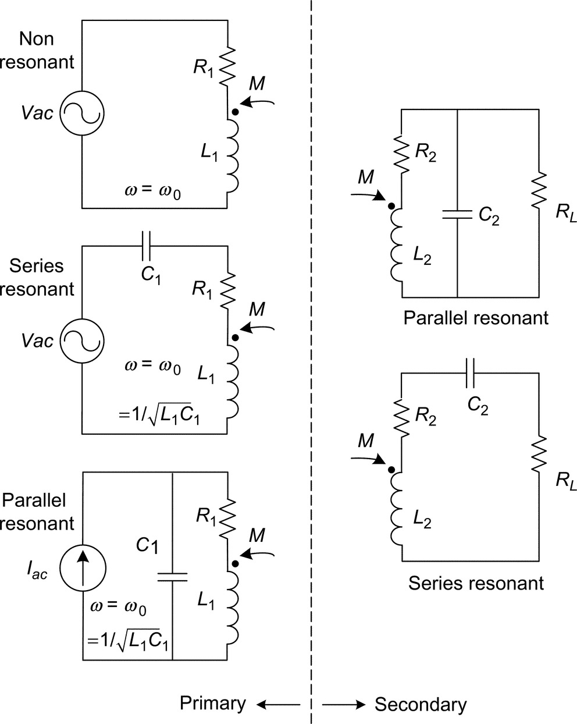

**FIG. 22.5** Six different compensation topologies for primary and secondary sides of inductive WPT system.

The primary coil can be resonated (series or parallel) or nonresonated as it does not affect the link efficiency *ηlink*. The series-resonant primary requires high-current and low-voltage output from the switched-mode power supply FETs, while the parallel resonant requires high-voltage and low-current output. High values of current increase the FET driver losses, and high voltages increase the FET capacitive losses. A combination of series- and parallel-resonant primary coil can be implemented to operate the system at high efficiencies[[13](https://learning.oreilly.com/library/view/power-electronics-handbook/9780128114087/B9780128114070000246.xhtml#bb0070)]. [Fig. 22.5](https://learning.oreilly.com/library/view/power-electronics-handbook/9780128114087/B9780128114070000246.xhtml#f0030) shows the different primary and secondary compensation topologies. In all these topologies, the system operating frequency is at . The power supply output may not be pure sinusoidal; however, the power is transferred to the secondary only at fundamental frequency *f*0. The other harmonics do not contribute to power transfer, but they increase the losses in the primary side.

[Table 22.1](https://learning.oreilly.com/library/view/power-electronics-handbook/9780128114087/B9780128114070000246.xhtml#t0010) shows a summary of the key system parameters for a two-coil WPT system including the resonance frequency, reflected impedance to the primary side, load quality and dissipation factors, and link efficiency. Not to mention that the above-mentioned parameters do not depend on the primary coil compensation topology. In addition, the maximum link efficiency has the same equation for both the series- and parallel-resonant secondary coil.

**Table 22.1**

**Inductive WPT system parameters for series- and parallel-resonant secondary**

|  |  |  |
| --- | --- | --- |
| **Secondary compensation** | **Series resonant** | **Parallel resonant** |
| Resonance frequency | si1_e | si2_e |
| Load quality (*Q*)/dissipation (*D*) factors | si3_e | si4_e |
| Reflected resistance to primary | si5_e | si6_e |
| Reflected reactance to primary | si7_e | si7_e |
| Load factor | si9_e | si10_e |
| Link efficiency | si11_e | si11_e |
| Maximum link efficiency | si13_e | si13_e |

It is observed from the [Table 22.1](https://learning.oreilly.com/library/view/power-electronics-handbook/9780128114087/B9780128114070000246.xhtml#t0010) that the link efficiency *ηlink* is a function of load factor *α* and *k*2*Q*1*Q*2; and,  is only a function of *k*2*Q*1*Q*2. [Fig. 22.6](https://learning.oreilly.com/library/view/power-electronics-handbook/9780128114087/B9780128114070000246.xhtml#f0035) shows the link efficiency of a two-coil inductive WPT system with a resonant (series or parallel) secondary side. For a fixed *k*2*Q*1*Q*2, there is a load factor *α* that maximizes the link efficiency. The maximum link efficiency increases by increasing *k*2*Q*1*Q*2, meaning that in inductive WPT systems, increasing not only the coupling factor but also the coil quality factors boost the efficiency.

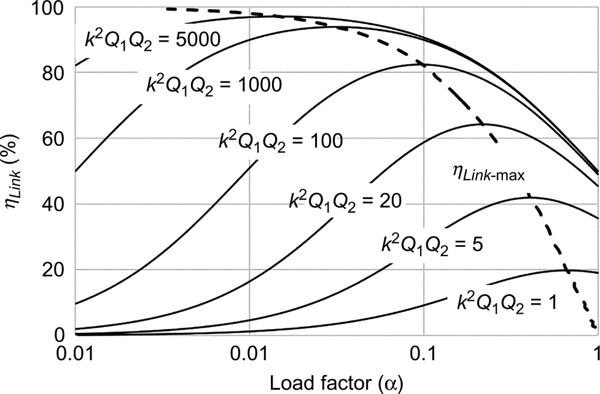

**FIG. 22.6** The link efficiency of a two-coil WPT system versus load factor *α* and *k*2*Q*1*Q*2.

In inductive WPT systems, the coupling factor is typically small, that is, in the range of 0.01–0.5. The low coupling factor leads to small values of impedance being reflected to the primary side. This brings the power supply close to unloaded operation mode at which its dissipation dominates the total power dissipated in the primary coil and transferred to the secondary side. Therefore, in loosely coupled systems, it is essential to optimize for the whole system efficiency by including the power supply, magnetic link, and also secondary side remote electronics.

## 22.5 WPT Systems With Multiple Coils

In WPT systems, there can be multiple coils in the transmitter, receiver, or in between them that help extend the use of WPT to practical applications. Here, the most common types of multiple-coil inductive WPT systems are reviewed, discussing their applications, (dis)advantages, and challenges.

### 22.5.1 SINGLE TRANSMITTER AND RECEIVER WITH MULTIPLE COILS IN BETWEEN

The single transmitter and receiver WPT structure can include one, two, or more repeaters (resonators) in between. There are different applications that implement such structures. One application is to transmit power to large distances using repeaters along the path or even transmit power along a curved path. The other application is to have the repeater tightly coupled to either the transmitter or the receiver [[14](https://learning.oreilly.com/library/view/power-electronics-handbook/9780128114087/B9780128114070000246.xhtml#bb0075)] (three-coil WPT, [Fig. 22.7A](https://learning.oreilly.com/library/view/power-electronics-handbook/9780128114087/B9780128114070000246.xhtml#f0040)), similarly, two repeaters in a four-coil WPT [[15](https://learning.oreilly.com/library/view/power-electronics-handbook/9780128114087/B9780128114070000246.xhtml#bb0080)] ([Fig. 22.7B](https://learning.oreilly.com/library/view/power-electronics-handbook/9780128114087/B9780128114070000246.xhtml#f0040)). There are two main reasons for such configurations: (a) to have more degrees of freedom to maximize the efficiency and desensitize the link gain versus coupling factor without scarifying one objective for the other as was discussed earlier in the chapter and (b) to have the highly coupled transmitter-repeater or repeater-receiver coils act as practical and efficient impedance matching elements in both the source and load sides.

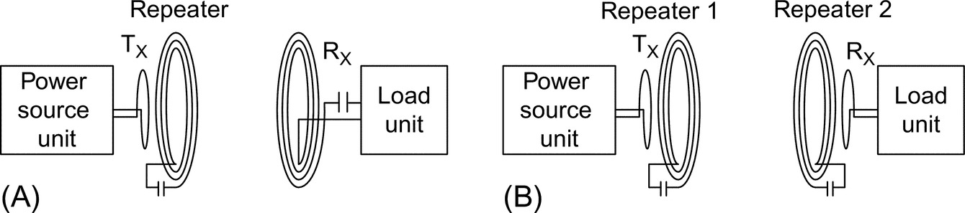

**FIG. 22.7** Three-coil and four-coil WPT structures. (A) Three-coil WPT and (B) four-coil WPT.

### 22.5.2 MULTIPLE TRANSMITTERS AND SINGLE RECEIVER

The applications that implement multiple transmitter coils and a single receiver are mainly classified into two areas, one is dynamic WPT and the other is misalignment tolerant systems. The dynamic WPT systems transfer the power wirelessly while the receiver is in motion. A known example is EV dynamic charging in which multiple transmitter coils are placed along the driving path and the receiver coil is placed in the moving vehicle. The challenge of such systems is to efficiently power the transmitter coils. A simple method is to have a power supply for each transmitter, and the power is transferred to the receiver by sensing it when it is aligned to it. The drawback of this method is the use of numerous power supplies. The other method is to have a long transmitter pad along the vehicle driving path. The disadvantage of this method is that only a portion of the coil transmits power while all of it is dissipating power. A way to solve these problems is to have multiple transmitters coils connected in parallel to one power supply. The current flows in a coil that is aligned with the receiver coil using reflected impedance while there is no current flowing in the other transmitter coils [[11](https://learning.oreilly.com/library/view/power-electronics-handbook/9780128114087/B9780128114070000246.xhtml#bb0060)] ([Fig. 22.8](https://learning.oreilly.com/library/view/power-electronics-handbook/9780128114087/B9780128114070000246.xhtml#f0045)).

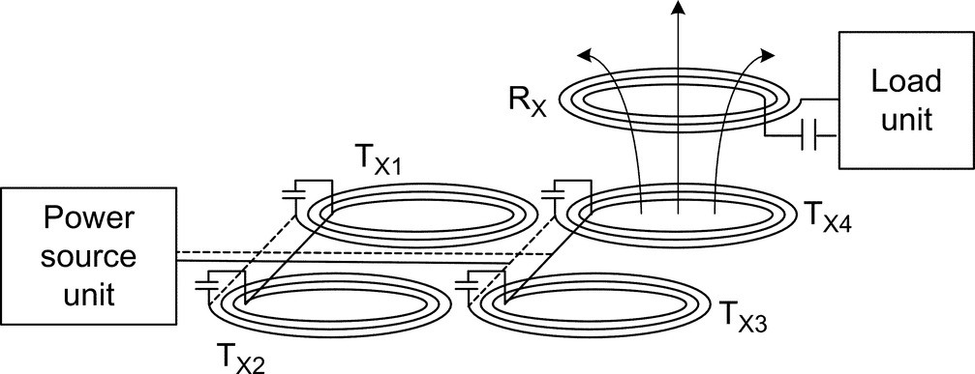

**FIG. 22.8** A dynamic WPT structure with parallel-connected transmitter coils.

The other application with multiple transmitter coils is to have a misalignment tolerant system. As the coupling (and so the efficiency) of a two mutually coupled coils drops sharply by a slight misalignment between them, implementing multiple transmitter coils can increase this tolerance [[12](https://learning.oreilly.com/library/view/power-electronics-handbook/9780128114087/B9780128114070000246.xhtml#bb0065)]. Multiple transmitter coils can also be used to provide a uniform magnetic field across a surface area giving the receiver the freedom of movement over that area [[16](https://learning.oreilly.com/library/view/power-electronics-handbook/9780128114087/B9780128114070000246.xhtml#bb0085)].

### 22.5.3 SINGLE TRANSMITTER AND MULTIPLE RECEIVERS

In some WPT applications, multiple receivers need to get the power simultaneously from a single transmitter pad ([Fig. 22.9](https://learning.oreilly.com/library/view/power-electronics-handbook/9780128114087/B9780128114070000246.xhtml#f0050)). The amount of power transferred to each receiver is linearly related to the resistance it reflects to the transmitter. In such systems, the first challenge is that the change of power transfer to one receiver could affect the amount of power transfer to other receivers. To avoid this, constant-current-flow topologies such as LCL in the transmitter coil are required.

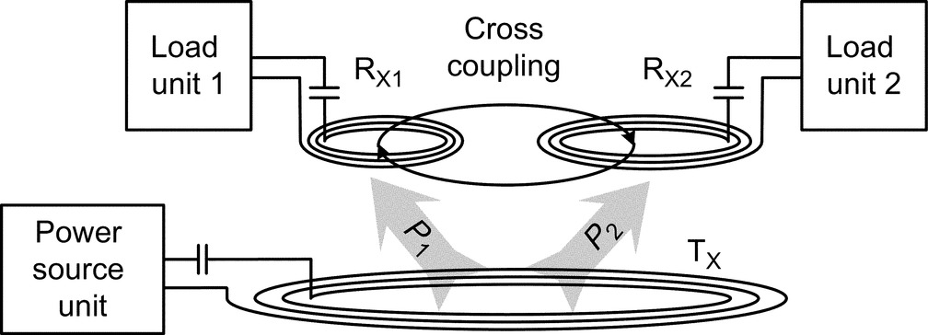

**FIG. 22.9** Single transmitter coil WPT with multiple receivers.

With the transmitter coil having a constant current, power sharing to the receivers can be implemented using dynamic (active) tuning in each receiver side. The dynamic tuning can be implemented using L-C network [[17](https://learning.oreilly.com/library/view/power-electronics-handbook/9780128114087/B9780128114070000246.xhtml#bb0090)], standard boost [[18](https://learning.oreilly.com/library/view/power-electronics-handbook/9780128114087/B9780128114070000246.xhtml#bb0095)], or tristate boost [[19](https://learning.oreilly.com/library/view/power-electronics-handbook/9780128114087/B9780128114070000246.xhtml#bb0100)]. In the L-C network method, a discrete matrix of L and C components is actively switched to control the reflected impedance to the transmitter side. The standard boost method controls the active power transfer to the receiver by changing the reflected resistance to the transmitter coil. Similarly, the tristate boost controls the active power flow, but also, the reactive power flow to the receiver can be controlled in case of detuning. The tristate boost has an extra degree of freedom compared with standard boost by shorting the inductive energy in boost (freewheeling).

One of the challenges in multiple-receiver WPT systems is the magnetic cross coupling between the receivers when they are in close proximity to each other ([Fig. 22.9](https://learning.oreilly.com/library/view/power-electronics-handbook/9780128114087/B9780128114070000246.xhtml#f0050)). The cross coupling would change the expected power transfer to the receivers and impose system performance issues. One method to reduce the cross coupling is to use multiresonant WPT system in which each receiver is resonant at one of the transmitter carrier frequencies [[20](https://learning.oreilly.com/library/view/power-electronics-handbook/9780128114087/B9780128114070000246.xhtml#bb0105)].

## 22.6 A Glance Into WPT Power Source Converter

In weakly coupled inductive powering applications, the design of transmitter coil power converter is directly linked to magnetic link design and therefore needs to be part of the whole WPT system optimization. The main reason is due to the weak coupling, as the amount of reflected resistance to the transmitter coil is quite small, the converter operates close to freewheeling. And large amount of current is needed to flow in the coil to generate the required magnetic field and power.

The choice of transmitter coil power converter depends on the WPT application, power level, and operating frequency. For example, in EVs, the amount of power required to wirelessly charge the battery can range from 3.3 kW up to several tens of kilowatts, with frequency ranges from 20 kHz up to few hundreds of kilohertz. For such power and frequency levels, highly efficient AC-AC power converters such as full-bridge AC-DC rectifier and DC-AC inverter can be used to drive the transmitter coil. These power converters have been well stablished in the past few decades in terms of efficiency, reliability, and cost.

An important benefit of inductive WPT is in applications with small size and medium to high power requirements. As the magnetic link size reduces, the reflected resistance to the transmitter coil gets reduced as well. To compensate for this reduction, the operating frequency needs to increase to keep the power level up. For example, in electronic devices such as phones, wearables, and laptops, the power rating can range from 1 W up to about few hundred watts. For inductive WPT in the megahertz frequency region, the operating frequency is typically bound to industrial, scientific, and medical (ISM) band of 6.78, 13.56 MHz, and so on. The power converter design in the megahertz region is critical as the dynamic losses increase in the FETs. There are several typically used DC-AC power inverters in the megahertz frequency range such as classes A, B, AB, C, D (ZCS and ZVS), and E. In this section, the focus is on switched-mode class-D and class-E power inverters as they deliver highest efficiencies of all the classes [[21](https://learning.oreilly.com/library/view/power-electronics-handbook/9780128114087/B9780128114070000246.xhtml#bb0110),[22](https://learning.oreilly.com/library/view/power-electronics-handbook/9780128114087/B9780128114070000246.xhtml#bb0115)].

### 22.6.1 CLASS-D INVERTER

Class-D inverter has a voltage output characteristic that is good to feed series-resonant transmitter coil. The resonance is not a critical requirement for class-D inverter although it increases the current for a fixed voltage. And the inverter can power resistive, inductive, and capacitive loads [[23](https://learning.oreilly.com/library/view/power-electronics-handbook/9780128114087/B9780128114070000246.xhtml#bb0120)]. [Fig. 22.10](https://learning.oreilly.com/library/view/power-electronics-handbook/9780128114087/B9780128114070000246.xhtml#f0055) shows the schematic of the class-D inverter with ideal waveforms. At resonance, the impedance seen by the inverter is the transmitter coil resistance *R*1, in addition to the reflected resistance from the receiver side *Rref*. In weakly coupled WPT systems, the *Rref* is very small and can bring the inverter to the freewheeling operation. At this condition, the static conduction losses in the FETs dominate both the power dissipated in the transmitter and transferred to the receiver ().

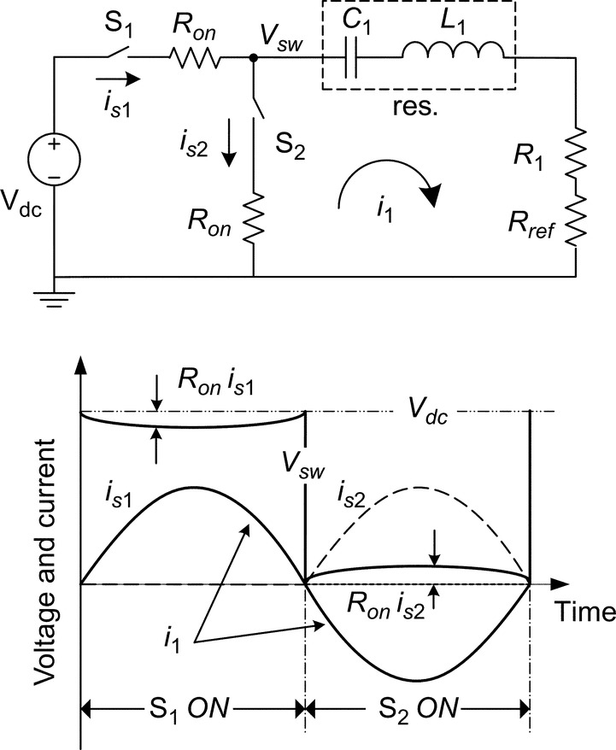

**FIG. 22.10** Class-D inverter with ideal waveforms.

The class-D output voltage is square wave and fixed, independent of the load or coupling variations. Only the fundamental harmonic of current (at receiver coil resonance *ω*0) contributes to the wireless power transfer, and the other harmonics (although small as are blocked by the resonance) cause dissipation in the transmitter coil. For moderately large transmitter coil loaded quality factor (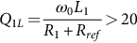), the coil current would be close to sinusoidal, operating at its series resonance frequency that is also *ω*0.

One of the challenges of class-D inverter in the megahertz frequency range is the switch output capacitive losses during S2 turn-on. A solution is to have the inverter output current lag the output voltage so it can self-commute to zero value during S2 turn-on (ZVS). To do so, one method is to have the impedance seen by the inverter to be slightly inductive by operating above the transmitter coil resonance frequency (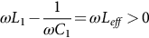) ([Fig. 22.11](https://learning.oreilly.com/library/view/power-electronics-handbook/9780128114087/B9780128114070000246.xhtml#f0060)). Note that the receiver coil is resonant at the operating frequency. Another way to provide lagging output current while not shifting the frequency from the transmitter coil resonance frequency is to add an inductive element *Lsh* in parallel to the inverter output [[24](https://learning.oreilly.com/library/view/power-electronics-handbook/9780128114087/B9780128114070000246.xhtml#bb0125)] ([Fig. 22.12](https://learning.oreilly.com/library/view/power-electronics-handbook/9780128114087/B9780128114070000246.xhtml#f0065)). The *Lsh* provides the negative current required for the *Vsw* to self-commute to zero during S2 turn-on (ZVS).

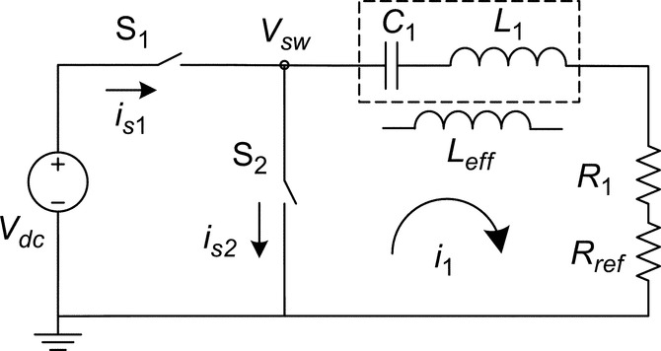

**FIG. 22.11** Class-D ZVS operating above the primary coil resonance frequency.

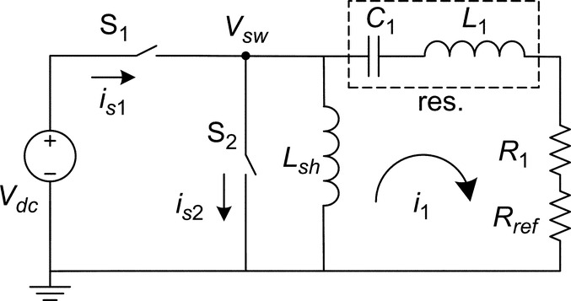

**FIG. 22.12** Class-D ZVS with additional inductor in parallel to the switch output.

### 22.6.2 CLASS-E INVERTER

The series-resonant transmitter coil (as for class-D) requires high amount of current that increases FET gate driver losses. The parallel-resonant coil, in the other hand, reduces the current rating of the switches by circulating it through the resonant tank. However, it produces high voltages across the switches that increase the FET output capacitive losses. A combination of series- and parallel-resonant transmitter coil would take advantage of low voltage rating of series-resonant and low current rating of parallel-resonant coil. Class-E inverter satisfies these conditions with doubled-tuned output circuit [[25](https://learning.oreilly.com/library/view/power-electronics-handbook/9780128114087/B9780128114070000246.xhtml#bb0130)]. [Fig. 22.13](https://learning.oreilly.com/library/view/power-electronics-handbook/9780128114087/B9780128114070000246.xhtml#f0070) shows the class-E inverter with ideal waveforms. The inverter operates between the transmitter series resonance frequency and the one of transmitter in parallel with the *Csh*.

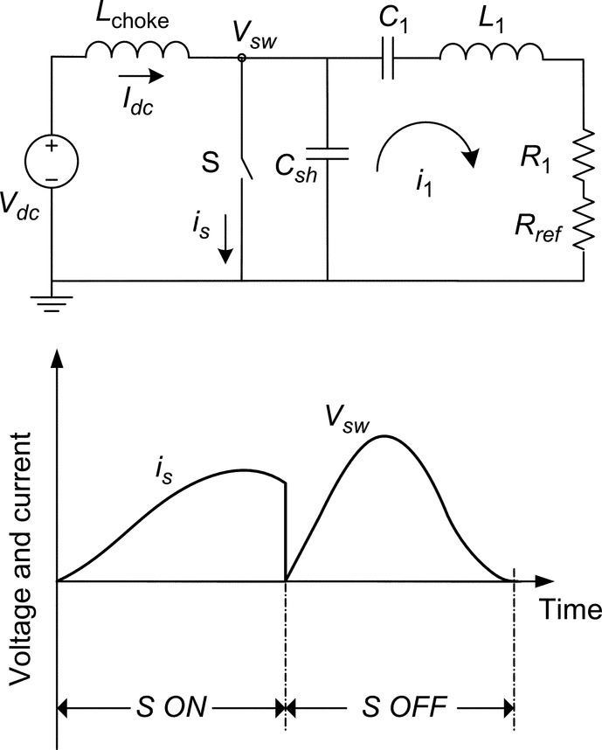

**FIG. 22.13** Class-E inverter with ideal waveforms.

An advantage of class-E compared with class-D with ZVS is that the output voltage slope approaches zero during the S turn-on and makes class-E generally more efficient than class-D. For the switch voltage and its slope to be zero at switch turn-on, it is a function of *Lchoke*, *Csh*, , and the oscillations in the *Csh-C*1*-L*1 tank during switch turn-off. This makes the class-E inverter more complicated to design and prone to nonoptimum operation when coupling factor and load vary, which are common characteristics of WPT systems [[22](https://learning.oreilly.com/library/view/power-electronics-handbook/9780128114087/B9780128114070000246.xhtml#bb0115)].

## 22.7 Efficient Magnetic Link Design

Earlier in the chapter, it was shown that the maximum link efficiency  is a function of *k*2*Q*1*Q*2 in which *k* is the coupling factor between the transmitter and receiver coils with quality factors of *Q*1 and *Q*2, respectively. To enhance the link efficiency, not only the coupling factor needs to increase, but also the coil quality factors should improve. This section's focus would be on the methods to increase the coupling and quality factors.

### 22.7.1 EFFECT OF LINK DIMENSION

The magnetic design of inductive WPT system includes the design of link dimensions, coil shape, placement, and the type of material and conductor used in them. The coupling factor between the transmitter and receiver coils, with self-inductances of *L*1 and *L*2, is 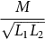 in which *M* is the mutual inductance between the two coils. In simple approximation for concentric-turn coils, the coupling factor is related to the ratio of the two-coil surface areas and inversely to the distance between them. The closer the transmitter and receiver coils to each other, the larger the coupling between them. And for coils that are very close to each other, the maximum coupling happens with coils having the same sizes. As the distance between the coils increases, there is an optimum ratio between the coil surface areas that leads to maximum coupling factor. [Fig. 22.14](https://learning.oreilly.com/library/view/power-electronics-handbook/9780128114087/B9780128114070000246.xhtml#f0075) shows an example of the effects of distance between coils and their relative sizes on the link maximum coupling factor.

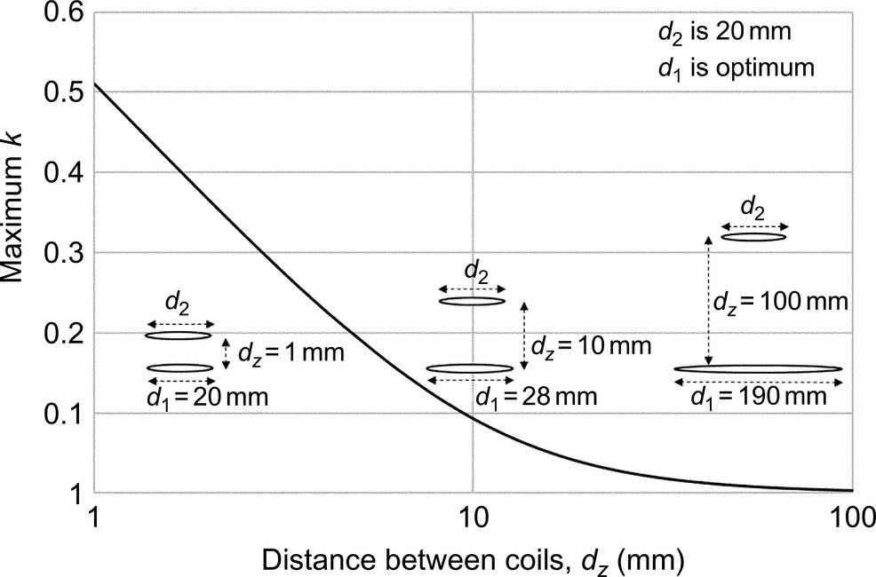

**FIG. 22.14** The maximum coupling factor *kmax* versus coil relative sizes and distance.

### 22.7.2 EFFECT OF COIL SHAPE AND ALIGNMENT

Circular coil is the most common form for the WPT resonator due to its symmetry, simplified analysis, and ease of fabrication. Other common coil forms include square and rectangular types.

Another important criterion that affects the coil shape is the misalignment between the transmitter and receiver coils. Misalignment tolerant inductive WPT systems are designed such that a specified misalignment between the coils does not drop the efficiency and power transfer significantly [[12](https://learning.oreilly.com/library/view/power-electronics-handbook/9780128114087/B9780128114070000246.xhtml#bb0065)]. Such systems provide spatial freedom of movement to the receiver coil that is beneficial for most WPT applications. For example, [Fig. 22.15A](https://learning.oreilly.com/library/view/power-electronics-handbook/9780128114087/B9780128114070000246.xhtml#f0080) shows the coupling factor *k* changes versus misalignment between the transmitter and receiver coils for two transmitter sizes. The more misalignment tolerant system has a larger transmitter coil to allow for small movements in the receiver coil while having minimal changes in *k*. [Fig. 22.15B](https://learning.oreilly.com/library/view/power-electronics-handbook/9780128114087/B9780128114070000246.xhtml#f0080) shows that for a fixed misalignment distance, the coupling factor drop is lower for large transmitter coil compared with the small coil. Another method to improve the misalignment tolerance is to have multiple transmitter coils [[26](https://learning.oreilly.com/library/view/power-electronics-handbook/9780128114087/B9780128114070000246.xhtml#bb0135)]. There are other factors, beside the misalignment tolerance, that affect the size and shape of coil, such as self-inductance and geometric constraints. The receiver side coil has typically more geometric constraints—for example, in a biomedical implant inside the body—and the WPT design process starts with the receiver coil followed by the transmitter.

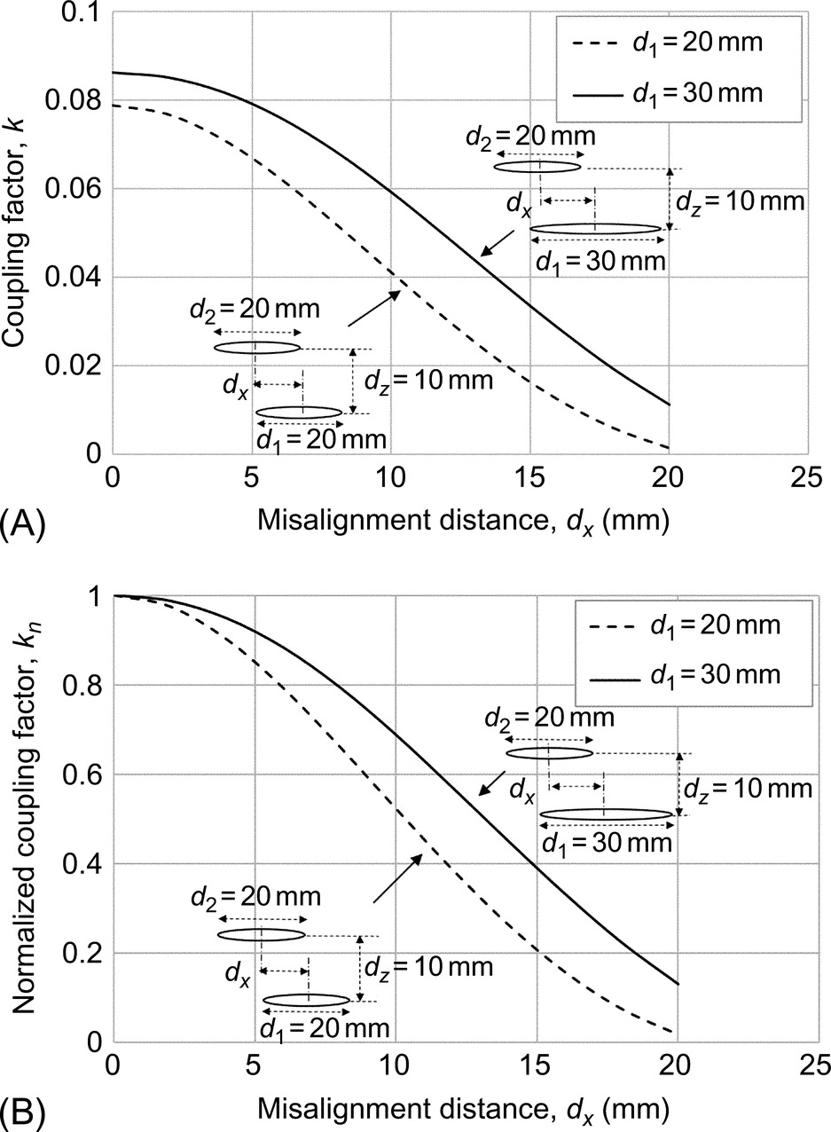

**FIG. 22.15** “Normalized” coupling factor *k* drop versus misalignment between transmitter and receiver coils. (A) Coupling factor *k* versus misalignment distance *dx.* (B) Normalized coupling factor *kn* versus *dx.*

### 22.7.3 EFFECT OF FERRITE CORE

Another way to increase the coupling factor is to use soft magnetic materials such as ferrite cores. The magnetic flux lines follow the path of minimum reluctance; therefore, the high permeable ferrite core can be used to shape the field and increase the coupling. As the ferrite cores are placed on one side of the transmitter/receiver coils to enhance the coupling, they also shield the magnetic field from being exposed to the surrounding objects. This helps the inductive WPT system satisfy the health and safety requirements associated with high magnetic field strengths. In some applications, adding a metal plate to the coil helps shielding the high frequency magnetic fields from penetrating into nearby objects and reducing the EMI disturbance ([Fig. 22.16](https://learning.oreilly.com/library/view/power-electronics-handbook/9780128114087/B9780128114070000246.xhtml#f0085)).

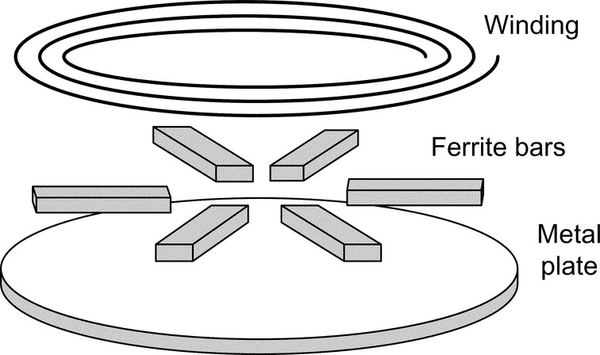

**FIG. 22.16** An example structure of inductive WPT coil including winding, ferrite, and metal plate.

A ferrite material with high saturation flux density, low AC power loss, and high bulk resistivity and permeability is beneficial in WPT systems. The most common types of ferrites used in inductive WPT systems are MnZn and NiZn ferrites. The MnZn ferrite has high permeability and high saturation flux density, while the NiZn ferrite has lower permeability and high bulk resistivity. The high-permeability ferrite increases the magnetic energy storage per geometric constraints, such as coil self-inductance. A ferrite with high bulk resistivity reduces the high-frequency-induced eddy and displacement currents.

A ferrite core increases not only the coupling factor and inductance but also the power dissipation. For sinusoidal excitation, the core loss is a function of frequency and magnetic flux density in the core. Its effects on the coil are well described by the coil quality factor *Q*. Increasing the coil inductance and resistance is somehow compensated in the quality factor that directly influences the link efficiency. However, other system requirements such as high inductance, magnetic field shielding, and high coupling factor are achieved by using ferrite cores in the transmitter and receiver coils.

### 22.7.4 EFFECT OF COIL WINDING

Reducing the coil winding AC resistance is an important step in magnetic link design as it increases the coil quality factor and link efficiency. Depending on the operating frequency, the winding conductor can be solid, foil, tubular, or litz. Solid round conductor is the most basic type of conductor, and its properties (such as resistance and inductance) have been well studied and determined. Solid wire is a building block of many types of wires such litz, and understanding its behavior is a critical step in the winding design. The AC power loss inside a current-carrying conductor is due to the high frequency eddy currents induced in it by the time-varying (1) internal magnetic field (skin effect) and (2) external magnetic field (proximity effect). The skin and proximity effects are orthogonal in round conductors and can be investigated separately. In the skin effect, the current flows mostly in the skin-depth region of the conductor, leaving the inner part having almost zero current flow (tubular conductor) that increases the AC resistance. One solution is to have multiple insulated concentric tubular conductors with optimum current flow to reduce the AC resistance [[27](https://learning.oreilly.com/library/view/power-electronics-handbook/9780128114087/B9780128114070000246.xhtml#bb0140)]. With the conductor radius close to skin depth, the current flow is close to uniform. At high frequencies—mostly above a megahertz—the solid conductor can be superior to other conductor types due to its low AC power loss, low cost, and ease of manufacturing.

A potential type of conductor is foil wire that can be used in inductive WPT systems [[28](https://learning.oreilly.com/library/view/power-electronics-handbook/9780128114087/B9780128114070000246.xhtml#bb0145)]. Copper foils with thicknesses close to skin depth in the multimegahertz frequency range (Cu skin depth is between 65 and 15 μm in the 1–20 MHz) are commercially available and affordable. In addition, with the state-of-the-art printed wiring (flexible) boards and electroplating methods, efficient inductors can be designed and fabricated. The other advantages of using foil conductor include high-current-carrying capability due to large cross-sectional area and improved thermal performance, and the inductors with low overall thickness can be designed. The foil conductor characteristics such AC resistance and inductance have been extensively studied in the literature for various applications. The most common application is in transformer windings with magnetic core surrounding the conductor [[29](https://learning.oreilly.com/library/view/power-electronics-handbook/9780128114087/B9780128114070000246.xhtml#bb0150)]. This forces the magnetic field contours to be parallel with the foil and simplifies the determination of foil impedance in to a 1D analysis. In inductive WPT, however, the magnetic core—if present—is located on one side of the coil, and the field contours have 2D pattern requiring numerical methods such as finite element (FE) analysis to determine the inductor impedance.

Another way to reduce the AC resistance of a conductor—with thickness (or radius) much bigger than the skin depth—is to have the current flow uniform across the conductor cross section. To do so, the conductor needs to be divided into multiple insulated skin-depth-sized strands, with each strand seeing the same amount of magnetic flux. This can be done by twisting the strands such that each one of them occupies all the positions across the conductor in a full twist. This structure is litz wire, and its principles can be applied on different types of conductors to reduce the AC resistance [[30](https://learning.oreilly.com/library/view/power-electronics-handbook/9780128114087/B9780128114070000246.xhtml#bb0155)]. The most common type of litz wire is made of solid round strands. However, same principles can be applied to design other forms of litz wire with rectangular foil strands [[31](https://learning.oreilly.com/library/view/power-electronics-handbook/9780128114087/B9780128114070000246.xhtml#bb0160)]. Litz wire is a common choice of inductor wire at frequencies up to few megahertz, above which the need for very thin strands (close to skin depth) makes the manufacturing of litz wire expensive.

In the inductors with multiple turns, the power losses are divided into skin and proximity dissipations. The skin effect loss can be reduced by optimum design of a single-turn winding. The proximity effect, in the other hand, depends on the field of nearby turns. The complete structures of coil, including the number of turns, layers, distance between them, and existence of ferrite core, are the design parameters for minimizing proximity effect and AC resistance. For efficient coil design in WPT system, the coil quality factor *Q* is the main parameter of interest. Therefore, not only the winding AC resistance needs to be reduced, but also the coil inductance would have to increase. As a coil structure with minimum AC resistance does not necessarily have the maximum inductance, the coil quality factor would be the main optimization objective. In a broader link design objective, both the transmitter and receiver need to be considered by maximizing *k*2*Q*1*Q*2.

## 22.8 Summary

This chapter covered different methods of WPT with the main focus on weakly coupled inductive WPT systems. Such systems are increasingly getting popular due to the advantages they bring compared with wired power transfer. Not only inductive WPT systems offer extended freedom of movement for source and load (relatively) such as in EVs, but also they are beneficial in applications where there is limited access to the load such as in biomedical implants. A typical two-coil inductive WPT was analyzed, and the system parameters including the magnetic link efficiency were derived. In order to increase the maximum link efficiency, both the coupling factor and coil quality factors need to increase. The effects of coil size, shape, structure, and placement were discussed to maximize link efficiency. In weakly coupled inductive WPT systems, the impedance reflected to the transmitter coil as seen by the inverter is quite small, and the inverter needs to be designed depending on the magnetic link. For high frequency (megahertz range) inverters, class-D (ZCS and ZVS) and class-E inverters were analyzed, and their (dis) advantages were discussed.

## References

[1] Balanis C.A. *Antenna Theory: Analysis and Design.* third ed. Hoboken, NJ: John Wiley & Sons, Inc.; 2005.

[2] Kimmich H.P. Bio-telemetry, based on optical transmission. *Biotelem Patient Monit.* 1982;9:129–143.

[3] Jarvis S., Mukherjee J., Perren M., Sweeney J.S. *On the fundamental efficiency limits of photovoltaic converters for optical power transfer applications.* In: 39th IEEE Photovoltaic Spec. Conf. (PVSC); 2013:1031–1035.

[4] Tsuji T., Fujimoto T., Izuto T., Togawa T. *Telemetry of organ temperature with quartz crystal resonator using ultrasonic detection for preoperative patient monitoring.* In: Proc. 12th Int. Symp. Biotel; 1993:378–380.

[5] Charthad J., Weber M.J., Chang T.C., Arbabian A. A mm-sized implantable medical device (IMD) with ultrasonic power transfer and a hybrid bi-directional data link. *IEEE J. Solid State Circuits.* 2015;50:1741–1753.

[6] Holmer N.G., Lindstrom K. Highly isolated power supply energized by ultrasound. *Med. Biol. Eng.* 1973;11(2):233–235.

[7] Theodoridis M.P. Effective capacitive power transfer. *IEEE Trans. Power Electron.* 2012;27:4906–4913.

[8] RamRakhyani A.K., Lazzi G. On the design of efficient multi-coil telemetry system for biomedical implants. *IEEE Trans. Biomed. Circuits Syst.* 2013;7:11–23.

[9] Campi T., Cruciani S., Palandrani F., Santis V.D., Hirata A., Feliziani M. Wireless power transfer charging system for AIMDs and Pacemakers. *IEEE Trans. Microw. Theory Tech.* 2016;64:633–642.

[10] Huh J., Lee S.W., Lee W.Y., Cho G.H., Rim C.T. Narrow-width inductive power transfer system for online electrical vehicles. *IEEE Trans. Power Electron.* 2011;26:3666–3679.

[11] Lee K., Pantic Z., Lukic S.M. Reflexive field containment in dynamic inductive power transfer systems. *IEEE Trans. Power Electron.* 2014;29:4592–4602.

[12] Budiha M., boys J.T., Covic G.A., Huang C.Y. Development of a single-sided flux magnetic coupler for electric vehicle IPT charging systems. *IEEE Trans. Industr. Inform.* 2013;60:318–328.

[13] Schuylenberg K.V., Puers R. *Inductive Powering, Basic Theory and Application to Biomedical Systems.* Netherlands: Springer; 2009.

[14] Kiani M., Jow U.M., Ghovanloo M. Design and optimization of a 3-coil inductive link for efficient wireless power transmission. *IEEE Trans. Biomed. Circuits Syst.* 2011;5:579–591.

[15] Sample A.P., Meyer D.A., Smith J.R. Analysis, experimental results, and range adaptation of magnetically coupled resonators for wireless power transfer. *IEEE Trans. Industr. Inform.* 2011;58:544–554.

[16] Zhong W.X., Liu X., Hui S.Y.R. A novel single-layer winding array and receiver coil structure for contactless battery charging systems with free-positioning and localized charging features. *IEEE Trans. Industr. Inform.* 2011;58:4136–4144.

[17] Hu A.P., Hussmann S. Improved power flow control for contactless moving sensor applications. *IEEE Power Electron. Lett.* 2004;2:135–138.

[18] Boys J.T., Covic G.A., Green A.W. Stability and control of inductively coupled power transfer systems. *IEE Proc. Electric Power Appl.* 2000;147:37–43.

[19] Pantic Z., Lukic S.M. Framework and topology for active tuning of parallel compensated receivers in power transfer systems. *IEEE Trans. Power Electron.* 2012;27:4503–4513.

[20] Pantic Z., Lee K., Lukic S.M. Receivers for multi-frequency wireless power transfer: deign for minimum interference. *IEEE J. Em. Topics Power Elect.* 2014;3:234–241.

[21] Florian C., Mastri F., Paganelli R.P., Masotti D., Costanzo A. Theoretical and numerical design of a wireless power transmission link with GaN-based transmitter and adaptive receiver. *IEEE Trans. Microw. Theory Tech.* 2014;62:931–946.

[22] Kendir G.A., et al. An optimal design methodology for inductive power link with class-E amplifier. *IEEE Trans. Circuits Syst.* 2005;52:857–866.

[23] Kazimierczuk M.K. Class-D voltage-switching MOSFET power amplifier. *IEE Proc. Electric Power Appl.* 1991;138:285–296.

[24] de Rooij M.A. *The ZVS voltage-mode class-D amplifier, an eGaN® FET-enabled topology for highly resonant wireless energy transfer.* In: IEEE Appl. Pow. Elect. Conf. (APEC); 2015:1608–1613.

[25] Troyk P.R., Schwan M.A.K. Closed-loop class E transcutaneous power and data link for microImplants. *IEEE Trans. Biomed. Eng.* 1992;39:589–599.

[26] Mirbozorgi S.A., Bahrami H., Sawan M., Gosselin B. A smart multi coil inductively coupled array for wireless power transmission. *IEEE Trans. Ind. Electron.* 2014;61:6061–6070.

[27] Etemadrezaei M., Lukic S.M. Multilayer tubular conductor for high Q-factor wireless power transfer system resonators. *IEEE Trans. Ind. Appl.* 2016;52:4170–4178.

[28] Sullivan C.R. *Layered foil as an alternative to Litz wire: multiple methods for equal current sharing among layers.* In: Workshop Con. Mod. Power. Elec. (COMPEL); 2014.

[29] Dowell P.L. Effects of eddy currents in transformer windings. *IEEE Proc.* 1966;113:1387–1394.

[30] Etemadrezaei M., Lukic S.M. Coated-strand litz wire for multi-megahertz frequency applications. *IEEE Trans. Magn.* 2016;52:1–11.

[31] Wang S., de Rooij M.A., Odendaal W.G., van Wyk J.D., Boroyevich D. Reduction of high-frequency conduction losses using a planar Litz structure. *IEEE Trans. Power Electron.* 2005;20:261–267.

**SECTION IV**

Power Generation and Distribution

**23**

# Energy Sources

Alireza Khaligh University of Maryland at College Park, College Park, MD, United States

Omer C. Onar Oak Ridge National Laboratory, Oak Ridge, TN, United States

## Abstract

In modern societies, development level and economic well-being of a society are directly measured by energy generation and consumption. Energy plays an important role in the economic health of a country that is reflected by the gross national product (GNP). The per capita GNP of a country is correlated to the per capita energy consumption. There is a steady demand to increase the energy generation capacity all over the world since the global energy consumption is rising. The main reasons are the technological developments, industrial revolution, and increase in population.

### KEYWORDS

Thermoelectric energy; Hydroelectric energy; Solar energy; Wind energy; Ocean energy; Geothermal energy; Nuclear energy; Fuel cells

23.1 [Introduction](https://learning.oreilly.com/library/view/power-electronics-handbook/9780128114087/B9780128114070000258.xhtml#s0010)

23.2 [Available Energy Sources](https://learning.oreilly.com/library/view/power-electronics-handbook/9780128114087/B9780128114070000258.xhtml#s0015)

23.2.1 Coal

23.2.2 Oil

23.2.3 Natural gas

23.2.4 Hydropower

23.2.5 Nuclear Power

23.2.6 Solar

23.2.7 Wind

23.2.8 Ocean

23.2.9 Hydrogen

23.2.10 Geothermal

23.2.11 Biomass

23.3 [Electric Energy Generation Technologies](https://learning.oreilly.com/library/view/power-electronics-handbook/9780128114087/B9780128114070000258.xhtml#s0075)

23.3.1 Thermoelectric Energy

23.3.2 Hydroelectric Energy

23.3.3 Solar Energy Conversion and Photo-Voltaic Systems

23.3.4 Wind Turbines and Wind Energy Conversion Systems

23.3.5 Ocean Energy Harvesting

23.3.6 Geothermal Energy Systems

23.3.7 Nuclear Power Plants

23.3.8 Fuel Cell Power Plants

23.4 [Conclusions](https://learning.oreilly.com/library/view/power-electronics-handbook/9780128114087/B9780128114070000258.xhtml#s0295)

[References](https://learning.oreilly.com/library/view/power-electronics-handbook/9780128114087/B9780128114070000258.xhtml#bi0010)

## 23.1 Introduction

In modern societies, development level and economic well-being of a society are directly measured by energy generation and consumption. Energy plays an important role in the economic health of a country that is reflected by the gross national product (GNP). The per capita GNP of a country is correlated to the per capita energy consumption. There is a steady demand to increase the energy generation capacity all over the world since the global energy consumption is rising. The main reasons are the technological developments, industrial revolution, and increase in population. In a modern and industrialized community, energy is used in every single human activity. Some major examples are the following:

• Household applications such as heating, cooking, lighting, and air conditioning

• Transportation—passenger cars, buses, trains, trucks, and aircrafts

• Manufacturing heat and electricity as well as user end or industrial products

• Irrigation and fertilizing in agricultural organizations

The worldwide energy consumption has been growing steadily and rapidly right after the industrial revolution. Today's global energy consumption has reached more than 500 EJ. This amount of energy is consumed with an hourly rate of 15 TW [[1](https://learning.oreilly.com/library/view/power-electronics-handbook/9780128114087/B9780128114070000258.xhtml#bb0010)]. Global energy consumption of 1900 was 0.7 TW. The United States consumes the greatest amount of energy per capita worldwide. The amount of energy consumed in the United States was 105 EJ or 29,000 TWh in 2005, with equivalent rate of 3.3 TW [[2](https://learning.oreilly.com/library/view/power-electronics-handbook/9780128114087/B9780128114070000258.xhtml#bb0015),[3](https://learning.oreilly.com/library/view/power-electronics-handbook/9780128114087/B9780128114070000258.xhtml#bb0020)]. If the hourly consumed power is 3.3 TW, 1 year of consumption corresponds to 29,000 TWh, by 3.3 TW×24 h×365 days. Between 1980 and 2004, the worldwide energy consumption annual growth rate was 2%. The total consumption in 2004 is given in [Table 23.1](https://learning.oreilly.com/library/view/power-electronics-handbook/9780128114087/B9780128114070000258.xhtml#t0010) according to the US Energy Information Administration [[1](https://learning.oreilly.com/library/view/power-electronics-handbook/9780128114087/B9780128114070000258.xhtml#bb0010)]. The estimated 15 TW total global consumption is mainly generated from the fossil fuels such as coal, oil, and gas.

**Table 23.1**

**Total energy consumption**

|  |  |  |
| --- | --- | --- |
| **Source type** | **Average power (TW)** | **Energy per year (EJ)** |
| Oil | 5.6 | 180 |
| Coal | 3.8 | 110 |
| Gas | 3.5 | 120 |
| Hydroelectric | 0.9 | 30 |
| Nuclear | 0.9 | 30 |
| Wind, solar, wood, geothermal | 0.13 | 4 |
| **Total** | **15** | **471** |

This 15 TW of total consumption is shared among several sectors. Around 37% of the total 15 TW is consumed by industrial sectors such as manufacturing, mining, construction, and agriculture. Twenty percent of the total consumption is by the personal and commercial transportation. Residential consumption such as residential lighting, heating, and household appliances corresponds to 11% of the total. Consequently, commercial lighting, heating, cooling, and water provision and sewing services consume 5% of the total [[4](https://learning.oreilly.com/library/view/power-electronics-handbook/9780128114087/B9780128114070000258.xhtml#bb0025)]. The other 27% of world's energy is lost in the energy generation and transmission stages. The overall energy consumption percentages by sector are shown in [Fig. 23.1](https://learning.oreilly.com/library/view/power-electronics-handbook/9780128114087/B9780128114070000258.xhtml#f0010).

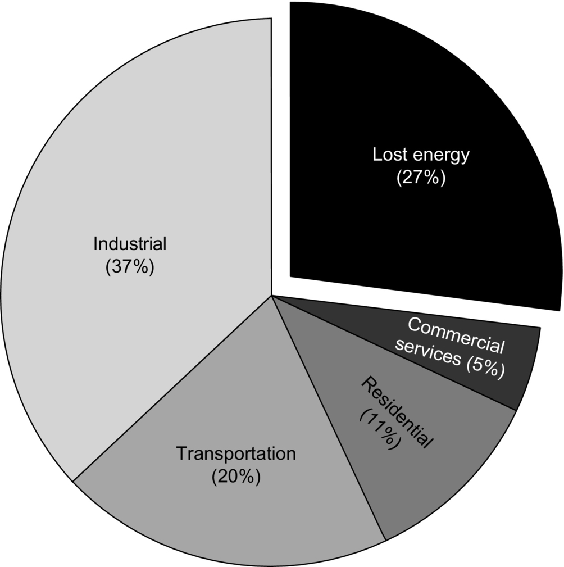

**FIG. 23.1** Percentage share of sectors on energy consumption.

According to [Fig. 23.1](https://learning.oreilly.com/library/view/power-electronics-handbook/9780128114087/B9780128114070000258.xhtml#f0010), the generation and transmission losses are considerably high. In order to generate 2 TW of electric power, approximately 5 TW of power is required. This is due to the fact that efficiency of a typical power plant is around 38% [[5](https://learning.oreilly.com/library/view/power-electronics-handbook/9780128114087/B9780128114070000258.xhtml#bb0030)]. [Fig. 23.1](https://learning.oreilly.com/library/view/power-electronics-handbook/9780128114087/B9780128114070000258.xhtml#f0010) also imposes that more than a quarter of the produced energy is lost in low efficient conventional energy conversion systems and transmission lines. This issue encourages the increased focus on high efficient renewable energy systems, which may also reduce or eliminate the transmission losses if they are built as distributed energy generation units. In comparison with the efficiency of conventional power plants, new generation of power plants using gas turbines or microturbines may reach a substantially higher efficiency of 55%; however, they still rely on another fossil fuel, which is natural gas [[6](https://learning.oreilly.com/library/view/power-electronics-handbook/9780128114087/B9780128114070000258.xhtml#bb0035)].

After the invention of steam engines, coal began to be the main source of energy in the eighteenth and nineteenth centuries. Since automobiles were invented and electricity usage became more common, coal left its popularity to the oil during the twentieth century. From 1920 to 1973, oil was the main resource fueling the industry and transportation, and its price steadily dropped during these years. Oil kept its expansiveness until the 1970s. In the oil crises of 1973 and 1979, price per barrel boosted from 5 to $45, and oil was not the best and most common source of energy production anymore [[7](https://learning.oreilly.com/library/view/power-electronics-handbook/9780128114087/B9780128114070000258.xhtml#bb0040)]. From these dates, coal and nuclear became the sources for electric power generation. In those years, energy conversation and increasing the energy efficiency gained importance. However, the use of fossil fuels has continued over the last 30 years, and their contribution to overall energy production has increased. During the last 3 years, coal has become the fastest growing fossil fuel, since it has large remaining reserves [[7](https://learning.oreilly.com/library/view/power-electronics-handbook/9780128114087/B9780128114070000258.xhtml#bb0040)]. On the other hand, renewable energy sources have gained interest due to the depletion of fossil fuels, followed by high oil prices, and climate change concerns related to the carbon emissions. Therefore, government support on development, deployment, incentives, and commercialization of renewable energies are ever increasing. For instance, in March 2007, it is agreed by the European Union members that at least 20% of their nations' energy should be produced from renewable sources by 2020. This is also a part of environmental concerns such as global warming [[8](https://learning.oreilly.com/library/view/power-electronics-handbook/9780128114087/B9780128114070000258.xhtml#bb0045)] and building a sustainable energy economy by reducing the nations' dependence on imported fossil fuels. However, although there is a large availability of renewable sources, their contribution to globally consumed energy is relatively poor.

In developed countries such as Germany and Japan, the national gross product is 6 kW per person and 11.4 kW per person in the United States. Bangladesh has a low consumption with 0.2 kW per person, while it is around 0.7 kW per person for a developing country such as India. Twenty-five percent of the overall world's energy is consumed by the United States, while its share of global energy generation is 22% [[4](https://learning.oreilly.com/library/view/power-electronics-handbook/9780128114087/B9780128114070000258.xhtml#bb0025)]. Energy consumption in the United States is shared by four broad sectors according to the US Department of Energy. Similar to the world's energy consumption, the largest user is the industrial sector, currently consuming 33% of the total energy. Next largest amount of energy is consumed for transportation followed by residential and commercial users. Energy consumption shares of the United States for four major energy consumption sectors (industrial, transportation, residential, and commercial) are demonstrated in [Table 23.2](https://learning.oreilly.com/library/view/power-electronics-handbook/9780128114087/B9780128114070000258.xhtml#t0015) [[4](https://learning.oreilly.com/library/view/power-electronics-handbook/9780128114087/B9780128114070000258.xhtml#bb0025),[9](https://learning.oreilly.com/library/view/power-electronics-handbook/9780128114087/B9780128114070000258.xhtml#bb0050),[10](https://learning.oreilly.com/library/view/power-electronics-handbook/9780128114087/B9780128114070000258.xhtml#bb0055)].

**Table 23.2**

**US nationwide energy consumption sectors**

|  |  |
| --- | --- |
| **Sector** | **Major use shares** |
| *Industrial*: This sector mainly consumes 33% of total energy for the manufacturing, producing, and processing goods such as chemical refining, metal production, paper, and cement production | t23-01-9780128114070 |
| *Transportation*: Twenty-eight percent of the total energy consumption is shared by this sector for land, sea, and air vehicles transporting people and goods | t23-02-9780128114070 |
| *Residential*: This sector consumes 21% of the total energy for household power requirements | t23-03-9780128114070 |
| *Commercial*: This sector includes the business, government, and other service providing institutions, facilities, and their equipments corresponding to 17% of total energy consumption | t23-04-9780128114070 |

Most of the electric power generation of the United States is provided by conventional thermal power plants. Most of these power plants are operated by coal. However, from 1990 to 2000, the number of natural gas or other types of gas-operated power plants was increased significantly. 270 GW of new gas-operated thermoelectric power plants were built in United States from 1992 to 2005. Only 14 GW capacity belonged to new nuclear and coal-fired power plants, with 2.315 GW of this amount being nuclear, while the remaining is the coal-fired power plants [[11](https://learning.oreilly.com/library/view/power-electronics-handbook/9780128114087/B9780128114070000258.xhtml#bb0060)]. The significant shift to the gas-operated power plants is due to the deregulation, political, and economic factors; however, nuclear and coal are considerably capital-intensive. On the other hand, there is a great potential for renewable energies in the United States. For instance, the US wind power capacity is close to 20 GW, which is sufficient to supply power to 4.5 million typical households [[12](https://learning.oreilly.com/library/view/power-electronics-handbook/9780128114087/B9780128114070000258.xhtml#bb0065)]. Although there is a great availability of the solar power, solar power percentage of total capacity is only 0.04% retrieved by plants that are currently in operation, including the new Nevada Solar One plant with 64 MW capacity and the largest solar thermal power station in the Mojave Desert with a total generation capacity of 354 MW, which is the world's largest solar plant [[13](https://learning.oreilly.com/library/view/power-electronics-handbook/9780128114087/B9780128114070000258.xhtml#bb0070)].

Electric power generation in the United States for 2006 is summarized in [Table 23.3](https://learning.oreilly.com/library/view/power-electronics-handbook/9780128114087/B9780128114070000258.xhtml#t0020) in terms of total capacity (MW), annual production (billion kWh), and units in operation [[14](https://learning.oreilly.com/library/view/power-electronics-handbook/9780128114087/B9780128114070000258.xhtml#bb0075)].

**Table 23.3**

**2006 Energy generation in the United States**

|  |  |  |  |
| --- | --- | --- | --- |
| **Source type** | **Total capacity (on nameplate) (MW)** | **Annual production (billions kWh)** | **Units in operation** |
| Coal-fired boiler power plants | 333,115 | 1995 | 1460 |
| Combined cycle natural gas plants | 216,269 | 505 | 1686 |
| Combustion turbine generators | 155,227 | 147 | 2882 |
| Nuclear power plants | 105,584 | 787 | 104 |
| Natural-gas-fueled boiler plants | 97,632 | 159 | 776 |
| Hydroelectric power plants | 96,988 | 282 | 4138 |
| Oil-fired boiler power plants | 34,975 | 7.8 | 327 |
| Wind power | 11,603 | 30.3 | 341 |
| Diesel generators | 8563 | 13.8 | 4514 |
| Biomass | 6256 | 53.5 | 270 |
| Geothermal | 3170 | 13.5 | 215 |
| Incinerators | 2671 | 12.3 | 96 |
| Petroleum-coke-fueled power plants | 1754 | 46.4 | 31 |
| Fuel oil power plants | 956 | 8.5 | 13 |
| Solar energy | 411 | 2.1 | 31 |

According to [Table 23.3](https://learning.oreilly.com/library/view/power-electronics-handbook/9780128114087/B9780128114070000258.xhtml#t0020), it is seen that the most contributing power source to the US energy production is the coal-fired thermoelectric power plants. Although the established power capacity of the nuclear power plants is less than that of the combined cycle natural gas plants and combustion turbine generators, nuclear power plants are the second greatest source in annual energy production. This is due to the higher efficiency of these plants and under-capacity operation of natural gas power plants and combustion turbine generators. Other than the nuclear power plants and fossil-fueled power plants, hydroelectric power plants have a significant contribution to the annual production although they require a relatively large number of units in operation. This is mainly due to the relatively lower power capacity of the hydroelectric power plants. Renewable energy sources of wind and solar still have insignificant number of units in operation, and their annual contribution is considerably insignificant to the nation's total energy production although the available potential capacity of these sources are really high.

The energy production rates of energy sources are given in [Fig. 23.2](https://learning.oreilly.com/library/view/power-electronics-handbook/9780128114087/B9780128114070000258.xhtml#f0015) [[14](https://learning.oreilly.com/library/view/power-electronics-handbook/9780128114087/B9780128114070000258.xhtml#bb0075)].

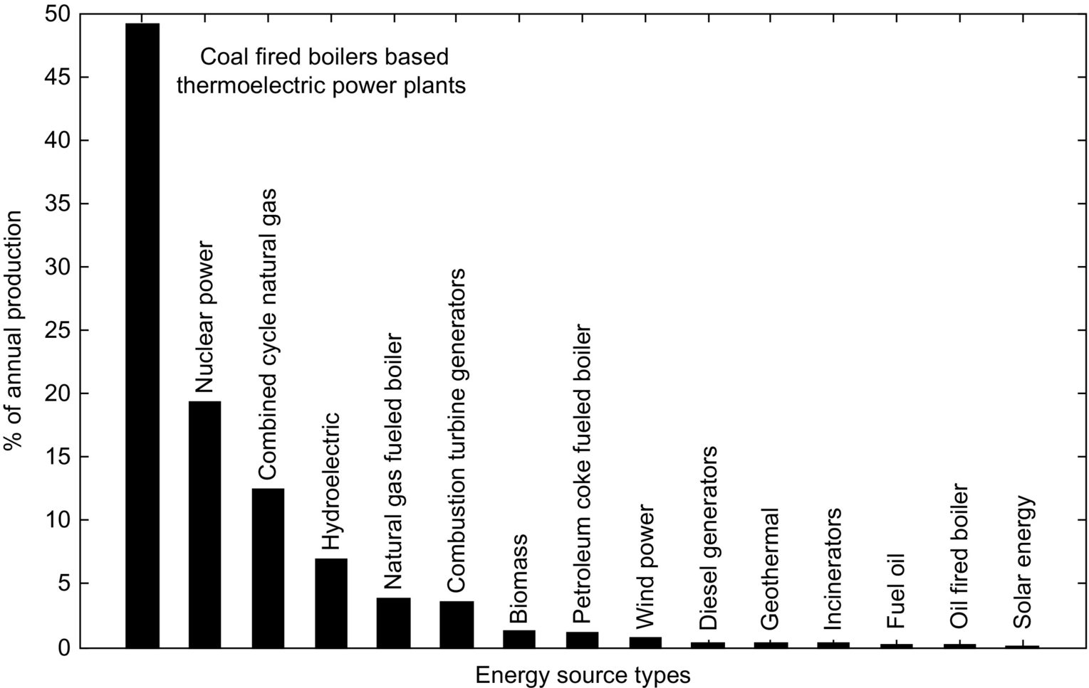

**FIG. 23.2** Percentage of the energy sources to the annual energy generation.

The energy demand of the world is rapidly and steadily increasing. In 2007, the electric power demand of the United States was 783 GW in summer and 640 GW in the winter. It is projected by the North American Electric Reliability Corporation (NERC) that the electric power demand of the United States will increase to 925 GW for summer and 756 GW winter in 2017 [[15](https://learning.oreilly.com/library/view/power-electronics-handbook/9780128114087/B9780128114070000258.xhtml#bb0080)]. Therefore, environmental concerns on global warming and sustainability along with the political considerations on the supplies' security will shift the overall energy consumption away from the fossil fuels. Nowadays, many researchers and politicians call for immediate actions for long-term sustainable energy solutions. Based on a growing consensus, peak oil may be reached in the near future, and this will result in severe oil price increases [[16](https://learning.oreilly.com/library/view/power-electronics-handbook/9780128114087/B9780128114070000258.xhtml#bb0085)]. If a long-term solution cannot be developed prior to the peak oil scenario, the world economy may face a grinding halt.

This chapter focuses on naturally available energy sources and deals with the efficient utilization of these sources. Moreover, renewable and sustainable energy generation techniques are discussed in this chapter. In addition, the operating principles, efficient utilization, and grid-connection issues as well as power electronic interfaces for these renewable energy sources are demonstrated. While inventing new methodologies to maximize the efficient usage of traditional sources such as coal, oil, and natural gas, it is of great importance to develop new technologies to produce emerging sources of energy from renewables.

Consequently, by efficient use of conventional energy sources and utilizing alternate sources of energy, the reserves of the conventional energy resources can last for longer, global warming can be slowed down, and environmental pollution can be reduced [[17](https://learning.oreilly.com/library/view/power-electronics-handbook/9780128114087/B9780128114070000258.xhtml#bb0090)].

## 23.2 Available Energy Sources

Primary sources of energy are fossil fuels such as oil, natural gas, coal, and other sources such as nuclear, solar, wind, hydroelectricity, or potential sources available in oceans. The energy that has not been converted or transformed into another form is known as primary energy source. More convenient form of energy such as electric energy is obtained by transforming primary energies in energy conversion processes. These converted forms are called as secondary energy sources.

### 23.2.1 COAL

Coal is the most abundant fossil fuel of the world with around 909 billion tons of reserves. It is expected to sustain for the next 155 years at the current production rate [[4](https://learning.oreilly.com/library/view/power-electronics-handbook/9780128114087/B9780128114070000258.xhtml#bb0025)]. Coal is the fastest growing fossil fuel to meet the energy demand of the global community. However, coal is the dirtiest energy source with numerous pollutants and high emissions [[11](https://learning.oreilly.com/library/view/power-electronics-handbook/9780128114087/B9780128114070000258.xhtml#bb0060)].

### 23.2.2 OIL

It is estimated that there is 57 ZJ of oil reserves on Earth. This amount includes the available but not necessarily recoverable reserves. Other estimates vary from 8 ZJ including currently proved and recoverable reserves to a maximum of 110 ZJ including nonrecoverable reserves [[18](https://learning.oreilly.com/library/view/power-electronics-handbook/9780128114087/B9780128114070000258.xhtml#bb0095)]. World's current oil consumption is 85 mbd, and it is estimated that the peak consumption will be 93 mbd in 2020. Oil and its chemical derivatives are mainly used for transportation and electric power generation.

### 23.2.3 NATURAL GAS

There is not any certain number indicating world's available natural gas reserves. However, according to the US Energy Information Administration, there are 237,726 billion cubic feet (cu-ft) of dry natural gas reserves in the United States, while the liquid natural gas reserves are of 9143 million barrels [[19](https://learning.oreilly.com/library/view/power-electronics-handbook/9780128114087/B9780128114070000258.xhtml#bb0100)]. Natural gas has become one of the major sources of electric power generation through the steam turbines and gas turbines due to their higher efficiency. Natural gas is cleaner than any other fossil fuels and produces fewer pollutants per generated unit energy. Burning natural gas produces about 30% less carbon dioxide than burning petroleum and about 45% less than burning coal for an equivalent amount of heat [[20](https://learning.oreilly.com/library/view/power-electronics-handbook/9780128114087/B9780128114070000258.xhtml#bb0105)]. Some of the natural gas power plants are operated in combined cycle mode to obtain higher efficiencies. In this operation, gas turbines are combined with the steam turbines in order to get the benefit of waste heat using steam turbines.

### 23.2.4 HYDROPOWER

Hydroelectric power plants supplied 16.4% of the world's electric power in 2005 [[21](https://learning.oreilly.com/library/view/power-electronics-handbook/9780128114087/B9780128114070000258.xhtml#bb0110)]. The hydroelectric power is not an effective solution, since most of the potential sites are already in use or they are not feasible to be exploited due to environmental and economical concerns. In addition, the life span of hydroelectric power plants is limited, due to soil erosion and accumulation. Because of these concerns, the construction of large hydroelectric power plants has stagnated. The new trend all over the world has been building smaller hydro power units called as *microhydro* since they can be a part of distributed generation, opening up many locations for power generation and they have less or negligible environmental effects [[22](https://learning.oreilly.com/library/view/power-electronics-handbook/9780128114087/B9780128114070000258.xhtml#bb0115),[23](https://learning.oreilly.com/library/view/power-electronics-handbook/9780128114087/B9780128114070000258.xhtml#bb0120)]. On the other hand, hydroelectric power plants have no emissions since no fuel is burnt. Hence, hydropower is a clean energy source in comparison with fossil-fuel-based energy sources. In 2005, the worldwide hydroelectricity consumption reached 816 GW with 66 GW of small hydro plants and 750 GW of large plants [[24](https://learning.oreilly.com/library/view/power-electronics-handbook/9780128114087/B9780128114070000258.xhtml#bb0125)].

### 23.2.5 NUCLEAR POWER

In 2006, 16% of the world's total electric power production was supplied by nuclear power that is accounted 2658 TWh [[11](https://learning.oreilly.com/library/view/power-electronics-handbook/9780128114087/B9780128114070000258.xhtml#bb0060),[25](https://learning.oreilly.com/library/view/power-electronics-handbook/9780128114087/B9780128114070000258.xhtml#bb0130),[26](https://learning.oreilly.com/library/view/power-electronics-handbook/9780128114087/B9780128114070000258.xhtml#bb0135)]. Total power capacity of the established nuclear power plants was about 372 GW by November 2007 [[25](https://learning.oreilly.com/library/view/power-electronics-handbook/9780128114087/B9780128114070000258.xhtml#bb0130)]. The remaining uranium resources are estimated to be 2500 ZJ by the International Atomic Energy Agency [[27](https://learning.oreilly.com/library/view/power-electronics-handbook/9780128114087/B9780128114070000258.xhtml#bb0140)]. Since there is plenty of available sources and developed technology, the contribution of nuclear power to the future's energy demand is not limited. However, there are political and environmental constraints, which restrict the growth of nuclear power plants. The cost of generating nuclear power is approximately equal to that of the coal power. Moreover, nuclear power has zero pollutant emissions such as CO, CO2, NO, and SO2.

### 23.2.6 SOLAR

Earth receives around 120,000 TW of solar energy resource per year. As an energy source, less than 0.02% of available solar resources are capable of entirely replacing all nuclear power and fossil fuels [[28](https://learning.oreilly.com/library/view/power-electronics-handbook/9780128114087/B9780128114070000258.xhtml#bb0145),[29](https://learning.oreilly.com/library/view/power-electronics-handbook/9780128114087/B9780128114070000258.xhtml#bb0150)]. Although it is still expensive in comparison with conventional energy conversion techniques, the fastest growing energy source in 2007 were grid-connected photovoltaic (PV) systems. The total installed capacity reached to 8.7 GW by increasing all PV installations by 83% in 2007 [[30](https://learning.oreilly.com/library/view/power-electronics-handbook/9780128114087/B9780128114070000258.xhtml#bb0155)]. High cost of manufacturing solar cells, reliance on weather conditions, storage, and grid-connection problems are the major barriers of further development of solar generation.

### 23.2.7 WIND

Wind is one of the greatest available potential energy sources. The available wind energy is estimated to be from 300 [[31](https://learning.oreilly.com/library/view/power-electronics-handbook/9780128114087/B9780128114070000258.xhtml#bb0160)] to 870 TW [[32](https://learning.oreilly.com/library/view/power-electronics-handbook/9780128114087/B9780128114070000258.xhtml#bb0165)]. Only 5% of the available energy is capable of supplying the current worldwide energy demands. However, due to fewer obstacles, most of this wind energy is available on the open oceans on which construction of wind turbines and energy transmission is relatively difficult and expensive. From 2006 to 2007, the installed wind turbines' capacity was increased by 27% to total of 94 GW according to the Global Wind Energy Council [[33](https://learning.oreilly.com/library/view/power-electronics-handbook/9780128114087/B9780128114070000258.xhtml#bb0170)]. However, the actual generated power is less than the nominal capacity since the nominal capacity represents the peak output, and the actual output is around 40% of the nominal capacity due to efficiency issues and lower wind speeds [[34](https://learning.oreilly.com/library/view/power-electronics-handbook/9780128114087/B9780128114070000258.xhtml#bb0175)].

### 23.2.8 OCEAN

Energy of ocean can be categorized in three major methods: *ocean wave power*, *ocean tidal power*, and *ocean thermal power*. All of these three methods can be installed as onshore or offshore applications.

Wave energy harvesting is a concept that the kinetic energy of waves of the deep water or waves hitting the shores is captured and converted to electric energy. The kinetic energy of waves is converted to electric energy using several different methods. It is estimated that the deep-water wave power resources vary from 1 to 10 TW [[35](https://learning.oreilly.com/library/view/power-electronics-handbook/9780128114087/B9780128114070000258.xhtml#bb0180)], while the total power of the waves hitting the shores may add an additional power of 3 TW [[31](https://learning.oreilly.com/library/view/power-electronics-handbook/9780128114087/B9780128114070000258.xhtml#bb0160),[36](https://learning.oreilly.com/library/view/power-electronics-handbook/9780128114087/B9780128114070000258.xhtml#bb0185)]. Capturing this entire amount of power is not practical and feasible. It is estimated that 2 TW of this power can be usefully captured [[37](https://learning.oreilly.com/library/view/power-electronics-handbook/9780128114087/B9780128114070000258.xhtml#bb0190),[38](https://learning.oreilly.com/library/view/power-electronics-handbook/9780128114087/B9780128114070000258.xhtml#bb0195)].

Ocean tides occur due to the tidal forces of the moon and the sun, in combination with the earth's rotation. Tidal power has a great potential for future energy generation since it is cleaner in comparison with fossil fuels and it is more predictable in comparison with other renewable energies such as wind and solar. The kinetic energy of the moving water can be captured by tidal stream or tidal current turbines. Alternatively, the barrages can be used to capture the potential energy created due to the height difference between the low and high tides. Various methods can be employed for the realization of these concepts. The total estimated tidal power potential is 3.7 TW [[39](https://learning.oreilly.com/library/view/power-electronics-handbook/9780128114087/B9780128114070000258.xhtml#bb0200)]. However, only around 0.8 TW of this amount is available due to the dissipation of tidal fluctuations. The amount of energy generated from ocean tides was 0.3 GW at the end of 2005 [[40](https://learning.oreilly.com/library/view/power-electronics-handbook/9780128114087/B9780128114070000258.xhtml#bb0205)], which is much less than the available potential.

The other way of generating power from the oceans is the ocean thermal energy conversion (OTEC). In this method, the temperature difference between the warm shallow water and the cold deep water is used to drive a heat engine, which in turn drives an electric generator [[41](https://learning.oreilly.com/library/view/power-electronics-handbook/9780128114087/B9780128114070000258.xhtml#bb0210)]. The efficiency of OTEC power plants is relatively low [[41](https://learning.oreilly.com/library/view/power-electronics-handbook/9780128114087/B9780128114070000258.xhtml#bb0210),[42](https://learning.oreilly.com/library/view/power-electronics-handbook/9780128114087/B9780128114070000258.xhtml#bb0215)] due to the power requirements of the auxiliary OTEC devices such as water intake and discharge pumps. Moreover, this technique is expensive since the efficiency is low and greater capacities of installations are required to produce reasonable amounts of energy [[43](https://learning.oreilly.com/library/view/power-electronics-handbook/9780128114087/B9780128114070000258.xhtml#bb0220)].

### 23.2.9 HYDROGEN

Hydrogen is an energy carrier [[44](https://learning.oreilly.com/library/view/power-electronics-handbook/9780128114087/B9780128114070000258.xhtml#bb0225),[45](https://learning.oreilly.com/library/view/power-electronics-handbook/9780128114087/B9780128114070000258.xhtml#bb0230)]; in other words, it is an intermediate medium for energy storage and carriage. Hydrogen is the most abundant element of the Earth (approximately corresponding 75% of the elemental mass of the universe) [[46](https://learning.oreilly.com/library/view/power-electronics-handbook/9780128114087/B9780128114070000258.xhtml#bb0235)], and it is the simplest and lightest element of all chemical elements with an atomic number of 1. Hydrogen exists in nature in combination with other elements such as carbon and nitrogen in fossil fuels, biological materials, or with oxygen in water [[47](https://learning.oreilly.com/library/view/power-electronics-handbook/9780128114087/B9780128114070000258.xhtml#bb0240)]. Hydrogen can be combusted in air, or it can react with oxygen using fuel cells to produce energy. The resultant combustion energy or electric energy does not cause any CO or CO2 emissions. However, splitting hydrogen from the combination of other elements require additional energy. The main source of global hydrogen production is natural gas (48%). Other sources of hydrogen production are oil (30%), coal (18%), and water electrolysis (4%) [[48](https://learning.oreilly.com/library/view/power-electronics-handbook/9780128114087/B9780128114070000258.xhtml#bb0245)]. Currently, most of the hydrogen is produced from gas derivatives such as natural gas, ethane, methane, ethanol, or methanol. Hydrogen production from fossil fuels, known as reformation, contains several pollutant emissions. Although electrolysis is clean, this method has various challenges and still has very poor efficiencies and high production costs. Biological or fermentative reactions can be another method of hydrogen production; however, this method has some obstacles such as the amount of products is not significant [[48](https://learning.oreilly.com/library/view/power-electronics-handbook/9780128114087/B9780128114070000258.xhtml#bb0245),[49](https://learning.oreilly.com/library/view/power-electronics-handbook/9780128114087/B9780128114070000258.xhtml#bb0250)]. Using hydrogen in hydrogen combustion engines is several percent more efficient than the conventional internal combustion engines. On the other hand, using hydrogen in the fuel cells is twice or three times more efficient than that of the internal combustion engines. However, there are several challenges for the commercialization of fuel cells such as the size, weight, cost, and durability. Other major technical difficulties related to hydrogen are the production, delivery, and storage issues.

### 23.2.10 GEOTHERMAL

Geothermal energy is the utilization of heat stored in the inner layers of the earth or collecting the absorbed heat derived from underground. The geothermal energy production has reached to 37.3 GW at the end of 2005 [[24](https://learning.oreilly.com/library/view/power-electronics-handbook/9780128114087/B9780128114070000258.xhtml#bb0125)]. 9.3 GW of this amount is used for electric power generation, while the rest of it is used for residential or commercial heating purposes. Enhanced geothermal systems (EGS) is a technique that extends the potential for the use of geothermal energy. In this technique, the heat is extracted by building subsurface fractures to which water can be added through injection wells. Through this technique, the electric generation capacity can reach to about 138 GW [[50](https://learning.oreilly.com/library/view/power-electronics-handbook/9780128114087/B9780128114070000258.xhtml#bb0255)]. The overall EGS capacity of the world is calculated to be more than 13 YJ, where 200 ZJ of this amount is extractable. By the technological improvements and investments, this amount is projected to increase over 2 YJ [[51](https://learning.oreilly.com/library/view/power-electronics-handbook/9780128114087/B9780128114070000258.xhtml#bb0260)]. However, in contrary to this enormous potential, geothermal supplies less than 1% of the world's energy demand as of 2008 [[21](https://learning.oreilly.com/library/view/power-electronics-handbook/9780128114087/B9780128114070000258.xhtml#bb0110)]. Geothermal energy has high availability (average daily availabilities more than 90%) and in fact has no pollutant emissions since it does not require any fuel or combustion. Furthermore, geothermal power stations do not rely on weather conditions. In addition, it is considered to be a sustainable source of energy since the extracted heat is relatively small in comparison with the heat reservoir's size. In other words, geothermal heat energy is replenished from deeper layers of the earth; therefore, it is not exhaustible.

### 23.2.11 BIOMASS

Biomass is a fuel that is also called biofuel, and the bioenergy is the energy enclosed in the biomass. Today, biomass has a small contribution to the overall energy supply, although it was the major fuel until the nineteenth century. In 2005, electric power from biomass was about 44 GW, while more than 230 GW biomass power is used for heating [[40](https://learning.oreilly.com/library/view/power-electronics-handbook/9780128114087/B9780128114070000258.xhtml#bb0205)]. As a sustainable energy source, biomass is a developing industry in many countries such as Brazil, the United States, and Germany. As an alternative to the fossil fuels, biomass production is significantly increasing worldwide. The biodiesel production increased by 85% to 1.03 billion gallons in 2005, and biodiesel became the world's fastest growing renewable source of energy. Bioethanol production was also increased by 8% and reached 8.72 billion gallons during 2005 [[40](https://learning.oreilly.com/library/view/power-electronics-handbook/9780128114087/B9780128114070000258.xhtml#bb0205)]. Even though it is commonly believed that biomasses may be carbon neutral, their current farming methods cause substantial carbon emissions [[52](https://learning.oreilly.com/library/view/power-electronics-handbook/9780128114087/B9780128114070000258.xhtml#bb0265),[53](https://learning.oreilly.com/library/view/power-electronics-handbook/9780128114087/B9780128114070000258.xhtml#bb0270)].

## 23.3 Electric Energy Generation Technologies

Electric energy generation is a process where the energy sources or energy potential is converted to electric energy. Energy generation can be done in various techniques. Due to the upcoming emerging challenges in the global energy supply systems, energy from the conventional sources needs more efficiency. In addition, there should be an increase in utilization of energy generation from alternative and renewable energy sources. In the following subsections, the alternative energy sources along with their conversion to electric energy are described.

### 23.3.1 THERMOELECTRIC ENERGY

Thermoelectric power plants are mainly coal-fired power stations. In a thermoelectric power plant, coal or other fuels are burnt in order to heat up the water in the boiler. In this system, the high pressurized steam rotates a steam turbine, which is coupled to an electric generator. After the steam passes through the turbine, it is cooled and condensed back to water in the condenser. This is known as Rankine cycle [[54](https://learning.oreilly.com/library/view/power-electronics-handbook/9780128114087/B9780128114070000258.xhtml#bb0275)]. More than 80% thermal power plants all over the world operate based on this cycle. In the Rankine cycle, there are four processes in which the working fluid's state is changed as shown in [Fig. 23.3](https://learning.oreilly.com/library/view/power-electronics-handbook/9780128114087/B9780128114070000258.xhtml#f0020) [[55](https://learning.oreilly.com/library/view/power-electronics-handbook/9780128114087/B9780128114070000258.xhtml#bb0280)]. These processes can be described as follows [[56](https://learning.oreilly.com/library/view/power-electronics-handbook/9780128114087/B9780128114070000258.xhtml#bb0285),[57](https://learning.oreilly.com/library/view/power-electronics-handbook/9780128114087/B9780128114070000258.xhtml#bb0290)]:

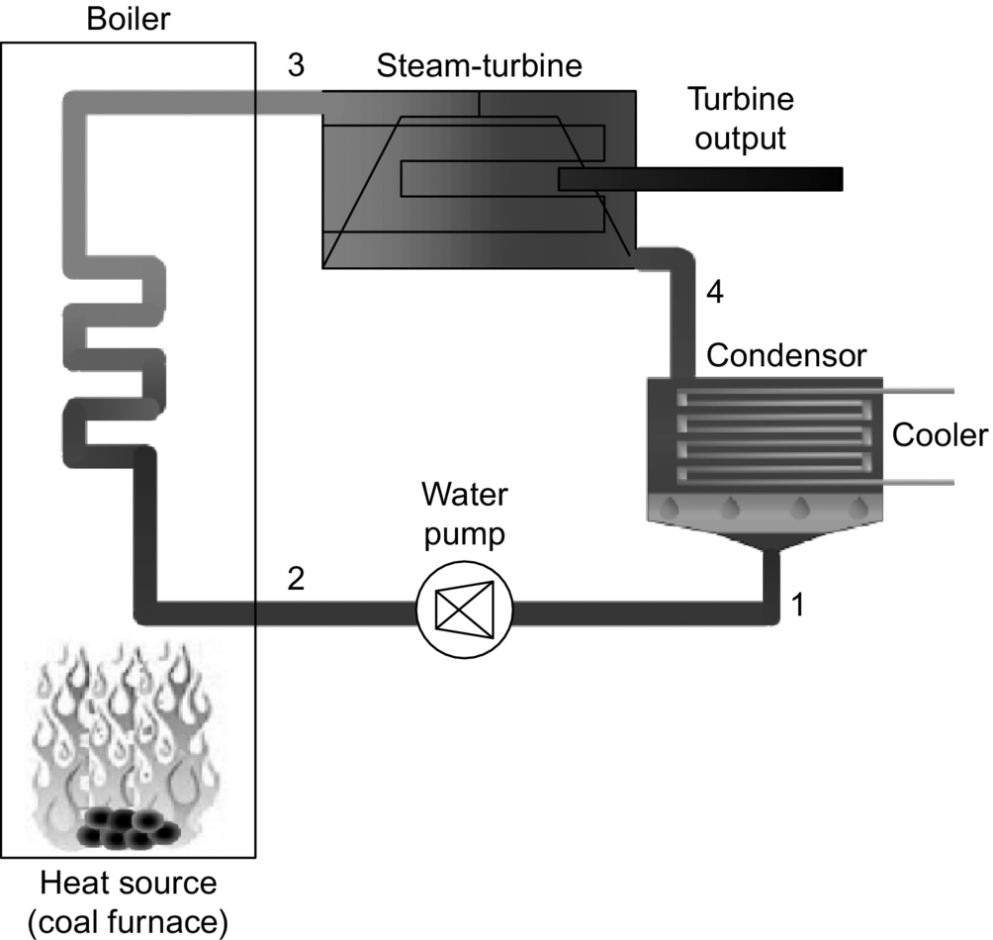

**FIG. 23.3** Rankine cycle block diagram.

*Process 1–2:* When the fluid is condensed and converted to liquid form, the liquid is pumped from low to high pressure. The pumping process requires a small amount of energy.

*Process 2–3:* The high-pressure liquid that pumped into the boiler is heated at constant pressure until it becomes saturated dry vapor. The boiler is energized by a heat source such as a coal furnace.

*Process 3–4:* During this process, saturated vapor passes through the steam turbine. The heat energy is converted into mechanical energy. While the steam passes through the turbine, it may somehow get condensed since this process decreases the pressure and temperature of the vapor.

*Process 4–1:* In this process, the vapor is condensed at a constant pressure and temperature in a condenser. As a result, wet vapor is converted to saturated liquid. The cooler helps keeping the temperature constant as the vapor changes its phase from steam to liquid.

These four processes of the Rankine cycle are shown in [Fig. 23.3](https://learning.oreilly.com/library/view/power-electronics-handbook/9780128114087/B9780128114070000258.xhtml#f0020).

Since coal is the most abundant energy source of the world, coal-fired power plants have been widely used in electric power generation all over the world [[58](https://learning.oreilly.com/library/view/power-electronics-handbook/9780128114087/B9780128114070000258.xhtml#bb0295)]. Coal is a cheap energy source, and coal-fired power plants have mature technology. Therefore, the generation cost is less, and thermoelectric power plants can be constructed anywhere close to fuel and water supply. Although the consumption sites might be relatively far away from the coal mines or water supplies, fuel and water can be transported to the generation plants. Since the coal has been the backbone of the electric power industry since the late 1800s, approximately 49% of the electric power generated in the world is supplied by coal-fired thermoelectric power plants [[59](https://learning.oreilly.com/library/view/power-electronics-handbook/9780128114087/B9780128114070000258.xhtml#bb0300)].

In a simple form, the operation of a coal-fired power plant can be similar to Rankine cycle. In this form, the plant consists of a boiler, a steam turbine driving an electric generator, a condenser, and a feedwater pump. Coal is first pulverized and burnt in the steam generation furnaces. The water in the boiler tubes is heated, and steam is generated in this way at high pressures. The steam generation process is composed of three subprocesses that are economizing, boiling, and superheating. In the economizer, the water is heated to a point that is close to the boiling point. Then, the steam is raised in the boiler. Finally, the steam is further heated and dried at the superheater. The steam at its final form is then conveyed to the steam turbine. The mechanical force pushing the turbine blades yields the steam turbine to rotate, which in turn drives the electric generator producing electricity. The cooler steam with lower pressure is released from the turbine. This steam is conveyed to the condenser to be liquefied. This water is pumped back to the steam generator, and the closed loop system is completed [[56](https://learning.oreilly.com/library/view/power-electronics-handbook/9780128114087/B9780128114070000258.xhtml#bb0285)]. Considering the other auxiliary devices and peripheral components such as cooling tower, coal conveyor, and ash and waste management units, the schematic of a coal-fired thermoelectric power plant can be presented in [Fig. 23.4](https://learning.oreilly.com/library/view/power-electronics-handbook/9780128114087/B9780128114070000258.xhtml#f0025).

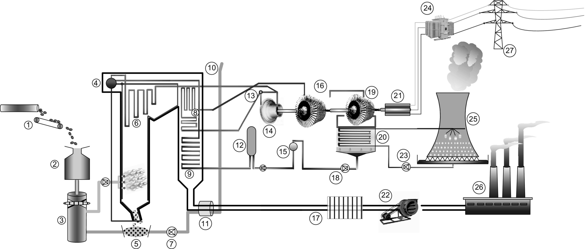

**FIG. 23.4** Schematic diagram of the thermoelectric power plant.

The components of the thermoelectric power plant are described in [Table 23.4](https://learning.oreilly.com/library/view/power-electronics-handbook/9780128114087/B9780128114070000258.xhtml#t0025).

**Table 23.4**

**Thermoelectric power plant components**

|  |  |  |
| --- | --- | --- |
| 1—Coal conveyor | 10—Air intake pipe | 19—Low-pressure turbine |
| 2—Coal hopper | 11—Air preheater | 20—Condenser |
| 3—Pulverization mill | 12—Feed heater | 21—Electric generator |
| 4—Boiler drum | 13—Steam governor | 22—Induced draught fan |
| 5—Ash hopper | 14—High-pressure turbine | 23—Cooling water pump |
| 6—Superheater | 15—Deaerator | 24—Power transformer |
| 7—Forced draught fan | 16—Intermediate-pressure turbine | 25—Cooling tower |
| 8—Reheater | 17—Precipitator | 26—Chimney stack |
| 9—Economizer | 18—Boiler feed pump from condenser | 27—Transmission network |

The operation of the cola-fired power plant begins with the coal conveyor. From an exterior stack, coal is conveyed through a coal hopper to the pulverizing fuel mill where it is grounded and converted to a fine powder. The pulverized coal is mixed with preheated air. The air is taken by an air intake pipe and pumped to be mixed with pulverized coal. This preheated air is supplied by the forced draught fan. In the boiler, where the air-fuel mixture is ignited at high pressure, the generated heat increases the temperature of the water. The water then changes its phase to steam where it flows vertically up the boiler tubes. This steam is passed to the boiler drum where its remaining water content is separated. This dry steam is then passed through a manifold from the drum into the superheater. In the superheater, further pressure and temperature increase; steam reaches about 200 bar and C. The turbine process of the power plant comprises three stages: high-pressure turbine, intermediate-pressure turbine, and low-pressure turbine. First, the steam passes to the high-pressure turbine through the pipes. Both the manual turbine control and the automatic set-point following can be provided by a steam governor valve. The temperature and the pressure of the steam decrease when it is exhausted from the high-pressure turbine. This steam is returned to the boiler reheater for further use. The reheated steam passes to the intermediate-pressure turbine. The steam released from the intermediate-pressure turbine is passed directly to the low-pressure turbine. Now, the steam is cooler and just above its boiling point. This steam is then condensed in the condenser by contacting thermally with the cold water tubes of the condenser. As a result, the steam is converted back into water, and the condensation causes a vacuum effect inside the condenser chest. The condensed water is prewarmed by the feed heater using the heat of the steam released from the high-pressure turbine and then in the economizer. Then, this prewarmed water is deaerated and passed by a feedwater pump, which completes the closed cycle. The cooling tower cools down the water from the condenser creating an intense and visible plume. Finally, the water is pumped back to the cooling water cycle. The induced draft fan draws the exhaust gas of the boiler. Here, an electrostatic precipitator is used. Finally, this exhaust gas is vented through the chimneys of the power plant.

In the thermoelectric power plants, load-following capability, efficiency, fuel and water management, and emissions are important issues. In addition, the active and reactive outputs of the power plant's generators and frequency and voltage regulations have impact on the power plant operation.

### 23.3.2 HYDROELECTRIC ENERGY

Hydroelectric energy is generated by the kinetic and potential energy of flowing or falling water by the effect of gravitational force. Hydroelectric is the most mature and widest utilized form of renewable energies. Hydroelectric energy has approximately 20% contribution to the overall world energy generation [[60](https://learning.oreilly.com/library/view/power-electronics-handbook/9780128114087/B9780128114070000258.xhtml#bb0305)]. No fuel is burnt at hydroelectric power plants; therefore, they do not have greenhouse gas emissions. The operating cost is relatively low since the water running the plant is supplied free by the nature. It is a renewable source of energy since the rainfall renews and enriches the water reservoirs.

Hydroelectric energy is generally obtained from the potential energy of dammed or reservoired water. When the water falls from a certain height of the reservoir output, it loses its potential energy and gains kinetic energy. The water flow drives a water turbine that is coupled to an electric generator, which in turn generates electricity. This generated energy is a function of the water volume and the difference between the source and outflow of the water [[61](https://learning.oreilly.com/library/view/power-electronics-handbook/9780128114087/B9780128114070000258.xhtml#bb0310)]. This height difference between the water output and turbine is called as “head.” The potential energy of the water is proportional to the head. In order to generate greater amounts of energy, the head can be increased by running the water for hydraulic turbine through a large and long pipe called as penstock [[62](https://learning.oreilly.com/library/view/power-electronics-handbook/9780128114087/B9780128114070000258.xhtml#bb0315)]. The cross-sectional view of a hydraulic dam and the hydroelectric power plant components are represented in [Fig. 23.5](https://learning.oreilly.com/library/view/power-electronics-handbook/9780128114087/B9780128114070000258.xhtml#f0030).

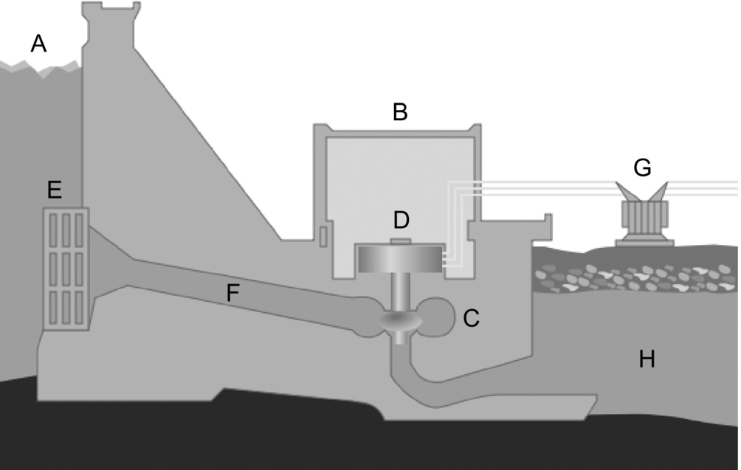

**FIG. 23.5** A hydroelectric dam and power plant components [[62](https://learning.oreilly.com/library/view/power-electronics-handbook/9780128114087/B9780128114070000258.xhtml#bb0315)].

In [Table 23.5](https://learning.oreilly.com/library/view/power-electronics-handbook/9780128114087/B9780128114070000258.xhtml#t0030), these components are explained.

**Table 23.5**

**Hydroelectric power plant components**

|  |  |
| --- | --- |
| A—Reservoir | E—Water intake |
| B—Intake | F—Penstock |
| C—Water turbine | G—Transformer and transmission lines |
| D—Electric generator | H—River |

Electric power generation in a hydroelectric power plant can be approximately calculated as [[63](https://learning.oreilly.com/library/view/power-electronics-handbook/9780128114087/B9780128114070000258.xhtml#bb0320)]:

 **(23.1)**

where *P* is the generated power (kW), *h* is the height (m), *r* is the water flow rate (m3/s), and *g* is the gravitational acceleration (m/s2). In Eq. [(23.1)](https://learning.oreilly.com/library/view/power-electronics-handbook/9780128114087/B9780128114070000258.xhtml#fo0010), the term *hrg* represents the potential energy of the water. *η*t and *η*g represent the efficiency of the water turbine and the generator, respectively. These efficiency rates are required for the water potential energy conversion into the electric energy.

The other methods of electric generation by hydroelectricity are the pumped storage hydroelectric power plants and run-of-the-river plants. In pumped storage method, the water is pumped into higher elevations by using the excess generation capacity during the periods when electric demand is lower. The water is released back into lower elevations through a turbine when the electric power demand is higher. In this method, water acts as an energy carrier in order to compensate the generation-consumption difference in a commercial device by improving the daily load factor [[61](https://learning.oreilly.com/library/view/power-electronics-handbook/9780128114087/B9780128114070000258.xhtml#bb0310)–[63](https://learning.oreilly.com/library/view/power-electronics-handbook/9780128114087/B9780128114070000258.xhtml#bb0320)]. In run-of-the-river plants, water reservoirs are not used, and the kinetic energy of the flowing water through a river is captured using waterwheels.

### 23.3.3 SOLAR ENERGY CONVERSION AND PHOTO-VOLTAIC SYSTEMS

Solar energy is one of the growing renewable energy sources, which is plentiful and has the greatest availability among other energy sources. The amount of solar energy supplied from the sun to the earth is capable of satisfying the total energy requirements of the earth for 1 year [[64](https://learning.oreilly.com/library/view/power-electronics-handbook/9780128114087/B9780128114070000258.xhtml#bb0325)]. Furthermore, solar energy does not produce pollutants or harmful by-products; it is free of emissions. Solar energy is applicable to many fields such as vehicular, residential, space, and naval applications.

#### **23.3.3.1 Photovoltaic Effect and Semiconductor Structure of PVs**

PV effect is known as a physical process in which a PV cell converts the sunlight into electricity. When a PV cell is subject to the sunlight, the absorbed amount of light generates electric energy, while remaining sunlight can be reflected or passed through. The electrons in the atoms of the PV cell are energized by the energy of the absorbed light. With this energy, these electrons move from their normal positions in the semiconductor PV material, and they create an electric flow, that is, electric current through an external electric circuit connected to the PV cell terminals. The built-in electric field that is a specific electric feature of the PV cells provides the voltage potential difference that drives the current through an external load [[65](https://learning.oreilly.com/library/view/power-electronics-handbook/9780128114087/B9780128114070000258.xhtml#bb0330)]. Two layers of different semiconductor materials are placed in contact with each other in order to induce the built-in electric field within a PV cell. The first layer that is *n-type* has abundance of electrons, and it is negatively charged. The other layer that is *p-type* has abundance of holes, and it is positively charged. Since the *n-type* silicon has excess electrons and *p-type* silicon has excess holes, contacting these layers together creates a p/n junction at their interface, thereby creating an electric field. In this contact, excess electrons move from the n-type side to the p-type side. As a result, a positive charge is built up along the n-type side of the interface and negative charge along the p-type side. Thus, an electric field is created at the surface where the layers meet, called the p/n junction. This electric field is due to the flow of electrons and holes. This electric field causes the electrons to move from the semiconductor toward the negative surface to carry current. At the same time, the holes move in the opposite direction, toward the positive surface, where they wait for incoming electrons [[65](https://learning.oreilly.com/library/view/power-electronics-handbook/9780128114087/B9780128114070000258.xhtml#bb0330)]. The basic structure of a p-n junction in a PV cell is illustrated in [Fig. 23.6](https://learning.oreilly.com/library/view/power-electronics-handbook/9780128114087/B9780128114070000258.xhtml#f0035).

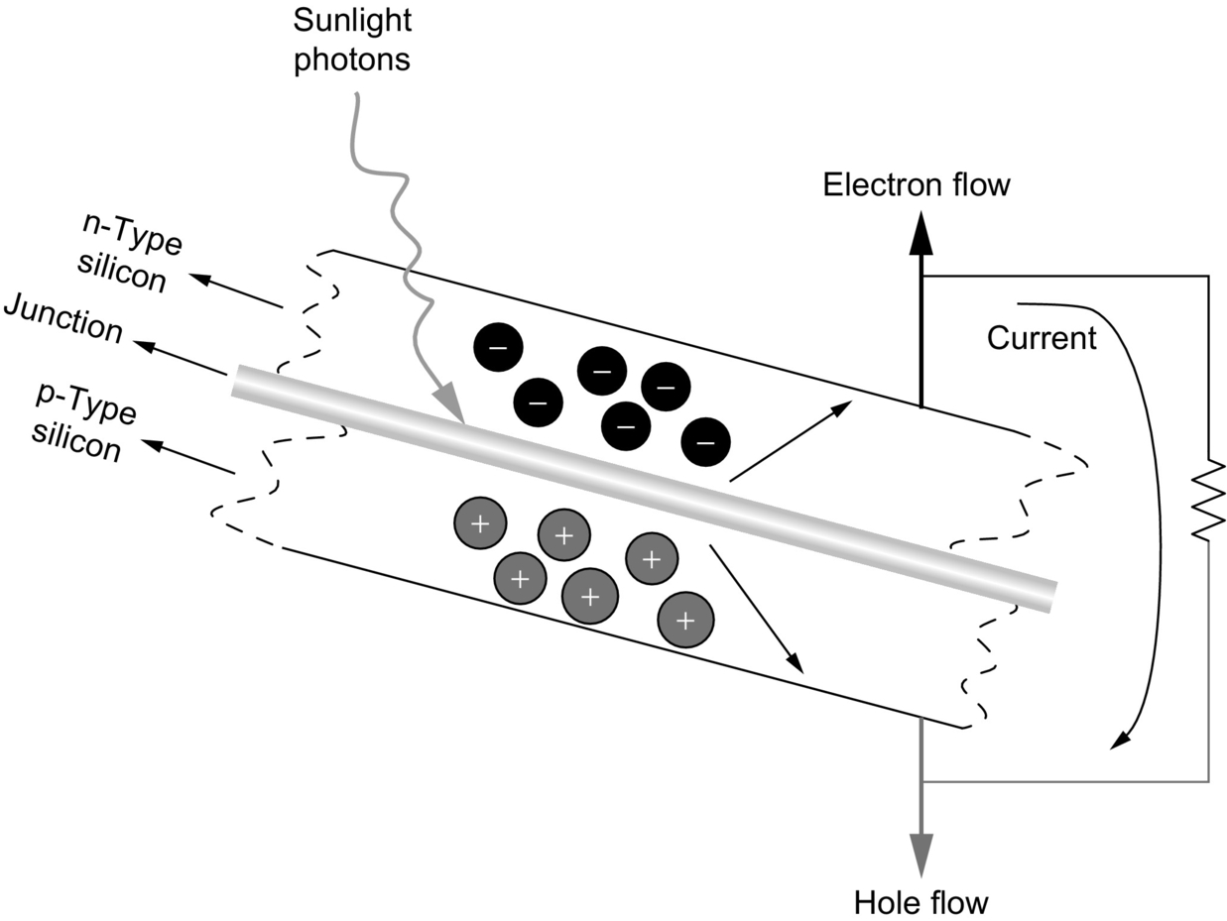

**FIG. 23.6** P-n junction structure and current flow in a PV cell.

#### **23.3.3.2 PV Cell/Module/Array Structures**

A PV or solar cell is the basic building block of a PV (or solar-electric) system. An individual PV cell is usually quite small, typically producing about 1 or 2 W of power [[66](https://learning.oreilly.com/library/view/power-electronics-handbook/9780128114087/B9780128114070000258.xhtml#bb0335)]. PV cells can be connected together to form a larger unit called modules in order to increase the power output of PV cells. Modules can be connected together and form larger units that are called arrays to generate more electric power. The output voltage of a PV system can be boosted by connecting the cells or modules in series. On the other hand, the output current can reach higher values by connecting them in parallel.

#### **23.3.3.3 Active and Passive Solar Energy Systems**

Based on the solar tracking capability, solar energy systems can be categorized into two types, passive and active systems [[67](https://learning.oreilly.com/library/view/power-electronics-handbook/9780128114087/B9780128114070000258.xhtml#bb0340),[68](https://learning.oreilly.com/library/view/power-electronics-handbook/9780128114087/B9780128114070000258.xhtml#bb0345)]. In passive solar energy systems, there are not any moving mechanisms for the panels. In this technique, the energy is absorbed and retained, and spaces are designed that naturally circulate air to transfer energy and referencing the position of a building to the sun to enhance energy capture. On the other hand, in active solar energy systems, typically, there are electric and mechanical components such as tracking mechanisms, sensors, motors, pumps, and fans to capture sunlight and process it into usable forms such as heating, lighting, and electricity. The panel positions are controlled in order to maximize exposure to the sun.

#### **23.3.3.4 Components of a Complete Solar Energy System**

In [Fig. 23.7](https://learning.oreilly.com/library/view/power-electronics-handbook/9780128114087/B9780128114070000258.xhtml#f0040), the block diagram of a solar energy system is demonstrated. In this system, the sunlight is captured by the PV array. The photodiode or photosensor signals determine the sun-tracking motor positions. This sun-tracking control helps following the daily and seasonal solar position changes to face the sun directly and capture the most available sunlight. A dc/dc converter is employed at the PV panels' output in order to operate at the maximum power point (MPP) based on the current-voltage (*I*-*V*) characteristics of the PV array [[69](https://learning.oreilly.com/library/view/power-electronics-handbook/9780128114087/B9780128114070000258.xhtml#bb0350)]. This dc/dc converter is controlled to operate at the desired current and voltage output of the PV array. A dc/ac inverter is usually connected to the output of this MPPT dc/dc converter in order to feed the ac loads for grid interconnection. A battery pack can be connected to the dc bus of the system to provide extra power that might not be available from the PV module during night and cloudy periods. The battery pack can also store energy when the PV module generates more power than the demanded. A grid connection is also useful to draw/inject power from/to the utility network to take the advantage of excess power or to recharge the batteries using grid power during the peak-off periods of the utility network.

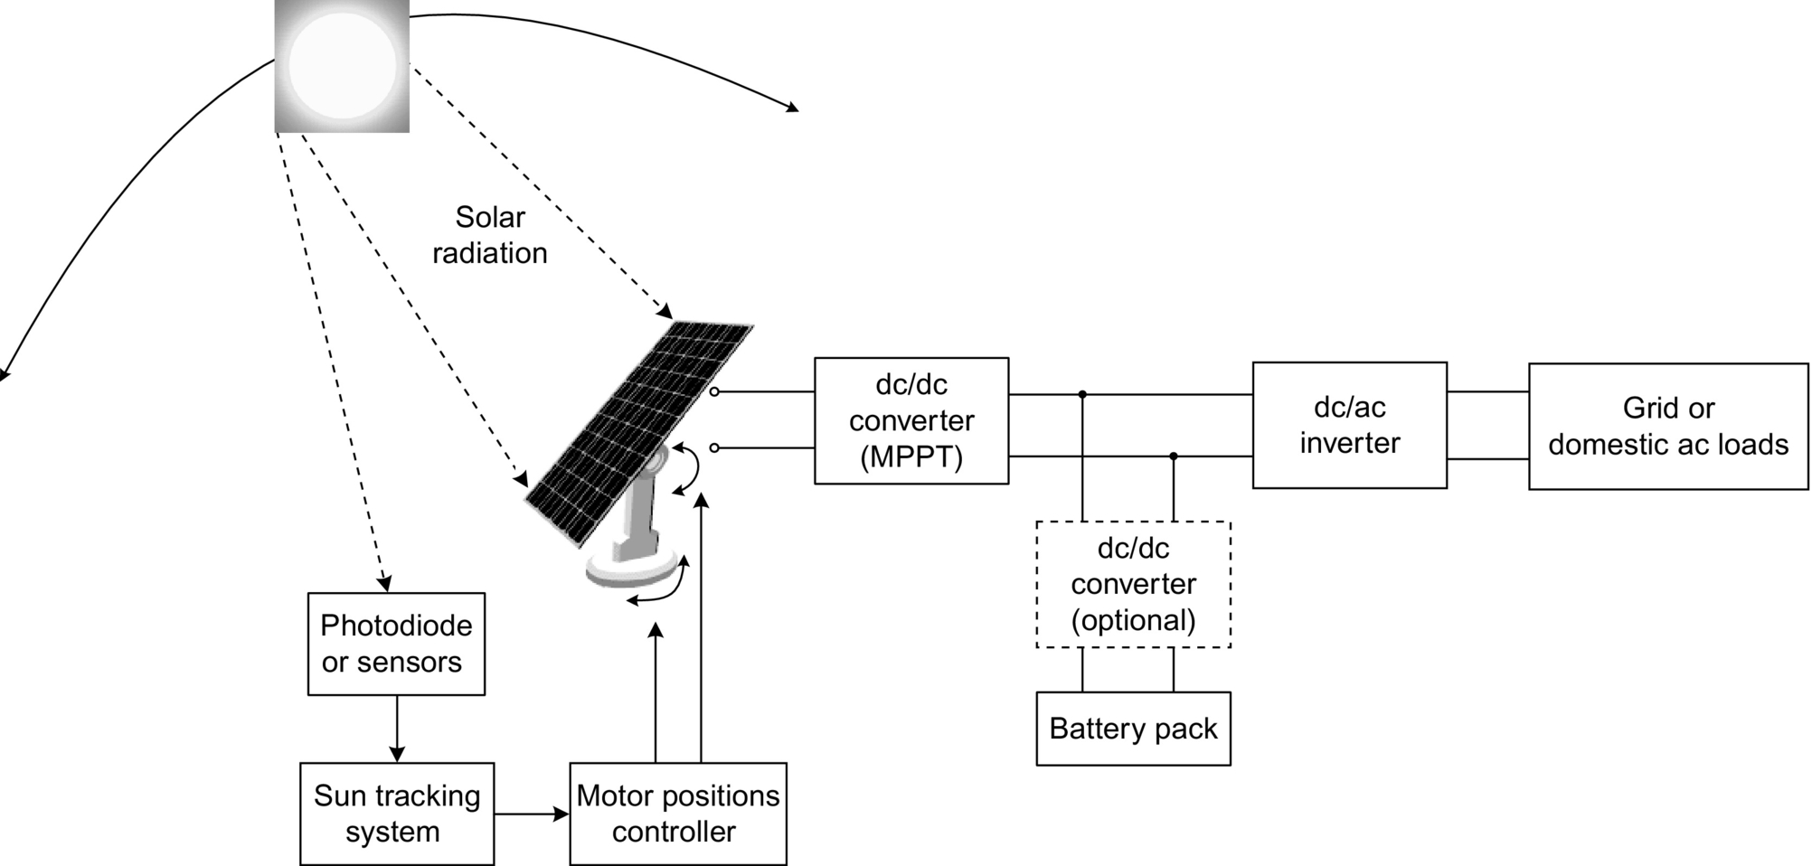

**FIG. 23.7** A solar energy system.

#### **23.3.3.5 *I*-*V* Characteristics of Photovoltaic (PV) Systems, PV Models, and Equivalent PV Circuit**

PV systems have a special current-voltage characteristic. As more current is drawn from the PV system, the system output voltage decreases. These characteristic curves differ at different solar insulation and temperature conditions; hence, the curves can be obtained by varying the load resistance (varying the output current) and measuring the output voltage for many different current values. *I*-*V* curve passes through two points for zero voltage and zero current.

• The short-circuit current (*I*sc): *I*sc is the current produced when the positive and negative terminals of the cell are short-circuited, and the voltage between the terminals is zero, which corresponds to zero load resistance.

• The open-circuit voltage (*V*oc): *V*oc is the voltage across the positive and negative terminals under open-circuit conditions, when the current is zero, which corresponds to infinite load resistance.

In order to extract maximum power from a PV system, for a constant ambient condition, there is only one current-voltage pair. On the *I*-*V* curve, the maximum power point (Pm) occurs when the product of current and voltage is maximum. Although the current is maximum, no power is produced at the short-circuit current due to zero voltage. In addition, no power is produced at the open-circuit voltage due to zero current. The MPP is somewhere between these two points. Maximum power is generated at about the “knee” of the curve. This point represents the maximum efficiency of the solar device in converting sunlight into electricity [[70](https://learning.oreilly.com/library/view/power-electronics-handbook/9780128114087/B9780128114070000258.xhtml#bb0355)]. A typical *I*-*V* curve characteristic of a PV system is given in [Fig. 23.8](https://learning.oreilly.com/library/view/power-electronics-handbook/9780128114087/B9780128114070000258.xhtml#f0045).

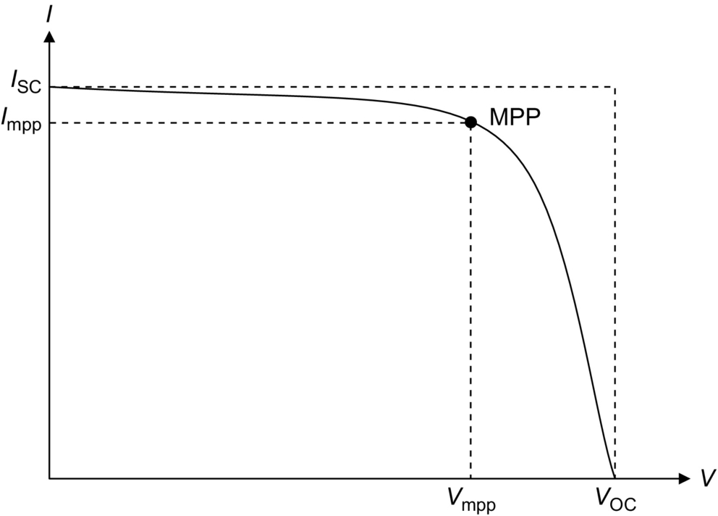

**FIG. 23.8** A typical *I*-*V* curve characteristic of a PV system.

PV systems exhibit nonlinear *I*-*V* characteristics [[71](https://learning.oreilly.com/library/view/power-electronics-handbook/9780128114087/B9780128114070000258.xhtml#bb0360)]. There are various models available to mathematically model the *I*-*V* characteristics of the PV systems. An equivalent circuit expressing the PV model characteristics is shown in [Fig. 23.9](https://learning.oreilly.com/library/view/power-electronics-handbook/9780128114087/B9780128114070000258.xhtml#f0050). This model is known as single-diode model and is one of the most common equivalent circuits representing PV system behaviors.

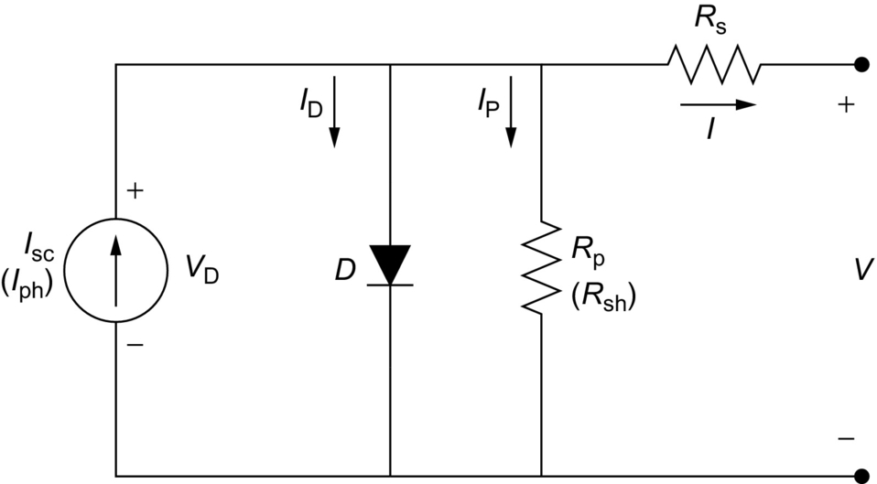

**FIG. 23.9** Single-diode model of solar cell equivalent circuit.

In this model, open-circuit voltage and short-circuit current are the key parameters. Illumination or solar radiation affects the short-circuit current, while the open-circuit voltage is affected by the material and temperature. In this model, *I*SC is the short-circuit current, *I*s is the diode reverse saturation current, *m* is the diode ideality factor (generally various between 1 and 5), and *V*T is the temperature voltage expressed as , which is 25.7 mV at 25*°*C. The equations defining this model are

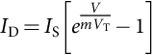 **(23.2)**

**** **(23.3)**

and

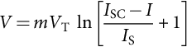 **(23.4)**

The *I*-*V* characteristic of the solar cell can be alternatively defined by [[72](https://learning.oreilly.com/library/view/power-electronics-handbook/9780128114087/B9780128114070000258.xhtml#bb0365)]

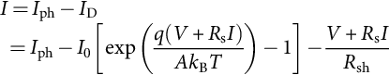 **(23.5)**

where *V* is the PV output voltage (V), *I* is the PV output current (A), *I*ph is the photocurrent (A), *I*D is the diode current (A), *I*0 is the saturation current (A), *A* is the ideality factor, *q* is the electronic charge (C), *k*b is Boltzmann's constant (), *T* is the junction temperature (K), *R*s is the series resistance (Ω), and *R*sh is the shunt resistance (Ω).

#### **23.3.3.6 Sun Tracking Systems**

Incident solar radiation is the most important parameter for the power generated by solar energy systems. Sun changes its position during the day from morning to night. Moreover, the sun orbit differs from one season to another. By properly following the sun, through utilizing sun-tracking systems, the incident solar irradiance can be effectively increased [[73](https://learning.oreilly.com/library/view/power-electronics-handbook/9780128114087/B9780128114070000258.xhtml#bb0370)]. A sun tracker is an electromechanical component used for orienting a solar PV panel, concentrating solar reflector, or lens toward the sun. Solar panels require a high degree of accuracy to ensure that the concentrated sunlight is directed precisely to the PV device. Solar tracking systems can substantially improve the amount of power produced by a system by enhancing morning and afternoon performance. For instance, the orientation of PV panels can increase the solar-electric energy conversion efficiency between 20% and 50% [[74](https://learning.oreilly.com/library/view/power-electronics-handbook/9780128114087/B9780128114070000258.xhtml#bb0375)–[78](https://learning.oreilly.com/library/view/power-electronics-handbook/9780128114087/B9780128114070000258.xhtml#bb0395)]. A fixed system oriented to a fixed sun-facing direction will have a relatively low annual production because they do not move to track the sun, which yields significant increase of incident irradiation. An efficient sun-tracking system should be capable of movement from north to south and from east to west as shown in [Fig. 23.10](https://learning.oreilly.com/library/view/power-electronics-handbook/9780128114087/B9780128114070000258.xhtml#f0055).

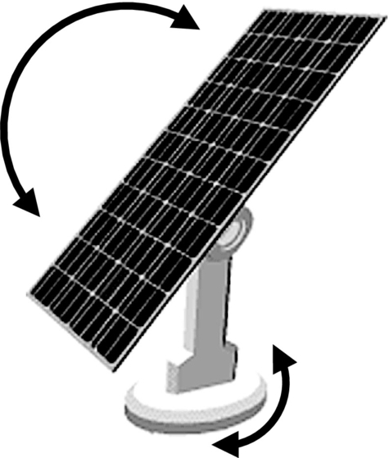

**FIG. 23.10** Rotations of a sun-tracking system.

#### **23.3.3.7 Maximum Power Point Tracking (MPPT) Techniques**

The conditions of radiation and temperature affect the current-voltage (*I*-*V*) characteristics of solar cells. The voltage and current should be controlled to track the maximum power of the PV systems in order to operate the PV systems at the point of (*V*max and . Maximum power point tracking (MPPT) techniques are used to extract maximum available power from the solar cells by controlling the voltage and current. Systems composed of various PV modules located at different positions should have individual power conditioning systems to ensure the MPPT for each module [[79](https://learning.oreilly.com/library/view/power-electronics-handbook/9780128114087/B9780128114070000258.xhtml#bb0400)]. In this section, most common and applicable MPPT techniques are described.

##### **Incremental conductance (INC) based maximum power point tracking (MPPT) technique**

The incremental conductance technique is the most commonly used MPPT for PV systems [[72](https://learning.oreilly.com/library/view/power-electronics-handbook/9780128114087/B9780128114070000258.xhtml#bb0365),[80](https://learning.oreilly.com/library/view/power-electronics-handbook/9780128114087/B9780128114070000258.xhtml#bb0405)–[82](https://learning.oreilly.com/library/view/power-electronics-handbook/9780128114087/B9780128114070000258.xhtml#bb0415)]. The technique is based on the fact that the sum of the instantaneous conductance *I*/*V* and the incremental conductance Δ*I*/Δ*V* is zero at the MPP, negative on the right side of the MPP, and positive on the left side of the MPP.

If the change of current and change of voltage is zero at the same time, no increment or decrement is required for the reference current. If there is no change for the current, while the voltage change is positive, reference current should be increased. Similarly, if there is no change for the current while the voltage change is negative, reference current should be decreased. Contrarily, the change of the current might not be zero. If the current change is not zero, while , the PV is operating at MPP. If the current change is not zero and , then . If  and , the reference current should be decreased. However, if  and , the reference current should be increased in order to track the MPP.

Practically, due to the noise and errors, satisfying the condition of  may be very difficult [[83](https://learning.oreilly.com/library/view/power-electronics-handbook/9780128114087/B9780128114070000258.xhtml#bb0420)]. Therefore, this condition can be satisfied with good approximation by

 **(23.6)**

where *ɛ* is a positive small value. Based on this algorithm, either the operating point is located in BC interval, or it is oscillating among the AB and CD intervals as shown in [Fig. 23.11](https://learning.oreilly.com/library/view/power-electronics-handbook/9780128114087/B9780128114070000258.xhtml#f0060).

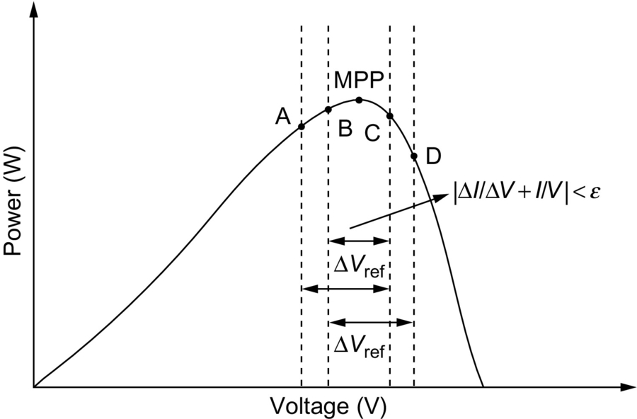

**FIG. 23.11** Operating point trajectory of incremental-conductance-based MPPT.

Selecting the step size (, shown in [Fig. 23.11](https://learning.oreilly.com/library/view/power-electronics-handbook/9780128114087/B9780128114070000258.xhtml#f0060), is a trade-off of accurate steady tracking and dynamic response. If larger step sizes are used for quicker dynamic responses, the tracking accuracy decreases, and the tracking point oscillates around the MPP. On the other hand, when small step sizes are selected, the tracking accuracy will increase. In the meantime, the time duration required to reach the MPP will increase [[84](https://learning.oreilly.com/library/view/power-electronics-handbook/9780128114087/B9780128114070000258.xhtml#bb0425)].

The normalized IV, PV (power-voltage), and absolute derivative of PV characteristics of a PV array are shown in [Fig. 23.12](https://learning.oreilly.com/library/view/power-electronics-handbook/9780128114087/B9780128114070000258.xhtml#f0065).

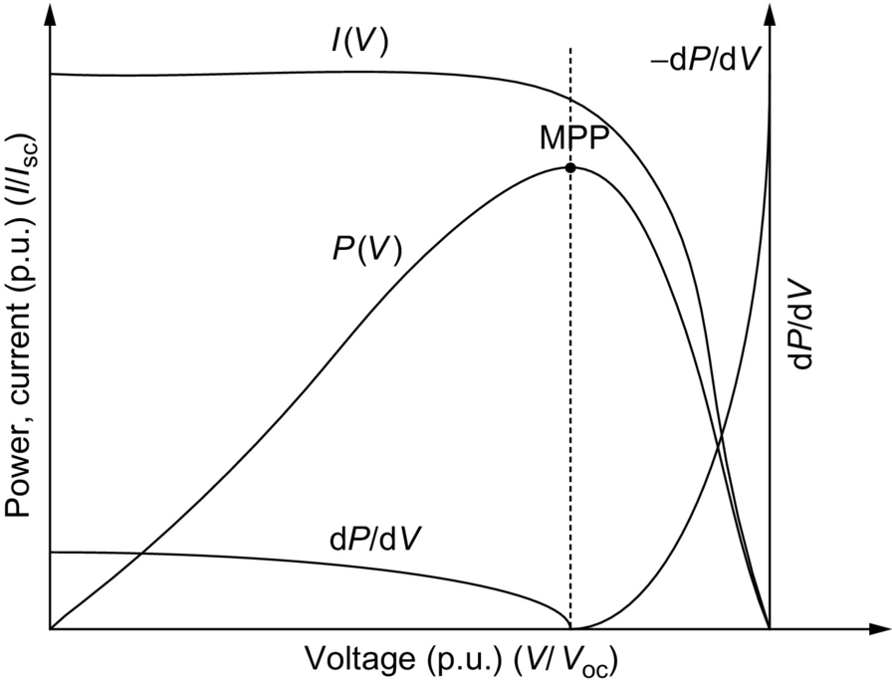

**FIG. 23.12** Normalized *IV*, *PV*, and  characteristics of a PV array.

From these characteristics, it is seen that the  decreases as the MPP is approached and it gets greater when the operating point gets away from the MPP. This relation can be given by

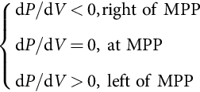 **(23.7)**

In order to obtain the operating MPP, d*P*/d*V* should be calculated. The d*P*/d*V* can be obtained by only measuring the incremental and instantaneous conductances of the PV array, that is, Δ*I*/Δ*V* and *I*/*V* [[80](https://learning.oreilly.com/library/view/power-electronics-handbook/9780128114087/B9780128114070000258.xhtml#bb0405)].

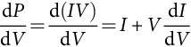 **(23.8)**

##### **Other maximum power point tracking techniques**

In the perturb-and-observe technique, the current drawn from the PV array is perturbed in a given direction, and if the power drawn from the PV array increases, the operating point gets closer to the MPP, and thus, the operating current should be further perturbed in the same direction [[85](https://learning.oreilly.com/library/view/power-electronics-handbook/9780128114087/B9780128114070000258.xhtml#bb0430)]. If the current is perturbed and this results in a decrease in the power drawn from the PV array, this means that the point of operation is moving away from the MPP, and therefore, the perturbation of the operating current should be reversed.

The *P*-*V* and *I*-*V* characteristics of a roof-mounted PV array are monotonously increasing or decreasing under stable insulation conditions. The *I*-*V* characteristic is a function of voltage, insulation level, and temperature. From these characteristics, MPPT controllers can be developed based on the linearized *I*-*V* characteristics [[86](https://learning.oreilly.com/library/view/power-electronics-handbook/9780128114087/B9780128114070000258.xhtml#bb0435)–[88](https://learning.oreilly.com/library/view/power-electronics-handbook/9780128114087/B9780128114070000258.xhtml#bb0445)].

Fractional open-circuit voltage-based method [[89](https://learning.oreilly.com/library/view/power-electronics-handbook/9780128114087/B9780128114070000258.xhtml#bb0450)–[96](https://learning.oreilly.com/library/view/power-electronics-handbook/9780128114087/B9780128114070000258.xhtml#bb0485)], fractional short-circuit-based method [[96](https://learning.oreilly.com/library/view/power-electronics-handbook/9780128114087/B9780128114070000258.xhtml#bb0485),[97](https://learning.oreilly.com/library/view/power-electronics-handbook/9780128114087/B9780128114070000258.xhtml#bb0490)], fuzzy-logic-controller-based method [[88](https://learning.oreilly.com/library/view/power-electronics-handbook/9780128114087/B9780128114070000258.xhtml#bb0445),[98](https://learning.oreilly.com/library/view/power-electronics-handbook/9780128114087/B9780128114070000258.xhtml#bb0495)–[106](https://learning.oreilly.com/library/view/power-electronics-handbook/9780128114087/B9780128114070000258.xhtml#bb0535)], neural-network-based method [[107](https://learning.oreilly.com/library/view/power-electronics-handbook/9780128114087/B9780128114070000258.xhtml#bb0540)–[112](https://learning.oreilly.com/library/view/power-electronics-handbook/9780128114087/B9780128114070000258.xhtml#bb0565)], ripple-correlation-based method [[113](https://learning.oreilly.com/library/view/power-electronics-handbook/9780128114087/B9780128114070000258.xhtml#bb0570)], current-sweep-based method [[114](https://learning.oreilly.com/library/view/power-electronics-handbook/9780128114087/B9780128114070000258.xhtml#bb0575)], and dc-link capacitor droop-control-based method [[115](https://learning.oreilly.com/library/view/power-electronics-handbook/9780128114087/B9780128114070000258.xhtml#bb0580),[116](https://learning.oreilly.com/library/view/power-electronics-handbook/9780128114087/B9780128114070000258.xhtml#bb0585)] are the other applicable methods for MPP tracking.

#### **23.3.3.8 Power Electronic Interfaces for PV Systems**

Power electronic interfaces are used either to convert the dc energy to ac energy to supply ac loads or connection to the grid or to control the terminal conditions of the PV module to track the MPP for maximizing the extracted energy. They also provide wide operating range, capability of operation over different daily and seasonal conditions, and reaching the highest possible efficiency [[117](https://learning.oreilly.com/library/view/power-electronics-handbook/9780128114087/B9780128114070000258.xhtml#bb0590)]. There are various ways to categorize power electronic interfaces for solar systems. In this book, power electronic interfaces are categorized as power electronic interfaces for grid-connected PV systems and stand-alone PV systems.

##### **Power electronic interfaces for grid connected PV systems**

The power electronic interfaces for grid-connected PV systems can be classified into two main criteria: classification based on inverter utilization and classification based on converter stage and module configurations.

###### **Topologies based on inverter utilization**

The centralized inverter system is illustrated in [Fig. 23.13](https://learning.oreilly.com/library/view/power-electronics-handbook/9780128114087/B9780128114070000258.xhtml#f0070).

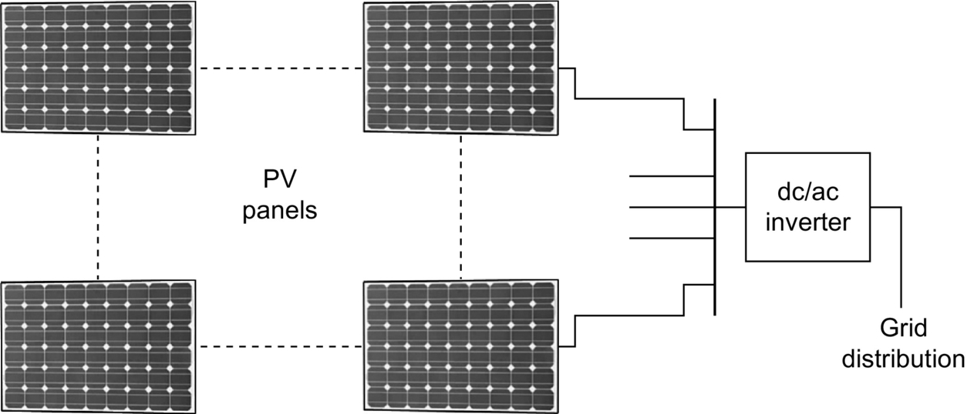

**FIG. 23.13** Conventional PV system technology using centralized inverter system topology.

In this topology, PV modules are connected in series and parallel to achieve the required current and voltage levels. Only one inverter is used in this topology at the common dc bus. In this topology, the inverter's power losses are higher than string inverter or multi-inverter topologies due to the mismatch between the modules and necessity of string diodes that are connected in series. In this topology, voltage boost may not be required since the voltage of series-connected string voltages is high enough [[118](https://learning.oreilly.com/library/view/power-electronics-handbook/9780128114087/B9780128114070000258.xhtml#bb0595)].

In string inverter topology, the single string of modules is connected to the separate inverters for each string [[119](https://learning.oreilly.com/library/view/power-electronics-handbook/9780128114087/B9780128114070000258.xhtml#bb0600)]. In this topology, voltage boosting may not be required if enough number of components are connected in series in each string.

In the multistring inverter topology, several strings are interfaced with their own integrated dc/dc converter to a common dc/ac inverter [[120](https://learning.oreilly.com/library/view/power-electronics-handbook/9780128114087/B9780128114070000258.xhtml#bb0605),[121](https://learning.oreilly.com/library/view/power-electronics-handbook/9780128114087/B9780128114070000258.xhtml#bb0610)] as shown in [Fig. 23.14](https://learning.oreilly.com/library/view/power-electronics-handbook/9780128114087/B9780128114070000258.xhtml#f0075).

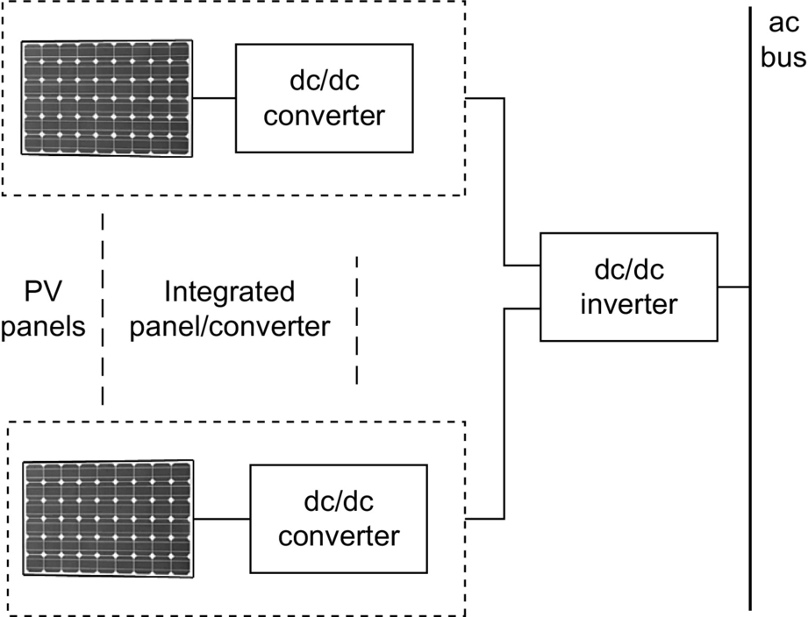

**FIG. 23.14** Multistring inverters topology.

Therefore, this is a flexible design with high efficiency. In this topology, each PV module has its integrated power electronic interface with utility. The power loss of the system is relatively lower due to the reduced mismatch among the modules, but the constant losses in the inverter may be the same as for the string inverter. In addition, this configuration supports optimal operation of each module, which leads to an overall optimal performance [[118](https://learning.oreilly.com/library/view/power-electronics-handbook/9780128114087/B9780128114070000258.xhtml#bb0595)]. This is due to the fact that each PV panel has its individual dc/dc converter and maximum power levels can be achieved separately for each panel.

###### **Topologies based on module and stage configurations**

The power electronic conditioning circuits for solar energy systems can be transformerless, or they can utilize high-frequency transformers embedded in a dc/dc converter, which avoids bulky low-frequency transformers. The number of stages in the presented topologies refers to the number of cascaded converters/inverters in the system.

Isolated dc/dc converters consist of a transformer between the dc/ac and ac/dc conversion stages [[122](https://learning.oreilly.com/library/view/power-electronics-handbook/9780128114087/B9780128114070000258.xhtml#bb0615)]. This transformer provides isolation between the PV source and load. A typical topology is depicted in [Fig. 23.15](https://learning.oreilly.com/library/view/power-electronics-handbook/9780128114087/B9780128114070000258.xhtml#f0080).

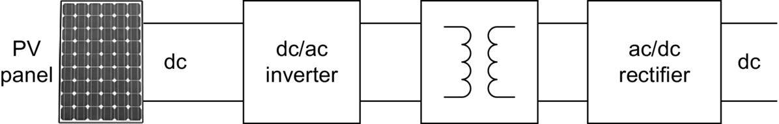

**FIG. 23.15** Isolated dc/dc converter topology.

In the topology shown in [Fig. 23.15](https://learning.oreilly.com/library/view/power-electronics-handbook/9780128114087/B9780128114070000258.xhtml#f0080), the outputs of the PV panel and dc/dc converter are dc voltages. The two-stage dc/dc converter consists of a dc/ac inverter, a high-frequency transformer, and a rectifier. In this topology, a capacitor can be used between the bottom leg of the high-frequency inverter and the transformer, forming an LC resonant circuit with the equivalent inductance of the transformer. This resonance circuit reduces the switching losses of the inverter. Alternatively, only two switches are enough if a push-pull converter is used; however, this topology requires a middle terminal outputted transformer [[118](https://learning.oreilly.com/library/view/power-electronics-handbook/9780128114087/B9780128114070000258.xhtml#bb0595)].

The topologies shown in [Fig. 23.16A and B](https://learning.oreilly.com/library/view/power-electronics-handbook/9780128114087/B9780128114070000258.xhtml#f0085) are two-stage single-module topologies, in which a dc/dc converter is connected to a dc/ac converter for grid connection. The dc/dc converter deals with the MPP tracking, and the dc/ac inverter is employed to convert the dc output to ac voltage for grid connection. These are nonisolated converters since they are transformerless.

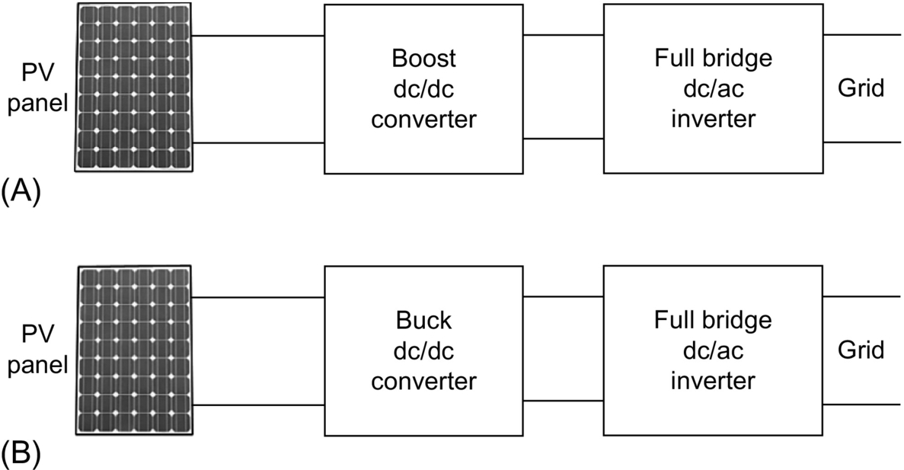

**FIG. 23.16** (A) Boost converter with full-bridge inverter; (B) buck converter with full-bridge inverter.

Instead of using a full-bridge inverter for the dc/ac conversion stage, a half-bridge inverter can also be used. In this way, number of switching elements can be reduced, and the controller can be simplified; however, for the dc bus, two-series-connected capacitor is required to obtain the midpoint. This midpoint of two-series-connected capacitors will be used as the negative terminal of the ac network of the half-bridge configuration.

The single-stage inverter for multiple modules is depicted in [Fig. 23.17](https://learning.oreilly.com/library/view/power-electronics-handbook/9780128114087/B9780128114070000258.xhtml#f0090), which is the simplest grid-connection topology [[123](https://learning.oreilly.com/library/view/power-electronics-handbook/9780128114087/B9780128114070000258.xhtml#bb0620)]. The inverter is a standard voltage-source PWM inverter, connected to the utility through an LCL filter. The input voltage, generated by the PV modules, should be higher than the peak voltage of the utility. The efficiency is about 97%. On the other hand, all the modules are connected to the same MPPT device. This may cause severe power losses during partial shadowing. In addition, a large capacitor is required for power decoupling between PV modules and utility [[124](https://learning.oreilly.com/library/view/power-electronics-handbook/9780128114087/B9780128114070000258.xhtml#bb0625)].

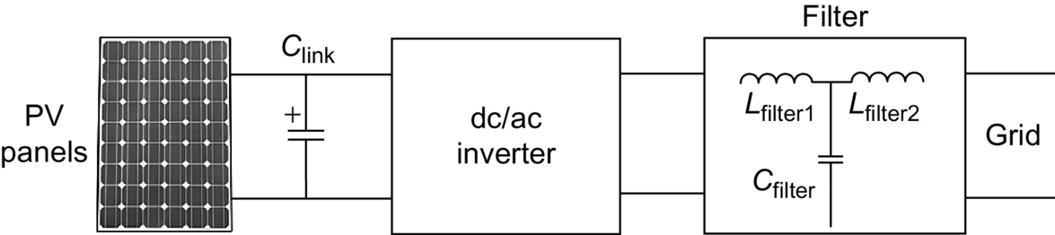

**FIG. 23.17** Single-stage inverter for multiple modules.

A topology for multimodule multistring interfaces is shown in [Fig. 23.18](https://learning.oreilly.com/library/view/power-electronics-handbook/9780128114087/B9780128114070000258.xhtml#f0095) [[121](https://learning.oreilly.com/library/view/power-electronics-handbook/9780128114087/B9780128114070000258.xhtml#bb0610),[125](https://learning.oreilly.com/library/view/power-electronics-handbook/9780128114087/B9780128114070000258.xhtml#bb0630)]. The inverter in [Fig. 23.18](https://learning.oreilly.com/library/view/power-electronics-handbook/9780128114087/B9780128114070000258.xhtml#f0095) consists of up to three boost converters, one for each PV string, and a common half-bridge PWM inverter. The circuit can also be constructed with an isolated current- or voltage-fed push-pull or full-bridge converter [[126](https://learning.oreilly.com/library/view/power-electronics-handbook/9780128114087/B9780128114070000258.xhtml#bb0635)] and a full-bridge inverter toward the utility. The voltage across each string can be controlled individually [[121](https://learning.oreilly.com/library/view/power-electronics-handbook/9780128114087/B9780128114070000258.xhtml#bb0610),[126](https://learning.oreilly.com/library/view/power-electronics-handbook/9780128114087/B9780128114070000258.xhtml#bb0635)].

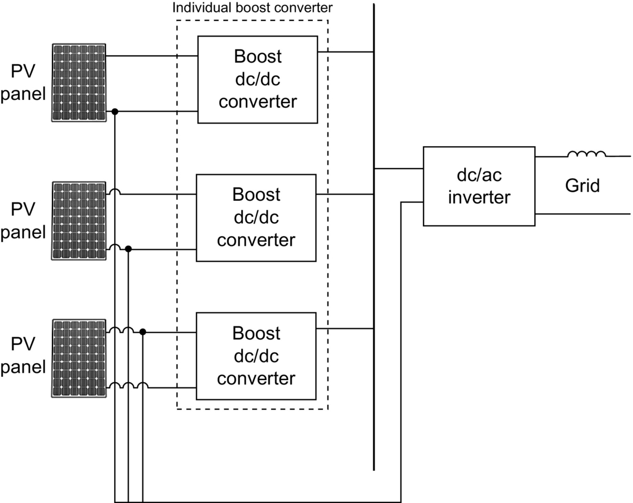

**FIG. 23.18** Topology of the power electronics of the multistring inverter.

As an alternative to the topology shown in [Fig. 23.18](https://learning.oreilly.com/library/view/power-electronics-handbook/9780128114087/B9780128114070000258.xhtml#f0095), other types of dc/dc converter can be employed to the first stage, such as isolated dc/dc converters.

##### **Power electronic interfaces for stand-alone PV systems**

The stand-alone PV systems are composed of a storage device and its controller for sustainable satisfaction of the load power demands [[127](https://learning.oreilly.com/library/view/power-electronics-handbook/9780128114087/B9780128114070000258.xhtml#bb0640)]. The storage device with the controller should provide the power difference when the available power from the PV panel is smaller than the required power at the load bus [[128](https://learning.oreilly.com/library/view/power-electronics-handbook/9780128114087/B9780128114070000258.xhtml#bb0645)]. When the available power from the PV panel is more than the required power, the PV panel should supply the load power, and the excess power should be used to charge the storage device. A simple PV panel/battery connection topology is shown in [Fig. 23.19](https://learning.oreilly.com/library/view/power-electronics-handbook/9780128114087/B9780128114070000258.xhtml#f0100).

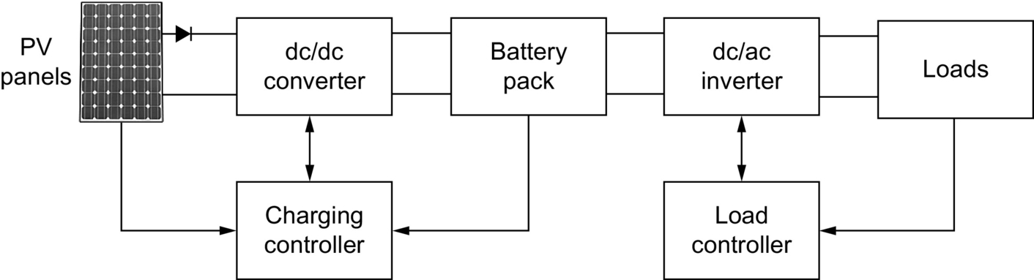

**FIG. 23.19** PV/battery connection for stand-alone applications.

In this simple topology, the dc/dc converter between the battery and the PV panel is used to capture all the available power from the PV panel. In this system, battery pack acts as an energy buffer, charged from the PV panel and discharged through the dc/ac inverter to the load side. The charging controller determines the charging current of the battery, depending on the MPP of the PV panels at a certain time. When there is no solar insulation available, the dc/dc converter disables, and the stored energy within the battery supplies the load demands. The battery size should be selected so that it can supply all the power demands during a possible no-insulation period. In addition, it could be fully charged during the insulated periods to store the energy for future use. Since the combined model produces ac electric energy, it should be converted to ac electric energy for domestic electric loads. The combined system requires a dc/ac inverter, which is also used to match the different dynamics of the combined energy system and various loads. The proper response of the PV/battery system to the overall load dynamics can be achieved by generating appropriate switching signals to the inverter while modulating for both active and reactive powers. The load bus voltage can be controlled by the modulation index control of the inverter; while the load control can be achieved by the phase angle control of the inverter.

### 23.3.4 WIND TURBINES AND WIND ENERGY CONVERSION SYSTEMS

Wind turbines are devices that are capable of capturing the kinetic energy of winds. This kinetic energy is converted to mechanical energy to rotate the turbine that is coupled to an electric generator. In this way, kinetic energy of the wind can be converted into a usable form of energy, that is, electric energy. Wind turbines can be installed stand-alone to power remote or isolated locations, or they can be grid-connected, to supply power to the utility grid. Wind power is renewable, widely distributed, plentiful, and it is a clean way of energy conversion. Additionally, it contributes in reducing the greenhouse gas emissions since it can be used as an alternative to fossil-fuel-based power generation [[129](https://learning.oreilly.com/library/view/power-electronics-handbook/9780128114087/B9780128114070000258.xhtml#bb0650)]. Although wind energy has a great potential to significantly contribute the world's power generation, only 1% of worldwide power requirement is supplied by wind turbines [[130](https://learning.oreilly.com/library/view/power-electronics-handbook/9780128114087/B9780128114070000258.xhtml#bb0655)].

Several key parameters such as air density, area of the blades, wind speed, and rotor area need to be considered in order to efficiently capture wind energy. Wind force is converted into a torque that rotates the blades of wind turbine. The wind force is stronger in higher air densities. In other words, kinetic energy of the wind depends on air density, and heavier winds carry more kinetic energy. At normal atmospheric pressure and at 15*°*C, the weight of the air is 1.225 kg/m3, but if the humidity increases, the density decreases slightly. The other fact that determines the air density is whether the air is warm or cold. Warmer winds are less dense than cold ones, so at high altitudes, the air is less dense [[131](https://learning.oreilly.com/library/view/power-electronics-handbook/9780128114087/B9780128114070000258.xhtml#bb0660)]. Besides the area of the blades (air swept area), the diameter of the blade plays important role in captured wind energy. Under the same conditions, more wind can be captured with longer blades and bigger rotor area of wind turbine [[130](https://learning.oreilly.com/library/view/power-electronics-handbook/9780128114087/B9780128114070000258.xhtml#bb0655),[131](https://learning.oreilly.com/library/view/power-electronics-handbook/9780128114087/B9780128114070000258.xhtml#bb0660)]. The other parameter is the wind speed. It is expected that wind kinetic energy arises as wind speed increases [[131](https://learning.oreilly.com/library/view/power-electronics-handbook/9780128114087/B9780128114070000258.xhtml#bb0660)].

Kinetic energy of the wind can be expressed as

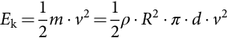 **(23.9)**

where *E*k represents kinetic energy of the wind, *m* stands for the mass of the wind, *v* is wind speed, *ρ* is air density, *A* is rotor area, *R* is blade length, and *d* stands for thickness of the “air disc” shown in [Fig. 23.20](https://learning.oreilly.com/library/view/power-electronics-handbook/9780128114087/B9780128114070000258.xhtml#f0105).

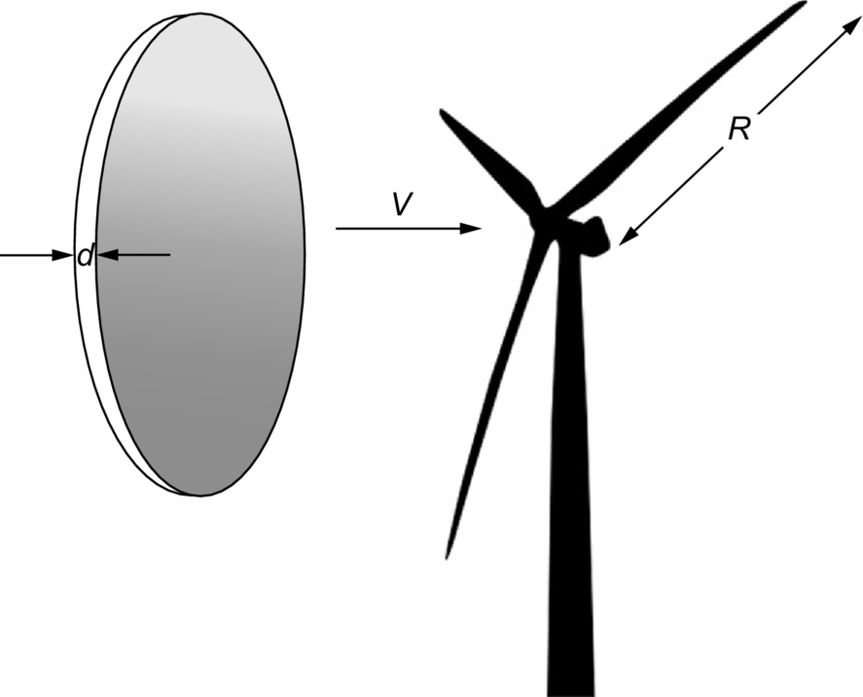

**FIG. 23.20** Kinetic energy of wind.

Hence, the overall wind power ( is [[131](https://learning.oreilly.com/library/view/power-electronics-handbook/9780128114087/B9780128114070000258.xhtml#bb0660)]

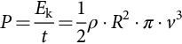 **(23.10)**

From [(23.10)](https://learning.oreilly.com/library/view/power-electronics-handbook/9780128114087/B9780128114070000258.xhtml#fo0055), it can be seen that the power content of the wind varies with the cube (the third power) of the average wind speed as shown in [Fig. 23.21](https://learning.oreilly.com/library/view/power-electronics-handbook/9780128114087/B9780128114070000258.xhtml#f0110).

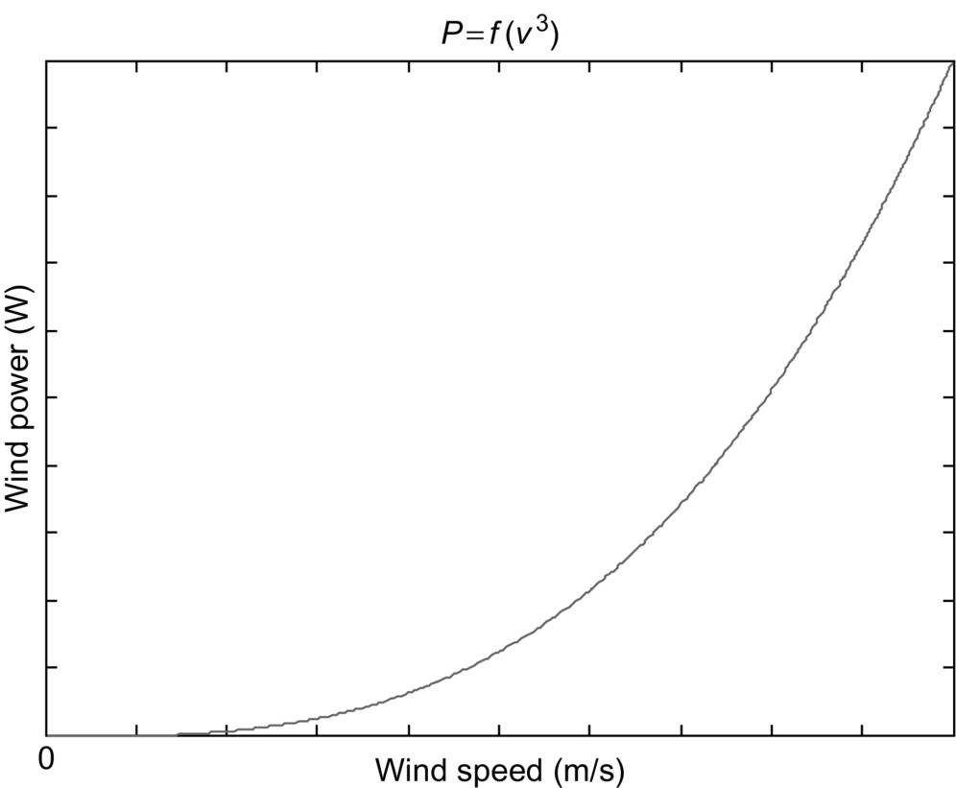

**FIG. 23.21** Specific wind power due to wind speed variation.

#### **23.3.4.1 Wind Turbine Power**

##### **Betz's law**

The theoretical maximum power that can be extracted from the wind is demonstrated by Betz's law [[132](https://learning.oreilly.com/library/view/power-electronics-handbook/9780128114087/B9780128114070000258.xhtml#bb0665),[133](https://learning.oreilly.com/library/view/power-electronics-handbook/9780128114087/B9780128114070000258.xhtml#bb0670)]. The wind turbines extract the kinetic energy of the wind. Higher wind speed results in higher extracted energy. It should be noted that the wind speed after turbine (after passes through turbine) is much lower than before it comes to the turbine (before energy is extracted) since the wind loses its speed by transferring its kinetic energy to wind turbine. That means wind speed before wind approaches (in front of) the turbine and its speed after (behind) turbine are different. [Fig. 23.22](https://learning.oreilly.com/library/view/power-electronics-handbook/9780128114087/B9780128114070000258.xhtml#f0115) shows both speeds. The wind after the turbine has less amount of energy due to decreased speed of wind.

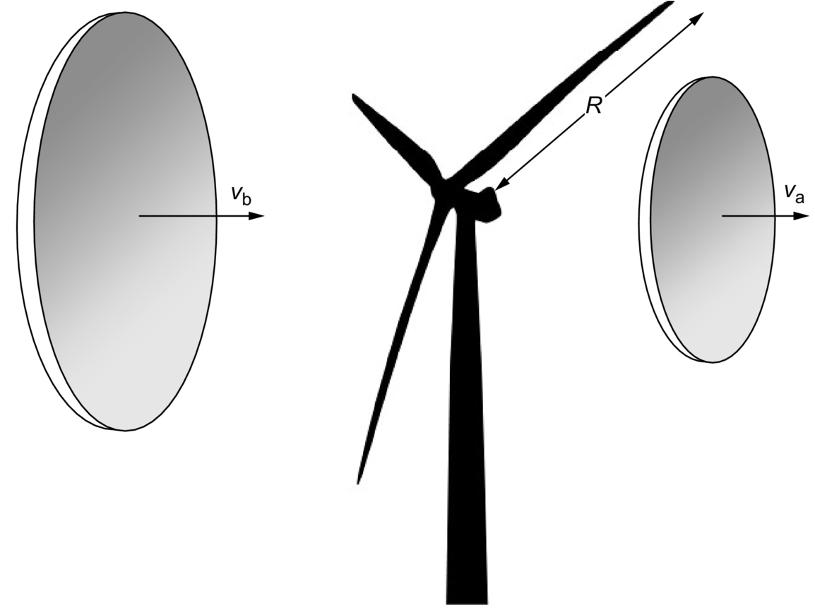

**FIG. 23.22** Wind speed before and after turbine.

The decreased wind speed, after turbine, provides information on the amount of possible extracted energy from the wind. The extracted power from the wind can be calculated using [(23.7)](https://learning.oreilly.com/library/view/power-electronics-handbook/9780128114087/B9780128114070000258.xhtml#fo0040)

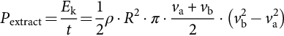 **(23.11)**

where *P*extracted shows maximum extracted power from the wind, *v*a and *v*b are wind speeds after and before passing through the turbine, *ρ* is the air density, and *R* demonstrates the radius of the blades.

The relation of total amount of power *P*total to the extracted power *P*extracted can be calculated as

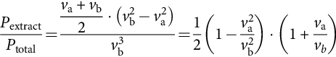 **(23.12)**

For the maximum power extraction, the ratio of the wind speed after and before the turbine can be calculated using 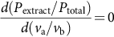.

Solving [(23.12)](https://learning.oreilly.com/library/view/power-electronics-handbook/9780128114087/B9780128114070000258.xhtml#fo0065) for *v*a/*v*b yields

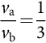 **(23.13)**

As a result, [(23.12)](https://learning.oreilly.com/library/view/power-electronics-handbook/9780128114087/B9780128114070000258.xhtml#fo0065) reaches its maximum value for 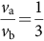.

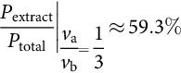 **(23.14)**

Eq. [(23.14)](https://learning.oreilly.com/library/view/power-electronics-handbook/9780128114087/B9780128114070000258.xhtml#fo0075) shows that the maximum extracted power from the wind is 59.3% of the total available power. In other words, it is not possible to extract all 100% of wind energy since the wind speed after turbine cannot be 0.

Betz's law indicates that the maximum theoretical extracted wind power is 59%. However, in practice, the real efficiency of wind turbine is slightly different.

#### **23.3.4.2 Different Electrical Machines in Wind Turbines**

There are many types of electric machines that are used in wind turbines. There is no clear criterion for choosing a particular machine to work as a wind generator. Based on the installed power, site of turbine, load type, and simplicity of control, the wind generator can be chosen. Squirrel-cage induction or brushless DC (BLDC) generators are usually used for small wind turbines in household applications. Doubly fed induction generators are usually used for megawatt size turbines. Synchronous machines and permanent-magnet synchronous machines (PMSM) can also be used for wind-turbine applications.

##### **Brushless DC (BLDC) machines**

Brushless DC machines (BLDC) are very popular in many applications due to the recent advances in their development. In addition, the development of fast semiconductor switches, cost-effective DSP processors, and other microcontrollers have influenced the development of the motor/generator drives. Brushless DC machines (BLDC) are widely used because of their simple control, efficiency, compactness, lightweight, ease of cooling, less noise, and low maintenance [[134](https://learning.oreilly.com/library/view/power-electronics-handbook/9780128114087/B9780128114070000258.xhtml#bb0675),[135](https://learning.oreilly.com/library/view/power-electronics-handbook/9780128114087/B9780128114070000258.xhtml#bb0680)]. Usually, BLDC machines are used in small wind turbines (up to 15 kW).

The simplified equivalent circuit of the BLDC generator connected to a diode rectifier is shown in [Fig. 23.23](https://learning.oreilly.com/library/view/power-electronics-handbook/9780128114087/B9780128114070000258.xhtml#f0120). This is the simplest way of using BLDC machine for wind applications, because there is no switch to control the phase current. The full bridge rectifies the induced voltages of variable frequency (because of variable wind speeds). Basically, the waveform of the induced electromotive force (EMF) is converted to dc voltage regardless of the input waveform. Usually, these types of wind turbines are connected to batteries; therefore, rectified electric power is used to charge the battery.

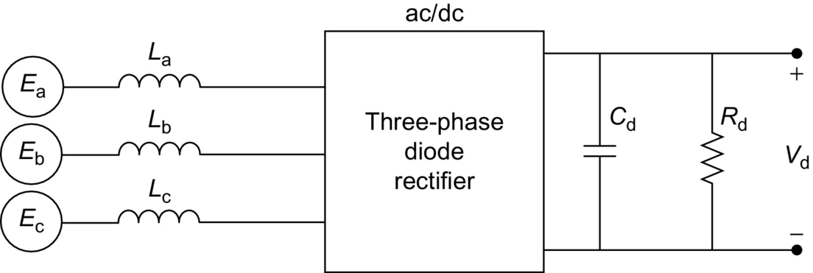

**FIG. 23.23** Diode rectifier connected to BLDC generator.

Three-phase active synchronous rectifiers can be used with BLDC generators. In this case, the controlled rectifier is used for BLDC phase current control. Usually, hysteresis regulators are used to control current. In synchronous rectifiers, active switching devices such as IGBTs or MOSFETs are used. By employing a PWM control strategy for the synchronous rectifier, MPP tracking of the wind turbine can be achieved. An inverter can be placed at the dc bus for grid interconnection or powering the ac loads.

##### **Permanent magnet synchronous machines**

For both fixed and variable speed applications, permanent-magnet (PM) synchronous machines can be used. The permanent-magnet synchronous generator (PMSG) is very efficient and suitable for wind-turbine applications. PM synchronous generators allow direct-drive energy conversion for wind applications. Direct-drive energy conversion helps eliminating the gearbox between the turbine and generator; thus, these systems are less expensive, and less maintenance is required [[136](https://learning.oreilly.com/library/view/power-electronics-handbook/9780128114087/B9780128114070000258.xhtml#bb0685),[137](https://learning.oreilly.com/library/view/power-electronics-handbook/9780128114087/B9780128114070000258.xhtml#bb0690)]. However, lower speed determined by the turbine shaft is the operating speed for the generator.

A wind power system where a PM synchronous generator is connected to a full-bridge rectifier followed by a boost converter is shown in [Fig. 23.24](https://learning.oreilly.com/library/view/power-electronics-handbook/9780128114087/B9780128114070000258.xhtml#f0125). In this case, the boost converter controls the electromagnetic torque. The supply side converter regulates the dc-link voltage and controls the input power factor. One drawback of this configuration is the use of diode rectifier that increases the current amplitude and losses. The grid-side converter can be used to control active and reactive power being supplied to the grid. Automatic voltage regulator (AVR) obtains the information of speed of turbine, dc-link voltage, current, and grid-side voltage and current. It calculates PWM pattern (control scheme) for converter. This configuration has been considered for small size (less than 50 kW) wind power systems (WPS) [[138](https://learning.oreilly.com/library/view/power-electronics-handbook/9780128114087/B9780128114070000258.xhtml#bb0695)].

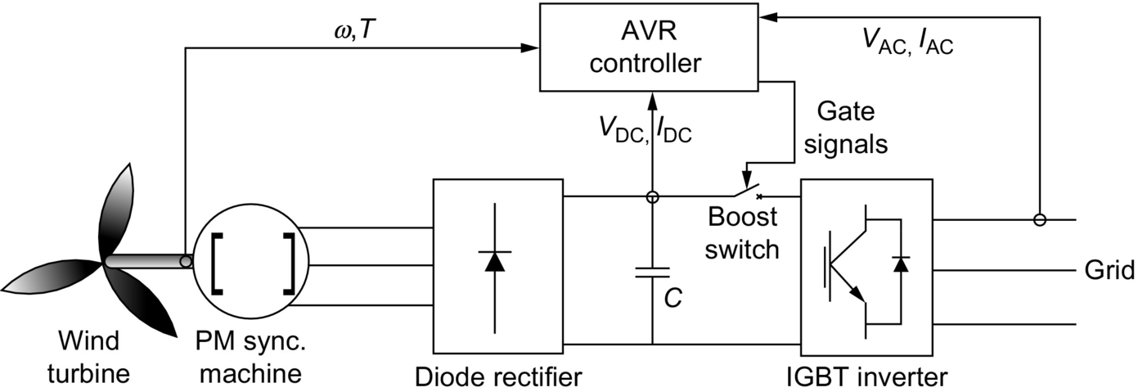

**FIG. 23.24** PM synchronous generator with rectifier/inverter.

Instead of using a diode rectifier cascaded by a dc/dc converter, both rectifier and inverter can be controllable. A PMSG where the PWM rectifier is placed between the generator and the dc link, and PWM inverter is connected to the utility is shown in [Fig. 23.25](https://learning.oreilly.com/library/view/power-electronics-handbook/9780128114087/B9780128114070000258.xhtml#f0130). In this case, the back-to-back converter can be used as the interface between the grid and the stator windings of the PMSG [[139](https://learning.oreilly.com/library/view/power-electronics-handbook/9780128114087/B9780128114070000258.xhtml#bb0700)]. The turbine can be operated at its maximum efficiency, and the variable speed operation of PMSG can be controlled by using a power converter that is utilized to regulate the maximum power flow. The stator terminal voltage can be controlled in several ways [[140](https://learning.oreilly.com/library/view/power-electronics-handbook/9780128114087/B9780128114070000258.xhtml#bb0705)]. In this system, utilizing the field orientation control (FOC) allows the generator to operate near its optimal working point in order to minimize the losses in the generator and power electronic circuit. However, the performance depends on the knowledge of the generator parameter that varies with temperature and frequency. The main drawbacks are the cost of PMs that increases the price of the machine and demagnetization of the PMs. In addition, it is not possible to control the power factor of the machine [[134](https://learning.oreilly.com/library/view/power-electronics-handbook/9780128114087/B9780128114070000258.xhtml#bb0675)].

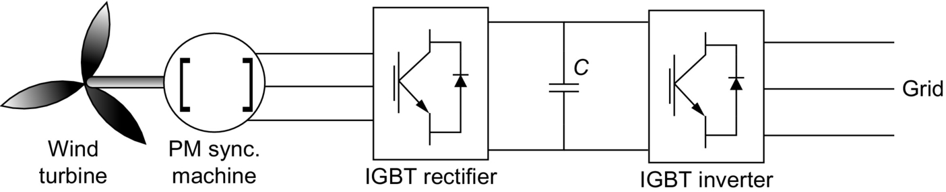

**FIG. 23.25** PM synchronous generator with back-to-back inverter.

##### **Squirrel cage induction machines**

The three-phase induction machines are commonly used in industrial motor applications. However, they can also be effectively used as generators in electric power systems. The main issue with induction machines as electric power generators is the need for an external reactive power source that will excite the induction machine, which is certainly not required for synchronous machines in similar applications. If induction machine is connected to the grid, the required reactive power can be provided by the power system. Induction machine may be used in cogeneration with other synchronous generators, or the excitation might be supplied from capacitor banks (only for stand-alone self-excited generator application) [[141](https://learning.oreilly.com/library/view/power-electronics-handbook/9780128114087/B9780128114070000258.xhtml#bb0710)–[146](https://learning.oreilly.com/library/view/power-electronics-handbook/9780128114087/B9780128114070000258.xhtml#bb0735)]. The reactive power required for excitation can be supplied using static VAr compensators [[147](https://learning.oreilly.com/library/view/power-electronics-handbook/9780128114087/B9780128114070000258.xhtml#bb0740),[148](https://learning.oreilly.com/library/view/power-electronics-handbook/9780128114087/B9780128114070000258.xhtml#bb0745)] or static compensators (STATCOMs) [[149](https://learning.oreilly.com/library/view/power-electronics-handbook/9780128114087/B9780128114070000258.xhtml#bb0750)].

Due to its low cost, brushless rotor construction does not need a separate source for excitation. No maintenance and self-protection against severe over loads, short circuits, and self-excited induction generators are used in wind-turbine applications [[142](https://learning.oreilly.com/library/view/power-electronics-handbook/9780128114087/B9780128114070000258.xhtml#bb0715)–[146](https://learning.oreilly.com/library/view/power-electronics-handbook/9780128114087/B9780128114070000258.xhtml#bb0735)]. The only drawback of these types of generators can be their inherent generated voltage and frequency regulation under varied loads [[150](https://learning.oreilly.com/library/view/power-electronics-handbook/9780128114087/B9780128114070000258.xhtml#bb0755)].

Common structure of a squirrel-cage induction generator with back-to-back converters is shown in [Fig. 23.26](https://learning.oreilly.com/library/view/power-electronics-handbook/9780128114087/B9780128114070000258.xhtml#f0135). In this structure, stator winding is connected to utility through a four-quadrant power converter. Two PWM VSI are connected back-to-back through a dc link. The stator-side converter regulates the electromagnetic torque and supplies reactive power, while the grid-side converter controls the real and reactive power delivered from the system to the utility and regulates the dc link. This topology has several practical advantages, and one of them is the possibility of fast transient response for speed variations. In addition, the inverter can operate as a VAR/harmonic compensator [[151](https://learning.oreilly.com/library/view/power-electronics-handbook/9780128114087/B9780128114070000258.xhtml#bb0760)].

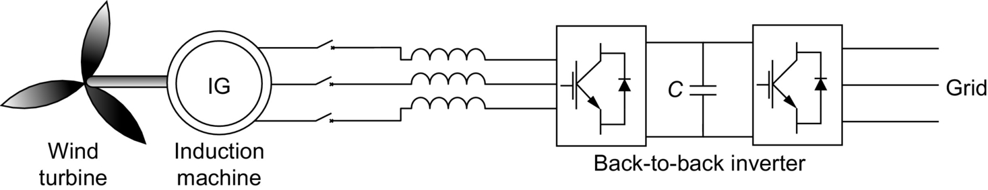

**FIG. 23.26** Induction machine controlled by back-to-back inverter.

On the other hand, the main drawback is the complex control system. Usually, FOC is used to control this topology, where its performance relies on the generator parameters, which vary with temperature and frequency. Hence, in order to supply the magnetizing power requirements, that is, to magnetize the machine, the stator-side converter must be oversized 30%–50% with respect to rated power.

##### **Doubly fed induction generator (DFIG)**

[Fig. 23.27](https://learning.oreilly.com/library/view/power-electronics-handbook/9780128114087/B9780128114070000258.xhtml#f0140) presents a topology consisting of a doubly fed induction generator (DFIG) with ac/dc and dc/ac converters, that is, a four-quadrant ac/ac converter using IGBTs connected to the rotor windings. In the DFIG topology, the induction generator is not a squirrel-cage machine, and the rotor windings are not short-circuited. Instead, they are used as the secondary terminals of the generator that provides the capability of controlling the machine power, torque, speed, and reactive power. To control the active and reactive power flow of the DFIG topology, rotor- and grid-side converters should be controlled separately [[152](https://learning.oreilly.com/library/view/power-electronics-handbook/9780128114087/B9780128114070000258.xhtml#bb0765)–[155](https://learning.oreilly.com/library/view/power-electronics-handbook/9780128114087/B9780128114070000258.xhtml#bb0780)].

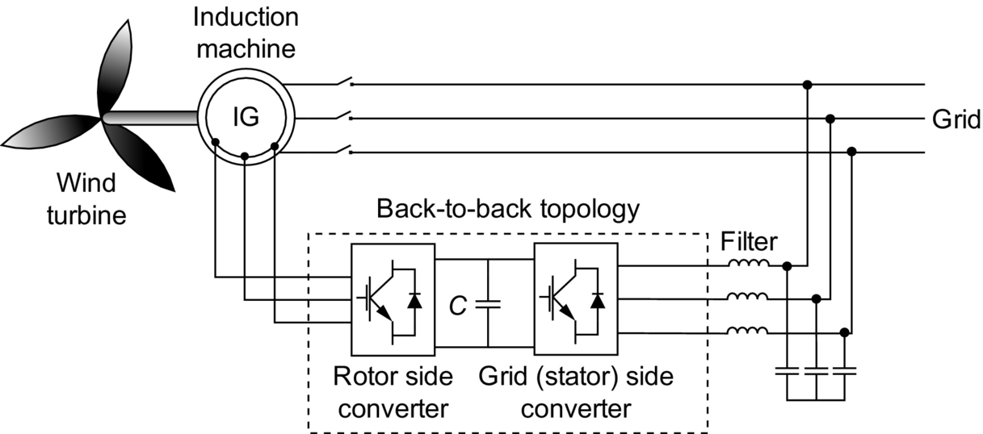

**FIG. 23.27** Doubly fed induction machine topology.

Wounded rotor induction machines can be supplied from both rotor and stator sides. The speed and the torque of the wounded rotor induction machine can be controlled by regulating voltages from both rotor and stator sides of machine. The DFIG can be considered as a synchronous/asynchronous hybrid machine. In the DFIG, similar to the synchronous generator, the real power depends on the rotor voltage magnitude and angle. In addition, the induction machine slip is also a function of the real power [[156](https://learning.oreilly.com/library/view/power-electronics-handbook/9780128114087/B9780128114070000258.xhtml#bb0785)]. DFIG topology offers several advantages in comparison with systems using direct-in-line converters [[157](https://learning.oreilly.com/library/view/power-electronics-handbook/9780128114087/B9780128114070000258.xhtml#bb0790),[158](https://learning.oreilly.com/library/view/power-electronics-handbook/9780128114087/B9780128114070000258.xhtml#bb0795)]. These benefits are the following:

• The main power is transferred through the stator windings of the generator that is directly connected to the grid. Around 65%–75% of the total power is transmitted through stator windings. The remaining power is transmitted using the rotor windings, that is, through the converters, which is about 25% of the total power. Since the inverter rating is 25% of total system power, the inverter cost and size can considerably be reduced.

• While the generator losses are the same in both topologies (direct-in-line and DFIG), the inverter losses can be reduced from around 3% to 0.75%, because the inverter is supposed to only transfer 25% of the total power. Therefore, approximately 2%–3% efficiency improvement can be obtained.

• DFIG topology offers a decoupled control of generator active and reactive powers [[159](https://learning.oreilly.com/library/view/power-electronics-handbook/9780128114087/B9780128114070000258.xhtml#bb0800),[160](https://learning.oreilly.com/library/view/power-electronics-handbook/9780128114087/B9780128114070000258.xhtml#bb0805)].

• Cost and size of the inverter and EMI filters can be reduced since the inverter size is reduced. In addition, the inverter harmonics are lowered because the inverter is not connected to the main stator windings.

In the rotor circuit, two voltage-fed PWM converters are connected back to back, while the stator windings are directly connected to the ac grid side as shown in [Fig. 23.27](https://learning.oreilly.com/library/view/power-electronics-handbook/9780128114087/B9780128114070000258.xhtml#f0140). The direction and magnitude of power between the rotor windings and stator windings can be controlled by adjusting the switching of the PWM signals of the inverters [[161](https://learning.oreilly.com/library/view/power-electronics-handbook/9780128114087/B9780128114070000258.xhtml#bb0810)–[163](https://learning.oreilly.com/library/view/power-electronics-handbook/9780128114087/B9780128114070000258.xhtml#bb0820)]. This is very similar to connecting a controllable voltage source to the rotor circuit [[164](https://learning.oreilly.com/library/view/power-electronics-handbook/9780128114087/B9780128114070000258.xhtml#bb0825)]. This can also be considered as a conventional induction generator without a zero rotor voltage.

To take the benefits of variable speed operation, the optimum operating point of the torque-speed curve should be tracked precisely [[165](https://learning.oreilly.com/library/view/power-electronics-handbook/9780128114087/B9780128114070000258.xhtml#bb0830)]. By controlling the torque of the machine, speed can be adjusted. Thus, using the instantaneous rotor speed value and by controlling the rotor current *i*ry in stator-flux-oriented reference frame, the desired active power can be obtained. Operation at the desired active power results in the desired speed and torque [[153](https://learning.oreilly.com/library/view/power-electronics-handbook/9780128114087/B9780128114070000258.xhtml#bb0770)]. On the other hand, the grid-side converter is controlled to keep the fixed dc-link voltage independent of the direction of rotor power flow. By using supply voltage vector-oriented control, the decoupled control of active and reactive power flow between rotor and grid can be obtained.

Using doubly fed induction generator, the oversizing problem can be solved. Still, speed range of turbine is wide enough; thus, a power converter, which is rated for much lower powers, can be placed in rotor side only, and stator is connected to grid directly. Since power flowing through rotor is usually around 25%–30% of power going through stator, the power electronic interface is designed for only 25%–30% of total power. This is the most important advantage of DFIG.

##### **Synchronous generators**

Synchronous generators are commonly used for variable speed wind-turbine applications, due to their low rotational synchronous speeds that produce the voltage at grid frequency. Synchronous generators can be an appropriate selection for variable speed operation of wind turbines [[166](https://learning.oreilly.com/library/view/power-electronics-handbook/9780128114087/B9780128114070000258.xhtml#bb0835),[167](https://learning.oreilly.com/library/view/power-electronics-handbook/9780128114087/B9780128114070000258.xhtml#bb0840)]. They do not need a pitch control mechanism. The pitch control mechanism increases the cost of the turbine and causes stress on turbine and generator [[168](https://learning.oreilly.com/library/view/power-electronics-handbook/9780128114087/B9780128114070000258.xhtml#bb0845)]. Synchronous generators in variable speed operation will generate variable voltage and variable frequency power. Using an AVR for the excitation of the field voltage, the output voltage of the synchronous generator can be controlled. However, induction generators require controlled capacitors for voltage control. In addition, their operating speed should be over synchronous speed in order to operate in generating mode [[169](https://learning.oreilly.com/library/view/power-electronics-handbook/9780128114087/B9780128114070000258.xhtml#bb0850)].

Multipole synchronous generators can be used more efficiently since the gear can be eliminated, and direct drive of the turbine and generator can be achieved [[170](https://learning.oreilly.com/library/view/power-electronics-handbook/9780128114087/B9780128114070000258.xhtml#bb0855),[171](https://learning.oreilly.com/library/view/power-electronics-handbook/9780128114087/B9780128114070000258.xhtml#bb0860)]. However, synchronous generators without multipoles require gearboxes in order to produce the required frequency for grid connection. On the other hand, a dc voltage source or an ac/dc converter is required for synchronous generators in wind applications in order to produce the required excitation voltage for the field windings. The synchronous generator connection with wind turbine is shown in [Fig. 23.28](https://learning.oreilly.com/library/view/power-electronics-handbook/9780128114087/B9780128114070000258.xhtml#f0145).

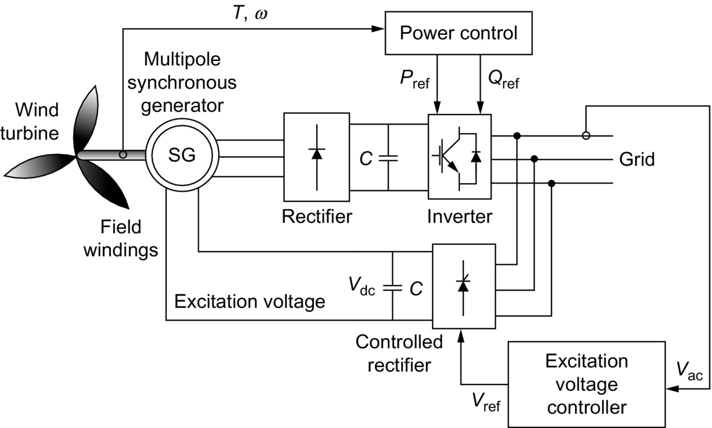

**FIG. 23.28** Multipole synchronous generator for wind-turbine applications.

#### **23.3.4.3 Energy Storage Applications for Wind Turbines**

The batteries and other dc energy storage devices can be connected to the dc links of any topologies. The main purpose of batteries is to assist the generator to meet the load demand. When the load current is smaller than generator current, the extra current is used to charge the battery energy storage. On the other hand, when the load current is larger than generator current, the current is supplied from the battery to the load. With this strategy, the voltage and frequency of the generator can be controlled for various load conditions. Energy storage decreases system inertia, improves the behavior of the system in the case of disturbances, compensates transients, and therefore improves the efficiency [[172](https://learning.oreilly.com/library/view/power-electronics-handbook/9780128114087/B9780128114070000258.xhtml#bb0865)]. However, it brings an initial cost to the system and requires periodical maintenance depending on the storage devices. Therefore, the voltage and frequency control can be modified by using batteries as the controllable load of the VSI as presented in [Fig. 23.29](https://learning.oreilly.com/library/view/power-electronics-handbook/9780128114087/B9780128114070000258.xhtml#f0150). In this way, the load can be regulated by controlling the power flow to the batteries. A bidirectional inverter/converter can be used for power flow from/to the batteries. As another alternative, the battery voltage can be converted to ac voltage with another individual inverter to provide power to AC loads. Although an induction generator is shown in [Fig. 23.29](https://learning.oreilly.com/library/view/power-electronics-handbook/9780128114087/B9780128114070000258.xhtml#f0150), these energy storage systems are applicable to any other topologies.

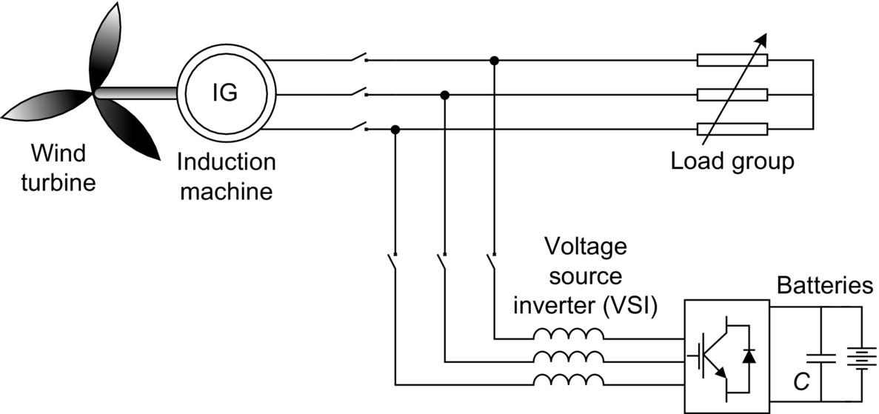

**FIG. 23.29** Voltage and frequency control using energy storage.

Storage systems can be connected in various forms to the wind-turbine systems [[173](https://learning.oreilly.com/library/view/power-electronics-handbook/9780128114087/B9780128114070000258.xhtml#bb0870)–[177](https://learning.oreilly.com/library/view/power-electronics-handbook/9780128114087/B9780128114070000258.xhtml#bb0890)]. Generally, a bidirectional dc/dc converter is required for the integration of the storage system to the doubly fed induction generator system [[178](https://learning.oreilly.com/library/view/power-electronics-handbook/9780128114087/B9780128114070000258.xhtml#bb0895)]. In this topology, one of the converters regulates the storage power, whereas the other is responsible for dc bus voltage control. The bidirectional energy storage topology for DFIGs in wind applications is shown in [Fig. 23.30](https://learning.oreilly.com/library/view/power-electronics-handbook/9780128114087/B9780128114070000258.xhtml#f0155).

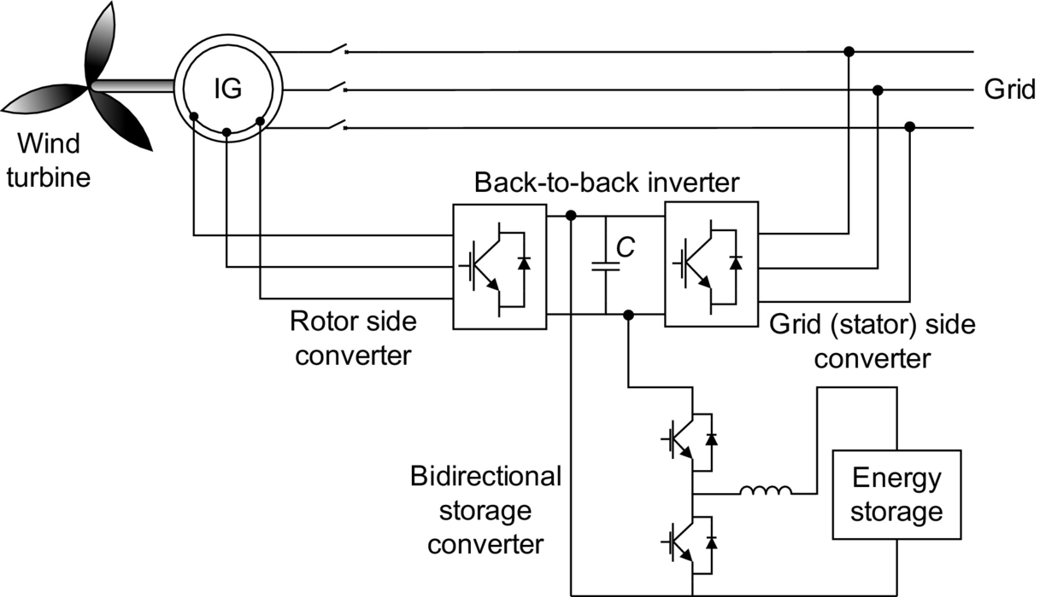

**FIG. 23.30** Energy storage with bidirectional converter in DFIG systems.

### 23.3.5 OCEAN ENERGY HARVESTING

#### **23.3.5.1 Ocean Wave Energy**

Ocean waves are a plentiful, clean, and renewable source of energy. The total power of waves breaking around the world's coastlines is estimated at 2–3 million megawatts. The west coasts of the United States and Europe and the coasts of Japan and New Zealand are good sites for harnessing wave energy [[179](https://learning.oreilly.com/library/view/power-electronics-handbook/9780128114087/B9780128114070000258.xhtml#bb0900)]. Wave energy conversion is one of the feasible future energy technologies; however, it is not mature enough. Therefore, the construction cost of wave power plants is considerably high. These energy systems are not developed and maturated commercially due to the problems of dealing with sea conditions, complexity, and difficulty of interconnection and transmission of electricity.

A wave power absorber, a turbine, a generator, and the power electronic interfaces are the main components of a typical ocean wave energy harvesting technique. The kinetic energy of the ocean waves are captured by absorbers. Either the absorbed kinetic energy of the waves is conveyed to turbines or the absorber directly drives the generator. The shaft of the electric generator is driven by the turbine. Turbines are generally used within the systems including rotational generators. Linear motion generators are used in systems without turbines, which can be direct driven by the power absorber or movement of the device. Due to the varying amplitude and period of the ocean waves, both linear and rotational generators generate variable frequency—variable amplitude ac voltage. This ac voltage can be rectified to dc voltage to take the benefit of dc energy transmission through the salty ocean water. dc transmission in salty water does not require an additional cable for the negative polarity. Thus, it will be more cost-effective than transmitting the power in ac form, which requires three-phase cables. Transmission cable length varies depending on the location of the application, which is either nearshore or offshore. However, the main idea and the principles are the same for both types of applications. After the dc power is transmitted from ocean to the land, a dc/dc converter or a tap-changing transformer can be used for voltage regulation. Depending on the utilized voltage regulation system, a dc/ac inverter is used before or after the voltage regulator. The voltage synchronization is provided by the inverter, and the output terminals of the inverter can be connected to the grid.

In [Fig. 23.31](https://learning.oreilly.com/library/view/power-electronics-handbook/9780128114087/B9780128114070000258.xhtml#f0160), a system level diagram of the ocean wave energy harvesting technology is shown. At an in-water substation, wave energy conversion devices (including the absorber, turbine, and generator) are interconnected. The substation consists of the connection equipments and controllers for individual devices. The outputs of the generators are connected to a common dc bus using dc/ac converters for transforming power before transmission to the shore. A transmission line connects the cluster to shore. An onshore inverter converts the dc voltage to a 50 or 60 Hz ac voltage for grid connection. An optional shore transformer with tap changer or a dc/dc converter compensates the voltage variations. A group of absorber, turbine, and generators could be used in a farm structure; thus, the captured energy can be increased.

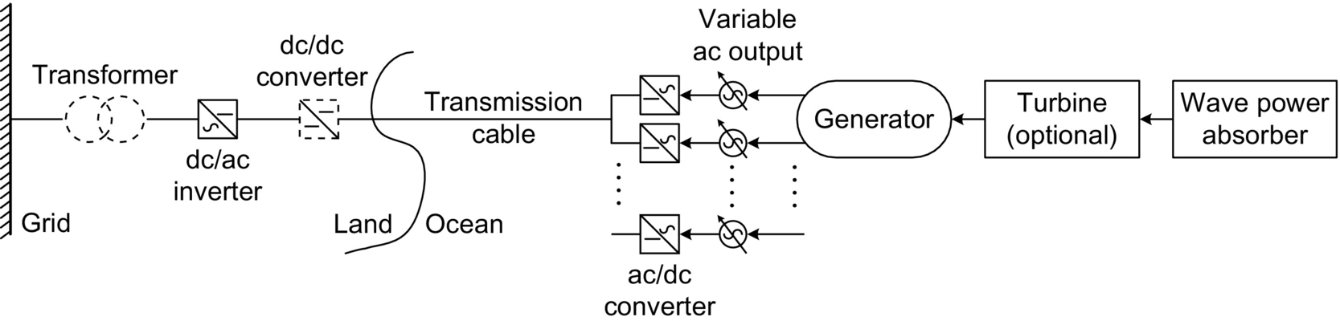

**FIG. 23.31** System level diagram of ocean wave energy harvesting.

Alternatively, the land converters might be moved offshore to come up with space limitations that may occur in land stations. This brings some complexity to the system and may require more maintenance, which is harder to deal, in comparison with landside converters. Moreover, the transformer can be installed offshore. This would increase the power transmission capability, since the higher voltage transmission will result in less transmission losses. However, in this case, the advantage of dc transmission will not exist. As a different option, boost dc/dc converters can be used after the ac/dc converter of the generator. This allows a high-voltage dc transmission link. In this case, both transmission losses will be kept at minimum, and only single-line dc transmission through the ocean water will be required.

##### **Energy of ocean waves**

The total potential and kinetic energy of an ocean wave can be expressed as

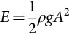 **(23.15)**

where *g* is the acceleration of gravity (9.8 m/s2), *ρ* is the density of water (1000 kg/m3), and *A* is the wave amplitude (m).

The power of a wave in a period is equal to the energy E multiplied by the speed of wave propagation, *v*g, for deep water

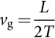 **(23.16)**

where *T* is the wave period (seconds) and *L* is the wave length (m) [[180](https://learning.oreilly.com/library/view/power-electronics-handbook/9780128114087/B9780128114070000258.xhtml#bb0905)].

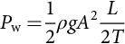 **(23.17)**

The dispersion relationship describes the connection between the wave period *T* and the wave length *L* as

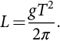 **(23.18)**

If [(23.18)](https://learning.oreilly.com/library/view/power-electronics-handbook/9780128114087/B9780128114070000258.xhtml#fo0095) is substituted in [(23.17)](https://learning.oreilly.com/library/view/power-electronics-handbook/9780128114087/B9780128114070000258.xhtml#fo0090), the power or energy flux of an ocean wave can be calculated as

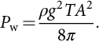 **(23.19)**

Instead of using the wave amplitude, wave power can also be rewritten as a function of wave height, *H* [m]. Considering that the wave amplitude is the half of the wave height, the wave power becomes

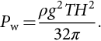 **(23.20)**

##### **Ocean wave energy harvesting technologies**

In general, ocean wave energy harvesting technologies can be classified into two types with respect to their distance from the shore: offshore ocean wave energy harvesting technologies and onshore ocean wave energy harvesting technologies. These are discussed in details in following subsections.

###### **Off-shore ocean wave energy harvesting technologies**

Offshore applications are located away from the shore, and they generally use a floating body as wave power absorber and another body that is fixed to the ocean bottom. Generally, linear generators with buoys are used in offshore applications. Linear generators are directly driven by the movement of a floating body on the ocean. Salter cam and buoys with air-driven turbines are the only applications involving rotational generators in offshore applications.

**23.3.5.1.2.1.1 Air-Driven Turbines based Off-Shore Technologies**

In air-driven turbine systems for offshore applications, the primary conversion is from wave to the pressurized air. Secondary conversion stage is the conversion to mechanical energy by rotating shaft of the turbine. The last stage is converting mechanical rotation into electric power by electric generators.

The operating principle of an offshore application that consists of a floating buoy with an air chamber and an air-driven generator is shown in [Fig. 23.32](https://learning.oreilly.com/library/view/power-electronics-handbook/9780128114087/B9780128114070000258.xhtml#f0165). In this system, the water level inside channel of the buoy increases when the waves hit the body. This increase in water level applies a pressure to the air in the air chamber. When the air is pressurized, it applies a force to the ventilator turbine and rotates it. This turbine drives the electric generator, and electricity is generated at the output terminals of this generator. When the waves are pulled back to the ocean, the air in the air chamber is also pulled back since the water level in the buoy channel decreases. Due to the syringe effect, this time, turbine shaft rotates in the contrary direction but produces electricity. There should be very good mechanical insulation through the air chamber and the ventilating generator to achieve higher efficiencies. However, this brings design complexity and additional cost to the system.

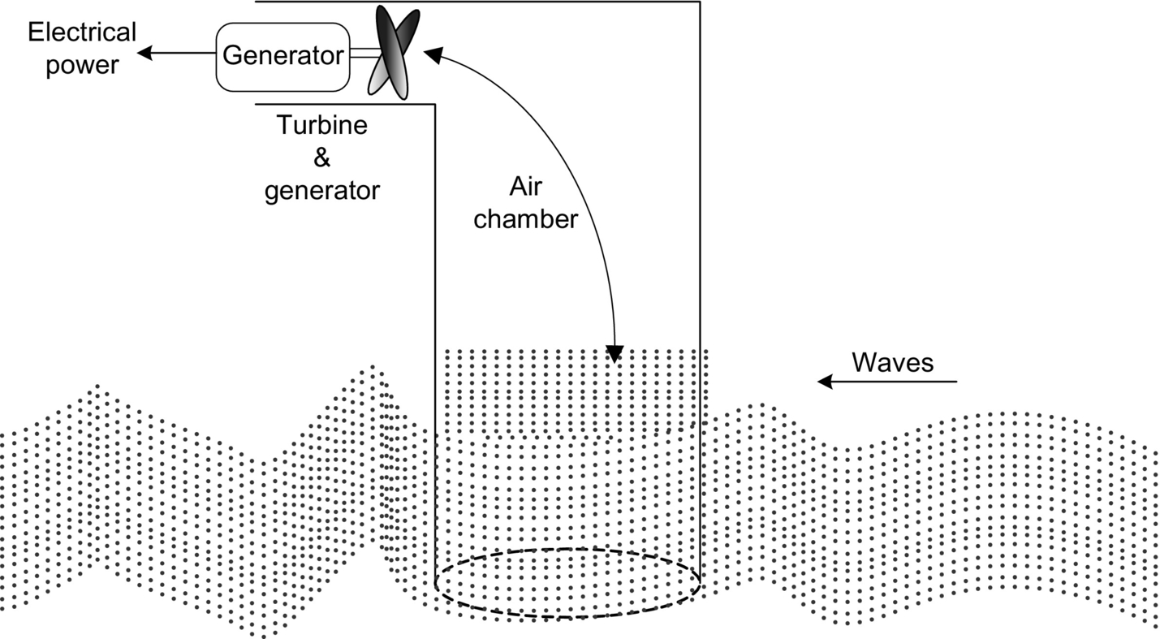

**FIG. 23.32** Spinning the air-driven turbines using wave power [[181](https://learning.oreilly.com/library/view/power-electronics-handbook/9780128114087/B9780128114070000258.xhtml#bb0910)].

In another method, water level increases, and air is taken out from the upper outlets while spinning the turbines as shown in [Fig. 23.33A](https://learning.oreilly.com/library/view/power-electronics-handbook/9780128114087/B9780128114070000258.xhtml#f0170). Contrarily, when the waves are pulled back to the sea, water level decreases. This results in sucking the air back from the upper inlets while spinning the turbines, as shown in [Fig. 23.33B](https://learning.oreilly.com/library/view/power-electronics-handbook/9780128114087/B9780128114070000258.xhtml#f0170).

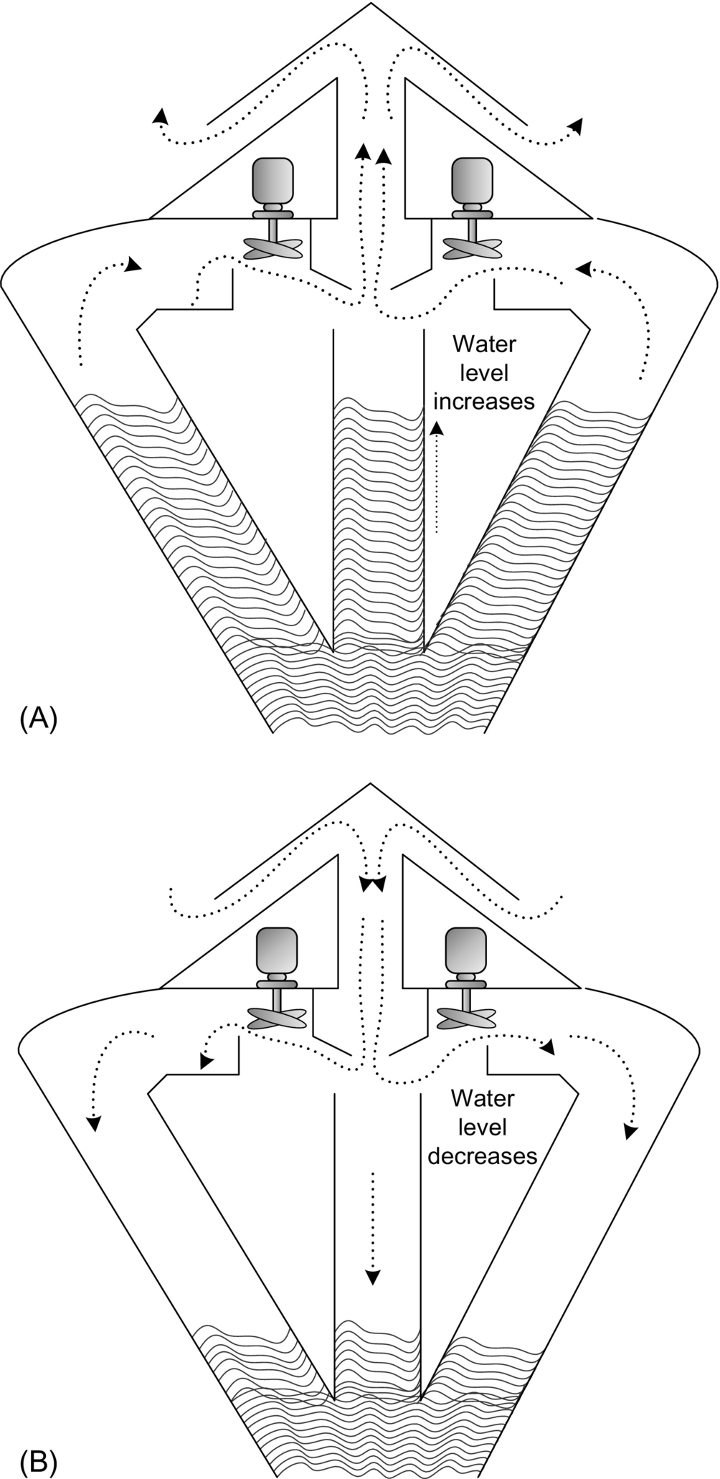

**FIG. 23.33** Air-pressure ring buoy: (A) water level increases, and air is taken out from the upper outlets; (B) Water level decreases, and air is pulled back from upper inlets.

**23.3.5.1.2.1.2 Direct-drive permanent-magnet linear generator-based buoy applications**

The height differences of the wave top and bottom levels yield an up and down motion for the piston that is the transaxle of the linear generator. When the wave is floating on the ocean surface, the buoy follows the motion of the wave. Buoy can move vertically on a pillar, which is connected to a hull. On the surface of the hull, PMs are mounted, while outside of the hull contains the coil windings. The pillar and stator are connected together on a concentrate foundation standing on the seabed of the ocean. The hull and mounted magnets, called rotor or piston, are the moving parts of the generator. Since the motion is linear, this generator is called a linear generator.

In [Fig. 23.34](https://learning.oreilly.com/library/view/power-electronics-handbook/9780128114087/B9780128114070000258.xhtml#f0175), the linear generator in the floating buoy and fixed pillar are shown.

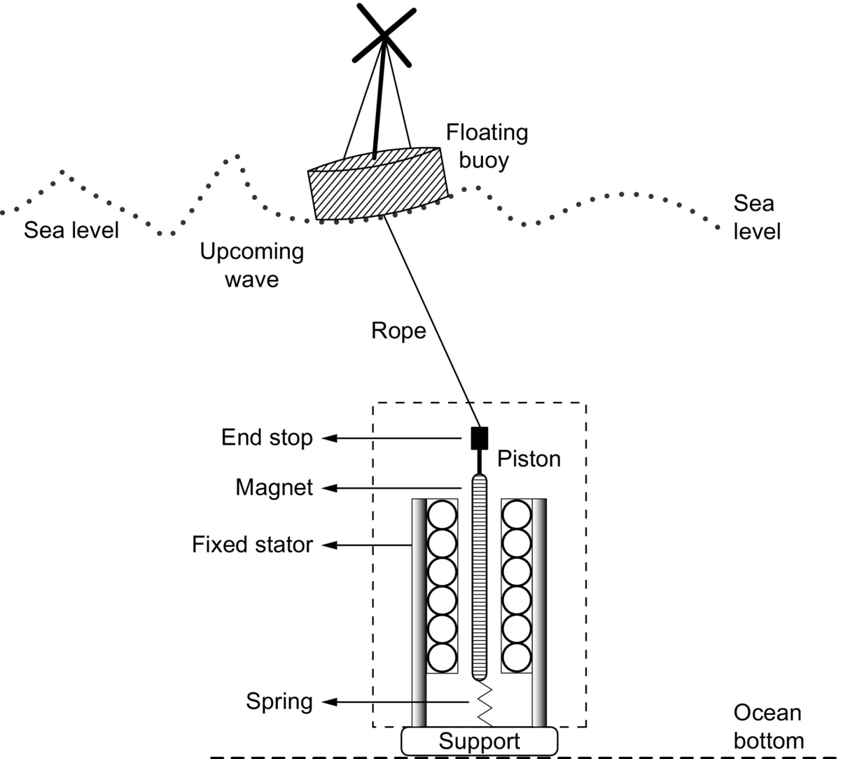

**FIG. 23.34** Linear generator-based buoy type wave energy harvesting method.

When the wave rises, the buoy will drive the generator piston through a stiff rope. When the wave subsides, the generator will be driven by the spring that stores the mechanical energy in the first case. Thus, electric generation is provided during both up and down motion. Due to the existence of variable frequency in the current and voltage from the stator, an ac/dc rectifier followed by a dc/ac converter is required to make the grid connection possible. Instead of placing moving parts to the ocean bottom, the PMs and the stator windings can be placed at the sea level [[182](https://learning.oreilly.com/library/view/power-electronics-handbook/9780128114087/B9780128114070000258.xhtml#bb0915)]. [Fig. 23.35](https://learning.oreilly.com/library/view/power-electronics-handbook/9780128114087/B9780128114070000258.xhtml#f0180) shows the x-y plane of the cross-sectional view of one pole of the longitudinal flux surface mounted linear PM generator.

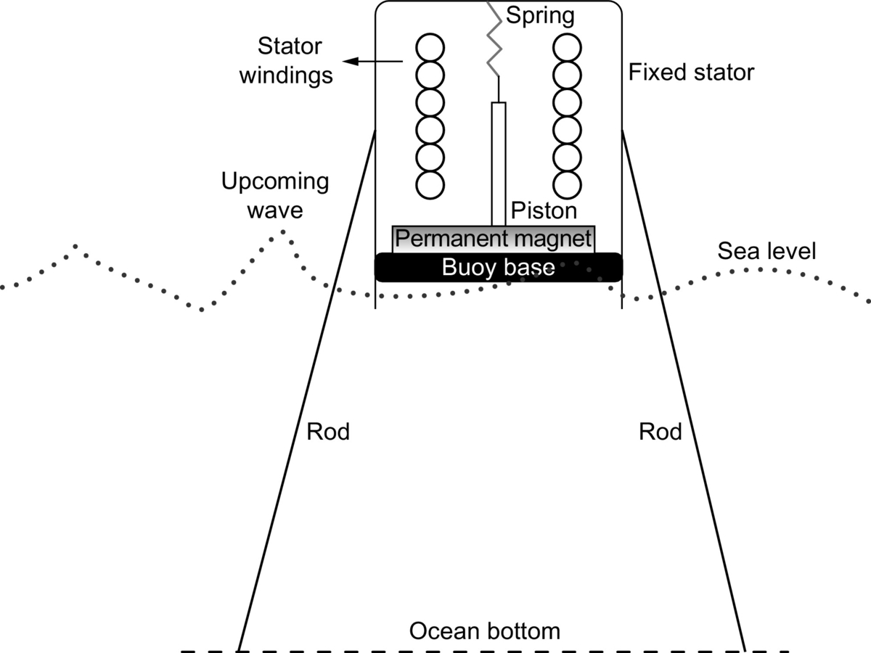

**FIG. 23.35** Schematic of a longitudinal flux permanent-magnet generator used for wave energy conversion.

**23.3.5.1.2.1.3 Salter Cam Method**

Salter cam method implementation is shown in [Fig. 23.36](https://learning.oreilly.com/library/view/power-electronics-handbook/9780128114087/B9780128114070000258.xhtml#f0185). Salter cam rolls around a fixed inner cylinder by activation of an incoming wave. Through the differential rotation between the cylinder and the cam, power can be captured. The motion of the cam is converted from wave to a hydraulic fluid. Then, hydraulic motor is used to convert the pressurized hydraulic fluid to rotational mechanical energy. Finally, rotational mechanical energy is converted to electricity by utilizing electric generators. Flywheels or pressurized liquids can be used as an intermediate step in order to reduce the intermittencies of the wave power.

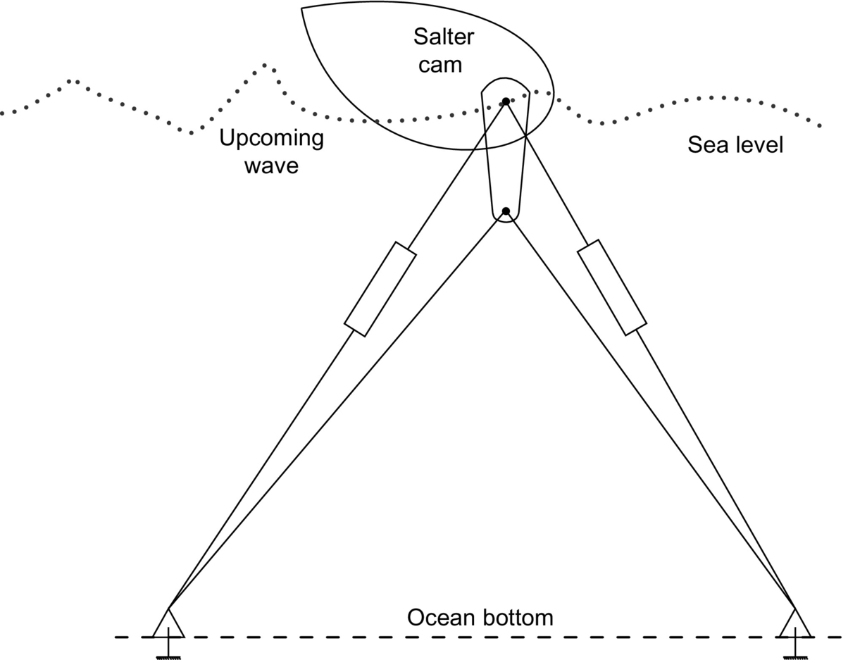

**FIG. 23.36** A schematic illustrating the fixation of salter cam wave energy conversion device.

###### **Near-shore ocean wave energy harvesting technologies**

Nearshore topologies are applied within the surfing zone of the ocean or right on the shore. Nearshore applications have some advantages and disadvantages in comparison with the offshore applications.

**23.3.5.1.2.2.1 Channel/reservoir/turbine based near-shore wave energy harvesting method**

Wave currents can be tapered into a narrow channel to increase their power and size in order to harness the wave energy. As shown in [Fig. 23.37](https://learning.oreilly.com/library/view/power-electronics-handbook/9780128114087/B9780128114070000258.xhtml#f0190), waves can be channeled into a catch basin and used directly to rotate the turbines. Since this method requires building a reservoir to collect the water coming with the waves to drive the turbine, it is more expensive in comparison with the other buoy-shaped offshore applications. However, it requires less maintenance in comparison with the offshore applications, since all components of the wave energy conversion system are located on land. Additionally, since a reservoir collects the ocean water, the intermittencies can be eliminated. This will create a convenient platform for voltage and frequency regulation. Building these types of plants in the locations, where they have regular and sustaining wave regimes, is more advantageous.

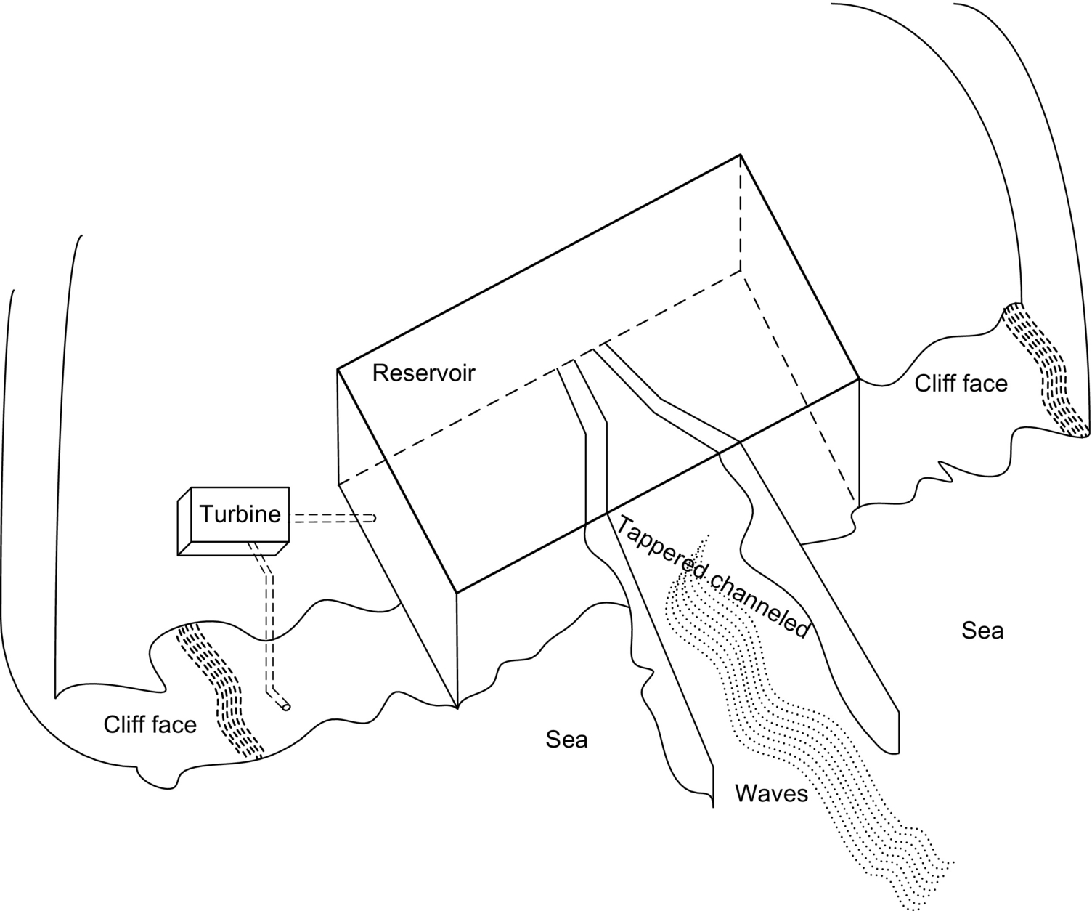

**FIG. 23.37** Channeled ocean wave to a reservoir to spin the turbines.

**23.3.5.1.2.2.2 Air-driven turbines based near-shore wave energy harvesting method**

Using oscillating water columns (OWC) that generates electricity from the wave-driven rise and fall of water in a cylindrical shaft or pipe is another way to harness the wave energy. The air is driven into and out of the top of the shaft due to the rising and falling water, powering an air-driven turbine that is shown in [Fig. 23.38](https://learning.oreilly.com/library/view/power-electronics-handbook/9780128114087/B9780128114070000258.xhtml#f0195).

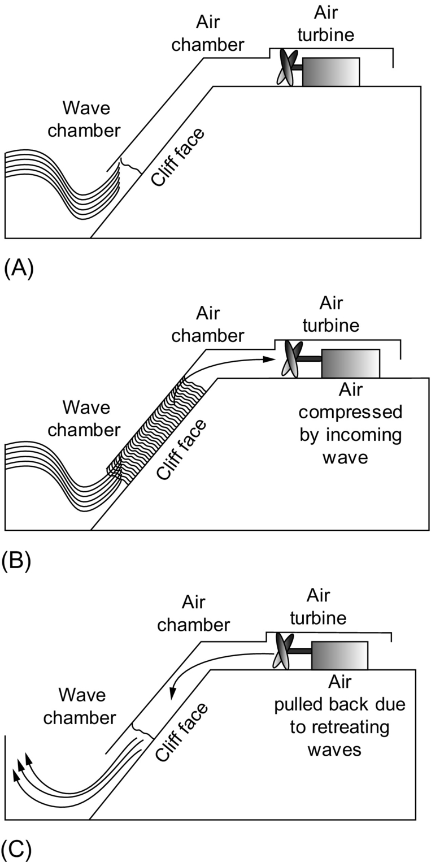

**FIG. 23.38** Air-driven turbines using the wave power: (A) upcoming wave starts filling the chamber; (B) air is compressed by rising water; (C) air is pulled back by retreating waves [[181](https://learning.oreilly.com/library/view/power-electronics-handbook/9780128114087/B9780128114070000258.xhtml#bb0910)].

The general structure of the nearshore air-driven turbine is shown in [Fig. 23.38A](https://learning.oreilly.com/library/view/power-electronics-handbook/9780128114087/B9780128114070000258.xhtml#f0195). Waves push the air through the ventilator that drives the electric machine as shown in [Fig. 23.38B](https://learning.oreilly.com/library/view/power-electronics-handbook/9780128114087/B9780128114070000258.xhtml#f0195). The wave retreats from the wave chamber inside the channel that decreases the pressure as shown in [Fig. 23.38C](https://learning.oreilly.com/library/view/power-electronics-handbook/9780128114087/B9780128114070000258.xhtml#f0195). This method is advantageous because of the capability of using not only the wave power but also the power from the tidal motions. However, mechanical isolation should be provided within the wave and air chambers in order to obtain better efficiencies. This will also bring some more cost and design complexities to the system.

#### **23.3.5.2 Ocean Tidal Energy**

The generation of electric power from ocean tides is similar to the traditional hydroelectric generation. A dam, known as a barrage, across an inlet is required for the simplest tidal power plants. In a tidal power plant, usually, a tidal pond created by a dam and a powerhouse, which contains a turbo generator, and a sluice gate to allow the bidirectional tidal flow. During the flood tide, the rising tidal waters fill the tidal basin after opening the gate of the dam. When the dam is filled to capacity, the gates are closed. The tidal basin is released through a turbogenerator after the ocean waters have receded. Power can be generated during ebb tide, flood tide, or both. When the water is pulled back, ebb tide occurs, and when the water level increases near the shore, flood tide happens [[183](https://learning.oreilly.com/library/view/power-electronics-handbook/9780128114087/B9780128114070000258.xhtml#bb0920)]. Tidal power can be economical at sites where mean tidal range exceeds 16 ft [[183](https://learning.oreilly.com/library/view/power-electronics-handbook/9780128114087/B9780128114070000258.xhtml#bb0920),[184](https://learning.oreilly.com/library/view/power-electronics-handbook/9780128114087/B9780128114070000258.xhtml#bb0925)].

Tidal current is not affected by the climate change, the lack of rain, or a snowmelt. Therefore, tidal energy harvesting is practical since the tidal current is regular and predictable. Moreover, environmental and physical impacts and pollution issues are negligible. Tidal power can additionally be used for water electrolysis for hydrogen production applications and desalination. However, tidal power generation is an immature technology, which needs further investigations and developments.

Tidal turbines can be used for tidal energy harvesting, similar to the wind turbines. Tidal turbines can be located where there is a strong tidal flow. These turbines have to be much stronger than wind turbines since the water is about 800 times as dense as air. They will be heavier and more expensive; however, they will be able to capture more energy at much higher densities [[181](https://learning.oreilly.com/library/view/power-electronics-handbook/9780128114087/B9780128114070000258.xhtml#bb0910)]. In [Fig. 23.39](https://learning.oreilly.com/library/view/power-electronics-handbook/9780128114087/B9780128114070000258.xhtml#f0200), a typical tidal turbine is shown.

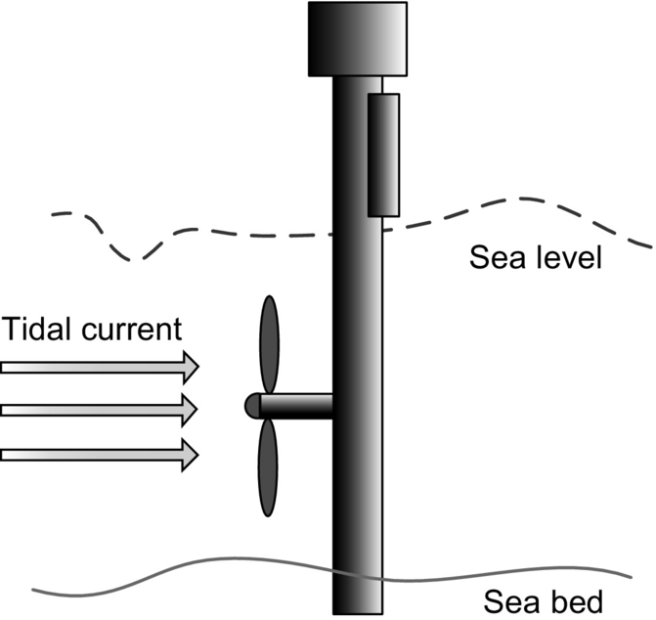

**FIG. 23.39** Tidal turbine.

Usually, tidal fences having multiple turbines are mounted in the entrance of channels that are affected by ocean tides. Tidal water is forced to pass through a fence structure, which is called caisson in this fence application. Unlike barrage stations, basins are not required for fence applications, and they can be used in a channel between the mainland and a nearby offshore island or between two islands. Tidal fences can be mounted at the entrance of channels that ocean water gets inside the land via a bay ([Fig. 23.40A](https://learning.oreilly.com/library/view/power-electronics-handbook/9780128114087/B9780128114070000258.xhtml#f0205)), or between the main land and an island ([Fig. 23.40B](https://learning.oreilly.com/library/view/power-electronics-handbook/9780128114087/B9780128114070000258.xhtml#f0205)), or simply between two islands (as shown in [Fig. 23.40C](https://learning.oreilly.com/library/view/power-electronics-handbook/9780128114087/B9780128114070000258.xhtml#f0205)). Since they do not require flooding the basin, tidal fences have much less impact on the environment. In addition, they are significantly cheaper to install; however, the caisson may disrupt the movement of large marine animals and shipping [T4].

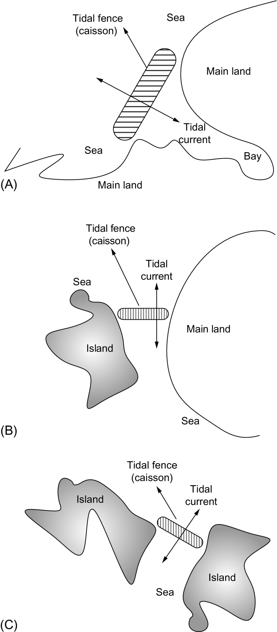

**FIG. 23.40** Tidal fences can be mounted (A) at the entrance of bays, (B) between the main land and an island, and (C) between two islands.

#### **23.3.5.3 Power Electronic Interfaces for Ocean Energy Harvesting Applications**

Both in ocean wave and ocean tidal energy harvesting applications, the generators may produce alternating currents and voltages that have varying magnitude and frequency. Therefore, output power of the ocean energy converters need further conditioning prior to the grid connection. In addition, the frequency of the output voltage should be regulated to be the same as grid frequency. Output power conditioning, amplitude, phase, and frequency of the conversion system can be regulated by utilizing power electronic converters.

Block diagram of a typical power conditioning system for a grid-connected ocean energy conversion system is shown in [Fig. 23.41](https://learning.oreilly.com/library/view/power-electronics-handbook/9780128114087/B9780128114070000258.xhtml#f0210). Ocean wave or ocean tide potential and kinetic energies rotate the water turbine, or a power absorber directly drives a linear generator with up and down motions. The varying wave and tides result in variable frequency and amplitude of the generator output. The ac power produced by the generator is converted into dc power via three-phase bridge rectifiers followed by a dc/ac inverter. The output of the dc/ac inverter generally contains harmonics, which should be filtered. Finally, output power can be connected to grid and transmitted to consumers after its voltage is increased and isolated by a power transformer.

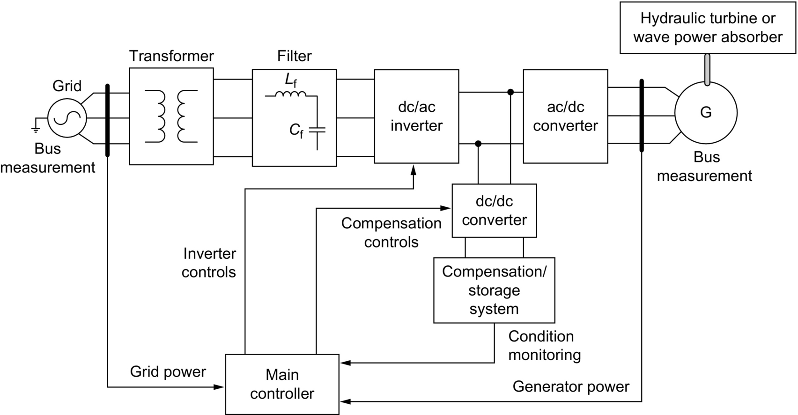

**FIG. 23.41** Grid connection and controls of tidal current power conditioning system.

During the intermittencies, power cannot be generated. Therefore, an energy storage system should be connected to the generator output or output of a conversion stage in the power conditioning system. Stored energy can be supplied to the grid during the intermittency periods. Hence, it is ensured that continual power is supplied to the grid.

### 23.3.6 GEOTHERMAL ENERGY SYSTEMS

Geothermal energy is the thermal energy that is stored in the inner layers of the Earth composed of rocks and fluids. The temperature of the inner layers of the Earth gets hotter as the depth increases. In deeper layers, it is even extremely hotter due to the hot molten rock called magma [[185](https://learning.oreilly.com/library/view/power-electronics-handbook/9780128114087/B9780128114070000258.xhtml#bb0930),[186](https://learning.oreilly.com/library/view/power-electronics-handbook/9780128114087/B9780128114070000258.xhtml#bb0935)].

Geothermal energy can be utilized by several methods. It can be used as direct heat for electric power generation. In the direct heat utilization, applications can be categorized as hydrothermal, agricultural, or industrial [[187](https://learning.oreilly.com/library/view/power-electronics-handbook/9780128114087/B9780128114070000258.xhtml#bb0940)]. Hydrothermal resources have low to moderate temperatures between 20 and 150*°*C. These resources can be utilized to provide direct heating for residential, industrial, and commercial sectors [[188](https://learning.oreilly.com/library/view/power-electronics-handbook/9780128114087/B9780128114070000258.xhtml#bb0945)]. These applications include but are not limited to water and space heating, greenhouse and agricultural heating, cleaning, textile processes, and food dehydration. Agricultural production is one of the utilization methods of direct use of geothermal energy. It is used to warm the greenhouses in order to provide cultivation. Industrial utilization examples can be food and cloth processing, manufacturing paper, pasteurizing milk, drying fish, vegetables and fruits, and even for refrigeration and air conditioning.

Other than the direct use of geothermal energy, it can be used as the heat and steam source for electric power plants. Instead of burning fossil fuels and generating heat for water boiling, geothermal power plants use the readily obtained heat or steam. Natural hot water and/or steam from the inner layers of the Earth are used to drive the turbines and generators to produce electricity. Absolutely, no fuel firing is required for heating or steam generation for geothermal power plants. Therefore, geothermal power plants do not have emissions, and they are environmentally clean. Moreover, since the extracted heat is replaced by the thermal energy of the Earth's inner layers, geothermal energy is sustainable and renewable.

Schematic of a geothermal power plant is presented in [Fig. 23.42](https://learning.oreilly.com/library/view/power-electronics-handbook/9780128114087/B9780128114070000258.xhtml#f0215).

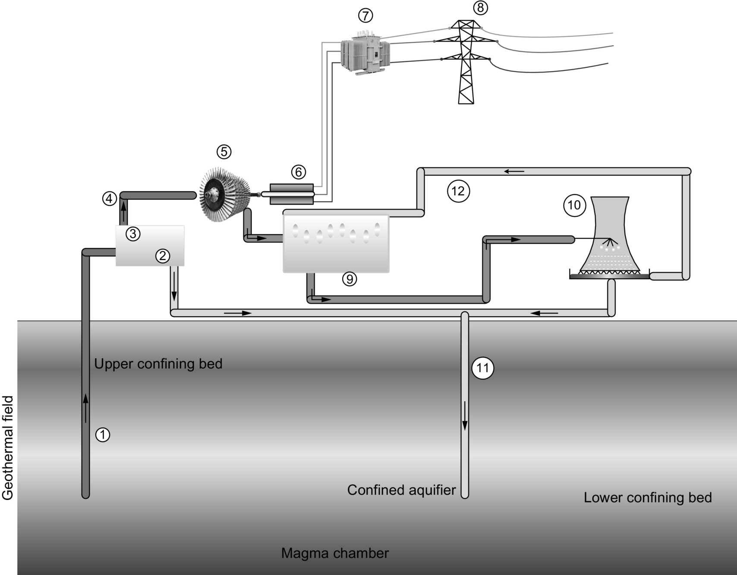

**FIG. 23.42** A geothermal power plant.

The components of the geothermal power plant are described in [Table 23.6](https://learning.oreilly.com/library/view/power-electronics-handbook/9780128114087/B9780128114070000258.xhtml#t0035).

**Table 23.6**

**Geothermal power plant components**

|  |  |
| --- | --- |
| 1—Production well | 7—Power transformer |
| 2—Water-steam mix | 8—High-voltage transmission lines |
| 3—Separator | 9—Condenser |
| 4—Steam | 10—Cooling tower |
| 5—Steam turbine | 11—Injection well |
| 6—Generator | 12—Water flow cycle |

The operating principle of a geothermal power plant is very similar to that of a coal-fired power plant. However, in geothermal power plants, hot steam and/or water is obtained from the deeper Earth layers instead of burning any fuel. Production well is used to draw hot water and/or steam from deeper layers. This mixture is separated by the separator in order to get the dry steam. Through a steam governor, a steam turbine is rotated by this high-pressure and high-temperature steam. Since the steam turbine is coupled to an electric generator, the mechanical steam power is converted into electric power. The output voltage of the generator is increased by a power transformer. The high voltage output of the power transformer can then be connected to the high-voltage transmission network. The steam loses its temperature and pressure after it goes through the steam turbine. Thus, the output flow of the steam turbine is condensed in the condensers. Condensed water is cooled down through the cooling tower, and cool water helps to condense the low-pressure/low-temperature steam in the condenser. The cooled water is then injected back to the inner Earth layers to get hot again. If the geothermal field is rich of hot water reservoirs, this cooled but still relatively warm water can be used for other heating purposes.

Geothermal energy is an abundant, secure, reliable, and renewable source of energy. It has high availability and capacity factor in comparison with other renewables. It is not a source of pollution for the environment; that is, their CO2 emissions are less than 0.2% of the cleanest fossil-fuel-fired power plant, SO2 emissions are less than 1%, and particulate emissions are less than 0.1%. It has an inherent energy storage capability and requires very small land area for establishment [[186](https://learning.oreilly.com/library/view/power-electronics-handbook/9780128114087/B9780128114070000258.xhtml#bb0935)].

Geothermal power plants can be classified into three main generation technologies: dry-steam power plant, flash-steam power plant, and binary-cycle power plant.

*Dry-steam power plants* are the most common geothermal power plants since they are simple and cost-effective. These power plants are applicable to the geothermal fields where the geothermal steam is not mixed with water. In this method, production wells are drilled down to the aquifer to get superheated and pressurized steam. This steam is brought to the surface at high speeds. When the expanding steam passes through the turbine, the generator generates electricity [[189](https://learning.oreilly.com/library/view/power-electronics-handbook/9780128114087/B9780128114070000258.xhtml#bb0950),[190](https://learning.oreilly.com/library/view/power-electronics-handbook/9780128114087/B9780128114070000258.xhtml#bb0955)]. The low-pressure steam output from the turbine is ventilated to the atmosphere in simple power plants. However, exhaust steam from the turbine is condensed in more complex power plants. The condensate can be reinjected to the reservoir by the injection wells, and/or it can be used as makeup cooling water.

*Flash-steam power plants* use a flash-steam technology where the hydrothermal source is in liquid form. This fluid is sprayed into a flash tank that is at a much lower pressure than the fluid. Therefore, the fluid immediately vaporizes rapidly into steam [[189](https://learning.oreilly.com/library/view/power-electronics-handbook/9780128114087/B9780128114070000258.xhtml#bb0950),[191](https://learning.oreilly.com/library/view/power-electronics-handbook/9780128114087/B9780128114070000258.xhtml#bb0960)]. This generated steam is used to rotate the steam turbines that are coupled to electric generators. The production well is kept under high pressure in order to prevent the geothermal fluid flashing inside the well [[186](https://learning.oreilly.com/library/view/power-electronics-handbook/9780128114087/B9780128114070000258.xhtml#bb0935)]. Instead of using a single flashing system, dual-flashing systems are also used. The brine from the high-pressure steam is piped into a low-pressure separator/flash tank where the pressure is additionally reduced to generate lower-pressure steam in the dual-flash systems. In order to generate additional electric power, this lower-pressure steam is piped into a lower-pressure stage of the turbine. The steam exhaust from the high and low pressure turbines is condensed. Just like the dry-steam plants, the condensate is then used as makeup cooling water or reinjected to the reservoir.

Although the dual-flash power plants have higher capital cost, they have higher thermoelectric efficiency. Resource characteristics, power plant output, thermodynamic and economic factors, and equipment availability are the factors affecting the decision to build and operate a single-flash or dual-flash geothermal power plants [[192](https://learning.oreilly.com/library/view/power-electronics-handbook/9780128114087/B9780128114070000258.xhtml#bb0965)]. Generally, dual-flash system is preferred if the fluid temperature is between 175 and 260*°*C, while single-flash systems are efficient enough for the fluid temperatures higher than 260*°*C.

*Binary-cycle power plants* are preferred when the geothermal resource is insufficiently hot to produce steam. Sometimes, the resource may have other chemical components causing impurities, and flashing may not become possible [[186](https://learning.oreilly.com/library/view/power-electronics-handbook/9780128114087/B9780128114070000258.xhtml#bb0935),[193](https://learning.oreilly.com/library/view/power-electronics-handbook/9780128114087/B9780128114070000258.xhtml#bb0970)]. In these cases, binary-cycle power plants are preferred. In binary-cycle geothermal power plants, isobutene, isopentane, or pentane is used as the secondary fluid that has a lower boiling point than water. Since a separate working fluid is used, the cycle is called “binary.” The geothermal fluid (water) is passed through a heat exchanger in order to heat up the secondary fluid. Secondary fluid vaporizes and expands through the turbines that are coupled to electric generators. After passing through the turbines, the working fluid is condensed and recycled for the next cycle. Moreover, the fluid remaining in the tank of flash-steam plants can be reutilized in binary-cycle plants. In a closed-cycle system, all of the geothermal fluid is injected back to the ground. Usually, binary-cycle plants are more efficient than the flash-steam plants in low to moderate temperatures of geothermal fluids. Furthermore, corrosion problems are avoided since a pure working fluid is used.

### 23.3.7 NUCLEAR POWER PLANTS

In nuclear power plants, energy is extracted from atomic nuclei by the controlled nuclear reactions. There are several available methods such as nuclear fission, nuclear fusion, and radioactive decay. The most common method is the nuclear fission. Similar to the conventional fossil-fuel-fired power plants, nuclear reactors generate heat in order to produce steam. However, unlike many conventional thermal power plants, nuclear power plants convert the energy released from the atoms' nucleus generally via nuclear fission, instead of burning fossil fuels. This energy is used for steam production that is utilized to operate the turbines that are coupled to electric generators. In this way, the mechanical work of the high-pressure steam is converted into electricity [[194](https://learning.oreilly.com/library/view/power-electronics-handbook/9780128114087/B9780128114070000258.xhtml#bb0975),[195](https://learning.oreilly.com/library/view/power-electronics-handbook/9780128114087/B9780128114070000258.xhtml#bb0980)].

The fission of an atom occurs when a relatively large fissile atomic nucleus such as uranium-235 or plutonium-239 absorbs a neutron. The atom is then split by the fission into two or more smaller nuclei with kinetic energy, gamma radiation, and free neutrons [[194](https://learning.oreilly.com/library/view/power-electronics-handbook/9780128114087/B9780128114070000258.xhtml#bb0975)]. Other fissile atoms may absorb a portion of these neutrons and create more fission, which release more neutrons, and so on [[195](https://learning.oreilly.com/library/view/power-electronics-handbook/9780128114087/B9780128114070000258.xhtml#bb0980)]. By using neutron moderators and neutron poisons, this nuclear chain reaction can be controlled in order to adjust the potion of neutrons that will cause more fission. Manual or automatic control systems are used for this purpose or to shut down the reactor if unsafe conditions are detected [[196](https://learning.oreilly.com/library/view/power-electronics-handbook/9780128114087/B9780128114070000258.xhtml#bb0985)].

Heat generation by the reactor core from fission involves several stages. The kinetic energy of the fission products is converted into thermal energy when a collision happens between the nuclei and nearby atoms. The reactor absorbs some of the gamma radiation produced during fission in the form of heat. Neutron absorption activates some materials, and the radioactive decay of fission products produces heat. Even after the reactor is shut down, this decay heat source may remain for some time. A nuclear reaction can generate heat power that is 1,000,000 times that of the equal mass of coal.

After the fission process, the heat released from the reactor is removed by a cooling system. This heat is conveyed to another part of the power plant, in which the thermal energy is utilized to generate electricity. The hot coolant in general is used as the heat source for a boiler. The boiler generates the pressurized steam that mechanically drives the steam turbines. The steam turbines rotate the electric generators [[197](https://learning.oreilly.com/library/view/power-electronics-handbook/9780128114087/B9780128114070000258.xhtml#bb0990)]. A simple operating schematic of a nuclear power plant is depicted in [Fig. 23.43](https://learning.oreilly.com/library/view/power-electronics-handbook/9780128114087/B9780128114070000258.xhtml#f0220).

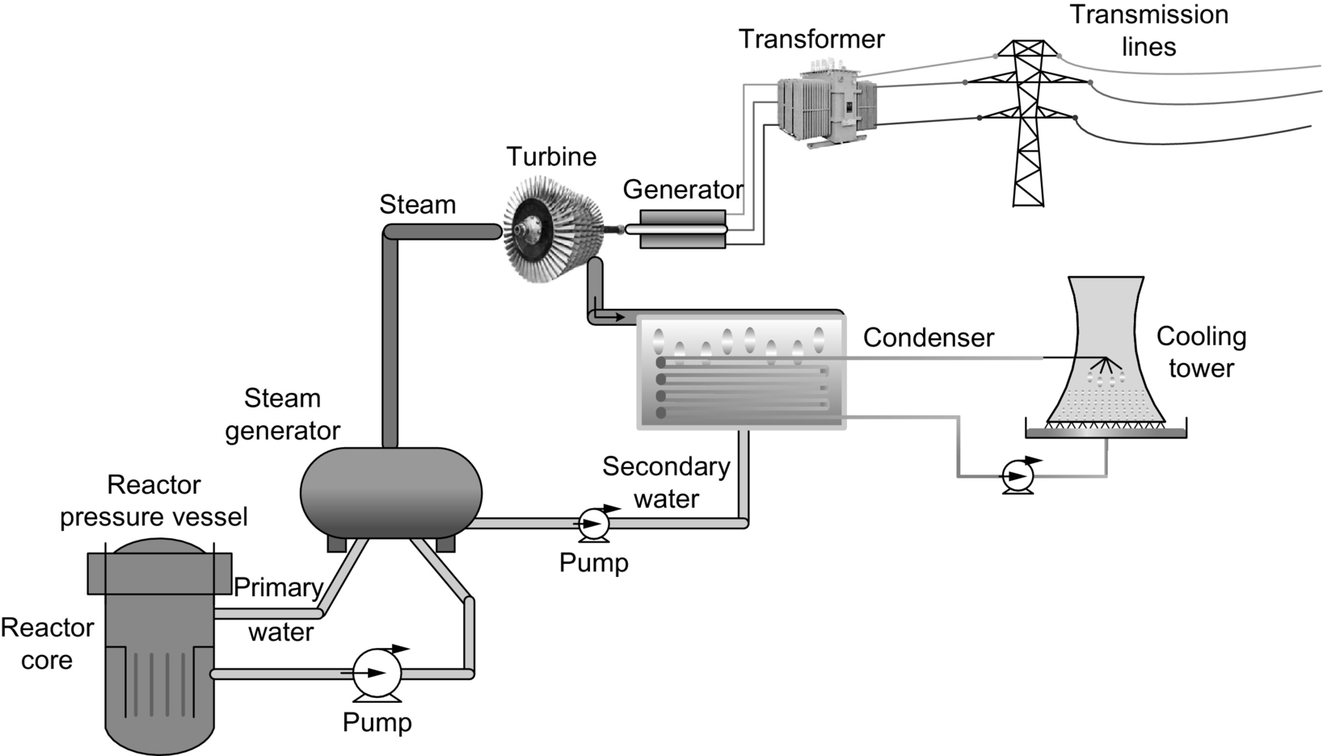

**FIG. 23.43** A typical nuclear power plant.

By utilizing different coolants and fuels and integrating different control methodologies, many different reactor designs can be accomplished. In order to meet a specific need, some of these designs can be employed for various applications. Space and naval applications are some of these specific applications. In these applications, generally highly enriched uranium is used as the fuel that increases the reactor's power density and efficiency [[198](https://learning.oreilly.com/library/view/power-electronics-handbook/9780128114087/B9780128114070000258.xhtml#bb0995)]. Currently, researchers are investigating new nuclear power generation techniques, known as the generation IV reactors. These new designs will have the possibility to offer cleaner and more secure fission reactors with less risk of the proliferation of nuclear weapons. New designs such as ESBWR offer passively safe plants, and other designs that are believed to be almost foolproof are being pursued or are available to be built [[199](https://learning.oreilly.com/library/view/power-electronics-handbook/9780128114087/B9780128114070000258.xhtml#bb1000)]. In the near future, it is expected that the fusion reactors will be viable, which will reduce or eliminate many safety risks associated with nuclear fission [[200](https://learning.oreilly.com/library/view/power-electronics-handbook/9780128114087/B9780128114070000258.xhtml#bb1005)].

### 23.3.8 FUEL CELL POWER PLANTS

Since the beginning of twenty-first century, fuel-cell technology has been rapidly developed and has shown an invasive improvement for the applications ranging from portable electronic devices to vehicular power systems and MW size power plants [[201](https://learning.oreilly.com/library/view/power-electronics-handbook/9780128114087/B9780128114070000258.xhtml#bb1010)–[203](https://learning.oreilly.com/library/view/power-electronics-handbook/9780128114087/B9780128114070000258.xhtml#bb1020)]. Fuel cells are promising future energy conversion devices due to their high efficiency, excellent performance, low or zero emissions, and wide application area.

Fuel-cell power plants are electrochemical devices that produce electric energy directly from a chemical reaction. Fuel cells use fuel on the anode side and oxidant on the cathode side. The chemical reaction occurs on the electrolyte. The reactants, that is, fuel and oxidant, flow into the cell, while the reaction product (water) flows out of the cell. Many fuel and oxidant types can be used for fuel cells. Generally, hydrogen as the fuel and oxygen as the oxidant, from the air, can be used. On the other hand, alcohols and hydrocarbons can be other fuel types for different fuel cells, while other oxidants may be chlorine and chlorine dioxide [[204](https://learning.oreilly.com/library/view/power-electronics-handbook/9780128114087/B9780128114070000258.xhtml#bb1025)–[206](https://learning.oreilly.com/library/view/power-electronics-handbook/9780128114087/B9780128114070000258.xhtml#bb1035)].

Just like a battery, a fuel cell is composed of an electrolyte and a pair of electrodes. However, unlike the batteries, the reactants are continuously replenished during the operation; therefore, the cell is not required to be recharged. Ideally, fuel cells operate and continue to produce energy as long as the reactants are appropriately supplied to the anode and cathode sides.

There are many kinds of fuel cells categorized by their electrolyte type. Most common fuel-cell types are as follows:

• Proton exchange membrane fuel cells (PEMFCs)

• Phosphoric acid fuel cells (PAFCs)

• Direct methanol fuel cells (DMFCs)

• Solid oxide fuel cells (SOFC)

• Molten carbonate fuel cells (MCFCs)

PEMFCs are generally used for residential, vehicular, and portable applications. Solid electrolyte structure reduces the corrosion, they can operate at low temperature, and they have quick start-up and faster response times. PAFCs are typically used for transportation, heating, and electric utility applications. They may reach high efficiency points in electric cogeneration applications [[207](https://learning.oreilly.com/library/view/power-electronics-handbook/9780128114087/B9780128114070000258.xhtml#bb1040),[208](https://learning.oreilly.com/library/view/power-electronics-handbook/9780128114087/B9780128114070000258.xhtml#bb1045)]. Currently, DMFCs are considered as a replacement alternative for batteries for small portable devices' power requirements. DMFC can be considered advantageous since methanol can be used directly without any reformer or fuel processor. However, they have relatively low efficiencies and slow response times since the reaction rate for the methanol is slow on presently available catalysts. On the other hand, DMFCs can be competitive with batteries since the simplicity, high storage density, and liquid methanol portability may compensate the relatively low efficiency [[207](https://learning.oreilly.com/library/view/power-electronics-handbook/9780128114087/B9780128114070000258.xhtml#bb1040)]. MCFCs and SOFC are generally used as large power plants for electric utility applications. Both the technologies have higher efficiencies, fuel flexibility, and inexpensive catalysts [[208](https://learning.oreilly.com/library/view/power-electronics-handbook/9780128114087/B9780128114070000258.xhtml#bb1045)]. However, they operate at really high temperatures generally between 600 and 1000*°*C. This high-temperature issue avoids these two fuel-cell technologies to be best candidates for portable or vehicular applications.

Especially, proton exchange membrane fuel cells are considered to be one of the most promising fuel-cell technologies among these next-generation fuel-cell power plants. This is due to their high efficiency and compact structure [[209](https://learning.oreilly.com/library/view/power-electronics-handbook/9780128114087/B9780128114070000258.xhtml#bb1050),[210](https://learning.oreilly.com/library/view/power-electronics-handbook/9780128114087/B9780128114070000258.xhtml#bb1055)]. The operating principle of PEMFCs is focused in this section.

The operating principle along with the basic components of a PEMFC is presented in [Fig. 23.44](https://learning.oreilly.com/library/view/power-electronics-handbook/9780128114087/B9780128114070000258.xhtml#f0225).

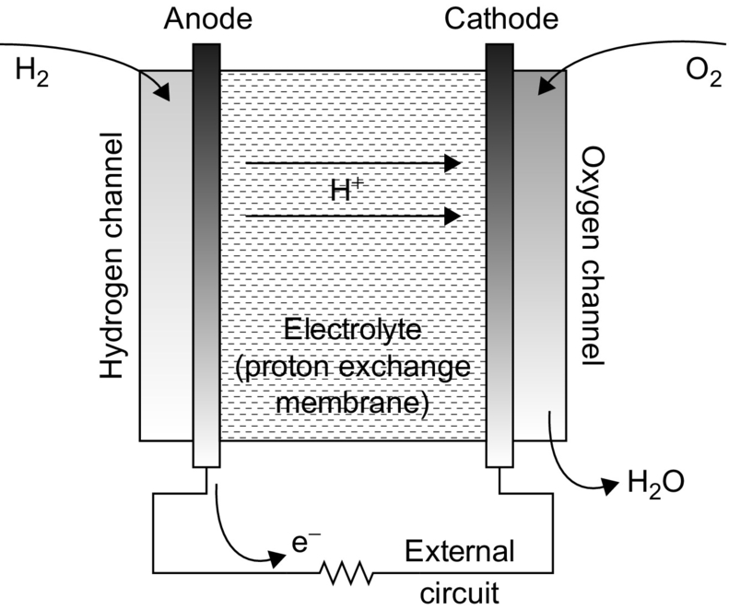

**FIG. 23.44** Components of a PEM fuel cell and its operating principle.

After the fuel is supplied to the anode side, the fuel is oxidized resulting in releasing electrons. The anode reaction for a fuel cell can be expressed as

 **(23.21)**

These released electrons are transported to the cathode side through an external circuit. The hydrogen protons are traveled through the proton exchange membrane to the cathode side. The oxidant (i.e., oxygen) is reduced at the cathode side, using the electrons coming from the external circuit. Therefore, the cathode reaction is

 **(23.22)**

The hydrogen protons travel through the membrane and balance the flow of electrons through the external circuit. Therefore, the overall reaction equation becomes

 **(23.23)**

A typical single fuel cell has a theoretical output voltage of 1.2 V. They generate ideally 0.6 A/cm2. In order to reach higher voltage outputs from a fuel-cell system, cells are connected in series in the form of a string. For higher current outputs, the cells or the cell strings should be connected in parallel. Unfortunately, the output voltage of a fuel cell or a fuel-cell system decreases as the current drawn from the fuel cell is increased. This voltage drop at the fuel-cell output is due to the ohmic, activation, and concentration losses [[211](https://learning.oreilly.com/library/view/power-electronics-handbook/9780128114087/B9780128114070000258.xhtml#bb1060)].

A typical current-voltage characteristic curve of a fuel cell is shown in [Fig. 23.45](https://learning.oreilly.com/library/view/power-electronics-handbook/9780128114087/B9780128114070000258.xhtml#f0230), which is also known as the polarization curve.

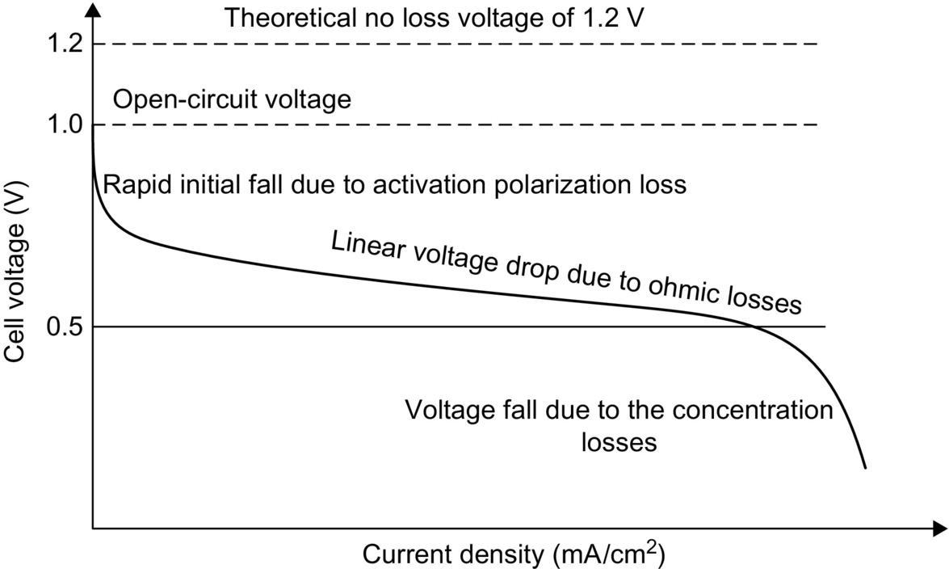

**FIG. 23.45** Current-voltage characteristic of a fuel cell.

The output voltage of a fuel cell is less than its theoretical value even in the open-circuit conditions. This is due to the fact that the open-circuit voltage is calculated based on the ideal burning enthalpy of the hydrogen. The activation loss is generally effective at the low current densities. Activation loss is due to the electrode kinetics in which the electrochemical reaction of hydrogen and oxygen is slow. Activation loss causes a nonlinear voltage drop as the current starts to be drawn from the fuel cell. Ohmic losses are due to the electron flow through the electrolyte and electrodes and the equivalent resistance of the external circuit. Ohmic losses are directly proportional to the current density, and they increase linearly as the current increases. Concentration losses are due to the inability of maintaining the initial fuel concentration on the electrodes. Fuel and oxidant should be supplied sufficiently and continuously in order to meet sustained load demands. If the current is more than a certain value, a fuel cell fails to meet the new power demand, and the output voltage dramatically decreases. Therefore, this loss is quite severe at the high current densities.

Due to the polarization and current-voltage characteristics of the fuel cells, power conditioning devices such as dc/dc and/or dc/ac converters are required to maintain a fixed and stable dc voltage for the load bus. The power conditioning is also useful for converting the fuel-cell output to an appropriate magnitude and type. Power conditioning unit (PCU) not only controls the fuel-cell output voltage but also delivers a high power factor in grid-connected applications. PCU can reduce or eliminate the harmonics and help them operate effectively under all conditions. A fuel-cell power plant operating together with a PCU is presented in [Fig. 23.46](https://learning.oreilly.com/library/view/power-electronics-handbook/9780128114087/B9780128114070000258.xhtml#f0235).

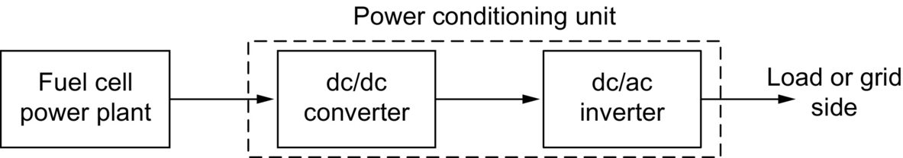

**FIG. 23.46** A fuel-cell power plant operation with PCU.

In the stationary or vehicular applications, a fuel-cell power plant may not be sufficient to satisfy all of the load demands [[210](https://learning.oreilly.com/library/view/power-electronics-handbook/9780128114087/B9780128114070000258.xhtml#bb1055)]. Especially during transient load changes or peak demand periods, a fuel cell needs to be operated with an auxiliary power device such as battery packs or ultracapacitors. By operating fuel cell cascaded with batteries and/or ultracapacitors, steady-state, peak power demands, and transient load changes can be controlled more efficiently. In the topology of [Fig. 23.47](https://learning.oreilly.com/library/view/power-electronics-handbook/9780128114087/B9780128114070000258.xhtml#f0240), the fuel-cell power plant is operated with auxiliary power devices.

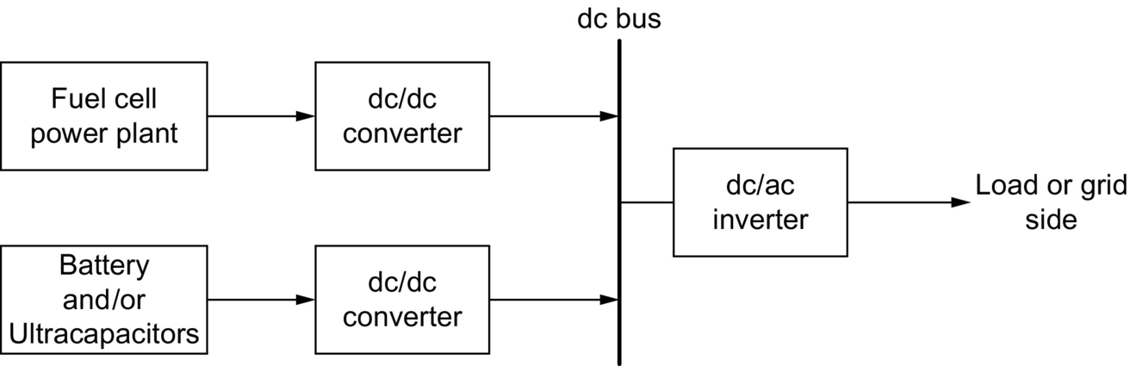

**FIG. 23.47** Fuel-cell power plant operation with auxiliary power devices.

## 23.4 Conclusions

In order to meet the future energy requirements, the energy should be generated and utilized wisely. Increasing the demand for energy, decreasing conventional fossil-fuel energy sources, and environmental concerns are driving forces toward renewable energy sources. However, the conventional sources will be utilized until modern, clean, and renewable technologies replace them. Therefore, a comprehensive strategy that supports a diversity of resources over the next century should be developed. Sustainable and long-term energy solutions in numerous forms are required to restructure the future's increasing energy demand.

## References

[1] World Consumption of Primary Energy by Energy Type and Selected Country Groups, Report of Energy Information Administration, International Energy Annual, 2005.

[2] Energy Consumption: Consumption per Capita, Technical Report by the World Resources Institute, [http://www.wri.org](http://www.wri.org/). Retrieved on 10 October 2010.

[3] World per Capita Total Primary Energy Consumption, 1980–2006, Report of Energy Information Administration, International Energy Annual, 2006.

[4] International Energy Outlook, Technical Report by the Energy Information Administration, Official Energy Statistics from the US Government, [http://www.eia.doe.gov](http://www.eia.doe.gov/), 2008. Retrieved on 09 October 2010.

[5] Energy Efficiency Measures and Technological Improvements, Continuum of Action, Annual Activity Report 2007 to 2008. (e8 is an “Energy Organization” comprising 9 leading electricity companies from the G8 countries).

[6] Coal Facts 2006 Edition with 2005 Data, Technical Annual Report of World Coal Institute, 2006.

[7] Yergin D. *The Prize: The Epic Quest for Oil, Money, and Power.* New York: Free Press; 1993.

[8] Official European Parliament Resolution on the Road Map for Renewable Energy in Europe, [http://www.europarl.europa.eu](http://www.europarl.europa.eu/), 2007. Retrieved on 25 September 2007.

[9] 2008 Buildings Energy Data Book, Prepared for the Buildings Technologies Program Energy Efficiency and Renewable Energy of US Department of Energy, by D&R International, Ltd., under contract to National Energy Technology Laboratory, 2008.

[10] Manufacturing Trend Data 1998 and 2002, Technical Report by the Energy Information Administration, Official Energy Statistics from the US Government, <http://www.eia.doe.gov/emeu/efficiency/mecs_trend_9802/mecs9802_table2b.html>. Retrieved on 10 February 2010.

[11] The WNA Market Report, The Global Nuclear Fuel Market: Supply and Demand 2007–2030, Technical Report by the World Nuclear Association (WNA).

[12] C.R. de Auza, Installed U.S. Wind Power Capacity Surged 45% in 2007, American Wind Energy Association Market Report, 2007.

[13] SEGS III, IV, V, VI, VII, VIII & IX, NEXTera Energy Sources, <http://www.nexteraenergyresources.com/content/where/portfolio/pdf/segs.pdf>. Retrieved on 14 October 2010.

[14] National Energy Survey of 2006, Technical Report by the Energy Information Administration, Official Energy Statistics from the US Government, [http://www.eia.doe.gov](http://www.eia.doe.gov/).

[15] 2008–2017 Regional & National Peak Demand and Energy Forecast Bandwidths, Technical Report by the: Load Forecasting Working Group of the Reliability Assessment Subcommittee, North American Electric Reliability Corporation (NERC), 2008.

[16] Russel G., Ann D. Oil officials see limit looming on production. *Wall Street J.* 2007;A1.

[17] S.S. Devgan, Impact of environmental factors on the economic evaluation of renewable energy alternative generation, in: Proceedings of 33rd Southeastern Symposium on System Theory, Athens, OH, USA, 2001, pp. 123–126.

[18] World Consumption of Primary Energy by Energy Type and Selected Country Groups, 1980–2004, Energy Information Administration, U.S. Department of Energy, July 2006.

[19] Natural Gas Reserves Summary as of December 31, 2007, Technical Report by the Energy Information Administration, Official Energy Statistics from the US Government.

[20] Natural Gas and the Environment, [http://www.naturalgas.org](http://www.naturalgas.org/). Retrieved on 10 October 2010.

[21] Key World Energy Statistics 2007, Annual technical report of the International Energy Agency.

[22] Brower M. In: *Cool Energy: Renewable Solutions to Environmental Problems.* The MIT Press; 1992.

[23] Environmental Impacts of Renewable Energy Technologies, Briefing paper of the “Union of Concerned Scientists”, August 2005.

[24] World Energy Intensity: Total Primary Energy Consumption per Dollar of Gross Domestic Product using Purchasing Power Parities: 1980–2004, Technical Report by the Energy Information Administration, Report released December 2008.

[25] World Nuclear Power Reactors, Technical report of the “Uranium Information Center,” August 2007.

[26] Nuclear Power in the World Today, Briefing paper 7, “Uranium Information Center”, August 2007.

[27] Global Uranium Resources to Meet Projected Demand, *Latest Edition of ‘Red Book’ Predicts Consistent Supply up to 2025.* International Atomic Energy Agency; 2006.

[28] International Energy Annual 2006, “World Energy Reserves,” Technical Report by the Energy Information Administration, Official Energy Statistics from the US Government, Report released June-December 2008.

[29] International Energy Annual 2006, World Energy Consumption in Standard U.S. Physical Units, Technical Report by the Energy Information Administration, Official Energy Statistics from the US Government, Report released June-December 2008.

[30] 2007 World PV Industry Reports, Annual World Solar PV Industry Report by Marketbuzz 2008.

[31] Tester J.W., Drake E.M., Driscoll M.J., Golay M.W., Peters W.A. *Sustainable Energy: Choosing Among Options.* Cambridge, MA: The MIT Press; 2005.

[32] Hermann W.A. Quantifying global exergy resources. *J. Energy.* 2006;31(12):1685–1702.

[33] Global Wind Energy Markets, Technical report by the Global Wind Energy Council, February 2008.

[34] Inoue A., Ali M.H., Takahashi R., Murata T., Tamura J. *A calculation method of the total efficiency of wind generator.* In: Proceedings of Power Electronics and Drives Systems (PEDS), Kuala Lumpur, Malaysia; 1595–1600. 2005;2.

[35] Brooke J., Engineering Committee on Oceanic Resources Working Group on Wave Energy Conversion, *Wave Energy Conversion.* Elsevier; 2003.

[36] McCormick M.E. *Ocean Wave Energy Conversion.* Mineola, NY: Dover Publications; 2007.

[37] Thorpe T.W. *An overview of wave energy technologies, status, performance, and costs.* In: Proceedings of Wave power: Moving towards commercial viability, London; 1999:1–16.

[38] Cruz J., Gunnar M., Barstow S., Mollison D., Cruz J. *Green Energy and Technology, Ocean Wave Energy.* Springer Science and Business Media; 2008.

[39] Munk W., Wunsch C. Abyssal recipes II: Energetics of tidal and wind mixing. *Deep-Sea Res.* June 1998;45:1977–2010.

[40] Renewables, Global Status Report 2006, Technical report by the REN21, Renewable Energy Policy Network for the 21st Century, 2006.

[41] D.E. Lennard, Ocean thermal energy conversion—past progress and future prospects, IEEE Proceedings on Physical Science, Measurement and Instrumentation, Management and Education Reviews, vol. 134, May 1987, pp. 381–391.

[42] Berger L.R., Berger J.A. Countermeasures to microbiofouling in simulated ocean thermal energy conversion with surface and deep ocean waters in Hawaii. *Appl. Environ. Microbiol.* 1986;51(6):1186–1198.

[43] Meegahapola L., Udawatta L., Witharana S. *“The ocean thermal energy conversion strategies and analysis of current challenges”.* In: Proceedings of International Conference on Industrial and Information Systems; 2007:123–128.

[44] The Hydrogen Economy: Opportunities, Costs, Barriers, and R&D Needs, by: Committee on Alternatives and Strategies for Future Hydrogen Production and Use, National Research Council, and National Academy of Engineering, National Academies Press, August 2004. Retrieved on 16 February 2009.

[45] J. McCarthy, Hydrogen. Stanford University, <http://www-formal.stanford.edu/jmc/progress/hydrogen.html>, 1995. Retrieved on 04 May 2009.

[46] D. Palmer, Hydrogen in the Universe. NASA, [http://imagine.gsfc.nasa.gov](http://imagine.gsfc.nasa.gov/), 1997.

[47] Hydrogen as an energy carrier, Technical Report by the Royal Belgian Academy Council of Applied Science, Belgium, April 2006.

[48] Lau F., Padro C.E.G. *Advances in Hydrogen Energy.* New York, USA: Springer; 2000.

[49] Rand D.A.J., Dell R.M. *Hydrogen Energy: Challenges and Prospects.* Royal Society of Chemistry; 2008.

[50] All About Geothermal Energy, Geothermal Energy Association, Washington DC, February 2007.

[51] The Future of Geothermal Energy, Impact of Enhanced Geothermal Systems (EGS) on the United States in the 21st Century, Technical Report by the Massachusetts Institute of Technology, 2006.

[52] Farigone J., Hill J., Tillman D., Polasky S., Hawthome P. Land clearing and biofuel carbon debt. *Science.* 2008;319:1235–1238.

[53] Searchinger T., Heimlich R., Houghton R.A., Dong F., Amani A., Fabiosa J., Tokgaz S., Hayes D. Use of U.S. croplands for biofuels increases greenhouse gases through emission from land-use change. *Science.* 2008;319:1238–1240.

[54] Sonntag R.E., Borgnakke C., Van Wylen G.J. *Fundamentals of Thermodynamics.* sixth ed. Haboken, New Jersey, USA: Wiley; 2002.

[55] Moran M.J., Shapiro H.N. *Fundamentals of Engineering Thermodynamics.* fifth ed. New York, USA: Wiley; 2003.

[56] Wicks F., Maleszweski J., Wright C., Zarbnicky J. *Thermodynamic analysis of an enhanced gas and steam cycle.* In: Proceedings of 37th Intersociety Energy Conversion Engineering Conference; 2004:456–459.

[57] Beltracchi L. A direct manipulation for water-based Rankine cycle heat engines. *IEEE Trans. Syst. Man Cybern.* 1987;17(3):478–487.

[58] Ratajczak T.J., Shahidehpour M. *Emerging technologies for coal-fired generation.* In: Proceedings of Power Engineering Society General Meeting, Quebec, Canada, October; 2006:1–9.

[59] Net Generation by Energy Source by Type of Producer, Annual Electric Power Report of the Energy Information Administration, U. S. Department of Energy, December 2008.

[60] Renewables, Global Status Report 2006 Update, Technical Report by the Renewable Energy Policy Network for the 21st Century, REN21, 2007.

[61] 21st Century Complete guide to Hydropower, Hydroelectric Power, Dams, Turbine, Safety, Environmental Impact, Microhydropower, Impoundment, Pumped Storage Diversion, Run-of-River, by U.S. Government, Progressive Management, Washington, DC, USA, September 2006.

[62] Wood A.J., Wollenberg B.F. *Power Generation, Operation, and Control.* second ed. Malden, MA, USA: Wiley-Interscience; 1996.

[63] Grigsby L.L. Electric Power Generation. *Transmission, and Distribution.* second ed. Boca Raton, FL: CRC Press; 2007.

[64] R. Chapo, Solar energy overview, [Ezinearticles.com](http://ezinearticles.com/), December 2008, [http://ezinearticles.com](http://ezinearticles.com/). Retrieved on 20 December 2009.

[65] U.S. Department of Energy, “PV Physics”, Energy Efficiency and Renewable Energy, Solar Energy Technologies Program, <http://www1.eere.energy.gov/solar>. Retrieved on 17 November 2009.

[66] U.S. Department of Energy, “PV Systems”, Energy Efficiency and Renewable Energy, Solar Energy Technologies Program, <http://www1.eere.energy.gov/solar>. Retrieved on 17 November 2009.

[67] Missouri Department of Natural Resources, “Missouri's solar energy resource”, [http://www.dnr.mo.gov](http://www.dnr.mo.gov/). Retrieved on 20 November 2009.

[68] U.S. Department of Energy, “Concentrating Solar Power”, Energy Efficiency and Renewable Energy, Solar Energy Technologies Program, [http://www1.eere.energy.gov](http://www1.eere.energy.gov/).

[69] Lasnier A., Ang T.G. *Photovoltaic Engineering Handbook.* New York: Adam Hilger Bristol; 1990 pp. 69–97.

[70] U.S. Department of Energy, “Current-voltage Measurements”, Energy Efficiency and Renewable Energy, Solar Energy Technologies Program, <http://www1.eere.energy.gov/solar>. Retrieved on 25 November 2009.

[71] Masoum M.A.S., Dehbonei H., Fuchs E.F. Theoretical and experimental analyses of photovoltaic systems with voltage and current-based maximum power-point tracking. *IEEE Trans. Energy Convers.* 2002;17(4):514–522.

[72] Koizumi H., Kurokawa K. *A novel maximum power point tracking method for PV module integrated converter.* In: IEEE 36th Power Electronics Specialists Conf., Recife, Brazil; 2005:2081–2086.

[73] Goswami Y., Kreith F., Kreder J. Principles of solar engineering. *Fundamentals of Solar Engineering.* Philadelphia: Taylor & Francis; 1999.

[74] Canova A., Giaccone L., Spertino F. *Sun tracking for capture improvement.* In: Proceedings of 22nd European Photovoltaic Solar Energy Conference (EUPVSEC), WIP Renewable Energies, Milano; 2007:3053–3058.

[75] Mohring H.D., Klotz F., Gabler H. *Energy yield of PV tracking systems.* In: Proceedings of 21st European Photovoltaic Solar Energy Conference, (EUPVSEC), WIP Renewable Energies, Barcelona, Spain, Dresden, September; 2006:2691–2694.

[76] Aracil C., Quero J.M., Castañer L., Osuna R., Franquelo L.G. *Tracking system for solar power plants.* In: Proceedings of IEEE 32nd Annual Conference in Industrial Electronics; 2006:3024–3029.

[77] M. Dominguez, I. Ameijeiras, L. Castaner, J.M. Wuero, A. Guerrero, L.G. Franquelo, A novel light source position sensor, Patent number P9901375.

[78] Pritchard D.A. Sun tracking by peak power positioning for photovoltaic concentrator arrays. *IEEE Contr. Syst. Mag.* 2003;3(3):2–8.

[79] Hohm D.P., Ropp M.E. *Comparative study of maximum power point tracking algorithms using an experimental, programmable, maximum power point tracking test bed.* In: Proceedings of 28th IEEE Photovoltaic Specialists Conference; 2000:1699–1702.

[80] Hussein K.H. Maximum photovoltaic power tracking: An algorithm for rapidly changing atmospheric conditions. *IEEE Proc. Transm. Distrib.* 1995;142(1):59–64.

[81] O'Sullivan D., Spruyt H., Crausaz A. *PWM conductance control.* In: Proceedings of IEEE 19th Annual Power Electronics Specialists Conference, New Orleans, Louisiana; 351–359. 1988;1.

[82] Bangyin L., Shanxu D., Fei L., Pengwei X. *Analysis and improvement of maximum power point tracking algorithm based on incremental conductance method for photovoltaic array.* In: Proceedings of IEEE 7th International Conference on Power Electronics and Drive Systems, Bangkok, Thailand; 2007:637–641.

[83] Hohm D.P., Ropp M.E. *Comparative study of maximum power point tracking algorithm.* In: Proceedings of 28th IEEE Photovoltaic Specialists Conference; 2000:1699–1702.

[84] Esram T., Chapman P.L. Comparison of photovoltaic array maximum power point tracking techniques. *IEEE Trans. Energy Convers.* 2007;22(2):439–449.

[85] Femia N., Petrone G., Spagnuolo G., Vitelli M. Optimization of perturb and observe maximum power point tracking method. *IEEE Trans. Power Electron.* 2005;20(4):963–973.

[86] Enslin J.H.R., Snyman D.B. *Simplified feed-forward control of the maximum power point in PV installations.* In: IEEE Industrial Electronics Conference, San Diego, CA, USA; 548–553. 1992;1.

[87] Kislovski A.S., Redl R. *Maximum-power-tracking using positive feedback.* In: IEEE 25th Power Electronics Specialists Conference, Taipei, Taiwan; 1065–1068. 1994;2.

[88] Won C.Y., Kim D.H., Kim S.C., Kim W.S., Kim H.S. *A new maximum power point tracker of photovoltaic arrays using fuzzy controller.* In: IEEE Power Electronics Specialists Conference, Taipei, Taiwan; 1994:396–403.

[89] Schoeman J.J., van Wyk J.D. *A simplified maximal power controller for terrestrial photovoltaic panel arrays.* In: Proceedings of 13th Annual IEEE Power Electronics Specialists Conference; 1982:361–367.

[90] Buresch M. *Photovoltaic Energy Systems.* New York: McGraw Hill; 1983.

[91] Hart G.W., Branz H.M., Cox C.H. Experimental tests of open loop maximum power-point tracking techniques. *Solar Cells.* 1984;13:185–195.

[92] Patterson D.J. *“Electrical system design for a solar powered vehicle”.* In: Proceedings of 21st Annual IEEE Power Electronics Specialists Conference, San Antonio, TX, USA; 1990:618–622.

[93] Xiao W., Dunford W.G. *A modified adaptive hill climbing MPPT method for photovoltaic power systems.* In: Proceedings of 35th Annual IEEE Power Electronics Specialists Conference, Aachen, Germany; 2004:1957–1963.

[94] Noh H.-J., Lee D.-Y., Hyun D.-S. *An improved MPPT converter with current compensation method for small scaled PV applications.* In: Proceedings of 28th Annual Conf. Industrial Electronics Society, Sevilla, Spain; 2002:1113–1118.

[95] Kobayashi K., Matsuo H., Sekine Y. *A novel optimum operating point tracker of the solar cell power supply system.* In: Proceedings of 35th Annual IEEE Power Electronics Specialists Conference, Aachen, Germany; 2004:2147–2151.

[96] B. Bekker, H.J. Beukes, Finding an optimal PV panel maximum power point tracking method, in: Proceedings of 7th AFRICON Conference, Africa, Botswana, Nigeria, 2004, pp. 1125–1129.

[97] Yuvarajan S., Xu S. *Photo-voltaic power converter with a simple maximum-power-point-tracker.* In: Proceedings of 2003 International Symposium Circuits Systems, Bangkok, Thailand; 2003 pp. III-399–III-402.

[98] Hilloowala R.M., Sharaf A.M. *A rule-based fuzzy logic controller for a PWM inverter in photo-voltaic energy conversion scheme.* In: Proceedings of IEEE Industrial Application Society Annual Meeting, Houston, TX, USA; 1992:762–769.

[99] Senjyu T., Uezato K. *Maximum power point tracker using fuzzy control for photovoltaic arrays.* In: Proceedings of IEEE International Conf. Industrial Technologies, Guangzhou, China; 1994:143–147.

[100] Yu G.-J., Jung M.-W., Song J., Cha I.-S., Hwang I.-H. *Maximum power point tracking with temperature compensation of photovoltaic for air conditioning system with fuzzy controller.* In: Proceedings of IEEE Photovoltaic Specialists Conference, Washington, DC, USA; 1996:1429–1432.

[101] Simoes M.G., Franceschetti N.N., Friedhofer M. *A fuzzy logic based photovoltaic peak power tracking control.* In: Proceedings of IEEE International Symposium Industrial Electronics, Pertoria, South Africa; 1998:300–305.

[102] Mahmoud A.M.A., Mashaly H.M., Kandil S.A., El Khashab H., Nashed M.N.F. *Fuzzy logic implementation for photovoltaic maximum power tracking.* In: Proceedings of 9th IEEE International Workshop Robot Human Interactive Communications, Osaka, Japan; 2000:155–160.

[103] Patcharaprakiti N., Premrudeepreechacharn S. *Maximum power point tracking using adaptive fuzzy logic control for grid connected photovoltaic system.* In: IEEE Power Engineering Society Winter Meeting, New York, NY; 2002:372–377.

[104] Wilamowski B.M., Li X. *Fuzzy system based maximum power point tracking for PV system.* In: Proceedings of 28th Annual Conference of IEEE Industrial Electronics Society; 2002:3280–3284.

[105] Veerachary M., Senjyu T., Uezato K. Neural-network-based maximum-power-point tracking of coupled-inductor interleaved-boost-converter-supplied PV system using fuzzy controller. *IEEE Trans. Ind. Electron.* August 2003;50(4):749–758.

[106] Khaehintung N., Pramotung K., Tuvirat B., Sirisuk P. *RISC microcontroller built-in fuzzy logic controller of maximum power point tracking for solar-powered light-flasher applications.* In: Proceedings of 30th Annual Conference of IEEE Industrial Electronics Society; 2004:2673–2678.

[107] Hiyama T., Kouzuma S., Imakubo T. Identification of optimal operating point of PV modules using neural network for real time maximum power tracking control. *IEEE Trans. Energy Convers.* June 1995;10(2):360–367.

[108] Ro K., Rahman S. Two-loop controller for maximizing performance of a grid-connected photovoltaic-fuel cell hybrid power plant. *IEEE Trans. Energy Convers.* 1998;13(3):276–281.

[109] Hussein A., Hirasawa K., Hu J., Murata J. *The dynamic performance of photovoltaic supplied dc motor fed from DC–DC converter and controlled by neural networks.* In: Proceedings of International Joint Conference on Neural Networks, Atlanta, Georgia, USA; 2002:607–612.

[110] Sun X., Wu W., Li X., Zhao Q. *A research on photovoltaic energy controlling system with maximum power point tracking.* In: Proceedings of Power Conversion Conference, Osaka, Japan; 2002:822–826.

[111] Samangkool K., Premrudeepreechacharn S. *Maximum power point tracking using neural networks for grid-connected system.* In: Proceedings of International Conference on Future Power Systems, Amsterdam, Netherlands; 2005:1–4.

[112] Zhang L., Bai Y., Al-Amoud A. *GA-RBF neural network based maximum power point tracking for grid-connected photovoltaic systems.* In: Proceedings of International Conference Power Electronics, Machines and Drives, Bath, UK; 2002:18–23.

[113] Midya P., Krein P.T., Turnbull R.J., Reppa R., Kimball J. *Dynamic maximum power point tracker for photovoltaic applications.* In: Proceedings of 27th Annual IEEE Power Electronics Specialists Conference, Baveno, Italy; 1996:1710–1716.

[114] Bodur M., Ermis M. *Maximum power point tracking for low power photovoltaic solar panels.* In: Proceedings of 7th Mediterranean Electrotechnical Conference, Antalya, Turkey; 1994:758–761.

[115] Kitano T., Matsui M., Xu D.-h. *Power sensor-less MPPT control scheme utilizing power balance at DC link-system design to ensure stability and response.* In: Proceedings of 7th Annual Conference on IEEE Industrial Electronics Society, Denver, Colorado, USA; 2001:1309–1314.

[116] Matsui M., Kitano T., Xu D.-h., Yang Z.-q. *A new maximum photovoltaic power tracking control scheme based on power equilibrium at DC link.* In: Conference Record 1999 IEEE Industrial Applications Conference, Phoenix, Arizona, USA; 1999:804–809.

[117] Kjaer S.B., Pedersen J.K., Blaabjerg F. *Power inverter topologies for photovoltaic modules—a review.* In: Proceedings of IAS'02 Conference, vol. 2; 2002:782–788.

[118] Blaabjerg F., Chen Z., Kjaer S.B. Power electronics as efficient interface in dispersed power generation systems. *IEEE Trans. Power Electron.* 2004;19(5):1184–1194.

[119] Meinhardt M., Cramer G. *Past, present and future of grid connected photovoltaic- and hybrid-power-systems.* In: Proceedings of IEEE Power Engineering Society Summer Meeting, vol. 2; 2000:1283–1288.

[120] Shimizu T., Hirakata M., Kamezawa T., Watanabe H. Generation control circuit for photovoltaic modules. *IEEE Trans. Power Electron.* May 2001;16(3):293–300.

[121] Meinhardt M., Wimmer D. *Multistring-converter: the next step in evolution of string-converter technology.* In: Proceedings of EPE'01 Conference, Graz, Austria; 2001:1–9.

[122] Bose B.K., Szczeny P.M., Steigerwald R.L. Microcomputer control of a residential photovoltaic power conditioning system. *IEEE Trans. Ind. Appl.* 1985;21(5):1182–1191.

[123] Lindgren B. *“Topology for decentralized solar energy inverters with a low voltage ac-bus”.* In: Proceedings of European Conference on Power Electronics and Applications, Lausanne, Switzerland; 1999:1–5.

[124] Kjaer S.B., Blaabjerg F. *A novel single-stage inverter for AC-module with reduced low-frequency ripple penetration.* In: Proceedings of 10th European Conference on Power Electronics and Applications, Toulouse, France; 2003:2–4.

[125] Lohner A., Meyer T., Nagel A. *“A new panel-integratable inverter concept for grid-connected photovoltaic systems”.* In: Proceedings of ISIE'96 Conference, vol. 2; 1996:827–831.

[126] Dorofte C. *Comparative analysis of four dc/dc converters for photovoltaic grid interconnection & design of a dc/dc converter for photovoltaic grid interconnection.* Aalborg, Denmark: Technical Report Aalborg University; 2001.

[127] S.J. Chiang, Design and Implementation of Multi-Functional Battery Energy Storage Systems, Ph.D. Dissertation, Department of Electrical Engineering, National Tsing Hua University, Hsin-Chu, Taiwan, R.O.C., 1994.

[128] Liaw C.M., Chen T.H., Chiang S.J., Lee C.M., Wang C.T. Small battery energy storage system. *IEEE Proceedings on Electric Power Applications.* 1993;140(1):7–17.

[129] Holttinen H., Meibom P., Orths A., Van Hulle F., Ensslin C., Hofmann L., McCann J., Pierik J., Tande J.O., Estanquerio A., Soder L., Strbac G., Parsons B., Smith J.C., Lemstrom B. *Design and operation of power systems with large amounts of wind power, first results of IEA collaboration.* In: Proceedings of Global Wind Power Conference, Adelaide, Australia, September; 2006:1–147.

[130] World Wind Energy Association, Press Release, February 21, 2008, Bonn, Germany.

[131] Danish Wind Power Association, <http://www.windpower.org/en>, November 2008.

[132] Betz A. *Introduction to the Theory of Machines.* New York, USA: Oxford-Pergamon Press; 1966.

[133] Ahmed N.A., Miyateke M.A. *A Stand-alone hybrid generation system combining solar photovoltaic and wind turbine with simple maximum power point tracking control.* In: Proceedings of 5th International Power Electronics and Motion Control Conference, vol. 1; 2006:1–7.

[134] Hendershot Jr. J.R., Miller T.J.E. *Design of Brushless Permanent-magnet Motors.* England: Oxford Magna Physics Publications; 1994.

[135] H.-W. Lee, Advanced Control for Power Density Maximization of the Brushless DC Generator, Ph.D. Dissertation University of Arlington, Texas, Arlington, TX, USA, 2003.

[136] Khan M.A., Pillay P., Malengret M. Impact of direct-drive WEC systems on the design of a small PM wind generator. *Proc. IEEE Bologna Power Tech. Conf.* 2003;2:7.

[137] Soderlund L., Eriksson J.-T., Salonen J., Vihriala H., Perala R. A permanent-magnet generator for wind power applications. *IEEE Trans. Magn.* 1996;32:2389–2392.

[138] Tog Inge Reigstad, Direct Driven Permanent Magnet Synchronous Generators with Diode Rectifiers for Use in Offshore Wind Turbines, Ph.D. Dissertation, Norwegian University of Science and Technology Department of Electrical Power Engineering, Trondheim, Norway, 2007.

[139] Li H., Chen Z. *Optimal direct-drive permanent magnet wind generator systems for different rated wind speeds.* In: Proceedings of European Conference on Power Electronics and Applications; 2007:1–10.

[140] A. Grauers, Design of Direct-Driven Permanent-Magnet Generators For Wind Turbines, Ph.D. Dissertation, Chalmers University of Technology, Gothenburg, 1996.

[141] Marques J., Pinheiro H., Gründling H.A., Pinherio J.R., Hey H.L. *A survey on variable-speed wind turbine system.* In: Cientifico Greater Forum of Brazilian Electronics of Power, COBEP'03, Cortaleza, Fortaleza, Brazil; 2003:732–738.

[142] Neam M.M., El-Sousy F.F.M., Ghazy M.A., Abo-Adma M.A. *The dynamic performance of an isolated self-excited induction generator driven by a variable-speed wind turbine.* In: Proceedings of International Conference on Clean Electric Power, Capri, Italy, May; 2007:536–543.

[143] Kumar G.S., Kishore A. *Dynamic analysis and control of output voltage of a wind turbine driven isolated induction generator.* In: Proceedings of IEEE International Conference on Industrial Technology, Bhubaneswar, India; 2006:494–499.

[144] Orabi M., Youssef M.Z., Jain P.K. *Investigation of self-excited induction generators for wind turbine applications.* In: Proceedings of Canadian Conference on Electrical and Computer Engineering, Niagara Falls, Ontario, Canada, vol. 4; 2004:1853–1856.

[145] Seyoum D., Rahman M.F., Grantham C. *“Inverter supplied voltage control system for an isolated induction generator driven by a wind turbine”.* In: Proceedings of Industry Applications Conference (38th IAS Annual Meeting), Salt Lake City, Utah, USA, vol. 1; 2003:568–575.

[146] Muljadi E., Sallan J., Sanz M., Butterfield C.P. *Investigation of self-excited induction generators for wind turbine applications.* In: Proceedings of IEEE Industry Applications Conference (34th IAS Annual Meeting), Phoenix, Arizona, USA, vol. 1; 1999:509–515.

[147] Ahmed T., Noro O., Matsuo K., Shindo Y., Nakaoka M. *Wind turbine coupled three-phase self-excited induction generator voltage regulation scheme with static VAR compensator controlled by PI controller.* In: Proceedings of International Conference on Electrical Machines and Systems, vol. 1; 2003:293–296.

[148] Ahmed T., Noro O., Hiraki E., Nakaoka M. Terminal voltage regulation characteristics by static Var compensator for a three-phase self-excited induction generator. *IEEE Trans. Ind. Appl.* 2004;40:978–988.

[149] Qiao W., Veneyagamoorthy G.K., Harley R.G. *Real-time implementation of a STATCOM on a wind farm equipped with doubly fed induction generators.* In: Proceedings of IEEE Industry Applications Conference (41st IAS Annual Meeting), vol. 2; 2006:1073–1080.

[150] Elder J.M., Boys J. t, Woodward J.L. The process of self-excitation in induction generators. *IEEE Proc.* 1983;130(B):103–108.

[151] C. Ma, R. Cheung, Advanced Voltage and Frequency Control for the Stand-Alone Self-excited Induction Generator, Electrical & Computer Engineering Department of Ryerson University, Toronto, Canada, 2008.

[152] Abolhassani M.T., Toloyat H.A., Enjeti P. *“Stator flux-oriented control of an integrated alternator/active filter for wind”.* In: Proceedings of the IEEE International Electric Machines and Drives Conference, Madison, Wisconsin, USA, vol. 1; 2003:461–467.

[153] Eel-Hwan S., Oh S.-B., Kim Y.-H., Kim C.-S. *Power control of a doubly fed induction machine without rotational transducers.* In: Proceedings of the Power Electronics and Motion Control Conference, Beijing, China, vol. 2; 2000:951–955.

[154] Azaza H., Masmoudi A. *On the dynamics and steady state performance of a vector controlled DFM drive systems.* In: Proceedings of IEEE International Conference on Man and Cybernetics, vol. 6; 2002:6.

[155] Tapia A., Tapia G., Ostolaza J.X., Saenz J.R. Modeling and control of a wind turbine driven DFIG. *IEEE Trans. Energy Convers.* 2003;18:194–204.

[156] Jiao L., Ooi B.-T., Joos G., Zhou F. Doubly-fed induction generator (DFIG) as a hybrid of asynchronous and synchronous machines. *Electr. Power Syst. Res.* 2005;76:33–37.

[157] Muller S., Diecke M., De Doncker R.W. Doubly fed induction generator systems for wind turbines. *IEEE Ind. Appl. Mag.* 2002;8:26–33.

[158] Pena R., Clare J.C., Asher G.M. A doubly fed induction generator using back-to-back PWM converters supplying an isolated load from a variable speed wind turbine. *IEEE Proc. Electric Power Appl.* 1996;143:380–387.

[159] Xu L., Tang Y. *Stator field oriented control of doubly-excited induction machine in wind power generation system.* In: Proceedings of 25th Mid West Symposium on Circuit and Systems; 1992:1449–1466.

[160] Xu L., Cheng W. Torque and reactive power control of a doubly fed induction machine by position sensorless scheme. *IEEE Trans. Ind. Appl.* 1995;31:636–642.

[161] Doradla S., Chakrovorty S., Hole K. A new slip power recovery scheme with improved supply power factor. *IEEE Trans. Power Electron.* 1988;3:200–207.

[162] Pena R., Clare J., Asher G. Doubly fed induction generator using back-to-back pwm converters and its application to variable-speed wind-energy conversion. *IEEE Proc. Electric Power Appl.* 1996;143:231–241.

[163] Tang Y., Xu L. A flexible active and reactive power control strategy for a variable speed constant frequency generating systems. *IEEE Trans. Power Electron.* July 1995;10:472–478.

[164] Feijo A., Cidrs J., Carrillo C. Third order model for the doubly-fed induction machine. *Electric Power Syst. Res.* 2000;56:121–127.

[165] Chowdhury B.H., Chellapilla S. Double-fed induction generator control for variable speed wind power generation. *Electric Power Syst. Res.* 2006;76:786–800.

[166] Sanchez J.A., Veganzones C., Martinez S., Blazquez F., Herrero N., Wilhelmi J.R. Dynamic model of wind energy conversion systems with variable speed synchronous generator and full-size power converter for large-scale power system stability studies. *Renew. Energy.* 2008;33:1186–1198.

[167] Bouscayrol A., Delarue P., Guillaud X. Power strategies for maximum control structure of a wind energy conversion system with a synchronous machine. *Renew. Energy.* 2005;30:2273–2288.

[168] Raina G., Malik O.P. Variable speed wind energy conversion using synchronous machine. *IEEE Trans. Aerosp. Electron. Syst.* 1985;21:100–105.

[169] Raina G., Malik O.P. Wind energy conversion using a self-excited induction generator. *IEEE Trans. Power Syst.* 1983;102:3933–3936.

[170] Borowy B., Salameh Z. Dynamic response of a stand alone wind energy conversion system with battery energy storage to a wind gust. *IEEE Trans. Energy Convers.* 1997;12:73–78.

[171] Chen Z., Spooner E. Grid power quality with variable speed wind turbine. *IEEE Trans. Energy Convers.* 2001;16:148–154.

[172] Baroudi J.A., Dinavahi V., Knight A.M. *A review of power converter topologies for wind generators.* In: IEEE International Conference on Electric Machines and Drives; 2005:458–465.

[173] Enslin J.H.R., Knijp J., Jansen C.P.J., Bauer P. *Integrated approach to network stability and wind energy technology for on-shore and offshore application.* In: 2003:185–192.

[174] Ran L., Bumby J.R., Tavner P.J. *Use of turbine inertia for power smoothing of wind turbines with a DFIG.* In: Proceedings of 11th International Conference on Harmonics and Quality Power; 2004:106–111.

[175] Strunz K., Brock E.K. *Hybrid plant of renewable stochastic source and multilevel storage for emission-free deterministic power generation.* In: Proceedings of Quality and Security Electric Power Delivery Systems CIGRE/IEEE PES International Symposium, October 8–10; 2003:214–218.

[176] Barton J.P., Infield D.G. Energy storage and its use with intermittent renewable energy. *IEEE Trans. Energy Convers.* June 2004;19:441–448.

[177] Cardenas R., Pena R., Asher G., Clare J. Power smoothing in wind generation systems using a sensorless vector controlled induction machine driving a flywheel. *IEEE Trans. Energy Convers.* March 2004;19:206–216.

[178] Abbey C., Joos G. Supercapacitor energy storage for wind energy application. *IEEE Trans. Ind. Appl.* 2007;43:769–776.

[179] Ocean Energy: Technology Overview, Renewable Development Initiative, <http://ebrdrenewables.com/sites/renew/ocean.aspx>. Retrieved on 26 February 2009.

[180] W.J. Jones, M. Ruane, Alternative Electrical Energy Sources for Maine, Appendix I, Wave Energy Conversion by J. Mays, Report No. MIT-E1 77–010, MIT Energy Laboratory, July 1977.

[181] Ocean Energy, Report of the US Department of Interior Minerals Management Service, Retrieved on 28 November 2008.

[182] Wolfbrandt A. Automated design of a linear generator for wave energy converters—a simplified model. *IEEE Trans. Magn.* 2007;42(7):1812–1819.

[183] Ocean Energy: Technology Overview, Renewable Development Initiative, [http://ebrdrenewables.com](http://ebrdrenewables.com/).

[184] Dixon D.A. *Fish and the Energy Industry.* In: EPRI (Electric Power Research Institute) research report, ASMFC Energy Development Workshop, October; 2006.

[185] Geothermal Energy, Power from the Depths, Technical Report, by NREL for US Department of Energy, DOE/Gp-10097-518 FS18, Golden, CO, USA, 8, December 1997.

[186] Sheth S., Shahidehpour M. *Geothermal energy in power systems.* In: Proceeding of IEEE Power Engineering Society General Meeting, vol. 2, Denver, CO, USA; 2004:1972–1977.

[187] International Energy Agency (IEA). *“Renewable Energy … into the Mainstream”.* Netherlands: Renewable Energy Working Party; 2002.

[188] M.H. Dickson, M. Fanelli, Istituto di Geoscienze e Georisorse, Pisa, Italy, <http://iga.igg.cnr.it/geothermal.php>. Retrieved on 04 March 2009.

[189] Braun G.W., McCluer H.K. Geothermal power generation in United States. *Proc.IEEE.* 1993;81(3):434–448.

[190] Geothermal Energy Assessment, The World Bank Group, [www.worldbank.org/html/fpd/energy/geothermal/assessment](http://www.worldbank.org/html/fpd/energy/geothermal/assessment). Retrieved on 17 March 2009.

[191] Clean Energy Basics: Introduction to geothermal energy production, NREL, [www.nrel.gov/energy](http://www.nrel.gov/energy).

[192] Short III W.P. Trends in the American geothermal energy industry. *Geotherm. Resour. Counc. Bull.* 1991;20(9):245–257.

[193] Geothermal Energy Facts, Advanced Level, Geothermal Education Office, [www.geothermal.marin.org/geoenergy](http://www.geothermal.marin.org/geoenergy). Retrieved on 17 March 2009.

[194] DoE Fundamentals Handbook: Nuclear Physics and Reactor Theory, vol. 1–2, US Department of Energy, FSC-6010, January 1993.

[195] Bodansky D. *Nuclear Energy: Principles, Practices, and Prospects.* second ed. New York, USA: Springer; 2008.

[196] Reactor Protection & Engineered Safety Feature Systems, The Nuclear Tourist, <http://www.nucleartourist.com/systems/rp.htm>. Retrieved on 02 April 2009.

[197] Hore-Lacy I. *Nuclear Energy in the 21st Century: World Nuclear University Press.* first ed. Maryland Heights, MO, USA: Academic Press; 2006.

[198] C. Ma, F. von Hippel, Ending the production of highly enriched uranium for naval reactors, The Nonproliferation Review, James Martin Center for Nonproliferation, Spring 2001.

[199] Hinds D., Maslak C. Next-generation nuclear technology: The ESBWR American Nuclear Society. *Nuclear News.* 2006;35–40.

[200] J. Perkins, Fusion energy: the agony, the ecstasy, and alternatives, [PhysicsWorld.com](http://physicsworld.com/), November 1997, <http://physicsworld.com/cws/article/print/1866>. Retrieved on 23 April 2009.

[201] Blomen L.J.M.J., Mugerwa M.N. *Fuel Cell Systems.* New York: Plenum; 1993.

[202] U.S. Department of Energy, Office of Fossil Energy. *Fuel Cell Handbook.* fifth ed. Morgantown, WV: National Energy Technology Laboratory; 2000.

[203] Anahara R., Yokokawa S., Sakurai M. Present status and future-prospects for fuel-cell power-systems. *Proc. IEEE.* 1993;81:399–408.

[204] O'hayre R., Cha S.-W., Colella W., Prinz F.B. *Fuel Cell Fundamentals.* second ed. New York: Wiley; 2009.

[205] Larminie J. *Fuel Cell Systems Explained.* second ed. New York, USA: Wiley; 2003.

[206] Appleby A.J. Fuel cell. In: ninth ed. New York: McGraw-Hill; 549–552. *McGraw-Hill Encyclopedia of Science & Technology.* 2002;vol. 7.

[207] Ellis M.W., Von Spakovsky M.R., Nelson D.J. Fuel cell systems: efficient, flexible energy conversion for the 21st century. *Proc. IEEE.* 2001;89(12):1808–1818.

[208] Rahman S. *Fuel cell as a distributed generation technology.* In: Proceedings of IEEE Power Engineering Society Meeting, vol. 1; 2001:551–552.

[209] Gao L., Jiang Z., Dougal R.A. An actively controlled fuel cell/battery hybrid to meet pulsed power demands. *J. Power Sour.* May 2004;130(1–2):202–207.

[210] Uzunoglu M., Alam M.S. Dynamic modeling, design, and simulation of a combined PEM fuel cell and ultracapacitor systems for stand-alone residential applications. *IEEE Trans. Energy Convers.* 2006;21(3):767–775.

[211] Yu X., Starke M.R., Tolbert L.M., Ozpineci B. Fuel cell power conditioning for electric power applications: a summary. *IET Electric Power Appl.* 2007;1(5):643–656.

**24**

# Photovoltaic System Conversion

Nimrod Vázquez Technological Institute of Celaya, Celaya, Mexico

Jeziel Vázquez Superior Technological Institute of South Guanajuato, Uriangato, Mexico

## Abstract

This chapter highlights in brief how solar cells produce electricity and will discuss in detail the various techniques available to track the sun in order to maximize the output power generated by the PV array. Moreover, not only the grid-connected and stand-alone converters required to operate PV systems efficiently will be described, but also the PV system design is discussed.

### KEYWORDS

Solar cells; PV panels; MPPT; Grid-connected converters; Stand-alone converters; PV system design

24.1 [Introduction](https://learning.oreilly.com/library/view/power-electronics-handbook/9780128114087/B978012811407000026X.xhtml#s0010)

24.2 [Solar Cell Characteristics](https://learning.oreilly.com/library/view/power-electronics-handbook/9780128114087/B978012811407000026X.xhtml#s0015)

24.3 [Photovoltaic Technology Operation](https://learning.oreilly.com/library/view/power-electronics-handbook/9780128114087/B978012811407000026X.xhtml#s0020)

24.4 [Maximum Power Point Tracking Components](https://learning.oreilly.com/library/view/power-electronics-handbook/9780128114087/B978012811407000026X.xhtml#s0025)

24.4.1 Voltage Feedback Control

24.4.2 Power Feedback Control

24.5 [MPPT Controlling Algorithms](https://learning.oreilly.com/library/view/power-electronics-handbook/9780128114087/B978012811407000026X.xhtml#s0040)

24.5.1 Perturb and Observe

24.5.2 Incremental Conductance Technique

24.5.3 Constant Reference

24.5.4 Current-Based Maximum Power Point Tracker

24.5.5 Voltage-Based Maximum Power Point Tracker

24.5.6 Other Methods

24.6 [Grid-Connected Photovoltaic System](https://learning.oreilly.com/library/view/power-electronics-handbook/9780128114087/B978012811407000026X.xhtml#s0075)

24.6.1 Isolated Converters

24.6.2 Transformerless Converters

24.6.3 Grid Synchronization

24.6.4 Islanding Mode

24.7 [Stand-Alone Photovoltaic System](https://learning.oreilly.com/library/view/power-electronics-handbook/9780128114087/B978012811407000026X.xhtml#s0100)

24.7.1 Power Converters

24.8 [Factors Affecting PV Output](https://learning.oreilly.com/library/view/power-electronics-handbook/9780128114087/B978012811407000026X.xhtml#s0110)

24.8.1 Temperature

24.8.2 Dirt and Dust

24.8.3 DC-AC Conversion

24.9 [PV System Design](https://learning.oreilly.com/library/view/power-electronics-handbook/9780128114087/B978012811407000026X.xhtml#s0130)

24.9.1 Criteria for a Quality PV System

24.9.2 Design Procedures

24.9.3 Power-Conditioning Unit

24.9.4 Battery Sizing

[References](https://learning.oreilly.com/library/view/power-electronics-handbook/9780128114087/B978012811407000026X.xhtml#bi0010)

[Further Reading](https://learning.oreilly.com/library/view/power-electronics-handbook/9780128114087/B978012811407000026X.xhtml#fr0010)

## 24.1 Introduction

For many years, fossil fuels have been the primary source of energy. However, due to the limited supply, the rate of deployment of fossil fuels is more rapid than their rate of production, and hence, fossil fuels will eventually run out. Moreover, the threat of global climate change caused by carbon dioxide (CO2) emissions from fossil fuels is one of the main reasons for the increasing consensus to reduce the consumption of such fuels. This reduction can be achieved by switching to renewable energy for many energy-requiring applications since it is “clean” and “green.” Today, the global trend is to use a nondepletable clean source of energy for a healthier and greener environment to save the future generation. The most efficient and harmless energy source is probably solar energy, which is so technically straightforward to use in many applications. Almost, all renewable energy sources, except nuclear and geothermal, are the energy forms originating from the solar energy.

Solar energy is considered one of the most promising energy sources due to its infinite power. Thus, modern solar technologies have been penetrating the market at faster rates, and photovoltaic (PV) technology that has the greatest impact, not because of the amount of electricity it produces but because photovoltaic cells—working silently, not polluting—can generate electricity wherever the sun shines, even in places where no other form of electricity can be obtained. PV is a combination of the Greek word for light and the name of the physicist Alessandro Volta. PV is the direct conversion of sunlight into electricity by means of solar cells.

This chapter will highlight in brief how solar cells produce electricity and will discuss in detail the various techniques available to track the sun in order to maximize the output power generated by the PV array. Moreover, the components required to operate grid-connected and stand-alone PV systems will be described. Additionally, the affecting factors and design issues of PV systems will be presented.

## 24.2 Solar Cell Characteristics

Solar cells are composed of various semiconductor materials that become electrically conductive when supplied with heat or light. The majority of the first-generation solar cells produced are composed of silicon (Si), which exists in sufficient quantities. However, more than 95% of these cells have power conversion efficiency about 17%, whereas solar cells that developed over the last decade in laboratory environment have efficiency as high as 31%. All technologies related to capturing solar energy to be used as direct electricity generator are described as photovoltaic technology, which is subdivided into crystalline, thin film, and nanotechnology.

Doping technique is used to obtain an excess of positive charge carriers (p-type) or a surplus of negative charge carriers (n-type). When two layers of different doping are in contact, then a p-n junction is formed on the boundary.

An internal electric field is built up causing the separation of charge carriers released by light, freeing electrons within the electric field proximity, which then pull the electrons from the p-side to the n-side ([Fig. 24.1](https://learning.oreilly.com/library/view/power-electronics-handbook/9780128114087/B978012811407000026X.xhtml#f0010)). The primary solar cell equivalent circuit ([Fig. 24.2](https://learning.oreilly.com/library/view/power-electronics-handbook/9780128114087/B978012811407000026X.xhtml#f0015)) contains a current source with a parallel diode, in addition to parasitic series (*R*s, normally small) and shunt (*R*sh) resistances (relatively large). *R*s is mainly affected by the factors such as the bulk resistance of the semiconductor material, metallic contacts, and interconnections, whereas *R*sh is affected mainly by the p-n junction nonidealities and impurities near the junction.

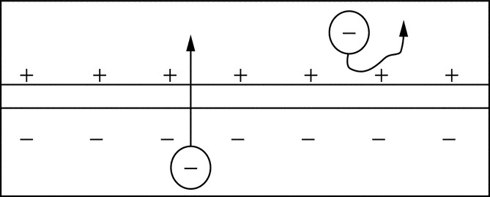

**FIGURE 24.1** Effect of the electric field in a PV cell [[1](https://learning.oreilly.com/library/view/power-electronics-handbook/9780128114087/B978012811407000026X.xhtml#bb0010)].

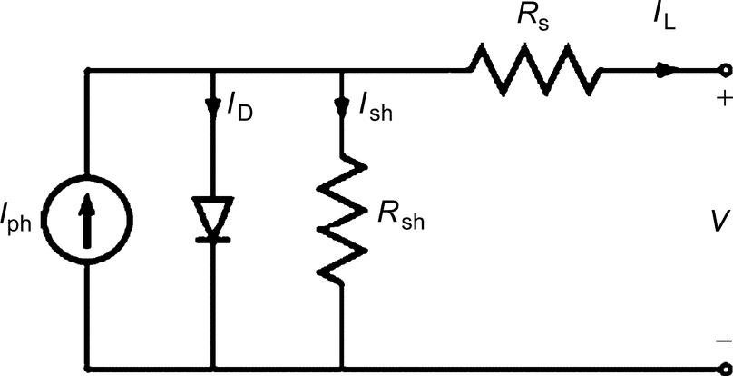

**FIGURE 24.2** Solar cell equivalent circuit.

A simplified equivalent circuit is shown in [Fig. 24.3](https://learning.oreilly.com/library/view/power-electronics-handbook/9780128114087/B978012811407000026X.xhtml#f0020).

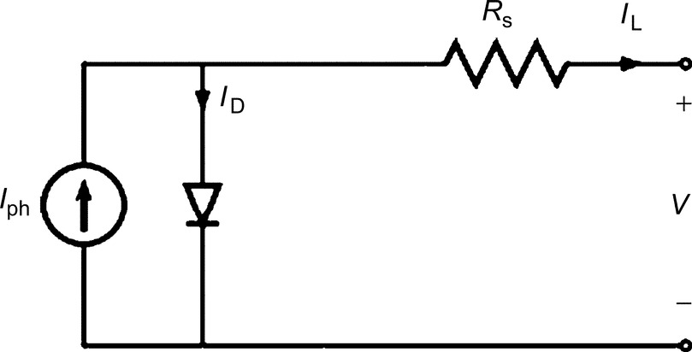

**FIGURE 24.3** Model for a PV cell.

The diode current is given by the Shockley equation:

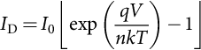 **(24.1)**

where *I*0 is the reverse saturation current, *q* is the charge carrier, *k* is the Boltzmann constant, *T* is the cell temperature, and *n* is the ideality factor.

The PV module has two limiting components ([Fig. 24.3](https://learning.oreilly.com/library/view/power-electronics-handbook/9780128114087/B978012811407000026X.xhtml#f0020)): open-circuit voltage (*V*OC) and short-circuit current (*I*sc). To determine *I*sc, set  and , and this value changes proportionally to the cell irradiance. To determine *V*OC, set the cell current ; hence,

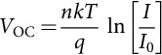 **(24.2)**

The PV module can also be characterized by the maximum point when the product (*V*mp (voltage, where power is maximum)  (current, where power is maximum)) is at its maximum value. The maximum power output is derived by

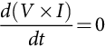 **(24.3)**

and

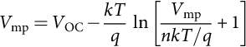 **(24.4)**

A PV module is normally rated using its *W*p, which is normally 1 kW/m2 under standard test conditions (STC), which defines the PV performance at an incident sunlight of 1000 W/m2, a cell temperature of  (), and an air mass (AM) of 1.5. The product ( is related to the product generated by () by a fill factor (FF) that is a measure of the junction quality and series resistance, and it is given by

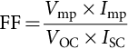 **(24.5)**

The closer the FF is to unity, the higher the quality of the PV module.

Finally, the last and most important factor of merit for a PV module is its efficiency (*η*), which is defined as

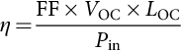 **(24.6)**

*P*in represents the incident power depending on the light spectrum incident on the PV cell.

To achieve the desired voltage and current levels, solar cells are connected in series (*N*s) and parallel (*N*p) combinations forming a PV module. The PV parameters are then affected as shown below:

 **(24.7)**

**** **(24.8)**

**** **(24.9)**

**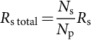** **(24.10)**

This model is shown in [Fig. 24.4](https://learning.oreilly.com/library/view/power-electronics-handbook/9780128114087/B978012811407000026X.xhtml#f0025).

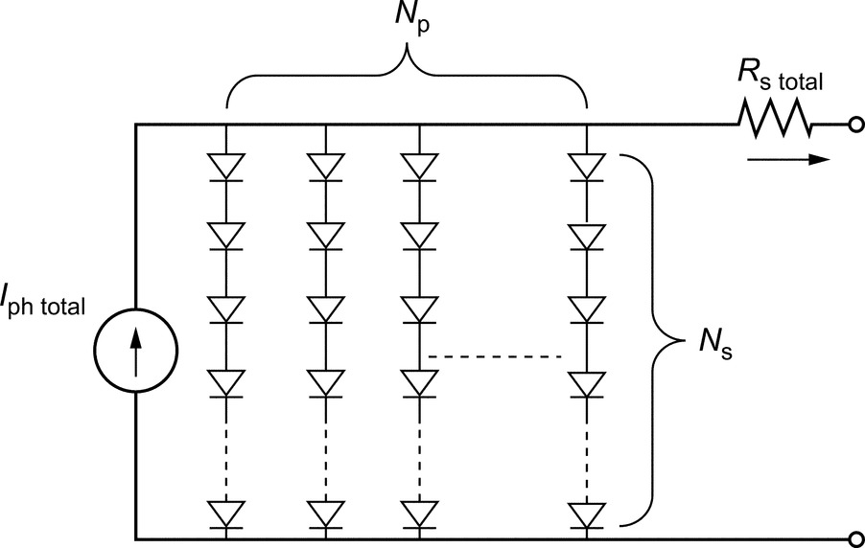

**FIGURE 24.4** PV module circuit model.

In order to obtain the appropriate voltages and outputs for different applications, single solar cells are interconnected in series (for larger voltage) and in parallel (for larger current) to form the photovoltaic module. Then, several of these modules are connected to each other to form the photovoltaic array. This array is then fitted with aluminum or stainless steel frame and covered with transparent glass on the front side ([Fig. 24.5](https://learning.oreilly.com/library/view/power-electronics-handbook/9780128114087/B978012811407000026X.xhtml#f0030)).

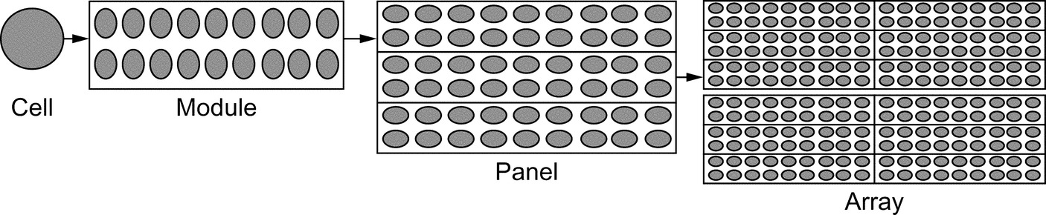

**FIGURE 24.5** Photovoltaic cells, modules, panels, and array.

The voltage generated by the array depends primarily on the design and materials of the cell, whereas the electric current depends primarily on the incident solar irradiance and the cell area. This current fluctuates since the path of the sun varies dramatically over the year, with winter and summer seasons being the two extreme excursions. The elevation angle of the sun (*θ*sunelevation) is expressed in degrees above the horizon. Azimuth angle (*ϕ*sunazimuth) of the sun is expressed in degrees from true north. Zenith angle (*θ*sunzenith) of the sun equals 90 degrees less than the elevation angle of the sun, or

 **(24.11)**

Azimuth, zenith, and elevation angles are illustrated in [Fig. 24.6](https://learning.oreilly.com/library/view/power-electronics-handbook/9780128114087/B978012811407000026X.xhtml#f0035).

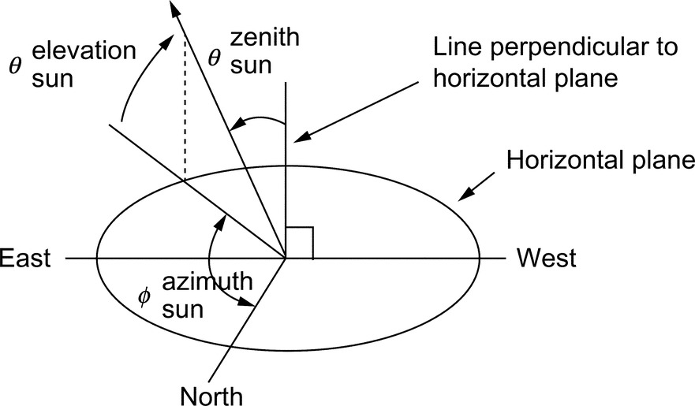

**FIGURE 24.6** Azimuth, zenith, and elevation angles of a vector pointed toward the sun.

The output from a typical solar cell that is exposed to the sun, therefore, increases from zero at sunrise to a maximum at midday and then falls again to zero at dusk. The radiation of the sun varies when reaching the surface of the earth due to absorption and scattering effect in the earth's atmosphere. PV system designers require the estimate of the insolation expected to fall on a randomly tilted surface and hence need a good evaluation of global radiation on a horizontal surface, horizontal direct, and diffuse components, in order to estimate the amount of irradiation striking a tilted plane.

## 24.3 Photovoltaic Technology Operation

Photovoltaic technology is used to produce electricity in areas where power lines do not reach. In developing countries, it helps improving living conditions in rural areas, especially in health care, education, and agriculture. In industrialized countries, such technology has been used extensively and integrated with the utility grid.

Photovoltaic arrays are usually mounted in a fixed position and tilted toward the south to optimize the noontime and the daily energy production. The orientation of fixed panel should be carefully chosen to capture the most energy for the season or for a year. Photovoltaic arrays have an optimum operating point called the maximum power point (MPP) as shown in [Fig. 24.7](https://learning.oreilly.com/library/view/power-electronics-handbook/9780128114087/B978012811407000026X.xhtml#f0040).

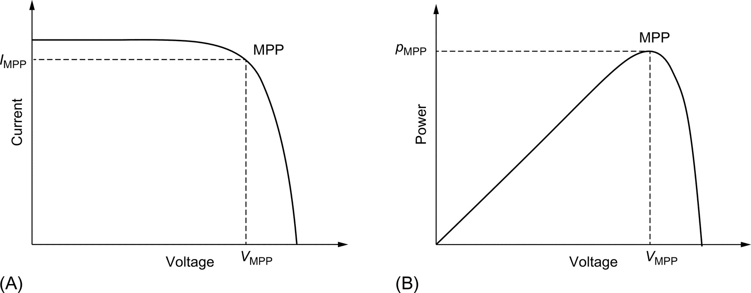

**FIGURE 24.7** Typical PV module curves: (A) *I*-*V* characteristic of a solar cell showing maximum power point (MPP) and (B) *P*-*V* characteristic of a solar cell showing MPP.

It is noted that power increases as voltage increases, reaching a peak value and decreases as the resistance increases to a point where current drops off. According to the maximum power transfer theory, this is the point where the load is matched to the solar panel's resistance at a certain level of temperature and insolation. The *I*-*V* curve changes as the temperature and insolation levels change as shown in [Fig. 24.8](https://learning.oreilly.com/library/view/power-electronics-handbook/9780128114087/B978012811407000026X.xhtml#f0045), and thus, the MPP will vary accordingly.

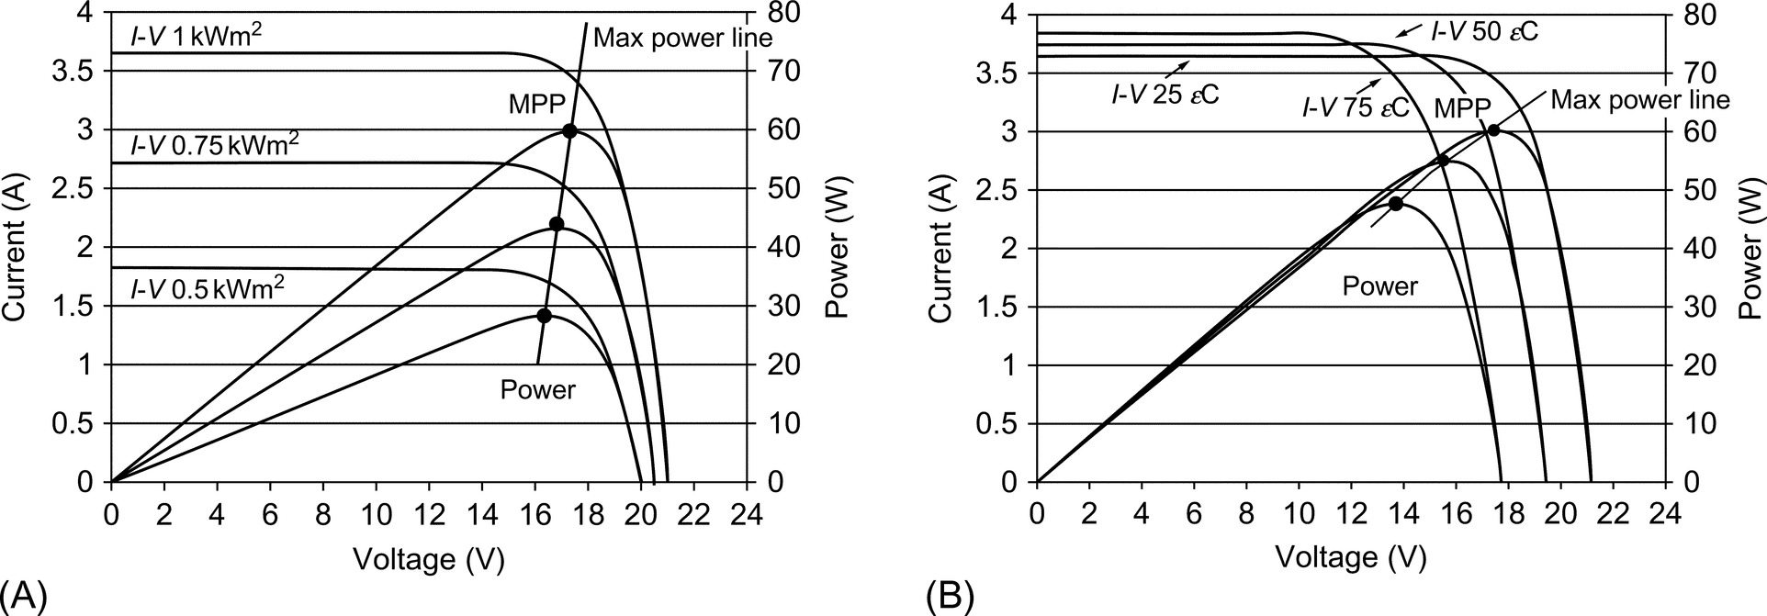

**FIGURE 24.8** PV module characteristics: (A) PV panel insolation and (B) PV panel temperature.

It is shown that the open-circuit voltage increases logarithmically, while the short-circuit current increases linearly as the isolation level increases. Moreover, increasing the temperature of the cell decreases the open-circuit voltage and increases slightly the short-circuit current, causing a reduction in the efficiency of the cell.

The PV panels, usually mounted on the roof or at a near open area, are fixed to face the sun at an angle matching the country's latitude. If possible, seasonal adjustment of the module's direction toward the sun is done manually. Since solar power technology is relatively expensive, it is important to operate panels at their maximum power conditions. However, to collect as much solar radiation as possible, it is more convenient and efficient to use a sun tracking mechanism causing the module's surface to track the sun throughout the day.

The tracking can be along either one axis or two axes, whereby double axis tracking provides a higher power output. The energy yield can be thus increased by about 20%–30% depending on the seasonal climate and geographic location. Although some claim that a fixed system costs less and requires almost no maintenance, different tracking mechanisms that utilized to control the orientation of the PV panels have proved their superiority over fixed systems in terms of converted power efficiency.

To get maximum power from the PV panel at the prevailing temperature and insolation conditions, either the operating voltage or current should be controlled by a maximum power point tracker (MPPT) that should meet the following conditions:

• Operate the PV system close to the MPP irrespective of the atmospheric changes.

• Have low-cost and high-conversion efficiency.

• Provide an output interface compatible with the battery charging requirement.

## 24.4 Maximum Power Point Tracking Components

The MPPT increases the energy that can be transferred from the array to an electric system. The main function is to adjust the panel's output voltage to supply the maximum energy to the load. Most current designs consist of three basic components: switch-mode DC-DC converter, control system, and tracking component.

The switch-mode converter is the core of the entire supply because the energy drawn, stored as magnetic energy, is released at different potential levels. By setting up the switch-mode section in various topologies such as buck or boost converter, voltage converters are designed providing a fixed input voltage or current, which correspond to the maximum power point, allowing the output resistance to match the battery. To achieve the above-stated mechanism, a controller is essential to continuously monitor the PV system and ensure its operation at the PV maximum power point by tracking this MPP. The controller's aim is to continuously measure the voltage and current values generated from the PV and compare them with certain threshold values in order to apply either voltage controlled method or power feedback control.

### 24.4.1 VOLTAGE FEEDBACK CONTROL

With the PV array terminal voltage being the controlled variable, voltage feedback controller forces the PV array to operate at its MPP by changing the array terminal voltage and neglecting the variation in the temperature and insolation level.

### 24.4.2 POWER FEEDBACK CONTROL

In this method, the power delivered to the load is the controlled variable. To achieve maximum power, *dp*/*dv* should be zero. This control scheme is not affected by the characteristics of the PV array, yet it increases power to the load and not power from the PV array. Factors such as fast shadows may cause trackers to lose the MPP momentarily. It is very critical to ensure that the time lost in seeking MPP again, which equates the energy lost while the array is off power point, is very short. On the other hand, if lighting conditions do change, the tracker needs to respond within a short amount of time to the change avoiding energy loss. Therefore, the controller's most important feature is its capability to quickly adjust the system to operate back at the MPPT.

## 24.5 MPPT Controlling Algorithms

Several proposed algorithms to accomplish MPPT are described in the following sections.

### 24.5.1 PERTURB AND OBSERVE

The perturb and observe (PAO) method has a simple feedback structure and few measured parameters. It operates by periodically perturbing (i.e., incrementing or decrementing) the duty cycle while controlling the array current as shown in [Fig. 24.9](https://learning.oreilly.com/library/view/power-electronics-handbook/9780128114087/B978012811407000026X.xhtml#f0050) and comparing the PV output power with that of the previous perturbation cycle. It measures the derivative of power Δ*p* and the derivative of voltage Δ*v* to determine the movement of the operating point. If the perturbation leads to an increase (or decrease) in array power, the subsequent perturbation is made in the same (or opposite) direction. This cost-effective technique can be easily implemented and is characterized by continuously tracking and very efficiently extracting the maximum power from PV. However, such method may fail under rapidly changing atmospheric conditions due to its slow tracking speed.

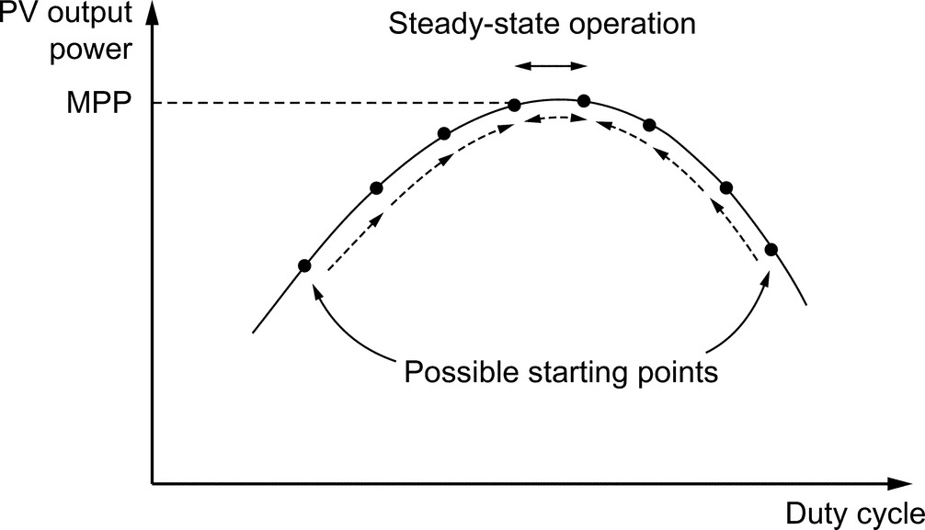

**FIGURE 24.9** PAO technique.

### 24.5.2 INCREMENTAL CONDUCTANCE TECHNIQUE

The incremental conductance technique (ICT) process based on the fact that the derivative of the power with respect to the voltage (*dp*/*dv*) vanishes at the MPP because it is the maximum point on the curve as shown in [Fig. 24.10](https://learning.oreilly.com/library/view/power-electronics-handbook/9780128114087/B978012811407000026X.xhtml#f0055).

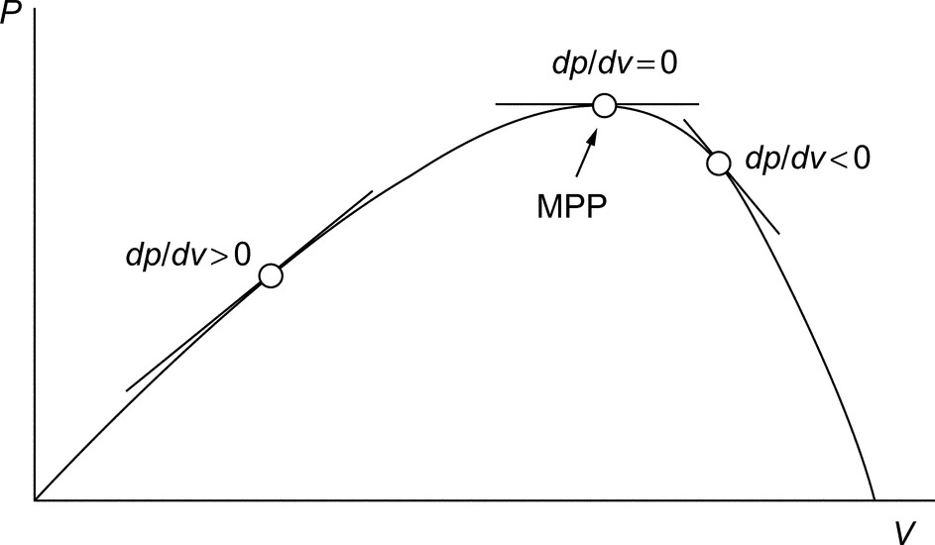

**FIGURE 24.10** The slope “conductance” of the *P*-*V* curve.

The ICT algorithm detects the MPP by comparing *di*/*dv* with  till it attains the voltage operating point at which the incremental conductance is equal to the source conductance. The algorithm starts by measuring the present values of the *I* and *V* and then uses the corresponding stored value (*I*b and *V*b) measured during the preceding cycle to calculate the incremental changes as  and . Based on the result obtained, the control reference signal *V*ref will be adjusted in order to move the array voltage toward the MPP voltage. At the MPP, 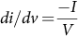, no control action is needed; therefore, the adjustment stage will be bypassed, and the algorithm will update the stored parameters at the end of the cycle. In order to detect any changes in weather conditions, the algorithm detects whether a control action took place when the array was operating at the previous cycle MPP (). This technique is accurate and well suited for rapid changes in atmospheric conditions; however, because the increment size approach is used to determine how fast the system is responding, ICT requires precise calculations of both instantaneous and increasing conductance.

### 24.5.3 CONSTANT REFERENCE

One very common MPPT technique is to compare the PV array voltage (or current) with a constant reference voltage (or current), which corresponds to the PV voltage (or current) at the maximum power point, under specific atmospheric conditions. The resulting difference signal (error signal) is used to drive a power conditioner, which interfaces the PV array to the load. Although the implementation of this method is simple, the method itself is not very accurate because it does not consider the effects of temperature and irradiation variations in addition to the difficulty in choosing the optimum point.

### 24.5.4 CURRENT-BASED MAXIMUM POWER POINT TRACKER

Current-based maximum power point tracker (CMPPT) is another MPPT technique that exists. Employed numerical methods show a linear dependence between the “cell currents corresponding to maximum power” and the “cell short-circuit currents.” The current *I*MPP operating at the MPP is calculated using the following equation:

 **(24.12)**

where *M*C is the “current factor” that differs from one panel to another and is affected by the panel surface conditions, especially if partial shading covers the panel. Although this method is easy to implement, an additional switch is added to the power converter to periodically short the PV array, increase the cost, and reduce the output power. This method also suffers from a major drawback due to periodic tuning requirement.

### 24.5.5 VOLTAGE-BASED MAXIMUM POWER POINT TRACKER

Similar to the above-mentioned method, voltage-based maximum power tracking (VMPPT) technique can also be applied. The MPP operating voltage is calculated directly from *V*OC:

 **(24.13)**

where *M*V is the “voltage factor.” The open-circuit voltage *V*OC is sampled by an analog sampler, and then, *V*MPP is calculated by [Eq. (24.13)](https://learning.oreilly.com/library/view/power-electronics-handbook/9780128114087/B978012811407000026X.xhtml#fo0070). This operating *V*MPP voltage is the reference voltage for the voltage control loop as shown in [Fig. 24.11](https://learning.oreilly.com/library/view/power-electronics-handbook/9780128114087/B978012811407000026X.xhtml#f0060). This method always “results in a considerable power error because the output voltage of the PV module only follows the unchanged reference voltage during one sampling period” [[2](https://learning.oreilly.com/library/view/power-electronics-handbook/9780128114087/B978012811407000026X.xhtml#bb0015)]. Albeit the implementation of this procedure is simple, it endures several disadvantages such as momentarily power converter shutdown causing power loss. Furthermore, such process depends greatly on the *I*-*V* characteristics and requires periodic tuning.

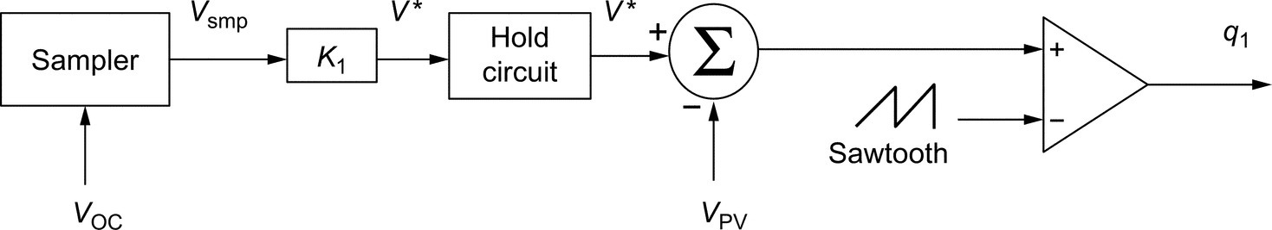

**FIGURE 24.11** The conventional MPPT controller using open-circuit voltage *V*OC.

Other researchers argue that these two practices are considered to be “fast, practical, and powerful methods for MPP estimation of PV generators under all insolation and temperature conditions” [[3](https://learning.oreilly.com/library/view/power-electronics-handbook/9780128114087/B978012811407000026X.xhtml#bb0020)].

### 24.5.6 OTHER METHODS

Automated techniques such as Fibonacci line search, ripple correlation control method, neural network, and fuzzy logic have also been introduced for MPPT. In order to generate a clear understanding in determining the advantages and disadvantages of each algorithm, a comprehensive experimental comparison between different MPPT algorithms was made and run for the same PV setup at South Dakota State University, and results showed that the ICT method has the highest efficiency of 98% in terms of power extracted from the PV array, the PAO technique has the efficiency of 96.5%, and finally, the constant voltage method has the efficiency of 88%.

The ICT method provided good performance under rapidly changing weather conditions and provided the highest tracking efficiency, although four sensors were required to perform the measurements for computations and decision-making. If the system required more conversion time in tracking the MPP, a large amount of power loss would occur. On the contrary, under perturb and observe method, losses are reduced if the sampling and execution speed were increased. The main benefit of this procedure is that only two sensors are required, which resulted in the reduction of hardware requirements and cost.

## 24.6 Grid-Connected Photovoltaic System

Grid-connected photovoltaic systems are composed of PV arrays connected to the grid through a power conditioning unit (PCU) and are designed to operate in parallel with the electric utility grid. The power conditioning unit may include the MPPT, the inverter, the grid interface, and the control system needed for efficient system performance. There are two general types of electric designs for PV power systems: systems that interact with the utility power grid as shown in [Fig. 24.12A](https://learning.oreilly.com/library/view/power-electronics-handbook/9780128114087/B978012811407000026X.xhtml#f0065) and have no battery backup capability and systems that interact and include battery backup as well as shown in [Fig. 24.12B](https://learning.oreilly.com/library/view/power-electronics-handbook/9780128114087/B978012811407000026X.xhtml#f0065). The latter type of system incorporates energy storage in the form of a battery to keep “critical load” circuits operating during utility outage. When an outage occurs, the unit disconnects from the utility and powers specific circuits of the load. If the outage occurs in daylight, the PV array is able to assist the load in supplying the loads.

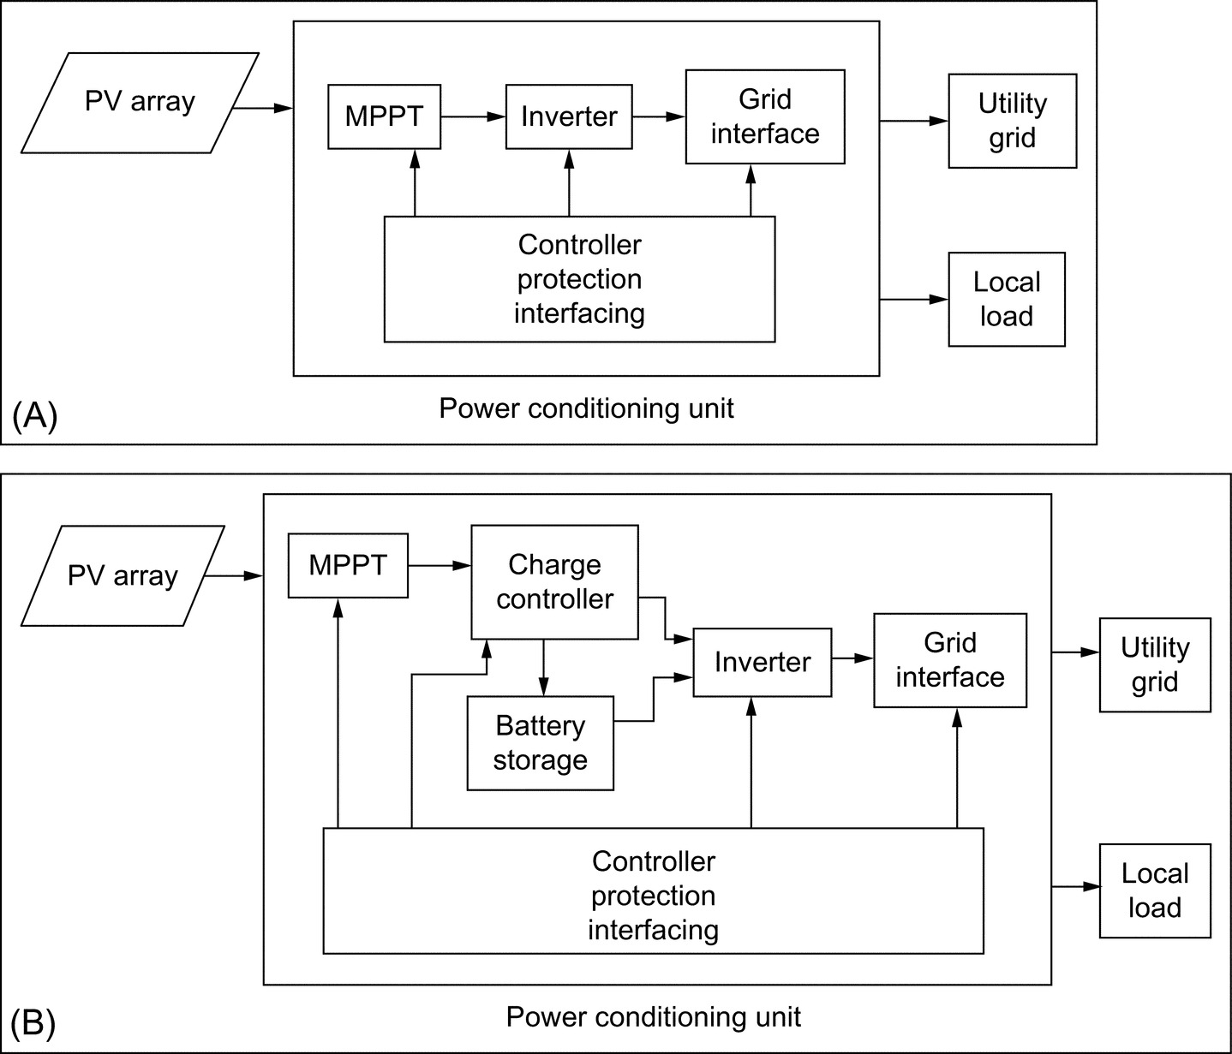

**FIGURE 24.12** Block diagrams of grid-connected PV system: (A) without battery backup and (B) with battery storage.

The major component in both systems is the DC-AC inverter or also called the power conditioning unit (PCU). The inverter is the key to the successful operation of the system, but it is also the most complex hardware. The inverter requirements include operation over a wide range of voltages and currents and regulated output voltage and frequency while providing AC power with good power quality that includes low total harmonic distortion and high power factor, in addition to highest possible efficiency for all solar irradiance levels. Inverters can be used in a centralized connection ([Fig. 24.13A](https://learning.oreilly.com/library/view/power-electronics-handbook/9780128114087/B978012811407000026X.xhtml#f0070)) for the whole array of PV, each PV module string is connected to a single inverter ([Fig. 24.13B](https://learning.oreilly.com/library/view/power-electronics-handbook/9780128114087/B978012811407000026X.xhtml#f0070)), and a single PV module is connected to a named microinverter ([Fig. 24.13C](https://learning.oreilly.com/library/view/power-electronics-handbook/9780128114087/B978012811407000026X.xhtml#f0070)).

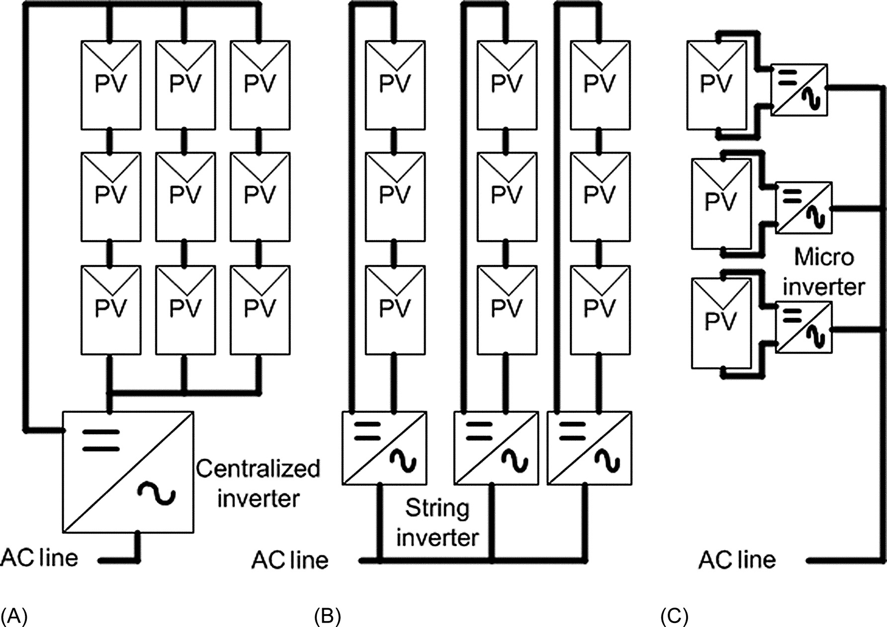

**FIGURE 24.13** Grid-connected PV system: (A) centralized, (B) string connection, and (C) microinverter.

The first circuit handled all the power, and the maximum power point is difficult to follow if there is voltage/current mismatching at the PV modules. The second option is more efficient than the first one since it minimizes the losses due to voltage/current mismatching and it enhances its modularity capability. The last circuit may perform a good tracking since each PV module is controlled independently; however, more stages and components are required.

For the last years, researchers have been working on developing different inverter topologies. The evolution of solid-state devices such as metal-oxide-semiconductor field-effect transistors (MOSFETs), insulated-gate bipolar transistors (IGBTs), microprocessors, and PWM-integrated circuits has allowed improvements on the inverter. Some research is being carried to ensure quality control, reliability, high efficiency, and lower cost since inverters are the key for a sustainable photovoltaic market.

### 24.6.1 ISOLATED CONVERTERS

For safety reasons, not only both the grid neutral line and the chassis of the PV modules must be grounded, but also the PCU may provide galvanic isolation. The first option is to place the isolation on the grid side, by using an AC low-frequency transformer ([Fig. 24.14A](https://learning.oreilly.com/library/view/power-electronics-handbook/9780128114087/B978012811407000026X.xhtml#f0075)), which makes the system big, heavy, and bulky. The second option is to include the isolation on the DC side, after the PV array, by using a high-frequency transformer ([Fig. 24.14B](https://learning.oreilly.com/library/view/power-electronics-handbook/9780128114087/B978012811407000026X.xhtml#f0075)), which is smaller and costs less than an AC transformer.

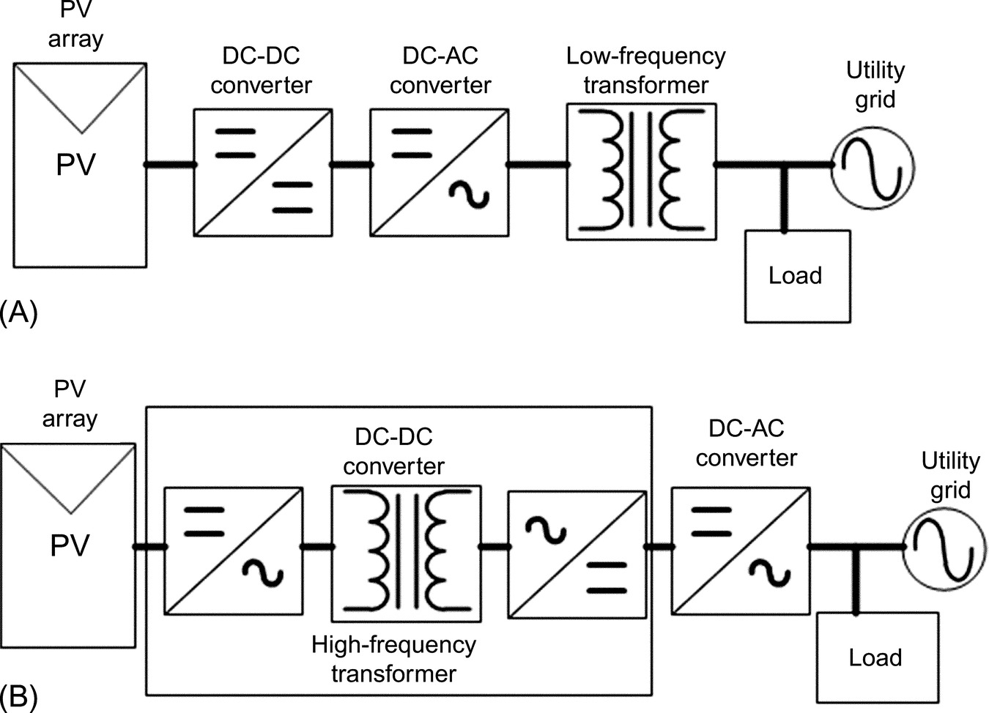

**FIGURE 24.14** Grid-connected isolated PV system: (A) low-frequency transformer and (B) high-frequency transformer.

These options have different drawbacks: low efficiency, the size and weight are compromised, and the cost should be high due to the inclusion of the isolation. Therefore, researchers are developing the PCUs without isolation.

### 24.6.2 TRANSFORMERLESS CONVERTERS

A costless PCU is obtained if the isolation is removed, but then, a common-mode resonant circuit appears due to the grounding cable, which includes the filter, the inverter, the grid impedance, and the PV parasitic capacitance. This common mode generates a leakage current (*i*leakage) that circulates through parasitic capacitances in PV array to the ground, as shown in [Fig. 24.15](https://learning.oreilly.com/library/view/power-electronics-handbook/9780128114087/B978012811407000026X.xhtml#f0080). The common-mode voltage, the modulation strategy, and the value of the parasitic capacitance greatly affect the value of the leakage current.

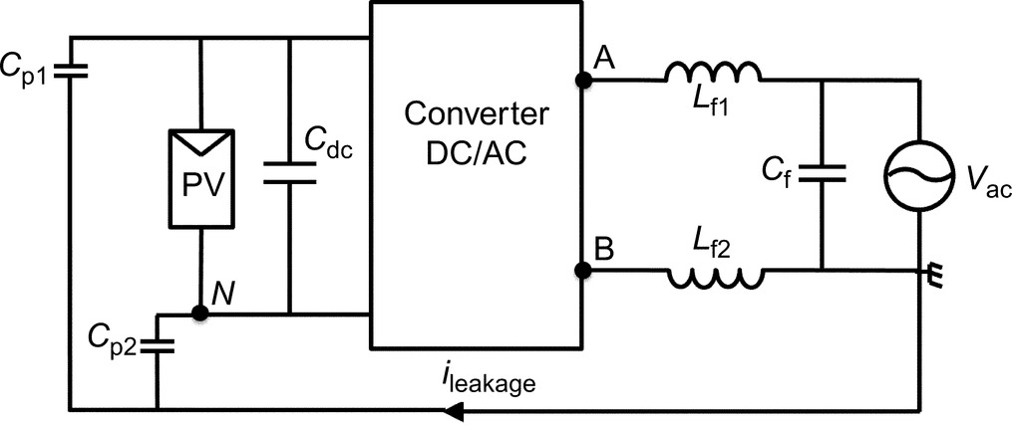

**FIGURE 24.15** Block diagram to illustrate the leakage current.

The parasitic capacitance value depends on many factors such as the PV panel and frame structure, the surface of cells, the distance between cells, the weather conditions, and the type of EMC filter. In order to reduce this parasitic current, different PCUs have been reported: H-5, HERIC, and common-mode inverters, among others.

A. H-5 inverter

This DC/AC converter is similar to the traditional full-bridge inverter topology, where the upper switches operate at grid frequency and the lower ones work at a high frequency. It has incorporated an extra switch S5 on the DC side that operates in both semicycles at a high frequency ([Fig. 24.16A](https://learning.oreilly.com/library/view/power-electronics-handbook/9780128114087/B978012811407000026X.xhtml#f0085)). The main characteristic of this configuration is that the PV array is decoupled from the grid when this extra switch is turned off.

Normally during active states, the current flows during freewheeling modes through two switches, but in active vectors, the current flows through three switches causing conduction losses, which become a disadvantage.

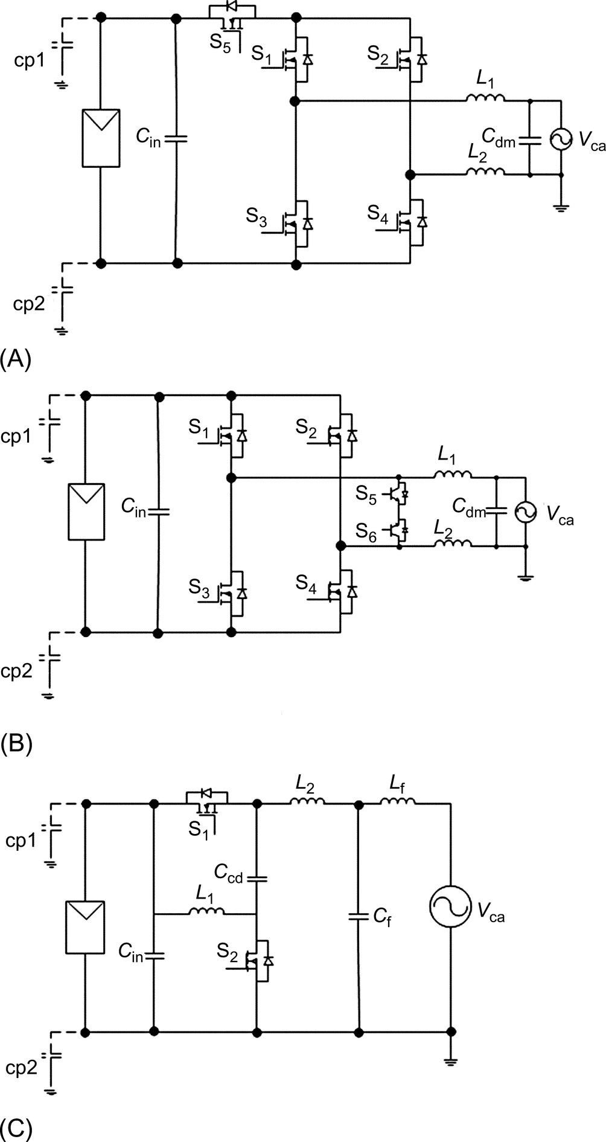

**FIGURE 24.16** Transformerless inverters for PV systems: (A) H-5, (B) HERIC, (C) a common-mode topology.

B. Heric inverter

This topology combines advantages from two alternatives: the three-level output voltage of the unipolar PWM, besides the reduced common-mode voltage as in the case of bipolar PWM. It consists of a full-bridge inverter plus two additional switches, as illustrated in [Fig. 24.16B](https://learning.oreilly.com/library/view/power-electronics-handbook/9780128114087/B978012811407000026X.xhtml#f0085). Each group of diagonal switches of the full bridge operates at a high frequency during the half wave of the grid. One of the two additional switches is turned on during the half wave of the grid. S5 or S6 is used when the disconnection occurs between the grid and PV array, which reduces the leakage current. The main drawback of this topology is the pair of additional semiconductors.

C. Common mode converter

There are different schemes for this configuration; the main idea is that the neutral terminal of the grid is connected straight to the negative of the PV array. Shown in [Fig. 24.16C](https://learning.oreilly.com/library/view/power-electronics-handbook/9780128114087/B978012811407000026X.xhtml#f0085) is an alternative; this topology is composed of two power MOSFETs (S1 and S2), and just a single device is conducting in each switching state. The converter includes two capacitors and three inductors (*C*f, *C*dc and *L*1, *L*2, *L*f).

Since the negative of the PV array is connected straight to the neutral line of the grid, the ground leakage current is very low, while the applied voltage to the parasitic capacitance is maintained almost constant.

### 24.6.3 GRID SYNCHRONIZATION

PV grid-connected converters need a phase and frequency tracking system to provide a reference signal in order to synchronize it with the grid voltage. It is critical in a synchronization system with a high degree of immunity to harmonics, unbalances, and power system disturbances as sags and swells.

There are several state-of-the-art techniques in detecting the phase angle of the grid voltages. A particular easy and simple to implement is the voltage zero-crossing technique. However, voltage sags and harmonics can disturb greatly the output signal. Digital schemes have improved zero-crossing method using filtering techniques: extended Kalman filters, low-pass filters, space vector, and recursive weighted least-square estimation.

Phase-locked-loop (PLL)-based algorithms can successfully reject harmonics, notches, voltage sags, and swells. At the same time, PLL algorithms provide the estimation of time-varying fundamental parameters from the distorted grid voltage waveform. Another representative technique in grid synchronization is the second-order generalized integrator frequency-locked loop (SOGI-FLL). SOGI-FLL-based techniques estimate important grid parameters for single- and three-phase systems, reducing undesirable frequency swing during phase-angle jumps.

### 24.6.4 ISLANDING MODE

For security reasons, the PV grid-connected inverters must be disconnected from the grid when the utility is disabled or out of operation. Once the grid is out, the PV system is operating in islanding mode, and this mode must be detected in order to shut off the system and separate it from the utility.

The islanding mode detector may be classified in local or remote techniques. The local techniques are based on the measurements of physical parameters at the common point of coupling, like voltage and current. The remote techniques are based on communication infrastructure between the electricity provider and the PV system. The local techniques may be subclassified in passive and active methods. These methods are briefly described as follows.

A. Passive methods

The passive method is based on not only the measurement of variables as voltage and current at common point of coupling but also obtaining parameters like *rms* voltage, *rms* current, frequency, phase, and total harmonic distortion. It established the range for the normal operation, and once the system is out of the specified range, the PV system is considered that is operating in islanding mode.

B. Active methods

The active methods also are based on the measurements of voltage and current, but additionally, these methods inject perturbations in order to accelerate the fastness of the detection. There are many methods.

One method is called the shift active frequency, during a small time, the injected current is zero (no sinusoidal current), and when the system is in islanding mode, the output frequency is naturally changed, and this will be detected fast.

A second method is called sandia voltage shift; in this scheme, a positive feedback is considered in the current loop; this loop tries to produce an instability at the output voltage. If the system is operated normally, this loop will not cause a major trouble since the stability is determined by the grid. However, when the islanding mode occurs, this loop will produce an instability at the output voltage, and this is detected fast as an under or overvoltage.

## 24.7 Stand-Alone Photovoltaic System

The main advantage of PV systems is their flexibility to be implemented in remote locations where grid connection is either impossible or very expensive to execute. Such systems are called stand-alone PV systems and are described in this section.

Stand-alone photovoltaic systems are usually a utility power alternative. They generally include solar charging modules, storage batteries, and controls or regulators as shown in [Fig. 24.17](https://learning.oreilly.com/library/view/power-electronics-handbook/9780128114087/B978012811407000026X.xhtml#f0090). Ground- or roof-mounted systems will require a mounting structure, and if AC power is desired, an inverter is also required. In many stand-alone PV systems, batteries are used for energy storage as they may account for up to 40% of the overall stand-alone PV system cost over its lifetime.

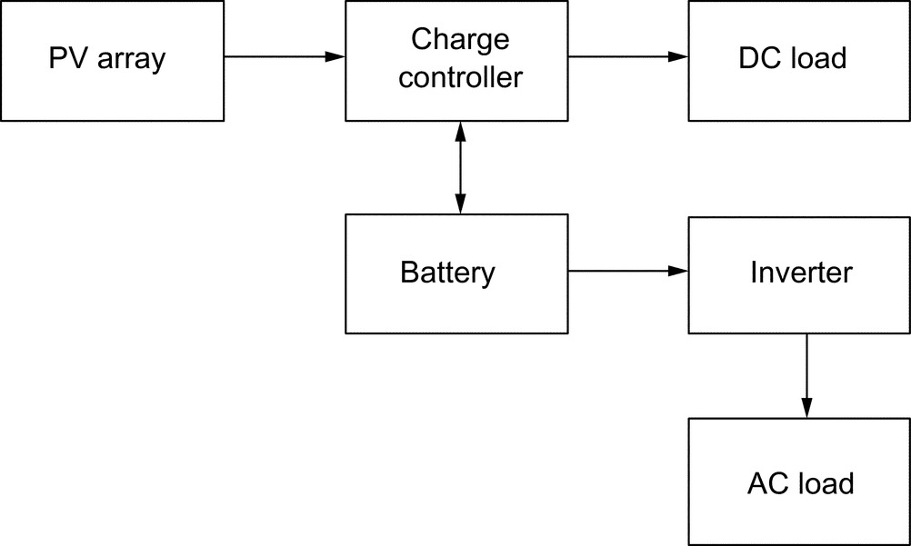

**FIGURE 24.17** Diagram of stand-alone PV system with battery storage power DC and AC loads.

These batteries cause losses in the PV system due to limited availability of time and energy to recharge the battery in addition to the insufficient battery maintenance. Hence, a charge controller is then used to control the system and prevent the battery from overcharging and overdischarging. Overcharging shortens the battery life and may cause gassing, while undercharging may lead to sulfation and stratification, which result in the reduction in battery effectiveness and lifetime.

Batteries are often used in PV systems for storing energy produced by the PV array during daytime and supplying it to electric loads as needed (during nighttime or cloudy weather). Moreover, batteries are also needed in the tracker systems to operate at MPP in order to provide electric loads with stable voltages. Nearly, most of the batteries used in PV systems are deep-cycle lead-acid batteries. These batteries have thicker lead plates that make them tolerate deep discharges. The thicker the lead plates, the longer the lifespan of the batteries. The heavier the battery for a given group size, the thicker the plates and the better the battery will tolerate deep discharges.

All deep-cycle batteries are rated in ampere-hour (AH) capacity, a quantity of the amount of usable energy it can store at nominal voltage. A good charge rate is approximately 10% of the total capacity of the battery per hour. This will reduce the electrolyte losses and the damage to the plates. A PV system may have to be sized to store a sufficient amount of power in the batteries to meet power demand during several days of cloudy weather, known as “days of autonomy.” The Institute of Electrical and Electronics Engineers (IEEE) has set several guidelines and standards for sizing lead-acid batteries (IEEE Std 1013–1990), for selecting, charging, and testing in stand-alone PV systems (IEEE Std 1361–2003), and for installing and maintaining them (IEEE Std 937–2007).

Nickel-cadmium batteries are also used for PV stand-alone systems but are often expensive. However, their main advantage is they are not affected by temperature as other battery types, hence mostly recommended for industrial or commercial applications in cold locations. IEEE has also drafted some guidelines for installation and maintenance (IEEE Std 1145–1999).

To extend battery's lifetime and for efficient system's operation, a charge controller is needed to regulate the flow of electricity from the PV modules to the battery and the load. The controller keeps the battery fully charged without overcharging it. Many controllers have the ability to sense the excess of electricity drawn from batteries to the load and stop the flow until sufficient charge is restored to the batteries. The latter can greatly extend the battery's lifetime. However, controllers in the stand-alone photovoltaic system are more complex devices that depend on battery state of charge, which in turn depends on many factors and is difficult to measure. The controller must be sized to handle the maximum current produced. Several characteristics should be considered before selecting a controller such as adjustable set points including high-voltage and low-voltage disconnects, temperature compensation, low-voltage warning, and reverse current protection. Moreover, the controller should ensure that no current flows from the battery to the array at night.

### 24.7.1 POWER CONVERTERS

There are different power converters for stand-alone systems, and they have different operating modes. They may be summarized as described below:

• Power delivered from the main voltage source

The power converter may be able to deliver energy directly to the load form the main voltage source, without the use of the battery set. This mode in some converters is not considered, and the load is just fed by the battery set.

• Not energy available from the main voltage source

It is possible to not have energy due to weather conditions, and then, the battery will deliver the energy to the load. This may be through a direct connection or by considering a power converter.

• Power delivered from main source and battery set

When the photovoltaic system cannot provide all required energy by the load, but still there is available energy, then the system could be operated to demand energy from both sources: the photovoltaic system and the battery set. Not all the power converters may operate in this form.

• Charging the battery set

Once the battery is empty, a charging mode must be considered. The battery is fed by the photovoltaic system through a power converter. This mode occurs if there is energy available from the renewable source.

• No energy available from any source

It is possible to not have energy due to weather conditions and also when the battery is discharged; then, the system is turned off, until the system has the energy to operate.

For stand-alone applications, it is possible to consider more than one solar panel, besides the battery set. Then, power converter with multiple inputs should be considered. One of the most important issues in these converters is the power administration, that is, to determine when each source should be used, in order to have the best operation of the system.

## 24.8 Factors Affecting PV Output

PV systems produce power in proportion to the intensity of sunlight striking the solar array surface. Thus, there are some factors that affect the overall output of the PV system and are discussed below.

### 24.8.1 TEMPERATURE

The output power of a PV system decreases as the module temperature increases. An increasing cell temperature at constant irradiance causes a reduction in *V*OC at a rate approximately of 2–2.5 mV/C. The short-circuit current, on the other hand, remains nearly constant. Since *V*mp is normally about 80% of *V*OC and the cells are series connected, it is important the combined effect on cell performance merit careful consideration. The temperature effect on monocrystalline solar cells is higher than polycrystalline silicon and thin-film solar cells; operating at temperatures higher than 25°C may reduce maximum output power by 15% in monocrystalline solar cells and by 5% in thin-film solar cells.

### 24.8.2 DIRT AND DUST

Dirt and dust can accumulate on the solar module surface, also known as soiling. The soil layer blocks the sunlight and reduces the output power. Estimation of soiling loss is difficult due to the variations in the soil type, geographic locations, and climatic conditions. In general, there are two types of soil shading on PV modules, namely, hard shading and soft shading. Hard shading occurs when a solid such as accumulated dust blocks the sunlight in a clear and definable shape. On the other hand, soft shading takes place when some particles such as smog or some dust reduce the overall intensity of the solar irradiance.

For hard shading, the performance of the PV module depends on the portions shaded of the PV module. Soft shading affects the current of the PV module, but the voltage remains the same. To get better performance, the solar module surface must be clean. Manually hand cleaning element by water with detergent is suggested one time per week on the panel.

### 24.8.3 DC-AC CONVERSION

Because the power from the PV array is converted back to AC as shown earlier, some power is being lost in the conversion process, in addition to losses in the wiring. Common inverters used have peak efficiencies of about 90%–98%. Recently, the new devices based on gallium nitride (GaN) and silicon carbide (SiC) are recommended for these power converters.

## 24.9 PV System Design

The goal for a solar direct electricity generation system or photovoltaic system is to provide high-quality, reliable, and green electric power. Then, some suggestions may be followed.

### 24.9.1 CRITERIA FOR A QUALITY PV SYSTEM

The criteria for quality PV system are as follows:

• Be properly sized and oriented to provide electric power and energy

• Good control circuit to reduce electric losses, overcurrent protection, switches, and inverters

• Good charge controller and battery management system, if the system contains batteries

### 24.9.2 DESIGN PROCEDURES

The first task in designing a PV system is to estimate the system's load. This is achieved by defining the power demand of all loads, the number of hours used per day, and the operating voltage. From the load ampere-hours and the given operating voltage for each load, the power demand is calculated. For a stand-alone system, the system voltage is the potential required by the largest load. When AC loads dominate, the DC system voltage should be chosen to be compatible with the inverter input.

### 24.9.3 POWER-CONDITIONING UNIT

The choice of the PCU has a great impact on the performance and economics of the system. It depends on the type of waveform produced, which in turn depends on the method used for conversion and the filtering techniques of unwanted frequencies. Several factors must be considered when selecting or designing the inverter:

• The power conversion efficiency

• Rated power

• Duty rating, the amount of time the inverter can supply maximum load

• Input voltage

• Voltage regulation

• Voltage protection

• Frequency requirement

• Power factor

• Islanding detection

### 24.9.4 BATTERY SIZING

PV system parameters need to be defined with the battery in mind. The amount of battery storage needed depends on the load energy demand and on weather patterns at the site. There is always a trade-off between keeping cost low and meeting energy demand. There are a number of basic battery characteristics that can have a significant impact on PV system performance.

Among the most important characteristics are temperature effects, recharge efficiency, charge voltage, and the number of days a PV battery will carry the load without energy from the PV array. It is important to clearly define battery charging requirements and meet those charging requirements with proper charge control voltage and array sizing.

## References

[1] J. Toothman, S. Alsous, How solar cells work, <http://science.howstuffworks.com/environmental/energy/solar-cell.htm>. (Accessed October 2010).

[2] Roberts S., Guariento N. *Building Integrated Photovoltaics: A Handbook.* Walter de Gruyter; 2009. <http://www.solarserver.com/knowledge/basic-knowledge/photovoltaics.html>.

[3] Jian W., Jianzheng L., Zhengming Z. *Optimal control of solar energy combined with MPPT and battery charging.* In: Proceedings of IEEE International Conference on Electrical Machines and Systems, vol. 1; 2003:285–288.

## Further Reading

[1] [www.worldenergy.org/](http://www.worldenergy.org/).

[2] Photovoltaics: solar electricity and solar cells in theory and practice, [www.solarserver.de/wissen/photovoltaic-e.html](http://www.solarserver.de/wissen/photovoltaic-e.html).

[3] Moller H. *Semiconductors for Solar Cells.* London: Artech House, Inc; 1993.

[4] Berkeley Lab. <http://www.lbl.gov/msd/pis/walukiewicz/0202_08_full_solar_spectrum.html>.

[5] Dezso Sera, Remus Teodorescu, Pedro Rodriguez. *PV panel model based on datasheet values.* In: Industrial Electronics, ISIE 2007, IEEE International Symposium volume; 2007:2392–2396.

[6] Messenger R.A., Ventre J. *Photovoltaic Systems Engineering.* CRC Press; 2003.

[7] Wenham S.R. *Applied Photovoltaics.* Routledge; 2012.

[8] S.C. Krauter, Solar Electric Power Generation-Photovoltaic Energy Systems: Modeling of Optical and Thermal Performance, Electrical Yield, Energy Balance, Effect on Reduction of Greenhouse Gas Emissions, Springer Science & Business Media, 2007.

[9] Chu C., Chen C. Robust maximum power point tracking method for photovoltaic cells: a sliding mode control approach. *Sol. Energy.* 2009;83(8):1370–1378.

[10] EE362L. *Power electronics, solar power, I–V characteristics.* Version October 14 2005. <http://www.ece.utexas.edu/grady/EE362L_Solar.pdf> (Accessed 23 February 2017).

[11] Lee D., Noh H., Hyun D., Choy I. *An improved MPPT converter using current compensation method for small scaled PV-applications.* In: Applied Power Electronics Conference and Exposition (APEC'03), vol. 1; 2003:540–545.

[12] Photovoltaic Fundamentals. <http://www.fsec.ucf.edu/PVT/pvbasics/index.htm>. (Accessed 23 February 2017).

[13] The solar sprint PV panel. <http://chuck-wright.com/SolarSprintPV/SolarSprintPV.html>. (Accessed 23 February 2017).

[14] M. A. Serhan, Maximum Power Point Tracking system: An Adaptive Algorithm for Solar Panels (Thesis), American University of Beirut, January 2005.

[15] Enslin J.H.R., Wolf M.S., Snyman D.B., Swiegers W. Integrated photovoltaic maximum power point tracking converter. *IEEE Trans. Ind. Electron.* 1997;44(6):769–773.

[16] Khalil A.A., El-Singaby M. *Position control of sun tracking system; circuits and systems.* In: Proceedings of the 46th IEEE International Midwest Symposium; 1134–1137. 2003;3.

[17] Kroutoulis E., Kalaitzakis K., Voulgaris N.C. Development of a microcontroller-based, photovoltaic maximum power tracking control system. *IEEE Trans. Power Electron.* 2001;16(1):46–54.

[18] Shengyi Liu. Maximum power point tracker model. *Control Model.* University of South Carolina; 2000 Available from: <http://vtb.engr.sc.edu/modellibrary_old>. (Accessed 23 February 2017).

[19] Hussein K.H., Mutta I., Hoshino T., Osakada M. Maximum photovoltaic power tracking: an algorithm for rapidly changing atmospheric conditions. *IEE Proc. Gener. Trans. Distrib.* 1995;142(1):59–64.

[20] Tse K.K., Henry S.H., Chung S., Hui Y.R., Ho M.T. *Novel maximum power point tracking technique for PV panels.* In: IEEE Power Electronics Specialists Conference, vol. 4; 2001:1970–1975.

[21] Noguchi T., Togashi S., Nakamoto R. Short-current pulse-based maximum power point tracking method for multiple photovoltaic-and-converter module system. *IEEE Trans. Ind. Electron.* 2002;49(1):217–223.

[22] HowStuffworks. <http://science.howstuffworks.com/solar-cell5.html>. (Accessed 23 February 2017).

[23] Masoum M., Dehbonei H., Fuschs E. Theoretical and experimental analyses of photovoltaic systems with voltage-and current-based maximum power point tracking. *IEEE Trans. Convers.* 2002;17(4):514–522.

[24] Hohm D., Ropp M. *Comparative study of maximum power point tracking algorithms using an experimental, programmable, maximum point test bed.* In: IEEE Photovoltaic Specialists Conference; 2000:1699–1702.

[25] Chicco G., Napoli R., Spertino F. *Experimental evaluation of the performance of grid-connected photovoltaic systems.* In: IEEE Melecon, Dubrovnik, Croatia; 2004:1011–1016.

[26] Mohan N., Undeland T., Robbins W. *Power Electronics: Converter, Applications and Design.* third ed. John Wiley and Sons; 2003.

[27] Rashid M.H. *Power Electronics: Circuits, Devices, and Applications.* Prentice Hall; 2004.

[28] Carbone R. *Grid-connected photovoltaic systems with energy storage.* In: International Conference on Clean Electrical Power, Capri, Italy; 2009:760–767.

[29] Gu B., Dominic J., Lai J.-S., Chen C.-L., LaBella T., Chen B. High reliability and efficiency single-phase transformerless inverter for grid-connected photovoltaic systems. *IEEE Trans. Power Electron.* 2013;28(5):2235–2245.

[30] Li W., Gu Y., Luo H., Cui W., He X., Xia C. Topology review and derivation methodology of single phase transformerless photovoltaic inverters for leakage current suppression. *IEEE Trans. Ind. Electron.* 2015;62(7):4537–4551. doi:10.1109/TIE.2015.2399278.

[31] Xiao H., Xie S. Transformerless split-inductor neutral point clamped three-level PV grid-connected inverter. *IEEE Trans. Power Electron.* 2012;27(4):1799–1808.

[32] Kerekes T., Todorescu R., Rodríguez P., Vázquez G., Aldabas E. A new high-efficiency single-phase transformerless PV inverter topology. *IEEE Trans. Ind. Electron.* 2011;58(1):184–191.

[33] Bae Y., Kim R.Y. Suppression of common-mode voltage using a multicentral photovoltaic inverter topology with synchronized PWM. *IEEE Trans. Ind. Electron.* 2014;61(9):4722–4733.

[34] Ji J., Wu W., He Y., Lin Z., Blaabjerg F., Shu-Hung H. A simple differential mode EMI suppressor for the LLCL-filter based single phase grid-tied transformerless inverter. *IEEE Trans. Ind. Electron.* 2015;62(7):4141–4147. doi:10.1109/TIE.2014.2385666.

[35] Xiao H., Xie S. Leakage current analytical model and application in single-phase transformerless photovoltaic grid-connected inverter. *IEEE Trans. Electromagn. Compat.* 2010;52(4):902–913.

[36] Yu W., Lai J.-S., Qian H., Hutchens C. High-efficiency MOSFET inverter with H6-type configuration for photovoltaic nonisolated AC-module applications. *IEEE Trans. Power Electron.* 2011;26(4):1253–1260.

[37] López Ó., Freijedo F.D., Yepes A.G., Fernández-Comesaña P., Malvar J., Teodorescu R., Doval-Gandoy J. Eliminating ground current in a transformerless photovoltaic application. *IEEE Trans. Energy Convers.* 2010;25(1):140–147.

[38] Salmi T., Bouzguenda M., Gastli A., Masmoudi A. A novel transformerless inverter topology without zero-crossing distortion. *Int. J. Renew. Energy Res.* 2012;2(1):140–146.

[39] López Ó., Teodorescu R., Freijedo F., Doval-Gandoy J. *Leakage current evaluation of a single-phase transformerless PV inverter connected to the grid.* In: IEEE Appl. Power Electron. Conf., Anaheim, CA; 2007:907–912.

[40] Su X., Sun Y., Lin Y. *Analysis on leakage current in transformerless single-phase PV inverters connected to the grid.* In: IEEE Power and Energy Eng. Conf., Wuhan, China, Mar; 2011:1–5.

[41] Vázquez N., Rosas M., Hernández C., Vázquez E., Perez-Pinal F. A new common-mode transformerless photovoltaic inverter. *IEEE Trans. Ind. Electron.* 2015;62(10):6381–6391.

[42] De Mango F., Liserre M., Aquila A.D., Pigazo A. *Overview of anti-islanding algorithms for pv systems. Part I: passive methods.* In: Power Electronics and Motion Control Conference, EPE-PEMC 12th International; 2006:1878–1883.

[43] Trujillo C.L., Velasco D., Figueres E., Garcera G. Analysis of active islanding detection methods for grid-connected microinverters for renewable energy processing. *Appl. Energy.* 2010;87(11):3591–3605.

[44] Ropp M., Larson D., Meandering S., McMahon D., Ginn J., Stevens J., Bower W., Gonzalez S., Fennell K., Brusseau L. *Discussion of a power line carrier communications-based anti-islanding scheme using a commercial automatic meter reading system.* In: Photovoltaic Energy Conversion, Conference Record of the 2006 IEEE 4th World Conference; 2006:2351–2354.

[45] Salam Z., Rahman A.A. *Efficiency for photovoltaic inverter: a technological review.* In: IEEE Conference on Energy Conversion (CENCON), Johor Bahru; 2014:175–180.

[46] A.D. Hansen et al, Models for a stand alone PV system, Technical report Riso National Laboratory, Norway, Roskilde, December 2000, <http://www.risoe.dk/solenergu/rapporter/pdf/sec-r-12.pdf>. (Accessed 23 February 2017).

[47] Sandia National Laboratories: Stand Alone Photovoltaic Systems: *A Handbook of Recommended Design Practices*, Springfield: National Technical Information Service, VA, 1988. (Accessed 23 February 2017).

[48] Karimov K.S., Chattha J.A., Ahmed M.M., et al. Journal of References. *Acad. Sci. Tajikistan.* 2002;XLV(9):75–83.

[49] Dankoff W. *Glossary of solar water pumping terms and related components.* 2009. [www.conergy.us/Desktopdefault.aspx/tabid-332/449\_read-3816/](http://www.conergy.us/Desktopdefault.aspx/tabid-332/449_read-3816/) Available from: (Accessed 23 February 2017).

[50] Bentley R.A. *Global oil depletion–methodologies and results.* In: Proc. 3rd Int. Workshop on Oil and Gas Depletion, Berlin, Germany published by the Australian Association for the Study of Peak Oil and Gas (ASPO); 2004:25–26.

[51] Hua C., Shen C. *Comparative study of peak power tracking techniques for solar storage system.* In: IEEE Applied Power Electronics Conference and Exposition, vol. 2; 1998:679–685 February.

[52] Hua C., Lin J. *DSP-based controller in battery storage of photovoltaic system.* In: IEEE IECON 22 International Conference on Industrial Electronics, Control and Instrumentation, vol. 3; 1996:1705–1710.

[53] Duryea S., Islam S., Lawrance W. A battery management system for stand-alone photovoltaic energy systems. *IEEE Ind. Appl. Mag.* 1999;7(3):67–72.

[54] Lorenzo E., Narvarte L., Preiser K., Zilles R. *A field experience with automotive batteries in shs's.* In: Proceeding of the 2nd World Conference and Exhibition on Photovoltaic Solar Energy Conversion Vienna., 1998:3266–3268.

[55] Diaz P., Egido M.A. Experimental analysis of battery charge regulation in photovoltaic systems. *Prog. Photovolt. Res. Appl.* 2003;11(7):481–493.

[56] Yang H., Wang H., Chen G., Wu G. Influence of the charge regulator strategy on state of charge and lifetime of VRLA battery in household photovoltaic systems. *Sol. Energy.* 2006;80:281–287.

[57] Garche J., Jossen A., Doering H. The influence of different operating conditions, especially over-discharge, on the lifetime and performance of lead acid batteries for photovoltaic systems. *J. Power Sources.* 1997;67:201–212.

[58] Enslin J., Snyman D. Combined Low Cost, High Efficient Inverter, Peak Power Tracker and Regulator for PV Applications. *IEEE Trans. Power Electron.* 1991;6(1):73–82.

[59] Linden D. *Handbook of Batteries.* New York, NY: McGraw Hill; 1995.

[60] IEEE guide for array and battery sizing in stand-alone photovoltaic (PV) systems, in: IEEE Std 1562–2007, pp.i–22, May 12, 2008.

[61] IEEE recommended practice for sizing lead-acid batteries for stand-alone photovoltaic (PV) systems, E-ISBN: 0-7381-2990-9, ISBN 1-55937-068-8, <http://ieeexplore.ieee.org/stamp/stamp.jsp?tp=&arnumber=210970>. (Accessed 23 February 2017).

[62] IEEE guide for selection, charging, test, and evaluation of lead-acid batteries used in stand-alone photovoltaic (PV) systems, E-ISBN: 0-7381-3581-X, PDF: ISBN 0-7381-3581-X SS95086, <http://ieeexplore.ieee.org/stamp/stamp.jsp?tp=&arnumber=1263341>. (Accessed 23 February 2017).

[63] IEEE recommended practice for installation and maintenance of lead-acid batteries for photovoltaic (PV) systems, E-ISBN: 978-0-7381-5592-0, ISBN: 978-0-7381-5591-3, <http://ieeexplore.ieee.org/stamp/stamp.jsp?tp=&arnumber=4238866>. (Accessed 23 February 2017).

[64] IEEE recommended practice for installation and maintenance of nickel-cadmium batteries for photovoltaic (PV) system, E-ISBN: 0-7381-1088-4, ISBN 1-55937-072-6, <http://ieeexplore.ieee.org/stamp/stamp.jsp?tp=&arnumber=89824>. (Accessed 23 February 2017).

[65] Mayfield R. *Photovoltaic Design and Installation for Dummies.* Hoboken, NJ: John Wiley & Sons; 2010.

[66] Thornton John P. *The effect of sand-storm on photovoltaic array and components.* In: Solar Energy Conference; 1992.

[67] Chaar L., Jamaleddine A., Ajmal F., Khan H. *Effect of wind blown sand and dust on pv arrays especially in UAE.* In: Power Systems Conference (PSC), South Carolina, USA; 2008.

[68] Mohandes B., El-Chaar L., Lamont L. Application study of 500 W photovoltaic (PV) system in the UAE. *Appl. Solar Energy J.* 2009;45(4):242–247.

[69] Al Hanai T., Bani Hashim R., El-Chaar L., Lamont L. *Study of a 900 W, thin-film, amorphous silicon pv system in a dusty environment.* In: International Conference on Renewable Energy: Generation and Applications - ICREGA'10, UAE: Al-Ain; 2010.

[70] Hosenuzzaman M., Rahim N.A., Selvaraj J., Hasanuzzaman M. *Factors affecting the PV based power generation.* In: 3rd IET International Conference on Clean Energy and Technology (CEAT) 2014, Kuching; 2014:1–6.

[71] Revati D., Priyadharshini N.P., Natarajan E. *A simulation study on critical factors that influence electrical performance of photovoltaic module.* In: 10th International Conference on Intelligent Systems and Control (ISCO), Coimbatore; 2016:1–5.

[72] Wang B., et al. *Research on influence between photovoltaic power and module temperature and ambient temperature.* In: IEEE International Conference on Power System Technology (POWERCON), Wollongong, NSW; 2016:1–5.

[73] Sarver T., Al-Qaraghuli A., Kazmerski L.L. A comprehensive review of the impact of dust on the use of solar energy: history, investigations, results, literature, and mitigation approaches. *Renew. Sust. Energ. Rev.* 2013;22:698–733.

[74] Maghami M.R., Hizam H., Gomes C., Radzi M.A., Rezadad M.I., Hajighorbani S. Power loss due to soiling on solar panel: a review. *Renew. Sust. Energ. Rev.* 2016;59:1307–1316.

[75] Costa S.C., Diniz A.S.A., Kazmerski L.L. Dust and soiling issues and impacts relating to solar energy systems: literature review update for 2012–2015. *Renew. Sust. Energ. Rev.* 2016;63:33–61.

**25**

# Power Electronics for Renewable Energy Sources

Syed M. Islam Curtin University, Perth, WA, Australia

Chem V. Nayar Curtin University, Perth, WA, Australia

Ahmed Abu-Siada Curtin University, Perth, WA, Australia

Md Mubashwar Hasan Curtin University, Perth, WA, Australia

## Abstract

The Kyoto agreement on global reduction of greenhouse gas emissions has prompted renewed interest in renewable energy systems worldwide. Many renewable energy technologies today are well developed, reliable, and cost competitive with the conventional fuel generators. The cost of renewable energy technologies is on a falling trend and is expected to fall further as demand and production increases. There are many renewable energy sources (RES) such as biomass, solar, wind, minihydro, and tidal power. However, solar and wind energy systems make use of advanced power electronics technologies, and therefore, the focus in this chapter will be on solar photovoltaic and wind power.

### KEYWORDS

Photovoltaics; Power electronics; Renewable energy; PV systems; Inverter types; Solar water pumping

25.1 [Introduction](https://learning.oreilly.com/library/view/power-electronics-handbook/9780128114087/B9780128114070000271.xhtml#s0010)

25.2 [Power Electronics for Photovoltaic Power Systems](https://learning.oreilly.com/library/view/power-electronics-handbook/9780128114087/B9780128114070000271.xhtml#s0015)

25.2.1 Basics of Photovoltaics

25.2.2 Types of PV Power Systems

25.2.3 Stand-Alone PV Systems

25.2.4 Grid-Connected PV Systems

25.3 [Power Electronics for Wind Power Systems](https://learning.oreilly.com/library/view/power-electronics-handbook/9780128114087/B9780128114070000271.xhtml#s0215)

25.3.1 Basics of Wind Power

25.3.2 Types of Wind Power Systems

25.3.3 Stand-Alone Wind Power Systems

25.3.4 Wind-Diesel Hybrid Systems

25.3.5 Grid-Connected Wind Energy Systems

25.3.6 Control of Wind Turbines

25.4 [Power Electronics for Hybrid Energy Systems](https://learning.oreilly.com/library/view/power-electronics-handbook/9780128114087/B9780128114070000271.xhtml#s0405)

25.4.1 Series Configuration

25.4.2 Switched Configuration

25.4.3 Parallel Configuration

25.4.4 Control of Hybrid Energy Systems

25.4.5 Grid-Connected Hybrid Energy Systems

[References](https://learning.oreilly.com/library/view/power-electronics-handbook/9780128114087/B9780128114070000271.xhtml#bi0010)

[Further Reading](https://learning.oreilly.com/library/view/power-electronics-handbook/9780128114087/B9780128114070000271.xhtml#fr0010)

## 25.1 Introduction

The Kyoto agreement on global reduction of greenhouse gas emissions has prompted renewed interest in renewable energy systems worldwide. Many renewable energy technologies today are well developed, reliable, and cost competitive with the conventional fuel generators. The cost of renewable energy technologies is on a falling trend and is expected to fall further as demand and production increases. There are many renewable energy sources (RES) such as biomass, solar, wind, minihydro, and tidal power. However, solar and wind energy systems make use of advanced power electronics technologies, and therefore, the focus in this chapter will be on solar photovoltaic and wind power.

One of the advantages offered by (RES) is their potential to provide sustainable electricity in areas not served by the conventional power grid. The growing market for renewable energy technologies has resulted in a rapid growth in the need of power electronics. Most of the renewable energy technologies produce DC power, and hence, power electronics and control equipment are required to convert the DC into AC power.

Inverters are used to convert DC to AC. There are two types of inverters: (a) stand-alone and (b) grid-connected. Both types have several similarities but are different in terms of control functions. A stand-alone inverter is used in off-grid applications with battery storage. With backup diesel generators (such as photovoltaic (PV)/diesel/hybrid power systems), the inverters may have additional control functions such as operating in parallel with diesel generators and bidirectional operation (battery charging and inverting). Grid-interactive inverters must follow the voltage and frequency characteristics of the utility generated power presented on the distribution line. For both types of inverters, the conversion efficiency is a very important consideration. Details of stand-alone and grid-connected inverters for PV and wind applications are discussed in this chapter.

[Section 25.2](https://learning.oreilly.com/library/view/power-electronics-handbook/9780128114087/B9780128114070000271.xhtml#s0015) covers stand-alone PV system applications such as battery charging and water pumping for remote areas. This section also discusses power electronic converters suitable for PV-diesel hybrid systems and grid-connected PV for rooftop and large-scale applications. Of all the renewable energy options, the wind turbine technology is maturing very fast. A marked rise in installed wind power capacity has been noticed worldwide in the last decade. Per unit generation cost of wind power is now quite comparable with the conventional generation. Wind turbine generators are used in stand-alone battery charging applications, in combination with fossil-fuel generators as part of hybrid systems and as grid-connected systems. As a result of advancements in blade design, generators, power electronics, and control systems, it has been possible to increase dramatically the availability of large-scale wind power. Many wind generators now incorporate speed control mechanisms like blade pitch control or use converters/inverters to regulate power output from variable-speed wind turbines. In [Section 25.3](https://learning.oreilly.com/library/view/power-electronics-handbook/9780128114087/B9780128114070000271.xhtml#s0215), electric and power-conditioning aspects of wind energy conversion systems were included.

## 25.2 Power Electronics for Photovoltaic Power Systems

### **25.2.1 BASICS OF PHOTOVOLTAICS**

The density of power radiated from the sun (referred as “solar energy constant”) at the outer atmosphere is 1.373 kW/m2. Part of this energy is absorbed and scattered by the earth's atmosphere. The final incident sunlight on earth's surface has a peak density of 1 kW/m2 at noon in the tropics. The technology of photovoltaics (PV) is essentially concerned with the conversion of this energy into usable electric form. Basic element of a PV system is the solar cell. Solar cells can convert the energy of sunlight directly into electricity. Consumer appliances used to provide services such as lighting, water pumping, refrigeration, telecommunication, and television can be run from PV electricity. Solar cells rely on a quantum-mechanical process known as the “photovoltaic effect” to produce electricity. A typical solar cell consists of a p-n junction formed in a semiconductor material similar to a diode. [Fig. 25.1](https://learning.oreilly.com/library/view/power-electronics-handbook/9780128114087/B9780128114070000271.xhtml#f0010) shows a schematic diagram of the cross section through a crystalline solar cell [[1](https://learning.oreilly.com/library/view/power-electronics-handbook/9780128114087/B9780128114070000271.xhtml#bb0010)]. It consists of a 0.2–0.3 mm thick monocrystalline or polycrystalline silicon wafer having two layers with different electric properties formed by “doping” it with other impurities (e.g., boron and phosphorous). An electric field is established at the junction between the negatively doped (using phosphorous atoms) and the positively doped (using boron atoms) silicon layers. If light is incident on the solar cell, the energy from the light (photons) creates free charge carriers, which are separated by the electric field. An electric voltage is generated at the external contacts, so that current can flow when a load is connected. The photocurrent (*Iph*), which is internally generated in the solar cell, is proportional to the radiation intensity.

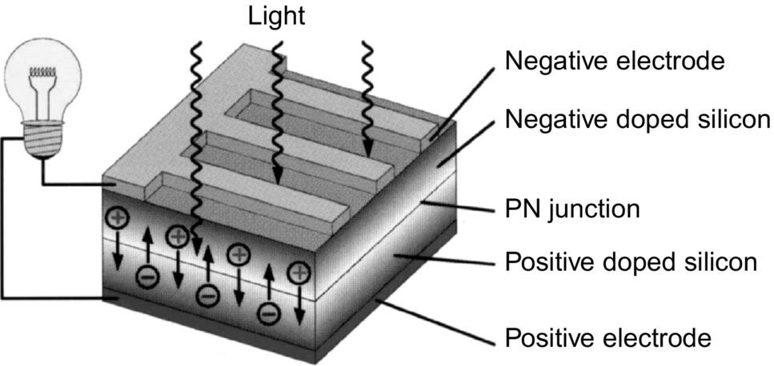

**FIG. 25.1** Principle of the operation of a solar cell.

A simplified equivalent circuit of a solar cell consists of a current source in parallel with a diode as shown in [Fig. 25.2A](https://learning.oreilly.com/library/view/power-electronics-handbook/9780128114087/B9780128114070000271.xhtml#f0015). A variable resistor is connected to the solar cell generator as a load. When the terminals are short-circuited, the output voltage and also the voltage across the diode is zero. The entire photocurrent (*Iph*) generated by the solar radiation then flows to the output. The solar cell current has its maximum (*Isc*). If the load resistance is increased, which results in an increasing voltage across the p-n junction of the diode, a portion of the current flows through the diode, and the output current decreases by the same amount. When the load resistor is open-circuited, the output current is zero, and the entire photocurrent flows through the diode. The relationship between current and voltage may be determined from the diode characteristic equation:

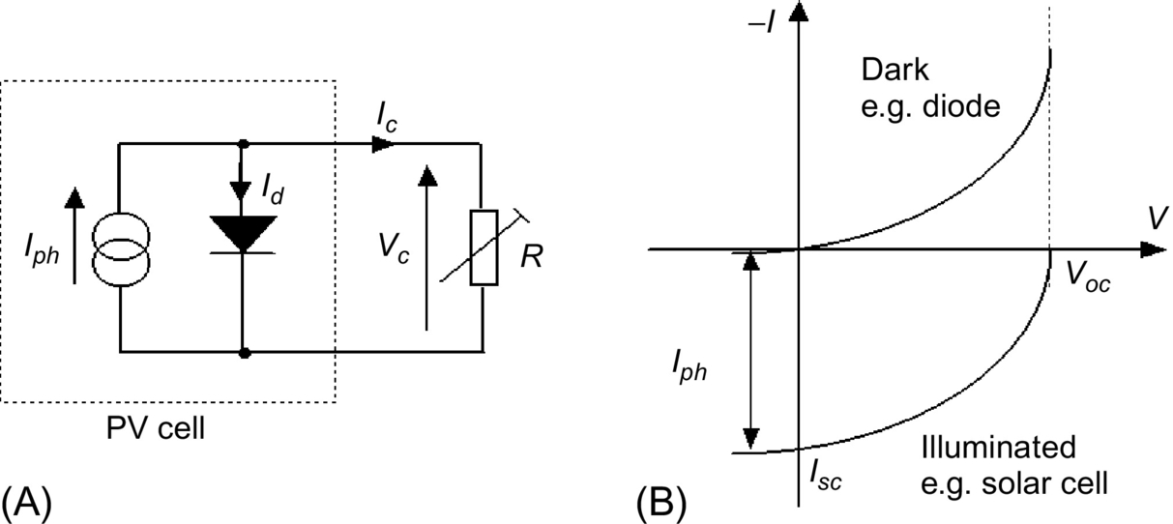

**FIG. 25.2** Simplified equivalent circuit for a solar cell.

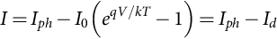 **(25.1)**

where *q* is the electron charge, *k* is the Boltzmann constant, *Iph* is photocurrent, *I*0 is the reverse saturation current, *Id* is diode current, and *T* is the solar cell operating temperature (K). The current versus voltage (*I-V*) of a solar cell is thus equivalent to an “inverted” diode characteristic curve shown in [Fig. 25.2B](https://learning.oreilly.com/library/view/power-electronics-handbook/9780128114087/B9780128114070000271.xhtml#f0015).

A number of semiconductor materials are suitable for the manufacturing of solar cells. The most common types using silicon semiconductor material (Si) are as follows:

• Monocrystalline Si cells

• Polycrystalline Si cells

• Amorphous Si cells

A solar cell can be operated at any point along its characteristic current-voltage curve, as shown in [Fig. 25.3](https://learning.oreilly.com/library/view/power-electronics-handbook/9780128114087/B9780128114070000271.xhtml#f0020). Two important points on this curve are the open-circuit voltage (*Voc*) and short-circuit current (*Isc*). The open-circuit voltage is the maximum voltage at zero current, while short-circuit current is the maximum current at zero voltage. For a silicon solar cell under standard test conditions, *Voc* is typically 0.6–0.7 V, and *Isc* is typically 20–40 mA for every square centimeter of the cell area. To a good approximation, *Isc* is proportional to the illumination level, whereas *Voc* is proportional to the logarithm of the illumination level.

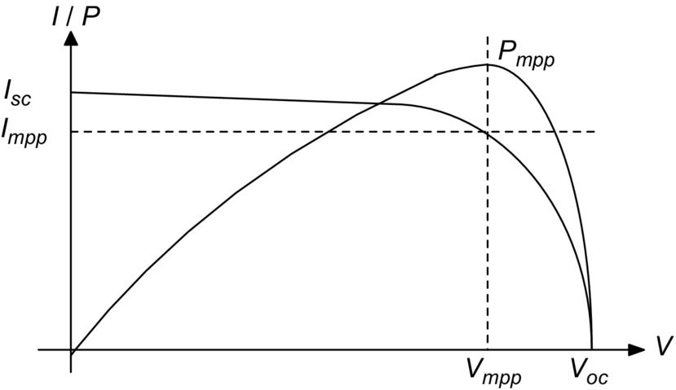

**FIG. 25.3** Current versus voltage (*I-V*) and current power (*P-V*) characteristics for a solar cell.

A plot of power (*P*) against voltage (*V*) for this device ([Fig. 25.3](https://learning.oreilly.com/library/view/power-electronics-handbook/9780128114087/B9780128114070000271.xhtml#f0020)) shows that there is a unique point on the *I-V* curve at which the solar cell will generate maximum power. This is known as the maximum power point (*Vmp* and *Imp*). To maximize the power output, steps are usually taken during fabrication; the three basic cell parameters are open-circuit voltage, short-circuit current, and fill factor (FF)—a term describing how “square” the *I*-*V* curve is given by

 **(25.2)**

For a silicon solar cell, FF is typically 0.6–0.8. Because silicon solar cells typically produce only about 0.5 V, a number of cells are connected in series in a PV module. A panel is a collection of modules physically and electrically grouped together on a support structure. An array is a collection of panels (see [Fig. 25.4](https://learning.oreilly.com/library/view/power-electronics-handbook/9780128114087/B9780128114070000271.xhtml#f0025)).

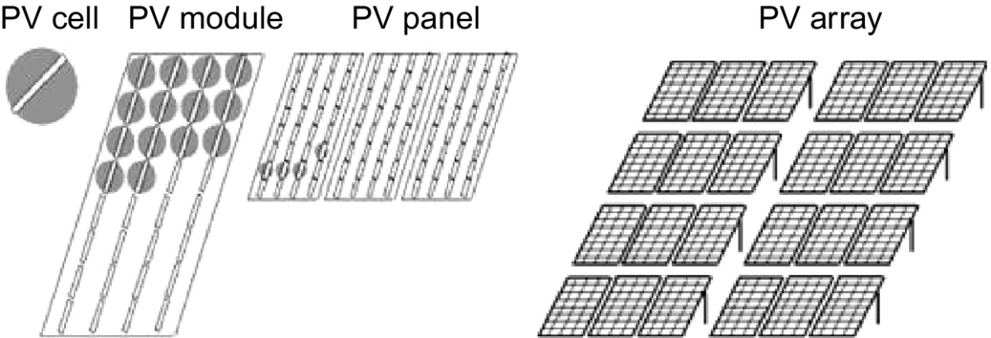

**FIG. 25.4** PV generator terms.

The effect of temperature on the performance of silicon solar module is illustrated in [Fig. 25.5](https://learning.oreilly.com/library/view/power-electronics-handbook/9780128114087/B9780128114070000271.xhtml#f0030). Note that *Isc* slightly increases linearly with temperature, but *Voc* and the maximum power, *Pm*, decrease with temperature [[1](https://learning.oreilly.com/library/view/power-electronics-handbook/9780128114087/B9780128114070000271.xhtml#bb0010)].

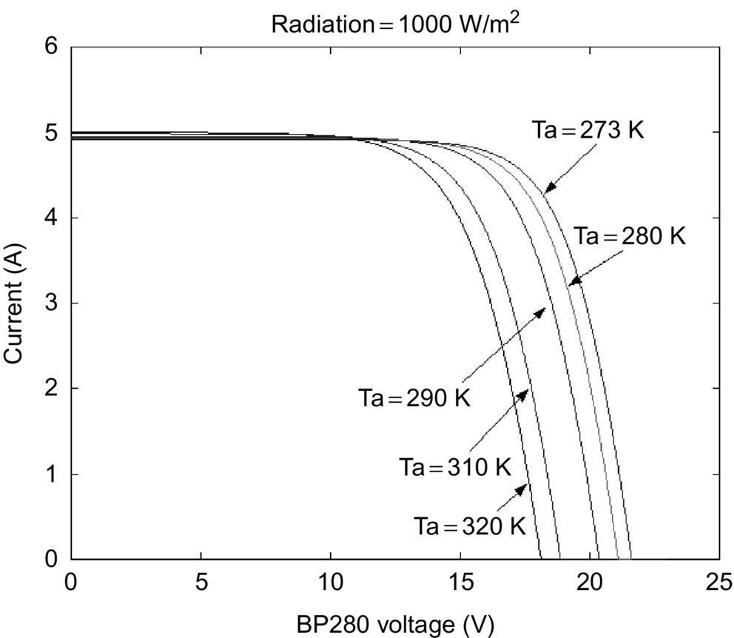

**FIG. 25.5** Effects of temperature on silicon solar cells.

[Fig. 25.6](https://learning.oreilly.com/library/view/power-electronics-handbook/9780128114087/B9780128114070000271.xhtml#f0035) shows the variation of PV current and voltages at different insolation levels. From [Figs. 25.5](https://learning.oreilly.com/library/view/power-electronics-handbook/9780128114087/B9780128114070000271.xhtml#f0030) and [25.6](https://learning.oreilly.com/library/view/power-electronics-handbook/9780128114087/B9780128114070000271.xhtml#f0035), it can be seen that the *I-V* characteristics of solar cells at a given insolation and temperature consist of a constant voltage segment and a constant current segment [[2](https://learning.oreilly.com/library/view/power-electronics-handbook/9780128114087/B9780128114070000271.xhtml#bb0015)]. The current is limited, as the cell is short-circuited. The maximum power condition occurs at the knee of the characteristic curve where the two segments meet.

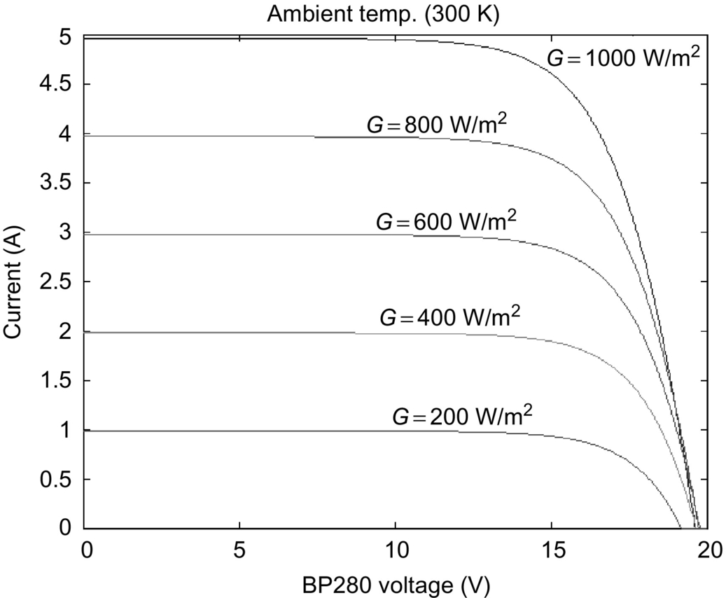

**FIG. 25.6** Typical current/voltage (*I-V*) characteristic curves for different insolation.

### 25.2.2 TYPES OF PV POWER SYSTEMS

Photovoltaic power systems can be classified as follows:

• Stand-alone PV systems

• Hybrid PV systems

• Grid-connected PV systems

Stand-alone PV systems, shown in [Fig. 25.7](https://learning.oreilly.com/library/view/power-electronics-handbook/9780128114087/B9780128114070000271.xhtml#f0040), are used in remote areas with no access to a utility grid. Conventional power systems used in remote areas often based on manually controlled diesel generators operating continuously or for a few hours. Extended operation of diesel generators at low load levels significantly increases maintenance costs and reduces their useful life. Renewable energy sources such as PV can be added to remote-area power systems using diesel and other fossil-fuel-powered generators to provide 24 h power economically and efficiently. Such systems are called “hybrid energy systems.” [Fig. 25.8](https://learning.oreilly.com/library/view/power-electronics-handbook/9780128114087/B9780128114070000271.xhtml#f0045) shows a schematic of a PV-diesel hybrid system. In grid-connected PV systems shown in [Fig. 25.9](https://learning.oreilly.com/library/view/power-electronics-handbook/9780128114087/B9780128114070000271.xhtml#f0050), PV panels are connected to a grid through inverters without battery storage. These systems can be classified as small systems like the residential rooftop systems or large grid-connected systems. The grid-interactive inverters must be synchronized with the grid in terms of voltage and frequency.

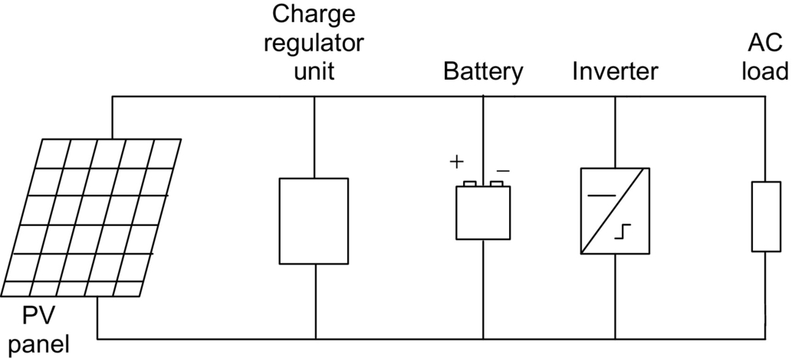

**FIG. 25.7** Stand-alone PV system.

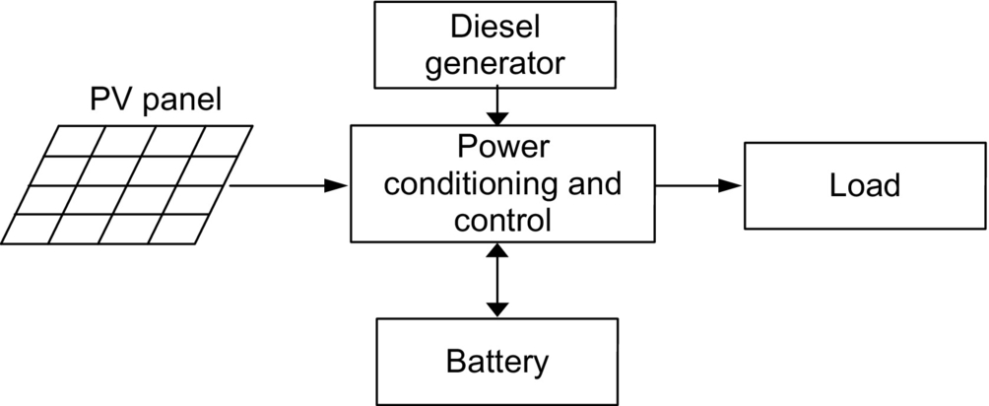

**FIG. 25.8** PV-diesel hybrid system.

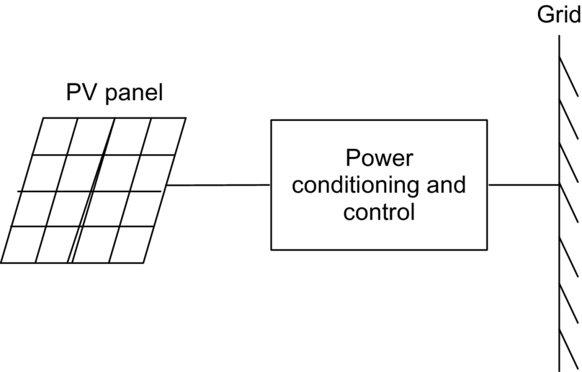

**FIG. 25.9** Grid-connected PV system.

### 25.2.3 STAND-ALONE PV SYSTEMS

The two main stand-alone PV applications are as follows:

• Battery charging

• Solar water pumping

#### **25.2.3.1 Battery Charging**

##### **Batteries for PV systems**

Stand-alone PV energy system requires storage to meet the energy demand during periods of low solar irradiation and nighttime. Several types of batteries are available such as the lead-acid, nickel-cadmium, lithium, zinc bromide, zinc chloride, sodium sulfur, nickel-hydrogen, redox, and vanadium batteries. The provision of cost-effective electric energy storage remains one of the major challenges for the development of improved PV power systems. Typically, lead-acid batteries are used to guarantee several hours to a few days of energy storage. Their reasonable cost and general availability has resulted in the widespread application of lead-acid batteries for remote-area power supplies despite their limited lifetime compared with other system components. Lead-acid batteries can be deep or shallow cycling gelled batteries, batteries with captive or liquid electrolyte, sealed and nonsealed batteries, etc. [[3](https://learning.oreilly.com/library/view/power-electronics-handbook/9780128114087/B9780128114070000271.xhtml#bb0020)]. Sealed batteries are valve regulated to permit the evolution of excess hydrogen gas (although catalytic converters are used to convert as much evolved hydrogen and oxygen back to water as possible). Sealed batteries need less maintenance. The following factors are considered in the selection of batteries for PV applications [[1](https://learning.oreilly.com/library/view/power-electronics-handbook/9780128114087/B9780128114070000271.xhtml#bb0010)]:

• Deep discharge (70%–80% depth of discharge)

• Low charging/discharging current

• Long duration charge (slow) and discharge (long duty cycle)

• Irregular and varying charge/discharge

• Low self-discharge

• Long lifetime

• Less maintenance requirement

• High-energy storage efficiency

• Low cost

Battery manufacturers specify the nominal number of complete charge and discharge cycles as a function of the depth of discharge (DOD), as shown in [Fig. 25.10](https://learning.oreilly.com/library/view/power-electronics-handbook/9780128114087/B9780128114070000271.xhtml#f0055). While this information can be used reliably to predict the lifetime of lead-acid batteries in conventional applications, such as uninterruptable power supplies or electric vehicles, it usually results in an overestimation of the useful life of the battery bank in renewable energy systems.

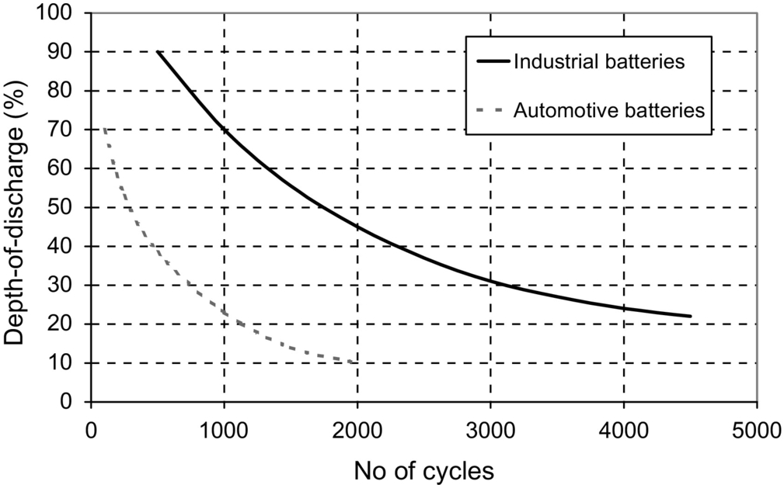

**FIG. 25.10** Nominal number of battery cycles versus DOD.

Two of the main factors that have been identified as limiting criteria for the cycle life of batteries in PV power systems are incomplete charging and prolonged operation at a low state of charge (SOC). The objective of improved battery control strategies is to extend the lifetime of lead-acid batteries to achieve a typical number of cycles shown in [Fig. 25.10](https://learning.oreilly.com/library/view/power-electronics-handbook/9780128114087/B9780128114070000271.xhtml#f0055). If this is achieved, an optimum solution for the required storage capacity and the maximum DOD of the battery can be found by referring to manufacturer's information. Increasing the capacity will reduce the typical DOD and therefore prolong the battery lifetime. Conversely, it may be more economic to replace a smaller battery bank more frequently.

##### **PV charge controllers**

Blocking diodes in series with PV modules are used to prevent the batteries from being discharged through the PV cells at night when there is no sun available to generate energy. These blocking diodes also protect the battery from short circuits. In a solar power system consisting of more than one string connected in parallel, if a short circuit occurs in one of the strings, the blocking diode prevents the other PV strings to discharge through the short-circuited string.

The battery storage in a PV system should be properly controlled to avoid catastrophic operating conditions like overcharging or frequent deep discharging. Storage batteries account for most PV system failures and contribute significantly to both the initial and the eventual replacement costs. Charge controllers regulate the charge transfer and prevent the battery from being excessively charged and discharged. Three types of charge controllers are commonly used:

• Series charge regulators

• Shunt charge regulators

• DC-DC converters

###### **A series charge regulators**

The basic circuit for the series regulators is given in [Fig. 25.11](https://learning.oreilly.com/library/view/power-electronics-handbook/9780128114087/B9780128114070000271.xhtml#f0060). In the series charge controller, the switch S1 disconnects the PV generator when a predefined battery voltage is achieved. When the voltage reduces below the discharge limit, the load is disconnected from the battery to avoid deep discharge beyond the limit. The main problem associated with this type of controller is the losses associated with the switches. This extra power loss has to come from the PV power, and this can be quite significant. Bipolar transistors, metal-oxide-semiconductor field-effect transistors (MOSFETs), or relays are used as the switches.

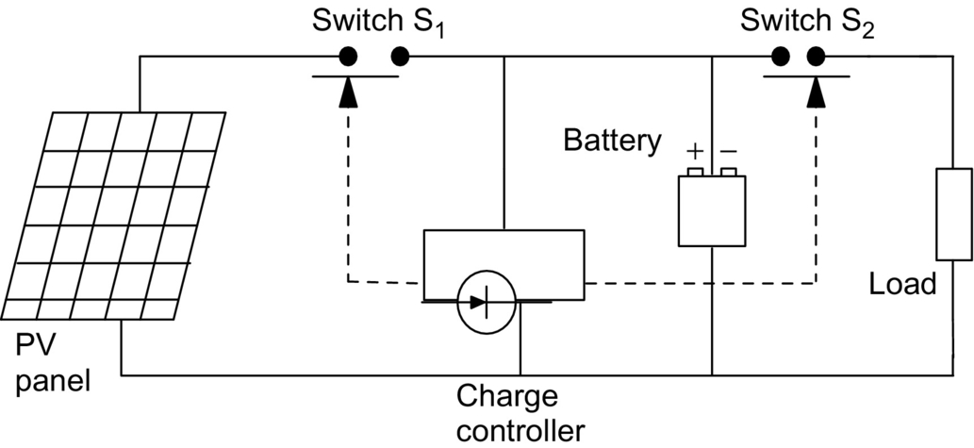

**FIG. 25.11** Series charge regulator.

###### **Shunt charge regulators**

In this type, as illustrated in [Fig. 25.12](https://learning.oreilly.com/library/view/power-electronics-handbook/9780128114087/B9780128114070000271.xhtml#f0065), when the battery is fully charged, the PV generator is short-circuited using an electronic switch (S1). Unlike series controllers, this method works more efficiently even when the battery is completely discharged as the short-circuit switch need not be activated until the battery is fully discharged [[1](https://learning.oreilly.com/library/view/power-electronics-handbook/9780128114087/B9780128114070000271.xhtml#bb0010)].

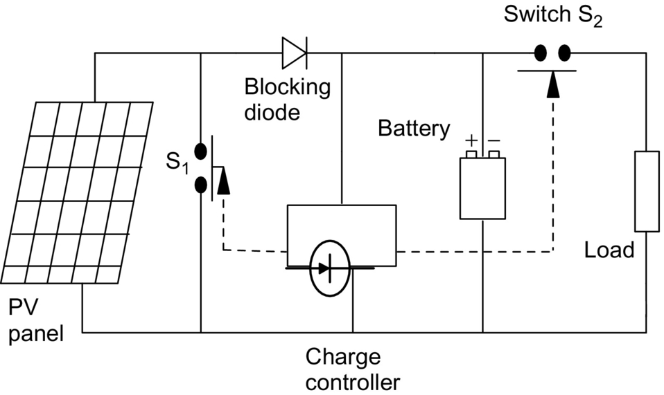

**FIG. 25.12** Shunt charge regulator.

The blocking diode prevents short-circuiting of the battery. Shunt charge regulators are used for the small PV applications (less than 20 A).

Deep discharge protection is used to protect the battery against the deep discharge. When the battery voltage reaches below the minimum set point for deep discharge limit, switch S2 disconnects the load. Simple series and shunt regulators allow only relatively coarse adjustment of the current flow and seldom meet the exact requirements of PV systems.

###### **DC–DC converter type charge regulators**

Switch-mode DC-to-DC converters are used to match the output of a PV generator to a variable load. There are various types of DC-DC converters such as the following:

• Buck (step-down) converter

• Boost (step-up) converter

• Buck-boost (step-down/step-up) converter

[Figs. 25.13](https://learning.oreilly.com/library/view/power-electronics-handbook/9780128114087/B9780128114070000271.xhtml#f0070)–[25.15](https://learning.oreilly.com/library/view/power-electronics-handbook/9780128114087/B9780128114070000271.xhtml#f0080) show simplified diagrams of these three basic types of converters. The basic concepts are an electronic switch, an inductor to store energy, and a “flywheel” diode, which carries the current during that part of switching cycle when the switch is off. The DC-DC converters allow the charge current to be reduced continuously in such a way that the resulting battery voltage is maintained at a specified value.

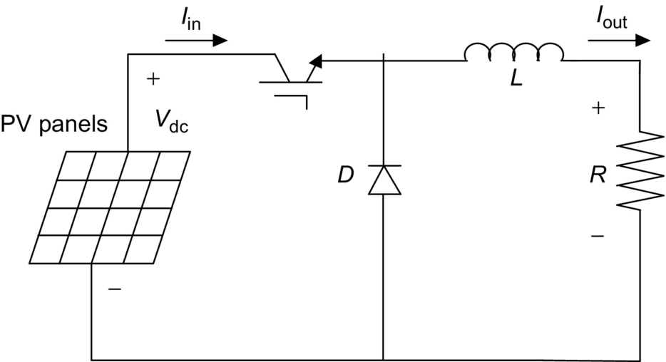

**FIG. 25.13** Buck converter.

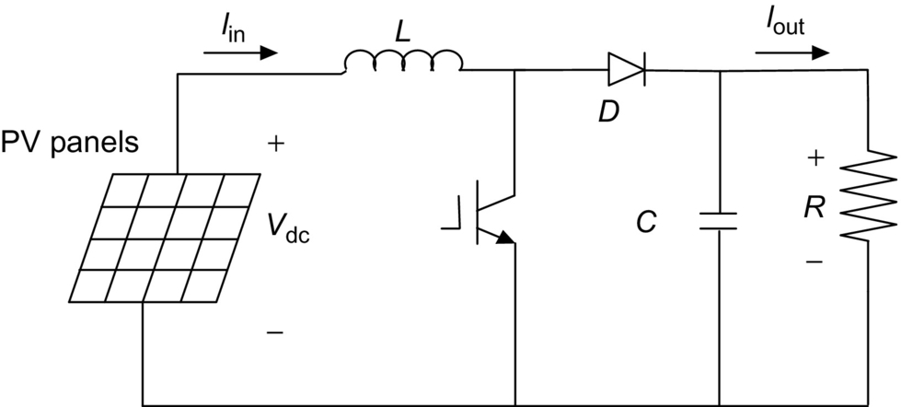

**FIG. 25.14** Boost converter.



**FIG. 25.15** Boost-buck converter.

##### **Maximum power point tracking (MPPT)**

A controller that tracks the maximum power point locus of the PV array is known as the MPPT. In [Fig. 25.16](https://learning.oreilly.com/library/view/power-electronics-handbook/9780128114087/B9780128114070000271.xhtml#f0085), the PV power output is plotted against the voltage for insolation levels from 200 to 1000 W/m2 [[4](https://learning.oreilly.com/library/view/power-electronics-handbook/9780128114087/B9780128114070000271.xhtml#bb0025)]. The points of maximum array power form a curve are termed as the maximum power locus. Due to high cost of solar cells, it is necessary to operate the PV array at its maximum power point (MPP). For overall optimal operation of the system, the load line must match the PV array's MPP locus.

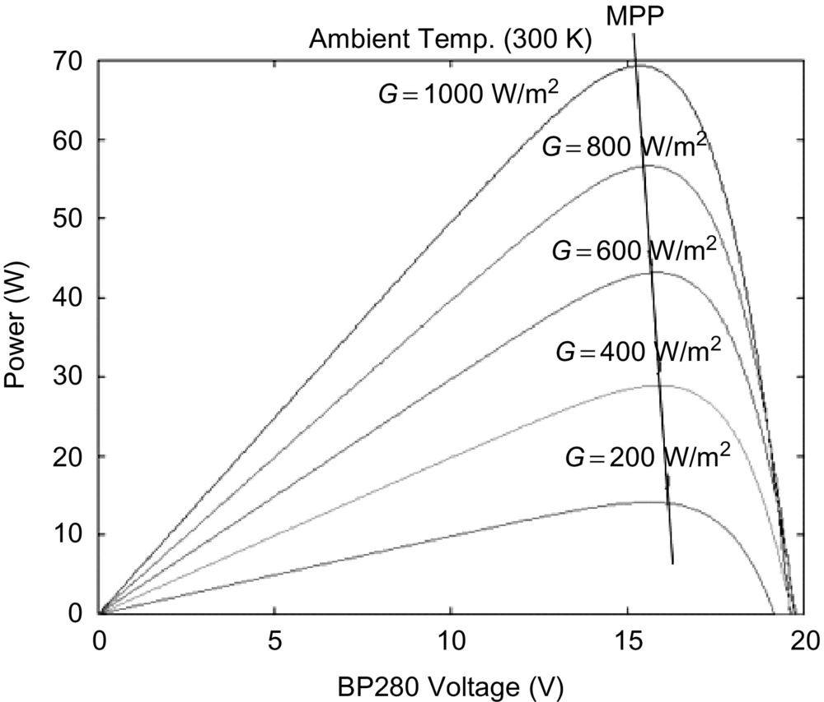

**FIG. 25.16** Typical power/voltage characteristics for increased insolation.

Referring to [Fig. 25.17](https://learning.oreilly.com/library/view/power-electronics-handbook/9780128114087/B9780128114070000271.xhtml#f0090), the load characteristics can be either curve OA or curve OB depending upon the nature of the load and its current and voltage requirements. If load OA is considered and the load is directly coupled to the solar array, the array will operate at point A1, delivering only power P1. The maximum array power available at the given insolation is P2. In order to use PV array power P2, a power conditioner coupled between array and the load is needed.

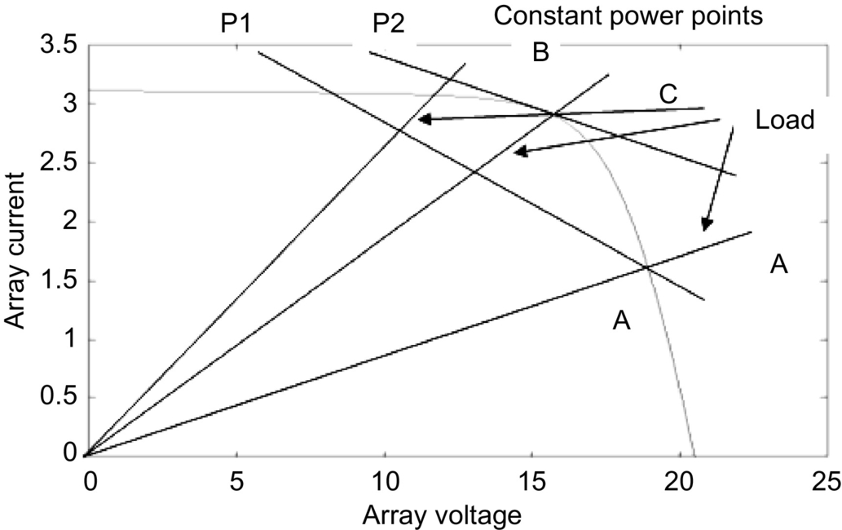

**FIG. 25.17** PV array and load characteristics.

There are generally two ways of operating PV modules at maximum power point. These ways take advantage of analog and/or digital hardware control to track the MPP of PV arrays.

##### **Analog control**

There are many analog control mechanisms proposed in different articles, for instance, fractional short-circuit current (*ISC*) [[5](https://learning.oreilly.com/library/view/power-electronics-handbook/9780128114087/B9780128114070000271.xhtml#bb0030)–[8](https://learning.oreilly.com/library/view/power-electronics-handbook/9780128114087/B9780128114070000271.xhtml#bb0045)], fractional open-circuit voltage (*VOP*) [[5](https://learning.oreilly.com/library/view/power-electronics-handbook/9780128114087/B9780128114070000271.xhtml#bb0030),[6](https://learning.oreilly.com/library/view/power-electronics-handbook/9780128114087/B9780128114070000271.xhtml#bb0035),[9](https://learning.oreilly.com/library/view/power-electronics-handbook/9780128114087/B9780128114070000271.xhtml#bb0050)–[12](https://learning.oreilly.com/library/view/power-electronics-handbook/9780128114087/B9780128114070000271.xhtml#bb0065)], and ripple correlation control (RCC) [[13](https://learning.oreilly.com/library/view/power-electronics-handbook/9780128114087/B9780128114070000271.xhtml#bb0070)–[16](https://learning.oreilly.com/library/view/power-electronics-handbook/9780128114087/B9780128114070000271.xhtml#bb0085)].

Fractional open-circuit voltage (*VOP*) is one of the simple analogue control methods. It is based on the assumption that the maximum power point voltage, *VMPP*, is a linear function of the open-circuit voltage, *VOC*. For example,  where . This assumption is reasonably accurate even for large variations in the cell short-circuit current and temperature. This type of MPPT is probably the most common type. A variation to this method involves periodically open-circuiting the cell string and measuring the open-circuit voltage. The appropriate value of *VMPP* can then be obtained with a simple voltage divider.

##### **Digital control**

There are many digital control mechanisms that were proposed in different articles, for instance, perturbation and observation (P&O) or hill climbing [[17](https://learning.oreilly.com/library/view/power-electronics-handbook/9780128114087/B9780128114070000271.xhtml#bb0090)–[22](https://learning.oreilly.com/library/view/power-electronics-handbook/9780128114087/B9780128114070000271.xhtml#bb0115)], fuzzy logic [[23](https://learning.oreilly.com/library/view/power-electronics-handbook/9780128114087/B9780128114070000271.xhtml#bb0120)–[27](https://learning.oreilly.com/library/view/power-electronics-handbook/9780128114087/B9780128114070000271.xhtml#bb0140)], neural network [[17](https://learning.oreilly.com/library/view/power-electronics-handbook/9780128114087/B9780128114070000271.xhtml#bb0090),[28](https://learning.oreilly.com/library/view/power-electronics-handbook/9780128114087/B9780128114070000271.xhtml#bb0145)–[30](https://learning.oreilly.com/library/view/power-electronics-handbook/9780128114087/B9780128114070000271.xhtml#bb0155)], and incremental conductance (IncCond) [[31](https://learning.oreilly.com/library/view/power-electronics-handbook/9780128114087/B9780128114070000271.xhtml#bb0160)–[34](https://learning.oreilly.com/library/view/power-electronics-handbook/9780128114087/B9780128114070000271.xhtml#bb0175)].

The P&O or hill-climbing control involves around varying the input voltage around the optimum value by giving it a small increment or decrement alternately. The effect on the output power is then assessed, and a further small correction is made to the input voltage. Therefore, this type of control is called a hill-climbing control. The power output of the PV array is sampled at an every definite sampling period and compared with the previous value. In the event, when power is increased, then the solar array voltage is stepped in the same direction as the previous sample time, but if the power is reduced, then the array voltage is stepped in the opposite way and try to operate the PV array at its optimum/maximum power point.

To operate the PV array at the MPP, perturb and adjust method can be used at regular intervals. Current drawn is sampled every few seconds, and the resulting power output of the solar cells is monitored at regular intervals. When an increased current results in a higher power, it is further increased until power output starts to reduce. But if the increased PV current results in lesser amount of power than in the previous sample, then the current is reduced until the MPP is reached.

#### **25.2.3.2 Inverters for Stand-Alone PV Systems**

Inverters convert power from DC to AC, while rectifiers convert it from AC to DC. Many inverters are bidirectional, that is, they are able to operate in both inverting and rectifying modes. In many stand-alone PV installations, alternating current is needed to operate 230 V (or 110 V), 50 Hz (or 60 Hz) appliances. Generally, stand-alone inverters operate at 12, 24, 48, 96, 120, or 240 V DC depending upon the power level. Ideally, an inverter for a stand-alone PV system should have the following features:

• Sinusoidal output voltage.

• Voltage and frequency within the allowable limits.

• Cable to handle large variation in input voltage.

• Output voltage regulation.

• High efficiency at light loads.

• Less harmonic generation by the inverter to avoid damage to electronic appliances like television, additional losses, and heating of appliances.

• Photovoltaic inverters must be able to withstand overloading for short term to take care of higher starting currents from pumps, refrigerators, etc.

• Adequate protection arrangement for over-/undervoltage and frequency, short circuit, etc.

• Surge capacity.

• Low idling and no load losses.

• Low battery voltage disconnect.

• Low audio and radio frequency (RF) noise.

Several different semiconductor devices such as metal-oxide-semiconductor field-effect transistor (MOSFETs) and insulated-gate bipolar transistors (IGBTs) are used in the power stage of inverters. Typically, MOSFETs are used in units up to 5 kVA and 96 V DC. They have the advantage of low switching losses at higher frequencies. Because the on-state voltage drop is 2 V DC, IGBTs are generally used only above 96 V DC systems.

Voltage-source inverters are usually used in stand-alone applications. They can be single phase or three phase. There are three switching techniques commonly used: square-wave, quasi-square-wave, and pulse-width modulation. Square-wave or modified square-wave inverters can supply power tools, resistive heaters, or incandescent lights, which do not require a high-quality sine wave for reliable and efficient operation. However, many household appliances require low distortion sinusoidal waveforms. The use of true sine-wave inverters is recommended for remote-area power systems. Pulse-width modulated (PWM) switching is generally used for obtaining sinusoidal output from the inverters.

A general layout of a single-phase system, both half bridge and full bridge, is shown in [Fig. 25.18](https://learning.oreilly.com/library/view/power-electronics-handbook/9780128114087/B9780128114070000271.xhtml#f0095). In [Fig. 25.18A](https://learning.oreilly.com/library/view/power-electronics-handbook/9780128114087/B9780128114070000271.xhtml#f0095), single-phase half bridge is with two switches, S1 and S2; the capacitors *C*1 and *C*2 are connected in series across the DC source. The junction between the capacitors is at the midpotential. Voltage across each capacitor is *Vdc*/2. Switches S1 and S2 can be switched on/off periodically to produce AC voltage. Filter (*Lf* and *Cf*) is used to reduce high-switch-frequency components and to produce sinusoidal output from the inverter. The output of inverter is connected to load through a transformer. [Fig. 25.18B](https://learning.oreilly.com/library/view/power-electronics-handbook/9780128114087/B9780128114070000271.xhtml#f0095) shows the similar arrangement for full-bridge configuration with four switches. For the same input source voltage, the full-bridge output is twice, and the switches carry less current for the same load power.

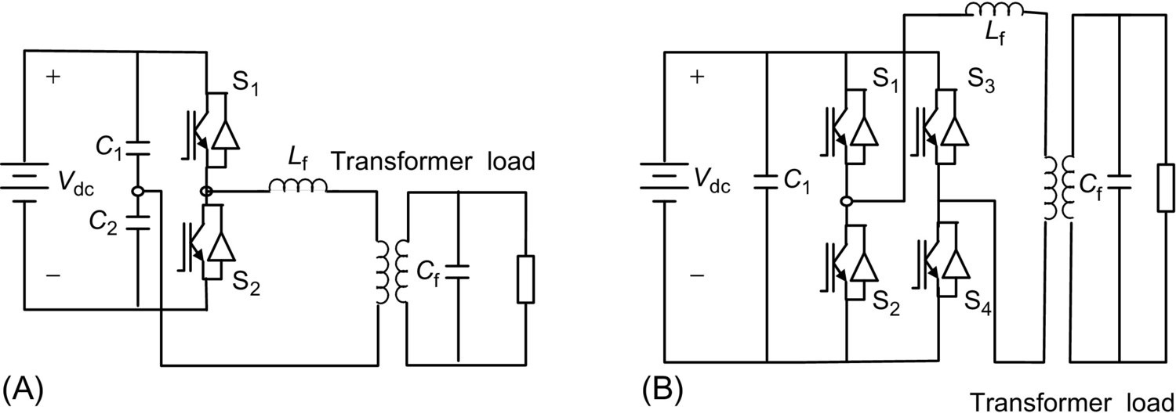

**FIG. 25.18** Single-phase inverter: (A) half bridge and (B) full bridge.

The power circuit of a three-phase four-wire inverter is shown in [Fig. 25.19](https://learning.oreilly.com/library/view/power-electronics-handbook/9780128114087/B9780128114070000271.xhtml#f0100). The output of the inverter is connected to load via three-phase transformer (delta/Y). The star point of the transformer secondary gives the neutral connection. Three phase or single phase can be connected to this system. Alternatively, a center tap DC source can be used to supply the converter, and the midpoint can be used as the neutral.

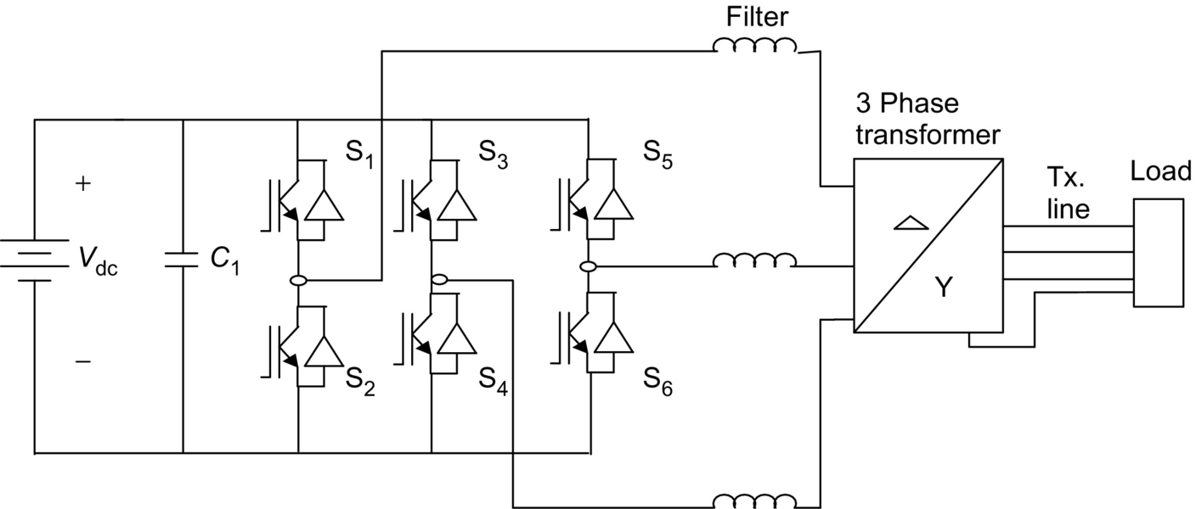

**FIG. 25.19** A stand-alone three-phase four-wire inverter.

[Fig. 25.20](https://learning.oreilly.com/library/view/power-electronics-handbook/9780128114087/B9780128114070000271.xhtml#f0105) shows the inverter efficiency for a typical inverter used in remote-area power systems. It is important to consider that the system load is typically well below the nominal inverter capacity *Pnom*, which results in low conversion efficiencies at loads below 10% of the rated inverter output power. Optimum overall system operation is achieved if the total energy dissipated in the inverter is minimized. The high conversion efficiency at low power levels of recently developed inverters for grid-connected PV systems shows that there is a significant potential for further improvements in efficiency.

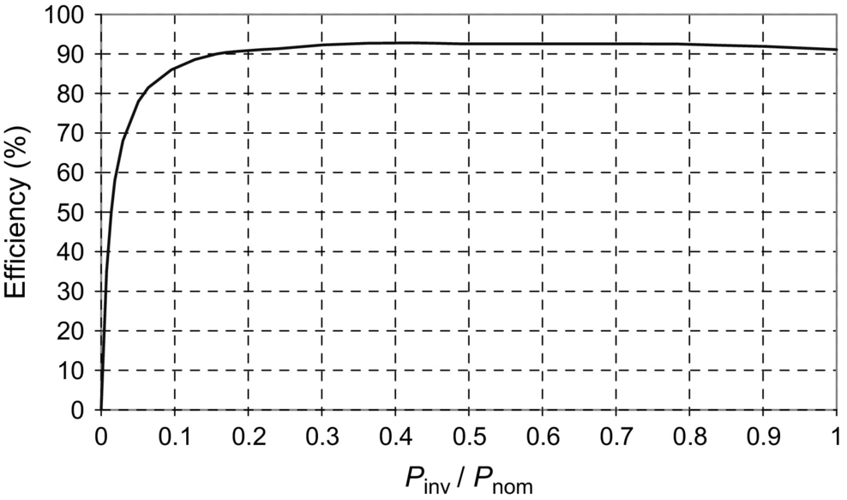

**FIG. 25.20** Typical inverter efficiency curve.

Bidirectional inverters convert DC power to AC power (inverter) or AC power to DC power (rectifier) and are becoming very popular in remote-area power systems [[3](https://learning.oreilly.com/library/view/power-electronics-handbook/9780128114087/B9780128114070000271.xhtml#bb0020),[4](https://learning.oreilly.com/library/view/power-electronics-handbook/9780128114087/B9780128114070000271.xhtml#bb0025)]. The principle of a stand-alone single-phase bidirectional inverter used in a PV/battery/diesel hybrid system can be explained by referring [Fig. 25.21](https://learning.oreilly.com/library/view/power-electronics-handbook/9780128114087/B9780128114070000271.xhtml#f0110). A charge controller is used to interface the PV array and the battery. The inverter has a full-bridge configuration realized using four power electronic switches (MOSFET or IGBTs) S1–S4. In this scheme, the diagonally opposite switches (S1 and S4) and (S2 and S3) are switched using a sinusoidally PWM gate pulses. The inverter produces sinusoidal output voltage. The inductors *X*1, *X*2, and the AC output capacitor *C*2 filter out the high-switch-frequency components from the output waveform. Most inverter topologies use a low-frequency (50 or 60 Hz) transformer to step up the inverter output voltage. In this scheme, the diesel generator and the converter are connected in parallel to supply the load. The voltage sources, diesel and inverter, are separated by the link inductor *Xm*. The bidirectional power flow between inverter and the diesel generator can be established.

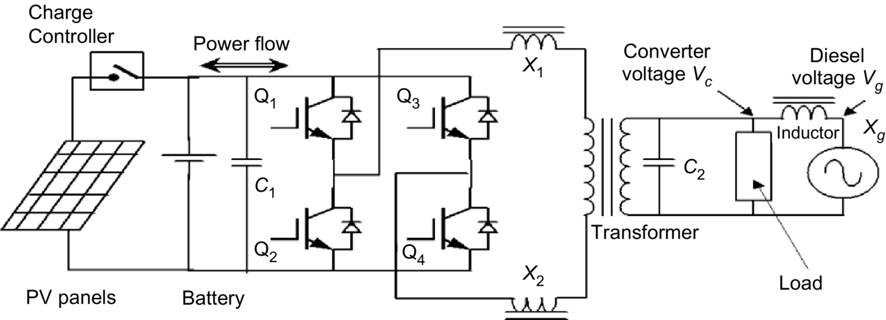

**FIG. 25.21** Bidirectional inverter system.

The power flow through the link inductor, *Xm*, is

 **(25.3)**

**** **(25.4)**

**** **(25.5)**

**** **(25.6)**

where *δ* is the phase angle between the two voltages. From Eq. [(25.4)](https://learning.oreilly.com/library/view/power-electronics-handbook/9780128114087/B9780128114070000271.xhtml#fo0025), it can be seen that the power supplied by the inverter from the batteries (inverter mode) or supplied to the batteries (charging mode) can be controlled by controlling the phase angle *δ*. The PWM pulses separately control the amplitude of the converter voltage, *Vc*, while the phase angle with respect to the diesel voltage is varied for power flow.

#### **25.2.3.3 Solar Water Pumping**

In many remote and rural areas, hand pumps or diesel-driven pumps are used for water supply. Diesel pumps consume fossil fuel, affect environment, need more maintenance, and are less reliable. Photovoltaic powered water pumps have received considerable attention recently due to major developments in the field of solar cell materials and power electronic systems technology.

##### **Types of pumps**

Two types of pumps are commonly used for the water pumping applications: positive and centrifugal displacement. Both centrifugal and positive displacement pumps can be further classified into those with motors that are (a) surface mounted and those that are (b) submerged into the water (“submersible”).

Displacement pumps have water output directly proportional to the speed of the pump but almost independent of the head. These pumps are used for solar water pumping from deep wells or bores. They may be piston-type pumps or use diaphragm driven by a cam and rotary screw-type pumps or use progressive cavity system. The pumping rate of these pumps is directly related to the speed, and hence, constant torque is desired.

Centrifugal pumps are used for low-head applications especially if they are directly interfaced with the solar panels. Centrifugal pumps are designed for fixed-head applications, and the pressure difference generated increases in relation to the speed of the pump. These pumps are rotating impeller type, which throws the water radially against a casing, so shaped that the momentum of the water is converted into useful pressure for lifting [[3](https://learning.oreilly.com/library/view/power-electronics-handbook/9780128114087/B9780128114070000271.xhtml#bb0020)]. The centrifugal pumps have relatively high efficiency, but it reduces at lower speeds, which can be a problem for the solar water pumping system at the time of low light levels. The single-stage centrifugal pump has just one impeller, whereas most borehole pumps are multistage types where the outlet from one impeller goes into the center of another and each one keeps increasing the pressure difference.

From [Fig. 25.22](https://learning.oreilly.com/library/view/power-electronics-handbook/9780128114087/B9780128114070000271.xhtml#f0115), it is quite obvious that the load line is located relatively faraway from *Pmax* line. It has been reported that the daily utilization efficiency for a DC motor drive is 87% for a centrifugal pump compared with 57% for a constant torque characteristic load. Hence, centrifugal pumps are more compatible with PV arrays. The system operating point is determined by the intersection of the *I-V* characteristics of the PV array and the motor as shown in [Fig. 25.22](https://learning.oreilly.com/library/view/power-electronics-handbook/9780128114087/B9780128114070000271.xhtml#f0115). The torque-speed slope is normally large due to the armature resistance being small. At the instant of starting, the speed and the back emf are zero. Hence, the motor starting current is approximately the short-circuit current of the PV array. By matching the load to the PV source through MPPT, the starting torque increases.

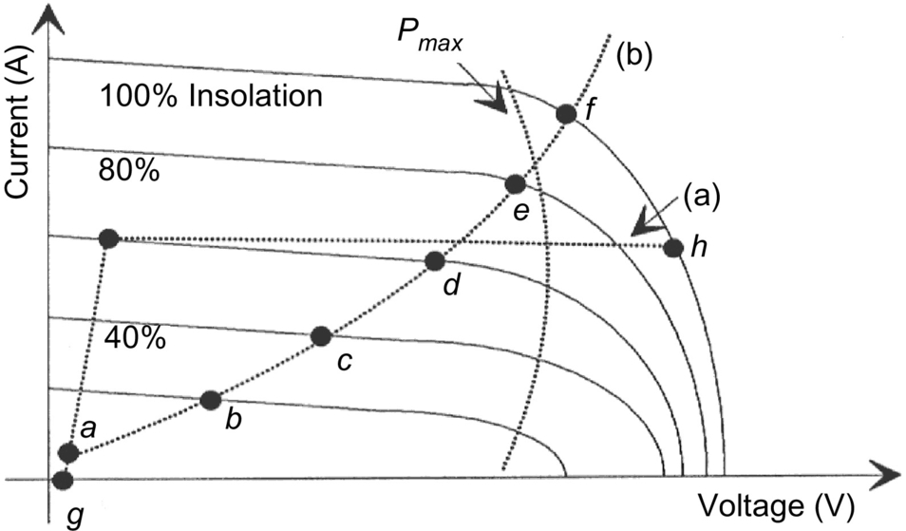

**FIG. 25.22** *I-V* characteristics of a PV array and two mechanical loads: (A) constant torque and (B) centrifugal pump.

The matching of a DC motor depends upon the type of load being used. For instance, a centrifugal pump is characterized by having the load torque proportional to the square of speed. The operating characteristics of the system (i.e., PV source, permanent magnet (PM) DC motor, and load) are at the intersection of the motor and load characteristics as shown in [Fig. 25.23](https://learning.oreilly.com/library/view/power-electronics-handbook/9780128114087/B9780128114070000271.xhtml#f0120) (i.e., points a, b, c, d, e, and f for centrifugal pump). From [Fig. 25.23](https://learning.oreilly.com/library/view/power-electronics-handbook/9780128114087/B9780128114070000271.xhtml#f0120), the system utilizing the centrifugal pump as its load tends to start at low solar irradiation (point a) level. However, for the systems with an almost constant torque characteristics in [Fig. 25.22](https://learning.oreilly.com/library/view/power-electronics-handbook/9780128114087/B9780128114070000271.xhtml#f0115), the start is at almost 50% of one sum (full insolation) that results in short period of operation.

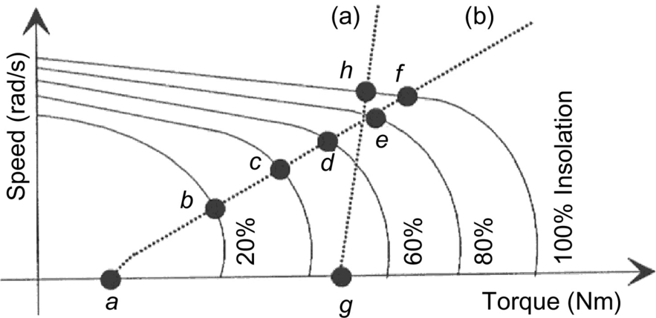

**FIG. 25.23** Speed torque characteristics of a DC motor and two mechanical loads: (A) helical rotor and (B) centrifugal pump.

##### **Types of motors**

There are various types of motors available for the PV water pumping applications:

• DC motors

• AC motors

DC motors are preferred where direct coupling to PV panels is desired, whereas AC motors are coupled to the solar panels through inverters. AC motors in general are cheaper than the DC motors and are more reliable, but the DC motors are more efficient. The DC motors used for solar pumping applications are as follows:

• Permanent magnet DC motors with brushes

• Permanent DC magnet motors without brushes

In DC motors with the brushes, the brushes are used to deliver power to the commutator and need frequent replacement due to wear and tear. These motors are not suitable for submersible applications unless long transmission shafts are used. Brushless DC permanent magnet motors have been developed for submersible applications.

The AC motors are of the induction motor type, which is cheaper than DC motors and available worldwide. However, they need inverters to change DC input from PV to AC power. A comparison of the different types of motors used for PV water pumping is given in [Table 25.1](https://learning.oreilly.com/library/view/power-electronics-handbook/9780128114087/B9780128114070000271.xhtml#t0010).

**Table 25.1**

**Comparison of the different types of motor used for PV water pumping**

|  |  |  |  |
| --- | --- | --- | --- |
| **Types of motor** | **Advantages** | **Disadvantages** | **Main features** |
| Brushed DC | Simple and efficient for PV applications  No complex control circuits is required as the motor starts without high-current surge  These motors will run slowly but do not overheat with reduced voltage | Brushes need to be replaced periodically (typical replacement interval is 2000–4000 h or 2 years) | Requires MPPT for optimum performance  Available only in small motor sizes  Increasing current (by paralleling PV modules) increases the torque  Increasing voltage (by series PV modules) increases the speed |
| Brushless DC | Efficient  Less maintenance is required | Electronic computation adds to extra cost, complexity, and increased risk of failure/malfunction  In most cases, oil cooled can't be submerged as deep as water cooled AC units | Growing trend among PV pump manufacturers to use brushless DC motors, primarily for centrifugal type submersible pumps |
| AC induction motors | No brushes to replace  Can use existing AC motor/pump technology that is cheaper and easily available worldwide. These motors can handle larger pumping requirements | Needs an inverter to convert DC output from PV to AC adding additional cost and complexity  Less efficient than DC motor-pump units  Prone to overheating if current is not adequate to start the motor or if the voltage is too low | Available for single or three supply  Inverters are designed to regulate frequency to maximize power to the motor in response to changing insolation levels |

##### **Power conditioning units for PV water pumping**

Most PV pump manufacturers include power-conditioning units (PCU) that are used for operating the PV panels close to their MPP over a range of load conditions and varying insolation levels and also for power conversion. DC or AC motor-pump units can be used for PV water pumping. In its simplest form, a solar water pumping system is composed of PV array, PCU, and DC water-pump unit as shown in [Fig. 25.24](https://learning.oreilly.com/library/view/power-electronics-handbook/9780128114087/B9780128114070000271.xhtml#f0125).

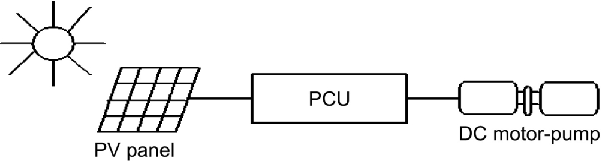

**FIG. 25.24** Block diagram for DC motor-driven pumping scheme.

In case of lower light levels, high currents can be generated through power conditioning to help in starting the motor-pump units especially for reciprocating positive displacement type pumps with constant torque characteristics, requiring constant current throughout the operating region. In positive displacement type pumps, the torque generated by the pumps depends on the pumping head, friction, pipe diameter, etc. and needs certain level of current to produce the necessary torque. Some systems use electronic controllers to assist starting and operation of the motor under low solar radiation. This is particularly important when using positive displacement pumps. The solar panels generate DC voltage and current. The solar water pumping systems usually have DC or AC pumps. For DC pumps, the PV output can be directly connected to the pump through MPPT, or a DC-DC converter can also be used for interfacing for controlled DC output from PV panels. To feed the AC motors, a suitable interfacing is required for the power conditioning. These PV inverters for the stand-alone applications are very expensive. The aim of power-conditioning equipment is to supply the controlled voltage/current output from the converters/inverters to the motor-pump unit.

These power-conditioning units are also used for operating the PV panels close to their maximum efficiency for fluctuating solar conditions. The speed of the pump is governed by the available driving voltage. Current lower than the acceptable limit will stop the pumping. When the light level increases, the operating point will shift from the MPP leading to the reduction of efficiency. For centrifugal pumps, there is an increase in current at increased speed, and the matching of *I-V* characteristics is closer for wide range of light intensity levels. For centrifugal pumps, the torque is proportional to the square of speed, and the torque produced by the motors is proportional to the current. Due to decrease in PV current output, the torque from the motor and consequently the speed of the pump are reduced, resulting in decrease in back emf and the required voltage of the motor. Maximum power point tracker can be used for controlling the voltage/current outputs from the PV inverters to operate the PV close to maximum operating point for the smooth operation of motor-pump units. The DC-DC converter can be used for keeping the PV panel output voltage constant and help in operating the solar arrays close to MPP. In the beginning, high starting current is required to produce high starting torque. The PV panels cannot supply this high starting current without adequate power-conditioning equipment like DC-DC converter or by using a starting capacitor. The DC-DC converter can generate the high starting currents by regulating the excess PV array voltage. DC-DC converter can be boost or buck converter.

Brushless DC motor (BDCM) and helical rotor pumps can also be used for PV water pumping [[35](https://learning.oreilly.com/library/view/power-electronics-handbook/9780128114087/B9780128114070000271.xhtml#bb0180)]. Brushless DC motors are a self-synchronous type of motor characteristics by trapezoidal waveforms for back emf and air flux density. They can operate off a low-voltage DC supply that is switched through an inverter to create a rotating stator field. The current generations of BDCMs use rare-earth magnets on the rotor to give high air gap flux densities and are well suited to solar application. The block diagram of such an arrangement is shown in [Fig. 25.25](https://learning.oreilly.com/library/view/power-electronics-handbook/9780128114087/B9780128114070000271.xhtml#f0130) that consists of PV panels, DC-DC converter, MPPT, and BDCM.

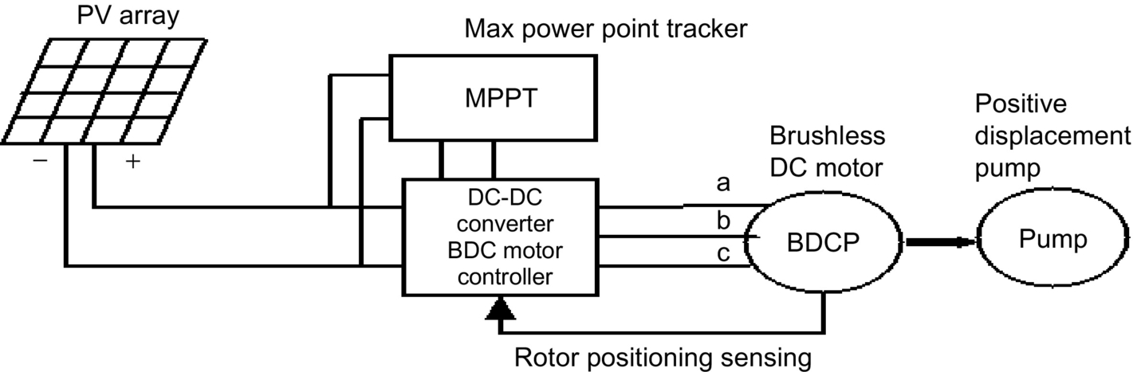

**FIG. 25.25** Block diagram for BDCM for PV application.

The PV inverters are used to convert the DC output of the solar arrays to the AC quantity so as to run the AC motor-driven pumps. These PV inverters can be variable frequency type, which can be controlled to operate the motors over wide range of loads. The PV inverters may involve impedance matching to match the electric characteristics of the load and array. The motor-pump unit and PV panels operate at their maximum efficiencies. Maximum power point tracker is also used in the power conditioning. To keep the voltage stable for the inverters, the DC-DC converter can be used. The inverter/converter has a capability of injecting high-switch-frequency components, which can lead to the overheating and the losses. So care shall be taken for this. The PV arrays are usually connected in series, parallel, or a combination of series-parallel configurations. The function of power electronic interface, as mentioned before, is to convert the DC power from the array to the required voltage and frequency to drive the AC motors. The motor-pump system load should be such that the array operates close to its MPP at all solar insolation levels. There are mainly three types of solar-powered water pumping systems as shown in [Fig. 25.26](https://learning.oreilly.com/library/view/power-electronics-handbook/9780128114087/B9780128114070000271.xhtml#f0135).



**FIG. 25.26** Block diagrams for various AC motor-driven pumping schemes.

The first system shown in [Fig. 25.26A](https://learning.oreilly.com/library/view/power-electronics-handbook/9780128114087/B9780128114070000271.xhtml#f0135) is an imported commercially available unit, which uses a specially wound low-voltage induction-motor-driven submersible pump. Such a low-voltage motor permits the PV array voltage to be converted to AC without using a step-up transformer. The second system, shown in [Fig. 25.26B](https://learning.oreilly.com/library/view/power-electronics-handbook/9780128114087/B9780128114070000271.xhtml#f0135), makes use of a conventional “off-the-shelf” 415 V, 50 Hz induction motor [[5](https://learning.oreilly.com/library/view/power-electronics-handbook/9780128114087/B9780128114070000271.xhtml#bb0030)]. This scheme needs a step-up transformer to raise inverter output voltage to high voltage. The third scheme as shown in [Fig. 25.26C](https://learning.oreilly.com/library/view/power-electronics-handbook/9780128114087/B9780128114070000271.xhtml#f0135) is composed of a DC-DC converter, an inverter that switches at a high frequency, and a mains voltage motor-driven pump. To get the optimum discharge (Q), at a given insolation level, the efficiency of the DC-DC converter and the inverter should be high. So the purpose should be to optimize the output from PV array, motor, and the pump. The principle used here is to vary the duty cycle of a DC-DC converter so that the output voltage is maximum. The DC-DC converter is used to boost the solar array voltage to eliminate the need for a step-up transformer and operate the array at the MPP. The three-phase inverter used in the interface is designed to operate in a variable frequency mode over the range of 20–50 Hz, which is the practical limit for most 50 Hz induction motor applications. Block diagram for frequency control is given in [Fig. 25.27](https://learning.oreilly.com/library/view/power-electronics-handbook/9780128114087/B9780128114070000271.xhtml#f0140).

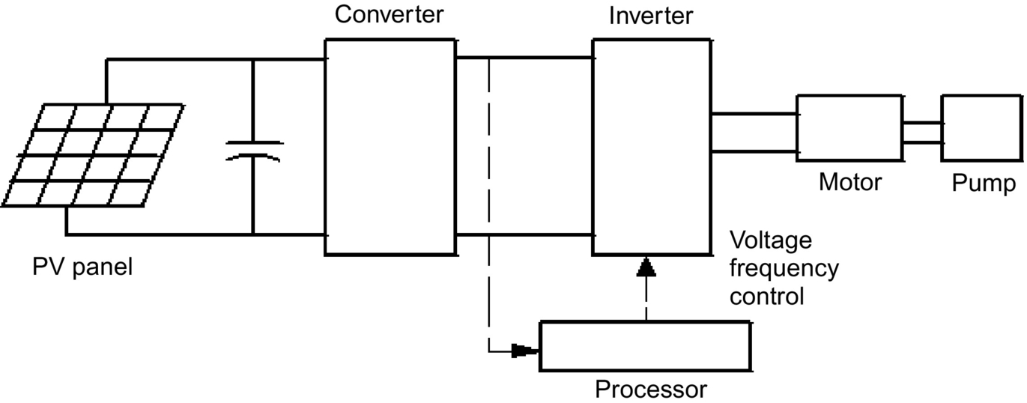

**FIG. 25.27** Block diagram for voltage/frequency control.

This inverter would be suitable for driving permanent magnet motors by incorporating additional circuitry for position sensing of the motor's shaft. Also, the inverter could be modified, if required, to produce higher output frequencies for high-speed permanent magnet motors. The inverter has a three-phase full-bridge configuration implemented by MOSFET power transistors.

### 25.2.4 GRID-CONNECTED PV SYSTEMS

The utility interactive inverters not only conditions the power output of the PV arrays but ensures that the PV system output is fully synchronized with the utility power. These systems can be batteryless or with battery backup. Systems with battery storage (or flywheel) provide additional power supply reliability. The grid connection of PV systems is gathering momentum because of various rebate and incentive schemes. This system allows the consumer to feed its own load utilizing the available solar energy, and the surplus energy can be injected into the grid under the energy by back scheme to reduce the payback period. Grid-connected PV systems can become a part of the utility system. The contribution of solar power depends upon the size of system and the load curve of the house. When the PV system is integrated with the utility grid, a two-way power flow is established. The utility grid will absorb excess PV power and will feed the house during nighttime and at instants while the PV power is inadequate. The utility companies are encouraging this scheme in many parts of the world. The grid-connected system can be classified as follows:

• Rooftop application of grid-connected PV system

• Utility-scale large system

For small household PV applications, a roof mounted PV array can be the best option. Solar cells provide an environmentally clean way of producing electricity, and rooftops have always been the ideal place to put them. With a PV array on the rooftop, the solar-generated power can supply residential load. The rooftop PV systems can help in reducing the peak summer load to the benefit of utility companies by feeding the household lighting, cooling, and other domestic loads. The battery storage can further improve the reliability of the system at the time of low insolation level, nighttime, or cloudy days. But the battery storage has some inherent problems like maintenance and higher cost.

For roof-integrated applications, the solar arrays can be either mounted on the roof or directly integrated into the roof. If the roof integration does not allow for an air channel behind the PV modules for ventilation purpose, then it can increase the cell temperature during the operation consequently leading to some energy losses. The disadvantage with the rooftop application is that the PV array orientation is dictated by the roof. In case, when the roof orientation differs from the optimal orientation required for the cells, then the efficiency of the entire system would be suboptimal.

Utility interest in PV has centered on the large grid-connected PV systems. In Germany, the United States, Spain, and in several other parts of the world, some large-scale PV plants have been installed. The utilities are more inclined with large-scale, centralized power supply. The PV systems can be centralized or distributed systems.

Grid-connected PV systems must observe the islanding situation, when the utility supply fails. In case of islanding, the PV generators should be disconnected from mains. PV generators can continue to meet only the local load, if the PV output matches the load. If the grid is reconnected during islanding, transient overcurrents can flow through the PV system inverters, and the protective equipments like circuit breakers may be damaged. The islanding control can be achieved through inverters or via the distribution network. Inverter controls can be designed on the basis of detection of grid voltage, measurement of impedance, frequency variation, or increase in harmonics. Protection shall be designed for the islanding, short circuits, over/under-voltages/currents, grounding, lightening, etc.

The importance of the power generated by the PV system depends upon the time of the day specially when the utility is experiencing the peak load. The PV plants are well suited to summer peaking, but it depends upon the climatic condition of the site. PV systems being investigated for use as peaking stations would be competitive for load management. The PV users can defer their load by adopting load management to get the maximum benefit out of the grid-connected PV plants and feeding more power into the grid at the time of peak load.

The assigned capacity credit is based on the statistical probability with which the grid can meet peak demand [[3](https://learning.oreilly.com/library/view/power-electronics-handbook/9780128114087/B9780128114070000271.xhtml#bb0020)]. The capacity factor during the peaks is very similar to that of conventional plants, and similar capacity credit can be given for the PV generation except at the times when the PV plants are generating very less power unless adequate storage is provided. With the installation of PV plants, the need of extra transmission lines, transformers can be delayed or avoided. The distributed PV plants can also contribute in providing reactive power support to the grid and reduce burden on VAR compensators.

#### **25.2.4.1 Inverters for Grid-Connected Applications**

Power conditioner is the key link between the PV array and mains in the grid-connected PV system. It acts as an interface that converts DC current produced by the solar cells into utility grade AC current. The PV system behavior relies heavily on the power-conditioning unit. The inverters shall produce good quality sine-wave output. The inverter must follow the frequency and voltage of the grid, the inverter has to extract maximum power from the solar cells with the help of MPPT, and the inverter input stage varies the input voltage until the MPP on the *I-V* curve is found. The inverter shall monitor all the phases of the grid. The inverter output shall be controlled in terms of voltage and frequency variation. A typical grid-connected inverter may use a PWM scheme and operates in the range of 2–20 kHz.

#### **25.2.4.2 Inverter Classifications**

The inverters used for the grid interfacing are broadly classified as follows:

• Voltage-source inverters (VSI)

• Current-source inverters (CSI)

The inverters based on the control schemes can be classified as follows:

• Current controlled (CC)

• Voltage controlled (VC)

The source is not necessarily characterized by the energy source for the system. It is a characteristic of the topology of the inverter. It is possible to change from one source type to another source type by the addition of passive components. In the voltage-source inverter (VSI), the DC side is made to appear to the inverter as a voltage source. The VSIs have a capacitor in parallel across the input, whereas the CSIs have an inductor in series with the DC input. In the CSI, the DC source appears as a current source to the inverter. Solar arrays are fairly good approximation to a current source. Most PV inverters are voltage source even though the PV is a current source. Current-source inverters are generally used for large motor drives though there have been some PV inverters built using a current-source topology. The VSI is more popular with the PWM VSI dominating the sine-wave inverter topologies.

[Fig. 25.28A](https://learning.oreilly.com/library/view/power-electronics-handbook/9780128114087/B9780128114070000271.xhtml#f0145) shows a single-phase full-bridge bidirectional VSI with (A) voltage control and phase-shift (*δ*) control—voltage-controlled voltage-source inverter (VCVSI). The active power transfer from the PV panels is accomplished by controlling the phase angle *δ* between the converter voltage and the grid voltage. The converter voltage follows the grid voltage. [Fig. 25.28B](https://learning.oreilly.com/library/view/power-electronics-handbook/9780128114087/B9780128114070000271.xhtml#f0145) shows the same VSI operated as (B) current controlled (CCVSI). The objective of this scheme is to control active and reactive components of the current fed into the grid using PWM techniques.

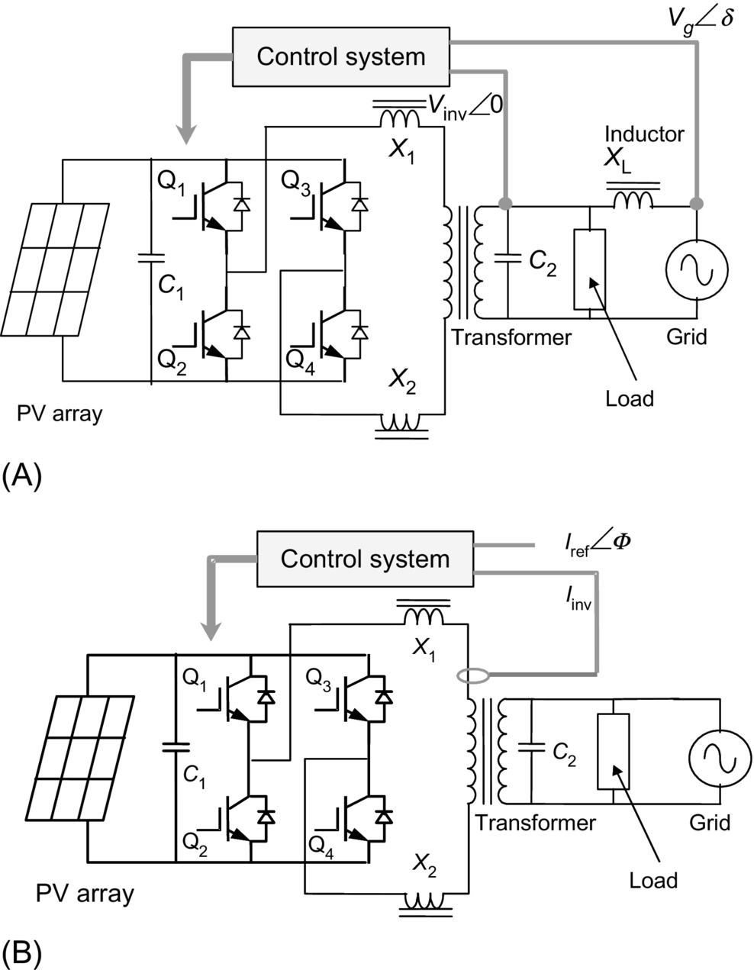

**FIG. 25.28** Voltage-source inverter: (A) voltage control and (B) current control.

#### **25.2.4.3 Inverter Types**

Different types are being in use for the grid-connected PV applications such as the following:

• Line-commutated inverter

• Self-commutated inverter

• Inverter with high-frequency transformer

##### **Line-commutated inverter**

The line-commutated inverters are generally used for the electric motor applications. The power stage is equipped with thyristors. The maximum power tracking control is required in the control algorithm for solar application. The basic diagram for a single-phase line-commutated inverter is shown in [Fig. 25.29](https://learning.oreilly.com/library/view/power-electronics-handbook/9780128114087/B9780128114070000271.xhtml#f0150) [[2](https://learning.oreilly.com/library/view/power-electronics-handbook/9780128114087/B9780128114070000271.xhtml#bb0015)].

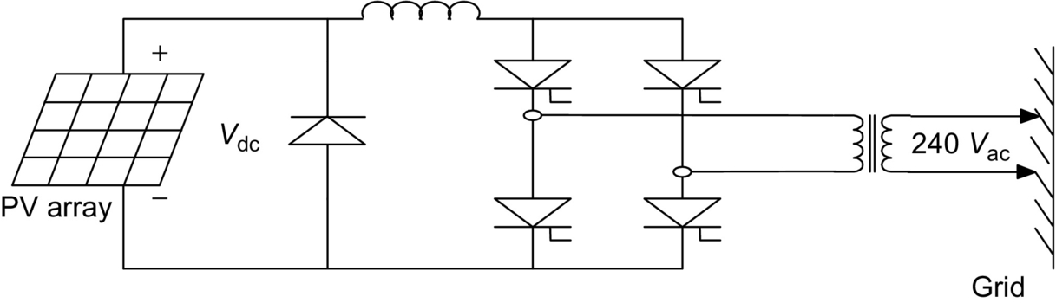

**FIG. 25.29** Line-commuted single-phase inverter.

The driver circuit has to be changed to shift the firing angle from the rectifier operation () to inverter operation (). Six-pulse or twelve-pulse inverters are used for the grid interfacing, but twelve-pulse inverters produce less harmonics. The thysistor-type inverters require a low-impedance grid interface connection for commutation purpose. If the maximum power available from the grid connection is less than twice the rated PV inverter power, then the line-commutated inverter should not be used [[2](https://learning.oreilly.com/library/view/power-electronics-handbook/9780128114087/B9780128114070000271.xhtml#bb0015)]. The line-commutated inverters are cheaper but inhibits poor power quality. The harmonics injected into the grid can be large unless taken care of by employing adequate filters. These line-commutated inverters also have poor power factor, poor power quality, and need additional control to improve the power factor. Transformer can be used to provide the electric isolation. To suppress the harmonics generated by these inverters, tuned filters are employed, and reactive power compensation is required to improve the lagging power factor.

##### **Self-commutated inverter**

A switch-mode inverter using pulse-width modulated (PWM) switching control can be used for the grid connection of PV systems. The basic block diagram for this type of inverter is shown in [Fig. 25.30](https://learning.oreilly.com/library/view/power-electronics-handbook/9780128114087/B9780128114070000271.xhtml#f0155). The inverter bridges may consist of bipolar transistors, MOSFET transistors, IGBTs, or gate turn-off thyristors (GTOs), depending upon the type of application. GTOs are used for the higher-power applications, whereas IGBTs can be switched at higher frequencies, that is, 16 kHz, and are generally used for many grid-connected PV applications. Most of the present day inverters are self-commutated sine-wave inverters.



**FIG. 25.30** Self-commutated inverter with PWM switching.

Based on the switching control, the voltage-source inverters can be further classified based on the switching control as follows:

• PWM (pulse-width modulated) inverters

• Square-wave inverters

• Single-phase inverters with voltage cancellations

• Programmed harmonic elimination switching

• Current-controlled modulation

##### **Inverter with high-frequency transformer**

The 50 Hz transformer for a standard PV inverter with PWM switching scheme can be very heavy and costly. While using frequencies more than 20 kHz, a ferrite core transformer can be a better option [[2](https://learning.oreilly.com/library/view/power-electronics-handbook/9780128114087/B9780128114070000271.xhtml#bb0015)]. A circuit diagram of a grid-connected PV system using high-frequency transformer is shown in [Fig. 25.31](https://learning.oreilly.com/library/view/power-electronics-handbook/9780128114087/B9780128114070000271.xhtml#f0160).



**FIG. 25.31** PV inverter with high-frequency transformer.

The capacitor on the input side of high-frequency inverter acts as the filter. The high-frequency inverter with PWM is used to produce a high-frequency AC across the primary winding of the high-frequency transformer. The secondary voltage of this transformer is rectified using high-frequency rectifier. The DC voltage is interfaced with a thyristor inverter through a low-pass inductor filter and hence connected to the grid. The line current is required to be sinusoidal and in phase with the line voltage. To achieve this, the line voltage (*V*1) is measured to establish the reference waveform for the line current *IL*⁎. This reference current *IL*⁎ multiplied by the transformer ratio gives the reference current at the output of a high-frequency inverter. The inverter output can be controlled using current control technique [[36](https://learning.oreilly.com/library/view/power-electronics-handbook/9780128114087/B9780128114070000271.xhtml#bb0185)]. These inverters can be with low-frequency transformer isolation or high-frequency transformer isolation. The low-frequency (50–60 Hz) transformer of a standard inverter with PWM is a very heavy and bulky component. For residential grid-interactive rooftop inverters below 3 kW rating, high-frequency transformer isolation is often preferred.

##### **Other PV inverter topologies**

In this section, some of the inverter topologies discussed in various research papers have been discussed.

###### **Multilevel converters**

Multilevel converters can be used with large PV systems where multiple PV panels can be configured to create voltage steps. These multilevel voltage-source converters can synthesize the AC output terminal voltage from different level of DC voltages and can produce staircase waveforms. This scheme involves less complexity and needs less filtering. One of the schemes (half-bridge diode-clamped three-level inverter [[37](https://learning.oreilly.com/library/view/power-electronics-handbook/9780128114087/B9780128114070000271.xhtml#bb0190)]) is given in [Fig. 25.32](https://learning.oreilly.com/library/view/power-electronics-handbook/9780128114087/B9780128114070000271.xhtml#f0165). There is no transformer in this topology. Multilevel converters can be beneficial for large systems in terms of cost and efficiency. Problems associated with shading and malfunction of PV units need to be addressed.



**FIG. 25.32** Half-bridge diode-clamped three-level inverter.

The utilization of cascaded multilevel inverter (CMLI) in high-voltage and high-power PV energy conversion has been recently increased [[38](https://learning.oreilly.com/library/view/power-electronics-handbook/9780128114087/B9780128114070000271.xhtml#bb0195)–[40](https://learning.oreilly.com/library/view/power-electronics-handbook/9780128114087/B9780128114070000271.xhtml#bb0205)]. CMLI consists of a number of inverter units that are fed by isolated PV array [[38](https://learning.oreilly.com/library/view/power-electronics-handbook/9780128114087/B9780128114070000271.xhtml#bb0195)]. Each unit utilizes low-voltage components, and the final output voltage is synthesized by combining all units in series. This topology has modular characteristic, since all the units are similar and have the same control strategy. This modularity feature makes it very easy to replace any faulty unit. Without discontinuing the load, it is also possible to bypass the faulty module by adopting a proper control technique [[41](https://learning.oreilly.com/library/view/power-electronics-handbook/9780128114087/B9780128114070000271.xhtml#bb0210)].

[Fig. 25.33](https://learning.oreilly.com/library/view/power-electronics-handbook/9780128114087/B9780128114070000271.xhtml#f9000) shows a five-level cascaded H-bridge inverter. Each inverter arm consists of a number of H-bridge units whose outputs are connected in series. Each unit comprises four switches (S1–S4) and one DC input supply (**Vdc**). The basic H-bridge unit shown in [Fig. 25.34](https://learning.oreilly.com/library/view/power-electronics-handbook/9780128114087/B9780128114070000271.xhtml#f9005) is able to produce three voltage levels (−**Vdc**, 0, and **Vdc**). The output voltage and switching logic of this H-bridge unit is shown in [Table 25.2](https://learning.oreilly.com/library/view/power-electronics-handbook/9780128114087/B9780128114070000271.xhtml#t0020).



**FIG. 25.33** Five-level cascaded H-bridge inverter.



**FIG. 25.34** Basic H-bridge unit.

**Table 25.2**

**Switching logic of an H-bridge unit**

|  |  |
| --- | --- |
| **Vout** | **Turn on switches** |
| Vdc | S1, S4 |
| 0 | S1, S3 |
| S2, S4 |
| −Vdc | S2, S3 |

In [Fig. 25.34](https://learning.oreilly.com/library/view/power-electronics-handbook/9780128114087/B9780128114070000271.xhtml#f9005), each phase arm contains two series-connected units. The output line voltages comprises five levels (−2 **Vdc**, **−Vdc**, 0, **Vdc**, and 2 **Vdc**). If the number of units in each phase arm is “*u*,” then the number of levels in the line voltage is (*l*=2*u*+1). All possible switching combinations for a five-level H-bridge inverter are presented in [Table 25.3](https://learning.oreilly.com/library/view/power-electronics-handbook/9780128114087/B9780128114070000271.xhtml#t0025).

**Table 25.3**

**All possible switching combination for various output levels of a 5-level CHB inverter**

|  |  |  |  |  |  |  |  |  |  |  |
| --- | --- | --- | --- | --- | --- | --- | --- | --- | --- | --- |
| **t25-01-9780128114070** | **U1** | **U2** | **U1** | | | | **U2** | | | |
| **Vo,U1** | **Vo,U2** | **S1** | **S2** | **S3** | **S4** | **S1** | **S2** | **S3** | **S4** |
| **2Vdc** | **Vdc** | **Vdc** | 1 | 0 | 0 | 1 | 1 | 0 | 0 | 1 |
| **Vdc** | **Vdc** | 0 | 1 | 0 | 0 | 1 | 1 | 0 | 1 | 0 |
| **Vdc** | 0 | 1 | 0 | 0 | 1 | 0 | 1 | 0 | 1 |
| 0 | **Vdc** | 1 | 0 | 1 | 0 | 1 | 0 | 0 | 1 |
| 0 | **Vdc** | 0 | 1 | 0 | 1 | 1 | 0 | 0 | 1 |
| **0** | **Vdc** | −**Vdc** | 1 | 0 | 0 | 1 | 0 | 1 | 1 | 0 |
| 0 | 0 | 1 | 0 | 1 | 0 | 1 | 0 | 1 | 0 |
| 0 | 0 | 1 | 0 | 1 | 0 | 0 | 1 | 0 | 1 |
| 0 | 0 | 0 | 1 | 0 | 1 | 1 | 0 | 1 | 0 |
| 0 | 0 | 0 | 1 | 0 | 1 | 0 | 1 | 0 | 1 |
| −**Vdc** | **Vdc** | 0 | 1 | 1 | 0 | 1 | 0 | 0 | 1 |
| **−Vdc** | 0 | −**Vdc** | 1 | 0 | 1 | 0 | 0 | 1 | 1 | 0 |
| 0 | −**Vdc** | 0 | 1 | 0 | 1 | 0 | 1 | 1 | 0 |
| −**Vdc** | 0 | 0 | 1 | 1 | 0 | 1 | 0 | 1 | 0 |
| −**Vdc** | 0 | 0 | 1 | 1 | 0 | 0 | 1 | 0 | 1 |
| **−2Vdc** | −**Vdc** | −**Vdc** | 0 | 1 | 1 | 0 | 0 | 1 | 1 | 0 |

A three-phase “*l*”-level CHB MLI needs 6(*l*−1) switching devices. No additional diodes are needed, except the antiparallel diodes in the switches. The current and voltage ratings of all switching devices are similar in case of symmetrical condition. In case of PV energy conversion, the input DC supplies of the H-bridge units are replaced by the PV arrays [[42](https://learning.oreilly.com/library/view/power-electronics-handbook/9780128114087/B9780128114070000271.xhtml#bb0215)–[45](https://learning.oreilly.com/library/view/power-electronics-handbook/9780128114087/B9780128114070000271.xhtml#bb0230)].

###### **Non-insulated voltage source**

In this scheme [[46](https://learning.oreilly.com/library/view/power-electronics-handbook/9780128114087/B9780128114070000271.xhtml#bb0235)], string of low-voltage PV panels or one high-voltage unit can be coupled with the grid through DC-to-DC converter and voltage-source inverter. This topology is shown in [Fig. 25.35](https://learning.oreilly.com/library/view/power-electronics-handbook/9780128114087/B9780128114070000271.xhtml#f0170). PWM switching scheme can be used to generate AC output. Filter has been used to reject the switching components.



**FIG. 25.35** Noninsulated voltage source.

###### **Non-insulated current source**

This type of configuration is shown in [Fig. 25.36](https://learning.oreilly.com/library/view/power-electronics-handbook/9780128114087/B9780128114070000271.xhtml#f0175). Noninsulated current-source inverters [[46](https://learning.oreilly.com/library/view/power-electronics-handbook/9780128114087/B9780128114070000271.xhtml#bb0235)] can be used to interface the PV panels with the grid. This topology involves low cost, which can provide better efficiency. Appropriate controller can be used to reduce current harmonics.



**FIG. 25.36** Noninsulated current source.

###### **Buck converter with half-bridge transformer link**

PV panels are connected to grid via buck converter and half bridge as shown in [Fig. 25.37](https://learning.oreilly.com/library/view/power-electronics-handbook/9780128114087/B9780128114070000271.xhtml#f0180). In this, high-frequency PWM switching has been used at the low-voltage PV side to generate an attenuated rectified 100 Hz sine-wave current waveform [[47](https://learning.oreilly.com/library/view/power-electronics-handbook/9780128114087/B9780128114070000271.xhtml#bb0240)]. Half-wave bridge is utilized to convert this output to 50 Hz signal suitable for grid interconnection. To step up the voltage, the transformer has also been connected before the grid connection point.



**FIG. 25.37** Buck converter with half-bridge transformer link.

###### **Flyback converter**

This converter topology steps up the PV voltage to DC bus voltage. Pulse-width-modulation-operated converter has been used for grid connection of PV system ([Fig. 25.38](https://learning.oreilly.com/library/view/power-electronics-handbook/9780128114087/B9780128114070000271.xhtml#f0185)). This scheme is less complex and has less number of switches. Flyback converters can be beneficial for remote areas due to less complex power-conditioning components.



**FIG. 25.38** Flyback converter.

###### **Interface using paralleled PV panels**

Low-voltage AC bus scheme [[48](https://learning.oreilly.com/library/view/power-electronics-handbook/9780128114087/B9780128114070000271.xhtml#bb0245)] can be comparatively efficient and cheaper option. One of the schemes is shown in [Fig. 25.39](https://learning.oreilly.com/library/view/power-electronics-handbook/9780128114087/B9780128114070000271.xhtml#f0190). A number of smaller PV units can be paralleled together and then connected to combine single low-frequency transformer. In this scheme, the PV panels are connected in parallel rather than series to avoid problems associated with shading or malfunction of one of the panels in series connection.



**FIG. 25.39** Converter using parallel PV units.

#### **25.2.4.4 Power Control through PV Inverters**

The system shown in [Fig. 25.40](https://learning.oreilly.com/library/view/power-electronics-handbook/9780128114087/B9780128114070000271.xhtml#f0195) shows control of power flow onto the grid [[49](https://learning.oreilly.com/library/view/power-electronics-handbook/9780128114087/B9780128114070000271.xhtml#bb0250)]. This control can be an analog or a microprocessor system. This control system generates the waveforms and regulates the waveform amplitude and phase to control the power flow between the inverter and the grid. The grid-interfaced PV inverters, voltage-controlled VSI (VCVSI), and current-controlled VSI (CCVSI) have the potential of bidirectional power flow. They not only can feed the local load but also can export the excess active and reactive power to the utility grid. An appropriate controller is required in order to avoid any error in power export due to errors in synchronization, which can overload the inverter.



**FIG. 25.40** Schematic diagram of a parallel processing DGS.

There are advantages and limitations associated with each control mechanism. For instance, VCVSIs provide voltage support to the load (here, the VSI operates as a voltage source), while CCVSIs provide current support (here, the VSI operates as a current source). The CCVSI is fast in response compared with the VCVSI, as its power flow is controlled by the switching instant, whereas in the VCVSI the power flow is controlled by adjusting the voltage across the decoupling inductor. Active and reactive powers are controlled independently in the CCVSI but are coupled in the VCVSI. Generally, the advantages of one type of VSI are considered as a limitation of the other type [[50](https://learning.oreilly.com/library/view/power-electronics-handbook/9780128114087/B9780128114070000271.xhtml#bb0255)].

[Fig. 25.41](https://learning.oreilly.com/library/view/power-electronics-handbook/9780128114087/B9780128114070000271.xhtml#f0200) shows the simplified/equivalent schematic diagram of a VCVSI. For the following analysis, it is assumed that the output low-pass filters (*Lf* and *Cf*) of VSIs will filter out high-order harmonics generated by PWMs. The decoupling inductor (*Xm*) is an essential part of any VCVSI as it makes the power flow control possible. In a VCVSI, the power flow of the distributed generation system (DGS) is controlled by adjusting the amplitude and phase (power angle (*δ*)) of the inverter output voltage with respect to the grid voltage. Hence, it is important to consider the proper sizing of the decoupling inductor and the maximum power angle to provide the required power flow when designing VCVSIs. The phasor diagram of a simple grid-inverter interface with a first-order filter is shown in [Fig. 25.42](https://learning.oreilly.com/library/view/power-electronics-handbook/9780128114087/B9780128114070000271.xhtml#f0205).



**FIG. 25.41** The equivalent circuit diagram of a VCVSI.



**FIG. 25.42** Phasor diagram of a VCVSI with resistive load and assuming the grid is responsible for supplying the active power [[50](https://learning.oreilly.com/library/view/power-electronics-handbook/9780128114087/B9780128114070000271.xhtml#bb0255)].

Referring to [Fig. 25.41](https://learning.oreilly.com/library/view/power-electronics-handbook/9780128114087/B9780128114070000271.xhtml#f0200), the fundamental grid current (*Ig*) can be expressed by Eq. [(25.7)](https://learning.oreilly.com/library/view/power-electronics-handbook/9780128114087/B9780128114070000271.xhtml#fo0040):

 **(25.7)**

where *Vg* and *Vc* are, respectively, the grid and the VCVSI's fundamental voltages and *Xm* is the decoupling inductor impedance. Using per-unit values (, , and ) where *Vbase*, *Zbase*, and *Sbase* are the base voltage, impedance, and complex power values, respectively, the grid apparent power can be expressed as Eq. [(25.8)](https://learning.oreilly.com/library/view/power-electronics-handbook/9780128114087/B9780128114070000271.xhtml#fo0045):

 **(25.8)**

Using per-unit values, the complex power of the VCVSI and decoupling inductor are

 **(25.9)**

**** **(25.10)**

where *Sgpu*, *Scpu*, and *Sxpu* are per-unit values of the grid, VCVSI, and decoupling inductor apparent power, respectively, and *Vgpu* is the per-unit value of the grid voltage.

[Fig. 25.43](https://learning.oreilly.com/library/view/power-electronics-handbook/9780128114087/B9780128114070000271.xhtml#f0210) shows the equivalent schematic diagram of a CCVSI. As a CCVSI controls the current flow using the VSI switching instants, it can be modeled as a current source, and there is no need for a decoupling inductor ([Fig. 25.43](https://learning.oreilly.com/library/view/power-electronics-handbook/9780128114087/B9780128114070000271.xhtml#f0210)). As the current generated from the CCVSI can be controlled independently from the AC voltage, the active and reactive power controls are decoupled. Hence, unity power factor operation is possible for the whole range of the load. This is one of the main advantages of CCVSIs.



**FIG. 25.43** The equivalent circuit of a CCVSI.

As the CCVSI is connected in parallel to the DGS, it follows the grid voltage. [Fig. 25.44](https://learning.oreilly.com/library/view/power-electronics-handbook/9780128114087/B9780128114070000271.xhtml#f0215) shows the phasor diagram of a CCVSI-based DGS in the presence of an inductive load (considering the same assumption as VCVSI section). [Fig. 25.44](https://learning.oreilly.com/library/view/power-electronics-handbook/9780128114087/B9780128114070000271.xhtml#f0215) shows that when the grid voltage increases, the load's active power consumption, which is supplied by the grid, increases and the CCVSI compensates the increase in the load reactive power demand. In this case, the CCVSI maintains grid supply at unity power factor, keeping the current phase delay with respect to the grid voltage at a fixed value (*θ*). Therefore, the CCVSI cannot maintain the load voltage in the presence of a DGS without utilizing extra hardware and control mechanisms. This limitation on load voltage stabilization is one of the main drawbacks of CCVSI-based DGS.



**FIG. 25.44** Phasor diagram of a CCVSI with inductive load and assuming grid is responsible for supplying the active power [[50](https://learning.oreilly.com/library/view/power-electronics-handbook/9780128114087/B9780128114070000271.xhtml#bb0255)].

Assuming the load active current demand is supplied by the grid (reactive power support function), the required grid current can be rewritten as follows:

 **(25.11)**

where *SL* is the demanded load apparent power. For grid power conditioning, it is preferred that the load operate at unity power factor. Therefore, the CCVSI must provide the remainder of the required current in Eq. [(25.12)](https://learning.oreilly.com/library/view/power-electronics-handbook/9780128114087/B9780128114070000271.xhtml#fo0065):

 **(25.12)**

For demand side management (DSM), it is desirable to supply the active power by the RES, where excess energy from the RES is injected into the DGS. The remaining load reactive power will be supplied by the CCVSI. Hence, Eq. [(25.12)](https://learning.oreilly.com/library/view/power-electronics-handbook/9780128114087/B9780128114070000271.xhtml#fo0065) can be rewritten as Eq. [(25.13)](https://learning.oreilly.com/library/view/power-electronics-handbook/9780128114087/B9780128114070000271.xhtml#fo0070):

 **(25.13)**

When using a voltage controller for grid-connected PV inverter, it has been observed that a slight error in the phase of synchronizing waveform can grossly overload the inverter whereas a current controller is much less susceptible to voltage phase shifts [[49](https://learning.oreilly.com/library/view/power-electronics-handbook/9780128114087/B9780128114070000271.xhtml#bb0250)]. Due to this reason, the current controllers are better suited for the control of power export from the PV inverters to the utility grid since they are less sensitive to errors in synchronizing sinusoidal voltage waveforms.

A prototype current-controlled-type power-conditioning system has been developed by the first author and tested on a weak rural feeder line at Kalbarri in Western Australia [[51](https://learning.oreilly.com/library/view/power-electronics-handbook/9780128114087/B9780128114070000271.xhtml#bb0260)]. The choice may be between additional conventional generating capacities at a centralized location and adding smaller distributed generating capacities using RES like PV. The latter option can have a number of advantages like as follows:

• The additional capacity is added wherever it is required without adding additional power distribution infrastructure. This is a critical consideration where the power lines and transformers are already at or close to their maximum ratings.

• The power-conditioning system can be designed to provide much more than just a source of real power, for minimal extra cost. A converter providing real power needs only a slight increase in ratings to handle significant amounts of reactive or even harmonic power. The same converter that converts DC PV power to AC power can simultaneously provide the reactive power support to the week utility grid.

The block diagram of the power-conditioning system used in the Kalbarri project has been shown in [Fig. 25.45](https://learning.oreilly.com/library/view/power-electronics-handbook/9780128114087/B9780128114070000271.xhtml#f0220). This CCVSI operates with a relatively narrow switching frequency band near 10 kHz. The control diagram indicates the basic operation of the power-conditioning system. The two outer control loops operate to independently control the real and reactive power flow from the PV inverter. The real power is controlled by an outer MPPT algorithm with an inner DC link voltage control loop providing the real current magnitude request *Ip*⁎, and hence, the real power export through PV converter is controlled through the DC link voltage regulation. The DC link voltage is maintained at a reference value by a PI control loop, which gives the real current reference magnitude as its output. At regular intervals, the DC link voltage is scanned over the entire voltage range to check that the algorithm is operating on the absolute MPP and is not stuck around a local MPP. During the night, the converter can still be used to regulate reactive power of the grid-connected system although it cannot provide active power. During this time, the PI controller maintains a minimum DC link voltage to allow the power-conditioning system to continue to operate, providing the necessary reactive power.



**FIG. 25.45** Block diagram of Kalbarri power-conditioning system.

The AC line voltage regulation is provided by a separate reactive power control, which provides the reactive current magnitude reference *IQ*⁎. The control system has a simple transfer function, which varies the reactive power command in response to the AC voltage fluctuations. Common to the outer real and reactive power control loops is an inner higher bandwidth zero average current error (ZACE) current control loop. *Ip*⁎ is in phase with the line voltages, and *IQ*⁎ is at 90° to the line voltage. These are added together to give one (per phase) sinusoidal converter current reference waveform (*Iac*⁎). The CCVSI control consists of analog and digital circuitry that acts as a ZACE transconductance amplifier in converting *Iac*⁎ into AC power currents [[52](https://learning.oreilly.com/library/view/power-electronics-handbook/9780128114087/B9780128114070000271.xhtml#bb0265)].

#### **25.2.4.5 System Configurations**

The utility compatible inverters are used for power conditioning and synchronization of PV output with the utility power. In general, four types of batteryless grid-connected PV system configurations have been identified:

• Central plant inverter

• Multiple string DC/DC converter with single-output inverter

• Multiple string inverter

• Module-integrated inverter

##### **Central plant inverter**

In the central plant inverter, usually a large inverter is used to convert DC power output of PV arrays to AC power. In this system, the PV modules are serially stringed to form a panel (or string), and several such panels are connected in parallel to a single DC bus. The block diagram of such a scheme is shown in [Fig. 25.46](https://learning.oreilly.com/library/view/power-electronics-handbook/9780128114087/B9780128114070000271.xhtml#f0225).



**FIG. 25.46** Central plant inverter.

##### **Multiple string DC/DC converter**

In multiple string DC/DC converter, as shown in [Fig. 25.47](https://learning.oreilly.com/library/view/power-electronics-handbook/9780128114087/B9780128114070000271.xhtml#f0230), each string will have a boost DC/DC converter with transformer isolation. There will be a common DC link, which feeds a transformerless inverter.



**FIG. 25.47** Multiple string DC/DC converter.

##### **Multiple string inverters**

[Fig. 25.48](https://learning.oreilly.com/library/view/power-electronics-handbook/9780128114087/B9780128114070000271.xhtml#f0235) shows the block diagram of multiple string inverter system. In this scheme, several modules are connected in series on the DC side to form a string. The output from each string is converted to AC through a smaller individual inverter. Many such inverters are connected in parallel on the AC side. This arrangement is not badly affected by the shading of the panels. It is also not seriously affected by inverter failure.



**FIG. 25.48** Multiple string inverter.

##### **Module integrated inverter**

In the module-integrated inverter system ([Fig. 25.49](https://learning.oreilly.com/library/view/power-electronics-handbook/9780128114087/B9780128114070000271.xhtml#f0240)), each module (typically 50–300 W) will have a small inverter. No cabling is required. It is expected that high volume of small inverters will bring down the cost.



**FIG. 25.49** Module-integrated inverter.

#### **25.2.4.6 Grid-Compatible Inverters Characteristics**

The characteristics of the grid-compatible inverters are as follows:

• Response time

• Power factor

• Frequency control

• Harmonic output

• Synchronization

• Fault current contribution

• DC current injection

• Protection

The response time of the inverters shall be extremely fast and governed by the bandwidth of the control system. The absence of rotating mass and use of semiconductor switches allow inverters to respond in millisecond time frame. The power factor of the inverters is traditionally poor due to displacement power factor and the harmonics. But with the latest development in the inverter technology, it is possible to maintain the power factor close to unity. The converters/inverters have the capability of creating large voltage fluctuation by drawing reactive power from the utility rather than supplying [[53](https://learning.oreilly.com/library/view/power-electronics-handbook/9780128114087/B9780128114070000271.xhtml#bb0270)]. With proper control, inverters can provide voltage support by importing/exporting reactive power to push/pull toward a desired set point. This function would be of more use to the utilities as it can assist in the regulation of the grid system at the domestic consumer level.

Frequency of the inverter output waveshape is locked to the grid. Frequency bias is where the inverter frequency is deliberately made to run at 53 Hz. When the grid is present, this will be pulled down to the nominal 50 Hz. If the grid fails, it will drift upward toward 53 Hz and trip on overfrequency. This can help in preventing islanding.

Harmonics output from the inverters have been very poor traditionally. Old thyristor-based inverters are operated with slow switching speeds and could not be pulse-width modulated. This resulted in inverters known as 6-pulse or 12-pulse inverters. The harmonics so produced from the inverters can be injected into the grid, resulting in losses, heating of appliances, tripping of protection equipments, and poor power quality. The number of pulses is being the number of steps in a sine-wave cycle. With the present advent in the power electronics technology, the inverter controls can be made very well. Pulse-width-modulated inverters produce high-quality sine waves. The harmonic levels are very low and can be lower than the common domestic appliances. If the harmonics are present in the grid voltage waveform, harmonic currents can be induced in the inverter. These harmonic currents, particularly those generated by a voltage-controlled inverter, will in fact help in supporting the grid. These are good harmonic currents. This is the reason that the harmonic current output of inverters must be measured onto a clean grid source so that the only harmonics being produced by the inverters are measured.

Synchronization of inverter with the grid is performed automatically and typically uses zero-crossing detection on the voltage waveform. An inverter has no rotating mass and hence has no inertia. Synchronization does not involve the acceleration of a rotating machine. Consequently, the reference waveforms in the inverter can be jumped to any point required within a sampling period. If phase-locked loops are used, it could take up a few seconds. Phase-locked loops are used to increase the immunity to noise. This allows the synchronization to be based on several cycles of zero-crossing information. The response time for this type of locking will be slower.

Photovoltaic panels produce a current that is proportional to the amount of light falling on them. The panels are normally rated to produce 1000 W/m2 at 25°C. Under these conditions, the short-circuit current possible from these panels is typically only 20% higher than the nominal current, whereas it is extremely variable for wind. If the solar radiation is low, then the maximum current possible under short circuit is going to be less than the nominal full-load current. Consequently, PV systems cannot provide the short-circuit capacity to the grid. If a battery is present, the fault current contribution is limited by the inverter. With the battery storage, it is possible for the battery to provide the energy. However, inverters are typically limited between 100% and 200% of nominal rating under current limit conditions. The inverter needs to protect itself against the short circuits because the power electronic components will typically be destroyed before a protection device like circuit breaker trips.

In case of inverter malfunction, inverters have the capability to inject the DC components into the grid. Most utilities have guidelines for this purpose. A transformer shall be installed at the point of connection on the AC side to prevent DC from entering into the utility network. The transformer can be omitted when a DC detection device is installed at the point of connection on the AC side in the inverter. The DC injection is essentially caused by the reference or power electronic device producing a positive half cycle that is different from the negative half cycle resulting in the DC component in the output. If the DC component can be measured, it can then be added into the feedback path to eliminate the DC quantity.

##### **Protection requirements**

A minimum requirement to facilitate the prevention of islanding is that the inverter energy system protection operates and isolates the inverter energy system from the grid if

• Overvoltage,

• Undervoltage,

• Overfrequency,

• Underfrequency exist.

These limits may be either factory set or site programmable. The protection voltage operating points may be set in a narrower band if required, for example, 220–260 V. In addition to the passive protection detailed above and to prevent the situation where islanding may occur because multiple inverters provide a frequency reference for one another, inverters must have an accepted active method of islanding prevention following grid failure, for example, frequency drift and impedance measurement. Inverter controls for islanding can be designed on the basis of detection of grid voltage, measurement of impedance, frequency variation, or increase in harmonics. This function must operate to force the inverter output outside the protection tolerances specified previously, thereby resulting in isolation of the inverter energy system from the grid. The maximum combined operation time of both passive and active protections should be 2 s after grid failure under all local load conditions. If frequency shift is used, it is recommended that the direction of shift be down. The inverter energy system must remain disconnected from the grid until the reconnection conditions are met. Some inverters produce high-voltage spikes, especially at light load, which can be dangerous for the electronic equipment. IEEE P929 gives some idea about the permitted voltage limits.

If the inverter energy system does not have the above frequency features, the inverter must incorporate an alternate anti-islanding protection feature that is acceptable to the relevant electricity distributor. If the protection function above is to be incorporated in the inverter, it must be type tested for compliance with these requirements and accepted by the relevant electricity distributor. Otherwise, other forms of external protection relaying are required that have been type tested for compliance with these requirements and approved by the relevant electricity distributor. The inverter shall have adequate protection against short circuit, other faults, and overheating of inverter components.

## 25.3 Power Electronics for Wind Power Systems

In the rural United States, the first windmill was commissioned in 1890 to generate electricity. Today, large wind generators are competing with utilities in supplying clean power economically. The average wind turbine size has been 300–600 kW until recently. The new wind generators of 1–3 MW have been developed and are being installed worldwide, and prototype of even higher capacity is under development. Improved wind turbine designs and plant utilization have resulted in significant reduction in wind energy generation cost from 35 cents/kWh in 1980 to less than 5 cents/kWh in 1999, in locations where wind regime is favorable. At this generation cost, wind energy has become one of the least cost power sources. Main factors that have contributed to the wind power technology development are as follows:

• High-strength fiber composites for manufacturing large low-cost blades

• Variable-speed operation of wind generators to capture maximum energy

• Advancement in power electronics and associated cost

• Improved plant operation and efficiency

• Economy of scale due to the availability of large wind generation plants

• Accumulated field experience improving the capacity factor

• Computer prototyping by accurate system modeling and simulation

[Table 25.4](https://learning.oreilly.com/library/view/power-electronics-handbook/9780128114087/B9780128114070000271.xhtml#t0015) is for wind sites with average annual wind speed of 7 m/s at 30 m hub height. Since the 1980s, wind technology capital costs have reduced by 80% worldwide. Operation and maintenance costs have declined by 80%, and the availability factor of grid-connected wind plants has increased to 95%. At present, the capital cost of wind generator plants has dropped to about $600/kW, and the electricity generation cost has reduced to 6 cents/kWh. It is expected to reduce the generation cost below 4 cents/kWh. Keeping this in view, the wind generation is going to be highly competitive with the conventional power plants. In Europe, the United States, and Asia, the wind power generation is increasing rapidly, and this trend is going to continue due to economic viability of wind power generation.

**Table 25.4**

**Wind power technology developments**

|  |  |  |  |
| --- | --- | --- | --- |
|  | **1980** | **1999** | **Future** |
| Cost per kilowatt-hour | $0.35–0.40 | $0.05–0.07 | si1_e$0.04 |
| Capital cost per kilowatt | $2000–3000 | $500–700 | si1_e$400 |
| Operating life | 5–7 years | 20 years | 30 years |
| Capacity factor (average) | 15% | 25%–30% | si3_e30% |
| Availability | 50%–65% | 95% | si3_e95% |
| Wind turbine unit size range | 50–150 kW | 300–1000 kW | 500–2000 kW |

The technical advancement in power electronics is playing an important part in the development of wind power technology. The contribution of power electronics in control of fixed-speed/variable-speed wind turbines and interfacing to the grid is of extreme importance. Because of the fluctuating nature of wind speed, the power quality and reliability of the wind-based power system needs to be evaluated in detail. Appropriate control schemes require power conditioning.

### 25.3.1 BASICS OF WIND POWER

The ability of a wind turbine to extract power from wind is a function of three main factors:

• Wind power availability

• Power curve of the machine

• Ability of the machine to respond to wind perturbations

The mechanical power produced by a wind turbine is given by

 **(25.14)**

The power from the wind is a cubic function of wind speed. The curve for power coefficient *Cp* and *λ* is required to infer the value of *Cp* for *λ* based on wind speed at that time.

Where tip-speed ratio, , *ρ*=air density, Kg m, *Cp*=power coefficient, *A*=wind turbine rotor swept area, m2, and *U*=wind speed in meters per second.

The case of a variable-speed wind turbine with a pitch mechanism that alters the effective rotor dynamic efficiency can be easily considered if an appropriate expression for *Cp* as a function of the pitch angle is applied. The power curve of a typical wind turbine is given in [Fig. 25.50](https://learning.oreilly.com/library/view/power-electronics-handbook/9780128114087/B9780128114070000271.xhtml#f0245) as a function of wind speed.



**FIG. 25.50** Power curve of wind turbine as a function of wind speed [[54](https://learning.oreilly.com/library/view/power-electronics-handbook/9780128114087/B9780128114070000271.xhtml#bb0275)].

The *Cp*–*λ* curve for 150 kW windmaster machine is given in [Fig. 25.51](https://learning.oreilly.com/library/view/power-electronics-handbook/9780128114087/B9780128114070000271.xhtml#f0250), which has been inferred from the power curve of the machine. The ratio of shaft power to the available power in the wind is the efficiency of conversion, known as the power coefficient *Cp*:



**FIG. 25.51** *Cp*–*λ* curve of wind machine [[54](https://learning.oreilly.com/library/view/power-electronics-handbook/9780128114087/B9780128114070000271.xhtml#bb0275)].

 **(25.15)**

The power coefficient is a function of turbine blade tip-speed to wind-speed ratio (*β*). A tip-speed ratio of 1 means the blade tips are moving at the same speed as the wind, and when *β* is 2, the tips are moving at twice the speed of the wind and so on [[55](https://learning.oreilly.com/library/view/power-electronics-handbook/9780128114087/B9780128114070000271.xhtml#bb0280)]. Solidity (*σ*) is defined as the ratio of the sum of the width of all the blades to the circumference of the rotor. Hence,

 **(25.16)**

where *N*=number of blades and *d*=width of the blades.

The power from a wind turbine doubles as the area swept by the blades doubles. But doubling of the wind speed increases the power output eight times. [Fig. 25.52](https://learning.oreilly.com/library/view/power-electronics-handbook/9780128114087/B9780128114070000271.xhtml#f0255) gives a family of power curves for a wind turbine. If the loading of the turbine is controlled such that the operating point is along the maximum power locus at different wind speeds, then the wind energy system will be more efficient.



**FIG. 25.52** Turbine power vs shaft speed curves.

#### **25.3.1.1 Types of Wind Turbines**

There are two types of wind turbines available [Fig. 25.53](https://learning.oreilly.com/library/view/power-electronics-handbook/9780128114087/B9780128114070000271.xhtml#f0260):



**FIG. 25.53** Typical diagram of HAWTs and VAWTs.

• Horizontal-axis wind turbines (HAWTs)

• Vertical-axis wind turbines (VAWTs)

Vertical-axis wind turbines (VAWTs) have an axis of rotation that is vertical, and so, unlike the horizontal wind turbines, they can capture winds from any direction without the need to reposition the rotor when the wind direction changes (without a special yaw mechanism). Vertical-axis wind turbines were also used in some applications as they have the advantage that they do not depend on the direction of the wind. It is possible to extract power relatively easier. But there are some disadvantages such as no self-starting system, smaller power coefficient than obtained in the horizontal-axis wind turbines, strong discontinuation of rotations due to periodic changes in the lift force, and the regulation of power that is not yet satisfactory.

The horizontal-axis wind turbines are generally used. Horizontal-axis wind turbines are, by far, the most common design. There are a large number of designs commercially available ranging from 50 W to 4.5 MW. The number of blades ranges from one to many in the familiar agriculture windmill. The best compromise for electricity generation, where high rotational speed allows the use of a smaller and cheaper electric generator, is two or three blades. The mechanical and aerodynamic balance is better for three-bladed rotor. In small wind turbines, three blades are common. Multiblade wind turbines are used for water pumping on farms.

Based on the pitch control mechanisms, the wind turbines can also be classified as follows:

• Fixed-pitch wind turbines

• Variable-pitch wind turbines

Different manufacturers offer fixed-pitch and variable-pitch blades. Variable pitch is desirable on large machines because the aerodynamic loads on the blades can be reduced and when used in fixed-speed operation they can extract more energy. But necessary mechanisms require maintenance, and for small machines, installed in remote areas, fixed pitch seems more desirable and economical. In some machines, power output regulation involves yawing blades so that they no longer point into the wind. One such system designed in Western Australia has a tail that progressively tilts the blades in a vertical plane so that they present a small surface to the wind at high speeds.

The active power of a wind turbine can be regulated either by designing the blades to go into an aerodynamic stall beyond the designated wind speed or by feathering the blades out of the wind, which results in reducing excess power using a mechanical and electric mechanism. Recently, an active stall has been used to improve the stability of wind farms. This stall mechanism can prevent power deviation from gusty winds to pass through the drivetrain [[56](https://learning.oreilly.com/library/view/power-electronics-handbook/9780128114087/B9780128114070000271.xhtml#bb0285)].

Horizontal-axis wind turbines can be further classified into fixed speed (FS) or variable speed (VS). The FS wind turbine (FSWT) generator is designed to operate at maximum efficiency while operating at a rated wind speed. In this case, the optimum tip-speed ratio is obtained for the rotor airfoil at a rated wind speed. For a VS wind turbine (VSWT) generator, it is possible to obtain optimum wind speed at different wind speeds. Hence, this enables the VS wind turbine to increase its energy capture. The general advantages of a VSWT are summarized as follows:

• VSWTs are more efficient than the FSWTs.

• At low wind speeds, the wind turbines can still capture the maximum available power at the rotor, hence increasing the possibility of providing the rated power for wide speed range.

#### **25.3.1.2 Types of Wind Generators**

Schemes based on permanent magnet synchronous generators (PMSG) and induction generators are receiving close attention in wind power applications because of their qualities such as ruggedness, low cost, manufacturing simplicity, and low-maintenance requirements. Despite many positive features over the conventional synchronous generators, the PMSG was not being used widely [[22](https://learning.oreilly.com/library/view/power-electronics-handbook/9780128114087/B9780128114070000271.xhtml#bb0115)]. However, with the recent advent in power electronics, it is now possible to control the variable voltage, variable frequency output of PMSG. The permanent magnet machine is generally favored for developing new designs, because of higher efficiency and the possibility of a rather smaller diameter. These PMSG machines are now being used with variable-speed wind machines.

In large power system networks, synchronous generators are generally used with fixed-speed wind turbines. The synchronous generators can supply both the active and reactive power, and their reactive power flow can be controlled. The synchronous generators can operate at any power factor. For the induction generator, driven by a wind turbine, it is a well-known fact that it can deliver only active power while consuming reactive power.

Synchronous generators with high power rating are significantly more expensive than induction generators of similar size. Moreover, direct-connected synchronous generators have the limitation of rotational speed being fixed by the grid frequency. Hence, fluctuation in the rotor speed due to wind gusts leads to higher torque in high power output fluctuations and the derived train. Therefore, in grid-connected application, synchronous generators are interfaced via power converters to the grid. This also allows the synchronous generators to operate wind turbines in VS, which makes gearless operation of the VSWT possible.

The squirrel-cage induction generators are widely used with the fixed-speed wind turbines. In some applications, wound rotor induction generators have also been used with adequate control scheme for regulating speed by external rotor resistance. This allows the shape of the torque-slip curve to be controlled to improve the dynamics of the drivetrain. In case of PMSG, the converter/inverter can be used to control the variable voltage, variable frequency signal of the wind generator at varying wind speed. The converter converts this varying signal to the DC signal, and the output of converter is converted to AC signal of desired amplitude and frequency.

The induction generators are not locked to the frequency of the network. The cyclic torque fluctuations at the wind turbine can be absorbed by very small change in the slip speed. In case of the capacitor-excited induction generators, they obtain the magnetizing current from capacitors connected across its output terminals [[55](https://learning.oreilly.com/library/view/power-electronics-handbook/9780128114087/B9780128114070000271.xhtml#bb0280),[57](https://learning.oreilly.com/library/view/power-electronics-handbook/9780128114087/B9780128114070000271.xhtml#bb0290),[58](https://learning.oreilly.com/library/view/power-electronics-handbook/9780128114087/B9780128114070000271.xhtml#bb0295)].

To take advantage of VSWTs, it is necessary to decouple the rotor speed and the grid frequency. There are different approaches to operate the VSWT within a certain operational range (cut-in and cut-out wind speed). One of the approaches is dynamic slip control, where the slip is allowed to vary up to 10% [[59](https://learning.oreilly.com/library/view/power-electronics-handbook/9780128114087/B9780128114070000271.xhtml#bb0300)]. In these cases, doubly-fed induction generators (DFIG) are used ([Fig. 25.54](https://learning.oreilly.com/library/view/power-electronics-handbook/9780128114087/B9780128114070000271.xhtml#f0265)). One limitation is that DFIG require reactive power to operate. As it is not desired that the grid supply this reactive power, these generators are usually equipped with capacitors. A gearbox forms an essential component of the wind turbine generator (WTG) using induction generators. This results in the following limitations:



**FIG. 25.54** Variable-speed doubly-fed induction generator (VSDFIG) system.

• Frequent maintenance

• Additional cost

• Additional losses

With the emergence of large wind power generation, increased attention is being directed toward wound rotor induction generators (WRIG) controlled from the rotor side for variable-speed constant-frequency (VSCF) applications. A wound rotor induction generator has a rotor containing a three-phase winding. These windings are made accessible to the outside via slip rings. The main advantages of a wound rotor induction generator for VSCF applications are as follows:

• Easier generator torque control using rotor current control.

• Smaller generator capacity as the generated power can be accessed from the stator and from the rotor. Usually, the rotor power is proportional to the slip speed (shaft speed-synchronous speed). Consequently, smaller rotor power converters are required. The frequency converter in the rotor (inverter) directly controls the current in the rotor winding, which enables the control of the whole generator output. The power electronic converters generally used are rated at 20%–30% of the nominal generator power.

• Fewer harmonics exist because control is in the rotor while the stator is directly connected to the grid.

If the rotor is short-circuited (making it the equivalent of a cage rotor induction machine), the speed is primarily determined by the supply frequency, and the nominal slip is within 5%. The mechanical power input (PTURBINE) is converted into stator electric power output (PSTATOR) and is fed to the AC supply. The rotor power loss, being proportional to the slip speed, is commonly referred to as the slip power (PROTOR). The possibility of accessing the rotor in a doubly fed induction generator makes a number of configurations possible. These include slip power recovery using a cycloconverter, which converts the ac voltage of one frequency to another without an intermediate DC link [[60](https://learning.oreilly.com/library/view/power-electronics-handbook/9780128114087/B9780128114070000271.xhtml#bb0305)–[62](https://learning.oreilly.com/library/view/power-electronics-handbook/9780128114087/B9780128114070000271.xhtml#bb0315)], or back-to-back inverter configurations [[63](https://learning.oreilly.com/library/view/power-electronics-handbook/9780128114087/B9780128114070000271.xhtml#bb0320),[64](https://learning.oreilly.com/library/view/power-electronics-handbook/9780128114087/B9780128114070000271.xhtml#bb0325)].

Using voltage-source inverters (VSIs) in the rotor circuit, the rotor currents can be controlled at the desired phase, frequency, and magnitude. This enables reversible flow of active power in the rotor, and the system can operate in subsynchronous and supersynchronous speeds, both in motoring and generating modes. The DC link capacitor acts as a source of reactive power, and it is possible to supply the magnetizing current, partially or fully, from the rotor side. Therefore, the stator-side power factor can also be controlled. Using vector control techniques, the active and reactive powers can be controlled independently, and hence, fast dynamic performance can also be achieved.

The converter used at the grid interface is termed as the line-side converter or the front-end converter (FEC). Unlike the rotor-side converter, this operates at the grid frequency. Flow of active and reactive powers is controlled by adjusting the phase and amplitude of the inverter terminal voltage with respect to the grid voltage. Active power can flow either to the grid or to the rotor circuit depending on the mode of operation. By controlling the flow of active power, the DC bus voltage is regulated within a small band. Control of reactive power enables unity power factor operation at the grid interface. In fact, the FEC can be operated at a leading power factor, if it is so desired. It should be noted that, since the slip range is limited, the DC bus voltage is less in this case when compared with the stator side control. A transformer is therefore necessary to match the voltage levels between the grid and the DC side of the FEC. With a PWM converter in the rotor circuit, the rotor currents can be controlled at the desired phase, frequency, and magnitude. This enables reversible flow of active power in the rotor, and the system can operate in subsynchronous and supersynchronous speeds, both in motoring and generating modes ([Fig. 25.55](https://learning.oreilly.com/library/view/power-electronics-handbook/9780128114087/B9780128114070000271.xhtml#f0270)).



**FIG. 25.55** Doubly fed induction generator power flow in generating mode: (A) subsynchronous and (B) supersynchronous.

### 25.3.2 TYPES OF WIND POWER SYSTEMS

Wind power systems can be classified as follows:

• Stand-alone

• Hybrid

• Grid-connected

### 25.3.3 STAND-ALONE WIND POWER SYSTEMS

Stand-alone wind power systems are being used for the following purposes in remote-area power systems:

• Battery charging

• Household power supply

#### **25.3.3.1 Battery Charging with Stand-alone Wind Energy System**

The basic elements of a stand-alone wind energy conversion system are as follows:

• Wind generator

• Tower

• Charge control system

• Battery storage

• Distribution network

In remote-area power supply, an inverter and a diesel generator are more reliable and sophisticated systems. Most small isolated wind energy systems use batteries as a storage device to level out the mismatch between the availability of the wind and the load requirement. Batteries are a major cost component in an isolated power system.

#### **25.3.3.2 Wind Turbine Charge Controller**

The basic block diagram of a stand-alone wind generator and battery charging system is shown in [Fig. 25.56](https://learning.oreilly.com/library/view/power-electronics-handbook/9780128114087/B9780128114070000271.xhtml#f0275).



**FIG. 25.56** Block diagram for a stand-alone wind generator and battery charging system.

The function of charge controller is to feed the power from the wind generator to the battery bank in a controlled manner. In the commonly used permanent magnet generators, this is usually done by using the controlled rectifiers [[65](https://learning.oreilly.com/library/view/power-electronics-handbook/9780128114087/B9780128114070000271.xhtml#bb0330)]. The controller should be designed to limit the maximum current into the battery, reduce charging current for high battery SOC, and maintain a trickle charge during full SOC periods.

### 25.3.4 WIND-DIESEL HYBRID SYSTEMS

The details of hybrid systems are already covered in [Section 25.2.4](https://learning.oreilly.com/library/view/power-electronics-handbook/9780128114087/B9780128114070000271.xhtml#s0105). Diesel systems without batteries in remote areas are characterized by poor efficiency, high maintenance, and fuel costs. The diesel generators must be operated above a certain minimum load level to reduce cylinder wear and tear due to incomplete combustion. It is a common practice to install dump loads to dissipate extra energy. More efficient systems can be devised by combining the diesel generator with a battery-inverter subsystem and incorporating RES, such as wind/solar where appropriate. An integrated hybrid energy system incorporating a diesel generator, wind generator, battery or flywheel storage, and inverter will be cost-effective at many sites with an average daily energy demand exceeding 25 kWh [[66](https://learning.oreilly.com/library/view/power-electronics-handbook/9780128114087/B9780128114070000271.xhtml#bb0335)]. These hybrid energy systems can serve as a minigrid as a part of distributed generation rather than extending the grid to the remote rural areas. The heart of the hybrid system is a high-quality sine-wave inverter, which can also be operated in reverse as battery charger. The system can cope with loads ranging from zero (inverter only operation) to approximately three times greater capacity (inverter and diesel operating in parallel).

Decentralized form of generation can be beneficial in remote-area power supply. Due to high cost of PV systems, problems associated with storing electricity over longer periods (like maintenance difficulties and costs), wind turbines can be a viable alternative in hybrid systems. Systems with battery storage provide better reliability. Wind power penetration can be high enough to make a significant impact on the operation of diesel generators.

High wind penetration also poses significant technical problems for the system designer in terms of control and transient stability [[29](https://learning.oreilly.com/library/view/power-electronics-handbook/9780128114087/B9780128114070000271.xhtml#bb0150)]. In earlier stages, wind-diesel systems were installed without assessing the system behavior due to the lack of design tools/software. With the continual research in this area, there is now software available to assist in this process. Wind-diesel technology has now matured due to research and development in this area. Now, there is a need to utilize this knowledge into cost-effective and reliable hybrid systems [[67](https://learning.oreilly.com/library/view/power-electronics-handbook/9780128114087/B9780128114070000271.xhtml#bb0340)]. In Western Australia, dynamic modeling of wind-diesel hybrid system has been developed in Curtin/MUERI, supported by the Australian Cooperative Research Centre for Renewable Energy (ACRE) program 5.21.

### 25.3.5 GRID-CONNECTED WIND ENERGY SYSTEMS

Small-scale wind turbines, connected to the grid (weak or strong grid), have been discussed here. Wind-diesel systems have been getting attention in many remote parts of the world lately. Remote-area power supplies are characterized by low inertia, low damping, and poor reactive power support. Such weak power systems are more susceptible to sudden change in network operating conditions [[68](https://learning.oreilly.com/library/view/power-electronics-handbook/9780128114087/B9780128114070000271.xhtml#bb0345)]. In this weak grid situation, the significant power fluctuations in the grid would lead to reduced quality of supply to users. This may manifest itself as voltage and frequency variations or spikes in the power supply. These weak grid systems need appropriate storage and control systems to smooth out these fluctuations without sacrificing the peak power tracking capability. These systems can have two storage elements. The first is the inertia of the rotating mechanical parts, which includes the blades, gearbox, and the rotor of the generators. Instead of wind speed fluctuation causing large and immediate change in the electric output of the generator as in a fixed-speed machine, the fluctuation will cause a change in shaft speed and not create a significant change in generator output. The second energy storage element is the small battery storage between the DC-DC converter and the inverter. The energy in a gust could be stored temporarily in the battery bank and released during a lull in the wind speed, thus reducing the size of fluctuations.

In larger-scale wind turbines, the addition of inverter control further reduces fluctuation and increases the total output power. Thus, the total output of the wind energy system can be stabilized or smoothed to track the average wind speed and can omit certain gusts. The system controller should track the peak power to maximize the output of the wind energy system. It should monitor the stator output and adjust the inverter to smooth the total output. The amount of smoothing would depend on SOC of the battery. The nominal total output would be adjusted to keep the battery bank SOC at a reasonable level. In this way, the total wind energy system will track the long-term variations in the wind speed without having fluctuations caused by the wind. The storage capacity of the battery bank needs only be several minutes to smooth out the gusts in the wind, which can be easily handled by the weak grid. In the cases, where the weak grid is powered by diesel generators, the conventional wind turbine can cause the diesel engines to operate at low capacity. In case of strong wind application, the fluctuations in the output of the wind energy generator system can be readily absorbed by the grid. The main aim here is to extract the maximum energy from the wind. The basic block layout of such a system [[69](https://learning.oreilly.com/library/view/power-electronics-handbook/9780128114087/B9780128114070000271.xhtml#bb0350)] is shown in [Fig. 25.57](https://learning.oreilly.com/library/view/power-electronics-handbook/9780128114087/B9780128114070000271.xhtml#f0280).



**FIG. 25.57** System block diagram of grid-connected wind energy system.

The function of the DC-DC converter will be to adjust the torque on the machine and hence ensure by measurement of wind speed and shaft speed that the turbine blades are operating so as to extract optimum power. The purpose of the inverter is to feed the energy gathered by the rotor and DC-DC converter, in the process of peak power tracking, to the grid system. The interaction between the two sections would be tightly controlled so as to minimize or eliminate the need for a battery bank. The control must be fast enough so that the inverter output power set point matches the output of the DC-DC converter. For a wound rotor induction machine operating over a two-to-one speed range, the maximum power extracted from the rotor is equal to the power rating of the stator. Thus, the rating of the generator from a traditional point of view is only half that of the wind turbine [[69](https://learning.oreilly.com/library/view/power-electronics-handbook/9780128114087/B9780128114070000271.xhtml#bb0350)]. Since half the power comes from the stator and half from the rotor, the power electronics of the DC-DC converter and inverter need to handle only half the total wind turbine output, and no battery would be required.

Power electronics technology also plays an important role in both system configurations and in control of offshore wind farms [[70](https://learning.oreilly.com/library/view/power-electronics-handbook/9780128114087/B9780128114070000271.xhtml#bb0355)]. Wind farms connect in various configurations and control methods using different generator types and compensation arrangements. For instance, wind farms can be connected to the AC local network with centralized compensation or with a HVDC transmission system and DC local network. Decentralized control with a DC transmission system has also been used [[71](https://learning.oreilly.com/library/view/power-electronics-handbook/9780128114087/B9780128114070000271.xhtml#bb0360)].

#### **25.3.5.1 Soft Starters for Induction Generators**

When an induction generator is connected to a load, a large inrush current flows. This is something similar to the direct online starting problem of induction machines. It has been observed that the initial time constants of the induction machines are higher when it tries to stabilize initially at the normal operating conditions. There is a need to use some type of soft-starting equipment to start the large induction generators. A simple scheme to achieve this is shown in [Fig. 25.58](https://learning.oreilly.com/library/view/power-electronics-handbook/9780128114087/B9780128114070000271.xhtml#f0285).



**FIG. 25.58** Soft starting for wind turbine coupled with induction generator.

Two thyristors are connected in each phase, back to back. Initially, when the induction generator is connected, the thyristors are used to control the voltage applied to the stator and to limit the large inrush current. As soon as the generator is fully connected, the bypass switch is used to bypass the soft-starter unit.

### 25.3.6 CONTROL OF WIND TURBINES

Theory indicates that operation of a wind turbine at fixed tip-speed ratio (*Cpmax*) ensures enhanced energy capture [[54](https://learning.oreilly.com/library/view/power-electronics-handbook/9780128114087/B9780128114070000271.xhtml#bb0275)]. The wind energy systems must be designed so that above the rated wind speed, the control system limits the turbine output. In normal operation, medium- to large-scale wind turbines are connected to a large grid. Various wind turbine control policies have been studied around the world. Grid-connected wind turbines generators can be classified as follows:

• Fixed-speed wind turbines

• Variable-speed wind turbines

#### **25.3.6.1 Fixed Speed Wind Turbines**

In case of a fixed-speed wind turbine, synchronous or squirrel-cage induction generators are employed and are characterized by the stiff power train dynamics. The rotational speed of the wind turbine generator in this case is fixed by the grid frequency. The generator is locked to the grid, thereby permitting only small deviations of the rotor shaft speed from the nominal value. The speed is very responsive to wind speed fluctuations. The normal method to smooth the surges caused by the wind is to change the turbine aerodynamic characteristics, either passively by stall regulation or actively by blade pitch regulation. The wind turbines often subjected to very low (below cut-in speed) or high wind speed (above rated value). Sometimes, they generate below rated power. No pitch regulation is applied when the wind turbine is operating below rated speed, but pitch control is required when the machine is operating above rated wind speed to minimize the stress. [Fig. 25.59](https://learning.oreilly.com/library/view/power-electronics-handbook/9780128114087/B9780128114070000271.xhtml#f0290) shows the effect of blade pitch angle on the torque-speed curve at a given wind speed.



**FIG. 25.59** *Cp*/*λ* curves for different pitch settings.

Blade pitch control is a very effective way of controlling wind turbine speed at high wind speeds, hence limiting the power and torque output of the wind machine. An alternative but cruder control technique is based on airfoil stall [[54](https://learning.oreilly.com/library/view/power-electronics-handbook/9780128114087/B9780128114070000271.xhtml#bb0275)]. A synchronous link maintaining fixed turbine speed in combination with an appropriate airfoil can be designed so that, at higher than rated wind speeds, the torque reduces due to airfoil stall. This method does not require external intervention or complicated hardware, but it captures less energy and has greater blade fatigue.

The aims of variable-pitch control of medium- and large-scale wind turbines were to help in start-up and shutdown operation, to protect against overspeed and to limit the load on the wind turbine [[72](https://learning.oreilly.com/library/view/power-electronics-handbook/9780128114087/B9780128114070000271.xhtml#bb0365)]. The turbine is normally operated between a lower and an upper limit of wind speed (typically 4.5–26 m/s). When the wind speed is too low or too high, the wind turbine is stopped to reduce wear and damage. The wind turbine must be capable of being started and run up to speed in a safe and controlled manner. The aerodynamic characteristics of some turbines are such that they are not self-starting. The required starting torque may be provided by motoring or changing the pitch angle of the blade. In case of grid-connected wind turbine system, the rotational speed of the generator is locked to the frequency of the grid. When the generator is directly run by the rotor, the grid acts like an infinite load. When the grid fails, the load rapidly decreases to zero resulting in the turbine rotor to accelerate quickly. Overspeed protection must be provided by rapid braking of the turbine. A simple mechanism of one of blade pitch control techniques is shown in [Fig. 25.60](https://learning.oreilly.com/library/view/power-electronics-handbook/9780128114087/B9780128114070000271.xhtml#f0295).



**FIG. 25.60** Pitch control block diagram of a PMSG.

In this system, the permanent magnet synchronous generator (PMSG) has been used without any gearbox. Direct connection of generator to the wind turbine requires the generator to have a large number of poles. Both induction generators and wound-filed synchronous generators of high pole number require a large diameter for efficient operation. Permanent magnet synchronous generators allow a small pole pitch to be used [[73](https://learning.oreilly.com/library/view/power-electronics-handbook/9780128114087/B9780128114070000271.xhtml#bb0370)]. The power output, *Pmech*, of any turbine depends mainly upon the wind speed, which dictates the rotational speed of the wind turbine rotor. Depending upon the wind speed and rotational speed of turbine, tip-speed ratio *λ* is determined. Based on computed *λ*, the power coefficient *Cp* is inferred. In the control strategy above, the torque output, *Tactual*, of the generator is monitored for a given wind speed and compared with the desired torque, *Tactual*, depending upon the load requirement. The generator output torque is passed through the measurement filter. The pitch controller then infers the modified pitch angle based on the torque error. This modified pitch angle demand and computed *λ* decides the new *Cp*, resulting in the modified wind generator power and torque output. The controller will keep adjusting the blade pitch angle till the desired power and torque output are achieved.

Some of the wind turbine generator includes the gearbox for interfacing the turbine rotor and the generator. The general drivetrain model [[72](https://learning.oreilly.com/library/view/power-electronics-handbook/9780128114087/B9780128114070000271.xhtml#bb0365)] for such a system is shown in [Fig. 25.61](https://learning.oreilly.com/library/view/power-electronics-handbook/9780128114087/B9780128114070000271.xhtml#f0300). This system also contains the blade pitch angle control provision.



**FIG. 25.61** Block diagram of drivetrain model.

The drivetrain converts the input aerodynamic torque on the rotor into the torque on the low-speed shaft. This torque on the low-speed shaft is converted to high-speed shaft torque using the gearbox and fluid coupling. The speed of the wind turbine here is low, and the gearbox is required to increase the speed so as to drive the generator at rated rpm, for example, 1500 rpm. The fluid coupling works as a velocity-in-torque-out device and transfers the torque [[72](https://learning.oreilly.com/library/view/power-electronics-handbook/9780128114087/B9780128114070000271.xhtml#bb0365)]. The actuator regulates the tip angle based on the control system applied. The control system here is based on a pitch regulation scheme where the blade pitch angle is adjusted to obtain the desired output power.

#### **25.3.6.2 Variable Speed Wind Turbines**

The variable-speed constant-frequency turbine drivetrains are not directly coupled to the grid. The power-conditioning device is used to interface the wind generator to the grid. The output of the wind generator can be variable voltage and variable frequency, which is not suitable for grid integration, and appropriate interfacing is required. The wind turbine rotor in this case is permitted to rotate at any wind speed by power-generating unit.

A number of schemes have been proposed in the past that allow wind turbines to operate with variable rotor speed while feeding the power to a constant-frequency grid. Some of the benefits that have been claimed for variable-speed constant-frequency wind turbine configuration are as follow [[69](https://learning.oreilly.com/library/view/power-electronics-handbook/9780128114087/B9780128114070000271.xhtml#bb0350)]:

• The variable-speed operation results in increased energy capture by maintaining the blade tip speed to wind-speed ratio near the optimum value.

• By allowing the wind turbine generator to run at variable speed, the torque can be fixed, but the shaft power allowed to increase. This means that the rated power of the machine can be increased with no structural changes.

• A variable-speed turbine is capable of absorbing energy in wind gusts as it speeds up and gives back this energy to the system as it slows down. This reduces turbulence-induced stresses and allows capture of a large percentage of the turbulent energy in the wind.

• More efficient operation can be achieved by avoiding aerodynamic stall over most of operating range.

• Better grid quality is due to the support of grid voltage.

Progress in the power electronic conversion system has given a major boost to implementing the concept of variable-speed operation. The research studies have shown that the most significant potential advancement for wind turbine technology was in the area of power electronic controlled variable-speed operation. There is much research underway in the United States and Europe on developing variable-speed wind turbine as cost-effective as possible. In the United States, the NASA MOD-0 and MOD-5B were operated as variable-speed wind turbines [[69](https://learning.oreilly.com/library/view/power-electronics-handbook/9780128114087/B9780128114070000271.xhtml#bb0350)]. Companies in the United States and Enercon (Germany) made machines incorporate a variable-speed feature. Enercon variable-speed wind machine is already in operation in Denham, Western Australia.

The ability to operate at varying rotor speed effectively adds compliance to the power train dynamics of the wind turbine. Although many approaches have been suggested for variable-speed wind turbines, they can be grouped into two main classes: (a) discretely variable speed and (b) continuously variable speed [[69](https://learning.oreilly.com/library/view/power-electronics-handbook/9780128114087/B9780128114070000271.xhtml#bb0350),[74](https://learning.oreilly.com/library/view/power-electronics-handbook/9780128114087/B9780128114070000271.xhtml#bb0375)].

#### **25.3.6.3 Discretely Variable Speed Systems**

The discretely variable-speed category includes electric system where multiple generators are used, either with different number of poles or with different ratio gearing connected to the wind rotor. It also includes those generators, which can use different number of poles in the stator or can approximate the effect by appropriate switching. Some of the generators in this category are those with consequent poles, dual winding, or pole amplitude modulation. A brief summary of some of these concepts is presented below.

##### **Pole changing type induction generators**

These generators provide two speeds, a factor of two apart, such as four pole/eight pole (1500/750 rpm at a supply frequency of 50 Hz or 1800/900 rpm at 60 Hz). They do this by using one-half the poles at the higher speed. These machines are commercially available and cost about 50% more than the corresponding single-speed machines. Their main disadvantage, in comparison with other discretely variable machines, is that the two-to-one speed range is wider than the optimum range for a wind turbine [[75](https://learning.oreilly.com/library/view/power-electronics-handbook/9780128114087/B9780128114070000271.xhtml#bb0380)].

##### **Dual stator winding two speed induction generators**

These machines have two separate stator windings, only one of which is active at a time. As such, a variety of speed ranges can be obtained depending on the number of poles in each winding. As in the consequent pole machines, only two speeds may be obtained. These machines are significantly heavier than single-machines, and their efficiency is less, since one winding is always unused, which leads to increased losses. These machines are commercially available. Their cost is approximately twice that of single-speed machines [[75](https://learning.oreilly.com/library/view/power-electronics-handbook/9780128114087/B9780128114070000271.xhtml#bb0380)].

##### **Multiple generators**

This configuration is based on the use of a multiple generator design. In one case, there may simply be two separate generators (as used on some European wind turbines). Another possibility is to have two generators on the same shaft, only one of which is electrically connected at a time. The gearing is arranged such that the generators reach synchronous speed at different turbine rotor speeds.

##### **Two speed pole amplitude modulated induction generator (PAM)**

This configuration consists of an induction machine with a single stator, which may have two different operating speeds. It differs from conventional generators only in the winding design. Speed is controlled by switching the connections of the six stator leads. The winding is built in two sections that will be in parallel for one speed and in series for the other. The result is the superposition of one alternating frequency on another. This causes the field to have an effectively different number of poles in the two cases, resulting in two different operating speeds. The efficiency of the PAM is comparable with that of a single-speed machine. The cost is approximately twice that of conventional induction generators.

The use of a discretely variable-speed generator will result in some of the benefits of continuously variable-speed operation, but not all of them. The main effect will be in increased energy productivity, because the wind turbine will be able to operate close to its optimum tip-speed ratio over a great range of wind speeds than will a constant speed machine. On the other hand, it will perform as single-speed machine with respect to rapid changes in wind speed (turbulence). Thus, it could not be expected to extract the fluctuating energy as effective from the wind as would be continuously variable-speed machine. More importantly, it could not use the inertia of the rotor to absorb torque spikes. Thus, this approach would not result in improved fatigue life of the machine, and it could not be an integral part of an optimized design such as one using yaw/speed control or pitch/speed control.

#### **25.3.6.4 Continuously Variable Speed Systems**

The second main class of systems for variable-speed operation is those that allow the speed to be varied continuously. For the continuously variable-speed wind turbine, there may be more than one control, depending upon the desired control action [[76](https://learning.oreilly.com/library/view/power-electronics-handbook/9780128114087/B9780128114070000271.xhtml#bb0385)–[80](https://learning.oreilly.com/library/view/power-electronics-handbook/9780128114087/B9780128114070000271.xhtml#bb0405)]:

• Mechanical control

• Combination of electric/mechanical control

• Electric control

• Electric/power electronics control

The mechanical methods include hydraulic and variable ratio transmissions. An example of an electric/mechanical system is one in which the stator of the generator is allowed to rotate. All the electric category includes high-slip induction generators and the tandem generator. The power electronic category contains a number of possible options. One option is to use a synchronous generator or a wound rotor induction generator, although a conventional induction generator may also be used. The power electronics is used to condition some or all the power to form an appropriate to the grid. The power electronics may also be used to rectify some or all the power from the generator, to control the rotational speed of the generator or to supply reactive power. These systems are discussed below.

##### **Mechanical systems**

###### **Variable speed hydraulic transmission**

One method of generating electric power at a fixed frequency while allowing the rotor to turn at variable speed is the use of a variable-speed hydraulic transmission. In this configuration, a hydraulic system is used in the transfer of the power from the top of the tower to ground level (assuming a horizontal-axis wind turbine). A fixed displacement hydraulic pump is connected directly to the turbine (or possibly gearbox) shaft. The hydraulic fluid is fed to and from the nacelle via a rotary fluid coupling. At the base of the tower is a variable displacement hydraulic motor, which is governed to run at constant speed and drive a standard generator.

One advantage of this concept is that the electric equipment can be placed at ground level making the rest of the machine simpler. For smaller machines, it may be possible to dispense with a gearbox altogether. On the other hand, there are a number of problems using hydraulic transmissions in wind turbines. For one thing, pumps and motors of the size needed in wind turbines of greater than about 200 kW are not readily available. Multiples of smaller units are possible, but this would complicate the design. The life expectancy of many of the parts, especially seals, may well be less than 5 years. Leakage of hydraulic fluid can be a significant problem, necessitating frequent maintenance. Losses in the hydraulics could also make the overall system less efficient than conventional electric generation. Experience over the last many years has not shown great success with the wind machines using hydraulic transmission.

###### **Variable ratio transmission**

A variable ratio transmission (VRT) is one in which the gear ratio may be varied continuously within a given range. One type of VRT suggested for wind turbines is using belts and pulleys, such as are used in some industrial drives [[69](https://learning.oreilly.com/library/view/power-electronics-handbook/9780128114087/B9780128114070000271.xhtml#bb0350),[81](https://learning.oreilly.com/library/view/power-electronics-handbook/9780128114087/B9780128114070000271.xhtml#bb0410)]. These have the advantage of being able to drive a conventional fixed-speed generator while being driven by a variable-speed turbine rotor. On the other hand, they do not appear to be commercially available in larger sizes, and those, which do exist, have relatively high losses.

##### **Electrical/mechanical variable speed systems – rotating stator induction generator**

This system uses a conventional squirrel-induction generator whose shaft is driven by a wind turbine through a gearbox [[54](https://learning.oreilly.com/library/view/power-electronics-handbook/9780128114087/B9780128114070000271.xhtml#bb0275),[81](https://learning.oreilly.com/library/view/power-electronics-handbook/9780128114087/B9780128114070000271.xhtml#bb0410)]. However, the stator is mounted to a support that allows bidirectional rotation. This support is in turn driven by a DC machine. The armature of the DC machine is fed from a bidirectional inverter, which is connected to the fixed frequency AC grid. If the stator support allowed to turn in the same direction as the wind turbine, the turbine will turn faster. Some of the power from the wind turbine will be absorbed by the induction generator stator and fed to the grid through the inverter. Conversely, the wind turbine will turn more slowly when the stator support is driven in the opposite direction. The amount of current (and thus the torque) delivered to or from the DC machine is determined by a closed loop control circuit whose feedback signal is driven by a tachometer mounted on the shaft of the DC machine.

One of the problems with this system is that the stator slip rings and brushes must be sized to take the full power of the generator. They would be subjected to wear and would require maintenance. The DC machine also adds to cost, complexity, and maintenance.

##### **Electrical variable speed systems**

###### **High slip induction generator**

This is the simplest variable-speed system, which is accomplished by having a relatively large amount of resistance in the rotor of an induction generator. However, the losses increase with increased rotor resistance. Westwind Turbines in Australia investigated such a scheme on a 30 kW machine in 1989.

###### **Tandem induction generator**

A tandem induction generator consists of an induction machine fitted with two magnetically independent stators, one fixed in position and the other able to be rotated, and a single squirrel-cage rotor whose bars extend to the length of both stators [[69](https://learning.oreilly.com/library/view/power-electronics-handbook/9780128114087/B9780128114070000271.xhtml#bb0350),[81](https://learning.oreilly.com/library/view/power-electronics-handbook/9780128114087/B9780128114070000271.xhtml#bb0410)]. Torque control is achieved by physical adjustment of the angular displacement between the two stators, which causes a phase shift between the induced rotor voltages.

##### **Electrical/power electronics**

The general configuration is shown in [Fig. 25.62](https://learning.oreilly.com/library/view/power-electronics-handbook/9780128114087/B9780128114070000271.xhtml#f0305). It consists of the following components:



**FIG. 25.62** Grid-connected wind energy system through AC/DC/AC converter.

• Wind generator

• Rectifier

• Inverter

The generator may be DC, synchronous (wound rotor or permanent magnet type), squirrel-cage wound rotor, or brushless doubly fed induction generator. The rectifier is used to convert the variable voltage variable frequency input to a DC voltage. This DC voltage is converted into AC of constant voltage and frequency of desired amplitude. The inverter will also be used to control the active/reactive power flow from the inverter. In case of DC generator, the converter may not be required or when a cycloconverter is used to convert the AC directly from one frequency to another.

#### **25.3.6.5 Types of Generator Options for Variable Speed Wind Turbines Using Power Electronics**

Power electronics may be applied to four types of generators to facilitate variable-speed operation:

• Synchronous generators

• Permanent magnet synchronous generators

• Squirrel-cage induction generators

• Wound rotor induction generators

##### **Synchronous generator**

In this configuration, the synchronous generator is allowed to run at variable speed, producing power of variable voltage and frequency. Control may be facilitated by adjusting an externally supplied field current. The most common type of power conversion uses a bridge rectifier (controlled/uncontrolled), a DC link, and inverter as shown in [Fig. 25.62](https://learning.oreilly.com/library/view/power-electronics-handbook/9780128114087/B9780128114070000271.xhtml#f0305). The disadvantage of this configuration includes the relatively high cost and maintenance requirements of synchronous generators and the need for the power conversion system to take the full power generated (as opposed to the wound rotor system).

##### **Permanent magnet synchronous generators**

The permanent magnet synchronous generator (PMSG) has several significant advantageous properties. The construction is simple and does not required external magnetization, which is important especially in stand-alone wind power applications and also in remote areas where the grid cannot easily supply the reactive power required to magnetize the induction generator. Similar to the previous externally supplied field current synchronous generator, the most common type of power conversion uses a bridge rectifier (controlled/uncontrolled), a DC link, and inverter as shown in [Fig. 25.63](https://learning.oreilly.com/library/view/power-electronics-handbook/9780128114087/B9780128114070000271.xhtml#f0310) [[82](https://learning.oreilly.com/library/view/power-electronics-handbook/9780128114087/B9780128114070000271.xhtml#bb0415)–[84](https://learning.oreilly.com/library/view/power-electronics-handbook/9780128114087/B9780128114070000271.xhtml#bb0425)].



**FIG. 25.63** Grid-connected PMSG wind energy system through DC/AC converter.

[Fig. 25.64](https://learning.oreilly.com/library/view/power-electronics-handbook/9780128114087/B9780128114070000271.xhtml#f0315) shows a wind energy system where a PMSG is connected to a three-phase rectifier followed by a boost converter. In this case, the boost converter controls the electromagnetic torque, and the supply side converter regulates the DC link voltage and controls the input power factor. One drawback of this configuration is the use of diode rectifier that increases the current amplitude and distortion of the PMSG. As a result, this configuration has been considered for small size wind energy conversion systems (smaller than 50 kW).



**FIG. 25.64** Grid-connected PMSG wind energy system through DC/AC converter with a boost chopper.

The advantage of the system in [Fig. 25.63](https://learning.oreilly.com/library/view/power-electronics-handbook/9780128114087/B9780128114070000271.xhtml#f0310) with regardant to the system showed in [Fig. 25.64](https://learning.oreilly.com/library/view/power-electronics-handbook/9780128114087/B9780128114070000271.xhtml#f0315) is it allows the generator to operate near its optimal working point in order to minimize the losses in the generator and power electronic circuit. However, the performance is dependent on the good knowledge of the generator parameter that varies with temperature and frequency. The main drawbacks, in the use of PMSG, are the cost of permanent magnet that increase the price of machine, demagnetization of the permanent magnet material, and it is not possible to control the power factor of the machine.

To extract maximum power at unity power factor from a PMSG and feed this power (also at unity power factor) to the grid, the use of back-to-back connected PWM voltage-source converters are proposed [[85](https://learning.oreilly.com/library/view/power-electronics-handbook/9780128114087/B9780128114070000271.xhtml#bb0430)]. Moreover, to reduce the overall cost, reduced switch PWM voltage-source converters (four switches) instead of conventional (six-switch) converters for variable-speed drive systems can be used. It is shown that by using both rectifier and inverter current control or flux-based control, it is possible to obtain unity power factor operation both at the WTG and the grid. Other mechanisms can also be included to maximize power extraction from the VSWT (i.e., MPPT techniques) or sensorless approaches to further reduce cost and increase reliability and performance of the systems.

##### **Squirrel-cage induction generator**

Possible architecture for systems using conventional induction generators that have a solid squirrel-cage rotor has many similarities to those with synchronous generators. The main difference is that the induction generator is not inherently self-exciting, and it needs a source of reactive power. This could be done by a generator side self-commutated converter operating in the rectifier mode. A significant advantage of this configuration is the low-cost and low-maintenance requirements of induction generators. Another advantage of using the self-commutated double converter is that it can be on the ground, completely separate from the wind machine. If there is a problem in the converter, it could be switched out of the circuit for repair, and the wind machine could continue to run at constant speed. The main disadvantage with this configuration is that, as with the synchronous generator, the power conversion system would have to take the full power generated and could be relatively costly compared with some other configurations. There would also be additional complexities associated with the supply of reactive power to the generator.

##### **Wound rotor induction generator**

A wound rotor induction rotor has three-phase winding on the rotor, accessible to the outside via slip rings. The possibility of accessing the rotor can have the following configurations:

• Slip power recovery

• Use of cycloconverter

• Rotor resistance chopper control

###### **Slip power recovery (static Kramer system)**

The slip power recovery configuration behaves similarly to a conventional induction generator with very large slip, but in addition, energy is recovered from the rotor. The rotor power is first carried out through slip rings and then rectified and passed through a DC link to a line-commutated inverter and into the grid. The rest of the power comes directly from the stator as it normally does. A disadvantage with this system is that it can only allow supersynchronous variable-speed operation. Its possible use in the wind power was reported by Smith and Nigim [[86](https://learning.oreilly.com/library/view/power-electronics-handbook/9780128114087/B9780128114070000271.xhtml#bb0435)].

In this scheme shown in [Fig. 25.65](https://learning.oreilly.com/library/view/power-electronics-handbook/9780128114087/B9780128114070000271.xhtml#f0320), the stator is directly connected to the grid. Power converter has been connected to the rotor of wound rotor induction generator to obtain the optimum power from variable-speed wind turbine. The main advantage of this scheme is that the power-conditioning unit has to handle only a fraction of the total power so as to obtain full control of the generator. This is very important when the wind turbine sizes are increasing for the grid-connected applications for higher penetration of wind energy and the smaller size of converter can be used in this scheme.



**FIG. 25.65** Schematic diagram of doubly fed induction generator.

###### **Cycloconverter (static Scherbius system)**

A cycloconverter is a converter that converts AC voltage of one frequency to another frequency without an intermediate DC link. When a cycloconverter is connected to the rotor circuit, sub- and supersynchronous operation variable-speed operation is possible. In supersynchronous operation, this configuration is similar to the slip power recovery. In addition, energy may be fed into the rotor, thus allowing the machine to generate at subsynchronous speeds. For that reason, the generator is said to be doubly fed [[87](https://learning.oreilly.com/library/view/power-electronics-handbook/9780128114087/B9780128114070000271.xhtml#bb0440)]. This system has a limited ability to control reactive power at the terminals of the generator, although as a whole it is a net consumer of reactive power. On the other hand, if coupled with capacitor excitation, this capability could be useful from the utility point of view. Because of its ability to rapidly adjust phase angle and magnitude of the terminal voltage, the generator can be resynchronized after a major electric disturbance without going through a complete stop/start sequence. With some wind turbines, this could be a useful feature.

###### **Rotor resistance chopper control**

A fairly simple scheme of extracting rotor power as in the form of heat has been proposed in [[48](https://learning.oreilly.com/library/view/power-electronics-handbook/9780128114087/B9780128114070000271.xhtml#bb0245)].

#### **25.3.6.6 Isolated Grid Supply System with Multiple Wind Turbines**

The isolated grid supply system with a wind park is shown in [Fig. 25.66](https://learning.oreilly.com/library/view/power-electronics-handbook/9780128114087/B9780128114070000271.xhtml#f0325). Two or more wind turbines can be connected to this system. A diesel generator can be connected in parallel. The converters, connected with wind generators, will work in parallel, and the supervisory control block will control the output of these wind generators in conjunction with the diesel generator. This type of decentralized generation can be a better option where high penetration of wind generation is sought. The individual converter will control the voltage and frequency of the system. The supervisory control system will play an important part in coordination between multiple power generation systems in a remote-area power supply having weak grid.



**FIG. 25.66** Schematic diagram of isolated grid system having a wind park.

#### **25.3.6.7 Power Electronics Technology Development**

To meet the needs of future power generation systems, power electronics technology will need to evolve on all levels, from devices to systems. The development needs are as follows:

• There is a need for modular power converters with plug-and-play controls. This is particularly important for high-power utility systems, such as wind power. The power electronic equipment used today is based on industrial motor drive technology. Having dedicated, high power density, modular systems will provide flexibility and efficiency in dealing with different energy sources and large variation of generation systems architectures.

• There is a need for new packaging and cooling technologies, and integration with PV and fuel cell will have to be addressed. The thermal issues in integrated systems are complex, and new technologies such as direct fluid cooling or microchannel cooling may find application in future systems. There is large potential for advancement in this area.

• There is a need for new switching devices with higher temperature capability, higher switching speed, and higher current density/voltage capability. The growth in alternative energy markets will provide a stronger pull for further development of these technologies.

## 25.4 Power Electronics for Hybrid Energy Systems

The combination of RES, such as PV arrays or wind turbines, with engine-driven generators and battery storage, is widely recognized as a viable alternative to conventional remote-area power supplies (RAPS). These systems are generally classified as hybrid energy systems (HES). They are used increasingly for electrification in remote areas where the cost of grid extension is prohibitive and the price for fuel increases drastically with the remoteness of the location. For many applications, the combination of renewable and conventional energy sources compares favorably with fossil-fuel-based RAPS systems, in regard to both their cost and technical performance. Because these systems employ two or more different sources of energy, they enjoy a very high degree of reliability as compared with single-source systems such as a stand-alone diesel generator or a stand-alone PV or wind system. Applications of hybrid energy systems range from small power supplies for remote households, providing electricity for lighting and other essential electric appliances, to village electrification for remote communities have been reported [[88](https://learning.oreilly.com/library/view/power-electronics-handbook/9780128114087/B9780128114070000271.xhtml#bb0445)].

Hybrid energy systems generate AC electricity by combining RES such as PV array with an inverter, which can operate alternately or in parallel with a conventional engine-driven generator. They can be classified according to their configuration as follows [[89](https://learning.oreilly.com/library/view/power-electronics-handbook/9780128114087/B9780128114070000271.xhtml#bb0450)]:

• Series hybrid energy systems

• Switched hybrid energy systems

• Parallel hybrid energy systems

The parallel hybrid systems can be further divided to DC or AC coupling. An overview of the three most common system topologies is presented by Bower [[90](https://learning.oreilly.com/library/view/power-electronics-handbook/9780128114087/B9780128114070000271.xhtml#bb0455)]. In the following, a comparison of typical PV-diesel system configurations is described.

### 25.4.1 SERIES CONFIGURATION

In the conventional series hybrid systems shown in [Fig. 25.67](https://learning.oreilly.com/library/view/power-electronics-handbook/9780128114087/B9780128114070000271.xhtml#f0330), all power generators feed DC power into a battery. Each component has therefore to be equipped with an individual charge controller and in the case of a diesel generator with a rectifier.



**FIG. 25.67** Series hybrid energy system.

To ensure reliable operation of series hybrid energy systems, both the diesel generator and the inverter have to be sized to meet peak loads. This results in a typical system operation where a large fraction of the generated energy is passed through the battery bank, therefore resulting in increased cycling of the battery bank and reduced system efficiency. AC power delivered to the load is converted from DC to regulated AC by an inverter or a motor generator unit. The power generated by the diesel generator is first rectified and subsequently converted back to AC before being supplied to the load, which incurs significant conversion losses.

The actual load demand determines the amount of electric power delivered by the PV array, the wind generator, the battery bank, or the diesel generator. The solar and wind charger prevents overcharging of the battery bank from the PV generator when the PV power exceeds the load demand and the batteries are fully charged. It may include MPPT to improve the utilization of the available PV energy, although the energy gain is marginal for a well-sized system. The system can be operated in manual or automatic mode, with the addition of appropriate battery voltage sensing and start/stop control of the engine-driven generator.

*Advantages are as follows*:

• The engine-driven generator can be sized to be optimally loaded while supplying the load and charging the battery bank, until a battery SOC of 70%–80% is reached.

• No switching of AC power between the different energy sources is required, which simplifies the electric output interface.

• The power supplied to the load is not interrupted when the diesel generator is started.

• The inverter can generate a sine wave, modified square wave, or square wave depending on the application.

*Disadvantages are as follows*:

• The inverter cannot operate in parallel with the engine-driven generator; therefore, the inverter must be sized to supply the peak load of the system.

• The battery bank is cycled frequently, which shortens its lifetime.

• The cycling profile requires a large battery bank to limit the depth of discharge (DOD).

• The overall system efficiency is low, since the diesel cannot supply power directly to the load.

• Inverter failure results in complete loss of power to the load, unless the load can be supplied directly from the diesel generator for emergency purposes.

### 25.4.2 SWITCHED CONFIGURATION

Despite its operational limitations, the switched configuration remains one of the most common installations in some developing countries. It allows operation with either the engine-driven generator or the inverter as the AC source, yet no parallel operation of the main generation sources is possible. The diesel generator and the RES can charge the battery bank. The main advantage compared with the series system is that the load can be supplied directly by the engine-driven generator, which results in a higher overall conversion efficiency. Typically, the diesel generator power will exceed the load demand, with excess energy being used to recharge the battery bank. During periods of low electricity demand, the diesel generator is switched off, and the load is supplied from the PV array together with stored energy. Switched hybrid energy systems can be operated in manual mode, although the increased complexity of the system makes it highly desirable to include an automatic controller, which can be implemented with the addition of appropriate battery voltage sensing and start/stop control of the engine-driven generator ([Fig. 25.68](https://learning.oreilly.com/library/view/power-electronics-handbook/9780128114087/B9780128114070000271.xhtml#f0335)).



**FIG. 25.68** Switched PV-diesel hybrid energy system.

*Advantages are as follows*:

• The inverter can generate a sine wave, modified square wave, or square wave, depending on the particular application.

• The diesel generator can supply the load directly, therefore improving the system efficiency and reducing the fuel consumption.

*Disadvantages are as follows*:

• Power to the load is interrupted momentarily when the AC power sources are transferred.

• The engine-driven alternator and inverter are typically designed to supply the peak load, which reduces their efficiency at part load operation.

### 25.4.3 PARALLEL CONFIGURATION

The parallel hybrid system can be further classified as DC and AC couplings as shown in [Fig. 25.69](https://learning.oreilly.com/library/view/power-electronics-handbook/9780128114087/B9780128114070000271.xhtml#f0340). In both schemes, a bidirectional inverter is used to link between the battery and an AC source (typically the output of a diesel generator). The bidirectional inverter can charge the battery bank (rectifier operation) when excess energy is available from the diesel generator or by the renewable sources and act as a DC-AC converter (inverter operation). The bidirectional inverter may also provide “peak shaving” as part of a control strategy when the diesel engine is overloaded. In [Fig. 25.69A](https://learning.oreilly.com/library/view/power-electronics-handbook/9780128114087/B9780128114070000271.xhtml#f0340), the renewable energy sources (RES) such as photovoltaic and wind are coupled on the DC side. DC integration of RES results in “custom” system solutions for individual supply cases requiring high costs for engineering, hardware, repair, and maintenance. Furthermore, power system expandability for covering the needs of growing energy and power demand is also difficult. A better approach would be to integrate the RES on the AC side rather than on the DC side as shown in [Fig. 25.69B](https://learning.oreilly.com/library/view/power-electronics-handbook/9780128114087/B9780128114070000271.xhtml#f0340).



**FIG. 25.69** Parallel PV-diesel hybrid energy system: (A) DC decoupling and (B) AC coupling.

Parallel hybrid energy systems are characterized by two significant improvements over the series and switched system configuration.

The inverter and the diesel generator capacity rather than their individual component ratings limit the maximum load that can be supplied. Typically, this will lead to a doubling of the system capacity. The capability to synchronize the inverter with the diesel generator allows greater flexibility to optimize the operation of the system. Future systems should be sized with a reduced peak capacity of the diesel generator, which results in a higher fraction of directly used energy and hence higher system efficiencies.

By using the same power electronic devices for both inverter and rectifier operation, the number of system components is minimized. Additionally, wiring and system installation costs are reduced through the integration of all power-conditioning devices in one central power unit. This highly integrated system concept has advantages over a more modular approach to system design, but it may prevent convenient system upgrades when the load demand increases.

The parallel configuration offers a number of potential advantages over other system configurations. These objectives can only be met if the interactive operation of the individual components is controlled by an “intelligent” hybrid energy management system. Although today's generation of parallel systems includes system controllers of varying complexity and sophistication, they do not optimize the performance of the complete system. Typically, both the diesel generator and the inverter are sized to supply anticipated peak loads. As a result, most parallel hybrid energy systems do not utilize their capability of parallel, synchronized operation of multiple power sources.

*Advantages are as follows*:

• The system load can be met in an optimal way.

• Diesel generator efficiency can be maximized.

• Diesel generator maintenance can be minimized.

• A reduction in the rated capacities of the diesel generator, battery bank, inverter, and renewable resources is feasible while also meeting the peak loads.

*Disadvantages are as follows*:

• Automatic control is essential for the reliable operation of the system.

• The inverter has to be a true sine-wave inverter with the ability to synchronize with a secondary AC source.

• System operation is less transparent to the untrained user of the system.

### 25.4.4 CONTROL OF HYBRID ENERGY SYSTEMS

The design process of hybrid energy systems requires the selection of the most suitable combination of energy sources, power-conditioning devices, and energy storage system together with the implementation of an efficient energy dispatch strategy. System simulation software is an essential tool to analyze and compare possible system combinations. The objective of the control strategy is to achieve optimal operational performance at the system level. Inefficient operation of the diesel generator and “dumping” of excess energy is common for many RAPS, operating in the field. Component maintenance and replacement contributes significantly to the life-cycle cost of systems. These aspects of system operation are clearly related to the selected control strategy and have to be considered in the system design phase.

Advanced system control strategies seek to reduce the number of cycles and the DOD for the battery bank, run the diesel generator in its most efficient operating range, maximize the utilization of the renewable resource, and ensure high reliability of the system. Due to the varying nature of the load demand, the fluctuating power supplied by the photovoltaic generator, and the resulting variation of battery SOC, the hybrid energy system controller has to respond to continuously changing operating conditions. [Fig. 25.70](https://learning.oreilly.com/library/view/power-electronics-handbook/9780128114087/B9780128114070000271.xhtml#f0345) shows different operating modes for a PV single-diesel system using a typical diesel dispatch strategy:



**FIG. 25.70** Operating modes for a PV single-diesel hybrid energy system.

Mode (I). The base load, which is typically experienced at nighttime and during the early morning hours, is supplied by energy stored in the batteries. Photovoltaic power is not available, and the diesel generator is not started.

Mode (II). PV power is supplemented by stored energy to meet the medium load demand.

Mode (III). Excess energy is available from the PV generator, which is stored in the battery. The medium load demand is supplied from the PV generator.

Mode (IV). The diesel generator is started and operated at its nominal power to meet the high evening load. Excess energy available from the diesel generator is used to recharge the batteries.

Mode (V). The diesel generator power is insufficient to meet the peak load demand. Additional power is supplied from the batteries by synchronizing the inverter AC output voltage with the alternator waveform.

Mode (VI). The diesel generator power exceeds the load demand, but it is kept operational until the batteries are recharged to a high SOC level.

In principle, most efficient operation is achieved if the generated power is supplied directly to the load from all energy sources, which also reduces cycling of the battery bank. However, since diesel generator operation at light loads is inherently inefficient, it is common practice to operate the engine-driven generator at its nominal power rating and to recharge the batteries from the excess energy. The selection of the most efficient control strategy depends on fuel, maintenance and component replacement cost, the system configuration, environmental conditions, and constraints imposed on the operation of the hybrid energy system.

### 25.4.5 GRID-CONNECTED HYBRID ENERGY SYSTEMS

Grid-connected hybrid renewable energy systems (RES), such as PV arrays or wind turbines, engine-driven generators, and battery storage, increase the reliability of the renewable energy supply to the grid [[91](https://learning.oreilly.com/library/view/power-electronics-handbook/9780128114087/B9780128114070000271.xhtml#bb0460)]. Different RES are connected to a common DC or AC bus, as illustrated in [Section 25.4.1](https://learning.oreilly.com/library/view/power-electronics-handbook/9780128114087/B9780128114070000271.xhtml#s0410). Usually, a power transformer is required to step up the inverter output voltage to a medium-/high-voltage grid. Such power transformer is subjected to a high initial cost, regular maintenance cost, and large physical size [[40](https://learning.oreilly.com/library/view/power-electronics-handbook/9780128114087/B9780128114070000271.xhtml#bb0205)]. The application of a suitable dielectric material enables the power conditioning of RES to be cheaper, more efficient, and lighter in weight. In [[40](https://learning.oreilly.com/library/view/power-electronics-handbook/9780128114087/B9780128114070000271.xhtml#bb0205)], a high-frequency, 10–20 kHz magnetic linked cascaded multilevel inverter (CMLI) is proposed, which eliminates the necessity of using a step-up power transformer to interface the CMLI to the grid. The block diagram of such grid-connected hybrid energy systems is shown in [Fig. 25.71](https://learning.oreilly.com/library/view/power-electronics-handbook/9780128114087/B9780128114070000271.xhtml#f0350). Various RES are connected in a common DC bus through suitable converter and high-frequency magnetic link (HFML) that is energized by the common DC bus. The HFML facilitates isolated DC supplies for the three-phase CMLI as shown in [Fig. 25.72](https://learning.oreilly.com/library/view/power-electronics-handbook/9780128114087/B9780128114070000271.xhtml#f0355). The HFML converts the DC bus voltage into 10–20 kHz square-wave voltage using a full bridge. This high-frequency square-wave voltage is fed to the primary of a multiwinding transformer (MWT), which involves full-bridge diode rectifier connected to the MWT secondary windings as shown in [Fig. 25.72A](https://learning.oreilly.com/library/view/power-electronics-handbook/9780128114087/B9780128114070000271.xhtml#f0355). The output terminals of the rectifiers are connected to the cascaded units of the CMLI as shown in [Fig. 25.72B](https://learning.oreilly.com/library/view/power-electronics-handbook/9780128114087/B9780128114070000271.xhtml#f0355). The CMLI inverter output terminals are connected to the grid. The main reasons of utilizing high-frequency voltage for the MWT are to reduce the transformer core size and to create galvanic isolation between the PV panels and the grid [[92](https://learning.oreilly.com/library/view/power-electronics-handbook/9780128114087/B9780128114070000271.xhtml#bb0465)]. It is possible to reduce the size of harmonic filter at the inverter output as CMLI generates output voltage with inherently low harmonic contents. Moreover, the cost of the overall conversion system can be reduced by the elimination of the step-up transformer [[93](https://learning.oreilly.com/library/view/power-electronics-handbook/9780128114087/B9780128114070000271.xhtml#bb0470),[94](https://learning.oreilly.com/library/view/power-electronics-handbook/9780128114087/B9780128114070000271.xhtml#bb0475)].



**FIG. 25.71** Block diagram of a typical Grid-connected RES hybrid energy system.



**FIG. 25.72** Circuital diagram of the Grid-connected hybrid energy systems. (A) High frequency magnetic link, (B) Grid connected CMLI.

## References

[1] Hille G., Roth W., Schmidt H. Photovoltaic system. In: *Fraunhofer Institute for Solar Energy Systems.* 1995 Freiburg, Germany.

[2] Wilk O.H. *Utility connected photovoltaic systems, presented at International Energy Agency (IEA): Solar Heating and Cooling Program.* Montreux 1992.

[3] Wenham R.S., Green M.A., Watt M.E. Applied photovoltaic. In: *Centre for Photovoltaic Device and Systems.* Sydney: University of New Southwales; 1998.

[4] Lawrance W.B., Dehbonei H. *A versatile PV array simulation tools.* In: Presented at ISES 2001 Solar World Congress, Adelaide, South Australia; 2001.

[5] Masoum M.A.S., Dehbonei H., Fuchs E.F. Theoretical and experimental analyses of photovoltaic systems with voltage and current-based maximum power-point tracking. *IEEE Trans. Energy Convers.* 2002;17:514–522.

[6] Bekker B., Beukes H.J. *Finding an optimal PV panel maximum power point tracking method.* In: Presented at 7th AFRICON Conference, Africa; 2004.

[7] Noguchi T., Togashi S., Nakamoto R. Short-current pulse based adaptive maximum-power-point tracking for photovoltaic power generation system. In: *Presented at Proceedings of 2000 IEEE International Symposium on Ind. Electronics.* 2000.

[8] Mutoh N., Matuo T., Okada K., Sakai M. *Prediction-data-based maximum-power-point-tracking method for photovoltaic power generation systems.* In: Presented at 33rd Annual IEEE Power Electronics Specialists Conference; 2002.

[9] Hart G.W., Branz H.M., Cox C.H. Experimental tests of open-loop maximum-power-point tracking techniques. *Solar Cells.* 1984;13:185–195.

[10] Patterson D.J. *Electrical system design for a solar powered vehicle.* In: Presented at 21st Annual IEEE Power Electron. Specialists Conference; 1990.

[11] Noh H.J., Lee D.Y., Hyun D.S. *An improved MPPT converter with current compensation method for small scaled PV-applications.* In: Presented at 28th Annual Conf. of the Ind. Electronics Society; 2002.

[12] Kobayashi K., Matsuo H., Sekine Y. *A novel optimum operating point tracker of the solar cell power supply system.* In: Presented at 35th Annual IEEE Power Electronics Specialists Conference; 2004.

[13] Midya P., Krein P.T., Turnhull R.J., Reppa R., Kimball J. *Dynamic maximum power point tracker for pholovoltaic applications.* In: Presented at 27th Annual IEEE Power Electron. Specialists Conference; 1996.

[14] Arcidiacono V., Corsi S., Larnhri L. *Maximum power point tracker for photovoltaic power plants.* In: Presented at Proceedings of IEEE Photovoltaic Specialists Conference; 1982.

[15] Lim Y.H., Hamill D.C. *Synthesis, simulation and experimental verification of a maximum power point tracker from nonlinear dynamics.* In: Presented at 32nd Annual IEEE Power Electronics Specialists Conference; 2001.

[16] Lim Y.H., Hamill D.C. Simple maximum power point tracker for photovoltaic arrays. *Electron. Lett.* May 2000;36:997–999.

[17] Zhang L., Bai Y., Al-Amoudi A. *GA-RBF neural network based maximum power point tracking for grid-connected photovoltaic systems.* In: Presented at International Conference on Power Electronics Machines and Drives; 2002.

[18] Hua C.C., Lin J.R. *Fully digital control of distributed photovoltaic power systems.* In: Presented at IEEE International Symposium on Industrial Electronics; 2001.

[19] Chiang M.L., Hua C.C., Lin J.R. *Direct power control for distributed PV power system.* In: Presented at Proceedings of Power Conversion Conference; 2002.

[20] Jain S., Agarwal V. A new algorithm for rapid tracking of approximate maximum power point in photovoltaic systems. *IEEE Power Electron. Lett.* 2004;2:16–19.

[21] Femia N., Petrone G., Spagnuolo G., Vitelli M. Optimization of perturb and observe maximum power point tracking method. *IEEE Trans. Power Electron.* 2005;20:963–973.

[22] D'Souza N.S., Lopes L.A.C., Liu X. *An intelligent maximum power point tracker using peak current control.* In: 36th Annual IEEE Power Electronics Specialists Conference; 2005:172–177.

[23] Simoes M.G., Franceschetti N.N., Friedhofer M. *A fuzzy logic based photovoltaic peak power tracking control.* In: Proceedings of 1998 IEEE International Symposium on Industrial Electronics; 1998:300–305.

[24] Mahmoud A.M.A., Mashaly H.M., Kandil S.A., Khashab H.E., Nashed M.N.F. *Fuzzy logic implementation for photovoltaic maximum power tracking.* In: Presented at Proceedings of 9th IEEE International Workshop on Robot and Human Interactive Communication; 2000.

[25] Patcharaprakiti N., Premrudeepreechacharn S. *Maximum power point tracking using adaptive fuzzy logic control for grid-connected photovoltaic system.* In: Presented at IEEE Power Eng Society Winter Meeting; 2002.

[26] Wilamowski B.M., Li X. *Fuzzy system based maximum power point tracking for PV system.* In: Presented at 28th Annual Conference of the IEEE Industrial Electronics Society; 2002.

[27] Veerachary M., Senjyu T., Uezato K. Neural-network-based maximum-power-point tracking of coupled-inductor interleaved-boost-converter-supplied PV system using fuzzy controller. *IEEE Trans. Ind. Electron.* Aug 2003;50:749–758.

[28] Ro K., Rahman S. Two-loop controller for maximizing performance of a grid-connected photovoltaic-fuel cell hybrid power plant. *IEEE Trans. Energy Convers.* Sept 1998;13:276–281.

[29] Hussein A., Hirasawa K., Hu J., Murata J. *The dynamic performance of photovoltaic supplied dc motor fed from DC–DC converter and controlled by neural networks.* In: Presented at Proceedings of 2002 International Joint Conference on Neural Networks; 2002.

[30] Sun X., Wu W., Li X., Zhao Q. *A research on photovoltaic energy controlling system with maximum power point tracking.* In: Presented at Proceedings of Power Conversion Conference; 2002.

[31] Wasynczuk O. Dynamic behavior of a class of photovoltaic power systems. *IEEE Trans. Power Appl. Syst.* 1983;102:3031–3037.

[32] Kuo Y.C., Lian T.J., Chen J.F. Novel maximum-power-point-tracking controller for photovoltaic energy conversion system. *IEEE Trans. Ind. Electron.* 2001;48:594–601.

[33] Yu G.J., Jung Y.S., Choi J.Y., Choy I., Song J.H., Kim G.S. *A novel two-mode MPPT control algorithm based on comparative study of existing algorithms.* In: Presented at Conference on Record of the Twenty-Ninth IEEE Photovoltaic Specialists Conference; 2002.

[34] Kohayashi K., Takano I., Sawada Y. *A study on a two stage maximum power point tracking control of a photovoltaic system under partially shaded insolation conditions.* In: Presented at IEEE Power Engineering Society General Meeting; 2003.

[35] Langridge D., Lawrance W., Wichert B. Development of a photo-voltaic pumping system using a brushless D.C. motor and helical rotor pump. *Solar Energy.* 1996;56:151–160.

[36] Mohan N., Undeland M., Robbins W.P. *Power Electronics.* New York: John Wiley and Sons Inc; 1995.

[37] Calais M., Agelidis V.G., Meinhardt M. Multilevel converters for single phase grid-connected photovoltaic systems an overview. *Solar Energy.* 1999;66:525–535.

[38] Xiao B., Hang L., Mei J., Riley C., Tolbert L.M., Ozpineci B. Modular cascaded H-bridge multilevel PV inverter with distributed MPPT for grid-connected applications. *IEEE Trans. Ind. Appl.* 2015;51(2):1722–1731.

[39] Daher S., Schmid J., Antunes F.L.M. Multilevel inverter topologies for stand-alone PV systems. *IEEE Trans. Ind. Electron.* 2008;55(7):2703–2712.

[40] Islam M.R., Youguang G., Jianguo Z. A high-frequency link multilevel cascaded medium-voltage converter for direct grid integration of renewable energy systems. *IEEE Trans. Power. Electron.* 2014;29(8):4167–4182.

[41] Lezana P., Ortiz G. Extended operation of cascade multicell converters under fault condition. *IEEE Trans. Ind. Electron.* 2009;56(7):2697–2703.

[42] Bandara K., Sweet T., Ekanayake J. Photovoltaic applications for off-grid electrification using novel multi-level inverter technology with energy storage. *Renew. Energy.* 2012;37(1):82–88.

[43] Rajkumar M., Valan M., Manoharan P.S. FPGA based multilevel cascaded inverters with SVPWM algorithm for photovoltaic system. *Sol. Energy.* 2013;87:229–245.

[44] Beser E., et al. A grid-connected photovoltaic power conversion system with single-phase multilevel inverter. *Sol. Energy.* 2010;84(12):2056–2067.

[45] Rahim N.A., Selvaraj J. Multistring five-level inverter with novel PWM control scheme for PV application. *IEEE Trans. Ind. Electron.* 2010;57(6):2111–2123.

[46] Hirachi K., Matsumoto K., Yamamoto M., Nakaoka M. *Improved control implementation of single phase current fed PWM inverter for photovoltaic power generation.* In: Presented at Seventh International Conference on Power Electronics and Variable Speed Drives (PEVD'98); 1998.

[47] Boegli U., Ulmi R. Realisation of a new inverter circuit for direct photovoltaic energy feedback into the public grid. *IEEE Trans. Ind. Appl.* 1986;22.

[48] Lindgren B. *Topology for decentralised solar energy inverters with a low voltage A-bus.* In: Presented at EPE99-European Power Electronics Conference; 1999.

[49] Masoud K., Ledwich G. *Aspects of grid interfacing: current and voltage controllers.* In: Presented at Proceedings of AUPEC 99; 1999.

[50] Sung H.K., Lee S.R., Dehbonei H., Nayar C.V. *A comparative study of the voltage controlled and current controlled voltage source inverter for the distributed generation system.* In: Presented at Australian Universities Power Engineering Conference (AUPEC), Hobart, Australia; 2005.

[51] Borle L.J., Dymond M.S., Nayar C.V. Development and testing of a 20 kW grid interactive photovoltaic power conditioning system in Western Australia. *IEEE Trans. Ind. Appl.* 1999;33:1–7.

[52] Borle L.J., Nayar C.V. Zero average current error controlled power flow for ac-dc power converters. *IEEE Trans. Power Electron.* 1995;10:725–732.

[53] Sharma H. *Grid Integration of Photovoltaics.* Australia: The University of Newcastle; 1998.

[54] Freris L.L. *Wind Energy Conversion Systems.* New York: Prentice Hall; 1990.

[55] Nayar C.V., Perahia J., Thomas F. *Small Scale Wind Powered Electrical Generators.* The Minerals and Energy Research Institute of Western Australia; 1992.

[56] Richardson R.D., McNerney G.M. Wind energy systems. *Proceedings of the IEEE.* 1993;81:378–389.

[57] Arillaga J., Watson N. Static power conversion from self-excited induction generators. *Proc. Inst. Electr. Eng.* 1978;125(8):743–746.

[58] Nayar C.V., Perahia J., Thomas F., Phillips S.J., Pryor T.L., James W.L. Investigation of capacitor excited induction generators and permanent magnet alternators for small scale wind power generation. *Renew. Energy.* 1991;125:381–388.

[59] Ackermann T., Sörder L. An overview of wind energy status-2002. *Renew. Sustain. Energy Rev.* 2002;6(1–2):67–128.

[60] Peresada S., Tilli A., Tonielli A. *Robust active-reactive power control of a doubly-fed induction generator.* In: Presented at IECON ′98; 1998.

[61] Long W.E., Schmitz N.L. Cycloconverter control of the doubly fed induction motor. *IEEE Trans. Ind. Gen. Appl.* 1971;7:162–167.

[62] Chattopadhyay A. An adjustable-speed induction motor drive with a thyristor-commutator in the rotor. *IEEE Trans. Ind. Appl.* 1978;14:116–122.

[63] Pena P., Clare J.C., Asher G.M. Doubly fed induction generator using back-to-back PWM converters and its application to variable speed wind-energy generation. In: *IEE Proc. Electric Power Appl.* . 1996;143.

[64] Azaza H. *On the dynamic and steady state performances of a vector controlled DFM drive.* In: Presented at IEEE International Conference on Systems, Man and Cybernetics; 2002.

[65] Bergey Windpower User Manual “10 kW Battery charging wind energy generating system”, Bergey Windpower Co., Oklahoma, USA, 1984.

[66] Enslin J.H.R., Leuschner F.W. *Integrated hybrid energy systems for isolated and semi-isolated users.* In: Presented at Proceedigns of Renewable Energy Potential in Southern African Conference, UCT, South Africa; 1986.

[67] Infield D.G. Wind diesel systems technology and modelling-a review. *Int. J. Renew. Energy Eng.* 1999;1(1):17–27.

[68] Sharma H., Islam S.M., Nayar C.V., Pryor T. *Dynamic response of a remote area power system to fluctuating wind speed.* In: Presented at Proceedings of IEEE Power Engineering Society (PES 2000) Winter Meeting; 2000.

[69] James W.L., Nayar C.V., Thomas F., Dymond M. *Variable speed asynchronous wind powered generator with dynamic power conditioning.* Australia: Murdoch University Energy Research Institute (MUERI); 1993.

[70] Blaabjerg F., Chen Z., Kjaer S.B. Power electronics as efficient interface in dispersed power generation systems. *IEEE Trans. Power Electron.* 2004;19:1184–1194.

[71] Blaahjerg F., Chen Z., Madsen P.H. *Wind power technology status, development and trends.* In: Presented at Proceeding of Workshop on Wind Power and Impacts on Power Systems, Oslo, Norway; 2002.

[72] Wilkie J., Leithead W.E., Anderson C. Modelling of wind turbines by simple models. *Wind Eng.* 1990;14:247–273.

[73] Westlake A.L.G., Bumby J.R., Spooner E. Damping the power angle oscillations of a permanent magnet synchronous generator with particular reference to wind turbine applications. *IEE Proc. Electr. Power Appl.* 1996;143:269–280.

[74] Manwell J.F., McGowan J.G., Bailey B.H. Electrical/mechanical options for variable speed turbines. *Solar Energy.* 1991;46:41–51.

[75] Andersen T.S., Kirschbaum H.S. *Multi-speed electrical generator applications in wind turbines.* In: Presented at AIAA/SERI Wind Energy Conference Proceedings, Boulder; 1980.

[76] Muljadi E., Butterfield C.P. Pitch-controlled variable-speed wind turbine generation. *IEEE Trans. Ind. Appl.* 2001;37(1):240–246.

[77] Riahy G., Freere P. *Dynamic controller to operate a wind turbine in stall region.* In: Presented at Proceeding of Solar ′97-Australia and New Zealand Solar Energy Society; 1997.

[78] Tan K., Islam S. Optimum control strategies in energy conversion of PMSG wind turbine system without mechanical sensors. *IEEE Trans. Energy Convers.* June 2004;19(2):392–399.

[79] Tan K., Islam S. *Mechanical sensorless robust control of permanent magnet synchronous generator for maximum power operation.* In: Presented at Australia University Power Engineering Conference, Australia; 2001.

[80] Wang Q., Chang L. *An independent maximum power extraction strategy for wind energy conversion system.* In: Presented at IEEE Canadian Conference on Electrical and Computer Engineering, Canada, Alberta; 1999.

[81] Perahia J., Nayar C.V. Power controller for a wind-turbine driven tandem induction generator. *Electric Mach. Power Syst.* 1991;19:599–624.

[82] Tan K., Islam S., Tumbelaka H. Line commutated inverter in maximum wind energy conversion. *Int. J. Renew. Energy Eng.* 2002;4(3):506–511.

[83] Muljadi E., Drouilhet S., Holz R., Gevorgian V. *Analysis of permanent magnet generator for wind power battery charging.* In: Presented at Thirty-First IAS Annual Meeting, IAS ′96, San Diego, CA, USA; 1996.

[84] Borowy B.S., Salameh Z.M. Dynamic response of a stand-alone wind energy conversion system with battery energy storage to a wind gust. *IEEE Trans. Energy Convers.* 1997;12(1):73–78.

[85] Raju A.B. *Application of power electronic interfaces for grid-connected variable speed wind energy conversion systems.* In: Department of Electrical Engineering; Bombay: Indian Institute of Technology; 2005.

[86] Smith G.A., Nigim K.A. Wind energy recovery by static Scherbius induction generator. *IEE Proc. C.* 1981;128:317–324.

[87] Anderson T.S., Hughes P.S. *Investigation of Doubly Fed Induction Machine in Variable Speed Applications.* Westinghouse Electric Corporation; 1983.

[88] Dehbonei H., Nayar C.V. *A new modular hybrid power system.* In: Presented at IEEE International Symposium on Industrial Electronics, Rio de Janeiro, Brazil; 2003.

[89] Nayar C.V., Phillips S.J., James W.L., Pryor T.L., Remmer D. Novel wind/diesel/battery hybrid system. *Solar Energy.* 1993;51:65–78.

[90] Bower W. *Merging photovoltaic hardware development with hybrid applications in the U.S.A.* In: presented at Proceedings Solar ′93 ANZSES, Fremantle, Western Australia; 1993.

[91] de Souza Ribeiro L.A., Saavedra O.R., De Lima S.L., De Matos J.G. Isolated micro-grids with renewable hybrid generation: the case of Lençóis island. *IEEE Trans. Sustainable Energy.* 2011;2:1–11.

[92] Jafari M., Malekjamshidi Z., Lei G., Wang T., Platt G., Zhu J. Design and implementation of an amorphous high frequency transformer coupling multiple converters in a smart micro grid. *IEEE Trans. Ind. Electron.* 2016;64(2):1028–1037.

[93] Yuan X. A set of multilevel modular medium-voltage high power converters for 10-MW wind turbines. *IEEE Trans. Sustainable Energy.* 2014;5:524–534.

[94] Carrasco M., Franquelo L.G., Bialasiewicz J.T., Galván E., Guisado R.C.P., Prats M.Á.M., et al. Power-electronic systems for the grid integration of renewable energy sources: a survey. *IEEE Trans. Ind. Electron.* 2006;53:1002–1016.

## Further Reading

[1] D.P. Hodel, Photovoltaics-electricity from sunlight, U.S. Department of Energy Report, DOE/NBMCE.